Blacksburg to Guatemala Archive Project
  - John Crowson
Ankit Agarwal
Arth Joshi

Final Repot
05/06/2015

Client: Kimberley Homer; Delegate, Christ Church Blacksburg Sister Parish

CS 4624 (Multimedia, Hypertext, and Information Access)
Professor Edward Fox
Spring 2015

Table of Contents
1 Executive Summary 3
2 User’s Manual 4
3 Developer’s Manual 8
4 Lessons Learned 13
4.1 Timeline/Schedule 13
4.2 Problems 13
4.3 Solutions 14
4.4 Future Work 14
5 Acknowledgements 14
6 References 15

1 Executive Summary
The primary objective of the Blacksburg to Guatemala Archive Project is to create a medium for cultural exchange between Christ Church, Blacksburg, and their sister parish in San Andres Itzapa, Guatemala. This project will create a website and will allow for these two parishes to remain in close contact following the recent visit of a delegation from Christ Church, Blacksburg, to Guatemala in January 2015. We are completing this project as soon as possible in order to minimize the delay between their visit and the establishment of such a cultural exchange. Both parishes will benefit from our project, satisfying a desire to remain in-touch and embrace cultural differences.
We decided to use WordPress to offer the simplest possible solution. WordPress will allow the client to easily maintain stories on the website and will also give readers an easy way to enjoy them. We chose a simple theme and then further perfected it to reduce any complications. We decided to only display aspects that were absolutely necessary to the project. Aside from the stories, categories and search are the only other modules that are visible to the readers. The website also allows users to leave comments on every story so they can interact with the parishes in an easy way.
Another big request from the client’s end was to allow for stories written in Spanish. We incorporated WordPress’s bilingual tools to support this functionality. Stories can be written in either language and they will be formatted appropriately. A search engine has also been implemented to display results in both English and Spanish.
Overall, the website was a success. The primary focus was usability and the tests we ran proved the website was easy to use. The client was also happy with the results and can see the website being very useful to both parishes.

2 User’s Manual
The purpose of this user manual is to show users how they can interact with the website. The manual will walkthrough the features of website. The website can be accessed at: www.blacksburg2guatemala.wordpress.com. The website is responsive so the user should not have a problem with using it on mobile devices. The home page is shown in Figure 1.
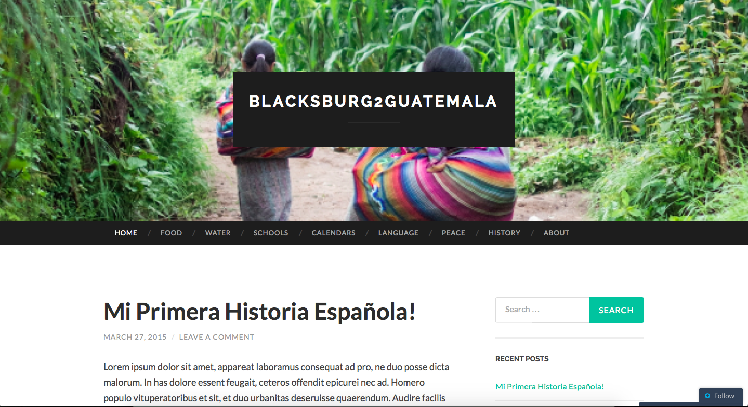
Figure 1: The home page of the website
The home page serves to be the central hub on the website giving users a list of stories sorted from the most recent to the oldest. The home page also displays a right sidebar, which contains a search field to search stories. Below the search engine is a list of recent posts on the website. The menu items right below the featured image are categories the stories will be broken down into. Clicking on of these will display stories in the respective category.

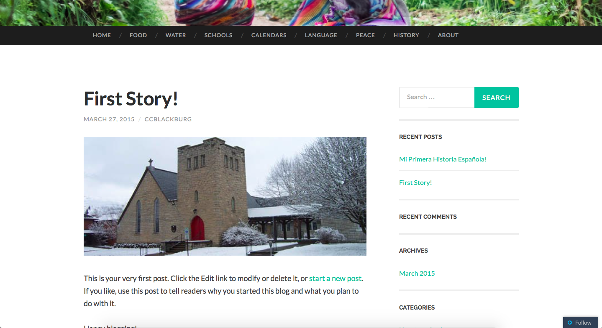
Figure 2: Story page
Clicking on a story will show then full content including pictures if any pictures are associated with the story. The image will be clickable to view at full resolution. The client can embed more than one image/video. The menu items will still be at the top of the page. The side bar will also persist for easy navigation to search and recent stories.

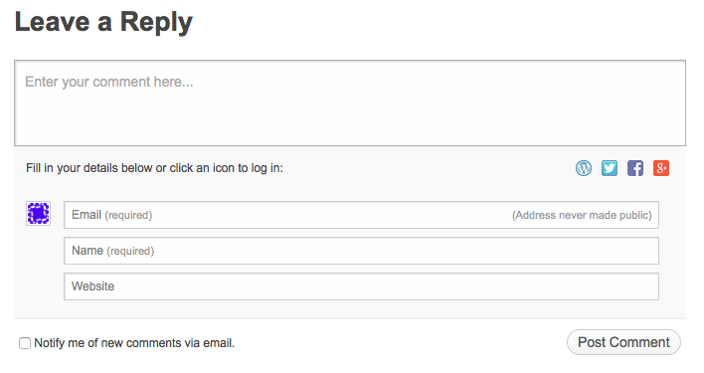
Figure 3: Reply dialog
Every story will also have a commenting section on the bottom of the page. Here the user can leave a reply if they desire. A reply can be anything from a reflection or a way to communicate with the parish. The reply dialog box will require users to enter email and name to prevent spam.

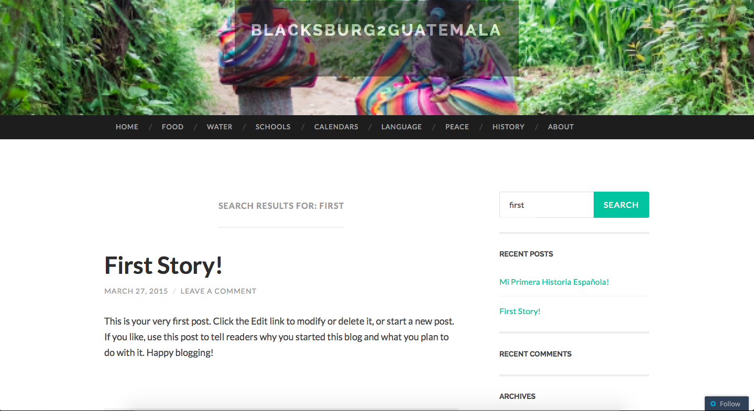
Figure 4: Search result functionality
Figure 4 shows how users can use the search engine. A user can search a story using the search bar on the right side bar. Stories can be searched in both English and Spanish. The user can also search categories. The results will be displayed based on how relevant each article is to the search term.

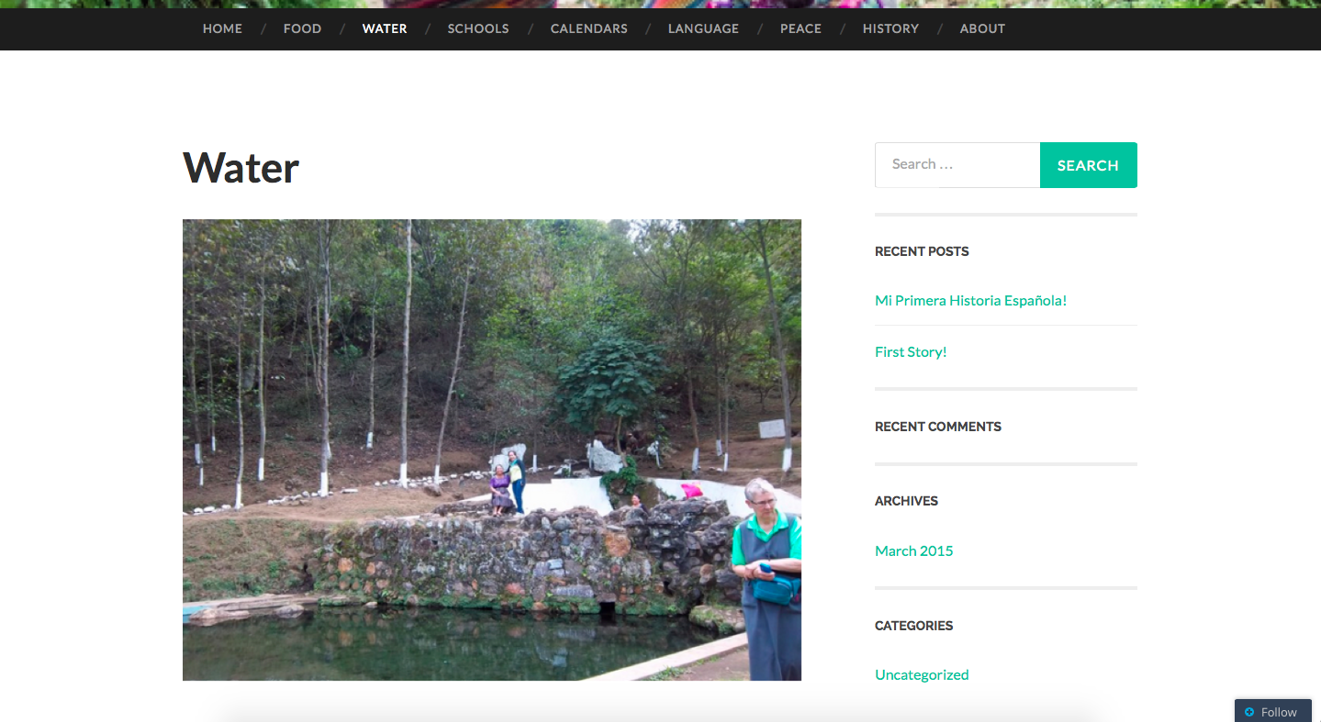
Figure 5: Water category page
Figure 5 shows what a sample category page looks like. Stories that are tagged to that category will be displayed in each subsection. Users can view a particular category that interests them the most.

3 Developer’s Manual
The purpose of this developer manual is to show how the parishes can upload content and generally change the website as they desire. The developer end of the website can be accessed at: https://wordpress.com/wp-login.php. The login page is shown in Figure 6. The username and password is as follows:
Username: ccblackburg
Password: multimedia

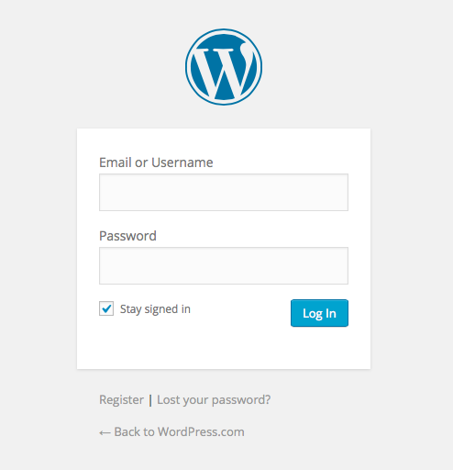

Figure 6: Login window for parish
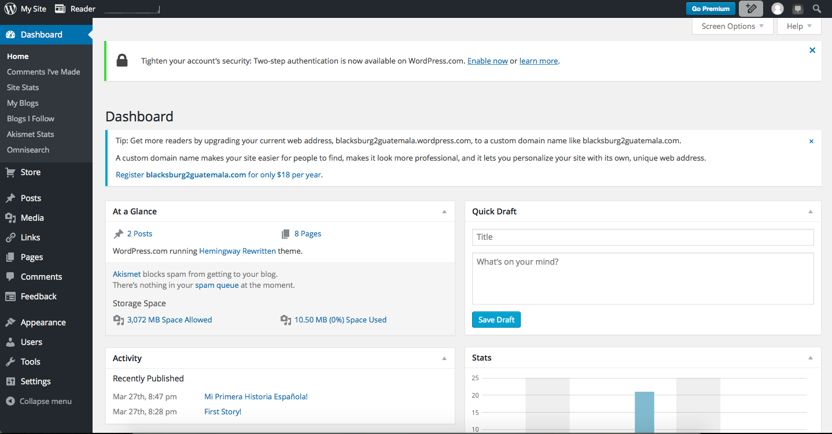
Figure 7: Dashboard Page
The successful login in will lead to Figure 7. One must click on “My Site” in the upper left corner. Clicking on that will lead to the dashboard for the WordPress website, as shown in Figure 8. 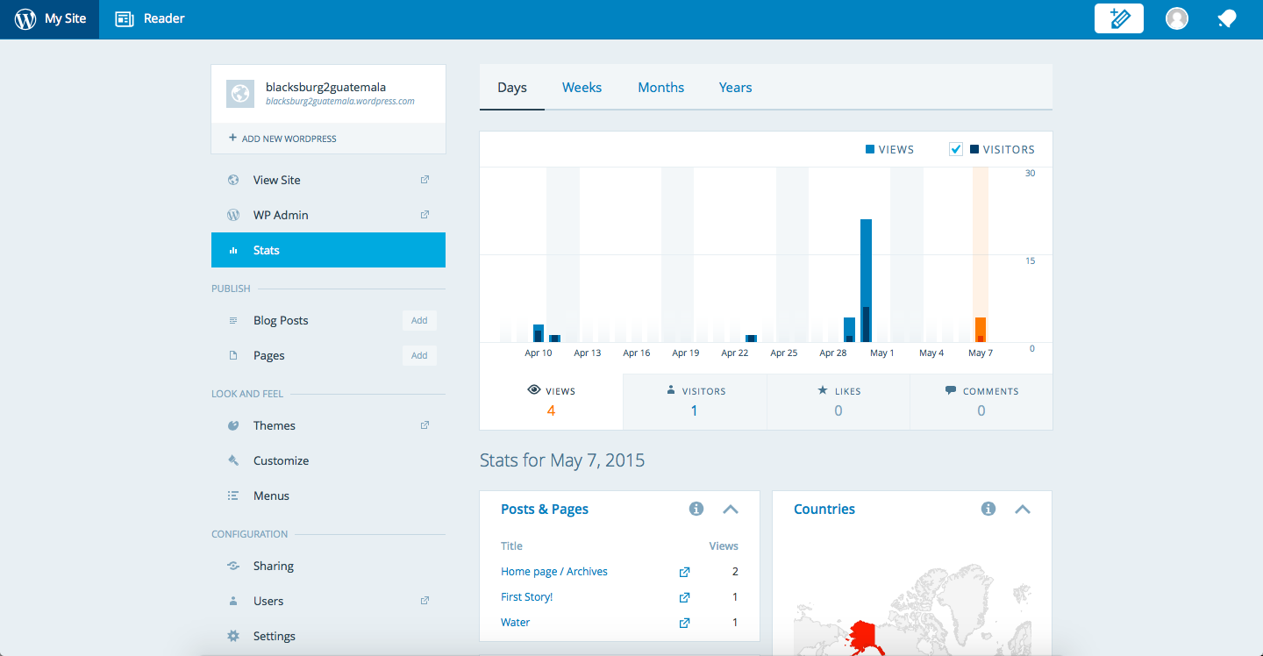
Figure 8: WordPress specific site Dashboard
Many tasks can be accomplished from this page. The landing page contains analytic information to see how many views the website is getting. Statistics can also be broken down by each category and page. One can also see what countries are visiting the page on a daily basis.

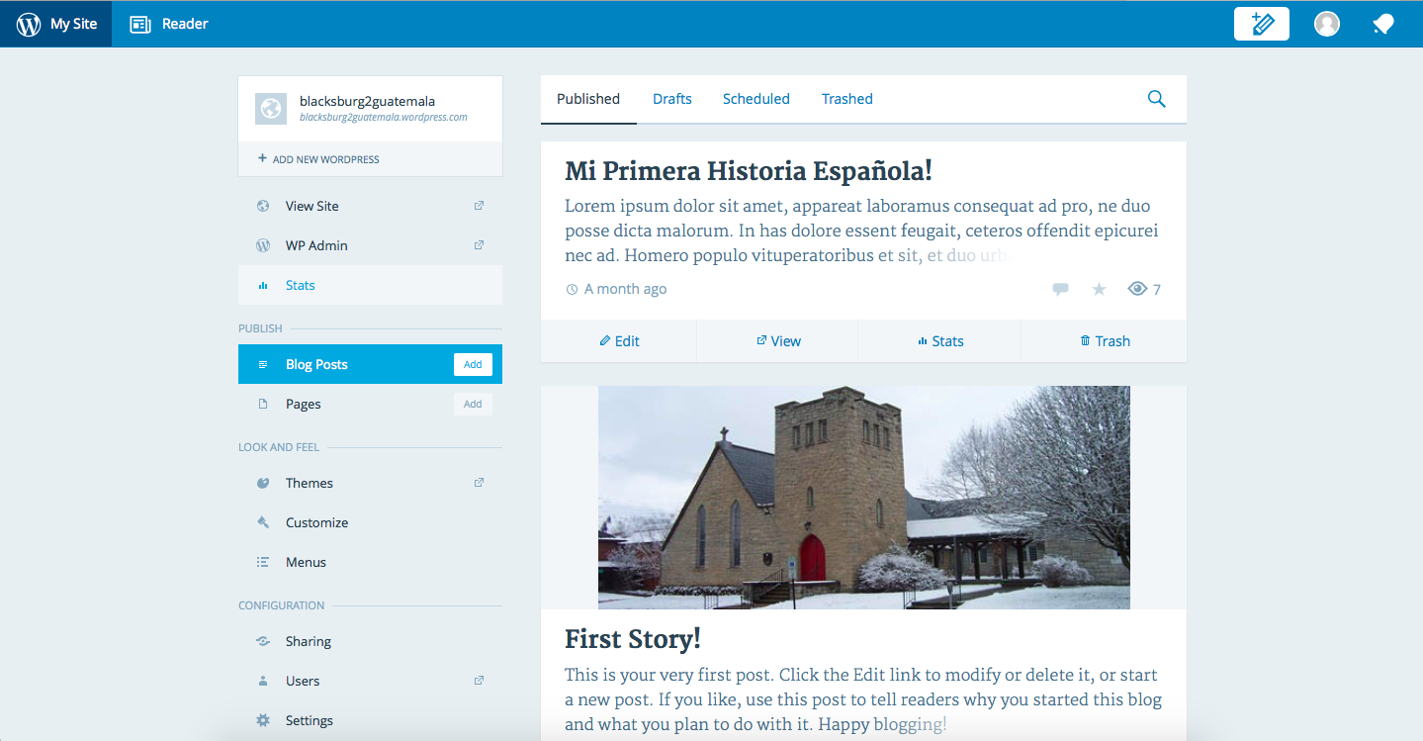
Figure 9: Blog post display
Clicking “Blog Posts” in the left side bar will lead you to this page, where one can manage all the posts on the website. A list of recent posts will be shown here. Clicking the pencil icon on the upper right will allow the client to post a new story as seen in Figure 10. From here the story can be added to the website. The story can be given categories and pictures can also be added.

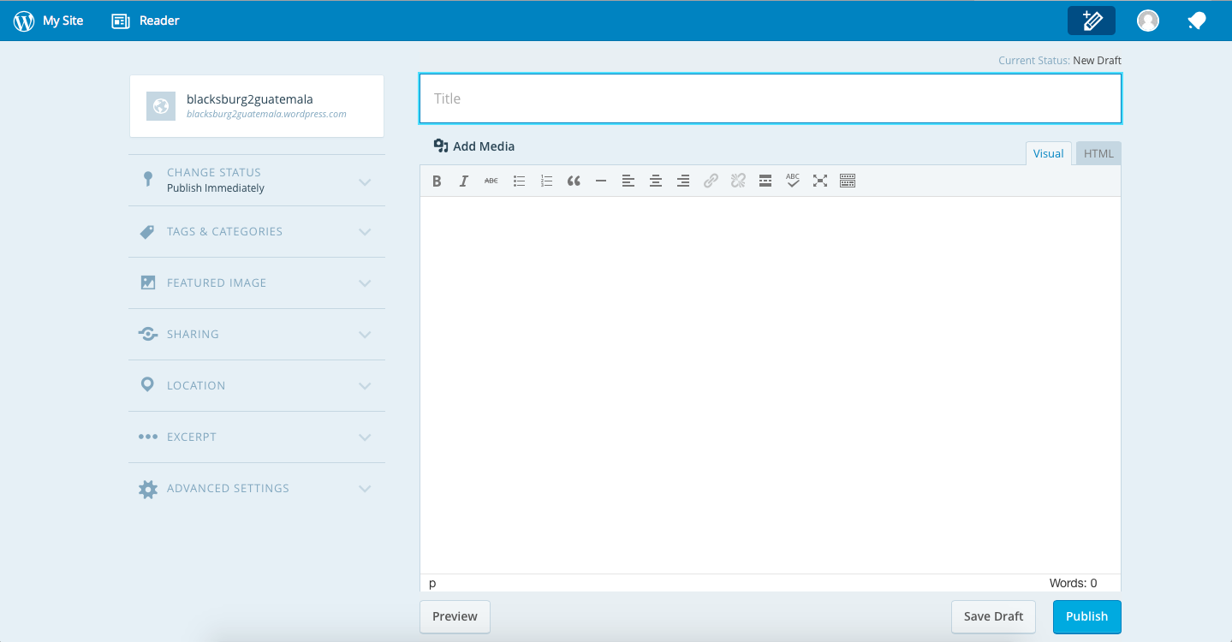
Figure 10: Creating a new blog post

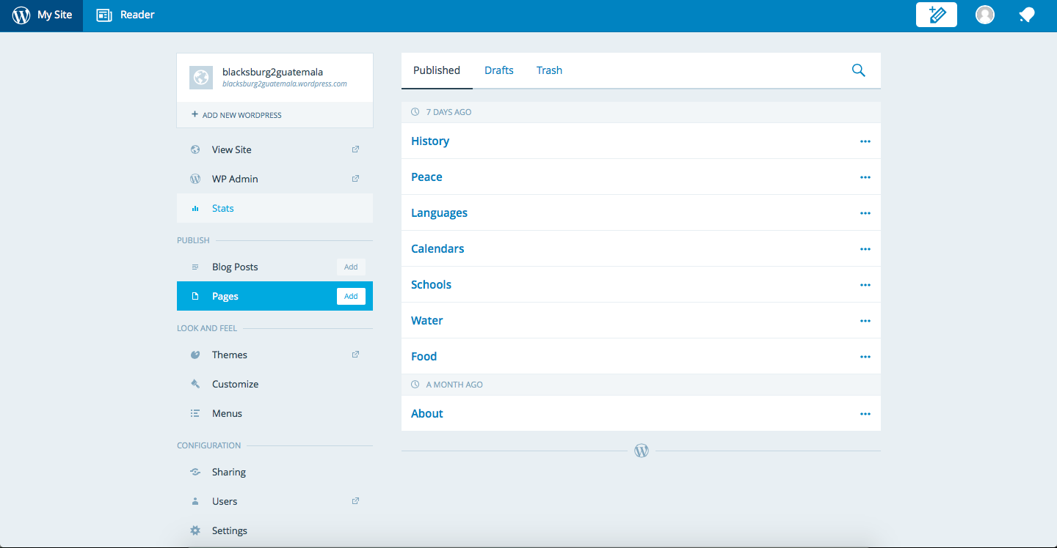
Figure 11: Pages display
Clicking “Pages” on the left side bar will display the categories already on the website as seen in Figure 11. New categories can be added from this page as well.
Many other tasks can be accomplished using the dashboard, including changing the look and feel of the website and changing commenting settings.

4 Lessons Learned

4.1 Timeline/Schedule
The project was broken down into multiple two week long phases, with deliverables due at the end of each phase. The project was spilt up into 4 two week long phases. Phase 1 was about identifying the tools that would be used on the project and website hosting. A big part of this phase was to investigate how the client will upload content to the website.
Phase 2 was to implement the website design. The design needed to be easy to use and free of extra noise. This means modules not absolutely necessary should be left out. Phase 3 involved publishing the stories and pictures to the website. This phase was heavily client dependent as the stories came from the client. The last phase was to implement a search tool that would search all possible stories and categories.
In general, we kept up with the phases and the two-week deadline for each phase. Phase 3 gave us some trouble, as the client was not ready with the stories. We instead worked on other aspects of the website while the client brought together the stories.

4.2 Problems
The biggest problem faced was theme selection for the WordPress website. The project required a particular theme to appeal to readers. The design had to be easy to use and clean, meaning obtrusive elements should not exist. The theme also needed to be multimedia friendly, as many stories have accompanying pictures/videos.
We found it hard to find a theme that satisfied all the requirements. Many themes did not have a coherent way of showing both pictures and text. The remaining themes were too busy in their design approach and had many unnecessary elements.
Another problem was bilingual support. WordPress automatically corrected Spanish stories as the software thought they were in English. This removed all the accent marks.

4.3 Solutions
To properly solve the theme problem, we had to customize a template. We went through each element of the theme and customized it to the requirements of the project. We cleaned up the way pictures were shown alongside stories. We also got rid of redundant elements on the page. We then added things we needed such as an About Us page.
To solve the language problem, we dug deep into the WordPress developer documentation and found a way to enable Spanish content. This stopped WordPress from automatically correcting the Spanish text.

4.4 Future Work
The deliverables specified in the contract with the client were completed. However, the website needs to have much more content. The parishes can accomplish this at a later date when there are enough stories to share. Following the developer’s manual will enable the parish to easily post new pictures and stories.
Furthermore, a translation feature can be added so that stories can be viewed in either language. We explored this feature, but there was no way to keep the full meaning. If there is a way no meaning can be lost in translation, this feature should be added.

5 Acknowledgements
The project team would like to thank the client, Kimberley Homer for her support and guidance throughout the project. She can be reached at: 540-231-9521 for any further questions. The team would also like to thank Dr. Edward Fox (fox@vt.edu) for introducing this project to our group in allowing us to create something that we hope will have an impact on the community. The project would not be what is without the two listed above and we thank you for giving us the opportunity.

6 References
Bego, Sven. "Software Engineering Project (2IP40) Software Requirements Document." Software Requirements Document. 28 Mar. 2006. Web. 12 Feb. 2015. <http://www.academia.edu/9021460/Software_Engineering_Project_2IP40_Software_Requirements_Document>.
Berezi, Tanya. Writing a Software Requirements Document: Web. 6 Mar. 2015. <http://home.adelphi.edu/~siegfried/cs480/ReqsDoc.pdf>.
"WordPress.org." Developer Documentation. WordPress. Web. 26 Mar. 2015. <http://codex.wordpress.org/Developer_Documentation>.
"WordPress.org." Multilingual WordPress. WordPress. Web. 26 Mar. 2015. <http://codex.wordpress.org/Multilingual_WordPress>.

