HNFE Internship - WebEx Info - Workshop - Health Literacy and Library Research

Webinar Connection Information:
Friday, August 26th, 2016
9:00 am | Eastern Daylight Time (New York, GMT-04:00)
Meeting number (access code): 640 800 014

Join the meeting at this URL
[Meeting URL]
Meeting number (access code): 640 800 014

*Use Google or Firefox browser to access the meeting, rather than Internet Explorer
*You may need to add the WebEx browser plug-in / Add-On. See page 2 for login screenshots.

Technical Assistance:
For any questions about joining the meeting please contact Ginny Pannabecker at: vpannabe@vt.edu, or via call or text at: 480-862-9353. For technical difficulties during the meeting, please use the Chat box to type a message describing the issue. If you are disconnected or can’t access the chat, please email or text Ginny instead. Thanks!

WebEx Login - Screenshots of the Login and Connection Process from the meeting link:

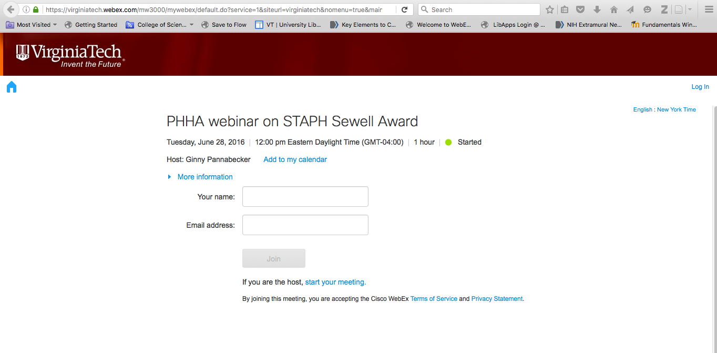
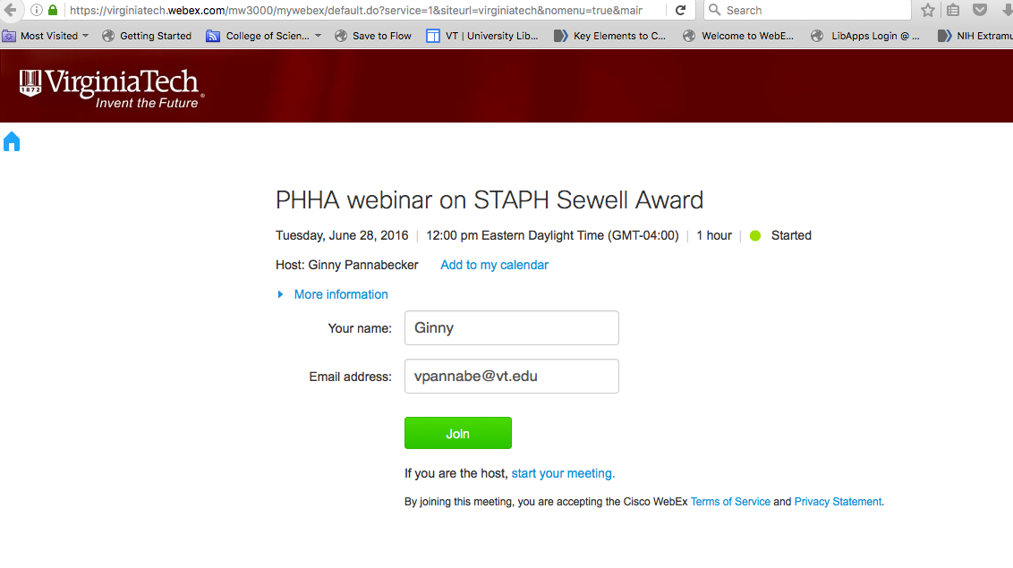
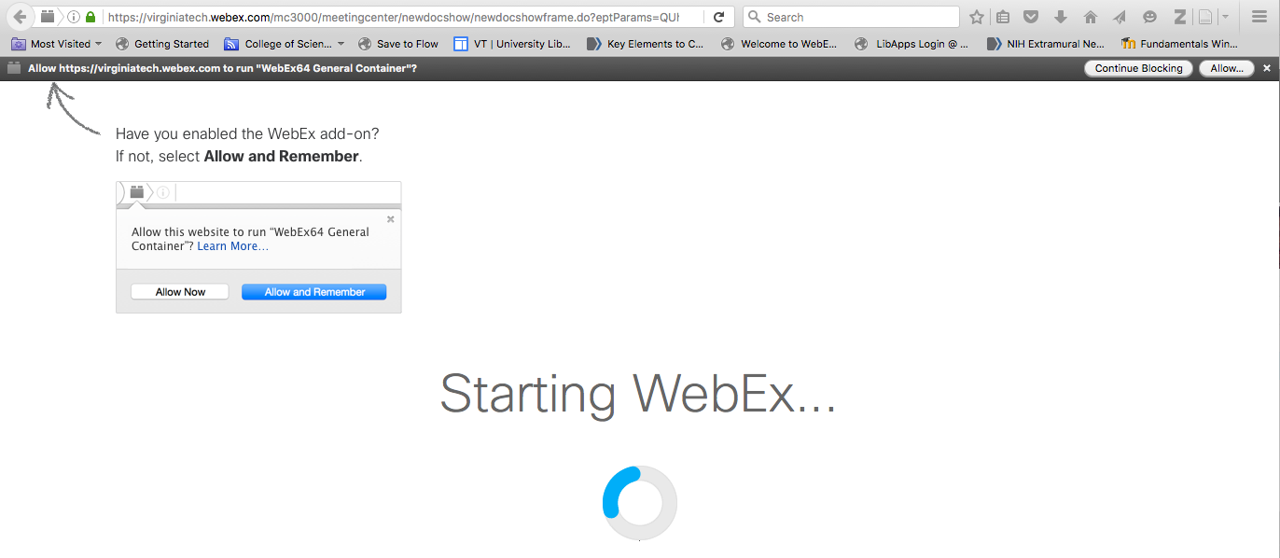

Technical Assistance:
For any questions about joining the meeting please contact Ginny Pannabecker at: vpannabe@vt.edu, or via call or text at: 480-862-9353.
For technical difficulties during the meeting, please use the Chat box. If disconnected or can’t access chat, email or text Ginny instead. Thanks!

