Strategic Social Media Plan-Business School
Donna Wertalik, M.S., Marketing

In efforts to build a central voice in The Pamplin College of Business at Virginia Tech, a 12-week plan evolved. This plan found a meeting place at a crossroads between education, social media placement and experimentation, and content marketing. A set of social media channels was developed as the source for those seeking academic news, trends in social media marketing, and engagement within the college and across campus. In this initiative, the goal was to reach an audience that consisted of current and prospective students, alumni, and leaders in academia.
With the intent to develop a robust community of influencers on all platforms within a specific timeframe, many steps had to be taken and dynamic metrics had to be followed and maintained. At the end of the project, the college would ideally have an all-knowing tone amongst the student and professional body as well as an exciting attitude with a passion for the business world. The college sought less casual conversations and more thought provoking, share worthy discussions. The students’ words would eventually inspire action within the college and social networks, while allowing those with a passion for business to have fun amongst fellow enthusiasts.
With all of that in mind, how would success be measured and reached? Basics had to be set – in a case like this, with so many intricacies and so many potential critics, it’s the little things that would matter the most. It began with a three-tiered system in regards to the social tone, voice and personality, which would aim to encompass the following criteria:
- Knowledgeable – always current with what is happening in the college and business worlds
- Progressive – inspiring and broadening ideas with a fresh business perspective
- Engaged – starting, sharing, and continuing the conversation
The next step in the evolution of this strategic plan was building a process to work by. By combining curation, facilitation, monitoring and management, the team would continuously reach goals.
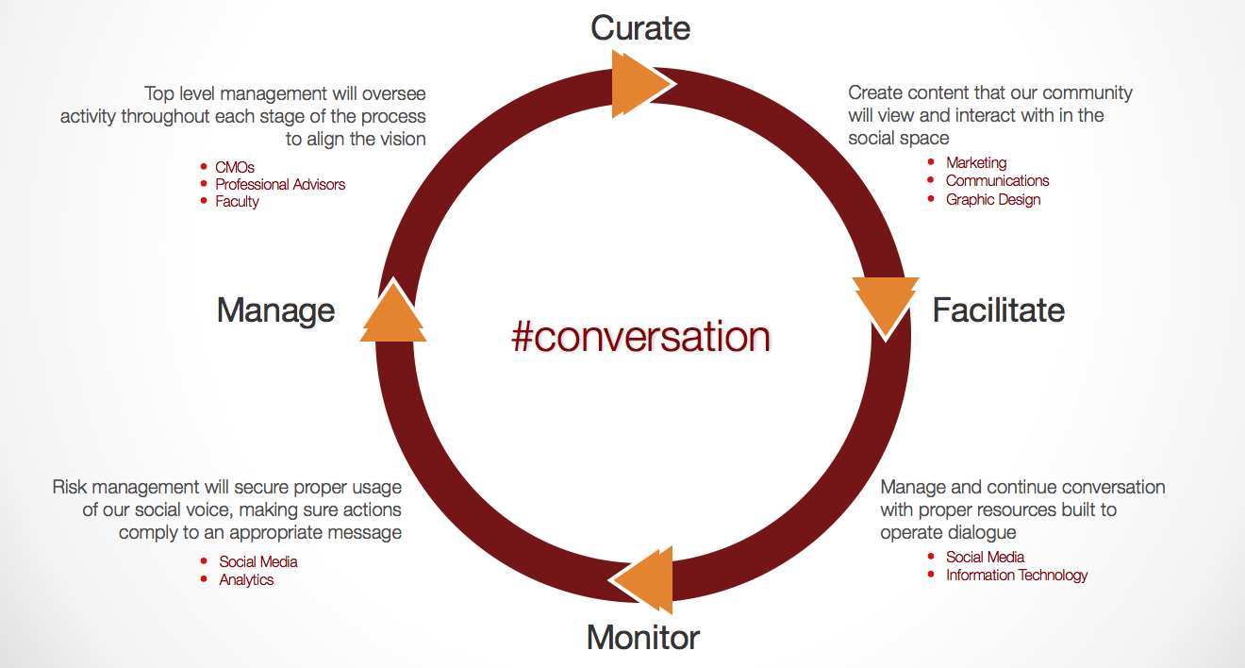
After coming full circle on the process, measurement was again questioned. What metrics would be appropriate to analyze action items in this plan? In what ways would measurable goals be attained? The scale of success was broken down into four major goals, each harboring a quantifiable KPI, as well as a tool that would harness those numbers.
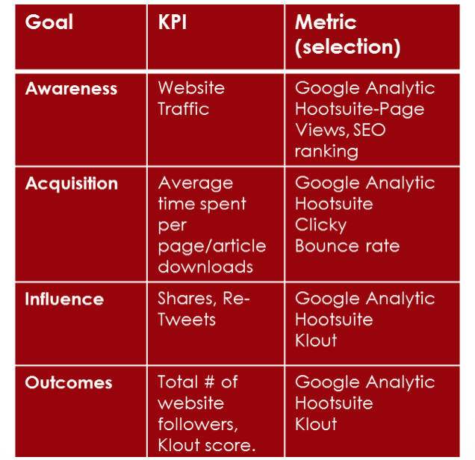
Finally, creativity had to be addressed. Social media is of course an art, a marketing tool, and so much more than just a means to communicate. Using periodical themes, the 12-week plan would become a 4-part plan. Timely elements of each period, such as national holidays, university events and trending topics would be helpful in focusing in and creating conversation. Between each period, goals and metrics and engagement could be analyzed, and within each period, new ideas would be brainstormed and implemented. In a single semester, the social plan would be launched with themes as the central strategic element to work by.
- Period 1 (Jan. 28th-Feb. 24th): Determination
  - Focus on all elements of a student’s life - fun, love, education, job-seeking, history, success
  - Super Bowl, Valentine’s Day, Business Horizons Fair, Black History Month
- Period 2 (Feb. 25th-March 24th): Tradition
  - Ring Dance, American Red Cross Month, St. Patrick’s Day
- Period 3 (March 25th- April 21st): Ut Prosim, So that I May Serve
  - The Big Event, 3.2 for 32 Run, Relay for Life
- Period 4 (April 22nd- Graduation): We Are The Future
  - Emphasize accomplishments of Graduates (jobs, internships, etc.)

Although the periodic breakdown, the systematic process and the graphical goals, the approach consisted of a team and some simple action items. Starting with a content calendar and moving through multiple social channels individually required a very genuine human aspect throughout. If that was ignored, strategic analysis would mean nothing. By nurturing that role during the 12 weeks, the following items could roll out with more influence than even planned.

- Create a comprehensive editorial content calendar across platforms to expand engagement and reach
  - Team Role: Develop Comprehensive Content Calendar- goal of leading up to 3 blog posts Per Week, 5-7 Tweets Per Day, and 1-3 Facebook Posts Per Day- Publish and Monitor
- Maintain an active Twitter Channel
  - Team Role: Identify Influential Professors, Students, and Alumni- Contacts. Secure a minimum of 15% influential Twitter Followers by April 21st, 2013.
- Build an engaged Facebook Channel
  - Team Role: Post up to 1-3 status updates per day that encourage readership of blogs, conversation, and Twitter following. Secure a minimum of 10% influential “Likes” by April 21st
- Keep and updated Blog current always
  - Team Role: Utilize targeted keywords and promotion on Twitter & Facebook; Measure success based on traffic analysis through Google Analytics (SEO and AdWords) to Establish and grow blog readership

Through the execution of each one of these shifting parts, it became evident that this was not just an experiment; it was something that could benefit the college in coming years in all areas. Prospective students, enrolled undergrad and graduate students, and alumni could all focus in and share thoughts, creating irreplaceable and influential connections. Between generations, industries, cities and even simple social likeness, groups could engage on a level they had not experienced previously. By working through a plan that was specific, measurable, attainable, relevant and timely, success was reached at a fast pace with few obstacles.

