EXERCISE: Developing Personas
Purpose: Understand course material selections and identify additional areas for Open Education Initiative program development
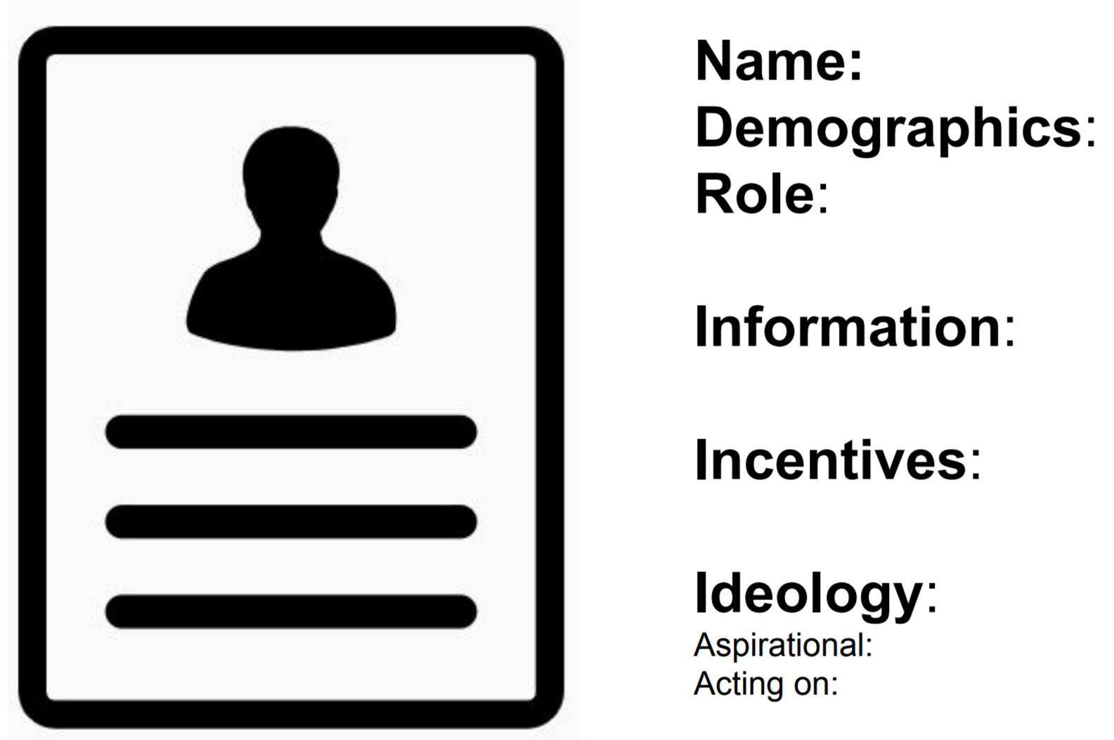
(regarding course materials)
(regarding course materials)
(regarding course materials)
© Graphic by Joseph Wilson CC BY
Summary & Program Actions:
https://thenounproject.com/term/profile/95841
© Anita Walz. Licensed with a Creative Commons Attribution (CC BY 4.0) International License

