Transforming Leadership Education Undergraduate Advising: Incorporating Growth Mindset and Design Thinking

Addison Sellon, M.S.
University of Nebraska-Lincoln

Hannah Sunderman, Ph.D.
Assistant Professor
Virginia Tech

L.J. McElravy, Ph.D.
Associate Professor; Graduate Chair & Leadership Program Coordinator; Associate Dean for Professional Development
University of Nebraska-Lincoln

Abstract
Academic advisors are an invaluable and steadfast component of leadership students’ higher education experience (Hunter & White, 2004; Mann, 2020; Museus, 2021; Spratley, 2020). Yet, given the myriad student paths and preferences, advising calls for flexibility, commitment, and personalization. Applying growth mindset and design thinking to the academic advising process in leadership education may help advisors meet the diverse needs of their students, integrating theory and practice. Notably, growth mindset and design thinking are linked to overall motivation, confidence, and problem-solving (Dweck, 2015; Hochanadel & Finamore, 2015; ​​Mann, 2020), allowing students to take ownership over and actively engage with their academic advising experience. Therefore, two advising manuals (i.e., a student manual and a faculty manual) were generated to incorporate growth mindset and design thinking-based approaches to the advising experience within leadership education. The manuals were implemented into various advising situations for data collection and feedback. Findings revealed an overall favorable opinion of the manual and guidance for further implementation within the advising process. The two manuals presented in the current paper provide leadership education students, academic advisors, and departments with various tools to enhance and guide their undergraduate student experience.
Introduction
Academic advisors play a critical and constant role in the lives of undergraduate students (Hunter & White, 2004; Mann, 2020; Museus, 2021; Spratley, 2020). The advisor and student connection centers around high levels of investment and support to encourage students to make the most of their undergraduate experience. Engagement between students and their academic advisors has been found to encourage students to actively participate in academic experiences while simultaneously expanding and developing those experiences (Mann, 2020).
Regardless of the apparent advantages of the advising experience, advisors have broadly voiced challenges that can arise within the advising environment, namely maintaining a student-centered focus and finding a best practice that all view as vital to student learning (Aiken-Wisniewski et al., 2015; Hunter & White, 2004). The leadership education department at a four-year, large, Midwestern university identified additional areas of improvement within their advising practices, including a desire to create a more streamlined and unified approach to advising and to incorporate leadership theories into their advising experiences. With these aims in mind, growth mindset and design thinking were identified as key leadership theories to address both field-wide and department-specific challenges to academic advising. Notably, recent studies have successfully explored the potential outcomes of incorporating growth mindset and design thinking into the advising process, further encouraging their application in the present study (Banter, 2020; Kyte et al., 2020; Mann, 2020).
With the recognition of the challenges inherent in academic advising, we developed two manuals (i.e., a student manual and an accompanying faculty manual) that integrated growth mindset and design thinking within the context of academic advising. The goal of the student manual was to provide structure to the academic advising process while simultaneously enhancing leadership education students’ confidence and independent problem-solving. A faculty manual was also developed to enhance the overall advising experience and complement the student manual, thus creating cohesion and unity for advisors and their students. Both manuals provide leadership education students and advisors with a general framework of the concepts and specific tools that allow for practice, collaboration, and guidance during the academic advising process. After the manuals were generated, they were implemented into a pilot study and focus group to collect feedback on their potential impact on advising. This manuscript further explores the potential impact that growth mindset and design thinking can have within leadership education academic advising while further clarifying the role of the advisor (Spratley, 2020). Through this exploration, we hope to provide leadership educators with the framework and tools to incorporate both practices into their advising relationships, enhancing the time and interactions they have with students.
Background and Related Literature
In the current application manuscript, a leadership education department at a four-year, large, Midwestern university expressed their need to enhance their advising practices. Specifically, the department wanted to create a unified advising experience while simultaneously remaining rooted in a personalized approach that meets students’ needs and contributes to the department’s purpose of “developing the human potential (“Agricultural Leadership, Education & Communication Strategic Plan 2017-2022,” 2022) Further, the department’s vision is to be “a leader in providing innovative programs to develop extraordinary teachers, leaders, and communicators” with one aspect of the mission being to “[provide] innovative strategies that support excellence and best practices in teaching, research, and engagement” (“Agricultural Leadership, Dducation & Communication Strategic Plan 2017-2022,” 2022). In line with the mission and needs of the department, two connected manuals (i.e., a student manual and a companion faculty manual) were formatted to address both the local and broad challenges within the field of leadership education academic advising. In so doing, we sought to create a united approach to academic advising within our department that would aid department faculty in their advising role.
To enhance student empowerment through the academic advising process, the concepts of growth mindset and design thinking were identified and combined due to their links with student motivation and self-confidence (Dweck, 2015; Hochanadel & Finnamore, 2015). These concepts have also been connected to empathy, creativity, and problem-solving (Goldman & Kabayadondo, 2017; Karpen et al., 2017, Mann, 2020). The department's aims, along with the recognized challenges of academic advising, were incorporated with the constructs of growth mindset and design thinking to develop student-centered advising manuals for both students and advisors.
Growth Mindset
Growth mindset, as defined by Dweck (2006), is the belief that one’s “basic qualities are things you can cultivate through your efforts, your strategies, and help from others” (p. 7). This concept is formulated around how an individual approaches and interacts with problems as well as processes failure. The opposite of a growth mindset is a fixed mindset, a mindset in which an individual views their intelligence and abilities as stagnant, rather than as something that can be grown and developed (Dweck, 2006). When applied to academic settings, whether the introduction came from an instructor, parent, or guardian, a growth mindset was found to increase students’ abilities to overcome challenges by providing enhanced motivation and self-confidence (Hochanadel & Finnamore, 2015; Dweck, 2015). Specifically in the context of academic advising, Kyte et al. (2020), found that sending micro-messages formulated around a growth mindset to struggling students encouraged them to feel more motivated to face their challenges. Additionally, the incorporation of growth mindset has been linked to students overcoming challenges and achieving their goals (Cairncross et al., 2015).
Design Thinking
Design thinking is a framework that emphasizes a human-centered problem-solving process. Following the framework developed by the British Design Council (2019), design thinking is generated from four unique phases: (a) Discover; (b) Define; (c) Develop; (d) Deliver. The Discover phase takes place when the individual is seeking to understand and recognize the problem at hand (Mann, 2020). The Define phase occurs when the specific challenge is identified after analyzing the information gathered during the Discover phase (Mann, 2020). The Develop phase represents when the individual begins to conceptualize and build solutions (Mann, 2020). Lastly, the Deliver phase takes place when the proposed solution is executed while feedback for adjustments is simultaneously received (Mann, 2020). When implemented in a higher education setting, design thinking has been found to encourage students to trust the process at hand, find a balance of control and freedom, not be afraid of failing, and focus on development throughout the process rather than the result (Coakley et al., 2014). When incorporated into academic advising, design thinking has the potential to provide individuals with a framework to process and overcome challenges through open communication, processing, and planning.
Growth Mindset and Design Thinking
Past studies have demonstrated the benefit of utilizing design thinking and growth mindset to foster student success (Banter et al., 2020; Spratley, 2020). By employing growth mindset and design thinking, advisors can encourage their students to view learning and their collegiate experience as a multifaceted process that expands and evolves (Lowenstein, 2013). Equipping students with design thinking opportunities and implementing growth mindset in their advising experience will allow for student success in their future as they will have experiences with problem-solving and not be discouraged by potential failure. Through these applications, students will be prepared to confront obstacles as they come and continue growing throughout their undergraduate experience and beyond.
Additionally, previous research has uncovered how the collaboration between students and the advisor allows for students to be actively engaged in their academic growth while working with their advisor to expand and develop their experiences (Mann, 2020). The utilization of growth mindset-centered language by advisors towards students has been found favorable to students as it made them feel encouraged and recognize that they had growth opportunities when faced with a challenge (Kyte et al., 2020). Advisors can prepare students to overcome obstacles and reach their goals by nurturing their growth mindset (Cairncross et al., 2015). In sum, applying design thinking techniques encourages creativity and collaboration in the student’s advising experience, while growth mindset encourages students to persevere against challenges and potential hardships during their learning experience. When combined, students have a growth-centered perspective of their goals along with a framework of how to achieve them.
Growth Mindset and Design Thinking in Leadership Education Academic Advising
Unique to academic advising within the field of leadership education, Banter et al. (2020) implemented design thinking practices into the leadership education academic advising process. One piece, in particular, that was developed was “curriculum roadmaps that detailed students’ progression in the program” (Banter et al., 2020, p. 72). This gave leadership students the chance to design their path and play a key role in their learning experience. Academic advisors play a crucial role in leadership student learning by, “generating awareness and connecting students to leadership education opportunities” (Spratley, 2020, p. 43). Advisors are a resource and a tool for students to utilize as they seek to grow in their undergraduate leadership experience.
Combining growth mindset and design thinking into the academic advising experience has a variety of potential advantages for leadership education students (Spratley, 2020; Banter et al., 2020). During the advising experience, advisors help their students grow and seek new opportunities. Through a growth mindset and design thinking, advisors can connect and collaborate with their students to explore and identify specific opportunities that are best suited for the student. Lowenstein (2013) also states that a growth mindset and design thinking can encourage students to perceive their education and college experiences as an ever-evolving multilayered process. When combined, the frameworks allow students to shift their thinking to a focus on growth and process while also providing steps in which they can engage with and overcome the problems they face. By so doing, students can work towards their success and take charge of their advising and education experiences.
Encouraging students to be in control of their advising experience also enforces the notion of student autonomy through self-directed learning. Student autonomy encourages students to have a sense of ownership in what they are doing and take control of their learning (Smith & Darvas, 2017) while self-directed learning fosters a sense of responsibility (Wilcox, 1996) and lifelong learning (Kreber, 1998; Van Woezik et al., 2019). The concepts of growth mindset and design thinking naturally encourage both student autonomy and self-directed learning as focus is on the student, their needs, and their growth. Through these concepts, students can take control of their own learning and continue further incorporating both concepts throughout their lives.
Growth mindset and design thinking have previously and can presently provide great value to undergraduate leadership education students and their advisors. Research has begun unveiling the benefits and support that these concepts can provide for students during the advising process (Banter et al., 2020; Mann, 2020; Spratley, 2020). The current study aimed to further explore the impact that can be had through incorporating growth mindset and design thinking into advising meetings. Through both manuals, tools are provided for academic advisors, specifically those working in leadership education, to integrate both concepts into their practices. Growth mindset and design thinking are both rooted in a rich history of research and implementations in various academic settings and, when combined, can help facilitate continued growth, ownership, and confidence for undergraduate leadership education students. Additionally, these resources provide advisors with a unique and structured framework to streamline the advising process while fostering engaging and collaborative environments for their students.
Description of the Application
In response to the challenges of academic advising, recognized both within our department and generally in the field (Hunter & White, 2004; Spratley, 2020), we composed two advising manuals. The first manual is centered around the student and designed to be a tool and space for the student to learn, reflect, and grow by applying growth mindset and design thinking to their college experiences. The second manual focuses on the advisor and serves as a complementary piece to the student manual to enhance undergraduate academic advising sessions. Both manuals were generated to be adaptable and formattable to best enhance the advising needs of that specific student and to cultivate student autonomy through self-directed learning. These manuals were then implemented within a leadership education program at a four-year, large, Midwestern university.
The first manual was generated to serve as a tool specifically for students and focuses on introducing both theories, interactive growth activities, yearly worksheets, and reflection questions. The learning objectives for this manual are that students will understand growth mindset and design thinking, know how to approach challenges by using growth mindset techniques, and be able to apply the steps of design thinking to frame their goals. The overall aim of the manual is to introduce students to these concepts during their meetings with their advisor in hope that overtime they extend these tools beyond advising and throughout their educational experiences.
Section One of the manual introduces a growth mindset and design thinking to the student. The pages within the first section include definitions of the overall concepts and the phases of design thinking (see Figure 1). Section One also provides figures and visuals of growth mindset and design thinking along with a portion describing the benefits of combining the concepts. These visuals enhance the general definitions of the terms to help students conceptualize both concepts. We recommend that Section One is introduced to the student before the first advising meeting to allow them to familiarize themselves with the concepts before meeting with their advisor. Once the student has met with their advisor, they can discuss the frameworks and process questions about growth mindset and design thinking.

Figure 1
Terms and Phrases of Concepts
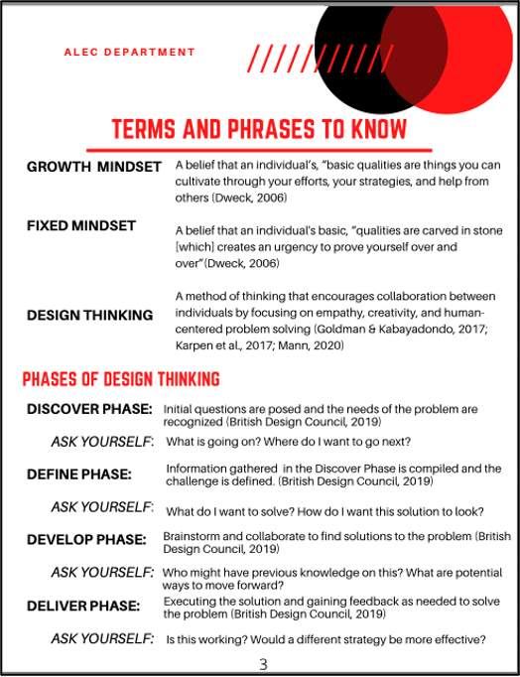

Section Two of the manual incorporates three growth activities that allow students to apply a growth mindset and design thinking to their present lives. These activities were generated to increase student familiarity with a growth mindset and design thinking and to provide an opportunity for students to recognize how both concepts can relate to their personal experiences. The first activity focuses on a growth mindset (see Figure 2) while others address design thinking and future planning. In the growth activity featured in Figure 2, the student is asked to connect factors of a growth mindset and fixed mindset to a challenge they are facing. Connecting the theories to current difficulties allows the student to begin actively applying the concepts to their life and introduces a frame for approaching and addressing challenges. All the growth activities in Section Two can be completed at any stage of the undergraduate experience and completed as often as desired. There are certain times within the manual when students are asked to complete specific activities; however, that is not the only time the activities can be applied. It is also important to note that the activities and exercises throughout the manual were not generated to be components required as homework, though advisors can decide how to address each exercise. Rather, the exercises were made for students to engage with as they see as most beneficial to them and their college experience.

Figure 2
Growth Activity 1, Page 1
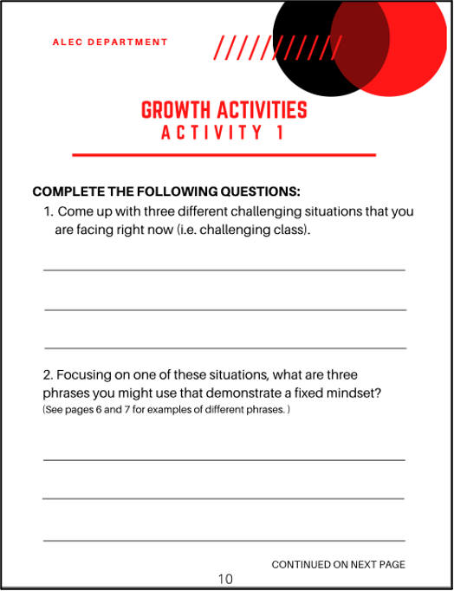

Section Three of the student manual focuses on conversations and concepts for the student and advisor to discuss relative to the year the student is in, which includes class schedules, selecting a minor, studying abroad, internships, and careers. Section Three follows a pattern of having three subsections for each year (i.e., Year One, Year Two, Year Three, Year Four): (a) expectations before the advising meeting, (b) expectations during the advising meeting, and (c) expectations after the advising meeting. This pattern provides structure, allowing the student and advisor to be prepared and understand the expectations for the advising meeting. Having expectations that are understood by both the student and the advisor allows them to initiate strong interactions and make the most of their time spent together. For example, the third year of the manual is centered around internships. Expectations of students before the meeting include completing the third growth activity, researching locations they would be interested in interning, attending a career fair, and preparing a resume. During the meeting, it is recommended that students be prepared to discuss the third growth activity, Growth Activity 3, with their advisor. This specific growth activity focuses on future planning and incorporates elements of design thinking (see Figure 3). Growth Activity 3 provides students with the space to reflect on their current and future jobs, what environments they might prefer, and how they may find long-term fulfillment in their careers. After the advising meeting, the manual asks students to complete the personal reflection questions, which are aimed to prepare them for the internship process (see Figure 4). Providing students with the space to begin thinking about and researching potential opportunities of interest to them before their advising session enables them to begin their advising session at a more intentional and specific level.

Figure 3 Figure 4
Growth Activity 3, Page 1 Year Three, Page 2
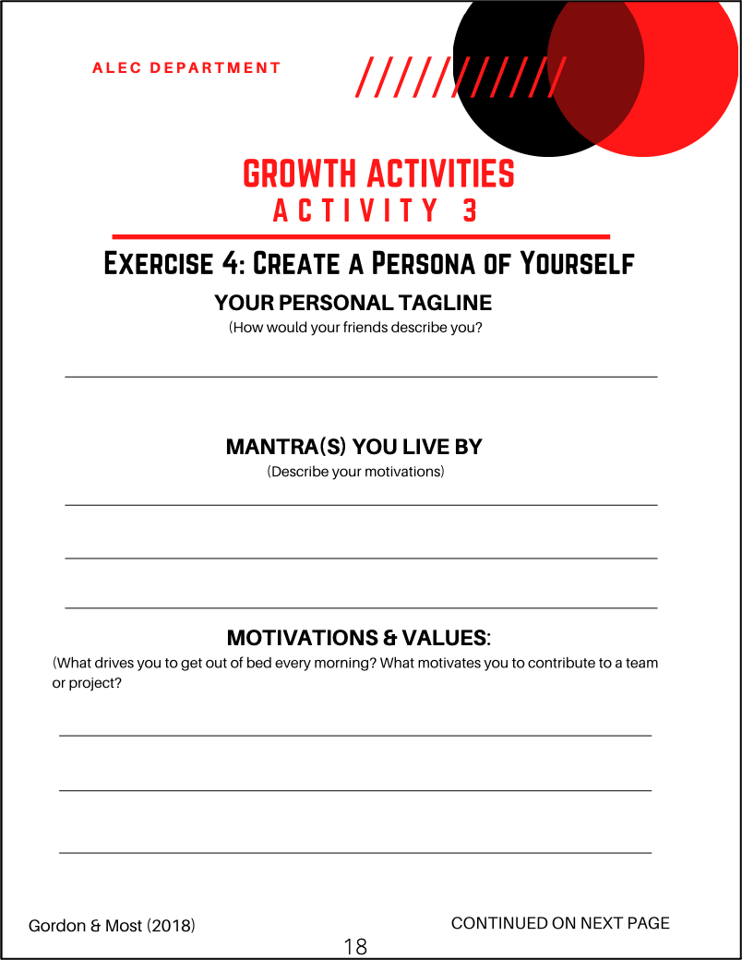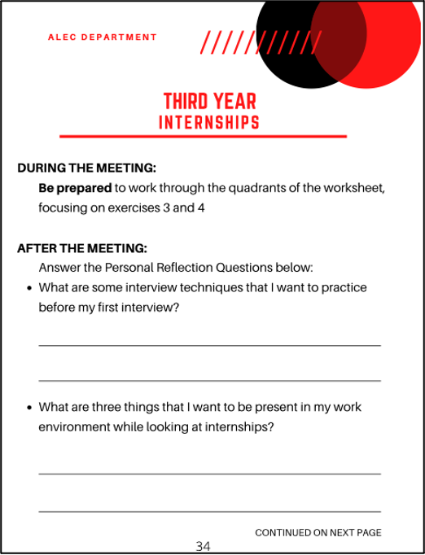

The final section, Section Four, of the student manual is a reflection at the end of each year for students to complete. These components aim to allow students to think about the previous year: what they enjoyed, where they saw growth, and what they would like to continue and adjust moving into the next year (see Figure 5). Section Four encourages students to spend time intentionally reflecting on their previous academic year to prepare for the next. This section was generated as a specific opportunity for students to spend time, whether physically written or mentally reflecting on, thinking about their past year, and channeling those reflections into what they want out of their next year.

Figure 5
End of Year Reflection, Year Three, Page 1
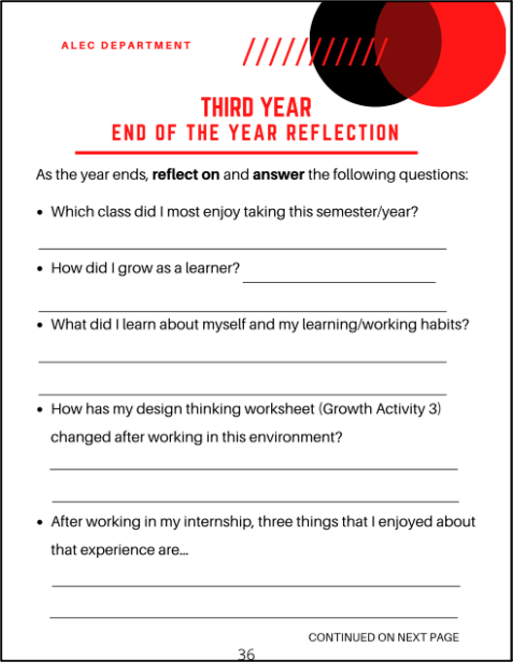

The student manual is presented as a fillable PDF. This format was incorporated after feedback from students who voiced their preference for online material rather than print material. The PDF version of the manual allows ease for students to have all their material in one central location while also providing efficiency for advisors. Offering the manual as a PDF creates a simple sharing and uploading process through learning management systems and other potential cloud-based file sharing systems. Doing so allows the advisor and their students to have a simple and direct way to share information. The online component of the fillable PDF also allows students to always have access to their manual, rather than potentially forgetting a printed copy during their advising meetings.
Our recommended timeline of the advising manual follows the four-year pattern of a traditional undergraduate student. However, the manuals also encourage a flexible and interpretative structure to advise in ways that best meet the needs of specific students. The current manual can be implemented into advising sessions for students on a non-traditional academic path, such as transfer students. For example, the advisor may choose to share the manual with the student before their initial meeting and then work with them to find a starting point that would best suit their needs, completing the manual from that point or selecting specific concepts from various sections that would be the most helpful to the student. We hope that by engaging in this process together, the student on a nontraditional academic path and their advisor will connect and spend time actively finding a place to begin their advising meetings.
The second manual that emerged to meet the needs of the leadership education program is a companion manual centered on the advisor. This manual stemmed from the student manual and is designed to guide advisors who implement the student manual in their advising sessions. This manual follows a timeline similar to the student manual and also includes four sections, one for each year of a traditional student experience. Each of the four sections is composed of an essence statement, timelines and reminders, overall goals, and tips for framing their thinking (see Figure 6). The faculty manual provides advisors with a recommended framework for implementing the student manual within their advising sessions. This manual is more condensed, highlighting ideas and suggestions for advisors to apply but ultimately encouraging advisors to use their preferred approach to advising. It is recommended that advisors also take time before their advising meetings to familiarize themselves with the content their student is focusing on. The advisor manual is similarly presented as a PDF, allowing for the same flexibility and ease for advisors to apply their material to their advising practices.
Figure 6
Advisor’s Guide, Year Two
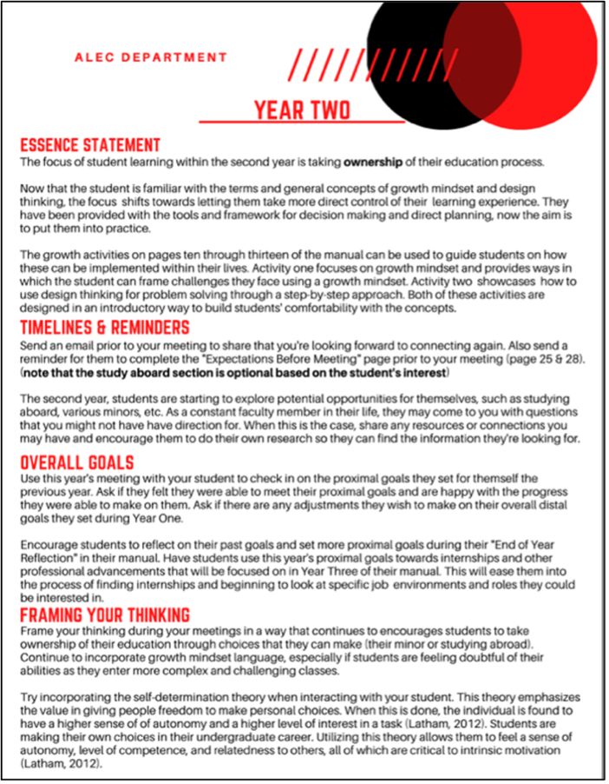

Each year in the advisor manual has a unique focus relative to the student’s year, referred to as the essence statement (see Figure 6). For example, Year One focuses on student understanding, meaning the advisor’s main role at this time is to help their students become comfortable with growth mindset and design thinking. Year Two highlights student ownership of their education process and incorporated growth mindset and design thinking to enhance that ownership. Year Three’s essence statement centers on the student finding structure and independence within their path. For the final year, Year Four, the advisor aims to help their student put motivation into motion as they begin to think about the next steps in their life. Timelines and reminders provide advisors with suggested email content and reminders to share with their students to ensure they are prepared for their upcoming meetings. Overall goals and goal setting are recommended for each year and incorporated into the student manual as well through reflections at the end of each year. Additional information at the end of the faculty manual includes further learning about goal setting. This material can be used by the advisor to familiarize or refresh themselves with the goal-setting theory that is used within the student manual or during an initial advising meeting in conversation with their student.
Each of the Framing Your Thinking sections includes suggested motivational theories that can be incorporated into the advising session relative to the students’ focus at that point in their manual (see Figure 6). In Year One we suggest and provide additional resources to help students better understand a growth mindset. This material is also recommended to be shared with the student if they are having difficulty understanding the growth mindset. The Year Two section suggests incorporating elements of the self-determination theory when interacting with students to encourage them to make personal choices and take charge of their undergraduate careers. Year Three poses optional discussion questions for the advisor to ask their student relative to the sections of the growth activity they were asked to complete. This year also incorporates Herzberg’s (1968) two-factor theory into this phase as students begin to think about future professions and what they may be looking for and value. Similarly, Year Four provides additional discussion questions for the remaining components of the growth activity and encourages conversation about which theories the students felt were most impactful to them and how they can see those theories being implemented in their future lives. At the end of the manual, further content and resources are included for each of the motivational theories for the advisor to explore and apply as they see fit (see Figure 7).

Figure 7
Advisor’s Guide, Self-Determination Theory
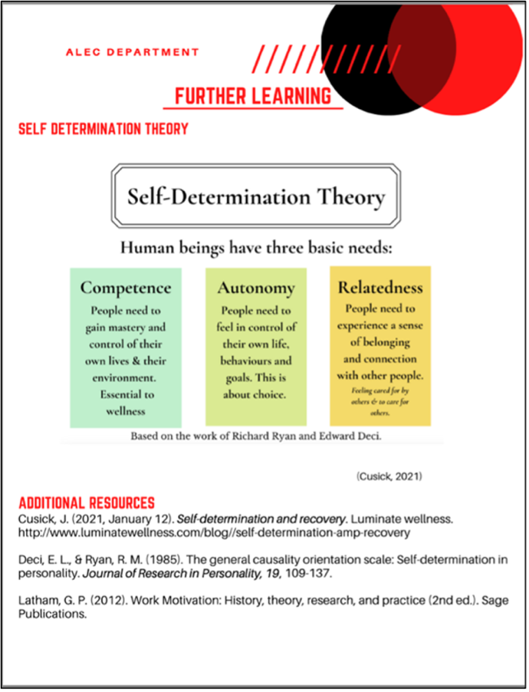

Evaluation of the Manuals and Outcomes/Results
The overall goal of the student and advisor manuals was to provide a cohesive framework for students and their advisors to increase student motivation, confidence, and problem-solving abilities. We gathered feedback and evaluations for both manuals using various settings of implementation. First, the manuals were piloted within a leadership education department at a four-year, large, Midwestern university. The pilot group consisted of a faculty advisor and three of their students. One student in the group was a traditional freshman student and the remaining two were considered non-traditional because they had come back to their undergraduate education after time away from higher education. The manuals were incorporated into their advising sessions for one semester, and feedback was then collected at the end of the semester. After utilizing the manuals, the advisor who implemented the manual and one of their students agreed to provide feedback on the manual. Both individuals were asked questions via surveys using response anchors recommended by Seemiller (2013; 0 = Did not increase, 3 = Greatly increased). The survey asked the individuals to respond to the following statements relative to student growth: (a) My understanding of growth mindset; (b) My understanding of design thinking; (c) My ability to implement a growth mindset in situations; (d) My ability to implement design thinking in situations; and (e) My belief that I can face problems and solve them. Utilizing the same response anchors, the advisor was also asked to answer the following statements relative to their experiences in the advising role: (a) Positive/beneficial interactions with my student during our meetings and (b) My preparation and confidence going into advising meetings. The responses from the pilot study are shown in Table 1 below.

Table 1
Responses from Pilot Study
Statement | Advisor Response | Student Response
My Understanding of Growth Mindset | 1 | 1
My Understanding of Design Thinking | 1 | 2
My Ability to Implement Growth Mindset in Situations | 1 | 2
My Ability to Implement Design Thinking in Situations | 1 | 2
My Belief That I Can Face Problems and Solve Them | 1 | 1
Positive/Beneficial Interactions with my Student During Our Meetings | 2 | N/A
My Preparation and Confidence Going into Advising Meetings | 2 | N/A
Note. Response anchors 0 = Did Not Increase; 1 = Somewhat Increased; 2 = Increased; 3 = Greatly Increased3 =

The evaluations from the student ratings averaged a score of 8.0 while the advisor rating averaged a 9.0. Both scores indicate that those who implemented the manual, whether advisors or students, identified a level of improvement in the advising experience as a result of the manual. Specifically, the advisor who implemented the advising manuals reported an average score of 2.0 in their evaluation of themself, meaning they felt the strongest increase, after incorporating the manuals, to be within their advising abilities. The limited number of responses received from the surveys presents a limitation to this method of feedback collection. Although the number of respondents was lower than anticipated, the scores received demonstrate an improvement when using the manuals over the course of just one semester rather than the intended time of four years.
A focus group composed of undergraduate students within a leadership education course was also utilized to collect feedback on the student manual. The focus group consisted of five students who independently worked through the student manual with regular check-ins with the primary researcher, who served as a theoretical advisor during the process. After looking over and using the manual, the students shared their thoughts on the following questions: (a) What do you see as strengths/benefits to using this manual during academic advising sessions?; (b) What do you see as challenges/difficulties to using this manual during academic advising sessions?; (c) How could this manual be improved to enhance academic advising sessions?; and (d) What other comments or observations do you have regarding the manual? The students within the focus group met independently from the researcher and collaboratively responded to the above questions. The feedback was then presented to the primary researcher and themes from the feedback were identified from each question.
When asked what they saw as the strengths of the manual, a sense of guidance, flexibility, and insight into the material were all identified as strong elements of the student manual. The focus group found the formatting of the manual to be both structured and fluid in nature, allowing students to follow along and engage with the material with ease while avoiding too rigid of a structure. When asked about the challenges and difficulties associated with the student manual, the structure was also identified. The structure, along with needing incentives for completing the manual, was seen by some students as “extra” components to their already present workload. Because the manual is not presented as required work but rather material that can be applied at the student's and their advisor's willingness, some students had difficulty recognizing the value of the manual without incentives. One student also asked, “If people aren’t struggling will the growth mindset activities be meaningful?” While a growth mindset can have an impact on individuals regardless of if they are currently struggling, the feedback allowed us to reexamine how the growth activities are presented in the manual to show students that both concepts can be applied beyond times of challenges. This distinction is a conversation that advisors can have with their students during their initial meetings to elaborate on how a growth mindset and design thinking can intertwine with their life.
When asked how the manual could be improved to enhance academic advising sessions, the focus group encouraged us to incorporate more examples and additional information about specific classes and majors. Due to the uniqueness of leadership education programs, it was difficult to add specific classes and examples to the general manual. However, this feedback is beneficial for each independent department to take into consideration when implementing the manual within their advising sessions. The final question we asked participants was for additional comments. The focus group reemphasized the valuable role of advisors and their involvement and passion throughout the advising process. The other comment received during the feedback collection process was to implement the manuals during the fall semester of the school year. Students identified the fall semester as the preferred time to begin the manual and continue the reflections into the spring semester, rather than completing the entire year in one semester. The focus group felt that implementing the manuals in the fall would enable students to better connect with and find meaning in the manual. They suggested the challenge of having students connect with the material as being, “rooted in the timing [of beginning the manual later in the spring semester].” While it was not possible to implement the manual in the fall semester in the current study due to timing, we recommend that leadership education programs begin implementation of the manual at the start of the fall semester.
Collecting assessment data from advisors and students actively implementing the manuals, as well as a focus group of undergraduate students, allowed us to gather a broad perspective. Utilizing both formats encouraged an assortment of feedback on the content of the manuals and how the manuals can be incorporated within a variety of settings and students, particularly with the limited numbers within the pilot group. One of the students in the pilot group was a freshman student at the beginning of their higher education experience with the other two being professionals who have come back to their higher education, whereas the students in the focus group consisted of juniors and seniors. The range of experience and insight created a thorough overview of where and how this manual can fit into and enhance the overall advising experience for leadership education students.
Reflections and Implications of the Manuals
This project aimed to propose the development, implementation, and assessment of student-centered academic advising manuals to enhance and develop the academic advising experience among leadership educators and leadership education programs. Specifically, these manuals aim to increase student independence and problem solving, while providing advisors with a resource for how to engage students. The manuals also promote self-directed learning and a sense of student ownership in their education, which can enhance overall student autonomy. The implementation and results of the advising manuals have multiple implications for leadership educators.
The first implication of these manuals is that students within the leadership education field will be able to broaden their understanding of growth mindset and design thinking. Studies have demonstrated both concepts' positive effects on students, specifically enhancing their motivation and innovation (Dweck, 2006; Hochanadel & Finamore, 2015; Kimbell, 2011). We hope that providing the manual as a resource for students to learn and grow through both concepts, will strengthen them in their current academic and future professional lives, such as attaining higher levels of empowerment, commitment, and problem-solving (Banter, 2020; Dweck, 2016). The concepts and activities in the manual were generated to apply to a variety of settings and for repeated use.
The second implication of the two manuals is to enhance the academic advising experience and address challenges surrounding the role of the academic advisor. As previously mentioned, Hunter and White (2004) share the challenge of establishing an academic advising process that everyone involved deems valuable. Additionally, Aiken-Wisniewski et al. (2015) state that while many advisors note that student engagement is a critical element of advising, additional tasks and expectations of the advisor can make it difficult to fully engage the student during their time together. The generated manuals can address both challenges by serving as a comprehensive resource that guides advisors into a student-centered framework during their meetings while allowing for an individualized approach to engaging students. For example, academic advisors and students may choose to work together to select the activities and conversations that most align with the student’s needs and goals. Further, the manuals share expectations and preparation requirements for both advisors and students, allowing them to spend quality and developmental time together during their advising sessions.
The final implication for the manuals is the adaptability and structure that they can serve within the field of academic advising. These manuals can be implemented into traditional leadership education advising formats or within online modules on platforms such as Canvas. The manuals were generated in a way that allows the department and advisors to modify the material in a way that best suits their needs. Beyond how the manuals are presented, they also can be adjusted into programs beyond undergraduate advising. The materials can be reformatted to serve in post-secondary education, such as masters and doctoral programs. Further, they can be utilized within a leadership education introductory course to introduce students to the concepts of growth mindset and design thinking, and the structure of academic advising. Grounded in growth mindset and design thinking, the manuals may contribute value and knowledge at the level of collegiate education (i.e., undergraduate or graduate work).
Recommendations of the Practitioner
Academic advisors within leadership education may wish to utilize only specific portions of the manuals. The manuals were designed to serve as a flexible tool during academic advising sessions that can be incorporated however the advisor and their student find the most beneficial to the student’s learning journey and student autonomy. The advisor can implement the manual in a manner that enhances the advising experience. Moreover, we recommend scholars build upon the present manuals and continue exploring growth mindset and design thinking in academic advising. While manuals are presently incorporated within a department of leadership education, future scholars may wish to expand the manuals on a larger scale within an institution, perhaps including graduate advising. Additionally, we encourage leadership educators who teach an introductory or survey course at an institution of higher education to utilize portions of the student manual to help their students plan for their time in college.
Another recommendation is for future studies to continue exploring the impact of the manuals on advisor and student experiences, particularly examining the approach’s ability to be incorporated into a wide variety of student situations and advising styles (e.g., non-traditional students, transfer students, students with marginalized identities). Due to the limited size of the sample, the present application was not able to determine the level of impact or significance of the manual on advising during the evaluation components of the study. This is considered a limitation of the study. Future studies should further examine this relationship and implement a means of evaluating the significance of the manuals within academic advising practices.
In sum, academic advisors often have strong and long-lasting impacts on the students with whom they work (Hunter & White, 2004; Mann, 2020; Museus, 2021; Spratley, 2020). Given the positive outcomes that have been linked to growth mindset and design thinking, particularly within academic advising (Spratley, 2020; Banter et al., 2020), we developed student and advisor manuals grounded in two well-established theories for utilization in leadership education academic advising. Favorable feedback emerged from our implementations of the manual, with the potential for future leadership educators and leadership education departments to utilize the manuals to strengthen the advising experience and edit the manuals to suit the needs of their students. These manuals in turn can provide leadership education, and academic advisors, with an efficient and time-friendly resource to use with their students to make the most out of the time they spend together.

References
“Agricultural leadership, education & communication strategic plan 2017-2022”. (2022, October 4). Agricultural leadership, education, and communication. Retrieved November 9, 2022 from https://alec.unl.edu/home/agricultural-leadership-education-communication-strategic-plan-2017-2022
Aiken-Wisniewski, S., Johnson, A., Larson, J., & Barkemeyer, J. (2015). A preliminary report of advisor perceptions of advising and of a profession. NACADA Journal 35(2), 60-70. Retrieved from https://doi.org/10.12930/NACADA-14-020
Banter, J., Egan, J., Hayes, K., & Phillips, B. (2020). Using design thinking as a student-centered approach to enhance an undergraduate leadership program. Journal of Leadership Education, 19(3), 69-74. https://doi.org/10.12806/V19/I3/A2
Cairncross, C., VanDeGrift, T., Jones, S. A., & Chelton, L. (2015). Best practices for advising at-risk first-year engineering students. Engineering Faculty Publications and Presentations, 36. Retrieved from http://pilotscholars.up.edu/egr_facpubs/36
Coakley, L. A., Roberto, M. A., & Segovis, J. C. (2014). Meeting the challenge of developing innovative problem-solving students using design thinking and organizational behavior concepts. Business Education Innovation Journal, 6(2). Retrieved from http://www.elmstpress.com/images/V6N2_final.pdf#page=34
Dweck, C. S. (2006). Mindset: The new psychology of success. Random House.
Dweck, C. (2015). Carol Dweck revisits the 'growth mindset'. Commentary, Education Week, 35(5), 20-24.
Dweck, C. (2016). What having a 'growth mindset' actually means. Harvard Business Review. Retrieved from: https://hbr.org/2016/01/what-having-a-growth-mindset-actually-means
Goldman, S., & Kabayadondo, Z. (2017). “Taking design thinking to schools: How the technology of design can transform teachers, learners, and classrooms,” in Taking Design Thinking to Schools: How the Technology of Design Can Transform Teachers, Learners, and Classrooms, eds S. Goldman and Z. Kabayadondo (New York, NY: Routledge), 3-19. https://doi.org/10.4324/9781317327585
Herzberg, F. (1968). One more time: How do you motivate employees? Harvard Business Review, 46, 53-62.
Hochanadel, A., & Finamore, D. (2015). Fixed and growth mindset in education and how grit helps students persist in the face of adversity. Journal of International Education Research- First Quarter 11(1), 47-50. https://doi.org/10.19030/jier.v11i1.9099
Hunter, M. S., & White, E. R. (2004). Could fixing: Academic advising: Fix higher education. College Student Educators International, 9(1), 20-25. Retrieved from https://doi.org/10.1177/108648220400900103
Karpen, O., Gemser, G., & Calabretta, G. (2017). A multilevel consideration of service design conditions: towards a portfolio of organizational capabilities, interactive practices and individual abilities. J. Serv. Theory Pract. 27, 384-407. https://doi.org/10.1108/JSTP-05-2015-0121
Kimbell, L. (2011). Rethinking design thinking: Part 1. Design and Culture, 3(3), 285-306, https://doi.org/10.2752/175470811X13071166525216
Kreber, C. (1998). The relationships between self-directed learning, critical thinking, and psychological type, and some implications for teaching in higher education. Studies in Higher Education, 23(1), 71-86. https://doi.org/10.1080/03075079812331380502
Kyte, S. B., Collins, E., & Deil-Amen, R. (2020). Mindset messaging: Fostering student support and confidence through micro-messaging in advisor communication. NACADA Journal, 40(1) 36-48. https://doi.org/10.12930/NACADA-19-08
Lowenstein, M. (2013). Envisioning the future. Drake, J. K., Jordan, P., & Miller M. A. (Eds.), Academic advising approaches: Strategies that teach students to make the most of college (243-257). Jossey-Bass.
Mann, C. (2020). Advising by design: Co-creating advising services with students for their success. Frontiers in Education, 5(99). https://doi.org/10.3389/feduc.2020.00099
Museus, S. D. (2021). Revisiting the role of academic advising in equitably serving diverse college students. NACADA Journal, 41(1), 26-32. https://doi.org/10.12930/NACADA-21-06
Seemiller, C. (2013). The student leadership competencies guidebook: Designing intentional leadership learning and development. San Francisco: Jossey-Bass.
Smith, V., & Darvas, J. W. (2017). Encouraging student autonomy through higher order thinking skills. Journal of Instructional Research, 6, 29-34. https://doi.org/10.9743/JIR.2017.5
Spratley, S. (2020). Exploring the role of the academic advisor in leadership education. Journal of Leadership Education, 19(2). https://doi.org/10.12806/V19/I2/R3
Von Woezik, T., Reuzel, R., & Koksma, Jur. (2019). Exploring open space: A self-directed learning approach for higher education. Cogent Education, 6(1). https://doi.org/10.1080/2331186X.2019.1615766
What is the framework for innovation? Design Council’s evolved double diamond. (2019, September 10). https://www.designcouncil.org.uk/news-opinion/what-framework-innovation-design-councils-evolved-double-diamond.
Wilcox, S. (1996). Fostering self-directed learning in the university setting. Studies in Higher Education, 21(2), 165-176. https://doi.org/10.1080/03075079612331381338

