Breakthroughs in Agricultural Productivity: Participatory Research and the Phytobiome

Margaret Zeigler, International Institute for Cooperation on Agriculture
Ann Steensland, Virginia Tech
Agriculture and food systems must provide nutrition and agricultural products for nearly 10 billion people by 2050. Agriculture is a powerful economic driver and by prioritizing agricultural productivity and innovation, food systems can become more resilient and improve the wider economy while generating employment. Yet, powerful solutions and approaches are needed that must move beyond “low-hanging fruit” when investing in low-income country agriculture systems. As part of the solution, we discuss innovations such as participatory research models from the International Potato Center (CIP) as well as how to unlock and harness existing plant genetics through the phytobiome.
Keywords: Agriculture, Agricultural Productivity, Food Systems, Innovation, International Potato Center (CIP), Phytobiome.
Introduction

Agriculture and food systems today must provide nutrition and agricultural products for 7.9 billion people on the planet. Agriculture is a powerful economic driver for employment and societal development and is inextricably linked with the natural environment. GDP growth originating in agriculture stimulates income growth among the 40 percent who are the poorest. (de Janvry & Sadoulet, 2010) The power of agriculture comes not only from its direct poverty-reduction effect but also from its potentially strong growth linkage effects on the rest of the economy. (de Janvry & Sadoulet, 2010; Fuglie et al., 2020)

By prioritizing agricultural productivity, food systems can become more resilient and improve the wider economy while generating employment. (Mellor, 2017; Mellor & Ranade, 2006) Public and private investments in agricultural research and development (R&D) have been the primary drivers of long-term agricultural productivity growth in high-income countries. (Heisey & Fuglie, 2018) Productivity growth in agriculture has raised the competitiveness of the sector and enabled the U.S. and other developed countries to expand output and withdraw resources such as labor and capital from the sector for use elsewhere in the economy. The economic value of productivity improvement has been high relative to R&D spending in these countries, leading to high economic returns to public agricultural research. (Heisey & Fuglie, 2018)

For example, beginning in the 1860s, society in the United States has moved from one in which nearly 60 percent of the population lived and worked on farms to one in which only 2 percent of the population are involved in direct production agriculture. (Heisey & Fuglie, 2018) This began in 1862 with the passage of the Morrill Land Grant College Act by the U.S. Congress, which established the national system of colleges and universities offering instruction and research in agriculture science and practice. Since that time, the U.S. has prioritized investments in agricultural science, research, and development leading to higher agricultural productivity and by establishing a robust agricultural enterprise leading to high economic growth rates.

By fostering additional investments in developing countries for agricultural research and innovation, more countries can transform their economies and achieve sustainable, productive food systems. Here we outline several priorities and scientific breakthroughs that can help with this transformation through public and private partnerships that are emerging in the arena of crop science.

More productivity for more countries

By 2050, nearly 10 billion people will require more food, feed, fiber, and biofuels to achieve healthy lives and thriving societies. How to achieve this with the existing land, water, and environmental limits will be a profound challenge for humankind.

Particularly troubling is that productivity in agriculture has not been achieved at a wide scale yet in many lower-income countries. Productivity, especially among smallholder farmers, must be prioritized to achieve the Sustainable Development Goal 2.3:

By 2030, double the agricultural productivity and incomes of small-scale food producers, in particular women, indigenous peoples, family farmers, pastoralists, and fishers, including through secure and equal access to land, other productive resources and inputs, knowledge, financial services, markets and opportunities for value addition and non-farm employment.

Improved productivity is a prerequisite for smallholder agriculture to become more resilient in the face of climate change. Increased agricultural productivity allows smallholders to minimize agricultural inputs, achieve and maintain food security, insulate agri-food systems against shocks, and to conserve and manage natural resources—lands, water, and ecological systems. (Fuglie et al., 2020)

Productivity in agriculture is distinct from “output” and “yield” and is usually measured in terms of Total Factor Productivity (TFP), which is a ratio of agricultural outputs (gross crop, livestock, and aquaculture products) compared to inputs (land, labor, fertilizer, feed, machinery, and livestock.) (Figure 1.) (Steensland, 2021) TFP measures changes in the efficiency with which these inputs are transformed into outputs. By prioritizing productivity, producers and policymakers can learn the extent to which increased output is due to better use of existing resources through the application of improved products, technologies, and practices—essentially, a measure of innovation adoption. (Steensland & Zeigler, 2021)

Figure 1: Total Factor Productivity (TFP)

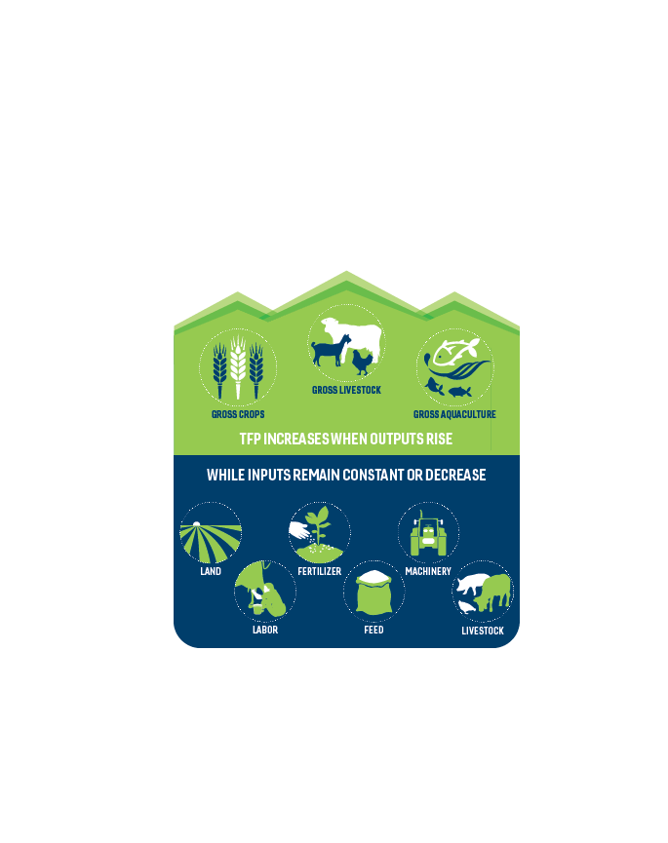
Source: 2021 Global Agricultural Productivity Report/Virginia Tech College of Agriculture and Life Sciences

Growth in global agricultural output is beginning to decline, as has productivity growth (Figure 2). While productivity as measured by TFP (green bars) increased as a share of agriculture output growth between 1961 and 2018, TFP has begun to decline in the latest decade. Land expansion as a global share of agricultural output has increased in the past decade, primarily due to opening of new land for cultivation in Sub-Saharan Africa. (Steensland, 2021)

Figure 2. Sources of Agricultural Output Growth: Global, 1961-2019
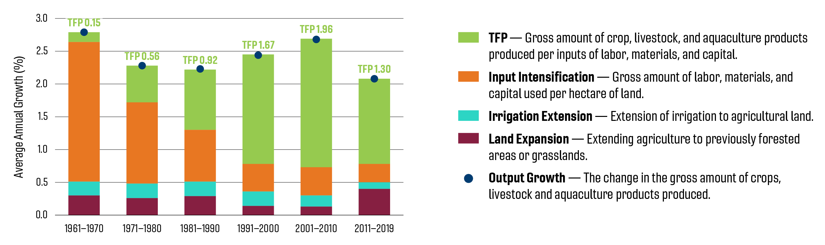
Source: 2021 Global Agricultural Productivity Report/Virginia Tech College of Agriculture and Life Sciences
Productivity growth varies greatly by region and countries (Figure 3). For India and the Transition Countries (Russia and CIS), high agricultural output growth rates are accompanied by growth in TFP since 2001. China has also shifted to a high productivity rate along with a reduction in inputs per hectare of agricultural land. North America and Europe have lower rates of productivity growth but have avoided land conversion and lowered their inputs per hectare of land. Latin America, Southeast Asia, and Sub-Saharan Africa all exhibit high average rates of agricultural output growth, but this has come at the expense in some case of land expansion, particularly evident in the case of Sub-Saharan Africa. (Steensland, 2021)

Figure 3. Sources of Agricultural Output Growth: Key Countries/Regions, 2001-2019

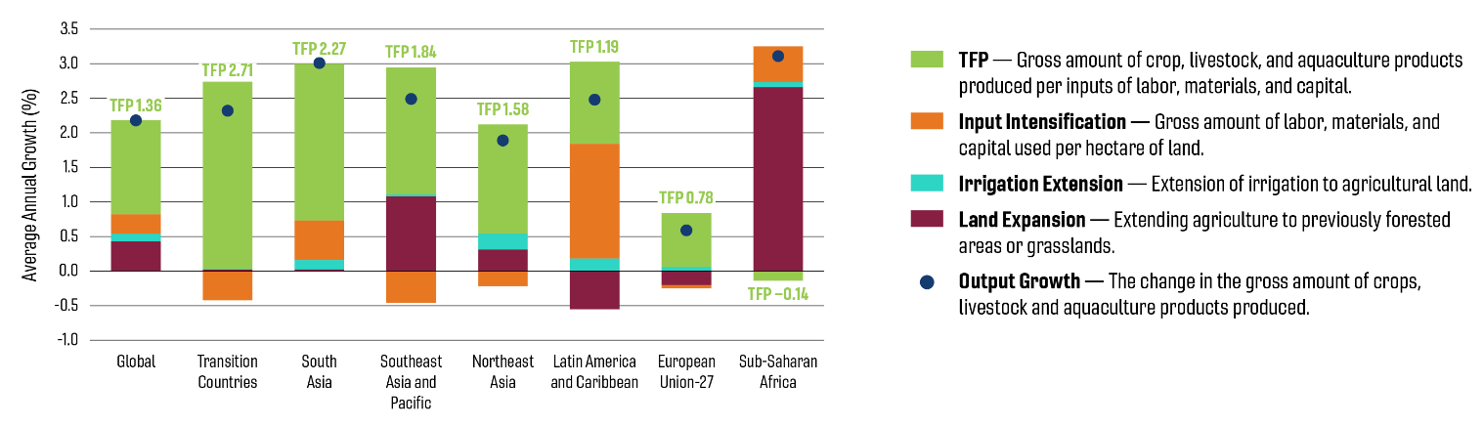
Source: 2021 Global Agricultural Productivity Report/Virginia Tech College of Agriculture and Life Sciences
During the past 20 years, “Transition Countries” including Russia and the former Soviet republics have had the highest TFP growth rate of any region or economic zone at 2.71 percent annually (2001-2019). In the 1990s, these transition countries experienced a shift from a planned agricultural sector to a market-based, profit-driven farm economy. These reforms, combined with public-sector investments in agricultural R&D and infrastructure were intended to accelerate TFP growth. Yet the outcome of these investments has been less consequential than previously thought. An analysis of TFP growth in Russia (1994-2013), for example, demonstrated that productivity growth has been driven largely by the decisions of large-scale land owners in the Southern agricultural district to adopt improved agricultural technologies, agronomic techniques, and farm management practices. (Rada et al., 2019)

Rising challenges to the agricultural enterprise

In the past two decades, new challenges have arisen that threaten the rate of productivity growth in agriculture. Chief among these challenges is climate change, which has far-reaching, global impacts on agriculture and food systems. In the past two decades, new challenges have arisen that threaten the rate of productivity growth in agriculture. Chief among these challenges is climate change, which has far-reaching, global impacts on agriculture and food systems. Since 1960, climate change has slowed agricultural productivity growth globally by 21 percent. (Ortiz-Bobea et al, 2021) That is the equivalent of losing the last seven years of productivity gains. The scale of the challenge demands systems-level solutions—it is no longer feasible to manage agroecosystems in isolation from their surrounding natural environment or to focus on individual crops for potential solutions.

The scale of the challenge demands systems-level solutions—it is no longer feasible to manage agroecosystems in isolation from their surrounding natural environment or to focus on individual crops for potential solutions.

Protecting the environment and natural resource base from degradation and overuse is also a key challenge. The integration of the environmental dimension as a component of development is therefore not an option but a necessity. Going forward, inputs such as water and fertilizer need to be managed at a systemwide level to balance cost with potential production increases and associated negative impacts on soils. These solutions must be scalable so that the potential benefits accrue to the widest range of stakeholders—especially those who are currently underserved.

The conservation of biodiversity is also an important aspect of the environmental component of the agriculture and food system. Genetic resources for food and agriculture, including crops, livestock, fish and forests, lie at the heart of the poverty, food security and environment nexus. The wise and sustainable use of genetic resources is fundamental to meeting these challenges, yet these resources themselves are more threatened today than at any period since the dawn of agriculture. The UN has reported that one million species are facing extinction and many crop varieties are lost each year. (IPBES, 2019) All these challenges are combining to create a threat to productivity and food security in the coming decades and will prevent the realization of the Sustainable Development Goals.

The 2021 Global Agricultural Productivity Index depicts the considerable gap that will arise by 2050 when the growing demands of a hungry world are no longer met by the projected rate of productivity growth (Figure 4). The middle-income countries are beginning to increase rates of productivity, but the productivity growth of high-income countries has declined over time. Particularly concerning are the low-income country productivity growth rates, which will require ever-higher levels of investment and partnership to reverse. (Steensland, 2021)

Figure 4. 2021 Global Agricultural Productivity Index (GAP Index)
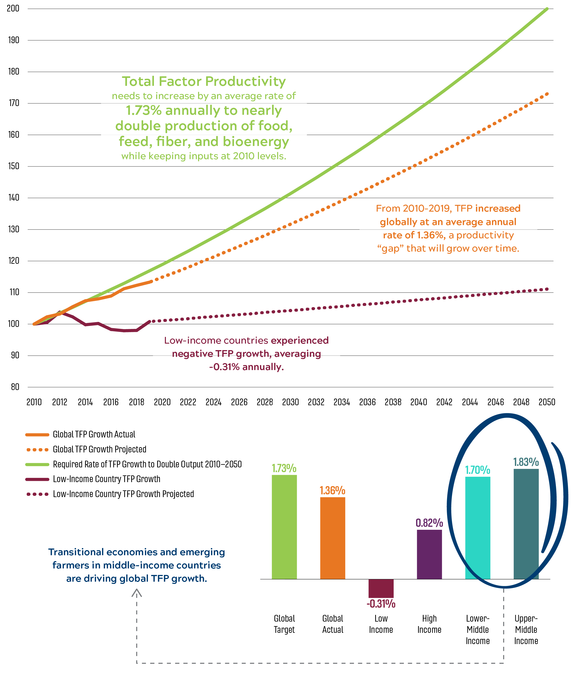
Source: 2021 Global Agricultural Productivity Report/Virginia Tech College of Agriculture and Life Sciences

Research innovation for sustainable productivity

It is urgent to invest in and innovate for the solutions that will not only improve productivity of farmers of all scales globally, but solutions that conserve as well as harness the potential of natural resources and biodiversity, as stated in Sustainable Development Goal 2.4:
By 2030, ensure sustainable food production systems and implement resilient agricultural practices that increase productivity and production, that help maintain ecosystems, that strengthen capacity for adaptation to climate change, extreme weather, drought, flooding and other disasters and that progressively improve land and soil quality.
The powerful solutions and approaches that are needed must move beyond “low-hanging fruit” that international donor governments prefer when investing in low-income country agriculture improvements. (Resnick et al., 2018) Sustained and targeted investments in public and private agricultural research systems that deliver innovation to farmers and rural communities are essential public goods and are the principal drivers of productivity. (Steensland & Zeigler, 2017) New plant varieties and management tools will be necessary to grow crops that provide reliable and nutritious sources of food with fewer inputs in the face of climate change.
Achieving this will require more funding for agriculture research to grow crops that provide reliable and nutritious sources of food on an improved productivity scale. Equally important are solutions that emerge from participatory research models as well as from new technology that can unlock genetic potential and bring systemic transformation to agriculture. Below we discuss innovations in participatory research models from an example found at the International Potato Center (CIP) in Peru as well as the example of how to unlock existing plant genetics through the phytobiome.

Participatory research as innovation
To fundamentally transform food systems and ensure that farmers will also realize benefits, farmers must be active participants in research, crop conservation and protection of biodiversity. As an example of innovative research, the International Potato Center (CIP) in Peru is developing new farmer partnership models of conservation and research that improve farmer productivity and conserve crop diversity while harnessing its potential.
As part of the CGIAR international consortium (One CGIAR), CIP uses its gene bank to conserve the world’s genetic diversity —cultivated, wild and breeding material—of potato and sweet potato for future use. It plays a critical role in providing new CIP innovations and products, particularly suitable varieties for farmers and consumers. The CIP gene bank conserves—in-vitro and in seed— the world’s most extensive collections of potato, sweet potato, and their wild relatives, as well as a unique collection of Andean roots and tubers—the genetic, physiological, and biochemical attributes of which the scientific community has just begun to explore. (CIP, 2019)
Native potato farmers who conserve high levels of agrobiodiversity have become known as potato custodians. These custodians conserve and grow varieties inherited from their parents, and they add to their collections by trading or purchasing new varieties at agrobiodiversity fairs or regional markets and events. Their work is important because it conserves the genetic diversity of potato, much of which has been lost outside its center of origin in the Andes.
Farmer-driven conservation is linked to continuously evolving local knowledge systems and conserves not only diversity of potato, but also the knowledge of its uses, traits, properties, and cultural attributes. (Hurst, 2021) CIP works closely with Andean communities on in-situ conservation of potato diversity and have returned potato and other root and tuber accessions to the communities that were previously lost due to civil unrest, disease, or climate change. Since 2000, CIP has collaborated with the Potato Park in Cusco, providing technical support to its six indigenous Quechua communities, and returning hundreds of potato landraces from its gene bank to the communities so farmers can conserve and continue to experiment in their fields with these landraces. Through on-farm conservation, the Park’s communities are enhancing their livelihood opportunities with technological, market, and policy innovations based on traditional knowledge and biocultural heritage. (Yun Loong Wong & Argumedo, 2011)
CIP is also supporting another farmer-led initiative, Association of Guardians of the Native Potato from Central Peru (AGUAPAN). AGUAPAN is made up of nearly 100 farming communities from eight regions of Peru using traditional practices of soil and seed management to grow ancestral varieties of potatoes. The organization represents farmers and collaborates with the government and the private sector, while advocating for agrobiodiversity conservation initiatives that improve farmer livelihoods.
Systems for documenting and monitoring genetic diversity will help conservationists focus on areas of high genetic diversity that can be conserved and harnessed for future use. CIP has developed its participatory research models to advance child nutrition, improve pest management, and develop new potato products, bringing many benefits back to farmer communities, while conserving the genetic diversity of potato and other roots and tubers. (Ortiz et al., 2020)

Understanding and unlocking existing genetic and phytobiome potential
To help farmers everywhere adapt to climate change and improve productivity, research must dramatically improve and use the genetic potential in existing germplasm resources. Globally, there are between five and seven million crop accessions in gene banks, the vast majority of which have been neither sequenced nor trait mined. (Food and Agriculture Organization, 2020). Understanding the vast potential of these germplasm resources will be the foundation of accelerated breeding programs for the coming decades.
This data gap concerning the accessions’ genetic potential makes it difficult and time-consuming for breeders to identify sources of desired traits or introduce them into local crops to create new, more climate-resilient varieties. This is a critical step to maximizing the utility of available germplasm resources to widest range of global stakeholders; understanding the vast potential of these germplasm resources will be the foundation of accelerated breeding programs for the coming decades. Such an approach has been incorporated into Action Track 5 of the 2021 UN Food Systems Summit. (Silverthorne & Barbuto, 2021)
While current genetic resources are used in plant breeding and field management strategies to address current biotic and abiotic stresses, these strategies do not scale for stakeholders who desperately need them and are not sufficient to address the climate change-induced challenges to come. All farmers, but particularly those in countries most impacted by climate change, will require research to develop new types of crops adapted to local environments, new crop varieties, and new field management practices.
Examples of such new solutions emerged from two workshops convened in August 2018 and August 2020 by the Supporters of Agricultural Research (SoAR) Foundation. Each convening comprised more than a dozen eminent scientists from the United States, the European Union, and China, from a range of research fields including biotic and abiotic stress tolerance, breeding strategies, photosynthetic efficiency, nitrogen fixation, and soils. The reports describe the need to consider multiple variables (plants, microbes, inputs) in the context of the environment since any change to a single variable impacts the entire system. (SoAR Foundation, 2018, 2020)
The overall strategy is to tackle these interrelated challenges as part of a connected system rather than as individual challenges. This “systems” approach has not previously been adopted because it requires a sophistication of research and computational tools that have only recently been developed and made available to plant science. Further, current ongoing efforts that tackle aspects of each challenge will need to be coordinated globally so that the outcomes scale for the maximum number of stakeholders.
To address this challenge, SoAR Foundation and its partners have proposed several goals that will help transform the future of crop research, including in developing countries. Central to the transformation is to recognize that plants within their surrounding environments represent “systems of systems” or the “phytobiome”—the entire assemblage of plants with their environment and the millions of organisms with which they interact. (SoAR Foundation, 2020) Understanding the soils, nutrients, water, microbial diversity, and interactions will be part of this transformative future research.
The first goal of the research transformation is to establish a public collaborative program to sequence the existing germplasm representing crop genetic diversity available in international seed banks. Advances in sequencing technology have led to a reduction in cost of an assembled 1Gb genome to the ~$2,500 range, and resequencing a plant genome to about $5/Gb. (SoAR Foundation, 2020) A public collaborative program should be initiated to sequence germplasm representing the genetic diversity available in seed banks of relevance to smallholder farmers. Sequencing targets should comprise representatives from across plant phylogeny, including crops, wild crop relatives, and potential crops. The germplasm selected should include diverse annual and perennial crop types (e.g., root and tuber crops), since root crops have different carbon allocation from shoot crops.
The prioritization and selection of targets should be undertaken by national and regional experts working on new crops and cropping systems and must include farmers who will be the end-users. The One CGIAR system and national agriculture research systems must enhance their cooperation to achieve this effort. This work is primarily a public effort since most of these crops are not currently commercially viable and of little interest to the private sector. Existing efforts to collect, conserve, and sequence diverse plant germplasm that could serve as a foundation for new farming systems are not currently well connected with each other, potential users, or funders.
The second goal is to establish public-private partnerships to use machine learning to develop low-cost trait mining tools for global agriculture. (SoAR Foundation, 2020) Sequence information is the basis for identifying and locating genetic information underlying key traits, such as drought tolerance. This process, “trait mining”, is currently a far more expensive and challenging step than obtaining sequence information and achieving high throughput will require artificial intelligence-based approaches, like machine learning.
Machine learning tools are evolving quickly, primarily for non-agricultural applications in the private sector. Rather than duplicating these tools, it would make sense to catalyze their application to agricultural datasets in the public sector. This approach is likely to be especially effective in plants because there are more than 300,000 species adapted to numerous environments. Traits of interest would include nutritional targets, as well as resilience to biotic (disease and pests) and abiotic (drought, flooding, salinity, heat) stresses. Specific crops and traits to target would be identified by relevant stakeholders.
The third goal is to establish an international coordinated initiative to phenotype diverse crop plant species and associated microbiomes above- and below-ground under field conditions. The plant phenotype represents the set of its observable characteristics resulting from the interaction of the plant genotype with the environment (GxE). For crops, the “environment” includes biotic (beneficial and pathogenic microbes), abiotic components (water and temperature) as well as managed inputs (nitrogen, phosphorus, and potassium). Plant phenomics is lagging sequencing but is a key part of understanding crop plants and their environmental interactions. (SoAR Foundation, 2020)
Examples of innovation in phenotyping crops for improvement include efforts by ICRISAT (International Crop Research Institute for the Semi-Arid Tropics) based in India and working globally to improve millets, chickpea, pigeon pea and groundnuts. Beginning December 3, 2021, ICRISAT launched the use of multispectral scanners in combination with a UAV (Unmanned Aerial Vehicle) Phenotyping Platform that provides crop information from high-resolution imaging, including insights into plants’ experience of agro-chemicals under biotic stress. (ICRISAT, 2021) The new PlantEye F600 scanners on the LeasyScan can scan both near-infrared (NIR) and the visible spectrum of light. NIR scanning, which was not available in the scanners used earlier, helps assess traits which can be distinguished with color intensity like plant senescence, stay green, foliar diseases (by distortion in color) and biomass quality traits like leaf nitrogen content. Advanced phenotyping traits like leaf area, plant height, biomass, etc., and water utilization traits like transpiration and transpiration rate can be measured faster than before with the new system; thousands of lines can be characterized in just five weeks, saving time and labor to gather field data.
Taken together, these goals have the potential to impact a broad range of stakeholders whose needs are currently underserved, particularly in developing countries, and builds upon existing research efforts and collaboration with potential funders. The goals have the potential to evolve and grow and can incorporate stakeholders, track benchmarks and outcomes and can link research innovations, key needs, and sources of financial support.
Individual member states and foundations are already supporting aspects of this research and there is the potential to partner with the private sector to extend the utility of existing tools to serve the needs of smallholder farmers. In addition to support from the U.S. Department of Agriculture Agricultural Research Service and National Institute of Food and Agriculture, the European Commission, Research Councils UK (RCUK), and The Bill & Melinda Gates Foundation also provides funding for these innovative approaches to build productivity in agriculture.
Conclusion
Agricultural productivity is the engine that drives smallholder farmers out of poverty and low-income countries into the middle class, but climate change threatens the prospects of smallholders to maximize their productivity potential. Worryingly, the negative impacts of climate change on agricultural productivity are more severe and last longer with each passing year. We must take a whole-of-systems approach to provide the tools smallholder farmers in low- and middle-income countries need.
Ultimately there is not one single solution to effectively build resilience in the face of a changing climate and falling productivity. But several solutions include participatory farmer research built upon traditional knowledge as well as harnessing new tools that can unlock the phytobiome for the benefit of farmers of all scales. These are just a few solutions within a large toolbox needed for resilience, productivity and sustainability in a food system that will feed 10 billion people in 2050.

REFERENCES
de Janvry, A., & Sadoulet, E. (2010). Agricultural Growth and Poverty Reduction: Additional Evidence. The World Bank Research Observer, 25(1), 1–20. https://doi.org/10.1093/wbro/lkp015
Food and Agriculture Organization. (n.d.). 2.5.1.a Conservation of genetic resources for food and agriculture (Plan genetic resources). Sustainable Development Goals. https://www.fao.org/sustainable-development-goals/indicators/251a/en/
Fugile, K., Gautam, M., Goyal, A., & Maloney, W. F. (2020). Harvesting prosperity: Technology and productivity growth in agriculture. World Bank Group.
Heisey, P., & Fuglie, K. O. (2018). Agricultural research investment and policy reform in high-income countries (ERR-249). U.S. Department of Agriculture, Economic Research Service. https://www.ers.usda.gov/webdocs/publications/89114/err-249.pdf?v=0
Hurst, G. (2021, October). Farming communities around the world hold the key to food system resilience. Food Tank. https://foodtank.com/news/2021/10/farming-communities-around-the-world-hold-the-key-to-food-system-resilience/
ICRISAT. (2021, December 3). Crop improvement programs at ICRISAT get a boost with new phenotyping facilities. ICRISAT Happenings. https://www.icrisat.org/crop-improvement-programs-at-icrisat-get-a-boost-with-new-phenotyping-facilities/
International Potato Center. (2019). Biodiversity for the future program.
https://cgspace.cgiar.org/handle/10568/100668
IPBES. (2019). Global assessment report on biodiversity and ecosystem services of the Intergovernmental Science-Policy Platform on Biodiversity and Ecosystem Services (Version 1). Zenodo. https://doi.org/10.5281/ZENODO.3831673
Mellor, J. W. (2017). Measuring the Impact of Agricultural Growth on Economic Transformation. In Agricultural Development and Economic Transformation: Promoting Growth with Poverty Reduction (pp. 29–46). Springer International Publishing. https://doi.org/10.1007/978-3-319-65259-7_3
Mellor, J. W., & Ranade, C. (2006). Why Does Agricultural Growth Dominate Poverty Reduction in Low- and Middle-income Countries? The Pakistan Development Review, 45(2), 221–240. JSTOR. http://www.jstor.org/stable/41260755
Ortiz, O., Thiele, G., Nelson, R., & Bentley, J. W. (2020). Participatory Research (PR) at CIP with Potato Farming Systems in the Andes: Evolution and Prospects. In H. Campos & O. Ortiz (Eds.), The Potato Crop (pp. 451–473). Springer International Publishing. https://doi.org/10.1007/978-3-030-28683-5_13
Ortiz-Bobea, A., Ault, T.R., Carrillo, C.M., Chambers, R.G. & Lobell, D.B. (2021). Anthropogenic climate change has slowed global agricultural productivity growth. Nature Climate Chang, 11(4), 306-312.
Rada, N., Liefert, W., & Liefert, O. (2019). Evaluating Agricultural Productivity and Policy in Russia. Journal of Agricultural Economics, 71. https://doi.org/10.1111/1477-9552.12338
Resnick, D., Haggblade, S., Babu, S., Hendriks, S. L., & Mather, D. (2018). The Kaleidoscope Model of policy change: Applications to food security policy in Zambia. World Development, 109, 101–120. https://doi.org/10.1016/j.worlddev.2018.04.004
Synthesis Report of Action Track 5: Building resilience to vulnerabilities, shocks, and stress. (2021). United Nations Food Systems Summit. Silverthorne, J., & Barbuto, R., 36. https://knowledge4policy.ec.europa.eu/sites/default/files/5-ACTION_TRACK-5_Scientific_Group_draft_Paper_8-3-2021_0.pdf
SoAR Foundation. (2018). Developing Global Priorities for Plant Research. Supporters of Agricultural Research (SoAR) Foundation. https://supportagresearch.org/our-projects/developing-global-priorities-for-plant-research
SoAR Foundation. (2020). Developing Global Priorities for Plant Research: Adapting agriculture to climate variability. Supporters of Agricultural Research (SoAR) Foundation. https://supportagresearch.org/our-projects/developing-global-priorities-for-plant-research
Steensland, A. (2021). 2021 Global Agricultural Productivity Report: Strengthening the climate for sustainable agricultural growth. Virginia Tech College of Agriculture and Life Sciences.
Steensland, A., & Zeigler, M. (2017). 2017 Global Agricultural Productivity Report: A world of productive sustainable agriculture. Global Harvest Initiative.
Steensland, A., & Zeigler, M. (2021). Productivity in Agriculture for a Sustainable Future. In H. Campos (Ed.), The Innovation Revolution in Agriculture: A Roadmap to Value Creation (pp. 33–69). Springer International Publishing. https://doi.org/10.1007/978-3-030-50991-0_2
Yun Loong Wong, B., & Argumedo, A. (2011, July 4). The thriving biodiversity of Peru’s potato park. Our World. https://ourworld.unu.edu/en/the-thriving-biodiversity-of-peru-potato-park

