Copyright Release Form
Dec 11, 2024
Graduate School
Virginia Tech
Blacksburg, VA
In accordance with Virginia Tech Graduate School requirements for the ETD submission, I hereby grant Virginia Tech a non-exclusive license to use my copyrighted thesis entitled “An XR-Driven Digital Twin Platform for Cybersecurity Education”. The license shall include the right to use, archive, distribute, and reproduce the thesis by Virginia Tech and its agents. I retain all ownership rights to the copyright of my thesis. Moreover, I retain the right to use all or part of this thesis to write future publications such as articles or books in the future.
Figure 4.1 was obtained from Wikipedia of the thesis document under Creative Commons Attribution 3.0. which states that You are free to:
Share — copy and redistribute the material in any medium or format for any purpose, even commercially.
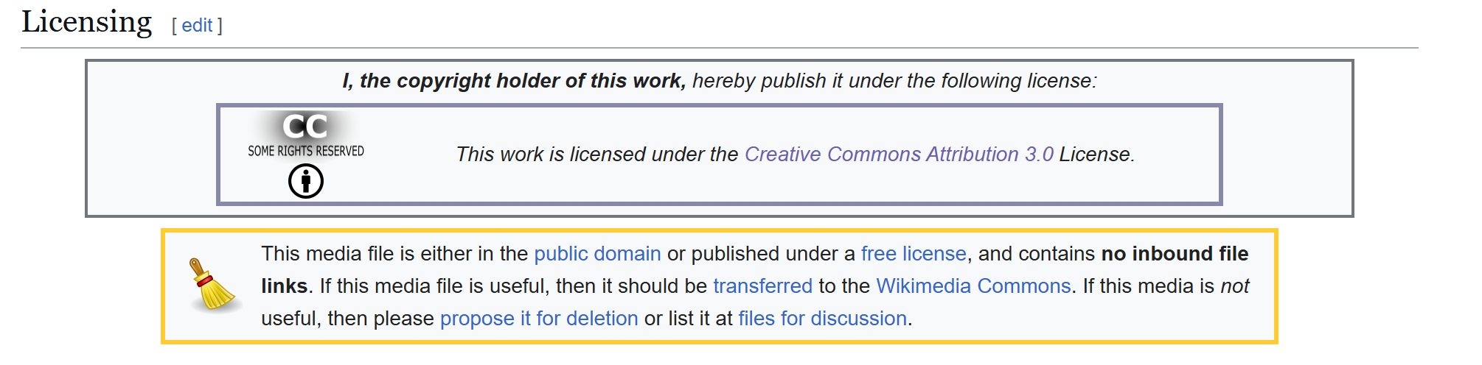
Author Signature : Anthony Lee
Date of Signature: 12/11/24

