Max Video Tutorials

Capstone Project Final Report

CS 4624
Multimedia, Hypertext, and Information Access
Dr. Edward A. Fox
Virginia Tech, Blacksburg, VA 24061

May 4, 2016

Project Team | Tyler DeYoung  Amanda Kahn  Deepika Darivemula  John Russell
Client | Dr. Charles Nichols  csnii@vt.edu

Table of Contents
Table of Figures 4
1: User Manual 5
1.1: Executive Summary 5
1.2: Contract Overview 5
1.3: Purpose of the Project 6
1.4: Scope and Users 6
1.5: Content of Videos 7
1.5.1: Topics Overview 7
1.5.2: Content Requirements 7
1.6: Video Requirements 7
1.7: Maintenance Requirements 8
2.1: Developer’s Manual - Design 8
2.1.1: Components/Tools Used 8
2.1.2: Project Organization 9
2.1.3: Video scripts / Design outlines 9
Video 1: Max basics 10
Topics to cover 10
Outline of Max Basics video 10
Video 2: Timing in Max 11
Topics to cover 11
Outline of Timing in Max video 11
Video 3: Coll object 12
Outline of Coll Object video 12
Video 4: Quad-speaker spatialization 13
Topics to cover 13
Outline of Quad-speaker Spatialization video 14
2.1.4: Interface Outlines/Design - Storyboards 15
Max Basics Storyboard 15
Timing Storyboard 18
Quad-speaker Spatialization Storyboard 20
Audio Modulation Storyboard 22
Additive Synthesis Storyboard 23
2.2: Developer’s Manual - Implementation 25
2.2.1: Major Tasks for Each Video 25
2.2.2: Implementation Schedule 25
Table 1: Implementation Schedule 25
2.2.3: Security 29
2.2.4: Documentation 29
2.2.5: Testing 29
2.3: Developer’s Manual – Prototype 30
2.3.1: Max Basics Video 30
2.3.2: Timing Video 35
2.3.3: Coll Object Video 39
2.3.4: Quad-speaker Spatialization 43
2.3.5: Audio Modulation 45
2.3.6: Additive Synthesis 47
3: Lessons Learned 52
3.1: Timeline / Schedule 52
3.2: Problems 54
3.3: Solutions 54
3.4: Lessons Learned 55
4: Testing 56
4.1: Initial Testing 56
4.2: Testing Process 56
4.3: Feedback 57
Table 2: Testing Feedback 57
4.3.1: Legend 58
4.3.2: Overall Comments from Initial Tester 58
4.3.3: Evaluation Methods 59
4.4: Problems Found During Testing 59
4.5: Future Work 59
5: Final Videos 60
Table 3: Information about all videos post-production 60
6: Acknowledgements 60
7: References 61

Table of Figures
Figure 1: Data Flow Model 9
Figure 2: Storyboard of steps 1 - 4 from the Max basics outline 15
Figure 3: Storyboard of steps 5 - 8 from the Max basics outline 16
Figure 4: Storyboard of steps 9 - 12 from the Max basics outline 16
Figure 5: Storyboard of steps 13 - 16 from the Max basics outline 17
Figure 6: Storyboard of steps 17 - 20 from the Max basics outline 17
Figure 7: Storyboard of steps 21 - 23 from the Max basics outline 18
Figure 8: Storyboard of steps 1 - 4 from the timing outline 18
Figure 9: Storyboard of steps 5 - 8 from the timing outline 19
Figure 10: Storyboard of steps 9 - 12 from the timing outline 19
Figure 11: Storyboard of steps 13 - 15 from the timing outline 20
Figure 12: Storyboard of steps 1 - 4 from the quad-speaker spatialization outline 20
Figure 13: Storyboard of steps 5 - 8 from the quad-speaker spatialization outline 21
Figure 14: Storyboard of steps 9 - 10 from the quad-speaker spatialization outline 21
Figure 15: Storyboard of steps 1 - 4 from the audio modulation outline 22
Figure 16: Storyboard of steps 5 - 8 from the audio modulation outline 22
Figure 17: Storyboard of step 9 from the audio modulation outline 23
Figure 18: Storyboard of steps 1 - 4 from the additive synthesis outline 23
Figure 19: Storyboard of steps 5 - 8 from the additive synthesis outline 24
Figure 20: iMovie Interface 30
Figure 21: Audio Editing 31
Figure 22: Pre-Production Video Information 32
Figure 23: Post-Production Video Information 33
Figure 24: Final Video 34
Figure 25: Max Timing tutorial 35
Figure 26: Editing the end of the Timing video 36
Figure 27: Screenshot from final Timing video 37
Figure 28: Screenshot from final Timing video 38
Figure 29: Editing the Coll Object video 39
Figure 30: Editing the Coll Object tutorial video 40
Figure 31: Screenshot from final Coll Object video 41
Figure 32: Screenshot from final Coll Object video 42
Figure 33: Sample patch by Dr. Nichols for Quad-speaker Spatialization tutorial 43
Figure 34: Second patch for Quad-speaker Spatialization tutorial 44
Figure 35: VST plugin in Audio Modulation tutorial 45
Figure 36: Crystal example 46
Figure 37: Example patch for Additive Synthesis 47
Figure 38: Cosine waves in the Audio Synthesis tutorial 48
Figure 39: Editing the Coll Object tutorial video 49
Figure 40: Screenshot from final Coll Object video 50
Figure 41: Screenshot from final Coll Object video 51

1: User Manual

1.1: Executive Summary

In MUS 3065, Computer Music and Multimedia, students learn how to use the Max programming environment in order to compose interactive digital music. This project aims to assist these students by making video tutorials about the more useful aspects of Max in order to reiterate core concepts and methods that Dr. Nichols teaches in class. The selected topics that the videos will cover are coll object, additive synthesis, audio modulation, quad-speaker spatialization, timing in Max, and Max basics. Each video will contain the recorded screen of the Max environment as well as voice-overs explaining what the narrator is doing in the video and why.

1.2: Contract Overview

The Max Video Tutorial Library for MUS 3065 was created for Dr. Charles Nichols and the students in his Computer Music and Multimedia class. In this class, students learn how to use the Max programming environment in order to compose interactive digital music. This project aims to assist these students by making video tutorials, composed into a digital video library, about the more useful aspects of Max. The deliverable for this project includes a series of Max video tutorials. The expectation for the outcome of this project is that students taking MUS 3065 will be better equipped to complete their assignments and participate in class discussions. Required skills involved in creating these tutorials include audio and video recording and Max proficiency. If there is an issue with proficiency regarding Max, https://cycling74.com/ (3), will be a useful reference for additional information.

The roles for the project are divided as follows:

Tyler DeYoung: Scriptwriter, Director
Amanda Kahn: Group Coordinator, Editor
Deepika Darivemula: Documentation, Tester
John Russell: A/V Controller, Voice Actor

Date that client has signed off on this: 1/27/16
Date that instructor has signed off on this: 1/27/16

1.3: Purpose of the Project

In response to student feedback, the instructor of MUS 3065 has decided to move away from assigned readings to required videos. Many of the students that have taken MUS 3065 in the past have preferred video tutorials to reading the documentation on the Max website. Ideally, providing the students of MUS 3065 with tutorial videos will motivate them to not only complete their assignments with a better understanding but also to equip them for better class participation. By creating detailed and focused videos on the specific topics that Dr. Nichols has chosen, students will be able to grasp Max and audio processing concepts more quickly. If a student did not understand something in lecture, or if a student requires assistance on a specific topic in order to complete an assignment, the videos provided will be a valuable resource.

1.4: Scope and Users

This project was designed with the students in Dr. Nichols’s Computer Music and Multimedia class as the target audience. The students in this class are typically Music and/or Computer Science majors. Therefore we have designed our videos to be easily understood by all students by focusing on what is taught in class and imitating the style of teaching that is done in class.

The video tutorials are intended to be a supplement to class lectures, but not a replacement. In order for the videos to be of maximum value, students must first attend class lectures and then watch videos as part of the homework to reinforce their understanding of the material.

1.5: Content of Videos

1.5.1: Topics Overview

- Coll object (8)
- Additive synthesis (10)
- Audio modulation (11)
- Quad-speaker spatialization (9)
- Timing in Max (7)
- Max basics (6)

1.5.2: Content Requirements

The content of each of these videos will be similar to the related documentation in the Max manual (3). Dr. Nichols does not teach straight from the manual or in the same order as the manual, so the process of getting draft scripts edited is very important in order to include all information that Dr. Nichols finds relevant for a specific topic.

1.6: Video Requirements

The final deliverable will be 1080p video and in .MOV format. These videos will be produced in the DISIS lab using QuickTime. Audio will be recorded using the built-in iMac microphone. The raw output of the video will be a .MOV file, which will be edited, saved, and organized for easy access by Dr. Nichols.

The standard production process for videos is as follows:
- The team will write and seek approval of a draft script on a specific topic. Based on the response from Dr. Charles Nichols, the client for this project, the script may be edited in order to include a specific piece of information. Our team will draft the script again, and then we will seek approval for the script by Dr. Nichols before proceeding.
- We will conduct a script and video rehearsal by doing a mock run through of the audio and video components for the video. Videos longer than 10 minutes in length will be split into multiple videos. The average length of each video will be between 5 and 10 minutes.
- The group will then record the on-screen video using the finalized script, using multiple takes if necessary. Audio will be recorded with an external microphone.
- The recorded audio and video will then be edited in either iMovie or Final Cut Pro. In addition to adding a title screen, the video and audio will be edited in order to make the whole video is consistent and smooth.
- Upon completion of the production of the video, our team will complete the final editing process for the video. This will involve our client, who must give his approval for each video. Any further editing Dr. Nichols suggests will be applied to the video.
- After the editing is complete, the team will test the quality and effectiveness of each video by showing it to a novice Max user in order to test his or her level of comprehension. The videos on more involved and advanced Max topics will be shown to more experienced Max users rather than a novice user.
- The group will review the video with the client, revising and redoing any aspects of the videos that the client finds to be subpar. After receiving approval from the client our group will add the completed video to our library, and store away the component pieces for future maintenance. At Dr. Nichols’ request, some videos may be uploaded to YouTube in addition to collecting all of the completed videos in a folder.

1.7: Maintenance Requirements

In addition to our deliverables, which are the tutorial videos themselves, we will supply Dr. Nichols with the raw unedited videos and iMovie/Final Cut Studio project files. This will allow future edits to be as easy as possible. If the videos are uploaded to YouTube, YouTube video annotations would also serve as a way to make minor edits to the videos if Max is updated and covered topics and objects are changed in small ways.

2.1: Developer’s Manual - Design

2.1.1: Components/Tools Used

Some necessary software that will be used for the duration of this project is Cycling’74 Max 7 (3), Mac OS X, Quicktime, and iMovie. Necessary equipment includes a microphone and audio interface.

2.1.2: Project Organization

The videos created for this project will be uploaded to Dr. Nichols’ YouTube channel to allow all audiences to gain access to them. His YouTube channel is named after himself, Charles Nichols, and already contains some of his other computer music works, some produced with Max. The link to his channel is https://www.youtube.com/user/CharlesSNicholsII (5). YouTube’s digital video library will be responsible for maintaining the uploaded tutorials.

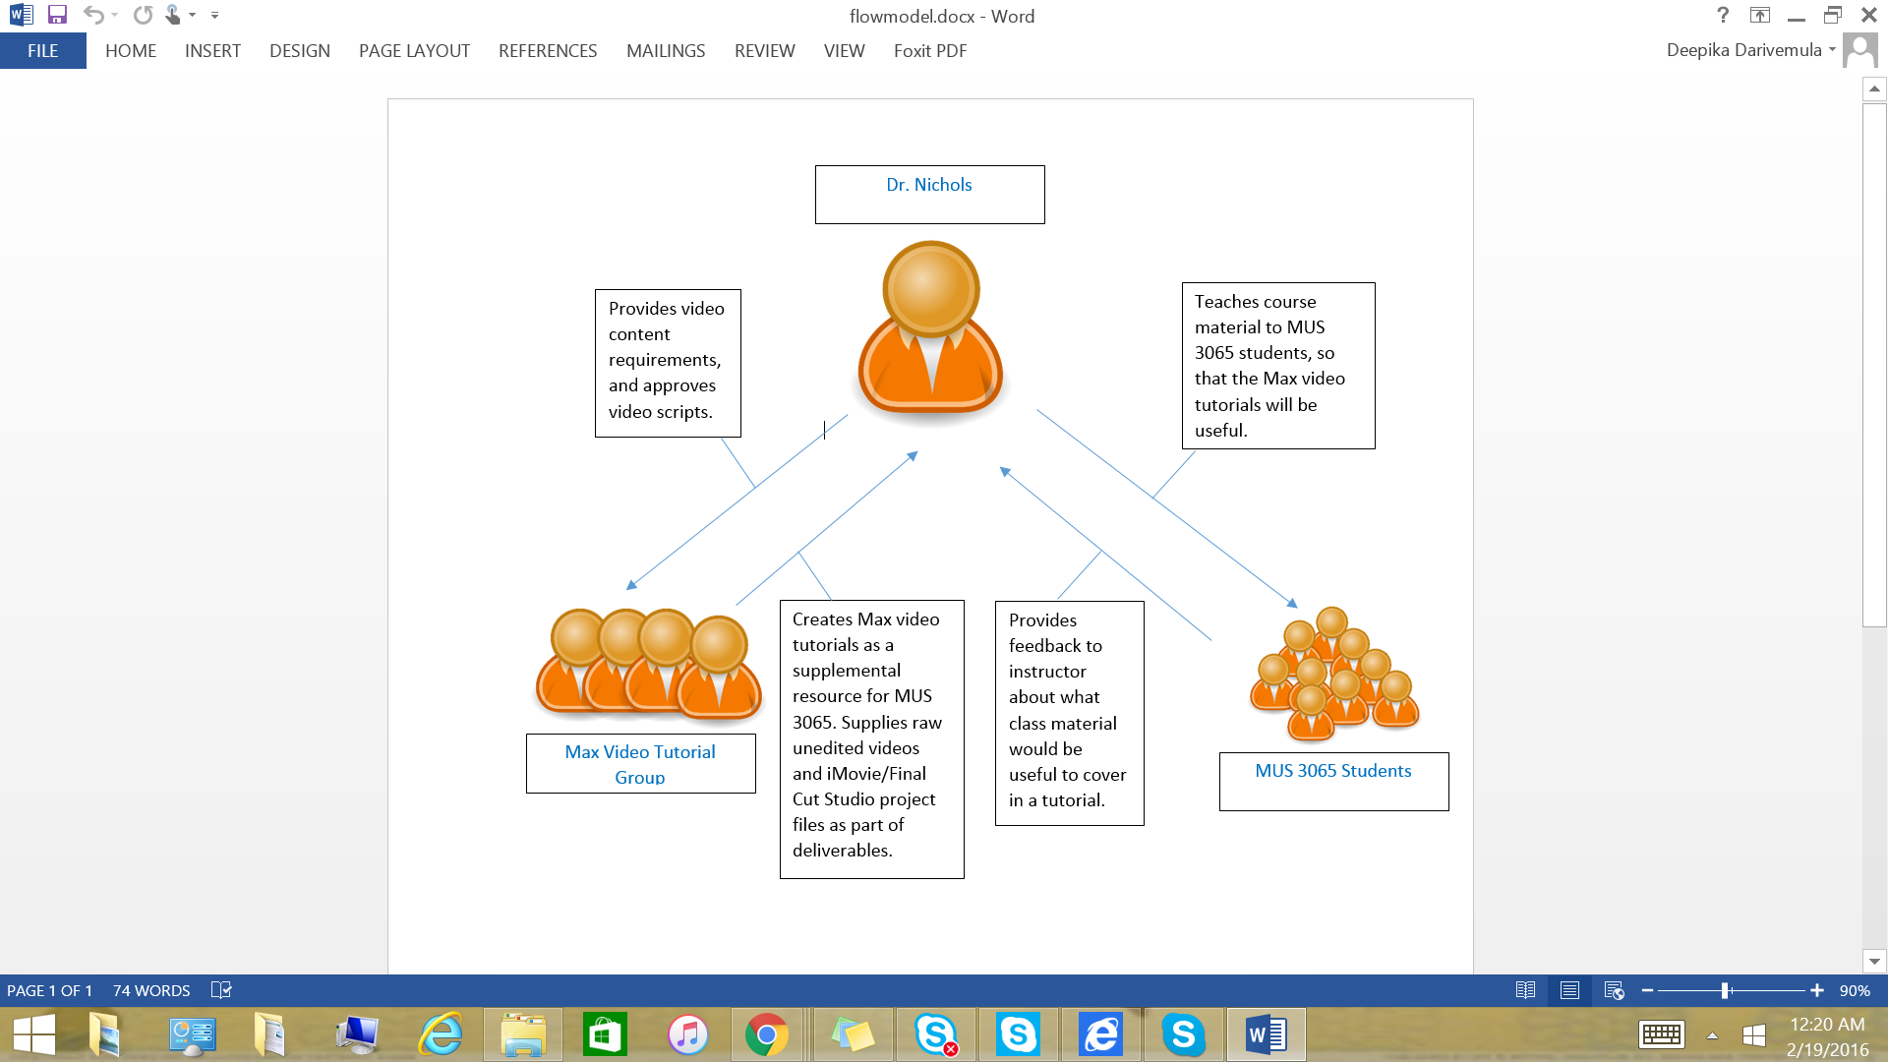
Figure 1: Data Flow Model

2.1.3: Video scripts / Design outlines

Below is the outline of our first script. All scripts will be designed with the topics to be covered at the top, and the script itself underneath. Scripts will be numbered into steps for ease of use during the recording process.

Video 1: Max basics

Topics to cover

- Creating objects
- Using print and its output to the console
- Creating messages
- Creating comments
- Patch cords/inlets/outlets
- Common keyboard shortcuts
- Locked vs unlocked patcher
- Ways to view help
- Loadbang
- Data Types

Outline of Max Basics video

- I = int box, make an int box
- Show lock and unlock, change int value
- Show outlets and inlets
- M = message, make a message
- Patch objects together (Message to Int box)
- Lock unlock again, show message working (sending value)
- Talk about unlocked value editing (Command Mac / control on PC)
- T = Toggle, make a toggle
- Patch toggle to int box, show outputs
- F = Float box, make a float box
- Patch float box to int box, show output (and the rounding that occurs)
- Delete floatbox and toggle and message.
- N = new object, make print object
- Show how to bring up help (Cmd + Shft + H)
- B = button, make button obj
- Button outputs bangs, bangs trigger events
- Patch together
- Click button (nothing should appear to be happening)
- Bring up console (Shift + Cmd + M)
- Show button click again
- Loadbang, close patch, clear console, restart patch
- Documentation, C = comment
- Alt + Drag = copy & paste, copy a comment box

Video 2: Timing in Max

Topics to cover

- SAMM
- Pipe
- Delay
- Timer
- Counter

Outline of Timing in Max video

- Make a message, and an intbox
- N = new obj, make a pipe object, make output message box
- Patch: message & intbox -> pipe -> message & set pipe param to 2000
- Send text, and numbers to show pipe working
- Repeat steps 1 - 4 with the ‘delay’ object (Inputs: Msg box, button, Outputs to a button and a message box)
- Explain that the delay obj only delays bangs
- Delete all objects
- Make two buttons, a Timer object and a message box
- Patch one button to each inlet in timer, and timer out to the message box
- Show that timer is a stopwatch by clicking the left button, waiting, then clicking the right button
- Pull up Sample Accurate Metronome Patcher
- Explain that max prioritizes Audio over other data types so the regular metro object in imprecise
- explain that the samm is sample accurate & show the samm working
- Reset & change the meter
- Reset & change the tempo
- Demo CounterExample.maxpat

Video 3: Coll object

Topics to cover

- Coll storing data
- Saving coll data to the patcher
- Coll storing lists
- Coll storing text
- Writing data to coll

Outline of Coll Object video

- Coll “allows for the storage, organization, editing, and retrieval of different messages.”
- “The Coll object maps input into output”
- Make int box -> coll -> int & button
- Double click on coll object to open text editor
- Explain that we are storing data for the coll object to use
- Type input output pairs:
0, 300;
1, 255;
3, 355;
- Increment int box and show how output changes/a bang happens
- Show how there isn’t a response/bang for a value of 2
- “Coll can output a list”
- Change data to:
0, 300 400;
1, 255 500;
3, 355;
- Unpack before output int box, show how coll outputs a list
- Change coll so it has text:
0, 300 foo;
1, 255 bar;
3, 355 car;
- After unpack make it a message box, show output of text as well
- Name coll, duplicate it, show how you have access to the same data from different colls named the same thing
- Save as txt file by double clicking on top bar
- Right click -> save with patcher
- Write data to coll
- pack 2 values (index, value) -> coll
- Double click on coll and show that the input/output pairs changed
- Coll is very powerful, show how long the help/reference is for it and how many different messages you can send it to manipulate data in ways useful to your patch

Video 4: Quad-speaker spatialization

Topics to cover

- Scale object
- Pictslider
- Bondo
- Quadpaint
- Quadpan

Notes for original patch by Dr. Nichols:

- Can be controlled by joystick, phone, game controller (i.e. wiimote), Kinect
- Joystick
  - Get values, scale them, display visually on pictslider, divide by 100, show outgoing value, send to bondo
- Phone
  - Get and unpack values, scale them, view visually on pictslider, divide by 100, then send them to bondo
- Bondo - updates all outgoing values as they come in (sends values to quadpan or quadpaint)
- quadpaint - scales values in order to display them visually on lcd
  - lcd - visual representation of sound moving around the room
- quadpan - scales the values, and turns them into signals
  - gain~ x4 (shows different sound levels in each speaker), which going to dac that will play the sounds at the given level
    - levelmeter used to display audio level from that particular speaker
- Comes out of speakers 1, 2, 5, 6

Outline of Quad-speaker Spatialization video

- Open Example patch 6.
- Explain that we will be demonstrating quad-speaker-spatialization using a patch constructed from Example patch 6.
- Open pre-constructed patch.
- Explain Scale
- Explain pictslider
- Explain bondo
- Explain quadpan
- Explain quadpaint
- Explain levelmeter
- Describe dataflow of the patch
- Turn on dac
- Demo moving the sound around the 4 speakers with the sliders
  - You won’t be able to hear it because YouTube is stereo, but the levelmeters and quadpaint will show it
- Explain that any numerical inputs scales to 0 to 100 will be able to move the quad-speaker sounds
- Cut off pictslider from bondo
- Attach multiquad
- Explain different messages multiquad accepts
- Demonstrate the 4 messages
- Explain that the colored objects are really things called subpatches, which are used to add modularity to patch design.
- Open new patcher create 2 msgboxes and a subpatch [msg] -> [p] -> [msg]
- Name the subpatch ‘+1*2’ and patch [inlet] -> [+ 1] -> [* 2] -> [outlet]
- Demo the function of the subpatch.

2.1.4: Interface Outlines/Design - Storyboards

The videos will be a screen recording of the Max application running on OS X with audio narrating the actions performed on screen. Each video will follow the script that is associated with it; each video will also have a storyboard associated with it for visualization purposes and to make the recording process easier. Each storyboard will be created on a standard sheet of printer paper and folded into quarters to show 4 scenes per page.

Max Basics Storyboard
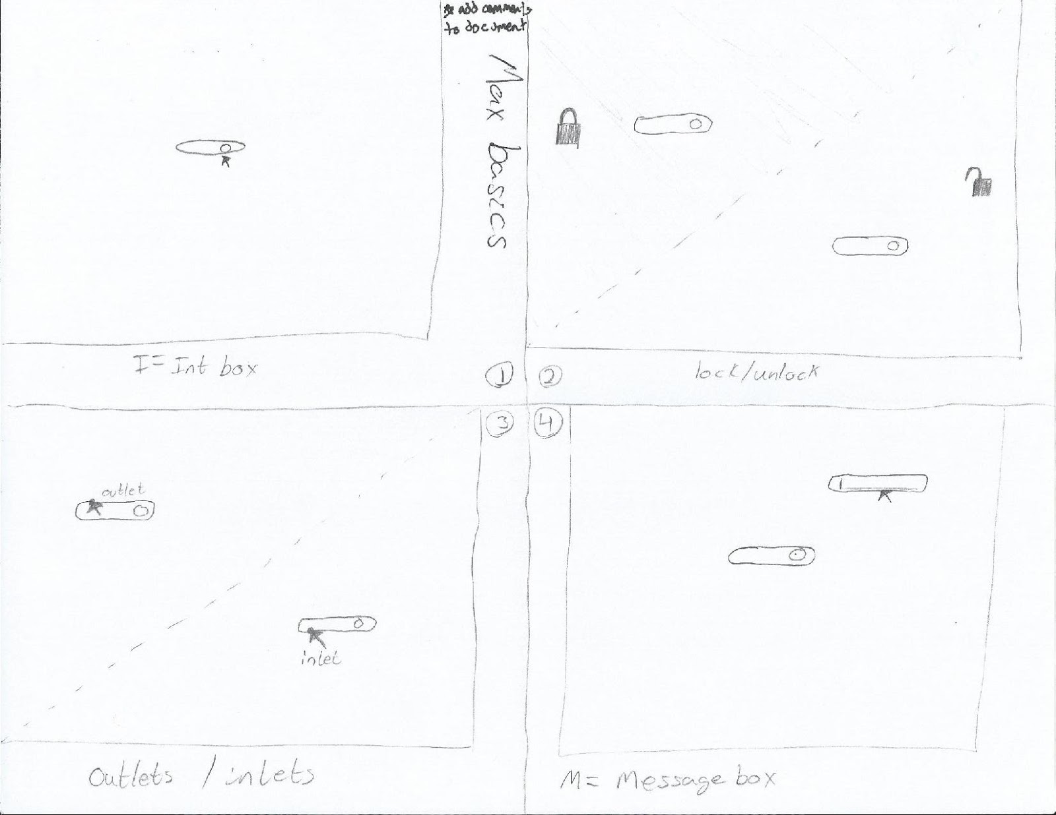
Figure 2: Storyboard of steps 1 - 4 from the Max basics outline

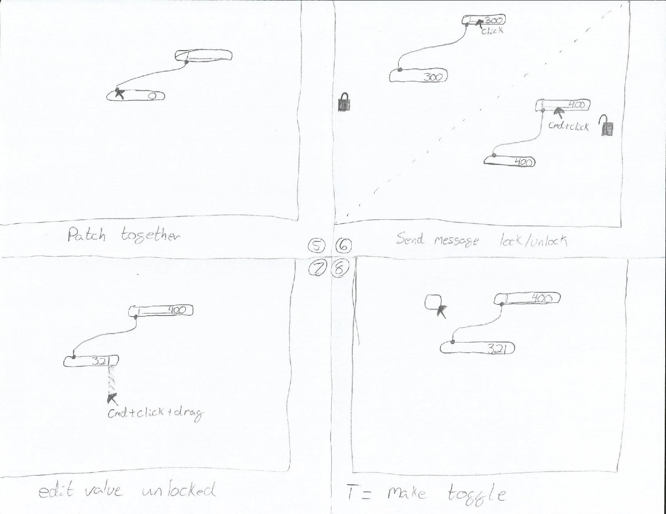
Figure 3: Storyboard of steps 5 - 8 from the Max basics outline

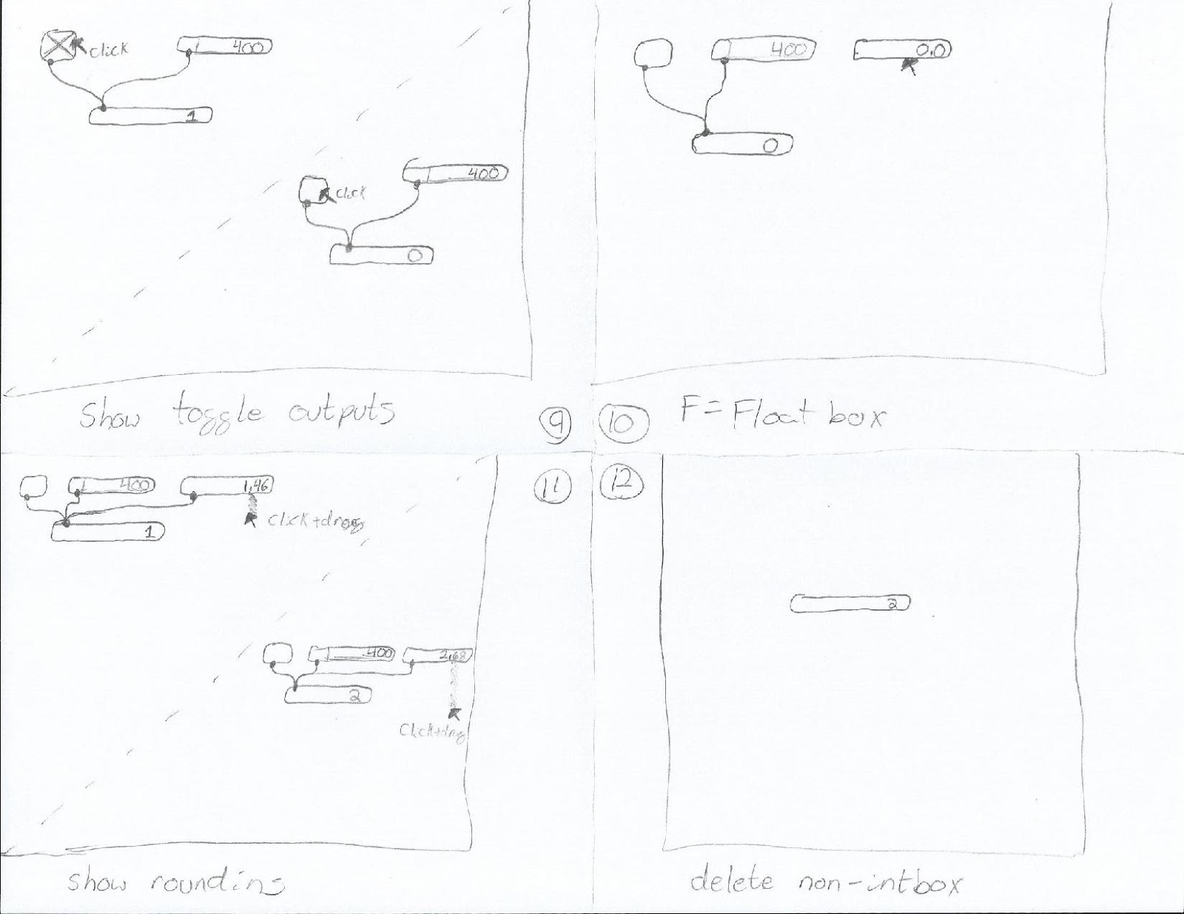
Figure 4: Storyboard of steps 9 - 12 from the Max basics outline
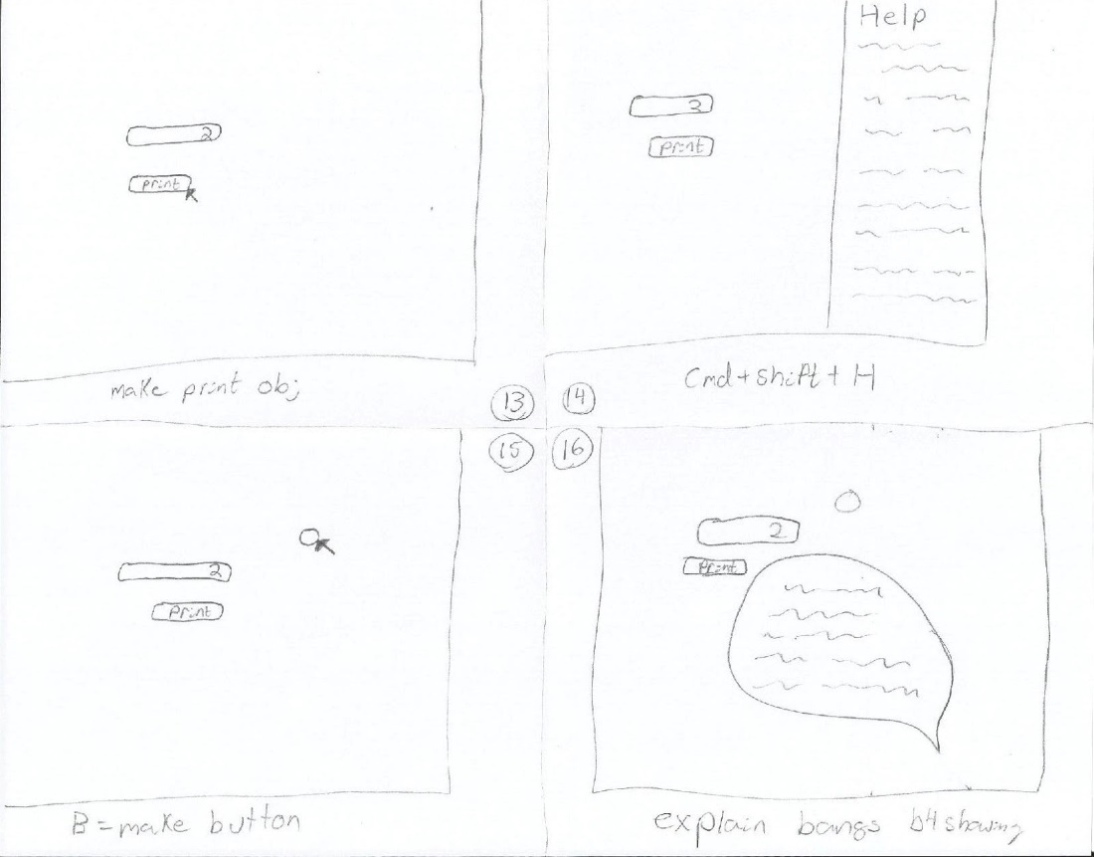
Figure 5: Storyboard of steps 13 - 16 from the Max basics outline

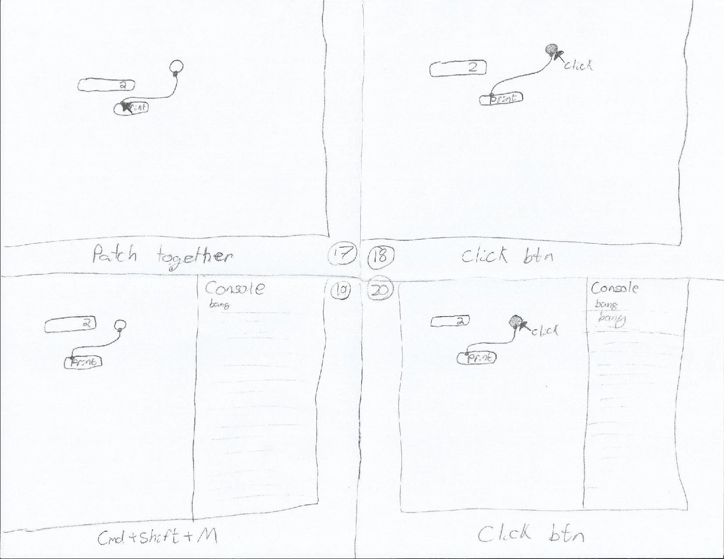
Figure 6: Storyboard of steps 17 - 20 from the Max basics outline

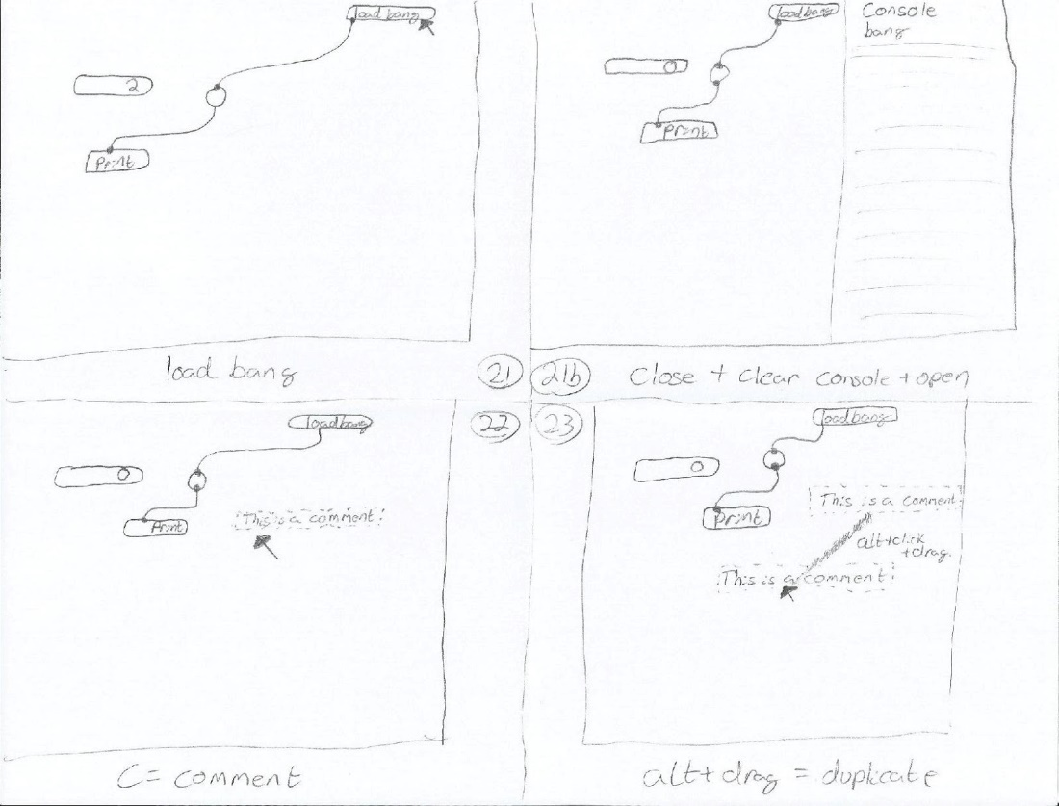
Figure 7: Storyboard of steps 21 - 23 from the Max basics outline

Timing Storyboard
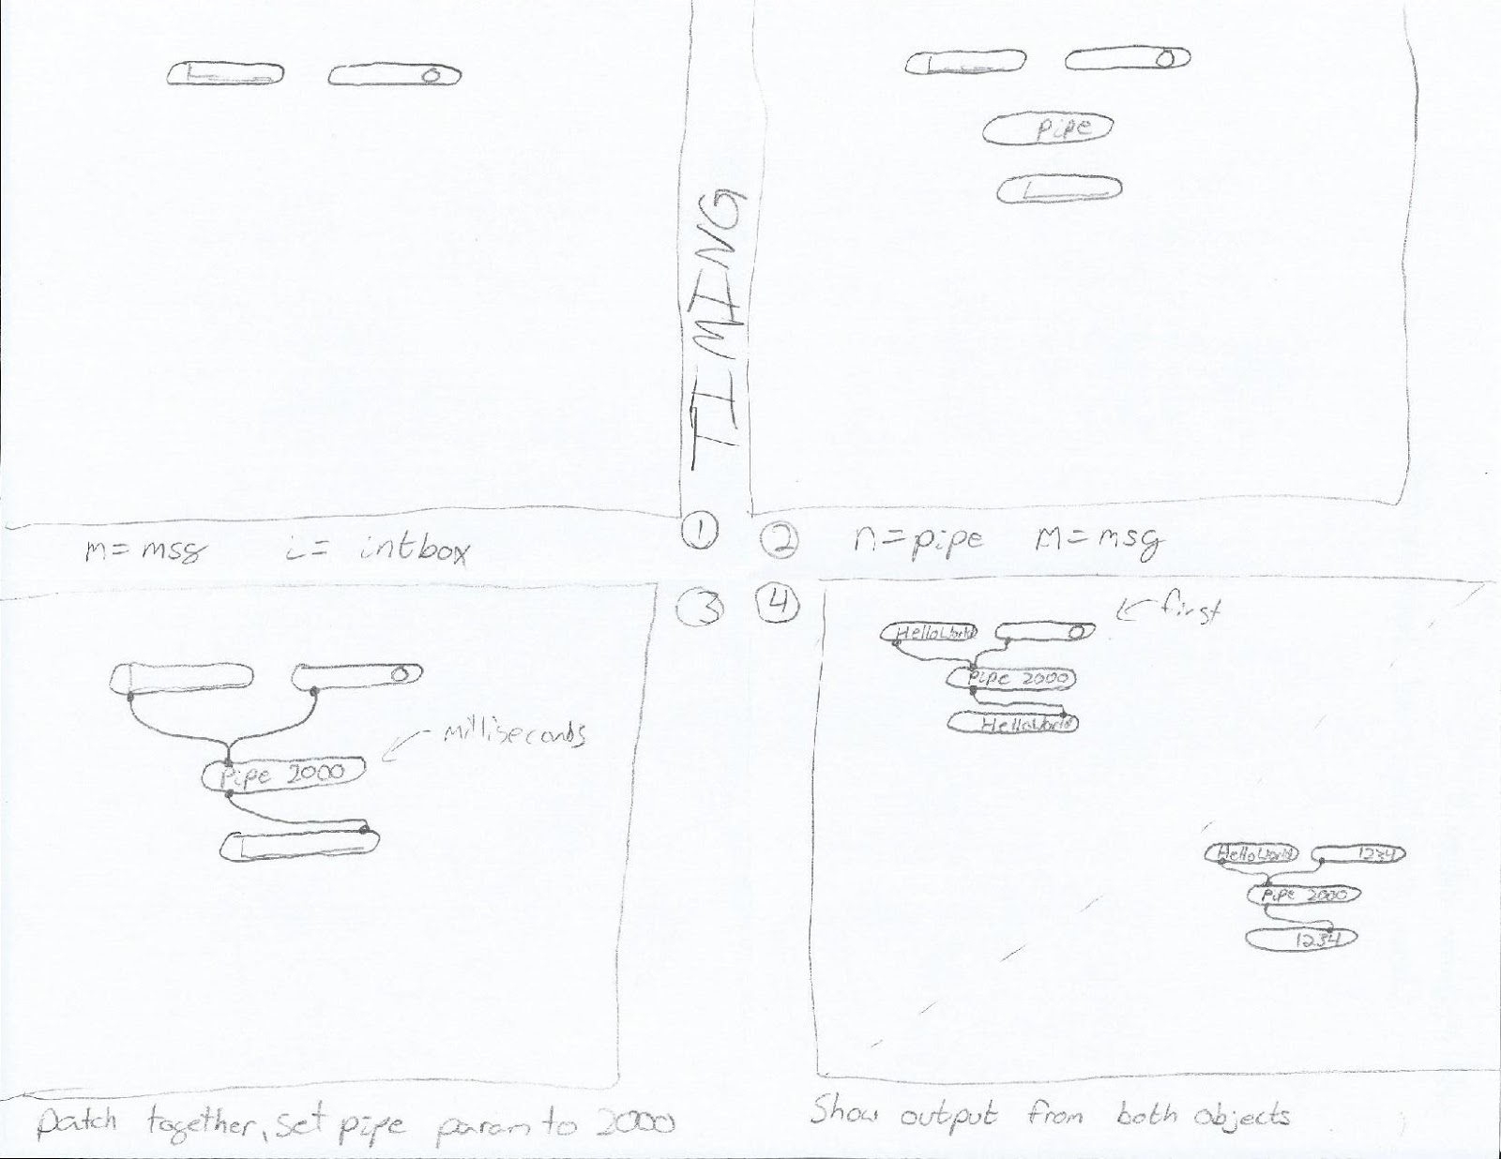
Figure 8: Storyboard of steps 1 - 4 from the timing outline
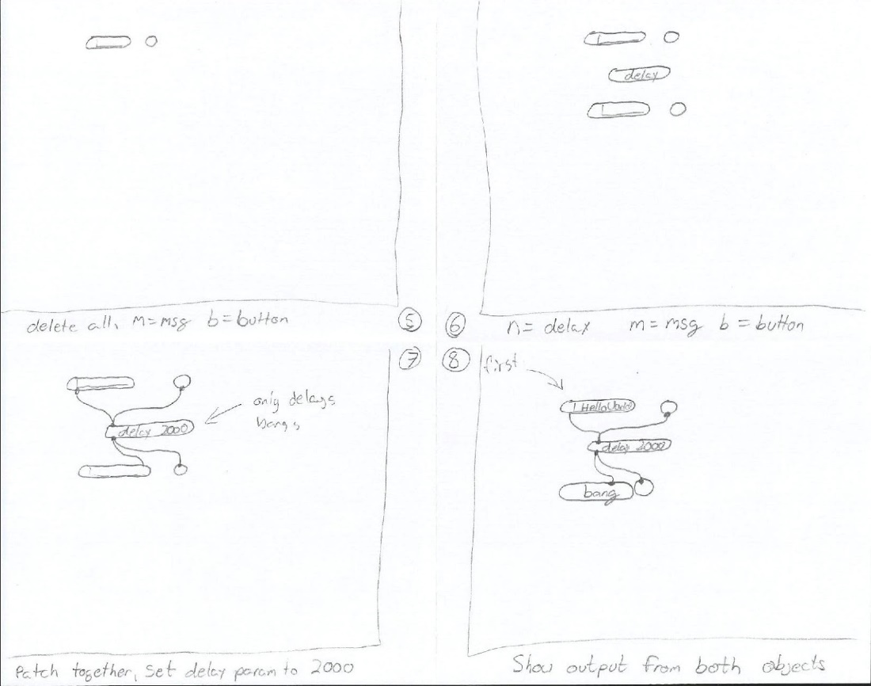
Figure 9: Storyboard of steps 5 - 8 from the timing outline

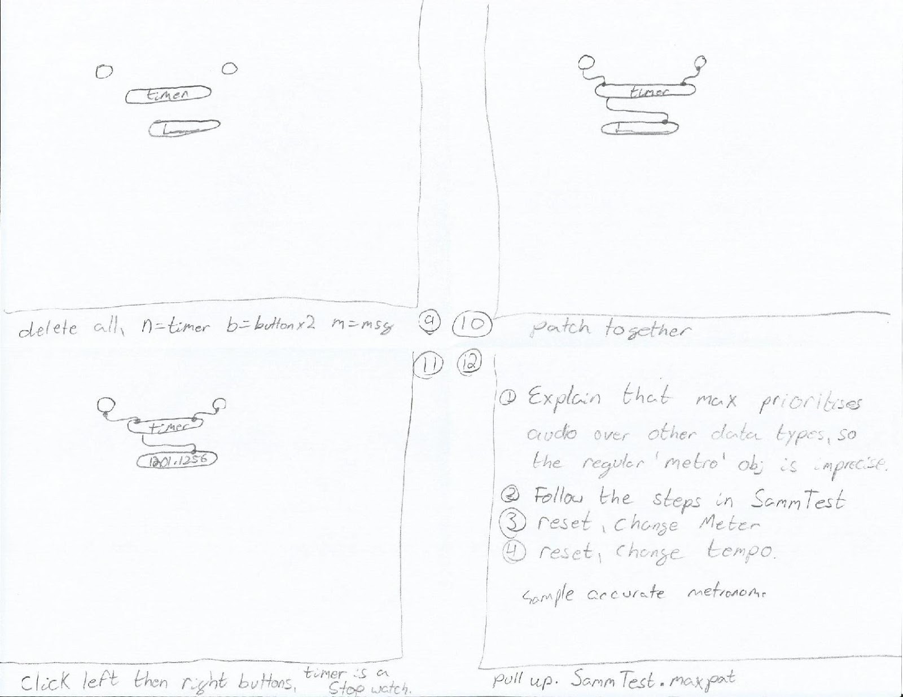
Figure 10: Storyboard of steps 9 - 12 from the timing outline
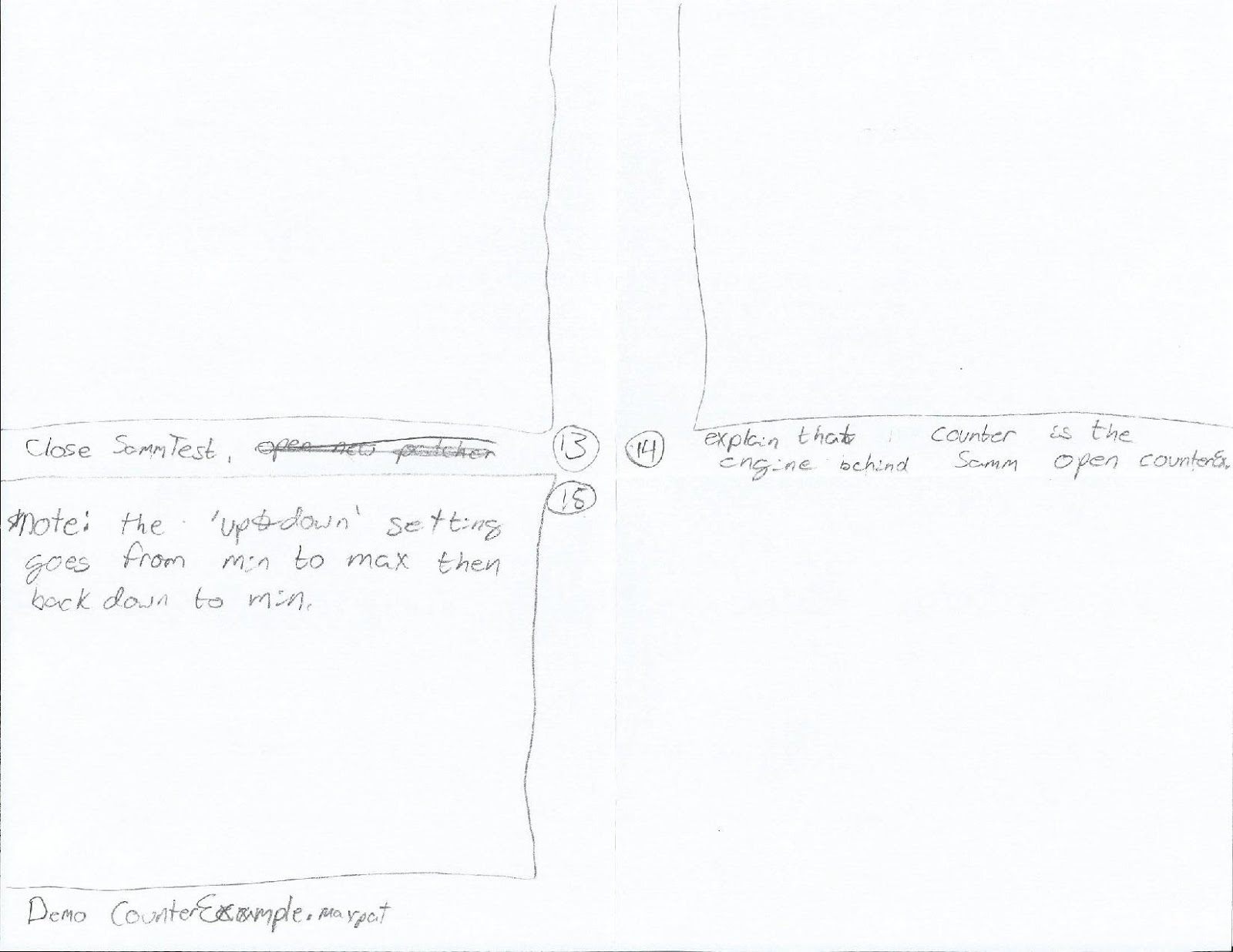
Figure 11: Storyboard of steps 13 - 15 from the timing outline

Quad-speaker Spatialization Storyboard
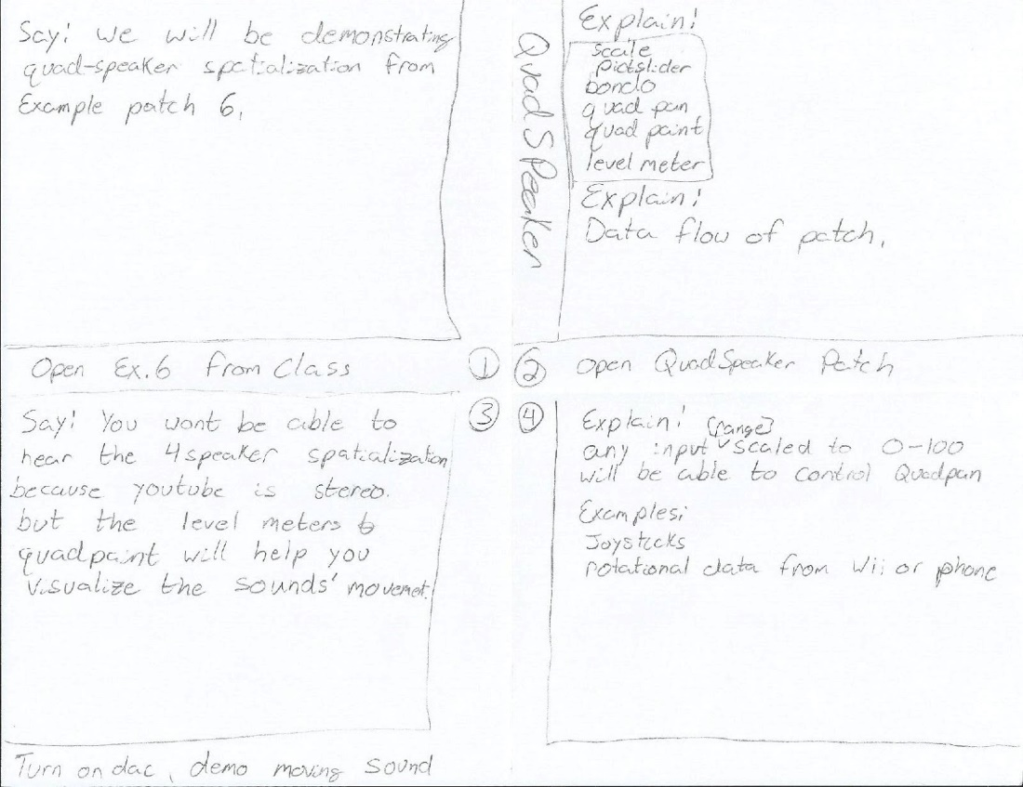
Figure 12: Storyboard of steps 1 - 4 from the quad-speaker spatialization outline
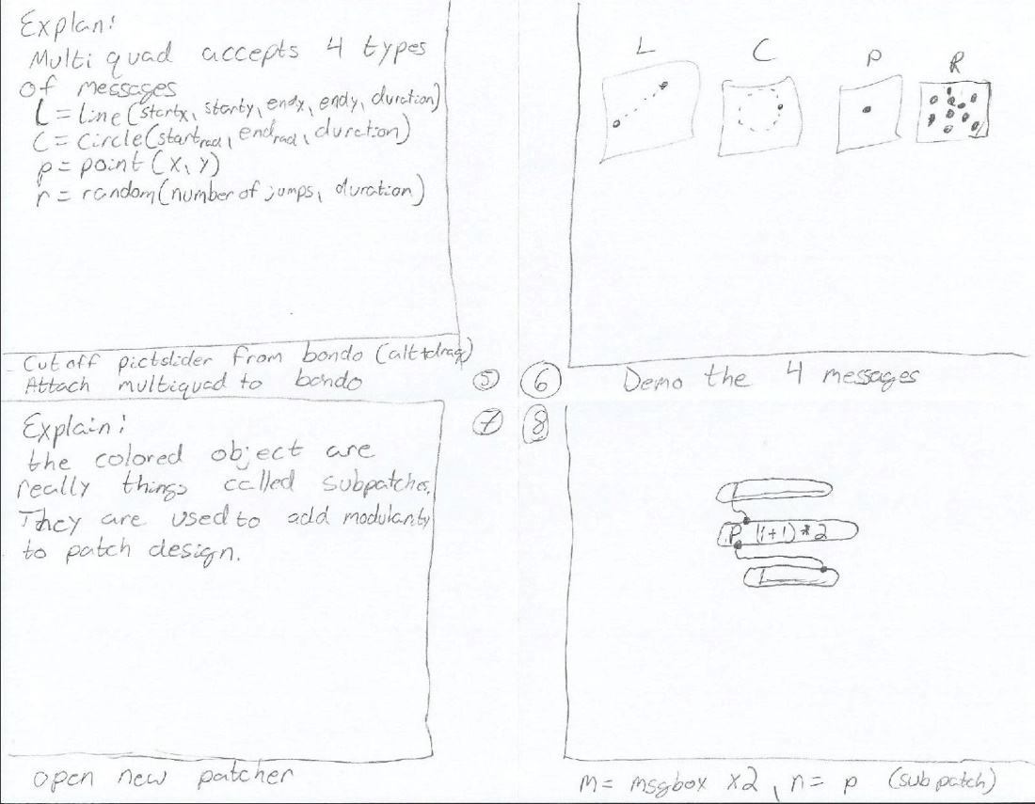
Figure 13: Storyboard of steps 5 - 8 from the quad-speaker spatialization outline

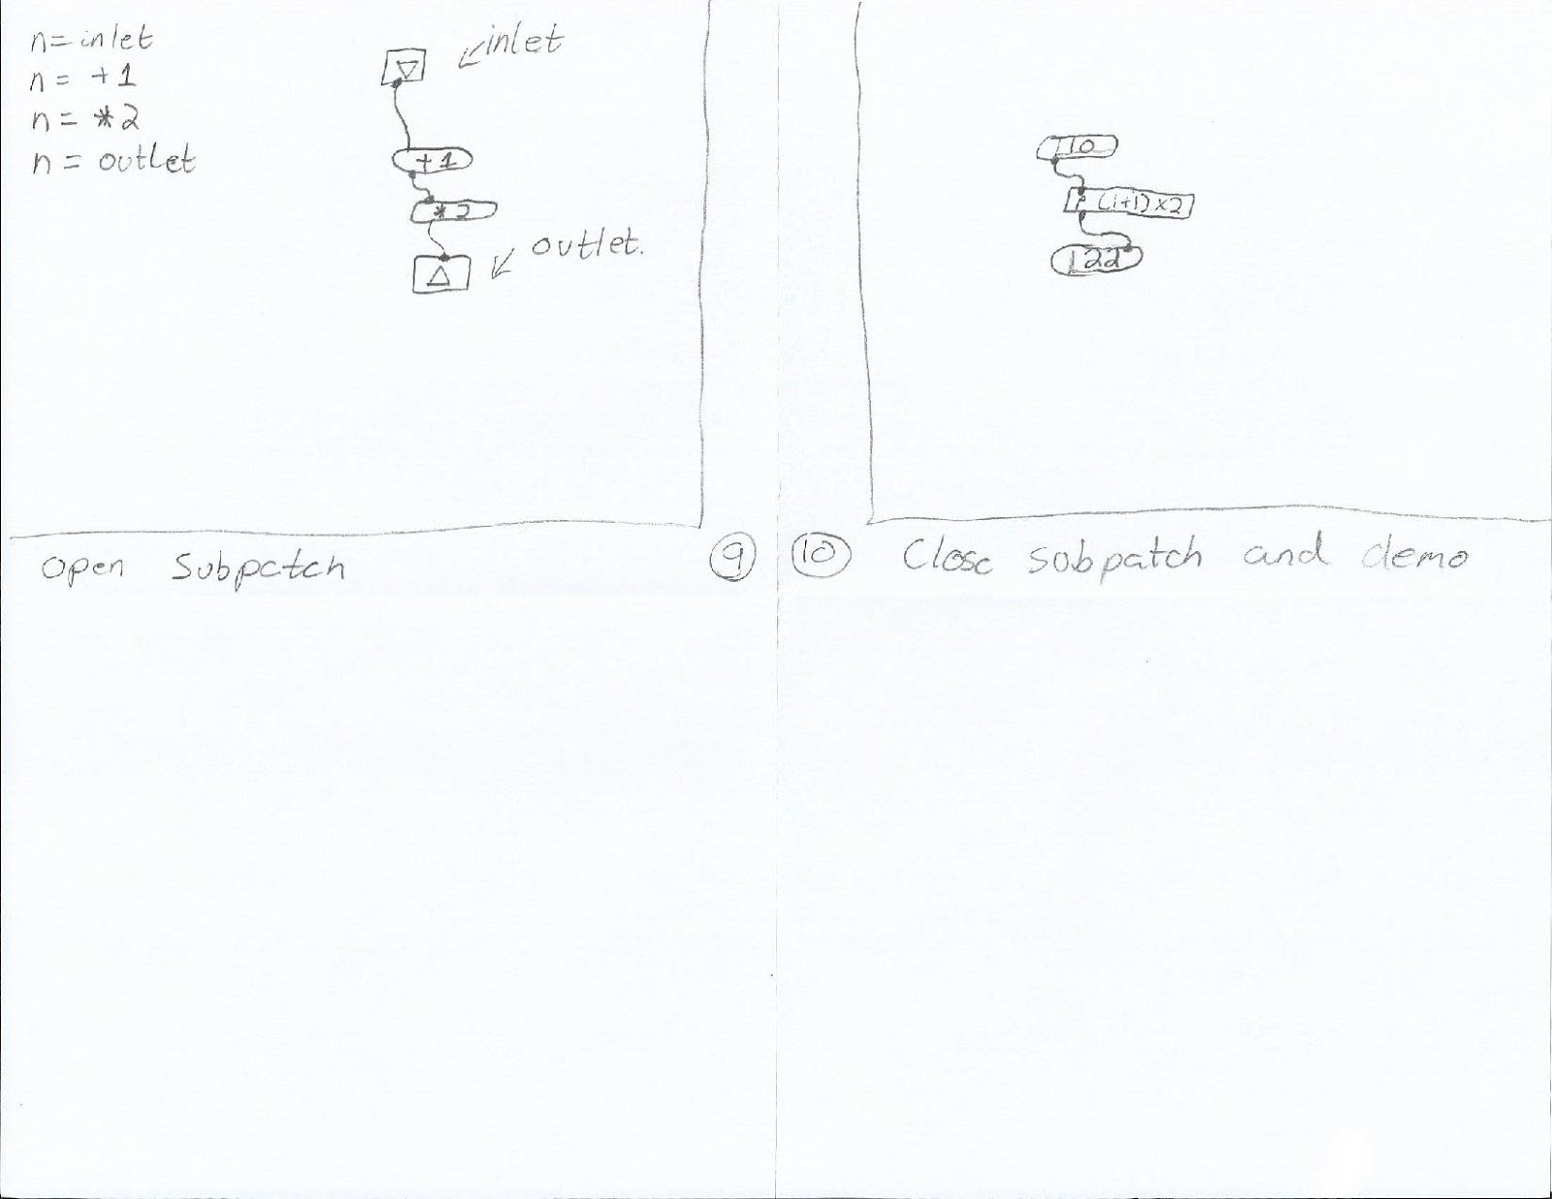
Figure 14: Storyboard of steps 9 - 10 from the quad-speaker spatialization outline

Audio Modulation Storyboard
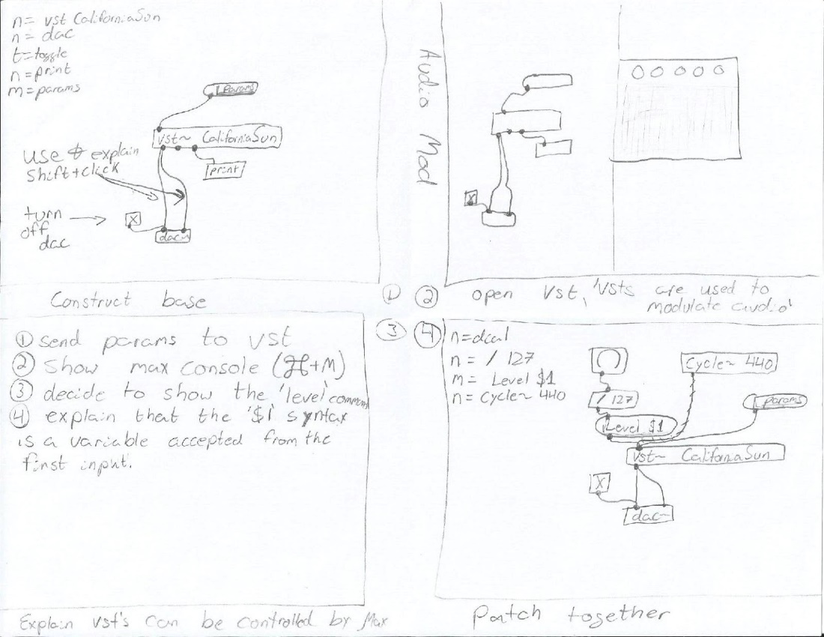
Figure 15: Storyboard of steps 1 - 4 from the audio modulation outline

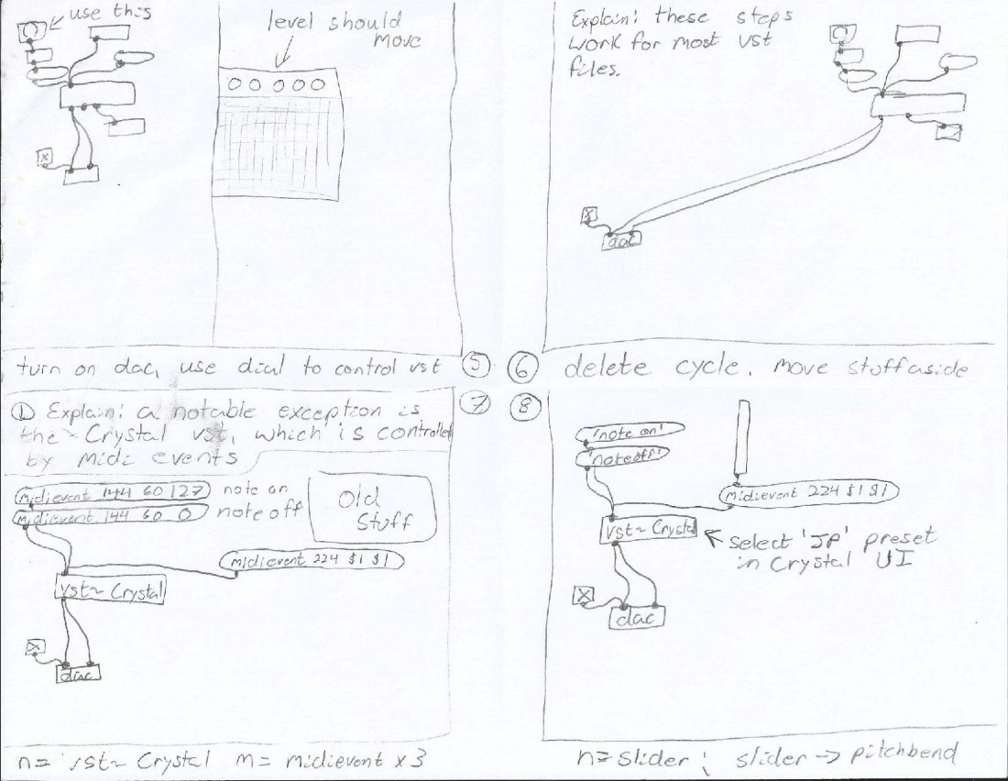
Figure 16: Storyboard of steps 5 - 8 from the audio modulation outline
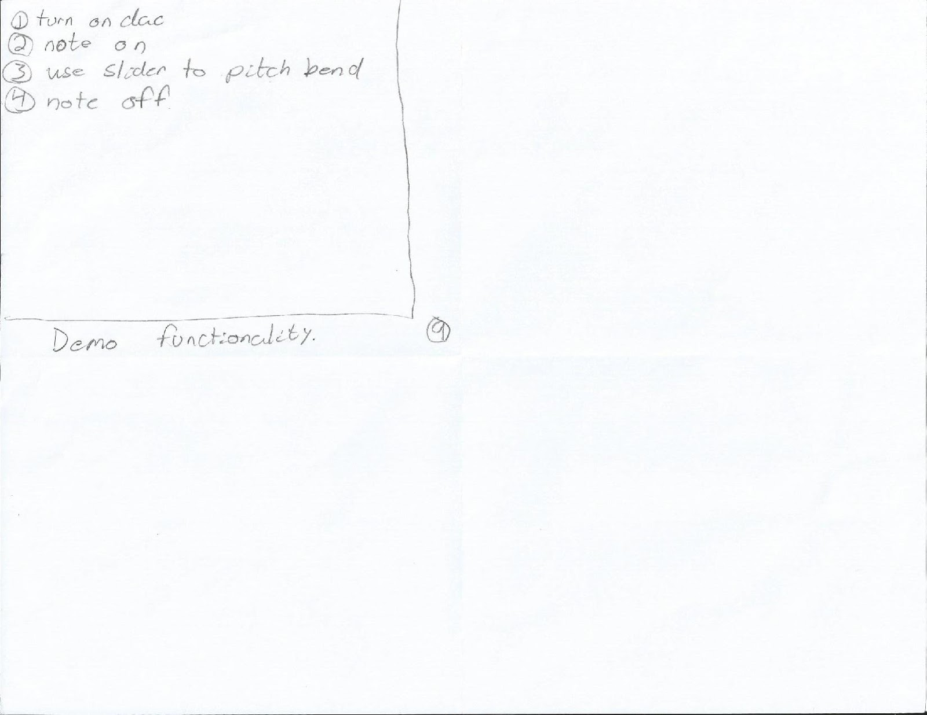
Figure 17: Storyboard of step 9 from the audio modulation outline

Additive Synthesis Storyboard
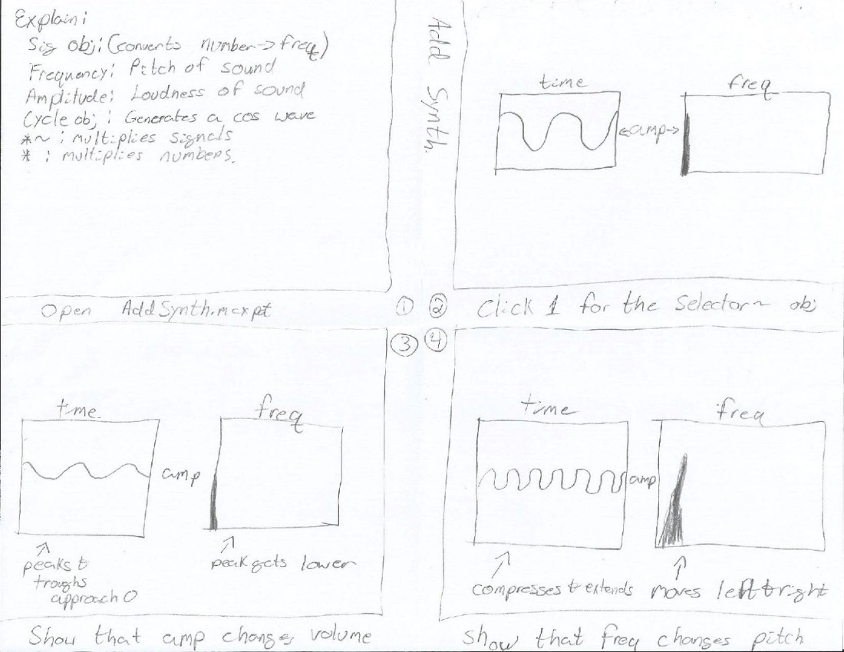
Figure 18: Storyboard of steps 1 - 4 from the additive synthesis outline
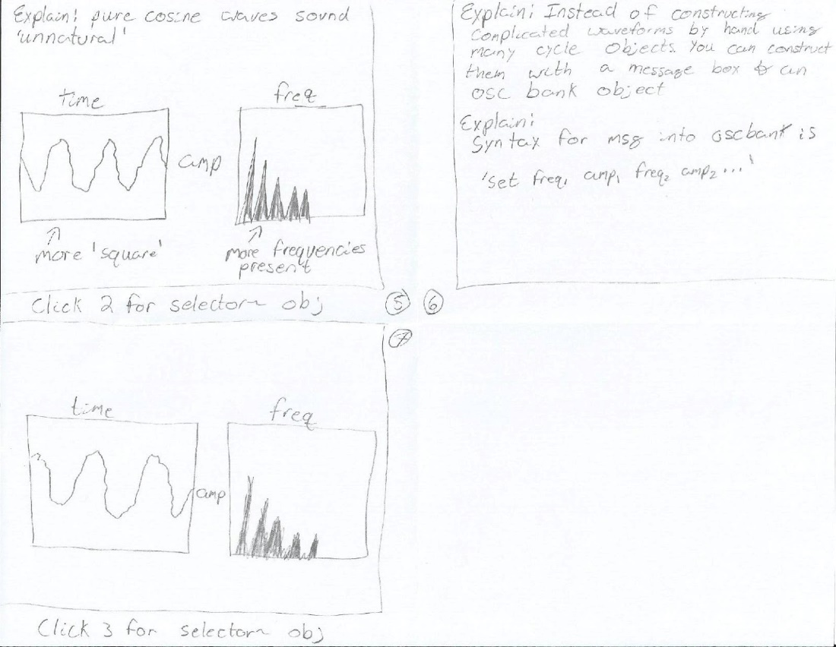
Figure 19: Storyboard of steps 5 - 8 from the additive synthesis outline

2.2: Developer’s Manual - Implementation

2.2.1: Major Tasks for Each Video

- Drafting a script for each video topic
- Storyboarding the narrator’s interaction with the Max software
- Filming the interaction with the Max software using Apple Quicktime’s on-screen recorder
- Post-Production in Apple’s iMovie to edit the video, remove errors, and export the project into one cohesive file

2.2.2: Implementation Schedule

Table 1: Implementation Schedule
Team Member(s) | Task | Start Date | Finish Date | Percent Complete | Prerequisites
All | Max Basics Draft | 1/27/2016 | 2/3/2016 | 100 | None
Tyler | Max Basics Storyboard | 2/15/2016 | 2/17/2016 | 100 | Max Basics Draft
Deepika & Amanda | Requirements and Design Report | 2/3/2016 | 2/19/2016 | 100 | None
Deepika & Amanda | Implementation Report | 3/2/2016 | 3/4/2016 | 100 | Requirements and Design Report
Tyler | Max Timing Storyboard | 3/15/2016 | 3/23/2016 | 100 | Max Timing Draft
Deepika & John | Max Basics Post-Production | 3/16/2016 | 3/23/2016 | 100 | Max Basics Filming
Deepika & Amanda | Prototype + Refinement Report | 3/16/2016 | 3/30/2016 | 100 | Implementation Report
Tyler | Max Timing Draft | 3/1/2016 | 3/31/2016 | 100 | None
John | Coll Object Draft | 3/1/2016 | 3/31/2016 | 100 | None
Amanda | Quad-speaker Spatialization Draft | 3/1/2016 | 3/31/2016 | 100 | None
Tyler | Coll Object Storyboard | 3/22/2016 | 3/31/2016 | Not Necessary* | Coll Object Draft
Tyler | Quad-speaker Spatialization Storyboard | 3/29/2016 | 3/31/2016 | 100 | Quad-speaker Spatialization Draft
John & Tyler | Max Timing Filming | 3/23/2016 | 4/6/2016 | 100 | Max Timing Storyboard
John & Tyler | Coll Object Filming | 3/30/2016 | 4/6/2016 | 100 | Coll Object Storyboard
Deepika & John | Max Timing Post-Production | 3/23/2016 | 4/18/2016 | 100 | Max Timing Filming
Deepika & John | Coll Object Post-Production | 3/30/2016 | 4/18/2016 | 100 | Coll Object Filming
Deepika & Amanda | Testing Report | 4/1/2016 | 4/19/2016 | 100 | Prototype + Refinement Report
John & Tyler | Quad-speaker Spatialization Filming | 4/6/2016 | 4/20/2016 | 100 | Quad-speaker Spatialization Storyboard
Deepika & John | Quad-speaker Spatialization Post-Production | 4/6/2016 | 4/20/2016 | 100 | Quad-speaker Spatialization Filming
Tyler | Audio Modulation Draft | 3/17/2016 | 4/22/2016 | 100 | None
Amanda | Additive Synthesis Draft | 3/17/2016 | 4/22/2016 | 100 | None
Tyler | Audio Modulation Storyboard | 4/5/2016 | 4/24/2016 | 100 | Audio Modulation Draft
Tyler | Additive Synthesis Storyboard | 4/12/2016 | 4/24/2016 | 100 | Additive Synthesis Draft
John & Tyler | Audio Modulation Filming | 4/13/2016 | 4/24/2016 | 100 | Audio Modulation Storyboard
John & Tyler | Additive Synthesis Filming | 4/13/2016 | 4/24/2016 | 100 | Additive Synthesis Storyboard
Deepika & John | Audio Modulation Post-Production | 4/13/2016 | 4/27/2016 | 100 | Audio Modulation Filming
Deepika & John | Additive Synthesis Post-Production | 4/13/2016 | 4/27/2016 | 100 | Additive Synthesis Filming
Deepika & Amanda | Final Project Report | 4/15/2016 | 4/27/2016 | 100 | Testing Report
* Dr. Nichols did not feel that a storyboard was necessary for this video due to the fact that the explanations do not require many visuals.

For each video topic, the team has split up in order to research and write a draft script. The draft script shall describe what key points the narrator of the video needs to make as well as describe any specific actions that are necessary in order to effectively inform the viewer about the topic.

Storyboards shall be made for each video topic. These storyboards shall be based on the draft scripts. The main goal of the storyboards is to allow the narrator to visualize the actions that must be performed when recording the video. The storyboards will also aid the narrator in following the scripts exact order so no topics or important actions are overlooked.

Filming shall take place in the DISIS Lab located in Newman Library. There, the team has access to a registered copy of Max, a microphone, audio interface and Apple’s Quicktime screen recorder. Filming and narration for each topic shall take place at the same time with the aid of the storyboard. In the event of a mistake while recording, the team plans to momentarily stop any action and then re-do whatever action was the source of the mistake. The raw video will then be edited in post-production to remove any errors and/or inconsistencies.

The team shall use iMovie to edit each video in order to ensure it is consistent and free of mistakes. Each video shall have a title slide depicting the video’s topic. The video will be exported in 1080p and sent to Dr. Charles Nichols for upload to his YouTube channel. The videos will be released at Dr. Nichols’ convenience for use next semester.

Reporting and documentation will take place up to the standards posted in the syllabus for CS 4624.

2.2.3: Security
All copies of our files will be delivered to Dr. Nichols upon completion of the final video.
Videos will be uploaded to a password protected YouTube Channel owned by Dr. Nichols.

2.2.4: Documentation
The group will maintain the following files:
- Drafts of scripts
- Storyboards
- Raw Video Files
- Post Production Files
All of these files will be delivered to Dr. Nichols upon completion of the final video

2.2.5: Testing
Video efficacy will be tested by presenting the videos to group members who do not have experience in Max, along with several other viewers who are chosen at random and have varying experience using Max. The videos will be evaluated by testers, who will then be asked to explain what they learned by using Max.

2.3: Developer’s Manual – Prototype

2.3.1: Max Basics Video

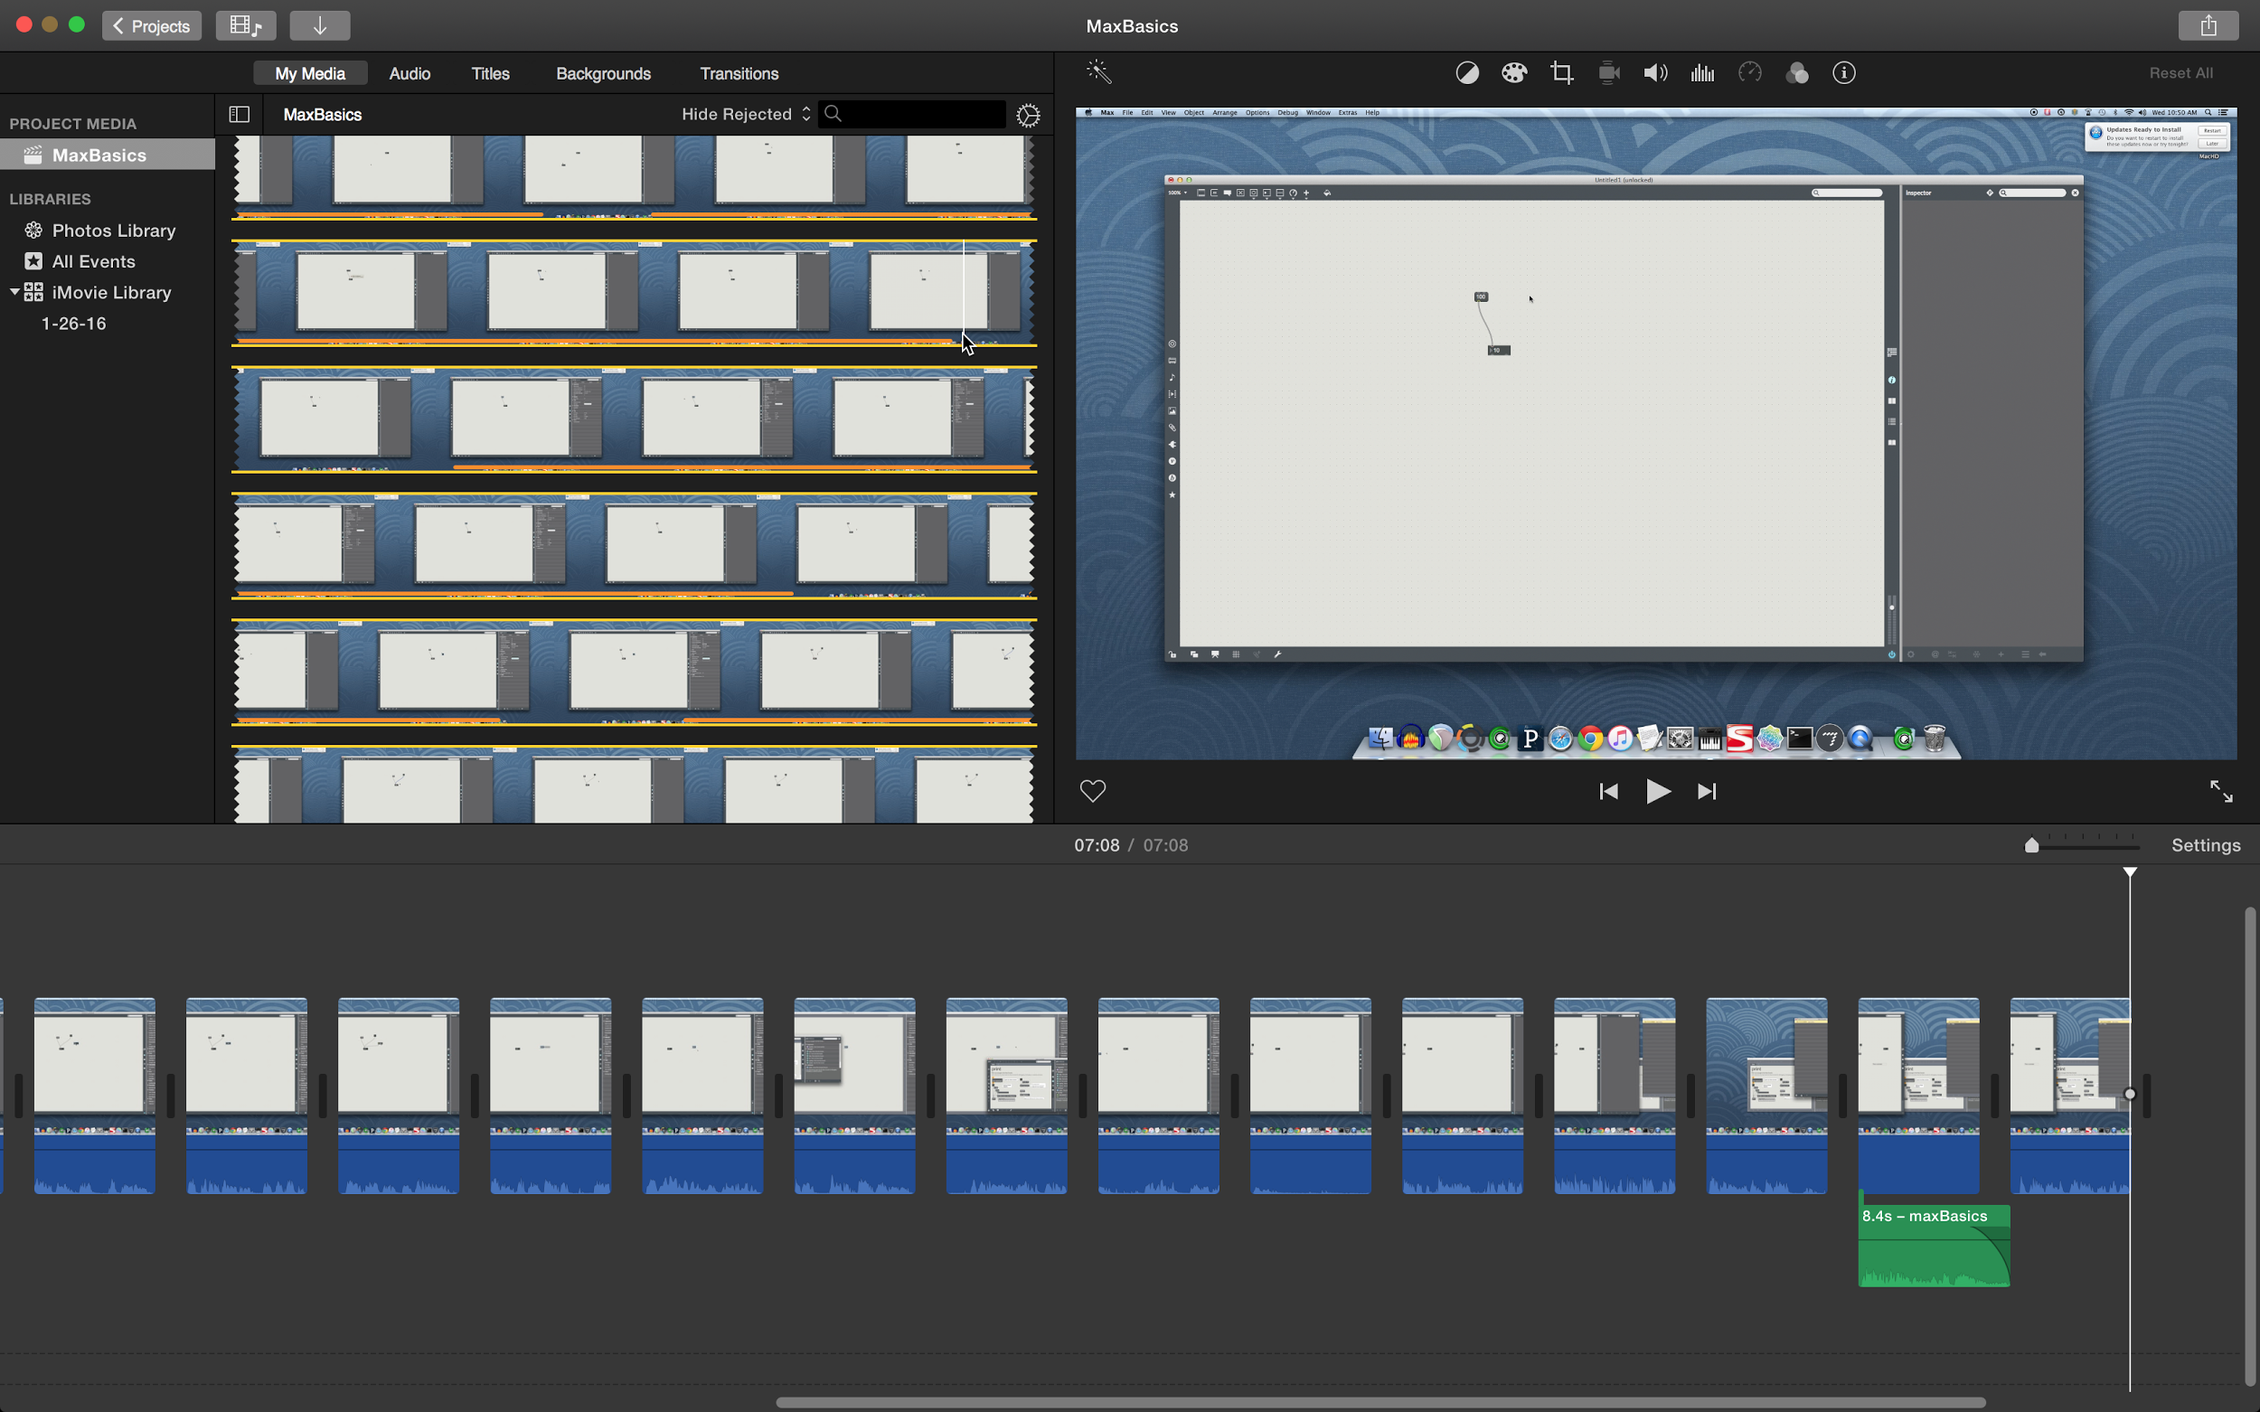
Figure 20: iMovie Interface

This is a screenshot of the whole iMovie project. The raw video is seen in the top left box of the screen, the “Project Media” section of iMovie. The bottom of the iMovie window shows the timeline of the final video, including any edits made. The video has been edited to remove pauses and mistakes in the raw video. Each cut can be seen by the breaks in the video screenshots at the bottom of the screen. The top right of the iMovie window is a player that allows the editor to quickly playback any section of the edited and raw video. This allows the editor to quickly examine the video and make changes as they see fit.
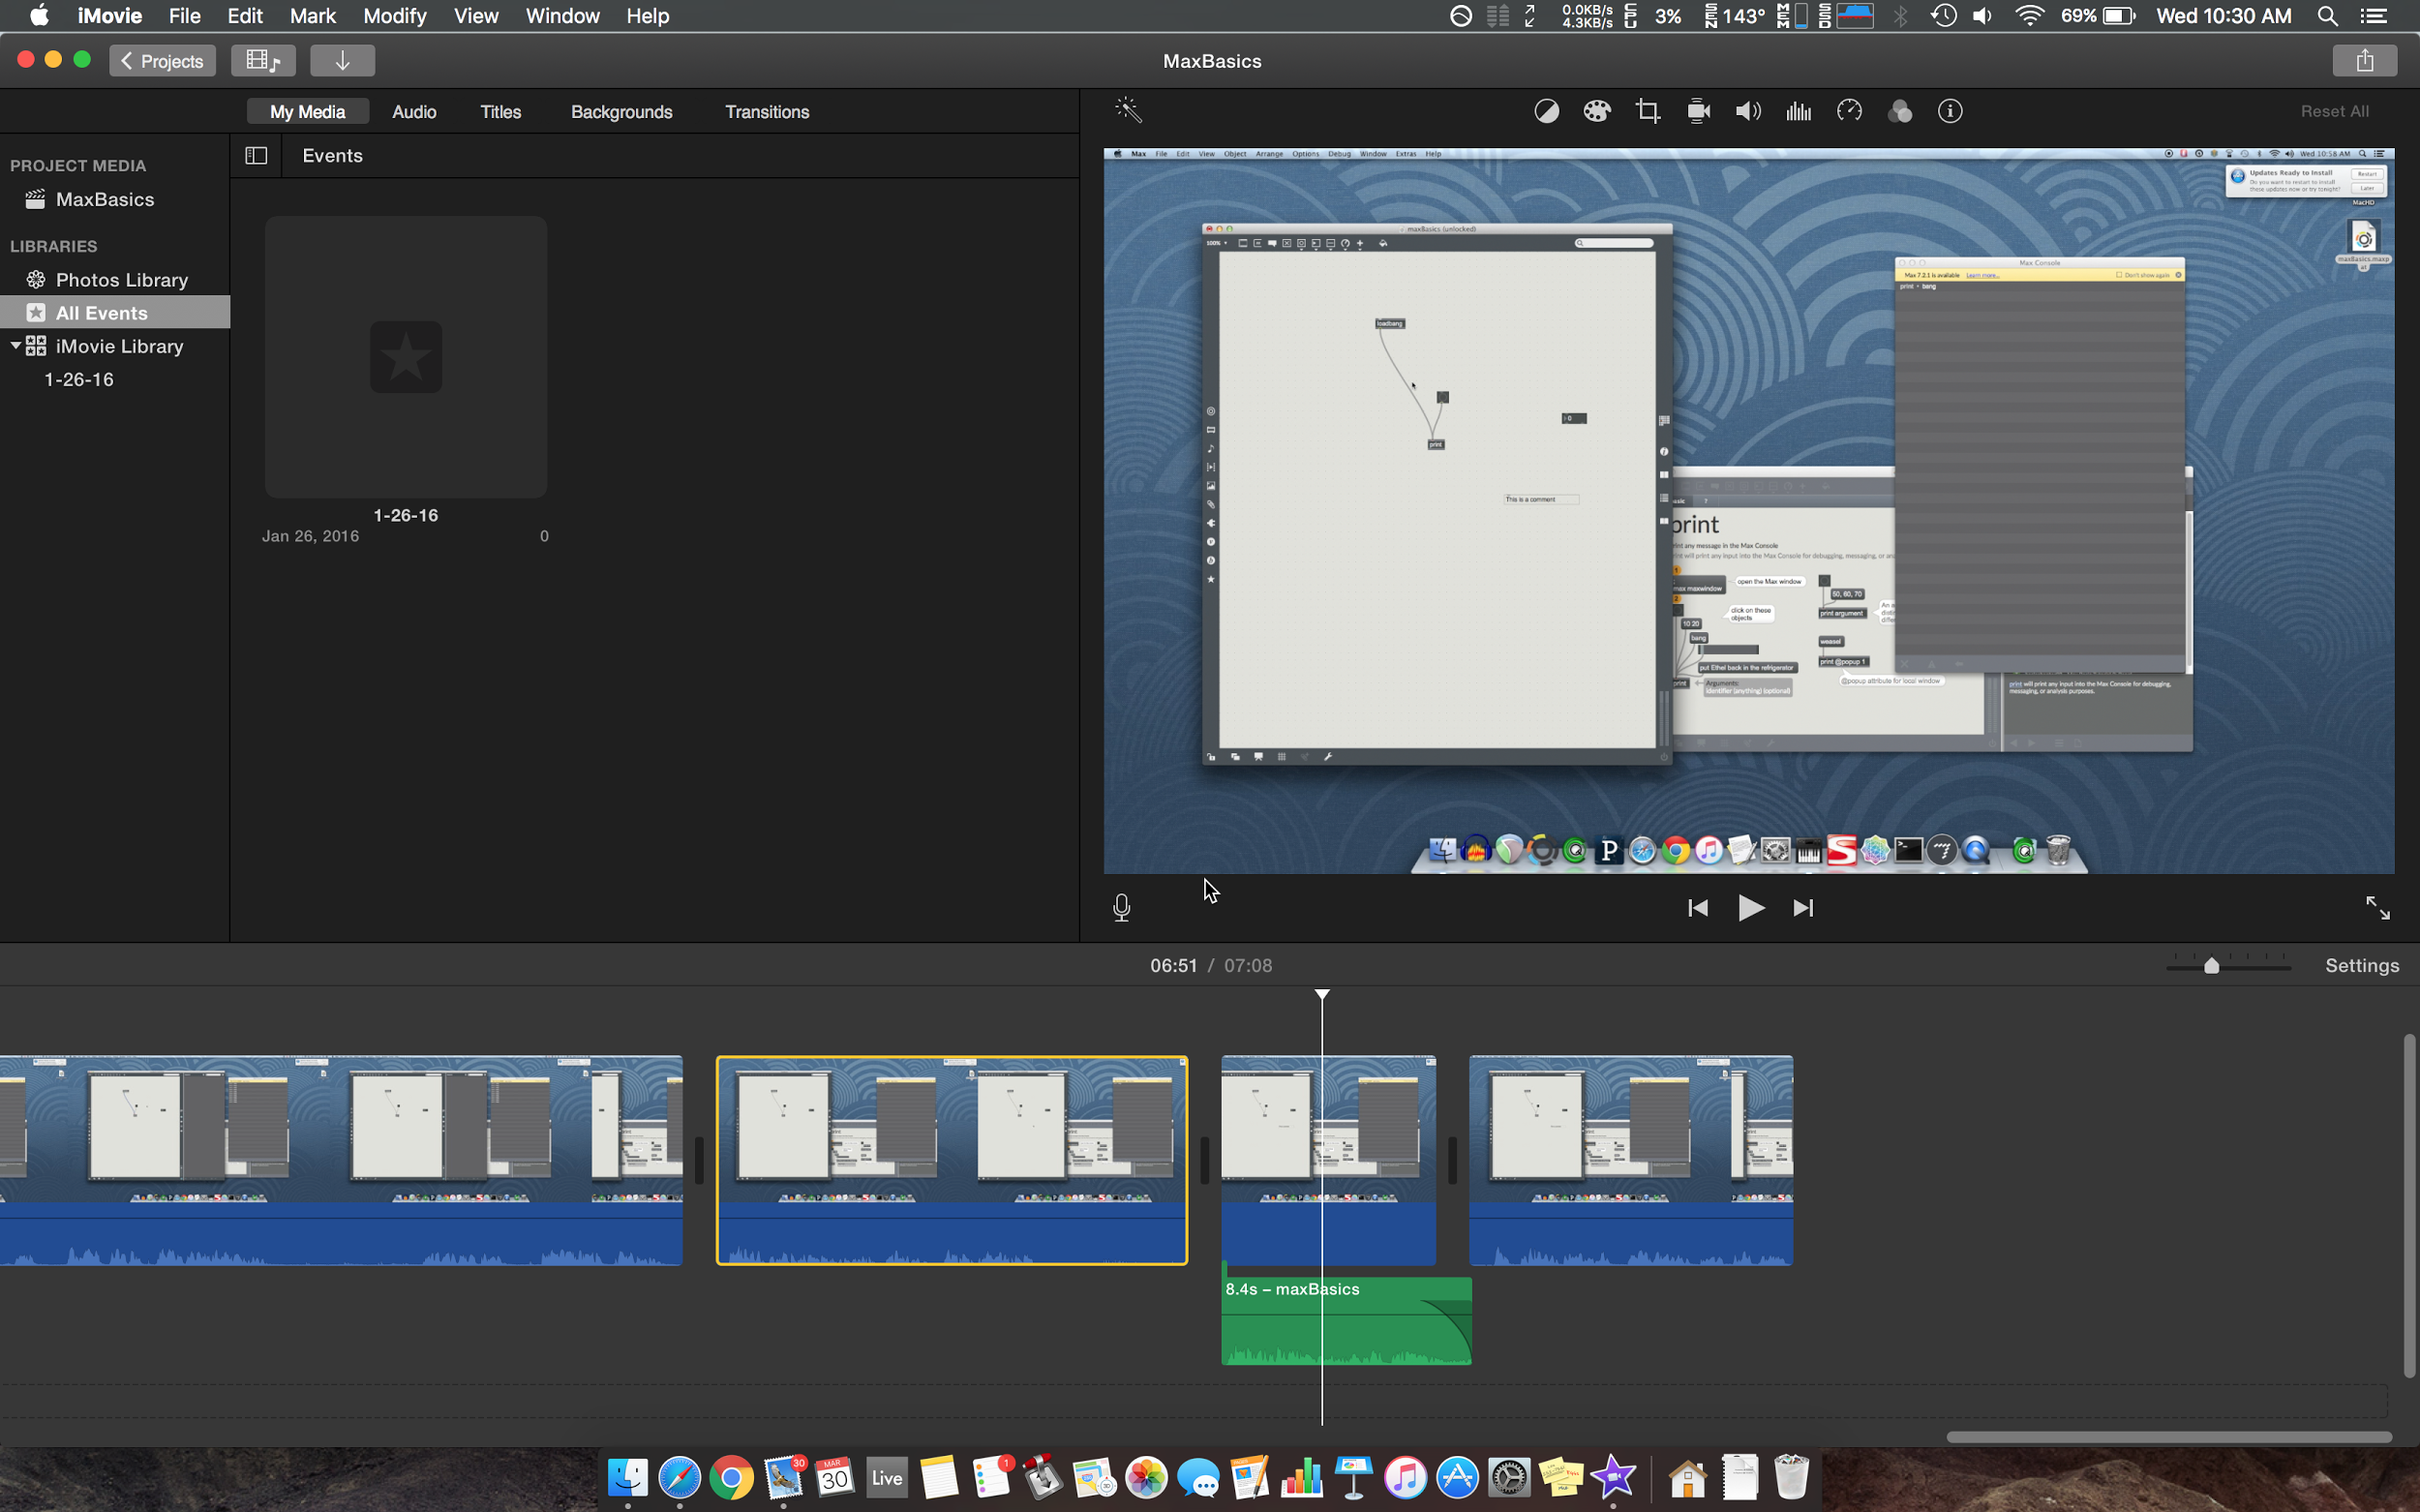
Figure 21: Audio Editing

Some audio editing was necessary during the end of the tutorial video. The green rectangle is the audio clip that was split from the video section above it. The audio section was then made to fade out in order to make the final video smoother and remove some pops and clicks that were present. After the fade out was added the final video was much more seamless and smooth.
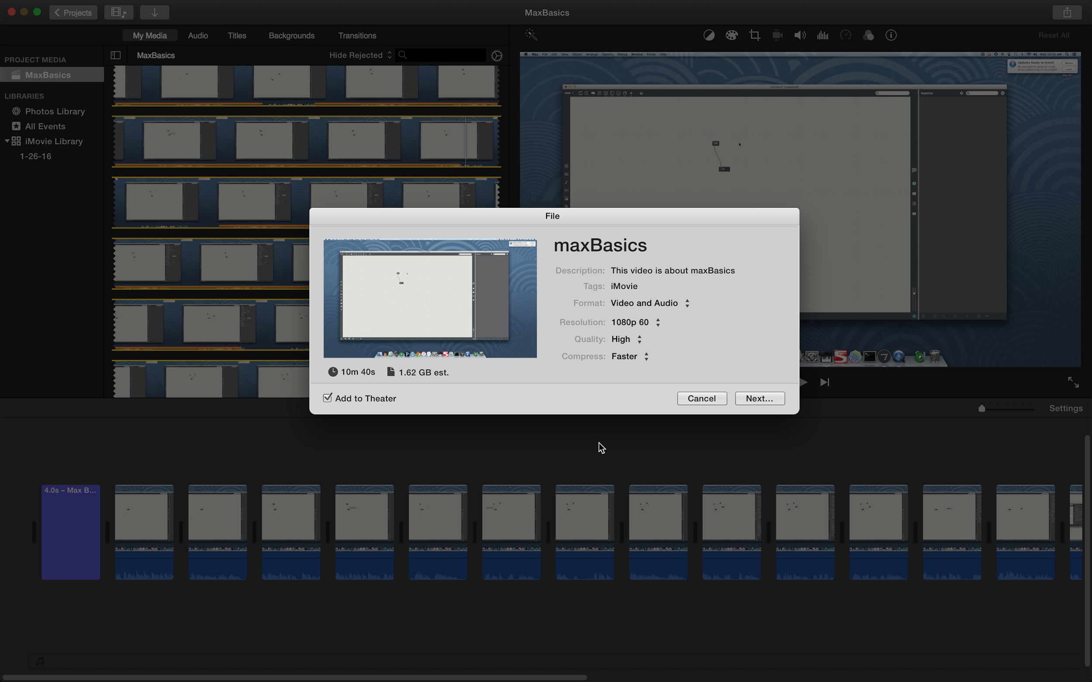
Figure 22: Pre-Production Video Information

Figure 22 shows the details for the raw video located in the “Project Media” section of iMovie in the top left corner of the screen. It is 10 minutes and 40 seconds in length, 1.62 GB in size, shot in 1080p, 60fps, and is in the .MOV format.
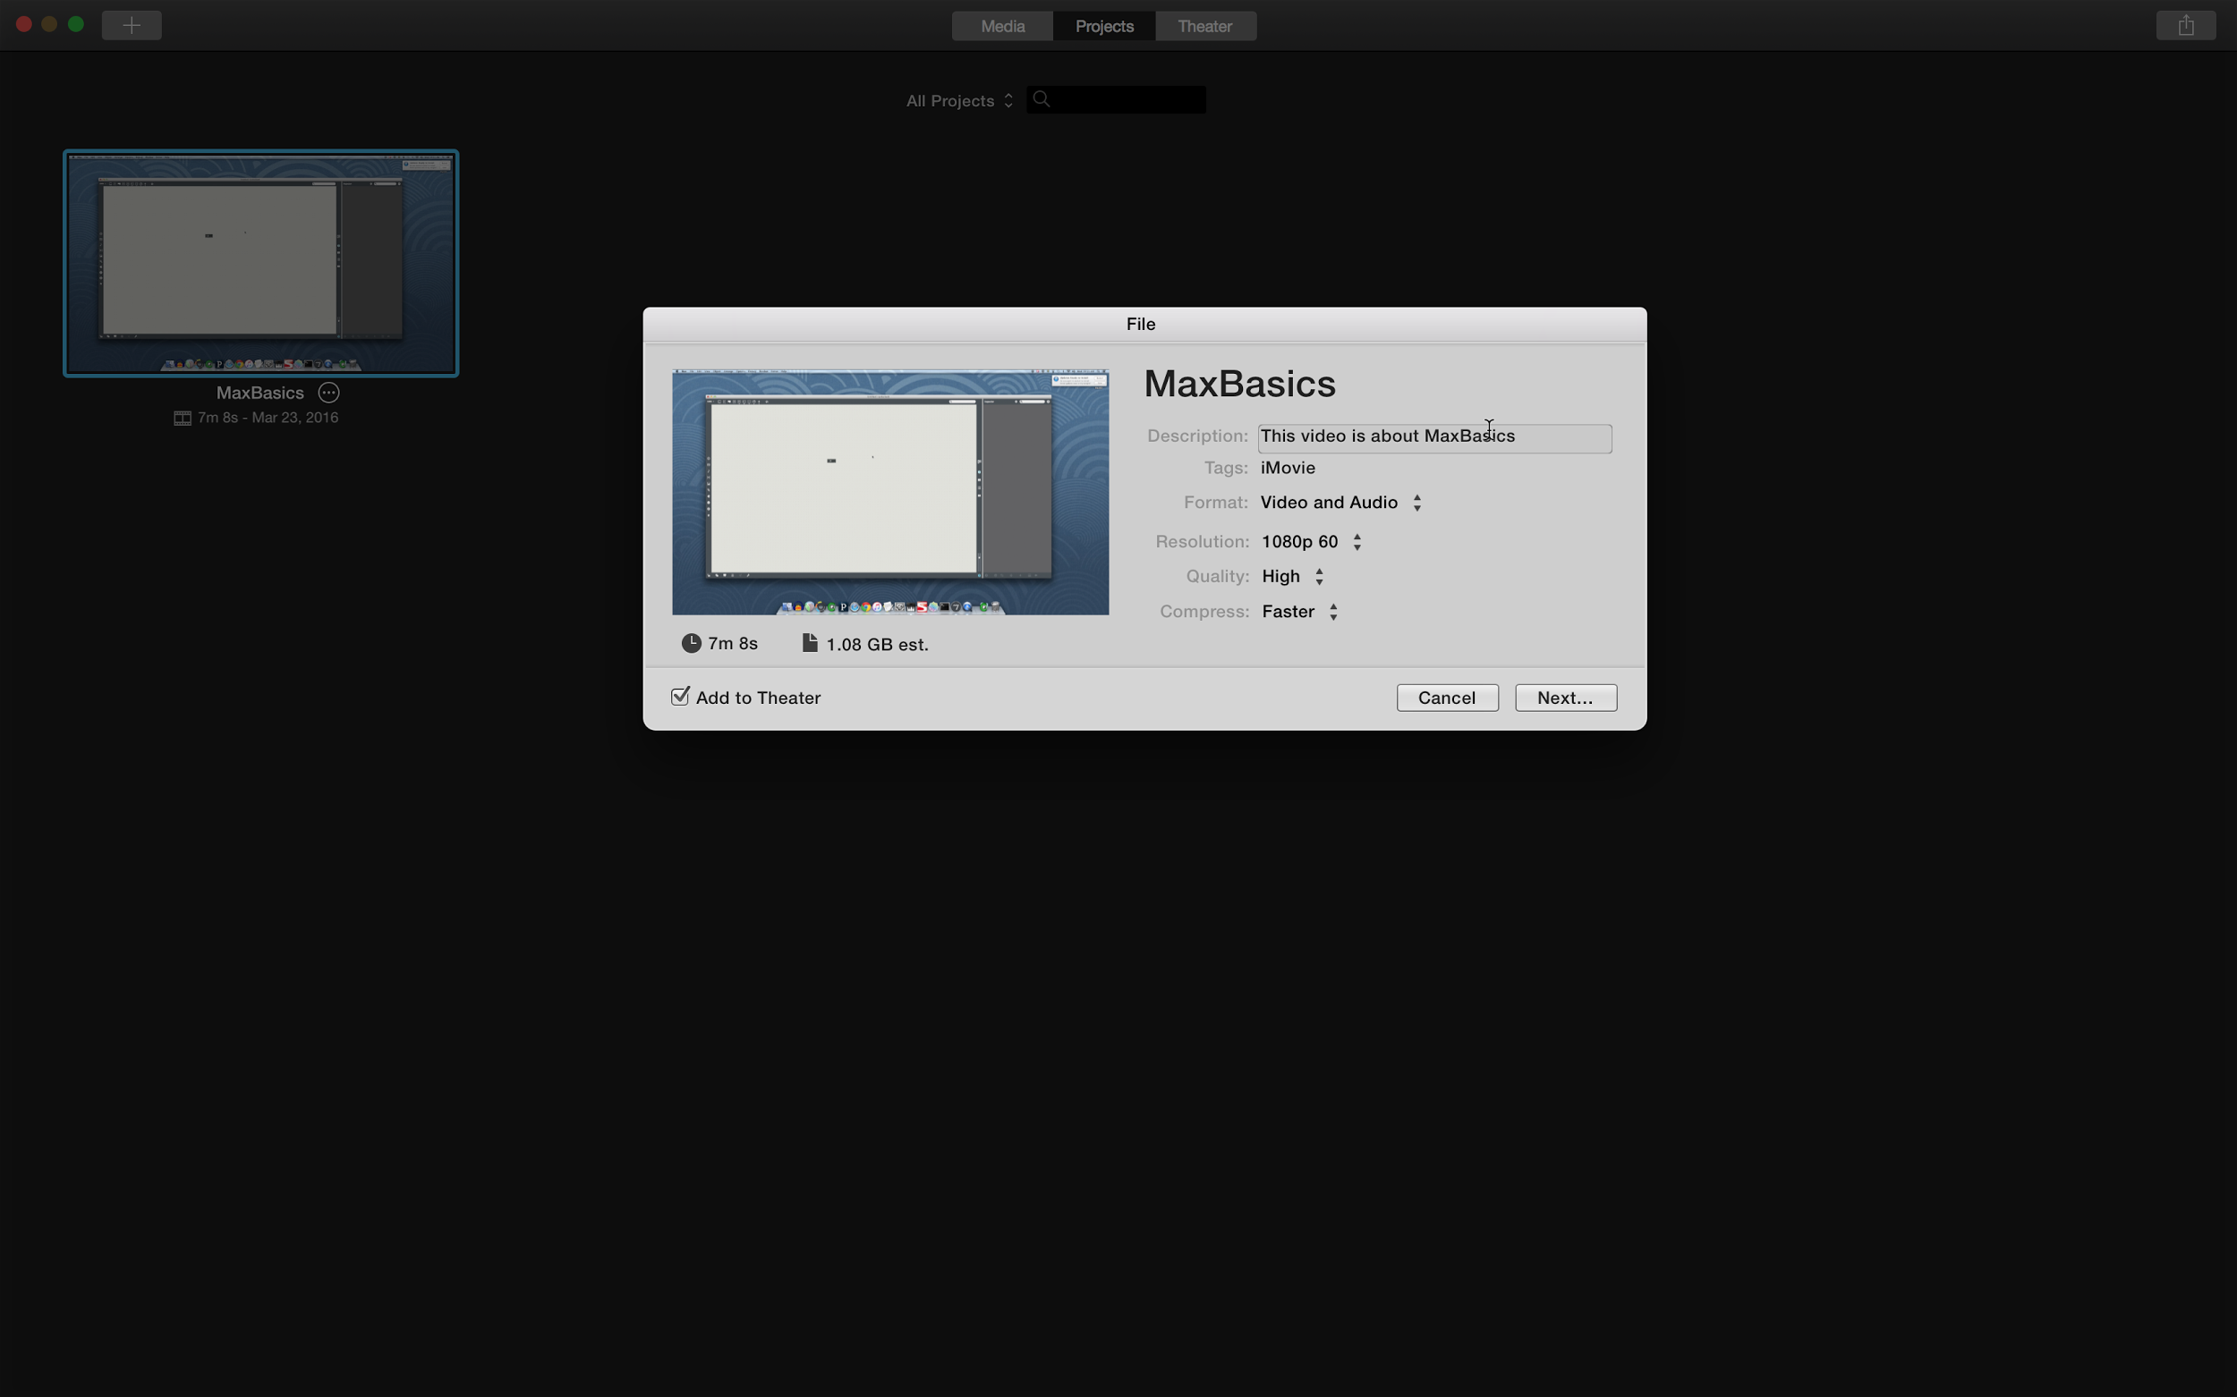
Figure 23: Post-Production Video Information

Above are the details for the final video, provided by iMovie. Due to editing, 3 minutes were taken off. The resulting quality of 1080p and 60fps stayed the same after exporting the project in the .MOV format.
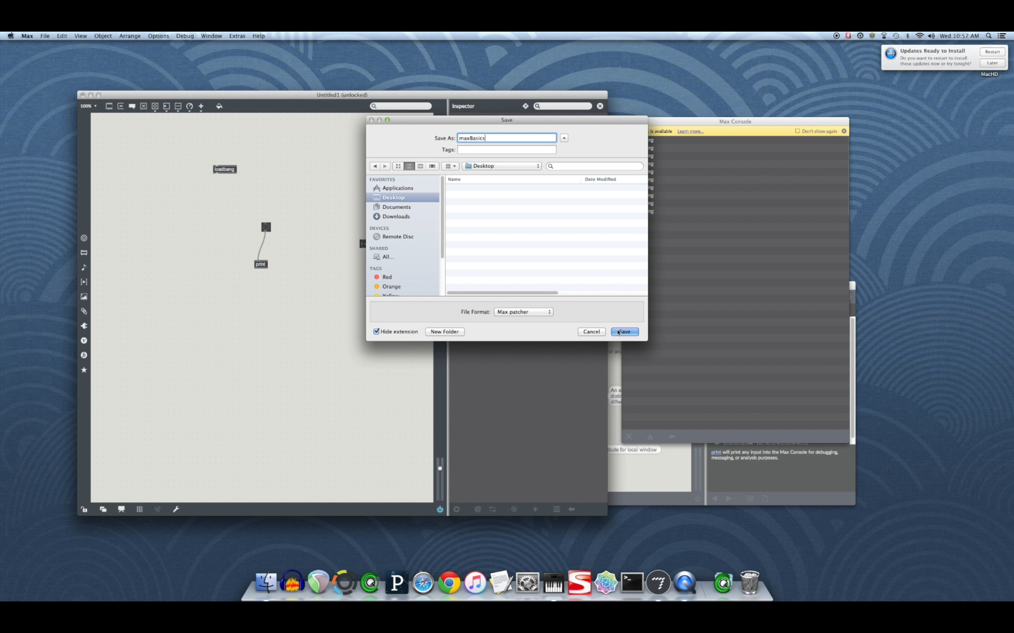
Figure 24: Final Video

This is a screenshot of the final video for Max Basics being played. Seen above is the section of the video where John is demonstrating the function of the loadbang object. The patch is saved, the Max patch is closed, and then the patch is reopened in order to show that the loadbang object outputs a bang as soon as the patch is loaded.

2.3.2: Timing Video

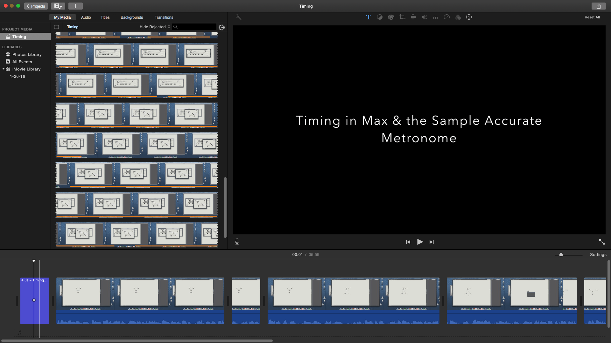
Figure 25: Max Timing tutorial

Pictured is the iMovie project for the Max Timing tutorial. There were less necessary edits on the raw video, and as a result there are less breaks in video on the timeline at the bottom of the screen.

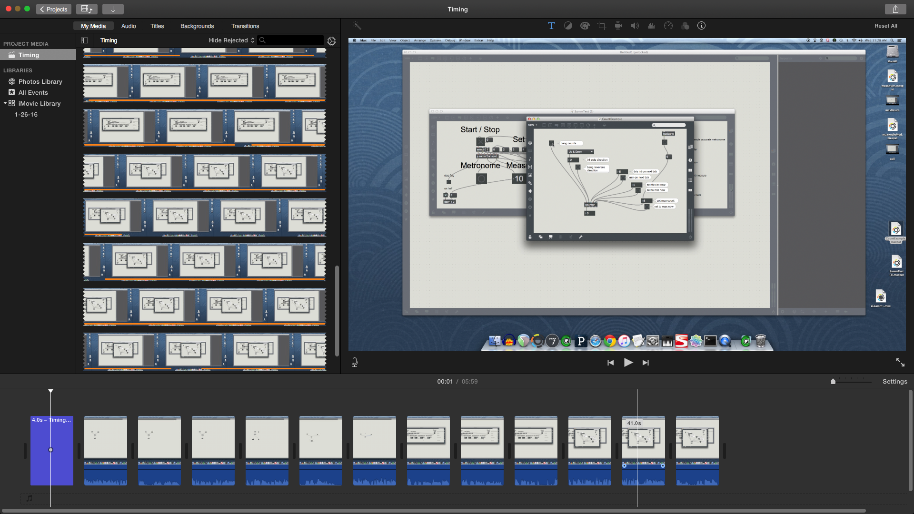
Figure 26: Editing the end of the Timing video

Figure 26 is once again in iMovie, this time towards the end of the timing video. Since this video talked about 3 different patches available in different windows, the ending of the video required more editing. The frame displayed is when John is talking about the counter object in Max.

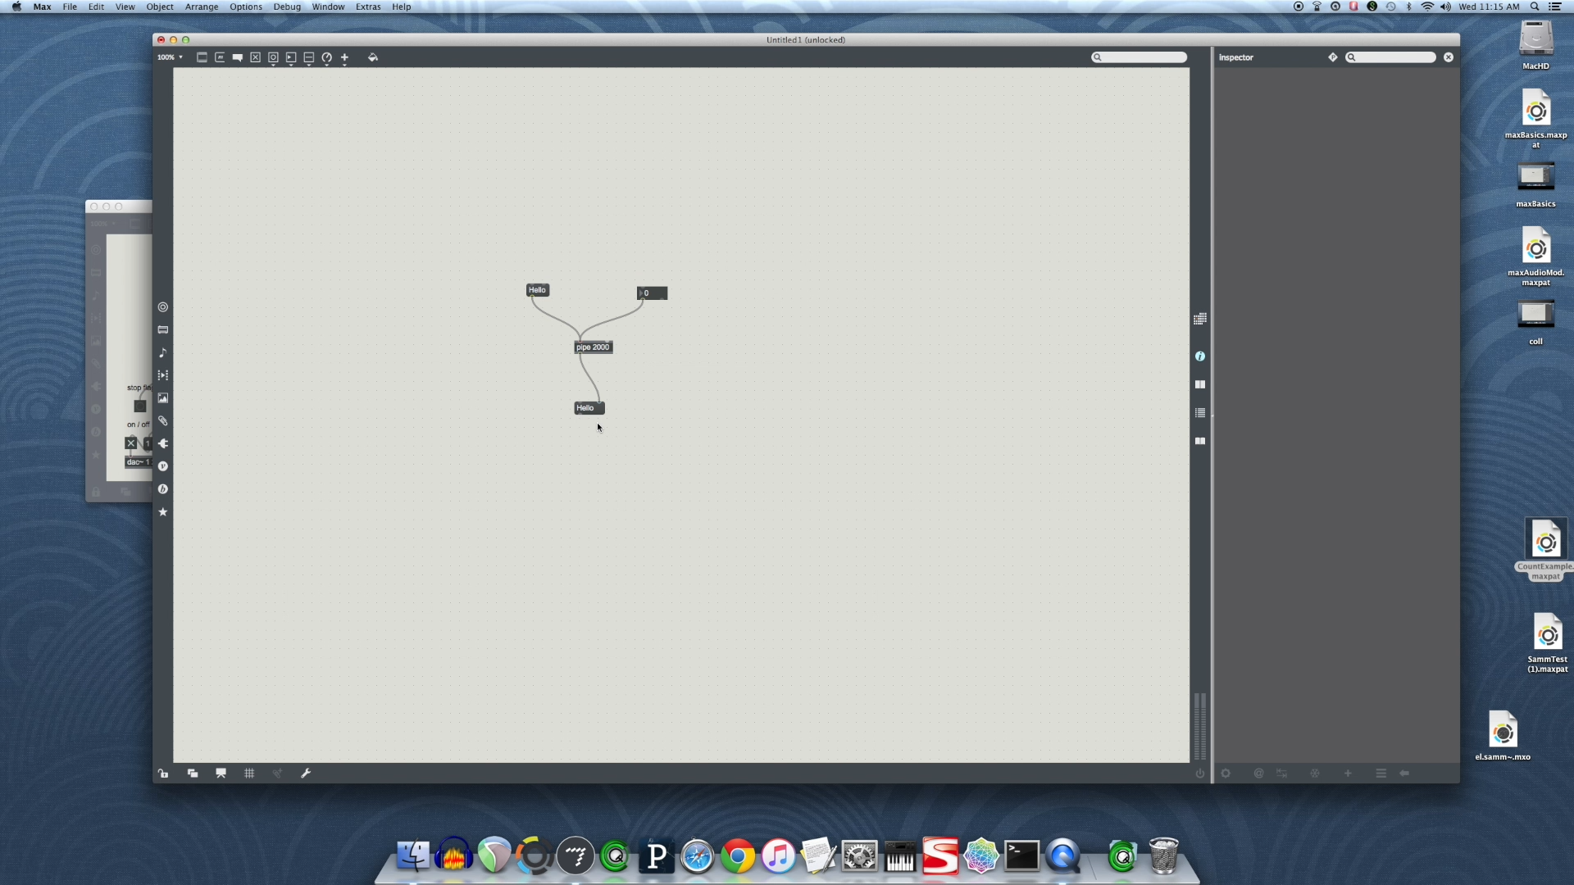
Figure 27: Screenshot from final Timing video

This is a screenshot from the final video for Timing in Max. Displayed is a frame when John talked about the pipe object in max. The input to the pipe object, whether a symbol or integer, is delayed for 2000 milliseconds before being sent to the message box connected to the output of the pipe object.

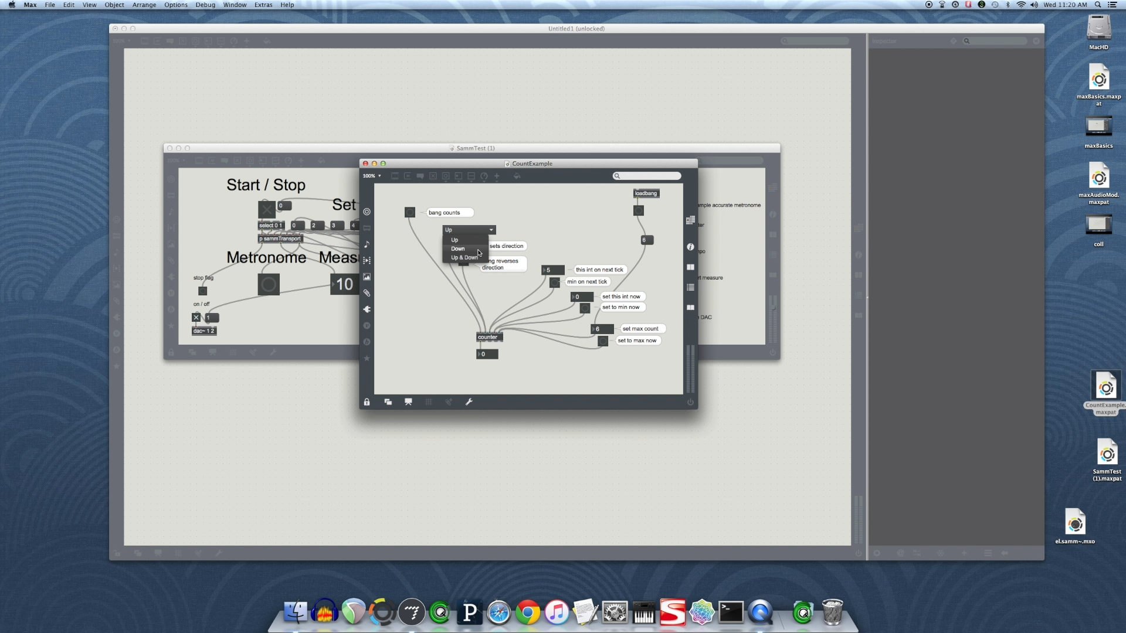
Figure 28: Screenshot from final Timing video

In this screenshot from the final video for Timing in Max, John explains the various functions of the counter object. Since the counter object counts how many bang objects it receives, different parameters can be added to specify what number to count to, when to reset and if the counter should also count down rather than overflowing to its lowest value, 0.

2.3.3: Coll Object Video

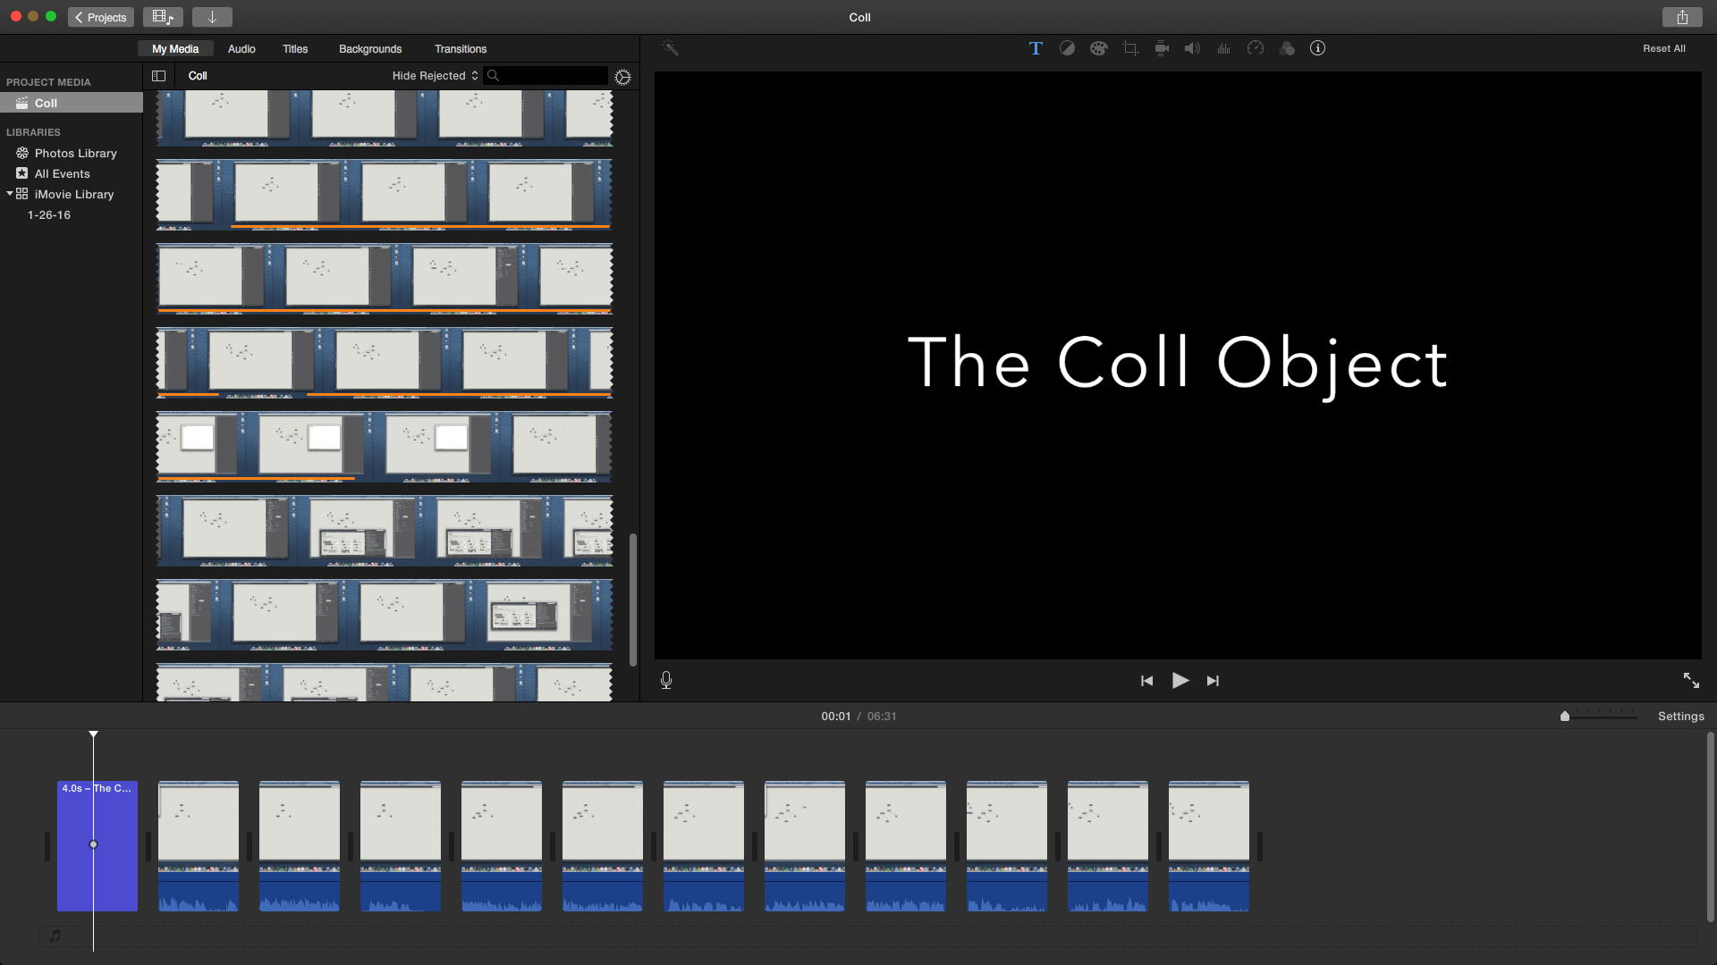
Figure 29: Editing the Coll Object video

Pictured is the iMovie project for the video describing the coll object in Max. The raw video can be seen in the scrollable field on the upper left side. The bottom field shows the title being displayed for 5 seconds.

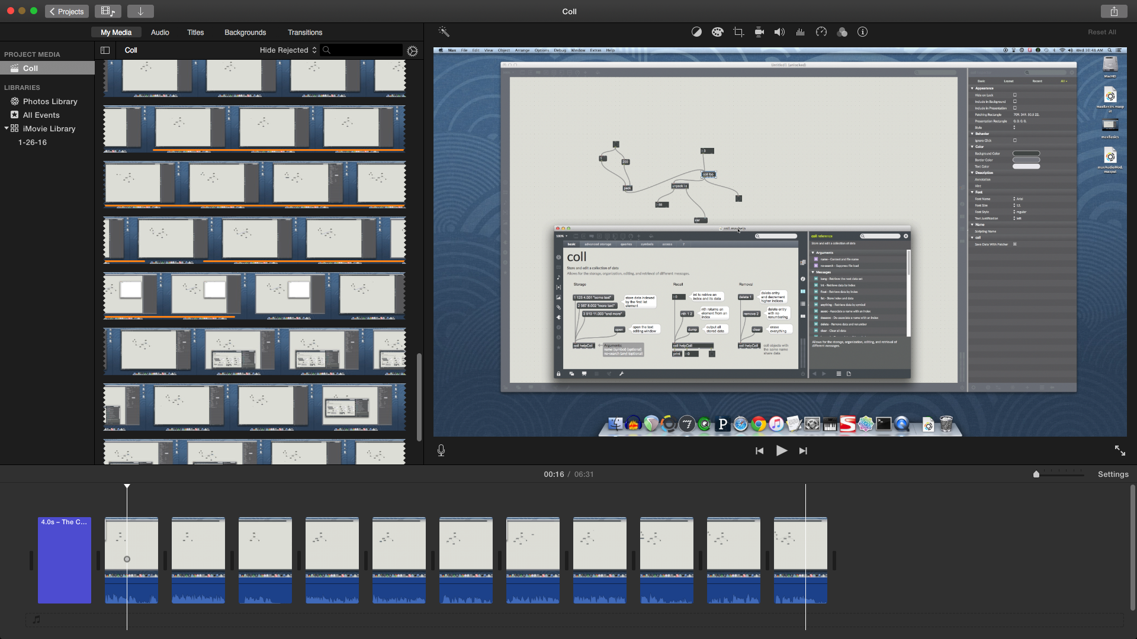
Figure 30: Editing the Coll Object tutorial video

Pictured is another frame of the Coll object tutorial’s iMovie project. Displayed is a frame where John is talking about the extensive documentation made available in the Max help window. The clips in the bottom bar after the title show the edits that were made to the raw video in order to create a smooth final video.

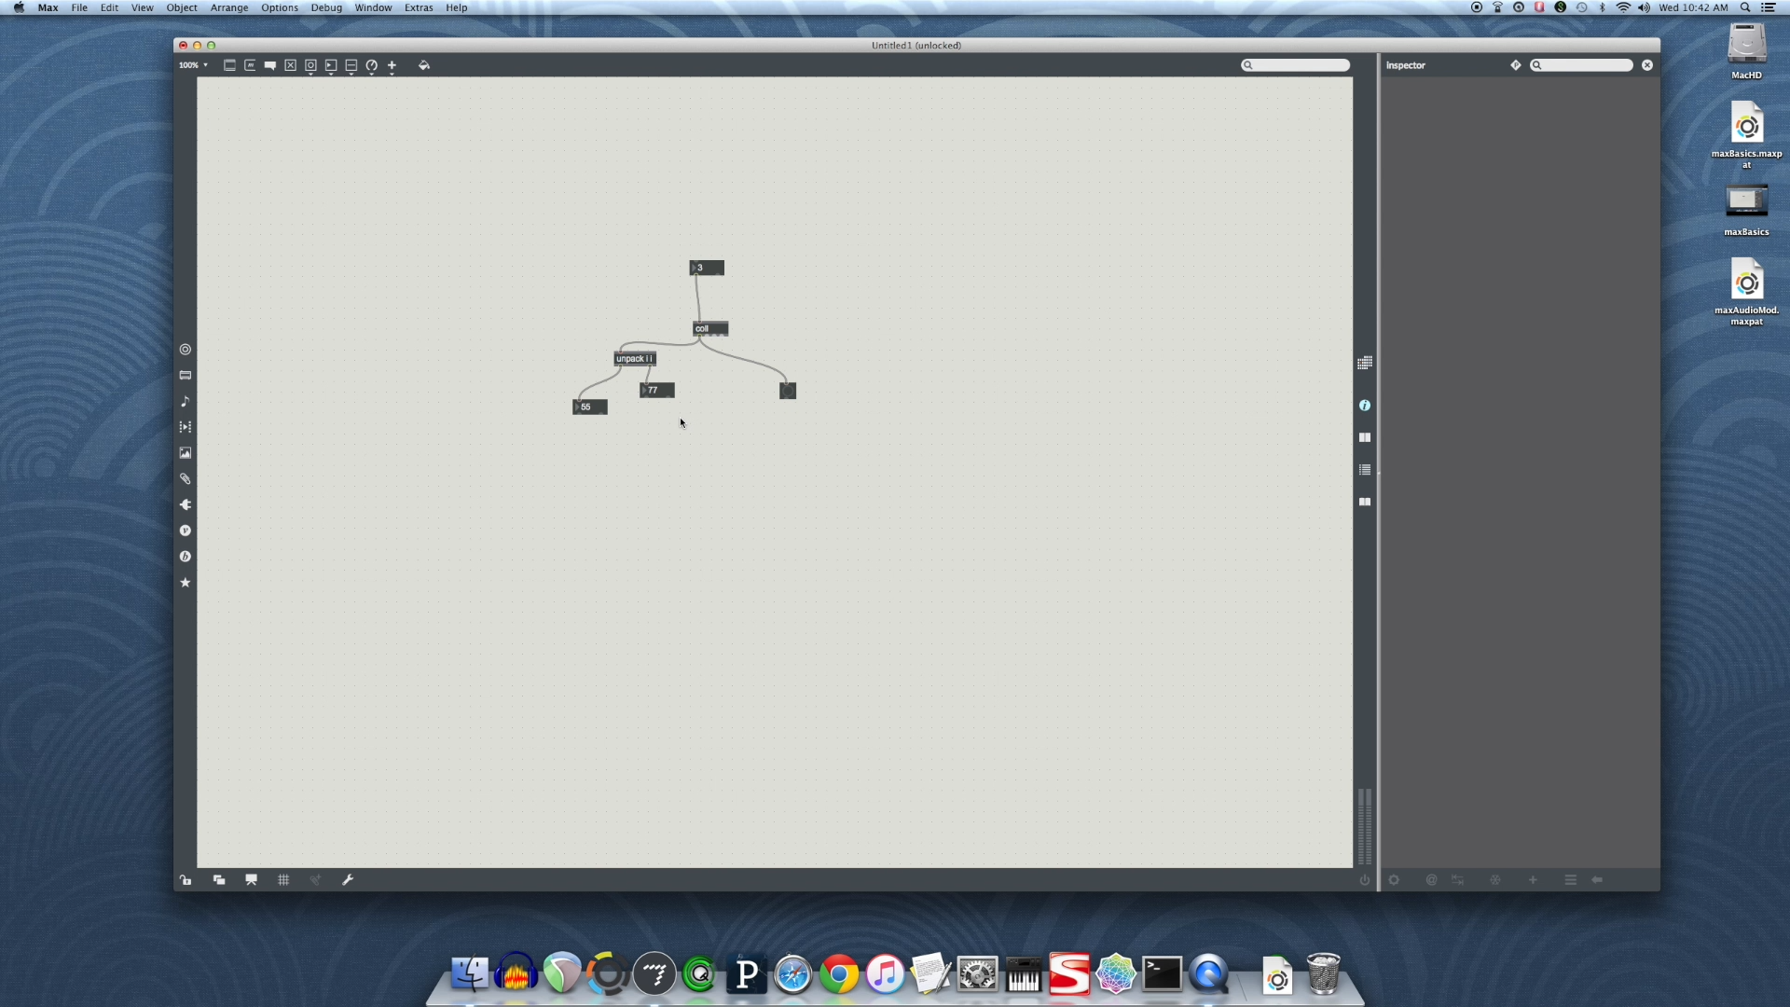
Figure 31: Screenshot from final Coll Object video

This is a screenshot of the final video for the coll object. Displayed is a frame where John is talking about the various types of data that the coll object can output. In this example, the coll object is outputting a list of integers into an unpack object, which then displays the two unpacked integers in two different integer boxes.

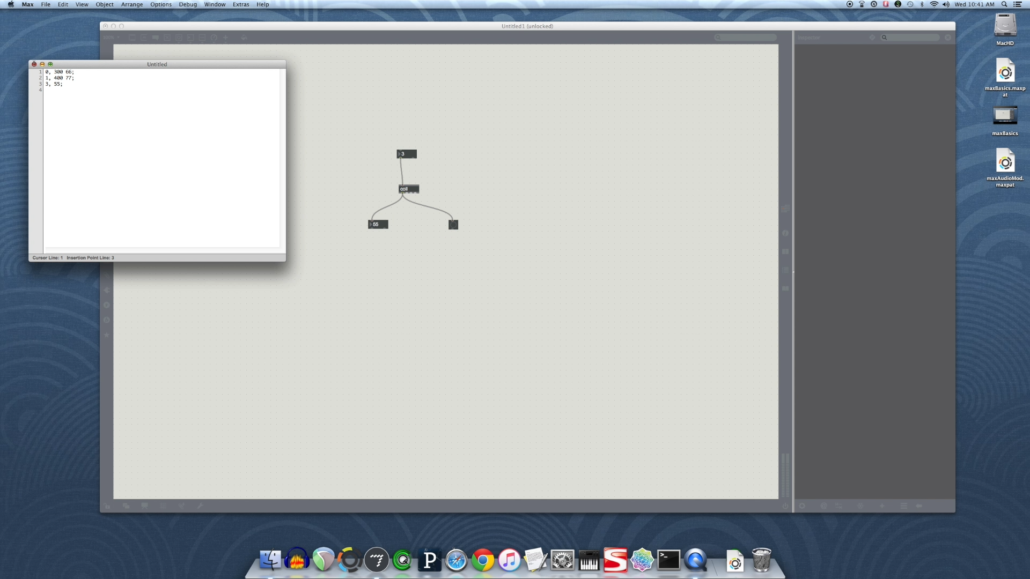
Figure 32: Screenshot from final Coll Object video

In this frame of the final video, John is entering data to be stored in the coll object. Showing that the user can double click on the coll object, the text editor then allows the user of Max to describe input-output pairings in order to specify what type of data is displayed when different inputs are set to the coll object.

2.3.4: Quad-speaker Spatialization
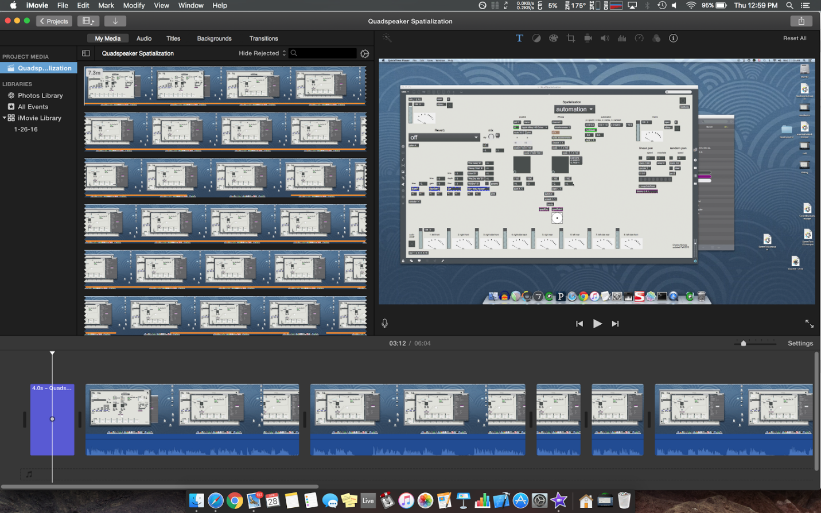
Figure 33: Sample patch by Dr. Nichols for Quad-speaker Spatialization tutorial

Pictured is the iMovie project for the Quad-speaker Spatialization tutorial video. The Max window shows a large example patch supplied to us by Dr. Nichols. In the video, John uses a smaller patch that concentrates on only quad-speaker spatialization.

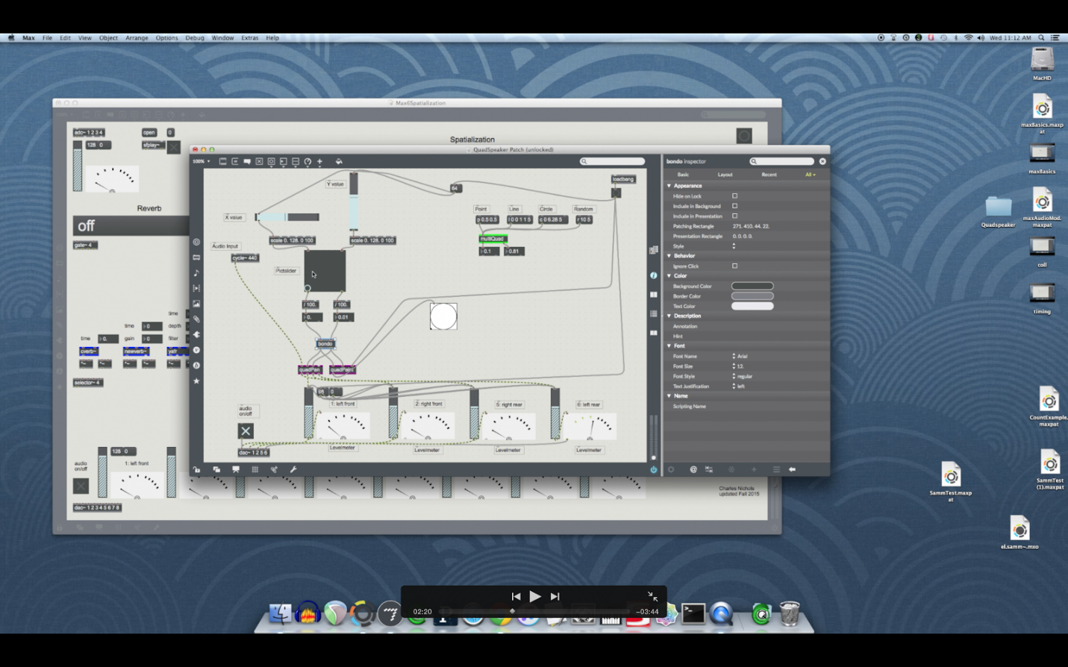
Figure 34: Second patch for Quad-speaker Spatialization tutorial

Pictured is a screenshot from the final Quad-speaker Spatialization tutorial video. The window in the foreground is the smaller patch that John used to describe how the spatialization works with multiple subpatches in Max.

2.3.5: Audio Modulation
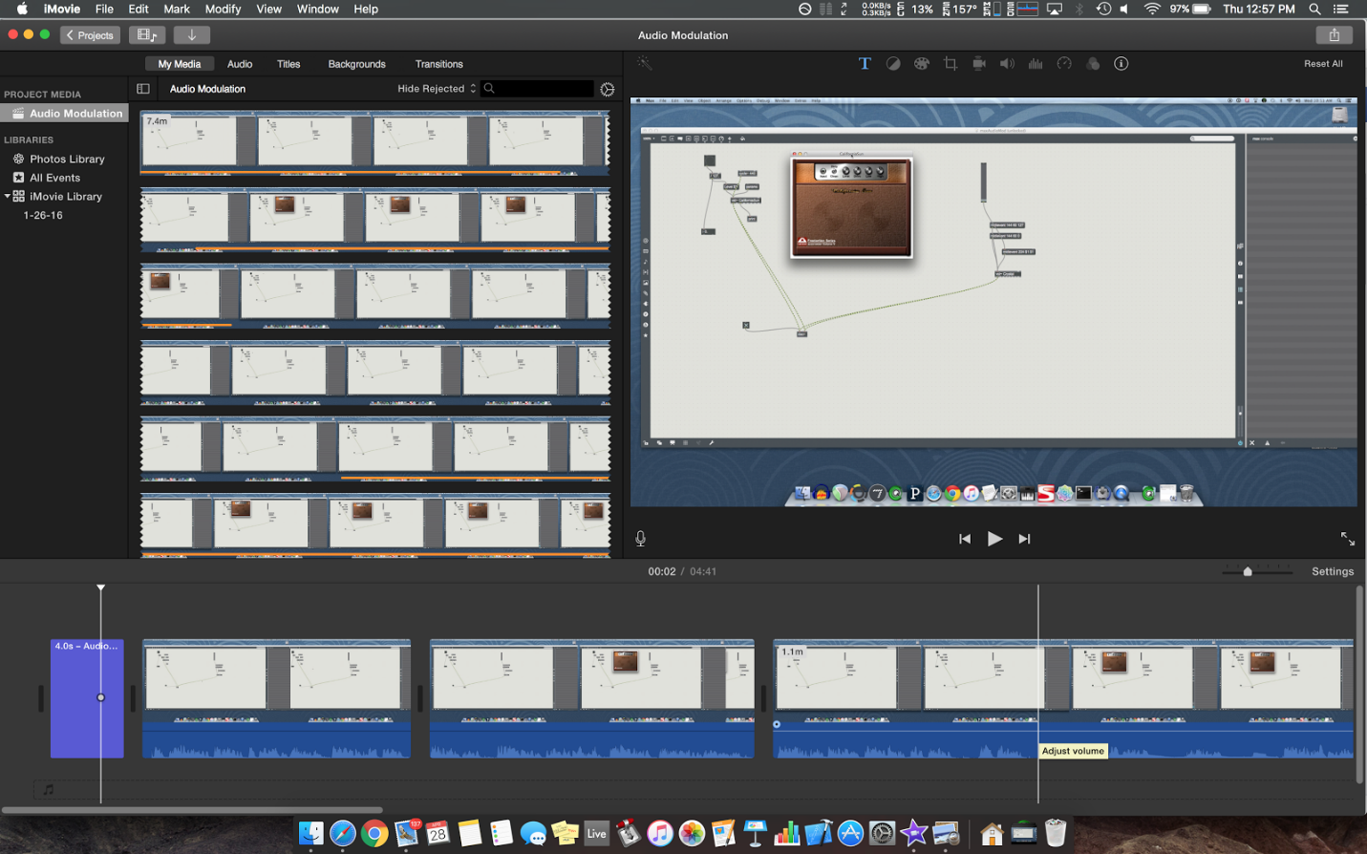
Figure 35: VST plugin in Audio Modulation tutorial

Pictured is the iMovie project for the Audio Modulation tutorial video. Pictured in the edited video is when John talks about how a VST plugin, in this case ‘California Sun’, processes audio to make the input signal sound like it is being driven by a hardware guitar amplifier.

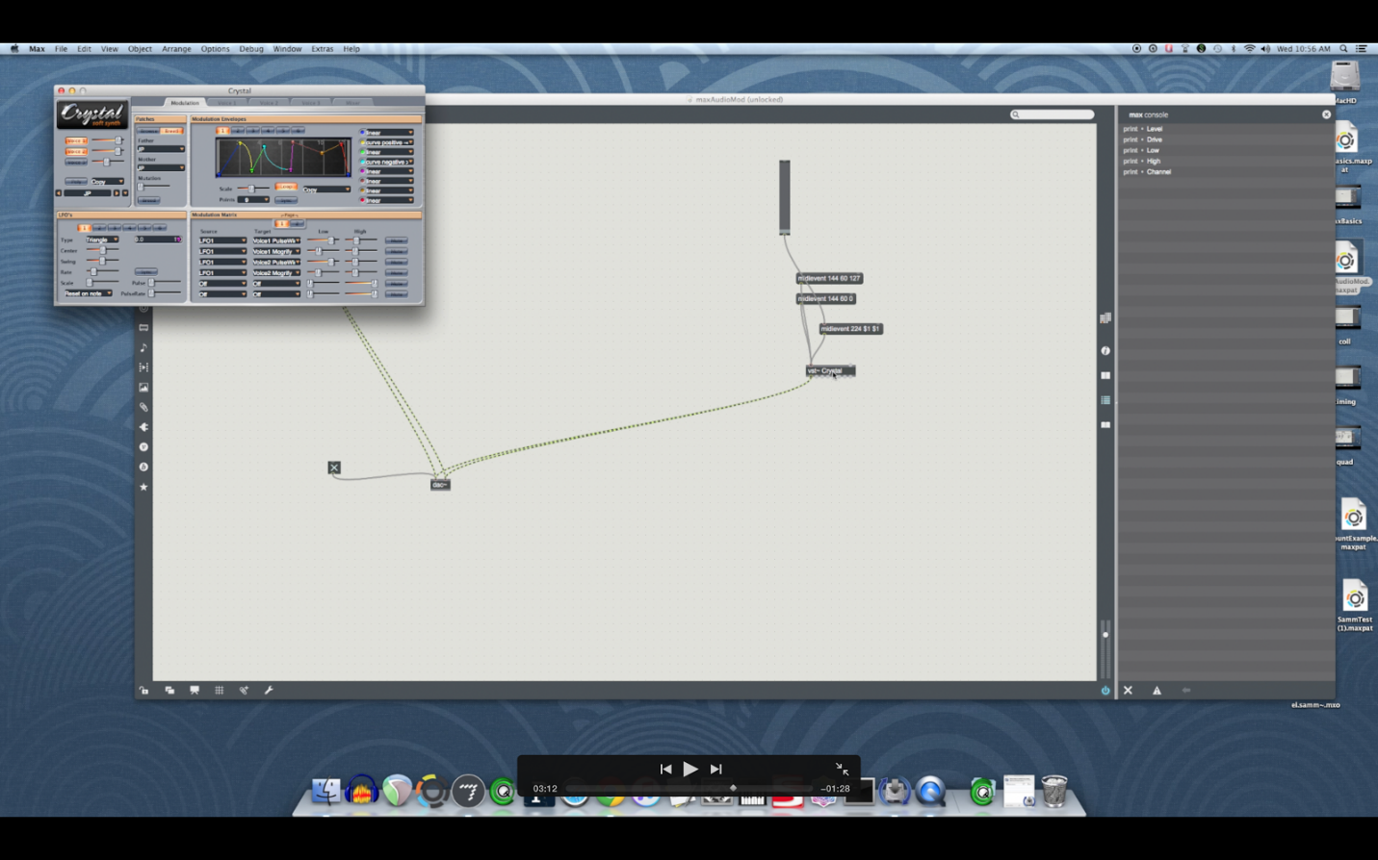
Figure 36: Crystal example

Pictured is a screenshot from the final Audio Modulation video. In this screenshot, John is talking about modifying parameters in a VST plugin called Crystal. Crystal is a free software synthesizer that can produce a wide range of interesting sounds. Modulating parameters, such as the pitch bend modulated in the video, can create very expressive sounds in Max.

2.3.6: Additive Synthesis
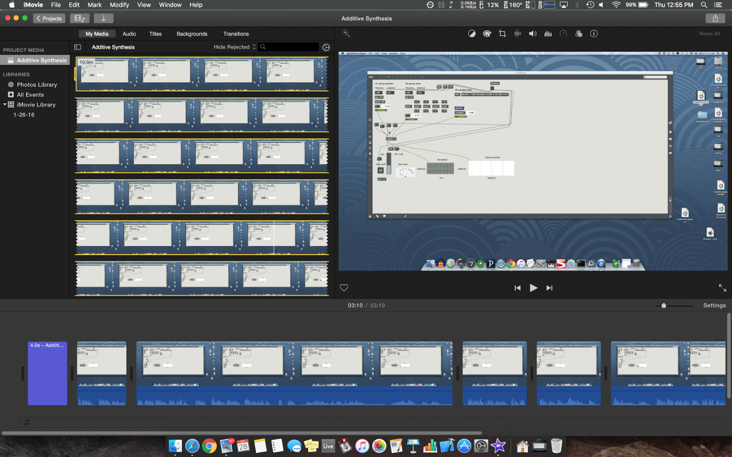
Figure 37: Example patch for Additive Synthesis

Pictured is the iMovie project for the Additive Synthesis tutorial video. Pictured is the Max patch John used to speaking about synthesis and additive synthesis in Max. Due to the content and size of this patch, this was the shortest video in the series.

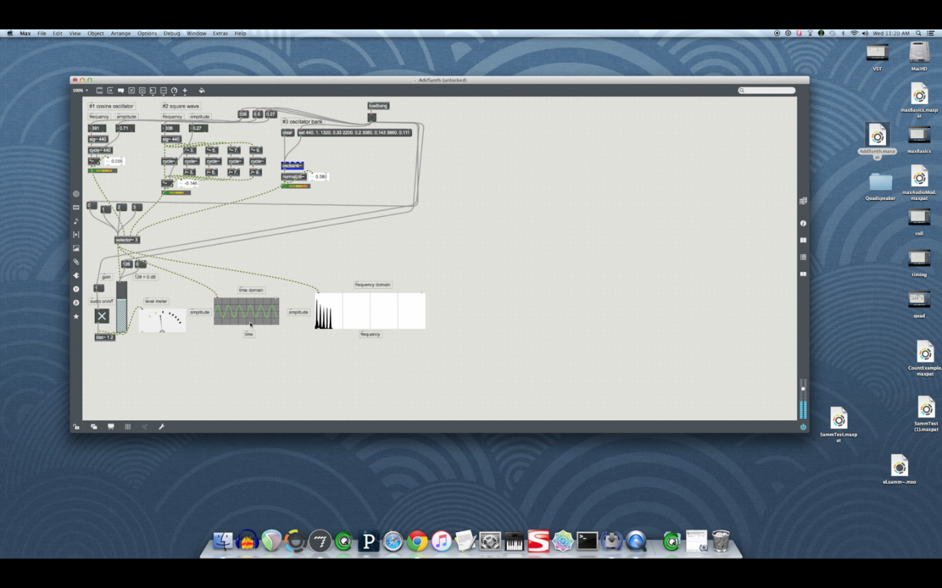
Figure 38: Cosine waves in the Audio Synthesis tutorial

Pictured is a screenshot from the final version of the Additive Synthesis tutorial video. In this frame, John is speaking about how one can combine multiple cosine waves of different frequencies and amplitudes in order to make a square wave. The square wave generally sounds more interesting and is more frequency rich than a single cosine wave.

Figure 39: Editing the Coll Object tutorial video

Pictured is another frame of the Coll object tutorial’s iMovie project. Displayed is a frame where John is talking about the extensive documentation made available in the Max help window. The clips in the bottom bar after the title show the edits that were made to the raw video in order to create a smooth final video.

Figure 40: Screenshot from final Coll Object video

This is a screenshot of the final video for the coll object. Displayed is a frame where John is talking about the various types of data that the coll object can output. In this example, the coll object is sending a list of integers into an unpack object, which then displays the two unpacked integers in two different integer boxes.

Figure 41: Screenshot from final Coll Object video

In this frame of the final video, John is entering data to be stored in the coll object. Showing that the user can double click on the coll object, the text editor then allows the user of Max to describe input-output pairings in order to specify what type of data is displayed when different inputs are set to the coll object.

3: Lessons Learned

3.1: Timeline / Schedule
We produced videos covering: coll object, additive synthesis, audio modulation, quad-speaker spatialization, timing in Max, and Max basics. We expected the production timeline of a single video to be about two to three weeks. The following shows the progress of our group.

January 19: First day of classes, after the presentation in class the group pitched the idea to do a series of videos for the Computer Music and Multimedia class. Dr. Nichols approved the initial concept.

January 21: The group approached Dr. Fox with the idea of working on video tutorials; preliminary approval was obtained. The group began further correspondence with Dr. Nichols to set up meetings as necessary.

January 24: Initial planning meeting with Dr. Nichols. The group met with Dr. Nichols to discuss requirements and the scope of the overall project. At this meeting Dr. Nichols asked the group to create videos covering: “coll object, additive synthesis, audio modulation, quad-speaker spatialization, timing in MAX and MAX basics.”

January 27: The group met and started discussing the topics of each video. The format of scripts and how detailed they should be was discussed. A draft script for the Max Basics tutorial was created based on documentation available on the Max website. This draft was prepared and sent to Dr. Nichols for critique later in the week.

February 3: The group met and made edits to the draft tutorial as requested by Dr. Nichols. The group discussed how to record and edit videos. After some experimentation and research, the group settled on using the built in screen recording feature in OS X’s Quicktime player and using iMovie to make edits to the videos later in the production process. The group also started to organize information for the Requirements and Design Report.

February 10: The group met in order to work on the Requirements and Design report. An email was sent to Dr. Fox asking for clarification about the necessary verboseness regarding the report.

February 17: The group met and finished much of the Requirements and Design report so it would be ready to turn in on February 19.

February 24: The group met and began production of the first tutorial, Max Basics.

March 2: The group met and divided up the remaining work on the Implementation Report in order to finish our parts separately, before it was due on March 4th.

March 9: The group met in order to make sure everything was in order to start filming. The equipment, such as the microphone and the screen capture software, was tested to ensure that filming would go smoothly. Issues were found and resolved or worked around.

March 14: Video editing software was tested using the screen capture videos taken on the 9th. The group decided iMovie has the tools necessary for successful post-production of the tutorial videos.

March 16: The group met and completed filming of the first tutorial, Max Basics.

March 21: Post-production for the Max Basics tutorial was started. Some problems were encountered concerning splitting the raw video in a fine-grained way. These issues would then be resolved during the next group meeting on the 23rd.

March 23: The group met and reviewed Implementation Report comments and discussed points of improvement. Post production for the Max Basics (6) tutorial was finished.

March 24: The group met during class and revised the Implementation Report as well as made refinements on the drafts of scripts for future.

March 30: The group met to complete the Prototype and Refinement Report.

April 6: Tyler and Amanda met to complete the quad-speaker spatialization draft in preparation to meet with Dr. Nichols, as he recently returned from travel.

April 13: The group met and finished the recording of two more videos, after the scripts were approved by Dr. Nichols. The two videos completed were Timing (7), and the Coll Object (8).

April 25: The Quad-speaker Spatialization (9) video was completed.

April 27: The group met and finished the recording of the final two videos. The completed tutorials were Additive Synthesis (10) and Audio Modulation (11). All reports were also completed by this date.

April 28: Final testing of each video was completed, and group finalized and submitted the final report.

3.2: Problems

While creating the Max Basics video, there were several issues that affected the production of future videos. The approach for the first video was a trial of our production process. Therefore the first video was produced independently of the remaining videos to accommodate modifications. The initial draft of the first video contained audio and video at the speed of conversational speech. After viewing the playback from the perspective of a user, it was decided that the current speed reduced the clarity of the content. Therefore, all future drafts were filmed at a much slower speed. Another issue that the initial conversational speed caused was that there were little or no pauses in the audio, which made editing very difficult. It was apparent that inserting purposeful pauses in the audio and video could signify a cut or an indication of an error that would need to be corrected in post-production. Adding these pauses and speaking slightly slower made editing more efficient because it prevented multiple re-recordings and resulted in a more cohesive video.

3.3: Solutions

During the development of the first video, Max Basics, one of the first issues was deciding whether to use an external or internal microphone. Our group initially planned to use the external microphone for better audio quality. However, both microphones in the DSIS lab either had bad batteries for their powered components or were behaving in an unexpected manner. Due to time constraints, our group tested the audio quality of the internal microphone in the iMac we were using to record. After some discussion, the audio quality was found to be sufficient for the purposes of our tutorial video. Therefore we decided to use the internal microphone which made the editing process easier because the audio and video were combined.

Another early decision that was made was whether the script followed during the recording of each video would come from a detailed and exact script, an outline, or a storyboard, which includes visual scenes and a brief descriptive caption for each scene. Our first draft of the video used an outline, but this was difficult in that it involved a lot of memorization and impromptu speech. However, a detailed script would be even more difficult to simultaneously read, speak about and create the video visuals, therefore it was ruled out. Our decision to use the storyboards that were already created as part of the production process as an outline to follow for the recording of the video was ideal, because the storyboard included visuals which became the basis for each video scene, and the captions became the talking points for each scene.

After recording, the next step was post-production to remove inconsistencies and errors, such as an unexpected pause. The iMovie application was selected because it was already available on the desktop that we were conducting the recording on. iMovie has the tools necessary to edit the tutorial video and was much easier to use and obtain as opposed to a more professional video editing program such as Final Cut or Avid’s video production suite.

The initial recording of the video was much longer than the required video length, not taking into account post-production editing. During each iteration of the draft, familiarity with the audio and video scripts for the video increased, and the length of the video reached the required length, and was well within the limits after post-production editing.

Additionally, as issues were met and then resolved, our completion dates were adjusted accordingly to reflect the timeline of our progress.

3.4: Lessons Learned

The experience of working on the first video affected the production process of the rest of the videos. Throughout the process of working on the first video, it was found that some parts of the production process took longer than expected. This resulted in pushing back expected due dates. The dates were not pushed back significantly due to the fact that many issues were worked out with the first video, and further issues of the same nature were not expected. Another contributing factor to the change in due dates is that the first video was done independently of the others. Each team member worked together to complete each step through the completion of the video. After the completion of the first video, each team member worked independently on an assigned portion of the video-making process for each subsequent video. Since each person was a part of the process for the first video, everyone is aware of the potential issues, and has knowledge of the best way to accomplish any given task. This resulted in multiple steps being completed concurrently and ultimately streamlined the process.

Some necessary extensions were out of the team’s control. Dr. Nichols has a busy schedule and has been out of town several times throughout the duration of this project. For this reason, the group has decided to go ahead with making the storyboards for completed scripts, prior to their approval. Due to prior feedback on the first video from Dr. Nichols, it is anticipated that further additions to the script will be easily made. In the event that the client would like something changed, the script and storyboard will each be edited accordingly.

4: Testing

4.1: Initial Testing

After the post-production edits were completed, the video was shown to a novice Max user and feedback was collected. The feedback was used to improve the quality of the videos in order to maximize benefit for the users. This is a sample output of the testing phase.

The following paragraph is the feedback received from one tester:

After viewing this video, I have gained a solid understanding of the basics of the Max language. The video went over many useful things that are required knowledge in order to begin using Max. Some of these things include how to create Max objects, how to make new objects, inlets and outlets, keyboard shortcuts, using the help window, how to write comments, and how to lock and unlock the patcher window. The narrator spoke clearly and at a reasonable pace and it was easy to understand and follow along despite the small text font in the video. Upon completion of this video, I feel like I have enough knowledge to begin experimenting with Max and further explore the concepts the video introduced.

4.2: Testing Process

As stated in section 4.1, we tested the quality of the videos by showing them to an inexperienced Max user in order to determine the viability of the videos as an educational resource. We selected the person in our group with the least experience in Max to be the tester. We asked our tester to view each of the completed videos, and fill in a chart with the following columns: Skills Gained/Reinforced, Level of Understanding, and Comments/Observations. We also requested that the tester provide overall comments on the quality of our product as a whole. The reasoning for using an inexperienced Max user as a tester was that we would be able to determine the quality of instruction in our videos because the tester would not be able to rely on prior knowledge of Max for comprehension of video content. We incorporated qualitative and quantitative feedback so that we could utilize the benefits of both detailed feedback and a numerical tool which could be used to make comparisons easily. The only variable that changed throughout the testing process was the video itself. All other variables, such as the tester, the testing environment, and the testing tools, remained the same for each test. The tester’s output is detailed in Table 2.

4.3: Feedback

Table 2: Testing Feedback
Video | Skills Gained/Reinforced | Level of Understanding | Comments/Observations
Max Basics | - Create Max objects  - Create new objects  - Inlets/Outlets  - Keyboard shortcuts  - Help window  - Comments  - Lock/Unlock patcher window  - Loadbang  - Data types  - Printing to console | 1 2 3 4 | The pace of the audio and video was appropriate for a viewer who is a novice Max user. I did not feel any necessary beginner topics were missing from the video content, and I feel able to create basic programs with the solid basis I gained from the video.
Coll Object | - coll object:  - What it does  - How it is used | 1 2 3 4 | This video gave a thorough overview of the coll object. Although I have gained an understanding of the coll object, I feel that some prior experience using Max and/or coll objects is required to maximize the benefit of this video. I am unable to start advanced usage of coll objects after viewing this video.
Timing | - Timing and messages  - Timer object  - Keeping time in Max  - Metronome  - Counter object | 1 2 3 4 | This video gives an overview of the concept of timing in Max. Although the content was clear, in my opinion, a background in Max is necessary in order to understand the importance of timing in the context of Max, and how the knowledge the video provides can be used to improve programs in Max.

4.3.1: Legend

1 - Viewing the video did not result in any understanding of the topics covered.
2 - Viewing the video resulted in a vague understanding of the topics covered.
3 - Viewing the video resulted in an understanding of the topics covered, however, the viewer is not confident with the material to try it independently.
4 - Viewing the video resulted in an understanding of the topics covered, and the viewer will use the skills gained in the video to develop his/her skills independently.

4.3.2: Overall Comments from Initial Tester

The narrator spoke clearly and at a reasonable pace and it was easy to understand and follow along for the entire length of the video. The audio and video merged well, resulting in high-quality videos. The short length of the videos allowed me to absorb the information without being overloaded or bored. Also, I appreciated the consistency in the presentation for each of the videos, because it made it clear that each video was part of a series and it was very professional. While I received the maximum benefit from the Max Basics video, being a novice Max user, I was unable to utilize maximum benefit from the coll Object and Timing videos for the same reason. However, I did recognize the detail and clarity in all the videos, therefore I believe that a viewer with some Max experience would have been able to harness the full benefit of all three videos.

4.3.3: Evaluation Methods

Upon receiving feedback, we proceeded to compare the feedback with the expected results of the testing. Our expected results were that the Skills Gained/Reinforced column would have all of the topics covered in the video, and the Level of Understanding would be four for each video. The first video, Max Basics, did meet our expected results because the Skills Gained/Reinforced column had all of the topics covered in the video and the Level of Understanding rating was four. However, the evaluation for the coll Object and Timing video did not meet the same standards. Upon further analysis, we realized that because our tester was a novice Max user, she was at a disadvantage when watching the more advanced videos because she lacked the Max background that our target users will have when watching the videos.

4.4: Problems Found During Testing

Using a novice Max tester worked well to evaluate the Max Basics video, however it was ineffective in evaluating the quality of the more advanced videos because our tester lacked the necessary background to gain the most benefit from these videos. Our target audience is students enrolled in Computer Music and Multimedia; they would already have had hands-on experience as well as lectures about Max, therefore their knowledge about Max is guaranteed to be more advanced than our tester’s knowledge about Max.

4.5: Future Work
Because of the problems found during testing, we identified a need for additional testers for the videos. The testers, who will be selected at random from next semester's class, will have varied levels of experience with Max, and will be able to give quality feedback regarding the effectiveness of our product. Any minor changes needed for the videos will be implemented by Dr. Nichols via YouTube annotations. All future edits to the videos must be through Dr. Nichols, because he has the intermediate versions of each video on his computer, which include the raw unedited videos and iMovie/Final Cut Studio project files. The raw unedited videos are transformed to the iMovie/Final Cut studio project files, and these project files are edited to produce the final video. Upon the conclusion of this project, Dr. Nichols will possess all intermediate files for each video. If the edit to the video is required, the person requesting the edit must bring his/her concern to Dr. Nichols who will then modify the iMovie project files, and upload the new video to his YouTube account. If an annotation to a video is requested, this must also go through Dr. Nichols, as the videos are uploaded to his account.

5: Final Videos

Table 3: Information about all videos post-production
Name | Length | Size (MB)
Max Basics (6) | 7:08 | 716.1
Timing (7) | 6:00 | 368
Coll Object (8) | 6:32 | 388.6
Quad-speaker Spatialization (9) | 6:05 | 581.6
Additive Synthesis (10) | 3:11 | 357.7
Audio Modulation (11) | 4:42 | 305.1

All videos were shot in 1080p, 60fps and in the .MOV format

6: Acknowledgements
Dr. Charles Nichols
csnii@vt.edu

Dr. Edward A. Fox
fox@vt.edu

7: References

- (2013, February 26). CS/ISE 5714 Spring 2013 Chapter 6. Constructing Design-
Informing Models [PowerPoint slides]. Retrieved from http://dopey.cs.vt.edu/courses/cs5714-S13/slides/Chapter_06_Modeling.pdf.

- Brunner, K., & Spillane, E. (2015, May 14). Contemplative Practice Interviews.
Retrieved from https://vtechworks.lib.vt.edu/handle/10919/52592

- Max 7 - Documentation Home. (n.d.). Retrieved from
https://docs.cycling74.com/max7/

- McCloskey, R. M., Miller, R. P., Green, B. G., & White, J. H. (2015, February 27).
Computer Science Seminar Series & Junior Faculty Interview Video Capture Project Report (Requirements and Design Draft). Retrieved from https://canvas.vt.edu/courses/18535/files/folder/Old/2015ProjectPresentationsReq+Design?preview=395074.

- Nichols, C. (n. d). Charles Nichols. Retrieved from
https://www.youtube.com/user/CharlesSNicholsII

- Russell, J., DeYoung, T., Kahn, A., & Darivemula, D. (2016, April 26). MaxBasics
[Video file]. Retrieved from https://www.youtube.com/watch?v=yb6TEVfNO-8

- Russell, J., DeYoung, T., Kahn, A., & Darivemula, D. (2016, April 18).
TimingInMax [Video file]. Retrieved from https://www.youtube.com/watch?v=7MCTWzK6tFs

- Russell, J., DeYoung, T., Kahn, A., & Darivemula, D. (2016, April 18). collObject
[Video file]. Retrieved from
https://www.youtube.com/watch?v=zPnVcm-lPhI&feature=youtu.be

- Russell, J., DeYoung, T., Kahn, A., & Darivemula, D. (2016, April 25).
Quadspeaker Spatialization [Video file]. Retrieved from https://www.youtube.com/watch?v=vTjkiq2xrX4

- Russell, J., DeYoung, T., Kahn, A., & Darivemula, D. (2016, April 27). Additive
Synthesis [Video file]. Retrieved from https://www.youtube.com/watch?v=fms4jU_tlN0

- Russell, J., DeYoung, T., Kahn, A., & Darivemula, D. (2016, April 27). Audio
Modulation & VST Plugins in Max [Video file]. Retrieved from https://www.youtube.com/watch?v=xzGTv5M449w

