Status of global accumulation of marine debris

Abstract:
The issue of marine debris pollution is a growing crisis, with detrimental effects on ecosystems, marine organisms, and human health. More than 800 coastal and marine species are affected, resulting in billions of dollars of economic losses each year. To better understand the dimensions of this challenge, it is important to establish a solid scientific knowledge base. This study aims to synthesize the global research and evidence of marine debris accumulation in coastal areas. Through a systematic literature review, we found that Europe and Asia are the primary regions where marine debris accumulation is studied, with the Atlantic and Pacific Oceans accounting for most of research. The majority of publications are by first authors from European and Asian institutions, with the US also contributing significantly. Most studies focus on the volume of marine debris, with general waste being the most studied type. Additionally, physical and environmental factors play a larger role than human-based factors in marine debris accumulation. Overall, there is a trend of increasing and relocating marine debris accumulation across all determining factors. We also identified important areas for future research to deepen our understanding of the factors influencing debris accumulation. In particular, there is a notable gap in the practical application of tools and methods for tracking and identifying marine debris, such as satellite remote sensing, specialized databases, and computational modeling approaches. The study findings offer vital insights for decision-making regarding marine debris accumulation, benefiting policymakers, researchers, and other stakeholders striving towards a more sustainable globe.

Keywords:
Marine debris, pollution, accumulation, plastic, systematic literature review

Introduction
Experts define marine debris pollution as any solid, persistent, anthropogenic waste that is released into oceanic or coastal environments (Borrelle et al., 2020). This includes both intentional and unintentional pollution, and can be debris discarded directly into the marine environment or transported there from freshwater or land-based origins. The most common documented types of marine debris are waste items such as plastics and microplastics, derelict fishing gear, and vessels (Guertin, 2019). Marine debris pollution is widespread, with evidence of debris accumulation on all continental coasts, from surfaces to sea beds in the oceans, and in remote locations (Hirai et al., 2011; Eriksen et al., 2014; Borrelle et al., 2020). As of 2020, it was estimated that approximately 370 million tons of plastic are produced each year (Plastics Europe, 2021); with 14 million tons of plastic debris end up in the ocean annually (Plastic pollution, 2021), mostly from terrestrial sources (Sherrington et al., 2016).
Marine debris pollution is an ever-growing crisis that continues to inflict severe damage to ecosystems, and poses a looming threat to human health and prosperity. Plastic debris has been observed to detrimentally impact marine organisms in many ways, including ingestion, entanglement, and interference/intrusion into behavioral habits (Bonanno and Orlando-Bonaca, 2018; Guertin, 2019; NOAA, no date). Further, there is evidence that plastics, specifically, have facilitated the introduction of (sometimes pathogenic) microbial organisms to new areas, known as biofouling (Subías-Baratau et al., 2022; Pasqualini et al., 2023). Human health concerns are also being raised as micro and nanoplastics, combined with their intrinsic and acquired toxic qualities are increasingly found in sources of drinking water and bioaccumulating within human food chains (Revel, Châtel and Mouneyrac, 2018). At a different scale, coastal communities and marine-based industries (e.g. fishing and tourism) are facing substantial negative economic implications, as the wildlife populations and aesthetic landscapes on which they depend are deteriorated as a result of marine debris (Guertin, 2019; NOAA, no date). At the 13th meeting of the U.N. Conference of Parties (COP 13), the Convention of Biological Diversity published a comprehensive report tying the rise of marine debris to negative impacts upon more than 800 coastal and marine species, human health, and billions of dollars of economic losses each year (Harding, 2016).
Marine debris pollution and accumulation is a volumetrically pervasive issue, and a highly complex one: its multifaceted nature makes conceptualization, measurement, and management very difficult, and accordingly, the full extent of the marine debris challenge is unclear. While the Abatement of Marine Debris is specifically identified under UN Sustainable Development Goal (SDG) Target 14.1, the lack of understanding regarding accumulation in coastal areas is undermining progress towards SDG 14: Life Below Water, and affecting other SDGs, such as SDG 12: Responsible Consumption and Production. To improve collective understanding of the many dimensions and interconnections of the marine debris challenge, it is crucial that a coherent and holistic foundation of scientific knowledge be developed. Accordingly, this study examines the global research and documented evidence of marine debris accumulation in coastal areas, with a goal to synthesize and characterize the current state of this knowledge.
Adopting a common approach for contemporary climate change adaptation research, a systematic literature review was conducted with the overarching aim of documenting the breadth of marine debris accumulation research currently undertaken. This review will address the answers to the following research questions: 1) what are the geographical regions in which marine debris research is focused; 2) what are the insights regarding the scholars who are publishing marine debris research; 3) what are the areas of marine debris research focus and factors of interests; 4) what are the composition and sources of marine debris; 5) what are the economic sectors of interest within marine debris research; 6) what are the sources and use of data and datasets; and 7) what are the factors determining accumulation of marine debris. The following section describes the methods of the systematic literature review (Section 2), with insights regarding the factors determining the coastal accumulation of marine debris synthesized (Section 3). A discussion of the current state, including a synthesis of insights and future needs, is also presented (Section 4).

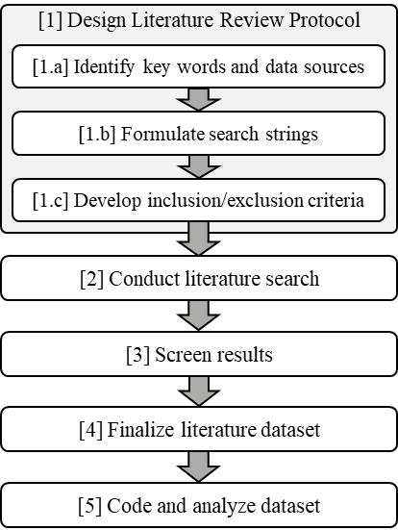
Methods
Fig.1.: Overview of literature review process utilized for this study
To map the current state of knowledge, data availability, and gaps regarding the coastal accumulation of anthropogenic marine debris, a systematic literature review was conducted. The systematic literature review method was chosen over conventional literature review practices because of its high level of rigor, transparency, and robustness (Mulrow, 1994; Brereton et al., 2007; Sampaio and Mancini, 2007; Williams Jr et al., 2021). Systematic reviews are commonly used to support the identification of gaps in the literature, and thus serve as a reliable starting point for advancing the knowledge in a field (Peričić and Tanveer, 2019).
The structure and organizing framework used to guide the data collection and review process are presented in Fig. 1. Specific activities include: designing the review protocol [1], completing the search process [2], screening the dataset [3], conducting quality checks and finalizing the dataset [4], and coding and analyzing the final data set [5]. Critical activities undertaken during the literature review protocol design [1] included the development of search parameters, keywords and data sources [1.a], corresponding search strings [1.b], and inclusion/exclusion criteria [1.c] (Fig.1.). Analysis [5] focused on the synthesis of themes, insights, and data found in peer-reviewed literature and technical reports across a broad range of disciplines and fields, and included, but was not limited to: environmental science, climate science, oceanography, ecology, computer science, geography, biology, economics, and urban studies.

Search strategy and protocol
As stated in the literature review protocol in Table 1, studies were retrieved on the 17th of October 2022 using two identified databases: SCOPUS and Web of Science. Both databases are reliable and frequently used in reviews across a wide spectrum of subjects (Okorie et al., 2018; Webster et al., 2020). We included peer-reviewed studies published from 2017 onward to capture recent developments given the rapidly evolving nature of the field and ensure the synthesis reflects the latest methodologies and global policy-relevant insights on marine debris accumulation.
Table 1: Literature review protocol
Item | Description/ Criteria | Rationale of the selection
Time Period | From January 2017 to 17th October 2022. | COP 13 (December 2016) marked the publication of U.N. report: “Marine Debris: Understanding, Preventing and Mitigating the Significant Adverse Impacts on Marine and Coastal Biodiversity” (Harding, 2016). It was among the first publications to quantify global, holistic impacts of marine debris, intended to spur action and attention across sectors. This literature review explores the post-COP 13 period.
Boolean Operators | AND between keywords; OR between similar keywords and related database search fields | This is common in literature review studies
Language | English | This is the language of the researchers
Article Type | Original studies only; peer-reviewed research manuscripts and technical reports. | Excludes non-peer reviewed literature, grey literature, editorials, and letters, as is consistent for systematic reviews.
Geography | Search focused on global geography; Regional focus was identified, and priority interest was on coastal areas (see inclusions/exclusions) | Avoid excluding relevant studies, insights, methodologies and/or themes that are emerging due to diverse global experience and responses to marine debris accumulation. Given the flow-based nature of marine debris flow, a focus on the point of accumulation (key word) was utilized to avoid duplicative/redundant insights (e.g., debris in-transit).
Types of research outputs | Case studies, descriptive research (e.g., qualitative models), analytical research (e.g., quantitative measurement and/or models); industry reports and publications. | Focused on the current state of scientific knowledge regarding marine debris accumulation in coastal areas, and the development of a research agenda (motivated by descriptive research insights, e.g., research gaps).

Key terms and search strings
The key terms relevant to the research included marine debris, ocean plastic, coast, and accumulation, and variations of these terms as identified in the search strings below (Table 2).
Table 2: Key search terms and strings
 | SCOPUS | Web of Science
Title | marin* debri* OR ocean plastic* AND coast* AND accum* | marin* debri* OR ocean plastic* AND coast* AND accum*
Abstract | marin* debri* OR ocean plastic* AND coast* AND accum* | marin* debri* OR ocean plastic* AND coast* AND accum*
Publication year | > 2017 | > 2017
Full search string | (TITLE-ABS-KEY ((marin* AND debri*) OR ("ocean plastics*")) AND ALL (coast*) AND (accum* )) AND PUBYEAR > 2017 AND PUBYEAR > 2017 | (((((((((TI=(marin* debri*)) OR TI=(ocean plastic*)) AND TI=(coast*)) AND TI=(accum*))) AND AB=(marin* debri*)) OR AB=(ocean plastic*)) AND AB=(coast*)) AND AB=(accum*))

Inclusion, exclusion and screening
In addition to key words, specific criteria and scope were established for the review to ensure accuracy and legitimacy of the study. Table 3 outlines the details of the geographic, marine debris, and language-based qualifications that were utilized as inclusion/exclusion criteria in the screening of the literature dataset.
Table 3: Summary of inclusion and exclusion criteria utilized to screen search results
Exclusion Code | Inclusion and Exclusion Criteria | Publications Excluded (#)
1 | Geographic qualification: ocean and/or salt water, excluding freshwater and brackish water; coastal areas, including beaches, mangroves, salt marshes and reefs, excluding offshore and inland accumulations. | 58
2 | Marine debris qualification: coastal debris, excluding offshore and land-based; persistent, excluding unique events or outliers; solid, excluding liquid forms; anthropogenic origin, manufactured and/or processed, excluding naturally-occurring marine debris. | 15
3 | Language of publication: English, excluding non-English publications. | 2

The process and results of the literature review protocol are presented in Table 4. Initial search returned a total of 215 publications based on the search strings (Table 2), divided between SCOPUS (n=146) and Web of Science (n=69). Initial screening of manuscript titles for out-of-scope publications, using the inclusion/exclusion criteria (Table 3), resulted in the preliminary exclusion of 19 publications (A), after which the datasets from SCOPUS and Web of Science were combined, and duplicate publications removed (B) (n=193). An additional 2 publications that were not returned in the original search were included by the authors via a brief snowball review of references. The resulting 195 publications were then fully reviewed, with two of the authors completing abstract reviews and corroborating the following results: 58 publications were excluded due to a focus beyond the geographic qualification criteria (Exclusion Code 1); 15 publications were excluded due to a focus beyond the marine debris qualification criterial (Exclusion Code 2); 6 publications were excluded due to both Exclusion Codes 1 and 2; and 2 publications were excluded due to their language of publication being non-English. A total of 114 publications were retained for full manuscript review and analysis, as shown in Table 4. A complete list of publications included in the final review set is included in Table SM-1 in the Supplementary Materials.
Table 4: Literature review searching and screening results
Step | Literature Review Protocol | SCOPUS | Web of Science | Total Publications (#)
A | Initial search | 146 | 69 | 215
B | Initial screening for out-of-scope | (15) | (4) | 196
C | Datasets combined and duplicates removed | (3) |  | 193
D | Manual addition of relevant manuscripts | 2 |  | 195
E | Detailed review and screening for Exclusion Codes (1 – 3) | Excl. Code 1 (58)  Excl. Code 2 (15)  Excl. Codes 1 & 2 (6)  Excl. Code 3 (2) |  | 114

Coding
A systematic coding approach was used to deductively and inductively identify insights regarding coastal marine debris accumulation, noting and assessing potentially relevant information from each article based on predetermined categories or qualities (Table 5) during the comprehensive review. During coding, general information (green items in Fig.2.) was differentiated from marine debris-specific information (blue items in Fig.2.), and both deductive and inductive assessment methods were utilized, as indicated in Fig.2.
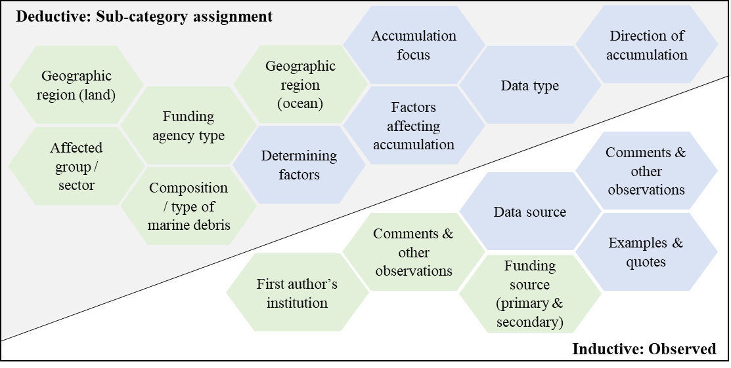
Fig.2.: Coding categories and formats used for deductive (sub-categorization and inductive (observed) assessment methods. Note: The green items show the general information gathered during coding, while the blue items show the marine-debris specific information. The line divides the analysis method into deductive (above the line) and inductive (below the line).
For simplicity, a deductive analysis method (green items in Fig.2.) was adopted for several key parameters for which sub-categories/classifications could be easily determined. These included, but were not limited to: composition/type of marine debris; geographic region (primary and secondary; land and ocean); affected groups/sector; determining factors and factors affecting accumulation; accumulation data and behavior, and funding agency. Sub-category options are identified in Table 5 for additional clarity and transparency. In contrast, some data were collected using an inductive approach, and these included directly observed and captured information including data and funding sources by name, examples and quotes that were provided within the publication, comments, and other observations.

Table 5: Coding categories and formats for deductive and inductive assessment
 | Coding categories | Deductive: Sub-category assignment options
General information coding and categorization | Geographic region (land)  (Primary and secondary) | North America  Central America  South America  Europe  Asia | Africa  Antarctica  Small Island States  Global  Australasia
General information coding and categorization | Geographic region (ocean)  (Primary and secondary) | Artic  Pacific  Atlantic | Indian  Southern  Global
General information coding and categorization | Primary affected group / sector | Fisheries  Shipping and transport  Recreation | Tourism  Other  More than one
General information coding and categorization | Funding agency type  (Primary and secondary) | National/federal agency  Intergovernmental organization  Private institute | Public institute  Non-profit/NGO  Other
General information coding and categorization | Composition/ type of marine debris | Disaster/hazard/event  Shipping/cargo/transport  Recreation debris | General waste  Micro/nano-plastics  Fishing gear
Marine debris specific coding and categorization | Accumulation focus | Coastal | Non-coastal
Marine debris specific coding and categorization | Factors affecting accumulation | Origin / source  Tide / current  Volume  Cause | Acute vs. chronic  Transport mechanisms  Other  More than one
Marine debris specific coding and categorization | Data type | Empirical | Secondary
Marine debris specific coding and categorization | Determining factors | Socio-cultural  Economic  Ecological  Climatic | Political  Policy-related  Other  More than one
Marine debris specific coding and categorization | Direction of accumulation | Increasing  Decreasing  Relocating  Starting | Stopping  Shifting  Varying  No direction
Marine debris specific coding and categorization | Raw data available? | Yes | No

Quality Check
Research team members conducting the quality check completed concurrent review and coding as a method for ensuring clarity and communication. During the comprehensive review stage, every publication (n=114) was reviewed and coded based on the deductive and inductive methods described in Section 2.4. Following the first review and coding, each publication and assessment dataset were reviewed a second time by a different research team member who confirmed categorization, sub-category selection, and other relevant information. A color-coding system was implemented internally to ensure full team review and discussion of any publications raising concern, uncertainty, or questions. Following the second review, a full team review of the entire dataset was completed, ensuring that each publication was reviewed a minimum of three times.

Analysis
After completing the coding process, analytic results were condensed and evaluated as quantitative statistics using Microsoft Excel. Analytic methods and insights are presented in detail in Section 3, and include descriptive statistics, geographic and topic-based insights, and specific information regarding scientific knowledge of types and composition, available data, and the factors determining and affecting marine debris accumulation. Cross-study findings, visualization of trends and patterns, new insights and/or confirm an existing consensus.

Results

Sourcing and use of data and datasets
Slightly less than half of the studies (46%) shared raw data in their findings. The majority of articles (57%) collected data empirically.
Almost half of the research publications (46%, n=53) made the raw data and/or results that were generated available, while the rest did not (54%, n=62). Most (57%, n=66) employed empirical data collection, while 42% (n=48) relied upon secondary data, and 1% (n=1) derived data using both methods. Half (n=58, 50%) of publications utilized empirically-collected data, whereas 18% (n=21) utilized public and private databases (e.g., UNEP, Walker et al., 2021); 11% (n=13) utilized data from mixed and/or miscellaneous sources (e.g., U.S. National River Flow Archive, (Newbould, Powell and Whelan, 2021); sentinel data from offshore Hawaii (Ciappa, 2021)), and 20% (n=23) integrated data from multiple sources (e.g., published literature reviews). Publications that incorporated data from multiple sources were commonly literature reviews and modeling studies, e.g., the life cycle of microplastics, and an ocean circulation model in South Africa that utilizes a multitude of datasets including General Bathymetric Chart of the Oceans, DRAKKAR Forcing Set, and ORCA025 (Collins and Hermes, 2019; Saling et al., 2020; Savoca et al., 2020).

Geographic regions in which marine debris research is focused
Industrialized economies possessing substantial shoreline, coastal communities, and heavily marine-based economies – namely Europe and Asia – represent the majority of geographic regions in which marine debris accumulation has been actively studied. Given their size and scale, it is not surprising that studies of accumulation in Atlantic and Pacific Oceans accounts for almost 70% of studied marine regions.
The burden of marine debris is arguably higher for certain regions, geographies, and communities around the world. As such, it was important to understand which regions were the focus of existing studies and publications on the topic of marine debris accumulation (Fig.3.). All seven continents were included in the reviewed publications (N=114), with the quantity of research publications comprised as follows: Europe (23%, n=26), Asia (19%, n=21) Central America and South America (13%, n=15), North America (9%, n=10), Australasia (8%, n=9), and Africa (6%, n=7). Antarctica and Small Island States were the least studied geographic land region at 2% (n=2) for each. The Atlantic and Pacific Oceans were the most frequently studied (44%, n=51; 23%, n=27, respectively), followed by the Indian (11%, n=13), Southern Ocean (2%, n=2), and Arctic Ocean (1%, n=1). Out of the 55 individually documented countries, Spain (n=10), the USA (n=9), Australia (n=8), and Brazil (n=7) top the list.

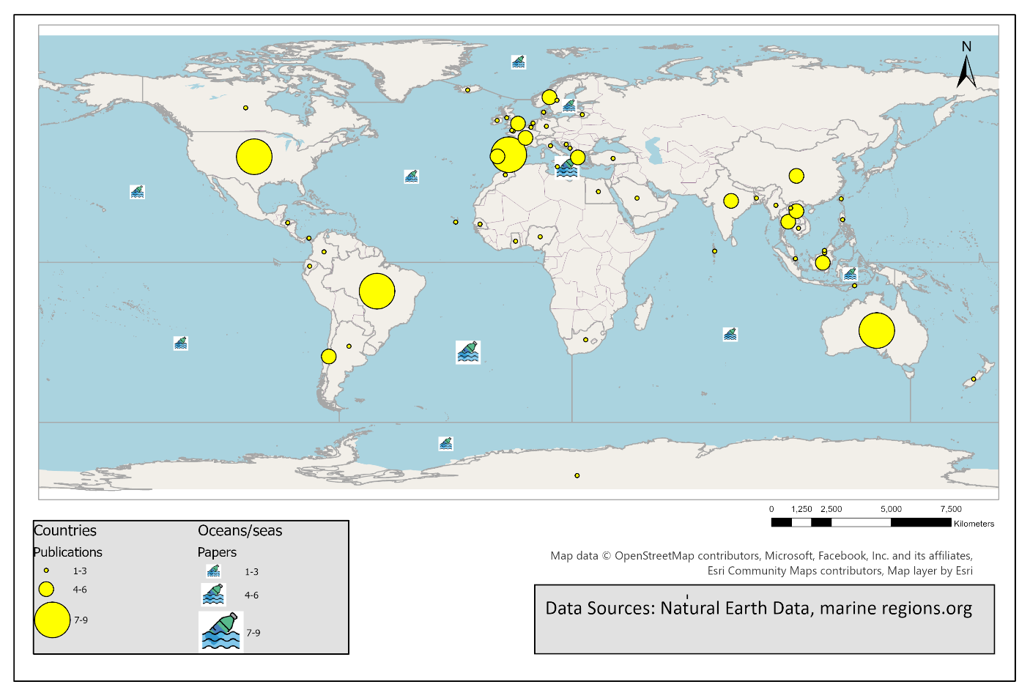
Fig.3.: Visual representation of the geographic regional focus of marine debris research, depicting the quantity of publications by the geographic region that was studied. Map created using Arc GIS Pro Software

Insights regarding the scholars who are publishing marine debris research
Publications by first authors based at European and Asian institutions (37% and 20%, respectively) represent the majority of publications, and U.S. institutions (11%) account for the highest share of publications when assessed by country. At least 50% of publications acknowledged national/federal funding sources.
In terms of publication leadership, European (37%, n=43) and Asian (19%, n=22) institutions were dominant, closely followed by North America (15%, n=17) and Australasia (13%, n=15). Other represented regions included Central/South America (8%, n=9), Africa (4%, n=5), and globally-distributed Small Island States (1%, n=1). Given that 50% (n=58) of the studies were funded by national governments and agencies, the distribution of research leadership by country was also of interest. After the USA, the next top countries to publish works were Australia (10%, n=11), Spain (8%, n=9), Italy (7%, n=8), and Brazil (6%, n=7). Based on the first author affiliations, there was an even spread of institutions. The Leibniz Centre for Tropical Marine Research (Germany) had the highest number of publications (n=3). Non-profit / non-governmental organizations (NGOs) funded 10% of total studies (n=11), followed by public institutes (9%, n=10), intergovernmental agencies (8%, n=9), and the private sector (4%, n=5). For 19% (n=22) of the studies, no external funding was received. Please refer to Table SM-2 in the Supplementary Materials.

Areas of marine debris research focus and factors of interest
The majority of studies (55%) covered a combination of research foci; of the studies with a single thematic focus, marine debris volume was the dominant interest, accounting for 59% of single-focus publications and 26% of total publications.
The implications of unmanaged and increasing marine debris are diverse and substantial, and increasing public interest and concern has motivated the exploration and collection of new data. To understand the main focus areas of current marine debris research, an inductive assessment of the major categories and factors of interest that emerged from the literature review was completed (Table 6). The majority of reviewed publications (55%, n=63) explored more than a single research question and focus. Among those that focused on a single factor of interest (45%, n=51), marine debris volume was the most frequently observed, accounting for 26% of the total (n=30). The remaining single-focus studies covered a range of topics that included transport mechanisms (6%, n=7), origin/source (3%, n=4), biological implications (3%, n=4), implications of tide/current (3%, n=3), composition (1%, n=1), and toxicity implications (1%, n=1). A comprehensive overview and examples for identified marine debris research factors of interest are presented in Table 6.

Table 6: Evidence for factors of research interest.
Description | Cases (#) | Published Research Examples
Factor of interest: Region-specific studies
Focused on multiple factors in a specific region of interest | 44 | - Micro and macro plastics in Antarctica (volume, transport, source) (Rota et al., 2022)  - Marine litter in Caribbean (source, volume, distribution, fate of debris (Kanhai, Asmath and Gobin, 2022)  - Microplastic presence in pumice stone on coasts in Thailand (Pradit et al., 2022)
Factor of interest: Volume of marine debris
Measurement of the volume and/or quantity of debris in the sample site. Includes total volume, density per given area, and/or distributions | 30 | - Areas that contain mangrove forests around the world aid in the trapping of marine debris (Luo, Not and Cannicci, 2021)  - Extent of marine litter accumulation in coastal seabird nests around the Delta du Saloum National Park, Senegal (Tavares, Moura and Merico, 2019)  - Use of remote sensing to detect amount of microplastics around a Maldives island (Patti et al., 2020)
Factor of interest: Debris-specific studies
Focused on multiple factors related to a specific type and/or origin of debris | 18 | - Effects of particle buoyancy, release location, and diel vertical migration on exposure of marine organisms to microplastics in Delaware Bay (Mason, Kukulka and Cohen, 2022)  - Marine organisms as bioindicators of plastic pollution across the seafloor at different levels around the globe (Orlando-Bonaca, Avio and Bonanno, 2022)  Review documenting the growing threat of microplastics and their effects on global aquatic ecosystems (Choudhury et al., 2022)
Factor of interest: Transport mechanisms
Ways in which marine debris is being moved from one area to another. Often pattern-oriented | 7 | - Oceanic currents and gyres frequently pick up marine debris and transport them, leading to accumulation in areas around the globe (Uchiyama et al., 2019; Miron et al., 2021)  - Wind patterns (stokes drift) have impacts on impact both on the timescales of particle dispersal and on the concentration in the main convergence zones (Bosi, Broström and Roquet, 2021)
Factor of interest: Origin and/or source
Where the marine debris is coming from, who/what is causing it, the nature/type of the pollution source | 4 | - Urbanized areas have higher rates consumption, leading to more waste production and a higher density of marine debris when comparing beaches in Senegal (Tavares et al., 2020)  - Landfill sites in Portugal were found to have a high waste leakage (Lopes et al., 2021)  - Beverage companies and shipping industry are responsible for bottles littering on beaches in New South Wales, Australia (Smith et al., 2018)  - Use of ocean circulation models to track the source of marine plastic in Easter Island ecoregion (Gennip et al., 2019)
Factor of interest: Biological implications
How is marine debris impacting the biota that comes into contact with it? | 4 | - Ingestion and physiological and/or toxicological harm due to marine debris in know hotspots around the globe (Ying et al., 2021; Høiberg, Woods and Verones, 2022)  - Deterioration of seagrass meadows around Mallorca Island may compromise the natural marine debris trapping services they provide (Sanchez-Vidal et al., 2021)  - Biofouling and the development of the plastisphere around Bahia Blanca Estuary, Argentina show marine debris as vectors of pathogens (Forero-López et al., 2022)  - Introduction of invasive species (marine NIS and pathogens) due to rafting on MPD on a global scale (Audrézet et al., 2021)
Factor of interest: Implications of tide and/or currents
How do tides and currents in the oceans influence the accumulation of debris? What are trends and patterns associated with oceanic processes? | 3 | - Stokes drift (Bosi, Broström and Roquet, 2021)  - Coastal processes that fragment macroplastics (Rizzo et al., 2021)  - Barotropic tidal currents transporting and accumulating microplastics in the ocean (Sterl, Delandmeter and Van Sebille, 2020)  - Tides transporting microplastics in Xiangshan Bay, China (Yin et al., 2022)
Factor of interest: Composition of marine debris
Focused on the material, composition, and/or make-up of the marine debris | 1 | - Particle content of debris (material, size, physical properties, color, original use) in Great Barrier Reef, Australia (Kroon et al., 2018)
Factor of interest: Toxicity implications
Focused on how harmful the debris is on a physio-chemical level- can tie into biological studies | 1 | - Chemical composition and interactions of marine debris through gastrointestinal tract of seabirds in Labrador Sea, Canada (Provencher et al., 2018)

Composition and sources
Two thirds of the studies studied “general waste” of marine debris: the mixture of all types, forms, and materials present in accumulating marine debris.

Increasing visuals and concern about the impacts of marine debris have been used to mobilize action and initiate policy interventions, ranging from single-use plastics bans to stewardship requirements for old fishing gear. The body of research about the types of marine debris (categories of primary composition), and the industries and sectors associated with these mismanaged materials, can provide insight into what actions are needed, not just actions that respond to highly visible conditions.

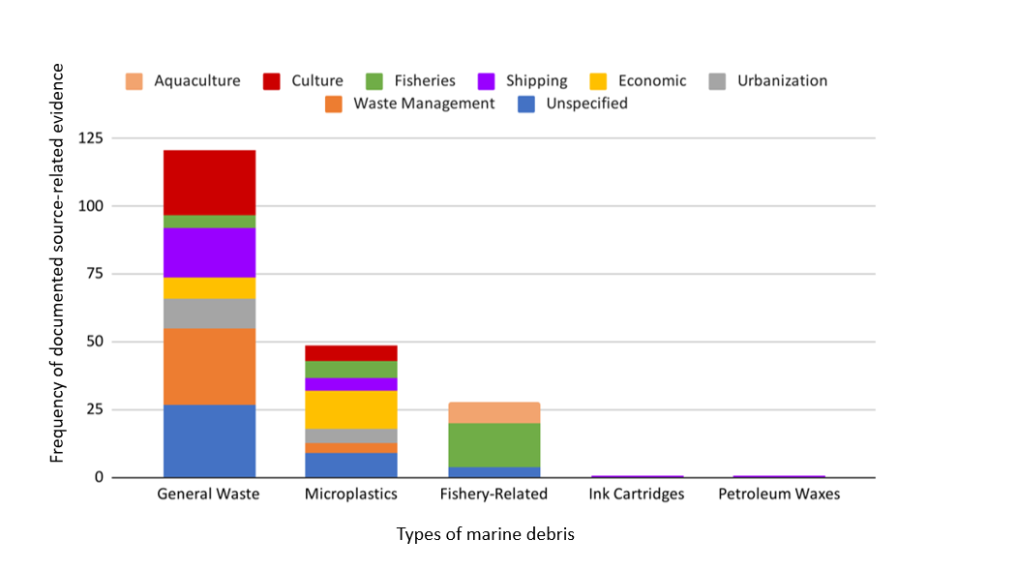
Fig.4.: Types of marine debris (by categories of primary composition), and the contributing sources of those debris types. Note: The category of marine debris is shown on the x-axis, while the frequency of documented source-related evidence is displayed on the y-axis. The bars indicate the source-composition of each marine debris category.

The general waste category included studies focusing on macroplastics, and comprised 66% (n=73) of the studies. The second most frequently represented category, microplastics, accounted for 27% (n=31) of the studies. Other marine debris categories found throughout the studies included fishing gear (n=6), petroleum waxes (n=1), and ink cartridges (n=1). We classified petroleum waxes and ink cartridges as their own debris type categories because they served as the sole focus of the respective studies; we classified articles that focused on multiple marine debris categories under ‘general waste’. For each marine debris type (category), eight (8) sources were identified: waste management, urbanization, economic, shipping, fisheries, human culture, aquaculture, and articles that did not specify a source of the debris. The source count in this figure is necessarily higher than the raw number of studies to account for publications that documented multiple sources for each of the marine debris types. Waste management was the largest source for the general waste category (n=28), and also contributed a small fraction to the microplastics category (n=4). Examples of waste management sources included wastewater treatment (Hipfner et al., 2018; Rios-Fuster et al., 2019; Grillo and Mello, 2021; Kanhai, Asmath and Gobin, 2022), landfills/dumpsites (Hohn et al., 2020; Pradit et al., 2020; Yin et al., 2020; Hajbane et al., 2021; Høiberg, Woods and Verones, 2022; Kanhai, Asmath and Gobin, 2022; Nukpezah et al., 2022), waste import/export policies (Walker, McGuinty and Hickman, 2021), response to a power plant meltdown (Hipfner et al., 2018), dissemination of health and medical gear (Giovacchini et al., 2018; Pradit et al., 2020), and general presence or absence of management infrastructure (Van Emmerik et al., 2018; Collins and Hermes, 2019; Ho and Not, 2019; Tavares, Moura and Merico, 2019, 2019; Owens and Kamil, 2020; Patti et al., 2020; Chenillat et al., 2021; Yin et al., 2022).
Human culture was another substantial source of marine debris – especially to the general waste category (n=24) and the microplastics category, (n=6). Aspects of culture-related sources included tourism and recreation (Garcés-Ordóñez et al., 2020; Chouchene et al., 2021; Suteja et al., 2021; Rota et al., 2022), clothing (Tavares et al., 2020; Choudhury et al., 2022; Islam et al., 2022), religious activities (Benson and Fred-Ahmadu, 2020; Shaikh and Shaikh, 2021; Nukpezah et al., 2022), and tobacco consumption (Velez et al., 2019; Grillo and Mello, 2021). Shipping was the most ubiquitous source, noted as contributing to four out of the five debris categories: n=18 for general waste, n=5 for microplastics, and the only source (n=1) for petroleum waxes and ink cartridges categories. Urbanization-related sources were found to contribute to general waste and microplastics categories, albeit at lesser frequency (n=10 and n=5, respectively). Examples that we classified as a consequence of urbanization included stormwater and sewage (Choudhury et al., 2022; Gacutan et al., 2022), wear from vehicle tires (Choudhury et al., 2022; Murawski et al., 2022), paint particles (Turner, 2021), and general presence of structures, infrastructure, and human activity (Perez, Soares-Gomes and Bernardes, 2018; Waite, Donnelly and Walters, 2018; Purba et al., 2019; Tavares et al., 2020; González Carman et al., 2021; Lopes et al., 2021).
Economic sources comprised the plurality of the microplastic category (n=14), and were also present in the general waste category (n=8). This source classification is industry-based, which include cosmetics (Choudhury et al., 2022), sachets (Dasgupta, Sarraf and Wheeler, 2022), packaging (Velez et al., 2019; Shaikh and Shaikh, 2021), microplastic manufacturing (Herrera et al., 2018; Provencher et al., 2018; Velez et al., 2019; Benson and Fred-Ahmadu, 2020; Sanchez-Vidal et al., 2021; Yin et al., 2022), plastic factories (Ferreira et al., 2021), and overall increases in production/industrial release (Guzzetti et al., 2018; Herrera et al., 2018; Purba et al., 2019; Yin et al., 2020; Dasgupta, Sarraf and Wheeler, 2022; Rodrigues et al., 2022). Fisheries were a source predictably dominant in the fishery-related debris category (n=16). However, this source was also noted to contribute to the general waste category (n=5) and microplastics category (n=6). These were distinguished from the fishery-related category because, while the source of the debris may have been traced to fisheries, compositionally, the debris itself was not necessarily related to fisheries. Examples of sources that fall under fisheries are industrial fishing (Agamuthu et al., 2019; Mearns et al., 2020; Song et al., 2021) small scale subsistence fishing (Tavares, Moura and Merico, 2019; Nukpezah et al., 2022), and fishing traps (Pedà et al., 2022). Aquaculture (n=8) was a category to subdivide articles within the fishery-related debris focus. This includes oyster farming (Chen et al., 2018), mussel farming (Islam et al., 2022), salmon (Ahrendt et al. 2021), and general aquaculture (Purba et al., 2019; Mearns et al., 2020; Yin et al., 2020).

Sectors of sources of interest within marine debris research
Most (59%) studies did not specify a sector; 20% of reviewed publications were focused on multiple sectors; 10% of the published studies focused explicitly on the fisheries sector.
We classified the sector for each article as any specific human dimension that was either the driver of marine debris or that was affected by the debris pollution. The majority of articles in the review did not specify a specific sector of focus, with 59% (n=67) having no sector focus mentioned at all. Twenty-one percent (n=24) focused on multiple sectors. The fisheries sector was the most commonly referenced individual sector, making up 10% (n=11) of the articles in the study. For instance, fisheries were found to be the primary responsible sector for debris pollution found in the Southeast German Bight (Meyerjürgens, Schöneich-Argent and Badewien, 2022). In this study, improper waste management of plastic fishing gear used for fishing activities resulted in sea organisms, octopi in this example, to become unconscious waste collectors via ingestion. Another example identified fishing zones within international waters as being associated with the highest probability for debris reaching the Easter Island Ecoregion, within a transit time of under 2 years (Gennip et al., 2019).
The shipping and transportation sector comprised 5% (n=6) of the reviewed literature. Examples include a study on ink cartridge spillage from a cargo ship (Turner, 2021), the role of shipping operations in petroleum wax pollution (Suaria et al., 2018), and plastic bottles originating from the shipping industry washing up on Australian beaches (Smith et al., 2018).
Recreation (3%, n=3) and tourism (2%, n=2) were also identified sectors of research interest. An article by Cohen-Sánchez et al. (2022) noted the effects of microplastic bioaccumulation in Mediterranean fish sought out by recreational fishers (Cohen-Sánchez et al., 2022). Beach recreation was identified as a primary contributor to marine debris, with beachgoers impacting debris volume (Pradit et al., 2020; Ryan et al., 2020).Tourism had only two articles, one about debris on tourist-heavy islands in Indonesia (Suteja et al., 2021), and the other about tourists polluting Caribbean and Colombian beaches (Garcés-Ordóñez et al., 2020).There was one miscellaneous article regarding sachet and bottle manufacturers, the development of accumulation of these products in Accra, Ghana, and Lagos, Nigeria (Dasgupta, Sarraf and Wheeler, 2022).

Factors determining accumulation of marine debris
Slightly under 2/3 of the total documented determining factors for marine debris accumulation were physical and environmental, while 37% were human-based. There is an overall trend of marine debris accumulation increasing and relocating across all determining factors.
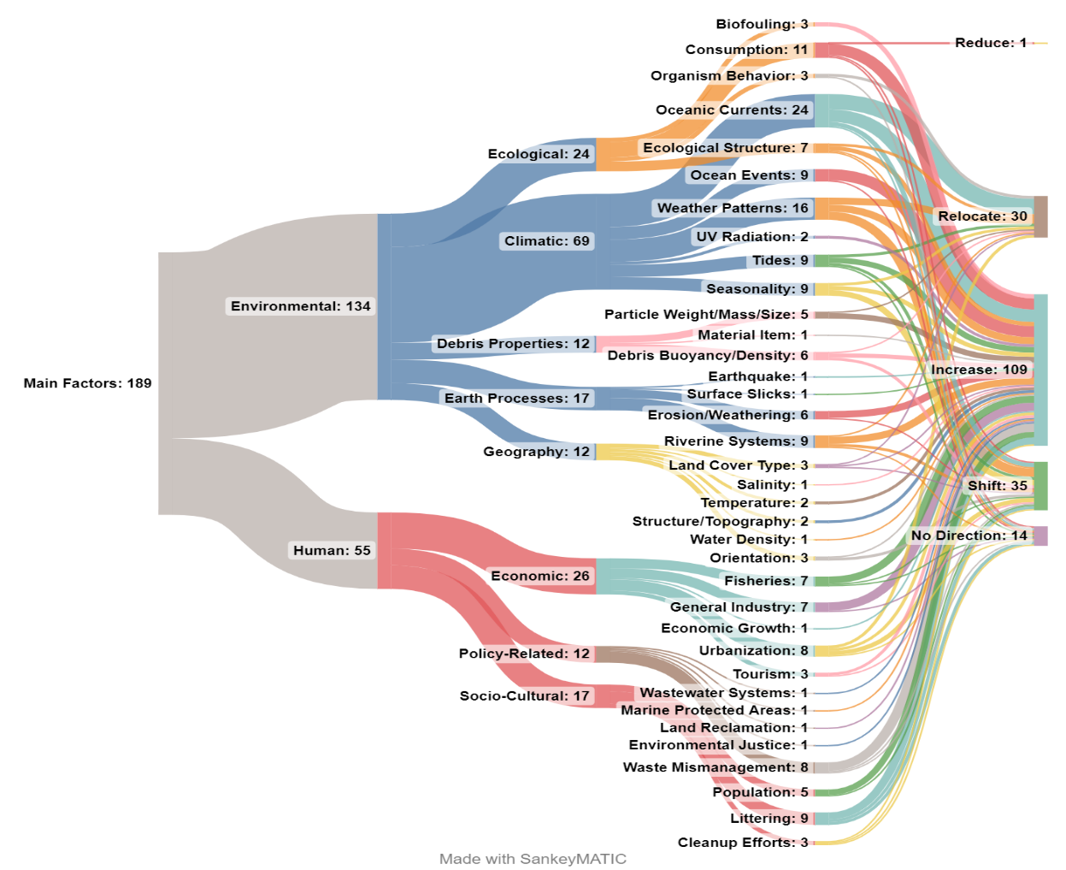
Fig.5.: Sankey diagram depicting the diverse themes, categories, factors affecting marine debris accumulation, and the impact of those factors upon accumulation (e.g., reduce, relocate, increase, shift) as presented within the reviewed literature. Each category and sub-category value reflect the number of publications focused on that particular theme and/or factor.
Two fundamental themes pertaining to the factors of accumulation were environmentally-driven factors (63%) and human-driven factors (37%) as shown in Fig.5. Five types of determinants of environmentally-driven factors were inductively identified: ecological (18%), climatic/oceanic/atmospheric (51%), debris properties (9%), earth processes (13%), and geography/physical environment factors (9%). The human driven factors were divided into three determinants: economic (47%), policy-related (22%), socio-cultural (31%). Determining factors were further divided into subcategories, as seen in the diagram above. Each subcategory corresponds to a direction of accumulation, which include increase (58%), shift (movement of accumulated debris from one marine location to another marine location; 19%), relocate (movement of accumulated debris from land to marine environments; 16%), no direction (7%), and reduce (<1%). Of the studies that had increasing debris accumulation, 13% of the determinants were ecological, 28% were climatic/oceanic/atmospheric, 7% were debris properties, 11% were earth processes, 7% were geographic/physical, 15% were economic, 8% were political, and 10% were socio-cultural. Of the studies that explored shifting debris accumulation between marine locations, 6% of the determinants were ecological, 43%were climatic/oceanic/atmospheric, 6% were debris properties, 9% were earth processes, 9% were geographical/physical, 14% were economic, 3% were political, and 11% were sociocultural. Of the studies that documented relocating debris from land-based origin to marine environments, 13% were ecological, 67% were climatic/oceanic/atmospheric, 7% were debris properties, 3% were earth processes, 3% were geographic/physical, and 7% were economic. Of the studies that had no direction of debris accumulation, 21% of the determinants were ecological, 21% were climatic/oceanic/atmospheric, 7% were earth processes, 21% were economic, 7% were policy-related, and 21% were socio-cultural. There was only 1 study that concluded a reduction in accumulation, which fell under ecological. For more detailed examples of factors of accumulation, refer to Table SM-3 in Supplementary Materials.

Discussion
Marine pollution, especially plastic pollution, is a growing global menace. There are currently an estimated 50-75 trillion pieces of plastic in the world’s oceans; experts project that by 2050, plastic will outweigh all fish in the sea (Fava, 2022). Regarding marine pollution, marine debris, or litter, has been identified as a significant factor that can degrade marine health and adversely affect biodiversity (Fauziah et al., 2021). Studies on marine debris have been gaining attention lately. Concerns about marine debris have been ongoing for many decades, but they have only become a major focus in recent years. While the issue has long been recognized, heightened awareness and intensified efforts to address it have emerged more prominently in the last few decades (De Matteis et al., 2022; Richon et al., 2023). We, therefore, conducted a systematic literature review aiming to synthesize the current state of knowledge of global marine debris pollution and accumulation while identifying the gaps in research and factors that should be prioritized in the future.
Our study found that, of the determinants of accumulation, environmental factors were dominant over human factors by frequency, but both were influential toward accumulation directions. In a similar vein, Moy et al. (2018) observed that marine debris is a significant concern in Hawaii, particularly after major natural events. For instance, the 2011 Tōhoku tsunami resulted in the displacement of millions of metric tons of large debris into the sea (Moy et al., 2018). Conversely, Sheavly and Register (2007) pointed out that the main contributors to marine debris are products of human consumption such as food wrappers, beverage containers, and cigarette (Sheavly and Register, 2007). The studies highlight the complex interplay between environmental and anthropogenic factors contributing to marine debris. This emphasizes the need for formulating strategies that address both predictable human behaviors and contingency planning for natural events (Lincoln et al., 2022).
As most studies documented an increase in accumulation, we identified two broad classifications regarding the reason for this rise. Our first classification attributes the increase to the concentration of pre-existing debris within a specific geographic area. According to our study findings various physical and environmental factors contribute to this concentration, such as ecological structures (e.g. mangroves (Luo, Not and Cannicci, 2021), saltmarshes (Yao et al., 2019), seagrass (Sanchez-Vidal et al., 2021)), organism behavior (e.g. ingestion (Perez-Venegas et al., 2020; Robuck et al., 2022), collecting, migrations), oceanic and climatic processes (e.g. gyres (Agamuthu et al., 2019), currents (Kelly et al., 2020), winds (Grillo and Mello, 2021), tides (Barrella et al., 2021), debris properties (e.g. buoyancy (Song et al., 2021), mass/density), geographic and environmental properties (e.g. rivers (Van Emmerik et al., 2018), salinity (Meyerjürgens, Schöneich-Argent and Badewien, 2022), and temperature (Meyerjürgens, Schöneich-Argent and Badewien, 2022). The one prominent human-related factor is the mismanagement of waste (Shaikh and Shaikh, 2021). Our study results align with previous findings that the spatial distribution of plastic marine debris is affected by various interacting elements (Browne, Galloway and Thompson, 2010; Kukulka et al., 2012; Ryan, 2013; Thiel et al., 2013). These studies suggest that local wind patterns influence how debris is dispersed, affecting particles of varying densities differently. Additionally, areas of higher debris density near coastlines are often linked to nearby human population densities.
The second classification points to the generation of new debris, leading to a higher volume of debris being introduced into the ocean. Our study found that the increasing volume of debris is driven by acute environmental events, such as weather events and floods (Barrella et al., 2021; Ferreira et al., 2021; Daniel, Ashraf and Thomas, 2022), and earthquakes (Agamuthu et al., 2019). Human factors also play a dominant role in this classification, including urbanization (Tavares et al., 2020; Barrella et al., 2021), industry (Ryan et al., 2019; Ahrendt et al., 2021), and behavioral habits (Shaikh and Shaikh, 2021; Choudhury et al., 2022). It is common for the areas of study to experience the compounding effects of both (Guzzetti et al., 2018; Lavers et al., 2019; Sakti et al., 2021). Consistent with our results, Issifu and Sumaila (2020) observed that the prevalent use of disposable plastics, coupled with inadequate waste disposal and recycling measures, leads to increasing oceanic litter accumulation (Issifu and Sumaila, 2020). Based on these results, we argue that physical and environmental factors tend to manipulate the dynamics of accumulation, while anthropogenic factors—with the exception of acute weather events—tend to be the generative forces of debris presence.
Understanding the complex interplay between factors influencing accumulation and the resultant trends requires a nuanced analysis beyond mere causality, as evidenced by recent studies in marine debris pollution. In the case of the relationships among factors of accumulation and direction of accumulation, it is important to note that the determinants are not essentially casualties of the corresponding directions of accumulation; many studies document up to several determining factors. For example, (Ryan et al., 2020) mentions the presence of cleanup efforts, but the overall trend of accumulation is increasing; although it can be easily inferred that cleanup efforts contribute to lower accumulation rates, it still must be consistent with the overall findings of the article. A study by (Cohen-Sánchez et al., 2022) likewise compares two sites for microplastic presence, one in a marine protected area, and one not. Despite a significantly smaller volume of debris in the marine protected area, there was still a growing presence in both sites. The establishment of a marine protected area can be individually singled out as a useful preventative measure, but in the scope of the entire article, it still becomes categorized as increasing accumulation. A comparable limitation arises in the classification of debris composition. Some studies cover both micro- and macroplastics (Velez et al., 2019; Pitacco, Orlando-Bonaca and Avio, 2022; Rota et al., 2022) which led to their classification under a broad ‘general waste’ category. In fact, two-thirds of the studies fall under this label due to the wide variety of waste types reported. While this categorization was necessary for consistency, it may obscure important distinctions in debris composition, reducing the level of detail and specificity that can be analyzed from the data. Therefore, it can consequently be difficult to incorporate the nuances of individual studies into this review. The phenomenon of marine debris pollution involves myriad, multi-directional, and entangled forces– both natural and anthropogenic. When researching this field, it is indeed difficult to accurately discuss one driving force without considering its connections to other forces.
There are multiple paths for future research in further developing the understanding of marine debris accumulation and the drivers behind it. One noticeable gap in the research is that there are multiple studies centered around technologies and strategies for tracking and identifying marine debris that have not been put into use yet, with examples including satellite imagery (Jamali and Mahdianpari, 2021; Gomez, Scandolo and Eisemann, 2022), database development (Sanchez-Vidal et al., 2021), and computational models (Cloux González et al., 2022). In order to have a semblance of practical purpose, the best steps forward are to apply these techniques to greater extents and to maximize on their potentials. We found some notable limitations of our study on transparency and accessibility of data across the studies included. While 46% of the publications made their raw data or results publicly available, the remaining 54% did not. This lack of data sharing limits the ability to verify findings, assess methodological rigor, and perform meaningful cross-study comparisons or meta-analyses. As a result, it introduces uncertainty regarding the scientific robustness of some reported patterns. Future research should prioritize open data practices to enhance scientific credibility and support more reliable cross-study comparisons. A key shortcoming in authorship patterns is the underrepresentation of scholars from low- and middle-income countries, particularly in highly impacted regions such as Africa, small island states, and parts of Central and South America. This may, in part, be due to the review’s inclusion criteria, which limited the analysis to English-language publications, potentially excluding important contributions from non-English-speaking regions. As a result, the global discourse on marine debris may lack diverse regional perspectives and context-specific insights. Increasing support for capacity building, equitable research collaborations, and funding mechanisms directed toward scholars and institutions in underrepresented regions is essential through future research. There are also geographic areas that may be currently understudied. For example, sub-Saharan Africa (n=7) (Collins and Hermes, 2019; Ryan et al., 2020; Tavares et al., 2020; Dasgupta, Sarraf and Wheeler, 2022), Central America (n=1,(Leonard & Lucas, 2020)), and small island states (n=3, (Andrades et al., 2018; Patti et al., 2020; Kanhai, Asmath and Gobin, 2022) need more attention, as these three regions have few studies. Especially since these are regions of rapid development and higher coastline vulnerability (Sowman and Raemaekers, 2018; Nagy et al., 2019), gathering more information about their struggles with marine debris pollution would be helpful in providing direction for planning, policy, and action.
5. Conclusions:
The aim of our study was to document and summarize the current knowledge about global marine debris pollution and accumulation. Based on our study results, most studies have shown an increase in debris accumulation, and there are two main reasons for this increase. One is the concentration of existing debris in a specific geographic area, and the other is the introduction of new debris into the ocean, leading to a higher volume of debris. Two main themes related to the factors of accumulation were identified: environmentally driven factors and human-driven factors. Environmental factors were found to be more dominant in influencing accumulation directions compared to human factors in terms of frequency, but both were influential. We found that physical and environmental factors primarily influence the accumulation dynamics, while anthropogenic factors, except for acute weather events, are the main contributors to the presence of debris. Our study has highlighted several areas for future research to further develop our understanding of marine debris accumulation and its drivers. One notable research gap is the lack of implementation of various studies focusing on technologies and strategies for tracking and identifying marine debris, such as satellite imagery, database development, and computational models. Future research should prioritize integrating these tools into large-scale monitoring systems and inform evidence-based policy measures aimed at reducing debris sources and improving marine waste management.

References

Agamuthu, P. et al. (2019) ‘Marine debris: A review of impacts and global initiatives’, Waste Management & Research, 37(10), pp. 987–1002. Available at: https://doi.org/10.1177/0734242X19845041.
Ahrendt, C. et al. (2021) ‘A decade later, reviewing floating marine debris in Northern Chilean Patagonia.’, Marine Pollution Bulletin, 168, p. 112372. Available at: https://doi.org/doi.org/10.1016/j.marpolbul.2021.112372.
Andrades, R. et al. (2018) ‘Marine debris in Trindade Island, a remote island of the South Atlantic’, Marine Pollution Bulletin, 137, pp. 180–184.
Audrézet, F. et al. (2021) ‘Biosecurity implications of drifting marine plastic debris: current knowledge and future research’, Marine Pollution Bulletin, 162, p. 111835.
Barrella, W. et al. (2021) ‘The Debris Distribution Model for Removal Planning of an Urbanized Estuarine Complex’, Quaestiones Geographicae, 40(1), pp. 97–107. Available at: https://doi.org/10.2478/quageo-2021-0008.
Benson, N.U. and Fred-Ahmadu, O.H. (2020) ‘Occurrence and distribution of microplastics-sorbed phthalic acid esters (PAEs) in coastal psammitic sediments of tropical Atlantic Ocean, Gulf of Guinea’, Science of The Total Environment, 730, p. 139013.
Bonanno, G. and Orlando-Bonaca, M. (2018) ‘Perspectives on using marine species as bioindicators of plastic pollution’, Marine Pollution Bulletin, 137, pp. 209–221. Available at: https://doi.org/10.1016/j.marpolbul.2018.10.018.
Borrelle, S.B. et al. (2020) ‘Predicted growth in plastic waste exceeds efforts to mitigate plastic pollution’, Science, 369(6510), pp. 1515–1518. Available at: https://doi.org/10.1126/science.aba3656.
Bosi, S., Broström, G. and Roquet, F. (2021) ‘The role of Stokes drift in the dispersal of North Atlantic surface marine debris’, Frontiers in Marine Science, 8, p. 697430.
Brereton, P. et al. (2007) ‘Lessons from applying the systematic literature review process within the software engineering domain’, Journal of systems and software, 80(4), pp. 571–583.
Browne, M.A., Galloway, T.S. and Thompson, R.C. (2010) ‘Spatial Patterns of Plastic Debris along Estuarine Shorelines’, Environmental Science & Technology, 44(9), pp. 3404–3409. Available at: https://doi.org/10.1021/es903784e.
Chen, C.-L. et al. (2018) ‘Snow lines on shorelines: Solving Styrofoam buoy marine debris from oyster culture in Taiwan’, Ocean & Coastal Management, 165, pp. 346–355.
Chenillat, F. et al. (2021) ‘Fate of floating plastic debris released along the coasts in a global ocean model’, Marine Pollution Bulletin, 165, p. 112116.
Chouchene, K. et al. (2021) ‘Microplastics on Barra beach sediments in Aveiro, Portugal’, Marine Pollution Bulletin, 167, p. 112264.
Choudhury, M. et al. (2022) ‘Growing Menace of Microplastics in and Around the Coastal Ecosystem’, in S. Madhav, S. Nazneen, and P. Singh (eds) Coastal Ecosystems. Cham: Springer International Publishing (Coastal Research Library), pp. 117–137. Available at: https://doi.org/10.1007/978-3-030-84255-0_6.
Ciappa, A.C. (2021) ‘Marine plastic litter detection offshore Hawai’i by Sentinel-2’, Marine Pollution Bulletin, 168, p. 112457.
Cloux González, S. et al. (2022) ‘Validation of a Lagrangian model for large-scale macroplastic tracer transport using mussel-peg in NW Spain (Ría de Arousa)’. Available at: https://minerva.usc.es/xmlui/handle/10347/27620 (Accessed: 18 July 2024).
Cohen-Sánchez, A. et al. (2022) ‘First detection of microplastics in Xyrichtys novacula (Linnaeus 1758) digestive tract from Eivissa Island (Western Mediterranean)’, Environmental Science and Pollution Research, 29(43), pp. 65077–65087. Available at: https://doi.org/10.1007/s11356-022-20298-8.
Collins, C. and Hermes, J.C. (2019) ‘Modelling the accumulation and transport of floating marine micro-plastics around South Africa’, Marine pollution bulletin, 139, pp. 46–58.
Daniel, D.B., Ashraf, P.M. and Thomas, S.N. (2022) ‘Impact of 2018 Kerala flood on the abundance and distribution of microplastics in marine environment off Cochin, Southeastern Arabian Sea, India’, Regional Studies in Marine Science, 53, p. 102367.
Dasgupta, S., Sarraf, M. and Wheeler, D. (2022) ‘Plastic waste cleanup priorities to reduce marine pollution: a spatiotemporal analysis for Accra and Lagos with satellite data’, Science of the Total Environment, 839, p. 156319.
De Matteis, A. et al. (2022) ‘A systemic approach to tackling ocean plastic debris’, Environment Systems and Decisions, 42(1), pp. 136–145. Available at: https://doi.org/10.1007/s10669-021-09832-0.
Eriksen, M. et al. (2014) ‘Plastic Pollution in the World’s Oceans: More than 5 Trillion Plastic Pieces Weighing over 250,000 Tons Afloat at Sea’, PLOS ONE, 9(12), p. e111913. Available at: https://doi.org/10.1371/journal.pone.0111913.
Fauziah, S.H. et al. (2021) ‘Marine debris in Malaysia: A review on the pollution intensity and mitigating measures’, Marine Pollution Bulletin, 167, p. 112258. Available at: https://doi.org/10.1016/j.marpolbul.2021.112258.
Fava, M.F. (2022) ‘Plastic pollution in the ocean: data, facts, consequences’, Ocean Literacy Portal, 9 May. Available at: https://oceanliteracy.unesco.org/plastic-pollution-ocean/ (Accessed: 18 July 2024).
Ferreira, A.T. da S. et al. (2021) ‘The dynamics of plastic pellets on sandy beaches: A new methodological approach’, Marine Environmental Research, 163, p. 105219.
Forero-López, A.D. et al. (2022) ‘Plastisphere on microplastics: in situ assays in an estuarine environment’, Journal of Hazardous Materials, 440, p. 129737.
Gacutan, J. et al. (2022) ‘Continental patterns in marine debris revealed by a decade of citizen science’, Science of The Total Environment, 807, p. 150742.
Garcés-Ordóñez, O. et al. (2020) ‘Plastic litter pollution along sandy beaches in the Caribbean and Pacific coast of Colombia’, Environmental pollution, 267, p. 115495.
Gennip, S.J.V. et al. (2019) ‘In search for the sources of plastic marine litter that contaminates the Easter Island Ecoregion’, Scientific reports, 9(1), p. 19662.
Giovacchini, A. et al. (2018) ‘Spatial distribution of marine litter along italian coastal areas in the Pelagos sanctuary (Ligurian Sea-NW Mediterranean Sea): A focus on natural and urban beaches’, Marine pollution bulletin, 130, pp. 140–152.
Gomez, A.S., Scandolo, L. and Eisemann, E. (2022) ‘A learning approach for river debris detection’, International Journal of Applied Earth Observation and Geoinformation, 107, p. 102682.
González Carman, V. et al. (2021) ‘Charismatic species as indicators of plastic pollution in the Río de la Plata Estuarine Area, SW Atlantic’, Frontiers in Marine Science, 8, p. 699100.
Grillo, A.C. and Mello, T.J. (2021) ‘Marine debris in the Fernando de Noronha Archipelago, a remote oceanic marine protected area in tropical SW Atlantic’, Marine Pollution Bulletin, 164, p. 112021.
Guertin, S. (2019) Marine Debris: Impacts on Ecosystems and Species | U.S. Fish & Wildlife Service. Available at: https://www.fws.gov/testimony/marine-debris-impacts-ecosystems-and-species (Accessed: 5 June 2024).
Guzzetti, E. et al. (2018) ‘Microplastic in marine organism: Environmental and toxicological effects’, Environmental toxicology and pharmacology, 64, pp. 164–171.
Hajbane, S. et al. (2021) ‘Coastal garbage patches: Fronts accumulate plastic films at Ashmore Reef marine park (Pulau Pasir), Australia’, Frontiers in Marine Science, 8, p. 613399.
Harding, S. (2016) ‘Marine Debris: Understanding, Preventing and Mitigating the Significant Adverse Impacts on Marine and Coastal Biodiversity.’, in. Secretariat of the Convention on Biological Diversity, Montreal (Technical Series No.83), p. 78.
Herrera, A. et al. (2018) ‘Microplastic and tar pollution on three Canary Islands beaches: an annual study’, Marine pollution bulletin, 129(2), pp. 494–502.
Hipfner, J.M. et al. (2018) ‘Beach-cast debris surveys on Triangle Island, British Columbia, Canada indicate the timing of arrival of 2011 Tōhoku tsunami debris in North America’, Marine pollution bulletin, 136, pp. 407–413.
Hirai, H. et al. (2011) ‘Organic micropollutants in marine plastics debris from the open ocean and remote and urban beaches’, Marine Pollution Bulletin, 62(8), pp. 1683–1692. Available at: https://doi.org/10.1016/j.marpolbul.2011.06.004.
Ho, N.H.E. and Not, C. (2019) ‘Selective accumulation of plastic debris at the breaking wave area of coastal waters.’, Environmental Pollution, 245, pp. 702–710.
Hohn, S. et al. (2020) ‘The long-term legacy of plastic mass production’, Science of the Total Environment, 746, p. 141115.
Høiberg, M.A., Woods, J.S. and Verones, F. (2022) ‘Global distribution of potential impact hotspots for marine plastic debris entanglement’, Ecological Indicators, 135, p. 108509.
Islam, T. et al. (2022) ‘Microplastic pollution in Bangladesh: research and management needs’, Environmental Pollution, 308, p. 119697.
Issifu, I. and Sumaila, U.R. (2020) ‘A review of the production, recycling and management of marine plastic pollution’, Journal of Marine Science and Engineering, 8(11), p. 945.
Jamali, A. and Mahdianpari, M. (2021) ‘A cloud-based framework for large-scale monitoring of ocean plastics using multi-spectral satellite imagery and generative adversarial network’, Water, 13(18), p. 2553.
Kanhai, L.D.K., Asmath, H. and Gobin, J.F. (2022) ‘The status of marine debris/litter and plastic pollution in the Caribbean Large Marine Ecosystem (CLME): 1980–2020’, Environmental Pollution, 300, p. 118919.
Kelly, A. et al. (2020) ‘Microplastic contamination in east Antarctic sea ice’, Marine Pollution Bulletin, 154, p. 111130.
Kroon, F.J. et al. (2018) ‘Classification of marine microdebris: A review and case study on fish from the Great Barrier Reef, Australia’. Available at: https://doi.org/doi:10.1038/s41598-018-34590-6.
Kukulka, T. et al. (2012) ‘The effect of wind mixing on the vertical distribution of buoyant plastic debris’, Geophysical Research Letters, 39(7), p. 2012GL051116. Available at: https://doi.org/10.1029/2012GL051116.
Lavers, J.L. et al. (2019) ‘Significant plastic accumulation on the Cocos (Keeling) Islands, Australia’, Scientific Reports, 9(1), p. 7102. Available at: https://doi.org/10.1038/s41598-019-43375-4.
Lincoln, S. et al. (2022) ‘Marine litter and climate change: Inextricably connected threats to the world’s oceans’, Science of The Total Environment, 837, p. 155709. Available at: https://doi.org/10.1016/j.scitotenv.2022.155709.
Lopes, C.S. et al. (2021) ‘Ingestion of anthropogenic materials by yellow-legged gulls (Larus michahellis) in natural, urban, and landfill sites along Portugal in relation to diet composition’, Environmental Science and Pollution Research, 28, pp. 19046–19063.
Luo, Y.Y., Not, C. and Cannicci, S. (2021) ‘Mangroves as unique but understudied traps for anthropogenic marine debris: a review of present information and the way forward’, Environmental Pollution, 271, p. 116291.
Mason, R.A., Kukulka, T. and Cohen, J.H. (2022) ‘Effects of particle buoyancy, release location, and diel vertical migration on exposure of marine organisms to microplastics in Delaware Bay’, Estuarine, Coastal and Shelf Science, 275, p. 107990.
Mearns, A.J. et al. (2020) ‘Effects of pollution on marine organisms’, Water Environment Research, 92(10), pp. 1510–1532. Available at: https://doi.org/10.1002/wer.1400.
Meyerjürgens, J., Schöneich-Argent, R.I. and Badewien, T.H. (2022) ‘An exploratory analysis of seabed litter dynamics in the SE German Bight’, Marine pollution bulletin, 177, p. 113515.
Miron, P. et al. (2021) ‘Transition paths of marine debris and the stability of the garbage patches’, Chaos: An Interdisciplinary Journal of Nonlinear Science, 31(3). Available at: https://pubs.aip.org/aip/cha/article/31/3/033101/342212 (Accessed: 16 July 2024).
Moy, K. et al. (2018) ‘Mapping coastal marine debris using aerial imagery and spatial analysis’, Marine Pollution Bulletin, 132, pp. 52–59. Available at: https://doi.org/10.1016/j.marpolbul.2017.11.045.
Mulrow, C.D. (1994) ‘Systematic reviews: rationale for systematic reviews’, Bmj, 309(6954), pp. 597–599.
Nagy, G.J. et al. (2019) ‘Climate vulnerability, impacts and adaptation in Central and South America coastal areas’, Regional Studies in Marine Science, 29, p. 100683.
Newbould, R.A., Powell, D.M. and Whelan, M.J. (2021) ‘Macroplastic debris transfer in rivers: a travel distance approach’, Frontiers in Water, 3, p. 724596.
NOAA (no date) Why is Marine Debris a Problem? | Marine Debris Program. Available at: https://marinedebris.noaa.gov/discover-marine-debris/why-marine-debris-problem (Accessed: 20 July 2024).
Nukpezah, D. et al. (2022) ‘Characterisation of litter and their deposition at the banks of coastal lagoons in Ghana’, Heliyon, 8(3). Available at: https://www.cell.com/heliyon/fulltext/S2405-8440(22)00285-7 (Accessed: 17 July 2024).
Okorie, O. et al. (2018) ‘Digitisation and the circular economy: A review of current research and future trends’, Energies, 11(11), p. 3009.
Orlando-Bonaca, M., Avio, C.G. and Bonanno, G. (2022) ‘Marine organisms as bioindicators of plastic pollution’, in Plastic Pollution and Marine Conservation. Elsevier, pp. 187–248. Available at: https://www.sciencedirect.com/science/article/pii/B9780128224717000031 (Accessed: 17 July 2024).
Owens, K.A. and Kamil, P.I. (2020) ‘Adapting coastal collection methods for river assessment to increase data on global plastic pollution: Examples from India and Indonesia’, Frontiers in Environmental Science, 7, p. 208.
Pasqualini, V. et al. (2023) ‘Harmful algae and pathogens on plastics in three mediterranean coastal lagoons’, Heliyon, 9(3), p. e13654. Available at: https://doi.org/10.1016/j.heliyon.2023.e13654.
Patti, T.B. et al. (2020) ‘Spatial distribution of microplastics around an inhabited coral island in the Maldives, Indian Ocean’, Science of the Total Environment, 748, p. 141263.
Pedà, C. et al. (2022) ‘The waste collector: information from a pilot study on the interaction between the common octopus (Octopus vulgaris, Cuvier, 1797) and marine litter in bottom traps fishing and first evidence of plastic ingestion’, Marine Pollution Bulletin, 174, p. 113185.
Perez, L., Soares-Gomes, A. and Bernardes, M.C. (2018) ‘A case study on the influence of beach kiosks on marine litter accumulating in Camboinhas beach, Southeast Brazil’, Journal of Coastal Conservation, 22, pp. 1085–1092.
Perez-Venegas, D.J. et al. (2020) ‘Monitoring the occurrence of microplastic ingestion in Otariids along the Peruvian and Chilean coasts’, Marine Pollution Bulletin, 153, p. 110966.
Peričić, T.P. and Tanveer, S. (2019) ‘Why systematic reviews matter’, A brief history, overview and practical guide for authors [Preprint].
Pitacco, V., Orlando-Bonaca, M. and Avio, C.G. (2022) ‘Plastic impact on marine benthic organisms and food webs’, in Plastic Pollution and Marine Conservation. Elsevier, pp. 95–151. Available at: https://www.sciencedirect.com/science/article/pii/B9780128224717000079 (Accessed: 18 July 2024).
Plastic pollution (2021). Resource. International Union for Conservation of Nature (IUCN).
Plastics Europe (2021) Plastics- the Facts 2021: An analysis of European plastics production, demand and waste data. Plastic Europe.
Pradit, S. et al. (2020) ‘Marine debris accumulation on the beach in Libong, a small island in Andaman Sea, Thailand.’, Applied Ecology & Environmental Research, 18(4). Available at: http://epa.niif.hu/02500/02583/00066/pdf/EPA02583_applied_ecology_2020_4_54615474.pdf (Accessed: 17 July 2024).
Pradit, S. et al. (2022) ‘The first evidence of microplastic presence in pumice stone along the coast of Thailand: a preliminary study’, Frontiers in Marine Science, 9, p. 961729.
Provencher, J.F. et al. (2018) ‘Garbage in guano? Microplastic debris found in faecal precursors of seabirds known to ingest plastics’, Science of the Total Environment, 644, pp. 1477–1484.
Purba, N.P. et al. (2019) ‘Marine debris in Indonesia: A review of research and status’, Marine pollution bulletin, 146, pp. 134–144.
Revel, M., Châtel, A. and Mouneyrac, C. (2018) ‘Micro(nano)plastics: A threat to human health?’, Current Opinion in Environmental Science & Health, 1, pp. 17–23. Available at: https://doi.org/10.1016/j.coesh.2017.10.003.
Richon, C. et al. (2023) ‘Legacy oceanic plastic pollution must be addressed to mitigate possible long-term ecological impacts’, Microplastics and Nanoplastics, 3(1), p. 25. Available at: https://doi.org/10.1186/s43591-023-00074-2.
Rios-Fuster, B. et al. (2019) ‘Anthropogenic particles ingestion in fish species from two areas of the western Mediterranean Sea’, Marine pollution bulletin, 144, pp. 325–333.
Rizzo, M. et al. (2021) ‘Examining the dependence of macroplastic fragmentation on coastal processes (Chesapeake Bay, Maryland)’, Marine Pollution Bulletin, 169, p. 112510.
Robuck, A.R. et al. (2022) ‘Birds of a feather eat plastic together: high levels of plastic ingestion in Great Shearwater adults and juveniles across their annual migratory cycle’, Frontiers in Marine Science, 8, p. 719721.
Rodrigues, F.G. et al. (2022) ‘Co-exposure with an invasive seaweed exudate increases toxicity of polyamide microplastics in the marine mussel Mytilus galloprovincialis’, Toxics, 10(2), p. 43.
Rota, E. et al. (2022) ‘Macro-and microplastics in the Antarctic environment: ongoing assessment and perspectives’, Environments, 9(7), p. 93.
Ryan, P.G. (2013) ‘A simple technique for counting marine debris at sea reveals steep litter gradients between the Straits of Malacca and the Bay of Bengal’, Marine pollution bulletin, 69(1–2), pp. 128–136.
Ryan, P.G. et al. (2019) ‘Rapid increase in Asian bottles in the South Atlantic Ocean indicates major debris inputs from ships’, Proceedings of the National Academy of Sciences, 116(42), pp. 20892–20897. Available at: https://doi.org/10.1073/pnas.1909816116.
Ryan, P.G. et al. (2020) ‘Monitoring marine plastics-will we know if we are making a difference?’, South African Journal of Science, 116(5–6), pp. 1–9.
Sakti, A.D. et al. (2021) ‘Multi-scenario model of plastic waste accumulation potential in indonesia using integrated remote sensing, statistic and socio-demographic data’, ISPRS International Journal of Geo-Information, 10(7), p. 481.
Saling, P. et al. (2020) ‘Life cycle impact assessment of microplastics as one component of marine plastic debris’, The International Journal of Life Cycle Assessment, 25, pp. 2008–2026.
Sampaio, R.F. and Mancini, M.C. (2007) ‘Estudos de revisão sistemática: um guia para síntese criteriosa da evidência científica’, Brazilian Journal of Physical Therapy, 11, pp. 83–89.
Sanchez-Vidal, A. et al. (2021) ‘Seagrasses provide a novel ecosystem service by trapping marine plastics’, Scientific reports, 11(1), p. 254.
Savoca, S. et al. (2020) ‘Plastics occurrence in juveniles of Engraulis encrasicolus and Sardina pilchardus in the Southern Tyrrhenian Sea’, Science of the Total Environment, 718, p. 137457.
Shaikh, I.V. and Shaikh, V.A.E. (2021) ‘A comprehensive review on assessment of plastic debris in aquatic environment and its prevalence in fishes and other aquatic animals in India’, Science of The Total Environment, 779, p. 146421.
Sheavly, S.B. and Register, K.M. (2007) ‘Marine Debris & Plastics: Environmental Concerns, Sources, Impacts and Solutions’, Journal of Polymers and the Environment, 15(4), pp. 301–305. Available at: https://doi.org/10.1007/s10924-007-0074-3.
Sherrington, C. et al. (2016) ‘Study to support the development of measures to combat a range of marine litter sources’, Report for European Commission DG Environment, 410. Available at: https://www.kosmopedia.org/wp-content/uploads/2020/09/MSFD-Measures-to-Combat-Marine-Litter.pdf (Accessed: 20 July 2024).
Smith, S.D. et al. (2018) ‘Tracing the source of marine debris on the beaches of northern New South Wales, Australia: The bottles on beaches program’, Marine Pollution Bulletin, 126, pp. 304–307.
Song, X. et al. (2021) ‘Large Plastic Debris Dumps: New Biodiversity Hot Spots Emerging on the Deep-Sea Floor’, Environmental Science & Technology Letters, 8(2), pp. 148–154. Available at: https://doi.org/10.1021/acs.estlett.0c00967.
Sowman, M. and Raemaekers, S. (2018) ‘Socio-ecological vulnerability assessment in coastal communities in the BCLME region’, Journal of Marine Systems, 188, pp. 160–171.
Sterl, M.F., Delandmeter, P. and Van Sebille, E. (2020) ‘Influence of Barotropic Tidal Currents on Transport and Accumulation of Floating Microplastics in the Global Open Ocean’, Journal of Geophysical Research: Oceans, 125(2), p. e2019JC015583. Available at: https://doi.org/10.1029/2019JC015583.
Suaria, G. et al. (2018) ‘The occurrence of paraffin and other petroleum waxes in the marine environment: a review of the current legislative framework and shipping operational practices’, Frontiers in Marine Science, 5, p. 94.
Subías-Baratau, A. et al. (2022) ‘Marine biofouling organisms on beached, buoyant and benthic plastic debris in the Catalan Sea’, Marine Pollution Bulletin, 175, p. 113405. Available at: https://doi.org/10.1016/j.marpolbul.2022.113405.
Suteja, Y. et al. (2021) ‘Stranded marine debris on the touristic beaches in the south of Bali Island, Indonesia: The spatiotemporal abundance and characteristic’, Marine Pollution Bulletin, 173, p. 113026.
Tavares, D.C. et al. (2020) ‘Density and composition of surface and buried plastic debris in beaches of Senegal’, Science of the Total Environment, 737, p. 139633.
Tavares, D.C., Moura, J.F. and Merico, A. (2019) ‘Anthropogenic debris accumulated in nests of seabirds in an uninhabited island in West Africa’, Biological conservation, 236, pp. 586–592.
Thiel, M. et al. (2013) ‘Anthropogenic marine debris in the coastal environment: a multi-year comparison between coastal waters and local shores’, Marine pollution bulletin, 71(1–2), pp. 307–316.
Turner, A. (2021) ‘Paint particles in the marine environment: an overlooked component of microplastics’, Water rEsearch x, 12, p. 100110.
Uchiyama, Y. et al. (2019) ‘Residual circulations and associated water mass transport in the South China sea analyzed with a coupled HYCOM-ROMS downscaling ocean model’, in AIP Conference Proceedings. AIP Publishing. Available at: https://pubs.aip.org/aip/acp/article-abstract/2157/1/020029/789083 (Accessed: 16 July 2024).
Van Emmerik, T. et al. (2018) ‘A methodology to characterize riverine macroplastic emission into the ocean’, Frontiers in Marine Science, 5, p. 372.
Velez, N. et al. (2019) ‘A baseline assessment of beach macrolitter and microplastics along northeastern Atlantic shores’, Marine Pollution Bulletin, 149, p. 110649.
Waite, H.R., Donnelly, M.J. and Walters, L.J. (2018) ‘Quantity and types of microplastics in the organic tissues of the eastern oyster Crassostrea virginica and Atlantic mud crab Panopeus herbstii from a Florida estuary’, Marine pollution bulletin, 129(1), pp. 179–185.
Walker, T.R., McGuinty, E. and Hickman, D. (2021) ‘Marine debris database development using international best practices: A case study in Vietnam’, Marine Pollution Bulletin, 173, p. 112948.
Webster, R.K. et al. (2020) ‘How to improve adherence with quarantine: rapid review of the evidence’, Public Health, 182, pp. 163–169. Available at: https://doi.org/10.1016/j.puhe.2020.03.007.
Williams Jr, R.I. et al. (2021) ‘Re-examining systematic literature review in management research: Additional benefits and execution protocols’, European management journal, 39(4), pp. 521–533.
Yao, W. et al. (2019) ‘Micro-and macroplastic accumulation in a newly formed Spartina alterniflora colonized estuarine saltmarsh in southeast China’, Marine Pollution Bulletin, 149, p. 110636.
Yin, C.S. et al. (2020) ‘Anthropogenic Marine Debris Accumulation in Mangroves on Penang Island, Malaysia’, Journal of Sustainability Science and Management, 15, pp. 36–60. Available at: https://doi.org/10.46754/jssm.2020.08.004.
Yin, M. et al. (2022) ‘Tide-driven microplastics transport in an elongated semi-closed bay: A case study in Xiangshan Bay, China’, Science of the Total Environment, 846, p. 157374.
Ying, L. et al. (2021) ‘Physiological responses of Pocillopora acuta and Porites lutea under plastic and fishing net stress’, Frontiers in Marine Science, 8, p. 712214.

