

THATCamp

Clients: Dr. Tom Ewing, Dr. Quinn Warnick

By: Harjas Ahuja, Jack Cobb, David Shapiro

CS 4624 ­ Multimedia and Hypertext

Dr. Edward Fox

1

Table Of Contents
Executive Summary
Work Accomplished …....………………………….………………...2
Project Requirements Report

​oblem Specification ……………………………………………….………3 Pr
Needs and Objectives ……………………………………………….……… 3 ​
Group Roles ……………………………………………….…….... 4
Deliverables and Equipment ………………………………………………….……. 4
Design Report
Scheduling Interviews ………………………………………………………... 8
Questionnaire ………………………………………………………... 9
Equipment ………………………………………………………... 10
Filming Locations ……………………………………………………….. 11 Scope of Videos ………………………………………………………... 12
Implementation Report
Timeline ………………………………………………………… 13
Group Roles/Teamwork ……………...……………...…………….…………… 14 Storyboard ………………………………………….…………… 14 Editing ……………………………………………………...…… 15
Prototype Report
Prototype Video …………………………….……………………15
Future Videos …………………………….………………….…....19 Final Cut Pro …………………………….………………….…….20
Refinement Report
Video Shooting …………………………….……………………..20
Video Editing …………………………….………………….…….22 Interview Question Refinement …………... ……………..….……………….…....22
Testing Report
Audio Editing Techniques ………………………….………………....23
Video Editing Techniques ………………………….………………....24 Video Screening …………………………….………………........25
References

2

Executive Summary
*This section is written around 5/5/15 and completion of the project*

Work Accomplished

Taking stock of what we actually accomplished, it is quite different from what was the
original plan. Initially, our clients thought that it would be best to get some interviews about
various projects related to the humanities before the weekend of the camp. This was done for two
reasons primarily. The first and most important was to get familiar with the camera equipment
and how to edit since we had no prior experience in this regard. Then, during the weekend of camp, we would be again be getting interviews, but from the attendees about camp and their thoughts. This was to be for a second set of videos that would again be short interviews, but feature the camp. We would also be gathering extra footage (b roll) for a short film about the
camp atmosphere and what the conference is like.

Leading up to camp, we actually were able to get close to the intended amount of
interviews. We were able to get the experience that we needed before camp so that we didn't
make mistakes during the important interviews. After talking with our clients before camp, we decided to change the type of videos that we were trying to get done. Our clients decided that it
would be best to have a couple short length videos that were able to keep the interest of the viewers better than quite a few interviews of attendees. In this regard, we still got the same
number of videos and the b roll of the camp that we were initially trying to. However, we made these interviews into two different compilations/montages of the weekend of camp. Both videos
used clips and audio from the interviews while showing the b roll of camp in some cases so it wasn't super boring. The first video is about THATCamp and what the attendees thought of it
and the way it was run. The second video is more centered around the attendees thoughts on the
humanities and technology's influence on it. In the end, we did not produce the number of
intended videos, but we were able to document the camp in a way that was more applicable and
interesting for the client's purpose and desires.

3

Project Requirements Report
*This section is written around 2/25/15 and before we began the project*

Problem Specification
For our project, we are creating videos for The Humanities and Technology (THAT)
Camp Virginia that is being held here at Virginia Tech. It will take place on Friday April 10th
and Saturday April 11th. There are several different types of videos that are going to be
produced, all with slightly different objectives in mind. Some are before camp while some are
during the camp as well. This is not planned to be a traditional documentary, but in some ways it
still is. This is mostly due to the nature of the event and the amount of time we have until the
weekend of the camp. We did not want to change how things ran, so we are producing this
documentary around that fact.

Needs and Objectives
The first set of videos leading up to camp are a series of smaller interviews with people
who are working on or are a part of any type of a digital humanities project. The outcome that we
are expecting is that these videos will be very short, to the point, and exciting, so that we can
generate interest for THAT Camp and hopefully garner further interest for camp. These videos will be released on the THAT Camp twitter feed and also put up on the website. In addition to
generating interest for camp, these interviews allow people who are working on their projects an
opportunity to talk about what the are working on and showcase their hard work. It also may
attract more people who would love to help with the project.

The second set of videos will be captured during the weekend of the camp. These videos
will be set up in an interview fashion where people can talk about any projects that they are working on or their experiences with the digital humanities. This is a different approach to
capturing the camp because since the camp has many different "scrum" type situations where people just quickly meet up and have mini pow wows. It can be difficult to capture good video
and audio of those types of situations. Having people volunteer for these interviews allows us to
still get footage of the event and more personal information on various different projects. This proposed solution seems like it would be an effective medium for us to capture the weekend's
proceedings. Once filmed, these interviews are being planned on being released as soon as possible, hopefully while the event is still ongoing, to attract more attention for the event.

4

The last portion of filming that we are planning on doing of the camp is to get a
walkthrough of the layout. The purpose of this shot is to allow people who were unable to attend to get a feel for what goes on in the camp and during that weekend. Since the camp is laid out in
both Newman Library and Torgerson Hall, the shot is going to be a walkthrough of the various
events that are going on, and the overall atmosphere. It is not going to really include any
interviews, but it is not finalized at this point. It may end up including some short cuts of video
from both different sets of interviews, and some unseen footage from the event, more specifically centered around one or two of the main meetings. This video would most likely be used as a final overview of the entire event, but ultimately would be as focused on any specific project because
that is what both sets of the previous interviews would be for.

Group Roles
Now we are going to establish the timeline for our project, the deliverables, group roles,
and how we will go about capturing the video for each portion of the project. No one in our
group has had previous video production experience, so we are all going to be helping each other
out with the various roles that we are each going to be doing for the production. Jack will be doing much of the editing of the videos. Harjas will be doing most of the set production and lighting. David will primarily be doing the filming and audio. Harjas will also be helping out
with the audio. As mentioned before, since our group is rather inexperienced with these tasks, we will all be assisting with all the roles, and none are set in stone. If we find that one of the group is
a prodigy or just much better at one role versus another, we will make sure that we are utilizing
them in that role as much as possible so that we are producing the best video possible.

Due to our lack of experience, All the members of our group have attended the class held
by Innovation Space about advanced videography as well as went tp the the TV Productions
Studio in Whitemore Hall. Both of those places were great resources and were able to answer the questions that we had about our project. We also took the class from Innovation Space so that we
can use the better cameras, sound equipment, and lighting that they offer for reservations. They
also will allow us to use their machines for editing the videos if we want to use their high end
software. Using the more high end editing software has its advantages over using something that is free such as Windows Movie Maker, especially if you need color restoration, graphic overlays,
or multiple video tracks that need to be synced or scenes edited out of them.

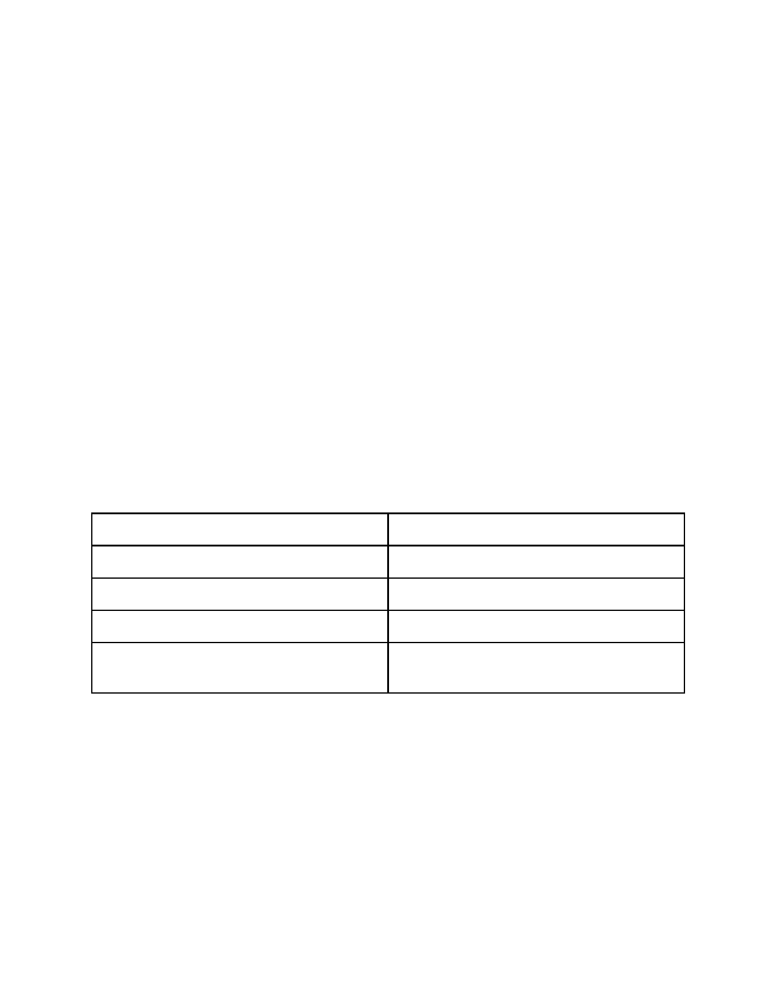
5

Deliverables and Equipment
As discussed, there are three main categories of deliverables. There is the first set of
interviews and resulting videos, which are going to be done by the time THAT Camp comes around, which is April 10th and 11th. This first set of videos is going to be at least 10 videos. That means we need to average just above 1 interview per week. Due to time constraints from
breaks and other work, we will most likely average two interviews per week, which would result in more than 10 interviews in total. That would give us the freedom to ensure quality editing and be able to take a week off before camp and make sure we were all caught up in editing and fully
prepared for camp. For each interview, we are going to get one of the Sony professional
camcorders that Innovation Space offers to those that have taken the advanced videography
class. If unavailable, they also have DSLRs that are available, and are also good. All the camera rentals come with the necessary audio equipment, but we can request a tripod if necessary. We
are also going to get one of the lighting kits so that we can be prepared if the location of the
interview does not have optimal lighting. The table below is a list of necessary equipment for these type of interviews. Figure 1 shows the most likely layout for the interviews in a generic
office setting. The set will obviously have to change slightly to accommodate for office size and
available space.

Equipment

Sony Camera/DSLR

Stage Lights (x3)

Lapel Microphone

Audio Transmitter
Purpose

Film Capture

Proper lighting

Capture Audio

Receive microphone audio and input to
camera

Table 1: Equipment that we will use for filming the first set of videos

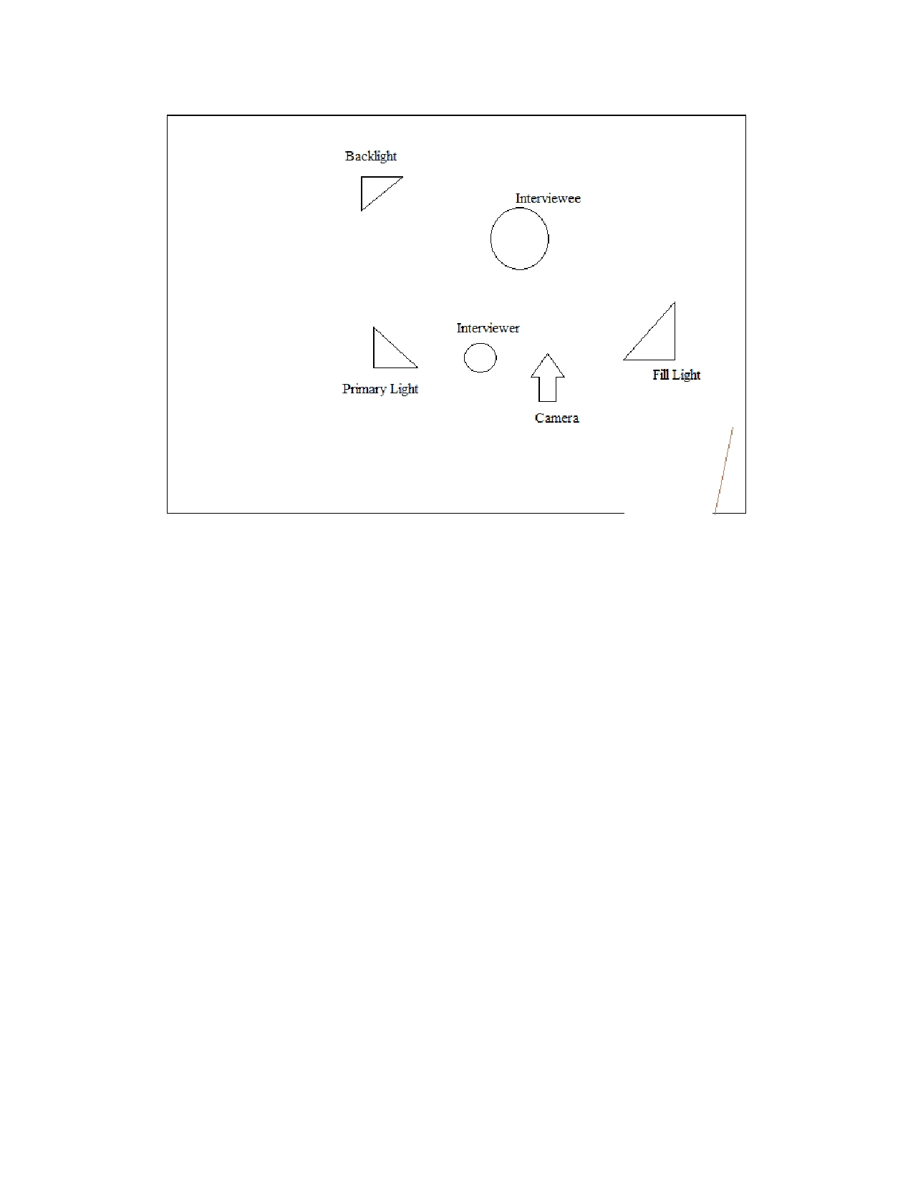
6

Figure 1: Room setup for filming interviews with the full lighting kits in a room

For The second set of videos, those will be filmed, edited, and hopefully released during
the weekend of THAT Camp. The plan is to get one­on­one interviews with people who are
attending camp who would like to discuss a project that they are involved with or are passionate
about. These videos would be edited together really quickly and released as soon as possible,
hopefully soon after filming, to draw attention to camp while it is still ongoing. These videos will
all be shot on the same set and in the same location, so we can set up a nice set with lighting to
use for all the interviews. Therefore, we would need to get equipment from Innovation Space yet
again. Since we know when this event is occurring so far ahead of time, we will definitely have
the professional Sony camcorder reserved for our use. We will also reserve a lighting kit that has all the necessary components. This would mean that there is more equipment that we would need
than the lighting used for the first set of interviews. The table below is a list of the necessary
components that we would need to reserve from Innovation Space to ensure that we have
everything for proper filming. Figure 2 also shows the setup for the interviews held during THAT Camp. There was also some talk about a video "confessional" booth where people
attending camp can share their quick thoughts on camp. That will be included in the figure as
well, and all equipment for that has also been accounted for.

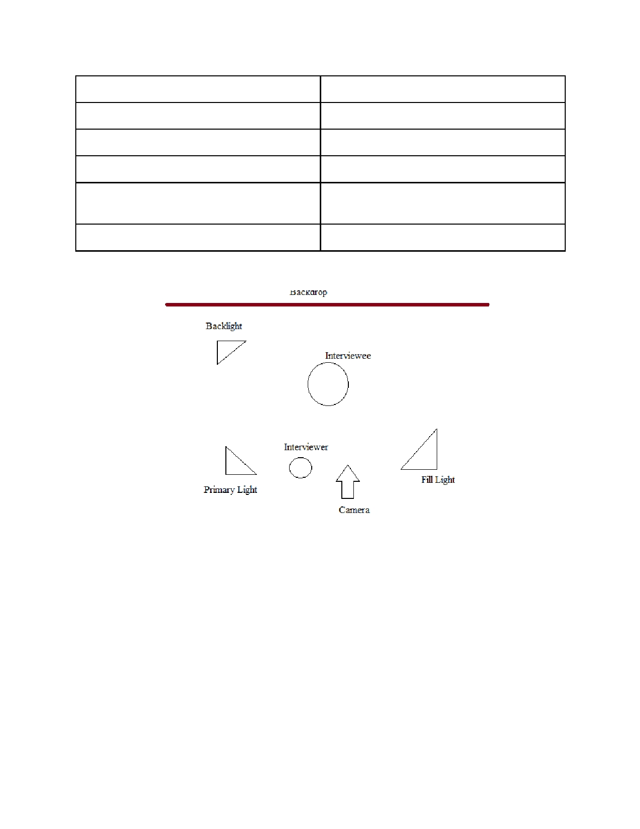
7

Equipment

Sony Camera/DSLR

Stage Lights (x4)

Lapel Microphone (x2)

Audio Transmitter

Tripod

Purpose

Film Capture

Proper lighting

Capture Audio

Receive microphone audio and input to
camera

Setup camera properly

Table 2: Filming equipment that we will use for the second set of interviews at THAT Camp

Figure 2: Setup for doing interviews at THAT Camp, where a room may not be available

For The third and final video, it is going to be filmed during the weekend of the camp is
going on. It is going to be more of a walkthrough, and will consist of a lot of B Roll footage interspersed with leftover interview footage or video booth confessional footage about camp.
This will most likely be the last video that is released due to the type of video it is, and the
amount of editing that has to be done. In addition, since the goal of the second set of videos is to
be released during the camp to draw attention to it while its going on, the editing of this video
will have to take a backseat to those. The only equipment that we would need is the exact same
from the second set of videos, minus the lighting equipment. We do not need the lighting

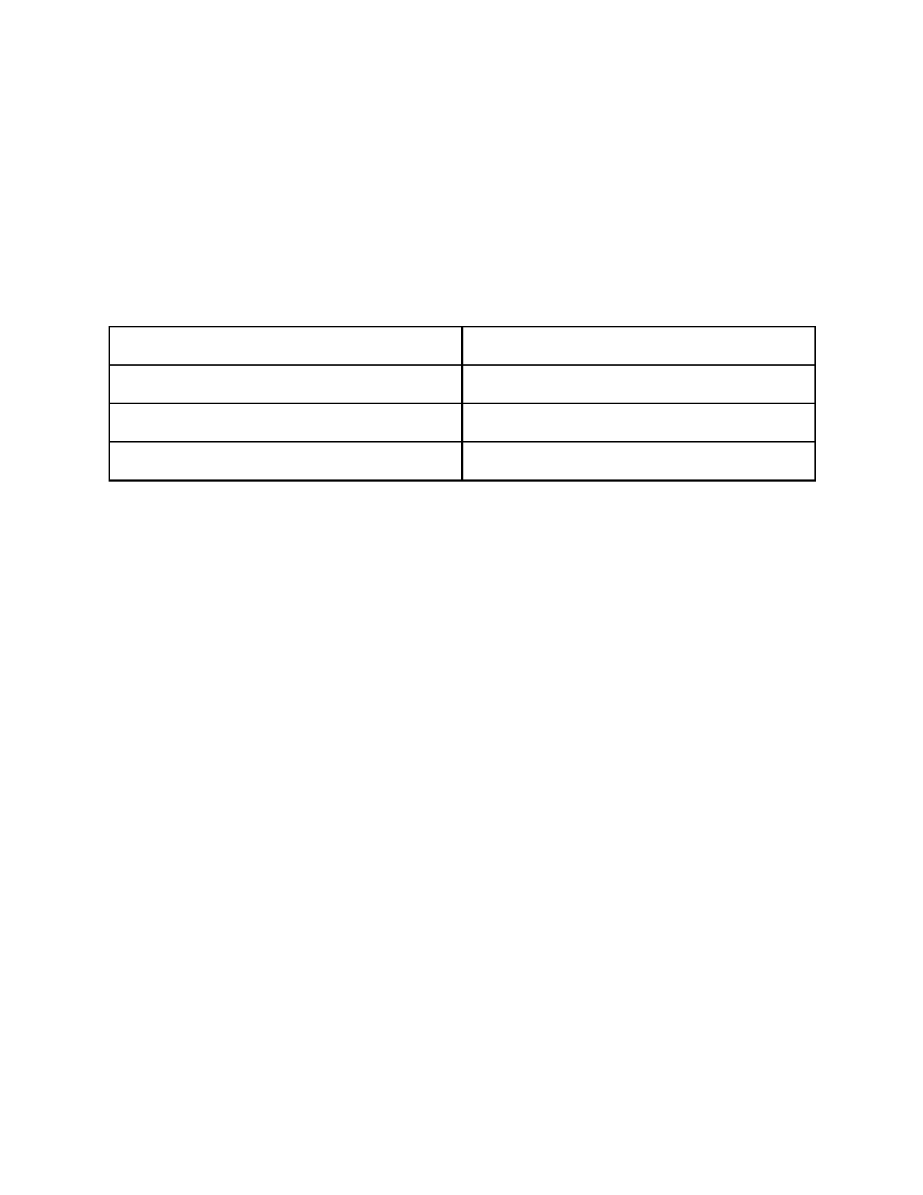
8

equipment, because we will already have the interview footage necessary for this video, and we
can not change the lighting of the rooms and locations where the camp events are occurring. There is one additional piece of equipment that we will get for shooting that is different from
above, and that is the GoPro that Innovation Space offers. We will most likely also get the "selfie stick" that allows for some creative angles to film from. The table below shows all the equipment
we will need for this portion.

Equipment Purpose

Sony Camera/DSLR Film capture

Go Pro Film capture

Selfie Stick Creative film capture

Table 3: Equipment that we will use to shoot B roll footage and stills for use in the final video

Design Report
*This section is written around 2/25/15 and before we began the project*

Scheduling Interviews
An important design aspect for our project involves us interviewing people who are working on
or involved with digital humanities projects. For the purpose of these interviews we have
designed a survey to be sent out to faculty and people attending THATCamp. The survey allows
us to schedule interviews with people involved in digital humanities projects. Our goal as
mentioned in the Requirements Report is to get a good amount of interviews done before the
actual event so that we can become proficient in the use of camera equipment. The survey will help us in accomplishing this goal. The survey has also been approved by the client and will be
our primary tool for scheduling interviews. Fig.3 shows the design of the survey.

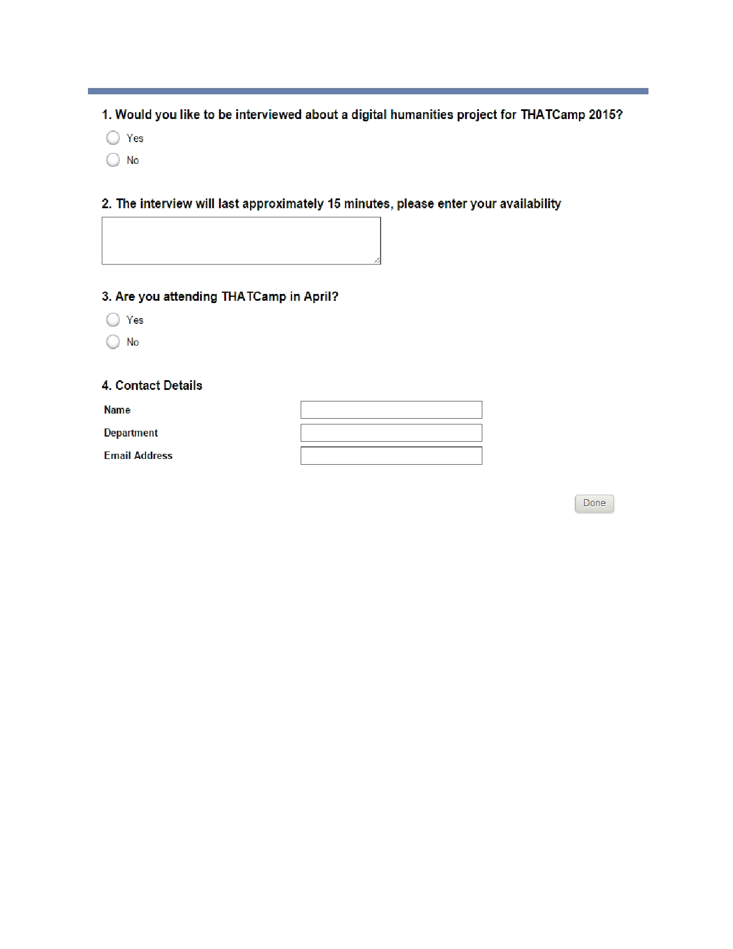
9

Figure 3: Questionnaire that is used to ask faculty about availability for project interviews

Questionnaire
The second design aspect for our project is a set of questions that we have formulated to
ask the people who we interview to better understand their involvement with THATCamp. These
questions will make them talk about their digital humanities projects in detail and what
THATCamp means to them. We are still in the process of finalizing these questions with our
client before we start conducting the formal interviews. Here is a draft of questions that we
intend to ask:

Q1. Please describe a digital humanities project that you have or intend to work on.

Q2. Describe a few benefits that technology has brought to the humanities department.

Q3. How does THATCamp serve to benefit the digital humanities project you are working on?

10

Q4. Can you name a few people who could be good resources for our project?

Equipment
Another design aspect of our project is the equipment we use to conduct interviews. This
includes video cameras, external microphones, lighting, tripods, etc. Choice of equipment is very
important in our final product, so we have consulted with Innovation Space on what equipment
will be most effective in producing our videos.
For our video cameras, we will be using Sony PMW­EX1R high definition video
cameras. These cameras are capable of capturing video up to a resolution of 1080p, at 60 frames
per second. They provide about 240 minutes of continuous use on one battery charge. Each camera will be lent to us with one extra battery, so battery life should not pose any type of
restriction when we are recording. We have taken a class on advanced video capture, where we were trained on topics such as configuring the PMW­EX1R to different lighting situations and filming from various venues. It is important that we configure the camera properly in order to
capture the highest quality shots, and come out with a professional looking final result. We plan
to use one GoPro camera mounted on a specially designed headband to capture B­Roll from a
first person perspective. We believe that this footage will provide a unique element to our video
documenting of THATCamp.
For our microphones, we will be using wireless lavalier microphones when conducting
interviews. In order to capture the highest possible quality when conducting interviews, we have
been recommended by Innovation Space to use a wireless lavalier microphone; this way the audio coming from the interview subject does not have to travel far before it is recorded by a
microphone. We will have a boom microphone on hand if needed, but are not expecting to use it. We also plan to use the shotgun microphone attached to the camera while capturing B­Roll with
the PMW­EX1R.. We have been trained by Innovation Space on how to attach external
microphones to the camera, and how to properly attach one to the interview subject. Lavalier
microphones consist of a transmitter and a receiver. The receiver must be powered on and have strong batteries in it. The boom microphone will plug directly into the video camera. We have
also been trained on how to configure all of these microphones.
For our lighting needs, we will be renting a Lowell light kit from Innovation Space. We
plan to use a 3 piece light kit, with 2 LED spotlights and one softbox. These will be primarily
used to light an area for conducting interviews. We will arrange the lights according to those as shown in Figure 4. We have been trained by Innovation Space on how to properly light a scene. It is important to have sufficient lighting when filming a scene so we have a professional looking

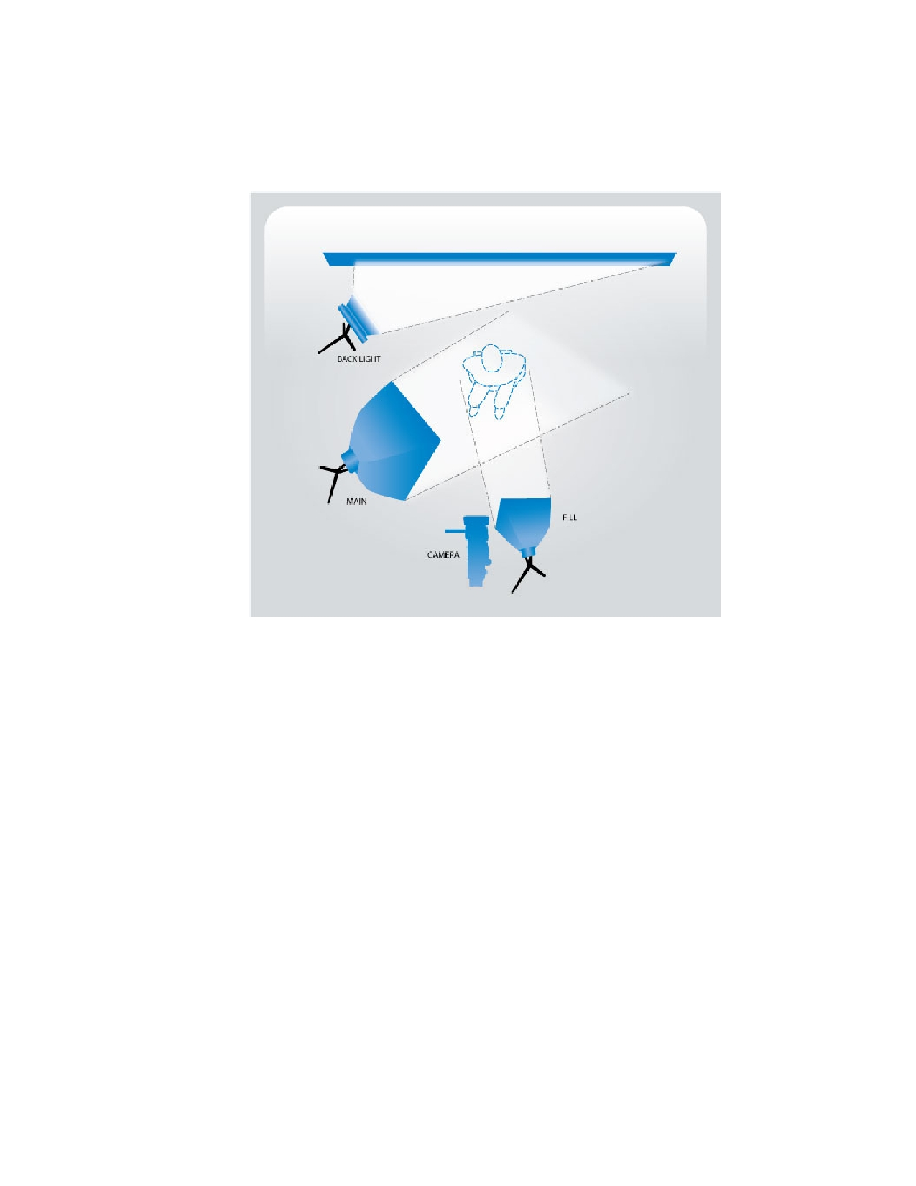
11

final product. It is also important to pay attention to things such as lighting temperature (cool to
warm) as well as shadows.

Figure 4: An example of how to light an individual for an interview using a 3 light setup
http://www.bhphotovideo.com/images/Lightfinterviews­1.jpg

Filming Locations
On the day of THATCamp, it is important that we set up our interview "booth" in an area
that suits our needs best. The most important factors to be considered are the location of the booth, the background noise, and the lighting. We would like to find an empty classroom in
Torgerson Hall, that is as close as possible to the main THATCamp action. This way,
participants do not have to feel like they are leaving the camp to participate in the interview. We
would like to choose a room where we can close the doors to eliminate as much background
noise as possible. We were offered to set up our interview "booth" in the hallway in Torgerson
where THATCamp is happening, but we fear there will be too much background noise with
THATCamp going on. Another factor to consider is the lighting situation of the area we choose to film in. Ideally there will be overhead fluorescent lights that we can adjust to our liking, but
more importantly we are hoping there will be windows to allow for natural light. We were

12

recommended by Innovation Space to keep lights in scene low, and use lights from our lighting
kit to illuminate the scene we are filming.
When collecting B­Roll, we would like for our shots to be as candid as possible. That is why we will be using a GoPro mounted in a first person perspective. The idea is that the person
filming will be participating in various THATCamp activities and capturing footage according to
what he is doing/seeing. We will also be using the Sony camcorders along with tripods to get
stable, smooth B­Roll.

Scope of Videos
The purpose of all three distinct types of videos that we will be creating has been
discussed lightly before. However, it needs to be expanded upon because the design of the project is due to the scope of the different videos. Although the project was intended to be a
documentary of THATCamp, after our meeting with the client, it was decided that we will be
going with three different sets of videos, all with slightly different purposes. The first set of videos will be produced in the weeks leading up to camp, and will be showcasing different
digital humanities projects that already exist at Virginia Tech. The purpose of this is to try and generate interest in the camp and to get those people to attend THATCamp. Since these videos
will be released through the THATCamp Virginia Twitter feed, they will be highlight the
projects and other eye catching aspects of digital humanities. The length of the videos is one of the most important factors that we have to consider while producing our videos. This is due to
the fact that people tend to have a very short attention span when dealing with videos on the
internet, so we must take advantage of that fact and produce our videos in such a way that they
have the most profound effect. The second set of videos will be produced while at camp by
interviewing camp participants. It doesn't matter if they are just attending camp or if they are a
part of a humanities project, anyone and everyone associated to digital humanities will be an
important resource to us. The purpose of these videos is to showcase the atmosphere of the camp and to give people a place to express their feelings about digital humanities. These videos will be
a little bit longer than the first set. They will also be released through the twitter account, so
again we must consider the attention span of the intended audience. However, since these videos
will be about camp events, it will draw the attention of people who made it to camp, or people who wanted to go but were unable to do so. A fair assumption to make here would be that the attention span of this audience will be slightly more since they will be more interested in the
content of the videos due to their attendance at the camp. The last video is a quick walkthrough of the camp while the camp is going on during the weekend. Since this is a timelapse video and

13

there will be no interview footage, it is not going to be very long. However, it will still be longer
than the first set of video interviews.

Implementation Report
*This section is written around 3/10/15 and during the early stages of the project*

Timeline
There is not a set timeline for the various videos that we will be creating through the
course of the project. However, as discussed previously, we will be creating the first set of
videos all the way up until the 10th and 11th of April, which is the date of THAT Camp. That
weekend we will be shooting the video for the second set of videos as well as the video
exhibiting the walkthrough of the camp activities. Upon completion of the camp, we expect to
have all footage produced and available for release and use for THAT Camp. Therefore, we will be rolling out videos as we are creating them. That is another benefit of the fact that these videos are intended to be very small scale and short so that they can be used as a teaser for the weekend
of camp. Depending on how many interviews we are able to get during camp and how much
footage we get for the walkthrough, we hope to have them all edited and cut together within the
following week or two. However, this only applies if we do not have any equipment
malfunctions or any software problems at Innovation Space that makes it difficult to edit the
videos and produce them within that timeframe.

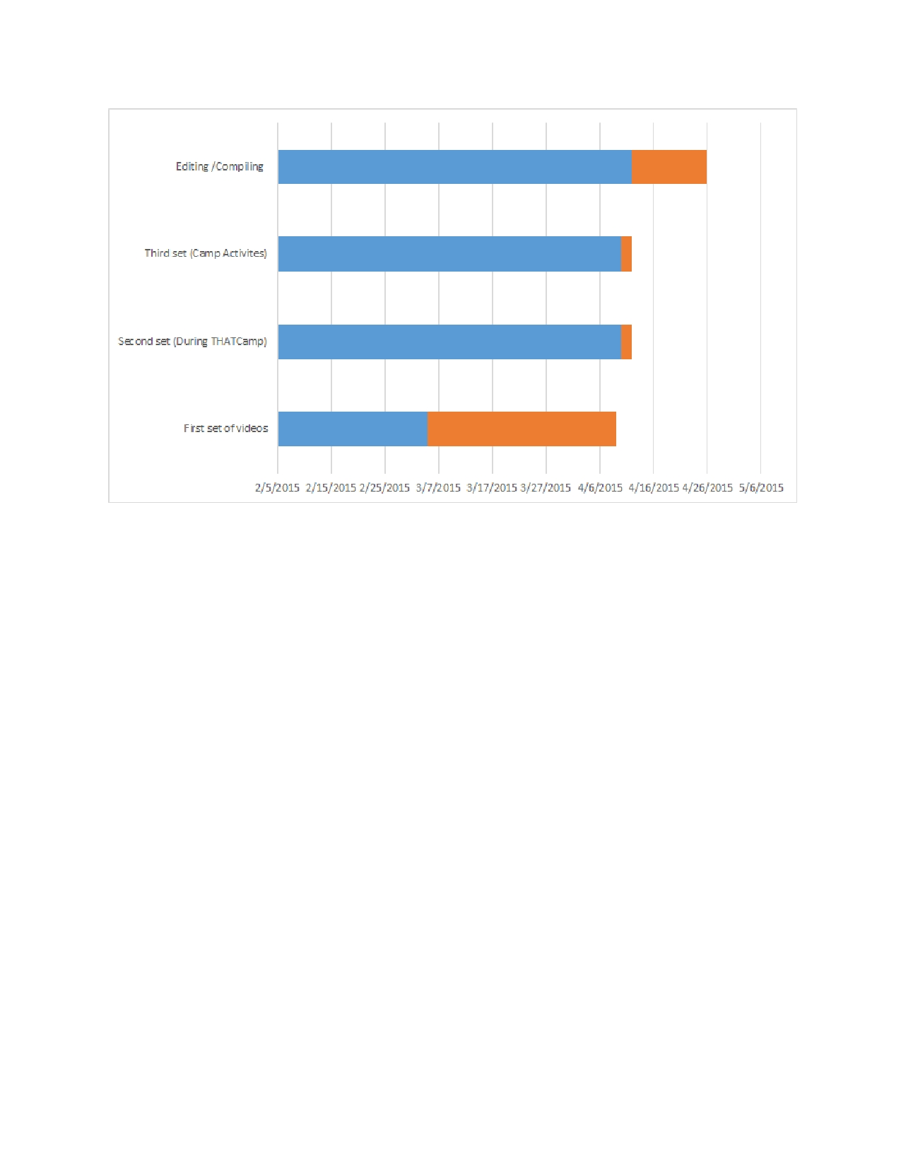
14

Figure 5​llustrates the planned schedule of shooting for the various tasks. Blue is the start time and orange is the
: ​ I
duration
​roup Roles / Teamwork G
As stated earlier all of our group members have little or no experience with video
production and handling equipment. However the class at Innovation Space helped us get a head
start on the different types of equipment and services available to us. This was a major factor
when designing the project timeline and in our communications with the client. We have designed the project timeline in such a way that it will allow us to get plenty of hands on
experience with using equipment and producing few videos before the camp actually takes place.
The way our current timeline stands we have all the group members contributing equally to every aspect of the project and we will keep switching roles such that every members gets a chance to experience all the different aspects of the project. This project plan and division of
roles was much appreciated by the client as well.

Storyboard

S​e we are creating videos, it is helpful to have a storyboard. Storyboards allow you to inc
outline the video and ensure that you have key scenes in place in the video and create
descriptions for those moments. It is a better way to ensure the pace of the video and allows you to create an outline for the video before shooting even occurs. It also allows everyone involved

15

in shooting the video and production to be on the same page for what the scope of the video is.
Another benefit of utilizing a storyboard is that you are forced to make crucial decisions early on
and it helps to get all the important details of the scene presented. That way, you are also more
likely to eliminate unnecessary footage and content, which is extremely important for our videos
since there purpose is to be short and concise.

Editing
Editing will consist of gathering all of the video footage, audio, and still shots (if any),
and organizing it into useable, indexed material. This consists of labeling and tagging each shot
with relevant information (Who is in the shot, what topic, location of shot, date/time of shot) and important timestamps (What time major events happen in the shot). Organizing our media in this way will make the rest of the editing process much more efficient. At this point we can begin to
piece together our final product. We will only be using footage we collected ourselves, we do not
plan to use any type of stock footage or pictures.
We will be editing all footage using Final Cut Pro X, in the Innovation Space lab. Using Final Cut Pro X, we will create title screens, credits, and other text screens. Final Cut Pro X will also allow us to splice clips together as well as trim clips to fit our needs. We will also be doing
post production on the video footage to adjust light and color levels.

Prototype Report
*This section is written around 3/25/15 and during the early stages of the project*

Prototype Video
Thus far, we have only talked about the videos that we are planning on doing, but this
section of the report will deal with what we have done already, and show screens from one of the
already finished interviews, as well as the editing and flow of the videos. The first set of videos
that lead up to the actual weekend of camp are the only ones that we have worked on thus far, because the other set of interviews and the other video are going to be shot during the weekend of THAT Camp. We have done a few interviews, but unfortunately the footage was corrupted, and we lost significant portions of the interview and as such they are no longer usable. We are
rescheduling the interviews to reshoot and get the material again. We have footage from an
interview with Karan Bhatia, who is a fellow student in CS 4264, and is doing a project about

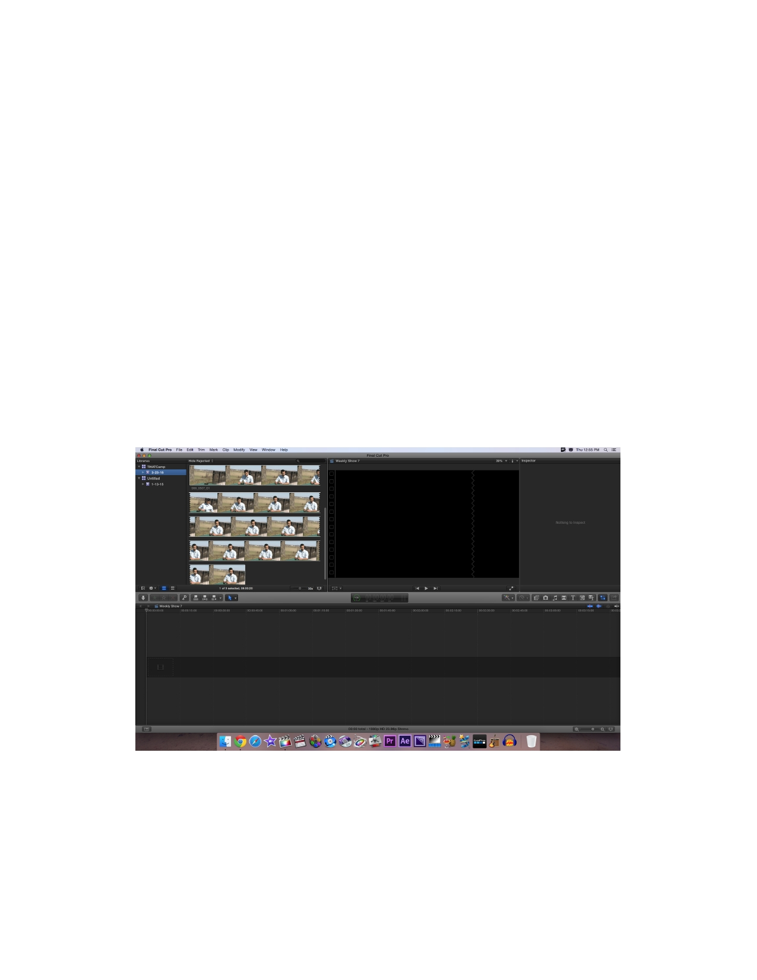
16

Soviet Era history. We contacted Karan along with a few other groups from our class that all
have projects that are related to digital humanities and we asked if they would be willing to do an interview. His group's project is to redo and help implement a website that allows for navigation
and access to various topics and information related to the Soviet Union and its history.
For this prototype video, we have constructed a complete interview that also allows us to use as a template for the other interviews that we will be creating leading up to camp, after which
we will be editing the interviews from that weekend. Most of the interviews that we will be
doing prior to the weekend of camp will have a very similar flow and questions, so this template will be very helpful for editing. The below screen shots will show various aspects of the editing we have been doing for the videos as well as key aspects of the interview video itself. The first
screenshot is a picture of Final Cut Pro, which is the editing software that we use to edit the
videos. This is what it looks like after just importing the video that we want, and about to create a new movie, which is just the term for a new video, no matter what the length. As you can see,
we have the footage already imported, and ready to be selected and broken down into various
clips. Down to the right and left, there are various tools that we use to create the video, which we
will be discussed further in depth in a later section.

Figure 6: Screen capture from early interview editing

The picture that is featured below is a screenshot of what it looks like after editing has
been done to the original footage, and we have a video formatted how we want it. As you can see

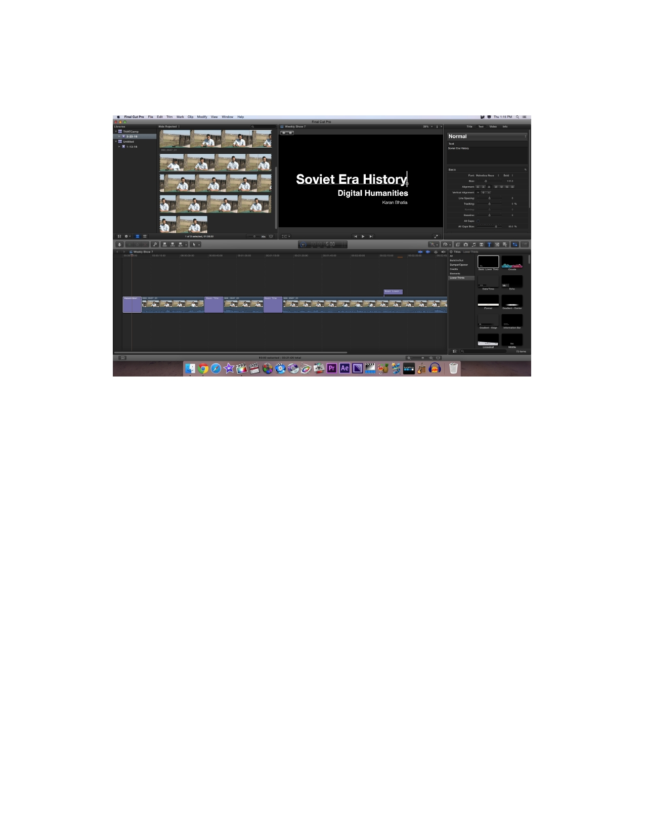
17

at the bottom, it shows the outline of the film, and the top right screen shows a preview of where
your cursor is at in the film stream on the bottom.

Figure 7: This screen dump is quick shot of the interview being edited and the flow of the video

The next screenshot (figure 8a) is showing that you can utilize title screens to
have text on a blank screen that we can use for titles, explanation, or in our case, show the question that we asked, or give some information as to what is coming up in the next video
sequence.

The screenshot after that (figure 8b) is an illustration on how we get text overlayed onto
the screen that is playing our video so that we can provide important information. The last
screenshot (figure 8c) is showing what the break slide in between scenes looks like. It is very
quick, but not too quick to where it isn't able to be read. We just decided that for the video that
break screens in between scenes that illustrate the question to be a nice way to change from scene to scene. In an effort to also provide the viewer with that same information during the
scene, incase they forgot what the scene was about, or they didn't catch the full break slide. To
illustrate this, we took two consecutive screenshots of the video while it was playing. The second
screenshot is a picture of the break slide, and the third screenshot is immediately following that, just during the scene. We wanted to include those two screenshots to help illustrate the flow of the video as it is being watched and how we transition from between scenes/questions and what
it looks like.

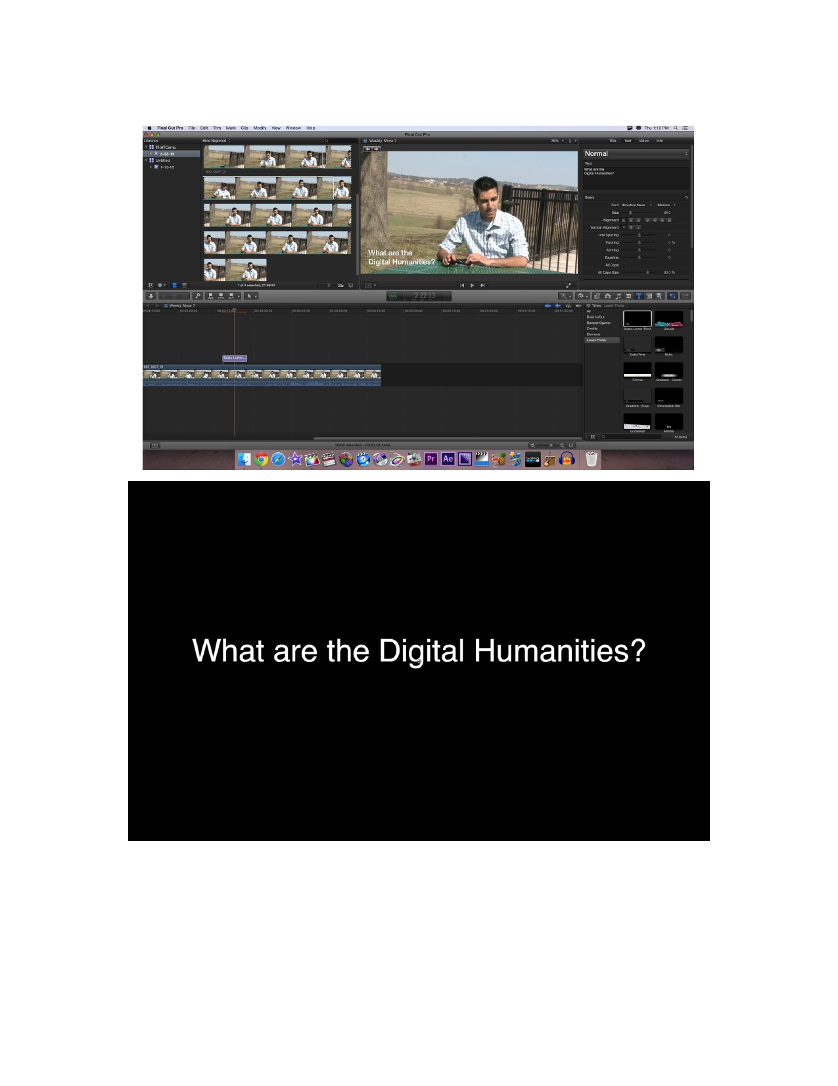
18

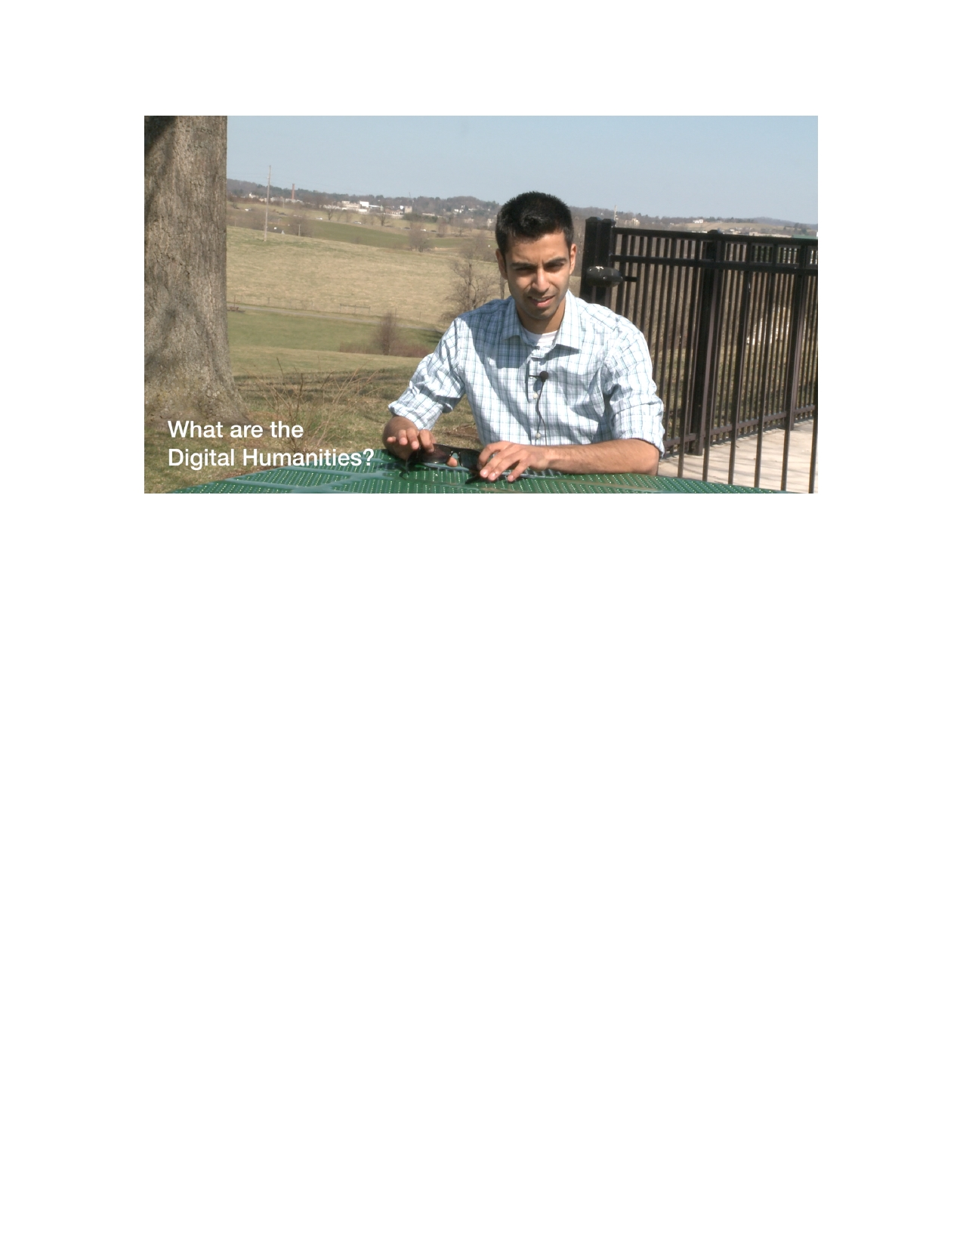
19

Figures 8a (top), 8b (middle), 8c (bottom): Illustrate the transition from showing the questions
and into the scene, where you can quickly tell what question is being answered

Future Videos
Next, we will be talking about the flow of the set of videos to be shot during the weekend
of THATCamp 2015. The experience that we gained while taking these primary interviews will be very valuable to us come April since this teaches us how to use the equipment efficiently and
also editing of videos using Final Cut Pro. There will be two sets of videos that we will be
shooting during the weekend of camp, the first set will be interviews of people attending camp
and the prototype of those will be very similar to the primary interviews we have conducted. We will be changing the set of questions we ask these people since they will be directly connected to
camp and more valuable resources. Not all of the interviews here will be used in our main
documentary, rather some of them will make up for B­roll as we showcase the events of camp.
The second video of this set of videos will be a comprehensive video of camp that will highlight all major events that take place over the weekend. It will be very important for our team to split up roles efficiently in order to capture all necessary events at camp. As the material of this video will be very important for our project we need to make sure the editing is done correctly and the
file does not get corrupted like one of our previous interviews. We will be working very hard
over the next couple of weeks to edit and capture as many videos as we can to become proficient before the weekend of camp. The prototype for our final video will consist of recording all major
events of camp along with all the interviews and B­roll material. The final step will be to bring

20

everything together in an organized way and edit all the recordings using Final Cut Pro and turn
our footage into usable video.

Final Cut Pro

We are using Final Cut Pro to edit all of our footage, and create our deliverables.
Innovation Space is providing both the software (Final Cut Pro) and the hardware (iMacs) to
make this possible. Each interview will follow the same template as described in the following
paragraph.

Each interview will open with a title screen. This title screen was created using the Titles
menu in Final Cut Pro. Under the titles menu, we have selected the "center right aligned elastic
title" This contains one main title with two right aligned sub titles directly below. We are using a
black and white color scheme that can be seen in other title screens throughout the video. In the following clip, the interviewee is responding to the question "What are the Digital Humanities."
In this clip we again use the Titles menu but this time it is overlaid over the clip of the
interviewee talking instead of being a stand alone title screen. In this case, we use a "lower left
aligned" title screen, and white text because it provides the best contrast. The purpose of
overlaying the title onto the video clip is to provide clarification to the viewer on what is being
talked about. Each clip obtained by using the trimming tool. This allows us to pick only the
important footage we want in our final product from the much larger sections of footage obtained
when we are recording interviews. This also allows us to cut out the footage between interview
questions, and created smoother transitions.

Refinement Report
*This section is written around 4/7/15 and right around the time of THATCamp filming*

Video Shooting
In order to improve the overall quality of the footage we are gathering, we will focus on
background noise, lighting, configuring the recording equipment correctly, paying special detail to setting up our shot, and focusing on our interview subject. Our first two interviews were shot

21

in the software engineering lab in the basement of McBryde Hall. This room has one server that
is up and running 24/7. Although we recognized that it would create background noise, we
thought that use on a directional audio recorder and post production would take care of this issue. Even with the use of a directional audio recorder, that background noise could still be heard, and
post production efforts were futile. We plan to take care when lighting the scene to reduce
shadows behind the subject, as well as minimize natural lighting. The problem natural lighting poses is if the sunlight level changes (such as a clouds moving in front of the sun), the camera
needs to be white balanced again.

We will also focus on configuring our equipment properly before beginning to record.
We will use auto focus instead of manual focus, because we have found it is just as effective if not more effective. We plan to frame our future interviews in a way that the interview subject is not in the direct center of the shot, but instead off to the side a bit. We found that it looks better
this way, and gives more of an interview "feel." We will also pay special attention to our
interview subject, making sure they keep eye contact with the interviewer, pause before and after
their responses (for editing purposes) as well as refrain from playing with hands, playing with
hair, touching face, fidgeting, etc.

During the weekend of THATCamp, we were able to get some great footage of the camp proceeding and interviews. The conference began around midday on Friday, and we were able to
move around between the four different workshops that were going on initially and get some
great B­roll footage of the event. We shot some footage of campus as well that we hoped that we
could use for some of the compilation video of camp. We did not get any interviews shot on
Friday, because the conference organizers thought that it would be better to wait until Saturday,
when there are a few more people attending, and not throwing anyone off the event.

On Saturday, we arrived before the workshops started at 9 am, and we set up an interview location on the first floor of Newman Library. After discussing the location with Dr Warnick, we got his input on which chairs to use, and we even moved a fake plant to try and help improve the
background. After a couple interviews, one of the people attending the event gave us some
wonderful tips and advice on how to setup the interview set and lighting, to help eliminate the
shadows and get the best shot possible. We also had a second camera setup as well as the audio
recorder incase something went wrong with the EX1R or the batteries went dead in the audio kit. The batteries actually did go out on one of the interviews, so we did a great job in planning ahead for that circumstance. In total we got about 15 interviews recorded of event attendees, where one
was Dr Ewing and another was the main event organizer, Amanda French. In addition to the

22

interviews, we also recorded some additional B roll for use in the main video of the camp. That
footage was of a couple of the workshops and the closing ceremonies once the camp was done at
4 pm.

Video Editing
In an effort to increase the quality of the videos, we are planning to learn more about
what editing features we can utilize in innovation space. Since we will be using final cut pro to
edit our videos, we have been familiarizing ourselves with the necessary tools, as well as
learning more about the lesser utilized features, so we can edit the videos the best we can with
the full power of the software at our disposal. To help make the interview videos more engaging,
we have started to make it a point of using fade in and fade outs to various relevant materials, whether it is screenshots of websites video of artifacts. This helps to keep the viewer engaged
and interested in the content that is being displayed.

To take it a step further, the staff at innovation space has been really helpful in teaching
us more about the editing features that we are using so that we are able to create better videos. They are there to help people in innovation space with their editing if they have questions, but
we have been using them in a slightly different manner, where we will ask them for small
amounts of help if we need it, but we will also get their opinions on what they consider to be the
best ways to edit scenes and videos together. We have also been looking more into transitions
between scenes, and have begun using cross dissolves to make those transitions better. In
addition to visual transitions between scenes, we have been using the audio effects that are
available in final cut pro. You can very easily separate the audio from the video, and once that is
done, you can keep the audio as voice over for showing other material we have, for instance, a
screenshot, or shot of artifacts. We have also been using another feature of the audio effects, and
that has been the logarithmic audio fade. This feature allows us to fade the audio going into the
next scene, or beginning the scene, so the sound seems less harsh and abrupt. Also, the
logarithmic fade sounds a lot better than just a linear fade of the audio because the logarithmic
fade sounds more akin to how natural audio decays versus a linear fade.

Interview Question Refinement
The quality of our interview questions that we had initially drafted had to be refined over
time. Our goal was to pose thought provoking questions to our interviewees so that we can show
what digital humanities means to different people. Our first two interviewees were seniors

23

majoring in Computer Science and group leaders for different digital humanities groups. We
focussed on asking them very straightforward, to the point questions just as we had mentioned in
the Questionnaire in the design report. Our goal was to understand the motivation behind them
choosing to work on a digital humanities project and get a brief description of the work that they
were doing. Our next interviewee was a Phd student doing research in the Computer Science
department. His research was primarily focussed on translating regular english language pages into Arabic. For this interview we had to change the requirements for the Interview Questions and had to let the interviewee take charge by going through important aspects of his research.
The only important question that we had to include in this interview was for him to describe how
his research related to the digital humanities.

The refinement of interview questions was dependent on a couple of factors, such as the person we were interviewing and also how much experience the person had working with digital
humanities. The biggest challenge that we came across while refining questions was when we were scheduled to interview one of our clients. Dr. Warnick had a great amount of experience
with digital humanities and is directly involved with THATCamp. We wanted to change our
questions to make them more specific to his project and the workshop he was leading at camp.
Our group decided that the best way to go about it was to discuss the questions with him
beforehand so we don't miss out on any important information. He helped us reformat a couple
questions that would sync with his answers in a better manner. We now have a set of three to
drafts for potential questions that we could ask people at camp depending on their experiences.

Testing Report
*This section is written around 4/25/15 and after we filmed camp and in post production*

Audio Editing Techniques
Upon inspection of footage shot on Saturday, April 11th, it was to our dismay that a small
fraction of the audio we had collected was not satisfactory. However, we were prepared for such
an incident, and were collecting audio from a secondary source as well, using a professional
audio recorder. Using Final Cut Pro, we were able to accomplish the following: 1. Remove sub
satisfactory audio from accompanied video clip. 2. Add audio from audio recorder to clip and

24

sync both tracks. The result was a clean looking clip with clear audio. We used this technique to
doctor 2 clips.

While conducting interviews, we dealt with intermittent background noise, coming from a nearby elevator. In a few clips we shot, it was slightly noticeable. In order to fix this problem, we applied a specialized filter to the audio track. This filter was included with Final Cut Pro and
is specifically designed to reduce background noise within a specific frequency. We were
successful in cleaning up our footage, to the point tho no background noise can be heard. We feel
this contributed to the overall quality of our final product.

We chose to include background music to our videos, because it adds a nice tone to the
videos. Incorporating this into our project posed several challenges that required a bit of creativity to overcome. Choosing the correct volume for background music can be tough,
especially when dealing with many clips with slightly different audio levels. The final decision
must take into account each clip, and compliment it well. We slowly fade in the music a few
seconds after the video begins, and fade out a few seconds after the final title screen is displayed.
This giver the final product a much smoother feel, without abrupt changes in the audio.

Finally, we made audio related changes to each interview clip. Because we show many
different interview clips back to back to back, we found it necessary to fade out the audio quickly at the end of each clip, as well as fade in quickly at the beginning of each clip. This created much
smoother transitions between the many clips we play.

Video Editing Techniques

Final Cut Pro has a variety of video editing techniques that helped us in making our
transitions smooth. Adding transitions gave our videos more fluidity and allowed for a fluid
change from clip to clip. Once the transition was added we could even adjust its parameters.
Final Cut Pro also allowed us to modify the transition effect in motion. The feature that we used
the most to edit our videos was the cross dissolve that allowed us to select an edit point, then
apply the transition with a few quick actions.

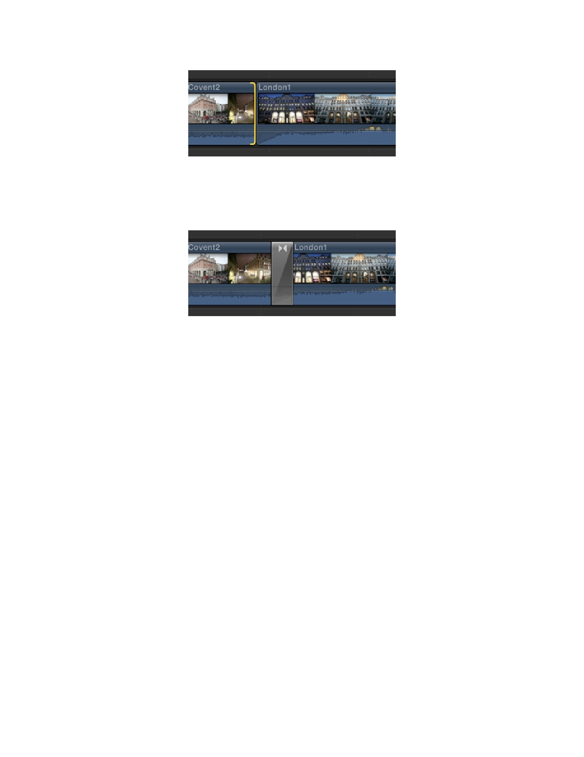
25

Figure 9: Edit point in Final Cut Pro
As we can see in the above figure, Final Cut Pro allows us to select an edit point between any
two clips by clicking the edge of the second clip.

Figure 10: Cross dissolve between scenes in Final Cut Pro
Once we chose to add Cross Dissolve, a grey space with a slight diagonal line and arrows facing
each other will appear on top of the edit point. This can be seen in the figure above. The effect
can be previewed by playing the clip beginning before the transition.

Video Screening

Once we have our first couple edits of the video that we think are decent, we watch them
ourselves, show them to our friends and roommates, and for a few of them, have even been
sending them along to our clients, Dr. Warnick and Dr. Ewing to see what they think. We do this
in an effort to get constructive criticism for how we can improve the videos. Both of the above
sections dealing with different Video Editing and Audio Editing techniques are incorporated into the videos before we export them as full videos for viewing. Before we even began filming of the
conference in April, we shot preliminary interviews and footage, as well as tried out various
editing techniques to see what worked and what did not for the final videos. The best example of chain of events was after Dr Warnick was gracious enough to do an interview with us, we edited
his interview a couple different ways, with a few different types of scene transitions, and we
uploaded it for his viewing.

26

From the feedback he gave us on his video and the several other interviews about various
digital humanities related projects, we were able to improve both his interview as well as the
other we had already shot and edited. We were also able to test some new ways of shooting and
capturing audio that we were able to utilize for the weekend of camp and capture the best
interviews possible. The first video that we finished of the weekend, we again uploaded it for our clients and were able to get preliminary feedback. From there, we were able to make any changes that were necessary to improve the quality of the videos, like adding more relevant b roll footage,
and lowering the volume of the background track a minor amount, which would seem like an
insignificant change, but ultimately can change the entire video. Since videos can not really be
"tested", it is extremely important to get feedback from outside sources, especially those with no
prior knowledge of the interviews, so that we will get honest and critical feedback about the
videos that help to gauge the quality of the videos.

27

References

Apple (author) "Adding Transition Between Clips." Final Cut Pro 7 User Manual. Apple.
Web. 6 May 2015.

<​tps://documentation.apple.com/en/finalcutpro/usermanual/index.html#chapter=47%26section ht
=2%26tasks=true​ >

Perlmutter, Patrick. "Applying the Cross Dissolve Transition in Final Cut Pro X." Tutorial for
Final Cut Pro X. Infinit Community. Web. 25 Apr. 2015.

<​tp://infinit.io/community/applying­the­cross­dissolve­transition­in­final­cut­pro­x/​
ht >

Jensen, Doug. "Mastering the Sony PMW­EX1 & EX1R." Instructional Videos and Innovative
Production Tools for Video, Television and Digital Photography. Vortex Media. Web. 5 Apr.

2015. <​tp://www.vortexmedia.com/DVD_EX1.html​
ht >

Robertson, Mark. "WHEN AND HOW TO USE A WIRELESS LAVALIER MIC." Reel
Videos: Tutorials, Tips and Interviews. Reeleso, 8 Aug. 2012. Web. 7 Apr. 2015.

<​tp://www.reelseo.com/wireless­lavalier­mic/​
ht >

"Zoom H4n Audio Recorder Operating Guide." Computing and Technology Help Pages. The
Evergreen State College. Web. 8 Apr. 2015.

<​tp://wikis.evergreen.edu/computing/index.php/Zoom_H4n_Audio_Recorder_Operating_Guid ht
e​ >

Driscoll, Edward. "RECORDING GOOD AUDIO FOR VIDEO." Videomaker, 1 Apr. 2009.
Web. 2 Apr. 2015.
<http://www.videomaker.com/article/14216­recording­good­audio­for­video>

28

Grula, Lorraine. "Video Lighting Techniques for Videos and Documentaries." Make A
Documentary. Desktop­Documentaries. Web. 5 Apr. 2015.

<​tp://www.desktop­documentaries.com/video­lighting­techniques.html​
ht >

"Reducing Background Noise in FCP." Apple Support Communities. Apple, 3 Nov. 2009. Web.
15 Apr. 2015. <https://discussions.apple.com/thread/2221200>

Innovation Space Website: ​tp://www.is.vt.edu/ ht

THATCamp Website: ​tp://virginia2015.thatcamp.org/ ht

