Experimental Investigation of Sound Transmission Loss in Concrete Containing Recycled Rubber Crumbs

Navid Chalangaran ª, Alireza Farzampour ^{b*}, Nima Paslar ^{c}, Hadi Fatemi ^{d}

Department of Civil Engineering, Qeshm Branch, Islamic Azad University, Qeshm, Iran
* Department of Civil and Environmental Engineering, Virginia Tech, Blacksburg, United States
Department of Civil Engineering, Payame Noor University (PNU), P.Obox,19395-4697 Tehran, Iran
⁴ Department of Civil Engineering, Shiraz Branch, Islamic Azad University, Shiraz, Iran

(Received keep as blank , Revised keep as blank , Accepted keep as blank )

Abstract. This study represents procedures and material to improve sound transmission loss through concrete without having any significant effects on mechanical properties. To prevent noise pollution damaging effects, and for reducing the transmission of the noises from streets to residential buildings, sound absorbing materials could be effectively produced. For this purpose, a number of several mixture designs have been investigated in this study to reduce the sound transmission through concrete, including control sample and three mixtures with recycled rubber with sizes of from 1mm up to 3 mm to limit the sound transmission. The rubber is used as a replacement of 5, 10, and 15 percent of sand aggregates. First, 7, 14 and 28-day strengths of the concrete have been measured. Subsequently, the sound transmission losses through the samples have been measured at the range of 63 Hz up to 6300 Hz by using impedance tube and the transfer function. The results show specimens containing 15% fine-grained crumbs, the loss of sound transmission were up to 190%, and for samples with 15% coarse-grained rubber, the loss of sound transmission were up to 228%, respectively. It is shown that concrete with recycled rubber crumbs could effectively improve environmental noise absorption.

Keywords: Concrete, Recycled Rubber Crumbs, Sound transmission Loss, Mix Design, Impedance Tube

1. Introduction

Sound pollution could be considered as a harmful factor for natural inhabitant, and environment. Urbanism, airports developments, and construction of highways around cities, could cause significant amount of noise pollution due to traffic having harmful effects on the habitants. In spite of industrial advances, exposure to excessive permissible sound is still one of the most hazardous health problems threatening the residents of urban areas and industrial workers in the world (Cho, 2013; Craik, 1982; Sousa and Gibbs, 2011; Kihlman, 1970; Ren et al., 2020; Farzampour and Eatherton, 2019; Farzampour et al. 2020; Williams and Partheeban, 2018, Farzmpour et al. 2019a, 2019b and 2019c; Paslar et al. 2020a; Paslar et al. 2020b). As sound waves encounter a solid hardboard, in addition to reflecting and absorbing waves, they pass through the surface which could negatively affect the health of residents. Researchers have conducted several studies on the sound transmission loss (STL) from materials from year 1990 to 2016 (Concha-Barrientos et al., 2004; Forouharmajd et al., 2016; Gholami et al., 2014; Yousefzadeh et al., 2008). Using materials that reduce the transmission of sound in private, public and industrial spaces can have a significant role in controlling sound and extra noise inside of buildings. Sound transmission loss through the concrete is estimated by two general measurement methods. The first method is to evaluate the sound transmission class and the second method is to calculate the transmission loss by using the impedance tube.(ASTM, 2009; Gholami et al., 2014).
Concrete is typically implemented for having high compressive and tensile strength for use in various structural applications. However, this material loses it’s resistance under environmental conditions, causing crack propagations and degradations. There are several producers to implement and refine the concrete to withstand the excessive environmental conditions by using additive materials, fibers and rubber crumbs in different shapes (Hosseini, 2020; Erdogdu et al., 2019; Fayed and Mansour, 2020) and mechanical properties leading to desirable resistance and durability (Farzampour, 2017, Farzampour et al. 2018). It is previously shown that adding blast furnace slag and fly ash could be useful in developing concrete resistance; however, improving the concrete behavior against transmitting the environmental loss is in need further investigations. Along the same lines, use of mineral admixtures is limited, and improvement methods are necessary for use in general applications and reducing the negative conditions threating the residential health (Farzampour, 2019; Mansouri et al., 2020; Chalangaran et al. 2020). Implementation of different materials for reducing the extra environmental noises could be used for various private and industrial sectors concrete applications (Forouharmajd and Mohammadi, 2016; Forouharmajd et al., 2016).
At this point there are a few major procedures to estimate the sound loss of different materials (Yousefzadeh et al., 2008). It is shown that using impedance tube of the transfer could effectively estimate the sound transmission loss compared to the rest of the procedures (Yousefzadeh et al., 2008). Along the same lines, previous studies showed that adding 10%, 20% and 30% plastic crumbs for reducing the heat transmission within the panel, and concluded that adding plastic crumbs could be useful for preventing heat transmission compared to the simple concrete panel (Batayneh et al., 2008; Ganjian et al., 2009; Rahim et al., 2013). Several researchers have examined the rate of sound transmission loss by testing a room for concrete with high porosity materials (Asdrubali et al., 2008; Collings and Stewart, 2011; Sukontasukkul, 2009). In this method, in a rectangular room with a smaller side of the sample, an audio source and a microphone are placed inside of the room and a microphone is placed outside the room. After the noise is emitted by the sound source, the amount of sound loss and the amount of sound absorption are measured by the microphone inside and outside of the room. The results show that by increasing the porous materials in the concrete, the reduction of sound transmission could be possible (Tan et al., 2016; Uthaichotirat et al., 2020).
In this study, a number of several mixture designs have been investigated to evaluate the sound transmission through concrete with recycled rubber crumbs with sizes of from 1mm up to 3 mm initially. Subsequently, the compressive test, and tensile resistance assessments are conducted to estimate the resistance loss and adhesion quality of rubber crumbs with the concrete matrix. The strength issues related to use of rubber crumbs in concrete are addressed by indicating the optimized additives percentages in mixtures. Ultimately, the effectiveness of rubber crumbs with different sizes in various rubber content for improving the sound transmission loss at specified frequencies ranges are evaluated and compared.

2. Sound transmission loss evaluation
The mix design is designed according to ACI 211-89 in which the slump is considered between 50mm to 70mm. The compressive strength is measured based on the samples with dimensions of 15 cm ×15 cm under 7, 14 and 28 curing days. The splitting tensile strength and Modulus of elasticity are evaluated with 15×30 cm cylinder samples, and are measured after complete curing condition. Each additive is examined separately for three different alternatives for strength development. Ultimately, the optimal compressive strength of Nano-silica with Metakaolin is measured and combined with the maximum weight amount of rubber crumbs, which is shown in Fig.1.
In this study four mixing designs were examined including one control sample and three mixing designs containing fine-grained waste rubber crumb aggregates with dimensions of 1-3 mm. The rubber crumbs have replaced with 5%, 10% and 15% of the sand’s weight. In order to investigate the compressive strength of the concrete, three samples of 150mm × 150 mm for 7 days old, three samples for 14 days and three samples for 28 days old were prepared. For better compatibility, super-plasticizer was used, and in all designs the concrete consistency was remained 10mm ± 50mm (Pfretzschner and Rodriguez, 1999), water-cement ratio is considered to be 0.29.

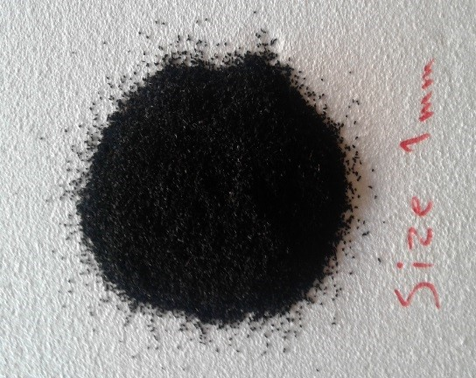 | 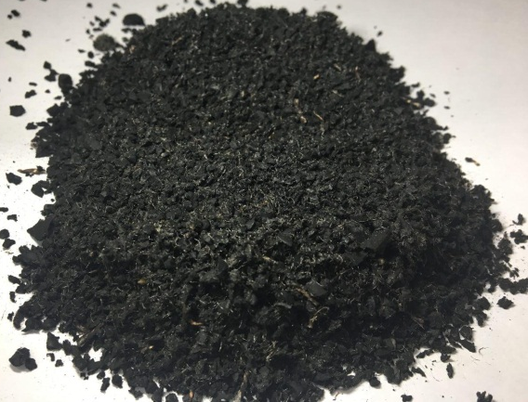
(a) Fine-grained rubber | (b) Coarse-grained rubber
Fig. 1 Fine-grained and coarse grained rubber used for sound loss improvements

The cement used in this study is chloride resistant TYPE 2 for having lower hydration heat. Chemical analysis of this cement is provided in Table 1. Rubber crumbs used in this research are obtained from tire wastes of cars with two different sizes. Crushed rubbers with dimensions of 1mm to 3 mm are named PR and the ones with dimensions of 3mm to 6 mm are named CR (Table 1). The gravel aggregate are used with dry weight of 1620 kg/m³ and the maximum dimension of 12.5 mm. The almond coarse gravel are considered to have a dry weight of 1600 kg/m³ and maximum dimension of 19 mm. Super plasticizer with commercial brand of Super Plast P.C 5000N is used to uniformly spread the concrete and prevent the particles from sticking together again by obstructing the space between particles. This also decreases the mix water up to 30% to improve the ultimate concrete strength. It is also determined that that by using Nano silica and Metakaolin additives in the concrete mix design, the water ratio should be set 0.4 or more to compensate the high water absorption of the additives. The details of rubber and aggregates are shown in Table 1.

Table 1. Common properties of the concrete chemical content

- The Chemical Component of the concrete
Chemical Component (%)
 | Cement
Sio2 | 21
Al2O3 | 5.4
Fe2O3 | 4.21
CaO | 63.59
MgO | 1.7
SO3 | 1.8
K2O | 0.8
Na2O | 0.12
L.O.I | 1.38

- The rubber component details
Chemical Component
substance | Weight percent
Natural rubber | 40%
SBR | 30%
Butadiene rubber | 20%
Butyl and halogenated butyl rubber | 10%

- The details of aggregate

Shear type | Average size | Nominal size
Fine-grained rubber | crumb rubber mixture  1,1.5, 2, 2.5, 3 mm | 1-3 mm | Angular and plain
Coarse-grained rubber | Crumb rubber mixture  3.5,4, 4.5, 5, 5.5, 6 mm | 3-6 mm | Angular and plain

Mix design is developed based on the standard procedure of ACI 211-89. For this purpose, four different mix designs with ultimate strength of 400 kg/cm² are considered, and each mix design includes three different alternatives with a specific additive. Super plasticizer is initially mixed with water and poured into the mixer, then additives are added to the mix. Subsequently, the aggregates and cement are poured into the mixer. For the sample with rubber crumbs, first the rubber crumbs and sand are mixed and then poured into the mixture following the previous producers for the rest of the mix designs.

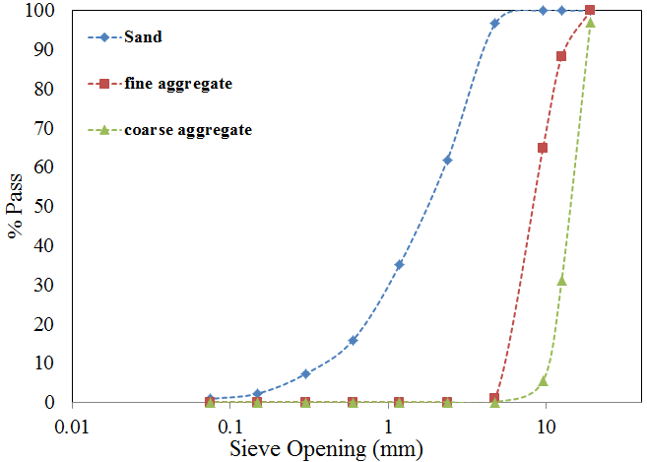
Fig. 2 Grading curves for used aggregates in concrete mixtures

After thorough mixing, the concrete slump is specified and then sampling is done. It is noted that in all sampling processes, casts are filled in three layers and each layer is tapped 25 times and finally smoothed and kept in maintenance pool following ASTM procedures. Table 2 summarizes the considered samples for sound loss investigations in concrete with recyclable rubber crumbs. To conduct this test, samples with diameter of 100mm and 50mm in height, as well as specimens with diameter of 30mm and 50 m in height were produced. To calculate the transducer loss according to the E2611 standard, the SW422 + SW477 model Impedance tube made by BSWA Company is used. This device has two no-porous cylinders with tough material and uniform surface to evaluate the sound frequencies between 63Hz to 1600 Hz for 100mm and 1600Hz and 6300 Hz for 30mm. It is noted that various parameters such as temperature, humidity and air pressure should be precisely monitored and reported for having high accuracy of obtaining the data. Based on the E2611 standard, the room temperature is set to be 20ºC, humidity rate index is considered to be 30% and air pressure is 1.2 kg/m³. Initially the frequencies of 120db were generated in form of white noise throughout the pipe. Subsequently, by evaluating the sound loss at the locations in which the microphones are located, the sound transmission functions are evaluated accordingly.
Fig. 3 shows the experimental test for which three microphones are established to send and retrieve the signal following the digital frequency assessment. The major advantages of using impedance tube over other methods are the high accuracy of sound loss, applicability of the method for smaller specimens, and precise calibration possibility. However, for this method the mold should be designed with high accuracy which might increase the preparations cost.
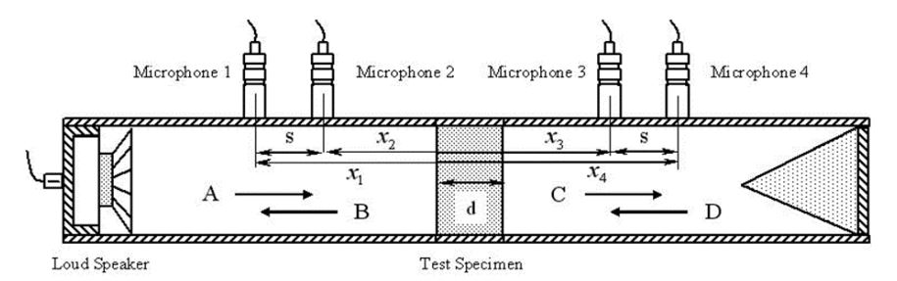
Fig. 3 Schematic of impedance tube for sound transmission loss (Jung et al., 2008; Wang et al., 2013; Zhao et al., 2014)

The kits are used to determine the sound absorption coefficient and surface impedance considering measurements and calculations that meet the standards ISO 10534-2, ASTM E1050 – 12, and transmission loss ASTM E2611 – 17.
By measuring the sound energy on the both sides of the separator, the sound energy could be evaluated. Eq.1 and Eq. 2 are used for further calculating the separator transfer coefficients (Chung and Blaser, 1980; Kimura et al., 2014; Vigran, 2012).

(1)
(2)

In which τ is the separator transfer coefficient, and Wi and Wt are audio power coming to the separator and audio power transmitted from the separator.

Table 2. Common properties of the concrete chemical content
Name | Gravel (kg/m3) | Sand (kg/m3) | Cement (kg/m3) | Water (kg/m3) | Rubber (kg/m3) | Plas (kg/m3)
Cont | 992 | 732.39 | 462.2 | 132.52 | - | 1.39
PR 5% | 992 | 695.79 | 462.2 | 132.52 | 36.6 | 1.39
PR 10% | 992 | 659.16 | 462.2 | 132.52 | 73.23 | 1.49
PR 15% | 992 | 622.54 | 462.2 | 132.52 | 109.85 | 1.59
CR 5% | 992 | 695.79 | 462.2 | 132.52 | 36.6 | 1.59
CR 10% | 992 | 659.16 | 462.2 | 132.52 | 73.23 | 1.59
CR 15% | 992 | 622.54 | 462.2 | 132.52 | 109.85 | 1.59

3. Investigations on the concrete mechanical properties

After drying the sample, to measure the compressive strength of concrete, samples from two flat surface are placed for further investigations. The constant loading speed is applied on the samples and by dividing the ultimate force applied on the cross-sectional area, the concrete compressive strength is calculated. Compressive strength, splitting tensile strength and modulus of elasticity are assessed according to ASTM C469 and C39 standards, which are shown in Fig. 4. To conduct compressive strength test, nine cubes with dimensions of 15×15 cm following the standard procedures with ages of 28,14,7 days are selected and evaluated. In addition, for the tensile test three samples with 15×30cm dimensions and 28 cured days are considered for each mix design. Along the same lines, to test the static modulus of elasticity using module enclosure, three samples with 15×30 cm dimensions and the curing age of 28 days are assessed. It is noted that samples are taken out after a day from molds, and after three days in water, they were put under the sunlight. Subsequently until the experiment, they were put at the ambient temperature. Ultimately, at minimum, 28 days after, the samples were tested for sound transmission test.
The compressive strength of the samples is investigated to determine the feasibility of this type of concrete for using as road or wall separators and construction blades. By increasing the amount of rubber crumbs, further decrease in the concrete’s resistance in generally observed. With replacing 5% of rubber crumbs with the sand, the compressive strength decrease 12.5%, and by increasing the amount of replacement percentage, the compressive strength in the sample containing the rubber crumbs decreased by 15.4% to 38.4%. The reason for the resistance loss in rubber-containing samples is that rubber crumbs are used as a substitute for the stone materials with soft texture and the presence of the rubber in concrete causes lack of adhesion in materials leading to less compressive resistance. The failure behavior of the samples shows that the samples bear a high compressive load after failure and have significant deformation without being collapsed. It is shown that samples containing rubber crumbs do not collapse after failure and can be reloaded with fewer loading cycles. This behavior reflects the high energy absorption of rubber-coated concrete. It is noted that the porosity of all samples was assessed to be with in the range of 3.5 to 5%.
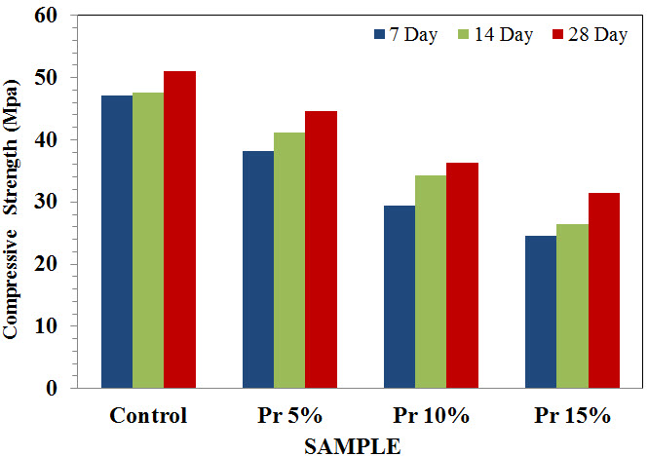
Fig. 4 Compressive strength of samples containing fine-grained rubber

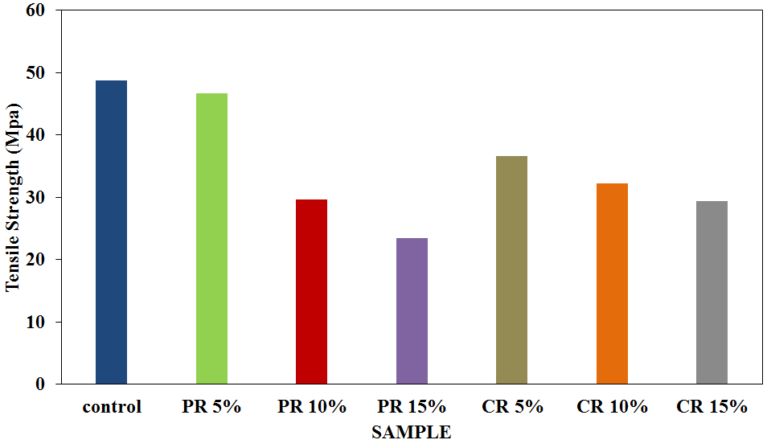
Fig. 5 Tensile strength of samples containing fine-grained rubber

By substituting the coarse aggregate with rubber crumbs, significant reduction in ultimate compressive strength of the concrete samples is observed. It is shown that using rubber crumbs could lead to 12.5%, 15% and 38.4% decrease in concrete strength with 5%, 10% and 15% rubber content respectively. This shows that the rubber crumbs could negatively affect the coherency of the mixture; however, after early cracks under compressive loads, the samples could endure high deformation without significant disjointments, and prevent the samples from early degradations.

3. Discussion of the results
For conducting STL tests in this study, the impedance tube is used to comparatively analyze the transducer loss of the control sample and the samples containing the rubber crumbs. Figs 6, 7 and 8 show that the fine-grained rubbers that has been replaced as substitute for the sand have a significant effect on the reducing the transmission of sound. The most harmful effects of the noise pollution on human body occur in the frequency range of 4000Hz to 20,000Hz for which the concrete with rubber crumbs has a major effect in reducing the voice transmissions (Farzampour, 2017).
According to the conducted tests, the more fine-grained rubbers is used, the greater the sound transmission loss. The sample that contains 15% more coarse-grained rubber has a noticeable reduction in the range of 2000Hz to 6300Hz compared to other samples. As it is shown, by increasing 5% of the fine rubber crumbs as a substitute for the sand aggregates in the concrete mix, the sound transmission loss is increased by 8% in average over the frequencies of 63Hz to 1400Hz which are shown in Figs 9, 10 and 11.

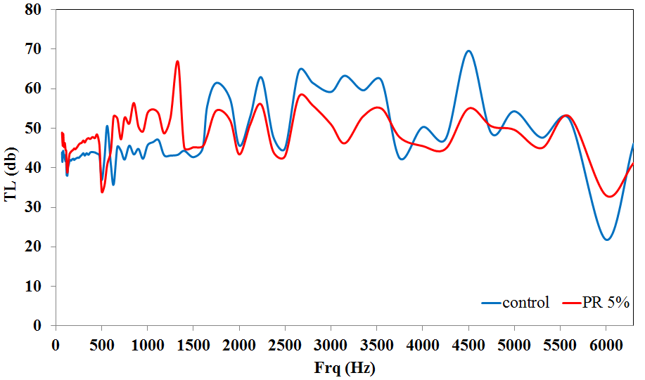
Fig. 6 STL for the concrete containing 5% fine-grained rubber

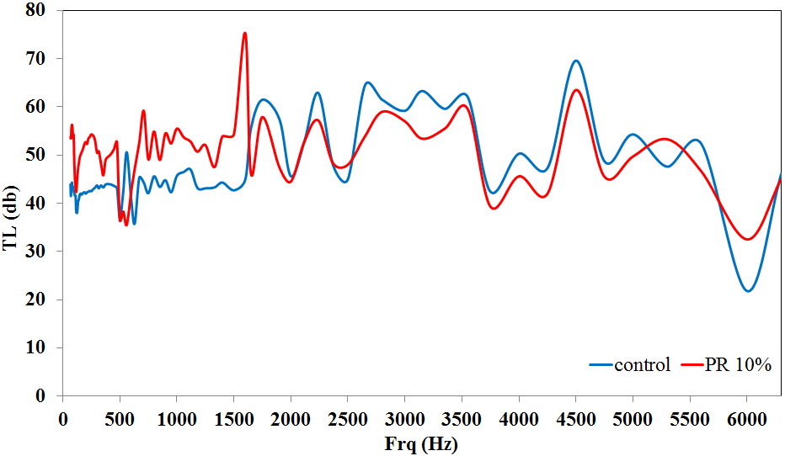
Fig. 7 STL for the concrete containing 10% fine-grained rubber

Fig. 8 STL for the concrete containing 15%fine-grained rubber

In addition, it is shown that the samples containing rubber crumbs could withstand loading even after early cracks leading to appropriate energy dissipation. The 15% coarse rubber crumbs could improve the sound loss by 18% in average as compared to 15% fine rubber crumbs, showing effectiveness of the coarse aggregates for sound transmission loss (Fig.11) despite the negative effects on the ultimate compressive strength. It is noted that by increasing the amount of rubber up to 15%, the compressive strength of the samples decreases up to 38% and 47% of the original sample in average for fine and coarse rubber crumbs, respectively. The effect of finer rubber crumbs on the modulus of elasticity are less than the ultimate compressive strength and tensile behavior. In addition, adding five percent Metakaolin additive could improve modulus of elasticity up to 8%, while adding five percent Nano silica could lead to lower modulus of elasticity up to 4%. By increasing the coarse rubber crumbs, the modulus of elasticity has remained unchanged for the samples with optimum additives; however, adding five more percent fine rubber crumbs leads to 15% reduction in modulus of elasticity.

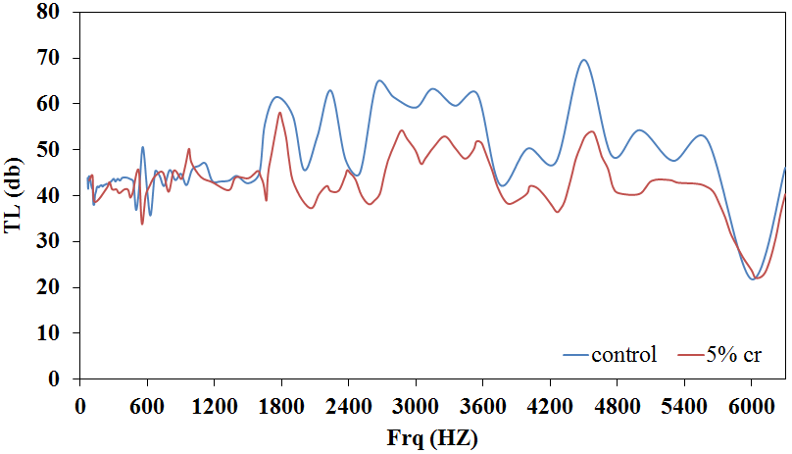
Fig. 9 STL for the concrete containing 5% coarse rubber

Fig. 10 STL for concrete containing 10%coarse rubber

Fig. 11 STL for concrete containing 15% coarse rubber

Fig.12 compares the results with the previous studies using different evaluations methods at frequencies of 500 Hz, 1000 Hz, 2000 Hz, 4000 Hz, and 6000Hz. For the concrete with 5% rubber crumbs, the major sound loss has occurred for the frequencies less than 1000Hz; however, the highest reduction in transmission is happened for the specimens with 10% rubber crumbs. It is shown that by increasing the rubber content, the sound loss effects are improved for the frequencies more than 1000Hz. In addition, the results show that samples containing fine particles in the range of 67Hz to 1400 Hz have a desirable performance compared to the rest of samples. Therefore, based on the comparisons to the previous studies on the effect of rubber crumbs in concrete admixtures, it is concluded that rubber crumbs could effectively improve the STL without losing expected mechanical properties if optimized percentages of additives and rubber are used.

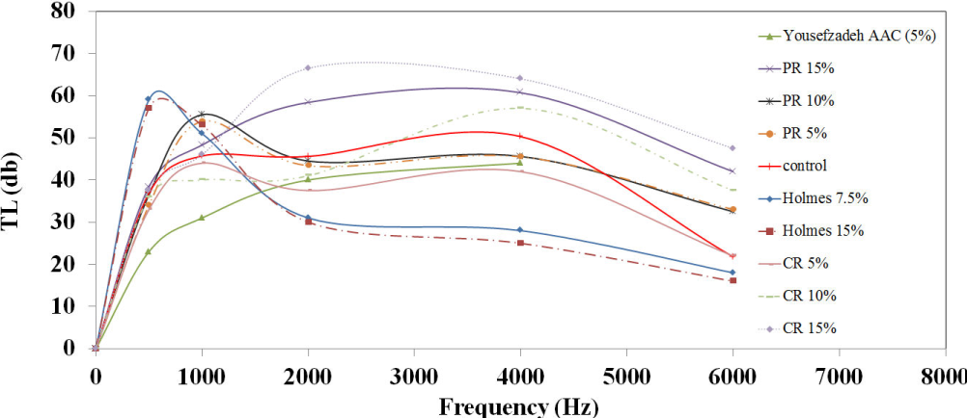
Fig. 12 STL Comparison of results with the previous studies using different evaluations methods

5. Conclusions
In this study, a number of concrete samples have been investigated to reduce the sound transmission through concrete, and improve the mechanical characteristics. It is shown that using optimized percentages of additive could reduce the negative effects of rubber particles in concrete efficiently. In general, the tube impedance method has shown some disadvantages at low frequencies, and could have possibility of poor sealing of the sample. Along the same lines, it is concluded that substituting sand aggregates with rubber crumbs specimens with 15% fine-grained crumbs or 15% coarse-grained crumbs could improve the STL up to 190% and 228%, while the implementation of 5% and 10% rubber crumb material has desirable effects on low frequencies noises reduction at the range of 63 Hz up to 6300 Hz. It is noted that there are several limitation of the sound transmission test using an impedance. Testing by two room or impedance tube could have some limitation. In the case of impedance tube, the results from the low frequency side must not be as accurate as the results from the high frequency side, which is due to the limitation on the length of the tube itself
It is shown that concrete with recycled rubber crumbs could effectively improve environmental noise absorption. Along the same lines, considering the desirable performance of this type of concrete at the high frequencies, it is possible to use the concrete with rubber crumbs and optimized additives in the waiting rooms of airports, and for various structural applications close to freeways to reduce STL without affecting the concrete’s ultimate strength.

Acknowledgments

References

Asdrubali F, D'Alessandro F, Schiavoni S (2008), “Sound absorbing properties of materials made of rubber crumbs”, J. Acoust. Soc. Am., 123(5), 3037
ASTM A. (2009). E2611-09 Standard test method for measurement of normal incidence sound transmission of acoustical materials based on the transfer matrix method ASTM International, West Conshohocken, PA, USA.
Batayneh M K, Marie I, Asi I (2008), “Promoting the use of crumb rubber concrete in developing countries”, J. Waste Manag., 28(11), 2171-2176,doi:https://doi.org/10.1016/j.wasman.2007.09.035.
Chalangaran, N., Farzampour, A., & Paslar, N. (2020). "Nano Silica and Metakaolin Effects on the Behavior of Concrete Containing Rubber Crumbs", CivilEng, 1(3), 264-274.
Cho T (2013), “Experimental and numerical analysis of floating floor resonance and its effect on impact sound transmission”, J. Sound Vib., 332(25), 6552-6561,doi:https://doi.org/10.1016/j.jsv.2013.08.011.
Chung J, Blaser D (1980), “Transfer function method of measuring in‐duct acoustic properties. I. Theory”, J. Acoust. Soc. Am., 68(3), 907-913,doi: https://doi.org/10.1121/1.384778.
Collings S, Stewart K (2011),“Building material panel transmission loss evaluation using an impedance tube”. Paper presented at the Proceedings of the ACOUSTICS.
Concha-Barrientos M, Steenland K, Prüss-Üstün A, Campbell-Lendrum D H, Corvalán C F, Woodward A, Organization W H. (2004). Occupational noise: assessing the burden of disease from work-related hearing impairment at national and local levels, World Health Organization.
Craik R (1982), “The measurement of structure-borne sound transmission using impulsive sources”, Appl. Acoust., 15(5), 355-361,doi:https://doi.org/10.1016/0003-682X(82)90024-X.

Erdogdu, S., Kandil, U., & Nayir, S. (2019), "Effects of cement dosage and steel fiber ratio on the mechanical properties of reactive powder concrete. Advances in concrete construction". 8(2), 139-144.
e Sousa A N, Gibbs B (2011), “Low frequency impact sound transmission in dwellings through homogeneous concrete floors and floating floors”, Appl. Acoust., 72(4), 177-189,doi:https://doi.org/10.1016/j.apacoust.2010.11.006.
Farzampour A (2017), “Temperature and humidity effects on behavior of grouts”, ADV CONCR CONSTR, 5(6), 659
Farzampour, A., Mansouri, I., & Hu, J. W. (2018). "Seismic behavior investigation of the corrugated steel shear walls considering variations of corrugation geometrical characteristics", International Journal of Steel Structures, 18(4), 1297-1305
Farzampour, A., Khatibinia, M., & Mansouri, I. (2019a), "Shape optimization of butterfly-shaped shear links using grey wolf algorithm". Ingegneria Sismica, 36, 27–41.
Farzampour, A., Mansouri, I., & Dehghani, H. (2019b). "Incremental dynamic analysis for estimating seismic performance of multi-story buildings with butterfly-shaped structural dampers", Buildings, 9(4), 78.
Farzampour, A., Eatherton, M. R., Mansouri, I., & Hu, J. W. (2019c). "Effect of flexural and shear stresses simultaneously for optimized design of butterfly-shaped dampers: Computational study", 4(23), 329-335
Farzampour, A., Eatherton, M.R. (2019), "Parametric computational study on butterfly-shaped hysteretic dampers", Front. Struct. Civ. Eng., 13, 1214–1226.
Farzampour A (2019), Compressive behavior of concrete under environmental effects: IntechOpen.
Farzampour, A., Mansouri, I., Mortazavi, S. J., & Hu, J. W. (2020). "Force–Displacement Relationship of the Butterfly-Shaped Beams Based on Gene Expression Programming", International Journal of Steel Structures, 20(6), 2009-2019.
Fayed S. and Mansour W, (2020). "Evaluate the effect of steel, polypropylene and recycled plastic fibers on concrete properties", 4 (10), 319-332
Forouharmajd F, Mohammadi Z. (2016),“The feasibility of using impedance tube with two microphones and sound absorption coefficient measurement of Iranian-made materials using transfer function method”,
Forouharmajd F, Mohammadi Z, Salehian j, Mosayebi m (2016), “The effect of foam thickness, sound intensity, and air layer on sound absorption coefficient of polyurethane foam using transfer function method”, HEALTH SYSTEM RESEARCH, 13(2)
Ganjian E, Khorami M, Maghsoudi A A (2009), “Scrap-tyre-rubber replacement for aggregate and filler in concrete”, Constr Build Mater., 23(5), 1828-1836,doi:https://doi.org/10.1016/j.conbuildmat.2008.09.020.
Gholami T, Piran Veyseh P, Aliabadi M, Farhadian M (2014), “Evaluation of noise pollution and its effects on subjective fatigue of staffs in the governmental banks of Hamadan city”, Iran Occupational Health, 11(5), 65-73
Jung S S, Kim Y T, Lee Y B, Cho S I, Lee J K (2008), “Measurement of sound transmission loss by using impedance tubes”, J KOREAN PHYS SOC, 53(2), 596-600,doi:https://doi.org/10.3938/jkps.53.596.
Kihlman T (1970), “Sound transmission in building structures of concrete”, J. Sound Vib., 11(4), 435-445,doi:https://doi.org/10.1016/S0022-460X(70)80005-0.
Kimura M, Kunio J, Schuhmacher A, Ryu Y (2014),“A new high-frequency impedance tube for measuring sound absorption coefficient and sound transmission loss”. Paper presented at the Proceedings of Inter-Noise, Melbourne, Australia.
Mansouri I, Shahheidari F S, Hashemi S M A, Farzampour A (2020), “Investigation of steel fiber effects on concrete abrasion resistance”, ADV CONCR CONSTR, 9(4), 367-374,doi:https://doi.org/10.12989/acc.2020.9.4.367.
Paslar, N., Farzampour, A., & Hatami, F. (2020a), "Investigation of the infill plate boundary condition effects on the overall performance of the steel plate shear walls with circular openings", Structures, 27, 824-836.
Paslar, N.; Farzampour, A.; Hatami, F. (2020b), "Infill plate interconnection effects on the structural behavior of steel plate shear walls", Thin-Walled Struct., 149, 106621.
Pfretzschner J, Rodriguez R M (1999), “Acoustic properties of rubber crumbs”, Polym. Test, 18(2), 81-92,doi:https://doi.org/10.1016/S0142-9418(98)00009-9.
Rahim N L, Sallehuddin S, Ibrahim N M, Amat R C, Ab Jalil M F (2013),“Use of plastic waste (high density polyethylene) in concrete mixture as aggregate replacement”. Paper presented at the Advanced Materials Research.
Ren, R., Liang, J. F., Liu, D. W., Gao, J. H., & Chen, L. (2020), "Mechanical behavior of crumb rubber concrete under axial compression". Advances in concrete construction, 9(3), 249-256.
Hosseini, S. A. (2020), "Application of various types of recycled waste materials in concrete constructions". Advances in concrete construction. 9(5), 479-489.
Sukontasukkul P (2009), “Use of crumb rubber to improve thermal and sound properties of pre-cast concrete panel”, Constr Build Mater., 23(2), 1084-1092,doi:https://doi.org/10.1016/j.conbuildmat.2008.05.021.
Tan W-H, Lim E, Chuah H, Cheng E, Lam C (2016), “Sound Transmission Loss of Natural Fiber Panel”, Int. J. Mech. Mechatron. Eng., 16, 33-42
Uthaichotirat P, Sukontasukkul P, Jitsangiam P, Suksiripattanapong C, Sata V, Chindaprasirt P (2020), “Thermal and sound properties of concrete mixed with high porous aggregates from manufacturing waste impregnated with phase change material”, J. Build. Eng., 29, 101111,doi:https://doi.org/10.1016/j.jobe.2019.101111.
Vigran T (2012), “Normal incidence sound transmission loss in impedance tube–Measurement and prediction methods using perforated plates”, Appl. Acoust., 73(4), 454-459,doi:https://doi.org/10.1016/j.apacoust.2011.11.009.
Wang Y, Zhang C, Ren L, Ichchou M, Galland M A, Bareille O (2013), “Influences of rice hull in polyurethane foam on its sound absorption characteristics”, Polym. Compos., 34(11), 1847-1855,doi: https://doi.org/10.1002/pc.22590.
Williams, K. C., & Partheeban, P. (2018), "An experimental and numerical approach in strength prediction of reclaimed rubber concrete. Advances in concrete construction". 6(1), 87.
Yousefzadeh B, Mahjoob M, Mohammadi N, Shahsavari A (2008), “An experimental study of sound transmission loss (STL) measurement techniques using an impedance tube”, J. Acoust. Soc. Am., 123(5), 3119
Zhao C, Wang P, Wang L, Liu D (2014), “Reducing railway noise with porous sound-absorbing concrete slabs”, Adv. Mater. Sci. Eng., 2014,doi:https://doi.org/10.1155/2014/206549.

Researcher, (Email: chalangaran@Gmail.com)
* Lecturer, PhD, (Email: afarzam@vt.edu)
Lecturer, (Email: n.paslar@pnuba.ac.ir)

