

CS4624

Multimedia, Hypertext, and Information Access

10 May 2022

Video UDL and AEM

Virginia Tech, Blacksburg, VA 24061

Instructor: Dr. Edward A. Fox

Client: Kimberley Homer, Mark Nichols
Team: Tyler Esposo, Matthew Ho, Sydney ​​Huynh, Catherine Lee, Josh Protacio, Daniel Stricoff

Table of Contents
- List of Figures 2
- List of Tables 3
- Abstract 4
- Introduction 5
  - Goal 5
  - Objective 5
  - Client 5
  - Team 6
  - Project Background 6
  - Timeline and Milestones 7
- Requirements 9
- Design 10
  - Interviewee Introduction Graphic 10
  - Intro 11
  - Example transition slides 11
  - Statistics Slides 12
  - Graphic Slides 13
- Implementation 15
  - Room Setup 15
  - Filming Angles 15
  - Microphone 15
  - Camera 15
  - Lights 16
  - Graphics 16
  - Implementation of Service 16
- Evaluation 19
- User’s Manual 20
- Developer’s Manual 20
  - Technology Structure and Flow 20
  - Storyboard 20
  - Required Technologies and Programs 24
  - File Inventory 24
- Lessons learned 30
  - Timeline and Schedule 30
  - Problems 32
  - Future Work 33
- Acknowledgements 34
- References 35

List of Figures
Figure 1.1: Persona – Teacher 6
Figure 1.2: Persona - Student 7
Figure 2.1: Interview Introduction Slide 10
Figure 2.2: Intro Slide 11
Figure 2.3: Example Transition Slide 11
Figure 2.4: Disability Statistic Slide 12
Figure 2.5: Specific Learning Disability (SLD) and Other Health Impairment (OHI)
Statistic Slide 12
Figure 2.6: UDL Graphic Slide 13
Figure 2.7: UDL Forms Graphic Slide 14
Figure 3: Video Screenshot 20
Figure 4: Technology Flow 21
Figure 5: Storyboard 22

List of Tables

Table 1: Spring 2022 Semester Timeline and Milestones 7
Table 2: Implementation of Service 16
Table 3: Interview Questions 23
Table 4: File Inventory 24

Executive Summary / Abstract
The profile of learners is ever-changing. Each student approaches, understands, and solves concepts differently. By anticipating and planning for learner variability, faculty, teachers, and students embrace their greatest strength: diversity. The Universal Design for Learning (UDL) is a framework that improves and enhances teaching and learning. The vision is to proactively design educational environments that are inclusive, accessible, and flexible for all learners. In order to optimize the design and delivery of course instruction, UDL focuses on providing multiple, flexible methods of representation, expression, and engagement.

While the UDL framework emphasizes accessibility for a diverse learner population, this flexibility with respect to how course material is displayed or delivered can also be found in Accessible Educational Materials (AEM). AEM highlights print or technology-based educational content that is designed to be usable and understandable across learner variability, regardless of format.

The purpose of this video project is to bring awareness to the benefits of implementing the UDL framework and ensuring materials are accessible at Virginia Tech. Our team filmed and created an eight-minute video that includes graphics and various testimonials from Carolyn Shivers, Alicia Johnson, Rachel Mirsen, and Nevada Kershner. The video will also include closed captioning to increase accessibility. To reflect upon how course instruction and delivery address learner variability and preferences, the video introduces the concept of UDL and AEM, presents testimonials, highlights statistics, and presents a call to action for faculty to enroll in an online professional development course on UDL in higher education. Faculty can find this UDL course on the Technology-Enhanced Learning and Online Strategies (TLOS) Professional Development website to learn more about accessibility best practices.

Throughout the semester, the team researched the application of the UDL framework and AEM in higher education, designed a storyboard for initial video concepts, created informational graphics, and developed a script that included narration, transitions, and interview questions. Furthermore, the team contacted multiple assistant professors and teaching assistants in order to hear their perspectives. The team filmed and edited interview footage, adding in proper transitions and detailed illustrations to deliver a promotional and information video about accessibility best practices at Virginia Tech. This video targets faculty members, encouraging them to incorporate UDL strategies into their course design and delivery. The Accessible Technologies Team at Virginia Tech can utilize this video to convey to faculty the value of Universal Design for Learning to support learner variability.

Introduction
The mission of Virginia Tech’s Accessible Technologies Mission is to “promote the use of teaching and learning strategies, communications practices, technologies, and technology standards that enable everyone in our university community, regardless of disability status, to learn and work” [1]. In alignment with such a mission, our team strives to depict the importance of enhancing the design and delivery of course instruction while encouraging enrollment in a universal design for learning professional development course. By creating an informational and promotional video, highlighting how the Universal Design for Learning (UDL) and Accessible Educational Materials (AEM) foster inclusive learning across Virginia Tech, we hope to increase awareness about learner variability [5, 10, 14].

4.1 Goal
The goal of the project is to create a promotional and information video, highlighting accessibility best practices, tools, and strategies used at Virginia Tech.

4.2 Objectives
- Create a video that is under 10 minutes in length.
- Include closed captioning and audio description.
- Capture testimonials from faculty and students regarding the impact of UDL and AEM.
- Design informational graphics to illustrate the principles of UDL and AEM and the resources available to employees and students for creating accessible content.
- Encourage faculty to enroll in the online professional development course of UDL and AEM.

4.3 Client
Virginia Tech’s Accessible Technologies Team within the Technology-enhanced Learning and Online Strategies (TLOS) Department supports students, faculty, and staff across the university in the creation of inclusive and accessible learning environments. This team provides access to assistive software equipment and workshops related to digital accessibility and the universal design for learning. The clients, Mark Nichols and Kimberly Homer, have a background in assistive technologies and teaching strategies for higher education. Mark Nichols serves as the Senior Director for Universal Design and Accessible Technologies; Kimberley Homer is an Accessible Technologies Analyst. Through leading professional development workshops and lectures, Nichols and Homer educate faculty on assistive technologies, innovative techniques, and the design of digital resources to create a more inclusive learning environment at the university.

4.4 Team
Below are the roles of individuals on the UDL and AEM Video Project for the Spring 2022 semester:

Team Member Roles:
Tyler Esposo – Videography/Secretary
Matthew Ho – Research/Script/VTechWorks Lead
Sydney Huynh – Research/Script/Presentation Lead
Catherine Lee – Artistic Director/Infographics Lead
Joshua Protacio – Videography/Project Leader
Daniel Stricoff – Interviewer/Voiceover

4.5 Project Background
In order to create a video that showcases how teachers and students can benefit from the flexibility and choice offered by accessibility features [2], the team began by researching case studies that applied the Universal Design for Learning framework in higher education courses [8, 9]. Furthermore, to better understand our stakeholders in this project, we created two personas: one from a teacher’s perspectives and one from a student’s perspective.

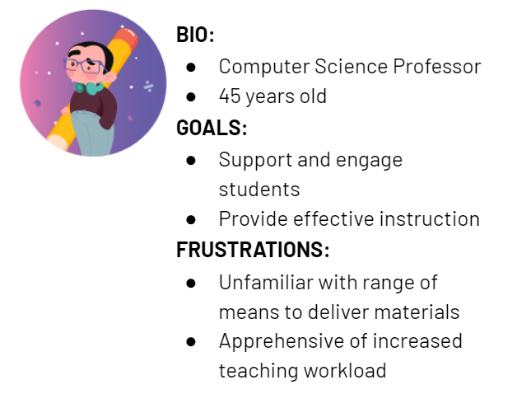
Figure 1.1: Persona - Teacher
Figure 1.1 shows an example persona representing a teacher’s perspective.
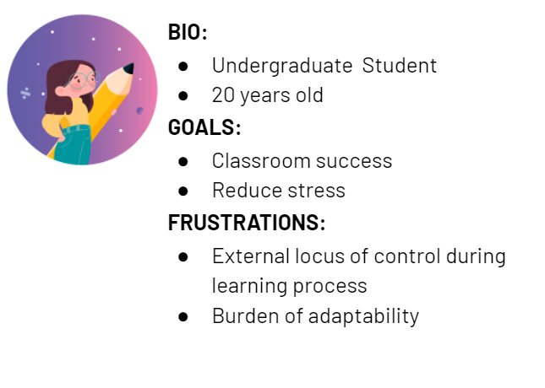
Figure 1.2: Persona - Student
Figure 1.2 shows an example persona representing a student’s perspective.

These personas helped our team create representations of our stakeholders to continuously reference and keep in mind as we created our video.

4.6 Timeline and Milestones

Date | Goals and Milestones
3 February | - Project launch:  - Initial meeting with client  - Establish expectations  - Determine video requirements
10 February | - Complete research and personas  - Create storyboard
15 February | - Progress Presentation I
22 February | - Review draft of script with clients
23 February | - Contact individuals to interview
1 March | - Begin filming video
16 March | - Begin editing video
31 March | - Review draft of video with client
1 April | - Register with VTechWorks
5 April | - Progress Presentation II
14 April | - Interim report
22 April | - Finalizing video edits
25 April | - Revisions based on feedback
26 April | - VTechWorks final submission  - Final Presentation
Table 1: Spring 2022 Semester Timeline and Milestones
Table 1 shows our project timeline for the 2022 Spring semester.

Requirements
The main requirement for the video is that it promoted the UDL and AEM course provided by the client. They wanted a five to ten minute long video that will spread awareness about UDL and the course so that people will eventually implement UDL ideas into their courses. To accomplish this, we were also tasked with gathering interviews from professors and students and incorporating that into our video. This involved gathering equipment such as high-quality cameras, microphones, and lighting. Additionally, it required time to set up each interview. Contacting an interviewee and scheduling a time to meet with them also took time.

In terms of video production and quality, our main requirement was to make this as professional looking as possible. We were not given much guidance on how to make the video other than it needs to be high quality. This meant that the audio and video needed to be close to perfect in our eyes. We had to have a final video output of at least 1080p, and the audio levels needed to be consistent throughout. In addition, there should be minimal background noise.

The video was also required to be accessible and contain elements of the UDL framework. This means including captions in the final video as well as ensuring the color palette of the graphics is suitable.

Design

The design component of the video includes graphics for transitions, informational slides, and labeling. This process consisted of gathering previous Virginia Tech graphics to ensure continuity with Virginia Tech’s digital branding. We also used the information on Virginia Tech’s website on branding and identity to choose fonts and colors for the video. In total, 17 graphics were created. Below are descriptions of the sample graphics for the video.

6.1 Interviewee Introduction Graphic
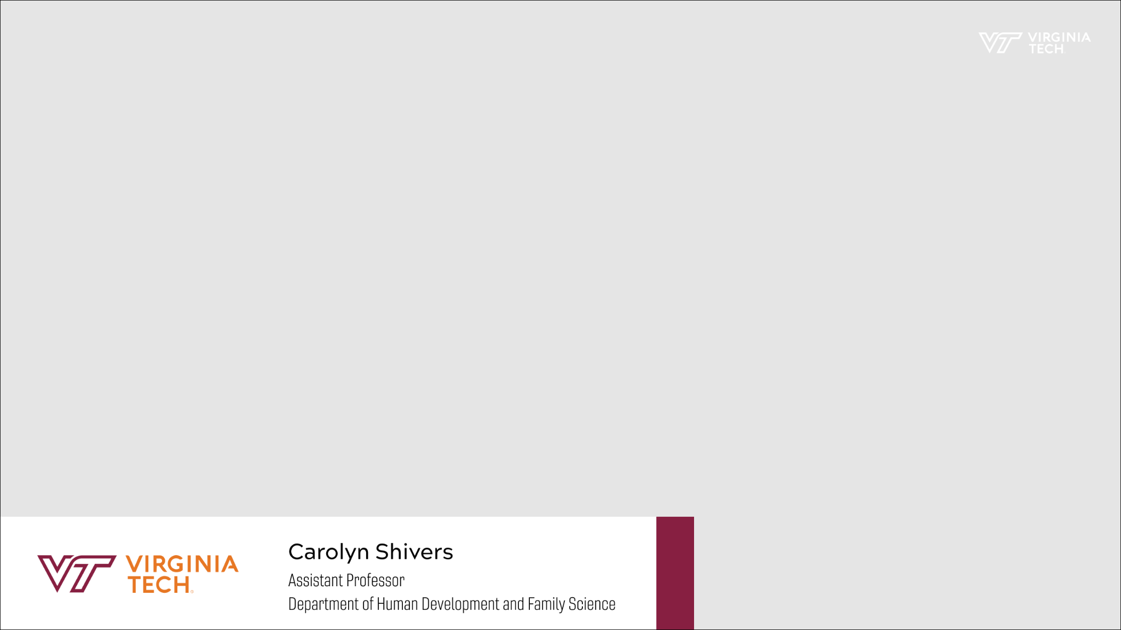
Figure 2.1: Interview Introduction Slide
Figure 2.1 shows an example of what is displayed on the screen when an interviewee is talking in the video. In the actual video, the screen is not gray, but instead, has the interviewee in the center of the screen, with their information in the bottom left corner.

6.2 Intro

Figure 2.2: Intro Slide
Figure 2.2 shows what is on the screen at the beginning of the video.

6.3 Example transition slides
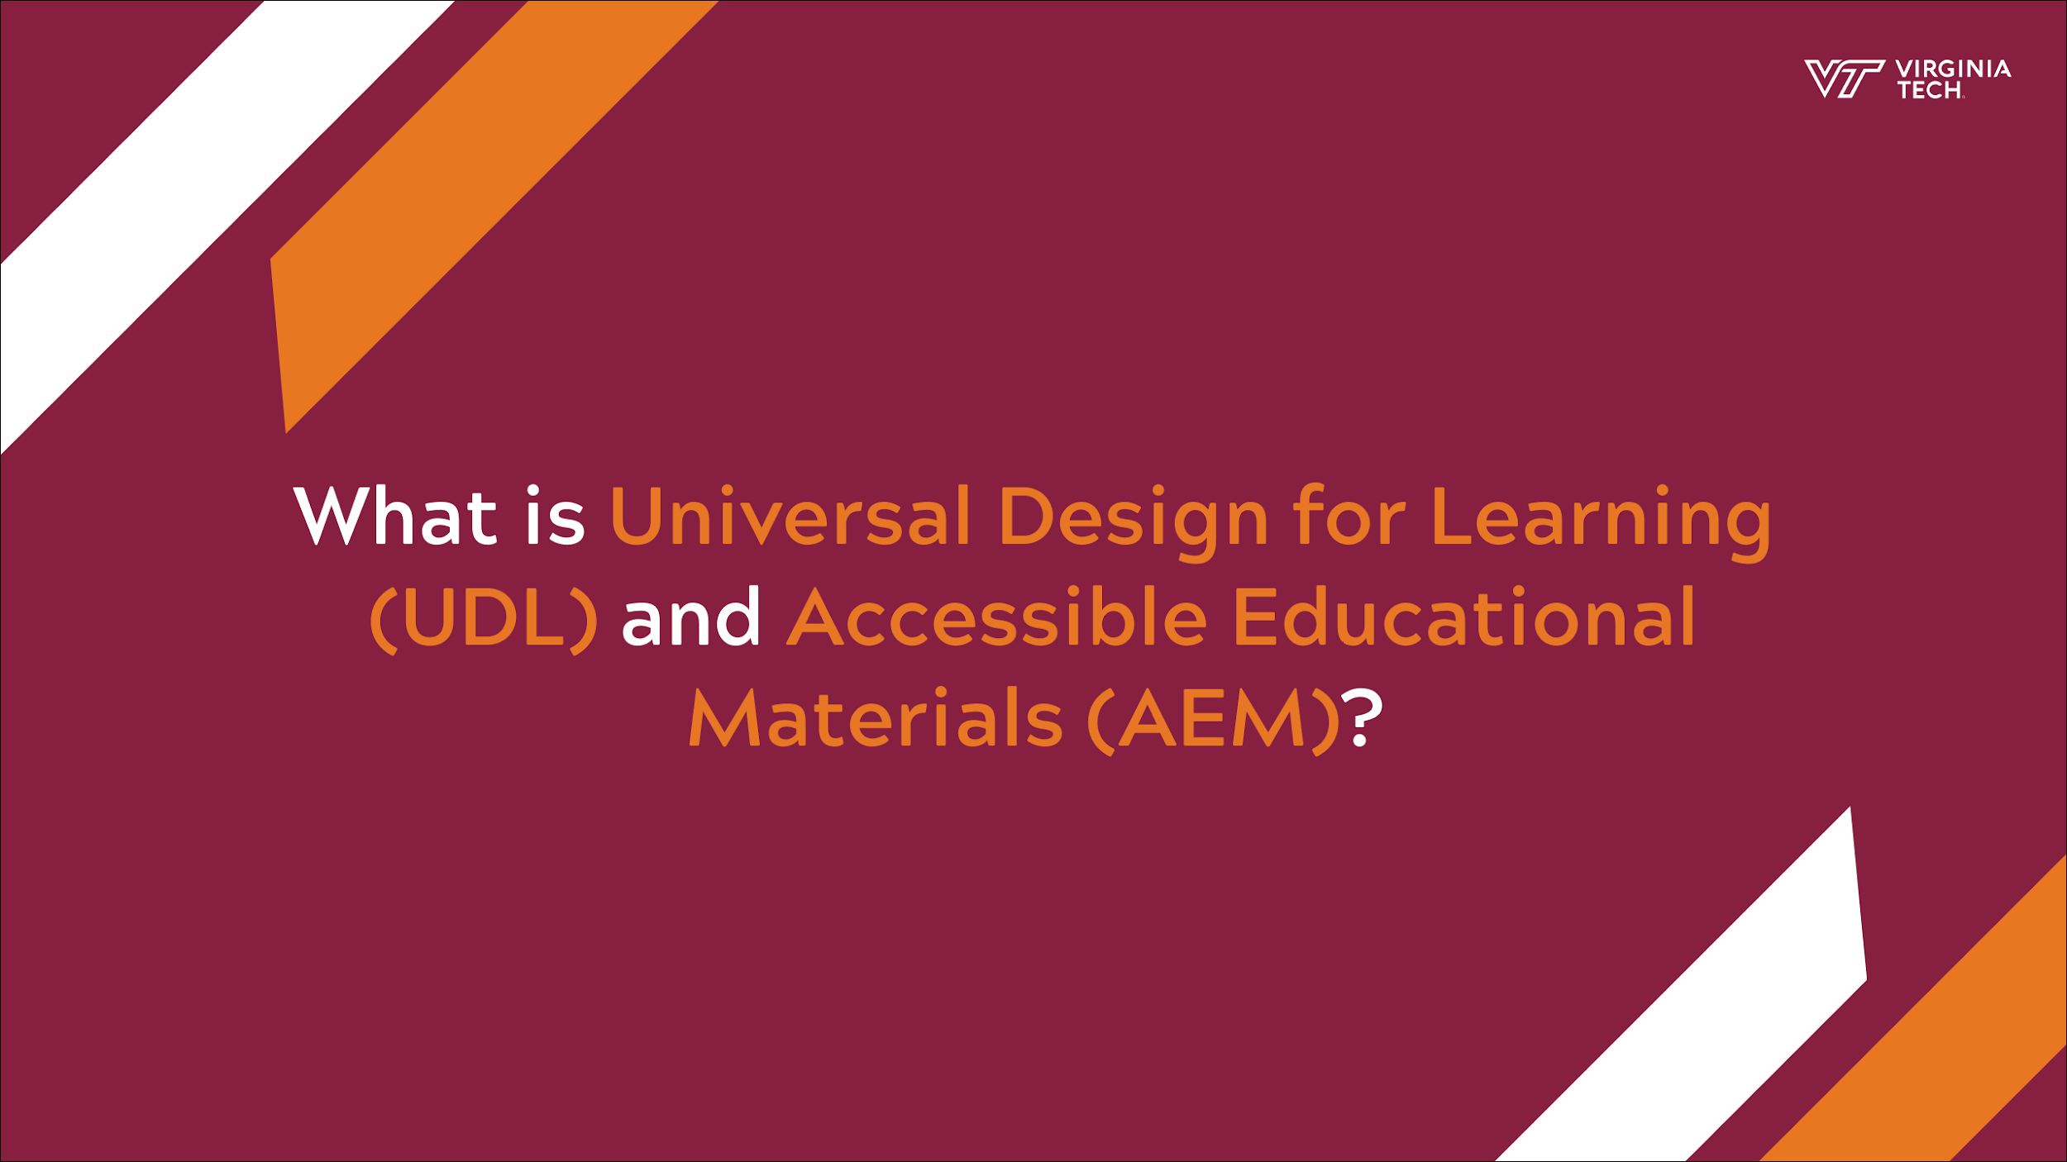

Figure 2.3: Example Transition Slide
Figure 2.3 shows an example of how the video will transition when each question is prompted by our narrator.

6.4 Statistics slides
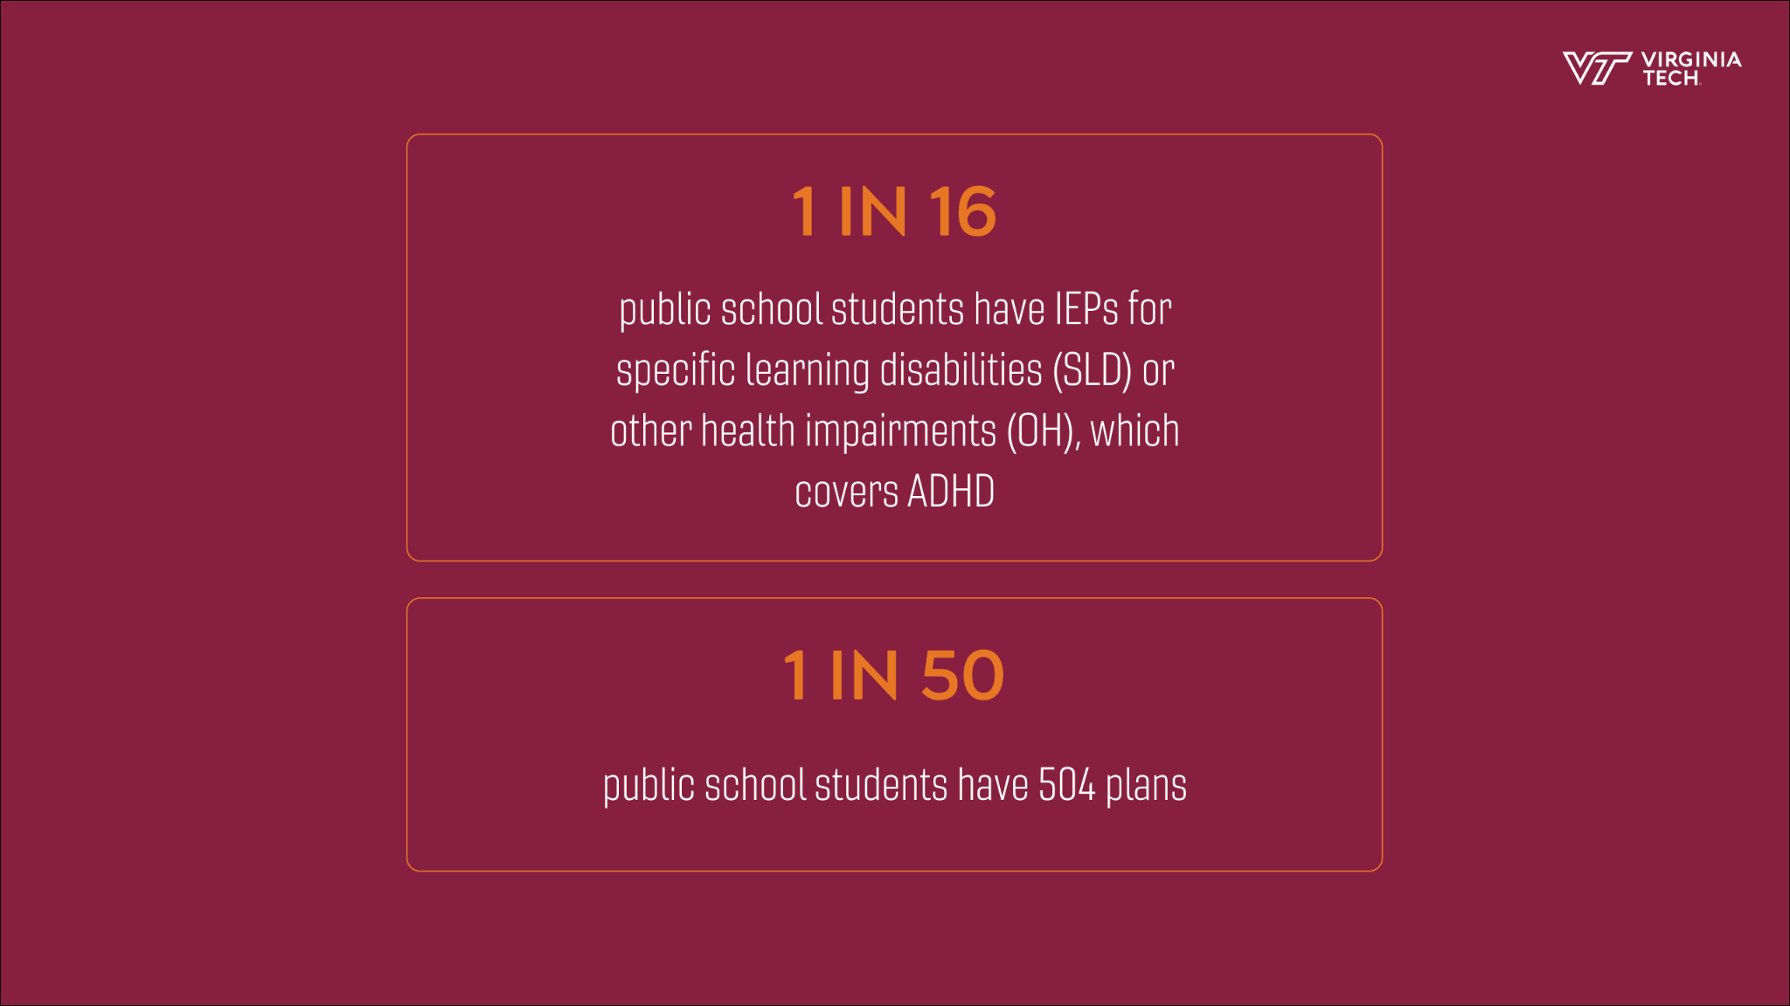
Figure 2.4: Disability Statistic Slide

Figure 2.4 shows statistics from the National Center for Learning Disabilities [12] that highlight the number of students living with disabilities. The first statistic emphasizes the proportion of students whose disabilities directly affect their education. The second statistic shows the proportion of students who receive government support in order to accommodate their disabilities. However, it should be noted that many students live with unidentified disabilities which makes it difficult for them to receive the support [11] they need since the methods for identification do not always work [7].

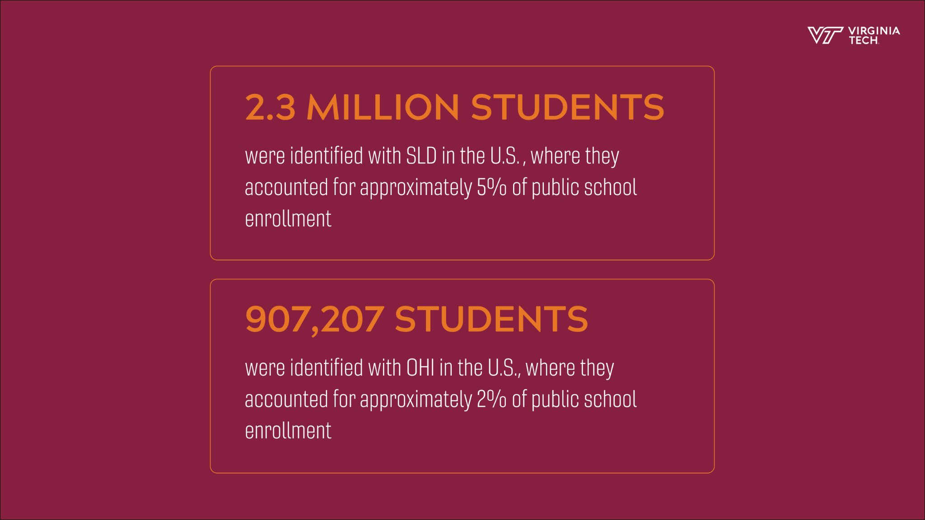
Figure 2.5: Specific Learning Disability (SLD) and Other Health Impairment (OHI) Statistic Slide
Figure 2.5 shows statistics that showcase figures related to Specific Learning Disability (SLD) and Other Health Impairment (OHI) and the sheer scope of those affected in public schools. The first statistic specifies the quantity of students affected by SLD in the U.S. The second statistic specifies the quantity of students affected by OHI in the United States. Students with SLD and OHI account for a significant portion of the population enrolled in public schools in this country.

6.5 Graphic slides

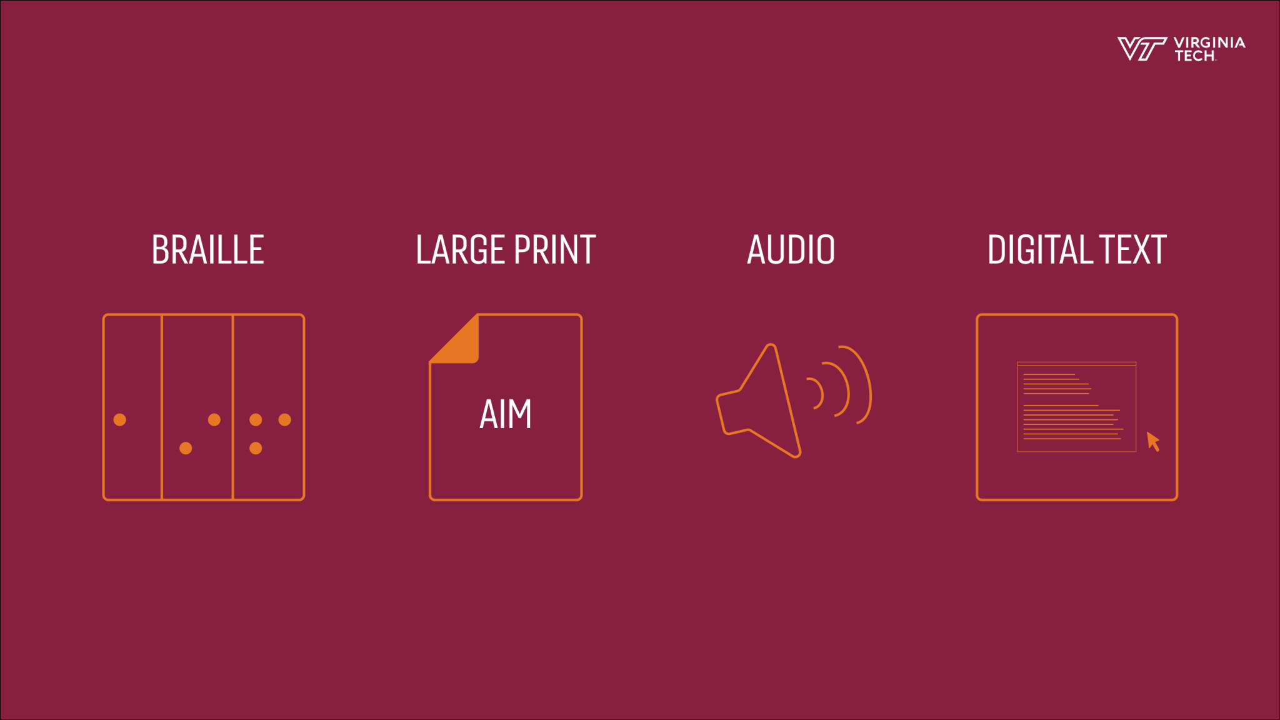
Figure 2.6: Forms of AEM Graphic Slide

Figure 2.6 shows various ways an educator can implement UDL and AEM.

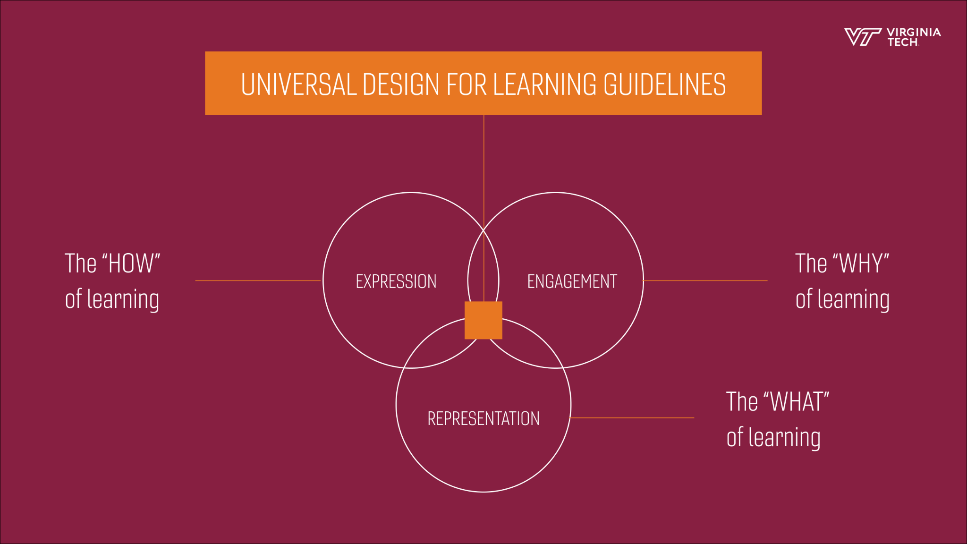
Figure 2.7: UDL Graphic Slide

Figure 2.7 displays the key principles of Universal Design for Learning which are: Expression, Engagement, and Representation.

Implementation

7.1 Room Setup

Each room that we held interviews at was set up in a way so that there was nothing distracting in the background and there had to be some sort of natural light. We also made sure that there was enough room to have Daniel and the interviewer face to face with each other. Even if this was for a video, we wanted it to be professional as if it was a real live interview. We filmed at professors’ respective offices and for the TAs we filmed the interviews in a room at Newman Library.

7.2 Filming Angles

The angle of the camera needed to stay the same the whole time to ensure consistency in our video. We did not want different videos holding different angles because it would look messy. On the first day of filming, we choose the left side of the interviewer to angle towards. In the rest of the interviews, we did our best to hold this same angle.

7.3 Microphone

The microphone that we used is the Rode VideoMicro Ultracompact Camera-Mount Shotgun Microphone [13]. This is Joshua’s personal microphone that he uses on his own camera. This was the equipment we ended up using, but it was not our initial plan. We had a RODE Wireless GO 2 that we booked from the library. It came with a lavalier microphone so that we could obtain clear audio of the interviewer and Daniel talking. This was the ideal set up since it would remove the background noise and produce clearer audio. However, when we were testing it, we realized that some of the LEDs on the screen were malfunctioning. This error made it impossible to read the screen since half of it was black and some parts were just white. As a beginner user, we thought it was better to find another method than to blindly trust that the microphones were working.

7.4 Camera

The camera is Joshua’s personal camera, a Sony Alpha a6100 [15] with a Sigma 16mm f/1.4 DC DN Contemporary Lens. This type of lens helped with getting the professional touch since it blurred the background to a point where the individual in the center was enhanced for videos. We had our camera sitting on a tripod so that our shots were clean and there was no movement in the video.

7.5 Lights

For our lights we used the Dracast LED500 Light Kit [4]. This came with three panel lights, three stands, four battery packs and a charger. This was a little overkill for our level of production, but one was helpful to add more light to a dim setting. We used this for all of our interviews to brighten up the scenes so that editing would be easier.

7.6 Graphics

Catherine created graphics for our video to make sure that we had professional looking slides and templates. We made sure to also use Virginia Tech templates to add professionality into our video. This includes the opening page, titles for all of the interviewers, and an outro.

7.7 Implementation of Service
Service ID | Service Name | Input file name(s) | Input file Ids (comma-sep) | Output file name | Output file ID | Libraries; Functions; Environments
S01 | Interview | Interview Questions.doc | T01 | CarolynInterview.mp4 | R01 | Premiere Pro, Google Doc
S01 | Interview | Interview Questions.doc | T01 | AliciaInterview.mp4 | R02 | Premiere Pro, Google Doc
S01 | Interview | Interview Questions.doc | T01 | LujeanInterview.mp4 | R03 | Premiere Pro, Google Doc
S01 | Interview | Interview Questions.doc | T01 | StudentInterview.mp4 | R04 | Premiere Pro, Google Doc
S02 | Awareness | Information Description.doc | T02 | Information Description.doc | T02 | UDL course, Google Doc
S03 | Editing | Interview Questions.doc,  Information Description.doc | T01, T02 | Final Cut.mp4 | R05 | Premiere Pro
S04 | Client Approval | Interview Questions.doc,  Information Description.doc,  Final Cut.mp4 | T01, T02, R05 | NA | NA | NA
S05 | Hosting/Presenting | Final Cut.mp4 | R05 | NA | NA | YouTube, Google Drive, Instagram, Facebook
Table 2: Implementation of Service
Table 2: Shows the processes and services involved in creating the video.
** Please note that since we are doing a video a lot of our input files are our interview questions and the output would be the recorded interview.
** The IDs go as follows: S - service; T text document; R - recording file
Interview Questions [T01] - This is the file that is oriented to our interviewees to get their opinions on UDL.
Information Description [T02] - This is the information that we have chosen to display in the video.
Interview Output files[R01 - R04] - These are the video recordings that we edit into the master video.
Final Cut [R05] - This is the last cut of the video after editing and it will be shown to the public.
Interview [S01] - These interviews were where we talked to professors/students who have used/experienced UDL approaches in classes.
Awareness [S02] - This service makes sure we fill our video with informational descriptions about UDL and AEM, including examples, the utility, and the benefits.
Editing [S03] - This service was done on DaVinci Resolve [3] to edit and cut all of the recordings into one video.
Client Approval [S04] - This service ensures that the client approves of the message and information contained in the final product.
Hosting/Presenting [S05] - This service makes the final cut of the video accessible to Virginia Tech faculty and students. It can be accomplished through various platforms that host videos like: YouTube, Instagram, and Facebook.

Evaluation
For our testing and evaluation, our script and video were viewed many times by every team member to obtain a variety of suggestions and opinions. Although only two team members were tasked with filming and editing, and two different team members were in charge of the script, each member was able to express concerns and suggestions throughout the video making process regardless of their role. Numerous viewings from multiple individuals allowed for many useful and unique perspectives.

Additionally, our project material was shared with our clients and professor throughout the editing process. By sharing the video with our clients, we were able to receive specific feedback as to what they needed from our product. Sharing our video with Dr. Fox also allowed us to receive feedback from a member of our target audience. Due to his familiarity with UDL and AEM, Dr. Fox was also able to give us feedback on the content of our video.

Each time the video was evaluated, a new edit of the video would be created and shared. The process of evaluation to editing was repeated until all viewers were content with the final product.

User Manual
The video is eight minutes and three seconds long and displayed in 1920x1080p. It is in the MP4 format and is viewable either from the finished 1.52 GB file, or from the website hosting the video. An internet connection is required for viewing the video without downloading the file. It is recommended to view the video on a screen larger than eight inches diagonally. However, viewing on smaller devices is still perfectly fine and acceptable.

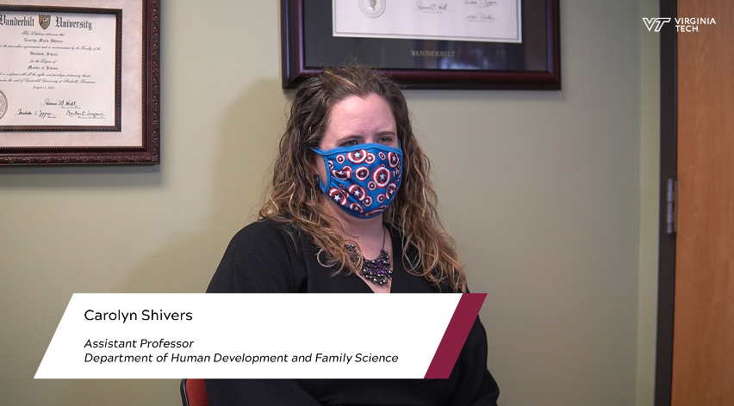
Figure 3: Video Screenshot
Figure 3 shows what interview introductions look like in the finished video.

Developer’s Manual
10.1. Technology Structure and Flow

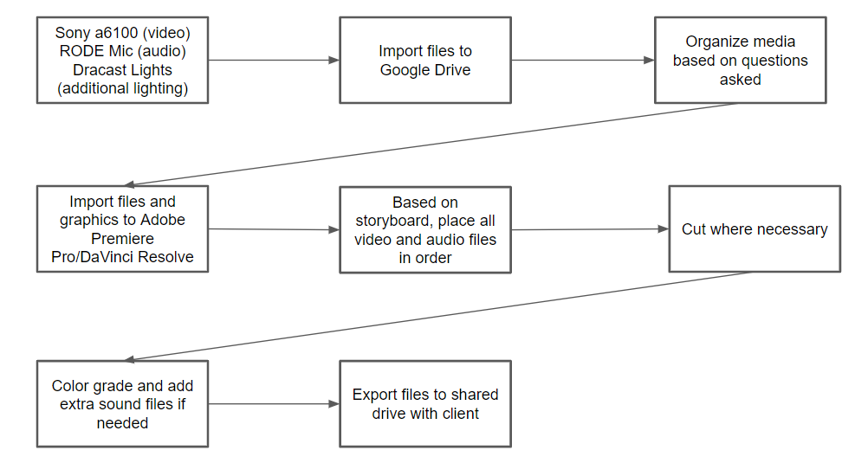
Figure 4: Technology Flow
Figure 4 shows the process used for filming content and producing a high-quality video.

10.2. Storyboard

Even though the only footage we collected were interviews with faculty members and students, we still decided to create a storyboard to plan out the flow of the video overall. The use of a storyboard was helpful in determining how the video would be edited. This would also build our argument for convincing faculty members to participate in the course being advertised. Our original thoughts were to feature graphics with lines from the script and then showcase the interviews later on in the video. Upon further review, we decided it was best to combine both aspects of our video and follow up information being presented with specific cuts from the interviews that were relevant. This video structure was pursued because of the possibility of providing similar information and insights at different points of the video which would be redundant. All in all, we are telling a story and the content being shown is just as important as how it is divulged to the audience.
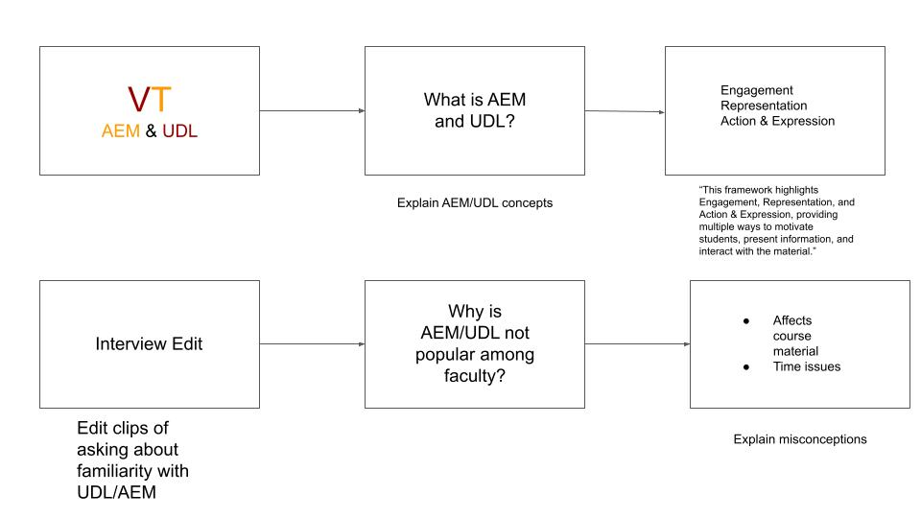
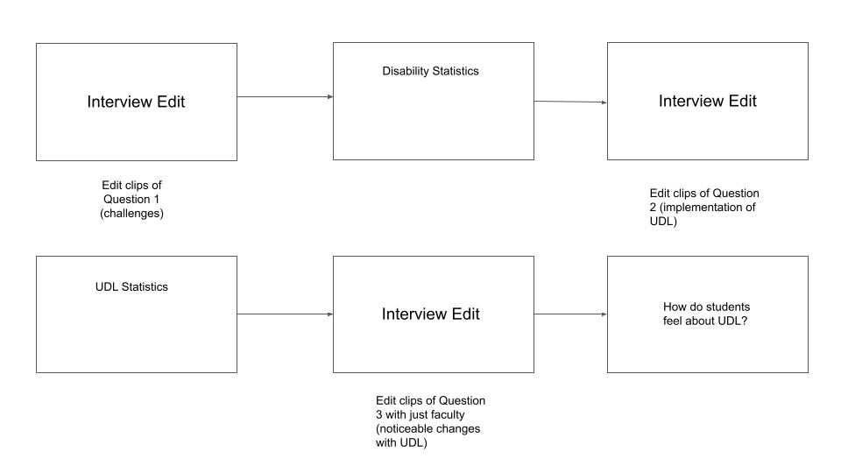
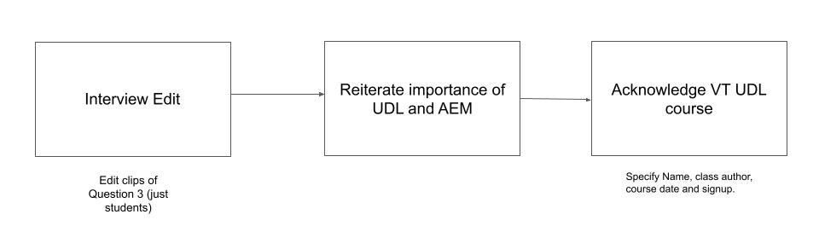
Figure 5: Storyboard
Figure 5 shows the storyboard for our video. The figure shows how the video flows from topic to topic.

Questions for Educators | Questions for TAs
Who are you? Describe yourself. | Who are you? Describe yourself.
Describe UDL in your own words. | Describe UDL in your own words.
What drove you to implement UDL in your classroom? | Have you been in a class using UDL elements? If so, what?
Do you think educators have a responsibility to create accessible learning environments? | Have you noticed a more positive classroom environment since adding UDL?
What were some challenges in implementing UDL? | What drove you to implement UDL in your classroom?
Are there any noticeable changes in your students’ educational experience and engagement since implementing UDL? | Do you think educators have a responsibility to create accessible learning environments?
What specific ways have you integrated UDL into your course? | Did you notice any challenges with implementing UDL?
Did you notice a difference in student learning/performance? | Are there any noticeable changes in your students’ educational experience and engagement since implementing UDL?
 | Have you been a student in a class with UDL? If so, describe your experience.
Table 3: Interview Questions
Table 3 shows the interview questions given to educators and student TAs. The left column lists questions for educators, and the right column lists questions for TAs.

10.3. Required Technologies and Programs

The camera used for production of the video was the Sony a6100 Mirrorless Camera. This was used with the Sigma 16mm f/1.4 DC DN Contemporary Lens. The camera was also mounted on a tripod for recording each interview. For lighting, the Dracast LED500 Light kit was used.

The microphone used for production was the RODE VideoMicro On-Camera Cardioid Condenser Microphone. While this mic is usually used for recording content in outdoor settings, the quality was still sufficient for interviews indoors.

The software used for video editing was DaVinci Resolve, and the software used to design the slides and create graphics for the video was Figma [6].

The camera, lens, and microphone were items owned by the team members. The lighting equipment was borrowed from the Virginia Tech library. If needed, the camera and microphone equipment can also be borrowed from the VT library [16].

10.4. File inventory

This section is dedicated to showing all relevant files for the creation of our video.

File name | File Type | Description
UDL + AEM research | .doc file | This document contains all the research, with links, for understanding UDL and AEM. The document highlights important statistics, definitions, and key results related to UDL and AEM.
Storyboard AEM/UDL | .doc file | This file contains the storyboard for the video promoting Virginia Tech’s UDL course.
Script Rough Draft | .doc file | This document contains an outline for the video and contains specific information about transitions, lines, and graphics/figures. It highlights what is included in the video and when.
Methodology | .doc file | This document contains information about the methods and processes used for producing the video.
TA Interview Questions | .doc file | This document contains questions for TAs who have experience with classes that implement UDL.
Pre - Interview Questions | .doc file | This document contains questions for instructors who have implemented UDL.
intro.png | .png file | This image is used at the beginning of the video.
udl_guideline.png | .png file | This image is used to show the important guidelines of UDL.
stats1.png | .png file | This image is used to show the important statistics about accommodations for students with disabilities.
stats2.png | .png file | This image is used to show important statistics about learner variability by showing the proportion of individuals with disabilities.
carolyn_shivers.png | .png file | This graphic introduces Carolyn Shivers.
alicia_johnson.png | .png file | This graphic introduces Alicia Johnson.
nevada_kershner.png | .png file | This graphic introduces Nevada Kershner.
rachel_mirsen.png | .png file | This graphic introduces Rachel Mirsen.
udl_and_aem.png | .png file | This graphic displays a question: what is UDL and AEM?
q3.png | .png file | This graphic displays a prompt: describe your familiarity with UDL and AEM.
aem.png | .png file | This graphic is shown when AEM is addressed.
aem_forms.png | .png file | This graphic shows various forms of AEM
q2.png | .png file | This image shows a question: what ways have you implemented UDL?
q4.png | .png file | This image shows a question: have you noticed positive changes after using UDL?
course_info.png | .png file | This image displays information about the VT UDL course.
sources.png | .png file | This image shows the sources referenced in the creation of the video.
credits.png | .png file | This image shows credits for the video.
CS_Intro.MP4 | .MP4 file  Size: 256 MB  Time: 0:42 | In this video, Carolyn Shivers introduces herself by stating her name and her profession.
CS_Context.MP4 | .MP4 file  Size: 268 MB  Time: 0:43 | In this video, Carolyn Shivers describes her background and experience with UDL.
ResultsFromUDL.MP4 | .MP4 file  Size: 376 MB  Time: 1:01 | In this video, Carolyn Shivers describes the results and benefits she has experienced from using UDL in her course framework.
ResponsibilityOfEducators.MP4 | .MP4 file  Size: 763.1 MB  Time: 1:59 | In this video, Carolyn Shivers expresses her opinions about educators having a responsibility to make education accessible.
ExamplesOfUDL.MP4 | .MP4 file  Size: 720.1 MB  Time: 1:57 | In this video, Carolyn Shivers discusses the ways in which she applies UDL and AEM to her own classes.
Challenges.MP4 | .MP4 file  Size: 792.1 MB Time: 2:08 | In this video, Carolyn Shivers acknowledges the challenges and advantages that she’s had while implementing UDL.
AJ_Intro.MP4 | .MP4 file  Size: 116 MB Time: 0:19 | In this video, Alicia Johnson states her name and what she does.
AJ_Context.MP4 | .MP4 file  Size: 196 MB Time: 0:32 | In this video, Alicia Johnson describes her background with UDL and AEM.
AJ_Q1.MP4 | .MP4 file  Size: 448 MB Time: 1:13 | In this video, Alicia Johnson mentioned the challenges she faced with UDL.
AJ_Q2.MP4 | .MP4 file  Size: 488 MB Time: 1:19 | In this video, Alicia Johnson talked about the benefits she’s noticed after using UDL.
AJ_Q3.MP4 | .MP4 file  Size: 520.1 MB  Time: 1:25 | In this video, Alicia Johnson discusses the tools she uses for implementing UDL.
AJ_Q4.MP4 | .MP4 file  Size: 208 MB Time: 0:34 | In this video, Alicia Johnson explains her reasoning and the reward for using UDL. She explains that UDL is worth implementing.
AJ_Q5.MP4 | .MP4 file  Size: 328 MB Time: 0:54 | In this video, Alicia Johnson discusses the responsibilities of educators and mentors.
Background.MP4 | .MP4 file  Size: 136 MB Time: 0:22 | In this long video, Rachel Mirsen states who she is and her background.
Results.MP4 | .MP4 file  Size: 496 MB Time: 1:20 | In this long video, Rachel Mirsen discusses the effects she has seen from UDL.
DefiningUDL.MP4 | .MP4 file  Size: 320 MB  Time: 0:52 | In this video, Rachel Mirsen defines, in her own words, UDL.
CostsAndBenefit.MP4 | .MP4 file  Size: 576.1 MB  Time: 1:33 | In this video, Rachel Mirsen explains why UDL is worth the time and effort it takes to implement the framework into classes.
Challenges.MP4 | .MP4 file  456 MB  Time: 1:13 | In this video, Rachel Mirsen discusses the challenges associated with UDL.
ExperienceWithUDL.MP4 | .MP4 file  Size: 564.1 MB  Time: 1:31 | In this video, Rachel Mirsen discusses her experience with UDL as a student and as a TA.
StudentPerspective.MP4 | .MP4 file  Size: 724.1 MB Time: 1:57 | In this video, Rachel Mirsen describes her experience with UDL as a student, with more detail.
Introduction.MP4 | .MP4 file  Size: 172 MB Time: 0:28 | In this video, Nevada Kershner introduces himself and states his background.
DefiningUDL.MP4 | .MP4 file  Size: 321 MB Time: 0:50 | In this video, Nevada Kershner describes what UDL is in his own words.
ExperienceWithUDL.MP4 | .MP4 file  Size: 464 MB  Time: 1:15 | In this video, Nevada Kershner discusses his experience with UDL.
ExamplesOfUDL.MP4 | .MP4 file  Size: 316 MB Time: 0:51 | In this video, Nevada Kershner gives a detailed description of an instance where UDL was used in one of his classes.
Results.MP4 | .MP4 file  Size: 508 MB  Time: 1:22 | In this video, Nevada Kershner states the outcomes resulting from the implementation of UDL.
Challenges.MP4 | .MP4 file  Size: 540.1 MB  Time: 1:27 | In this video, Nevada Kershner describes the challenges associated with implementing UDL.
WorthIt.MP4 | .MP4 file  Size: 544.1 MB  Time: 1:28 | In this video, Nevada Kershner discusses whether UDL is worth the time and effort it takes to implement it into classes.
CasualConversation.MP4 | .MP4 file  Size: 152 MB  Time: 0:24 | In this video, Nevada Kershner is talking to another interviewee. This footage is mostly for testing purposes.
UDLCourse.MP4 | .MP4 file  Size: 292 MB Time: 0:47 | In this video, Daniel Stricoff brings awareness to the upcoming UDL course offered by Virginia Tech.
UDLCourse2.MP4 | .MP4 file  Size: 268 MB Time: 0:43 | This video is another, shorter take for the original video clip that discusses VT’s new UDL course.
Statistics.MP4 | .MP4 file  Size: 632.1 MB  Time: 1:42 | In this video, Daniel Stricoff goes over key statistics about learning disabilities. He also acknowledges the fact that current education standards are not enough and proposes UDL as the solution for promoting more accessible learning.
Misconceptions.MP4 | .MP4 file  Size: 124 MB Time: 0:20 | In this video, Daniel Stricoff, goes over misconceptions and mistakes educators make in the context of addressing UDL.
LearnerVariability.MP4 | .MP4 file  Size: 148 MB  Time: 0:24 | In this video, Daniel Stricoff addresses the diverse learner variability of students and promotes UDL as the all-encompassing form of educational framework that meets the needs of all learners.
Challenges.MP4 | .MP4 file  Size: 96 MB  Time: 0:15 | In this video, Daniel Stricoff discusses the two main challenges associated with implementing UDL.
Accessibility.MP4 | .MP4 file  Size: 440 MB  Time: 1:11 | In this video, Daniel Stricoff defines accessibility and accessible materials or AEM.
Accessibility2.MP4 | .MP4 file  Size: 316 MB Time: 0:52 | This video is the shorter and improved version of the video defining accessibility.
UDLCourse.m4a | .m4a file  Size: 331 KB Time: 0:41 | This audio recording is another, shorter take for the original video clip that discusses VT’s new UDL course.
Statistics.m4a | .m4a file  Size: 2.3 MB  Time: 1:23 | In this audio recording, Daniel Stricoff goes over key statistics about learning disabilities. He also acknowledges the fact that current education standards are not enough and proposes UDL as the solution for promoting more accessible learning.
Misconceptions.m4a | .m4a file  Size: 162 KB Time: 0:20 | In this audio recording, Daniel Stricoff, goes over misconceptions and mistakes educators make in the context of addressing UDL.
LearnerVariability.m4a | .m4a file  Size: 192 KB  Time: 0:24 | In this audio recording, Daniel Stricoff addresses the diverse learner variability of students and promotes UDL as the all-encompassing form of educational framework that meets the needs of all learners.
Challenges.m4a | .m4a file  Size: 106 KB  Time: 0:13 | In this audio recording, Daniel Stricoff discusses the two main challenges associated with implementing UDL.
Accessibility.m4a | .m4a file  Size: 387 KB  Time: 0:48 | In this audio recording, Daniel Stricoff defines accessibility and accessible materials or AEM.
Table 4 - File Inventory
Table 4 lists all of the files used in the creation of the video. The first column shows the file name. The second column gives the file type. For the video and audio files, the size and time, which is given in minutes and seconds, are also listed in the second column. The third column gives a long description of the files’ contents.

Lessons Learned

11.1 Timeline and Schedule

We had an original schedule during the beginning of the semester, but it has now changed and shifted as we adapted to the circumstances of our project. We will be talking about our timeline in 4 different sections: Introduction, Interviews, Editing, and Final Touches. These sections are a way to group our progress over the semester; some sections overlap as we transition to the next, but that is expected. Our team is continuously working to make sure we finish the stage before, while some members are preparing us all for the next. In the next paragraphs we will be going in depth into each section to show how our schedule worked.

Introduction

This section deals with project launch and includes our initial client meeting where we met to talk about our expectations and learned more about the video. From the VideoUDL + AEM page, we could only get a glimpse of what we were going to do. In the meeting we learned a lot more about the background of the project and why it is important. We also learned the basic information that we needed to start the project off like video length, content, and where it will end up being posted. This section also dealt with the storyboard/script creation for our video. We created a script to understand the kind of questions we wanted to be asking our interviewers. We had our clients oversee it to make sure it was in the direction of what they wanted the content to be, and we moved on from there. As some of our team members were putting the final touches to the script, the video/interview team got the next section ready by booking and gathering equipment ahead of time to make sure everything is available.

Interviews

This was the start of our filming. We had 2 professors: Professor Carolyn Shivers and Professor Alicia Johnson. These were filmed within a week, and we asked Professor Shivers if we could interview her TAs/students; that is how we got a chance to interview Nevada Kershner and Rachel Mirsen. These different perspectives of Professor and TA/student help explain how UDL has changed from professors using it, to having been taught using it. We used our script that was finalized by our clients to ask them questions on their thoughts on the effect of UDL. For our TA/student interviews we changed the questions to fit the scope of their knowledge, while still holding the same theme of content. We also filmed Daniel for his voiceover part in this section so that we got the majority of the filming done. If we needed to film to add final touches, we still had the option.

Editing

At the end of filming, we had some of our members move on to make sure that the storyboard was completed and ready. In this section we needed to fit the content from the interviews into the right sections of the video. We planned to create a flowing story with our interviews, and we did not just want to edit all four videos together but have intent in our placement. We also completed our second presentation where we updated the class on our progress. We were a little behind, but that just helped us understand the timeline we really had to finish for this project. We edited the interview clips, voiceover, and graphics together in one video after a week and a half. We then showed the draft of the video to our client so that we could receive feedback on changes they would like to see. We sent the draft to our professor Edward Fox so that we could get a different perspective on the video and receive his feedback as a public audience member. This took a big chunk of time, so we had some members work on this while other members worked on the final presentation. We also had all team members give feedback on the edited video so that we could catch any small mistakes and bring up small additions to enhance the video.

11.2 Problems

We have had our share of problems in this project. Most of them were during our filming period. Equipment not working played a big part in our problems, but we had solid solutions to all of them.

Microphone

One of the problems we initially faced was a problem with our microphones. We initially booked the Rode Wireless GO 2 set from the library. It came with 2 wireless microphones, 2 lavalier microphones, a receiver, and some wires for uploading files and charging. This was a little advanced for our team, but we were determined to try to get the best audio quality possible. When we tried to use the microphones, the screen had some malfunctioning LEDs that would not turn on, so the display was not clear or readable. We tried to work with the broken screen, but the system was causing more trouble and frustration that we decided it was not worth the time. In this situation we had to think fast because we had our first video interview coming up. We used Joshua’s personal microphone instead of the Rode Wireless microphones. Joshua’s Rode VideoMicro Ultra Compact Camera-Mount Shotgun Microphone is usually used for outdoor settings, but we made it work for our purposes. Overall, the audio sounded much better than the audio from the built-in microphones in the camera.

Camera

Another problem that we had with our equipment was the camera. We used Joshua’s personal camera which was a Sony Alpha a6100 with a Sigma 16mm lens. When we set it up for the first interview and started recording, we realized that it would always turn off after 5 minutes of recording. We soon realized that the camera could not take more than 5 minutes of video files and we realized that we needed to find a solution fast while we were at the interview. We then came up with a solution to just start and stop the recording at every question that Daniel asked. This way, we stayed under the limit before the camera would heat up and corrupt the file while recording. This was a great move because now we have different files for each question, so organization of the recordings was much easier since handling smaller files is better than handling one huge video file.

11.3 Future Work

Video Enhancements
Along with the closed captioning that our client will provide for our product, future teams could also work to create audio descriptions for our video that describe what is being depicted on the screen for audiences who are visually impaired. Additionally, other teams could work to embed interactive links into our video for individuals who would like to learn more about any of the content covered. In videos contained on YouTube and other platforms, creators often display clickable graphics in certain parts of their video.

Spreading Awareness
In the future other teams could help with the circulation of our video whether it be through YouTube or various forms of social media such as Twitter and Facebook. Other teams should aim to use platforms that are popular with educators at Virginia Tech.

Additional Videos
During the recording process, four interviews were conducted, and our team filmed more than the required five minutes of content. In total, 31 minutes and 39 seconds of footage from four interviews were recorded. Given our extensive materials, a future team could create other videos promoting Virginia Tech’s course on UDL. Additionally, another team could use a website to host a collection of small clips about UDL and AEM that users could have as a resource. There are various questions and unique responses that can be used in other videos since it is difficult to fit all the recorded content into a single eight-minute video.

In the future, others can use and build upon our current research as well. Gathering new information would help in an effort to spread awareness for UDL and encourage more educators to use this framework.

In addition to assembling more information on the topic, it would also be beneficial for teams to gain various other perspectives in the context of UDL and AEM. Given the diversity of different learner variabilities, additional interviews would help give the audience more insight as to how UDL and AEM benefits all types of students. An example of this might be interviewing someone who is hearing impaired or those with learning disabilities who have unique experiences with UDL and AEM.

Acknowledgements
Mark Nichols, Sr. Director Universal Design & Accessible Technologies
- mnichol1@vt.edu
Kimberley Homer, Accessible Technologies Analyst
- homerk@vt.edu
Carolyn Shivers, Assistant Professor, Department of Human Development and Family Science
- shivercm@vt.edu
Alicia Johnson, Visiting Assistant Professor, School of Education
- jalicia@vt.edu
Edward A. Fox, Professor, Department of Computer Science
- fox@vt.edu

Accessible Technologies Office
2020 Torgersen Hall (0292)
620 Drillfield Dr
Blacksburg, VA 24061
Phone: +1 (540) 231-3272

References
[1] Accessible Technologies at Virginia Polytechnic Institute and State University. (2020, July 13). Making Technology Accessible. Accessible Technologies. Retrieved April 15, 2022, from https://www.assist.vt.edu/.
[2] CAST. (2022, January 20). What is accessibility? National Center on Accessible Educational Materials. Retrieved April 15, 2022, from https://aem.cast.org/get-started/defining-accessibility.
[3] Blackmagic Design. DaVinci Resolve, Version 17.3. (2021, August 20). https://www.blackmagicdesign.com/products/davinciresolve/.
[4] Draco Broadcast. Dracast LED500 Plus Series Bi-Color LED Panel Light. (2021, February 26). https://dracobroadcast.com/product/dracast-led500-plus-series-bi-color-led-light/.
[5] Evmenova, A. (2018). Preparing Teachers to Use Universal Design for Learning to Support Diverse Learners. Journal of Online Learning Research. Retrieved April 15, 2022, from https://files.eric.ed.gov/fulltext/EJ1184985.pdf.
[6] Figma. Figma, Version 112.2. (2022). https://www.figma.com/.
[7] Gorski, Deb. (2022). “What Is RTI?” What Is Response to Intervention (RTI)? | RTI Action Network, The National Center for Learning Disabilities. Retrieved April 15, 2022, from http://www.rtinetwork.org/learn/what/whatisrti.
[8] He, Y. (2014, June 2). Universal Design for Learning in an Online Teacher Education Course: Enhancing Learners' Confidence to Teach Online. Retrieved April 15, 2022, from https://jolt.merlot.org/vol10no2/he_0614.pdf.
[9] Kilpatrick, J. R., Ehrlich, S. , & Bartlett, M. (2021). Learning from COVID-19: Universal Design for Learning Implementation Prior to and During a Pandemic. The Journal of Applied Instructional Design, 10(1). Retrieved April 15, 2022, from https://dx.doi.org/10.51869/101jkmbse.
[10] Kumar, K. L., & Wideman, M. (2014). Accessible by design: Applying UDL principles in a first year undergraduate course. Canadian Journal of Higher Education, 44(1), 125–147. Retrieved April 15, 2022, from https://doi.org/10.47678/cjhe.v44i1.183704.
[11] National Center for Education Statistics. (2021). Students With Disabilities. Condition of Education. U.S. Department of Education, Institute of Education Sciences. Retrieved April 15, 2022, from https://nces.ed.gov/programs/coe/indicator/cgg.
[12] NCLD, National Center for Learning Disabilities. (2019, November 21). “Identifying Struggling Students.” Retrieved April 15, 2022, from https://www.ncld.org/research/state-of-learning-disabilities/identifying-struggling-students/.
[13] Rode. Rode VideoMicro On-Camera Cardioid Condenser Microphone. (2015). https://rode.com/en/microphones/on-camera/videomicro.
[14] Smith, F. G. (2012, August 31). Analyzing a college course that adheres to the Universal Design for Learning (UDL) framework. Journal of the Scholarship of Teaching and Learning. Retrieved April 15, 2022, from https://eric.ed.gov/?id=EJ992116.
[15] Sony. Sony a6100 Mirrorless Camera. (2019). https://electronics.sony.com/imaging/interchangeable-lens-cameras/aps-c/p/ilce6100-b.
[16] Equipment Rental:
Media Design Studio A
3320 Torgersen Hall
620 Drillfield Dr
Blacksburg, VA 24061
Email: techlending@vt.edu

