Planting Date, Yield, and Nitrogen Management for Strawberries in the Coastal Plain of Virginia
By
Ursula Tankard Deitch

Major Project/ Report submitted to the faculty of
Virginia Polytechnic Institute and State University in
partial fulfillment of the requirements for the degree of
Online Master of Agricultural and Life Sciences
In
Environmental Sciences

Mark Reiter, Chair
Steve Rideout
Zachary Easton
Gregory Welbaum

April 18, 2016
Eastern Shore Agricultural Research and Extension Center
Painter, VA

Planting Date, Yield, and Nitrogen Management for Strawberries in the
Coastal Plain of Virginia

Abstract
Fresh market strawberry (Fragaria × ananassa) availability in mid to late -April signals the beginning of locally available fresh fruit and vegetables for the mid-Atlantic region. Of the 290 acres of fresh market strawberries grown in Virginia annually, the majority are produced in the coastal plain of Virginia using intensely managed annual hill production systems. The objective of this study was to evaluate the potential yield of strawberries, determine how yield components change with planting date and cultivar, and assess the fertility management techniques recommended by Virginia Cooperative Extension’s Commercial Vegetable Production Guide for strawberries. June-bearing cultivars ‘Camarosa’ and ‘Chandler’ were grown in Painter, Virginia during the 2012-2013 season. Three planting dates (Sept. 21, 28, and Oct. 5) were assessed while evaluating the cultivars performance. Petiole nitrate-N readings and leaf tissue were collected at initial flower and mid-flower to evaluate the accepted fertigation recommendations. The cultivar trial yielded between 7,205 – 21,393 lbs./acre. Overall, ‘Camarosa’ yielded highest with the early planting date (Sept. 21; 21,393 lbs./acre). As the planting dates moved later into the fall, ‘Camarosa’ lost yield while the yield for ‘Chandler’ remained constant and averaged 9,705 lbs./acre. Harvest pick data also indicated that ‘Camarosa’ out performs ‘Chandler’ both early and late in the season for berry number and yield. Petiole nitrate-N and leaf tissue data suggested that excess N fertilization leads to lower yields. In conclusion, strawberry cultivar ‘Camarosa’ should be a standard for farmer’s in the mid-Atlantic and planted late to mid-September while continuously monitoring and adjusting N fertility as needed.

Table of Contents

Abstract ii
Table of Contents iv
List of Tables v
List of Figures vi
Introduction 1
Materials and Methods 5
Results and Discussion 6
Conclusions 11
References 23
List of Tables

Table 1. Plant yield for a planting date (PD) × cultivar interaction for plasticulture strawberries grown on sandy loam soils in the mid-Atlantic 12

Table 2. Total number of strawberries harvested per harvest date for plasticulture strawberries grown on sandy loam soils in the mid-Atlantic 13

Table 3. Yield of strawberries per harvest date for plasticulture strawberries grown on sandy loam soils in the mid-Atlantic 14

Table 4. Average weight of strawberries per harvest for plasticulture strawberries grown on sandy loam soils in the mid-Atlantic 15

Table 5. Weight per berry for a planting date (PD) × cultivar interaction for plasticulture strawberries grown on sandy loam soils in the mid-Atlantic 15

Table 6. Leaf tissue nutrient concentrations at mid-flower for sandy loam soils in the mid-Atlantic 16

Table 7. Petiole nitrate reading #2 – A planting date (PD) × cultivar interaction for plasticulture strawberries grown on sandy loam soils in the mid-Atlantic 16

List of Figures
Figure 1. Mid-Atlantic coastal plain of the United States comprised mainly of sandy loam soils in the temperate zone. 17
Figure 2. Annual hill production system of strawberries on sandy loam soils 18
Figure 3. Petiole nitrate levels collected at initial flower on 2 May 2013 and at mid-flower on 9 May 2013 in Painter, VA in relation to strawberry yield over all three planting dates 19
Figure 4. Leaf % N collected at initial flower on 2 May 2013 in Painter, VA as it relates to strawberry yield 20
Figure 5. Leaf % S collected at initial flower on 2 May 2013 in Painter, VA as it relates to strawberry yield 21
Figure 6. Petiole nitrate levels at initial flower on 2 May 2013 in Painter, VA in relation to leaf % N concentrations from the same date 22

Introduction
In Virginia approximately 290 acres of fresh market strawberries (Fragaria × ananassa) are grown annually (US Dept. Agriculture, 2012). This equates to nearly $4.466 million dollars in farm gate value each year from strawberry sales in Virginia (US Dept. Agriculture, 2012). The majority of strawberry production occurs in the coastal plain of Virginia (Fig. 1) and is locally marketed. Sales by pick-your-own, pre-pick, roadside stands, and farmer markets’ occur over a 5-week period and kick off the summer small fruit and vegetable season. The peak harvest months in Virginia are late April, May, and early June.
Soils in the coastal plain of Virginia are predominately sandy loams (~65% sand, 25% silt, and 10% clay in the 0-6-inch horizon) (USDA-NRCS, 2016), and coarser textured soils have a greater propensity to leach nutrients like nitrogen (N) and sulfur (S) compared to finer textured soils with greater concentrations of silt and clay (Zotarelli et al., 2007). It was also demonstrated that phosphorus (P) may leach in sandy loam systems after a P saturation point is reached (Han, 2015). As a result, sandy loam soils have important environmental and crop production implications for freshwater and saltwater systems; which is especially important due to small fruit production being located in the Chesapeake Bay Watershed.
In the eastern United States, strawberries traditionally were grown in the matted-row production system where strawberry plugs are set in the spring, and crowns develop throughout the summer giving rise to runner plants that fill in the beds. Fruit is first harvested in the spring of the second year and plants are typically left in the ground for several seasons (Fernandez, 2001). Matted-row systems continue to be of significance in areas removed from the seaboard and at higher elevations (Hokanson, 2000). However, the annual hill production system (Fig. 2), which was developed in California, is the most commonly used system by strawberry growers in the coastal plain of the mid-Atlantic. The hill system is also referred to as “strawberry plasticulture” in which strawberry transplants (fresh-dug or plugs) are planted in early fall in double rows on fumigated raised beds that are covered with black plastic mulch at plant densities of ≈ 17,400 plants/acre (Poling, 1993). The fall planted transplants are then harvested the following spring and are most commonly fruited only one year (Hokanson, 2000). Double drip tubing is typically buried 1 to 2 inches deep under the plastic mulch. The annual hill system provides a degree of weed and pest control through the combination of plastic mulch and soil fumigation. Other important advantages to the annual hill production system over the previously used matted row culture, include earlier and longer harvests, cleaner fruit, the potential to control water penetration, ability to fertigate through the drip irrigation system, and increased quality and yields (Pattison and Wolf, 2007; Poling, 2004).
Commercial strawberry production requires intensive and precise fertilization. Fertilizer applications through drip irrigation (fertigation), under the annual hill production system, allows for the precise timing and uniform distribution of fertilizer nutrients. Fertigation can reduce fertilizer usages and minimize groundwater pollution by applying fertilizer where and when the plant needs the nutrient. About 50% of the N (60-75 lbs. N/acre), 50% of the K, and all of the recommended P is applied pre-plant in the fall prior to laying plastic mulch, with the remaining N and K being applied in the spring in a 1:1 ratio through the drip irrigation system (Poling, 1993). These pre-plant fertilizer applications of N and K supply early nutrition to the plant in the fall and early winter when mid-Atlantic growers typically do not run their drip irrigation systems (Poling, 1993). In the spring, drip irrigation applications begin at green-up and continue through harvest. The current N recommendation for strawberries in an annual hill production system in Florida is for daily injections between 0.30 and 0.76 lbs. N per acre per day, depending on the phenological stage of the crop, with a maximum of 152 lbs. N per acre during the season (Hochmuth and Albregts, 1994; Hochmuth et al., 1996). Strawberries grown in the mid-Atlantic region follow a similar N fertilization regimen with a maximum of 120 lbs. N per acre recommended for sandy loam soils in an annual hill system (Wilson, et al. 2012), with 60 lbs. of N applied in the fall at bed formation and the remainder applied through drip in the spring.
Collecting petiole samples, starting at green up, and analyzing nitrate-N concentrations is the most accurate methodology for determining fertilizer amounts throughout the growing season. A petiole nitrate meter can be used to monitor the nitrate-N concentrations and the fertigation schedule can be altered based on nitrate sufficiency levels (Hartz, 1996). Values between 600 and 800 ppm nitrate-N when plants resume spring growth and prior to bloom, falling to 300 to 500 ppm during bloom and 200 to 500 ppm during harvest are considered sufficient (Demchak, 2012). Florida recommended petiole nitrate-N concentrations of 600-800 ppm at first harvest (DeValerio, et al. 2003). While North Carolina recommended petiole nitrate-N concentrations between 3,000 -5,000 ppm at first harvest (Hicks, 2015). Plant tissue N sufficiency ranges for strawberries are 3-4% (Bryson, et al. 2014).
Inorganic N fertilizers are commonly used for small fruit production and either contain nitrate or the fertilizer N source eventually becomes nitrate due to natural microbial activity (Bottoms, et al. 2013). Nitrate is soluble in water and is weakly retained by the soil due to the soils low anion exchange capacity. Nitrate, therefore, moves through the soil at virtually the same speed as water. If the proper amount of N fertilizer and proper irrigation regimes are used for crop production, the chances of N leaching is reduced. A study by Bruggeman et al. (1995) suggested that more than 63% of the shallow wells at a depth of 75 feet or less, in Northampton County on the Eastern Shore of Virginia, contain nitrate-N concentrations above natural background levels of 0.2 ppm. Nitrate-N levels above the assumed natural background concentration were defined as nitrate detection. The average concentration of the 131 sampled shallow wells was almost 5 ppm. Nitrate-N concentrations above the EPA’s lifetime Health Advisory Levels (HALs) of 10 ppm were found in 17% of sampled shallow wells. If proper irrigation regimes are used, N leaching is reduced keeping soluble fertilizer in the plants’ effective root zone of 6 inches (Gärdenäsa, 2005). Therefore, reducing nutrient leaching by utilizing appropriate fertilization and irrigation programs is a desired practice for strawberry production and supports the current best management practice efforts for the state.
The popularity of the annual hill production system in the southeastern United States and portions of the Atlantic seaboard are influencing the cultivar picture. Commercially grown cultivars in North Carolina and the mid-Atlantic are June bearers (NC Cooperative Extension, 2012). Presently, strawberry growers are using cultivars developed in the University of California, Davis, program, ‘Chandler’ and ‘Camarosa’, or from the University of Florida program, ‘Sweet Charlie’ (Hokanson et al., 2000). These three cultivars have been selected for acceptable yield and marketability in North Carolina and the mid-Atlantic, extending the harvest season over a six-week period, but, in cooler-than-average spring temperatures, the harvest can last 2 months (Poling, 1993). ‘Chandler’ is the standard cultivar for u-pick producers because of its high yield compared to other plasticulture cultivars, cold hardiness, and because it is well liked by consumers for its good flavor, fruit size and attractive red fruit color (NC Cooperative Extension, 2012). ‘Camarosa’, a newer cultivar on the market, has very large firm fruit and has superior shelf-life and handling characteristics compared to ‘Chandler’. However, ‘Camarosa’ is not as cold hardy as ‘Chandler’, leading to yield issues in colder parts of the mid-Atlantic region. In the warmer winter areas of North Carolina, ‘Camarosa’ production now surpasses ‘Chandler’ in acreage (NC Cooperative Extension, 2012).
The objective of this study was to evaluate planting date’s impact on yield from cultivars ‘Camarosa’ and ‘Chandler’ utilizing an annual hill production system. Additionally, fertilization management was also analyzed in response to overall yield and fruit quality parameters.
Materials and Methods
A field experiment was conducted during the 2012-2013 growing season. The experimental site was located at the Virginia Tech Eastern Shore Agricultural Research and Extension Center (AREC) in Painter, VA. The soil was a Bojac sandy loam (course-loamy, mixed, thermic Typic Hapludults) that consisted of 65% sand, 25% silt, and 10% clay in the 0-6-inch horizon (USDA-NRCS, 2016). The study was arranged in a factorial arrangement of 2 cultivars and 3 planting dates in a randomized complete block design with four replications.
Plug transplants of June-bearing ‘Chandler’ and ‘Camarosa’ varieties were obtained from an Ontario, Canada nursery. Transplanting occurred on Sept. 21, 28 and Oct. 5, 2012. Plants were set through methyl bromide fumigated, black polyethylene mulch on a standard 2 row raised bed spaced 16 inches on center. In the field setting, polyethylene beds were spaced on 5-ft. row centers with double line drip irrigation installed under the mulch. Drip irrigation was used to meet plants’ water and fertilizer requirements. The Virginia Commercial Vegetable Production Recommendations (Wilson, et. al. 2012) were followed for water, fertilizer, and pest management throughout the season. Each plot contained 40 plants, with the center 20 plants being designated for fresh fruit harvest and plant sampling. Fruit with at least 75% red color was harvested, graded, counted and weighed twice weekly from 14 May 2013 through the 3 June 2013 for a total of 7 harvests. Marketable fruit were considered free of rot, well-shaped, and weighing 8 g or more per fruit.
On 2 May 2013 at first flower and 9 May 2013 at mid-flower, during active growing daylight hours, 10 plant petioles were collected from the most fully expanded, mature, trifoliate leaves to measure petiole nitrates. Petiole nitrate-N readings were analyzed using a LAQUA Twin Nitrate Meter (Spectrum Technologies, Aurora, IL). Whole leaf samples of the most-recent, fully expanded trifoliate leaf from 10 plants in each plot were also collected at mid- flower (9 May 2013), dried at 130°F, mini-ground to pass a 0.425 mm sieve, and analyzed using a Elementar Vario EL Cube (Hanau, Germany) for leaf % N, % carbon (C) and leaf % S using dry combustion techniques (Elementar, 2016).
Statistical analysis of the data was conducted using analysis of variance procedures (PROC GLM) (SAS Institute, 2016) to determine the effect of planting date and N concentrations as they related to strawberry cultivar. Mean separations were conducted using Fisher’s protected least significance difference (LSD) test at the 10% significance level. Linear and non-linear regression analysis was used to compare leaf tissue and petiole N concentrations to yield and to compare N tissue comparison methodologies.
Results and Discussion
Overall marketable strawberry fruit yield varied between 7,205 and 21,393 lbs./acre; which is typical for mid-Atlantic producers with averaged marketable yields of 20,000
lbs./acre (Poling, 1993). A significant difference was noted with a planting date × cultivar interaction (p = 0.0064). ‘Camarosa’ yielded higher (21,393 lbs./acre) with the September 21 early planting date as compared to later planting dates and also yielded higher than any ‘Chandler’ planting date (Table 1). The early success of ‘Camarosa’ was also noted in the 2005 Southeast Regional Strawberry Plasticulture Production Guide, where it stated that planting dates for ‘Camarosa’ are about the same time as ‘Chandler’, but most growers prefer to set this cultivar at least three days ahead of ‘Chandler’ (Poling et al., 2005). As the planting dates moved later into the fall, ‘Camarosa’ lost yield while the yield for ‘Chandler’ remained constant (Table 1). This result is a direct response to the cold hardiness of ‘Chandler’ when compared to ‘Camarosa’.
When putting harvest pick number into the model, the first planting date (Sept. 21) on the fourth picking yielded the greatest number of berries harvested with ‘Camarosa’ (Table 2). Therefore, the best option for growers targeting the early season u-pick market would be ‘Camarosa’ at an early planting date (Sept. 21). The early planting date of ‘Camarosa’ would also be a good choice for extending the u-pick season because it still had a higher number of berries harvested than ‘Chandler’ for the final harvest on the same Sept. 21 planting date (Table 2). However, if the farmer is going to plant late (Oct. 5), ‘Chandler’ will have more berries later in the growing season than ‘Camarosa.’
When comparing yield to harvest pick number, the first planting date (Sept. 21) had the best results for both varieties. During week two of harvest, pick number four, yielded the highest for both varieties; however, ‘Camarosa’ still significantly out yielded ‘Chandler’ on that harvest date (Table 3). Even though berry number was different during the last pick (Table 2), yield overall was the same across all planting dates and both varieties (Table 3). Therefore, growers selling by the pound or per container would see no difference regardless of cultivar or planting date if they are looking to extend the season. Overall, a main effect, averaged across planting date and cultivar showed that berries reached maximum size during the fourth harvest pick on the second week of harvest (Table 4) at 22.63 grams/berry; which corresponded with highest yields for both varieties (Table 3). Therefore, the end of the second week of picking is optimal for plasticulture strawberry production systems regardless of planting date or cultivar.
For the planting date × cultivar interaction, ‘Camarosa’ had the largest berries over all treatments if planted after September 28 (Table 5). Similar to Fernandez et al. (2001) findings, ‘Chandler’ produced statistically smaller berries than ‘Camarosa’. Kays (1998) stated that with many fruits and vegetables, consumers discriminate based upon size. Larger fruit are generally preferred and the very small fruit being left unpicked. As an industry standard, when the average fruit weight on a harvest day falls below 8 g per berry harvests cease (Weber et al. 2005). Although there is a concern regarding fruit size, it was observed that the first planting date of ‘Camarosa’ had the highest fruit yields, making it a more desirable planting date even though they were smaller berries. When compared to the berries of ‘Chandler’ on that first planting date, the berries from ‘Camarosa’ were equivalent in size therefore, ‘Camarosa’ is still a good cultivar option for growers in the mid-Atlantic. In all cases, the berry sizes were larger than the minimal 8 g/berry threshold suggested by Weber et al. (2005).
Leaf tissue collected at mid-flower had no statistical impact based on cultivar or planting date. Overall N and S averaged 3.02% and 0.19% at flowering, respectively (Table 6). Currently accepted strawberry leaf tissue sufficiency ranges for mature leaves from new growth is 2.10-4.00% N and 0.15 to 0.30% S (Bryson et al., 2014). Therefore, in all cases the ‘typical’ fertility and irrigation regime utilized according to Virginia Cooperative Extension recommendations provided sufficient water and fertility for crop needs (Wilson et al. 2012). For the resulting C:N and N:S ratios, C:N was 15.54 and N:S ratio was 15.61 (Table 6). An elevated N:S (> 18:1) can lead to poor assimilation of either of these nutrients and often causes yellowing of the leaves (Hicks et al., 2015). However, we did not experience any visual leaf discoloration in our study.
Petiole nitrate-N readings taken at first flower on 2 May 2013 indicated that a planting date × cultivar interaction was not significant; however, the planting date main effect was significant (p = 0.0206). Petiole nitrate-N readings for plants planted on September 21 (PD1; 1,563 ppm) were on average lower when compared to September 28 and October 5 plants (PD2 and PD3 at 2,238 and 2,688 ppm, respectively; LSD_{0.10} = 479 ppm). Therefore, plants planted during the later planting dates had more nitrate-N in the plant’s tissue; which is needed for berry production. Nitrate-N availability is necessary in the spring during the vegetative and fruiting period to increase yield as stated by Casteel (2004).
At mid-flower, on 9 May 2013, ‘Camarosa’ had overall lower nitrate-N concentrations compared to higher concentrations found in ‘Chandler’ (Table 7). We speculate that ‘Chandler’ may overall be a lower yielding cultivar when compared to ‘Camarosa’, since ‘Chandler’ has higher nitrate-N concentrations at mid-flower than ‘Camarosa’. However, further investigation of the yield potential of ‘Chandler’, as related to nitrate-N concentrations, compared to ‘Camarosa’ is needed. Based on University of Florida’s sufficiency ranges for petiole sap testing (DeValerio et al. 2003), nitrate-N levels for this study exceeded the sufficiency ranges (at first harvest 600-800 ppm); therefore, fertigation could have been reduced to apply less overall N based on petiole nitrate testing. Planting date had no effect on nitrate-N interactions in the second nitrate-N readings at mid-flower.
A negative linear regression occurred when comparing petiole nitrate-N concentrations and overall yield at both petiole nitrate samplings (Fig. 3). At our practiced N fertilization amounts, yield decreased as petiole nitrate-N concentrations increased above the currently accepted sufficiency range (600-800 ppm) (DeValerio et al. 2003). Higher yielding planting dates had lower nitrate-N concentrations. Fitting with soil fertility theory, plant and yield decline occurred when over fertilization occurred. The working curve in Fig. 3 begins higher than the University of Florida’s recommended nitrate-N concentrations at harvest (DeValerio et al. 2003) and yields in this study were effectively reduced by 2,082 lbs. strawberries/acre with each incremental 500 ppm petiole nitrate-N increase (Fig.3). Albregts et al. (1991) had similar findings stating that, excessive N fertilization rates reduced yields, delayed ripening, and produced soft fruit. The yield decrease was noticed at nitrate-N concentrations at approximately 2,000 ppm at mid-flower on the second reading date of 9 May 2013.
All leaf S concentrations were between 0.16 – 0.21% at first pick. The sufficiency range for leaf % S is 0.19-0.26% at initial harvest (Bryson et al. 2014). Leaf N concentration (Fig. 4) further supports the theory that excess N could lead to a reduction in yield, similar to petiole nitrate-N data. Sufficiency levels for leaf N concentrations at initial harvest are between 3-3.5% (Bryson et al. 2014). Analysis of leaf %N to nitrate-N concentrations from the first sampling at initial flower on 2 May 2013, showed a weak correlation between %N and nitrate-N (Fig. 6). As the leaf N concentration increased by 0.1%, yield was statistically reduced by 1,562 lbs. strawberries/acre. Regarding leaf S (Fig. 5), concentrations were adequate and did not cause a reduction in yield as demonstrated with over applications of N.
Conclusions
Strawberry cultivar ‘Camarosa’ continues to outperform ‘Chandler’ and is an industry stand out when transplanted in the early fall in the mid-Atlantic coastal plain due to its large, firm fruit and potential yields. ‘Camarosa’ also provides superior early and late season yields and berry quantity compared to ‘Chandler’. Regarding strawberry fertility, farmers need to be cognizant and properly monitor N status throughout the growing season. Nitrogen is a highly variable nutrient as it moves readily throughout the plant-soil system. A reduction in yield occurred when excess N was plant available using the current accepted N fertility recommendations with our yield potential. Overall, accepted N fertility recommendations for strawberry production in the mid-Atlantic needs more evaluation along with in-season N status monitoring and measurement.

Table 1. Plant yield for a planting date (PD) × cultivar interaction for plasticulture strawberries grown on sandy loam soils in the mid-Atlantic.
 | Cultivar
Planting Date | ‘Camarosa’ | ‘Chandler’
 | --------------lbs./acre--------------
Sept. 21 | 21,393 a† | 10,270 bc
Sept. 28 | 13,016 b | 8,398 c
Oct. 5 | 7,205 c | 10,447 bc
LSD_{0.10} | 4,116
†Means followed by different letters are significantly different across rows and columns.

Table 2. Total number of strawberries harvested per harvest date for plasticulture strawberries grown on sandy loam soils in the mid-Atlantic
 | ‘Camarosa’ |  |  | ‘Chandler’
Harvest | Sept. 21 | Sept.  28 | Oct.  5 | Sept.  21 | Sept.  28 | Oct.  5
 | ---------------------------------berry number/acre------------------------------
May 14 | 13,403 | 14,241 | 12,398 | 22,785 | 25,131 | 12,231
May 17 | 68,523 | 32,670 | 19,267 | 25,466 | 20,942 | 24,125
May 20 | 90,639 | 45,738 | 26,639 | 38,534 | 23,288 | 44,062
May 24 | 146,261 | 57,968 | 33,340 | 62,827 | 42,722 | 59,811
May 28 | 116,774 | 86,115 | 25,298 | 54,953 | 33,676 | 36,859
May 31 | 97,675 | 23,958 | 14,743 | 43,728 | 39,707 | 60,816
June 3 | 35,016 | 11,560 | 9,215 | 21,277 | 17,089 | 28,817
LSD_{0.10} 28,521

Table 3. Yield of strawberries per harvest date for plasticulture strawberries grown on sandy loam soils in the mid-Atlantic
 | ‘Camarosa’ |  |  |  | ‘Chandler’
Harvest | Sept.  21 |  | Sept.  28 | Oct.  5 | Sept.  21 | Sept.  28 | Oct.  5
 |  | ---------------------------------------lbs./acre-----------------------------
May 14 | 707 |  | 917 | 725 | 1,098 | 1,293 | 652
May 17 | 3,007 |  | 1,763 | 1,077 | 1,193 | 882 | 983
May 20 | 3,628 |  | 2,478 | 1,390 | 1,568 | 1,080 | 1,749
May 24 | 6,548 |  | 3,157 | 2,098 | 3,000 | 2,056 | 3,018
May 28 | 4,032 |  | 3,499 | 1,160 | 1,861 | 1,234 | 1,558
May 31 | 2,690 |  | 847 | 523 | 1,275 | 1,425 | 1,725
June 3 | 770 |  | 355 | 247 | 491 | 429 | 763
LSD_{0.10} | 929

Table 4. Average weight of strawberries per harvest for plasticulture strawberries grown on sandy loam soils in the mid-Atlantic
Harvest | Weight
 |  | ----grams/berry----
1 | 23.47
2 | 20.88
3 | 20.27
4 | 22.63
5 | 17.10
6 | 14.84
7 | 11.09
LSD_{0.10} 1.2103

Table 5. Weight per berry for a planting date (PD) × cultivar interaction for plasticulture strawberries grown on sandy loam soils in the mid-Atlantic
 | ‘Camarosa’ |  | ‘Chandler’
 |  | -----------grams/fruit----------
Sept. 21 |  | 16.8 b† | 17.0 b
Sept. 28 |  | 21.5 a | 18.1 b
Oct. 5 |  | 22.2 a | 17.6 b
LSD _{0.10} |  | 2.5
†Means followed by different letters are significantly different across rows and columns.

Table 6. Leaf tissue nutrient concentrations at mid-flower for sandy loam soils in the mid-Atlantic
 | N† | C | S | C:N | N:S
 | ------------------------------------%------------------------------
Sept. 21 | 3.02 a | 46.26 a | 0.198 a | 15.50 a | 15.26 a
Sept. 28 | 3.02 a | 46.05 ab | 0.192 ab | 15.34 a | 15.74 a
Oct. 5 | 2.90 a | 45.61 b | 0.184 b | 15.79 a | 15.82 a
LSD_{0.10} | N/A | N/A | N/A | N/A | N/A
†Sufficiency range = 2.1% (Bryson et al., 2014)

Table 7. Petiole Nitrate Reading at mid-flower – A Planting Date (PD) × cultivar Interaction for plasticulture strawberries grown on sandy loam soils in the mid-Atlantic
 | ‘Camarosa’ | ‘Chandler’
 | ---------------ppm---------------
Sept. 21 | 1600 b† | 2625 a
Sept. 28 | 1310 b | 3075 a
Oct. 5 | 2675 a | 2425 a
LSD_{0.10} | 770
†Means followed by different letters are significantly different across rows and columns.

Fig. 1. Mid-Atlantic Coastal Plain of the United States comprised mainly of sandy loam soils in the temperate zone. (Anonymous, 2016).

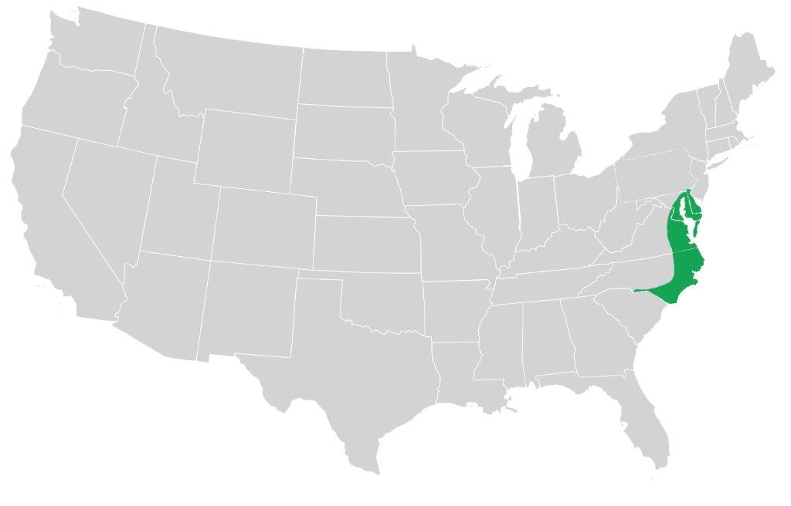

Fig. 2. Annual hill production system of strawberries on sandy loam soil (NC Small fruit and specialty crop IPM, 2010)
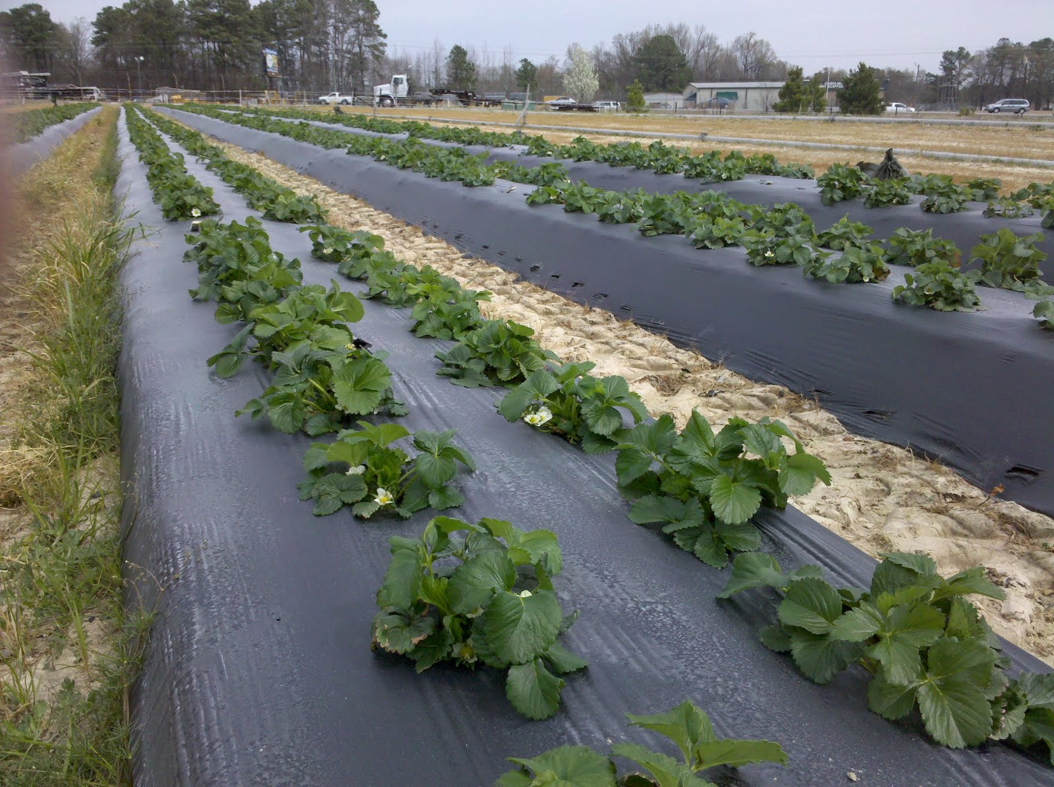

Figure 3. Petiole nitrate-N concentrations collected first bloom on 2 May 2013 and mid-flower on 9 May 2013 in Painter, VA in relation to strawberry yield over all three planting dates.

Figure 4. Leaf % N collected at initial flower on 2 May 2013 in Painter, VA as it relates to strawberry yield.

Figure 5. Leaf % S collected at initial flower on 2 May 2013 in Painter, VA as it relates to strawberry yield.

Figure 6. Petiole nitrate-N concentrations from initial flower on 2 May 2013 in relation to leaf % N levels in Painter, VA.

Literature Cited
Albregts, E.E., C.M. Howard, and C.K. Chandler. 1991. Effect of high N rates on fruiting strawberry. Soil Crop Sci. Soc. 100: 198-200
Anoymous, 2016. Atlantic Coastal Plain. Available at: https://en.wikipedia.org/wiki/Atlantic_coastal_plain
Archbold, D.D. and C.T. MacKown. 1988. Fate of fertilizer nitrogen in matted-row strawberry culture. Adv. Strawberry Prod. 7:32–35
Bottoms, T.G., M.P. Bolda, M.L. Gaskell, T.K. Hartz. 2013. Determination of Strawberry Nutrient Optimum Ranges through Diagnosis and Recommendation Integrated System Analysis. HortTechnology 23(3): 312-318
Bruggeman, A.C., Mostaghimi, S., Holtzman, G.I., Shanholtz, V.O., Shukla, S., Ross, B.B. 1995. Monitoring Pesticide and Nitrate in Virginia’s Groundwater- A Pilot Study. American Society of Agricultural Engineers. 38(3): 797-807
Bryson, G.M., Mills, H.A., Sasseville, D.N., Jones, J.B., Barker, A.V. 2014. Plant Analysis Handbook III – A guide to sampling, preparation, analysis, and interpretation for agronomic and horticultural crops. Athens, GA. Micro-Macro Publishing, Inc.
Campbell CR, Miner GS. 2000. Strawberry, annual hill culture. In: Campbell CR, editor. Reference sufficiency ranges for plant analysis in the southern region of the United States. Raleigh (NC): NC Dept of Agriculture & Consumer Services. Southern Cooperative Series Bulletin 394.
Casteel, S. 2004. Strawberry fertility and nutrient management. NCDA&CS Agronomic Division
Plant/Waste/Solution /Media Section
Demchak, K., 2012. The Mid-Atlantic Berry Guide for Commercial Growers 2013-2014. The Pennsylvania State University, State College, PA.
DeValerio, J., Hochmuth, R., Dinkins, D., Sweat, M., and Simonne, E. 2003. Extension Programs in Northeastern Florida Help Growers Produce Quality Strawberries by Improving Water and Nutrient Management. IFAS Publication #HS-956
Elementar. 2016. Available at http://www.elementar.de/en/products/vario-serie/vario-el-cube.html (verified 21 March 2016).
Fernandez, G.E., Butler, L.M., Louws, F.J. 2001. Strawberry Growth and Development in an Annual Plasticulture System. HortScience 36(7): 1219-1223.
Gärdenäsa, A.I., Hopmansb, J.W., Hansonb, B.R., Šimůnekc, J. 2005. Two-dimensional modeling of nitrate leaching for various fertigation scenarios under micro-irrigation. Agricultural Water Management. 74(3): 219–242
Han, K., Kleinman, P.J.A., Saporito, L.S., Church, C., McGrath, J.M., Reiter, M.S., Tingle, S.C., Allen, A.L., Wang, L.Q., Bryant, R.B. 2015. Phosphorus and Nitrogen Leaching Before and After Tillage and Urea Application. Journal of Environmental Quality Vol. 44 no. 2.
Hartz,T.K., Hochmuth, G.J. 1996. Fertility Management of Drip-Irrigated Vegetables. HortTechnology 6(3): 168-172.
Hicks, K., Pettit, A., McGinnis, M. 2015. Strawberry fertility management. Available at: http://www.ncagr.gov/agronomi/documents/StrawberryFertility-Feb2015.pdf North Carolina Department of Consumer Services, Raleigh, NC.
Hochmuth, G., and E. Albregts. 1994. Fertilization of strawberries in Florida. CIR1141. 11 Dec. 2015. < http://edis.ifas.ufl.edu/pdffiles/CV/CV00300.pdf>
Hochmuth, G.J., E.E. Albregts, C.C. Chandler, J. Cornell, and J. Harrison 1996. Nitrogen fertigation requirements of drip-irrigated strawberries. J. Amer. Soc. Hort. Sci. 121:660-665.
Hokanson, S.C., Finn, C.E. 2000. Strawberry Cultivar Use in North Amercia. HortTechnology 10(1):94-106
Kays, S.J. 1998. Preharvest factors affecting appearance. Postharvest Biology and Technology. 15:233-247
Miner, G.S., E.B. Poling, D.E. Carroll, and L.A. Nelson. 1997. Influence of fall nitrogen and spring nitrogen-potassium applications on yield and fruit quality of ‘Chandler’ strawberry. J. Am. Soc. Hortic. Sci. 122(2):290–295
NC Cooperative Extension. 2012. Strawberry Growers Information – Varieties. Available at:
https://strawberries.ces.ncsu.edu/strawberries-plasticulture-considerations-varieties/
NC Small Fruit and Specialty Crop IPM. 2010. Strawberry Update and Chilly Weekend Weather. http://ncsmallfruitsipm.blogspot.com/2010_03_01_archive.html
Neeteson, J.J. and Carton, O.T. 2001. The Environmental Impact of Nitrogen in Field Vegetable Production. Acta Hortic. 563, 21-28. DOI: 10.17660/ActaHortic.2001.563.1
Pattison, J.A. and T.K. Wolf. 2007. Evaluating protected culture for season extension in small fruits. Progress Report to the Southern Region Small Fruits Consortium. 22 July 2008. <http://www.smallfruits.org/SRSFCReserchFunding/2007.htm>.
Poling, E.B. 1993. Strawberry plasticulture in North Carolina: Part II. Preplant, Planting, and Postplant Considerations for Growing ‘Chandler’ Strawberry on Black Plastic Mulch. HortTechnology 3(4).
Poling, E.B. An Introductory Guide to Strawberry Plasticulture. https://www.uaex.edu/farm-ranch/crops-commercial-horticulture/docs/Guide%20to%20Strawberry%20Plasticulture.pdf
Poling, E.B., Krewer, G., Smith, J.P.2005. Southeast Regional Strawberry Plasticulture Production Guide. Southern Region Small Fruit Consortium
SAS Institute. 2016. SAS users guide: Statistics. SAS Inst., Cary,N.C.
Ulrich, A., M. A. E. Mostafa, and W. W. Allen. 1980. Strawberry deficiency symptoms: a visual and plant analysis guide to fertilization. Publ. 4098. Univ. Calif. Div. Agric. Sci. Berkeley.
USDA-NRCS. 2016. Web Soil Survey [Online]. Available at http://websoilsurvey.sc.egov.usda.gov/App/WebSoilSurvey.aspx (verified 16 Mar 2016).
USDA. 2016. Strawberry grades and standards. Available at: https://www.ams.usda.gov/grades-standards/strawberries-grades-and-standards
Weber, C. 2005. Geneva strawberry variety trial results 2004. New York Berry News. 4(3)
Wilson, H.P., T.P. Kuhar, S.L. Rideout, J.H. Freeman, M.S. Reiter, R.A. Straw, et al. 2012. Commercial vegetable production recommendations. Virginia. Virginia Coop. Ext., Blacksburg, VA.
Zotarelli, L., Scholberg, J.M., Dukes, M.D., Munoz –Carpena, R. 2007. Monitoring of nitrate leaching in sandy soils: Comparison of three methods. J. Environ. Qual. 36:953-962.

