CS 4624: Multimedia, Hypertext, and Information Access

Virginia Tech, Blacksburg VA 24061
Spring 2021

Disease Spread Simulator

Final Report

By: Joey Merline, Cameron Stevens, Justin Hess, Anthony Castellone

Client: Luis Escobar

Professor: Edward A. Fox

Date: May 12, 2021

Table of Contents

Executive summary / Abstract 3
Introduction 4
Requirements 4
Data collection 4
Data Visualization 4
Simulation 5
Design 5
Implementation 6
Plans 8
R Implementation Details 8
Shiny Implementation 8
Testing/Evaluation/Assessment 8
Users’ Manual 9
Developer’s Manual 9
Lessons Learned 9
Timeline/schedule 9
Problems 10
Solutions 10
Future work 10
Acknowledgements 11
References 11
Appendices 11

Executive summary / Abstract

The goal of our project is to provide a prediction tool to allow researchers to model the spread of Chronic Wasting Disease in deer populations in Virginia. We will provide predictions of prevalence of Chronic Wasting Disease on a county by county basis, and simulations of the changing prevalence in counties over time. This tool will be provided in the form of a website, which will allow user input for different parameters affecting the prevalence of Chronic Wasting Disease and displaying results from the predictions our application will make. We will allow the user to provide parameters for the importance of both deer population density and the vegetation level that affects the prevalence of Chronic Wasting Disease. The website will have many options to display the prevalence values we calculate including a statewide heatmap of prevalence by county and a county specific view.

We designed the website using R-shiny, as our client Professor Escobar has experience using R-shiny, and some preliminary R scripts were provided to us. To evaluate and predict prevalence of Chronic Wasting Disease, we use data provided to us by Professor Escobar which has information from Chronic Wasting Disease testing that was done within the last 20 years. This data has information about where and when these tests were performed, and information about the deer that were tested, including age, sex, species, and Chronic Wasting Disease status. We were also provided with vegetation data which allows us to know the vegetation level around the area where the deer were tested. Using these two data sets, we perform statistical analysis using parameters set by the user to determine the importance of deer population density and vegetation levels to predict a prevalence value for each county where a positive Chronic Wasting Disease test was performed.

Introduction

Chronic Wasting Disease (CWD) is a neurological disease that is always fatal to the host animal. The disease is spread through free-ranging animals and is contagious before the infected animal has symptoms. CWD is spread when prions are shed from a contagious animal to the environment via bodily fluids. Prions are not much more than infectious proteins that are normally found in the host animal which have been misfolded. Chronic Wasting Disease has been experimentally transmitted to other Mammalian species, including rodents, livestock animals, and primates. CWD is already posing a great threat to the population of deer species in North America, and could pose other environmental and public health threats. [1]

Chronic Wasting Disease was first identified in wild populations of deer in 1981 in Colorado, and has since spread to over 25 US states and several Canadian provinces. The disease was first spread into the Mid-Atlantic Region in West Virginia in 2005, and into Virginia in 2009. CWD has now been detected in 9 counties in North-Western Virginia. [2]

Our project is Disease Spread Simulator. The goal is to design a web application that helps to predict the spread of Chronic Wasting Disease in deer populations in Virginia. Our application provides predictions of prevalence of Chronic Wasting Disease by county, and provides detailed information on a county by county basis.

Requirements

Data collection
In order to reasonably predict the prevalence of CWD for deer populations in northern Virginia, we need a large enough collection of samples such that the models created in our scripts are statistically significant. The data set we used was provided by the client and contains CWD testing data from several counties in Northwest Virginia. This data set contains thousands of deer samples collected by the Virginia Department of Wildlife Resources. The data has information on the date, sample type, species, sex, age, location (latitude-longitude and county), and infection status. We were also provided a separate data file which contains values which measure the vegetation growth in the sampled area; this will be one of our primary variables of interest when predicting prevalence in deer populations.

Data Visualization
Once the data is collected and formatted, it has to be made human readable through visualizations. To achieve this, we decided to use a choropleth map of the northern Virginia area separated by county. Counties with higher amounts of positive cases are shaded lighter in color while counties with lower CWD prevalence are darker. In addition to a map, we also include traditional graphs and charts to illustrate the current disease spread as well as projections based on the change of environmental variables (vegetation index and population density).

Simulation
While we want to be able to display current information about CWD prevalence, another important project goal is to simulate changes to several variables - vegetation, population density of deer, and as a lower priority, age - and predict how those changes would affect the prevalence. The user should be able to adjust these parameters and get an accurate visualization of how prevalence will change in that scenario. In order for a user to effectively use the application and predict the effect of a policy decision on CWD prevalence, that user would first need to estimate the effect of that decision on forests and deer populations.

Design

For the sake of visual design, the main talking point is the conception of the user interface. See the Implementation or Developer’s Manual sections for design details pertaining to code or other implementation-specific details. The basis for the user interface design stemmed from several wireframes developed early on in project development. Wireframes were created using MockFlow [5] to illustrate the UI features for the simulation and identify important sections of the application.

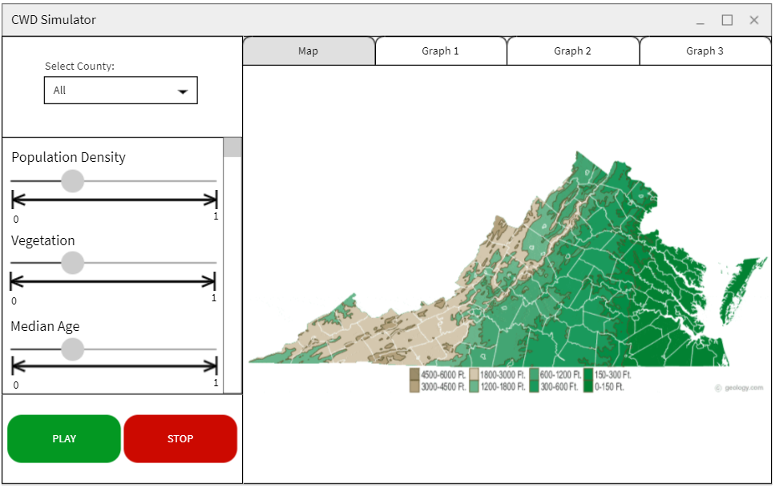
Figure 1: Wireframe depicting the simulation’s UI. Created using MockFlow.

The application allows the user to select specific counties (as seen in the drop down box) and adjust variables of interest in those counties. These adjustments can be run against the models for CWD prevalence from previous years to predict the CWD prevalence for that specific county based on the new parameters. For a convenient and intuitive user experience, there are several labeled sliding scales which can be changed, each corresponding to one of the variables of interest. For example, the user could simulate a hypothetical scenario where deforestation takes place in a specific county by selecting the county of interest and sliding the vegetation slider to the left. The user is able to start and stop the simulation to get the specific prevalence information at a specific time. Also, the user will have multiple alternative ways of viewing the information available to them. This includes bar graphs depicting total testing over time and pie charts of the ratio of healthy to unhealthy deer tested at each point in time, with explanations with each graph on what they represent and how input parameters may affect them.

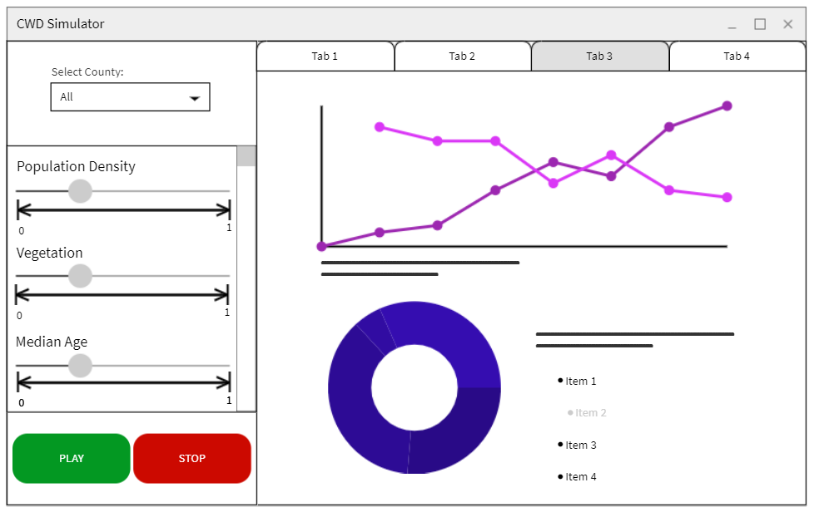
Figure 2: Wireframe depicting the simulation’s UI, illustrating the data graphs (infections by year/county). Created using MockFlow.

Implementation

The dataset we were provided is represented in a large CSV file containing samples of deer by the Virginia Department of Wildlife Resources. Firstly, since this data file is raw, our client provided an R script that removes the samples that are missing values by searching for fields equal to “NA”. The provided file then was used to create a few plots (positive samples and samples missing data) using the ggplot2 library. This file is for the most part for us to understand that we are not working with every sample in the dataset, and to help us remove samples that cannot contribute to the predicted prevalence value for a particular county.

The methodology behind the calculation of prevalence values is inspired by a similar study in which Michael Tabak analyzed the prevalence of several diseases in pigs [3]. This is worth mentioning since we were provided a version of the code used in that study to guide our project in a certain direction. So there are similarities between our script and the provided script that analyzes data on pigs. These would include the type of distribution used to model prevalence and the function used to relate demographic variables with prevalence values. This distribution relies on the sensitivity of CWD, which is the probability of an animal testing positive for CWD when infected, and the specificity, which is the contrapositive. However, there are key differences; our script predicts the effects of different variables, we organize models into six different groups based on county, and we compare models differently.

After filtering out incomplete samples from the supplied data file, the next task is to organize the samples by county and compute prevalence values for each county based on the population density of deer in that county and vegetation index at the location of deer samples. We have written an R script that parses this data file, creating a table (data frame) for samples of each county, from which we can calculate the probability that a deer in that county has CWD. In order to model the prevalence for a given demographic parameter, we use a Bernoulli distribution for each data of each county. This type of distribution is essentially a binomial distribution of one independent experiment.

In terms of specific implementation details, we use several packages in R to perform statistical modeling and create visualizations. Stan is a programming language that is designed for statistical inference, and there is a package called RStan [4] that allows R scripts to interface with Stan. Calculating probability based on the probability mass functions of beta distributions and Bernoulli distributions is still possible with the use of Stan code, but Stan provides some helpful functions and is used for convenience and reducing code complexity.

To model the prevalence for a given subset of data (county), our Bernoulli distribution has to be a function of the variables whose effect on the distribution of CWD we’re predicting. In order to organize deer samples with the corresponding population density and vegetation index at their location, we create a vector for each demographic variable whose length is equal to the number of samples for that county. In order to allow the user to simulate “what-if” scenarios with different demographic variables, we multiply each of these vectors by a scalar which changes to match changes to the slider in the UI. We use the logit function (to create probability values) on the demographic parameters of a sample along with a vector of regression coefficients corresponding to these parameters. The regression coefficients are modeled using a normal distribution as an uninformed prior distribution. The purpose of the prior distribution is essentially to make the Bernoulli distribution dependent on the demographic variables. This is contrasted to posterior distributions, which are created after taking into account relevant variables.

In order to examine the effects of variables independently, we specify a model for each variable, and do this for each county. To determine which model is more accurate, we have a function that, given a graph, calculates an information criterion value (based on the mean likelihood and variance for the set of samples). This value is compared for models of the same sample space to determine which is most appropriate for the prediction of prevalence values. Once prevalence values are calculated, we pass those to a function that generates output for the user.

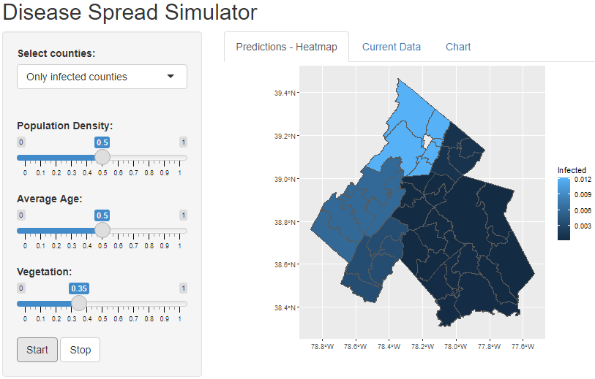
Figure 3: Later iteration of UI in RShiny

Our current implementation allows the user to create several plots to visualize the data. One type of graphic the user can generate is a map of the entire state of Virginia. This graphic can either display a choropleth map (heatmap) of the number of cases in each county or a heatmap showing the percentage of deer for each county that are positive for CWD. If the sliders are at their default positions, a visualization for the current prevalence of CWD is shown based on the best fit model. Otherwise the best fit model will be run considering the adjusted demographic variables, and a plot will be generated predicting CWD prevalence for these new values. Another graphic that users can generate shows only the counties that deer data has been collected from. This graphic has the same functionality as the previously mentioned model, but can additionally plot the longitude and latitude coordinates of where CWD positive deer were found. The R script was written knowing that the input data is subject to change, so it can handle significant changes in the dataset - like if CWD were to spread into more counties.

For the implementation of the UI, we decided to use Shiny. The was the most useful as it provided library functions for many of the UI elements depicted in the wireframe. Also, since it is in R, it integrated well with the existing codebase. The Shiny API offers built-in library functions for the parameter buttons, sliders for user input, the drop-down box for selecting counties, and the ability to plot graphs and charts.

Testing/Evaluation/Assessment

In terms of testing for the functionality of our project, this mostly consisted of comparing results for prevalence based on the sample data to those of other diseases to see if the numbers were within a reasonable range. The main source of comparison was the study on pigs mentioned in the previous section. Otherwise, we made sure that adjustments to demographic variables did not result in unrealistic changes in CWD prevalence. As long as the models we used to generate prevalence values are not too far off, the predictive aspects of the project should not be too far off either.

A large part of the verification of statistical results is based on the nature of the models used to produce those results. The study from which ours was based created confidence intervals for disease prevalence with a certain percentage confidence, which is related to the p-value of the statistical model used to create those confidence intervals. For a tested hypothesis, the p-value is a measure of the probability that the results would occur by random chance, as opposed to being a consequence of the assumptions used when performing a statistical test. Generally, a smaller p-value is associated with a tighter confidence interval with a higher percentage confidence, and a more statistically significant result.

Ultimately, in terms of the testing and validity of the model, the section of our implementation that is most important is the creation of posterior distributions for the sensitivity and specificity. In the script, we approximate the center of the distribution, but a confidence level of at least 0.95 is used to create the distribution. This confidence level corresponds to a p-value of 0.05, which is a standard benchmark for statistical significance. To better approximate the center of the distribution, we would need actual test data pertaining to the specific and sensitivity of CWD, which is not included with the sample data we received.

The main area of improvement we should explore in terms of testing is cross validation of models. Cross validation is typically used to indicate how well a trained model will predict data that is not part of the dataset used to train it. Leave-one-out cross validation was used in the provided study, but we focused primarily on the functionality of the models and the user experience, leaving model validation for last. We also tried to avoid stealing the thunder of the study on pigs as much as possible, so we saved model validation for last. Ideally our next step would be to add some kind of cross validation method for our models, such as the holdout method, which approximates a function based on training data and uses that to predict new values.

Users’ Manual

When first opening our application users will be met with a screen containing the map of Virginia color coded by current Chronic Wasting Disease cases by county. This map is the main focal point of the application, and it is located where all of our relevant output data will be displayed on the different screens of our application (see Figure 3).

On the left of the screen, there are 3 sliders which correspond to their labeled values of Population Density, Average Age, and Vegetation. By moving these sliders, users are able to affect the predictions of Chronic Wasting Disease that our application runs. By increasing a slider, the prediction that is run will have a higher value for that parameter. In other words, the posterior distribution created (the model after change in demographic variables is taken into account) is informed by the change in the variable determined by the slider. A slider that is centered is considered at its default position (no change). Under these sliders are buttons that control the running of the CWD prevalence predictions.

By pressing the “start” button at the bottom left of the screen, the prevalence predictions will be updated using the inputted values for the parameters from the sliders. By pressing the “start” button multiple times, the user can have the simulation run for multiple years in a row, each time the button is pressed a new prediction will be run for the following year. When the user presses the “stop” button, prediction values will be deleted and the map and data will be reset to the baseline, real-life values.

There are 3 different tabs across the top of the screen. The first tab, “Predictions-Heatmap,” is selected by default and displays the map of Virginia counties color coded by their CWD case values or prediction values. The second tab, “Current Data,” contains the data tables of our current data, which has information on sample date, sample origin, species, sex, age, location, CWD status, and vegetation data corresponding to the location.

The final tab, “Charts,” contains graphs representing the spread of CWD as well as percentages of infected deer. These graphs will include our baseline real-life data as well as data that is generated from the current simulation based off of user inputs, separated by year.

The target users for our application are scientists and researchers that are studying the spread of Chronic Wasting Disease in Virginia. The main goal for these users is to run simulations to predict the prevalence of Chronic Wasting Disease in Virginia counties and retrieve relevant data that could guide policy such as culling. This goal has several subtasks that the user would want to accomplish:
- Provide input parameters for prevalence prediction
- View data visualization in a map format
- View experimental input data and data based on the current simulation
- View graphs representing disease spread and infection percentage for input data and simulation data

Developer’s Manual

A methodologies exercise was completed during the design phase of the project, for which we laid out several tasks that our system needs to perform. These tasks are organized in a flowchart (since complex tasks are composed of subtasks) indicating the required capabilities of the system. See Figure 4 for details.

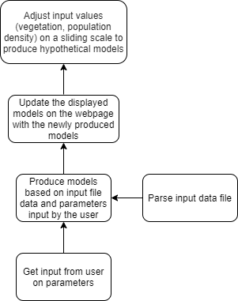
Figure 4: Flowchart of work activities from methodology assignment

The code is structured in such a way that one file performs computations pertaining to the sample data, while another file functions as the user interface, allowing users to view data visualizations and adjust demographic parameters. The former takes a similar approach to model computation as the related study on prevalence of various diseases in pigs, so any continuation should refer to that study if the modeling process is unclear.

Other relevant files include the supplied comma-separated data file, the supplied vegetation index file, and the two scripts that Mariana wrote to clean the first file and match vegetation index values to deer samples. After running these scripts, a cleaned version of the data (no samples missing fields) is produced with most of the deer having been paired with a vegetation index value. This is the data file that is used in the model computation in the CWD modeling R script.

This backend file parses the data, separating deer samples by county and year. This is because models should be generated for each year (so a regression can allow us to extrapolate) and for each county (deer samples from a specific location only affect the expected prevalence for that location). After parsing the data into an organized table of samples and samples’ respective attributes, we run a model specified in Stan code which is based on that used in the original study. Model validation and posterior distribution calculation follow suit, but as mentioned in the evaluation section, leave-one-out cross validation was not used in our implementation.

The GUI file runs the model calculation file, and creates several plots based on the results. The sliders from the user interface correspond to scalar values in the GUI code which are used to run an additional model with the vectors corresponding to demographic parameters multiplied by the new scalars. This will change the resulting prevalence distribution by varying amounts depending on the best fit model (determined in the backend file) and the magnitude of the change to the demographic variables.

To run the script, developers will first need to download the appropriate versions of R and RStudio. RStudio is the development environment used to get most of this working. Once RStudio is installed and the project files are all added to the same workspace or directory, the interactive display should be visible along with the output from the sample data. There were some troubles getting scripts to run when the working directory was set incorrectly, so be sure to change that if the file cannot be run.

Lessons Learned

Timeline/schedule

The following table represents the schedule followed for the project design stages and shows when deliverables were due.

Table 1: Project calendar highlights
Jan. 26 | Feb. 9 | Feb. 23 | March 9
-Group formation  -Background research | -Presentation 1  -Client signed off on project | -UI Wireframe | -Initial UI implementation
March 9 | March 23 | April 6 | April 20
-Initial UI implementation | -Presentation 2 | -Interim Report  -Finalizing UI  implementation | -Final Presentation
May 5th
-Finalize project

-Peer evaluation

Problems

The lack of hard deadlines is certainly a problem for full time students in the midst of a pandemic. Since there is no pressure to turn something in, it can be hard to find time where everyone is available to meet up and prepare one of the deliverables listed at the start of the semester. The pandemic has complicated scheduling not only due to the physical distance between group members, but also due to the risk each one of us has to face during the semester. One of our group members ended up getting sick during a critical period of project production, and there’s no way to foresee or expect that situation. The best we can do is manage our time efficiently and work as a group to pick up the slack.

Another issue we encountered was the scope of the project, from an educational point of view. Dealing with statistical models is a very delicate task, and it is easy to do incorrectly if the one doing the statistical analysis is inexperienced. As computer science students, we are primarily programmers, so at least one member of the group must go out of their comfort zone to cover the area of the project with which we are less confident.

Solutions

In an ideal world, the problem of soft deadlines would be solved by a leader that holds group members accountable for doing their part by a certain time. For our group in particular, no one had much experience managing a team, so it was certainly more of a learning experience during the planning of the schedule two months in advance, setting up meetings with the client or with fellow group members, and communicating often and effectively. The solution is honestly to practice these skills and hone them over time. While the expectations are high, we are also in the process of learning; this problem is part of the process, and a preview of what is to come in the professional work environment.

We’re more suited as programmers than statisticians, but since we cannot hire a team to consult, the best we can do is designate a team member to study up and become a statistics expert. We were referred to Virginia Tech’s Statistics Department, but they do not perform extended project consultation for school projects. However, the department does have appointments where one can ask brief questions and find out who to ask for more help. Many of the professors on campus are willing to help a student interested in their field, so this is a useful option.

Future work
The simulation could be a lot more granular in how it defines regions. Instead of by county, the simulation could provide much smaller zones within the counties to provide the user greater control over how they view the disease prevalence in a region. Additionally, a feature that allows users to save the parameters of their simulation on their browser would be helpful, as the user would not have to re-input their data with each session.

As mentioned in the evaluation section, the accuracy of the models produced could be improved by performing a cross validation technique during model calculations. Given the differences between our data and that of the original study, it was unclear whether leave-one-out cross validation would be applicable in the same way that it was used in the provided code we were referencing. Work certainly needs to be done to determine if this would be the best technique, and if so what different calculations need to be made to implement it.

Acknowledgements

Professor Luis Escobar - Assistant Professor, Department of Fish and Wildlife Conservation
Mariana Castaneda - M.Sc. Student, Department of Fish and Wildlife Conservation
Michael Tabak - co-author of a similar study

References

[1] Carlson, C.M., Hopkins, M.C., Nguyen, N.T., Richards, B.J., Walsh, D.P., and Walter, W.D., 2018, Chronic wasting disease—Status, science, and management support by the U.S. Geological Survey: U.S. Geological Survey Open-File Report 2017–1138, 8 p., https://doi.org/10.3133/ofr20171138.

[2] Virginia Department of Wildlife Resources, 2021, Chronic Wasting Disease, acc. 5.5.2021
https://dwr.virginia.gov/wildlife/diseases/cwd/

[3] Tabak MA, Pedersen K, Miller RS. Detection error influences both temporal seroprevalence predictions and risk factors associations in wildlife disease models. Ecol Evol. 2019;9:10404–10414. https://doi.org/10.1002/ece3.5558

[4] Stan Development Team (2020). “RStan: the R interface to Stan.” R package version 2.21.2, http://mc-stan.org/.

[5] A Produle Systems (P) Limited. “Mockflow.” acc. 4.4.2021 https://www.mockflow.com/.

