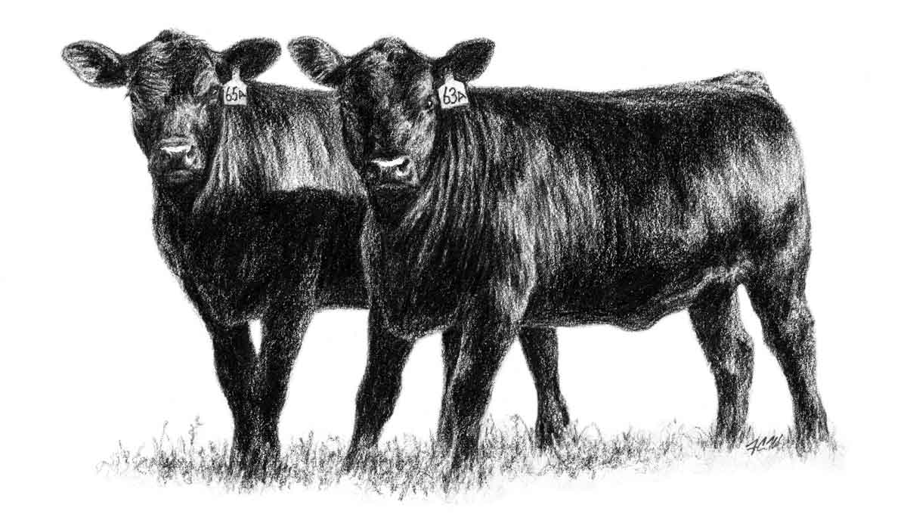
Winter Beef Producer Meeting
at


December 6, 2023 – 5:30pm – 7:30pm

Meal Provided
Speakers & Special Guests: Dr. Vitor Mercadante - Virginia Tech, Rockingham Cooperative & Pendleton Community Bank

RSVP required by November 29. Call 540 468 2225 or email karis@vt.edu. Listen to local radio for weather event updates.

Meal and Meeting Sponsored by

If you are a person with a disability and desire any assistive devices, services or other accommodations to participate in this activity, please contact VCE Highland at 540-468-2225/TDD*) during business hours of 9 a.m. and 5 p.m. to discuss accommodations 5 days prior to the event. *TDD number is (800) 828-1120.

Beef Producer Winter Meeting Agenda
December 6, 2023

5:20 – 5:30 pm – Sign In
5:30 – 6:00 pm – Welcome Guests & Enjoy Meal
6:00 – 6:10 pm – Recognition of Sponsor, Rockingham Cooperative
6:10 – 6:30 – Farm Financial Products & Services, Pendleton Community Bank
- Dayne Davis, AVP Business Development Officer - (304) 358 3622 - dmdavis@yourbank.com
- Chelsey Simmons, Financial Center Manager - clsimmons@yourbank.com

6:30 – 7:30 pm – Adoption of Reproductive Technologies in Beef Production
Dr. Vitor Mercadante, Virginia Tech
Associate Professor and Extension Specialist,
School of Animal Sciences
Program Sponsors:



Large Animal Clinical Sciences, Virginia Tech
175 W Campus Drive - Blacksburg, VA 24061
Phone: (540) 231-9153 - Mobile: (352) 672-4061
Twitter: @vitormercadante - www.beefrepro.org

7:30pm – Program Evaluation & Adjourn


Your Extension Staff:
Kari Sponaugle
Extension Agent, ANR
karis@vt.edu – 540 468 2225
https://highland.ext.vt.edu

Jordan Alexander
4-H/ANR Program Educator
(540) 839-7261 - jordan98@vt.edu
https://bath.ext.vt.edu
NOTES

__________________________________________________________________________________________________________________________________________________________________________________________________________________
__________________________________________________________________________________________________________________________________________________________________________________________________________________
__________________________________________________________________________________________________________________________________________________________________________________________________________________
__________________________________________________________________________________________________________________________________________________________________________________________________________________
______________________________________________________________________
__________________________________________________________________________________________________________________________________________________________________________________________________________________
__________________________________________________________________________________________________________________________________________________________________________________________________________________
__________________________________________________________________________________________________________________________________________________________________________________________________________________
__________________________________________________________________________________________________________________________________________________________________________________________________________________
__________________________________________________________________________________________________________________________________________________________________________________________________________________
______________________________________________________________________

