Jamie King, University Arborist
VT Facilities Department
Sterrett Center, room 38C
(540) 231-3718

Alumni Mall Soil Renovation
January 29, 2020

OVERVIEW
The Alumni Mall promenade located in the northeast quadrant of Virginia Tech’s Blacksburg campus represents an opportunity for improving the urban tree canopy at the University. Planting trees along this spacious median strip and along both sides of the street in tree wells will beautify the campus while adding much needed green infrastructure to this region of campus. Previous efforts to improve the site have reportedly suffered high mortality rates and low success. Over the winter of 2019/2020 Jamie King, University Arborist, conducted a soil structure and chemical analysis to help develop a plan towards improving the Alumni Mall area, this report details the results of that study.

METHODS
- Soil core samples were collected at sites throughout Alumni Mall for bulk density testing.
- Core samples were oven-dried and weighed for bulk density testing in the FREC UF lab.
- Soil samples were aggregated by zones for chemical analysis.
- Aggregated samples were sent to the Bartlett Tree Experts lab for chemical analysis.

RESULTS

Soil Density
Bulk density is the measured density of soil in a specific volume and is used to determine the proportion of soil particles to void spaces in a sample. The spaces between soil particles are pathways for water and air movement, they enable plants to access these essential elements for plant growth. Relative high bulk densities have little to no spaces for water and air and thus are inhospitable for plant health. Foot traffic, vehicle traffic, and heavy equipment movement compact soils and increase bulk density.
Figure 1 illustrates the sites where the samples were collected and Table 1 shows the measured results. Soils with a bulk density higher than 1.6 g/cm3 restrict root growth; every site tested measured as moderate to high bulk density. The average bulk density for the median at the Alumni Mall was calculated as 1.46 g/cm3, this level of compaction significantly limits the health of most plants.
Figure 1: Soil sample sites.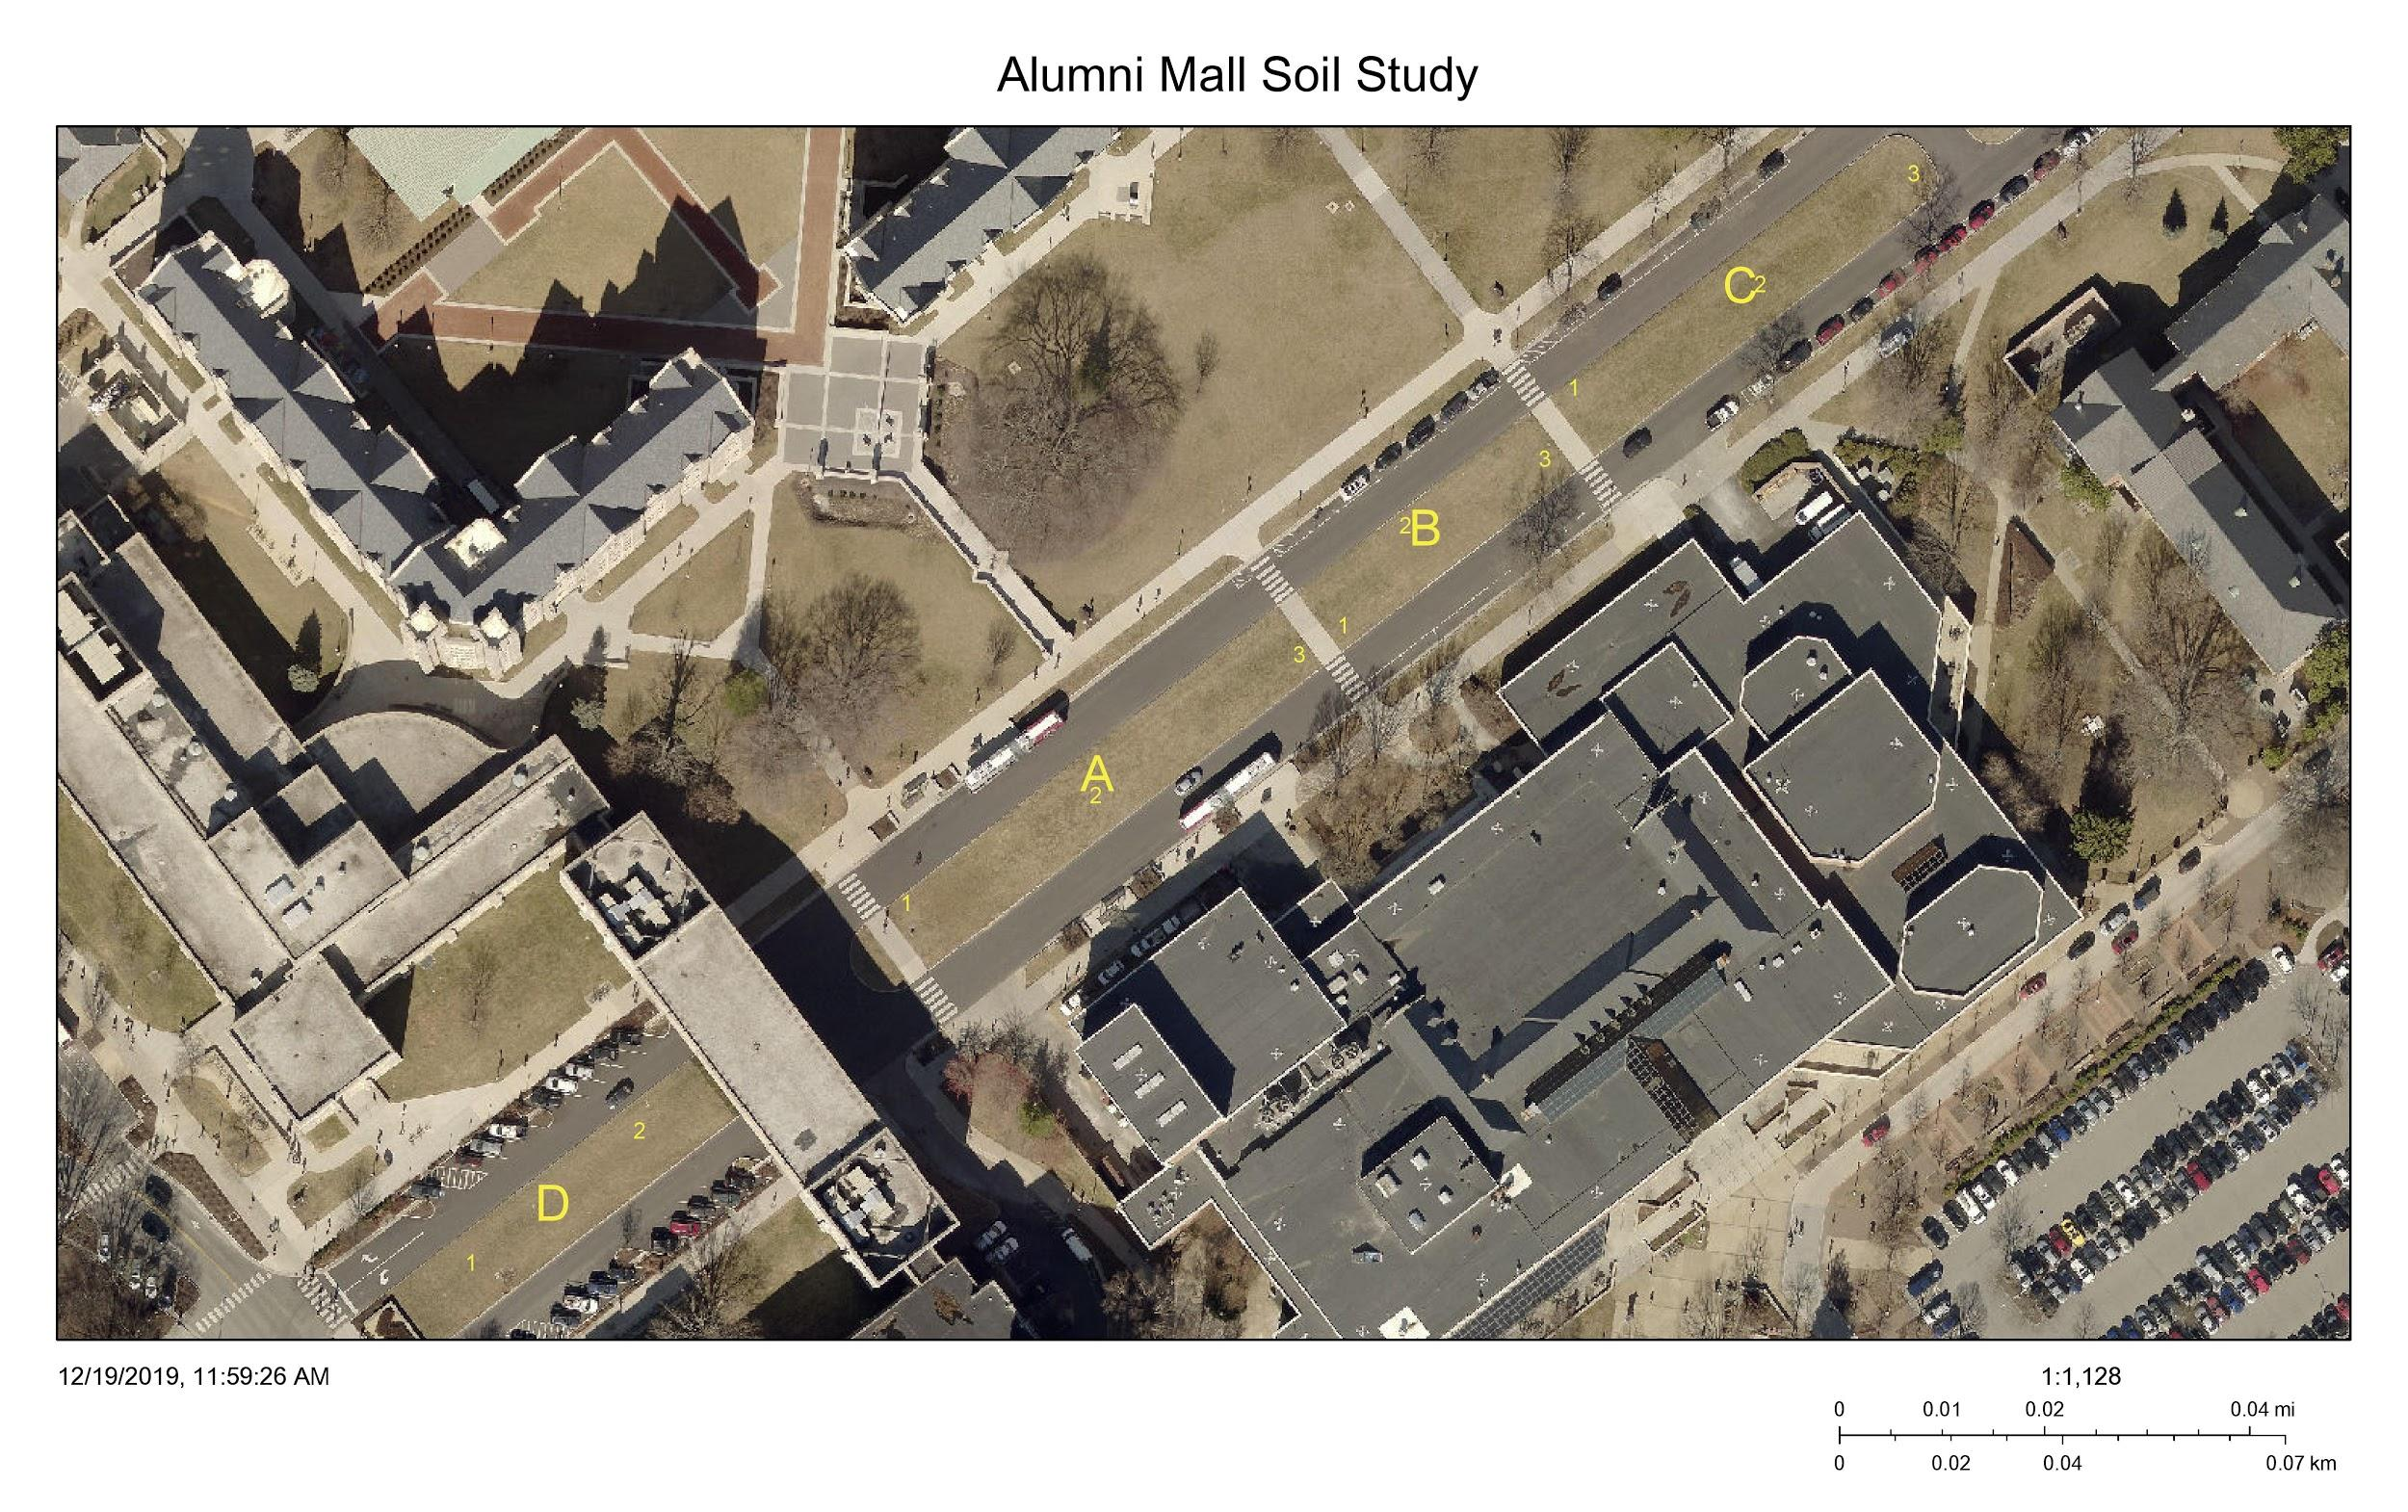
Table 1: Soil bulk density results.
Site ID | Site Average g/cm3 | Overall Average g/cm3
A1 | 1.532554348 | 1.462366601
A2 | 1.400923913
A3 | 1.324782609
B1 | 1.391413043
B2 | 1.558097826
B3 | 1.388586957
C1 | 1.502173913
C2 | 1.476195652
C3 | 1.533913043
D1 | 1.433369565
D2 | 1.544021739

Soil Chemistry
The pH of soil is important to plant health; pH levels too high or too low can limit a plant’s ability to access available nutrients in soil. Figures 2, 3, 4, and 5 illustrate the measured soil pH levels from the sites sampled; the results are consistently high/alkaline, average 7.3, and limit plant selection to trees that are tolerant of high pH levels.
Organic matter is a necessary soil component for plant growth and may be used as an indicator of biotic activity in the soil. High levels of organic matter retain moisture longer for plant access and increase biotic activity that is important for soil health. Figures 2, 3, 4, and 5 illustrate the percentage of organic matter measured in the samples selected; the results are generally low, average 3.3%, and indicate low biotic activity and poor soil health.
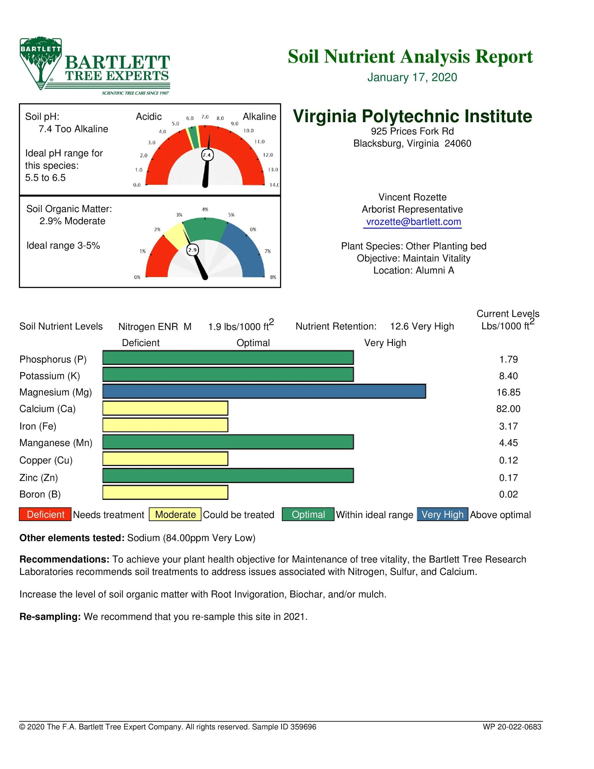
Nutrient levels in soil must be sufficient to support plant health or plants will not grow. Figures 2, 3, 4, and 5 illustrate the measured nutrient levels from the sites sampled; the results show remarkable deficiencies in some macronutrients and many micronutrients. These deficiencies will limit plant health and growth.
Figure 2: Chemical analysis of site Alumni A.

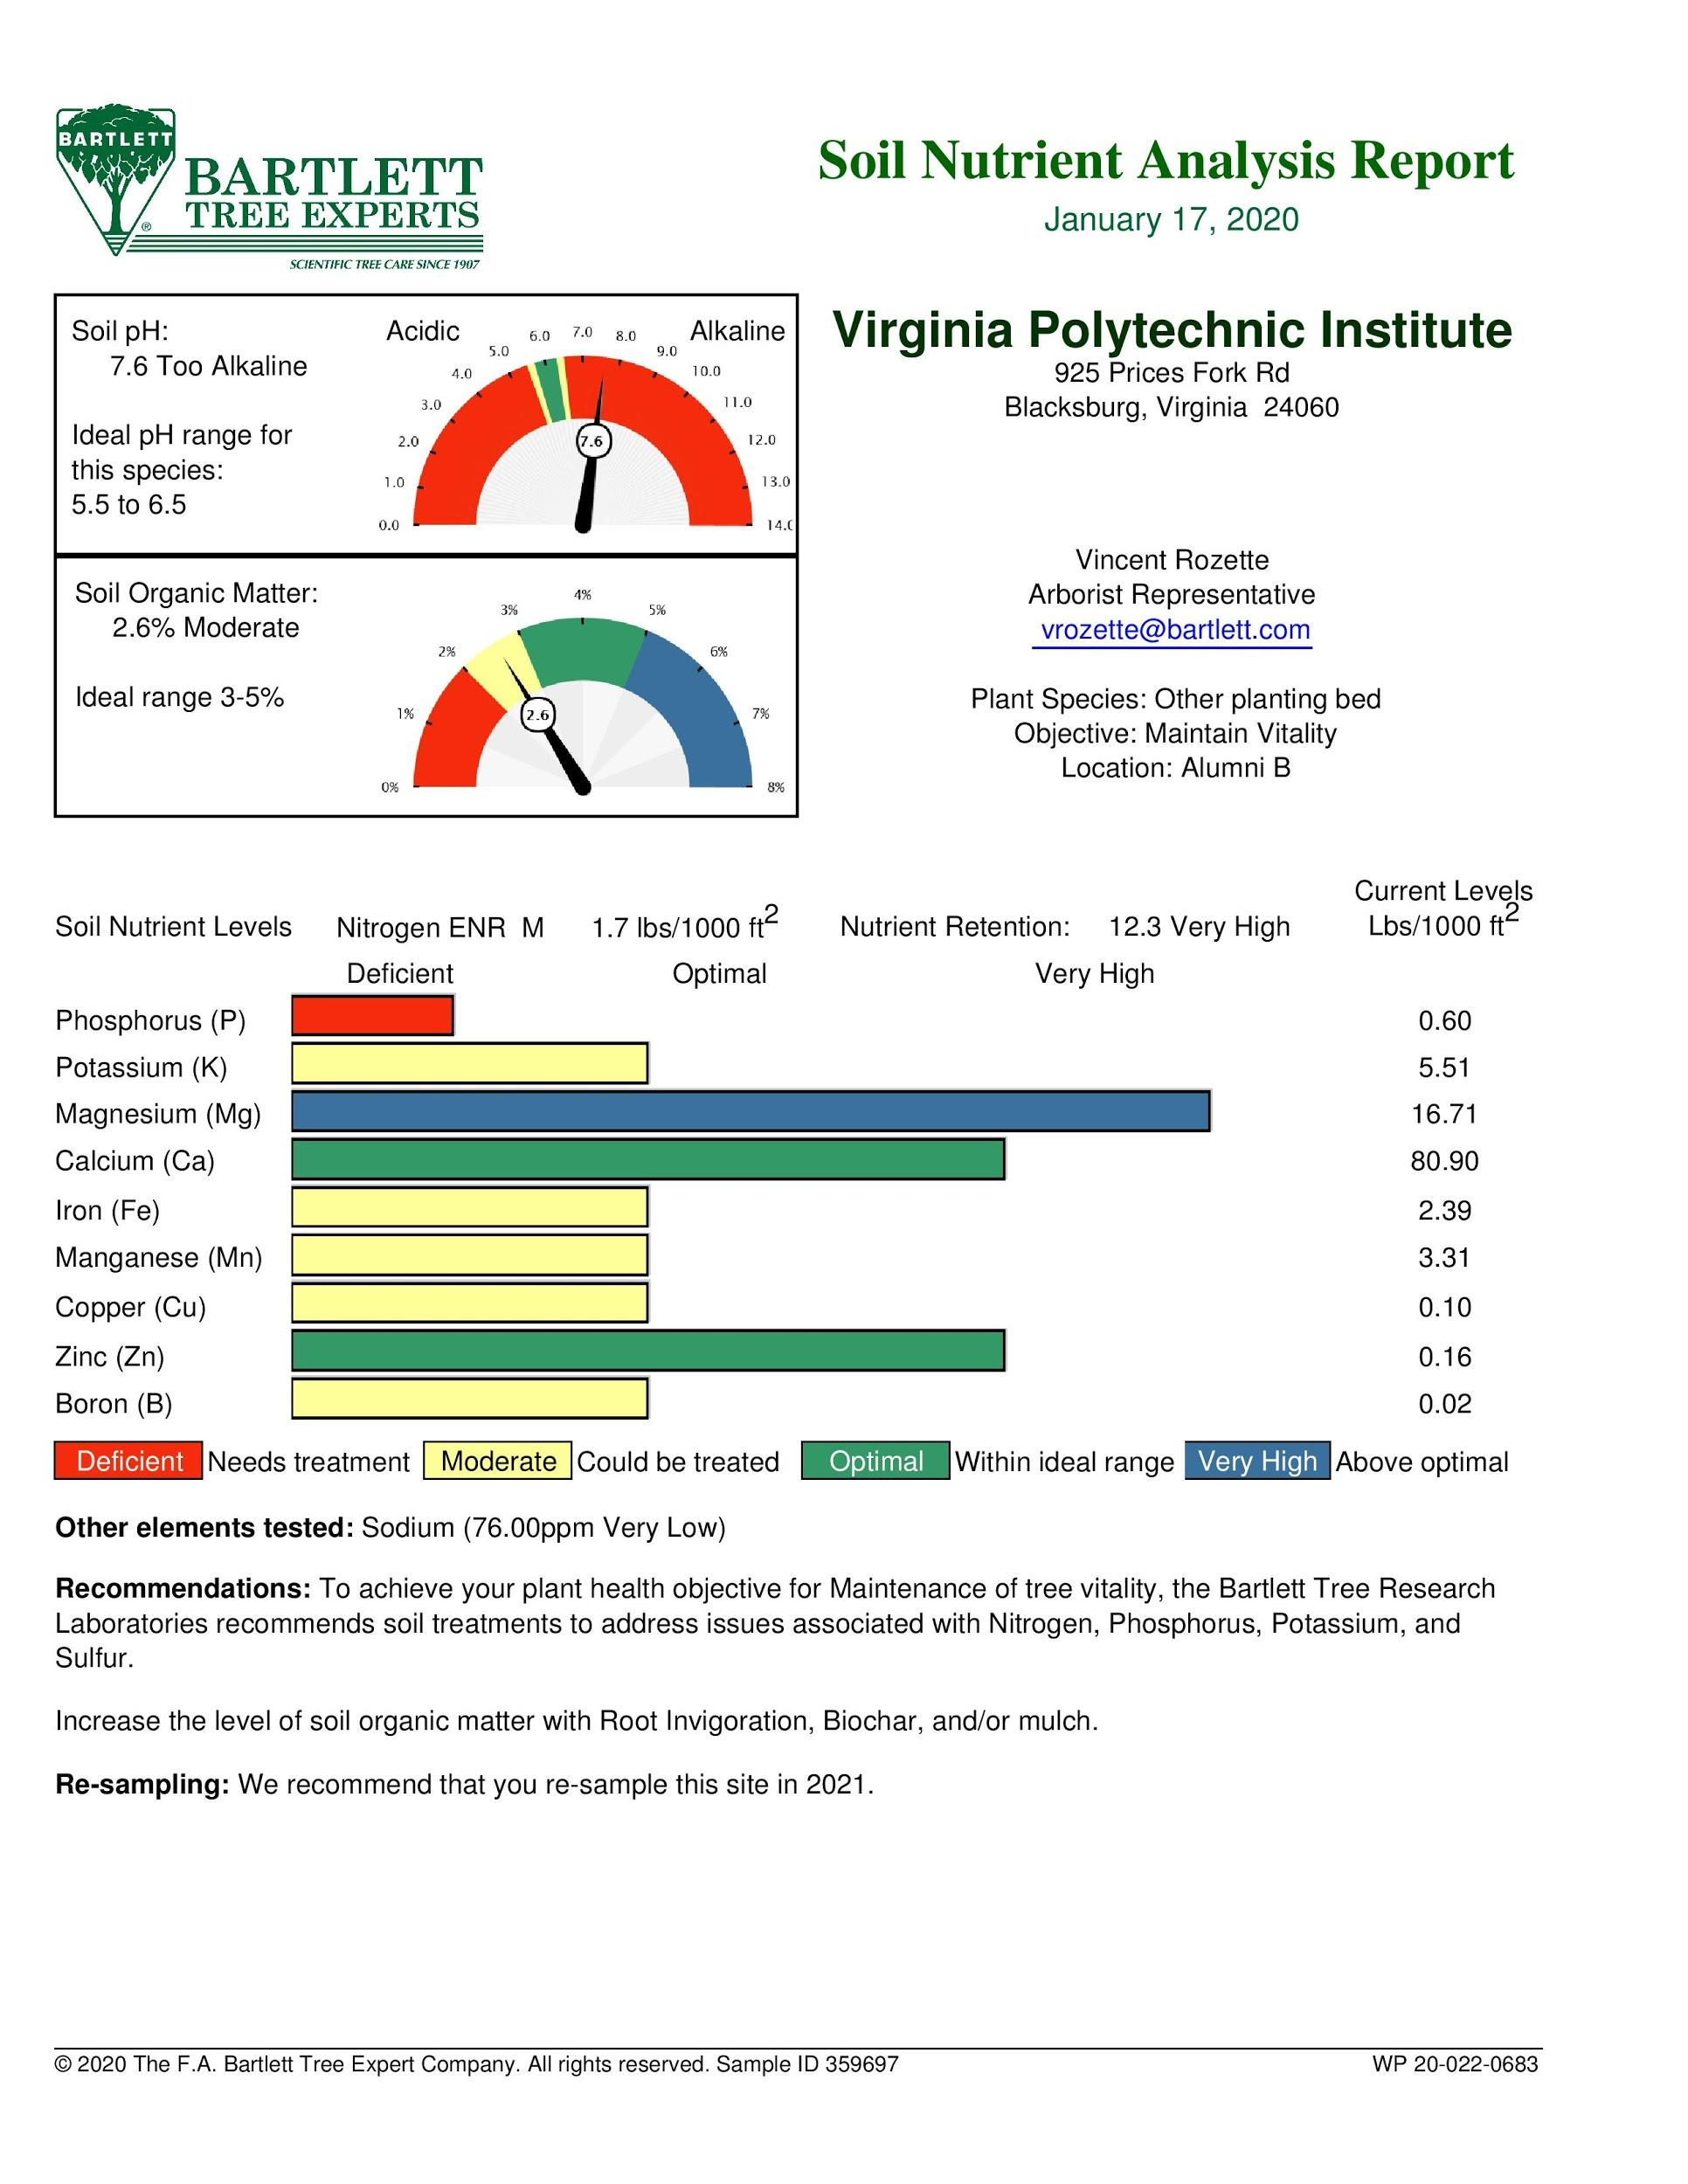

Figure 3: Chemical analysis of site Alumni B.

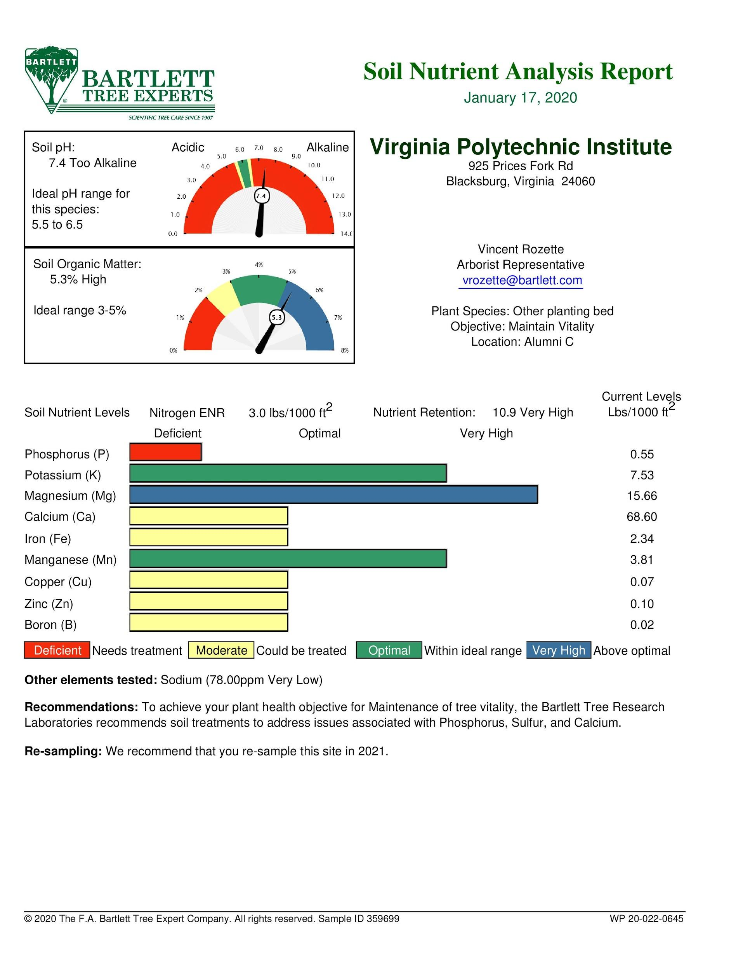
Figure 4: Chemical analysis of site Alumni C.

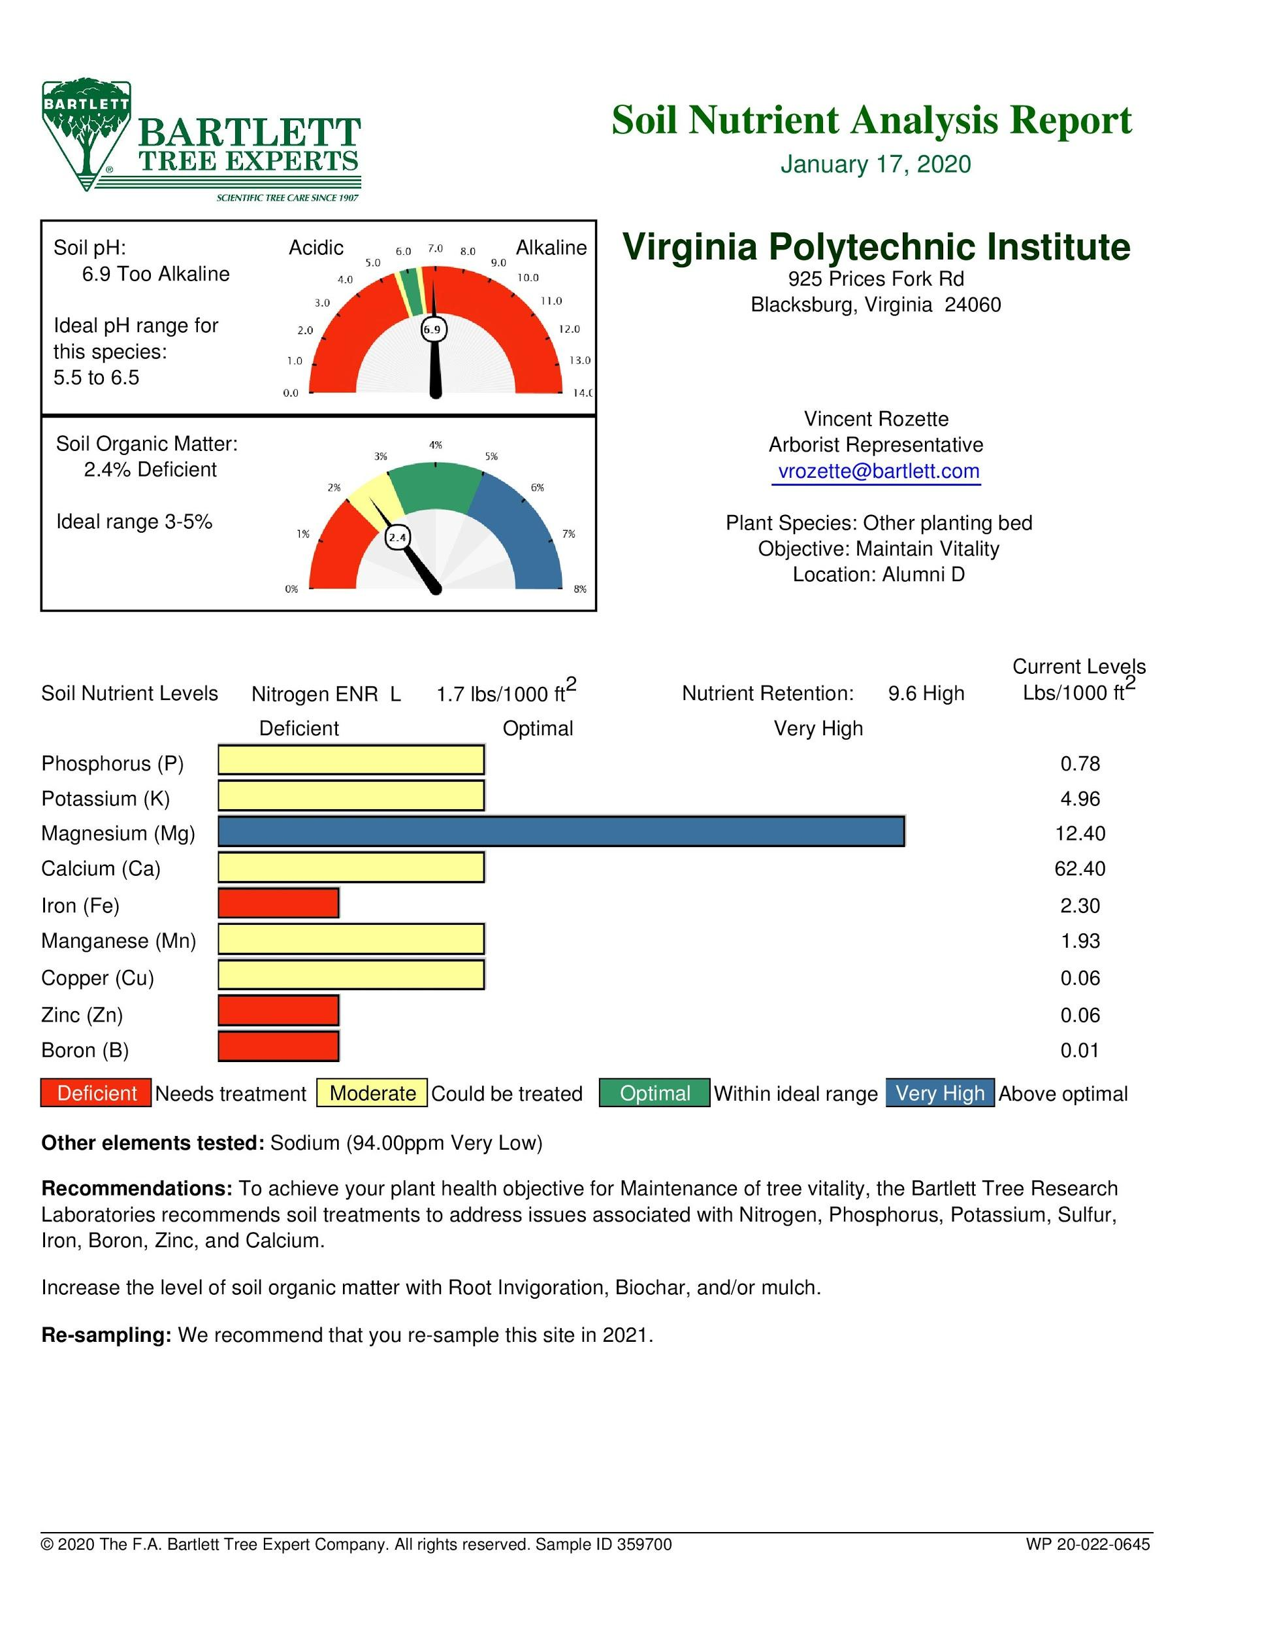
Figure 5: Chemical analysis of site Alumni D.

RECOMMENDATIONS
The soil in the median at Alumni Mall is compacted, highly alkaline, has low organic matter, and many nutrient deficiencies. A complete soil replacement will eliminate these problems but would require 629,331.8 cubic yards of soil, approximately $17.6 million, plus shipping and installation.
Another approach to improve the soil at this location is with an amendment strategy that will add organic matter/nutrients, lower soil pH, and reduce compaction. Using the soil profile rebuilding technique, a crew can incorporate 5% compost into the existing soil while de-compacting the soil profiles with a back-hoe. This approach requires 31,466 cubic yards of compost, approximately $1.1 million, plus shipping and installation.
Beyond soil replacement or amendment, some tree species may tolerate the poor soil conditions at Alumni Mall. The careful selection of urban tolerant species like Styphnolobium japonicum, Pistacia chinensis, Catalpa speciosa, and Gymnocladus dioicus may increase the survival rates when planting this site but results may suffer. Soil volume in the median may support 30 large trees and 15 medium sized trees, approximately $7,200 plus shipping and planting labor.

