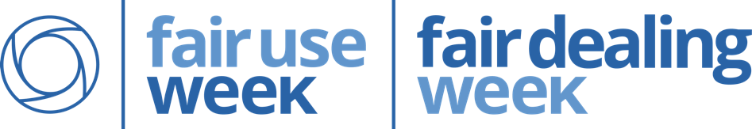
The Fair Use Week exhibit was curated and designed by: Virginia (Ginny) Pannabecker, Anita Walz, Robert Sebek, Keith Gilbertson, and Scott Fralin; Panel design by: Robert Sebek; Exhibit implementation by: Scott Fralin. Fair Use Week / Fair Dealing Week image via http://fairuseweek.org/, CC BY 4.0 license.

This handout is licensed
Resources
Fair Use Week exhibit, February 22 – March 4, 2016
University Libraries, Virginia Tech

“A Fair(y) Use Tale,” by Professor Eric Faden, transcribed video: youtu.be/lmOa3DFRicY

Fair Use Week: fairuseweek.org/

Fair Use Evaluator tool – Learn more about the 4 Factors! librarycopyright.net/resources/fairuse/

Fair Use Week, University Libraries at Virginia Tech: lib.vt.edu/copyright/fair-use-week/

Bibliography for Copyright and Fair Use: lib.vt.edu/copyright/fair-use-week/bibliography.html

Open @ VT Blog: blogs.lt.vt.edu/openvt/
What is fair use?

Fair Use is a four-factor exemption of U.S. Copyright Law 17 U.S. Code § 107, which allows anyone to:

- Re-distribute
- Perform
- Electronically transmit
- Publicly display
- Create new versions of others’ copyrighted works
… without permission*

*When the potential use is deemed to be ‘fair,’ rather than ‘infringing.’ Only a court can decide what is truly ‘fair use.’

However, U.S. law allows anyone to conduct a well-informed fair use analysis in good faith, using the four factors: Purpose (of the use), Nature (of the work), Amount (of the work used), and Effect (on the commercial value – potential or current) to determine if their proposed use of copyrighted material is more fair or more infringing. *See the Fair Use Evaluator Tool in the Resources below for guidance.

