

Crisis Events Template Generation and Information Extraction using LLM

Final Report
CS4624: Multimedia/Hypertext
Virginia Tech, Blacksburg VA 24060
Mohamed Farag

Prepared by Group 15
Nick Hess
Jackson Small
Gibbs Gresge
Alex Ryu
Aneesh Tummeti

May 1, 2025

Table of Contents
Table of Contents 2
Executive Summary 4
Introduction 5
Problem 5
Motivation 5
General Approach 5
Requirements 7
Functional Requirements 7
Non-Functional Requirements 8
Design 9
System Architecture Overview 9
Frontend (Next.js and Tailwind CSS) 9
Backend (Flask) 9
Database (MongoDB) 9
Authentication 9
Containerization (Docker) 10
Data Flow 10
Template Structure 11
Design Principles 11
Implementation 12
Project Setup and Planning 12
Frontend Development 12
Backend Development 12
Template Generation and Summary Flow 13
Integration and Polishing 13
Testing / Evaluation / Assessment 15
User's Manual 16
Admin View 16
User View 20
Other Features 22
Developer’s Manual 25
Running Locally 25
Source Code 25
Environment Variables 26
Authentication 26
Database 28
Next.js Frontend 29
Backend 29
Dockerfile 30
Lessons Learned 32
Timeline / Schedule 32
Problems 32
Solutions 33
Future Work 33
Acknowledgments 34
References 35
Appendix 36
1. Project Description 36
2. Trello Example 37

Executive Summary
In an age where real-time access to reliable information is critical, crisis events such as hurricanes, earthquakes, and public safety incidents often generate a deluge of fragmented, unstructured data spread across numerous online sources. This makes it difficult for emergency responders, researchers, and decision-makers to quickly extract accurate, actionable insights. Our capstone project, Crisis Events Template Generation and Information Extraction using LLM, addresses this challenge by developing a web application that automates the process of summarizing crisis events and extracting key information from a set of user-provided webpages.
The core functionality of the application is powered by a Large Language Model (LLM), which enables both the generation of structured templates for different types of crises (e.g., natural disasters, mass casualty events) and the automatic filling of those templates with relevant facts derived from online content. Users select a crisis category and upload URLs related to a specific event; the system then scrapes and cleans the text using BeautifulSoup [8], passes the content to the LLM for inference, and returns a populated template highlighting key data points such as dates, locations, intensities, and impacts.
The project combines a modern web technology stack: a responsive frontend built with Next.js [1] and Tailwind CSS [2], secure authentication via GitHub OAuth [10] using NextAuth.js [3], and a backend implemented with Flask and MongoDB. The backend handles LLM-based processing and web scraping, exposing endpoints that communicate with the frontend via JSON. Docker is used to containerize and streamline deployment [6].
To date, our team has successfully built a functioning prototype with support for initial template generation, web scraping from multiple URLs, and text-to-slot mapping using LLMs. We’ve implemented role-based access control, enabling admins to manage templates while allowing end-users to generate and store summaries. We have also addressed key technical hurdles such as asynchronous scraping performance.
Looking ahead, we plan to enhance the LLM prompting strategy, increase template flexibility, and broaden the range of supported crisis event types. Additionally, we will polish the user interface, improve error handling, and complete user and developer documentation. By project’s end, our goal is to deliver a scalable, user-friendly solution that enables quick and structured extraction of critical crisis event information paving the way for faster, data-informed responses to emergencies.

Introduction

Problem
Crisis events such as hurricanes, earthquakes, wildfires, and mass casualty incidents are often covered across numerous online platforms including news articles, government reports, and social media updates. This results in an abundance of unstructured, scattered data that makes it difficult for emergency responders, analysts, and stakeholders to efficiently extract the essential facts. Details such as dates, locations, severity levels, casualty counts, and economic impacts are often buried within lengthy narratives or inconsistent formats. The manual process of reviewing and summarizing these sources is not only time-consuming but also prone to oversight and inconsistency, potentially delaying critical decision-making during emergencies.

Motivation
The increasing frequency and severity of crisis events worldwide underscore the need for efficient tools to support rapid situational awareness. Accurate and timely summaries of such events can significantly improve the response capabilities of public safety agencies, humanitarian organizations, and researchers. Our client, Dr. Mohamed Farag, proposed a solution to streamline this information overload by leveraging recent advancements in Natural Language Processing (NLP) to automate the extraction and summarization process (See Appendix 1 Project Description). By structuring and standardizing the output using predefined templates, the system would reduce cognitive load and help users focus on the most relevant aspects of a crisis.

General Approach
To address this challenge, we are developing a full-stack web application that enables users to generate structured crisis event summaries from a set of URLs. The system supports two main functionalities: (1) generating reusable templates tailored to specific crisis event categories (e.g., hurricanes, shootings), and (2) extracting relevant information from user-provided web content to populate these templates.
The frontend, built with Next.js and styled using Tailwind CSS, offers a user-friendly interface for inputting URLs, selecting crisis categories, and viewing results. Authentication is handled via GitHub OAuth using NextAuth.js, with user data and generated summaries stored in a MongoDB database. On the backend, we use Flask to manage two primary endpoints—one for scraping web content using BeautifulSoup and another for performing LLM-based template filling and summarization via the Hugging Face Transformers library [7]. Results are passed between components as JSON objects, ensuring a clean and scalable architecture.
This modular system architecture allows for future enhancements, including support for additional crisis types, improved LLM prompt design, and more robust administrative controls. Together, these elements aim to deliver a practical, efficient, and accessible solution for crisis information extraction.

Requirements
The requirements of our system will be listed in both functional and non-functional perspectives.

Functional Requirements
- Template Generation
The system must allow administrators to create generalized templates for different crisis event categories. Templates must contain placeholder fields representing key attributes relevant to each crisis type (e.g., <formation-date>, <affected-locations>)
- Template Completion
Users must be able to input a list of URLs related to a specific crisis event. The system must scrape content from the provided URLs and pass the relevant text to a LLM. The LLM must fill in the placeholders within a selected template using the extracted data.
- Admin Controls
Administrators must have the ability to create and delete crisis event templates via a front-end interface. Admins must also be able to manage stored summaries and moderate content.
- User Interaction
Users must be able to log in using GitHub OAuth. Authenticated users must be able to select a crisis category, upload URLs, and receive completed summaries. Users must be able to delete their generated summaries and view previously saved ones.
- Data Storage
The system must store user information, generated summaries, and templates in a MongoDB database. Each stored summary must retain metadata such as user ID, timestamp, category, and URLs used.
- Web Scraping
The system must accurately extract readable text from HTML pages using BeautifulSoup. Scraped content must be cleaned to remove boilerplate code, navigation elements, and other non-informative content.
- API and Backend Integration
The backend must expose RESTful endpoints for scraping and LLM inference. These endpoints must accept and return data in JSON format for seamless frontend-backend integration.

Non-Functional Requirements
- Performance
The LLM must be able to return a filled template within a reasonable amount of time passed submission. Web scraping and LLM tasks should be optimized for minimal latency and efficient resource use.
- Scalability
The system architecture must support future extensions such as additional crisis types, alternative LLM models, or new authentication providers.
- Security
User data must be securely stored and authenticated using OAuth standards. Admin-only features must be protected by role-based access control.
- Portability
The entire application must be containerized using Docker to ensure consistent deployment across environments.
- Usability
The frontend must provide a clean and intuitive user experience, with clear instructions and visual feedback during scraping and summarization. Error handling should provide helpful messages for missing URLs, invalid templates, or model failures.
- Maintainability
Code should be modular and documented to support future development and debugging. A Developer Manual will be created to support ongoing maintenance and potential handoff of the system.

Design
The system architecture for the Crisis Events Template Generation and Information Extraction web application follows a modular, full-stack design. It consists of three primary components: the frontend user interface, the backend API server, and the database. Each component is built using modern technologies that emphasize maintainability, scalability, and responsiveness.

System Architecture Overview
The application is divided into the following core modules:

Frontend (Next.js and Tailwind CSS)
Presents a user-friendly interface for logging in, submitting URLs, selecting crisis categories, viewing generated summaries, and managing templates (for admins). Uses React components and Tailwind CSS for consistent styling. Manages authentication state using NextAuth.js and securely communicates with the backend API endpoints.

Backend (Flask)
Handles two main endpoints, scraping and LLM. Scraping accepts a list of URLs, extracts readable text from each using BeautifulSoup, and returns a combined, cleaned text blob. The LLM endpoint accepts a selected template and the scraped text, then runs an LLM inference to fill in the template’s placeholders with relevant information. Responses are returned as an array of strings for attributes and a string for the template.

Database (MongoDB)
Stores user profiles, admin-created templates, and user-generated summaries. Supports role-based access for features like template creation or deletion.

Authentication
Handled via GitHub OAuth using NextAuth.js. Maintains session state and protects admin routes.

Containerization (Docker)
Each component is containerized for consistent development and deployment. Docker ensures compatibility across environments and simplifies setup for future maintainers.

Data Flow
The user journey through the system can be described as follows:
- Login: User authenticates via GitHub OAuth.
- Template Selection: User selects a crisis category; corresponding template is retrieved from the database.
- URL Submission: User provides one or more URLs related to a specific crisis event.
- Scraping & Preprocessing: Flask backend scrapes all pages using BeautifulSoup and filters out non-essential content.
- LLM Inference:The cleaned text and selected template are sent to the LLM, which fills in each placeholder with relevant data extracted from the content.
- Storage: The summary is saved to MongoDB and associated with the user’s profile.
- Result Display: An email is sent to the user’s email associated with GitHub informing them the template is uploaded. The populated summary is displayed on the frontend, where the user can review and (optionally) delete it.
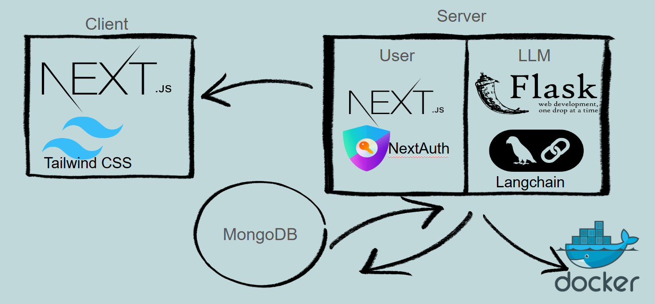
Figure 1: System Architecture

Template Structure
Each template consists of a short narrative with parameterized fields that the LLM is expected to fill. For example:
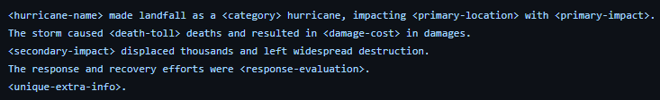
Figure 2: Example of a template created by an admin.

Design Principles
Modularity: Each component (frontend, backend, database, LLM) is independently deployable and testable.
Security: Authentication is required for all user actions; admin routes are protected via role-based checks.
Scalability: The system is designed to support additional crisis types, multiple LLM backends, and future cloud deployment.
Resilience: Docker-based architecture ensures that the system can be easily re-deployed in case of failure or environment changes.

Implementation

Project Setup and Planning
The project began with setting up the foundational components of the system, including version control through GitHub and a clear project structure. The frontend was initialized using Next.js, while the backend was scaffolded with Flask. Early commits focused on aligning the team around an implementation plan, setting up the repository, and documenting the general direction of the application. A modular folder structure was established from the beginning to support separation between components like frontend pages, backend API logic, and database operations. A Trello board was created to keep track of tasks and to make assignments easier (see Figure A2).

Frontend Development
Frontend development focused initially on establishing core pages and building the authentication system. The team integrated GitHub OAuth using NextAuth.js, allowing users to securely sign in and eventually enabling role-based access to different parts of the application. Login and registration forms were created and styled, and later enhanced with dynamic theme switching and user-friendly UI elements like avatars and popovers.
Following the authentication system, the team built out key user-facing pages. This included a dashboard where users could input URLs and select crisis event templates, a new-summary page for displaying LLM-generated outputs, and an admin-only interface for managing templates. A reusable sidebar component was introduced for navigation, with content and links tailored dynamically based on whether a user was authenticated and their access level.

Backend Development
Backend development proceeded in parallel, focusing first on scraping and then on LLM integration. Using BeautifulSoup, the team implemented functionality to scrape readable text from a list of user-submitted URLs. A Python function was created to accept these URLs, process the content, and return a cleaned block of text for downstream use.
In the next phase, the backend began interfacing with an LLM model titled “TheBloke/CapybaraHermes-2.5-Mistral07B-GGUF” [11] through the Hugging Face transformers pipeline. The model receives a crisis event template and relevant article text, and saves the template, key attributes, and other relevant information such as a timestamp and user ID of the admin who created the template to MongoDB. A Flask endpoint was built to handle this interaction, and the endpoints are accessible via HTTP requests.
As the project progressed, Flask and the Next.js frontend were containerized using Docker, making it easier to manage environments and prepare for deployment. Docker Compose was used to ensure that both frontend and backend services could be spun up together in a local or cloud-based setting.

Template Generation and Summary Flow
The core functionality was developed iteratively. Admins can input example paragraph summaries into the system, which the LLM then uses to create generalized templates for a specific crisis category. These templates contain placeholder tags that represent key data points (such as <event-date>, <location>, or <max-wind>). Users interact with this system by selecting a template, submitting URLs relevant to a specific crisis event, and then receiving a filled-in summary. The backend handles text preprocessing, prompt construction, and LLM inference. All generated summaries are stored in MongoDB along with metadata such as user ID, event category, and source URLs.

Integration and Polishing
Toward the middle of the development cycle, work shifted toward refining the integration between components. This included connecting the frontend submission form to the Flask scraping and generation endpoints, validating inputs, and ensuring consistent data formatting across the application. UI enhancements like form validation, responsive layout tweaks, and minor animations were added to improve user experience. In addition, the team began exploring LangChain as a way to simplify prompt management and model interaction [9]. Tests were also conducted using quantized models to improve inference speed and reduce memory usage during local LLM runs.
Other enhancements included the addition of a background process for improved scraping efficiency, cleanup of environment variables and unused files, and preparation for internal client demos. By this stage, the system was able to accept user-submitted URLs, extract relevant content, generate structured crisis event summaries, and display them in an accessible and secure web interface.

Testing / Evaluation / Assessment
The following table tests the LLM tasked with generating different types of templates and the time it takes to do so.

Disaster Type | Website | Template Generated | Time Taken (s)
Wildfire | https://www.usatoday.com/story/news/nation/2025/03/27/carolina-wildfires-firefighters-containment/82685874007/ | Hurricane <hurricane-name> was a Category <category> hurricane that affected <primary-affected-location> and caused <primary-effect>. The hurricane had winds up to <max-wind-speed>. Hurricane <hurricane-name> also affected <secondary-affected-area>. <unique-extra-info>. | 143.17
Shooting | https://apnews.com/article/pembroke-park-florida-shooting-3b1ae1336d8fe88164ca480ccfee8f5f | A shooting occurred in <primary-location>. The shooter, identified as <shooter>, fatally shot <number-of-victims> victims and injured <injured-count> others. The incident took place on <shooting-date>. Authorities are investigating the motive behind the shooting. <unique-extra-info> | 44.32
Hurricane | https://www.npr.org/2025/03/27/nx-s1-5340659/appalachian-town-still-in-recovery-six-months-after-flooding-from-hurricane-helene | Hurricane <hurricane-name> was a Category <category> hurricane that affected <primary-affected-location> and caused <primary-effect> on <hurricane-date>. The hurricane had winds up to <max-wind-speed>. Hurricane <hurricane-name> also affected <secondary-affected-area>. <unique-extra-info>. | 84.628

Figure 3: Template Generation Test.

User's Manual
The current version of the Crisis Events Template Generation and Information Extraction system allows users to generate structured summaries of crisis events based on text scraped from web pages.
Once the frontend and backend are running, navigate to localhost:3000 in a web browser. You will be asked to sign in with GitHub. 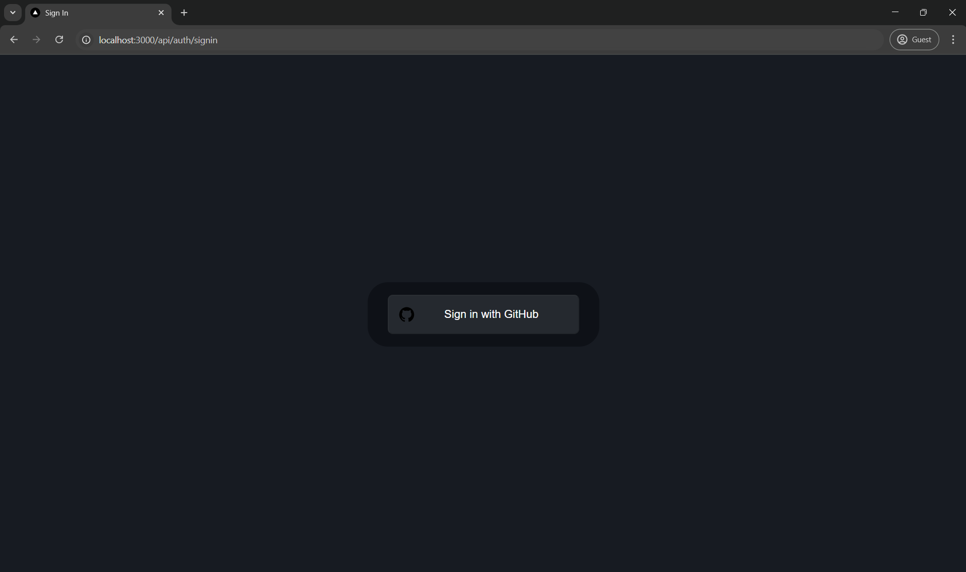
Figure 4: Root Sign In Page.

Admin View
Once you sign in, you will be routed to the Admin Panel. Because you are the first user in the fresh install of mongodb, you will be assigned the role of “admin”. All following users will be assigned the role of “user”.
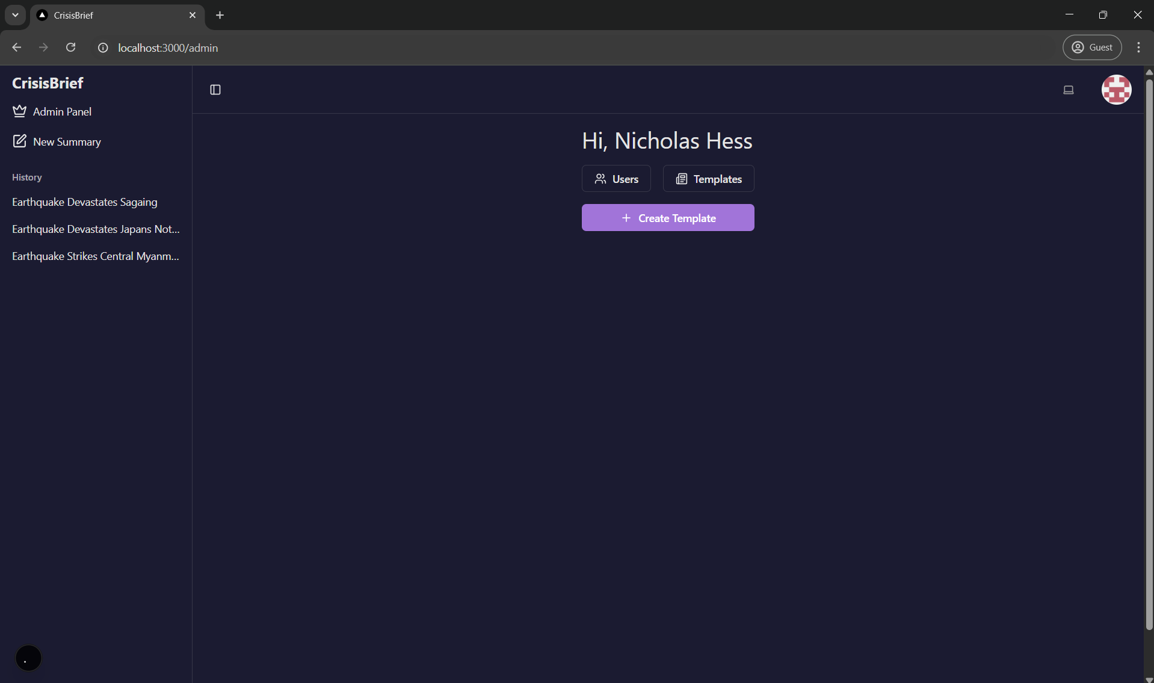
Figure 5: Admin Page to create Template.

In the admin panel, you can navigate to the Users page. Here you can view and manage (delete, change role) all users and admin.

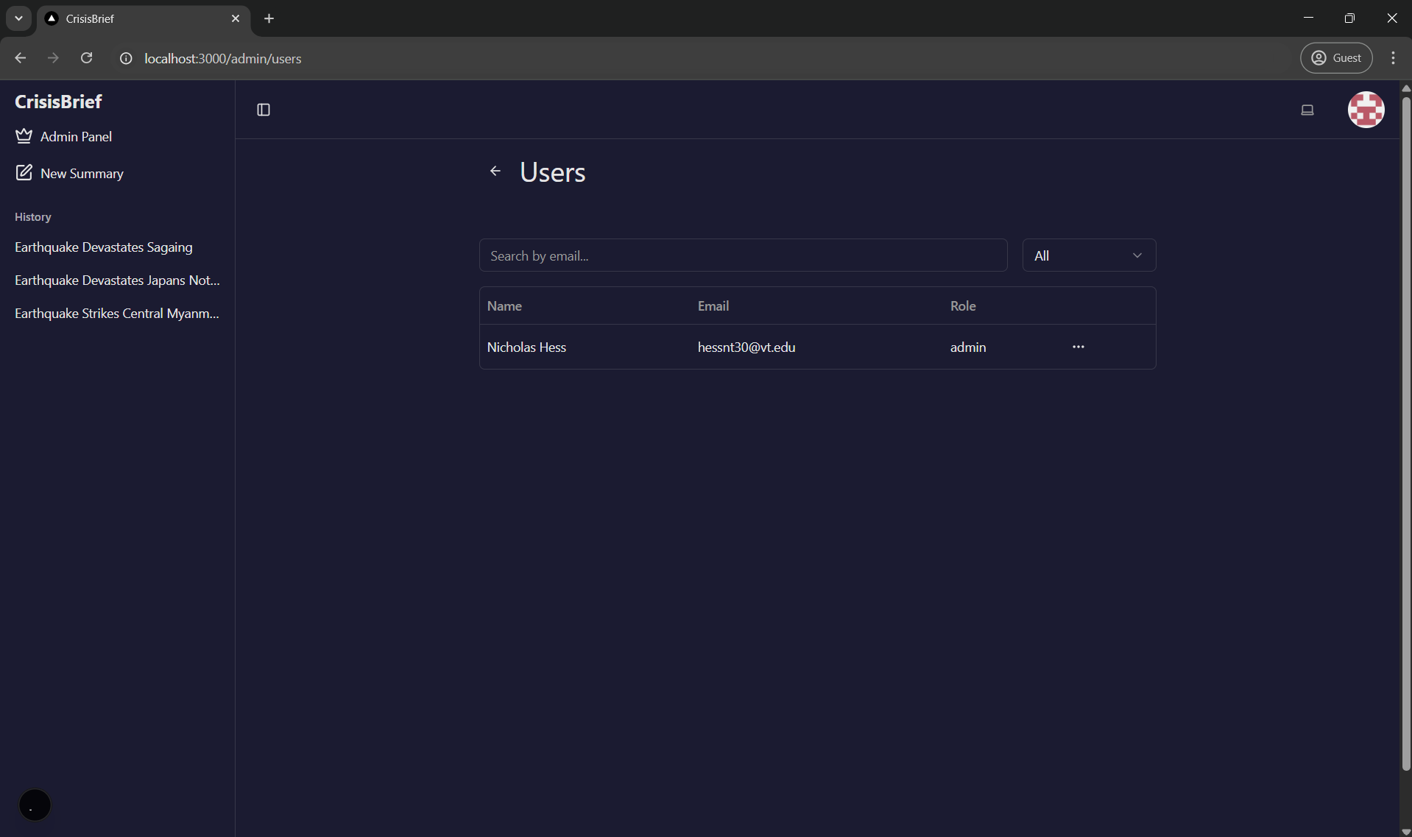
Figure 6: Admin Panel for Users
From the admin panel you can also navigate to the Templates page.
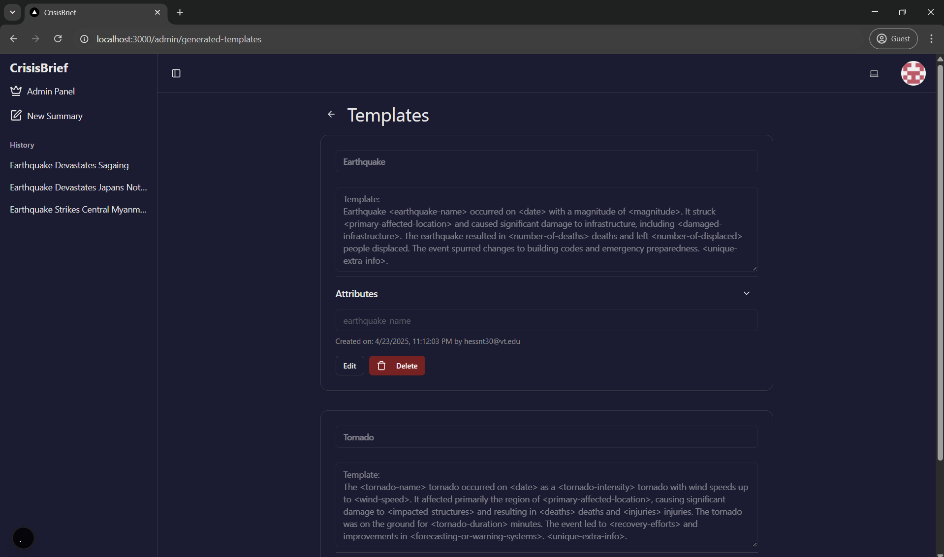
Figure 7: Admin Template Page to edit or delete current templates
Here you can view, edit and delete templates that have been created. You can see who created it and when.
From the admin panel, you can navigate to the New Template page.
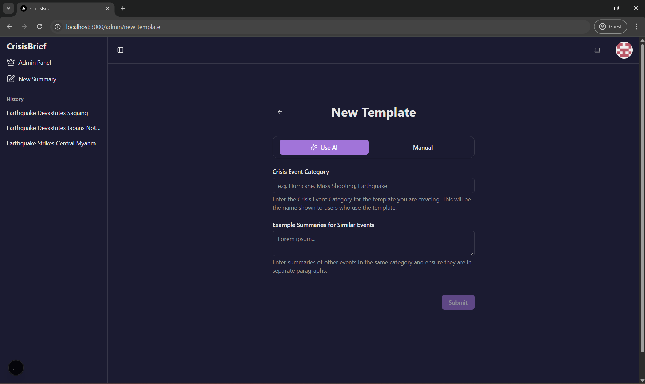
Figure 8: New Template Generation

Here you can generate templates using AI. First, input a crisis event category, then input summaries of different examples of crisis events within that category. Below is an example of.

Crisis Event Category: Earthquake
Example Summaries for Similar Events:
The 2010 Haiti earthquake struck near Port-au-Prince on January 12 with a magnitude of 7.0. It caused massive destruction to buildings and infrastructure, including hospitals and government facilities. The disaster resulted in over 200,000 deaths and left more than a million people homeless. Limited resources and an overwhelmed emergency response system complicated rescue and recovery efforts.

The 2011 Tōhoku earthquake occurred off the northeastern coast of Japan on March 11 with a magnitude of 9.0. It triggered a powerful tsunami that devastated coastal towns and caused a critical failure at the Fukushima Daiichi nuclear power plant. The combined disaster led to significant loss of life, widespread displacement, and long-term environmental and economic impacts.

The 2004 Indian Ocean earthquake occurred on December 26 off the coast of Sumatra, Indonesia, with a magnitude of 9.1–9.3. It triggered a massive tsunami that swept across 14 countries, causing over 230,000 deaths. Entire communities were wiped out, especially in Indonesia, Sri Lanka, India, and Thailand. The scale of destruction prompted one of the largest international humanitarian responses in history.

The 1994 Northridge earthquake struck the Los Angeles area of California on January 17 with a magnitude of 6.7. The quake caused severe damage to highways, buildings, and homes, with over 50 people killed and thousands injured. Infrastructure damage included collapsed freeway overpasses and widespread power outages. The event spurred major changes to building codes and emergency preparedness in California.

The 2008 Sichuan earthquake hit China’s Sichuan province on May 12 with a magnitude of 7.9. It caused the deaths of nearly 90,000 people and displaced millions. Entire villages were flattened, and numerous schools collapsed, raising questions about construction standards. The government mobilized a large-scale military and civilian rescue effort, and the tragedy led to significant national mourning and rebuilding initiatives.

Once you request to generate the template, you will receive a status message from the backend, either an error message or a success message. Now the template is being generated on the backend asynchronously. You will receive an email (to the email your GitHub account is associated with) once the template has been generated. It will tell you how long it took to generate. You can now view the template in the admin panel.
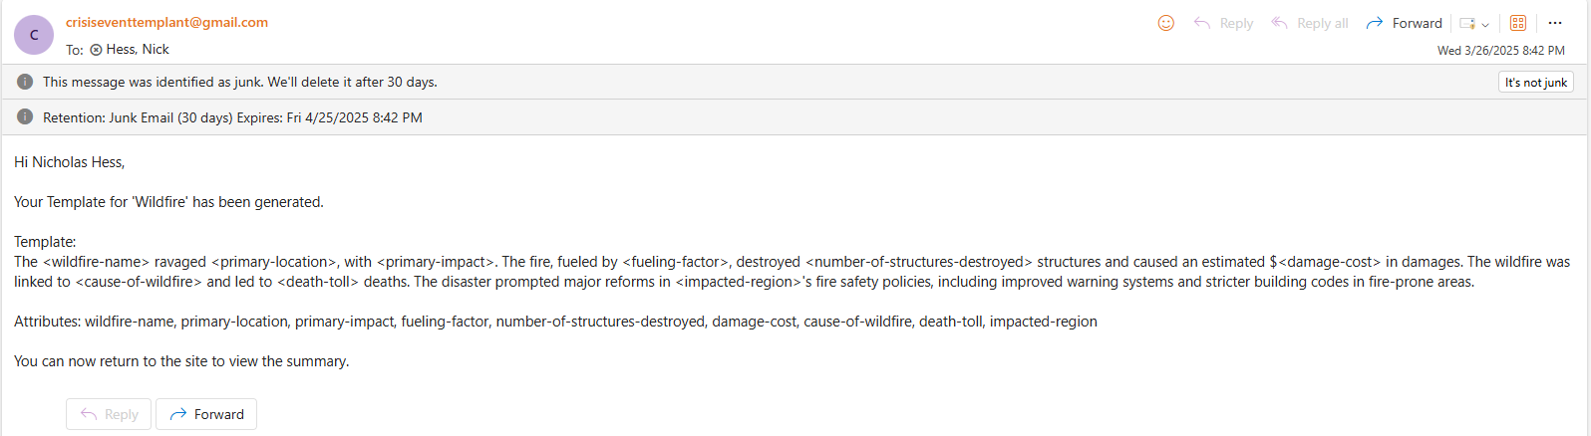
Figure 9: Email of template sent to admin

User View
Users do not have access to any admin features/pages and instead will be redirected to /unauthorized.

You can generate a summary using that example. The example summaries need to be separated into their own paragraphs where each paragraph is related to only one event within the category. Remember that your output will only be as good as your input, so upload meaningful examples.

To generate summaries using these templates, navigate from the sidebar to the New Summary page.
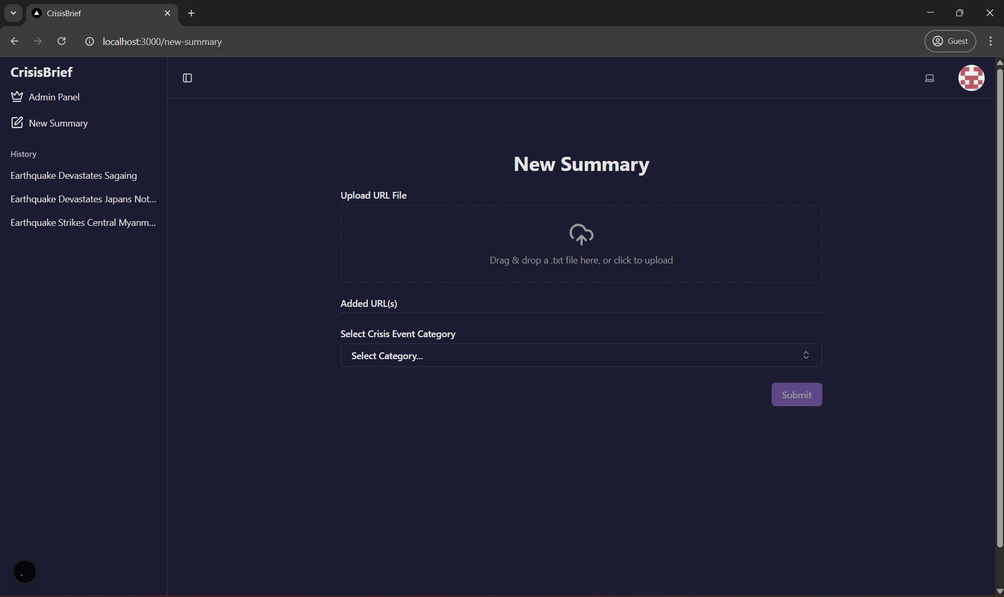
Figure 10: New Summary Generation Page.

Here you can upload a .txt file with urls related to a single crisis event, then select the category from the available created templates. The urls in the text file must each be on their own line, separated by a new line. Below is an example.

https://apnews.com/article/japan-earthquake-tsunami-2011-2ad5bd78f4fe1dabd1261e78219441ab
https://www.britannica.com/event/Japan-earthquake-and-tsunami-of-2011

Once you request to generate the summary, you will receive a status message from the backend, either an error message or a success message. Now the summary is being generated on the backend asynchronously. Once the summary is finished generating, the user will again receive an email with the summary notifying them of its completion.

To view the summary in the web app, navigate to the top most entry in the History section of the sidebar. Summaries are ordered by most recent, so your most recent generated summary will appear at the top of the list.
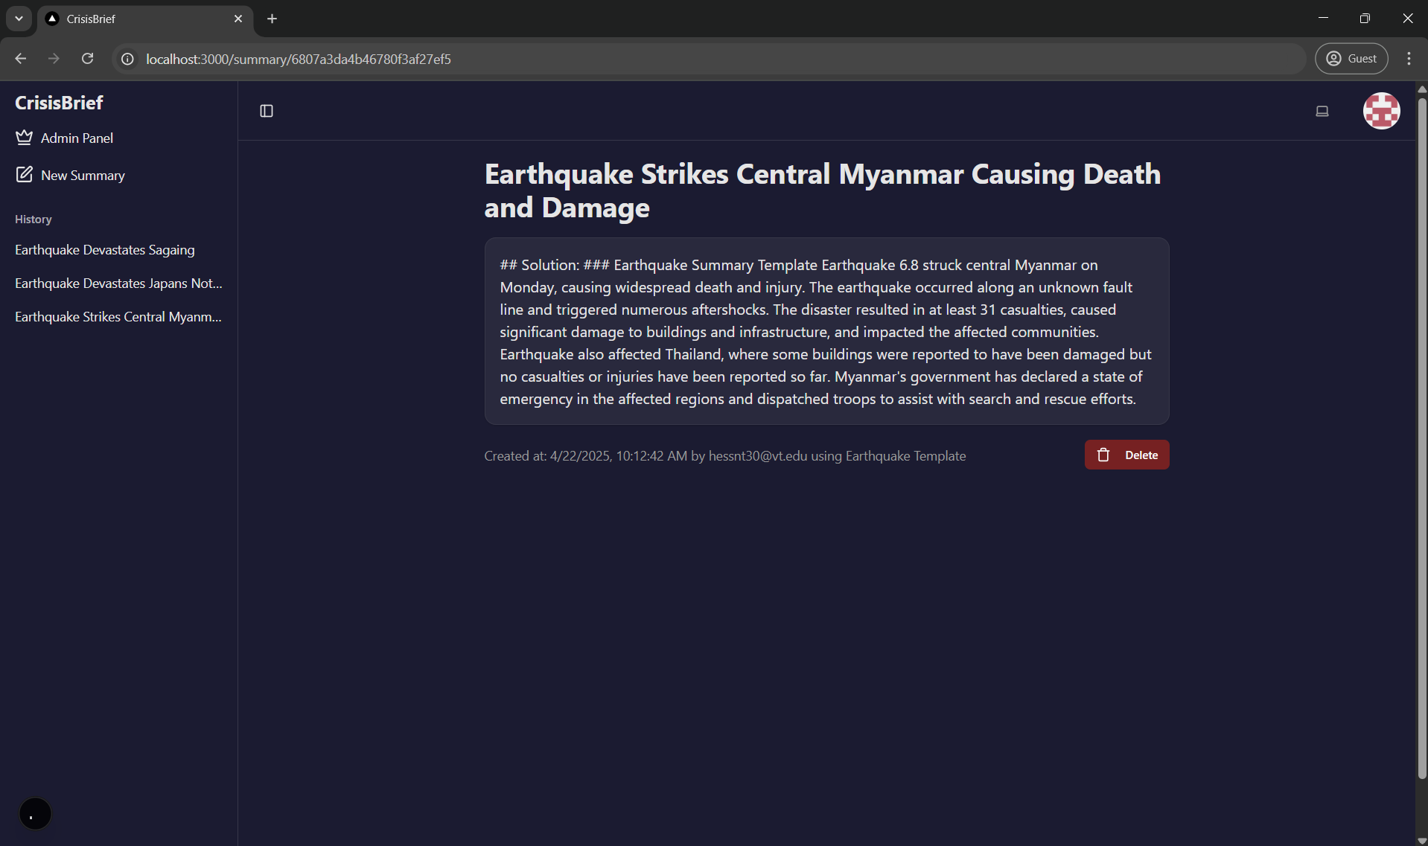
Figure 11: Generated Summary

Other Features
In the top right of the web app, you will find your GitHub profile picture. Upon clicking it, you will be greeted with the following menu:
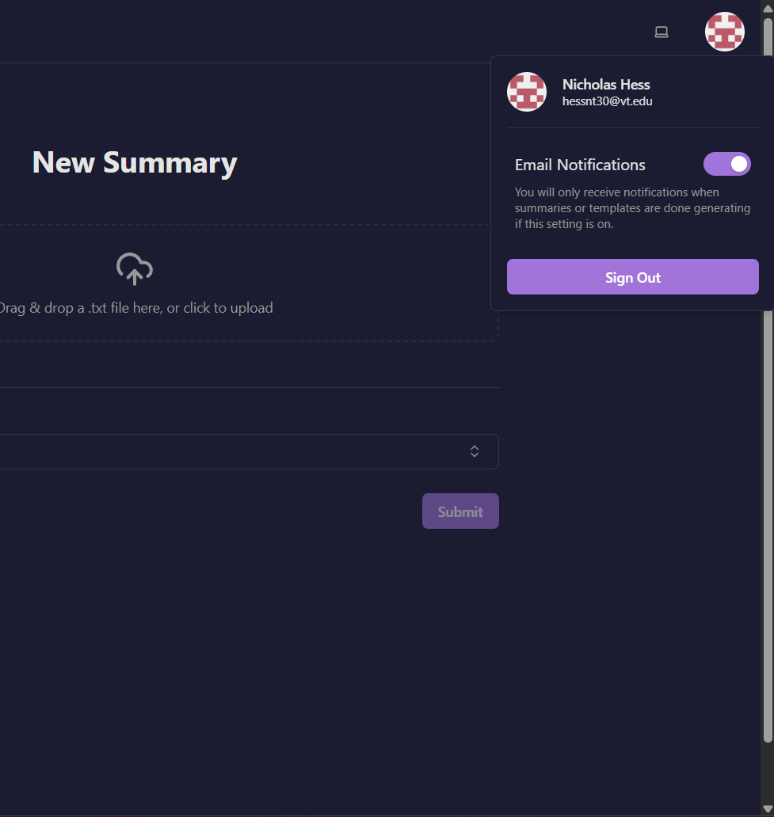
Figure 12: Email Notification Tab

Here you can toggle your email preferences, which are set to on by default. Turning off email notifications means you will not receive any email notifications from the application. You can also sign out of the web app from here.
To the left of the GitHub profile picture, you will see a theme switcher, which once clicked will display the following menu:
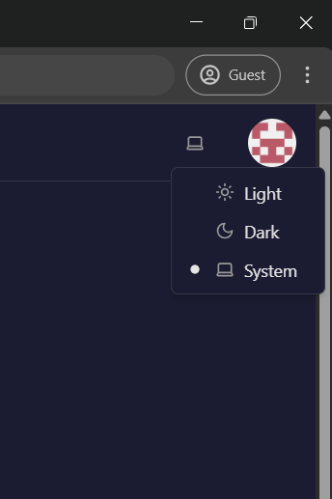
Figure 13: Website Theme Change Tab

The theme defaults to your system preferences, but you can manually change the theme as well. For example, light mode:
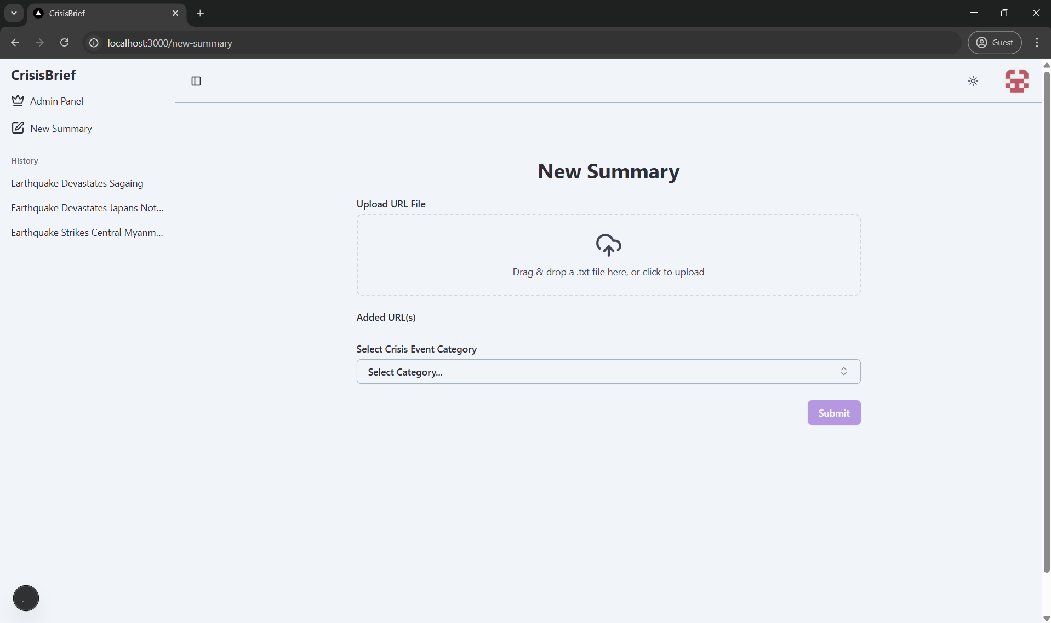
Figure 14: Light Theme View

Developer’s Manual

Running Locally
The following sections include information about each part (Authentication, Frontend, etc) of our project, and include installation instructions at the top of each section. These installation instructions will get the project running locally on your machine as frontend and backend services. You can find instructions at the end of the Developer’s Manual to install and run locally using Docker.

Source Code
The first step is to clone our source code to your local machine. Click this link (https://github.com/gibbsgresge/CrisisEventSite), then copy the HTTPS link in the dropdown by clicking the code button.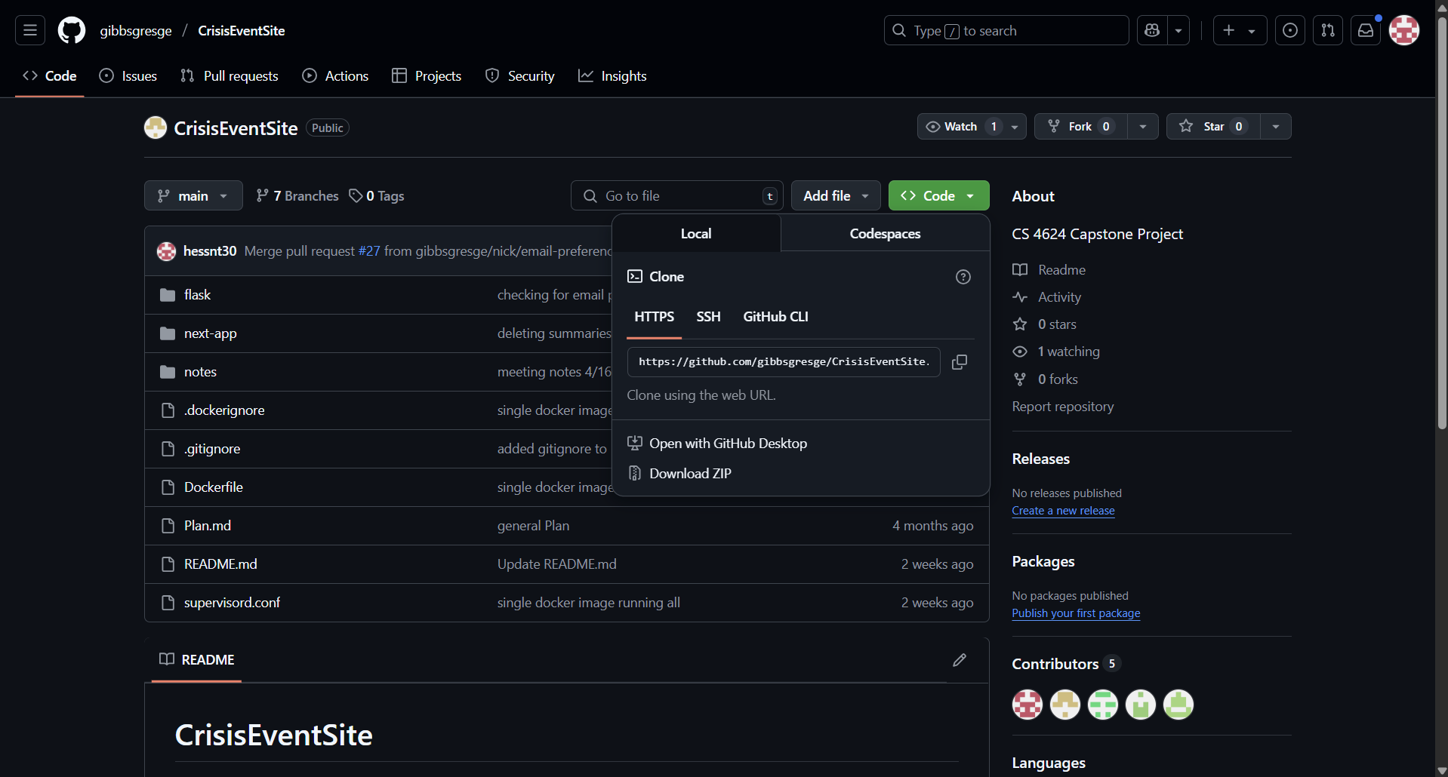
Figure 15. GitHub repository webpage
Ensure you have Git (https://git-scm.com/downloads) installed, then go to your terminal and type git clone https://github.com/gibbsgresge/CrisisEventSite.git. You have now cloned our source code to your local machine.

Environment Variables
In the ~/next-app directory of the project, create an .env file. Here is an example of what the file should look like:
MONGODB_URI=mongodb://localhost:27017/

NEXTAUTH_URL="http://localhost:3000"
NEXTAUTH_SECRET="[you will fill this in]"

GITHUB_ID="[you will fill this in]"
GITHUB_SECRET="[you will fill this in]"

Copy and paste this in your .env file. In the Authentication section, you will fill in the missing three environment variables.

Authentication
To run the frontend and use authentication, you will need to follow these instructions to create your own GitHub OAuth credentials. We use GitHub OAuth along with NextAuth to handle the important implementation of authentication to ensure our users’ experience is secure.
- Go to your GitHub settings
- Go to Developer settings (the icon looks like this `<>`), then go to OAuth apps (https://github.com/settings/developers) and create a new OAuth app. Fill out the inputs for the OAuth application exactly like below.
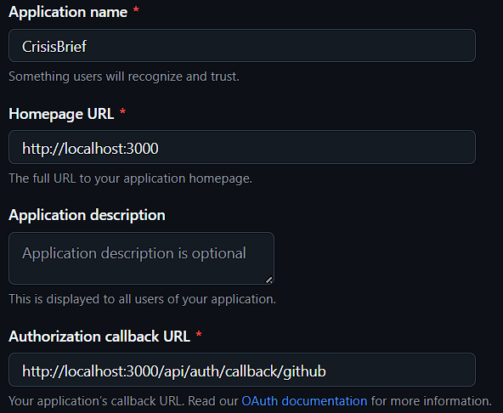
Figure 16. OAuth settings for now (url will change once deployed).
- Generate a GitHub secret key, then copy your secret key and GitHub Client ID. Create a .env file in the ~/next-app/ (let ~/ be the root directory) directory of our code base, then paste the secret key and Client ID as shown below (see Figure 8).
- Next, generate your own NEXTAUTH_SECRET (we used the following command to generate a NEXTAUTH_SECRET: openssl rand -base64 32). Copy and paste this secret and include this environment variable: NEXTAUTH_URL=”http://localhost:3000”

You should now have a .env file that looks like this (with the mongdb connection string as well):
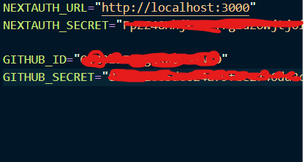
Figure 17: .env File Implementation
NOTE: If the project is deployed, you will need to change the NEXTAUTH_URL in the .env file, and in your GitHub OAuth application setup to the deployed URL.

Database
We chose to use a NoSQL database for this because it makes iterative development easier in the beginning as our database schema could change at any given point (e.g, we added a field to the user object later on in development and NoSQL made this process painless). We went with MongoDB because of its suite of products and seamless integration with JSON structured data since we are using TypeScript.
To get it running locally on your machine,
- Install MongoDBCompass (https://www.mongodb.com/products/tools/compass) to easily create and access your local database. Follow the installation instructions.
- Add MONGODB_URI="mongodb://localhost:27017/" to the .env in the ~/next-app/ .env file.

With MongoDBCompass you can easily view the collections users, accounts (this is created by NextAuth.js and can be ignored mostly, used for sessions), generated_templates, and generated_summaries. These won’t show up until you create documents by logging in and generating content.

Next.js Frontend
Now that you have an OAuth app set up in GitHub and the MongoDB instance ready, you can move on to the Next.js frontend application.
- Navigate to the ~/next-app/ directory and run npm install in a terminal to install all required dependencies.
- After the dependencies have successfully installed, run npm run dev and open http://localhost:3000 in a web browser.

You can now develop on the frontend. This project uses Next.js App Router, so all folders within ~/next-app/src that have a folder with a page.tsx within them are a route. Our reusable React components can be found in the ~/next-app/src/components folder. We utilize shadcn/ui (https://ui.shadcn.com/) for a lot of our components, so we would recommend using components from that site in the case you need new components. The MongoDB connection file can be found in ~/next-app/src/lib/mongodb.ts. The NextAuth logic can be found in ~/next-app/src/api/auth/[...nextauth]/route.ts. All queries using Next.js server side functions can be found in `~/next-app/src/server/queries.ts`. In the client components that call the server functions, we use react-query (https://tanstack.com/query/latest/docs/framework/react/overview) for handling caching and data validation, we highly recommend continuing to use this pattern.

Backend
We chose to use Flask as the web framework due to its lightweight nature, ease of use, and support for REST APIs. For model inference, we used LlamaCpp to run a quantized GGUF version of a high-performance open-source LLM (CapybaraHermes-2.5), which enables local inference without reliance on cloud APIs, as that was a core project requirement. We integrated it with LangChain’s LLMChain and PromptTemplate to structure and manage the prompt templates. Threading is implemented to maintain fast response times while enabling background tasks such as email notifications. BeautifulSoup is used to scrape paragraph content from the given URLs.
Next.js also offers a semi backend like service. As mentioned above we used the open source package NextAuth.js for authentication. Furthermore, we wrote multiple queries in a file `queries.ts` to directly communicate with the database, rather than the standard call to a backend server, hence why using Next is integral to this project.
To handle long LLM times we also implemented an email service. Once a user/admin generates a template/summary the user is sent back a string saying “X is in progress expect an email when complete” Meanwhile the backend is running as normally but instead of returning the expected string a new thread begins of sending an email to the user with the generated template/summary and at the same time send the string to the running frontend on a different thread. This solidifies why Python and Next.js were used. Python for the ease of multi-threading and Next for the SRR and semi-backend-like capabilities.
We created a Gmail account to send the emails using the `smtplib` Python package. The credentials to the Gmail account are below:
Address: crisiseventtemplant@gmail.com
Password: VirginiaTechDaBest1872
To run the backend, you first need to install the dependencies. We recommend using a virtual environment to run the backend to ensure there are no dependency issues. In the project's Flask directory (`~/flask/`), first create a virtual environment by running python -m venv venv, then run source venv/Scripts/activate. Now to install dependencies, run pip install -r requirements.txt to install all required packages. Then, start the backend by running python app.py. The server will be available at http://localhost:5000.

Dockerfile
Refer to the Environment Variables and Authentication sections to set up the environment variables before continuing with Docker.

For the Docker file follow the following instructions:
Run the following command in the project’s root directory: docker build -t crisis-full .
Once the image is done building, run the following command to run the image: docker run --gpus all -p 5000:5000 -p 3000:3000 -p 27017:27017 crisis-full

Lessons Learned

Timeline / Schedule
Weeks | Milestone / Progress
Week 1 (late Jan) | Initial planning, team setup, repo creation, and tech stack selection
Week 2-3 | Initialized Next.js frontend, implemented GitHub OAuth login
Week 4 | Started backend Flask setup and added starter scraping/LLM code
Week 5-6 | Developed login/register UI, added theme switching, user role UI logic
Week 7-8 | Added multi-URL input UI, integrated frontend and backend via Docker
Week 9 | Created admin-facing template creation page
Week 10 | Connected template generation logic with backend; started end-to-end tests
Week 11 | Refactored backend with LangChain, improve scraping, prepared demo build

Week 12 | Make Docker file with complete project
Week 13 | Test Docker file on multiple computers
Week 14 | Write final report

Table 1. Timeline Table

Problems
A major challenge was identifying the right Large Language Model (LLM) for our use case. We needed a model capable of handling relatively large input contexts—since multiple scraped URLs are passed in—and producing focused, structured outputs. Many models we tested were either too slow, lacked the necessary input token capacity, or generated unstructured and verbose responses that didn’t align with our template needs.
Running LLM inference within our Flask backend also presented difficulties. Some models were too resource-intensive to run efficiently on our local environments, particularly when containerized with Docker. We faced memory-related issues when trying to scale or chain larger models, which slowed progress on building a more robust backend pipeline. We also encountered uncertainty around how to allow users to choose from multiple model options at runtime. Our current implementation is rigid in terms of which model is used. This limited our flexibility in testing and comparing model behavior.

Solutions
To address model constraints, we began exploring smaller LLMs and better prompt design strategies. We also experimented with using LangChain to create more modular and context-aware interactions with the model, which could eventually help streamline how inputs are formatted and passed.
To mitigate backend performance issues, we refined our Docker setup and made sure the Flask service could reliably manage scraping and inference jobs without crashing. Lighter-weight models and memory-aware containers helped reduce some of the instability we initially encountered. While dynamic model selection remains an open design question, we’ve scoped it as a post-MVP enhancement. For now, we’ve focused on stability and correctness using a default model setup.

Future Work
In the next development phase, we plan to improve the robustness of the end-to-end flow by refining our prompt construction and expanding template support across more crisis categories. We're also planning to improve user experience by allowing summaries to be saved and displayed in a personal history view. Model selection and performance tuning will remain an area of focus. We may explore hosted LLM services or serverless inference options to overcome hardware and memory constraints in our Dockerized backend. Additional frontend features, including error feedback, improved form validation, and admin template editing are planned for completion before the final demo. These updates will help bring the application closer to our original vision: a responsive, secure, and accurate system for summarizing crisis events in real time.

Acknowledgments
We would like to sincerely thank Dr. Mohamed Farag, our client and course instructor for CS4624, for his ongoing guidance, support, and feedback throughout the course of this project. His insights into real-world applications of information extraction and web technologies helped shape the direction of our work and challenged us to consider both the technical and user-centered aspects of our system.
We also acknowledge the collaborative effort of all team members: Nick Hess, Jackson Small, Gibbs Gresge, Alex Ryu, and Aneesh Tummeti. Your consistent contributions and teamwork were essential to the progress made so far. Each member brought a unique set of skills and perspectives that enabled us to build a working prototype and overcome technical hurdles.

References
[1] Next.js, “The React Framework for the Web,” Vercel, [Online]. Available: https://nextjs.org/
[2] Tailwind CSS, “Rapidly build modern websites without ever leaving your HTML,” Tailwind Labs, [Online]. Available: https://tailwindcss.com/
[3] NextAuth.js, “Authentication for Next.js,” [Online]. Available: https://next-auth.js.org/
[4] Flask, “Flask Documentation,” Pallets Projects, [Online]. Available: https://flask.palletsprojects.com/
[5] MongoDB, “The Developer Data Platform,” MongoDB, Inc., [Online]. Available: https://www.mongodb.com/
[6] Docker, “Empowering App Development for Developers,” Docker Inc., [Online]. Available: https://www.docker.com/
[7] Hugging Face, “Transformers: State-of-the-art Machine Learning for Pytorch, TensorFlow, and JAX,” Hugging Face, [Online]. Available: https://huggingface.co/docs/transformers/index
[8] BeautifulSoup, “Beautiful Soup Documentation,” Crummy.com, [Online]. Available: https://www.crummy.com/software/BeautifulSoup/bs4/doc/
[9] LangChain, “Building applications with LLMs through composability,” [Online]. Available: https://www.langchain.com/
[10] GitHub, “GitHub OAuth Apps,” GitHub Docs, [Online]. Available: https://docs.github.com/en/developers/apps/building-oauth-apps
[11] HuggingFace, “TheBloke/CapybaraHermes-2.5-Mistral-7B-GGUF” [Online]. Available: https://huggingface.co/TheBloke/CapybaraHermes-2.5-Mistral-7B-GGUF

Appendix

Project Description

Short title: Crisis Events Template Generation and Information Extraction using LLM
Long title: Using LLMs to generate a crisis event template and fill in the information needed from a set of webpages
Contact person and their contact information: Mohamed Farag (mmagdy@vt.edu)
Project description (paragraph): Given a set of webpages about a crisis event, the web app will use an LLM to generate a template that summarizes the crisis event and extract the specific information from the provided webpages. The templates could be generated using the LLM or a manually for each type of crisis events. The users should be able to upload a set of webpages that will help the LLM to find the information needed to complete the template.
Project deliverables: A web app and a backend server with the LLM model. User and developer manual.
Expected impact of the project: Students will learn about information extraction, LLMs, and finally web application development.
Required skills of the team engaging in the project: web app development, database development.
Type of project : web application, Natural Language Processing

Trello Example
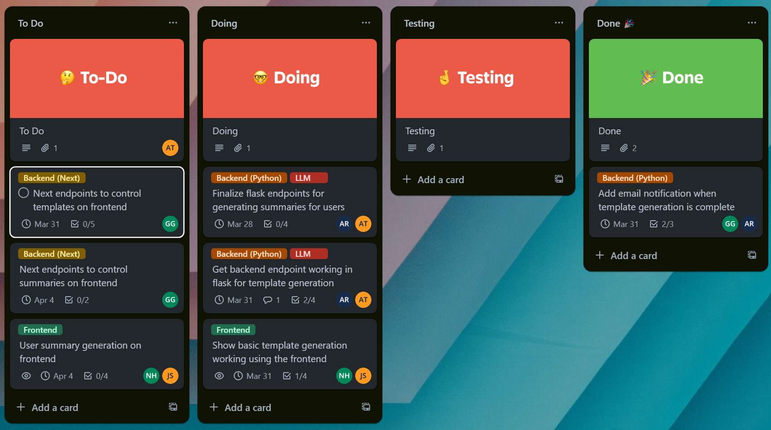
Figure A2: Trello board with task cards used during development.

