Shoulder kinematics during cyclic overhead work are affected by a passive arm support exoskeleton

Giulia Casu¹, Isaiah Barajas-Smith², Alan Barr²,
Brandon Phillips², Sunwook Kim³, Maury A. Nussbaum³
David Rampel², Massimiliano Pau¹, Carisa Harris-Adamson^{2,4}

¹Department of Mechanical, Chemical and Materials Engineering,
University of Cagliari, Cagliari, Italy
²Department of Medicine, University of California, San Francisco, CA, USA
³Virginia Tech, Department of Industrial and System Engineering, Blacksburg, VA, USA
⁴School of Public Health, University of California, Berkeley, CA, USA

ORCID: Giulia Casu: 0000-0002-4320-659X
Isaiah Barajas-Smith: 0000-0002-2453-5400
Alan Barr: 0000-0001-6275-0358
Brandon Phillips: 0000-0001-6474-316X
Carisa Harris-Adamson: 0000-0003-4031-5034
Massimiliano Pau: 0000-0001-9835-3629
Sunwook Kim: 0000-0003-3624-1781
Maury Nussbaum: 0000-0002-1887-8431

The manuscript contains 4988 words, 2 Tables and 4 Figures (color printing), 47 references.
There is an appendix with 1 Figure (color printing) and 1 Table
The abstract is 146 words long

Correspondence to: Giulia Casu, MSc., Department of Mechanical, Chemical and Materials Engineering, University of Cagliari, Piazza d’Armi, 09123, Cagliari (ITALY)
E-mail: giuliacasu.gc@outlook.it

Abstract
Purpose: We investigated the influence of passive arm-support exoskeleton (ASE) with different levels of torque (50, 75, and 100%) on upper arm osteokinematics.
Methods: Twenty participants completed a cyclic overhead drilling task with and without ASE. Task duration, joint angles, and angular acceleration peaks were analyzed during ascent and descent phases of the dominant upper arm.
Results: Maximum ASE torque was associated with decreased peak acceleration during ascent (32.2%; SD 17.8; p < 0.001) and descent phases (38.8%; SD 17.8; p < 0.001). Task duration remained consistent. Increased torque led to a more flexed (7.2°; SD 5.5; p > 0.001) and internally rotated arm posture (17.6°; SD 12.1; p < 0.001), with minimal changes in arm abduction.
Conclusion: The small arm accelerations and changes in osteokinematics we observed, support the use of this ASE, even while performing overhead cyclic tasks with the highest level of support.
Keywords: passive exoskeleton, joint angles, arm acceleration
Abbreviations
- Work-related musculoskeletal disorders (WMSDs)
- Upper extremity (UE)
- Arm-support exoskeleton (ASE)
- Dynamic overhead (DO)
- Institutional Review Board (IRB)
- Flexion-Extension (FE)
- Abduction-Adduction (AA)
- Internal axial rotation (IR) External axial rotation (ER)
- Range of motion (ROM)
1. Introduction
The high frequency and severity of work-related musculoskeletal disorders (WMSDs) in the construction industry is a critical issue worldwide. According to the United States Bureau of Labor and Statistics, U.S. private construction industries reported 74,520 injuries and illness cases in 2020, of which approximately 30% involved the upper extremity (UE) (BLS, 2023). Moreover, data from the 2015 European Working Conditions Survey showed that 54% of construction workers reported pain in the UE (EWCS, 2016).
Construction workers are exposed to high-force demands and extreme postures, which can lead to physical fatigue, pain, injury, and loss of productivity (Meo et al., 2013; Seo et al., 2016). Construction tasks such as electrical work, drywall installation, sanding, drilling, and painting require sustained overhead reach, which is recognized as a major risk factor for the onset of UE-WMSDs (Svendsen et al., 2004; Rempel et al., 2010; Chopp et al., 2010; Alabdulkarim and Nussbaum, 2019; Latella et al., 2022). Moreover, the daily use of power tools that require high-force exertions increases the risk of shoulder tendon injuries (Frost et al., 2002), especially during overhead reach.
Shoulder impingement is the most common cause of shoulder pain and injury (Stenlund et al., 2002) and is related to the osteokinematics and arthrokinematics of the shoulder complex. Osteokinematics describes the gross movement of bones while arthrokinematics describes the motion between joint surfaces. For example, during arm abduction and flexion (osteokinematics), the rotator cuff muscles facilitate the slide, roll, and spin (arthrokinematics) of the humeral head to maintain contact with the glenoid fossa and minimize compression of the supraspinatus tendon under the coracoacromial arch, as detailed in Appendix. Insufficient or abnormal humeral translations (sliding) due to fatigue, muscle imbalances, and postural deviations have been linked to shoulder injury (Dal Maso et al., 2015), likely due to compression of the structures under the coracoacromial arch as arm elevation increases (Muraki et al., 2010; Hughes et al., 2012).
To prevent the development of shoulder WMSDs, passive arm-support exoskeletons (ASEs) have been used to support workers in forward reach or overhead postures (McFarland and Fischer 2019), as they provide a torque that elevates the arms and effectively relieves shoulder burden by transferring the bearing load to another part of the body (typically the lumbar spine). Thus, during tasks requiring prolonged elevation of the arms (e.g., painting, ceiling work, etc.), ASE use is ideal with a maximum level of support, i.e., capable of relieving the external shoulder torque resulting from upper limb weight. This ultimately results in reduced shoulder muscle activity (Kim et al., 2018 a; Van Engelhoven et al., 2018) and perceived effort (Huysamen et al., 2018; McFarland and Fischer 2019) and higher overall productivity (Butler and Wisner, 2017). However, ASEs can also alter or change UE osteokinematics, which may increase worker discomfort and risk of injury. This outcome has been attributed to the constraints imposed by the added mass and/or the fastening straps, thereby restricting movement (Kim et al., 2018 b). Laboratory studies have found only slight modifications of UE joint angles when wearing an exoskeleton that provided low torque support with increased arm flexion up to 10.7° (Maurice et al., 2020; McFarland et al., 2022) and arm abduction up to 9.9° (Schmalz et al., 2019; Maurice et al., 2020). On the other hand, in other studies the use of high torque support involved over-compensation of movements, leading to altered shoulder, elbow, and wrist joint angles in the sagittal and coronal plane (Sylla et al., 2014; McFarland et al., 2022). Therefore, when the task to be performed requires frequent UE movements, rather than the maintenance of static overhead postures, the use of lower torque support may be more effective.
By modifying UE joint angles, ASE torque may also influence arm acceleration during overhead activities, thus resulting in an unnatural movement that, in the long-term, potentially increases the risk of developing shoulder disorders. However, to our knowledge, no previous studies have evaluated the magnitude of assistive accelerations provided on the arm by different levels of ASE torque during a cyclic task. It has been reported that in some sports activities involving throwing, high acceleration movements of the arm are associated with the development of shoulder injuries (Pappas et al., 1985; Rose and Noonan, 2018). Such disorders result from exposure to high amounts of stress for short periods of time, despite a careful athletic training focused on strengthening the stabilizers of the shoulder and thus managing cumulative stress on the arm (Dowling et al., 2020). Although the magnitude of speed and accelerations in sports is typically much larger than those expected during traditional occupational work, the prolonged exposures (hours/day per years) to even lower stress, in combination with poor physical preparation, may trigger a cumulative load effect that has previously been associated with an increased risk for musculoskeletal problems and shoulder pathology (Roquelaure et al., 2011; Holtermann et al., 2010).
Therefore, we aimed to investigate the influence of different levels of a passive ASE torque (50, 75 and 100%), normalized to the user’s anthropometry, on the osteokinematics of the shoulder, compared to the unassisted condition (no ASE), during an overhead drilling task performed cyclically. Upper arm 3D posture and acceleration magnitude were analyzed during both the raising (ascent) and lowering (descent) phases of the arm. Posture at the end of the descent phase was evaluated to investigate device-induced postural changes when returning to a neutral posture. The impact of ASE on task duration was also analyzed. In summary, the following null hypothesis were tested:
Null Hypothesis 1: There is no effect of ASE torque on shoulder posture and peak acceleration, during the ascent phase.
Null Hypothesis 2: There is no effect of ASE torque on shoulder posture and peak acceleration, during the descent phase.
Null Hypothesis 3: There is no effect of ASE torque on shoulder posture at the end of the descent phase.
Null Hypothesis 4: There is no effect of ASE torque on total task duration.
2. Material and Methods
2.1 Study Design and Participants
This was a repeated-measures laboratory study that included 20 participants (17 male, 3 female) with a mean (standard deviation) age, height, and body mass of 34.1 (10.0) years, 177.6 (7.0) cm, and 78.1 (8.7) kg, respectively. The percentage of women (15%) was consistent with that in the entire US construction workforce (11%) (Hegewisch and O’Farrell, 2015; BLS Women in the labor force, 2023). All but one were right-hand dominant.
People between 18-65 years old, half of whom had prior construction work experience, were invited to participate in this study and asked to simulate a dynamic overhead (DO) drilling task. To set the ASE with the minimum (50%) and maximum (100%) normalized torque, male participants had to have mass between 53 kg (1st percentile) and 114 kg (88th percentile) and female participants between 61 kg (21st percentile) and 122 kg (96th percentile) (Chen et al., 2020). Candidates outside of these ranges, as well as those having an acute or chronic musculoskeletal disorder within the previous 6 months, were excluded. The study was approved by the Institutional Review Board (IRB) of the University of California San Francisco (UCSF), and participants provided written informed consent prior to any data collection.
2.2 Apparatus and instrumentation
The DO task was conducted by using a hand-held, light-duty drill (RYOBI® Tools HP44L, mass=388 g; tip external diameter=9 mm), in a custom steel cage characterized by a wall and a ceiling panel (Fig.1). Two sets of four hollow tubes (internal diameter=10 mm) that were serially mounted to the ceiling panel and protruded downward were used to simulate overhead drilling targets. The height of the ceiling panel was individually adjusted such that the participant's shoulder and elbow were flexed at 90° in the sagittal plane when reaching the overhead targets, while standing in the center of the cage, with feet parallel.
A 6-axis force platform (BP6001200, AMTI, Watertown, MA, 1200 Hz) was located at the center of the cage (Fig. 1) to measure, at the beginning of each trial, participants’ baseline ground reaction force components (x, mediolateral, y, anteroposterior, z, vertical). The force platform was subsequently used to calculate the forces applied (see below) to each target through custom-developed LabVIEW software (National Instrument Corp, Inc., Austin, USA).
Joint angles and angular accelerations were measured at 60 Hz using a full body wearable motion capture system (Xsens MVN Awinda, Xsens, Enschede, The Netherlands) that included 17 inertial measurement units placed, according to manufacturer guidelines, on the head, sternum, and sacrum, and bilaterally on the shoulder, upper arm, forearm, hand, upper leg, lower leg, and foot. When testing the last seven subjects, the sensor on the upper arm was moved from being on the arm to being on the exoskeleton arm cuff to avoid artifacts caused by the device-sensor interference. For the same sample and aim, one calibration of the system (4-second N-pose plus a 15-second walk) after each torque condition was performed instead of just one at the beginning of the experiment. After calibration, participants were asked to perform simple movements with varying levels of torque to familiarize themself with the ASE.
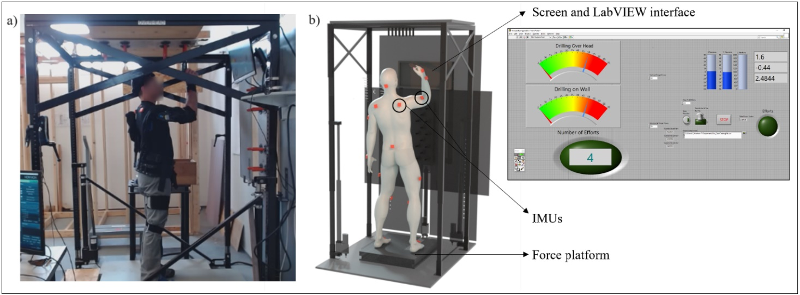
Fig. 1: a) Participant wearing the exoskeleton during the DO task b) Schematic view with an indication of the instrumentation used to provide visual and auditory feedback on the magnitude and duration of each simulated drilling activity.

2.3 Drilling task
Participants started the DO drilling task while standing on the force platform with their arms resting alongside their body. Participants used their non-dominant hands to touch a screw located in the pocket of a tool belt to simulate screw retrieval. Then, they were instructed to move their hands toward the midline of the body to connect the tip of the tool held in the dominant hand with the fingertips of the non-dominant hand. From this position, participants used both hands to elevate the tip of the drill into the hole of one of the four tubes. Upon reaching the target, the non-dominant hand was free to return to the start position. While using the tool, participants exerted a force of approximately 50 N (visually controlled in real-time on a screen) against the target and sustained each effort for two seconds. This magnitude and duration were selected to ensure that all participants could complete the task without experiencing substantial fatigue. Audible and visual feedback was provided to indicate when participants should stop exerting force and resume the initial position. The drilling task was performed cyclically, with 20 replications. A 10-minute break was provided between randomized conditions (no ASE, 50, 75, 100% torque). Participants were instructed to perform the task as realistically as possible, by freely moving their lower limbs and feet and self-selecting the rate of movements and duration between each of the cycle.
2.4 Independent Variables
The independent variable was the ASE torque, corresponding to 50, 75, and 100% of the torque created at the shoulder level; the torque magnitude was the same bilaterally. The “no ASE” condition meant that no exoskeleton was used to perform the task. The maximum level of torque (100%) was defined by the torque sufficient to freely float the arms while maintaining a relaxed 90° shoulder and elbow posture. Torque levels were provided by a passive ASE (Ekso EVO, Ekso Bionics, Inc., San Rafael, USA) equipped with an internal linkage system that converts spring compression into shoulder torque. The different magnitudes of torque were provided using five interchangeable spring cartridges (range spring force 21.6 - 67.7 N). Custom software, based on a subject’s height, weight, and sex, was used to predict proper fit of the ASE and the cartridge needed to attain an amount of torque as close as possible to the desired one. Previous studies have demonstrated that this specific ASE model is advantageous due to its not excessive mass (~4 kg) and the possibility to be easily worn and adjusted like a sort of backpack (Bennett et al., 2023; Perez et al., 2020).
2.5 Dependent Variables
Outcome measures included two kinematic variables, i.e., joint angles and angular accelerations in up to three planes of motion. Also, the duration of the task was measured to evaluate any torque influence on execution time. Specific measures are provided in detail below:
- Joint angles of the dominant upper arm, following the manufactured recommended ZXY Euler sequence (X: anterior-posterior axis; Y: medial-lateral axis; Z: vertical axis), were used to analyze upper arm posture with respect to the trunk in the sagittal plane (flexion (+) / extension (-), FE), in the coronal plane (abduction (+) / adduction (-), AA), and in the axial plane (internal (+) / external (-) axial rotation, IR/ER) in each direction separately.
- The total angular acceleration (eq.1) of the dominant upper arm relative to the trunk was calculated using all three acceleration components ($a_{x}$, around AA axis, $a_{y}$, around FE axis, $a_{z}$, around IR/ER rotation axis).
$A_{tot}= \sqrt{a_{x}^{2}+ a_{y}^{2}+ a_{z}^{2}}$ (1)
Both the peak total angular acceleration ($A_{tot}$) and the absolute peak of the angular acceleration in each plane ($a_{x}$, $a_{y}$, $a_{z}$) were used for the analysis because of potentially greater concern with prolonged exposure.
- The total duration was defined and calculated as the time between the start and the end of the DO task, identified on the FE angle time series since the task was mainly performed in the sagittal plane.
2.6 Data processing
Joint angles and angular accelerations were recorded and processed with the Xsens MVN Analyze software (version 2020.0.0). As in a previous comparable study, a low-pass filter was applied to the raw acceleration data using a fourth-order Butterworth filter (5 Hz) (Korshøj et al., 2014). A custom routine developed in Matlab (R2019a, MathWorks, Natick, Massachusetts, USA) was used to process kinematic data and calculate task duration. The FE angle was used to define the start and end of each cyclic movement (Fig. 2a). The start of each cycle was defined as the time when the upper arm FE angle deviated more than 2° for more than 1 s from the visually checked neutral position. Accordingly, the end was defined as the time when the upper arm returned to the baseline FE angle (i.e., the angle assumed at the beginning of the task). Each cycle was segmented into three phases, namely ascent, drilling, and descent (Fig. 2b), defined as follows:
- The start of the ascent phase was defined as the start of each cyclic movement, as described above. The end was identified as the last time at which the slope of the FE angle assumed an arbitrary value greater than 0.5°, chosen after checking all data.
- During the drilling phase, participants maintained contact with the target, so the slope was less than 0.5°.
- The beginning of the descent phase was defined as the first time, after the drilling phase, at which the slope again assumed a value greater than 0.5°. The end was defined as the end of each cyclic movement, as described above.
Finally, both the ascent and descent phases were divided temporally into two equally sized windows. These windows were used to explore shoulder kinematics in the first and second halves of the motion since the excursion of the rotator cuff muscles under the acromion changes with increasing elevation (Flatow et al., 1994).
Our analysis of the dependent variables focused on four of the five identified phases: ascent phase (1st half), ascent phase (2nd half), descent phase (1st half), and descent phase (2nd half). The mean value of each dependent measure was calculated across cycles and participants. The drilling phase was excluded from the analysis because characterized by a static shoulder posture that was irrelevant to the study aim.
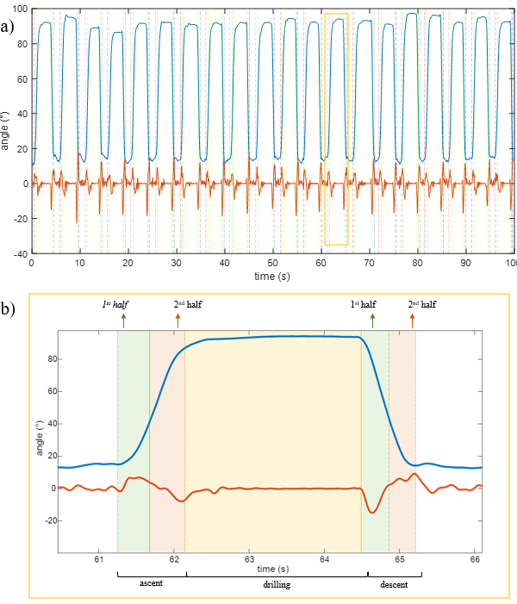
Fig. 2: Data processing. a) Representation of the upper arm FE angle (in light blue) and angular acceleration around the y-axis (a_{y} in red) as a function of time, for one participant. The red and blue dashed lines denote respectively the start and end of each cyclic movement. b) Detailed representation of the 13th drilling movement with identification of the five phases.
2.7 Statistical analysis
A total of 400 cycles (20 participants, 20 cycles) were analyzed for the 50, 75, and 100% torque conditions; 398 cycles were analyzed for the no ASE condition, due to an instrumentation problem that occurred in two of the cycles. To assess the effect of torque level on each dependent measure, separate one-way, repeated measures analysis of variance (RM-ANOVA) or non-parametric Wilcoxon analysis of variance were completed, based on the normality of the data. Statistical analyses were separately performed for each of the four predefined phases, and statistical significance was determined at p < 0.05. Statistical analysis of the posture at the end of the descent phase was conducted separately for flexion (or abduction or IR) and extension (or adduction or ER) movements. Because we made changes in sensor position and calibration, we completed a t-test to compare data from the last seven subjects with the prior 13; this test confirmed that the protocol change did not significantly affect the results (p>0.05). All analyses were performed using the IBM SPSS Statistics v.20 software (IBM, Armonk, NY, USA).
3. Results
3.1. Ascent phase
Peaks total angular acceleration during both halves of the ascent phase are reported for each condition in Table 1.
Table 1: Mean (SD) of the peak angular acceleration across participants and cycles, for each condition and each phase. Superscript letters across each row represent groupings from post-hoc pairwise comparisons. Here and below, significant effect of torque level are highlighted using bold font.
Peak total angular acceleration (°/s²) | no ASE | 50%  torque | 75%  torque | 100%  torque | p Value
Ascent phase (1st half) | 1028.8  (254.4) ^{a,b,c} | 768.4  (218.2) ª | 692.2  (201.2) ^{b} | 776.1  (342.7) ^{c} | < 0.001
Ascent phase (2nd half) | 920.8  (199.5) ^{a,b,c} | 720.3  (173.1) ª | 735.1  (195.0) ^{b} | 786.0  (402.3) ^{c} | < 0.001
Descent phase (1st half) | 1172.2  (220.1) ^{a,b,c} | 943.1  (214.2) ª | 851.2  (177.8) ^{b} | 899.1  (177.0) ^{c} | < 0.001
Descent phase (2nd half) | 1658.5  (537.3) ^{a,b,c} | 1127.5  (305.5) ª | 1001.7  (319.1) ^{b} | 1047.2  (366.1) ^{c} | < 0.001

The absolute peak angular acceleration (x,y,z) and maximum joint angles (abduction, flexion, IR) measured during the ascent phase are displayed in Fig. 3 and further detailed in the Appendix. Using the exoskeleton with different magnitudes of torque significantly decreased the angular acceleration around the y-axis (p < 0.001 for both halves), z-axis (p = 0.005 and p < 0.001 during the 1st and 2nd half, respectively), and x-axis (significant only during the 1st half, p = 0.013). Concurrently, we found a significant increase in flexion (p = 0.018 and p = 0.007 during the 1st and 2nd half, respectively) and IR (p < 0.001 and p < 0.001 during the 1st and 2nd half, respectively).

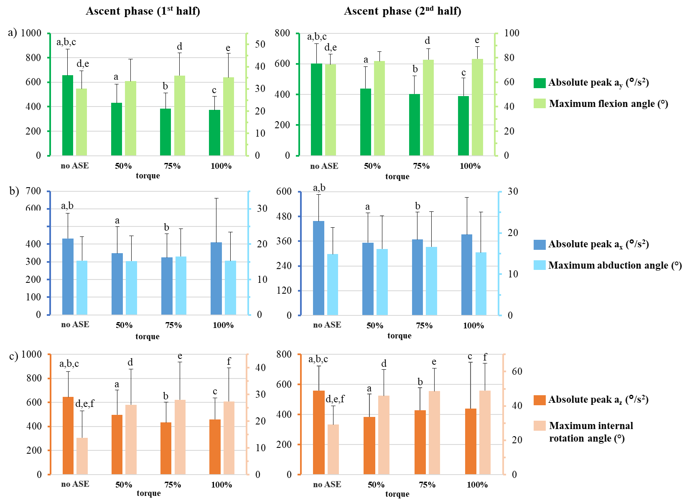
Fig. 3: For the 1st half (on the left) and 2nd half (on the right) of the ascent phase, the absolute peak angular acceleration is displayed in relation to the maximum joint angle. Angular acceleration is around the (a) y-axis i.e., flexion axis; (b) x-axis i.e., abduction axis; (c) z-axis i.e., IR axis. Matching letters indicate statistical significance obtained from post-hoc comparisons.

3.2. Descent phase
Table 1 shows the peak angular acceleration during the two halves of the descent phase. Fig. 4 shows the acceleration peak in each plane (x,y,z) in relation to the maximum joint angle (abduction, flexion, IR). The use of the exoskeleton with different magnitudes of torque significantly affected the angular acceleration, by decreasing it, around the x-axis (p = 0.008 and p < 0.001 during the 1st and 2nd half, respectively), y-axis (p = 0.021 and p < 0.001 during the 1st and 2nd half, respectively), and z-axis (p < 0.001 for both halves). An increased IR of the arm (p < 0.001 for both halves) was observed during the descent phase while maximum flexion and abduction changed only slightly.

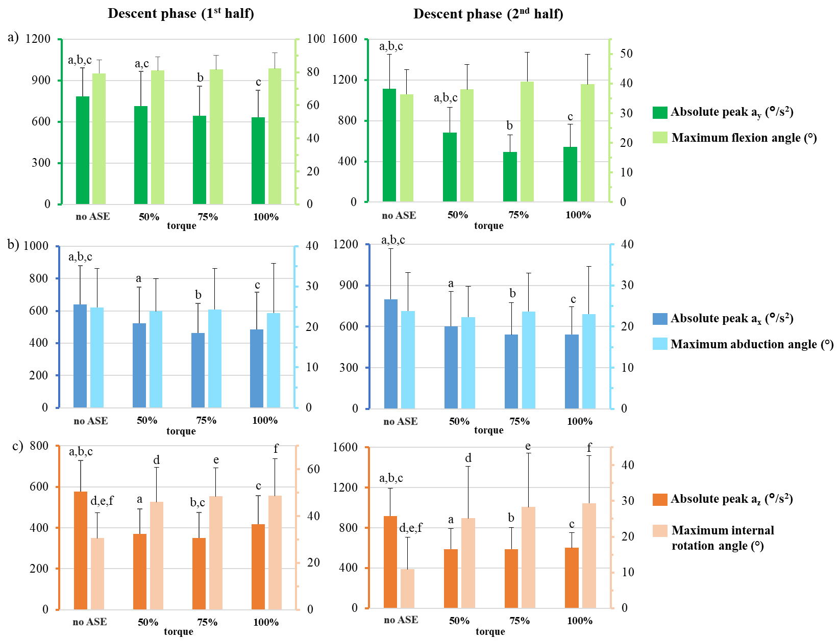
Fig. 4: For the 1st half (on the left) and 2nd half (on the right) of the descent phase, the absolute peak angular acceleration is displayed in relation to the maximum joint angle. Angular acceleration is around the (a) y-axis i.e., flexion axis; (b) x-axis i.e., abduction axis; (c) z-axis i.e., IR axis Matching letters indicate statistical significance obtained from post-hoc comparisons.
3.3. End of the descent phase
Table 2 summarizes the angle and the number of times the participants completed the descent phase of the arm in flexion, extension, abduction, adduction, IR, and ER for each torque condition.

Table 2: Mean (SD) and total number of movements (N) performed in the sagittal, coronal, and axial planes at the end of the descent phase. Superscript letters across each row represent groupings from post-hoc paired comparisons.
Posture at end of descent phase |  | no ASE | 50%  torque | 75%  Torque | 100%  torque | p  Value
Flexion (+) | angle (°) | 6.6  (5.2)^{a,b,c} | 11.1  (8.0) ^{a,c} | 14.6  (10.1) ^{b} | 13.9  (8.7) ^{c} | <0.001
Flexion (+) | N | 218^{a,b,c} | 347ª | 368^{b} | 366^{c} | <0.001
Extension (-) | angle (°) | 4.3  (3.3) ^{a,b,c} | 1.6  (3.8) ª | 0.7  (1.2) ^{b} | 0.5  (1.1) ^{c} | <0.001
Extension (-) | N | 180 ^{a,b,c} | 53 ª | 32 ^{b} | 34 ^{c} | <0.001
Abduction (+) | angle (°) | 12.9  (6.0) | 12.3  (6.9) | 13.8  (8.7) | 13.5  (7.8) | 0.796
Abduction (+) | N | 378 | 372 | 394 ^{b,c} | 359 ^{c} | 0.429
Adduction (-) | angle (°) | 0.3  (0.9) | 0.3  (0.6) | 0.1  (0.5) ^{b,c} | 0.7  (1.8) ^{c} | 0.155
Adduction (-) | N | 20 | 28 | 6 ^{b,c} | 41 ^{c} | 0.400
IR (+) | angle (°) | 5.3  (7.3) ^{a,b,c} | 9.6  (9.4) ª | 13.0  (11.4) ^{b} | 11.8  (9.7) ^{c} | 0.031
IR (+) | N | 142 ^{a,b,c} | 260 ª | 282 ^{b} | 284 ^{c} | 0.007
ER (-) | angle (°) | 11.6  (8.8) ^{b,c} | 9.3  (18.6) | 4.2  (5.8) ^{b} | 3.9  (6.1) ^{c} | 0.014
ER (-) | N | 256 ^{a,b,c} | 140 ª | 118 ^{b} | 116 ^{c} | 0.010

3.4. Task duration
The mean (SD) task duration across participants for the unassisted condition was 101.3 (14.6) seconds (s). Wearing the exoskeleton with 50, 75, and 100% torque, the respective total durations were 103.0 (17.6), 105.7 (18.1), and 103.4 (16.9) s. There were no statistically significant differences in movement duration between conditions (p = 0.570).
4. Discussion
We investigated the influence of ASE torque on the osteokinematics of the UE while performing a DO task. We found an overall decrease in the peak angular acceleration of the dominant arm when wearing the exoskeleton with respect to the unassisted condition. Nevertheless, such alterations did not significantly change task duration, regardless of the torque provided. When using the ASE, participants assumed a slightly more flexed (up to 7.2°) and internally rotated posture (up to 17.6°) of the arm, during each trial and between cycles, both of which were more pronounced when the magnitude of ASE torque was high. In abduction, a slight (2°) and non-statistically significant increase was observed. Despite the differences observed between phases (later discussed in detail), these findings support the safe use of this ASE, even while performing overhead cyclic tasks with the highest level of support.

4.1. Ascent phase
During both halves of the ascent phase, the peak total angular acceleration (Table 1) and the three acceleration components (Fig. 3) were all significantly reduced when performing the task with different magnitudes of torque; as such, our hypothesis 1 was not supported. Peak acceleration decreased up to 32%, indicating that participants may have relied on the device to elevate their arm, thereby controlling the rate of motion to perform lower acceleration movements. When the ASE was not worn, participants actively generated a moment at the shoulder joint to counteract gravity and lift the arm. This motion resulted in higher accelerations that required more energy. It is possible that ASE torque allowed participants to minimize the muscular work required to move arms against gravity, and that the reduced acceleration allowed users to reach the target more efficiently. It is also possible that more familiarity with the ASE could, over time, resulted in accelerations more similar to the unassisted condition. Further studies are needed to verify this hypothesis.
When wearing the ASE, the peak total acceleration increased approximately with the magnitude of torque during the 2nd half of the ascent phase (Table 1). Despite this, accelerations while wearing the ASE were always smaller than in the unassisted condition. Even though injury-related values achieved during sports were not reached (Pappas et al., 1985; Rose and Noonan, 2018), quantifying arm accelerations with and without assistance represents only a first step, which should be followed by further longitudinal studies to investigate the potential effects of cumulative exposure to low-acceleration movements.
With increasing magnitudes of torque, a linear increase was also observed for acceleration around the x (AA) axis and z (IR/ER) axis, but not for the y (FE) axis (Fig. 3). One possible explanation is that the horizontal component of the ASE torque may have exceeded the other two, thus causing participants to adopt a more abducted and internally rotated posture. This explanation is supported by the increased IR (up to 20°) observed during conditions where ASE torque was provided, compared to the unassisted condition. This finding is consistent with the maximum 9° increase of shoulder rotation reported by (Maurice et al., 2020) when subjects performed an overhead pointing task with and without the commercial PAEXO exoskeleton. In contrast, (McFarland et al., 2022) observed a maximum decrease in IR by 316% (Δ24.6°) with exoskeleton use while performing an overhead task with the shoulders flexed at 120°. These differences may be explained by some heterogeneity of the activity simulated and the exoskeleton models tested. For example, the height and the location of the overhead target relative to the midline of the body could influence the amount of rotation measured while performing the task. From an anatomical point of view, the subacromial space width changes during abduction and rotation, and the supraspinatus is closest to the anterior inferior border of the acromion in 90° of abduction with 45° IR (Graichen et al., 1999; Dal Maso et al., 2015). However, the consequences of an increased IR of the arm when using the exoskeleton are not yet clear.
In the other plane, the maximum abduction angle increased up to 2° with increasing torque but without reaching statistical significance. Regardless, these findings are consistent with a previous study performed in a real construction workplace that showed a 4° increase in shoulder abduction while working at variable heights with the Ekso EVO exoskeleton (Bennett et al., 2023). Specifically, the author hypothesized this variation to be due to the device’s spring force, which can alter the typical movement pattern during elevation (Bennett et al., 2023).
Increasing torque also led to increased maximum flexion angle during the 2nd half of the ascent phase, which was surprising since the target height (and thus the maximum angle of upper arm flexion) was set at the beginning of the experiment. However, participants during the trials were allowed to freely change their feet positions, which could have influenced the shoulder posture required to reach the target. Therefore, the observed variations might result from a combination of the specific strategy adopted by the participant and the presence of the exoskeleton. On the other hand, (McFarland et al., 2022) found that ASE use caused increased minimum shoulder elevation angle (up to 10.7°). An increase in the minimum arm flexion angle would explain the observed increase in the maximum flexion angle (up to 7.2°) measured during the 1st half of the ascent phase, when torque was provided. Therefore, the variations found during this phase could be related to ASE use.
4.2. Descent phase
Similarly, during the descent phase, the peak angular acceleration and its three components decreased with increasing magnitudes of torque, leading us to reject hypothesis 2. Specifically, peak total acceleration decreased up to 39% during the 2nd half of the descent phase with ASE torque. One possible explanation is that to resume neutral posture, participants counteracted ASE torque, thus performing a slower, low-acceleration movement with respect to the unassisted condition. This adaptation has been observed in previous studies, wherein participants reported the feeling of “fighting” the system when moving the arm in opposition to the exoskeleton torque (Sylla et al., 2014; Maurice et al., 2020). Knowing the activation level of the shoulder antagonist muscles could be important in supporting or refuting this explanation because of their main involvement in shoulder extension movements. The need to counteract the support provided by the exoskeleton could cause increased activation of these muscles with respect to the unassisted condition. This case has been recently observed by (Theurel et al., 2018) who, simulating a lifting-lowering task, reported a 95% increase in the average workload of the triceps brachii when wearing an ASE set to fully support a 9 kg load handled. Although increased muscle activity was measured for the entire task, the antagonistic muscles were mostly active during the arm lowering phase. Therefore, the variation we observed with respect to the unassisted condition could be due to counteracting the exoskeleton torque.
Joint angle variations were not affected by the direction of the arm motion, thus results found during the descent phase mirrored those observed during the ascent phase.
4.3. End of the descent phase
When using the exoskeleton, participants typically completed each cycle with a more flexed and internally rotated arm compared to the unassisted condition (Table 2); we thus reject hypothesis 3. This postural variation could be interpreted as not completely counteracting the support provided by the exoskeleton when returning to a neutral posture. Indeed, the mean flexion angle at the end of the movement increased with increasing magnitudes of torque, reaching a plateau at 75% torque, with an 8° increase. In this regard, our results are consistent with those of previous studies demonstrating that the use of a passive ASE during overhead work led to restrictions in shoulder flexion ROM due to a substantial reduction of shoulder extension (Kim et al., 2018 b; Perez et al., 2020; Bennett et al., 2023). Increased forward flexion, especially if sustained, and increased duration of exposure are risk factors for UE-WMSDs (Karlqvist et al., 1994; Svendsen et al., 2004; Dennerlein and Johnson, 2006; Van Rijn et al., 2010; McFarland et al., 2022), but how the passive motion provided by the exoskeleton use may influence this risk is still unclear.
In the coronal plane, we did not find any statistically significant differences between conditions. However, the 100% torque condition did have twice as many movements in adduction as the unassisted condition (Table 2), probably because a flexed and adducted arm was more convenient to shorten the path toward the overhead target.
4.4. Duration of the task
We found a 2 to 5% increase in duration to perform the task with the ASE. However, since this variation, as hypothesized, was small and not statistically significant, it is possible that task productivity doesn’t change with the use of the exoskeleton, as recently reported by (Maurice et al., 2020). Moreover, since the participants were free to select their preferred rate of movement, the short task duration allows us to assume that the results were not affected by fatigue. On the contrary, the use of an ASE over a longer period or when performing more demanding work may reduce muscle fatigue and subsequent decreases in the cycle time required to complete a given task. This was exemplified in the work by Kim et al. (Kim et al., 2018 a) who, after simulating a repetitive, precision drilling task, and instructing participants to work “as quickly and accurately as possible”, reported a decrease of nearly 20% in completion time with an exoskeleton vest. The work height, together with the performance speed and the weight of the pneumatic drill (up to 3 kg), differ from our study, though, which at least partially explains the different results found.
5. Limitations
The first limitation was the minor change in the experimental set-up of the upper arm sensor locations for the last seven participants. The analysis of kinematic patterns confirmed a decrease in inter and intra-subject variability after this implementation, thus a higher accuracy of the average results. Still, for the sake of accuracy, it should be considered that the Xsens MVN system is characterized by a certain degree of error, when compared to the gold standard (i.e. optical motion capture system) as regards UE kinematics. In particular, previous studies reported an average RMSE up to 19° for FE and AA movements and 30° for IR and ER movements (Mavor et al., 2020). Secondly, we observed differences between participants in terms of arm direction that might be related to the large SD calculated. Such variability may result from a combination of the specific strategy adopted by participants and ASE effects. Finally, we did not investigate differences due to experience and sex which could be important factors in the interpretation of the results.
6. Conclusions
Although it is known that ASE use can alter UE joint angles, prior work has not evaluated the magnitude of assistive accelerations provided on the arm by different torque levels. This study attempted to partly fill this gap by quantifying the magnitude of arm acceleration with and without an increasing ASE torque.
As previously reported, we found a significant increase in arm flexion and internal rotation with ASE support compared to the unassisted condition. Nevertheless, the small magnitudes of arm acceleration and osteokinematics changes found in this study support the use of this device, even while performing overhead cyclic tasks with the highest level of support.
Future studies should investigate the consequences of cumulative exposure to these changes, especially over a long period. Moreover, shoulder muscle activity should be analyzed to understand its possible relation with osteokinematics changes.
Funding This work was supported by CPWR, The Center for Construction Research and Training [grant numbers U60‐OH009762‐11].
Conflict of interest: The authors declare no competing interests.
Acknowledgements:
Ethical Approval: This study was performed in line with the principles of the Declaration of Helsinki. Approval was granted by the IRB of the University of California San Francisco (UCSF).
Consent to Participant: Informed consent was obtained from all individual participants included in the study.

References
Alabdulkarim, S., Kim, S., Nussbaum, MA.,2019. Effects of exoskeleton design and precision requirements on physical demands and quality in a simulated overhead drilling task. Applied Ergonomics. 80:136–45. https://doi.org/10.1016/j.apergo.2019.05.014
Alabdulkarim, S., Nussbaum, MA., 2019. Influences of different exoskeleton designs and tool mass on physical demands and performance in a simulated overhead drilling task. Applied Ergonomics. 74:55–66. https://doi.org/10.1016/j.apergo.2018.08.004
Bennett, ST., Han, W., Mahmud, D., Adamczyk, PG., Dai, F., Wehner, M., 2023. Usability and Biomechanical Testing of Passive Exoskeletons for Construction Workers: A Field-Based Pilot Study. Buildings. 13:822. https://www.mdpi.com/2075-5309/13/3/822
BLS. 2023. Nonfatal Occupational Injuries and Illnesses Requiring Days Away from Work. https://data.bls.gov/PDQWeb/cs [Accessed August 07, 2023]
BLS 2023. Women in the labor force: a databook. https://www.bls.gov/opub/reports/womens-databook/2022/home.htm#:~:text=In%202021%2C%2056.1%20percent%20of,of%20the%20COVID%2D19%20pandemic. [Accessed November 21, 2023]
Butler, T., Wisner, D., 2017. Exoskeleton technology: Making workers safer and more productive. ASSE Professional Development Conference and Exposition. 17-579. https://onepetro.org/ASSPPDCE/proceedings-abstract/ASSE17/All-ASSE17/77236
Chen, H., Schall, M., Fethke, N., 2022. Gyroscope Vector Magnitude: A proposed measure for accurately measuring angular velocities. Occupational and Environmental Health; https://doi.org/10.1101/2022.10.05.22280752
Chen, TC., Clark, J., Riddles, MK., Mohadjer, LK., Fakhouri, TH., 2020. National Health and Nutrition Examination Survey, 2015− 2018: sample design and estimation procedures. https://www.cdc.gov/nchs/data/series/sr_02/sr02-184-508.pdf
Chopp, JN., Fischer, SL., Dickerson, CR., 2010. The impact of work configuration, target angle and hand force direction on upper extremity muscle activity during sub-maximal overhead work. Ergonomics, 53:1, 83-91 https://doi.org/10.1080/00140130903323232
Dal Maso, F., Raison, M., Lundberg, A., Arndt, A., Allard, P., Begon, M., 2015 Glenohumeral translations during range-of-motion movements, activities of daily living, and sports activities in healthy participants. Clinical Biomechanics. 30:1002–7. https://doi.org/10.1016/j.clinbiomech.2015.06.016
Dennerlein, JT., Johnson, PW., 2006. Changes in upper extremity biomechanics across different mouse positions in a computer workstation. Ergonomics. 49:1456–69. https://doi.org/10.1080/00140130600811620
Dowling, B., McNally, M. P., Chaudhari, A. M., & Oñate, J. A. (2020). A review of workload-monitoring considerations for baseball pitchers. Journal of athletic training, 55(9), 911-917. https://doi.org/10.4085/1062-6050-0511-19
EWCS, 2016. European Foundation for the Improvement of Living and Working Conditions. Living and working in Europe. LU: Publications Office; 2017. https://data.europa.eu/doi/10.2806/640587
Flatow, E., Soslowsky, LJ., Ticker, J., Pawluk, R., Hepler, M., Ark, J., 1994. Excursion of the Rotator Cuff Under the Acromion. The American Journal of Sports Medicine. 22(6): 779-788 http://deepblue.lib.umich.edu/handle/2027.42/67283
Frost, P., Bonde, JPE., Mikkelsen, S., Andersen, JH., Fallentin, N., Kaergaard, A., 2002. Risk of shoulder tendinitis in relation to shoulder loads in monotonous repetitive work. American Journal of Industrial Medicine. 41:11–8. https://doi.org/10.1002/ajim.10019
Graichen, H., Bonel, H., Stammberger, T., Englmeier, KH., Reiser, M., Eckstein, F., 1999. Subacromial space width changes during abduction and rotation a 3-D MR imaging study. Surgical and Radiologic Anatomy. 21(1);59 https://link.springer.com/article/10.1007/BF01635055
Hegewisch, A., O’Farrell, B., 2015. Women in the construction trades: Earnings, workplace discrimination, and the promise of green jobs: Findings from the IWPR Tradeswomen Survey. Washington, DC: Institute for Women’s Policy Research. https://citeseerx.ist.psu.edu/document?repid=rep1&type=pdf&doi=6b1841725908b4906aa4694a9fb9c183e875b2a4
Holtermann, A., Jørgensen, M. B., Gram, B., Christensen, J. R., Faber, A., Overgaard, K., & Søgaard, K. (2010). Worksite interventions for preventing physical deterioration among employees in job-groups with high physical work demands: background, design and conceptual model of FINALE. BMC public health, 10, 1-12. https://bmcpublichealth.biomedcentral.com/articles/10.1186/1471-2458-10-120
Hughes, PC., Green, RA., Taylor, NF., 2012. Measurement of subacromial impingement of the rotator cuff. Journal of Science and Medicine in Sport. 15:2–7. https://doi.org/10.1016/j.jsams.2011.07.001
Huysamen, K., Bosch, T., de Looze, M., Stadler, KS., Graf, E., O’Sullivan, LW., 2018. Evaluation of a passive exoskeleton for static upper limb activities. Applied Ergonomics. 70:148–55. https://doi.org/10.1016/j.apergo.2018.02.009
Karlqvist, L., Hagberg, M., Selin, K., 1994. Variation in upper limb posture and movement during word processing with and without mouse use. Ergonomics. 37:1261–7. https://doi.org/10.1080/00140139408964904
Kim, S., Nussbaum, MA., Mokhlespour Esfahani, MI., Alemi, MM., Alabdulkarim, S., Rashedi, E., 2018 a. Assessing the influence of a passive, upper extremity exoskeletal vest for tasks requiring arm elevation: Part I – “Expected” effects on discomfort, shoulder muscle activity, and work task performance. Applied Ergonomics. 70:315–22. https://doi.org/10.1016/j.apergo.2018.02.025
Kim, S., Nussbaum, MA., Mokhlespour Esfahani, MI., Alemi, MM., Jia, B., Rashedi, E., 2018 b. Assessing the influence of a passive, upper extremity exoskeletal vest for tasks requiring arm elevation: Part II – “Unexpected” effects on shoulder motion, balance, and spine loading. Applied Ergonomics. 70:323–30. https://doi.org/10.1016/j.apergo.2018.02.024
Korshøj, M., Skotte, JH., Christiansen, CS., Mortensen, P., Kristiansen, J., Hanisch, C., 2014. Validity of the Acti4 software using ActiGraph GT3X+accelerometer for recording of arm and upper body inclination in simulated work tasks. Ergonomics. 57:247–53. https://doi.org/10.1080/00140139.2013.869358
Latella, C., Tirupachuri, Y., Tagliapietra, L., Rapetti, L., Schirrmeister, B., Bornmann, J., 2022. Analysis of Human Whole-Body Joint Torques During Overhead Work With a Passive Exoskeleton. IEEE Trans Human-Mach Syst. 52:1060–8. https://ieeexplore.ieee.org/document/9647004
Maurice, P., Camernik, J., Gorjan, D., Schirrmeister, B., Bornmann, J., Tagliapietra, L., 2020. Objective and Subjective Effects of a Passive Exoskeleton on Overhead Work. IEEE Transactions on Neural System and Rehabilitation Engineering. 28:152–64. https://ieeexplore.ieee.org/document/8856265/
Mavor, M. P., Ross, G. B., Clouthier, A. L., Karakolis, T., & Graham, R. B. (2020). Validation of an IMU suit for military-based tasks. Sensors, 20(15), 4280. https://doi.org/10.3390/s20154280
McFarland, T., Fischer, S., 2019. Considerations for Industrial Use: A Systematic Review of the Impact of Active and Passive Upper Limb Exoskeletons on Physical Exposures. IISE Transactions on Occupational Ergonomics and Human Factors. 7:322–47. https://doi.org/10.1080/24725838.2019.1684399
McFarland, TC., McDonald, AC., Whittaker, RL., Callaghan, JP., Dickerson, CR., 2022. Level of exoskeleton support influences shoulder elevation, external rotation and forearm pronation during simulated work tasks in females. Applied Ergonomics. 98:103591. https://doi.org/10.1016/j.apergo.2021.103591
Meo, SA., Alsaaran, ZF., Alshehri, MK., Khashougji, MA., Almeterk, AAZ., Almutairi, SF., 2013. Work-Related Musculoskeletal Symptoms among Building Construction Workers in Riyadh, Saudi Arabia. Pak J Med Sci. 2013;29:1394–9. http://dx.doi.org/10.12669/pjms.296.4052
Muraki, T., Yamamoto, N., Zhao, KD., Sperling, JW., Steinmann, SP., Cofield, RH., 2010. Effect of Posteroinferior Capsule Tightness on Contact Pressure and Area beneath the Coracoacromial Arch during Pitching Motion. American Journal of Sports Medicine. 38:600–7. https://doi.org/10.1177/0363546509350074
Pappas AM, Zawacki RM, Sullivan TJ. Biomechanics of baseball pitching: A preliminary report. The American Journal of Sports Medicine. 1985;13(4):216-222. doi:10.1177/036354658501300402
Perez, LE., Högberg, D., Iriondo, PA., Lämkull, D., Garcia Rivera, F., 2020. Motion Behavior and Range of Motion when Using Exoskeletons in Manual Assembly Tasks. Advances in Transdisciplinary Engineering. IOS. http://ebooks.iospress.nl/doi/10.3233/ATDE200159
Rempel, D., Star, D., Barr, A., Janowitz, I., 2010. Overhead drilling: Comparing three bases for aligning a drilling jig to vertical. Journal of Safety Research. 41:247–51. https://doi.org/10.1016/j.jsr.2010.01.003ù
Roquelaure, Y., Bodin, J., Ha, C., Le Manac'h, A. P., Descatha, A., Chastang, J. F., & Imbernon, E. (2011). Personal, biomechanical, and psychosocial risk factors for rotator cuff syndrome in a working population. Scandinavian journal of work, environment & health, 502-511. http://www.jstor.org/stable/23064885
Rose, MB., Noonan, T., 2018. Glenohumeral internal rotation deficit in throwing athletes: current perspectives. Open Access Journal of Sports Medicine. 9:69–78. https://doi.org/10.2147/OAJSM.S138975
Seo, J., Lee, S., Seo, J., 2016. Simulation-Based Assessment of Workers’ Muscle Fatigue and Its Impact on Construction Operations. Journal of Construction Engineering and Management. 142:04016063. https://doi.org/10.1061/(ASCE)CO.1943-7862.0001182
Schmalz, T., Schändlinger, J., Schuler, M., Bornmann, J., Schirrmeister, B., Kannenberg, A., 2019. Biomechanical and Metabolic Effectiveness of an Industrial Exoskeleton for Overhead Work. IJERPH. 16:4792. https://www.mdpi.com/1660-4601/16/23/4792
Stenlund, B., Lindbeck, L., Karlsson, D., 2002. Significance of house painters’ work techniques on shoulder muscle strain during overhead work. Ergonomics. 45:455–68. https://doi.org/10.1080/00140130210136954
Sugamoto, K., Harada, T., Machida, A., Inui, H., Miyamoto, T., Takeuchi, E., 2002. Scapulohumeral Rhythm: Relationship Between Motion Velocity and Rhythm. Clinical Orthopaedics and Related Research. 401:119.https://journals.lww.com/clinorthop/fulltext/2002/08000/scapulohumeral_rhythm__relationship_between_motion.14.aspx
Svendsen, SW., Bonde, JP., Mathiassen, SE., Stengaard-Pedersen, K., Frich, LH., 2004. Work related shoulder disorders: Quantitative exposure-response relations with reference to arm posture. Occupational and Environmental Medicine. 61:844–53. http://dx.doi.org/10.1136/oem.2003.010637
Sylla, N., Bonnet, V., Colledani, F., Fraisse, P., 2014. Ergonomic contribution of ABLE exoskeleton in automotive industry. International Journal of Industrial Ergonomics. 44:475–81. https://doi.org/10.1016/j.ergon.2014.03.008
Theurel, J., Desbrosses, K., Roux, T., Savescu, A., 2018. Physiological consequences of using an upper limb exoskeleton during manual handling tasks. Applied Ergonomics. 67:211–7. https://doi.org/10.1016/j.apergo.2017.10.008
Van Engelhoven, L., Poon, N., Kazerooni, H., Barr, A., Rempel, D., Harris-Adamson, C., 2018. Evaluation of an adjustable support shoulder exoskeleton on static and dynamic overhead tasks. Proceedings of the Human Factors and Ergonomics Society Annual Meeting. 62:804–8. https://journals.sagepub.com/doi/10.1177/1541931218621184
Van Rijn, RM., Huisstede, BM., Koes, BW., Burdorf, A., 2010. Associations between work-related factors and specific disorders of the shoulder – a systematic review of the literature. Scandinavian Journal of Work, Environment & Health. 36:189–201. https://doi.org/10.5271/sjweh.2895 |
Wagner, H., Pfusterschmied, J., Tilp, M., Landlinger, J., von Duvillard, SP., Müller, E., 2014. Upper-body kinematics in team-handball throw, tennis serve, and volleyball spike. Scandinavian Journal of Medicine & Science in Sports. 24:345–54. https://doi.org/10.1111/j.1600-0838.2012.01503.x
Wikimedia commons. https://commons.wikimedia.org/wiki/File:Rotator_cuff_syndrome.jpg [Accessed January 31, 2024]

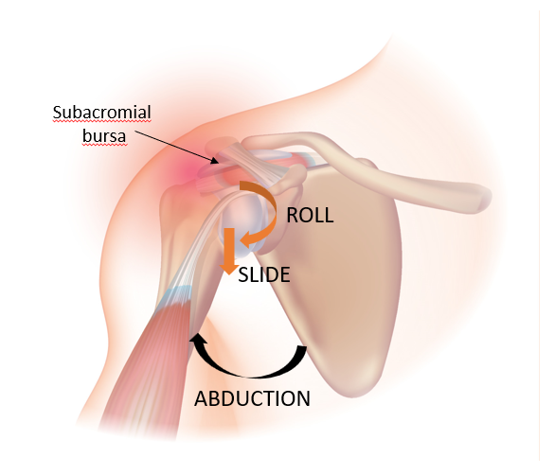
Appendix
During abduction of the arm, the humeral head slides and rolls to maintain contact with the glenoid fossa while maintaining space for the supraspinatus tendon (Fig. A.1). During the four studied phases, some secondary movements were found (Table A.1), but these were excluded from the calculation of the mean angles displayed in Fig. 3 and Fig. 4 because they mostly occurred among only the left-handed participant.
Fig. A.1: Arthrokinematics of the shoulder complex Adapted from (Wikimedia Commons).

Table A.1: Number of times that, for each phase and each condition, the maximum joint angle in the coronal and axial plane followed the secondary direction (i.e., adduction and ER, respectively).
Number of secondary movements |  | Total | no ASE | 50%  torque | 75%  torque | 100%  torque
Ascent phase  (1st half) | Adductions | 42 | 7 | 7 | 1 | 27
Ascent phase  (1st half) | ERs | 89 | 47 | 20 | 7 | 15
Ascent phase  (2nd half) | Adductions | 73 | 20 | 14 | 20 | 19
Descent phase  (1st half) | Adductions | 31 | 6 | 6 | 11 | 8
Descent phase  (2nd half) | Adductions | 14 | 4 | 4 | 1 | 5
Descent phase  (2nd half) | ERs | 173 | 119 | 26 | 6 | 22

