Port Logo and Video
CS 4624
Virginia Tech
Blacksburg, VA
May 8th, 2013
Students: Joshua Rush
Stuart Whitehead
Client: Purdom Lindblad

Table of Contents

Section 1 Executive Summary 1
1.1 Project Summary……………………………………………………1

Section 2 User’s Manual 2
2.1 Using the Port Logo…….……………………………….…….……2

2.2 Using the Port Video……………...…….………….……………….2

Section 3 Developer’s Manual 3
3.1 File Index……………………..…….………………….……………3
3.1.1 Video Files………………..………………………….………3
3.1.2 Audio Files………………….….………….………...……….4
3.1.3 Logo Files…………………………….…………….….……5

3.2 Storyboard……………………………………….…………………5

3.3 Logo…………………….………………………………………… 18

Section 4 Lessons Learned 21
4.1 Schedule……….………….…………………….…………………21

4.2 Problems & Solutions…………………….…….…………………21

Section 5 Acknowledgements 22
5.1 Special Thanks…………………………………………………….22

Section 6 References 23
6.1 Works Cited……………………………………………………….23

Section 1 Executive Summary

  - Project Summary

The goal of this project was to create a logo and video to help promote the Port research space. Port is a digital research commons located on the library side of Torgersen Bridge, in room Torgersen 3320. It has seven computers with a variety of software installed that students might not easily get access to otherwise. The Port space also has a meeting room, appropriate for small consulting sessions and groups. The space can be reserved online through the Virginia Tech Library website. Anyone is free to use Port to utilize the software on the computers. A valid Hokie passport is required to gain entrance to the space.
In order to inform and promote Port, Purdom Lindblad, our client, wanted both a logo designed for the space and a video to promote all that Port has to offer. Purdom is one of three library employees in charge of Port. These deliverables are designed and created with the goal of attracting people of all disciplines and levels to use Port, regardless of major or year (senior, freshman, or faculty). The end product promotes Port as a sandbox where one can learn and explore any subject they wish.
The logo is designed with the theme of learning in mind and aesthetic appeal. Our client wanted the logo to be easily usable in a variety of situations including a Port website, on flyers, and on notices inside the Port space. Also, two versions of the logo were requested: one full size, used in places such as a banner on a website, and a smaller compact version, used where a logo of square dimensions would be required. The two logos should obviously be similar in design to mesh well when viewed together.
Over the course of the semester, Stuart was able to design and create a logo that fulfilled these needs. After initial designs were approved by the client, Stuart created the logo in a free vector graphics program, Inkscape. Every few weeks while meeting with the client, we discussed the progress on the logo and got continuous feedback to evolve the logos into what became the final product. Both a small and full size version of the logo were delivered in several formats so that Purdom would have the correct logo for any situation.
The video requested was a 3-5 minute promotional video that could be uploaded to YouTube or embedded in the Port website. Throughout the semester, Stuart and Josh used Innovation Space equipment to film the Port lab, the meeting space, and the surrounding areas in and outside of Torgersen Bridge. They also collected screen casts of library faculty showcasing software offered in Port. Josh wrote narration for the video which Stuart recorded in the Innovation Space sound booth. The video was compiled and edited by Josh using Adobe Premiere Pro CS6 (http://www.adobe.com/products/premiere.html). Music for the video was retrieved from http://www.jewelbeat.com. Josh completed several drafts throughout the semester, adding to and changing the video as more footage was captured and feedback from the client was taken into consideration. The final video is 3 minutes and 49 seconds long and can be viewed at http://www.youtube.com/watch?v=4QtfpyOC6q0.
Section 2 Users’ Manual

  - Using the Port Logo

The Port logo created is available in varying formats to suit any need. Both the full size and smaller versions are provided in SVG, PNG, and PDF formats. The SVG is a vector graphics file which is editable in a vector graphics program. The PNG has a transparent background, perfect for overlaying on various media such as a website or flyer. The PDF allows it to be resized without any loss of quality. All Port logo files can either be obtained through the project’s entry into VTechWorks or through Purdom Lindblad, the client for this project. Purdom’s contact information is listed in the acknowledgements section.

  - Using the Port Video

The Port video can be viewed on YouTube at the following URL: http://www.youtube.com/watch?v=4QtfpyOC6q0. The video will eventually be embedded in the Port website which does not have a domain name yet. The client, Purdom Lindblad, has a copy of the video which can be obtained by contacting her using the information in the acknowledgements section of this paper. There is also a copy of the video available through VTechWorks. The video is 1.02 GB in size, has a resolution of 1920 x 1080, a frame rate of 29 frames per second, and stereo audio sampled at 48 kHZ. It is in .avi format and can be viewed with Windows Media Player (http://windows.microsoft.com/en-us/windows/download-windows-media-player), or VLC (http://www.videolan.org/vlc/index.html).

Section 3 Developer’s Manual

  - File Index

    - Video Files (portvid.zip)
The following files are the raw video files used to create the promotional video. The numbers denote the order the footage was shot in.
70- Photoshop screen cap 1.mov – Filming of Brian Craig creating a screen capture of Photoshop’s puppet feature.
71- Photoshop screen cap 2.mov – Filming of Brian Craig creating a screen capture of Photoshop’s puppet feature, take 2.
72- Indesign screen cap.mov – Filming of Brian Craig creating a screen capture of InDesign.
73- meeting room pan slower.mov – A slow pan of the Port meeting space.
74- meeting room pan.mov – A medium speed pan of the Port meeting space.
75 – outside door.mov – A still shot
76 – Kyle mills entering take 1.mov – First take of a student entering Port.
77 – Kyle mills entering take 2.mov – Second take of a student entering Port.
78 – side desk short pan.mov – A short pan of Port from outside the side desk.
79 – side desk long pan.mov – A long pan of Port from outside the side desk.
80 – outside desk.mov – A still shot of the outer desk from Torgersen Bridge.
81 – outside desk zoom.mov – A zoom in on the outer Port desk.
82 - outside desk zoom people.mov - A zoom in of the outer Port desk including people studying in Torgersen Bridge.
83 - outside desk zoom people slower.mov - A slow zoom in of the outer Port desk including people studying in Torgersen Bridge.
84 - outside desk zoom farther.mov - A zoom in on the outer Port desk from the back corner of Torgersen Bridge.
85 - outside desk zoom farther take 2.mov – Second take of a zoom in on the outer Port desk from the back corner of Torgersen Bridge.
86 - middle bridge pan.mov – A pan of Torgersen Bridge from the center of bridge.
87 - middle bridge pan people.mov - A pan of Torgersen Bridge from the center of bridge including a group of students walking by.
88 - far bridge.mov – A still shot of Torgersen Bridge from the back corner.
89 - far bridge pan.mov – A pan shot of Torgersen Bridge from the back corner.
90 - lab discussion.mov – Students discussing with faculty members in the Port lab.
91 - lab corner pan.mov – A pan shot of students using the Port lab.
92 - lab corner pan 2.mov – Second take of a pan shot of students using the Port lab.
93 - lab corner quick pan.mov – A fast pan of the Port lab.
94 - soundless sound test.mov – Sound test with Brian Matthews.
95 - soundless sound test 2.mov - Sound test with Brian Matthews.
96 - sound test.mov – Sound test with Brian Matthews
97 - Brian speech.mov – Brian Matthews, Associate Dean of Learning and outreach, gives a speech on why Port exists.
98 - screen saver 1.mov – A still shot of the Port screen saver.
99 - screen saver 2.mov – Second take of a still shot of the Port screen saver.
B92 - python group.dv – A still shot of the Graduate Python Working Group in the Port meeting space.
B93 - python group board.dv - A still shot of the Graduate Python Working Group in the Port meeting space with a whiteboard of their group name on it in the background.
B95 - still corner.dv – A still shot of the Port lab from the corner.
B96 - still door.dv – A still shot of the main Port door.
B97 - still computer.dv – A still shot of a computer in the Port lab.
B98 - bridge center.dv – A still shot of Torgersen bridge from in front the Pylons.
B99 - Bridge center 2.dv – A second take of a still shot of Torgersen bridge from in front the Pylons.
B100 - Outside port zoom.dv – A zoom shot on the Port room from outside of Newman Library.
B101 - torg crosswalk.dv – A still shot of students walking across the crosswalk in from of Torgersen.
B102 - Umall bus.dv – A still shot of the University Mall bus stop in front of Newman Library.
B103 – library.dv – A still shot of Newman Library.
B104 - outside port still.dv – A still shot of the Port room from outside of Newman Library.
B105 - outside close.dv – A zoomed in shot of the Port room from outside of Newman Library.
DataVisualizationRecording.avi – A screen cast of two types data visualization software.
DataVisualizationmp4.mp4 - A screen cast of two types data visualization software in mp4 format.
InDesign Demo.mp4 – A screen cast showcasing InDesign.
PhotoShopDemo1.mp4 – A screen cast showcasing Adobe Photoshop’s puppet feature.
Port.prproj – The Adobe Premiere project file used for editing the video.
Port final.avi – the final video.

3.1.2 Audio Files

media locator.wav – narration about a media locator software.
meeting space.wav – narration about the Port meeting space.
open.wav – narration about who Port is open to.
photoshop.wav – narration about the Adobe Photoshop screen cast.
Port intro.wav – narration giving basic information about Port.
software.wav – narration explaining the types of software available at Port.
time.wav – narration telling the time Port is open.
tutorials.wav – narration explaining the tutorials Port offers for their software.
water sanitation.wav – narration about a water sanitation map visualization software.
Building Inspirations.wav – A soothing piano background song.
Piano House.wav – An upbeat piano background song.

3.1.3 Logo Files (PortLogo.zip)

compass.svg – SVG of the compass used in the logo.
portlogo1.pdf – PDF of the first iteration of the logo.
portlogo2.svg – SVG of the second logo iteration.
portlogo3.pdf – PDF of the third iteration of the logo.
portlogo3.svg – SVG of the third logo iteration.
portlogo4.pdf – PDF of the fourth iteration of the logo.
portlogo4.svg – SVG of the fourth logo iteration.
portlogo4large.pdf – PDF of the fourth iteration logo enlarged.
portlogo4large.svg – SVG of the fourth iteration logo enlarged.
portlogo4largeTrans.png – transparent background PNG of the fourth iteration logo enlarged.
portlogosmall.pdf – PDF of the first small logo iteration.
portlogosmall.svg – SVG of the first small logo iteration.
portlogosmall2.pdf – PDF of the second small logo iteration.
portlogosmall2.svg – SVG of the second small logo iteration.
portlogosmall2large.pdf – PDF of the second small logo iteration enlarged.
portlogosmall2large.svg – SVG of the second small logo iteration enlarged.
portlogosmall2largetrans.png – transparent background PNG of the second small logo iteration enlarged.

  - Story Board

Screen 1
Description: Title screen displaying Port logo and philosophy

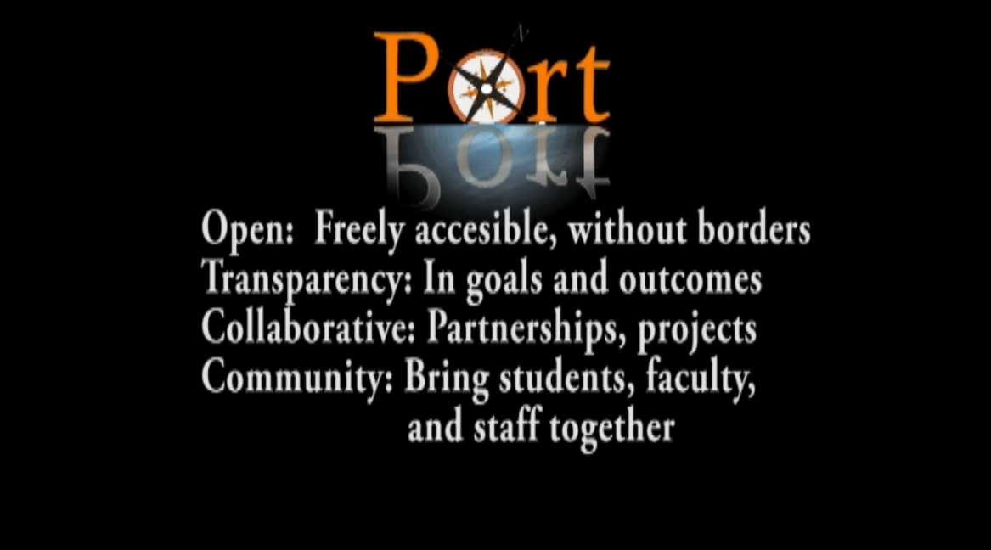
Length: 10 sec
Video: Black background with text and logo overlaid.
Audio: ‘Rising Inspirations’ starts to play at 8 sec.
Text:
Open: Freely accessible, without borders
Transparency: In goals and outcomes
Collaborative: Partnerships, projects
Community: Bring students, faculty, and staff together
Stills: Transparent version of the large port logo in the top center of the screen.
Transition: Fade to white

Screen 2 of
Description: Show the main entrance to port
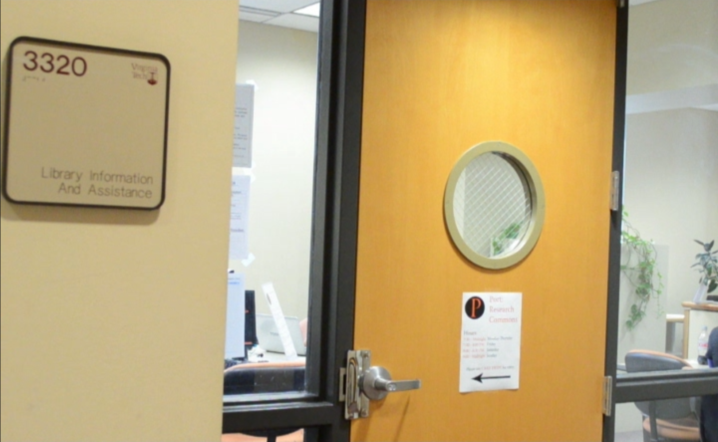
Length: 8 sec
Video: Still shot of the main entrance to port. Transition to a short pan of Torgersen Bridge.
Audio: ‘Rising Inspirations’ continues to play. Narration starts.
Narration: “Port is a digital research commons located in Torgersen Bridge”
Transition: Fade to black

Screen 3
Description: A student enters through the main entrance.
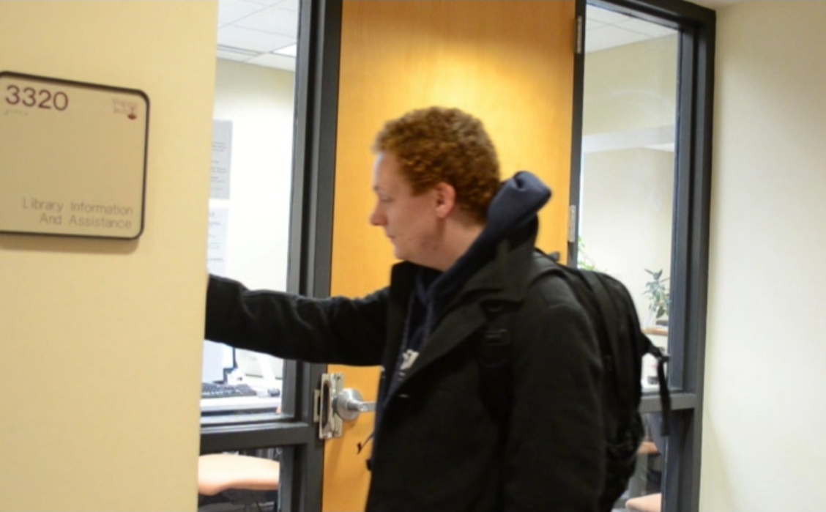

Length: 8 sec
Video: A student swipes his card and enters the main entrance to Port.
Audio: ‘Rising Inspirations’ continues to play over narration.
Narration: “The space is open to anyone with a valid Hokie Passport”
Transition: Fade to black

Screen 4
Description: Students shown using the computers in the Port lab.
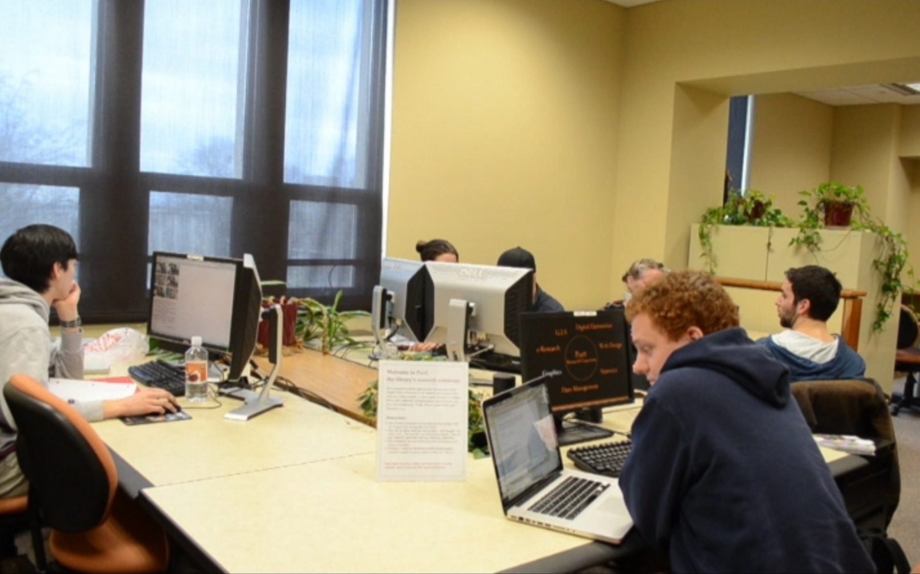
Length: 10sec
Video: Long pan from corner of lab showing students using the computers. Transition into the port screensaver showing a ring of highlighted software types.
Audio: ‘Rising Inspirations’ continues to play over narration.
Narration: “There are several computers with geospatial, statistical, visualization, and text analysis software pre-installed.”
Transition: Fade to black.

Screen 5
Description: The Port meeting space is shown adjacent to the lab.
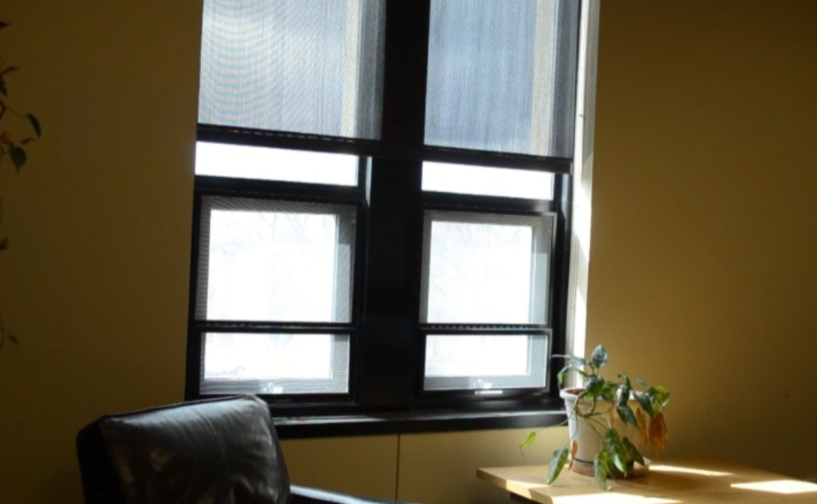
Length: 12 sec
Video: A Long pan of the entire meeting space.
Audio: ‘Rising Inspirations’ continues to play over narration.
Narration: “There’s also a meeting space for classes, small groups, and seminars.”
Transition: Fade to black.

Screen 6
Description: Faculty member shown interacting with a student.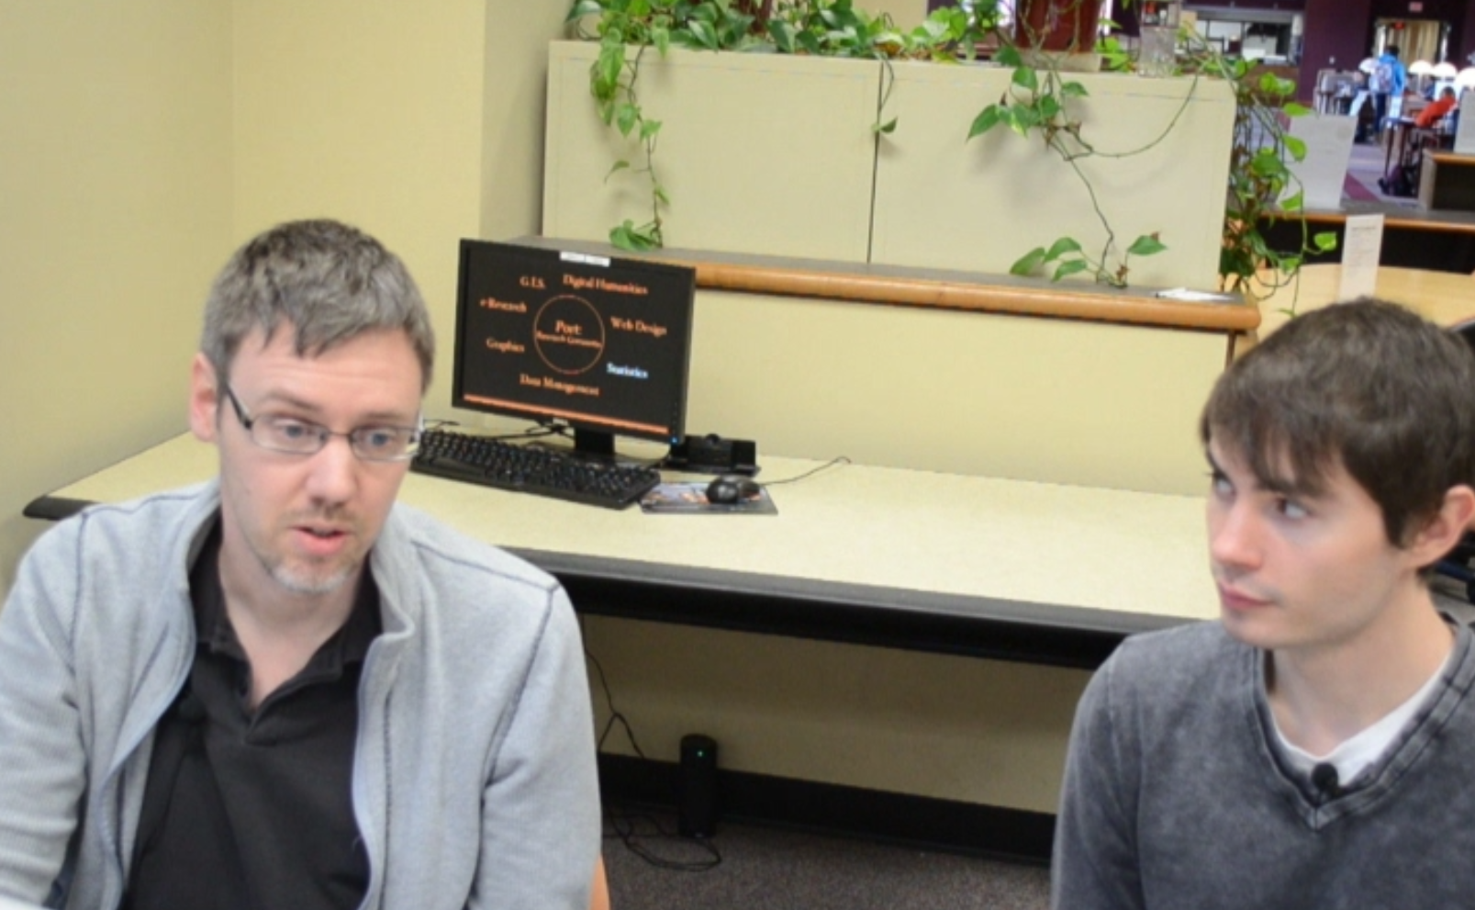
Length: 6 sec
Video: Still shot of faculty member interacting with a student.
Audio: ‘Rising Inspirations’ continues to play over narration.
Narration: Port offers tutorials and guidance on how to use their software to suit your needs.
Transition: Cross Dissolve.

Screen 7
Description: Adobe Photoshop demonstration shown.
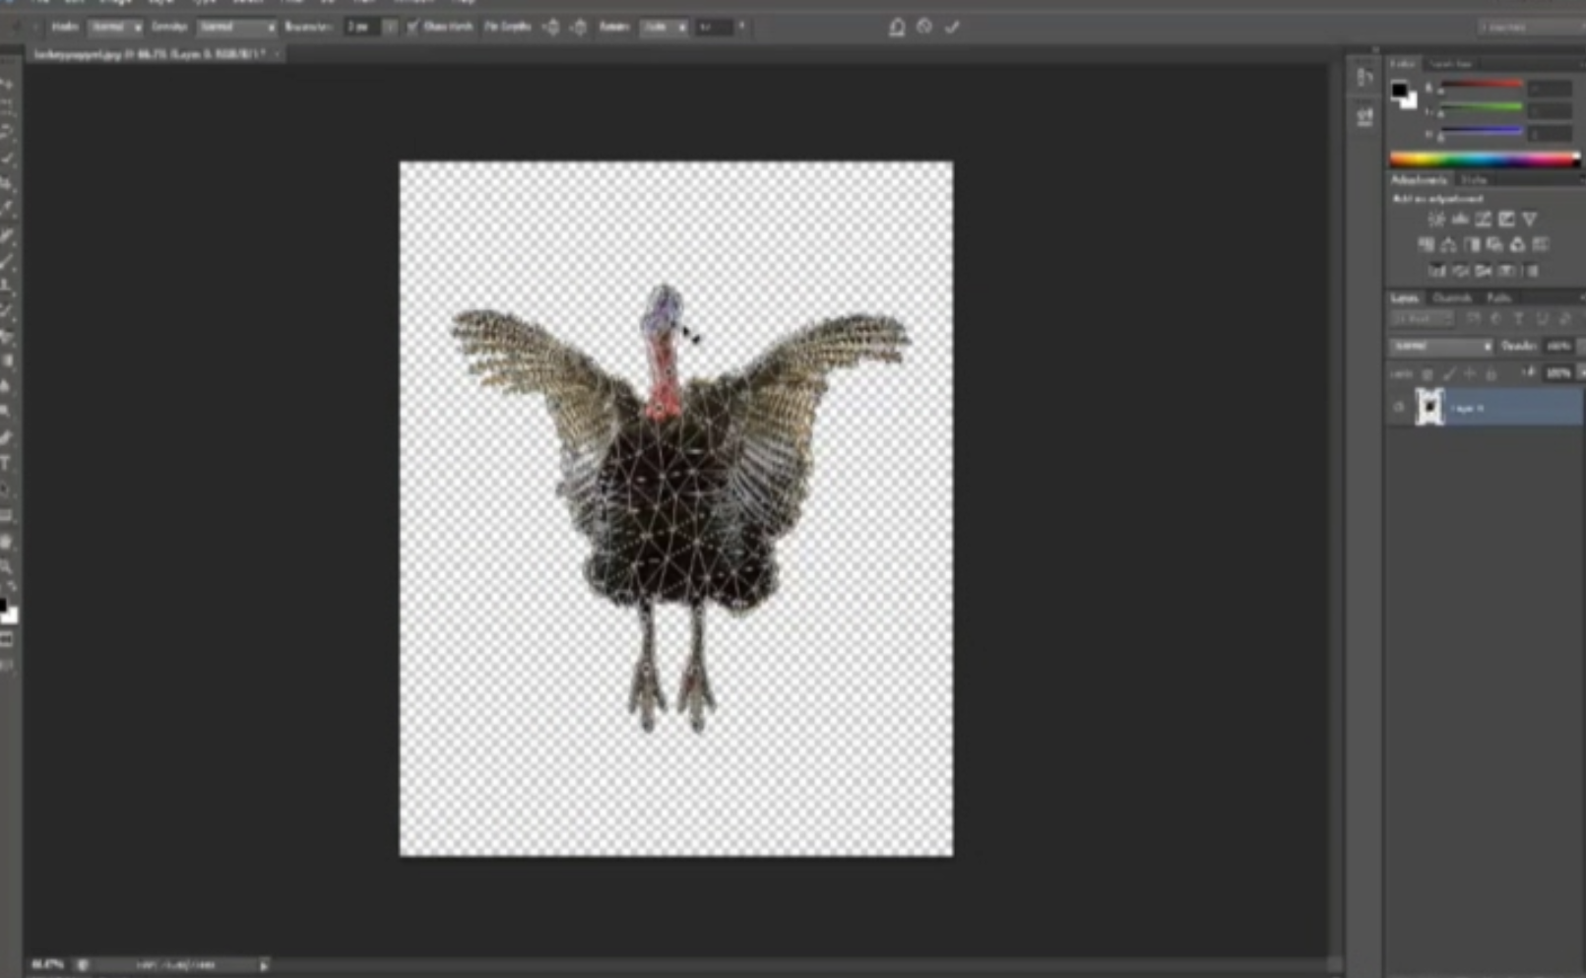
Length: 15 sec
Video: A screen cast of Adobe Photoshop is shown. The user applies hinges to an image, then manipulates the image using these hinges.
Audio: ‘Rising Inspirations’ continues to play over narration.
Narration: “Here we see a demonstration of Adobe Photoshop’s puppet feature.”
Transition: Fade to black.

Screen 8
Description: Screen cast of water sanitation map shown.
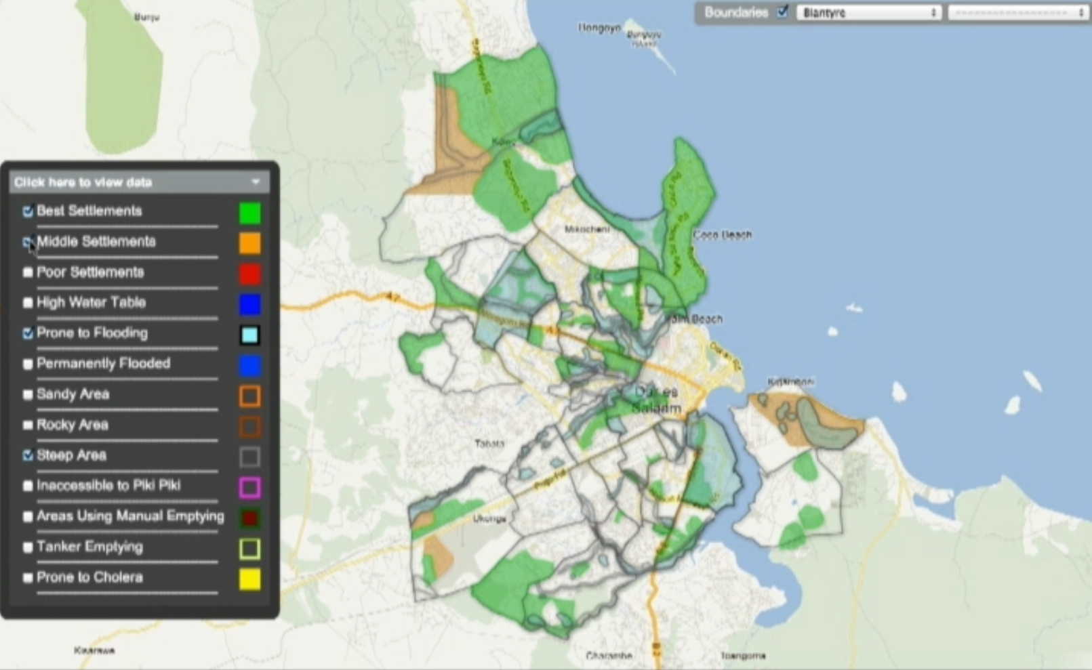

Length: 15 sec
Video: A screen cast of Google fusion tables showing a water sanitation map is shown. The user selects different areas to highlight and the map updates accordingly.
Audio: ‘Rising Inspirations’ continues to play over narration.
Narration: “Students can use the visualization software to build and integrate tools such as a water sanitation map”
Transition: Fade to black.

Screen 9
Description: A screen cast of media visualization software is shown.
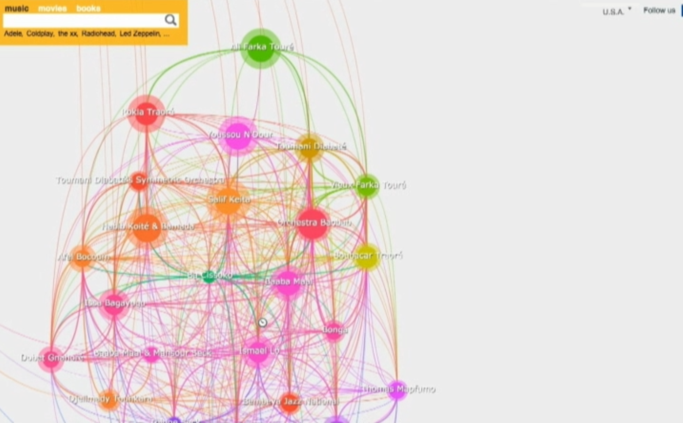
Length: 15 sec
Video: A screen cast showing LivePlasmas media visualization is shown. The user searches for an artist and views a web of related artists.
Audio: ‘Rising Inspirations’ continues to play over narration.
Narration: “… or a media locator”
Transition: Cross fade

Screen 10
Description: Interview with Brian Matthews in the Port meeting space.
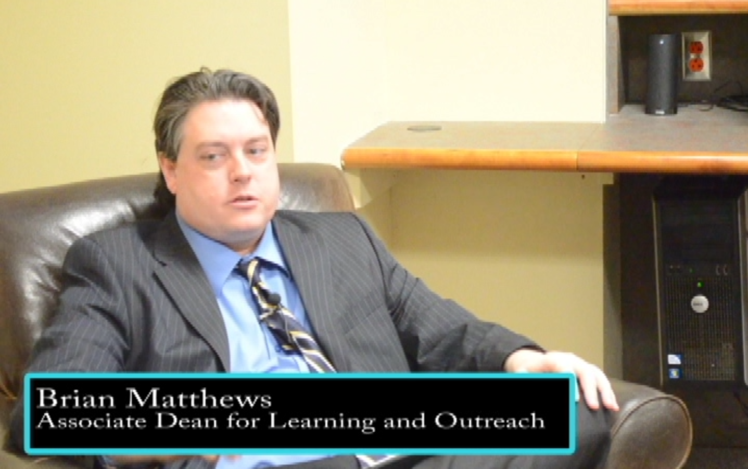
Length: 15 sec
Video: Brian sits in a chair in the Port meeting space and begins a speech about the importance of Port.
Audio: ‘Rising Inspirations’ fades away as Brian begins his speech.
Speech: “So, libraries are going through some pretty significant transformations right now. And this is really at a global scale driven by collections. A lot of our collections are moving from print to digital, and this opens up, the byproduct of that is that it opens up…”
Text: Brian’s name and title are shown in box at the bottom of the screen:
“Brian Matthews
Associate Dean for Learning and Outreach”
Transition: Fade to black.

Screen 11
Description: Port shown from Torgersen side of Torgersen Bridge.
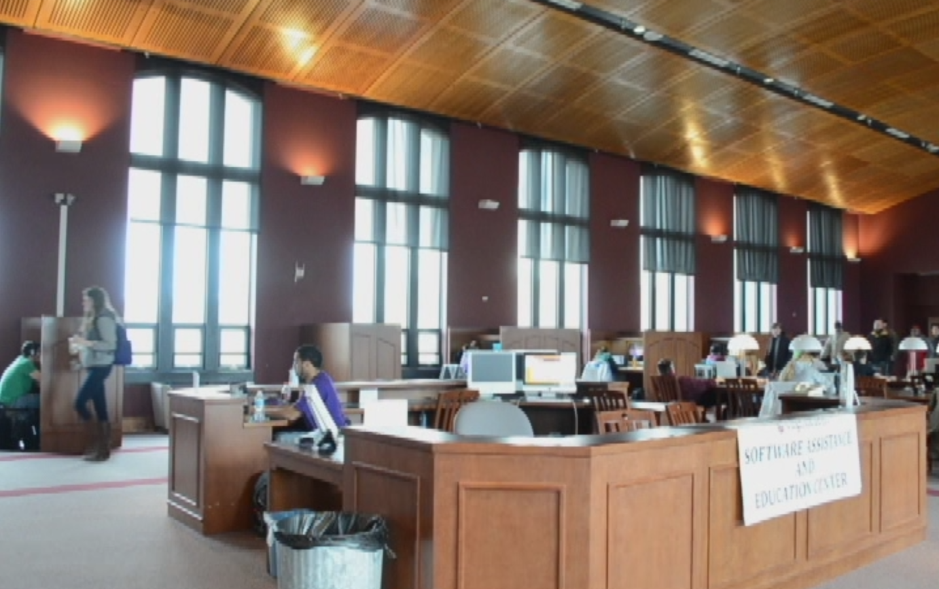

Length: 10 sec
Video: Slowly pans across Torgersen Bridge from the back corner, showing students moving across the bridge. Stop on Port and do a zoom in transition of the Port meeting space which opens up into the bridge.
Audio: Brian’s speech continues.
Speech: “…spaces we can give back to users, give back to faculty. So we spent a lot of time studying what do these spaces need to be and beyond wireless, beyond electricity, the attribute that keeps coming back over and over again is variety.”
Transition: Cross dissolve

Screen 12
Description: Brian continues giving his speech.
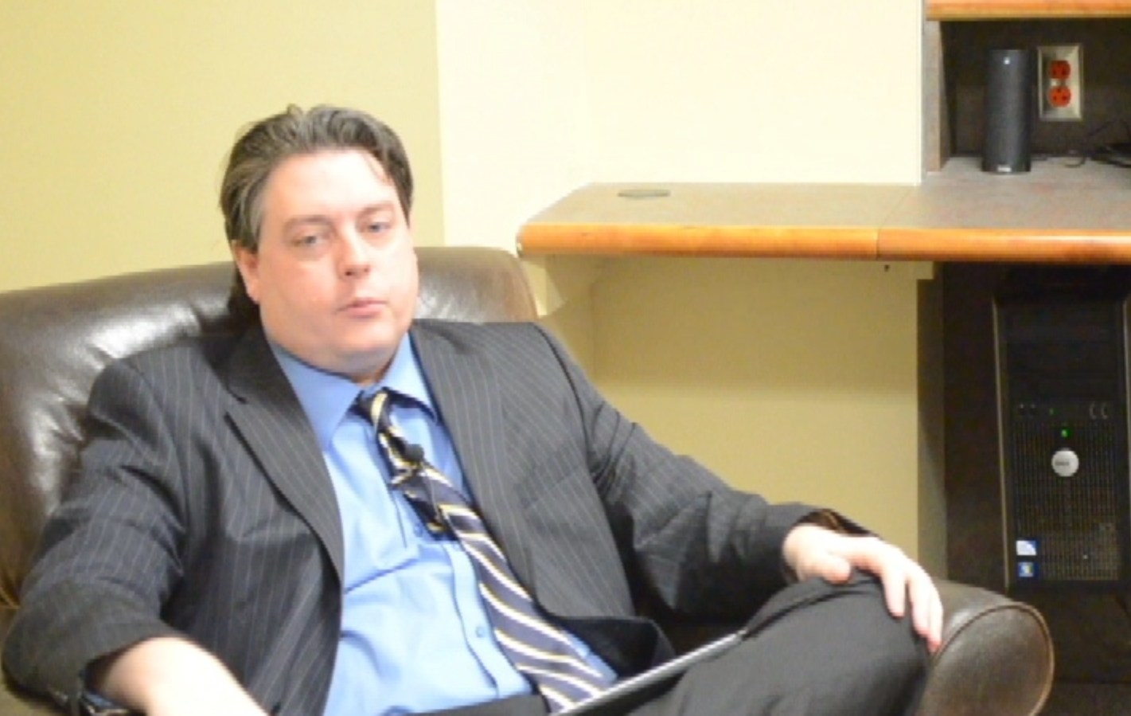
Length: 20 sec
Video: Brian continues his speech in the Port meeting space
Audio: Brian’s speech continues.
Speech: “We need a variety of spaces for a variety of different tasks that students and faculty have. We spend a lot of time thinking about the environment that we want to create and the environment really sets the stage for the types of behaviors, the types of activities, the types of perceptions that can occur in that area. If you take for example…”
Transition: Cross Dissolve

Screen 13
Description: Collaboration in Port is shown.
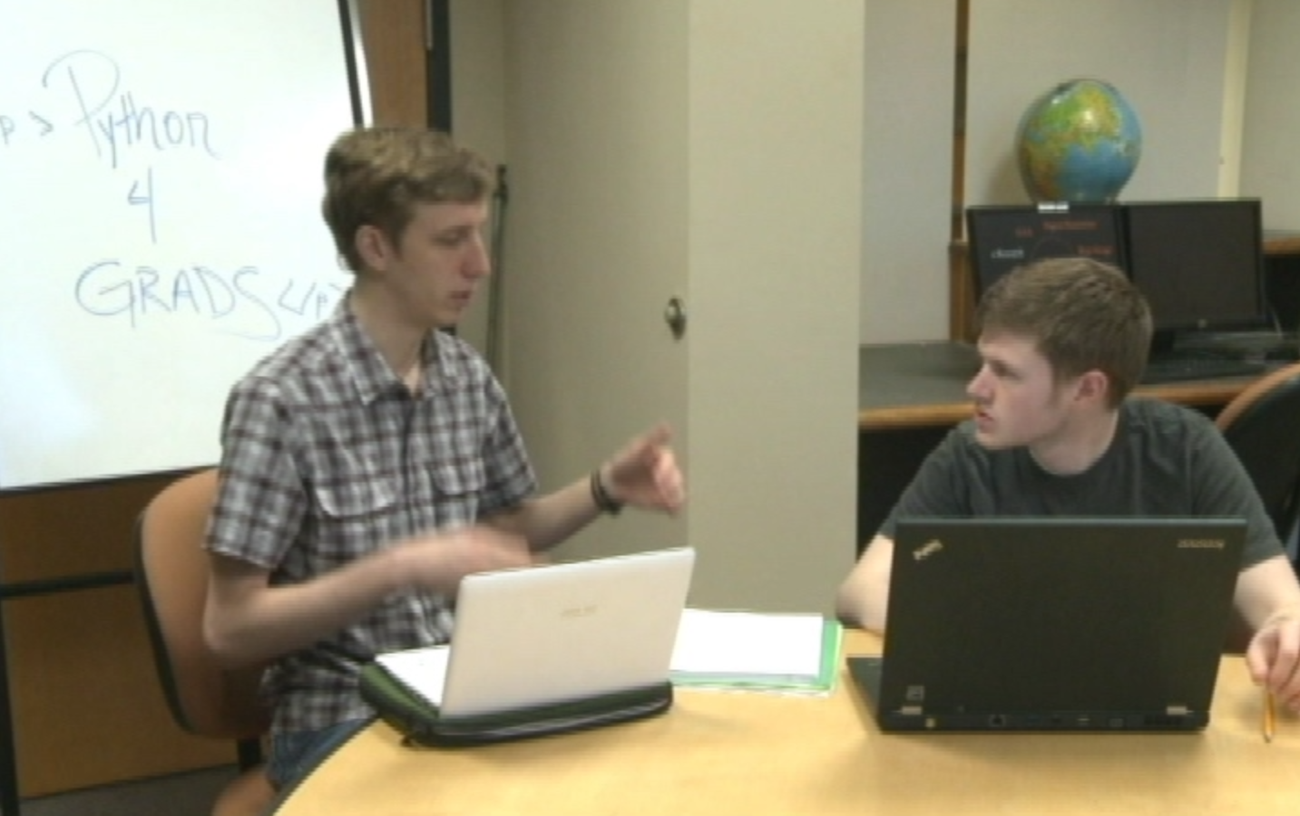
Length: 15 sec
Video: A slow pan of the Port lab shows faculty and students collaborating. Dip to black in a transition to the python graduate working group in the Port meeting space.
Audio: Brian’s speech continues.
Speech: “…a group who is going to brainstorm; they sort of need a different type of environment than a group that is writing a paper or developing a website or rehearsing a talk. Same thing with individuals, if you have someone who’s doing coding or design work it’s different from someone who needs to read a book or prepare for a test.”
Transition: Cross dissolve

Screen 14
Description: Brian finishes his speech. 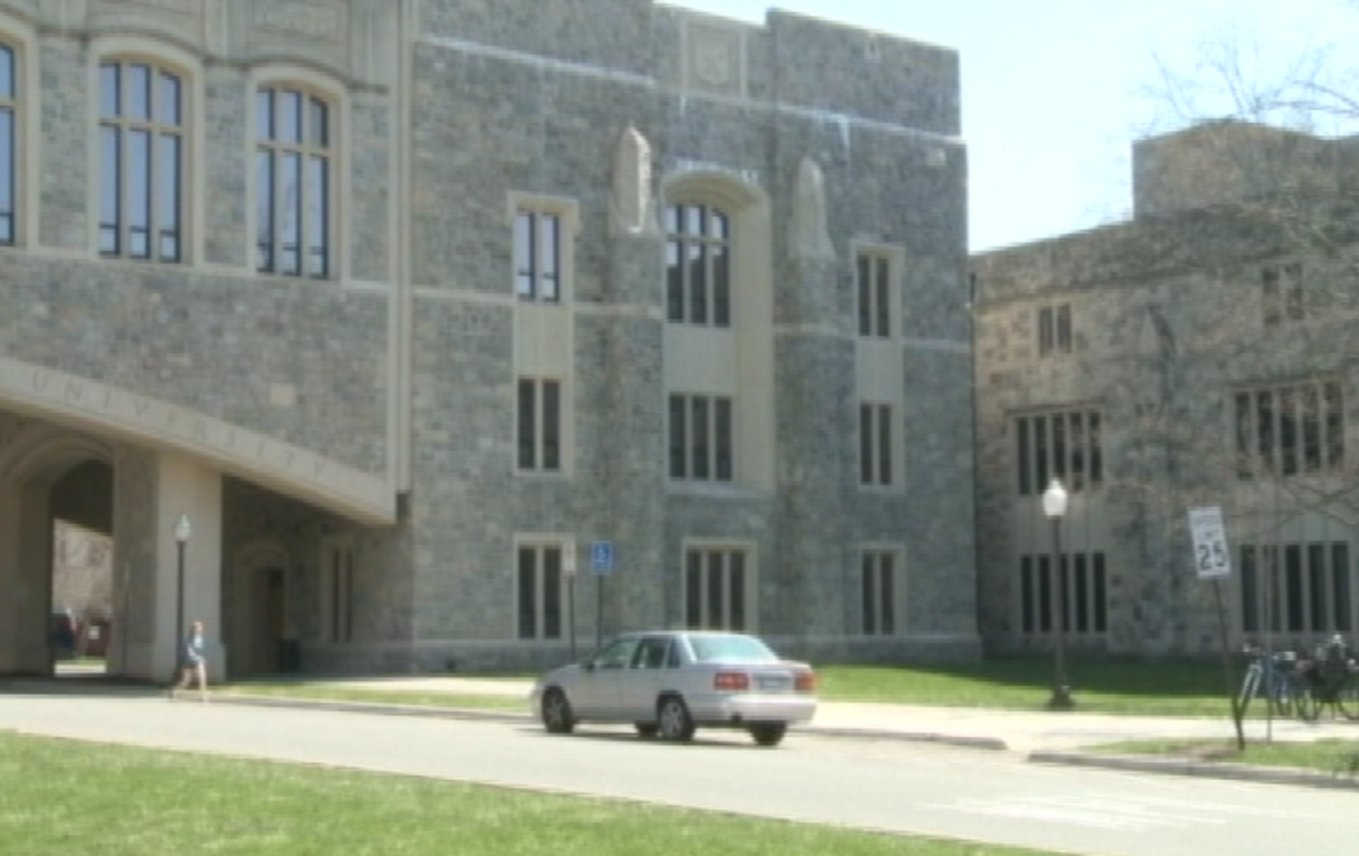

Length: 45 sec
Video: Cut back to Brian who continues his speech. Cross dissolve into a picture of Torgersen Bridge from outside, with Port centered. Cross dissolve back to Brian who finishes his speech.
Audio: Brain finishes his speech. ‘Piano House’ fades in.
Speech: “So, really what we’re kind of starting to see is the library is sort of this vast ecosystem and that’s where Port comes in as one of those destinations in that ecosystem and what’s cool about Port is it has flexibility to be a lot of different things. It can be a consultation space, it can be a studio space, it can be a lab, it can be a multimedia productivity space. And that’s really the keys we’re looking at. It’s a place to explore, it’s a place to dabble and it’s a place to discover and share and collaborate. And really it’s still in its sort of early stages and we’re trying to give it room to evolve and grow and figure out what Port needs to become.”
Transition: Fade to black.

Screen 15
Description: Port hours of operation are shown in a closing screen.
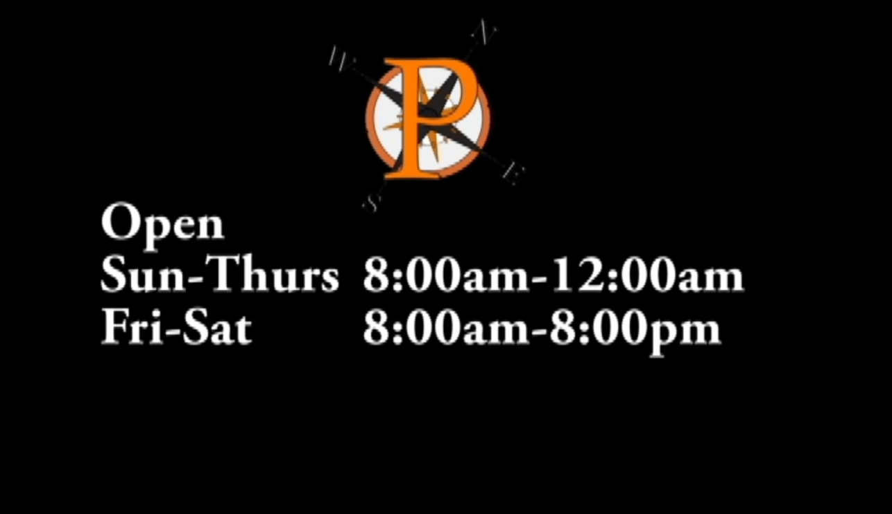
Length: 3 sec
Video: Black background while Port logo and hours of operation are shown.
Audio: ‘Piano House’ plays in the background
Text: Port’s hours of operation are shown in the middle of the screen:
“Open
Sun-Thurs 8:00am-12:00am
Fri-Sat 8:00am-8:00pm”
Stills: The smaller version of the Port logo is shown in the top center of the screen.
Transition: Fade to black

Screen 16
Description: Credits
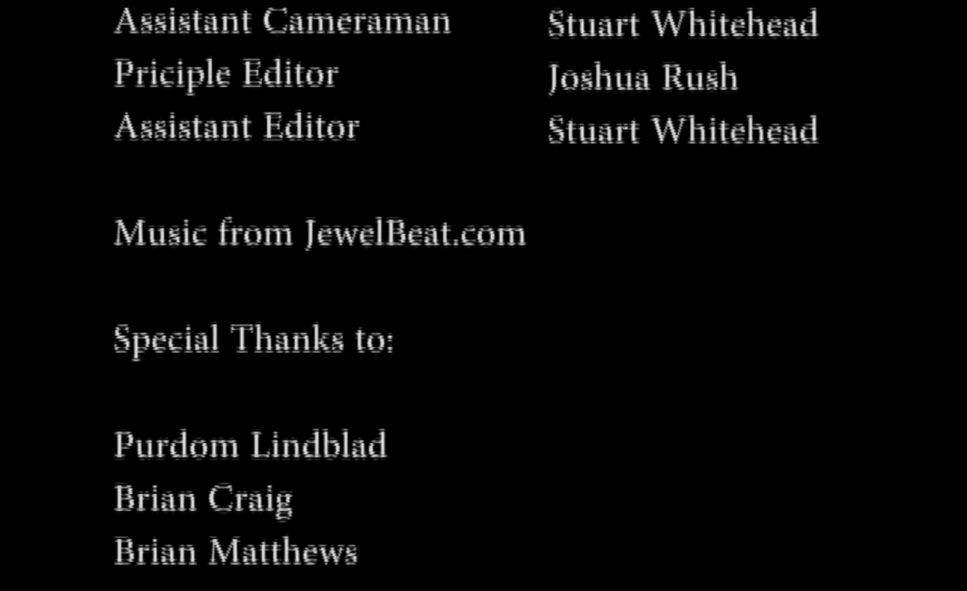
Length: 15 sec
Video: Credits scroll up the screen.
Audio: ‘Piano House’ plays in the background and fades away once the credits finish.
Text: “
Principal Cameraman Joshua Rush
Assistant Cameraman Stuart Whitehead
Principle Editor Joshua Rush
Assistant Editor Stuart Whitehead
Music from JewelBeat.com
Special Thanks to:
Purdom Lindblad
Brain Craig
Brian Matthews
Kyle Mills
Scott Pennington
“

  - Logo

The first iteration of the logo:
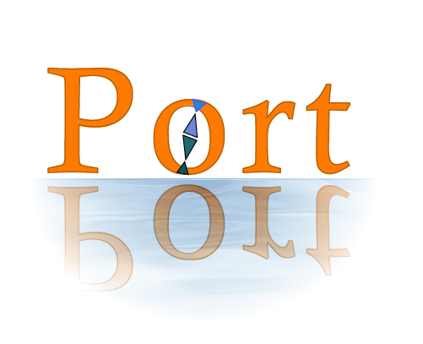
This version was the initial idea. The client’s current logo used orange text, so we decided to stick with that. With the theme of a port being a place where ships dock for supplies, and the Port lab being a place where anyone could come for knowledge, the water filter was added and the word Port reflected in the water. The o was meant to be a compass, and that work was completed in later versions.

The second iteration of the logo:
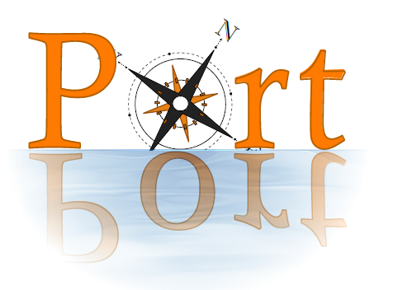
This version replaces the o with a compass design.

Final logo:
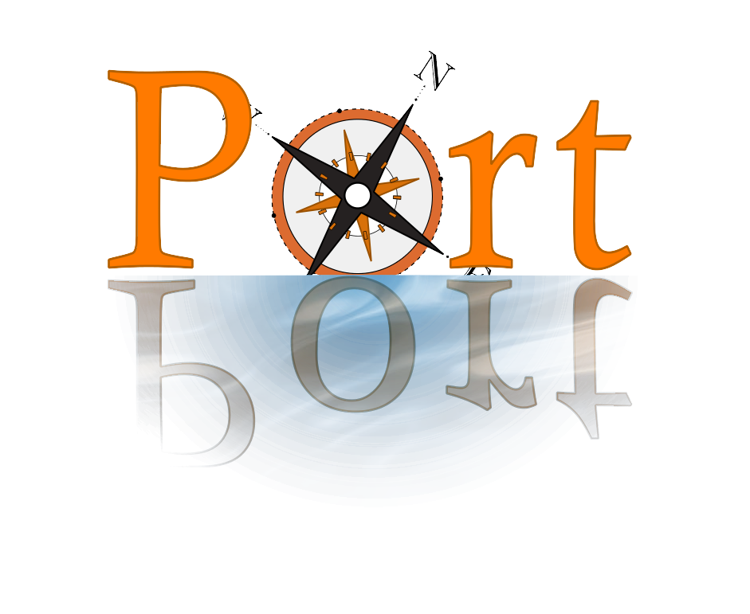
The final logo with some small color changes.

The small logo, version 1:
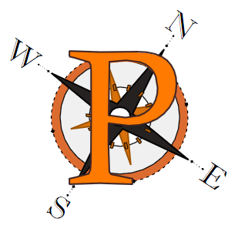
The initial idea for the small logo: the P with a darker border on top of the compass used in the full size logo.

Final iteration of small logo:
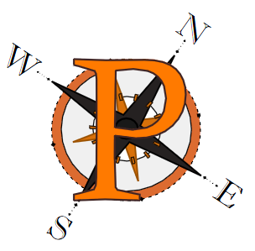
This version colors in the center circle of the compass to make sure the color doesn’t interfere with the perception of the P in the center. The P was also slightly repositioned and recolored. SVG and PDF versions of each logo are provided and can be edited in any image editor.

Section 4 Lessons Learned

  - Schedule

- Friday, February 15th: Preliminary research, set up work, get understanding of other example videos, reserve camera
- Thursday, February 28th: Begin drawing concept ideas for logo, plan sequences and shots for video
- Friday, March 15th: Continue shooting for video, get feedback for logo ideas
- Monday, March 25th: Midterm presentation
- Friday, March 29th: Complete shooting for video, begin editing, finalize logo
- Friday, April 12th: Continue editing, present logo
- Friday, April 26th: Wrap up editing, present video, user testing (gauge reception of video and logo)
- Monday, May 6th: Complete any final changes, archive all materials
- Wednesday, May 8th: Final presentation

  - Problems & Solutions

There were a number of obstacles faced during the project. Josh and Stuart were both new to the Innovation space equipment, so they had to familiarize themselves with it in order to use it. A library faculty member, Scott Pennington, was helpful in teaching Josh and Stuart how to use the equipment.
The same camera was not used for each day of shooting, so there were some resolution and quality differences in the footage. There was also inconsistent lighting in some of the shots. These problems were solved using effects in Adobe Premiere to normalize the resolution and the lighting. Adobe premiere allows the editing clips to enhance the lighting or resize the clip to solve these problems.
Because so many different video file types were used (mp4, avi, dv, mov), Adobe Premiere had a difficult time exporting the film. One of the file types was not supported, so Josh had to try deleting certain clips to identify which one needed to be converted. DataVisualizationmp4.mp4 was the unsupported file, and was converted to avi format. Unfortunately, the conversion process corrupted the metadata of the file, causing it to not be recognized correctly by Adobe Premiere. To solve the problem, Josh had to use Fraps to record his screen while watching the mp4 file. Fraps records uncompressed video, so the quality did not suffer and the resulting file was compatible with Adobe Premiere.
Premiere’s default export settings diminished the quality of the video and caused a shaky effect. Multiple file types and codecs were tried, but all of them produced the same effect to varying degrees. The problem was eventually solved by matching the sequence settings when exporting, so no compression took place. The resulting video was 20 GB, a size that is not manageable or watchable using media players. This problem was solved by using another piece of software: VirtualDub (http://www.virtualdub.org/) to compress the video. Using the Xvid MPEG-4 lossless codec, the video was compressed to 1GB without losing any quality. This size and level of quality was ideal for the client, who can compress the video further to suit her needs.
In making the logo, the only notable obstacle was creating logo versions with transparent backgrounds. The client needed logo versions with transparent backgrounds so the logos could be easy dropped into any project and instantly look good. This was somewhat difficult to achieve with the way the full size logo’s water filter on the bottom worked. However after much manipulation in Adobe Photoshop, a transparent background was obtained for both logo versions without loss of the quality of the original logo.

Section 5 Acknowledgements

Client: Purdom Lindblad email: purdom6@vt.edu
Brian Craig – Provided screen casts of Photoshop and InDesign
Brian Matthews – Was filmed speaking about Port’s importance
Kyle Mills – A student who assisted with filming some shots.
Scott Pennington – Assisted with reserving equipment and teaching Josh and Stuart how to use it. Provided screen casts for water sanitation map and media locator.
Collin Brittle – Systems Engineer and head of Python Graduate Working Group.
Tyler Bradley – Python Graduate Working Group member who assisted with filming.
Darren Maczka – Python Graduate Working Group member who assisted with filming.

Section 6 References
Works Cited
Adobe Photoshop CS3. Berkeley, CA: Adobe, 2007. Computer software.
Google Maps. Computer software. Https://maps.google.com/. Google, 8 Feb. 2005. Web. 14 Apr. 2013.
Hiitola, Bethany. Inkscape. Birmingham, U.K.: Packt Pub., 2010. Computer software.
Jago, Maxim. Adobe Premiere Pro CS6. [Berkeley, Calif.]: Peachpit Press, 2012. Computer software.
Lee, Avery. VirtualDub. Http://www.virtualdub.org/. Vers. 1.9.11. Web. 15 Apr. 2013.
Liveplasma. Computer software. Liveplasma.com. Web. 15 Apr. 2013.
Matthews, Brian. "Why Is Port Important?" Personal interview. 28 Feb. 2013.
Viers, Russell, José Ramos, Gerhard Koren, and Dan Brodnitz. Adobe InDesign CS5. Berkeley, CA: Peachpit Press, 2011. Computer software.

