Using a Systems-Centric Knowledge Graph to support Facility Maintenance
Akhileswar Reddy Yanamala,¹ Ashit Harode,² and Walid Thabet, Ph.D., CM-BIM³

¹Ph.D student, Department of Building Construction, Virginia Tech, Blacksburg, VA, 24061-1020; email: akhileswar@vt.edu (Corresponding author)
²Ph.D candidate, Department of Building Construction, Virginia Tech, Blacksburg, VA, 24061-1020; email: ashit02@vt.edu
³W.E. Jamerson Professor, Department of Building Construction, Virginia Tech, Blacksburg, VA, 24061-1020; email: thabet@vt.edu

ABSTRACT
Throughout an asset's lifecycle, rates of early failure, random failure, and wear-out failure underscore the need for robust maintenance strategies, including Corrective, Preventive, and Predictive approaches. Even though the use of BIM has increased in recent years in the field of facility maintenance and management, the BIM technology is not utilized to its full potential to make the facility management more proactive and cost efficient. While existing research focused on developing systems-centric FM-Capable BIMs, there are limitations in how the data is stored and accessed. Existing research also shows that access to the right data at the right time is very crucial for proactive maintenance decision making and cost management. The literature review of recent efforts uncovered gaps in research regarding the utilization of knowledge graphs for facility management. This research presents a novel approach to represent Building Information Modeling (BIM) data as a systems-centric knowledge graph. This systems-centric knowledge graph enhances facility management by facilitating efficient queries for maintenance and emergency scenarios. To validate the utilization of knowledge graphs for systems-centric searches, authors selected a case study as a mechanical zone of an elementary school building. To create the knowledge graph of the case study, authors divided the systems in the zone into subsystems and developed small component knowledge graphs for each subsystem. Later all the component graphs were merged to create a federated knowledge graph of the selected zone. This process allowed authors to create the knowledge graph without complications and helped in quality control by eliminating any input errors. The developed knowledge graph was queried for various emergency scenarios developed based on the discussions with FM staff. The queried results were highlighted in the Navisworks 3D model to display. This research implementation offers practical implications for facility managers, emphasizing the potential for further advancements in Digital Twin development.
AUTHOR KEYWORDS: Systems-centric, FM-Capable BIM, Knowledge Graphs, Graph Database, Label Property Graph (LPG), Resource Description Framework (RDF), Digital Twin, Facility Maintenance, Ontology

INTRODUCTION
During an asset lifecycle, the asset goes through three rates of failure, (1) rate of early failure that peaks around the installation and then decreases as the lifecycle continues, (2) rate of random failure with a steady failure rate during the asset life, and (3) rate of wear out failure that increase as the asset exceeds its design lifetime (Jezzini et al. 2013). There are three basic approaches for the maintenance of an asset: (1) Corrective or reactive, (2) Preventive, and (3) Predictive maintenance. Corrective maintenance refers to the actions taken after failure has occurred. This approach increases the maintenance interval and thus minimizes the cost of servicing an asset but results in unplanned downtime (Molęda et al. 2023). A good maintenance program for assets should decrease both the cost of maintenance and downtime (Jezzini et al. 2013). A maintenance program should be proactive, including preventive and predictive maintenance strategies. Proactive maintenance includes monitoring and correcting the root failure causes in an asset. Providing scheduled systematic inspection, detection, and correction falls under preventive maintenance. Predictive maintenance compares trends in an asset’s operational parameters against operational limits and thresholds to detect, analyze and correct issues before failure occurs.
Efficient management of facilities relies heavily on access to operational and maintenance (O&M) data and information, contributing to heightened productivity, informed proactive maintenance decisions, and reduced overall lifecycle cost of assets (Becerik-Gerber et al. 2012; Chen et al. 2020). The utilization of Building Information Modelling (BIM) serves as a central repository for supporting access to O&M data. However, for BIM to effectively aid facility O&M, it must be configured to furnish essential O&M information alongside the as-built details of the facility and its assets. These BIMs are commonly classified as FM-enabled BIMs or FM-Capable BIMs (Becerik-Gerber et al. 2012; Ensafi et al. 2022). Noteworthy examples provided by Sacks et al. (2018), Sadeghi et al. (2018), and Yang and Ergan (2017) focus on embedding data in handover BIMs with an emphasis on space and asset management. Their research highlights that the adoption rate of FM-Capable BIMs for supporting facility management and maintenance is currently slow and is at an early stage of development.
Facility managers tend to have a systems-driven or system-oriented viewpoint of their facility. FM-Capable BIMs leverage inter-connected building systems and their components to provide facility managers with easier and faster searches for the location of any system component and access to its data embedded in the BIM, improving maintenance and operation of the facility. By providing a tool to access exact locations of assets and necessary data through an FM-capable BIM allows facility managers to quickly and accurately evaluate and respond to major maintenance events or issues (Ensafi et al. 2022). In an attempt to develop such tools Ensafi et al. (2022) outlined and established requirements and configuration procedures for as-built system-centric models. The study identified four essential characteristics for an effective handover FM-Capable BIM supporting facility management and maintenance: (i) a data-centric model, (ii) comprehensive and accurate model graphics, (iii) a system-centric model, and (iv) the capability to link the model to the owner’s facility management system. To validate their approach, a systems-centric FM-Capable BIM model was constructed within Navisworks, incorporating system-centric data standards. The model underwent testing by identifying components of building systems for two emergency scenarios, utilizing Navisworks' built-in "Find Items" feature, and saving the results as viewpoints. While Ensafi et al. (2022) research proves relevant and effective in developing a Systems-Centric FM-Capable BIM, there is room for improvement in its application, particularly concerning how data is accessed. This challenge stems from the storage and accessibility of system-centric data in Navisworks, the software chosen for validating their study and a widely preferred tool in the construction industry.
Harode et al. (2022) investigated advancements in how facility managers access system-centric data. By creating Power BI dashboards that can host BIM models along with embedded data in a highly customizable environment. Harode et al. (2022) addressed two issues when accessing BIM models; first, the lack of knowledge and skill among facility managers when interacting with BIM model authoring and viewing tools (Akanmu et al. 2020). Second, the data overload when accessing and viewing model geometry and data to respond to relevant facility maintenance scenarios (Ensafi and Thabet 2021). However, Harode et al. (2022) and Ensafi et al. (2022) both did not discuss the research area of effective storage of systems-centric data in the development of systems-centric FM-Capable BIM.
The "Find Item" feature in Navisworks, utilized for systems-centric search among model elements, functions comparably to executing a search query in a relational database (tabular database). Relational databases store data in table or matrix form, due to this more importance is given to elements than relationships which affects how the relational information is queried. It gets even more tedious to query relational information as the data gets bigger, the computation and representation of complex relationships become resource-intensive, demanding a substantial number of joins between databases(Batra and Tyagi 2012).
Alternatively, knowledge graphs store the data in a graph structure, using nodes and edges giving equal importance to elements and relations between them. Nodes represent the elements in the data and edges represent relations between the elements. Additionally, nodes and edges can store properties associated with them (McComb 2019). This structure of knowledge graphs closely resembles the interconnectivity of building systems and assets in a facility leading the author to hypothesize that knowledge graphs could be more effective to represent facility elements and components and perform data searches to support facility operations and management.
Knowledge graphs has been utilized in multiple fields including contact tracing during COVID-19 pandemic (Mao et al. 2021), testing scalability and visibility in data analysis of supply chain data (Hong and Chen 2022), and assisting investigations to discover names and entity relationship in criminal cases (Carnaz et al. 2021). Knowledge graphs has been used in the construction industry as well, which is discussed in detail in the upcoming section.
To test the authors’ hypothesis regarding the functionality of knowledge graphs to depict the relations between model elements and lack of research on effective ways to store O&M data to support creating FM-capable BIMs, this paper formulates the following two research questions:
- How can building assets be represented using a knowledge graph?
- Can knowledge graph be used to effectively store facility management data and support systems-centric searches?
This paper presents a methodology for utilizing a graph database to represent a BIM model in the form of a knowledge graph to facilitate the querying of building information based on systems-centric properties. This querying can help in facility management (FM) to identify building elements and their dependencies during maintenance or emergency situations. To answer the research questions identified, the objective of this paper is defined as: Develop a knowledge graph and graph ontology for BIM to facilitate facility management with the capability of efficient systems-centric querying.
This research builds upon the case study conducted by Yanamala et al. (2023) by utilizing the same BIM model. The BIM model consists of a two-story elementary and middle school building encompassing various spaces for administrative offices, studios, labs, classrooms, kitchen, cafeteria, and a gymnasium with some ancillary spaces. The authors selected Zone-4 from four identified HVAC thermal zones in the building, which includes the gymnasium and adjacent supporting spaces for implementation. This zone is served by a single rooftop air handling unit, supply, return, and exhaust air ducts, exhaust fan and gravity roof ventilators.

LITERATURE BACKGROUND
A literature review search was conducted using the Scopus and Web of Sciences databases. Relevant publications were identified and results were analyzed using the VOSviewer (Wong 2018) to determine occurrences and co-occurrences of selected keywords and to identify the research gap. The selected databases were searched for selected keywords in the title and abstract of publications using the query (“graph database" OR "graph data") AND ("BIM" OR "building information model" OR "building information modeling" OR "FM" OR "facility management" OR "facility manager" OR "AEC" OR "construction").
The search was conducted for publications beginning in the year 2000. To ensure that papers addressing topics being searched including knowledge graphs, ifc and BIM are being represented together in the VOSviewer network map, a common label was given to all the synonymous words of these topics that appeared in the search. For example, ‘graph data’, ‘graph model’, ‘graph data model’, and ‘graph database’ were all replaced with ‘knowledge graphs’ so that papers with these words appear all together in the VOSviewer network map. A thesaurus file was created to upload in the VOSviewer, listing the synonymous labels and given common label.
Search results from the Scopus database yielded 281 publications that were further filtered to exclude physics, chemical, social, medical, and other irrelevant subject areas. This resulted in 201 publications including any type of publication published between 2000-2022. The title and abstract for all 201 publications are exported to a CSV file and imported into the VOSviewer to create a network map of repeated words showing their occurrences and co-occurrences. When creating the VOSviewer map, the ‘Binary Counting’ option is selected, the created thesaurus file is uploaded, and the threshold for minimum occurrences of a word is set to 5. VOSviewer returned 179 words which appeared at least in 5 different publications from the 201 publications. All 179 words are included and resulted in a network map (Fig. 1) containing the occurrences and co-occurrences of the 179 words that appeared at least 5 times in the 201 publications identified. A similar search and filtering processes were conducted using the Web of Science database and the results yielded 110 publications. A similar VOSviewer network map was generated.
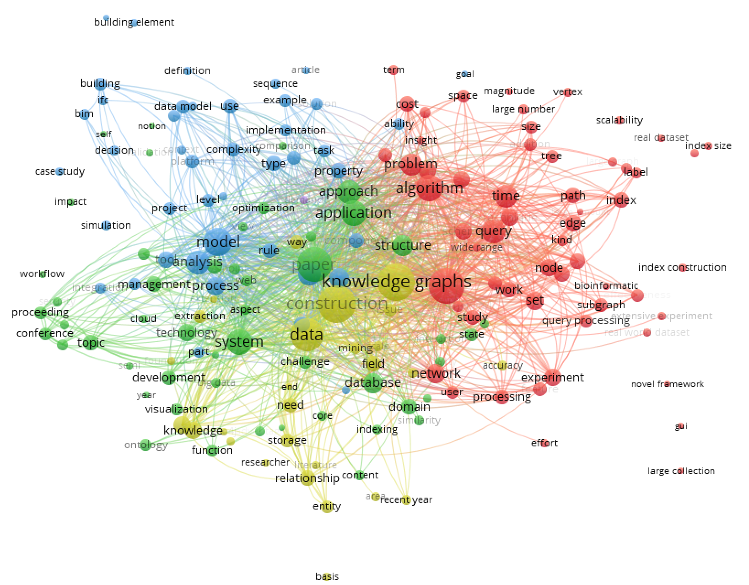
Fig. 1. Image showing the network map generated in VOSviewer using Scopus results.
Based on the VOSviewer network map generated using results from Scopus database, the word ‘BIM’ occurred in 13 publications and co-occurred with the words replaced by ‘knowledge graphs’ in 9 publications. Similarly, the word ‘IFC’ occurred in 9 publications and co-occurred with the words replaced by ‘knowledge graphs’ in 8 publications, and there are no co-occurrences of the words ‘BIM’ and ‘IFC’. This indicates that there could be 17 publications discussing BIM or IFC in combination with Knowledge graphs in Scopus database.
In the network map generated using results from Web of Science database, the word ‘BIM’ occurred in 9 publications and co-occurred with the words replaced by ‘knowledge graphs’ in 7 publications, the word ‘IFC’ occurred in 5 publications and co-occurred with the words replaced by ‘knowledge graphs’ in all 5 publications, and the words ‘BIM’ and ‘IFC’ co-occurred in 4 publications. This indicates that there could be 13 publications discussing the topic of BIM or IFC in combination with Knowledge graphs in Web of Science database.
By analyzing the VOSviewer network maps generated for Scopus and Web of Science databases, it was determined that there were very few publications that address the areas of BIM or IFC and knowledge graphs together with a total of 17 publications in Scopus and 13 publications in Web of Science. In addition to that, the words ‘FM’, ‘facility management’, ‘facility maintenance’ and ‘facility manager’ did not appear in any of the VOSviewer network maps.
The authors reviewed the publications addressing the BIM or IFC and knowledge graphs together and found that research in this area have focused mainly on how to convert BIM and GIS data into a knowledge graphs, advantages of using knowledge graphs for creating emergency routes in a building, tracking changes to 3D models, and creating integrated BIM-GIS models.
Hor et al. (2018) and Malinverni et al. (2020) used knowledge graphs to convert GIS model data into a graph model. Hor et al. (2018) Converted GIS and BIM model data into RDF (Resource Description Framework) graphs and linked them using common properties. The linked RDF graphs are imported into Neo4j to create combined GIS and BIM knowledge graph in order to facilitate integrated search functionality between both BIM and GIS data. Malinverni et al. (2020) converted GIS model data into a graph data using semantic web, Python and Arango DB (a graph database). Hu et al. (2020) used knowledge graphs to represent dependencies among clashes and identify an optimum sequence for clash resolution that can reduce the number of elements required to be moved to generate a clash free model. Spatial data extracted from BIM was combined using a knowledge graph. This data included indoor location of occupants and feedback on their thermal comfort. The database was used as input for a machine learning algorithm capable of predicting occupant’s thermal preference with a 14%-28% accuracy (Abdelrahman et al. 2022).
Ismail et al. (2018), Ismail et al. (2017), and Nahar (2017) used knowledge graphs for creating emergency routes converting BIM data into a knowledge graph using an IFC file and creating additional relationships using Cypher in Neo4j to facilitate creation of emergency routes. Additionally, Ismail et al. (2017) converted different BIM building models into knowledge graphs to compare different versions of the models and identify design changes.
Zhao et al. (2020) and Xu and Abualdenien (2018) used knowledge graphs to represent BIM model data as a graph model. Zhao et al. (2020) converted an IFC BIM model into an XML file. Using Cypher language, nodes and edges are created from the XML file. Xu and Abualdenien (2018) used Python code to extract model information from an IFC file and convert it to Cypher code that was imported into the Neo4j platform to create the knowledge graph. Additionally, Xu and Abualdenien (2018) developed a methodology to query graphical data (dimensions/coordinates) of the model from the knowledge graph to identify intersecting or overlapping objects in the model.
The authors conclude that very little research work is being conducted to utilize knowledge graphs to support facility maintenance and management, an indication that a research gap may exist in this area. Authors believe there is a need for more applied research and implementation in this area for future technological developments in the realm of facility maintenance and management.
RESEARCH METHODOLOGY
This paper aims at leveraging knowledge graph models to represent the mechanical system of a mechanical zone for an elementary and middle school building. The graph model will define the spatial relationships between the mechanical systems’ elements and the required data parameters to perform systems-centric searches. This will include each element and its spatial connectivity to other components, and its corresponding systems-centric and asset identification parameters. Using various systems-centric search scenarios, the research will demonstrate how the implementation can support facility maintenance emergencies. A four-step research methodology is adopted as shown in Fig. 2 to identify required data, create the knowledge graph and perform systems-centric searches.
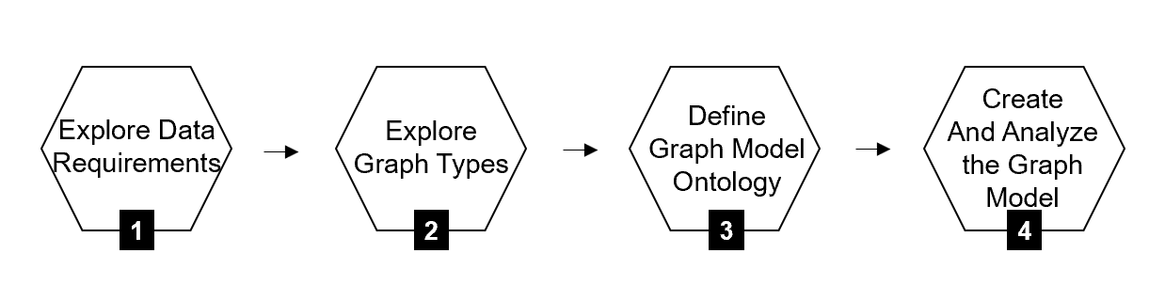
Fig. 2. Methodology steps adopted to create the knowledge graph model and perform analysis.
In Step 1, data requirements were defined to represent a zone’s mechanical elements including their systems-centric and spatial relationships using a knowledge graph. Facility managers when viewing a 3D model focuses on identifying building systems, sub-systems, and components to determine relationships and dependencies between the building systems (Ensafi et al. 2022). During a maintenance emergency, it is critical to be able to quickly identify building components and systems responsible for or impacted by the emergency to allow for a faster response to the issue (Ensafi et al. 2022). Therefore, BIM should be configured with systems-centric parameters to support facility managers in isolating components showing functional relationship and dependencies between building components and systems.
To support a systems-centric navigation and search of the BIM, the authors embedded fifteen systems-centric parameters identified by Harode et al. (2022), in the knowledge graph. These systems-centric parameters are based on a multi-level system hierarchy which includes System, System Type, System Classification, and System Name as the four hierarchical levels of system and remaining parameters related to special and other asset connections. The fifteen system-centric parameters are SYSTEM, SYSTEM_TYPE, SYSTEM_CLASSIFICATION, SYSTEM_NAME, CATEGORY, ASSET_GROUP, FLOOR, ZONE, LOCATION_CODE, LOCATION_SERVED, EQUIPMENT_SERVED, PARENT_ASSET_TAG, PANEL_NUMBER, CIRCUIT_NUMBER, and PANEL_LOCATION.
In Step 2, two common types of knowledge graph structures, Labeled Property Graphs (LPG) and Resource Description Framework (RDF) that are currently adopted for graph implementations were reviewed. Yanamala et al. (2023) with the references from (Baken 2020), described the structures of both LPG and RDF graph models, and concluded that LPG graph structure is more compact and provides better performance for real-time applications. Fig. 3 illustrates an RDF graph structure (a) and provides an example (b), and Fig. 4 illustrates an LPG graph structure (a) and provides an example (b).
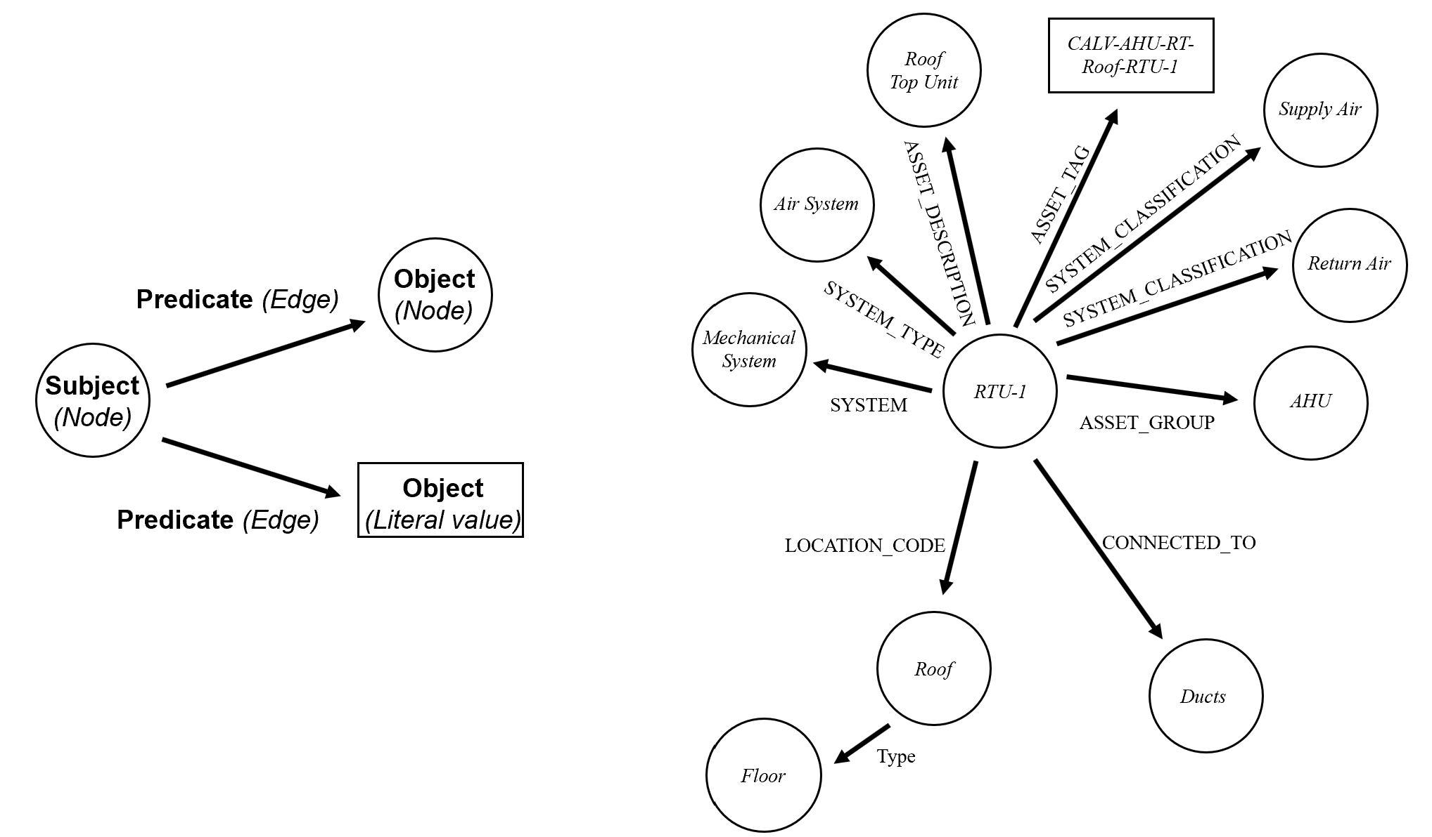
(a) (b)
Fig. 3. (a) RDF graph structure. (b) Example RDF graph model of building assets.
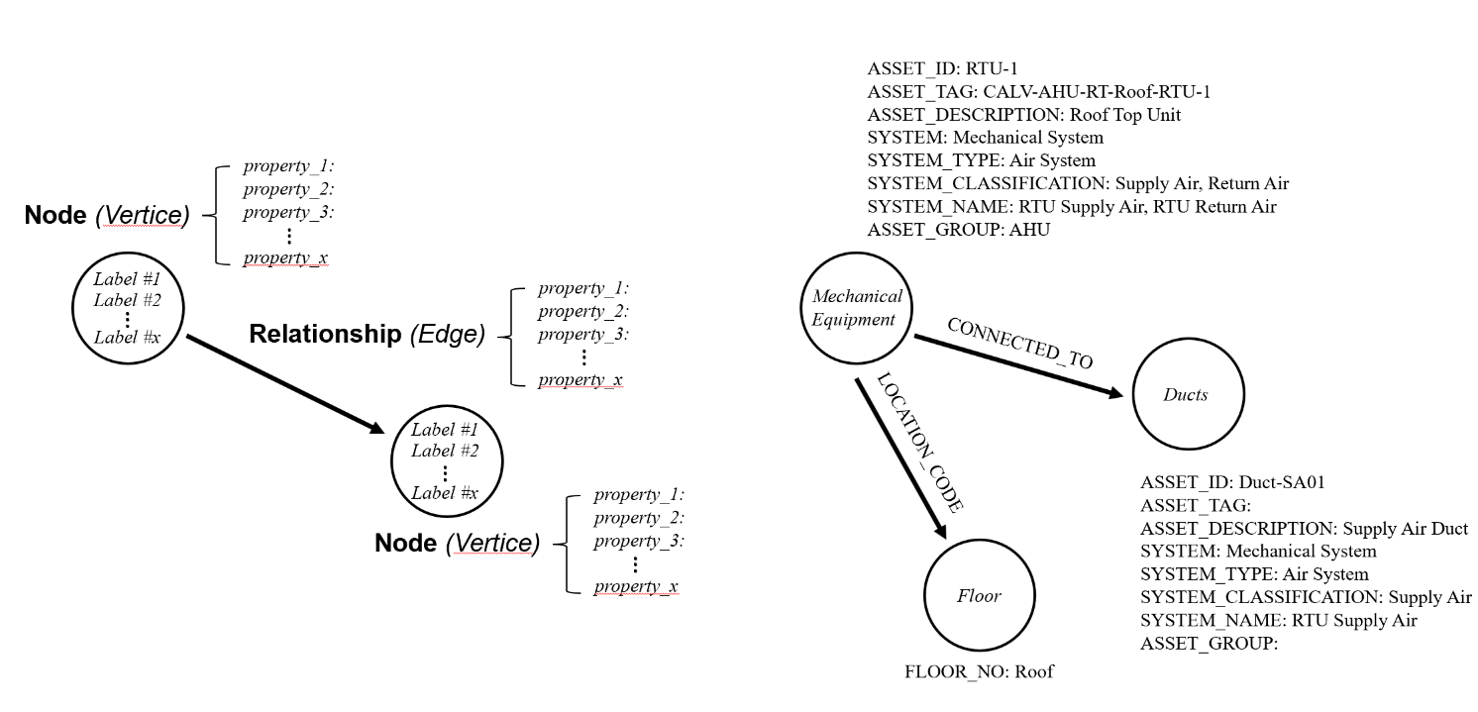
(a) (b)
Fig. 4. (a) LPG graph structure. (b) Example LPG graph model of building assets.
To develop a graph-based FM-Capable BIM, the authors have embraced an LPG model, proficient at representing nodes as assets/spaces with systems-centric properties. The LPG graph structure facilitates the incorporation of properties in nodes, enhancing their representation as assets and enabling swift network traversal to bolster facility maintenance. An LPG based graph type used by the Neo4j platform was chosen over an RDF as it accurately represents building systems’ components and supports appropriate data integration.
In Step 3, a graph model ontology is defined to represent mechanical elements of a facility. Graph ontology is a blueprint for the development of the knowledge graph, which describes each and every element of the graph that is being used in its development. The two common ontologies in the industry are RealEstateCore ontology and Brick ontology. While the Brick ontology is predominantly an equipment or asset centric, the RealEstateCore predominantly deals with the external factors related to an asset like space and people (Qiang et al. 2023). Yanamala et al. (2023) discussed the RealEstateCore ontology and importance of ontology for knowledge graphs and created own ontology to support the systems-centric view of a facility which is further modified in this research. As shown in Fig. 5, the ontology structure employs nodes (vertices) and relationships (edges) to delineate distinct instances of the Zone 4 mechanical system, encompassing various spatial relationship types and their corresponding data models. The proposed ontology is crafted to uphold a systems-centric perspective of the mechanical system, employing a knowledge graph equipped with specific interfaces and a variety of relationship types. Nodes are identified as instances of these interfaces, each assigned a unique label, and interconnections between nodes are established through defined relationships, identified as edges.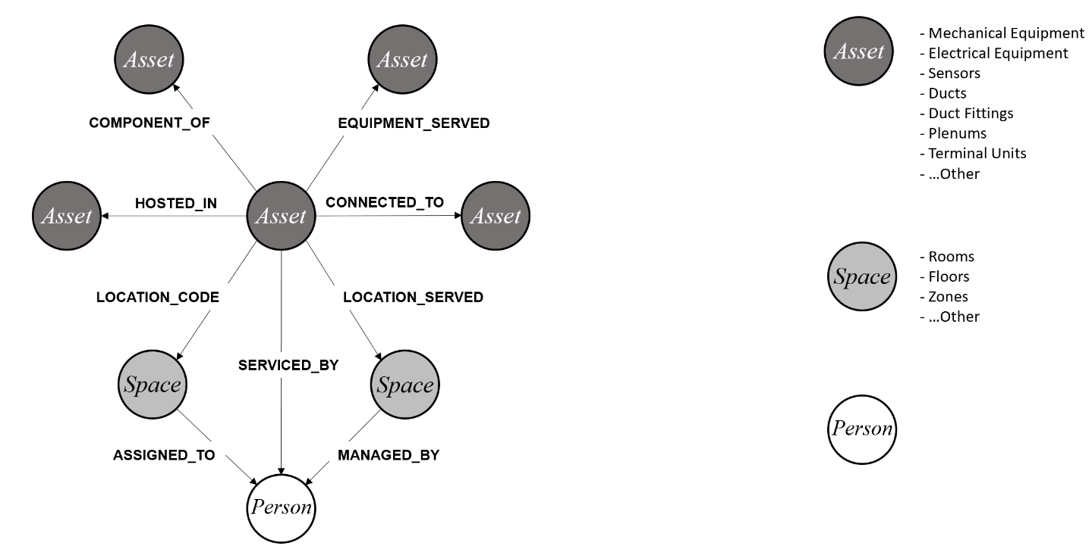
Fig. 5. Proposed Graph Model Ontology.
Yanamala et al. (2023) described Asset and Space nodes and their associated edges, the additional Person node and related edges developed in this research are defined:
    - Person: A user, occupant, or maintenance personnel.
    - SERVICED_BY: Identifies the facility staff who is responsible for maintaining and servicing an asset. Such as Mechanical Equipment, etc.
    - MANAGED_BY: Identifies the person who occupies and manages a space. This can be a building’s administrative manager or custodian other than a maintenance personnel.
    - ASSIGNED_TO: Identifies the person to whom a space is assigned. An example would be a director of a lab or an occupant of an office.
The arrow direction for the SERVICED_BY relationship is always from an asset to a person specifically maintenance personnel. The MANAGED_BY and ASSIGNED_TO relationships always direct from space to person, indicating a building personnel. Apart from this, there can be various occupants of a space that are temporary or permanent, who need to be alerted in case of an emergency. These relations are not included here as these are generally managed by administrative staff at a building level rather than facility staff. In cases where there isn’t a building level administrative staff, another relation OCCUPIED_BY can be added to include occupants’ information.
In Step 4, a graph model for the selected zone’s mechanical system of the school building is developed and analyzed. Based on spatial relationship between graphical elements in the Revit model, A knowledge graph model was created. Neo4j, a graph database platform, was chosen to create the knowledge graph model. Arrows, a graphical tool for Neo4j, is used to create separate component graphs for different subsystems of the mechanical system. These component graphs are then imported into Neo4j and merged into a federated knowledge graph model, with special attention given to eliminating duplicate nodes. Systems-centric properties were added to the knowledge graph to describe and categorize mechanical components.
The graph model is then analyzed using several maintenance scenarios. Cypher queries are created to query the graph model and identify model elements for each scenario. Results of the query with instances identified are exported and linked to Navisworks for visualization in the 3D model. This allows users to visually realize the components associated with the emergency in a 3D environment. This integrated approach streamlines maintenance tasks and enhances the understanding of complex building systems for facility managers and maintenance personnel.

KNOWLEDGE GRAPH MODEL:
Data Model Specifications and Case Study
The data model outlined in Table 1 serves to articulate various data parameters for typical components (or nodes) within the selected zone's mechanical system. These parameters encapsulate identification and systems-centric data, offering recorded information about each instance (e.g., asset description). This data model does not delineate any relationships between instances in the graph, as such relationships are established in accordance with the ontology structure.
Table 1. Table showing example of how node properties are assigned to nodes in knowledge graph.
Node Properties | Mechanical System Components
Node Properties | Mechanical Equipment | Electrical Equipment | Air Terminals | Ducts/ Duct Fittings
SYSTEM | X |  | X | X
SYSTEM_TYPE | X |  | X | X
SYSTEM_CLASSIFICATION | X |  | X | X
SYSTEM_NAME | X |  | X | X
ASSET_GROUP | X | X | X
ASSET_ID | X | X | X | X
ASSET_TAG | X | X | X
ASSET_DESCRIPTION | X | X | X | X

Apart from the nodes in Table 1, Spatial nodes: Room, Floor, and Zone are assigned respective identification parameters, for example ROOM_NO for Room nodes. For the person nodes, parameters like Name, Email, and Phone were added as a sample. These parameters can be expanded in the future based on the requirements like Organization, Location, etc.
Neo4j uses Cypher language to create a knowledge graph. To minimize Cypher coding the Arrows application is used. Arrows allows users to create a graph with nodes, relationships, and parameters through a graphical interface. A Cypher code is then automatically generated for the graph and imported into Neo4j to create the Neo4j graph model. The graph can then be queried using various search scenarios. Fig. 6 shows the process followed for developing graph model.
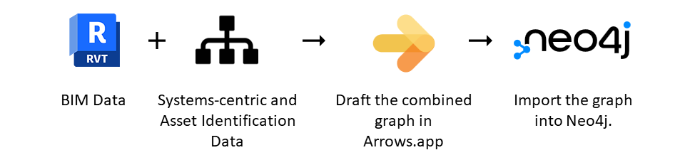
Fig. 6. Steps followed to develop graph model.
The case study used in this research is an elementary and middle school two-story building, spanning 122,525 square feet. Using 2D plans and the Revit model, the mechanical system is examined, leading to the division of the building into four thermal mechanical zones based on distinct configurations of components for cooling, heating, and ventilation. Zone 1 encompasses classrooms, labs, studios, and main administrative offices, utilizing Dedicated Outdoor Air System (DOAS) units and a Variable Refrigerant Flow (VRF) system. Zones 2, 3, and 4 include the kitchen, cafeteria, and gymnasium areas, respectively, served by three separate packaged Rooftop Air Handling Units (RTUs), with Zone 4 selected for detailed analysis.
Within Zone 4, the Gymnasium, locker rooms, bathrooms, an office space, storage room, and a small corridor are accommodated. The mechanical system layout on a 2D floor plan is illustrated in Fig. 7 depicting the supply and exhaust mechanisms. A packaged Rooftop Unit (RTU-1) provides supply air to the Gymnasium and other spaces. A portion of air specifically from the gymnasium is returned and combined with outdoor air to enhance energy efficiency. Simultaneously, another portion undergoes extraction through gravity roof ventilators (GRH-1 and GRH-2) embedded in the gymnasium ceiling. These ventilators, devoid of moving parts, serve the dual purpose of heat removal in summer and moisture extraction in winter, contributing to the overall ventilation of the gymnasium space. For other sections within Zone 4, a comprehensive air extraction approach is employed. An exhaust fan (EF-6), positioned on the roof of the second floor directly above the gymnasium toilets, expels air from these spaces, including toilets and locker rooms. To facilitate natural ventilation, transfer ducts interconnect the office, storage room, and the adjacent corridor, promoting unrestricted airflow between these areas.
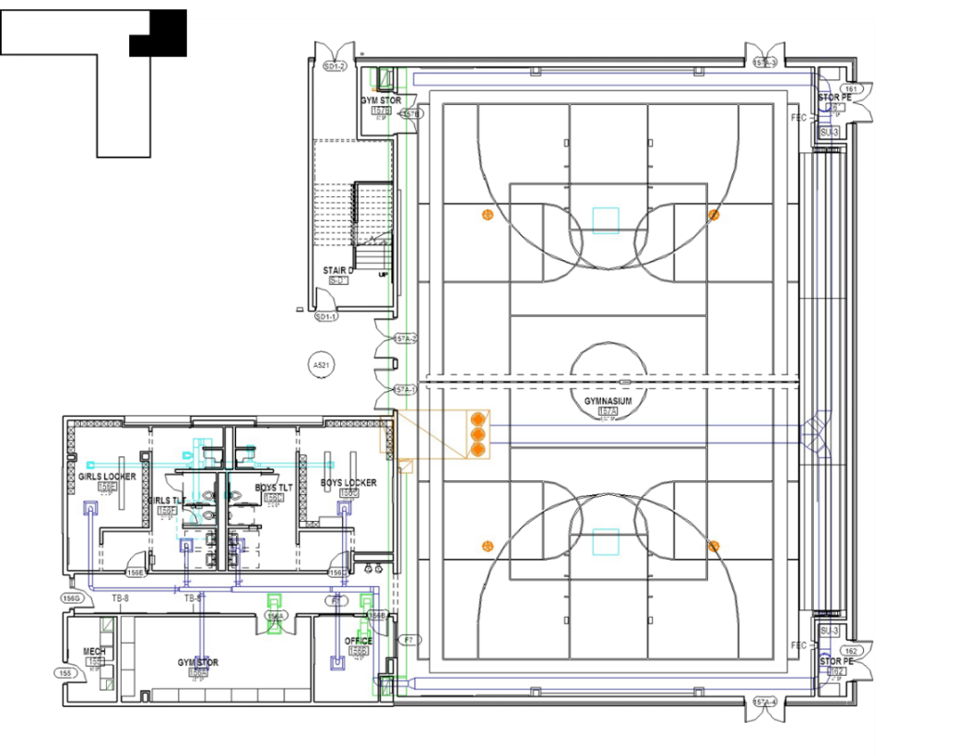
Fig. 7. 2D floor plan and the mechanical system horizontal layout for Zone 4.
The riser diagram shown in Fig. 8 was created to further explain the mechanical system layout and illustrate the components responsible for cooling, heating, and ventilation in Zone-4.
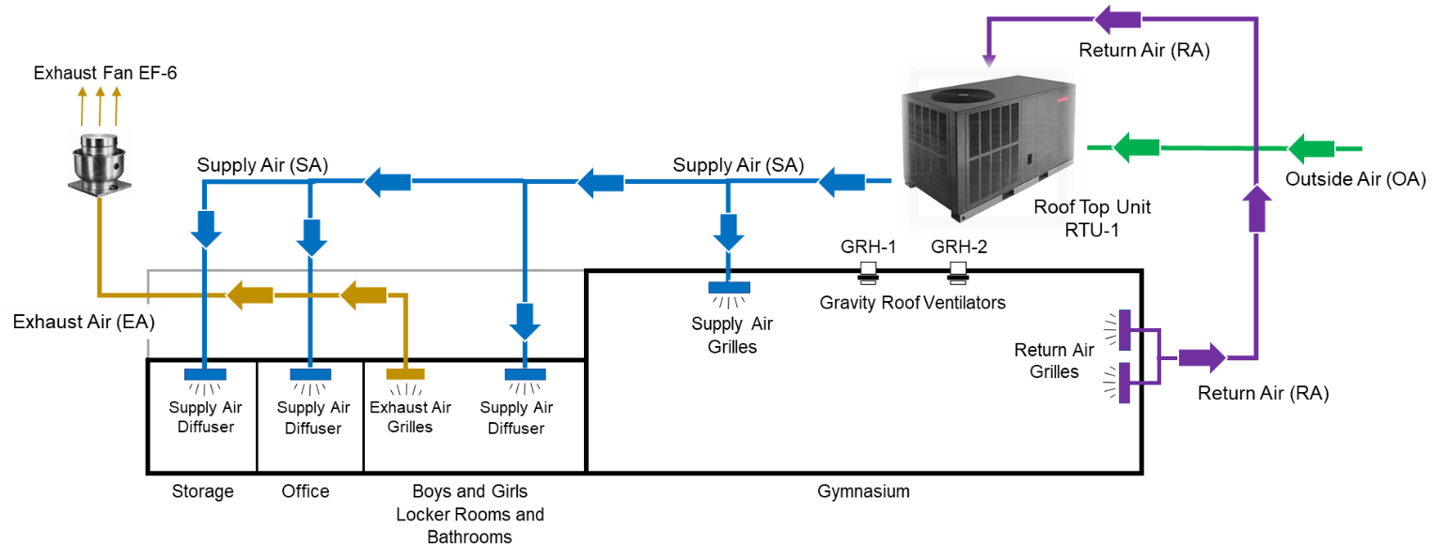
Fig. 8. Riser diagram showing the mechanical system vertical layout for Zone-4.
Fig. 9 showcases an example of 3D Revit model detailing the supply air mechanical system part in Zone 4, which will be integrated into our systems-centric knowledge graph. Each component, including equipment, terminal units (grilles and diffusers), ducts, and duct fittings, is assigned a distinctive ID. The unique identifiers for equipment are derived from the design 2D plans. Ducts, duct fittings, and terminal units are allocated unique IDs by the authors, with the ID structure indicating the mechanical subsystem to which the component belongs. For instance, duct components associated with the supply air (SA) system are sequentially numbered with a SA designation (Duct-SA01 through Duct-SA27). Similarly, components related to the return air (RA) and exhaust air (EA) systems are designated as Duct-RA01 to Duct-RA19 and Duct-EA01 to Duct-EA28, respectively. Duct fittings share a numbering pattern aligned with ducts, such as Duct Fitt-SA01 through Duct Fitt-SA-34 for supply air (SA) system fittings.
Grilles are assigned unique identifiers as GR-SA01 to GR-SA12, GR-RA01 to GR-RA02, and GR-EA01 to GR-EA02 for supply air, return air, and exhaust air systems, respectively. Additionally, supply diffusers, return diffusers, and exhaust diffusers follow a similar numbering convention, designated as Diff-SA01 to Diff-SA06, Diff-RA01 to Diff-RA04, and Diff-EA01 to Diff-EA06, respectively. This structured identification system ensures clarity and organization within the representation of Zone 4's mechanical system in our systems-centric knowledge graph.
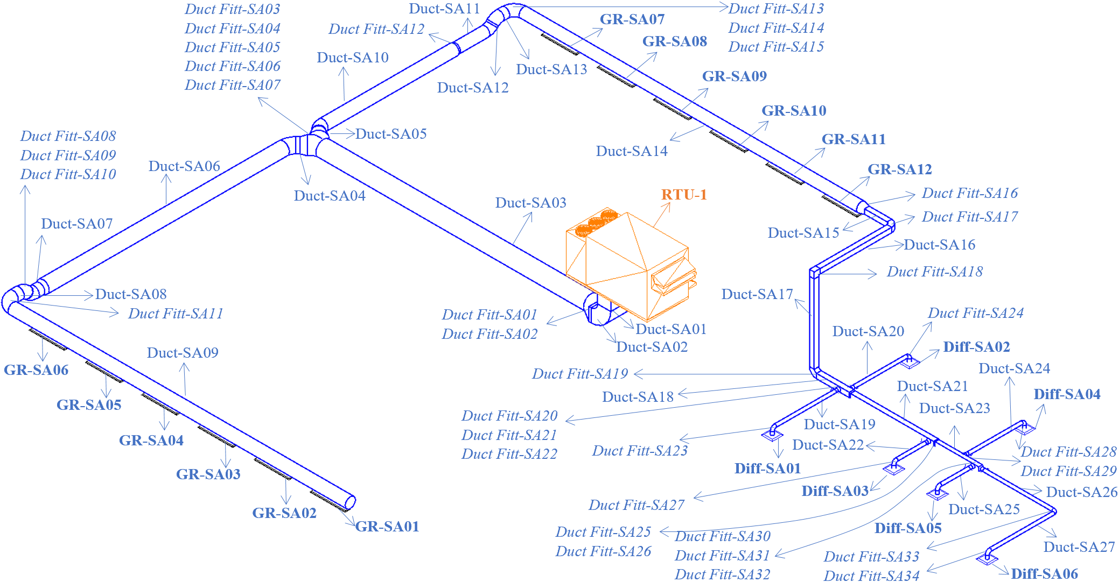
Fig 9. Detailed 3D Revit model indicating unique IDs of supply air components of Zone 4.
The special relational data of assets is extracted from the Revit model of the case study building. To ensure that all mechanical system components, properties, and their spatial connectivity are represented in the knowledge graph, Spatial information from the 3D model was first captured and organized in several Excel spreadsheets to review asset components, their properties, and their spatial relationships prior to constructing the knowledge graph. Fig. 10 shows examples of the spreadsheets developed with the data captured.
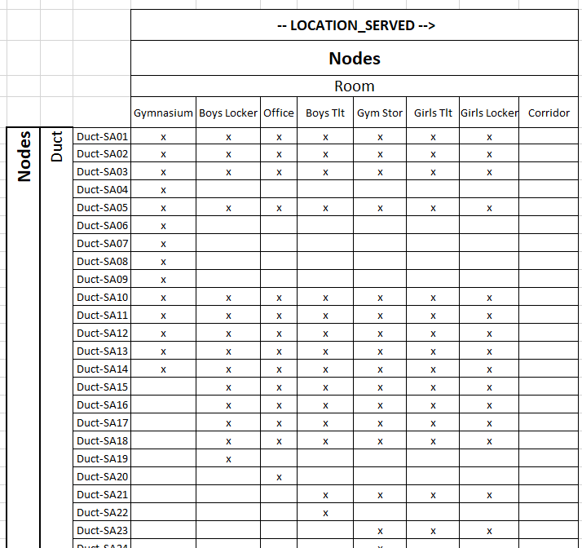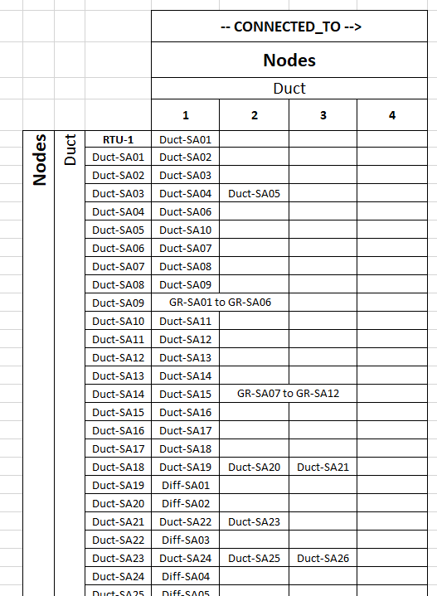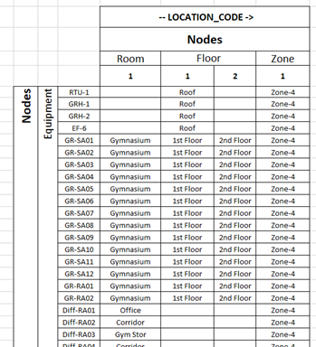
Fig. 10. Excel spreadsheets showing system components, properties, and their spatial connectivity.
Table 2 summarizes how Zone-4 mechanical system components and properties are represented in the graph model. All components are represented using nodes with only mechanical and electrical equipment have node properties defined. Systems-centric properties are represented using nodes (e.g. FLOOR), node property (e.g. SYSTEM) or edges (e.g. LOCATION_CODE). Values for the systems-centric property CATEGORY are used as label names for the different nodes in the graph model (e.g. Category = Mechanical Equipment). The two systems-centric properties EQUIPMENT_SERVED and PARENT_ASSET_TAG are not represented in the graph model under this study since Zone-4 does not have any equipment that is serving other equipment and, therefore, have no parent asset tag values.
Table 2. Representation of Zone-4 mechanical system components in the graph model.
Elements of the knowledge graph | Node | Node Property | Edge | Edge Property | Label
Mechanical System Components
Mechanical Equipment | x
Electrical Equipment | x
Air Terminals (grilles and diffusers) | x
Ducts | x
Duct Fittings | x
Spaces | x
Systems-Centric Properties
SYSTEM |  | x
SYSTEM_TYPE |  | x
SYSTEM_CLASSIFICATION |  | x
SYSTEM_NAME |  | x
CATEGORY |  |  |  |  | x
ASSET_GROUP |  | x
ROOM | x | x
FLOOR | x
ZONE | x
CONNECTED_TO |  |  | x
LOCATION_CODE |  |  | x
LOCATION_SERVED |  |  | x
EQUIPMENT_SERVED
PANEL_NUMBER | x | x
CIRCUIT_NUMBER | x | x
Asset Identification Properties
ASSET_ID |  | x
ASSET_TAG |  | x
ASSET_DESCRIPTION |  | x
PARENT_ASSET_TAG

Fig. 11 depicts the proposed structure of the graph ontology for a segment of the mechanical system knowledge graph model showing the EF-6 equipment node, its properties, and various edges connecting other nodes, including Person, Zone, Floor, Room, Ducts, Duct Fittings, and Electrical Equipment, each possessing distinct properties.
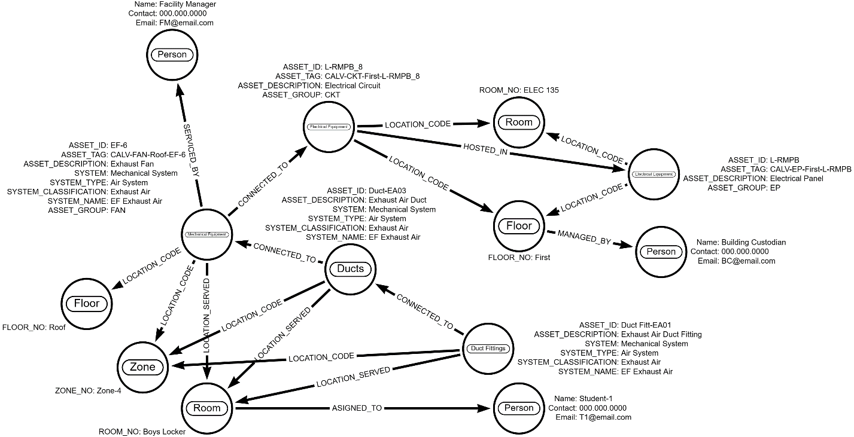
Fig. 11. Segment of Zone-4 mechanical system knowledge graph model.
This graph representation shows that the EF-6 node, categorized as Mechanical Equipment, is characterized by three identification properties and five systems-centric properties. It establishes a connection with DUCT-EA03 (Node: Ducts) through a CONNECTED_TO edge. DUCT-EA03, in turn, is defined by two identification properties and four systems-centric properties. The spatial location of EF-6 is specified through two LOCATION_CODE edges, linking to two space node types (Node: Floor and Node: Zone). The associated properties for each node include FLOOR_NO = Roof and ZONE_NO = Zone-4. Additionally, the space served by EF-6 is identified using a LOCATION_SERVED edge, associating it with one space node type (Node: Room) with the property ROOM_NO = Boys Locker.
For electrical control, EF-6 is connected to the L-RMPB_8 circuit (Node: Electrical Equipment) via a CONNECTED_TO edge. The circuit node, in turn, is linked to the L-RMPB electrical panel (Node: Electrical Equipment) through a HOSTED_IN edge. The panel's location is defined using a LOCATION_CODE edge and is associated with two space node types (Node: Room and Node: Floor) with the respective properties ROOM_NO = ELEC 135 and FLOOR_NO = First.
For personnel identification, The EF-6 is connected to a person node through a SERVICED_BY edge indicating the person responsible for its service or maintenance. Similarly, Floor nodes are connected to a person node through a MANAGED_BY edge indicating the person managing the floor for daily activities. And Room nodes are connected to a person node with an ASSIGNED_TO edge, signifying the person assigned to that room for utilization. Each person node is characterized by three properties: Name, Contact, and Email, providing essential information for communication or conveying emergency details.

Knowledge Graph Model Development
The construction of the Zone-4 mechanical system graph model was executed using the Arrows application , a JavaScript-based tool provided by Neo4j labs. This application facilitates the graphical creation of graph nodes and edges, enabling the embedding of data for node labels, edge types, as well as node and edge properties. The modeling process involved the creation of five distinct component graphs: Gym-SA, Gym-RA_EA, OtherSpaces-SA, OtherSpaces-RA_EA, and Electrical. This segmented approach allowed the authors to concentrate on the specific scope of each component graph, ensuring precision and minimizing errors. Subsequently, the five separate Arrows component graphs, using the generated Cypher code, were imported into the Neo4j platform and seamlessly combined to form the comprehensive federated knowledge graph model.
The Gym-SA graph contains all nodes and edges for components of the supply air system for the gymnasium. This includes RTU-1, all supply air ducts (Duct-SA01 to Duct-SA-14), all supply grilles (GR-SA01 to GR-SA12) and several space type nodes (Room, Floor and Zone) representing the physical locations of assets or locations that are being served by the assets. The Gym-RA_EA graph contains all nodes and edges for components of the return and exhaust air systems for the gymnasium. In addition to the RTU-1, this includes the gravity relief hoods (GRH-1 and GRH-2), all return air ducts (Duct-RA01 to Duct-RA12), all exhaust air ducts (Duct-EA01 and Duct-EA02), all return and exhaust grilles (GR-RA01, GR-RA02, GR-EA01 and GR-EA02). Several space type nodes (Room, Floor and Zone) are also included.
The OtherSpaces-SA graph (Fig. 12) contains all nodes and edges for components of the supply air system for the boys and girls locker rooms and bathrooms, office, storage and small corridor. In addition to the RTU-1, this includes all supply air ducts (Duct-SA01 to Duct-SA-27) and all supply diffusers (Diff-SA01 to Diff-SA06). Nodes and edges representing components of the exhaust and return air for these supporting spaces were modeled in the OtherSpaces-RA_EA graph. In addition to the RTU-1, this includes the exhaust fan (EF-6), all return ducts (Duct-RA01 to Duct-RA19), all exhaust ducts (Duct-EA01 to Duct-EA28), all return diffusers (Diff-RA01 to Diff-RA03) and all exhaust diffusers (Diff-EA01 to Diff-EA06). Several space type nodes (Room, Floor and Zone) are also included in both graphs.
The Electrical component graph comprises the details of panels, circuits, and their location for the mechanical equipment RTU-1 and EF-6. There are two electrical circuits (L-RMPB_8 and U_LMPB-MEMA_1), two electrical panels (L-RMPB and U-LMPB-MEMA) and two space type nodes representing their locations. It should be noted that the gravity relief hoods (GRH-1 and GRH-2) (aka Gravity relief ventilators) are non-powered devices and work on pressure differential between the inside and outside of the building to exhaust part of the air from the gymnasium. Since they are not connected to any circuits/panels, they are not represented in the Electrical graph.
Before importing the Cypher code of each graph into the Neo4j platform, the graphs were examined to ensure that all mechanical system components, properties, and their spatial connectivity are represented by the correct nodes and edges. To perform this check, the Arrows component graphs were exported as JSON files and converted into Excel spreadsheets using www.convertcsv.com. Information in the generated Excel files were crosschecked with the spreadsheets shown in Fig. 10 to verify accuracy and completeness of the graphs.

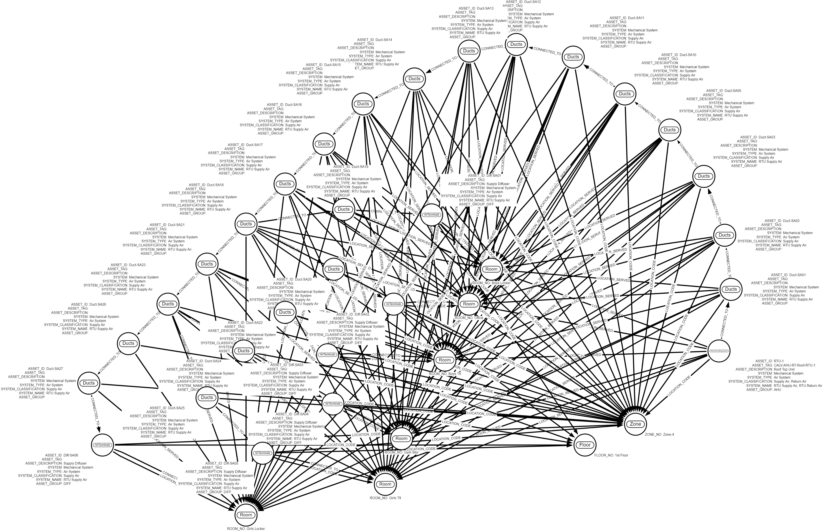Fig. 12. OtherSpaces-SA graph showing supply air system components for other spaces.
After a meticulous review and verification process for the five component graphs, the Arrows Cypher query corresponding to each component graph was imported and merged along the process within the Neo4j platform to create comprehensive knowledge graph database. This integration aimed to construct the comprehensive federated graph model. To prevent the creation of duplicate nodes and ensure the integrity of links in the final federated knowledge graph, common (repetitive) nodes were amalgamated. Identification and consolidation of these common nodes were performed manually, and the findings were documented in a table for tracking. For instance, the Mechanical Equipment node of exhaust fan EF-6 appeared in two of the five Arrows component graphs, namely OtherSpaces-RA_EA and Electrical. To systematically manage repetitive nodes and prevent duplication, the importation sequence followed a specific order: Gym-SA, Gym-RA_EA, OtherSpaces-SA, OtherSpaces-RA_EA, and Electrical. During the sequential importation of graphs, adjustments were made to the Cypher query to facilitate the amalgamation of common nodes. This essential process, guided by the methodology proposed by Yanamala et al. (2023), involved meticulous adjustments to the Cypher queries to ensure the coherent integration of common nodes. A comprehensive discussion of this procedure is presented, focusing specifically on the first two component graphs in the sequential importation process.
Fig. 13 shows the first component graph Gym-SA imported in the Neo4j platform. Fig. 14 shows the second Gym-RA_EA graph combined with Gym-Sa graph in Neo4j. Before combining these two graphs, five nodes were identified that are repetitive between the two graphs: Mechanical System node RTU-1, The Space nodes Gymnasium, First Floor, Roof, and Zone-4. Cypher code is changed to merge these five repetitive nodes as mentioned in the example above. Fig. 15 shows the changed Cypher code used to merge the Gym-RA_EA graph with Gym-SA graph, the changes made to the Cypher code of Gym-RA_EA were highlighted.
This process is repeated when merging other component graphs until the complete federated graph model is created.
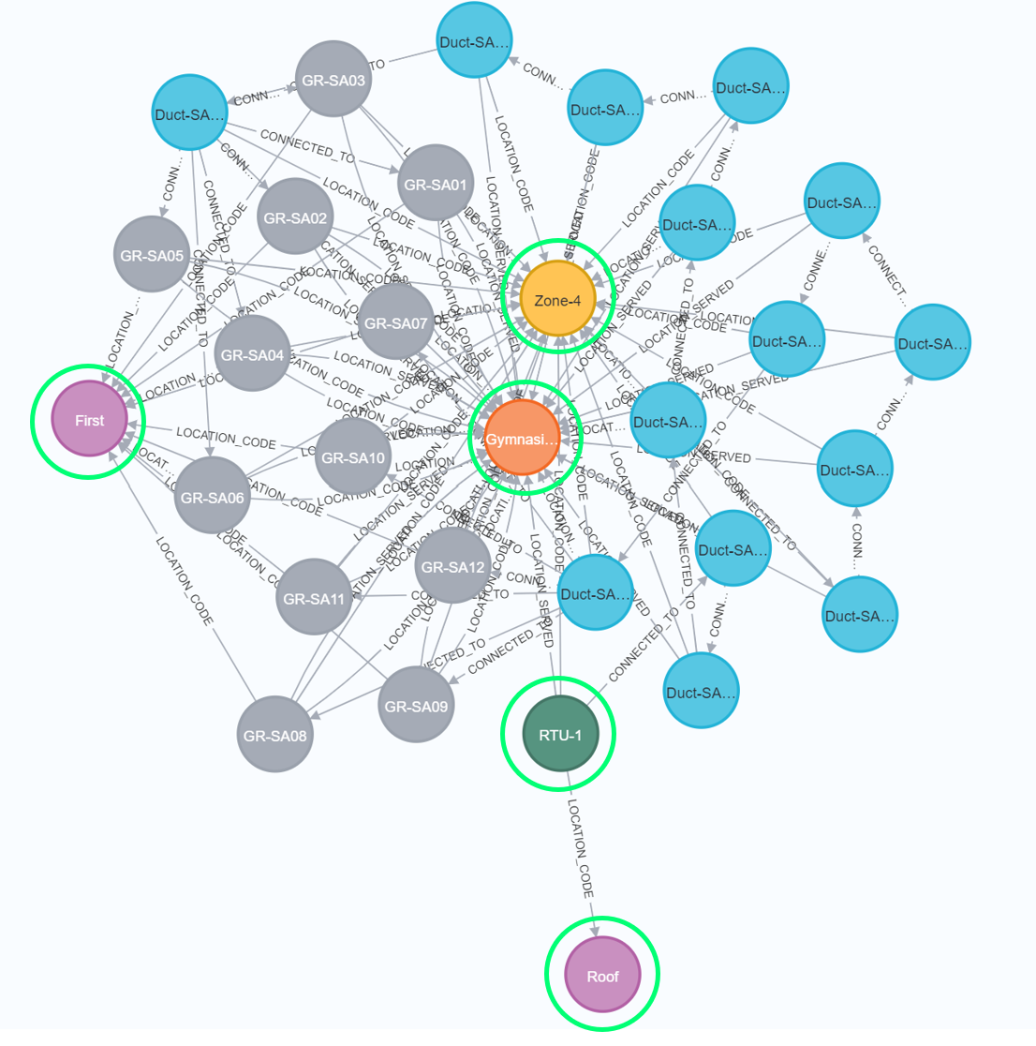
Fig. 13. Gym-Sa graph-1 in Neo4j highlighting the common nodes.

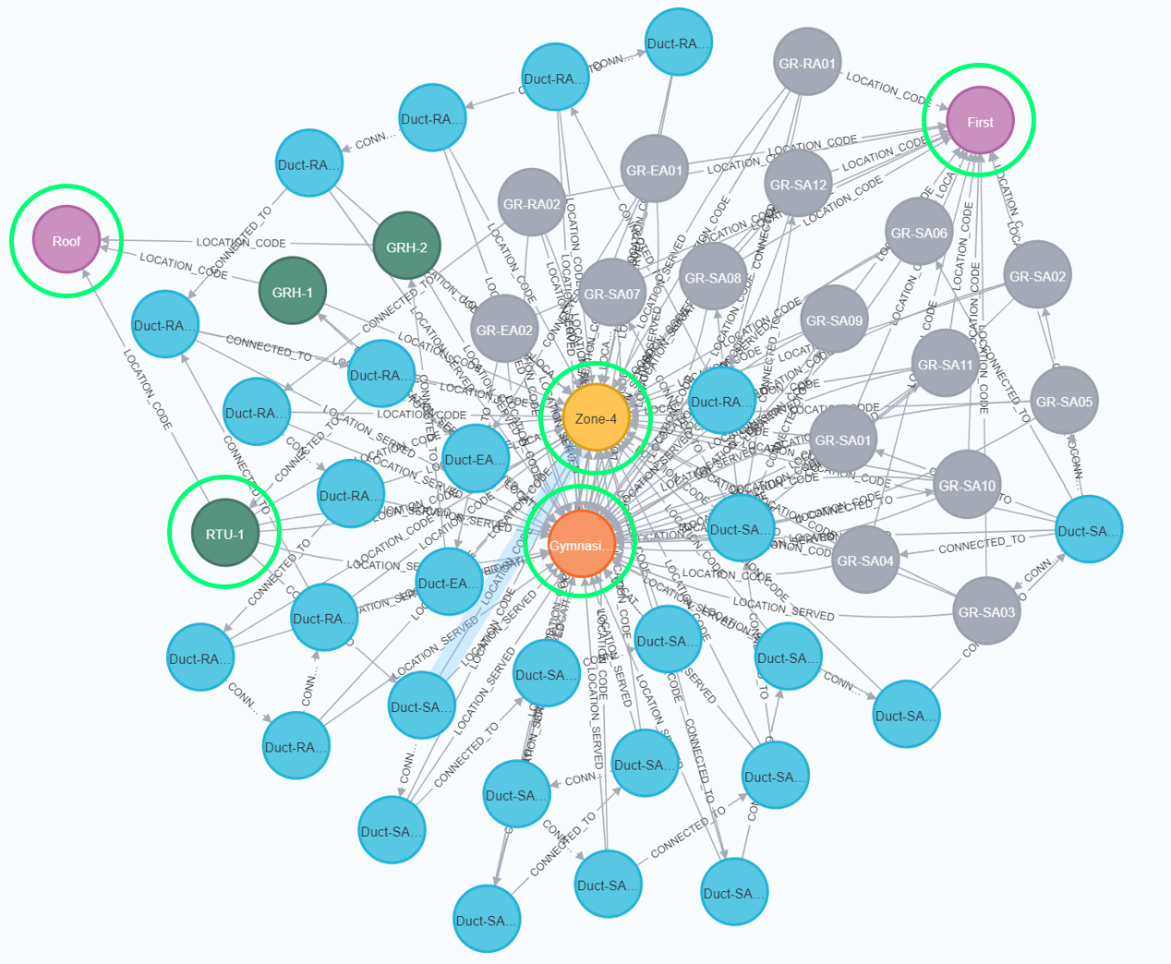
Fig. 14. Gym-RA_EA graph combined with Gym-SA graph in Neo4j highlighting the common nodes.

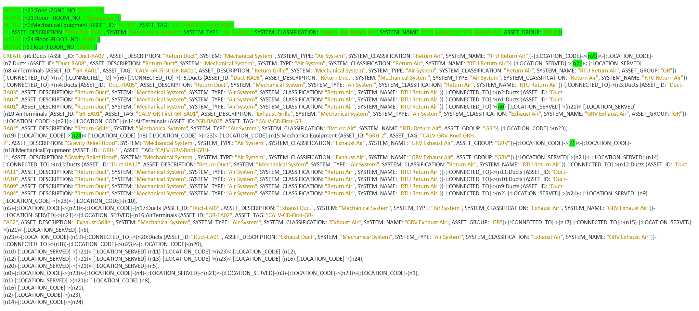
Fig. 15. Modified Cypher code to merge Gym-RA_EA graph with Gym-SA graph highlighting the changed portions of code.
SYSTEMS-CENTRIC ANALYSIS USING THE KNOWLEDGE GRAPH MODEL
The federated Neo4j knowledge graph customized with systems-centric properties can be queried to filter specific components of Zone 4 mechanical system. This would allow users performing a maintenance task by identifying system components associated with or impacted by a maintenance emergency. Example inquires a facility staff may need answers, to perform emergency maintenance may include:
- Where is an equipment located?
- What equipment or systems are serving a specific space and providing heating, cooling, or ventilation?
- What are the components of a system (HVAC) or subsystem (Supply Air) supporting a space?
- What are the spaces that are being served by a specific piece of equipment?
- What is the mechanical subsystem a component such as a duct or pipe is part of?
- Who are the occupants of a space that are impacted by the shutdown of an equipment?
- What is the electrical circuit supporting an equipment and what panel and space is it located?
- What equipment serving other equipment.
The following describes searches using the Cypher query for three example maintenance scenarios to identify the mechanical systems components contributing to or impacted by the emergency.
Scenario-1 (a): Identify a component of a system or equipment serving a specific room in the building.
A facility manager needs to identify all mechanical equipment serving a specific room such as the Gymnasium or the Boys toilet room, and also to determine the room, floor or zone where the equipment is physically located. This requires finding all mechanical equipment having a relationship of type LOCATION_SERVED to the desired room being served (i.e. Gymnasium or Boys toilet) and to identify nodes of type Room, Floor and Zone that are linked to the equipment with a LOCATION_CODE relationship type.
Search #1: Required Cypher Code
Match (n:`Mechanical Equipment`) – [r:LOCATION_SERVED] -> (g: Room {ROOM_NO: 'Gymnasium'})
Match (n:`Mechanical Equipment`) – [m:LOCATION_CODE] -> (z)
Return n, r, g, z
Search #2: Required Cypher Code
Match (n:`Mechanical Equipment`) – [r:LOCATION_SERVED] -> (g: Room {ROOM_NO: 'Boys Tlt’})
Match (n:`Mechanical Equipment`) – [m:LOCATION_CODE] -> (z)
Return n, r, g, z
Fig. 16 shows results of executing the Cypher code for search #1 and results are manually highlighted in the overall knowledge graph of zone-4. From the first search, three Mechanical Equipment type nodes (RTU-1, GRH-1, and GRH-2) are identified with a LOCATION_SERVED edge connection to one Space node (Gymnasium). The location of each of the mechanical equipment is also highlighted through several LOCATION_CODE edges with Room, Floor and Zone nodes defining their corresponding location. From the second search, two Mechanical Equipment type nodes (RTU-1, EF-1) are identified with a LOCATION_SERVED edge connection to one Space node (Boys Tlt). The location of each of the mechanical equipment is also highlighted through several LOCATION_CODE edges with Room, Floor and Zone nodes defining their corresponding location.
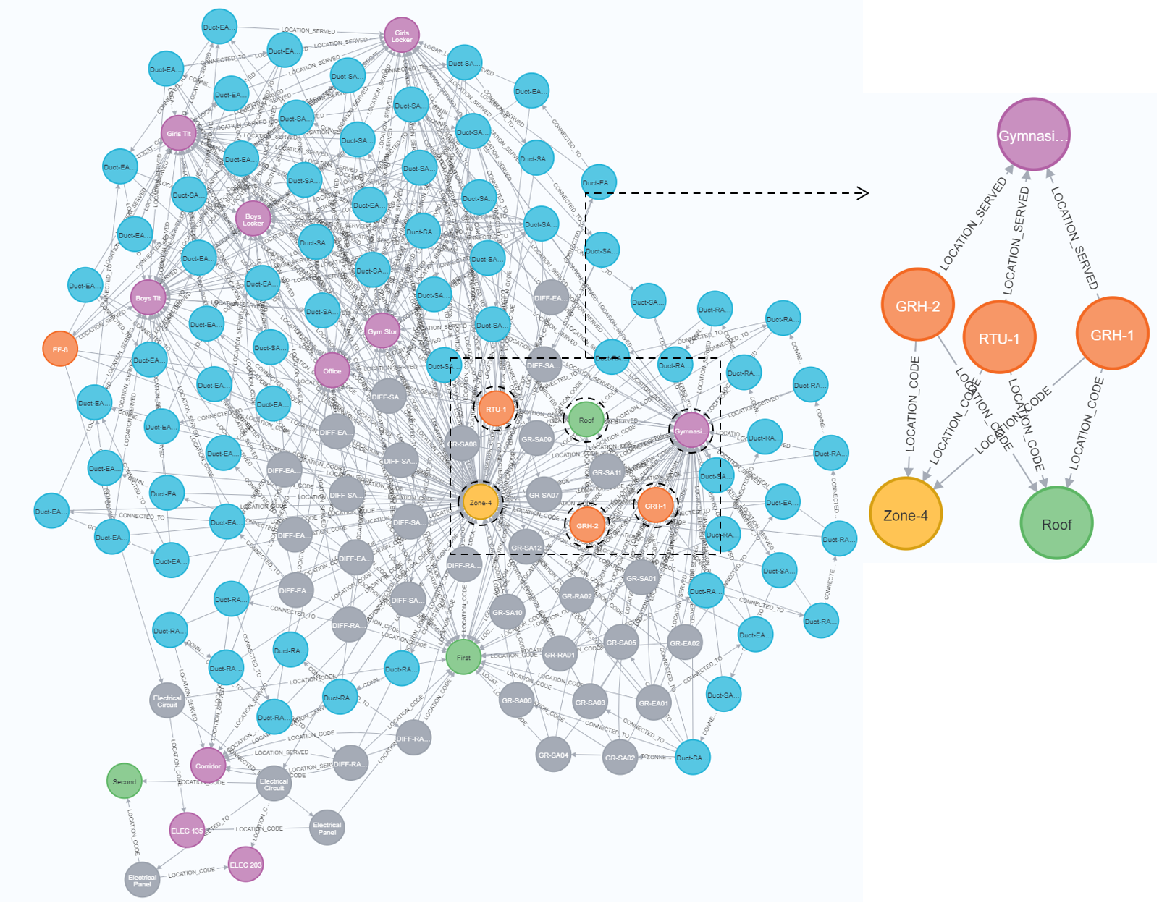
Fig. 16. Neo4j graph highlighting the results of scenario-1 (a) Search #1 query.
Scenario-1 (b): Identify a system or components of a system serving a specific room in the building.
A facility manager walks into a space (e.g. Gymnasium) and wants to know what all components of the air system supporting the space or components of a subsystem included in the Supply Air/ Return Air/ Exhaust Air system of that space (e.g. Gymnasium). Fig. 17 shows the results of the query and are highlighted in the overall developed knowledge graph.
Search: Required Cypher Code
Match (n) – [r:LOCATION_SERVED] -> (g: Room {ROOM_NO: 'Gymnasium’})
Where n SYSTEM_CLASSIFICATION CONTAINS 'Supply Air’
Return n, r, g
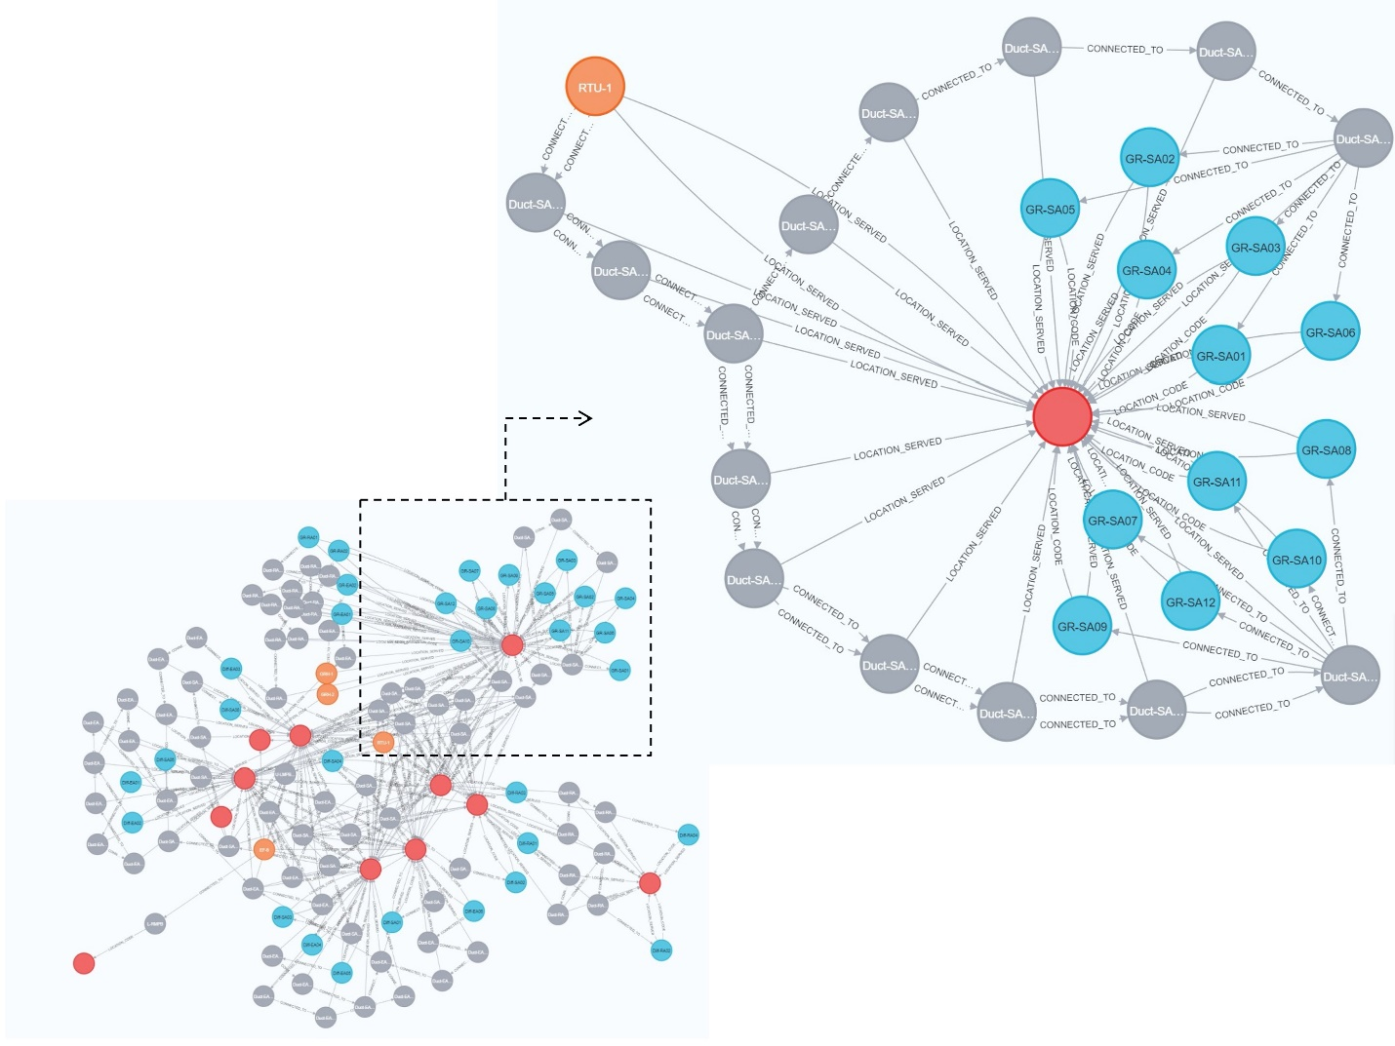
Fig. 17. Neo4j graph highlighting the results of scenario-1 (b) Search query.
Scenario-2: Identify the person that services an asset and the person that is responsible for the space served by that asset.
A facility manager noticed an issue with the RTU-1 unit (Mechanical Equipment) and he needs to contact the person that occupies and manages the space and could be impacted by maintenance shutdown. Fig. 18 shows the results of the cypher query executed.
Search: Required Cypher Code
Match (a: ‘Mechanical Equipment’ {ASSET_ID: 'RTU-1'}) – [:LOCATION_SERVED] -> (b)
Match (b) – [:MANAGED_BY] -> (c)
Match (a)-[:SERVICED_BY]->(d)
Return a, b, c, d
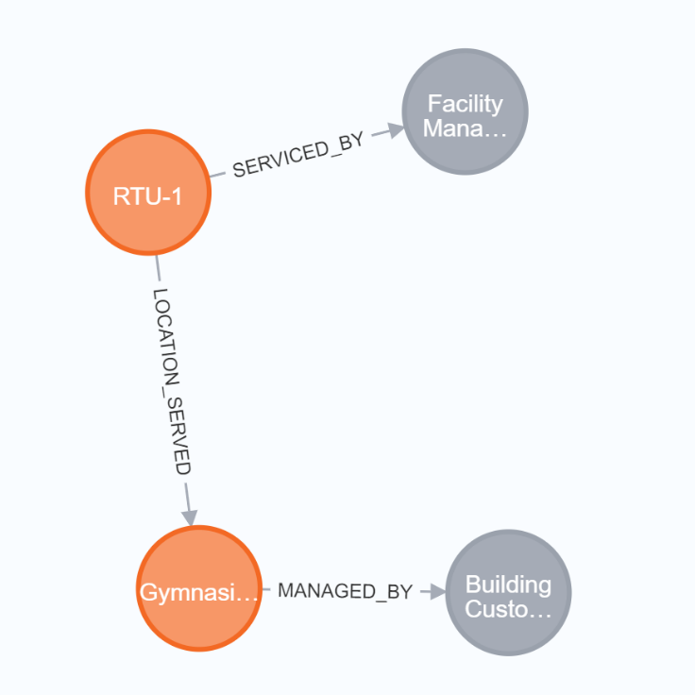
Fig. 18. Neo4j graph results of scenario-2 search query.
Bloom, a data visualization tool developed by Neo4j, enables users to explore and interact with Neo4j graph databases seamlessly, all without the necessity of coding using pre-defined queries. Above searches can be saved as standard search phrases using Neo4j Bloom. This would allow for future automatic access to the search without the need to type or re-type the Cypher query code. Fig. 19 shows an example of the Bloom window created for the scenario 1(a) search#1 phrases defined in the scenarios above.

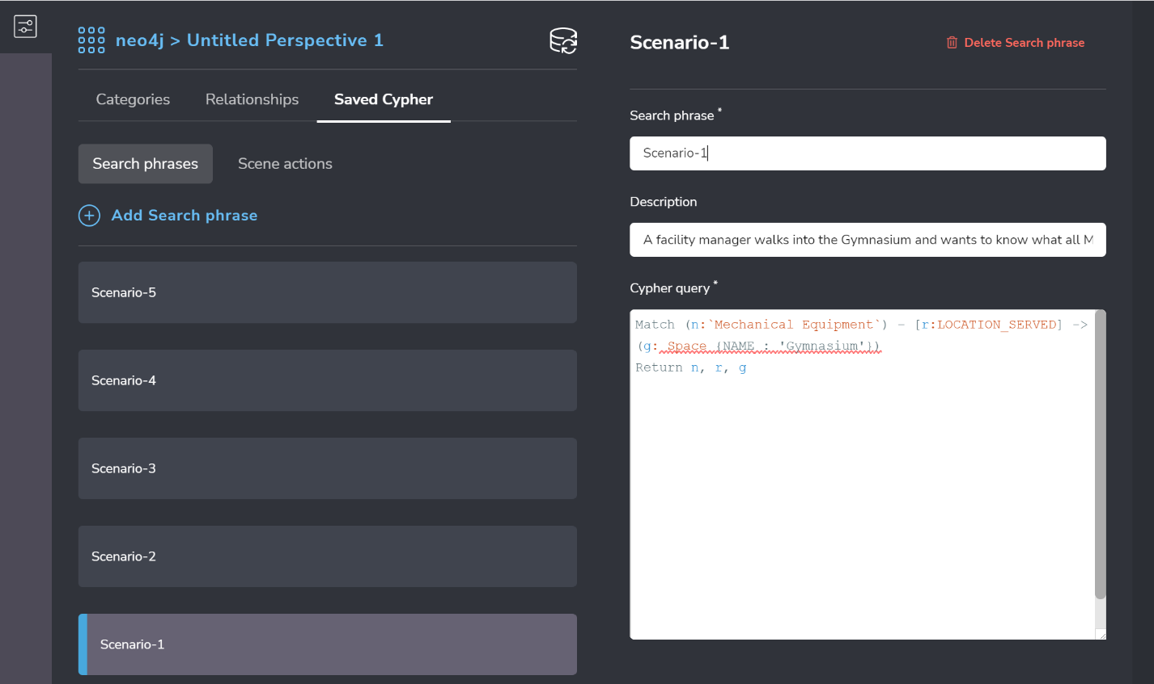
Fig. 19. Screenshot showing creation of scenario 1(a) Search #1 Phrases in Bloom.
Once the search phrases are created for each scenario, they can be easily accessed from the search field of Bloom for querying the required information according to the scenarios. During an emergency, facility staff can readily execute the pre-defined Cypher queries to inquire the mechanical systems or components that are contributing to or impacted by emergency.

VISUALIZING RESULTS IN 3D
The search results for each scenario are linked to the Navisworks model to graphically view the elements identified under each search. Linking the knowledge graph search results to Navisworks starts by creating a mock search set in Navisworks. This mock search set can use any rule and is created to export out the schematics of the Navisworks search set as an XML file for a given Navisworks project. Parallelly, the ASSET_IDs of the resulted nodes from the executed cypher query are exported from graph database as a CSV file. An example of a Cypher query added at the conclusion of the actual scenario's Cypher query to export the ASSET_IDs of the resulting nodes:
RETURN a.ASSET_ID as Asset ID
CALL apoc.export.csv.query(query, "file name.csv", {})
This query is designed to retrieve and export the ASSET_IDs associated with the nodes generated from the preceding Cypher query.
The XML file exported from Navisworks was edited using python script, replacing the existing search rules with the new rules using the ASSET_IDs in the CSV file. The edited XML file is then saved and imported back into Navisworks. In Navisworks, the search set imported from the XML file was executed to highlight the results from the search query of Neo4j. The detailed stepwise process followed by authors is outlined below.
  - Created an example search set with one search rule and saved it as ‘ExampleSearchSet’:
Category = ASSET PROPERTIES
Property = ASSET_ID
Condition = contains
Value = Duct-SA01
  - Exported the “ExampleSearchSet” from Navisworks in XML format(File Name: “ExaxmpleSearchSet.xml”).
  - Exported the queried nodes’ ASSET_ID value to a CSV file, using the cypher code discussed earlier.
  - Using python, the exported XML is edited to add the ASSET_ID values of the queried nodes and saved to a new search XML file (E.g., ‘Scenario 1(a) search #1.xml’).
  - Manually imported the new search sets XML file in Navisworks and executed the search set to highlight the 3D elements associated with resulted nodes of cypher query.
An example of 3D visualization in Navisworks highlighting the elements corresponding to the resulted nodes of search scenario 1(b) are shown in Fig. 20.
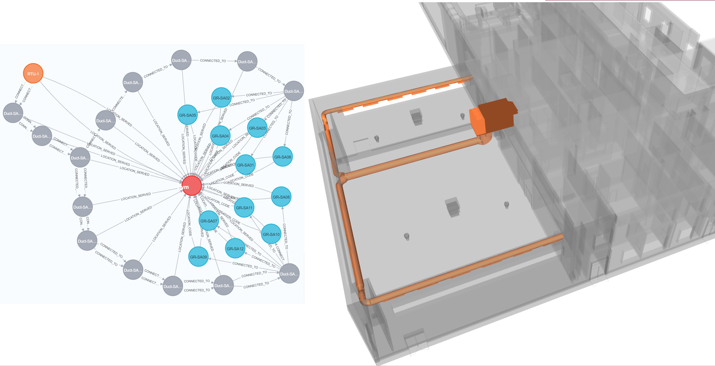
Fig. 20. Navisworks 3D visualization of results from Scenario 1(b).
Comparative analysis using knowledge graphs ve graphical tools

CONCLUSION
Based on the literature review conducted, current publications have focused mainly on the exploration of methods for converting BIM/GIS data into knowledge graphs. As part of the novelty of this research, the authors have represented the BIM data as a knowledge graph adding additional systems-centric data to help facility managers easily query building elements and their dependencies during maintenance or emergency situations.
A systems-centric knowledge graph can be queried for system-centric searches to identify the potentially affected building system components during a maintenance emergency. The ability to identify system components resulting in or impacted by a maintenance emergency allows facility staff to respond quickly to situations and manage the facilities effectively. Building information models that are able to provide critical O&M information along with as-built information of the facility and its assets can be considered as FM-capable BIM. By incorporating the systems-centric capabilities, FM-capable BIMs can be produced to assist facility staff in managing their facilities more effectively by providing holistic information about the assets.
The research questions identified were answered by this research as the authors were able to successfully develop the knowledge graph representing the building assets and perform the systems-centric searches. The structure of knowledge graphs, with nodes and edges defining their connections closely resembles the spatial connections between the building assets in a 3D model. This resemblance made it easier to represent the building assets as a knowledge graph. For example, each asset is represented as a node, and its relationship with other assets, spaces, and people was represented as an edge. In this research, the systems-centric and facility management data is stored as properties of nodes, and the structure of the graph is used for systems-centric searches as it represents the structure of special connections of building assets and their systems.
To develop the knowledge graph, the authors have divided the building Zone 4 systems into five sub-systems and used Arrows application to create a component graph for each sub-system. The component graph models are then combined in Neo4j to create the complete federated graph model. This approach allowed the authors to focus on the quality development of each of the smaller component graphs and eliminate any input errors. As the graphs can be enormous with all the systems in the building, it would be overwhelming for users to create one entire graph of the facility at a time. This modular feature of graphs is also very helpful when the graphs of additional systems are developed and have to be merged into the existing graph database or to allow several users to collaborate in generating a graph model for a large facility with multiple systems. For example, in this research five component graphs of supply air and return & exhaust air to the Gym and other spaces, and the electrical system are combined to form a federated knowledge graph database of air system of Zone. As more mechanical zones are added and other systems such as plumbing or electrical need to be represented, component graphs can be developed independently by users from different disciplines then merged into a single federated knowledge graph database.
To utilize the modularity of graphs effectively, it is very important to have a defined and agreed upon Ontology that provides the standards for naming and connections between nodes representing different assets, space, people, etc. Similar to graphs, ontologies can also be modular and can be created independently and combined. For example, in this research, the proposed ontology focused on the relationship between assets of the air system with spaces and people. This ontology can be expanded to include relationships among people and spaces.
In this research, the results of the graph queries were connected to Navisworks using a semi-manual process to highlight the results of the search graphically in the 3D model. Further research is needed to develop a fully automated connection between the graph database and Navisworks or to explore if any more streamlined 3D visualization could be possible using other applications such as Autodesk Platform Services (Formerly known as Forge) or developing any web application using the available APIs.
Additionally, real-time (dynamic) sensor data can be added to the systems-centric model to represent performance information about the assets. This would help facility managers to perform Fault Detection and Diagnostics of assets based on sensor data and access the condition of the assets. With the inclusion of real-time sensor data along with the already included specification and submittal (static) data, the graph model can behave more as a Digital Twin. The research in this paper can be considered as a foundation for the development of Digital Twin and with more advanced analysis of the graph data and real-time data, a more mature Digital Twin level can be created.
One of the lessons learned from this research is that the graph database created in Neo4j is not sharable as it is created in the desktop version of Neo4j and is stored in the desktop where it is created. For practical purposes, future development of graph databases should consider using web version of Neo4j storing data and queries on Neo4j servers. This involves additional paid subscription costs but would allow the option to share the database with others.
Additionally, the graphs were created using Arrows application and all node properties were added manually. In future studies alternate options should be explored like an excel table with all the properties can be used to import directly into Neo4j if the basic structure of the graph is already present in the Neo4j. This utilization of excel sheet for properties will not only save time while creating the graph but will also be useful to review, edit, and add new properties with ease if required.
Future research by the researchers is focusing on the development of Digital Twin incorporating data from sensors and using machine learning and AI technologies for data analysis in the process of taking the Digital Twin to higher maturity levels. Also, the potential of using knowledge graphs for storing facility maintenance and inspections data to support the predictive analysis of the digital twin is being explored.

DATA AVAILABILITY STATEMENT
Some or all data, models, or code that supported the findings of this study are available from the corresponding author upon reasonable request, this includes: (1) Spatial relationship data extracted from Revit 3D model. (2) Cypher codes for each component graph generated Arrows application and modified Cypher codes used in Neo4j. (3) High-definition images of all component graphs and federated knowledge graph. (4) Python code used to create the XML search sets of Cypher query results.
ACKNOWLEDGMENTS
The authors would like to acknowledge and thank the construction industry partners and software providers who took part in this work and provided their valuable time, experience, and 3D model to support the research. The views and findings expressed in this paper are those of the authors and do not reflect those of the industry partners and software providers.
REFERENCES:
"Arrows." <https://arrows.app/>. (December 17, 2023).
Abdelrahman, M. M., Chong, A., and Miller, C. (2022). "Personal thermal comfort models using digital twins: Preference prediction with BIM-extracted spatial–temporal proximity data from Build2Vec." Building and Environment, 207, 108532.
Akanmu, A. A., Olayiwola, J., and Olatunji, O. A. (2020). "Automated checking of building component accessibility for maintenance." Automation in Construction, 114, 103196.
Baken, N. "Linked data for smart homes: Comparing RDF and labeled property graphs." Proc., LDAC2020—8th Linked Data in Architecture and Construction Workshop, 23-36.
Batra, S., and Tyagi, C. (2012). "Comparative analysis of relational and graph databases." International Journal of Soft Computing and Engineering (IJSCE), 2(2), 509-512.
Becerik-Gerber, B., Jazizadeh, F., Li, N., and Calis, G. (2012). "Application areas and data requirements for BIM-enabled facilities management." Journal of construction engineering and management, 138(3), 431-442.
Carnaz, G., Nogueira, V. B., and Antunes, M. "A graph database representation of portuguese criminal-related documents." Proc., Informatics, MDPI, 37.
Chen, W., Das, M., Chen, K., and Cheng, J. C. "Ontology-based data integration and sharing for facility maintenance management." Proc., Construction Research Congress 2020, American Society of Civil Engineers Reston, VA, 1353-1362.
Ensafi, M., Harode, A., and Thabet, W. (2022). "Developing systems-centric as-built BIMs to support facility emergency management: A case study approach." Automation in Construction, 133, 104003.
Ensafi, M., and Thabet, W. (2021). "Challenges and gaps in facility maintenance practices." EPiC Series in Built Environment, 2, 237-245.
Harode, A., Ensafi, M., and Thabet, W. (2022). "Linking BIM to Power BI and HoloLens 2 to Support Facility Management: A Case Study Approach." Buildings, 12(6), 852.
Hong, Y.-C., and Chen, J. (2022). "Graph database to enhance supply chain resilience for industry 4.0." International Journal of Information Systems and Supply Chain Management (IJISSCM), 15(1), 1-19.
Hor, A.-H., Sohn, G., Claudio, P., Jadidi, M., and Afnan, A. (2018). "A semantic graph database for BIM-GIS integrated information model for an intelligent urban mobility web application." ISPRS Annals of the Photogrammetry, Remote Sensing and Spatial Information Sciences, 4, 89-96.
Hu, Y., Castro-Lacouture, D., Eastman, C. M., and Navathe, S. B. (2020). "Automatic clash correction sequence optimization using a clash dependency network." Automation in Construction, 115, 103205.
Ismail, A., Nahar, A., and Scherer, R. (2017). "Application of graph databases and graph theory concepts for advanced analysing of BIM models based on IFC standard." Proceedings of EGICE, 161-173.
Ismail, A., Strug, B., and Ślusarczyk, G. "Building knowledge extraction from BIM/IFC data for analysis in graph databases." Proc., Artificial Intelligence and Soft Computing: 17th International Conference, ICAISC 2018, Zakopane, Poland, June 3-7, 2018, Proceedings, Part II 17, Springer, 652-664.
Jezzini, A., Ayache, M., Elkhansa, L., Makki, B., and Zein, M. "Effects of predictive maintenance (PdM), Proactive maintenace (PoM) & Preventive maintenance (PM) on minimizing the faults in medical instruments." Proc., 2013 2nd International conference on advances in biomedical engineering, IEEE, 53-56.
Malinverni, E. S., Naticchia, B., Lerma Garcia, J. L., Gorreja, A., Lopez Uriarte, J., and Di Stefano, F. (2020). "A semantic graph database for the interoperability of 3D GIS data." Applied Geomatics, 1-14.
Mao, Z., Yao, H., Zou, Q., Zhang, W., and Dong, Y. (2021). "Digital contact tracing based on a graph database algorithm for emergency management during the COVID-19 epidemic: Case study." JMIR mHealth and uHealth, 9(1), e26836.
McComb, D. (2019). "Semantic Ontology: The Basics." Semantic Ontology: The Basics, <https://www.semanticarts.com/semantic-ontology-the-basics/>. (December 11,, 2022).
Molęda, M., Małysiak-Mrozek, B., Ding, W., Sunderam, V., and Mrozek, D. (2023). "From Corrective to Predictive Maintenance—A Review of Maintenance Approaches for the Power Industry." Sensors, 23(13), 5970.
Nahar, A. (2017). "Applying graph theory concepts for analyzing BIM models based on IFC standards." Master's Thesis. Technische Universität Dresden, Dresden, Germany.
Qiang, Z., Hands, S., Taylor, K., Sethuvenkatraman, S., Hugo, D., Omran, P. G., Perera, M., and Haller, A. (2023). "A systematic comparison and evaluation of building ontologies for deploying data-driven analytics in smart buildings." Energy and Buildings, 292, 113054.
Sacks, R., Eastman, C., Lee, G., and Teicholz, P. (2018). BIM handbook: A guide to building information modeling for owners, designers, engineers, contractors, and facility managers, John Wiley & Sons.
Sadeghi, M., Mehany, M., and Strong, K. "Integrating building information models and building operation information exchange systems in a decision support framework for facilities management." Proc., Construction Research Congress 2018, 770-779.
Wong, D. (2018). "VOSviewer." Technical Services Quarterly, 35(2), 219-220.
Xu, S., and Abualdenien, M. S. J. (2018). "Investigation of graph-databases for storing and analysing building models." Masterarbeit, Technische Universität München.
Yanamala, A. R., Harode, A., and Thabet, W. "A proposed systems-centric ontology for a graph-based digital twin." Proc., EC3 Conference 2023, European Council on Computing in Construction, 0-0.
Yang, X., and Ergan, S. (2017). "BIM for FM: Information requirements to support HVAC-related corrective maintenance." Journal of Architectural Engineering, 23(4), 04017023.
Zhao, Q., Li, Y., Hei, X., and Yang, M. (2020). "A graph-based method for IFC data merging." Advances in Civil Engineering, 2020.

FIGURE CAPTION LIST:
Fig. 1. Image showing the network map generated in VOSviewer using Scopus results.
Fig. 2. Methodology steps adopted to create the knowledge graph model and perform analysis.
Fig. 3. (a) RDF graph structure. (b) Example RDF graph model of building assets.
Fig. 4. (a) LPG graph structure. (b) Example LPG graph model of building assets.
Fig. 5. Proposed Graph Model Ontology.
Fig. 6. Steps followed to develop graph model.
Fig. 7. 2D floor plan and the mechanical system horizontal layout for Zone 4.
Fig. 8. Riser diagram showing the mechanical system vertical layout for Zone-4.
Fig 9. Detailed 3D Revit model indicating unique IDs of supply air components of Zone 4.
Fig. 10. Excel spreadsheets showing system components, properties, and their spatial connectivity.
Fig. 11. Segment of Zone-4 mechanical system knowledge graph model.
Fig. 12. OtherSpaces-SA graph showing supply air system components for other spaces.
Fig. 13. Gym-Sa graph-1 in Neo4j highlighting the common nodes.
Fig. 14. Gym-RA_EA graph combined with Gym-SA graph in Neo4j highlighting the common nodes.
Fig. 15. Modified Cypher code to merge Gym-RA_EA graph with Gym-SA graph highlighting the changed portions of code.
Fig. 16. Neo4j graph highlighting the results of scenario-1 (a) Search #1 query.
Fig. 17. Neo4j graph highlighting the results of scenario-1 (b) Search query.
Fig. 18. Neo4j graph results of scenario-2 search query.
Fig. 19. Screenshot showing creation of scenario 1(a) Search #1 Phrases in Bloom.
Fig. 20. Navisworks 3D visualization of results from Scenario 1(b).

