Randolph County Housing Study, 2022

Prepared by
The Virginia Center for Housing Research at Virginia Tech (VCHR)
Mel Jones, Research Scientist
Seungbee Choi, Postdoctoral Associate
And
West Virginia University Extension
Daniel Eades
Extension Rural Development Specialist

April 6, 2023

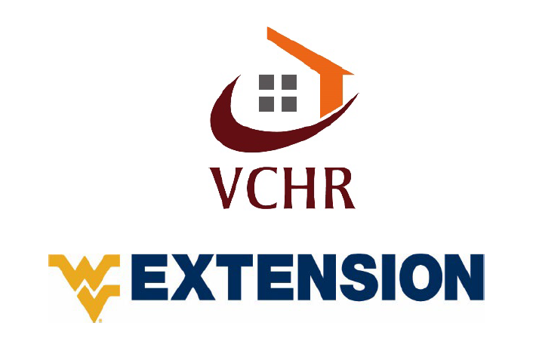

Executive Summary
Randolph County has community assets that make it a distinct housing market in the region. The City of Elkins is a regional economic hub that provides access to retail, dining, and entertainment. It serves as a gateway to the Monongahela National Forest, which has evolved into an outdoor recreation hotspot with easy access to iconic destinations like Seneca Rocks, Canaan Valley, and Blackwater Falls. The County’s rural environment offers access to unique lifestyle amenities and a slower pace of life that many people find appealing. Locally, anchor institutions such as Davis and Elkins College (D&E) and Davis Health System provide stable sources of economic, human, and social capital. Forward-looking investments like enhanced broadband coverage delivered through public and private partnerships will allow the community to take advantage of trends in remote work.
With a market vacancy rate between 2–7 percent and many for-sale units remaining on the market for 30 days or less, Randolph County and the greater Elkins community demonstrate a healthy housing market. However, affordability data for both rental units and owned/for-sale homes highlight the need for more low-income and market rate rentals and homes.
Data for low-income residents indicate that more than 2,300 households, including more than 1,000 renters, are cost-burdened and unable to access housing without sacrificing other elements of their basic well-being. At least half of the workers in the County’s top 10 occupations are unable to afford the median gross rent ($691 per month) as single earners, including workers in critical occupations such as home health and personal care aides, nursing assistants, and retail workers and cashiers. Nearly 1,000 cost-burdened households have low incomes and may be at risk of homelessness or regularly endure extreme hardship to retain their housing.
Whereas concrete housing numbers for higher earners are harder to quantify, income and occupation data show that experienced workers earning at or above the 90th percentile in 4 of the County’s top 10 occupations can afford the median homeownership costs as single earners as well as support substantial housing costs. Moreover, nearly 1,600 highly paid workers earning more than $40,000 annually and who can afford more than $1,000 per month for housing commute into the County for their primary job. Interviewees and focus group attendants suggested that there exists demand for moderate- and upper-income housing in the County, especially in the $200,000 to $250,000 price range. For both high and low-income workers, opportunities for homeownership is essential for anchoring these residents in the County. Both the cost and availability of housing factor into workers’ choice to live in the County. Without appropriate housing options, they are likely to live elsewhere.
The County should promote the development of a variety of housing to meet the needs of current and prospective residents. This includes creating turnkey, well-located homes for higher-income households and a mix of upper- and moderate-income rental units as well as new income-restricted units. This broad approach to housing development addresses the desires of higher earners, frees up occupied moderate-income properties, and stabilizes vulnerable low-income community members. Although the market likely won’t support the large-scale development required to gain economies of scale, there are opportunities for infill development in upper-story lofts and demolition or rehabilitation of blighted units. In addition, investments in repair, maintenance, and upgrades to existing homes owned by low- and moderate-income households will stabilize existing housing stock, enhancing property values, local tax revenues, and community attractiveness. If the County and City of Elkins are to be successful in catalyzing housing development and plan to encourage more growth, they should embark on community development initiatives and conduct planning considering combined development efforts.

Contents
Executive Summary 1
Approach 4
About Team 4
Data and Methodological Notes 5
Study Geography 5
Data Analysis 5
Focus Groups and Interview 6
Important Terms and References 6
Introduction 7
Household Characteristics 9
Household Size 10
Household Type 11
Age of Householder 12
Tenure 13
Household Income 13
Other Vulnerable Populations 19
Housing Unit Characteristics 20
Housing Condition 26
Vacancy 34
Housing Costs 34
Housing Needs 36
Recommendations 38
References 40
Appendix I. Owned/For-Sale and Rented/For-Rent Housing Gap 42

Approach
The Virginia Center for Housing Research at Virginia Tech (VCHR), West Virginia University Extension Service, Woodlands Development Group, the Homeownership Center, and the Randolph County Housing Authority collaborated to complete this study. The study benefited from subject matter experts in the housing market, affordable housing, workforce and economic development, and housing policy and planning, as well as local expertise in housing, planning, economic development, and community development.

The team sought to understand changing market-wide housing dynamics and demand in rural and urban portions of the County. They also identified housing needs, including workforce housing and housing affordability, vacant and dilapidated housing and home repair/maintenance needs, and supportive housing need.

This report discusses the study team’s analysis and findings. It also describes the importance of these findings in the context of workforce and economic development to emphasize the interconnectedness of housing issues and their implications for Randolph County’s communities and businesses. The analysis and conclusions discussed in this report will inform the team’s forthcoming program and policy recommendations.

About Team
The Virginia General Assembly and Virginia Tech created VCHR in 1989 to respond to the housing research needs of Virginia and the nation. In its 25-year performance record, VCHR has established an unparalleled reputation for high-quality research on affordable housing that integrates policy, building technology, and the housing industry. Mel Jones, Research Scientist and Associate Director, led the project team. As a faculty member at VCHR, Ms. Jones has conducted housing studies for communities and regions throughout Virginia and beyond. Mel has developed a unique expertise in assessing housing data and applying it to help communities tackle housing affordability, community development, and economic development goals. Seungbee Choi, Postdoctoral Associate, has conducted numerous research projects at VCHR. He specializes in quantitative and empirical research related to housing issues using various datasets. Seungbee has helped communities through in-depth research on residential mobility and housing policies.

The West Virginia University Extension Service connects communities to timely, research-based knowledge from the state’s land-grant university. Extension’s community and economic development technical assistance and educational programs strengthen the capacity of citizens and organizations throughout the state of West Virginia to understand community change and identify opportunities to improve their social and economic well-being. Daniel Eades, an Extension Associate Professor and state Specialist, coordinated local research efforts at West Virginia University (WVU) in Morgantown, WV. His teaching and outreach activities engage government and community leaders in the process of data-driven economic development decision making and support a breadth of community and economic development initiatives focused on local planning and place making.

Data and Methodological Notes
The study team analyzed market-wide housing data to understand supply and demand dynamics in Randolph County and the surrounding region as well as specific housing needs in the County.
The availability of high-quality, publicly available data is limited because the Census is unable to collect sufficient sample data to make reliable estimates for many rural jurisdictions and other small places. The team analyzed and reported only reliable data, which was supplemented with local assessment data and information from interviews with local experts and stakeholders. The study team conducted interviews with the following stakeholders:
- local housing experts, including realtors, developers, and housing providers
- those who understand existing and future need, such as K–12 school representatives, local elected officials and government staff, representatives of the faith community, economic developers, community service providers, and employers

Study Geography
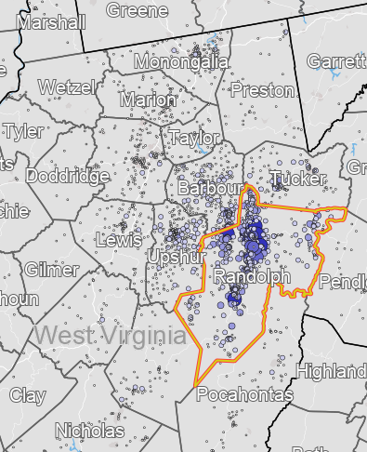
The team compared Randolph County to counties in the regional housing market delineated using commuting pattern data. Households generally choose a home within an acceptable commuting distance from their job or look for a job within an acceptable commuting distance of their home. For this analysis, the regional market includes Upshur, Tucker, and Barbour Counties. The availability and diversity of housing options within a reasonable commute of Randolph County may make these counties a desirable alternative to living in Randolph County, especially given the diversity of housing preferences. Furthermore, the team considered the City of Elkins, the ZIP code surrounding Elkins (26241), and each of the towns within the County: Harman, Beverly, Mill Creek, Coalton, Montrose, and Huttonsville.

Figure 1. Commuting to Randolph for Primary Jobs
Source: U.S. Census Bureau, Center for Economic Studies, LEHD

Data Analysis
Data used in this study were from the following sources: 2015–2019 US Census Bureau American Community Survey (ACS) published tables, 2014–2018 HUD Consolidated Housing Affordability Strategy (CHAS) data, the Bureau of Labor Statistics (BLS) State Occupational Employment and Wage Estimates, and the Workforce West Virginia Labor Market Information program. The study team calculated the reliability of ACS and CHAS estimates and used only reliable estimates when performing the analysis. Given the limited sampling for very small geographies, most data for the regional market is reported at the county level.

To assess housing needs for workers, BLS and Workforce West Virginia Labor Market Analysis data on wages by occupation were used as well as 2019 OnTheMap data from the US Census Bureau for Economic Studies. The team used the most-recent wage data available (2018) to evaluate whether workers can afford the prevailing rents in the market.

Household nonresponse increased substantially in the ACS during the COVID-19 pandemic because of the challenges of conducting a household survey, especially for households with lower socioeconomic status—those most likely to experience housing burden and other housing-related challenges. Although the Census Bureau has refined its methodology to reduce the effect of nonresponse bias owing to the COVID-19 pandemic, the organization still labels 2020 data as experimental. Therefore, we used 2019 5-year estimates in this report and encourage the community to consider updating quantitative data following the release of the 2017-2021 5-year ACS estimates in winter and spring 2023.

Focus groups and interview
The team collected qualitative data collection and stakeholder engagement through in-person and online focus groups and interviews, public meetings, and stakeholder input meetings to solicit input from local experts, stakeholders, and the public. The study team conducted interviews with realtors, housing providers, local government staff, elected officials, businesses, and other stakeholders to gain insight into local challenges and development opportunities. The data collected from interviews helped the team interpret quantitative data and test its validity. Interview data is included throughout the report, providing examples of real-life experiences that make the data conclusions more concrete and comprehensible.

Important Terms and References
Tenure – The method by which a household possesses their home: renting, fully owned with no home loan, or owned with a mortgage or other home loan.

Cost-burdened Households – The US Department of Housing and Urban Development (HUD) established the term “cost-burdened” to describe households that need more affordable housing. HUD defines cost-burdened households as “families who pay more than 30 percent of their income for housing... and may have difficulty affording necessities such as food, clothing, transportation, and medical care.” Severely cost-burdened households pay 50 percent or more of their income for housing and are likely to be making tough choices between housing and other necessities.

Percent of Area Median Income (AMI) – HUD sets income limits by household size that determine eligibility for assisted housing programs. HUD develops these income limits based on Median Family Income estimates and Fair Market Rent area definitions for each metropolitan area, parts of some metropolitan areas, and each non-metropolitan county. These income limits are useful tools for housing needs assessments because they are a common standard with which to categorize households based on income considering household size. VCHR has provided the 2020 income limits for Barbour County for reference; in addition, appropriate annual income limits based on data vintage were applied in the analysis.

Table 1. 2022 HUD Income Limits for Randolph County, WV
Income Level | 1-person | 2-person | 3-person | 4-person
<30% AMI  (extremely low income) | $13,590 | $18,130 | $23,030 | $27,750
30–50% of AMI  (very low income) | $22,050 | $25,200 | $28,350 | $31,450
50–80% of AMI  (low income) | $35,250 | $40,250 | $45,300 | $50,300

Housing Affordability – Housing affordability is a broad term used to discuss the degree to which housing units in a market or submarket meet the income-based needs of households in that market. Researchers and practitioners generally consider housing affordability for income groups that may face challenges related to affording housing, including the following:

- extremely low-income households that do not make enough money to obtain decent housing
- young professionals who wish to become homeowners but cannot find a starter home with associated costs within their budget
- established owners who cannot find an appropriate home to “upgrade” to as their families grow and they enter their professional prime

Housing affordability is not usually a concern for higher-income households that can obtain their desired housing without sacrificing other household needs such as safety, transportation, medical care, food, education, and childcare. However, a shortage of housing for households at any income level may affect businesses expanding in the market or economic development efforts for attracting new businesses.

Householder – This report refers to “householder” when the available data pertains to the householder as defined by the US Census. According to the Census subject definitions, “the householder refers to the person (or one of the people) in whose name the housing unit is owned or rented (maintained) or, if there is no such person, any adult member, excluding roomers, boarders, or paid employees. If the house is owned or rented jointly by a married couple, the householder may be either the husband or the wife. The person designated as the householder is the ‘reference person’ to whom the relationship of all other household members, if any, is recorded.”

Introduction
Housing plays a critical role in economic opportunity for individual workers and their families, affecting current and future workers, employers, communities, and regional markets. Benefits of appropriate, affordable housing and consequences when such housing is unavailable are most concrete at the individual and neighborhood level. However, as demand for housing increases and housing becomes more expensive to produce, its availability and affordability have distinct effects on businesses and markets. This overview illuminates some of the connections between housing, individual economic opportunity, workforce, and economic development that have been explored by researchers.

Individuals and families choose where to live based on a host of related features, resources, amenities, and opportunities. For instance, they choose access to specific schools, proximity to grocers and other shopping, proximity to family and other important social networks, and opportunities for recreation and exercise. Households choose the best housing they can afford and gravitate toward markets that offer better housing “packages” at the best prices. Housing costs are among the top five factors affecting where households choose to live and work. To provide a high quality of life for all households, jurisdictions must encourage developers and builders to produce housing that is appropriate and affordable for households at every income level.

According to data from the U.S. Census Bureau and Brookings, 56 major metropolitan areas (populations greater than 1 million) reported population declines between July 2020 and July 2021. At the same time, smaller metro areas experienced higher population growth than in the previous 2 years, and non-metro areas reported the greatest annual population gain in over a decade (Frey, 2022). This population migration has been accompanied by changes in housing preferences. Concurrently, more Millennial homebuyers have entered the market. Both trends may provide rural and small communities with a competitive advantage.

Even before the COVID-19 pandemic, the data implied an increased preference for detached home options. Furthermore, the pandemic appears to have accelerated this trend. This preference has risen from 55 percent to 59 percent and from 55 percent to 61 percent among Millennials (aged 26–42) and Gen X, respectively (Broberg, 2020). Similarly, data from Pew Research Center point to increased desirability for homes that are larger and farther apart (60 percent of those surveyed), even if schools, stores, and restaurants are several miles away (Gomez, 2021). The CoreLogic Single-Family Rent Index (SFRI) by property type suggests a shift in demand during the pandemic to more interior and exterior residential space and to communities with lower population density. This has led to higher rent increases for detached houses—more than 5 percent higher than for attached properties (Boesel, Chen, & Nothaft, 2021).

Despite the trend toward lower-density living, younger generations (especially Millennials) show a preference for suburban living that allows for both personal space and easy access to walkable downtowns with central city amenities. Home amenities desired include more interior and exterior space as well as “specialty spaces,” such as a home office or private workspace; however, there was an expressed preference for affordability even if it requires accepting a smaller house or lot (Coomer, 2019; Broberg, 2020). Randolph County’s small towns, lower cost of living, and vibrant downtown amenities in Elkins may setup the community for capitalizing on current demand trends.

Household Characteristics
In total, 28,930 people comprise 11,135 households in Randolph County. Most households (67 percent) live in unincorporated parts of the County. One quarter of households live in the City of Elkins, and more than 50 percent live in or near the City of Elkins in the 26241 ZIP code, which encompasses many of the City-adjacent housing developments or settlements. Beverly and Mill Creek are the largest towns in the County. Harman, Huttonsville, Montrose, and Womelsdorf (Coalton) each include less than 1 percent of County households. The number of households has fluctuated by 2–4 percent over 10 years (2010–2019), with a net loss of 2 percent. Focus group participants and stakeholders have observed growth in population and households in the years since 2019 as well as associated demand in the housing market. Although these trends cannot be observed or verified until the 2021 ACS data is released, conversations with realtors, lenders, and other focus group participants indicated that desirable properties were selling in under 30 days.
Table 2. Population and Number of Households in Randolph County by Jurisdiction
Source: US Census Bureau, 2019 ACS 5-Year Estimates
 | Population |  | Households
 | Estimate | Percent | Estimate | Percent
Randolph County | 28,930 | 100% | 11,135 | 100%
ZIP Code 26241 (including Elkins City) | 13,702 | 47% | 5,627 | 51%
Elkins City, West Virginia | 7,072 | 24% | 2,744 | 25%
Beverly Town, West Virginia | 746 | 3% | 346 | 3%
Harman Town, West Virginia | [60-145] | 0% | [37-99] | <1%
Huttonsville Town, West Virginia | [122-352] | 1% | [49-97] | <1%
Mill Creek Town, West Virginia | 689 | 2% | 291 | 3%
Montrose Town, West Virginia | [91-225] | 1% | [47-111] | <1%
Coalton Town*, West Virginia | [183-411] | 1% | [81-143] | <1%
Unincorporated Areas | 19,628 | 68% | 7,422 | 67%
*Womelsdorf in ACS published tables

Household Size
The average household size in Randolph County is 2.40 and the average family size is 3.05.
Figure 2. Households by Size
Source: VCHR Tabulation of 2019 ACS 5-year Estimates
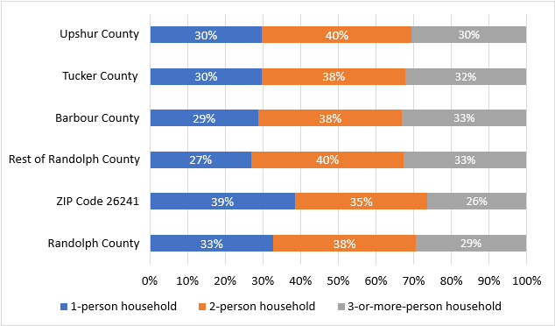

Randolph County includes a larger proportion of one and two-person households than surrounding counties, in part because households in City of Elkins and its surrounding neighborhoods include a larger proportion of one and two-person households than the unincorporated parts of the County do. The 26241 ZIP code also includes more non-family households, that is, singles and people with roommates.

Household Type
Figure 3: Family and Non-Family Households as a Percent of All Households
Source: VCHR Tabulation of 2019 ACS 5-year Estimates
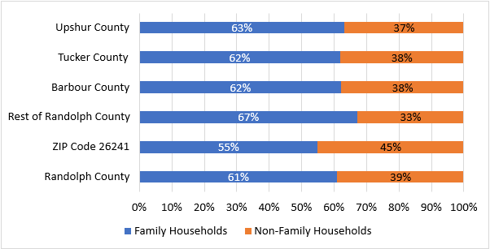

Age of Householder
Randolph County has one of the highest proportions of households headed by someone 65 and older in the study area. These households are more prominent in the 26241 ZIP code than in the rest of the County, suggesting that Elkins and the surrounding neighborhoods may be preferred among (and possibly more accessible by) householders 65 and older. One third of County households are headed by someone 65 or older, and 37 percent include at least one person 65 or older. Moreover, 39 percent are headed by someone 45–64, 25 percent by someone 25–44, and less than 3 percent by someone younger than 25. About one quarter of households include children, that is, at least one person younger than 18.

Figure 4: Age of Householder as a Percent of All Households
Source: VCHR Tabulation of 2019 ACS 5-year Estimates
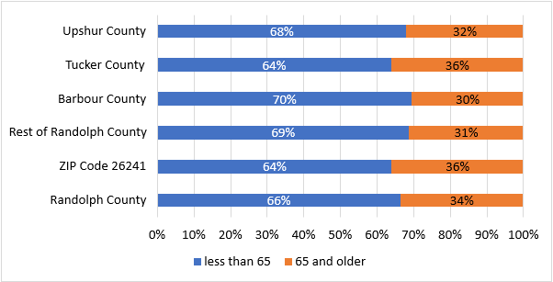

Figure 5: Randolph County Households by Tenure and Age of Householder
Source: VCHR Tabulation of 2019 ACS 5-year Estimates

Households headed by someone younger than 44 are far more likely to rent than those headed by someone older.

Tenure
Randolph County has the largest proportion of renters in the study region, and renters are more concentrated in and around Elkins. This is likely driven in part by the presence of Davis and Elkins College, which has a population of just over 800 students.
Figure 6. Households by Tenure (Renter/Owner)
Source: VCHR Tabulation of 2019 ACS 5-year Estimates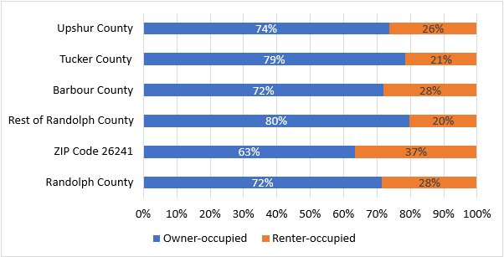

Throughout the study region, renters tend to have far-lower incomes than owners do. The median income in Randolph is the second-highest in the study region, and household incomes in and around the City of Elkins are much higher than that in the County overall.

Household Income
Median income in Randolph County is among the highest in its commute shed but 7 percent lower than the West Virginia median. Renters have significantly lower incomes than owners throughout the entire commute shed. The median renter household in Randolph County has an income of $25,625 and can afford no more than $640 per month for housing. The median owner household has an income of $51,815, more than twice that of the median renter, and they can afford no more than $1,295 per month for housing costs. The income gap between owners and renters in the Elkins area is larger: the owner median is 58 percent greater than the renter median.

Table 3. Median Household Income
Source: 2019 ACS Median Income, VCHR Tabulation of Maximum Affordable Housing Costs
 | Median Income | Maximum Affordable Housing Costs
West Virginia | $46,711 | $1,168
Randolph County | $43,320 | $1,083
ZIP Code 26241 | $42,563 | $1,064
Barbour County | $38,459 | $961
Tucker County | $49,118 | $1,228
Upshur County | $40,322 | $1,008

Figure 7. Median Income by Tenure (Renter/Owner)
Source: VCHR Tabulation of 2019 ACS 5-year Estimates

Approximately 40 percent of Randolph County households are not working. The high percentage of non-working households is partially comprised of households who are retired: 24 percent of households receive retirement income from a source other than social security, and 37 percent of householders are 65 or older. In addition, 4,587 households (41 percent) receive social security income either from retirement or disability. Furthermore, approximately 4,674 individuals in the County have a disability.

Table 4. Households with a Disability
Source: VCHR tabulation of 2014–2018 CHAS data
 | Randolph County | ZIP Code 26241 | Barbour County | Tucker County | Upshur County | Webster County
With a Disability | 4,674 | 2,203 | 2,920 | 4,674 | 3,506 | 1,662
% of Total Households with Disability | 17.1% | 16.7% | 17.6% | 21.3% | 14.4% | 19.6%

Among working households, 3,860 are single-earner households and 2,340 include two or more earners.
Figure 8. Number of Workers in Households
Source: VCHR Tabulation of 2019 ACS 5-year Estimates

Randolph County workers and the households they comprise have different abilities to pay for housing based on their occupation and household composition. The following table shows the wages and income required to support a household of varying compositions and annual costs for necessary household expenses (Glasmeier, 2020).
Table 5. Wage/Income Requirements and Expenses by Household Composition
Source: MIT Living Wage Calculator
 | 1 Adult |  |  | 2 Adults, 1 Working |  | 2 Adults, Both Working
 | 0 Kids | 1 Kid | 2 Kids | 1 Kid | 2 Kids | 0 Kids | 1 Kid | 2 Kids
Living Wage | $14.96 | $29.81 | $37.80 | $28.52 | $34.22 | $12.16 | $16.66 | $21.73
Poverty Wage | $6.19 | $8.38 | $10.56 | $10.56 | $12.74 | $4.19 | $5.28 | $6.37
Required Ann. Gross Income | $31,126 | $62,007 | $78,628 | $50,573 | $59,313 | $50,573 | $69,300 | $90,403
Food | $3,351 | $4,937 | $7,417 | $7,645 | $9,856 | $6,143 | $7,645 | $9,856
Childcare | $0 | $7,648 | $15,296 | $0 | $0 | $0 | $7,648 | $15,296
Medical | $2,599 | $7,207 | $6,994 | $6,994 | $7,303 | $6,092 | $6,994 | $7,303
Housing | $6,791 | $8,894 | $8,894 | $8,894 | $8,894 | $7,609 | $8,894 | $8,894
Transport | $5,509 | $9,776 | $12,709 | $12,709 | $15,012 | $9,776 | $12,709 | $15,012

The following graph compares maximum affordable housing costs for workers to the median rent and owner costs in the County for the top 10 occupations by employment. These 10 occupations represent 2,943 jobs, or 29 percent of total jobs in Randolph County. We conducted this analysis for one- and two-worker household scenarios. We assumed that both workers earn the same wage in the two-worker scenario. For single earners, we examined housing affordability for workers earning at the median and at the 90th percentile to represent the experience of highly skilled workers or workers who are advanced in their careers.
For low-wage workers, sharing housing costs with another worker is required to afford median rent in the County. Home health and personal care aids, nursing assistants, and fast-food counter workers struggle to afford housing in the County as single earners even when earning at the 90th percentile. Cashiers and retail salespersons struggle to afford housing in the County as single earners unless they are earning at the 90th percentile. Workers in each of these occupations would likely find homeownership unattainable unless they share housing costs with another worker.
Stakeholders interviewed also highlighted the challenge of providing affordable housing options, especially for middle-income households. One individual commented that although there were sufficient homes for upper-level professionals and low-income housing, there was little available stock between the two. Focus group attendees pointed to existing developments such as Bridgewater and Highland Meadows as examples of mixed-development neighborhoods that provide an entry point for new buyers and an opportunity for residents to build wealth. Attendees specifically identified homes in the $200,000–250,000 range as a target for future housing development.
There are high-wage workers among the top 10 occupations by employment. Heavy Tractor Trailer Truck Drivers, Registered Nurses, Post-secondary Teachers, and General and Operations Managers can afford median ownership costs in Randolph as single earners and can support substantial housing costs when earning at or above the 90th percentile. Nearly 1,600 highly paid workers with earning greater than $40,000 annually (who can afford more than $1,000/month for housing) commute into the County for their primary job. In-commuting households are a potential source of demand.

Although not included in the following data, remote workers may present another high-wage segment to target for recruitment. Remote work severs the need to be located near the place of employment, leading some households to opt for larger and more-affordable spaces in lower-density areas, moving out of high-rise structures in the urban core to suburban and exurban single-family homes (Boesel, Chen, & Nothaft, 2021). This trend was confirmed in part by conversations with local realtors, who noted an increase in buyers from outside the County moving from one- or two-bedroom units and desiring a larger home either because of a growing family or because they could simply afford a larger house in the County than they can in an urban area. In line with national data (National Association of REALTORS, 2021), most buyers are looking for at least a 3-bedroom, 2-bath home with additional space for a home office. While incomes for remote workers vary, the Ascend program, a remote worker recruitment program coordinated by West Virginia’s Department of Tourism and Department of Economic Development and the West Virginia University Brad and Alys Smith Outdoor Economic Development Collaborative, gathered applicant data and found average salaries ranging from $65,700 to $115,000 (P.Winfrey, personal communication, October 25, 2022).

Table 6: Housing Affordability by Occupation Category
Source: VCHR Tabulation of Lightcast Data
Maximum Affordable Housing Cost | Single Earner  at the Median |  | Single Earner  at the 90th Percentile | Two Earners
Management Occupations | $1,690 |  | $3,278 | $3,379
Business and Financial Operations Occupations | $1,380 |  | $2,359 | $2,761
Computer and Mathematical Occupations | $1,562 |  | $2,459 | $3,123
Architecture and Engineering Occupations | $1,785 |  | $2,712 | $3,570
Community and Social Service Occupations | $1,002 |  | $1,410 | $2,005
Legal Occupations | $1,345 |  | $2,858 | $2,690
Educational Instruction and Library Occupations | $1,099 |  | $1,829 | $2,199
Arts, Design, Entertainment, Sports, and Media Occupations | $899 |  | $1,566 | $1,798
Healthcare Practitioners and Technical Occupations | $1,516 |  | $2,299 | $3,033
Healthcare Support Occupations | $593 |  | $687 | $1,186
Protective Service Occupations | $996 |  | $1,354 | $1,991
Food Preparation and Serving Related Occupations | $545 |  | $690 | $1,089
Building and Grounds Cleaning and Maintenance Occupations | $567 |  | $848 | $1,134
Personal Care and Service Occupations | $567 |  | $1,020 | $1,135
Sales and Related Occupations | $716 |  | $1,198 | $1,432
Office and Administrative Support Occupations | $804 |  | $1,173 | $1,608
Farming, Fishing, and Forestry Occupations | $889 |  | $1,494 | $1,777
Construction and Extraction Occupations | $1,102 |  | $1,704 | $2,203
Installation, Maintenance, and Repair Occupations | $950 |  | $1,544 | $1,899
Production Occupations | $830 |  | $1,306 | $1,661
Transportation and Material Moving Occupations | $817 |  | $1,302 | $1,634
Cannot afford lower quartile rent
Cannot afford median rent; can afford lower quartile rent only
Can afford median rent
Can afford to rent but cannot afford to own
Can afford to rent and own

Table 7. Maximum Affordable Housing Costs by 2022 HUD Income Limits for Randolph County, WV
Income Level | 1-person | 2-person | 3-person | 4-person
<30% of AMI  (extremely low income) | $339 | $453 | $500 | $693
30–50% of AMI  (very low income) | $551 | $630 | $708 | $786
50–80% of AMI  (low income) | $881 | $1,006 | $1,132 | $1257

Other Vulnerable Populations
According to the Code of Federal Regulations 91.5, an individual or family “at-risk of homelessness” has an annual income below 30 percent of HUD Area Family Median Income (HAMFI). In Randolph County, 1,430 households have an income of less than 30 percent of the AMI. Among extremely low-income households, 995 and 760 households spend more than 30 percent and 50 percent of their income on housing, respectively. These households are vulnerable to changes in the external environment, such as the COVID-19 pandemic.
Table 8. Number of Households by Income Level
Source: VCHR Tabulation of 2014–2018 CHAS Data
 | <30% of HAMFI | 30–50% of HAMFI | 50–80% of HAMFI | 80–100% of HAMFI | >100% of HAMFI
Owner | [476,794] | 790 | 1,270 | [473,797] | 4,600
Renter | 795 | [382,658] | [595,985] | [191,459] | 900
Total | 1,430 | 1,310 | 2,060 | 960 | 5,500

Table 9. Number of Cost-Burdened Households by Income Level
Source: VCHR Tabulation of 2014–2018 CHAS Data
 | <30% of HAMFI | 30–50% of HAMFI | 50–80% of HAMFI
Cost-Burdened | 995 | [421,709] | [331,609]
Severely Cost-Burdened | 760 | [126,334] | [42,178]

Other vulnerable populations include households living in overcrowded conditions and elderly households. Although statistics on overcrowding are not significant, the data show that 4,194 households include at least one elderly person aged 62 or older.
Table 10. Number of Households with Person Aged 62 or Over by Income Level
Source: VCHR Tabulation of 2014–2018 CHAS data
 | <30% of HAMFI | 30–50% of HAMFI | 50–80% of HAMFI | 80–100% of HAMFI | >100% of HAMFI
Household with Person Aged 62 or Over | [257,501] | 480 | 885 | 870 | 1,395

Housing Unit Characteristics
Figure 10. Housing Units by Number of Bedrooms*
Source: VCHR Tabulation of 2019 ACS 5-year Estimates
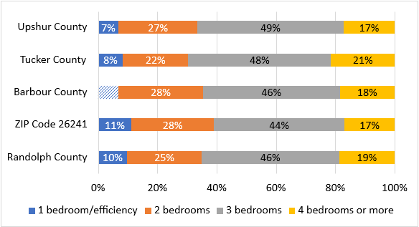
*Hashed portions represent unreliable estimates

Whereas more than 70 percent of County households include one or two people, 65 percent of homes are sufficiently large to accommodate households with 4 or more people. Only 10 percent of the County housing stock is appropriately sized to accommodate a one or two-person household. Even two-bedroom units, which could accommodate a three-person family, two roommates, or a couple with a dedicated office space, are in relatively short supply relative to the proportion of one and two-person households. Figures 11 and 12 are shaded to indicate the mismatch between household size and unit size.

Table 11. HUD Assumptions for Maximum Unit Occupancy
Efficiency | 1-Bedroom | 2-Bedroom | 3-Bedroom
1 Person | 2 People | 3 People | 5 People

Figure 11. Proportion of Households by Number of People
Source: VCHR Tabulation of 2019 ACS 5-year Estimates

Figure 12. Proportion of Housing Units by Number of Bedrooms
Source: VCHR Tabulation of 2019 ACS 5-year Estimates

Figure 13. Housing Units by Type of Structure*
Source: VCHR Tabulation of 2019 ACS 5-year Estimates
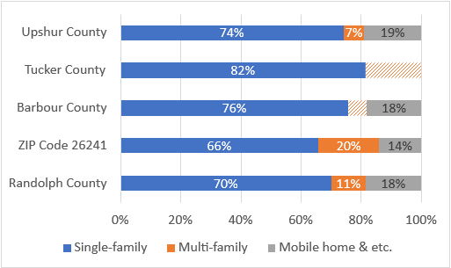
*Hashed bars indicate unreliable data.
Most of the County’s housing units are single-family detached stick-built units. Fewer than 485 single-family stick-built units are attached units (i.e., townhome or duplex). There are 2,620 mobile and manufactured units in the County and as many as 37 households living in RVs or other types of vehicles. Multifamily buildings include 1,404 housing units, most (44 percent) of which are in small buildings with 3 or 4 units. About one quarter are in larger buildings with 20 units or more.

Figure 14. Housing Units by Year Built
Source: VCHR Tabulation of 2019 ACS 5-year Estimates
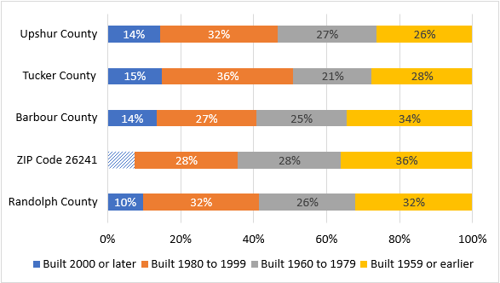

Figure 15. House Value
Source: VCHR Tabulation of 2019 ACS 5-year Estimates
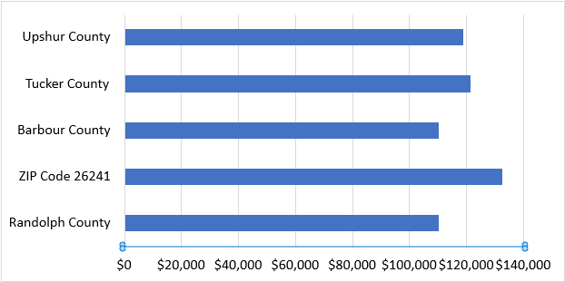

Randolph County’s housing stock is younger than that of Barbour County but generally older than those in Tucker and Upshur counties. Housing built before 1959 is more concentrated in and around Elkins. More details for the 26241 ZIP Code area and City of Elkins are provided in Figures 17 and 18. Most of the County’s housing was built over two periods: prior to 1939 and 1970–1999.

Figure 16. Number of Housing Units by Decade Built
Source: VCHR Tabulation of 2019 ACS 5-year Estimates

Figure 17. Parcels by Year Built, Zip Code 26241
Source: WVU Tabulation of Randolph County Assessment Data
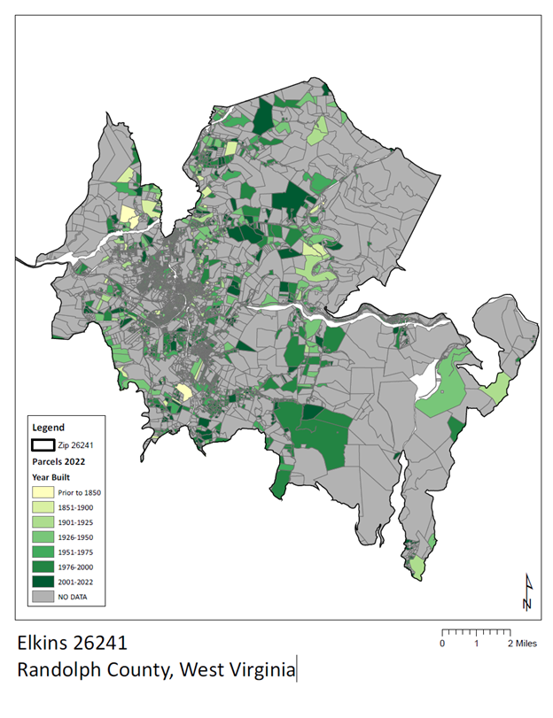

Figure 18. Parcels by Year Built, City of Elkins
Source: WVU Tabulation of Randolph County Assessment Data
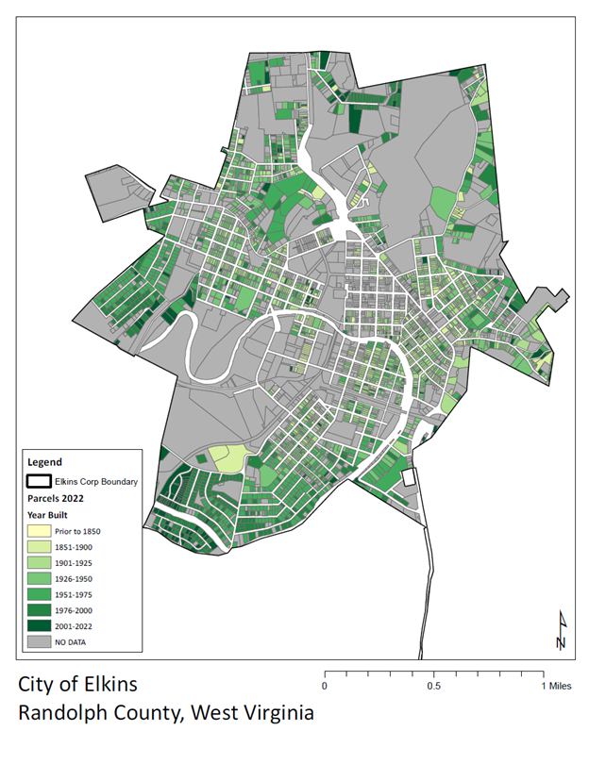

Housing Condition
Several interviewees raised concerns about the condition of affordable rental and for-sale units. Housing service providers and lenders explained that households often cannot find a home in an acceptable condition to buy because of either preference for updated turn-key properties or mortgage lending restrictions. Assessment data can be used to make inferences about housing conditions; however, these inferences should be validated by conducting a field survey of selected properties. The Randolph County Assessor’s office provided data between the years 2017 and 2022. Many parcels are absent from the data provided. Although some of the excluded parcels did appear to be residential, many of the parcels with missing values include non-residential properties and parcels owned for business interests.
Assessment data describing property conditions was available for 10,102 parcels. This data presented in Figures 19–21 show that property conditions for most parcels in the County remained unchanged between 2017 and 2022 (40 percent). Only 1 percent of properties (132) saw an improvement in conditions, whereas 2 percent of them (419) saw a decline in conditions.
Figure 19. Change in Housing Condition, Randolph County, 2017–2022
Source: WVU Tabulation of Randolph County Assessment Data
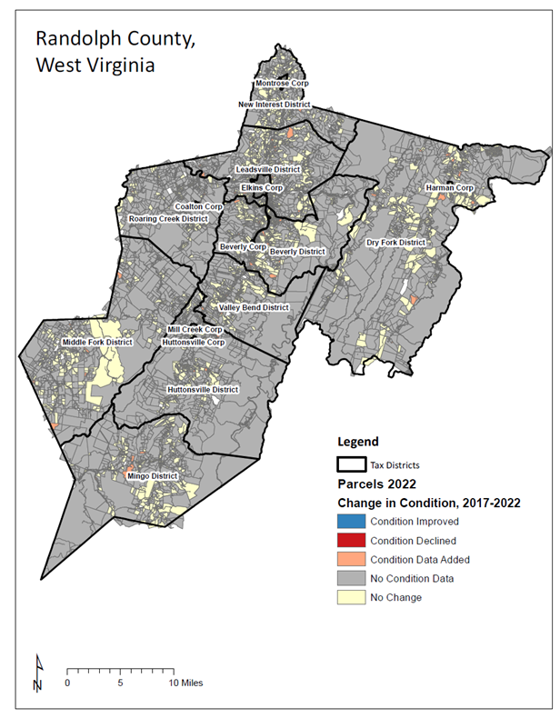

Figure 20. Change in Housing Condition, ZIP Code 26241, 2017–2022
Source: WVU Tabulation of Randolph County Assessment Data
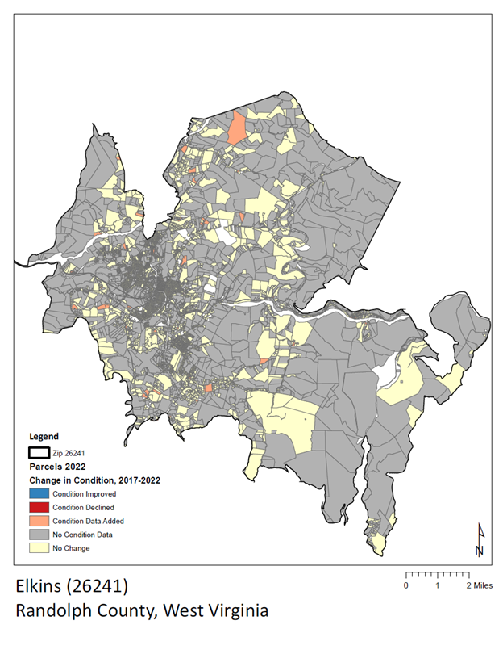I

Figure 21. Change in Housing Condition, City of Elkins, 2017–2022
Source: WVU Tabulation of Randolph County Assessment Data
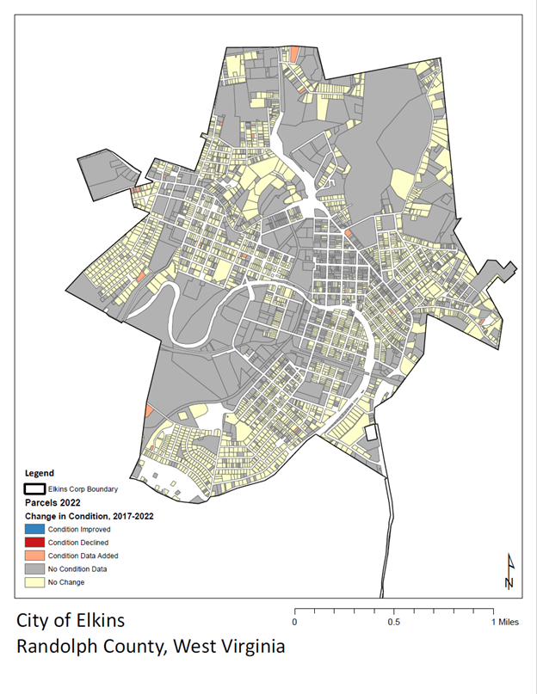

The change in assessed building values was calculated for parcels with available data for 2017 to 2022 (with many parcels being excluded for lack of data). The following charts show changes in housing values across much of the County (Figures 22 and 23) and across the City of Elkins and surrounding areas (Figures 24 and 25).

Of the 23,770 parcels for which assessment data was provided, property value data was available for 22,179 parcels for the 2017 and 2022 periods (93 percent). Most of the properties (70 percent) with reported data increased in value, of which 57 percent increased less than 25 percent, 8 percent increased 25–50 percent, and 5 percent increased more than 50 percent in value.

Figure 22. Residential Buildings by Change in Assessed Value, 2017–2022
Source: WVU Tabulation of Randolph County Assessment Data
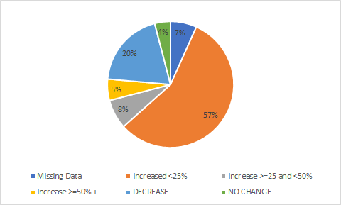

Figure 23. Percent Change in Assessed Value, Randolph County, 2017–2022
Source: WVU Tabulation of Randolph County Assessment Data
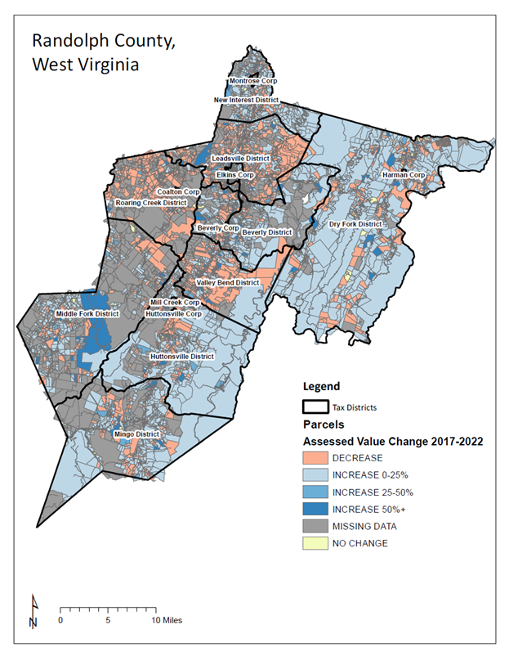
Figure 24. Percent Change in Assessed Value, ZIP Code 26241, 2017–2022
Source: WVU Tabulation of Randolph County Assessment Data
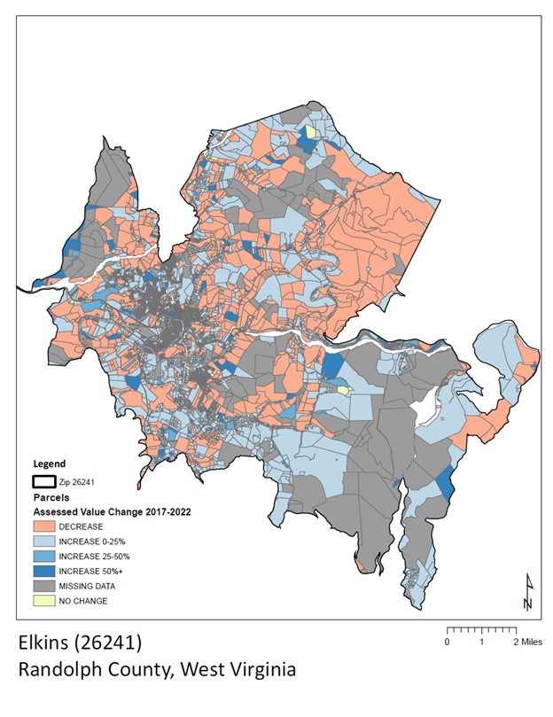
Figure 25. Percent Change in Assessed Value, City of Elkins, 2017–2022
Source: WVU Tabulation of Randolph County Assessment Data
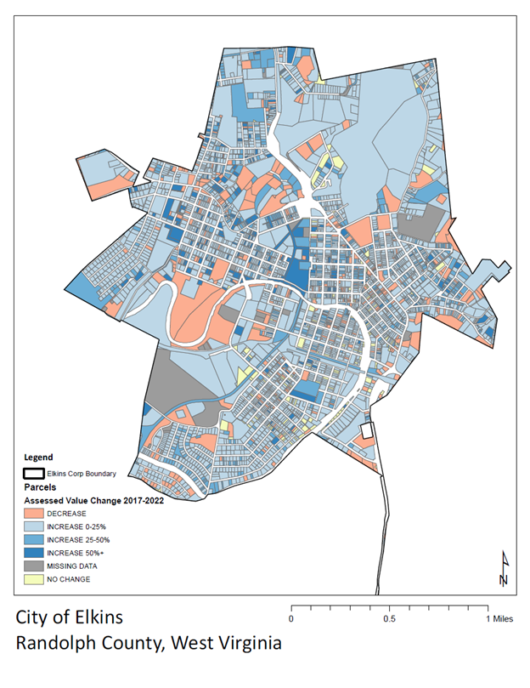

Vacancy
Table 12. Vacancies in Randolph County
Source: VCHR Tabulation of 2019 ACS 5-year Estimates
 | Randolph County | ZIP Code 26241
Market Vacancy Rate | 2–5% | 2–7%
Seasonal Vacancies | 1,519 (48% of vacancy) | 341 (32% of vacancy)
Long-term Vacancies | 948 (30% of vacancy) | 335 (31% of vacancy)

The County and Elkins-area market vacancy rate (for rent/for sale) is in a healthy range, showing that units can be added while absorption remains strong. The Elkins-area vacancy rate is slightly higher than the County. Thus, units in the Elkins area may experience more turnover or may include units that are less desirable owing to need or preference (e.g., size, affordability, condition, or location). Stakeholders in Elkins indicated that rental demand was sufficiently strong that property owners with well-maintained units could be selective in tenant choice. In some areas (Edgewater and David Street), property owners were allowing renters to break lease agreements because they maintained waiting lists for the property. Relators and lenders confirmed that the for-sale property market is healthy, suggesting that most homes of adequate size, type, condition, and location are sold in 20–30 days. Median days on the market (approximately 30 days) allows sellers to sell their home in a reasonable amount of time and allows buyers sufficient time to conduct important consultations such as home inspections before choosing their home.

These countywide market trends are not experienced evenly throughout the market. Some places are in higher or lower demand, or they may experience more activity and turnover than others. For example, in very rural communities like Harman, stakeholders mentioned that very few properties were available for sale or for rent and that there was little demand immediately in town. In contrast, homes in mixed and upper-income subdivisions close to Elkins like Highland Meadows and Sullivan’s Crossing were selling quickly.

Seasonal and long-term vacancies account for the largest share of total vacancies. Seasonal vacancies are held for seasonal use and are not for rent or sale. Long-term vacancies are properties that are abandoned, slated for demolition, or otherwise vacant for the long term (e.g., the owner has relocated to long-term care but still owns the home). Long-term vacancies may present an opportunity for reinvestment or redevelopment if they are in desirable places and can respond to prevailing household demand trends.

Housing Costs
Median selected owner costs include mortgage or other home loan payments, real estate taxes, various forms of insurance, utilities, fuels, and/or condominium fees. Median monthly housing costs in Randolph County range from $617 for renters in the Elkins area to $932 for owners with a mortgage. Owner costs are in the midrange for counties in the commute shed, higher than those in Webster and Tucker, and lower than those in Upshur and Barbour. However, rent in the County is among the highest in the commute shed—only Upshur County has higher rents. In the County and in the Elkins area, rents and owner costs have increased substantially since 2017.
Figure 26. Gross Rent
Source: VCHR tabulation of 2011–2019 ACS 5-year Estimates

Figure 27. Owner Costs for Owners with a Mortgage
Source: VCHR Tabulation of 2011–2019 ACS 5-year Estimates

Housing Needs
Approximately 2,335 households (16 percent of all households) spend more than 30 percent of their income on housing. Households that pay more than 30 percent of their income for housing, particularly those with low and moderate incomes, may not have sufficient money to pay for other needs such as transportation, healthcare, food, and education. Therefore, the number of cost-burdened households is a good indicator of the number of households that need more affordable housing.
Most cost-burdened households (70 percent) that have very low income are likely to be single-earner households or households who have no workers and whose inhabitants are likely retired and/or disabled. Indeed, 741 cost-burdened households (32 percent) are seniors. Single earners earning the median wage in the occupations of healthcare support, food preparation and serving, building and ground cleaning and maintenance, and personal care and service have too little income to afford the median rent in the County.
Table 13. 2022 HUD Income Limits for Randolph County, WV
Income Level | 1-person | 2-person | 3-person | 4-person
<30% AMI  (extremely low income) | $13,590 | $18,130 | $23,030 | $27,750
30–50% of AMI  (very low income) | $22,050 | $25,200 | $28,350 | $31,450
50–80% of AMI  (low income) | $35,250 | $40,250 | $45,300 | $50,300

Although renters are more likely to be cost-burdened, owners make up a larger proportion of cost-burdened households. At least 336 households fully own their home (with no mortgage payments) and are burdened by utilities, taxes, and/or insurance. Moreover, 752 households (32 percent of cost-burdened households) have a mortgage. They have likely become cost-burdened because of economic hardship. Owner costs with a mortgage increased 10 percent over the period 2010–2019.
Furthermore, 1,115 cost-burdened households are renters (48 percent of cost-burdened households), and rental affordability was a topic routinely mentioned by stakeholder groups. Rent increased 42% over the 2010–2019 period, which places a burden on those with fixed incomes, working part-time, or earning low wages. According to local housing service providers, many landlords moved to 1–3-month leases following pandemic moratoriums and then increased rent (by $100–150) to receive a larger assistance payment. The housing service providers we spoke with felt that evictions were underreported. Although modeled data from Census Eviction Lab estimates 6.3 evictions in the County for every 100 renter households in 2018, raw block group data showed as high as 17.4 per 100 in Elkins (Eviction Lab, 2018).

Figure 28: Randolph County Rental Housing Stock by Affordability Level
Source: VCHR Tabulation of 2014–2018 CHAS data

There is insufficient rental stock to serve households with extremely low incomes, who outnumber the existing units available to them. In addition, most of the existing units affordable to this group (about two-thirds) are occupied by households with higher incomes. Because the market does not impose occupancy standards that restrict the affordable supply of units to the renters who need them, the gross deficit of affordable units balloons because of the mismatch between affordable units and renters. Rental units with site-based assistance can impose occupancy standards. However, the supply of such units for renters below 30 percent of HAMFI is scarce, and market pressures create greater scarcity of affordable units. If dedicated affordable housing units are provided for cost-burdened households making 30 percent of HAMFI or less, units affordable to households making 30–50 percent of HAMFI may become available. Although households with higher incomes may compete to occupy these units, it will help relieve market pressure on midrange units.

As shown in Figure 28, there are relatively few rental units with rents affordable to households with income greater than 80 percent of AMI (i.e., greater than $40,250 for a two-person household). There may be room in the market to create higher-end rental units and attract households out of units priced more affordably. This trend in the housing stock may also be indicative of market response to a trend toward homeownership as households achieve moderate and higher incomes. However, as shown in Figure 29, the owned and for-sale stock is also relatively small for households with moderate or higher incomes.

Despite much less cost-burden among owner households, there is likely a need for homeownership support among cost-burdened, low-, and moderate-income owners, especially for those who have little agency to cover costs through budgeting or higher earnings. With fewer units affordable to moderate- and higher-income households, there is room to create modest homeownership opportunities affordable to households with income greater than the median. Although current residents tend to spend less than 30 percent of their income for housing, some households would likely choose to “upgrade” to a more expensive home if the opportunity were available. Furthermore, there are nearly 600 workers who can readily afford to own a home based on their annual income.

Figure 29: Randolph County Owned/For-Sale Housing Stock by Affordability Level
Source: VCHR Tabulation of 2014–2018 CHAS Data

Recommendations
Increasing demand for housing along with a healthy housing market offers an opportunity for strategic investment in housing:
- creating turnkey, well-located homes for higher-income households
- building high-quality subsidized housing and homeownership pathways for low-wage workers
- investing in repair, maintenance, and upgrade of housing stock owned by low- and moderate-income households (including/especially for seniors)
- infill development that addresses both rental and ownership
Turnkey, well-located homes for higher-income households
Quantifying demand for market rate properties is less straightforward than low-income housing. However, the rate of housing construction both nationally and in rural communities has yet to return to the pre-2008 recession level. Data for the County and conversations with stakeholders indicate a lack of units affordable to both moderate- and higher-income owners and renters. Moreover, paired income and housing cost data for both the resident workforce and commuters show that many can afford substantial housing costs even as single earners. New construction or rehabilitation of older properties to create more turnkey, market-rate housing options for these high earners would help satisfy housing demand for the group and free up properties for middle- and lower-income earners.
High-quality, subsidized housing and homeownership pathways for low-wage workers
As the County seeks growth opportunities and to accommodate high-earning workers, incorporating income-restricted, subsidized housing for low-wage workers and home modification and repair support will increase the County’s competitiveness and avoid deterioration of the housing stock. Growth in rent and owner costs with a mortgage indicate increasing demand and threaten to displace low-income community members. Seniors may be forced to endure inadequate, deteriorating housing to make ends meet. Low-wage workers in retail, food services, and healthcare may choose to seek places where wages and housing opportunities are more advantageous.
Rental housing is an important steppingstone for most households, whether they are new residents, young people just forming households, households recovering from crisis (economic or otherwise), or households changing life situations (downsizing or otherwise). Well-managed, attainable, accessible, affordable rental housing can stabilize households and communities as well as anchor households in a community.
Home repair, maintenance, and upgrade
An essential first step is ensuring that eligible owners in the County are taking full advantage of the Weatherization Assistance Program, Federal Home Loan Bank Affordable Housing Program, and other opportunities for home repair and upgrades, such as organized volunteer home rehab projects. These programs are complex, and homeowners may be suspicious of programs that either offer free services or require a lien or deed of trust. Local leadership is required to coordinate resources. Outreach and education programs should raise awareness, address fears, and support eligible homeowners. Local programs, including tax abatement for seniors and specific home upgrades, low- or no-interest loan programs for home repair and upgrade, and referrals to licensed contractors can complement these services.
Infill development that addresses both rental and ownership
Infill development can complement maintenance, repair, or upgrade of the existing stock and promote community development. Limited demand in a healthy market requires that development also proceed slowly. Because economies of scale are less achievable in this context, infill and strategic investments that benefit both households and the community offer more advantages than larger developments. Examples include the development of apartments above retail and offices in the downtown that increase both livability for residents and patronage of community services and business. Stakeholders suggested that property owners are increasingly interested in converting upper floors into apartments or fixing up the ones that are already there, and that additional high-quality rentals would help the rental market. Similarly, the data suggest that there are few higher-end rental units despite the number of households that can afford them. Local stakeholders should inventory blighted units. Cross-sector partnerships between development entities, local governments, lenders, and service providers should be explored to facilitate the acquisition, rehabilitation, and sale of abandoned units or the demolition of blighted units and construction of new subsidized and market-rate units.

Housing investments such as new home construction and housing rehabilitation are reported to not only benefit residents but also have positive spillover to surrounding neighborhoods and communities. Housing investment can improve the quality of neighborhoods by replacing aging or vacant houses or by facilitating the development of vacant sites (Edmiston, 2012). Evidence shows that housing investment is positively associated with an increase in neighborhood housing prices, suggesting that the neighborhood's quality has increased because of housing investment. In Camden, New Jersey, home prices increased by 42 percent following a redevelopment project (Smith & Hevener, 2011). For homes close to new investment, increases in value are reported regardless of region and housing type (Ding & Knapp, 2002; Edmiston, 2012; Kurvinen & Vihola, 2016; Zahirovich-Herbert & Gibler, 2014). The effect of housing investment appears to be greater in low-income neighborhoods, likely because of the lower quality of low-income neighborhoods on average (Ding et al., 2000). However, the effect is not extensive and is only effective within 0.25 miles. Given the small scale of spillover effects, cities, towns, and neighborhoods as well as local programs should coordinate their investment. Targeting and directing investment to specific neighborhoods like the City of Elkins’ 5th Ward may help the community capture the maximum benefit.

References
Boesel, M., Chen, S., & Nothaft, F. E. (2021). Housing preferences during the pandemic: E ffect on home price, rent, and inflation measurement. Business Economics, 56(4), 200–211.
Broberg, B. (2020). The 2020 NAR Community Preference Survey. On Common Ground. National Association of Realtors. Chicago, IL. Retrieved October 11, 2022, from https://www.nar.realtor/on-common-ground/the-2020-nar-community-preference-survey
Coomer, B. (2019). Millennial Home Buying Preferences. National Association of Home Builders. Washington, D.C. Retrieved October 23, 2022, from https://www.nahb.org//media/B40AF16ACD1F43D09074A423C4EC21C8.ashx
Ding, C., & Bingham, R. D. (2000). Beyond edge cities: Job decentralization and urban sprawl. Urban Affairs Review, 35(6), 837–855.
Ding, C., & Knaap, G. J. (2002). Property values in inner‐city neighborhoods: The effects of homeownership, housing investment, and economic development. Housing Policy Debate, 13(4), 701–727.
Edmiston, K. D. (2012). Nonprofit housing investment and local area home values. Economic Review-Federal Reserve Bank of Kansas City, 67.
Frey, W. H. (2022). Big cities saw historic population losses while suburban growth declined during the pandemic. Brookings. Retrieved September 12, 2022, from https://www.brookings.edu/research/big-cities-saw-historic-population-losses-while-suburban-growth-declined-during-the-pandemic/
Glasmeier, A. K. (2020). Living wage calculator. Massachusetts Institute of Technology. Retrieved September 19, 2022, from livingwage.mit.edu
Gómez, V. (2021). More Americans now say they prefer a community with big houses, even if local amenities are farther away. Pew Research Center. Retrieved September 30, 2022, from https://www.pewresearch.org/fact-tank/2021/08/26/more-americans-now-say-they-prefer-a-community-with-big-houses-even-if-local-amenities-are-farther-away/
Hepburn, P., Louis, R., & Desmond, M. (2020). Eviction Tracking System: Version 1.0. Princeton: Princeton University.
Kurvinen, A. T., & Vihola, J. (2016). The impact of residential development on nearby housing prices. International Journal of Housing Markets and Analysis, 9(4), 671–690.
National Association of REALTORS® Research Group. (2021). 2021 Home Buyers and Sellers Generational Trends Report. Retrieved October 11, 2022, from https://www.nar.realtor/sites/default/files/documents/2021-home-buyers-and-sellers-generational-trends-03-16-2021.pdf
Smith, M. M., & Hevener, C. C. (2011). The impact of housing rehabilitation on local neighborhoods: The case of small community development organizations. American Journal of Economics and Sociology, 70(1), 50–85.
Zahirovich-Herbert, V., & Gibler, K. M. (2014). The effect of new residential construction on housing prices. Journal of Housing Economics, 26, 1–18.

Appendix I. Owned/For-Sale and Rented/For-Rent Housing Gap

HUD’s Comprehensive Housing Affordability Strategy disability definition includes those with hearing or vision impairment, cognitive limitations, self-care or independent living limitations, and ambulatory limitations.

