Evaluating Soil Solarization and Mustard Seed Meal as Preplant Treatments for Weed Control in Annual Hill Plasticulture Strawberry Production

Baker D. Aljawasim¹, Charles Johnson², Mikel Manchester³ and Jayesh B. Samtani⁴
¹Graduate Research Assistant (ORCID 0000-0002-4288-3812), Hampton Roads Agricultural Research and Extension Center, School of Plant and Environmental Sciences, Virginia Polytechnic Institute and State University, 1444 Diamond Springs Road, Virginia Beach, VA 23455 and Lecturer at Department of Plant Protection, College of Agriculture, Al-Muthanna University; ²Emeritus Professor (ORCID 0000-0002-2163-1253), Southern Piedmont Agricultural Research and Extension Center, School of Plant and Environmental Sciences, Virginia Polytechnic Institute and State University, 2375 Darvills Road, Blackstone, VA, 23824; ³ Graduate Research Assistant (ORCID 0000-0002-2997-0516), Hampton Roads Agricultural Research and Extension Center, School of Plant and Environmental Sciences, Virginia Polytechnic Institute and State University, 1444 Diamond Springs Road, Virginia Beach, VA 23455; ⁴Associate Professor (ORCID 0000-0003-2193-8519), Hampton Roads Agricultural Research and Extension Center, School of Plant and Environmental Sciences, Virginia Polytechnic Institute and State University, 1444 Diamond Springs Road, Virginia Beach, VA 23455.
Author for correspondence: Jayesh B. Samtani, Associate Professor and Small Fruit Extension Specialist, Hampton Roads Agricultural Research and Extension Center, School of Plant and Environmental Sciences Virginia Tech.
Email:jsamtani@vt.edu.
Abstract
Alternative strategies to fumigation are needed to manage weeds and improve fruit yield in the annual hill plasticulture strawberry production system. Field experiments were conducted in Blackstone, Virginia, for two consecutive growing seasons, 2013/14 and 2014/15, to assess the efficacy of 4 wk and 8 wk soil solarization (SS) and mustard seed meal (MSM) at 1121 kg ha⁻¹, alone and in combination, for weed control efficacy and crop yield estimation in an annual hill plasticulture strawberry production system. These treatments were compared to 1,3-dichloropropene (1,3-D) + chloropicrin (Pic) fumigation standard at 188 kg ha⁻¹ and the untreated control (UTC). Over both growing seasons, compared to 1,3-D+ Pic, the SS-MSM-8wk and SS-8wk treatments provided equivalent or reduced cumulative weed count, including weed count of several dominant weed species, annual ryegrass, speedwell, common chickweed, and cudweed. The SS-4wk and MSM-4wk treatments did not affect weed density compared to UTC. The MSM-8 wk and 4 wk treatments reduced cumulative weed counts over UTC. In the second growing season, the total yield was significantly higher in the 1,3-D + Pic fumigation treatment compared with other treatments. The SS-4wk, MSM-4wk, and MSM-8wk treatments did not improve the total or marketable yield compared to UTC. The marketable yield in SS-MSM-8wk was similar to that of the 1,3-D + Pic treatment. In conclusion, the SS-8wk and SS-MSM-8wk treatments may be effective weed management strategies for organic growers, small farms, or growers who cannot use chemical fumigants due to new regulations and potential risks to human health.

Nomenclature: Annual ryegrass, Lolium multiflorum L.; Speedwell, Veronica filiformis S.; Common chickweed, Stellaria media L.; Cudweed, Gnaphalium americanum M.; Chloropicrin, 1,3-dichloropropene; strawberry, Fragaria xananassa Duchesne.

Keywords: Fumigant alternatives, biosolarization, weed management, organic farming, yield, Virginia.

Introduction
Strawberry is a major local market produce at a global scale, with the fresh strawberry market valued at $18.19 billion in 2019 and projected to grow to $27.82 billion by 2031 (Samtani et al. 2019; Skyquestt 2024). In the U.S., the South Atlantic region, including Alabama, Georgia, North Carolina, South Carolina, and Virginia, ranks third in fresh market strawberry production, after California and Florida. In a survey conducted on strawberry production practices in Virginia, growers were queried regarding the most significant category of pest that poses a threat to their crop, and 31% of the respondents identified weeds as the primary threat (Christman and Samtani 2019). In the Commonwealth of Virginia, most growers use the annual hill production (AHP) system with plasticulture, where plug plants are transplanted in the fall (September to the first week of October) to harvest fruits in the subsequent spring (Flanagan et al. 2020; Samtani et al. 2019). The AHP system consists of a raised bed of soil covered with plastic mulch with drip tape below for irrigation and spring fertigation. Typically, growers adopting the AHP system will fumigate beds, and the choice of fumigant depends on the pest type that needs to be controlled (Lalk et al. 2020; Poling 2015). Weeds, particularly those that emerge in the plant hole or through the plastic mulch, can reduce strawberry yield and lower fruit quality (Benlioğlu et al. 2005). Methyl bromide (MB), the most effective pre-plant soil fumigant against weeds and other pests, was banned under the Montreal Protocol due to its ability to deplete the ozone layer (Ajwa et al. 2003; Backstrom 2002). Further, MB is associated with other negative effects, such as the effects on soil biodiversity, groundwater contamination, and human health risks (López-Aranda et al. 2016; Mei et al. 2021; Noling and Becker 1994). Although the AHP system faces many challenges, one such challenge is finding alternative solutions to effectively replace MB fumigation.
Alternative fumigants currently being used to control weeds in the AHP system, include chloropicrin (Pic), metam sodium, or a combination of chloropicrin and 1,3-dichloropropene (1,3-D) (Fennimore and Boyd 2018). Chloropicrin (Pic) is effective against soilborne fungal and bacterial pathogens but is less effective against nematodes and weeds. Further, 1,3-D and metam products are effective against weeds and nematodes, but regulations on their use are increasing, including the need for untreated buffer areas, the creation of a fumigation management plan before application, and worker safety precautions (Noling and Becker 1994; Samtani et al. 2017). Fewer farmers are willing to fumigate due to human health issues and the cost of application; therefore, alternative approaches to fumigation are needed to control pests, including weeds, and to maintain crop health and yields.
Sustainable weed management refers to the use of practices and techniques that minimize the negative impacts of weeds on agricultural systems, while promoting environmental, economic, and social sustainability (Sims et al. 2018). Therefore, complete weed management, with minimal ecological hazards, is required (Esposito et al. 2021). Soil solarization (SS) is an alternative strategy to fumigation that has been used to control soilborne pests by using solar energy to increase the soil temperature to levels lethal to these pests (Camprubí et al. 2007; Monteiro and Santos 2022). Solarization can be achieved by covering the moistened soil with a clear polyethylene tarp for a specified duration. It is expected that the soil temperature under the tarp will increase substantially above the ambient air temperature, thereby providing adequate weed control (Gill and Garg 2014). Increased soil temperatures due to SS can range from 37 °C to 55 °C at a depth of 15 cm, which can kill most soilborne pests (Jacobs 2019; Samtani et al. 2017). Annual weeds are more easily controlled by SS than perennial weeds; however, the efficiency of this method depends on the weed species, the plastic tarp used, the duration of exposure, daylength, and depth of the seed in the soil (Rubin et al. 2007). Several weeds, including annual bluegrass (Poa annua L.), redroot pigweed (Amaranthus retroflexus L.), wild radish (Raphanus raphanistrum L.), and wild chamomile (Matricaria recutita L.), were controlled with 100% efficiency using SS in Turkey (Boz 2004). The effectiveness of SS can be increased by using various organic amendments such as mustard seed meal (MSM), composts, crop residues, and green and animal manures, which contribute to specific pathogen suppression mechanisms (Bidima et al. 2022; Gamliel et al. 2000). Incorporation of organic compounds with SS improved the efficiency of SS in controlling soilborne pests by producing toxic compounds and increasing soil temperature by 1 to 3 C (Rubin et al. 2007).
Mustard seed meal (MSM), a byproduct of the mustard oil extraction process, contains glucosinolates (GLS). When applied to moist soil, MSM normally undergoes enzymatic hydrolysis to produce isothiocyanates, thiocyanate (SCN), nitriles, and other chemicals (Borek and Morra 2005; Borowy and Kaplan 2020). In a 2-year trial, MSM was applied to strawberries at a rate of 64.4 g/m², which decreased weeding time in one year but had no impact in the second year (Miller 2006). The biomass of wild oat (Avena fatua), Italian ryegrass (Lolium multiflorum), redroot pigweed (Amaranthus retroflexus), and prickly lettuce (Lactuca serriola) were all decreased by MSM application at a rate of 2 MT ha⁻¹ (Handiseni et al. 2011). Eight weeks after treatment, MSM applied alone to the soil surface of containers at 113, 225, and 450 gm⁻² reduced the number of annual bluegrass seedlings by 60%, 86%, and 98%, respectively, and the number of common chickweed (Stellaria media L.) seedlings by 61%, 74%, and 73%, respectively (Boydston et al. 2008). No previous study is known to have investigated the effectiveness of SS and MSM in the Commonwealth of Virginia. This study aimed to assess the efficacy of SS and MSM with different treatment periods in providing weed control and maintaining fruit yield relative to fumigated and untreated controls in an annual hill strawberry plasticulture production system.
Materials and Methods
Site and Treatment Descriptions. A field study was conducted at the Southern Piedmont Agricultural Research and Extension Center (AREC) in Blackstone, Virginia (37.0830° N, −77.9736° W). The study was conducted in sandy loam soil during 2013/14 and 2014/15 growing seasons using a randomized complete block design consisting of eight treatments and four replicates. Each block comprised eight adjacent beds, 10 m long and 20 cm high, with a bed-top width of 80 cm. The beds were oriented north-south. The center 4.6 m length of each bed was used for strawberry plug transplanting and data collection and will be referred to as a plot from here on.
Based on soil test recommendations, preplant fertilizers were applied at the time of bed formation in both years. The fertilizer volumes applied to plots receiving MSM treatments were adjusted to account for the nutritional composition (6% N) of the MSM. All plots received 78 kg ha⁻¹ of N (ammonium and nitrate nitrogen), 78 kg ha⁻¹ of P₂O₅, and 235 kg ha⁻¹ of K₂O. Preplant treatments included pelletized MSM (1,120 kg ha⁻¹, MustGro™; Mustard Products & Technologies, Inc., Saskatoon, Sk., Canada) covered with either black virtually impermeable film (VIF, 1.25 mil, TriEst Ag Group, Inc., Greenville, NC 27835) or a clear embossed polyethylene tarp (1 mil, Robert Marvel Plastic Mulch, LLC, Annville, PA 17003) four or eight weeks before transplanting (WBT), or a clear tarp without MSM 4 or 8 WBT. 1,3-D + Pic (188 kg ha⁻¹, 1,3-dichloropropene plus chloropicrin, 40:60 by weight) was applied at 3 WBT and covered with VIF, which was included as a grower standard control. An untreated control (UTC) covered with black VIF was also included (Table 1).
In both years, soil temperatures were recorded at 10-minute intervals during the treatment period at depths of 5, 15, and 30 cm in the solarized and non-solarized beds using temperature probes (U12-015; Onset Hobo Data Loggers; Onset Computer Corporation, Bourne, MA 02532). For SS and UTC, the temperatures in 2013 were recorded from September 7 through October 3, 2013, for a 4-wk duration period, and from August 1 through October 1, 2013, for an 8-week duration period. For the 2014/15 growing season, the temperature was recorded from September 4 through October 3, 2014, for a 4-wk duration period for all treatments, and from August 7 through October 3, 2014, for an 8-wk duration period. On October 2, 2013, and October 2, 2014, Italian ryegrass [Lolium perenne ssp. multiflorum (Lam.) Husnot] was seeded at a rate of 280 kg/ha⁻¹ prior to punching holes for transplanting strawberries to improve drainage, provide a grass walkway, and reduce weed growth in the furrow space. ‘Chandler’ strawberry cultivar (Aaron’s Creek Farms Plant Nursery, Buffalo Junction, VA 24529) was transplanted on October 2, 2013, and October 3, 2014, in staggered double row with 30 cm between rows and 30 cm between plants within each row. Beds were irrigated and fertigated using a single 15-mil drip line with 30.5-cm emitter spacing (Berry Hill Irrigation, Inc., Buffalo Junction, VA 24529) the following spring after the first bloom. Plots were fertigated weekly using calcium nitrate fertilizer to provide 7.8 kg/ha⁻¹ nitrogen and 1.4 kg/ha⁻¹ Epsom salts. During the strawberry season, Italian ryegrass was regularly mowed to maintain a height of 8 cm, to avoid overshadowing the strawberry plants. When the temperature dropped below -9 to -12°C which is critical for protecting the crown (Nestby and Bjørgum 1999), strawberry plants were protected with a 40 gm⁻² floating row cover (Atmore Industries, Inc., Atmore, AL 36502).
Data Collection. Weed density was observed after strawberry plugs were transplanted under a 1.5-m-long, 0.8-m-wide monitoring window covered with a clear tarp on bed tops (Figure 1). For treatments with a 1.25 mil black VIF tarp, the weed monitoring window was made by replacing the black tarp with a one mil clear tarp to distinguish the treatment effect from the suppressive effects of the black plastic tarp (Muramoto et al. 2014; Samtani et al. 2017). For data collection, weeds were counted by species, and the cumulative total weed density was calculated by summing the numbers of all species in each plot. Weed evaluation dates for both growing seasons were determined when weeds covered more than 50% of the monitoring window area in the UTC. During the 2013-2014 growing season, weed count data were recorded 9 weeks after transplanting (WAT), 18 WAT, and 27 WAT. For the 2014/15 growing season, emerging weeds were counted at 7 and 24 WAT. Weeds growing on the bed shoulders were not counted but were hand-weeded at each weed evaluation date.
The plant vigor of all plants in each plot was graded on a scale of 0 (all plants died in the plot) to 10 (all plants were extremely vigorous). Plant vigor ratings were recorded monthly for each plot from November to April and averaged for each growing season. Separate plant canopy diameter measurements (width × length) were obtained for each plant in the plot on March 21, 2014, and April 15, 2015, for the two growing seasons.
In May, strawberry fruits were collected weekly from 20 plants outside the designated weeding window area. Deer browsing of strawberry foliage was observed in some plots during the first growing season, compromising yield data. In the second growing season, the fruits were sorted into marketable and nonmarketable categories for each plot. Fruits weighing < 10 g were considered nonmarketable. Infected, rotten, overripe, damaged, or misshapen fruits were also considered nonmarketable. Total yield was calculated by adding the weights of the marketable and nonmarketable fruits. Cumulative berry yield data from each plot were summed over all harvests, divided by the number of plants in each plot, and presented as marketable, nonmarketable, and total yield per plant.
Data analysis. Before performing analysis of variance (ANOVA), the data were examined for normality of residuals and transformed as needed. A log (x + 1) transformation was used to achieve normality of residuals for all individual weed species and cumulative weed counts and cumulative weed counts. Normalized data were subjected to analysis of variance (ANOVA) at P ≤ 0.05, with the growing season, block, and treatments treated as independent variables. Data were analyzed with growing seasons and treatments as fixed effects and block as random effect, using generalized linear mixed models in JMP 14 software (SAS Institute Inc., Cary, NC, USA). The separation letter is based on the transformed least-squares mean value; however, the back-transformed mean values are presented. For weed density, crop vigor rating, stand count, and canopy diameter data, if the interaction between the growing season and treatment was significant, the data were assessed separately for each growing season. Additionally, yield data for the second season were independently analyzed. Multiple comparisons were conducted using protected Fisher's least significant difference (LSD) method.
Results and Discussion
Soil temperatures. The soil temperature at 5 cm depth underneath a clear tarp (SS plots) was slightly higher (Table 2) in the 2013/14 growing season than in the 2014/15 growing season, except for SS-4wk, which was similar for both years. Other studies have indicated that weed seeds, plants, insects, and plant pathogens, such as nematodes and fungal pathogens, may be eliminated by maintaining the soil temperature above 40°C (Monteiro and Santos 2022), which was achieved in this study. For the SS-4wk and SS-8wk treatments, the time above 40 °C was higher in 2013/14 than in 2014/15, consistent with a study in Virginia Beach, VA (Samtani et al. 2017). For both growing seasons, the total time above 40 C at the 5 cm depth was greater in SS-4wk and SS-8wk than in untarped plots (Table 2). The highest soil temperatures for the SS-4wk and SS-8wk plots during the 2013/14 growing season were 44.7 C, and 48.9 C, respectively; temperature differences were ≥ 7 °C and ≥ 11.1 °C higher than in the untarped treatments. The soil temperature difference was ≥ 8.7 °C for the SS-4wk period and ≥ 6.5 °C for the SS-8wk period, compared with untarped plots for the 2014/15 growing season. For both growing seasons, the mean soil temperature was approximately 5 C higher than that in the untarped plots. The clear plastic film or tarp that was used in the SS plots allowed solar radiation to flow through the film while trapping heat and raising soil temperatures, which may be lethal for weeds (D’Addabbo et al. 2010). The maximum air temperatures during the preplant SS treatment period, as retrieved from the Weather Underground website (https://www.wunderground.com), were almost similar at 36 °C and 37 °C during the 2013/14 and 2014/15 growing seasons, respectively (Underground 2023).
Weed density. Annual ryegrass (Lolium multiflorum L.), speedwell (Veronica austriaca S.), common chickweed (Stellaria media L.), and cudweed (Gnaphalium L.) were the predominant weed species in both growing seasons. Other weed species, including wild onion (Allium ascalonicum L.), dwarf cinquefoil (Potentilla canadensis L.), and purple dead nettle (Lamium purpureum L.), were counted during the 2013/14 growing season. For the 2014/15 growing season, bittercress (Cardamine breweri S.), flatweed (Hypochaeris radicata), fescue sedge (Carex festucacea S.), seaside bittercress (Cardamine angulata H.), and carpetweed (Mollugo L.) were the less abundant weed species. The growing season by treatment interaction was not significant for all dominant weed species and cumulative weed count, and only treatment effects were observed (Table 3). For annual ryegrass, SS-MSM-8wk and SS-8wk plots had significantly lower weed density than UTC, SS-4wk and 1,3-D + Pic plots for both growing seasons, which may be due to the longer time above 40 C in the soil (Table 2). For both growing seasons, speedwell weed density was lowest in MSM-8wk, SS-8 wk, SS-MSM-8wk, and 1,3-D + Pic plots compared to UTC plots. Common chickweed density was lower in the 1,3-D + Pic, MSM-8wk, SS-8wk, and SS-MSM-8wk plots than in the UTC, SS-4wk, and SS-MSM-4wk plots in both growing seasons (Table 3). The weed density of cudweed was lowest in the SS-MSM-8wk plots compared with all other treatments. Cudweed density was the highest in UTC but was not significantly different from that in the SS-4wk plots, which may be in part due to the potential for continued wind seed dispersal and germination of cudweed seeds post-treatment in the planting hole (Nichols et al. 2015). For cumulative total weed density (sum of all species), the SS-MSM-8wk plots had the lowest weed density, followed by the SS-8wk, MSM-4wk, MSM-8wk and 1,3-D + Pic plots. The results of this study are consistent with earlier research suggesting that SS can effectively suppress a variety of weed species, including perennial grasses and chickweed (Elmore et al. 1993; Elmore 1991; Khan et al. 2003; Samtani et al. 2017). In this study, the 1,3-D + Pic treatment was moderately efficient in controlling weeds. Other studies have shown that the combination of 1,3-D + Pic can provide good pathogen control but limited weed control (Samtani et al. 2017; Sande et al. 2011). Overall, MSM treatment alone provided weed control efficacy similar to that of 1,3-D + Pic, indicating that MSM alone has moderately efficient weed control activity. Other studies have reported that several weed species, including annual bluegrass and common chickweed, can be controlled by the addition of MSM products to the soil surface (Boydston et al. 2008). The mode of action of MSM products involves the release of thiocyanate in the presence of myrosinase enzyme and water, which may account for some of the observed phytotoxicity of small weeds (Borek and Morra 2005). In both growing seasons, the SS-4wk treatments had the highest weed density, whereas the lowest weed density was observed in the SS-MSM-8wk treatment among all other weed control treatments. Weed density assessments were performed in a “window” location in this study. Therefore, the black tarp in grower fields is expected to have an additive effect with the fumigant to provide more effective weed control than was shown in this study.
There is increased interest in alternative non-chemical techniques due to inefficiency and growing concerns about the effects of fumigant usage on humans and the environment in strawberry production systems (Lamers et al. 2014). The combination of SS and MSM could play an important role as a sustainable technique for weed control in Virginia's annual plasticulture strawberry production system, particularly in organic strawberry production systems (Monteiro and Santos 2022; Wang et al. 2015). However, the duration of SS varies depending on location due to several factors, such as typical soil temperature, solar radiation, and the temperature necessary to kill weed seeds. Generally, a longer period of SS would be required for effective weed control.
Crop vigor ratings. Crop vigor ratings were analyzed separately by growing season due to a significant interaction between growing season and treatment (P = 0.0125). Preplant application of MSM without solarization increased crop vigor ratings in the 2013/14 growing season compared to SS and 1-3-D + Pic treatments or UTC (Figure 2). However, MSM without solarization did not increase crop vigor ratings compared to UTC in the 2014/15 growing season. Ratings from both SS-MSM treatments were similar to those from the MSM-4wk treatment in 2013/2014 and 1,3-D + Pic in 2014/2015. Crop vigor ratings for strawberry plants treated with solarization alone were statistically similar to those treated with UTC in both growing seasons. Crop vigor ratings from the use of MSM alone were higher than those for 1,3-D + Pic in the 2013/2014 experiment but were lower in the 2014/2015 trial. In the 2014/15 growing season, plants treated with 1,3-D + Pic had significantly higher vigor ratings compared with UTC, and the plants treated with SS-MSM-8wk, SS-8wk, and SS-MSM-4wk had vigor rating indices statistically similar to those of the 1,3-D+Pic plots for the 2014/15 growing season (Figure 2). For vigor rating improvement, MSM products serve as an excellent source of nutrients, crude protein 30%, phosphorus ranging from 0.7% to 0.8%, potassium between 0.8% and 1.1%, calcium at 0.7%, magnesium at 0.6%, and sulfur ranging from 0.8% to 1.7%, 6.4% lignin, 2.1% total extractable polyphenols, a carbon to nitrogen ratio of 14, and a lignin to nitrogen ratio of 1.1 which may help to improve strawberry plant growth (Balesh et al. 2005; Banuelos and Hanson 2010). The overall average vigor index for all treatments in the 2013/14 growing season was significantly higher than that in the 2014/15 growing season. Leaf spots and browning along leaf margins were diagnosed during the second growing season, contributing to a lower vigor rating (Figure 2). Strawberry stand counts did not differ among all the treatments for either growing season (data not shown).
Plant canopy diameter. Only the treatment main effect was significant for the plant canopy (Figure 3). The plants treated with 1,3-D + Pic, MSM-8wk, SS-8wk, and SS-MSM-8wk plots had significantly higher canopy diameters than those in the UTC and SS-4wk plots (Figure 3). Plant diameters were similar to UTC when preplant SS and/or MSM treatments were applied for only 4 weeks versus 8 weeks. These findings are consistent with other studies that show solarized treatments with temperatures above 40 ºC have been shown to be important in increasing strawberry canopy volumes to levels similar to those associated with the application of 1,3-D + Pic (Jacobs 2019). Plant diameter is an important indicator for strawberry plants because of its positive correlation with fruit yield, regardless of the cultivar and production system (Kim et al. 2021; Salamé-Donoso et al. 2010).
Crop yield. The growing season by treatment interaction was significant (P = 0.022) for total, marketable, and nonmarketable yields. However, significant plant foliage damage by deer was observed in the experimental plots during the 2013/14 growing season, resulting in no significant treatment differences in both marketable and total yields (data not shown). Therefore, yield results are only presented for the 2014/15 growing season, when plots treated with 1,3-D + Pic produced a significantly higher total yield than all other treatments. The marketable yield for 1,3-D + Pic was significantly higher than that of UTC and all other treatments, except for SS-MSM-8wk. (Table 4). Yield was lower with SS-4wk than with UTC due to weed competition with the crop plant for nutrients, and this finding was consistent with a previous study (Samtani et al. 2017). In other studies, strawberry yield increased by 12% compared to UTC during SS-10wk treatment period, and the yield of pickling cucumber (Cucumis sativus L.) was higher in the SS-6wk plots than in the UTC plots (Keinath 1995). In addition, the results described in the present study are consistent with those of other studies stating that 1,3-D and Pic (61:33) increased strawberry yield over UTC or SS with chicken manure (de los Santos et al. 2021).
The efficacy of SS may be enhanced when incorporated with MSM products to provide adequate alternative soil disinfestation and improve plant growth. However, other studies have suggested that the application of MSM alone could be problematic due to the lack of sufficient temperature to generate active compounds to control soil pests (Kim et al. 2021). The addition of organic amendments, such as MSM with SS, enhances pest control and increases soil temperature by 1 to 3 C (Rubin et al. 2007). Further, the application of MSM with SS improved the plant canopy because MSM products contain 4.5% nitrogen, 33.6% protein, 16.6% lipid, and 5.5% carbohydrate (Dai and Lim 2015). However, MSM with SS did not provide significant yield improvements compared to the untreated control and 1,3-D + Pic-fumigated soil (Conti et al. 2014).
In summary, the combination of SS+MSM-8wk reduced weed densities and increased crop vigor, and plant diameter was comparable to or greater than that of the 1,3-D + Pic treatment. However, MSM and SS alone were more variable, sometimes improving weed control, plant vigor, and yield, but sometimes not. Geographic location, soil conditions, weather, tarp thickness, treatment period, and bed orientation might affect the soil solarization efficiency. The longer duration of SS- 8wk was more effective than SS-4wk for weed control.
Practical Implications
Weeds, especially those that appear through the plant hole or plastic mulch, could lower strawberry yield due to competition with strawberries for nutrients, sunlight, and moisture. Managing weeds is a big challenge for growers transitioning from traditional farming to organic farming. Weed control is primarily achieved through two methods: mechanical management employing specific agricultural techniques or application of herbicides. However, the increasing prevalence of herbicide-resistant weeds, escalating costs of herbicides, and potential contamination of water sources with these chemicals have raised significant public concerns. Consequently, restrictions on herbicide usage have been enforced to address these concerns (Datta and Knezevic 2013). In response, weed scientists are actively researching alternative and integrated approaches to weed management, aiming to reduce reliance on herbicides and mitigate their adverse impacts. The current study identified that SS+MSM-8 weeks can provide efficient control of many weed species in strawberry production systems and improve plant health compared with UTC. This treatment could serve as an alternative weed management practice to chemical herbicides in strawberry production systems. Organic producers, small farms, and growers facing weed problems in buffer areas may find SS+MSM a useful weed management tool. However, the following challenges exist in adopting this technology, including the limited effectiveness of SS in geographic areas with little sunshine and high rainfall. In addition, SS involves keeping land out of production for several weeks, which may disrupt the usual cropping cycle (Abouziena and Haggag 2016). The cost, product quality, and efficacy of MSM for weed control could vary from year to year.
Acknowledgment
The authors would like to thank the Virginia Department of Agriculture and Consumer Services for partially funding this study.
Conflict of Interest
No conflicts of interest have been declared.

References
Abouziena H, Haggag W (2016) Weed control in clean agriculture: a review1. Planta daninha 34:377-392
Ajwa HA, Klose S, Nelson SD, Lopez-Aranda J, Gullino ML, Lamberti F, Minuto A (2003) Alternatives to methyl bromide in strawberry production in the United States of America and the Mediterranean region. Alternatives to Methyl bromide in Strawberry Production in the United States of America and the Mediterranean Region:1000-1025
Backstrom MJ (2002) Methyl bromide: the problem, the phase out, and the alternatives. Drake J Agric L 7:213
Balesh T, Zapata F, Aune J (2005) Evaluation of mustard meal as organic fertiliser on tef (Eragrostis tef (Zucc) Trotter) under field and greenhouse conditions. Nutrient Cycling in Agroecosystems 73:49-57
Banuelos GS, Hanson BD (2010) Use of selenium-enriched mustard and canola seed meals as potential bioherbicides and green fertilizer in strawberry production. HortScience 45:1567-1572
Benlioğlu S, Boz Ö, Yildiz A, Kaşkavalci G, Benlioğlu K (2005) Alternative soil solarization treatments for the control of soil‐borne diseases and weeds of strawberry in the Western Anatolia of Turkey. Journal of Phytopathology 153:423-430
Bidima MGS, Chtaina N, Ezzahiri B, El Guilli M, Barakat I (2022) Effect of soil solarization and organic amendments on Sclerotium rolfsii Sacc sclerotia. Archives of Phytopathology and Plant Protection 55:1014-1030
Borek V, Morra MJ (2005) Ionic thiocyanate (SCN-) production from 4-hydroxybenzyl glucosinolate contained in Sinapis alba seed meal. Journal of Agricultural and Food Chemistry 53:8650-8654
Borowy A, Kaplan M (2020) Evaluating mustard seed meal for weed suppression in borage (Borago officinalis L.) cultivation. Acta Agrobotanica 73
Boydston RA, Anderson T, Vaughn SF (2008) Mustard (Sinapis alba) seed meal suppresses weeds in container-grown ornamentals. HortScience 43:800-803
Boz O (2004) Efficacy and profitability of solarization for weed control in strawberry. Asian J Plant Sci 3:731-735
Camprubí A, Estaún V, El Bakali M, Garcia-Figueres F, Calvet C (2007) Alternative strawberry production using solarization, metham sodium and beneficial soil microbes as plant protection methods. Agronomy for sustainable development 27:179-184
Christman J, Samtani JB (2019) A survey of strawberry production practices in Virginia.
Conti S, Villari G, Faugno S, Melchionna G, Somma S, Caruso G (2014) Effects of organic vs. conventional farming system on yield and quality of strawberry grown as an annual or biennial crop in southern Italy. Scientia Horticulturae 180:63-71
D’Addabbo T, Miccolis V, Basile M, Candido V (2010) Soil solarization and sustainable agriculture. Sociology, organic farming, climate change and soil science:217-274
Dai R, Lim L-T (2015) Release of allyl isothiocyanate from mustard seed meal powder entrapped in electrospun PLA–PEO nonwovens. Food Research International 77:467-475
Datta A, Knezevic SZ (2013) Flaming as an alternative weed control method for conventional and organic agronomic crop production systems: a review. Advances in agronomy 118:399-428
de los Santos B, Medina JJ, Miranda L, Gómez JA, Talavera M (2021) Soil disinfestation efficacy against soil fungal pathogens in strawberry crops in Spain: an overview. Agronomy 11:526
Elmore C, Roncoroni J, Giraud D (1993) Perennial weeds respond to control by soil solarization. California Agriculture 47:19-22
Elmore CL (1991) Weed control by solarization. Soil solarization:61-72
Esposito M, Crimaldi M, Cirillo V, Sarghini F, Maggio A (2021) Drone and sensor technology for sustainable weed management: A review. Chemical and Biological Technologies in Agriculture 8:1-11
Fennimore SA, Boyd NS (2018) Sustainable weed control in strawberry. Pages 383-403 Weed Control: CRC Press
Flanagan RD, Samtani JB, Manchester MA, Romelczyk S, Johnson CS, Lawrence W, Pattison J (2020) On-farm evaluation of strawberry cultivars in coastal Virginia. HortTechnology 30:789-796
Gamliel A, Austerweil M, Kritzman G (2000) Non-chemical approach to soilborne pest management–organic amendments. Crop protection 19:847-853
Gill HK, Garg H (2014) Pesticide: environmental impacts and management strategies. Pesticides-toxic aspects 8:187
Handiseni M, Brown J, Zemetra R, Mazzola M (2011) Herbicidal activity of Brassicaceae seed meal on wild oat (Avena fatua), Italian ryegrass (Lolium multiflorum), redroot pigweed (Amaranthus retroflexus), and prickly lettuce (Lactuca serriola). Weed Technology 25:127-134
Jacobs T (2019) Effects of sudangrass cover crop and soil solarization on weed and pathogen management in organic strawberry production: California Polytechnic State University
Keinath AP (1995) Reductions in inoculum density of Rhizoctonia solani and control of belly rot on pickling cucumber with solarization. Plant disease 79:1213-1219
Khan A, Srivastava R, Ghorai A, Singh S (2003) Efficient soil solarization for weed control in the rain-fed upland rice ecosystem. International agrophysics 17
Kim DS, Kim S, Fennimore SA (2021) Evaluation of broadcast steam application with mustard seed meal in fruiting strawberry. HortScience 56:500-505
Lalk GT, Bi G, Zhang Q, Harkess RL, Li T (2020) High-tunnel production of strawberries using black and red plastic mulches. Horticulturae 6:73
Lamers J, Mazzola M, Rosskopf E, Kokalis-Burelle N, Momma N, Butler D, Shennan C, Muramoto J, Kobara Y Anaerobic soil disinfestation for soil borne disease control in strawberry and vegetable systems: current knowledge and future directions. Pages 165-175
López-Aranda JM, Domínguez P, Miranda L, de los Santos B, Talavera M, Daugovish O, Soria C, Chamorro M, Medina JJ (2016) Fumigant use for strawberry production in Europe: The current landscape and solutions. International Journal of Fruit Science 16:1-15
Mei C, Amaradasa BS, Chretien RL, Liu D, Snead G, Samtani JB, Lowman S (2021) A Potential Application of Endophytic Bacteria in Strawberry Production. Horticulturae 7:504
Miller TW (2006) Natural herbicides and amendments for organic weed control.
Monteiro A, Santos S (2022) Sustainable approach to weed management: The role of precision weed management. Agronomy 12:118
Muramoto J, Baird G, Koike S, Bolda M, Klonsky K, Zavatta M, Shennan C Integrated rotation systems for soilborne disease, weed and fertility management in strawberry/vegetable production. Pages 269-274
Nestby R, Bjørgum R (1999) Freeze injury to strawberry plants as evaluated by crown tissue browning, regrowth and yield parameters. Scientia horticulturae 81:321-329
Nichols V, Verhulst N, Cox R, Govaerts B (2015) Weed dynamics and conservation agriculture principles: A review. Field crops research 183:56-68
Noling JW, Becker J (1994) The challenge of research and extension to define and implement alternatives to methyl bromide. Journal of nematology 26:573
Poling E (2015) Plasticulture strawberry SE growers ultimate guide. 2015 ed. North Carolina Strawberry Assn., Apex, NC
Rubin B, Cohen O, Gamliel A Soil solarization: an environmentally-friendly alternative. Pages 26-28
Salamé-Donoso TP, Santos BM, Chandler CK, Sargent SA (2010) Effect of high tunnels on the growth, yields, and soluble solids of strawberry cultivars in Florida. International Journal of Fruit Science 10:249-263
Samtani JB, Derr J, Conway MA, Flanagan RD (2017) Evaluating soil solarization for weed control and strawberry (Fragaria xananassa) yield in annual plasticulture production. Weed Technology 31:455-463
Samtani JB, Rom CR, Friedrich H, Fennimore SA, Finn CE, Petran A, Wallace RW, Pritts MP, Fernandez G, Chase CA (2019) The status and future of the strawberry industry in the United States. HortTechnology 29:11-24
Sande D, Mullen J, Wetzstein M, Houston J (2011) Environmental impacts from pesticide use: a case study of soil fumigation in Florida tomato production. International journal of environmental research and public health 8:4649-4661
Sims B, Corsi S, Gbehounou G, Kienzle J, Taguchi M, Friedrich T (2018) Sustainable weed management for conservation agriculture: Options for smallholder farmers. Agriculture 8:118
Skyquestt (2024) Fresh strawberry market size, share, growth analysis, by types, category, applications, distribution channel—Industry forecast 2024–2031.
Underground W (2023) Weather Underground. Accessed 04/29/2023, 2023
Wang X, Gu M, Niu G, Baumann PA (2015) Herbicidal activity of mustard seed meal (Sinapis alba ‘IdaGold’and Brassica juncea ‘Pacific Gold’) on weed emergence. Industrial Crops and Products 77:1004-1013

Table 1. Preplant treatments applied in this study, their tarp type, abbreviations used in figures, application rate and dates of the treatment application.
Treatments | Tarp | Abbreviation | Rate | Date (s) of application
 |  |  |  | 2013/14 | 2014/15
Untreated control | VIFª (black) | UTC | -------- | Oct 1, 2013 | Aug 7, 2014
1,3-dichloropropene (40 %) + chloropicrin (60%) | VIF | 1,3-D + Pic | 188 kg ha⁻¹ | Aug 15 | Sep 4
Mustard seed meal, 4 weeks | VIF | MSM-4wk | 1,120 kg ha⁻¹ | Sep 1 | Sep 4
Mustard seed meal, 8 weeks | VIF | MSM-8wk | 1,120 kg ha⁻¹ | Aug 1 | Aug 7
Soil Solarization, 4 weeks | Clear | SS-4wk |  | Sep 1 | Sep 4
Soil Solarization, 8 weeks | Clear | SS-8wk |  | Aug 1 | Aug 7
SS, Mustard Seed Meal, 4 weeks | Clear | SS-MSM-4wk | 1,120 kg ha⁻¹ | Sep 1 | Sep 4
SS, Mustard Seed Meal, 8 weeks | Clear | SS-MSM-8wk | 1,120 kg ha⁻¹ | Aug 1 | Aug 7
ª VIF = virtually impermeable film.

Table 2. Soil temperature collected at a 5-cm depth during the 4wk and 8wk soil solarization treatment periods, in beds with no tarp or a clear tarp in annual plasticulture strawberry production in Blackstone, Virginia.
Treatments | Time | High temperature |  |  | Mean temperature |  |  | Time >40 C
Treatments | Time | 2013 | 2014 |  | 2013 | 2014 |  | 2013 | 2014
 | wk | --------C--------- |  |  | --------C--------- |  |  | ------h------
No Tarp 5 cm ^{a,} | 4 | 37.7 | 34.2 |  | 22.9 | 22.9 |  | 0 | 0
No Tarp 5 cm ^{a,} | 8 | 37.8 | 37.4 |  | 24.4 | 24.1 |  | 0 | 0
Soil solarization 5 cm^{b} | 4 | 44.7 | 42.9 |  | 27.7 | 27.7 |  | 34 | 4
Soil solarization 5 cm^{b} | 8 | 48.9 | 43.9 |  | 29.7 | 28.0 |  | 160 | 41
ª Replication of the untreated control bed without a tarp was left uncovered until the start of the treatment to measure the soil temperature.
^{b} In 2013, data are from August 1 through October 1, 2013, for the 8-wk SS and from September 7 through October 3, 2013, for the 4-wk SS treatments. For 2014, data are from August 7 through October 3, 2014, and from September 4 through October 3, 2014, for the 8-wk and the 4-wk SS plots, respectively.

Table 3. Cumulative weed counts across the 2013/2014 and 2014/2015 growing seasons in Blackstone, VA, as affected by preplant treatments in annual plasticulture strawberry production.
Treatmentsª | Annual ryegrass |  |  | Speedwell |  |  | Common chickweed |  |  | Cudweed |  |  | Cumulative  weed count
Treatmentsª | ---------------------------------- plants m⁻² --------------------------------------
UTC | 14.5 | ab |  | 12.5 | a |  | 11.1 | ab |  | 67.8 | a |  | 56.5 | a
1,3-D + Pic | 9.0 | ab |  | 4.4 | bc |  | 3.5 | cd |  | 26.5 | bc |  | 22.0 | b
MSM-4wk | 6.7 | bcd |  | 6.6 | ab |  | 9.0 | bc |  | 16.5 | cd |  | 13.7 | b
MSM-8wk | 8.1 | cd |  | 2.9 | c |  | 4.7 | cd |  | 16.5 | cd |  | 13.8 | b
SS-4wk | 7.3 | abc |  | 9.6 | ab |  | 16.3 | a |  | 47.3 | ab |  | 39.4 | a
SS-8wk | 2.3 | de |  | 1.7 | c |  | 3.8 | cd |  | 10.0 | d |  | 8.4 | b
SS-MSM-4wk | 9.0 | abc |  | 8.4 | ab |  | 11.3 | ab |  | 20.6 | c |  | 17.2 | a
SS-MSM-8wk | 1.3 | e |  | 1.8 | c |  | 1.7 | d |  | 2.9 | e |  | 2.4 | c
Pr< F | 0.0005 |  |  | 0.0023 |  |  | 0.0003 |  |  | <0.0001 |  |  | <0.0001

ª abbreviation: UTC, Untreated control; 1,3-D + Pic, 1,3-dichloropropene (40 %) + chloropicrin (60%); MSM-4wk, mustard seed meal, 4 weeks; MSM-8wk, mustard seed meal, 8 weeks; SS-4wk, soil solarization, 4 weeks; SS-8wk, soil solarization, 8 weeks; SS-MSM-4wk, soil solarization, mustard seed meal, 4 weeks; SS-MSM-8wk, soil solarization, mustard seed meal, 8 weeks.
^{b} means within a column followed by the same letter are not significantly different based on Fisher’s protected least significant difference (α = 0.05). The weed data comes from a 1.5 by 0.8 m⁻² fixed quadrat window and was converted to per square meter.

Table 4. Cumulative marketable and total strawberry yield in 2014/2015 growing season in the
Blackstone, VA, as affected by preplant treatments in annual plasticulture strawberry production.
Treatments ª | Marketable yield |  | Total yield
 | -----------------------g plant⁻¹-------------------
UTC | 320 | b^{c} | 389 | bc
1,3-D + Pic^{b} | 478 | a | 638 | c
MSM-4wk | 347 | bc | 438 | bc
MSM-8wk | 359 | bc | 441 | bc
SS-4wk | 269 | c | 338 | c
SS-8wk | 377 | b | 475 | b
SS-MSM-4wk | 288 | bc | 397 | bc
SS-MSM-8wk | 383 | ab | 487 | b
Pr< F | 0.005 |  | 0.001
ª abbreviation: UTC, Untreated control; 1,3-D + Pic, 1,3-dichloropropene (40 %) + chloropicrin (60%); MSM-4wk, mustard seed meal, 4 weeks; MSM-8wk, mustard seed meal, 8 weeks; SS-4wk, soil solarization, 4 weeks; SS-8wk, soil solarization, 8 weeks; SS-MSM-4wk, soil solarization, mustard seed meal, 4 weeks; SS-MSM-8wk, soil solarization, mustard seed meal, 8 weeks.
^{b}1,3-dichloropropene plus chloropicrin (40:60 by weight) was shank fumigated at 188 kg ha⁻¹.
^{C} means in the same column with the same letter are not statistically different using the least significant difference at P< 0.05. P-value presented is of the treatment main effect.

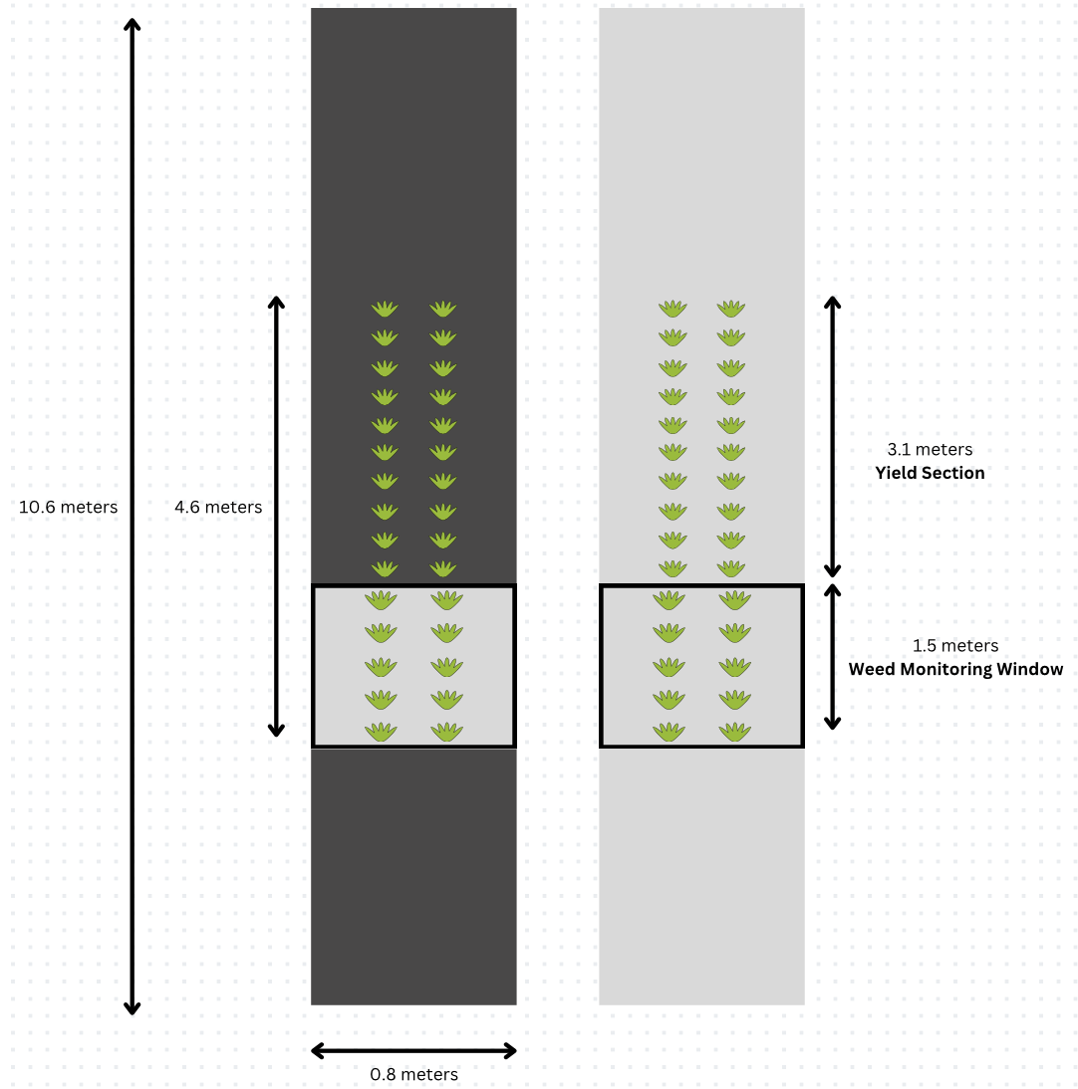 Figure 1. An illustration of the weed monitoring window in black tarp (left) and clear tarp (right) on bed tops measuring 1.5 meters long and 0.8 meters wide. There were 20 strawberry plants in the yield section used for yield collection (Credit: Alana Martin).

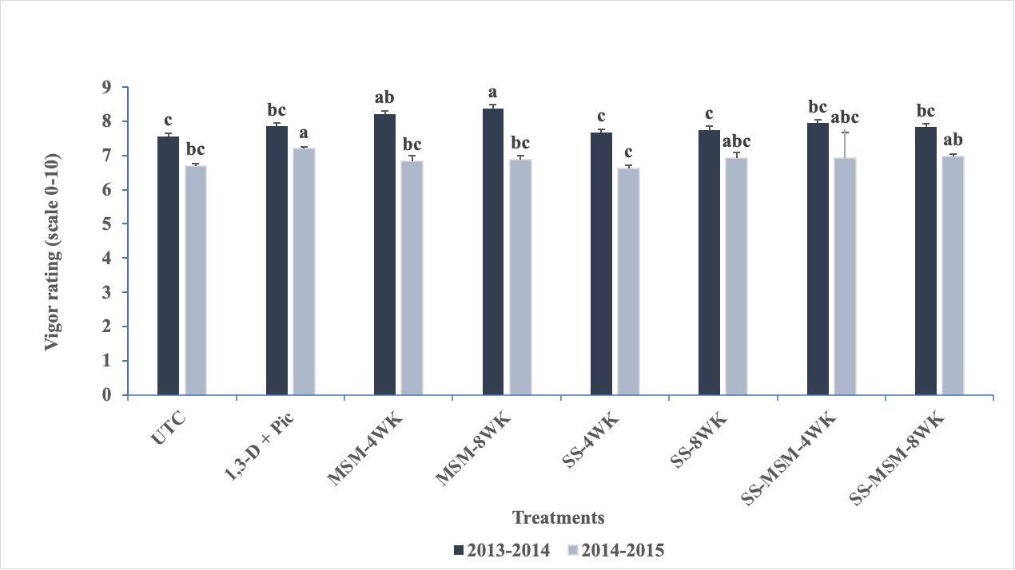
Figure 2. Crop vigor rating is indicated by an index ranging from 0 (all plants are dead) to 10 (all plants are vigorous and no disease) and averaged for each season. All strawberry plants in each plot were evaluated visually. Abbreviation: UTC, Untreated control; 1,3-D + Pic, 1,3-dichloropropene (40 %) + chloropicrin (60%); MSM-4wk, mustard seed meal, 4 weeks; MSM-8wk, mustard seed meal, 8 weeks; SS-4wk, soil solarization, 4 weeks; SS-8wk, soil solarization, 8 weeks; SS-MSM-4wk, soil solarization, mustard seed meal, 4 weeks; SS-MSM-8wk, soil solarization, mustard seed meal, 8 weeks. Values in the bar graph are presented as mean with standard error. Treatment means for each growing season, with the same letters are not significantly different based on Fisher`s Least Significant Difference at alpha= 0.05.
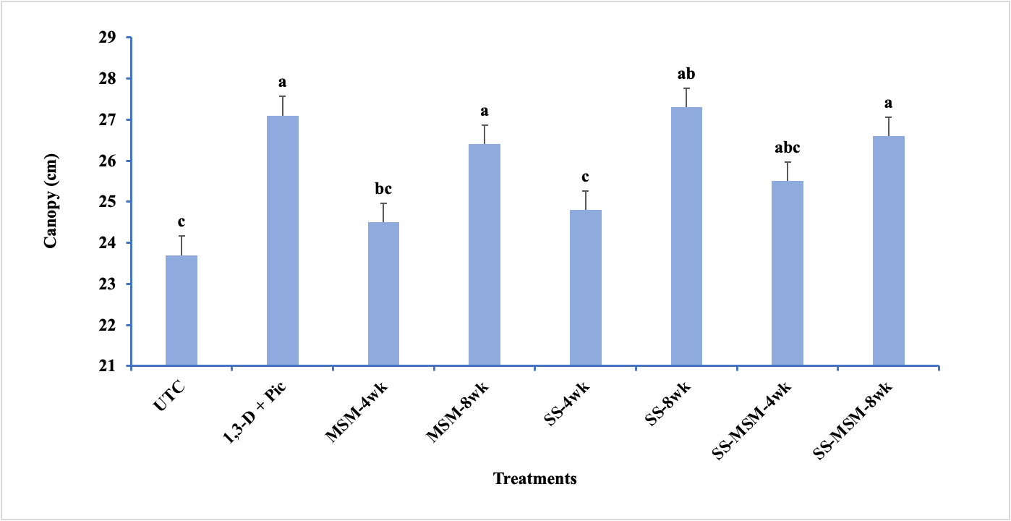
Figure 3. Main treatment effect on plant canopy diameter of strawberries in the 2013/14 and 2014/15 growing seasons Abbreviation: UTC, Untreated control; 1,3-D + Pic, 1,3-dichloropropene (40 %) + chloropicrin (60%); MSM-4wk, mustard seed meal, 4 weeks; MSM-8wk, mustard seed meal, 8 weeks; SS-4wk, soil solarization, 4 weeks; SS-8wk, soil solarization, 8 weeks; SS-MSM-4wk, soil solarization, mustard seed meal, 4 weeks; SS-MSM-8wk, soil solarization, mustard seed meal, 8 weeks. Treatment means with the same letters are not significantly different based on Fisher`s Least Significant Difference at alpha= 0.05. Data were collected on 20 plants per replicate. Values presented are mean with standard error.

