User Documentation

Introduction
This documentation will walk you through the setup and running procedures of the get_tiff.py program. This program will assist you in pulling sea surface temperature data and sea surface salinity data.

Step 1: Program Installation
There are two necessary files: get_tiff.py and convert_folder.py. This program will need a clean working directory to download data and store the raw and TIFF data files. Thus, once downloaded, move both files to a designated folder on your computer. The main program file is get_tiff.py. This is the file that you will run in order to grab and convert data. However, get_tiff.py relies on convert_folder.py, so that is why it is important for both of these files to be in the same location on your computer.

Step 2: Installing Dependencies
Next, ensure that the following libraries, shown in Figure 1 and Figure 2, are installed using your package manager of choice (pip, conda, etc.)

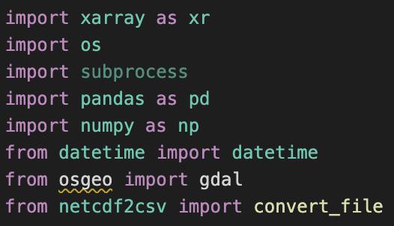

Figure 1: Libraries

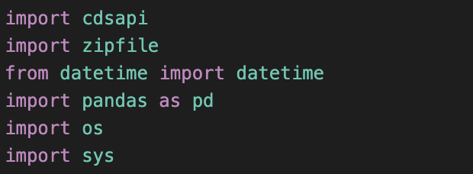
Figure 2: More Libraries

These libraries are necessary for the program to run. From personal experience, conda was the easiest package manager to do this in. Stackoverflow is immensely helpful for solving errors should you experience any difficulties installing any of the libraries.

Step 2: API Key Setup
The cdsapi Python library requires some additional setup. If you don’t already have an account with https://cds.climate.copernicus.eu/, create one. Then, navigate to your user profile and find your personal UID and API Key. Take note of these values shown in Figure 3.

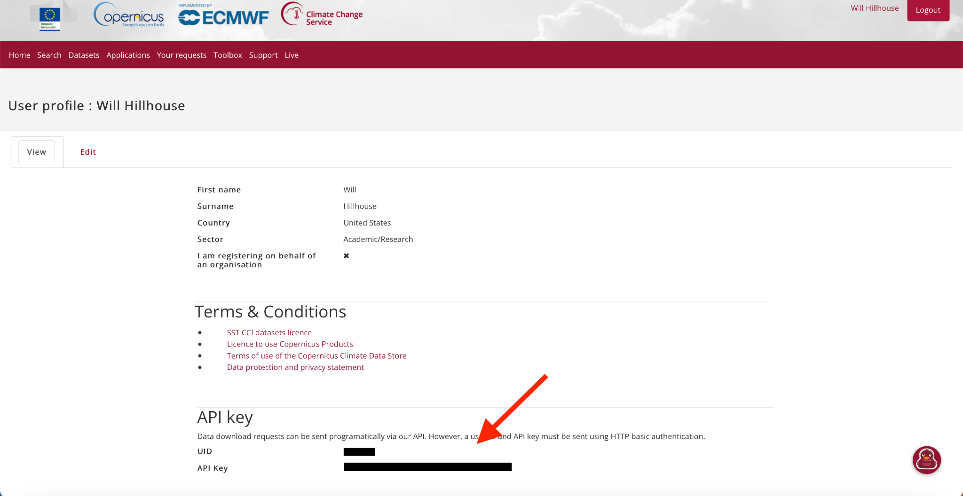
Figure 3: API Key Setup

Next, in the folder “/Users/{your username}/” on your computer create a file named “temp.txt”. We will need to change the name of this file later. Copy and paste the following two lines into the newly created file:

url: https://cds.climate.copernicus.eu/api/v2
key: {UID}:{API Key}

Replace “{UID}” and “{API Key}” with your personal UID and API key. Now, open a terminal and navigate to the folder “/Users/{your username}/” on your computer. Then, type the following command to change the name of your temporary text file to the required name for the Python library:
mv temp.txt .cdsapirc
If you are on a Windows machine use this command:
rename temp.txt .cdsapirc
Once this is complete, the cdsapi Python library will be able to set up a client when the program is run.

Step 3: Running the Program
The final step is running the program. The program has two primary commands and a “help” command. The first command allows the user to specify a range of dates to grab surface temperature and surface salinity data for. This command is specified by a “-dr” in the command line argument and takes two inputs: “start_date” and “end_date”, both taking the form “MM/YYYY”. The second command allows the user to specify a single month to grab surface temperature and surface salinity data for. This command is specified by a “-d” in the command line argument and takes one input: “date”, which also takes the form “MM/YYYY”. The “help” command is specified by a “-h” in the command line argument and takes no inputs. This command prints out a help menu for the two commands described above and provides examples for running both commands. This help menu is shown in Figure 4.

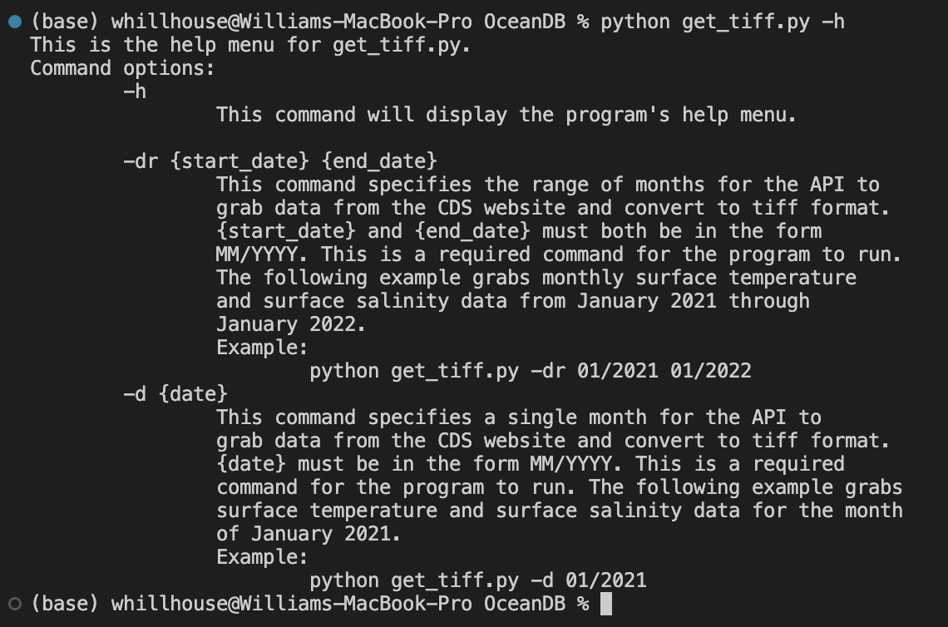
Figure 4: Help Menu

Step 4: Final Outputs
The final output of this program creates two folders in the directory where get_tiff.py is located. The first folder is called “raw_data”. This folder contains the raw NetCDF files for the month/months that the program downloaded from the CDS website using the API. The second folder is called “tiff_data”. This folder contains the final TIFF files for surface temperature and salinity data that were converted from the raw NetCDF files. This folder is organized by surface temperature and salinity, and further organized by year. Each TIFF file takes on the naming convention: “MM_YYYY_sosaline.tiff” for salinity, or “MM_YYYY_sosstsst.tiff” for surface temperature.

