College Match and Undermatch: Assessing Student Preferences, College Proximity, and Inequality in Post-College Outcomes

ABSTRACT

Recently, multiple studies have focused on the phenomenon of “undermatching”—when students attend a college for which they are overqualified, as measured by test scores and grades. The extant literature suggests that students who undermatch fail to maximize their potential. However, gaps remain in our knowledge about how student preferences—such as a desire to attend college close to home—influence differential rates of undermatching. Moreover, previous research has not directly tested whether and to what extent students who undermatch experience more negative post-college outcomes than otherwise similar students who attend “match” colleges. Using ELS:2002, we find that student preferences for low-cost, nearby colleges, particularly among low-income students, are associated with higher rates of undermatching even among students who are qualified to attend a “very selective” institution. However, this relationship is weakened when students live within 50 miles of a match college, demonstrating that proximity matters. Our results show that attending a selective postsecondary institution does influence post-college employment and earnings, with less positive results for students who undermatch as compared with peers who do not. Our findings demonstrate the importance of non-academic factors in shaping college decisions and post-college outcomes, particularly for low-income students.

KEYWORDS

Higher Education, Undermatching, Inequality, College Proximity

Introduction
The problem of finding a good “college match” has interested educational researchers for some time. Previous research examines college choice from a number of angles, including: why students attend college (Cabrera & La Nasa, 2000; Perna, 2006), how choices vary by racial/ethnic group (Hurtado et al., 1997; Perna, 2000), and the factors that help determine whether they will persevere in college (Morgan, 2005). An aspiring student’s college choice process may be hampered due to less access to valuable cultural and social capital that can influence where students apply; how they determine what makes a good college match; and their ability to navigate organizational aspects such as choosing a major, finding mentors, enrolling in classes, and preparing for future employment (Grodsky & Riegle-Crumb, 2010; Author, 2011). Lack of “college knowledge” may lead to less advantageous choices for minority, low-income, rural, or first-generation college attendees in particular (Kao & Thompson, 2003).
Recently, studies have focused on the phenomenon of students who undermatch; that is, students who attend a college for which they are overqualified (as measured by test scores and GPA). The extant literature suggests that undermatching is negative and representative of poor decision-making; that is, students who choose a college for which they are overqualified are not maximizing their educational potential (Hoxby and Turner, 2013). Thus, the college match literature tends to foreground a knowledge deficit approach, focusing on what prospective college students lack. Consequently, we know comparatively little about the extent to which consciously chosen student preferences—such as a desire to stay close to home—may outweigh academic match factors. For students in regions lacking a range of higher educational institutions at different selectivity levels, finding a match institution can be a challenge, particularly for students who express a preference to remain at home while attending college. Living at home during college is a strategy disproportionately employed by low-income students (Author, 2015), pointing to the possibility for geographic factors to exacerbate undermatching among students with fewer economic resources.
Regional case studies have provided valuable in-depth context for understanding why some students may undermatch (Bowen et al., 2009; Roderick et al., 2011). However, we need to know more about whether and to what extent college match matters for college completion and labor market outcomes. Though previous researchers have examined the in-school experiences of undermatched students, to our knowledge, none have assessed whether students who undermatch have less advantageous early career outcomes as compared to otherwise similar students who do not undermatch.
Our study uses the Education Longitudinal Study of 2002 (ELS:2002) to evaluate two primary research questions: (1) To what extent do students’ preference to attend college close to home and the availability of proximal match colleges influence whether or not students enroll in a match institution? and (2) What are the effects of college match and “mismatch” for students’ college completion and postgraduate outcomes, including employment and income? To answer these questions, we provide an overview of the factors that affect college match, including how rates of undermatching vary by race/ethnicity, gender, geographic region, student preferences and the availability of proximal match colleges. In the next stage, we assess the consequences of undermatch for college and labor market outcomes, as well as potential differences in effects by race/ethnicity, gender and level of college selectivity qualifications. Earnings gaps by gender, race/ethnicity, and social class background remain a serious concern, and it may be that undermatching exacerbates these gaps. Our focus on level of college selectivity considers whether the effects of undermatching vary by the level of college selectivity students are eligible to attend. For example, if undermatching has more deleterious effects for students qualified to attend “selective” colleges compared to the effects for those qualified to attend “somewhat selective” colleges, this will assist educators in focusing intervention strategies.
Our findings demonstrate the importance of non-academic factors in shaping students’ college attendance decisions, particularly among low-income students. Students who state a preference for a low-cost college, or a college close to home, are more likely to undermatch than otherwise similar students. However, this relationship is attenuated when students live within 50 miles of a match college. We show that undermatching is indeed associated with less favorable post-college outcomes, as compared with outcomes for comparable students attending a match college, including lower earnings and lower likelihood of employment. We find little evidence to suggest that the observed negative effects of undermatching for employment and earnings vary by race/ethnicity or gender. However, we note that the effects of undermatching do vary by level of college selectivity qualification; college completion and full-time employment outcomes appear to be most strongly negative among students who attend non-selective institutions, yet whose highest qualification level was “somewhat selective.” Taken together, these findings lead us to reconsider the extant literature’s attention to individualistic interventions, given the importance of geographic considerations and the fact that a significant proportion of students express a preference to remain close to home. We suggest moving the undermatching conversation toward consideration of structural solutions, such as improving regional higher education offerings, in order to better serve the significant proportion of students whose academic preparedness gives them access to an institution that is somewhat selective or above, yet do not live within a reasonable distance of a match college.

Literature Review
Undermatching refers to the phenomenon of highly-prepared students applying to and attending less selective colleges, for which they are overqualified as measured by high school grades and test scores. Concerns about undermatching are largely shaped by two assumptions: that students would not choose to undermatch if they had better information (i.e. the “information deficit” argument) and that undermatching leads to less advantageous college and postgraduate outcomes (i.e. the “maximization” argument) (Hoxby and Avery, 2013). Both the information deficit and maximization arguments are typically elaborated within a rational choice framework, focusing on individual choices and decision-making. Alternatively, viewed through the lens of conflict theory, the factors that lead students to undermatch illustrate how the U.S. education system serves as a stratifying institution, facilitating the unequal distribution of the benefits of college along class lines (Author, 2017; Collins 1971; Tiboris, 2014). Yet, some researchers disagree that undermatching has such deleterious effects, arguing that the extant literature privileges some forms of college match over others (Bastedo & Flaster, 2014; Fosnacht, 2014; Tiboris, 2014). Students may make informed decisions to attend less selective colleges, discarding a maximization strategy in favor of a preference for geographic location, “fit,” family ties, or lower costs.
We begin by reviewing the prior research on which groups are most likely to undermatch, and why. Then, we turn our attention to two remaining gaps in the literature on college match that are the focus of our study: geographic considerations, including the potential influence of region and college proximity on college decision-making; and the potential for college match and undermatch to shape college completion and early career outcomes.

Factors Leading to Undermatch
Despite the ever-growing number of students who seek to attain a higher education degree, educational researchers have noted that the enrollment patterns of high-achieving, low-income students do not match those of otherwise similar students from higher-income families (Hoxby and Avery, 2013; Smith, Pender, and Howell, 2013; Bastedo & Jaquette, 2011). For example, Smith, Pender, and Howell (2013) find that students in the lowest quartile income bracket are 24% more likely to undermatch than the highest income students. From a rational choice perspective, students who undermatch—particularly students who are poor, members of historically underrepresented groups, or first-generation college attenders—are making such decisions because they lack the knowledge, attitudes, and preferences that would facilitate elite college attendance (Deutschlander, 2017). Thus, a rational choice framework presumes that students suffer from an information deficit, and that once this deficit is corrected, students will prefer to apply to the highest quality school possible in order to maximize their outcomes. Of course, not all low-income high achievers undermatch. Hoxby and Avery (2013) describe two pathways among low-income college aspirants. “Achievement-typical” students’ college application patterns resemble those of upper-income high-achieving students; these students seek to attend the most prestigious institution they qualify to attend. In contrast, “income-typical” students’ application patterns do not prioritize colleges by academic rank; these students tend to favor colleges that are affordable or close to home (Hoxby and Avery 2013). This perspective informed the focus of an experiment conducted by Hoxby and Turner (2015), which utilized an individual-level information-based intervention aimed at encouraging income-typical students to place a higher value on colleges’ academic rank, with the goal of changing their application behaviors.
Though the undermatching literature is primarily concerned with low-income high achievers, researchers have also investigated race/ethnicity as a potential mediating factor. For example, Bowen et al. (2009), find that more than 24 percent of all high-achievers are racial and ethnic minorities; however, racial/ethnicity minority group members make up roughly 30 percent of low-income high-achievers, as compared with 18 percent for whites. Because underrepresented minority students are more likely to be economically disadvantaged relative to whites, the intersections of other identities with class further highlights the stratifying factors that lead to differential outcomes. For instance, Black, Cortes, and Lincove (2015) examine Texas’s Top Ten Percent Plan, a race-neutral policy that guarantees admission to one of Texas’ public universities to students graduating in the top 10 percent of their high school class. They find that black and Hispanic students remain disproportionately likely to undermatch compared to their white and Asian peers: 68% of white and 79% Asian students in the top 10% apply to flagship colleges compared to 47% of black and 51% of Hispanic students. Moreover, only 29% of black and 32% of Hispanic students ultimately enrolled, and these differences were mitigated only for black students whose AP and exit exam outcomes exceeded the average for entering top-tier college freshmen (Black, Cortes and Lincove 2015; see also Bowen et al. 2009; Roderick et al. 2008; Smith, Pender and Howell 2013). As Black et al. (2015) contend, even with “perfect information”—guaranteed acceptance to a top-tier university—undermatching still occurs, particularly among historically underrepresented groups. Though the authors suggest that physical distance may be a factor explaining the observed rates of undermatching, they do not assess geographic factors or college proximity.
Multiple studies suggest that higher rates of undermatching among racial/ethnic minority groups and low-income students are explained by the overrepresentation of these students in lower-quality schools. For instance, Roderick et al. (2008) consistently find support for the importance of a high school’s “college-going culture” when matching students with colleges based on academic qualifications. Similarly, low-income students more often attend schools in districts with under-resourced public high schools, are not in cohorts with many high achievers, and are unlikely to encounter teachers or advisors who attended a selective college (Hoxby and Avery, 2013; Rodriguez, 2013). Even after controlling for relevant self-selection and demographic variables, students with access to high schools with affluent peers, Advanced Placement course offerings, SAT preparatory courses, and lower pupil-to-student ratios are more likely to enroll in selective and elite colleges (Hurwitz, Smith, Howell, & Pender, 2012; Klugman, 2012). Thus, differential distribution of school-based resources influences students’ college choice set, leading to undermatch for students who are disadvantaged in an educational system that is stratified by class and race/ethnicity.
Interventions that improve the quantity and quality of college preparation—increasing resources in low-income schools, and “correcting” individuals’ information deficits—may provide income-typical students the opportunity to make different choices by broadening their college choice set. For example, treated students in Hoxby and Turner’s (2015) experiment were given customized information including college costs, how to apply, and graduation rates. They were also provided with fee waivers. Results found that treated students were 56 percent more likely to apply to match colleges. Roderick et al (2008) show that students qualified to attend selective or very selective colleges who have strong connections to teachers and have discussions at school about the college planning process are 9 percent more likely to attend a match school than peers who did not have such mentorship. Even so, as pointed out previously, perfect information does not provide perfect protection against undermatching for low-income and historically underrepresented students (Black, Cortes and Lincove, 2015). This literature lacks information on how students’ preferences inform their college decisions. That is, students may make informed decisions that do not fulfill the expectations of the maximization argument.

Student Preferences, Region, and College Proximity
Multiples studies have found that students utilize a holistic college decision-making approach that includes a number of non-academic factors—some of which may lead to undermatching—such as cost, opinions of peers and family, college fit, and geographic location (Black et al., 2015; Burkander, 2014; Park, 2013; Tiboris, 2014). Called the preferences approach, this perspective considers the autonomy of student choices outside of economics-based models that typically assume that patterns of college attendance among high-income families are the norm. Tiboris (2014) argues that, in many cases, “Undermatching...is based on autonomously chosen and defensibly authentic commitments” (p. 650). Viewed through the preferences lens, we would be remiss in attempting to persuade students to “reject these commitments” based on assumptions that students are not acting in their own best interest (Ibid.).
Geographic location presents a problem for low-income, highly-prepared students who might prefer to attend a selective college. Previous research notes that there is a mismatch in the location of selective colleges and the location of high schools from which underrepresented high-achievers are likely to be recruited, and that travel costs are typically not covered by financial aid packages (Griffith & Rothstein, 2009; Hill & Winston, 2010; Hillman, 2016; Hoxby & Avery, 2013). Approximately 46 percent of elite colleges are located in the Northeast, yet just 12 percent of students with a GPA of 3.5 or higher who are in the bottom income quartile live in the Northeast (Griffith & Rothstein, 2009). Griffith and Rothstein (2009) argue that college proximity has two distinct effects on application decisions: (1) Distance can impose travel costs that are not covered by financial aid. Consequently, students may attend college close to home for convenience, lower travel costs, and for the option of living at home to avoid paying for room and board, and (2) Living close to a selective 4-year college can expose students to what these colleges have to offer and encourage students to try to attend a selective 4-year college. Both effects suggest that as distance to a selective college increases, the likelihood that a student may decide to apply decreases, regardless of their level of college preparedness. As such, the proximity of potential match colleges may influence student preferences in ways that increase the likelihood of undermatching, particularly for low-income college applicants.
Relatedly, researchers have addressed the possibility that students disfavor more distant, selective colleges because they take cultural and familial factors into consideration when formulating their college choice set. Such students may decide that they will not fit in at such schools due to as assumption of cultural mismatch. Tinto (1987), in his widely cited theory of college retention and fit, argues that both individual (intentions and commitments) and institutional (adjustment, difficulty, incongruence, and isolation) considerations interact to create a college adaption process akin to assimilation to an “academic culture” (see also Author, 2011). Successful students—those who are academically prepared and who come from college-going homes and schools—will replace their home with this new academic environment. Yet, critics of Tinto’s theory have referred to this process as “cultural suicide” for historically underrepresented students (Tierney, 1999; Author, 2011). In other words, as Burkander (2014) argues, college match is a product not of just an individual’s access to information from college, but of their cultural, classed, and regionally informed identities in the context of both home and school.

Undermatching Outcomes
In framing the need for interventions to address undermatching, Hoxby and Avery (2013) make two claims: (1) Selective colleges want low-income, high-achieving students to attend; therefore, undermatching is the effect of decisions made by students, not institutions; and (2) The application stage is where differentiation between achievement-typical and income-typical students occurs, because low-income, high-achieving students who begin at a selective colleges have similar rates of persistence and achievement as their high-income, highly-prepared peers. Consequently, Hoxby and Avery (2013) direct our focus towards the early stages of the college choice process—the pre-college phase—as the genesis of college mismatch.
At the matriculation stage, results are mixed, signaling that negative and positive outcomes are not clearly delineated between those who undermatch and those who do not. Fosnacht (2014), for instance, finds that students who undermatched engaged in more active and collaborative college environments, though they also perceived less challenging experiences and reported less satisfaction in college than matched peers. Similarly, Kurlaender and Grodsky (2013) find that while undermatched students accumulate more credits when they attend less demanding institutions, they do not earn higher grades. Finally, Bowen et al. (2009) note that the “big-fish-little-pond” circumstance that undermatching creates may lead to a lower likelihood of graduating from college.
What is rarely considered in previous studies on undermatching, as noted by Radford (2013), Bastedo and Flaster (2014), and Park (2013), is the entire process of college choice, from predisposition, preparation, application, and matriculation to persistence, graduation, and beyond. In particular, we know surprisingly little about the post-college income and employment outcomes of students who undermatch, as compared to otherwise similar peers who attend match institutions. Previous literature on college outcomes has noted the benefits of attending a selective college, including rich instructional, extracurricular and financial resources as well as presumed post-graduation benefits including improved social/occupational networks; graduate and professional school attendance; rates, sector, and level of employment; and post-college earnings (Hoxby & Avery, 2013; Bowen et al., 2009, Baum et al., 2010; Bastedo & Jaquette, 2011; Kurlaender & Grodsky, 2013; Rodriguez, 2013). As Student Financial Aid Services Inc. (2014) states, “College undermatching threatens [the] nation’s future talent pool... This not only perpetuates the cycle of poverty, but also robs our nation of smart, diverse leadership to solve future problems” (p. 1). As a policy concern, then, undermatching evokes apprehension for both individual and social outcomes, in the form of lost income and productivity. Yet, while the benefits of selective colleges are often described, the link between college match and post-college labor market outcomes has yet to be directly measured.
In sum, strong concerns remain about the potential for undermatching to negatively affect students’ college outcomes, particularly given the demonstrated higher rates of undermatching among historically underrepresented and low-income students. Moreover, undermatching is framed as a potential loss for society in general, as the nation misses out on the contributions of a significant portion of the populace who do not make their way to the elite colleges they are qualified to attend. However, these concerns are primarily framed with the expectation that, given the correct information, students will naturally make the choice to maximize their educational outcomes by attending the highest-selectivity college for which they are qualified. Previous research has not adequately explored the extent to which other important match factors—including student preferences, geographic location, and college proximity—additionally shape college decisions, including the choice to undermatch. Finally, the extant literature relies on findings related to the benefits of attending elite colleges to conclude that students who undermatch will experience worse college outcomes than otherwise similar students who do not undermatch, yet fails to provide valid, nationally-representative comparisons to fully test this assumption.

Data and Methods

ELS captures critical life transitions among a cohort of students who were in the tenth grade in U.S. public and private schools in 2002. Three follow-ups were conducted in 2004 (12th grade), 2006 (two years after high school) and 2012 (eight years after high school). Seven hundred and fifty schools participated in ELS, accounting for more than 15,000 student and parent survey responses. In-school survey questionnaires were administered for the base year and first follow-up, while subsequent rounds were completed with a mixture of mailed surveys, telephone, and in-person interviewing. Detailed information was collected on students’ family background, academic performance, college admissions test scores, college applications, colleges attended and early labor market outcomes. We combine ELS data with information on the academic selectivity of colleges using the Barron’s Admissions Competitive Index. The Barron’s Index categorizes colleges into 7 ordered categories based on SAT/ACT scores of admitted students, acceptance rate, and the high school grade point average and class rank required for admissions.
Estimating academic undermatch is a complex process. Regardless of approach, no perfect method exists (Rodriguez, 2015). Our approach is similar to those taken in three prior regional and national studies (i.e., Bowen et al., 2009; Roderick et al., 2008; Smith et al., 2013). We use the Barron’s classifications to estimate the highest level of college selectivity a student qualifies to attend based on their high school academic credentials and compare that to the college where the student ultimately enrolls. To determine whether a student qualifies to attend a college of a given selectivity level, we use a probit model to predict whether a student is admitted to any college in each selectivity level as a function of their high school grade point average, their scores on NCES-administered tests of math and reading achievement, Advanced Placement (AP) participation, and International Baccalaureate participation. Students need not apply to a school in a given selectivity level to be included in this model since high school credentials should impact both the probability of applying to schools in each selectivity category and the probability of acceptance conditional on application. After predicting each student’s probability of admission to each college selectivity level, we determine the highest level to which they qualify for admission. We set the threshold for determining qualification to a given selectivity level at .90, following the method using by Smith, Pender and Howell (2013). Students are classified as having undermatched if the institution they attend is of a lower selectivity than the highest selectivity level to which they qualify.
Our analysis includes 2 primary components. First, we examine the demographic, socioeconomic, and geographic factors associated with undermatching as well as some of the mechanisms that may lead some groups to undermatch more than others. Second, we compare college graduation rates and early labor market outcomes of students that undermatch compared to otherwise similar students who do not.
First, we use linear probability models to examine the student characteristics associated with undermatching. The covariates used in these models include: student demographics and socioeconomic status (race/ethnicity, parental education, parental income, generational status [e.g., “first generation” students are first in their family to attend college], and student gender); student academic achievement (high school GPA, test scores, participation in the AP and International Baccalaureate programs); and whether there is an academic match school within 50 miles of the student’s home. Including high school achievement measures as predictors of undermatching shows whether undermatching is more or less concentrated at different points in the achievement distribution. Many studies show that the availability of proximal colleges influences students’ enrollment decisions, particularly the decisions of lower income students who may be the most likely to undermatch (Author 2015; Tinto 1973; Turley 2009). Including an indicator for the availability of a match school close by helps investigate this directly. We also include interactions between college proximity and student demographics to see if some students’ enrollment decisions are more influenced by the availability of local colleges than others. We also estimate models with high school fixed effects to see whether students with different demographic or socioeconomic attributes who attend the same schools vary in their propensity to undermatch. The fixed effects approach is desirable because it controls for all unobservable attributes of the local college context that may be correlated with students’ enrollment decisions as well as differences among high schools in, for example, the availability of college counseling. In addition to examining undermatching overall, we also break up the analysis to examine whether the correlates of undermatching vary at different points in the selectivity distribution.
Second, we use ordinary least squares (OLS), fixed effects and instrumental variables (IV) models to compare college graduation rates and early employment outcomes for students that undermatch with otherwise similar students that do not. The general version of the basic OLS model is:
$Y=β_{1}U+Dβ_{2}+Aβ_{3}+ ε$ (1)
where the outcome Y is predicted as a function of undermatching ($U)$ and controls for demographic, socioeconomic and academic achievement measures ($A)$. The simplest (naïve) model predicts student outcomes (receipt of a bachelor’s degree, unemployment, and earnings) as a function of whether or not the student undermatched and controls for demographic and academic factors. The effect of undermatching in this model may not be causal, however, since other unobserved factors that are correlated with both undermatching and student outcomes remain uncontrolled. Many of these unobserved factors may relate to the local college context or to the availability of college information from high school personnel. Therefore, our second approach adds high school fixed effects to control for all such unobserved differences. Model 2 is identical to Model 1 but with the addition of the school fixed effect:
$Y=β_{1}U+Dβ_{2}+Aβ_{3}+ π_{s}+ε$ (2)
These models, for example, compare the odds of college graduation among students that do and do not undermatch and who attend the same high schools and have similar academic and demographic characteristics. The fixed effects models could still be biased if there are unobserved factors within high schools that are correlated with both undermatching and student outcomes. To address this source of bias, we use an IV model where we instrument for undermatching using the proximity from a student’s high school to the closest college in the highest selectivity category to which they qualify based on their high school credentials. We use linear, quadratic and cubic terms of the logged miles to the closest match school in the model (see Table 6 for the first stage IV results).
$U=β_{1}Ln(Miles to Match)+{β_{2}Ln(Miles to Match)}^{2}+{β_{3}Ln(Miles to Match)}^{3}+Dβ_{2}+Aβ_{3}+ε$ (3)
In the second stage we use the predicted values of U to identify the effect of undermatching on student outcomes:
$Y=β_{1}Û+Dβ_{2}+Aβ_{3}+ε$ (4)

Prior studies have used proximity to local colleges to instrument for college attendance and have found that it is a strong instrument. The instrument used here varies within high schools since it depends not only on the proximity of colleges but also on students’ academic credentials, which vary within schools. Here we identify the effect of undermatching on student outcomes by only using the variation in undermatching that is induced by proximity to colleges in students’ highest academic selectivity qualification range.

Results

Descriptives
In Table 1 we begin by showing some descriptive information on colleges in each Barron’s classification. There are 190 institutions that receive Barron’s rankings of most or highly competitive. This constitutes about 13 percent of all four-year colleges. Nearly half of four-year colleges fall into the somewhat selective (competitive) category, while about 20 percent fall into the selective (very competitive) and non-selective categories. The median student lives about 45 miles from a very selective institution, 14 miles from a somewhat selective institution, and about 7 miles from a two-year institution. While the vast majority of students have a two-year college within 50 miles of their residence, only about half of students have a very selective college within 50 miles of their residence. Not surprisingly, students that attend very selective institutions travel much farther from home for college compared to students that attend less selective colleges (Hoxby, 2009).
In Table 2 we show the percentage of students that undermatch. The upper panels tabulate the level of institution attended by students with the highest level of institution students qualified to attend. The shaded cells indicate the students that are considered to have undermatched. Our findings here are similar to those of Smith, Pender and Howell (2013). Therefore, we provide a brief overview of the landscape of undermatch before turning to our main variable of interest in the lower panels: proximity to a match college.
Overall, we find that 39 percent of students undermatch. However, 45 percent of students who qualified to attend “very selective” institutions undermatch compared to only 34 percent of students whose highest eligibility level was “somewhat selective” institutions. This is not surprising given that there are far fewer very selective colleges. Moreover, those few that do exist tend to be located further away from the median student’s home than less selective colleges (as shown in Table 1). More than 80 percent of students who qualified to attend a very selective or selective college either overmatch, match, or attend a college one selectivity category below the highest level of college they were eligible to attend. By contrast, students qualified to attend somewhat selective or non-selective four-year colleges are more likely to enroll in two-year colleges or to not attend college at all.
The lower panels of Table 2 show our results disaggregated by race/ethnicity, income level and the presence of a match school within 50 miles. Unlike previous studies, we display these results by level of college selectivity to explore how rates of undermatch vary by selectivity level. In contrast to Smith, Pender and Howell (2013), we see very similar overall rates of undermatching for Hispanic students relative to white students. Black students are less likely than white students to undermatch (30 percent versus 41 percent) but much of this is due to the fact that black students are qualified to colleges of lower selectivity than white students based on their prior academic achievement. However, for both of these historically underrepresented groups, rates of undermatch vary by level of college selectivity eligibility relative to white students. Black students are more likely than whites to undermatch at the highest selectivity levels, while the opposite result is observed for Hispanic students. Lower income students are much more likely to undermatch than higher income students (47 percent versus 33 percent). This is the case at each level of selectivity access. Lastly, we show that rates of undermatching are lower for students who live in close proximity to a match school. Thirty-eight percent of students with a match school nearby undermatch, compared to 44 percent of students without a match school nearby.

Correlates of Undermatching
Next, in Tables 3–5 we examine the correlates of undermatching. Table 3 includes all students, Table 4 includes students eligible to attend a very selective institution and Table 5 includes students eligible to attend a very selective or selective institution. First, in Table 3 we see evidence that parent income and education levels are strongly correlated with undermatching. The probability of undermatching is about 20 percent higher for students whose parents earn less than 50 thousand dollars per year compared to students whose parents earn 100 thousand dollars or more. The probability of undermatching is 21 percent lower for students with a college educated parent relative to students whose parents did not graduate from high school. Model 1 also shows that higher levels of math achievement are associated with lower probabilities of undermatching.
In models 2 and 3 we add measures that capture whether the student has a match school within 50 miles of their home residence as well as several measures of student preferences for different college characteristics. The probability of undermatching is about 5 percent lower for students that live within 50 miles of a match school. Similarly, students who value the academic reputation of colleges and who want to live away from home during college are less likely to undermatch. Students who are concerned about college costs and those that prefer to live at home during college are more likely to undermatch. The interaction included in model 3 suggests that, although students who want to live at home during college are more likely to undermatch, this relationship is weaker when the student lives within 50 miles of a match school. The results from this model highlight the importance of geographic constraints for students’ college choices. Model 5 adds high school fixed effects to the model. Here we see that most of the associations described previously retain statistical significance, even when comparing students attending the same high schools. Parent income and educational attainment, high school achievement, proximity to a match school, and various college preferences remain associated with the probability of undermatching among students attending the same high schools.
When we restrict the analysis to students who qualify to attend a very selective institution (Table 4) or who are eligible to attend a very selective or selective institution (Table 5), the results are largely consistent with those presented thus far. There are a few exceptions. In Table 4, we see that black students who qualify to attend a very selective institution are much more likely to undermatch than otherwise similar white students. This was not the case in Table 3, where we found lower rates of undermatching among black students across the entire sample. Low income students who qualify to attend a very selective institution are more likely to undermatch than high income students, but that relationship is weaker when there is a match school within 50 miles of the student’s residence (Table 4, model 4).
Overall, the results from Tables 3–5 suggest that lower levels of parent income and education, lower academic achievement, lack of proximity to a match school and preferences for a low cost college that is close to home are consistent predictors of undermatching. Though black students are less likely to undermatch than white students on average, this is due to the fact that they qualify to attend less selective schools. When we restrict the analysis to students qualified to attend a very selective institution, we find that black students are much more likely to undermatch than white students.

Career Outcomes
In the final stages of our analyses, we examine the relationship between undermatching and student early career outcomes by the 2012 follow-up. The estimate of interest from Model 1 is $β_{1},$ which shows whether students that undermatch experience different college and employment outcomes than otherwise similar students that do not undermatch. The results from this model are shown in model 1 of Table 6. The probability of bachelor’s degree receipt is 18 percent lower for students that undermatch relative to other students who attend college. However, this estimate could be biased due to unobserved factors correlated with both undermatching and college outcomes. Our first approach to controlling for this endogeneity is to include high school fixed effects to control for unobservable regional differences in the availability of colleges and differences between high schools in school quality. Model 2 includes the addition of the school fixed effects. In the fixed effects models, students who undermatch are 14 percent less likely to receive a bachelor’s degree compared to students who do not undermatch, as shown in Table 6. A final approach to account for the endogeneity of undermatching is to instrument for undermatching using the distance between students’ high schools and the closest university that provides an academic match. We use the log of the miles to the closest match school, since the measure tends to be skewed. The model also includes a quadratic and cubic to account for non-linearities. In the second stage we use the predicted values of undermatching to identify its effect on student outcomes.
Results from the first stage estimation are shown separately in Table 12 (see Appendix A). Consistent with the results presented in Tables 3–5, students that live farther away from a match school are more likely to undermatch. Results from the second stage are presented in model 3 of Table 7. The standard errors increase significantly in the IV models compared to the OLS and FE models, but the point estimate remains statistically significant. In the IV model, students that undermatch are 20 percent less likely to receive a bachelor’s degree than students who do not undermatch.
Table 7a repeats the main models in Table 7 separately by the highest level of college selectivity the student qualified to attend. In Table 7a, the effect of undermatching seems the most strongly negative for students whose highest qualification level was “somewhat selective.” Referring back to Table 2, we saw that the majority of students eligible to attend a “very selective” or “selective” institution who undermatch attend a college that is at least somewhat selective or better. In contrast, undermatching students whose highest qualification level is somewhat selective attend a non-selective college or two-year institution.
Table 8 shows the results for respondents’ early career outcomes, including employment and earnings in 2012. Among all students, in model 1, those who undermatched are three percent less likely to be employed full time, and earn nearly $3,000 less than those who did not undermatch. In the fixed effects and instrumental variables models (Models 2 and 3), we see increased chances of unemployment among undermatched students compared to matched students, and the income gap surpasses $12,000 annually. Results are similar when we reduce the sample to those not currently enrolled in a postsecondary institution.
Similar to Table 7a, Table 8a repeats the main models in Table 8 by students’ highest level of selectivity. The analysis in Table 8a shows generally non-significant results when estimated separately by highest selectivity qualification. However, the instrumental variables models do predict more negative employment and earnings outcomes for students who qualify to attend very selective colleges who undermatch, and more negative full-time employment for undermatching students whose highest qualification level was somewhat selective.
The right side of Table 8 shows the results of these early career outcomes for students who, in 2012, were not currently enrolled in any postsecondary institution. Consistent with the results for all students, those who undermatched are less likely to be employed, and their earnings are lower. In model 1, undermatched students who are not enrolled in postsecondary education in 2012 are 4 percent less likely than matched students to be employed, and are nearly 6 percent less likely to be employed full time. Those who undermatched earn approximately $3,000 less than those who attended a match institution. After adding high school fixed effects in Model 2, these relationships decrease slightly. In the IV model (model 3), on the other hand, undermatched students are 21 percent less likely to be employed full time. This suggests that, compared to all students, students who undermatched and are not currently attending postsecondary institutions fare worse in terms of employment overall.
Tables 9 and 10 show the results for respondents’ early career outcomes, including employment and earnings in 2012, but focus on racial/ethnic and gender interactions. These interactions examine whether women and historically underrepresented racial/ethnic groups are especially disadvantaged when they undermatch as compared to similar males and white students. On the left side of Table 10, OLS and fixed effects models suggest a small (p≤.10) additional disadvantage for women who undermatch, as compared with male students, but these effects do not attain significance in IV models nor on the right side of the table, among students not currently enrolled in college. Most of these interactions fail to reach significance, suggesting that undermatching in most cases does not “doubly disadvantage” either women or racial/ethnic minority students as compared with similar men and majority group students who undermatch. That is, students who undermatch and some subgroups—most notably, women and black students—experience worse employment and income outcomes compared to students who do not undermatch, men, and whites, respectively, but that the negative effects of undermatching are not exacerbated for historically disadvantaged groups.

Conclusion
In this article, we contribute to the ongoing debate over the importance of finding a good college match. We examine (1) whether and to what extent the undermatching phenomenon—students attending colleges for which they are overqualified—is driven by college proximity and student preferences to remain close to home, and (2) whether students who undermatch experience more negative early career outcomes, as measured by income and employment, than otherwise similar students who do not undermatch. Current research concerned with mismatch tends to focus on student knowledge deficits, suggesting that students undermatch because they lack accurate information about the affordability and benefits of selective and very selective colleges. To date, this body of research has not examined early career trajectories to assess whether undermatching predicts more negative post-college outcomes. Our research seeks to fill these gaps by assessing alternative explanations for undermatching, most notably student preferences and geographic factors, and by exploring early career outcomes using employment and earnings data from recent national longitudinal data. We use high school fixed effects to control for unobserved factors that may relate to students’ local context, such as the availability of college-focused counseling in students’ schools. Our approach also includes using proximity and selectivity (nearest match college) to instrument for undermatching, allowing us to identify the effects of undermatching on college outcomes among otherwise similar students. Our results indicate that lower levels of parent income and education, lower student academic achievement, lack of proximity to a match school and preferences for a low-cost institution close to home consistently predict undermatching. In addition, our findings demonstrate a negative relationship between undermatching and college and early career outcomes, including graduation rates, employment, and income by the year 2012 follow-up, eight years after this cohort of students’ expected high school graduation. Finally, we show that undermatching has the most negative effects—as measured by rates of college completion and post-college employment—for students whose highest selectivity level is a somewhat selective college.
Previous research suggests that students’ lack of information is a major factor leading to students’ failure to attend the most selective higher education institution they are eligible to attend based on their grades and academic preparation. This line of reasoning relies on a rational choice perspective, assuming that if students had accurate information about the highest college selectivity level they are qualified to attend, and were aware of the benefits of attending a more selective college, they would seek to maximize their outcomes by attending the best institution available to them. Accordingly, college interventions aimed at low-income and historically underrepresented applicants tend to focus on student-centered, individualistic solutions—how to encourage academically prepared students to attend selective schools, and how to help selective schools find high-achieving, low-income students. Yet, selective and highly selective colleges are not evenly distributed across the population. Students may have to travel much farther than they would otherwise prefer in order to attend such institutions, making attending a selective or very selective match college a particular hardship for the very students that research suggests would benefit most—low-income students and members of historically underrepresented groups.
We demonstrate that undermatching has significant deleterious effects for important post-college outcomes. We are also interested in exploring the extent to which these negative effects may differentially affect subgroups within the sample. Earnings gaps by gender, race/ethnicity, and social class background have received sustained attention, and it seems possible that undermatching could exacerbate these gaps given the aforementioned higher propensity of women, black students, and lower-income students to undermatch at selective and very selective colleges. Detailed results from the 2012 follow-up (see Appendix B) show that women are 16 percent less likely than men to be employed full-time, and earned about 27 percent less. Similarly, students from lower- and middle-income families earn significantly less than students from families above the $100,000 income mark. Among all students, Black students earned about 20 percent less than white students, or about 15 percent less among students not currently enrolled in college. Controlling for test scores and GPA does not eliminate these gaps. However, we find little evidence in ELS to suggest that the observed negative effects of undermatching for employment and earnings vary by race/ethnicity or gender. That is, our findings demonstrate that these gaps persist even when women, low-income students, and racial/ethnic minority group members attend colleges that are a good match for their level of preparation, and that are comparable to those attended by similarly-qualified men, higher-income families, and whites.
Our results confirm the differential odds of undermatching reported in previous research. Even with the academic qualifications necessary for admission to selective or very selective colleges, some historically underrepresented groups—women, African Americans, and low-income students—remain at greater risk of undermatching than otherwise similar students. These findings lend support to the conflict perspective on higher education: systems of privilege that lead to structural disadvantages for women, low-income and underrepresented minority groups remain in place. Moreover, these disadvantages are not sufficiently ameliorated via higher education; instead, our results suggest that student preferences and geographic factors act as additional constraints on the already limited ability of historically underrepresented groups to utilize attendance at a selective or very selective college as a pathway to mobility. That is, differential access to and distribution of higher education institutions contributes to stratification by race/ethnicity and economic class.
Our analytical focus on regional variation in availability of match colleges highlights an intractable problem that much of the extant undermatching literature fails to address: how to ensure positive college and post-college outcomes for students who live more than 50 miles away from a match school? We find that, among all colleges, propensity to undermatch among students who would prefer to live at home is significantly reduced if there is a match university nearby. Among those with qualifications to attend selective and very selective colleges, having a match school nearby similarly reduces the chances that a student from a low-income family will undermatch. As previous research shows, even when children are open to attending more distant colleges, some families will prefer that their college-aged children stay close to home, and this preference is more often expressed in low-income families and those with a recent history of immigration (Author 2015). For example, even if a Hispanic student living in rural Texas is accepted to Harvard and receives a generous financial aid package, this will not eliminate the higher economic costs of travel and living away from home, and the potentially higher social/emotional costs of being far away from family and support networks. Moreover, there may be little use in arguing for elite colleges to accept more match students that are going unnoticed, if such colleges neither have enough seats available for all qualified students, nor enough interest in expanding their financial aid packages to cover travel and other ancillary costs.
It seems clear that access to a high quality postsecondary institution confers important benefits, and we demonstrate that these benefits extend beyond the college experience to influence employment and earnings. Moreover, we show that the negative post-college effects of undermatching seem to be most deleterious for students whose highest qualification level is somewhat selective, highlighting a significant distinction between the benefits conferred by attendance at colleges with at least a minimal degree of selectivity, and those that are non-selective. Most efforts to reduce undermatching focus on getting more information to students and their families about elite colleges (Hoxby & Turner, 2013); making college applications cheaper or simpler (McKenna, 2015); or urging elite colleges to step up recruitment among low-income and underrepresented students (Bastedo & Bowman, 2015). However, these efforts will not solve problems of basic geography, nor a preference to remain close to home. Though we estimate that 83 percent of students have a somewhat selective college within 50 miles of their residence, these colleges have limited enrollment, leaving a significant proportion of students without access to even the lowest level of selectivity.
Prior intervention efforts also highlight the focus of much previous literature on the question of whether students who undermatch lack information, or make a positive choice to attend college close to home, even if that means choosing a less selective institution. We suggest that the answer is likely a combination of these factors, and point to a different, more pertinent question: how can the rewards that accrue to attendance at an elite college be more equitably distributed among students who would prefer to live close to home, and who lack an elite college in their vicinity? Rather than reshuffling the supply of students among the limited number of selective colleges, a more straightforward solution may be to improve the resources and offerings at regional four-year institutions and community colleges. States could choose to invest in raising the status of regional colleges and universities that are close to overlooked students’ communities. Such a result would constitute a win-win, avoiding the zero-sum game of students competing for a limited number of elite college slots. It is also important to remember that a growing proportion of students seek to attend college not because they desire higher learning per se, but because they perceive no alternatives to obtaining socioeconomic stability (Author 2017). States and localities could choose to invest in non-college routes to mobility, such as attracting newer industries like technology development and renewable energy.
College enrollment is on the rise because young people—and their parents—increasingly see college as the only pathway to mobility (Author 2014, Author 2017). A continued focus on elite colleges as the best choice for high-achieving students may be of limited practical benefit. Future research should consider more creative means of providing an excellent higher education outside of the small circle of very selective institutions. Promising lines of inquiry into less selective institutions’ ability to engage students and provide high-quality faculty interaction (e.g., Fosnacht, 2014) should be explored further. In addition, researchers should evaluate the potential for opening up alternative pathways to rewarding careers that do not rely on college completion. As the number of young adults seeking a higher education continues to climb, and the racial/ethnic and economic profile of these students becomes yet more diverse, securing a sustainable future for the nation’s college aspirants remains of critical concern.

Table 1. Number of Colleges in Each Selectivity Category and Proximity of Colleges to Student's Residence
Original Barron's Coding | Barron's Coding Used | Number of Colleges with this Barron's Rating | Median Distance from Students' Zip Code Centroid to Closest College with This Rating | Percentage of Students with a School of this Rating within 50 Miles | Median Distance from Students' Zip Code Centroid to College Attended for Students that Attend a College in this Category
Most Competitive, Highly Competitive | Very Selective | 190 | 44.88 | 0.53 | 151.39
Very Competitive | Selective | 276 | 27.87 | 0.66 | 73.41
Competitive | Somewhat Selective | 671 | 14.48 | 0.83 | 52.07
Less Competitive, Non-Competitive | Non-Selective | 284 | 29.03 | 0.68 | 24.59
Not a Barron's Category | Two-Year | 2275 | 6.86 | 0.92 | 12.27

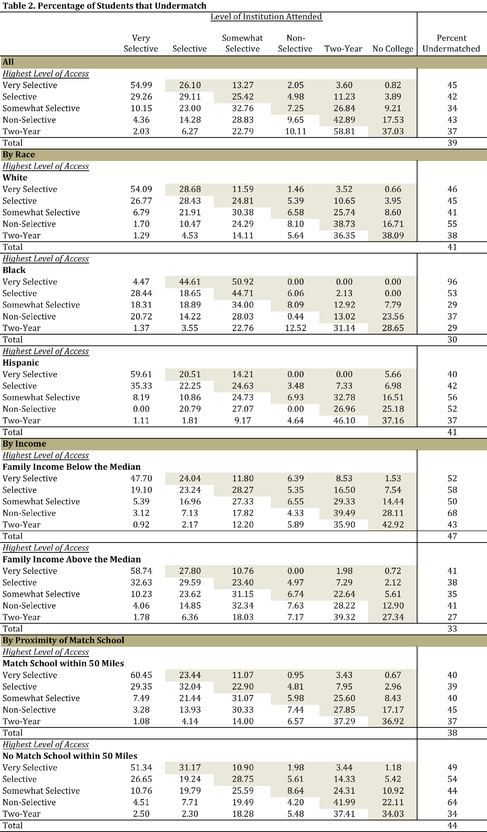
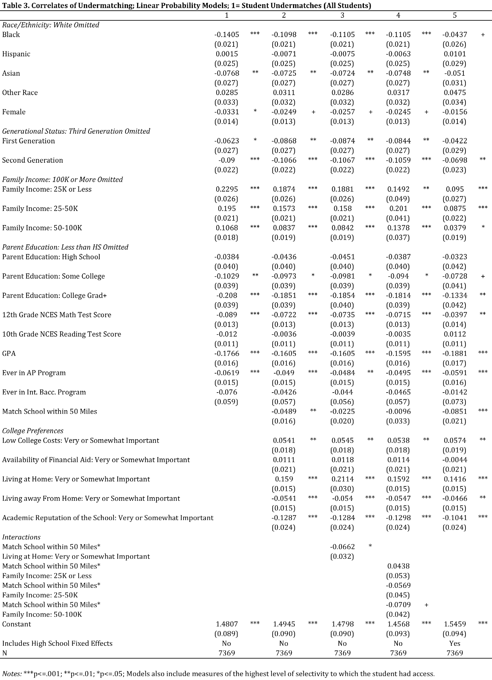
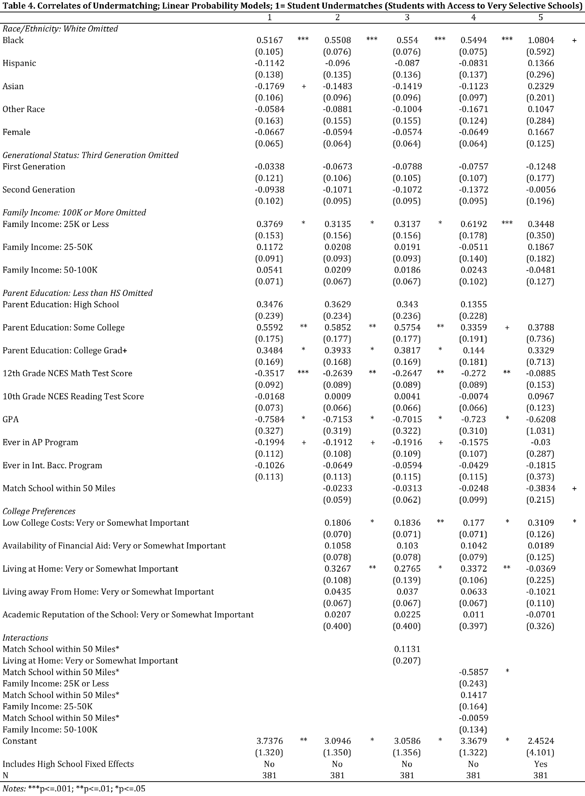

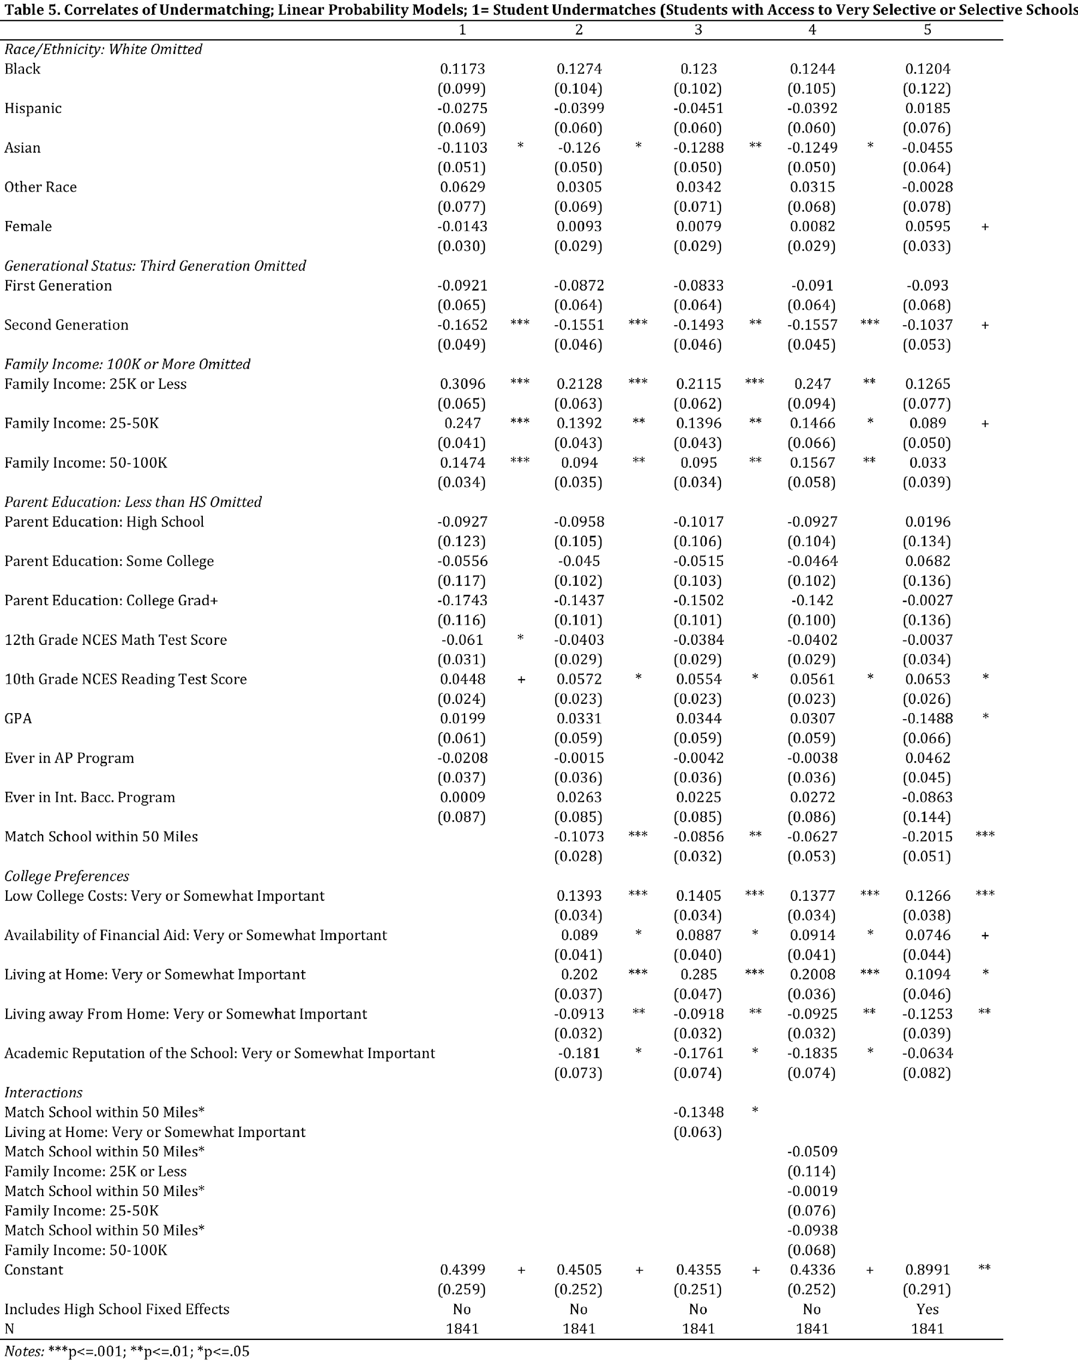

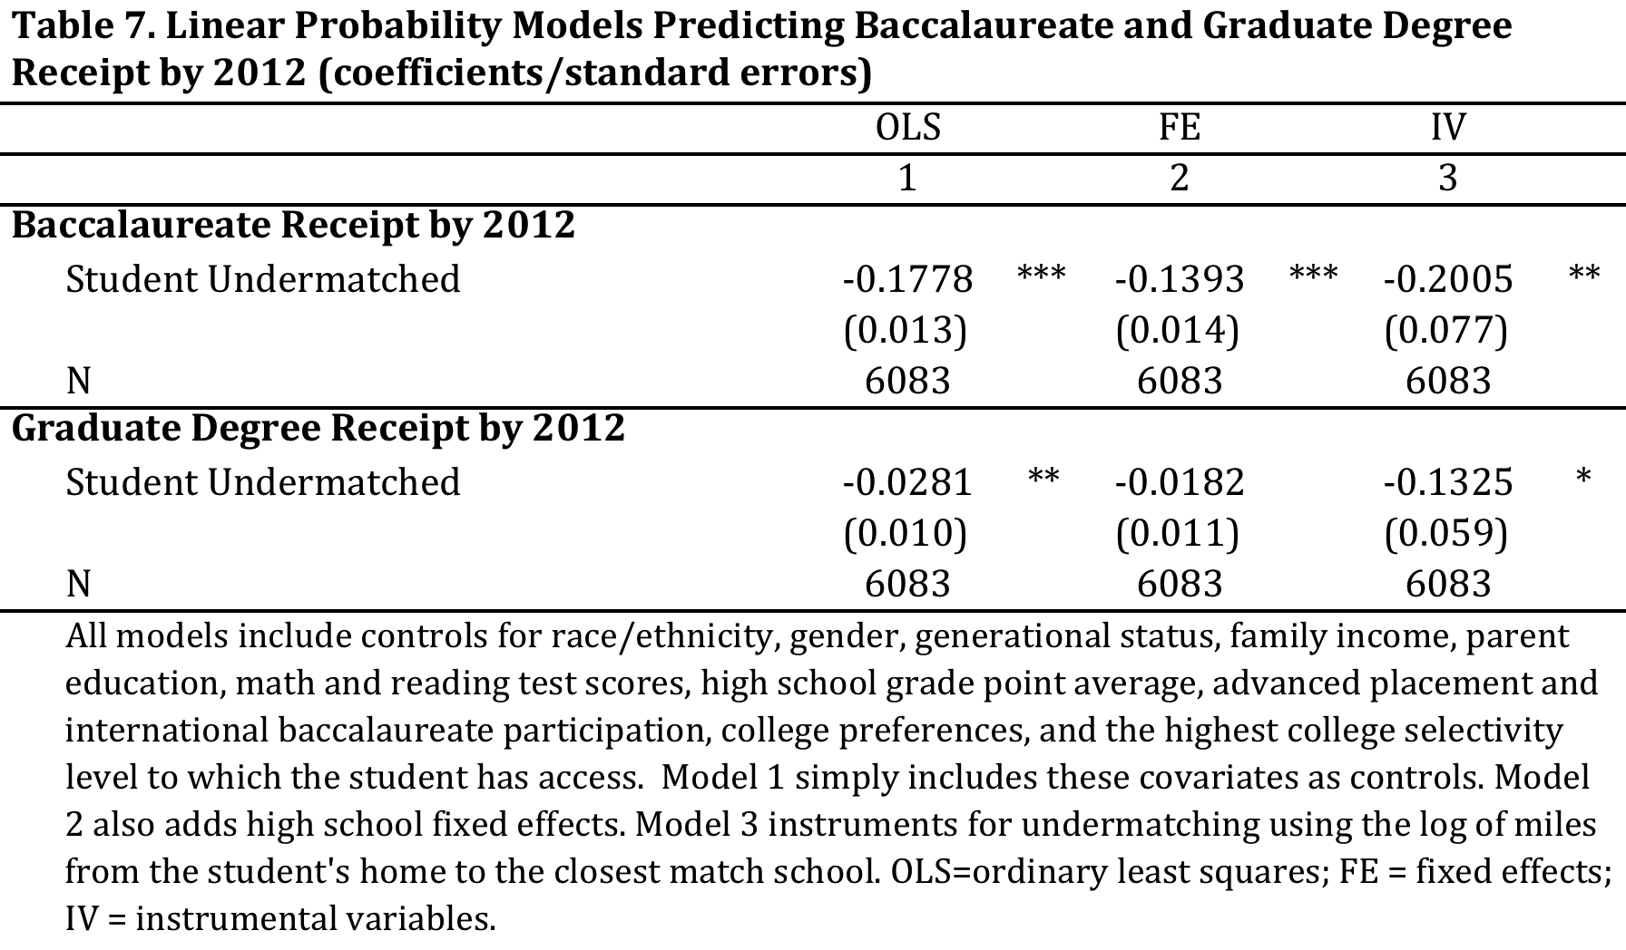

Table 7a. Linear Probability Models Predicting Baccalaureate and Graduate Degree Receipt by 2012 (coefficients/standard errors)†
 |  | Students with Access to Very Selective Schools |  |  |  |  |  | Students with Access to Selective Schools |  |  |  |  |  | Students with Access to Somewhat Selective Schools
 |  | OLS |  | FE |  | IV |  | OLS |  | FE |  | IV |  | OLS |  | FE |  | IV
 |  | 1 |  | 2 |  | 3 |  | 1 |  | 2 |  | 3 |  | 1 |  | 2 |  | 3
Baccalaureate Receipt by 2012
 | Student Undermatched | -0.048 |  | 0.0263 |  | -0.1365 |  | -0.0932 | ** | -0.0176 |  | -0.1744 |  | -0.2971 | *** | -0.2569 | *** | -0.2559 | +
 |  | (0.042) |  | (0.094) |  | (0.124) |  | (0.029) |  | (0.042) |  | (0.134) |  | (0.034) |  | (0.047) |  | (0.131)
 | N | 354 |  | 354 |  | 346 |  | 1353 |  | 1353 |  | 1340 |  | 1549 |  | 1549 |  | 1510
Graduate Degree Receipt by 2012
 | Student Undermatched | 0.1191 | + | 0.2198 |  | 0.6973 | ** | -0.0264 |  | -0.0017 |  | -0.0677 |  | -0.1006 | *** | -0.0607 | * | -0.3417 | ***
 |  | (0.066) |  | (0.153) |  | (0.228) |  | (0.032) |  | (0.045) |  | (0.128) |  | (0.020) |  | (0.029) |  | (0.093)
 | N | 354 |  | 354 |  | 346 |  | 1353 |  | 1353 |  | 1340 |  | 1549 |  | 1549 |  | 1510
† Same as Table 7 but reported separately by highest selectivity level to which the student had access

Table 8. Linear Probability/OLS Models Predicting Early Career Outcomes in 2012 (coefficients/standard errors)
 |  | All Students |  |  |  |  |  | Students Not Currently Enrolled in PSE
 |  | OLS |  | FE |  | IV |  | OLS |  | FE |  | IV
 |  | 1 |  | 2 |  | 3 |  | 1 |  | 2 |  | 3
Employed in 2012
 | Student Undermatched | -0.023 | + | -0.017 |  | -0.097 |  | -0.038 | ** | -0.028 | + | -0.062
 |  | (0.013) |  | (0.014) |  | (0.068) |  | (0.015) |  | (0.016) |  | (0.077)
 | N | 5787 |  | 5787 |  | 5619 |  | 4372 |  | 4372 |  | 4252
Employed Full Time in 2012
 | Student Undermatched | -0.035 | * | -0.024 |  | -0.170 | * | -0.058 | ** | -0.052 | ** | -0.212 | *
 |  | (0.017) |  | (0.018) |  | (0.086) |  | (0.018) |  | (0.020) |  | (0.099)
 | N | 5778 |  | 5778 |  | 5778 |  | 4368 |  | 4368 |  | 4368
Earnings in 2012 (log income)
 | Student Undermatched | -0.050 |  | -0.014 |  | -0.205 |  | -0.066 | + | -0.044 |  | -0.147
 |  | (0.035) |  | (0.038) |  | (0.207) |  | (0.039) |  | (0.043) |  | (0.245)
 | N | 5335 |  | 5335 |  | 5335 |  | 4093 |  | 4093 |  | 4093
 | All models include controls for race/ethnicity, gender, generational status, family income, parent education, math and reading test scores, high school grade point average, advanced placement and international baccalaureate participation, college preferences, and the highest college selectivity level to which the student has access. Model 1 simply includes these covariates as controls. Model 2 also adds high school fixed effects. Model 3 instruments for undermatching using the log of miles from the student's home to the closest match school. OLS=ordinary least squares; FE = fixed effects; IV = instrumental variables.

Table 8a. Linear Probability/OLS Models Predicting Early Career Outcomes in 2012 (coefficients/standard errors)†
 |  | Students with Access to Very Selective Schools |  |  |  |  |  | Students with Access to Selective Schools |  |  |  |  |  | Students with Access to Somewhat Selective Schools
 |  | OLS |  | FE |  | IV |  | OLS |  | FE |  | IV |  | OLS |  | FE |  | IV
 |  | 1 |  | 2 |  | 3 |  | 1 |  | 2 |  | 3 |  | 1 |  | 2 |  | 3
Employed in 2012
 | Student Undermatched | -0.0683 |  | 0.0208 |  | -0.226 | + | -0.0125 |  | -0.0051 |  | -0.0114 |  | 0.011 |  | 0.0079 |  | 0.0401
 |  | (0.054) |  | (0.132) |  | (0.136) |  | (0.022) |  | (0.032) |  | (0.093) |  | (0.023) |  | (0.037) |  | (0.089)
 | N | 249 |  | 249 |  | 245 |  | 991 |  | 991 |  | 979 |  | 1119 |  | 1119 |  | 1096
Employed Full Time in 2012
 | Student Undermatched | -0.0656 |  | -0.0431 |  | -0.1242 |  | -0.0097 |  | 0.0655 |  | -0.0277 |  | -0.0508 |  | -0.0233 |  | -0.2638 | *
 |  | (0.071) |  | (0.194) |  | (0.178) |  | (0.033) |  | (0.048) |  | (0.140) |  | (0.034) |  | (0.054) |  | (0.124)
 | N | 249 |  | 249 |  | 245 |  | 990 |  | 990 |  | 978 |  | 1118 |  | 1118 |  | 1095
Earnings in 2012 (log income)
 | Student Undermatched | -0.0871 |  | -0.7627 |  | -1.2231 | * | 0.0835 |  | 0.0139 |  | 0.5164 |  | -0.1074 |  | -0.0336 |  | -0.2911
 |  | (0.137) |  | (0.732) |  | (0.576) |  | (0.083) |  | (0.108) |  | (0.425) |  | (0.070) |  | (0.110) |  | (0.251)
 | N | 226 |  | 226 |  | 222 |  | 938 |  | 938 |  | 927 |  | 1080 |  | 1080 |  | 1056
*Students not currently enrolled in PSE
† Same as Table 8 but reported separately by highest selectivity level to which the student had access.

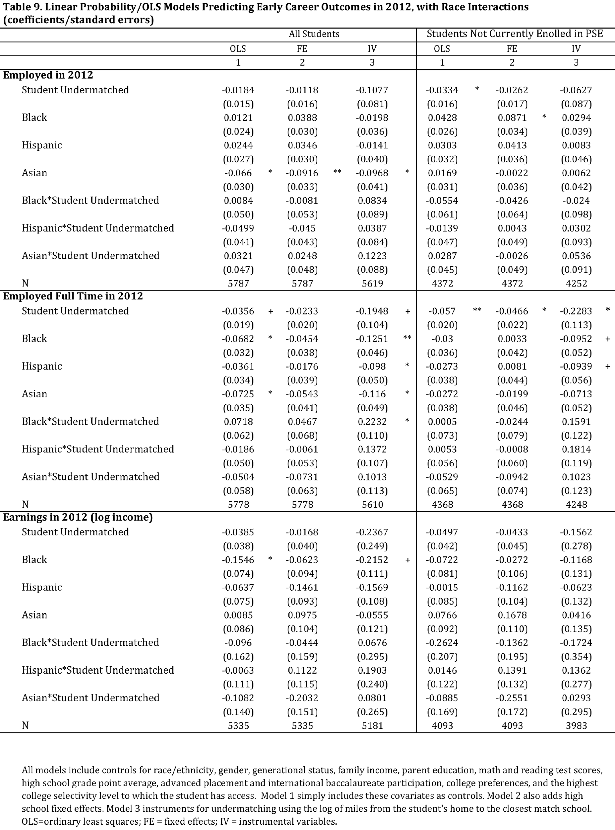

Table 10. Linear Probability/OLS Models Predicting Early Career Outcomes in 2012, with Gender Interactions (coefficients/standard errors)
 |  | All Students |  |  |  |  |  | Students Not Currently Enrolled in PSE
 |  | OLS |  | FE |  | IV |  | OLS |  | FE |  | IV
 |  | 1 |  | 2 |  | 3 |  | 1 |  | 2 |  | 3
Employed in 2012
 | Student Undermatched | 0.0007 |  | 0.0082 |  | -0.1786 |  | -0.0171 |  | -0.0094 |  | -0.0794
 |  | (0.017) |  | (0.019) |  | (0.160) |  | (0.018) |  | (0.020) |  | (0.184)
 | Female | -0.042 | ** | -0.0393 | * | -0.1063 | + | -0.0776 | *** | -0.0831 | *** | -0.1037
 |  | (0.015) |  | (0.016) |  | (0.057) |  | (0.015) |  | (0.017) |  | (0.067)
 | Female*Student Undermatched | -0.0435 | + | -0.0468 | + | 0.1242 |  | -0.0378 |  | -0.0349 |  | 0.0229
 |  | (0.024) |  | (0.026) |  | (0.149) |  | (0.026) |  | (0.028) |  | (0.171)
 | N | 5787 |  | 5787 |  | 5619 |  | 4372 |  | 4372 |  | 4252
Employed Full Time in 2012
 | Student Undermatched | -0.0105 |  | 0.0046 |  | -0.3519 | + | -0.0358 |  | -0.0289 |  | -0.4263 | +
 |  | (0.022) |  | (0.024) |  | (0.207) |  | (0.023) |  | (0.025) |  | (0.249)
 | Female | -0.0992 | *** | -0.0952 | *** | -0.2197 | ** | -0.1247 | *** | -0.131 | *** | -0.2685 | **
 |  | (0.018) |  | (0.020) |  | (0.074) |  | (0.019) |  | (0.021) |  | (0.091)
 | Female*Student Undermatched | -0.0447 |  | -0.0524 |  | 0.2732 |  | -0.041 |  | -0.0426 |  | 0.3218
 |  | (0.030) |  | (0.032) |  | (0.194) |  | (0.032) |  | (0.035) |  | (0.232)
 | N | 5778 |  | 5778 |  | 5610 |  | 4368 |  | 4368 |  | 4248
Earnings in 2012 (log income)
 | Student Undermatched | -0.0355 |  | -0.0067 |  | -0.4591 |  | -0.0707 |  | -0.0489 |  | -0.334
 |  | (0.045) |  | (0.050) |  | (0.449) |  | (0.050) |  | (0.057) |  | (0.530)
 | Female | -0.2567 | *** | -0.2567 | *** | -0.4056 | ** | -0.2644 | *** | -0.2447 | *** | -0.3634 | +
 |  | (0.041) |  | (0.046) |  | (0.156) |  | (0.044) |  | (0.049) |  | (0.186)
 | Female*Student Undermatched | -0.0266 |  | -0.0139 |  | 0.3705 |  | 0.0091 |  | 0.009 |  | 0.2644
 |  | (0.062) |  | (0.066) |  | (0.414) |  | (0.069) |  | (0.075) |  | (0.485)
 | N | 5335 |  | 5335 |  | 5181 |  | 4093 |  | 4093 |  | 3983
 | All models include controls for race/ethnicity, gender, generational status, family income, parent education, math and reading test scores, high school grade point average, advanced placement and international baccalaureate participation, college preferences, and the highest college selectivity level to which the student has access. Model 1 simply includes these covariates as controls. Model 2 also adds high school fixed effects. Model 3 instruments for undermatching using the log of miles from the student's home to the closest match school. OLS=ordinary least squares; FE = fixed effects; IV = instrumental variables.

References
Bastedo, M., & Bowman, N. (2015). Improving Admission of Low-SES Students at Selective Colleges: Results from a National Experiment.
Bastedo, M. N., & Flaster, A. (2014). Conceptual and Methodological Problems in Research on College Undermatch. Educational Researcher, 0013189X14523039. http://doi.org/10.3102/0013189X14523039
Bastedo, M. N., & Jaquette, O. (2011). Running in Place: Low-Income Students and the Dynamics of Higher Education Stratification. Educational Evaluation and Policy Analysis, 33(3), 318–339. http://doi.org/10.3102/0162373711406718
Baum, S., Lapovsky, L., & Ma, J. (2010). Tuition discounting: Institutional aid patterns at public and private colleges and universities, 2000-01 to 2008-09. Washington, DC: The College Board.
Black, S. E., Cortes, K. E., & Lincove, J. A. (2015). Apply Yourself: Racial and Ethnic Differences in College Application (Working Paper No. 21368). National Bureau of Economic Research. Retrieved from http://www.nber.org/papers/w21368
Bowen, W. G., Chingos, M. M., & McPherson, M. S. (2009). Crossing the Finish Line: Completing College at America’s Public Universities. Princeton University Press.
Burkander, K. N. (2014). Culture, class, and college: A mixed-method contextual understanding of undermatch. MICHIGAN STATE UNIVERSITY. Retrieved from http://gradworks.umi.com/36/35/3635423.html
Cabrera, A. F., and La Nasa, S. M. (2000). Understanding the college choice process. New Directions for Institutional Research 2000(107):5-22. http://doi.org/10.1002/ir.10701
Collins, Randall. 1971. “Functional and Conflict Theories of Educational Stratification.” American Sociological Review 36:1002-1019
Deutschlander, D. (2017). Academic Undermatch: How General and Specific Cultural Capital Structure Inequality. Sociological Forum, 32(1), 162-185.
Fosnacht, K. J. (2014). Selectivity and the College Experience: How Undermatching Shapes the College Experience Among High-Achieving Students. Presented at the American Educational Research Association Annual Meeting, Chicago, IL.
Griffith, A. L., & Rothstein, D. S. (2009). Can’t get there from here: The decision to apply to a selective college. Economics of Education Review, 28(5), 620–628. http://doi.org/10.1016/j.econedurev.2009.01.004
Grodsky, E., & Jones, M. T. (2007). Real and imagined barriers to college entry: Perceptions of cost. Social Science Research, 36(2), 745–766. http://doi.org/16/j.ssresearch.2006.05.001
Grodsky, E., & Riegle-Crumb, C. (2010). Those Who Choose and Those Who Don’t: Social Background and College Orientation. The ANNALS of the American Academy of Political and Social Science, 627(1), 14 –35. http://doi.org/10.1177/0002716209348732
Hill, C. B., & Winston, G. C. (2010). Low-income students and highly selective private colleges: Geography, searching, and recruiting. Economics of Education Review, 29(4), 495–503. http://doi.org/10.1016/j.econedurev.2009.12.004
Hillman, N.W. (2016). Geography of College Opportunity: The Case of Education Deserts. American Educational Research Journal 53(4):987-1021. http://doi.org/10.3102/0002831216653204
Hoxby, C. (2009). The Changing Selectivity of American Colleges. Journal of Economic Perspectives, 23(4), 95-118. http://doi.org/10.1257/jep.23.4.95
Hoxby, C. M., & Avery, C. (2013). The Missing “One-Offs”: The Hidden Supply of High-Achieving, Low Income Students. Brookings Papers on Economic Activity.
Hoxby, C., & Turner, S. (2013). Expanding College Opportunities for High-Achieving, Low Income Students. Stanford Institute for Economic Policy Research: Discussion Paper #12-014.
Hurtado, S., Inkelas, K. K., Briggs, C., & Rhee, B.-S. (1997). Differences in College Access and Choice among Racial/Ethnic Groups: Identifying Continuing Barriers. Research in Higher Education, 38(1), 43–75.
Hurwitz, M., Smith, J., Howell, J., & Pender, M. (2012). The Role of High Schools in Students’ Postsecondary Choices. Retrieved from http://research.collegeboard.org/publications/role-high-schools-students-postsecondary-choices
Kao, G., & Thompson, J. S. (2003). Racial and Ethnic Stratification in Educational Achievement and Attainment. Annual Review of Sociology, 29, 417–442.
Kim, D. (2004). The Effect of Financial Aid on Students’ College Choice: Differences by Racial Groups. Research in Higher Education, 45(1), 43–70.
Klugman, J. (2012). How Resource Inequalities Among High Schools Reproduce Class Advantages in College Destinations. Research in Higher Education, 53(8), 803–830. http://doi.org/10.1007/s11162-012-9261-8
Kurleander, M., and Grodsky, E. (2013). Mismatch and the Paternalistic Justification for Selective College Admissions. Sociology of Education, 86(4), 294-310.
McKenna, L. (2015, October 22). The New Common App? The Atlantic. Retrieved from http://www.theatlantic.com/education/archive/2015/10/new-common-app/411820/
Morgan, S. L. (2005). On the edge of commitment: educational attainment and race in the United States. Stanford University Press.
Nora, A. (2004). The Role of Habitus and Cultural Capital in Choosing a College, Transitioning From High School to Higher Education, and Persisting in College Among Minority and Nonminority Students. Journal of Hispanic Higher Education, 3(2), 180 –208. http://doi.org/10.1177/1538192704263189
Park, E. (2013). Low-income students’ access to selective higher education. INDIANA UNIVERSITY. Retrieved from http://gradworks.umi.com/36/02/3602806.html
Perna, L. (2000). Differences in the Decision to Attend College among African Americans, Hispanics, and Whites. The Journal of Higher Education, 71(2), 117–141. http://doi.org/10.2307/2649245
Perna, L. (2006). Studying College Access and Choice: A Proposed Conceptual Model. In J. C. Smart (Ed.), Higher Education: Handbook of Theory and Research (Vol. 21, pp. 99–157). Springer Netherlands.
Radford, A. W. (2013). Top student, top school? how social class shapes where valedictorians go to college. Chicago: University of Chicago Press.
Roderick, M., Coca, V., & Nagaoka, J. (2011). Potholes on the Road to College High School Effects in Shaping Urban Students’ Participation in College Application, Four-year College Enrollment, and College Match. Sociology of Education, 84(3), 178–211. http://doi.org/10.1177/0038040711411280
Roderick, M., Nagaoka, J., Coca, V., Moeller, E., Roddie, K., Gilliam, J., & Patton, D. (2008). From High School to the Future: Potholes on the Road to College (Research Report). Chicago, IL: Consortium on Chicago School Research at the University of Chicago.
Rodriguez, A. (2013). Unpacking the Black Box: Estimating the High School-Level Effects of Undermatching on Underrepresented Students (Doctoral dissertation). ProQuest.
Rodriguez, A. (2015). Tradeoffs and Limitations: Understanding the Estimation of College Undermatch. Research in Higher Education, 56(6), 566–594. http://doi.org/10.1007/s11162-015-9363-1
Rouse, C. E. (1995). Democratization or Diversion? The Effect of Community Colleges on Educational Attainment. Journal of Business & Economic Statistics, 13, 217–224.
Smith, J., Pender, M., & Howell, J. (2013). The full extent of student-college academic undermatch. Economics of Education Review, 32, 247–261. http://doi.org/10.1016/j.econedurev.2012.11.001
Student Financial Aid Services, Inc. (2014). College Undermatching Threatens Nation’s Future Talent Pool. Enhanced Online News. http://www.enhancedonlinenews.com/news/eon/20141204005529/en/undermatching/high-achieving/low-income
Tiboris, M. (2014). What’s Wrong With Undermatching? Journal of Philosophy of Education, 48(4), 646–664. http://doi.org/10.1111/1467-9752.12091
Tierney, W. G. (1999). Models of Minority College-Going and Retention: Cultural Integrity versus Cultural Suicide. The Journal of Negro Education, 68(1), 80–91. http://doi.org/10.2307/2668211
Tinto, V. (1973). College Proximity and Rates of College Attendance. American Educational Research Journal, 10(4), 277–293. https://doi.org/10.3102/00028312010004277
Tinto, V. (1987). Leaving College: Rethinking the Causes and Cures of College Attrition. Chicago: University of Chicago Press.
Turley, R. N. L. (2009). College Proximity: Mapping Access to Opportunity. Sociology of Education, 82(2), 126–146. https://doi.org/10.1177/003804070908200202

Appendix A: Detailed IV Results
Table 6. First Stage IV Results, Linear Probability Predicting Undermatching (coefficients/standard errors)
 | Log(Miles to Closest Match School) | 0.111 | ***
 |  | (0.009)
 | Log(Miles to Closest Match School)^2 | -0.0001
 |  | (0.000)
 | Log(Miles to Closest Match School)^3 | -0.001 | ***
 |  | (0.000)
 | F Statistic | 46 | ***

Appendix B: Detailed Early Career Outcomes 2012
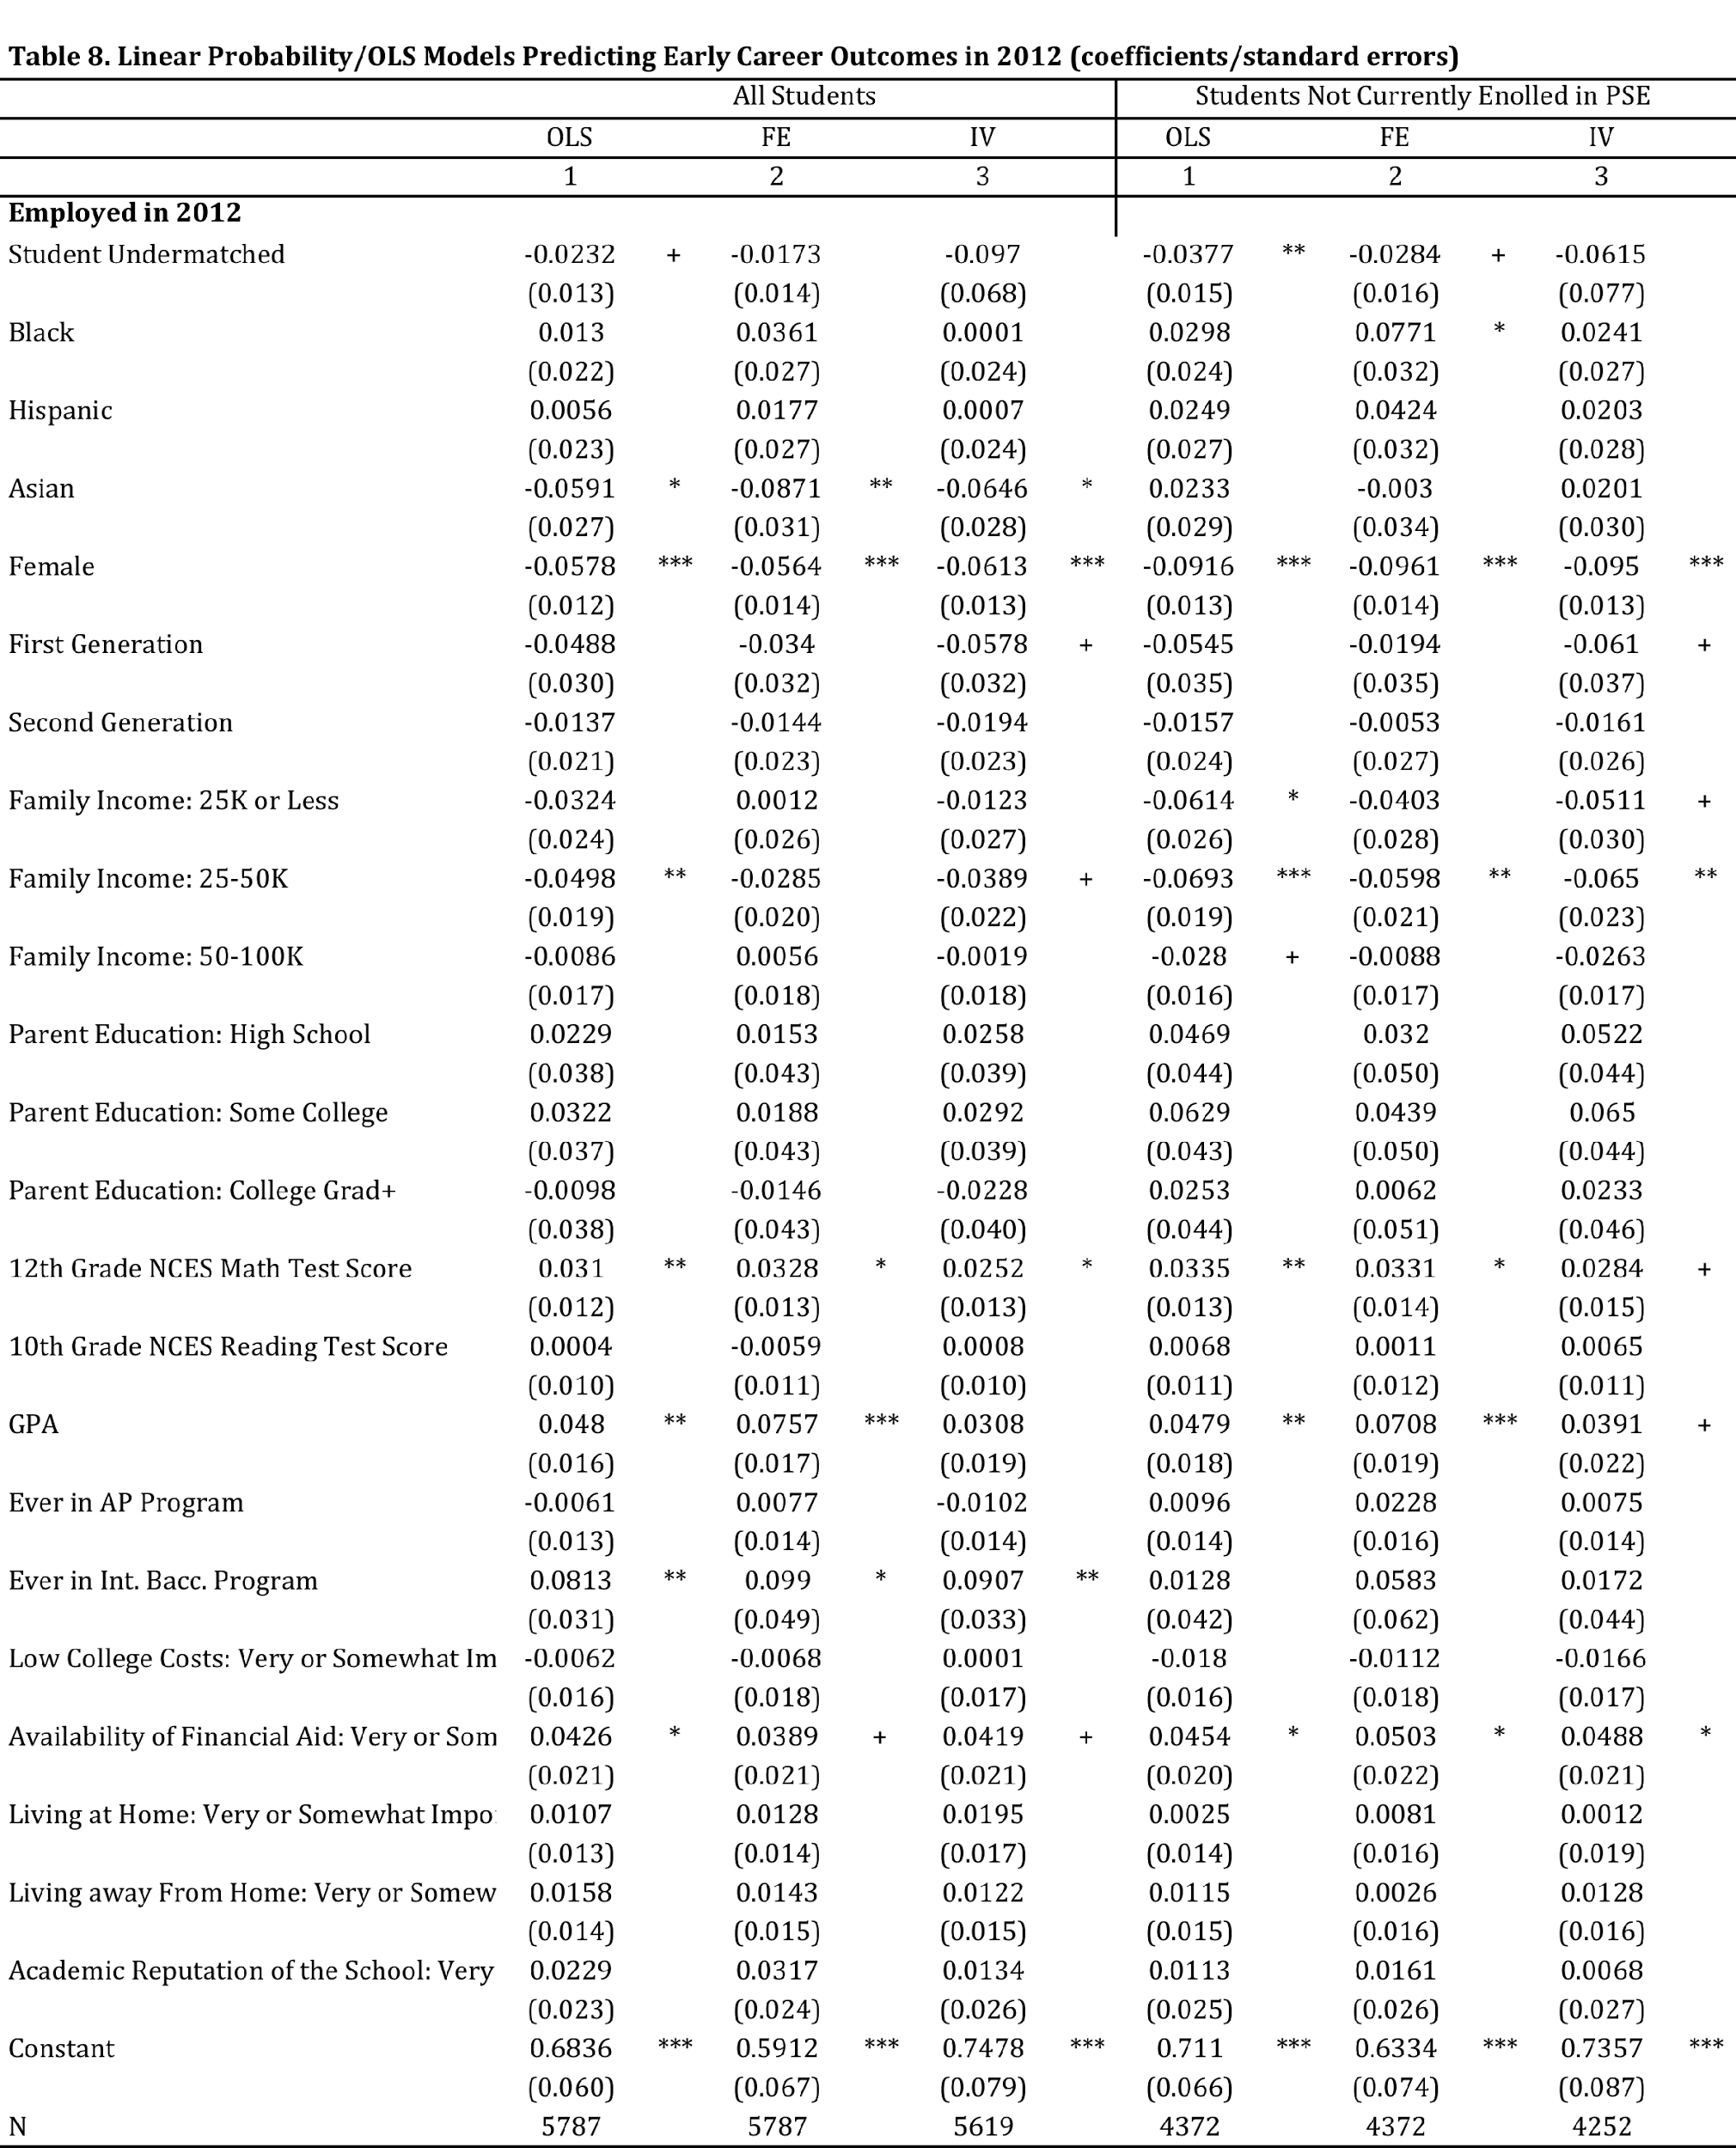

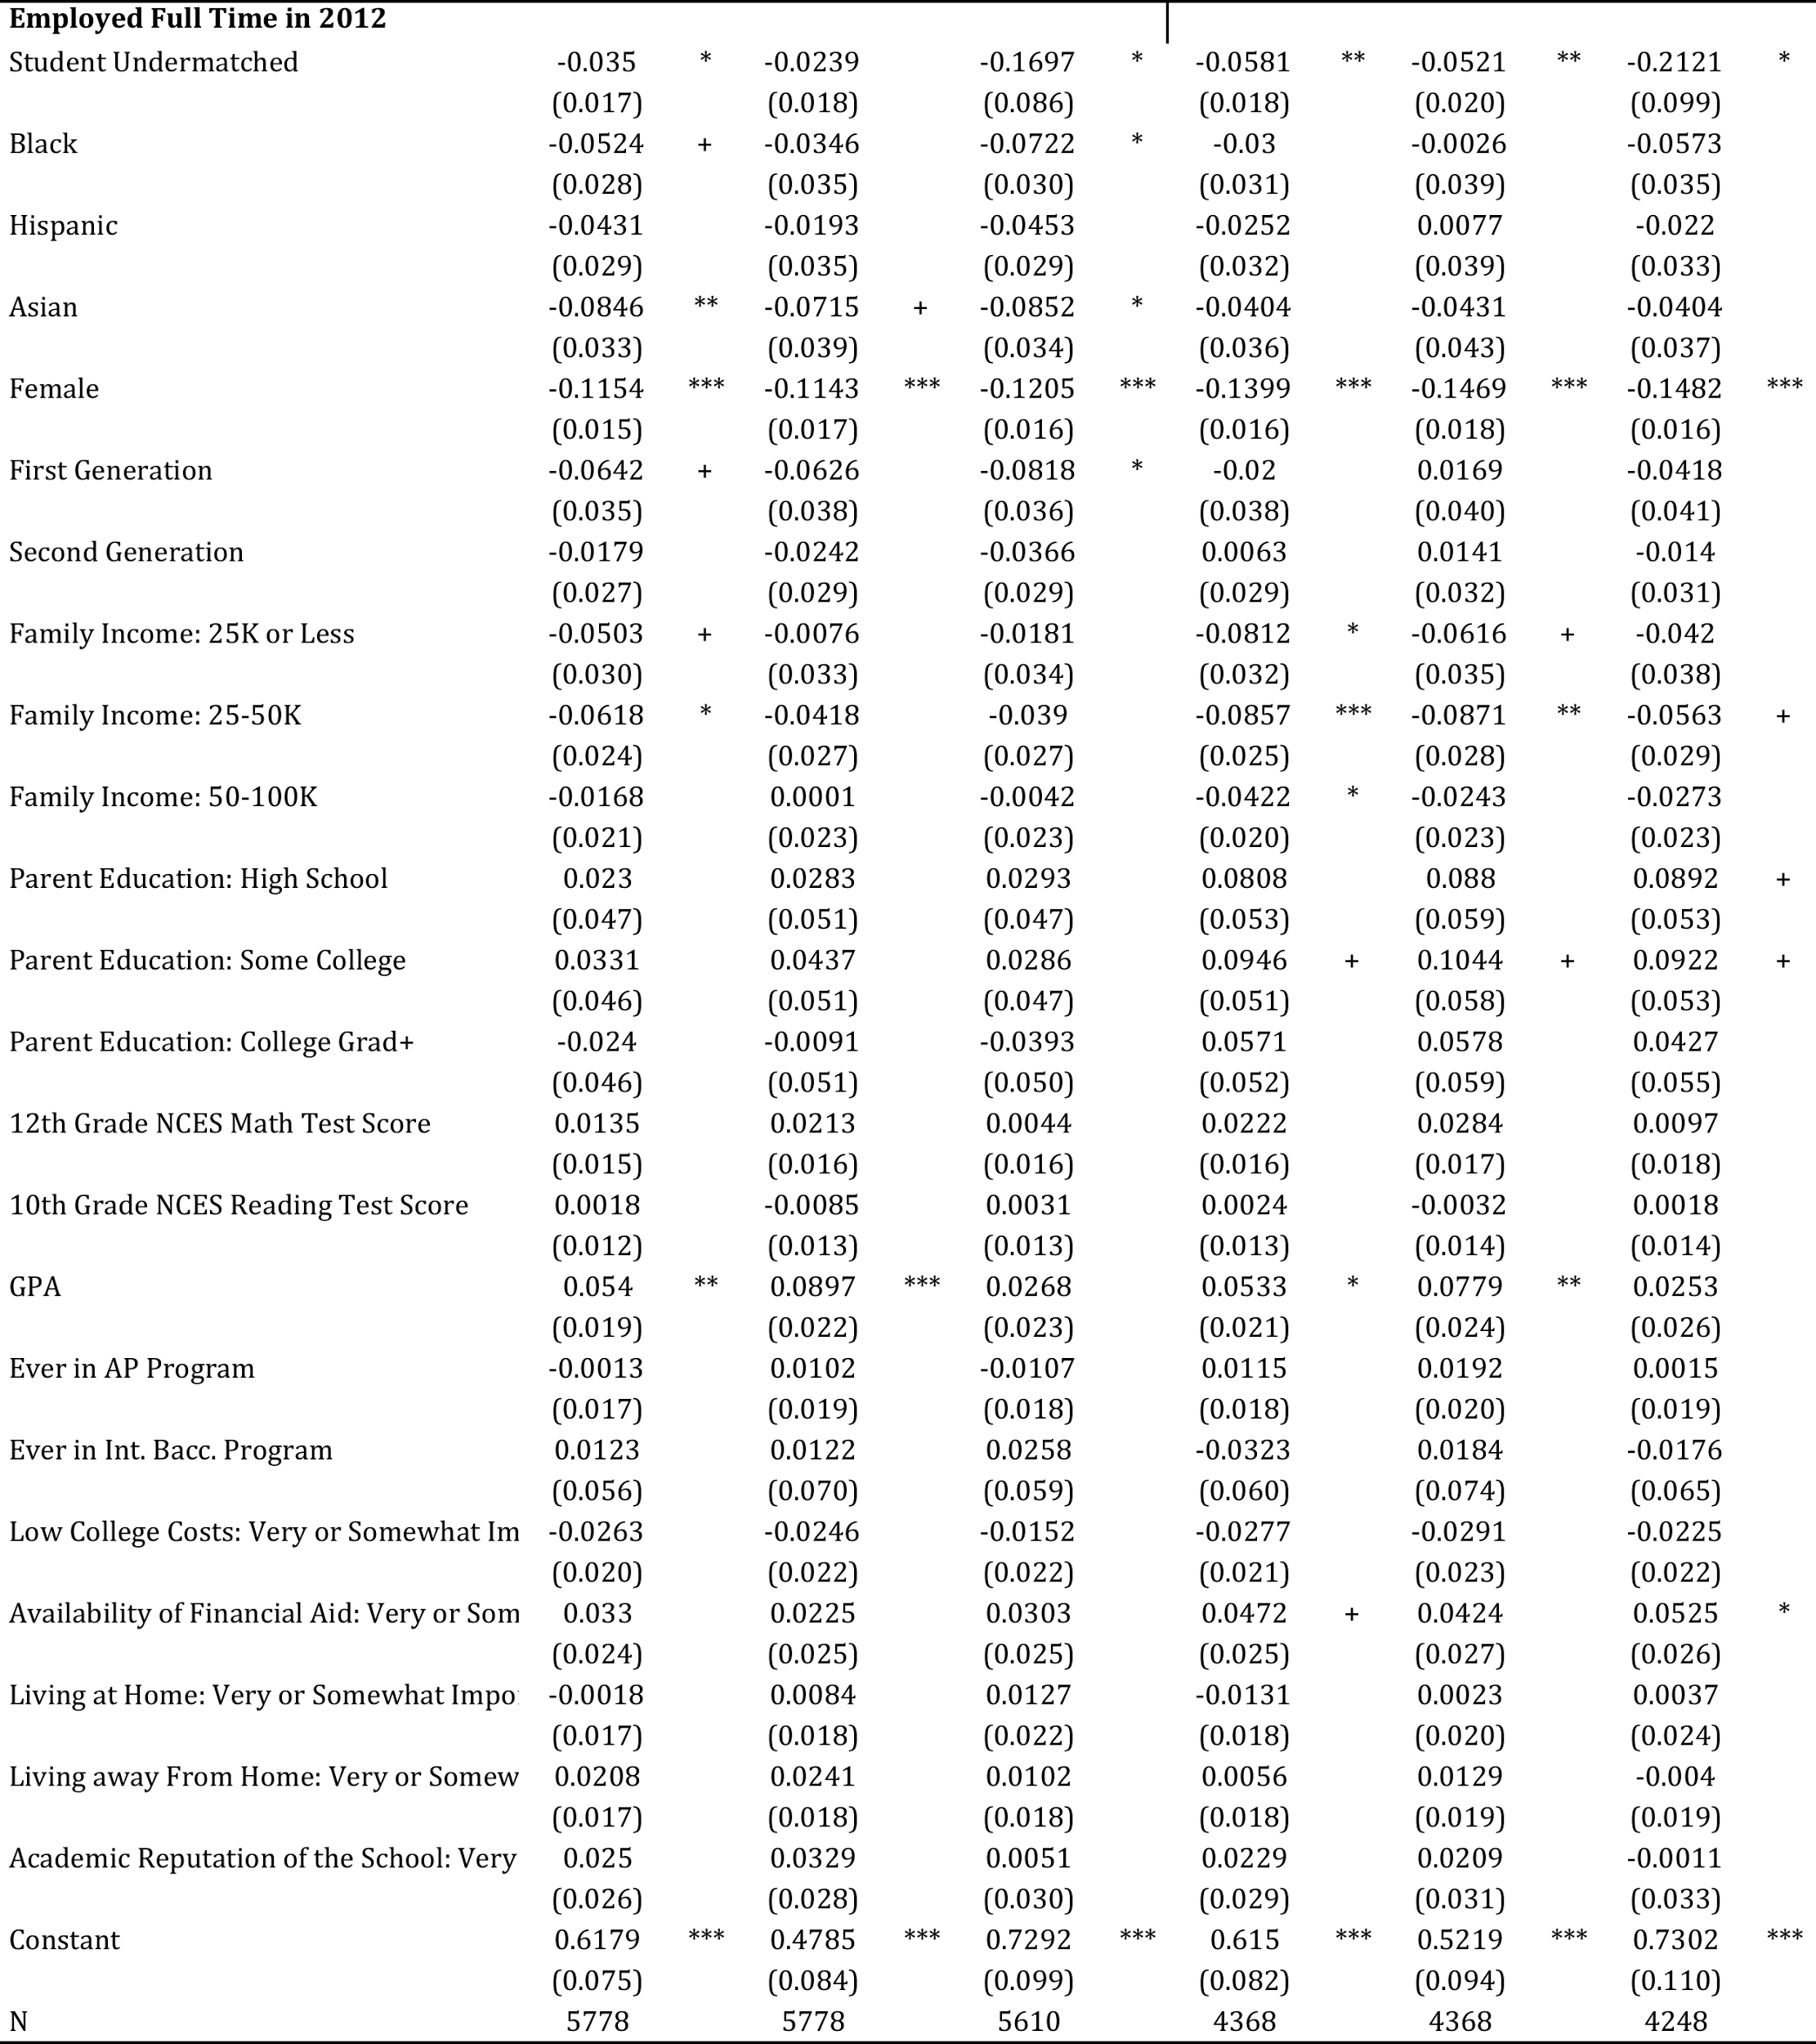

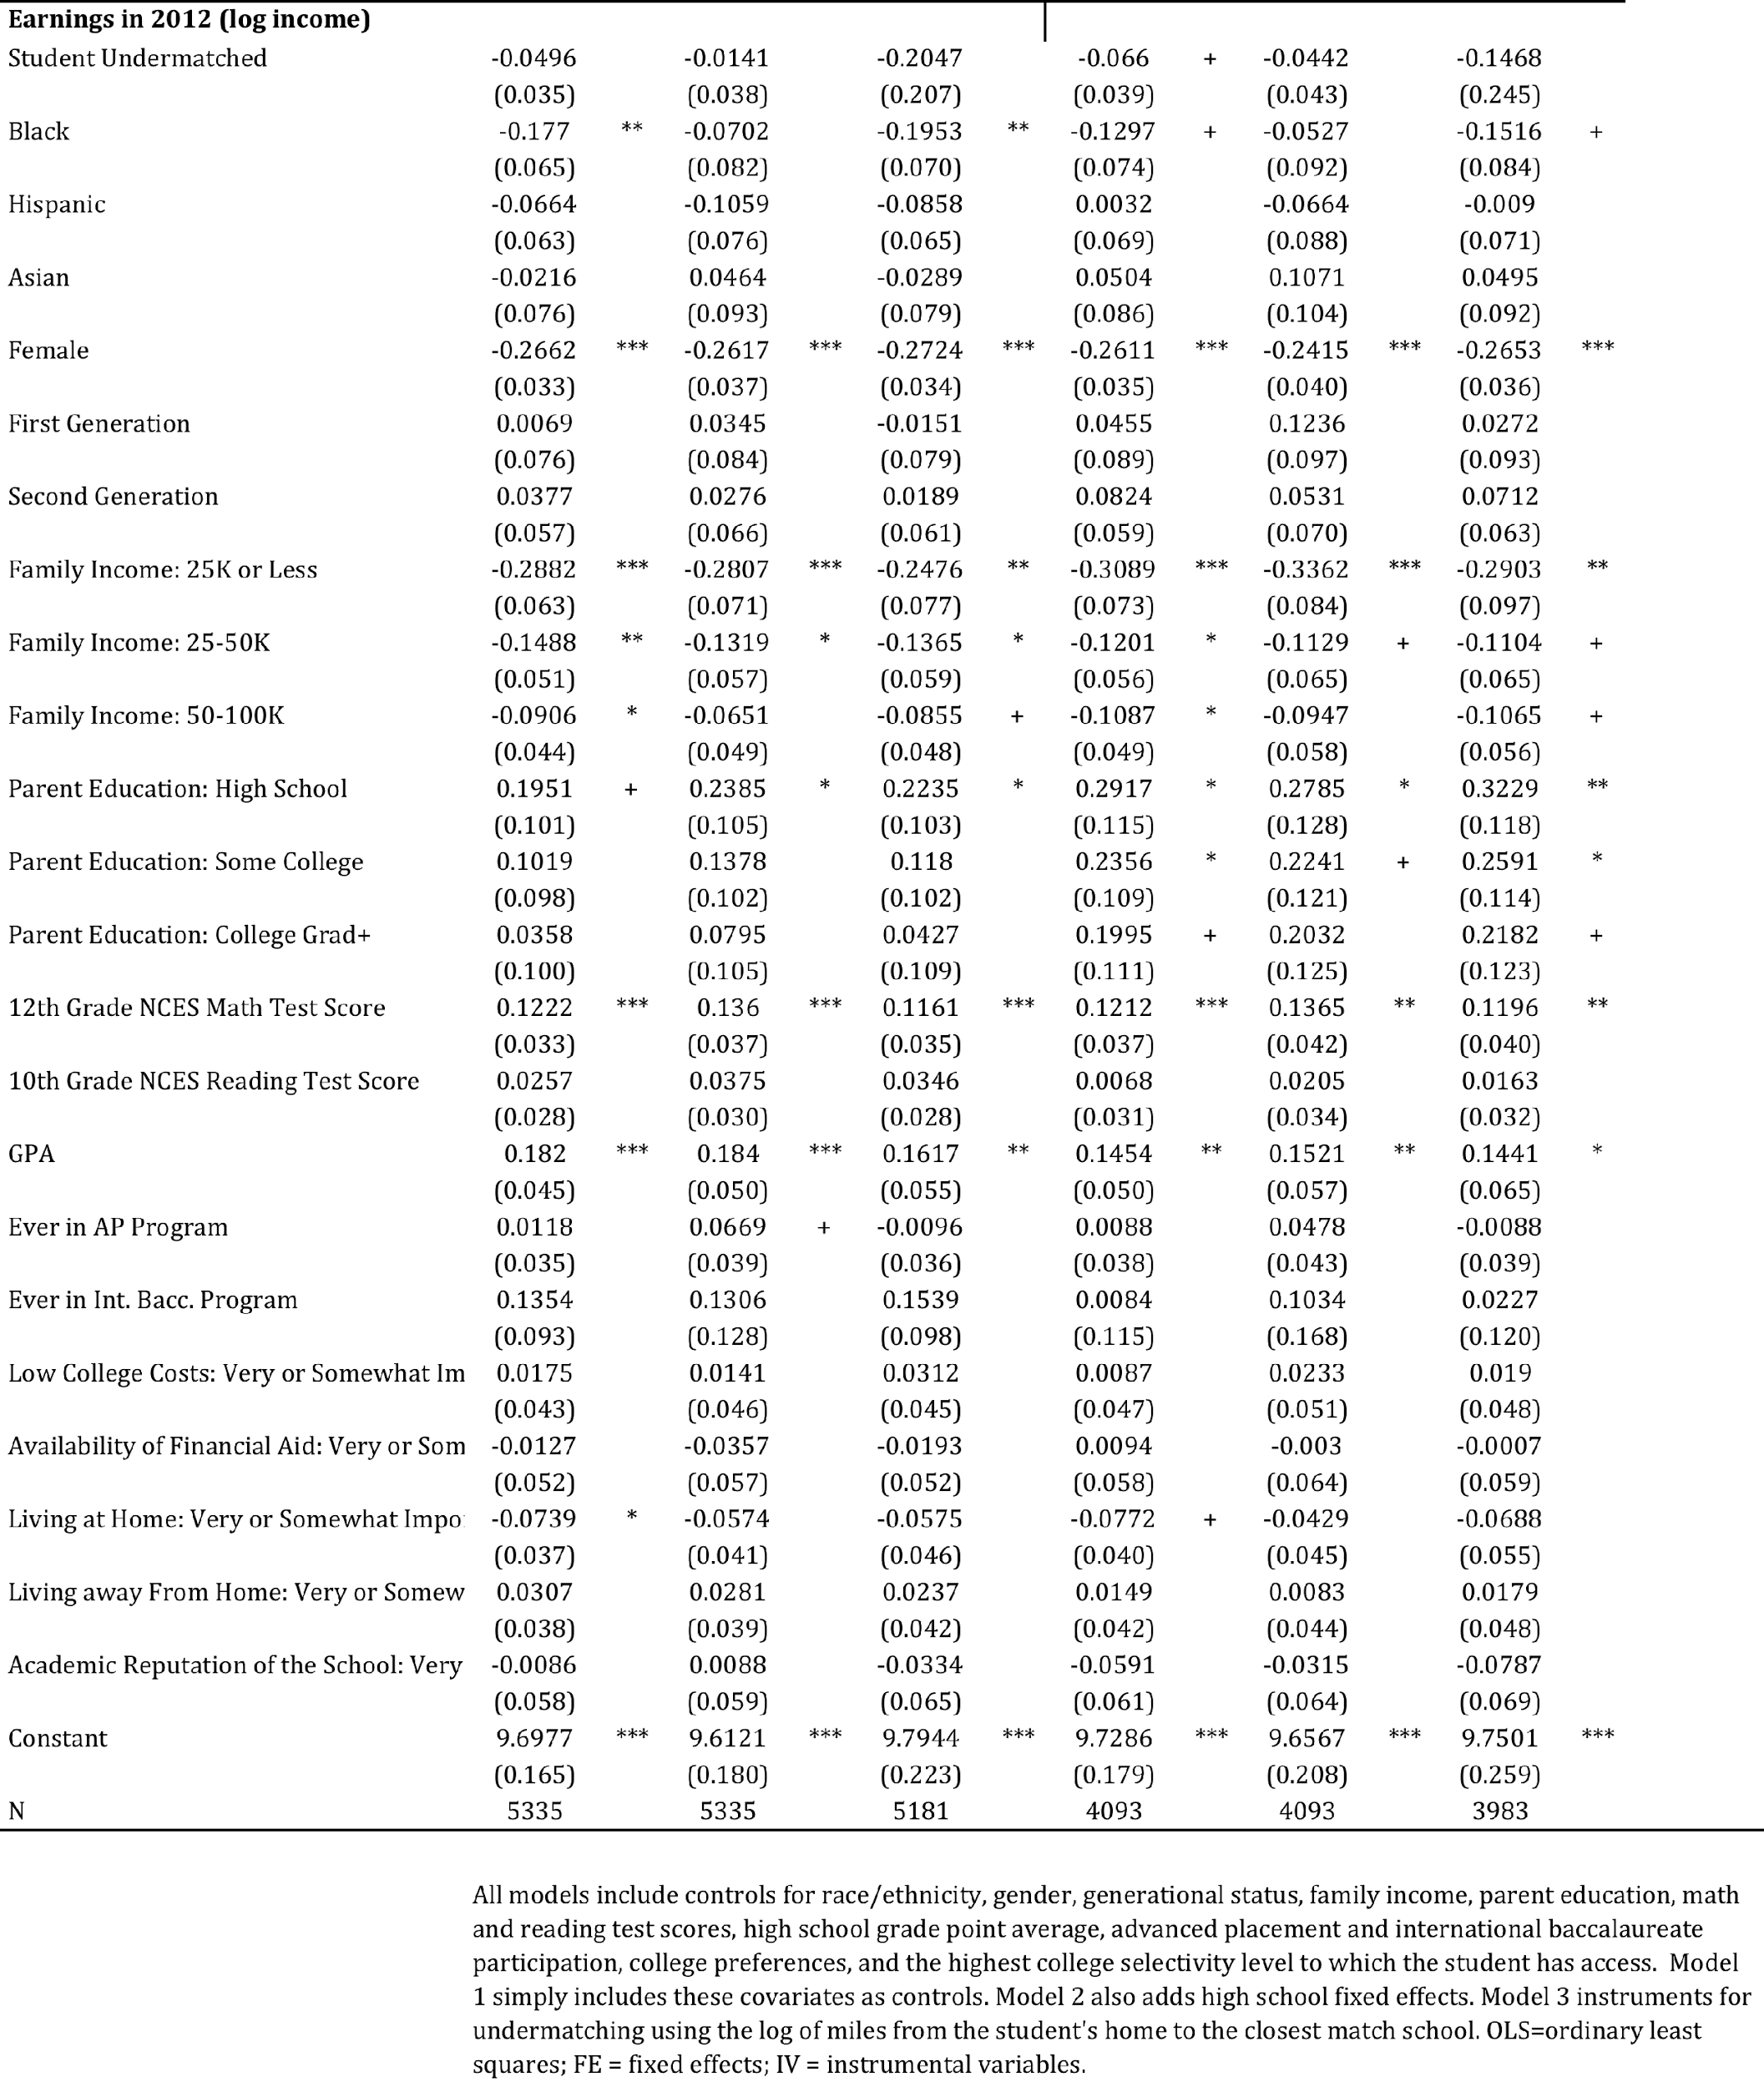

Hoxby and Avery (2013) define “selective colleges” as colleges and universities that are categorized “Very Competitive Plus” or “Most Competitive” in Barron’s Profiles of American Colleges. Match was determined by comparing individuals’ standardized test scores to the median scores of students enrolled in the college.
Rodriguez (2013) notes that calculations on undermatching, especially for underrepresented students, vary widely across the literature based on the operational definitions of “selectivity” and “qualifications.”
The 7 categories include: most competitive, highly competitive, very competitive, competitive, less competitive, noncompetitive, and special. We omit students that attend schools in the special category because these are schools that specialize in areas such as music or art so their ordering in the selectivity rank is less clear. Two year colleges are not included in Barron’s categories. We therefore add a category for two-year colleges that is below the noncompetitive category. We add a final category for students that do not enroll in college. This results in a total of 9 ordered selectivity categories. Following the approach of Smith, Pender, and Howell (2013), we further re-categorize schools into the following 6 groups: very selective (most competitive, highly competitive); selective (very competitive); somewhat selective (competitive); nonselective (less selective, noncompetitive); two-year college; no college.
We use NCES-administered math and reading exam scores in the prediction equation in lieu of SAT/ACT scores. Scores on the NCES exams are highly correlated with SAT/ACT scores and are preferable because they are available for the vast majority of sample members. By contrast, only about 60 percent of sample members had taken the SAT or ACT by the end of 12th grade.
Rouse (1995), for example, estimates the effect of attending a two-year versus a four-year college on educational attainment using the proximity of local colleges as an instrument. Researchers have cautioned that using proximity to college may not constitute an exogenous instrument if parents who care about higher education make conscious decisions to live near colleges (Card 1995; Rouse 1995). We mitigate this concern by also considering students’ selectivity qualification range. That is, it does not seem likely that families make relocation decisions based on proximity to a college that they have predicted is a good "match" for their child's academic capabilities.

