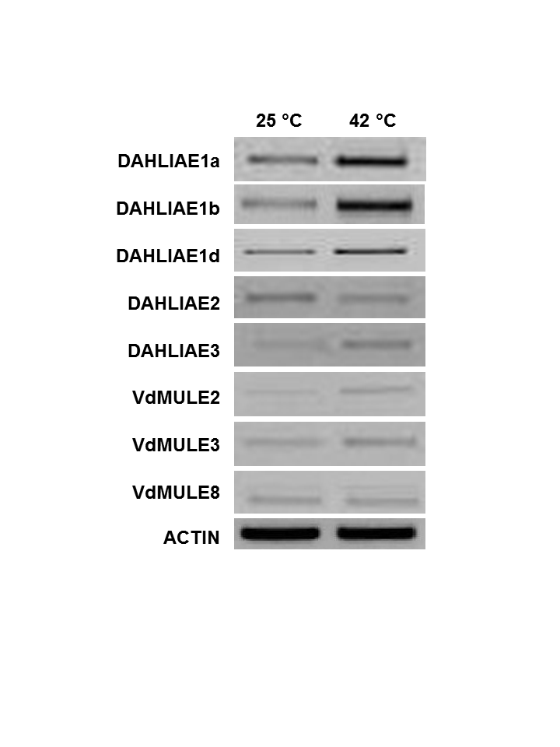
Supplemental Figure 4
Amyotte et al., 2012

