APPENDIX
Mass (Q), concentration (C), volume (V), flux (F) and rate constants (k) were expressed in $μ$mol, μmol/L, L, μmol/min and min⁻¹ respectively. The unit of time (t) was min. The unit of body weight (BW) was kg. Abbreviations generally followed the form of X_{ab}, where X was the variable type (Q, C, V, F, k, f) with f denoting a fractional proportion. The a represented the precursor (for F and k) or pool of interest (Q, C, V) and b was the reaction product or secondary reference for the parameter, i.e. f_{btAAbtPrt} refers to the fractional proportion of AA in body tissue protein.
The total mass of plasma AA ($Q_{aAA(i)})$, extracellular free AA ($Q_{xAA(i)})$, intracellular free AA ($Q_{nAA(i)})$, body tissue protein bound AA ($Q_{btAA(i)})$ and mammary tissue protein bound AA ($Q_{mtAA(i)})$ for the i^{th} AA (i= Ile, Leu, Lys, Met, Phe and Val) were determined as:
$Q_{aAA(i)}=V_{a(i)}× C_{aAA(i)}$, (1)
$Q_{xAA(i)}=V_{x(i)}×C_{xAA\left(i\right)}$, (2)
$Q_{nAA(i)}=V_{n(i)}×C_{nAA(i)}$, (3)
$Q_{tAA(i)}=BW×1000×f_{btPrt}×f_{btAAbtPrt}×K_{BWAA}$, (4)
$Q_{mtAA(i)}=MW×1000×f_{mtPrt}×f_{mtAAmtPrt}$, (5)
where $C_{xAA(i)}$was assumed to be equal to venous AA concentrations because the exchange between capillary and interstitial space is very rapid and no other sources of AA enter the vessel before sampling (Hanigan et al., 2009). The $C_{aAA(i)}$ and $C_{xAA(i)}$ were the average AA concentration over time in arterial and venous blood. The $C_{nAA(i)}$ was from the literature (Hanigan et al., 2009, Yoder, 2019). $V_{x(i)}$ was assumed to be 20% of mammary tissue wet weight and $V_{n(i)}$ was total wet weight minus $V_{x(i)}$ and tissue dry matter (Hanigan et al., 2009). The $V_{a(i)}$ was a function of BW, which includes both blood and interstitial space. The $f_{btAAbtPrt}$ represented the concentration of each AA in body protein (μmol/g), and $f_{btPrt}$ represented the protein fraction in body tissues. The $f_{mtAAmtPrt}$ represented the concentration of each AA in mammary tissue protein (μmol/g), and $f_{mtPrt}$ represented the protein fraction in mammary tissue. These values were from Williams (1978). $K_{BWAA}$ was the proportion (g/g) of body tissue protein considered in $Q_{btAA(i)}$, which is from Huang et al. (2019). A portion of body protein was not considered in the model as the turnover rate was too slow to be uniquely identified during the course of the infusion. The MW represents the wet weight of mammary glands.
The mass of each isotopically labeled AA was calculated from the total pool size and background isotopic enrichment:
${Qi}_{aAA(i)}=Q_{aAA(i)}×E_{a}$, (6)
${Qi}_{xAA(i)}=Q_{xAA(i)}×E_{x}$, (7)
${Qi}_{nAA(i)}=Q_{nAA(i)}×E_{n}$, (8)
${Qi}_{btAA(i)}=Q_{btAA(i)}×E_{t}$, (9)
${Qi}_{mtAA(i)}=Q_{mtAA(i)}×E_{m}$, (10)
where $E_{a}$ and $E_{x}$ were the background isotopic enrichment for individual AA in arterial and venous blood before the infusion. The $E_{t}$ was assumed to be equal to $E_{a}$. The $E_{n}$ and $E_{m}$ were assumed to be equal to background isotope enrichment of individual AA in milk before the infusion.
Fluxes among pools were assumed to be mass action, which included AA exchange between plasma and non mammary tissue, influx and efflux between the extracellular space and intracellular space, or exchange between intracellular AA and mammary tissue protein.
$F_{aAAbtAA(i)}=k_{aAAbtAA(i)} × Q_{aAA\left(i\right) }$, (11)
$F_{xAAnAA(i)}=k_{xAAnAA(i)} × Q_{xAA(i)}$, (12)
$F_{nAAxAA(i)}=k_{nAAxAA(i)} × Q_{nAA(i)}$, (13)
$F_{nAAmtAA(i)}=k_{nAAmtAA(i)} × Q_{nAA(i)}$, (15)
The AA flux from arterial blood to extracellular space and efflux to venous blood were the products of plasma flow (MPF, L/min) and arterial ($C_{aAA(i)})$ and extracellular AA concentrations ($C_{xAA(i)})$. Amino acid clearance by the body ( $F_{aAAbcAA\left(i\right)}$) (represents all non mammary utilization and excretion) was calculated as the difference of absorption and mammary uptake. The AA catabolized by mammary tissue ($F_{aAAmcAA\left(i\right)}$) was calculated as the difference of uptake and AA excreted into milk protein.
$F_{aAAxAA\left(i\right)}=C_{aAA(i)}×MPF$, (16)
$F_{xAAvAA\left(i\right)}=C_{xAA(i)}×MPF$, (17)
$F_{aAAbcAA\left(i\right)}=F_{absorption(i)}+F_{infusion(i)}+F_{xAAvAA\left(i\right)}-F_{aAAxAA\left(i\right)}$, (18)
$F_{aAAmcAA\left(i\right)}={F_{xAAnAA\left(i\right)}-F}_{nAAxAA\left(i\right)}-F_{nAAmAA(i)}$, (19)
The animals were mature and thus not expected to be growing, or if growing, at a very low rate. Therefore, tissue protein pools were assumed to be in steady state over the 12 h sampling period, protein degradation was set equal to synthesis:
$F_{btAAaAA(i)}=F_{aAAbtAA(i)}$, (20)
$F_{mtAAnAA(i)}=F_{nAAmtAA(i)}$, (21)
The AA incorporation into milk protein was calculated from milk protein output and the AA composition of milk protein:
$F_{nAAmAA(i)}=F_{milk}×f_{mPrt}×f_{mAAmPrt}$, (22)
where $F_{milk}$ was milk output (g/min), $f_{mPrt}$ was the fraction of milk as protein (g/g), $f_{mAAmPrt}$ was the fraction of each AA in milk protein (μmol/g), which were from Lapierre et al. (2012).
The differential equations describing changes in $Q_{aAA(i)}$, $Q_{btAA(i)}$, $Q_{xAA(i)}$, $Q_{nAA(i)}$, $Q_{mtAA(i)}$ with respect time were
$\frac{dQ_{aAA(i)}}{dt}=F_{absorption(i)}+ F_{btAAaAA(i)}+ F_{infusion(i)}+F_{xAAvAA\left(i\right)}- F_{aAAbcAA\left(i\right)}- { F}_{aAAxAA\left(i\right)}- F_{aAAbtAA\left(i\right)}$ (23)
$\frac{dQ_{btAA(i)}}{dt}=F_{aAAbtAA(i)}- F_{btAAaAA(i)}$, (24)
$\frac{dQ_{xAA(i)}}{dt}= F_{aAAxAA\left(i\right)}+F_{nAAxAA(i)}- F_{xAAnAA\left(i\right)}-F_{xAAvAA(i)}$, (25)
$\frac{dQ_{nAA(i)}}{dt}= F_{xAAnAA\left(i\right)}+F_{mtAAnAA\left(i\right)}-F_{nAAxAA\left(i\right)}- F_{nAAmtAA\left(i\right)}-F_{nAAmcAA\left(i\right)}-F_{nAAmAA\left(i\right)}$, (26)
$\frac{dQ_{mtAA(i)}}{dt}= F_{nAAmtAA\left(i\right)}-F_{mtAAnAA\left(i\right)}$, (27)

The differential equations describing changes in ${Qi}_{aAA(i)}$, ${Qi}_{btAA(i)}$, ${Qi}_{xAA(i)}$, ${Qi}_{nAA(i)}$, and ${Qi}_{mtAA(i)}$ with respect to time were:
$\frac{d{Qi}_{aAA(i)}}{dt}={Fi}_{absorption(i)}+ {Fi}_{btAAaAA(i)}+ {Fi}_{infusion(i)}{+ Fi}_{xAAvAA\left(i\right)}- {iF}_{aAAbcAA\left(i\right)}- {Fi}_{aAAxAA\left(i\right)}- {Fi}_{aAAbtAA(i)}$, (28)
$\frac{d{Qi}_{btAA(i)}}{dt}={Fi}_{aAAbtAA(i)}- {Fi}_{btAAaAA(i)}$, (29)
$\frac{d{Qi}_{xAA(i)}}{dt}= {Fi}_{aAAxAA\left(i\right)}+{Fi}_{nAAxAA(i)}- {Fi}_{xAAnAA\left(i\right)}-{Fi}_{xAAvAA(i)}$, (30)
$\frac{d{Qi}_{nAA(i)}}{dt}= {Fi}_{xAAnAA\left(i\right)}+{Fi}_{mtAAnAA\left(i\right)}-{Fi}_{nAAxAA\left(i\right)}- {Fi}_{nAAmtAA\left(i\right)}-{Fi}_{nAAmcAA\left(i\right)}-{Fi}_{nAAmAA\left(i\right)}$, (31)
$\frac{d{Qi}_{mtAA(i)}}{dt}= {Fi}_{nAAmtAA\left(i\right)}-{Fi}_{mtAAnAA\left(i\right)}$, (32)

The isotopic fluxes were calculated from total fluxes and isotope enrichment as follows:
$E_{a}= \frac{{Qi}_{a}}{Q_{a}}$, (33)
${Fi}_{ab}= F_{ab} × E_{a}$, (34)
where $E_{a}, {iQ}_{a},$and $Q_{a}$represents the isotope enrichment, mass of the isotopically labeled AA, and mass of total AA for each of the AA pool. The flux of isotopically labelled AA from pool a to b is represented as ${iF}_{ab}$. There is one exception when fitting predicted isotope enrichment in intracellular space to observed values due to the time delay of AA from intracellular space to milk protein, thus a delay function was used:
En(t) =Em(t+lag) (35)
The processing time from synthesis of protein in Golgi to release into alveolar space was previously observed to be 81 mins by Hanigan et al. (2009). The En(t) represents the isotope enrichment in intracellular space at time t (min), and Em(t+lag) represents the isotope enrichment in milk at time t+81 (min) relative to the isotope infusion time.

References
Hanigan, M. D., J. France, S. J. Mabjeesh, W. C. McNabb, and B. J. Bequette. 2009. High rates of mammary tissue protein turnover in lactating goats are energetically costly. The Journal of nutrition 139(6):1118-1127.
Huang, X., K. Estes, P. Yoder, C. Wang, N. Jiang, T. Pilonero, and M. Hanigan. 2019. Assessing availability of amino acids from various feedstuffs in dairy cattle using a stable isotope-based approach. Journal of Dairy Science.
Lapierre, H., G. Lobley, L. Doepel, G. Raggio, H. Rulquin, and S. Lemosquet. 2012. Triennial Lactation Symposium: Mammary metabolism of amino acids in dairy cows. Journal of animal science 90(5):1708-1721.
Williams, A. 1978. The amino acid, collagen and mineral composition of preruminant calves. The Journal of Agricultural Science 90(3):617-624.
Yoder, P. S. 2019. Evaluation of amino acid transport and protein metabolism in the mammary gland of dairy cattle. in Dairy Science. Vol. Doctorate Virginia Polytechnic Institute and State University

Supplemental Table 1. Model stoichiometric constants and other factors.
Items | Units | Ile | Leu | Lys | Met | Phe | Tyr | Val
$f_{btPrt}$, $f_{mtprt}$ | g protein/g BW | --------------------------------0.1883----------------------------------
$f_{btAAbtPrt}$, $f_{mtAAmtPrt}$ | μmol AA/ g protein | 173.8 | 436.1 | 397.4 | 133.3 | 184.0 | 165.5 | 283.4
$$f_{mAAmprt}$$ | μmol AA/ g milk protein | 368.9 | 618.9 | 416.5 | 124.6 | 182.2 | 323.9 | 510.7
$$K_{BWAA}$$ | g/g | --------------------------------0.01-----------------------------------
$$f_{xVol}$$ | L extracellular space/kg MBW | ---------------------------------0.2--------------------------------------

Supplemental Table 2. Model inputs.
Animal | Period | MPF, L/min | BW, kg
1 | 1 | 15.3 | 622.6
1 | 2 | 11.3 | 626.5
1 | 3 | 10.6 | 645.7
1 | 4 | 14.8 | 639.6
2 | 1 | 18.9 | 716.9
2 | 2 | 12.9 | 753.9
2 | 3 | 12.4 | 756.7
2 | 4 | 13.1 | 788.7
3 | 1 | 9.9 | 718.9
3 | 2 | 8.1 | 668.1
3 | 3 | 9.3 | 902.0
3 | 4 | 13.1 | 709.6
4 | 1 | 11.7 | 703.5
4 | 2 | 9.4 | 739.7
4 | 3 | 12.1 | 717.6
4 | 4 | 12.0 | 730.0

Supplemental Table 3. Model inputs.
Items | Animal | Period | Ile | Leu | Lys | Met | Phe | Val
C_{aAA,} μmol/L | 1 | 1 | 163 | 286 | 78 | 22 | 50 | 282
C_{aAA,} μmol/L | 1 | 2 | 147 | 233 | 116 | 35 | 43 | 263
C_{aAA,} μmol/L | 1 | 3 | 190 | 258 | 130 | 35 | 52 | 346
C_{aAA,} μmol/L | 1 | 4 | 153 | 240 | 80 | 14 | 51 | 330
C_{aAA,} μmol/L | 2 | 1 | 101 | 158 | 62 | 27 | 43 | 219
C_{aAA,} μmol/L | 2 | 2 | 137 | 231 | 74 | 26 | 54 | 285
C_{aAA,} μmol/L | 2 | 3 | 125 | 213 | 85 | 33 | 43 | 218
C_{aAA,} μmol/L | 2 | 4 | 133 | 201 | 108 | 39 | 51 | 266
C_{aAA,} μmol/L | 3 | 1 | 154 | 264 | 120 | 49 | 49 | 273
C_{aAA,} μmol/L | 3 | 2 | 132 | 188 | 145 | 41 | 48 | 285
C_{aAA,} μmol/L | 3 | 3 | 150 | 221 | 96 | 19 | 48 | 307
C_{aAA,} μmol/L | 3 | 4 | 143 | 273 | 83 | 15 | 48 | 279
C_{aAA,} μmol/L | 4 | 1 | 121 | 184 | 109 | 48 | 39 | 250
C_{aAA,} μmol/L | 4 | 2 | 138 | 179 | 89 | 21 | 45 | 297
C_{aAA,} μmol/L | 4 | 3 | 164 | 265 | 83 | 21 | 43 | 260
C_{aAA,} μmol/L | 4 | 4 | 115 | 192 | 88 | 33 | 30 | 168
C_{xAA,} μmol/L | 1 | 1 | 122 | 222 | 39 | 13 | 34 | 238
C_{xAA,} μmol/L | 1 | 2 | 75 | 126 | 51 | 22 | 18 | 179
C_{xAA,} μmol/L | 1 | 3 | 122 | 167 | 57 | 17 | 25 | 278
C_{xAA,} μmol/L | 1 | 4 | 104 | 165 | 33 | 3 | 28 | 245
C_{xAA,} μmol/L | 2 | 1 | 57 | 85 | 19 | 14 | 20 | 176
C_{xAA,} μmol/L | 2 | 2 | 94 | 165 | 25 | 7 | 27 | 229
C_{xAA,} μmol/L | 2 | 3 | 77 | 137 | 31 | 18 | 20 | 163
C_{xAA,} μmol/L | 2 | 4 | 84 | 119 | 46 | 21 | 23 | 201
C_{xAA,} μmol/L | 3 | 1 | 85 | 154 | 51 | 34 | 19 | 191
C_{xAA,} μmol/L | 3 | 2 | 68 | 87 | 61 | 15 | 16 | 199
C_{xAA,} μmol/L | 3 | 3 | 100 | 146 | 36 | 5 | 26 | 252
C_{xAA,} μmol/L | 3 | 4 | 90 | 177 | 33 | 3 | 27 | 220
C_{xAA,} μmol/L | 4 | 1 | 64 | 91 | 37 | 24 | 11 | 184
C_{xAA,} μmol/L | 4 | 2 | 78 | 83 | 24 | 3 | 14 | 219
C_{xAA,} μmol/L | 4 | 3 | 122 | 198 | 35 | 6 | 19 | 213
C_{xAA,} μmol/L | 4 | 4 | 68 | 116 | 31 | 17 | 10 | 99
C_{nAA,} μmol/L | -- | -- | 153 | 225 | 89 | 48 | 109 | 250
F_{nAAmAA,} μmol/min | 1 | 1 | 393 | 652 | 497 | 169 | 261 | 491
F_{nAAmAA,} μmol/min | 1 | 2 | 458 | 761 | 580 | 197 | 305 | 573
F_{nAAmAA,} μmol/min | 1 | 3 | 436 | 725 | 553 | 187 | 290 | 546
F_{nAAmAA,} μmol/min | 1 | 4 | 464 | 771 | 588 | 199 | 308 | 580
F_{nAAmAA,} μmol/min | 2 | 1 | 440 | 731 | 557 | 189 | 292 | 550
F_{nAAmAA,} μmol/min | 2 | 2 | 443 | 735 | 560 | 190 | 294 | 553
F_{nAAmAA,} μmol/min | 2 | 3 | 416 | 691 | 526 | 179 | 276 | 520
F_{nAAmAA,} μmol/min | 2 | 4 | 399 | 663 | 505 | 171 | 265 | 499
F_{nAAmAA,} μmol/min | 3 | 1 | 376 | 624 | 476 | 161 | 250 | 470
F_{nAAmAA,} μmol/min | 3 | 2 | 325 | 540 | 412 | 140 | 216 | 407
F_{nAAmAA,} μmol/min | 3 | 3 | 301 | 500 | 381 | 129 | 200 | 376
F_{nAAmAA,} μmol/min | 3 | 4 | 357 | 593 | 452 | 153 | 237 | 446
F_{nAAmAA,} μmol/min | 4 | 1 | 479 | 795 | 606 | 206 | 318 | 599
F_{nAAmAA,} μmol/min | 4 | 2 | 432 | 717 | 547 | 186 | 287 | 540
F_{nAAmAA,} μmol/min | 4 | 3 | 456 | 758 | 577 | 196 | 303 | 570
F_{nAAmAA,} μmol/min | 4 | 4 | 473 | 786 | 599 | 203 | 314 | 592
Supplemental Figure 1. Predicted and observed Leu isotopic ratios versus infusion time for one infusion.
- Arterial plasma
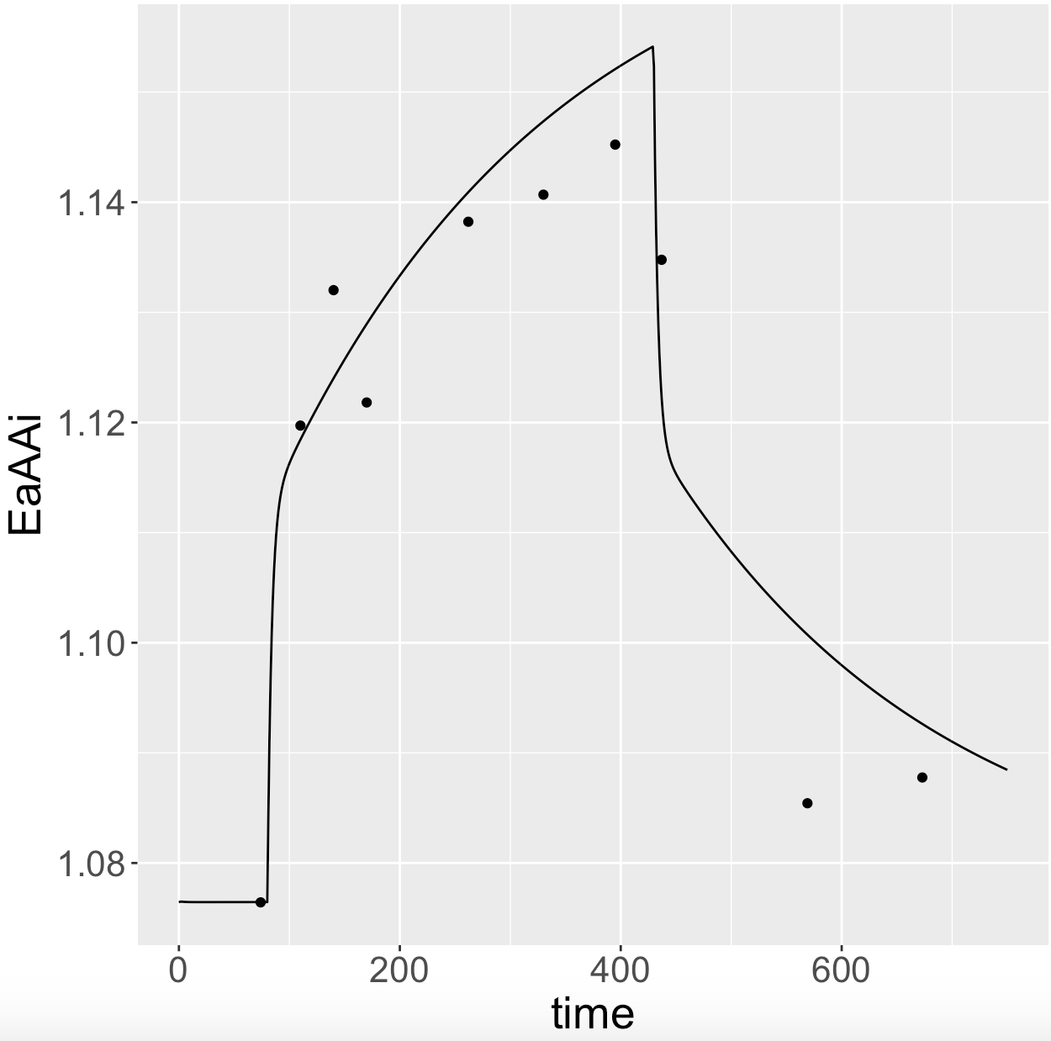
- Venous plasma

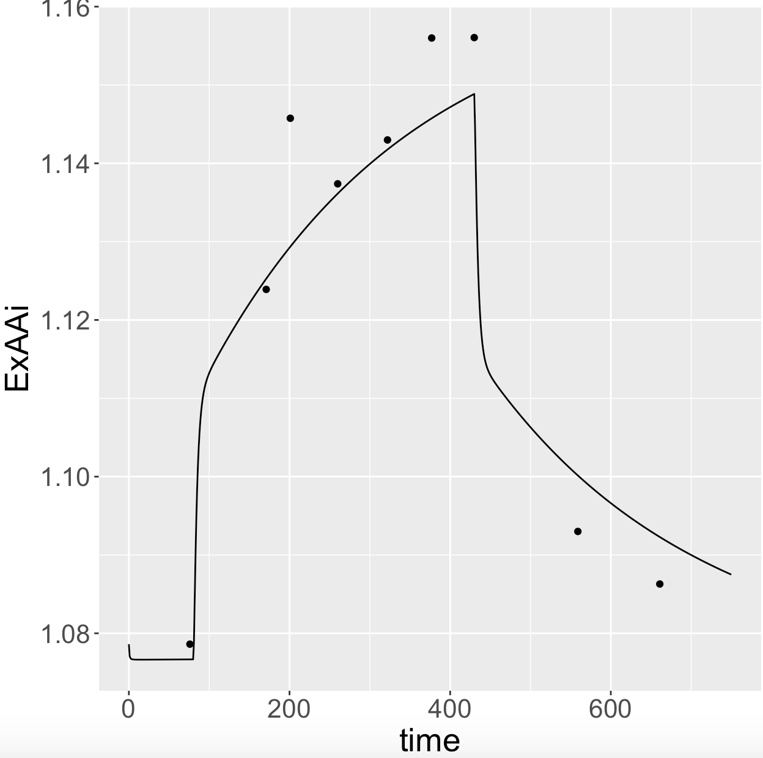

- Milk

