Website Psychology Diversity

Team
Michael D’Avella, Ian Imperial, Nathan Mussie, Nabil Saad, Jay Park

Class
CS 4624 - Multimedia, Hypertext, and Information Access

Instructor
Edward A. Fox

Clients
Virginia Tech Psychology Department and Diversity Committee

Location
Virginia Tech, Blacksburg VA, 24061
Date
May 1, 2018
Table of Contents

Table of Figures 3
- Executive Summary 4
- Introduction 5
  - Clients 5
  - Goal of the Webpages 5
- Requirements 8
  - Project Requirements 8
  - Extra Deliverables 8
  - Future Work 9
- Design 10
  - Mobile Usability 10
  - Main Page Functionality 10
  - Calendar and Events 10
  - Multimedia Content 11
  - First Design Scheme 11
  - Design Submissions 12
  - Final Design 13
- Implementation 14
  - WordPress.com 14
  - WordPress.org 14
  - WordPress.com to WordPress.org 14
  - Plugins 15
  - Mobile Use Considerations 15
  - CSS Styling 16
- Testing / Evaluation / Assessment 17
  - Content Prototype 17
  - Design Prototype 17
  - Testing with Diversity Committee 17
  - Testing with Psychology Department 17
  - Assessment from Psychology Department 18
  - New Design Submissions 19
  - Final Presentation of Project 19
- User Manual 20
  - Home Page 20
  - Courses We Offer 20
  - Our Team 21
  - Student Involvement 22
  - Research 23
  - Service 23
  - Future Faculty Program 24
  - Training Certificate Program 25
  - Events 26
  - Resources Page 26
  - Student Achievements 27
  - Video Tutorials
- Developer Manual 30
  - Getting Started 30
  - Editing Existing Content 32
- Lessons Learned 35
  - Virginia Tech Webmaster 35
  - WordPress Functionality 35
  - WordPress.com vs. WordPress.org 36
  - Timeline for Project 36
- Acknowledgements 38
- References 39

Table of Figures

Figure 1. Iowa State University Diversity Homepage 5
Figure 2. Penn State Diversity Homepage 6
Figure 3. Virginia Tech Neuroscience Homepage 6
Figure 4. Initial Design Scheme 11
Figure 5. Design Submission 1 12
Figure 6. Design Submission 2 13
Figure 7. Virginia Tech Diversity Homepage 20
Figure 8. Courses We Offer Page 21
Figure 9. Our Team Page 22
Figure 10. Student Involvement Page 22
Figure 11. Research Page 23
Figure 12. Service Page 24
Figure 13. Future Faculty Page 24
Figure 14. Training Certificate Program Page 25
Figure 15. Frequently Asked Questions 25
Figure 16. Events Page 26
Figure 17. Resources Page 27
Figure 18. Graduate Student Achievements Page 27
Figure 19. Bouchet Society 28
Figure 20. Invitation to Administrate Email 30
Figure 21. WordPress Login Page 31
Figure 22. Dashboard Page 31
Figure 23. Visit Site 32
Figure 24. Customize 33
Figure 25. Customize Options 33
Figure 26. Edit Page 34
1.0 Executive Summary

This semester in CS 4624, Multimedia, Hypertext, and Information Access, our team pursued a project with the Virginia Tech Psychology Department and their Diversity Committee. We were tasked with enhancing the current Diversity and Inclusion webpages that are offered on the Psychology Department’s website. The clients desired for us to create new webpages that would enhance the recruitment of potential students and faculty, bring better awareness to the Department’s Diversity and Inclusion endeavors to current students and faculty, and allow users to easily and conveniently utilize the Department’s resources concerning Diversity and Inclusion.

We developed a new website for the Department that included eleven distinct pages with content related to Diversity and Inclusion. The information for the pages was gathered from the InclusiveVT Inclusion and Diversity Strategic Planning Guide [4], provided to us by our clients. We gathered a library of multimedia content for use on the website from the Department. We performed user walkthroughs and distributed a survey to members of the Department in order to gauge user satisfaction and areas requiring improvement. This survey also allowed users to submit additional multimedia content for our use.

The Department had also faced the issue of the ease of editing the current webpages that they are hosting. They wanted to be able to edit their webpages in an easier fashion, being able to upload news articles and new events that the Department was holding. They requested that we consider this as we approach the development of the new webpages.

We utilized WordPress to allow for a user-friendly environment for editing the webpages in the future. We made all of the clients administrators for the website so that they can make future changes and add other individuals to become administrators. We also created video tutorials that detail the step-by-step instructions to edit each portion of the website. These seven videos will allow for the clients and anyone with administrative access in the Department to be able to easily edit content without having to spend time learning the technology on their own.

They also were interested in updating their entire Psychology Department website, upgrading all of the current webpages to be modernized. If they found our design to be favorable to the current website’s design, then they would proceed to convert the entire website. This was a consideration for us as we proceeded, making sure to think about how the entire Department website could be converted and the effort that would involve for them or anyone who undertakes that task.
2.0 Introduction

This section will highlight the Clients that we worked with as well as their motivation for the development and revitalization of the Diversity and Inclusion webpages for the Psychology Department.

2.1 Clients

For this project, our main points of contact were Dr. Robert Stephens, Chair of the Psychology Department; Dr. Danny Axsom, Chair of the Department’s Diversity Committee; Dr. Roseanne Foti, incoming Chair of the Psychology Department; and Ben Pfountz, the Psychology Department IT Specialist. We also attended several Diversity Committee meetings and spoke with the Committee members about our vision for the project and where we were in development.

2.2 Goal of the Webpages

The Clients’ vision was for us to update the Diversity and Inclusion webpage that the Department is currently hosting. They noted that they liked some of the design aspects from other departments’ webpages, such as Iowa State University’s Diversity webpage [1] and Penn State’s Diversity webpage (see Figures 1 and 2) [2]. They also really liked the style of the Virginia Tech Neuroscience homepage (see Figure 3), which makes use of the new theme that Virginia Tech had adopted for new webpages [5].

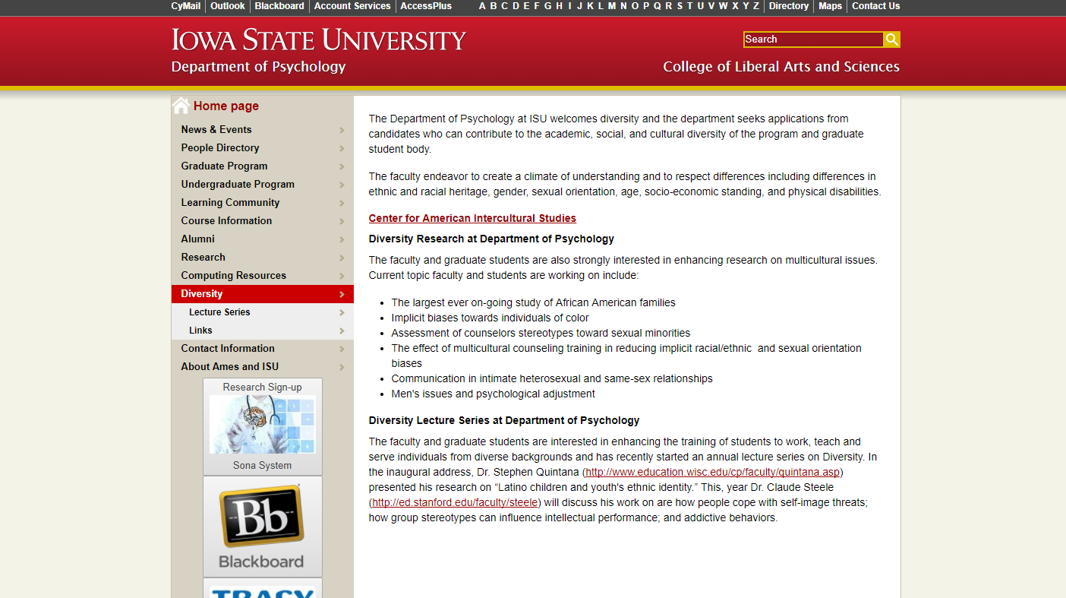
Figure 1. Iowa State University Diversity Homepage
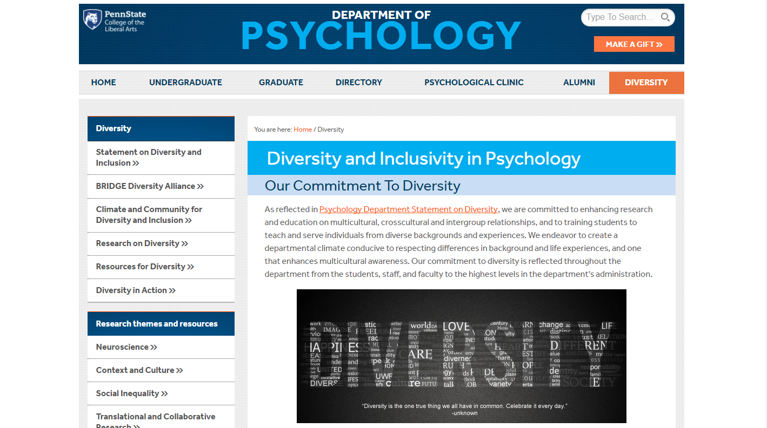
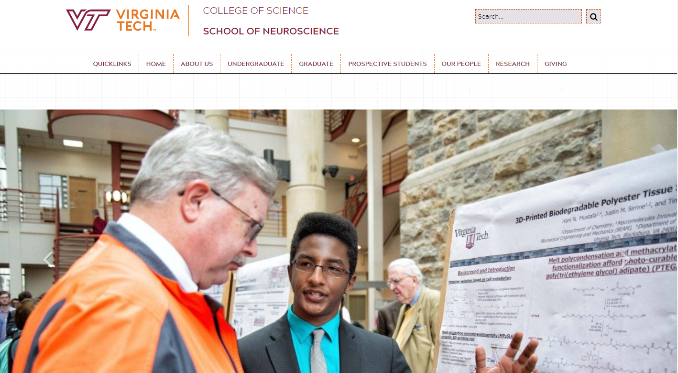
Figure 2. Penn State Diversity Homepage
Figure 3. Virginia Tech Neuroscience Homepage
The Clients wanted us to focus on how potential students and faculty would be utilizing these webpages. They wanted the webpages to be easy to understand and for navigation to not become a complicated procedure. They wanted to be able to showcase what the Department is doing in terms of promoting Diversity and Inclusion, and what is being done not only in the Department itself, but also in the University and the surrounding community as well.

3.0 Requirements

This section will highlight the requirements for the project as presented to the team by the Clients. It will also note the requirements that the team created after speaking more with the Clients and gathering their feedback on initial ideas.

3.1 Project Requirements

The original requirement for the project was to update the current Diversity and Inclusion webpage on the Psychology Department website in order to enhance the recruitment of potential students and faculty, bring better awareness to the Department’s Diversity and Inclusion endeavors to current students and faculty, and allow users to easily and conveniently utilize the Department’s resources concerning Diversity and Inclusion.

We expanded on this original requirement in our meetings with the Clients. We proposed creating a new central webpage for the Diversity and Inclusion portion of the Department that contained separate webpages the user can navigate to, containing information on even more facets of the Diversity and Inclusion endeavors that the Department is instituting.

We decided we needed to include more multimedia into the webpages because, as of the beginning of the project, the webpages lacked pictures and video. Many users enjoy seeing photographs that would illustrate what the Department would be doing. We advocated to create a page for the Diversity Committee and its members that users could utilize to learn more about the Committee members and visually see who those individuals are.

The webpages would need to be able to be included into Ben Pfountz’s Drupal project that hosts the current Department website. Therefore the pages would have to be either static or hosted by a third party, as Ben did not want us meddling too much on the server side of things.

3.2 Extra Deliverables

The Clients repeatedly brought up the point that the current Department website is hard to edit for anyone unfamiliar with how it was originally designed. They noted that they do not all have access to the webpages and find it difficult to make changes to areas such as News Articles or Events. Due to this problem, the team proposed that we could make video tutorials highlighting how to make changes to the content of the webpages we created. This way, the Clients, or whoever has access to the webpages, can modify the content of the webpages in areas such as News Articles or Events and not have to worry about the resulting impact on the overall website or have to run through an in-person tutorial with the IT Department.

We also decided to design the webpages and choose software that would best facilitate easier access to the editing of content for the Department. We chose software that members of the Department could actually learn on their own and make adjustments to their own webpages to add their own style to their page. Because the webpages’ design layouts are independent, changes to one page will not affect changes to other pages.

3.3 Future Work

As our group finishes the project, there can still be additional work to be completed. A huge advantage of WordPress is that it is very user-friendly for non-technical users. With a part of the website already being in WordPress, migration to WordPress for the entire Psychology Department as a whole can be started.

We have also discussed potentially bestowing the responsibility of maintaining the WordPress page to future Computer Science students. We were considering talking to the Web Development Club at Virginia Tech to see if they would have anyone interested in taking on that task.

4.0 Design

For our design, we wanted to have an easily accessible website that would be both nice to look at, as well as user friendly. We also wanted it to be able to merge in with the existing Virginia Tech website experience. In the case of a user coming from an already upgraded Virginia Tech website, their switch over would be almost seamless to provide the best user experience and to eliminate the need for the user to learn new norms for navigating our website. This was also done to adhere to Nielsen’s usability heuristics of using recognition rather than recall, as well as following platform conventions [6]. Both of these heuristics decrease the probability of a user being confused when on the site, and increase the chances of them staying on the site and using it to further their research on the website without getting frustrated. We tried to reach out directly to the Virginia Tech webmaster for the template files, but unfortunately we did not get a response, so we did our best to create a custom theme that fit well into the overall university theme. This actually turned out well for us, as it gave us a little more room to customize the site to our liking.

4.1 Mobile Usability

Another major factor that we took into consideration for our design was mobile readability. The original website was horrendous to use on a smartphone, as all the elements just shrank down to scale to the screen, leading to a painful user experience. As smartphones and other mobile devices become more mainstream, it becomes more and more important to cater to the growing number of people that use them. With this in mind, we created a dynamic and responsive website that would adapt to the user’s device to provide the best experience for their screen real-estate.

4.2 Main Page Functionality

We included easily accessible tabs at the top of the page, neatly organized, so that any user would be able to easily come in and find the information that they needed (see Figure 7). We also included a large rotating image slideshow into the main page. This helped to show the most recent and most important information to the user first in an easy to read and eye catching way. With a setup like this, they were able to draw more attention to their major upcoming programs to increase student turnout and participation.

4.3 Calendar and Events

On one of the menu bar pages, we created a calendar so that the user would be able to see what events were coming up (see Figure 16). On the homepage are past events, so that if it is a recurring event, the user could go in and see what was talked about and what happened at the event, so they could be ready for the next time it is held. With all of these calendar features, we made it easier for people to export the events to their Google calendars with the click of a button, making it substantially easier for people to add the events, and also potentially increasing turnout to events a great deal.

4.4 Multimedia Content

Gathering multimedia content for our website proved difficult at first. The pictures on the original department of Psychology’s website either had outdated or blurry pictures so we didn’t want to pull too much from it. Initially, we pulled our content from different sources, for example, whenever we talked about other organizations within our website we’d pull pictures from their website/Google images. But we realized that couldn’t sustain us for long, so we then created a Google Doc and shared it with our clients to drop relevant multimedia content in. Furthermore, our clients released a survey through the department of Psychology’s listserv that prompted the department to submit multimedia content. The clients notified us that there would be upcoming events that would be great to see on the website, so they would try to obtain any pictures that were taken at said events. Currently, we have a lot more multimedia content on the website, stemming from a multitude of sources, more than we had originally.

4.5 First Design Scheme

The first design scheme that we developed and presented to the clients (Figure 4) contained a mix of dropdown content and graphics that we had gathered from the current Department webpages.

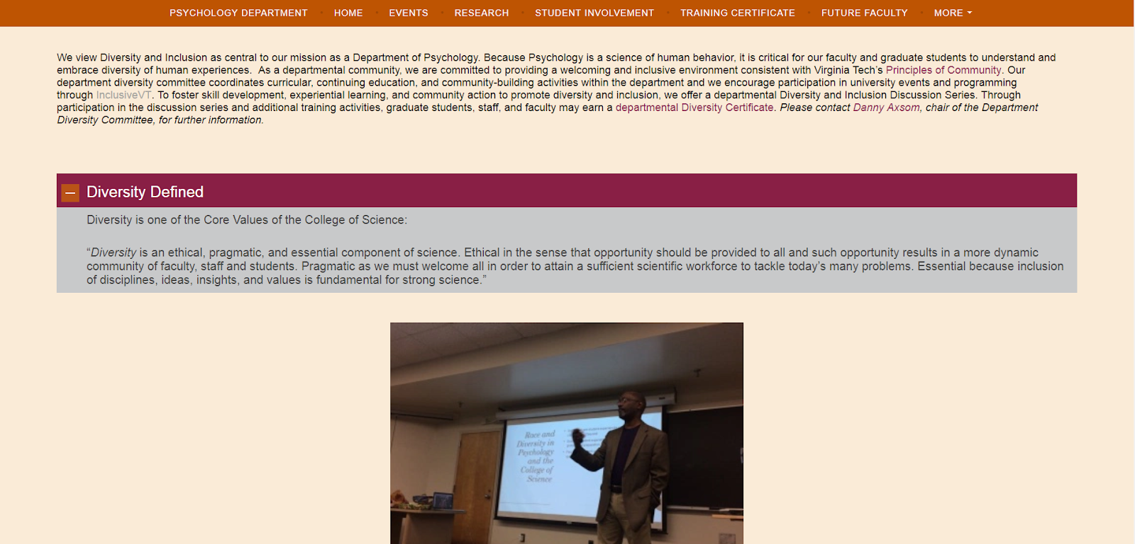
Figure 4. Initial Design Scheme

It contained no backgrounds behind the text, and all of the text was colored black. It appeared that there was a good amount of space not being utilized on the pages as well.

4.6 Design Submissions

The team designed two new layouts for the webpages that were suggested to the clients, in an effort to alleviate the amount of open space on the pages and to be more aesthetically pleasing.

The first design (Figure 5) utilized a background for all of the content on the page that was the same orange as the menu bar. The text was colored white in order to read it better. It was suggested to add more variety to the pages as well as draw the user’s eye to the text.
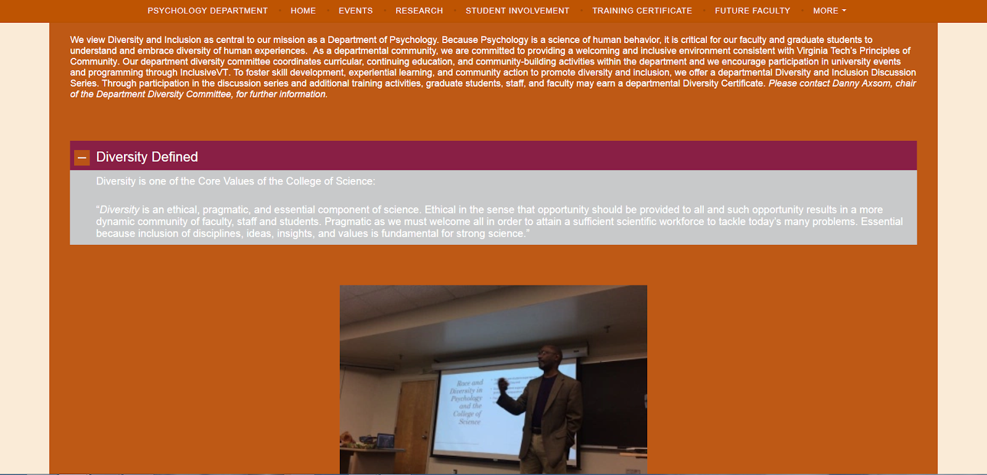
Figure 5. Design Submission 1

The second design (Figure 6) split the content into sections, divided by backgrounds of alternating colors. The colors chosen were a light gray and a light orange, which were specified in Virginia Tech Branding documents. We changed the text color in the orange sections to white to make it easier to read. The alternating sections were intended to split the content and allow the user to be able to read the information more easily.
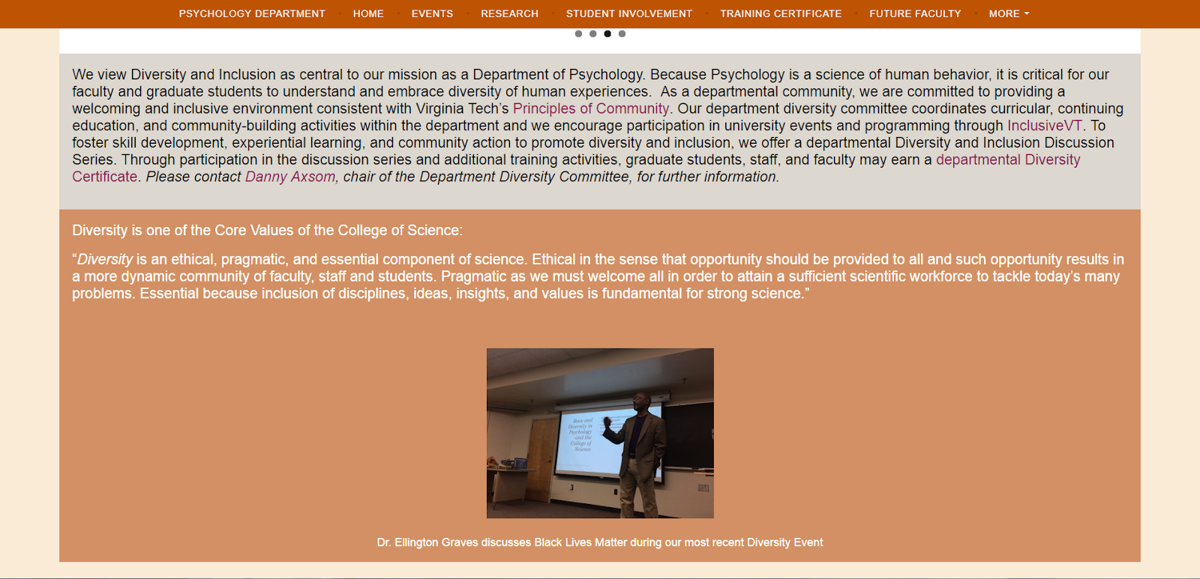
Figure 6. Design Submission 2

4.7 Final Design

The team presented the two designs (Figures 5 and 6) to the clients and they unanimously chose the second design (Figure 6) for the pages. Their reasoning was that the orange in the first design was very powerful, and even though our eyes are attuned to the color because of the branding Virginia Tech uses, not all people are used to it.

5.0 Implementation

After determining the requirements and deciding on a design, our group began our implementation. We started on WordPress.com, but along the way, we decided it would be better to use WordPress.org for added capabilities of customizability and plugins.

5.1 WordPress.com

Our initial implementation was done on WordPress.com. We created a website for Diversity & Inclusion with the Virginia Tech Psychology Department, and added content based off of our discussions with our clients. In our Developer Manual, we display the step by step process that we used in adding the content to the website. WordPress.com offered a fairly simple-to-use interface that, despite having not used it before, we were able to pick up pretty quickly.

5.2 WordPress.org

After a tip from another group and further discussion with our clients, we decided to migrate from WordPress.com to WordPress.org. This change allowed us to utilize plugins on the webpages we designed without paying for the memberships that WordPress.com requires.

WordPress.org eliminated any WordPress ads on the webpages and allowed us to use our own custom domain name. WordPress.com requires a WordPress domain name if we were to use the free membership [11].

WordPress.org only requires that the user host their own domain and for the website to be designed in WordPress [13]. Virginia Tech offers its own hosting services which the team utilized to create a domain for the website [9]. The team migratied the WordPress.com webpages into WordPress.org and the new domain. Once that was completed, we expanded on the original design, since WordPress.org has more capabilities concerning webpage functionality. Our clients requested our webpage be more interactive in the sense that people would be able to view their content in a refreshing manner. So by porting our prototype over to this new website, our team was able to do just that.

5.3 Migration from WordPress.com to WordPress.org

In order to migrate from WordPress.com to WordPress.org, we reached out to VT Web Hosting at Virginia Tech [9]. We got in contact with Joy Huntley of The Hosting Team, who helped us in getting our site set up with one of our clients, Ben Pfountz, serving as our network liaison. We discuss the process of acquiring the domain name in Section 9.2.

After our domain name was set up and hosting was successful through Virginia Tech, WordPress.org required that we download a zip file containing the contents necessary to run WordPress for our website [12]. We uploaded all of these files to our hosting page via Cyberduck. We edited the wp-config.php file to allow us to configure the settings for our website properly. At this point, we were able to create username and passwords for logging in, to make changes to the website with our admin properties with the wp-admin.php and wp-login.php files.

After creating accounts, we learned the new interface of the Dashboard for WordPress.org, which offered more customizability than with WordPress.com. We created the same pages we had on WordPress.com and transferred the content over. From there, we were able to expand and explore the new capabilities that WordPress.org offered.

5.4 Plugins

One of the plugins we used in our project was the Events Calendar plugin. We were looking for a plugin that would allow users to look at upcoming event information, while looking as polished as the rest of the website. Out of the many calendar plugins, this plugin looked the most polished, with neat transitions, as well as hover-over effects to add an extra element of design. It was also incredibly broad in its functionality. It was very simple for the admins of the site to use, with an event added easily by clicking a add event link at the top of the page. After that, the admin is given text boxes to fill information into. On the user side, the user is able to click on the event to see a brief view of the event on the calendar page. If the user wishes to add the event to their calendar, they can click on Export to Google Calendar, to easily and automatically add the event with all of the event details into their personal calendar. If the user wishes to see more information on the event, they are able to click on the See More Information button to open up a dedicated page for that particular event, which is created automatically by the plugin when the user creates the event, taking away another layer of complexity from the administrator’s perspective. One thing we would have liked to do was have a Google Calendar import, so that the admins could just import from a single Google Calendar into the events calendar, so that they didn’t have to maintain two separate calendars. Unfortunately, that was only included with the paid version of the plugin. Doing an analysis on our requirements, we believed that the slight decrease in functionality was worth the increases in other features, such as the better UI, as well as other functionality not found in calendars with Google Calendar import features.

5.5 Mobile Use Considerations

We had a couple of different mobile use considerations regarding our website. There were problems with things such as certain sizes of different sections, and dimensions in the website. Initially we thought of certain precautions to ensure mobile compatibility -- things like changing all dimensions to percentages so that the website would scale and just ensure proper mobile UI methods were practiced. Next, we needed to adopt a trial and error approach and realized we had to tailor different parts of our website to adhere to the mobile version. The header of our website was one of our first problems; since the dimensions of the mobile version are smaller, the header image was overlapping with our menu bar. After fixing that, the search bar began to go to different places once the page was loaded. Next, the text of our description box wasn’t legible in the mobile version of the website for some reason, which our client brought up after we sent the website out for them to test. So there were multiple considerations that we thought of as well as developed as we went along, and they were all important in the finalization of our website.
5.6 CSS Styling

To make our website aesthetically appealing, we dealt a lot with the CSS styling. WordPress.org has an option for editing appearance with a CSS editor. Similarly, whenever we select the “Customize Page” option on any page of the website, we are able to edit the CSS there. This is what allowed us to select percentages for margin padding, select the font to use, and select what colors the fonts would be. These aspects made the pages livelier and gave our site a sense of identity. We adhered to Virginia Tech branding by making sure the colors we use on our pages aligned with the official Virginia Tech branding colors.

6.0 Testing / Evaluation / Assessment

6.1 Content Prototype

For our content prototype, we extracted several pieces of content for potential pages based off of our meetings with our clients. They provided us with the InclusiveVT Inclusion and Diversity Strategic Planning Guide [4]. The InclusiveVT Inclusion and Diversity Strategic Planning Guide provided information for departments to advance goals of diversity and inclusion. The Department of Psychology used this guide as a template to create a 50 page guide [4] that the Department of Psychology would abide by. We scanned this document and parsed out the key information and content that should be added to our WordPress website. We separated important information to different pages that a user on our website could view to learn. The different pieces of content can be seen in Section 7, our User Manual.

6.2 Design Prototype

Our intentions were to design the website similar to that of other Virginia Tech websites such as the homepage of the College of Science School of Neuroscience [5]. However, since we were unable to use the Content Management System (CMS) that Virginia Tech departments use for those pages, we tried to create a design similar to those pages on WordPress.com [7]. The design prototype can be seen in Section 7, our User Manual. Although it was not exactly what we envisioned, our clients and our team were both happy with the product, and will continue with developing with this design. In our migration to WordPress.org, we hope to enhance the website further in terms of design and aesthetic. The customizability of WordPress.org allowed for a lot more freedom in what we were able to do with the website.

6.3 Testing with Diversity Committee

After we created a prototype that was satisfactory for testing, we asked our client to distribute the website to members in the department, particularly those in the Diversity Committee. We want to ensure that the website we create will be easy to use and easy to navigate for these members, so we want to see what thoughts the committee had regarding such aspects. We created a Google Forms questionnaire/survey to receive this feedback from the participants.

6.4 User Testing and Survey with Psychology Department

As a lot of us learned about usability heuristics from our Introduction to Human-Computer Interaction course (CS 3724), we wanted to apply this knowledge when deciding which questions to ask during our testing. The questions were as follows:

- What did you think of the text on the pages? What changes, if any would you make to them?
- What pages do you think are the most important to see on the menu bar? Do you think any of the pages in the “More” section should be on the main menu bar?
- What design aspects do you think we could add to the pages that would make it better for your purposes?
- Try using the Search bar at the top of the site and look up “Tier 1”. Rank the difficulty in finding the Training Certificate Program.
- Try navigating to the Psychology Department’s home page. Rank the difficulty in getting to that page.
- Navigate to the “Our Team” page. Locate Julie Dunsmore’s information. What is she a director for?
- Did you experience any problems when navigating the pages? If so, what?
- If you visited the site on a smartphone or tablet device, did you have any trouble navigating the website? Were there any visual or formatting problems?
- Do you have any other suggestion for the website?

These questions helped us in checking to see if we are missing anything on our pages. They also let us check to see if our pages are indeed intuitive to use. We asked to see if our minimal design was simple to understand, as well as if it was easy to read and use. We also wanted to make sure it was efficient, so we asked which sections should be most easily accessible, i.e., which pages should be linked from the menu bar. Since the Diversity Committee would be utilizing our website for their needs, we also asked to see if there was anything they personally would want to add to the website so that we could do it for them. We also made sure it was easy to navigate and asked them if they ran into any problems while navigating.

We then had a section for “User Input”. In this section, we asked takers of the survey to provide any multimedia content they may have, such as photos, videos, links, and/or text to include. Anything they provided in this section could help us to add information to enhance the website.

6.5 Assessment from Psychology Department

After gathering responses to our survey, we looked at the suggestions and answers to help us edit our page. For the first question, some users suggested that some information was not up-to-date, so we did more research to make sure it was. Others said they had no ideas for changes and that it was easy to read.

For the second question, we asked if any sections should be moved to the menu bar. Between these responses and speaking with our clients, we made adjustments to the menu bar as necessary. Part of the reason we added a calendar to the ‘Events’ page was based on one of the responses for the third question about what should be added. We also added captions to the home page banner images as requested from this question.

People were able to navigate the pages and use the search bar with ease as indicated by their responses. However, we adjusted some margins and bindings based off of issues with viewing the site on a smartphone or adjusting the window.

Other small comments were made in a few of the responses that allowed us to fine tune the details of our website. We were also able to gather resources and multimedia content in the User Input section of the survey that we added to the website as requested.

6.6 New Design Submissions

One of the tests we conducted was a walkthrough of the website during one of our client meetings. We wanted to give the clients a realistic idea of how each page would look and about the overall flow of the website. During this walkthrough, the clients noted that there was a good amount of unused white space on the pages.

Due to this critique, the team decided to construct two new design layouts for their approval. The clients ended up selecting the design that features alternating background colors for each content section of a page.

6.7 Final Presentation of Project

We used the final presentation in class to discuss our progress and learning experience for the project and to reflect on the process of creating our product as well as the long-term use of the website. Dr. Axsom was able to be a guest for the presentation and offered feedback to the class about his interactions with the team.

7.0 User Manual

The team has constructed a WordPress website for the Department with website hosting coming from Virginia Tech. This section will feature how the user will access and utilize the Psychology Department’s Diversity and Inclusion website.

7.1 Home Page

The user will navigate to http://www.diversity.psyc.vt.edu/ (see Figure 7), which is the main page for the Diversity and Inclusion website for the Psychology Department.

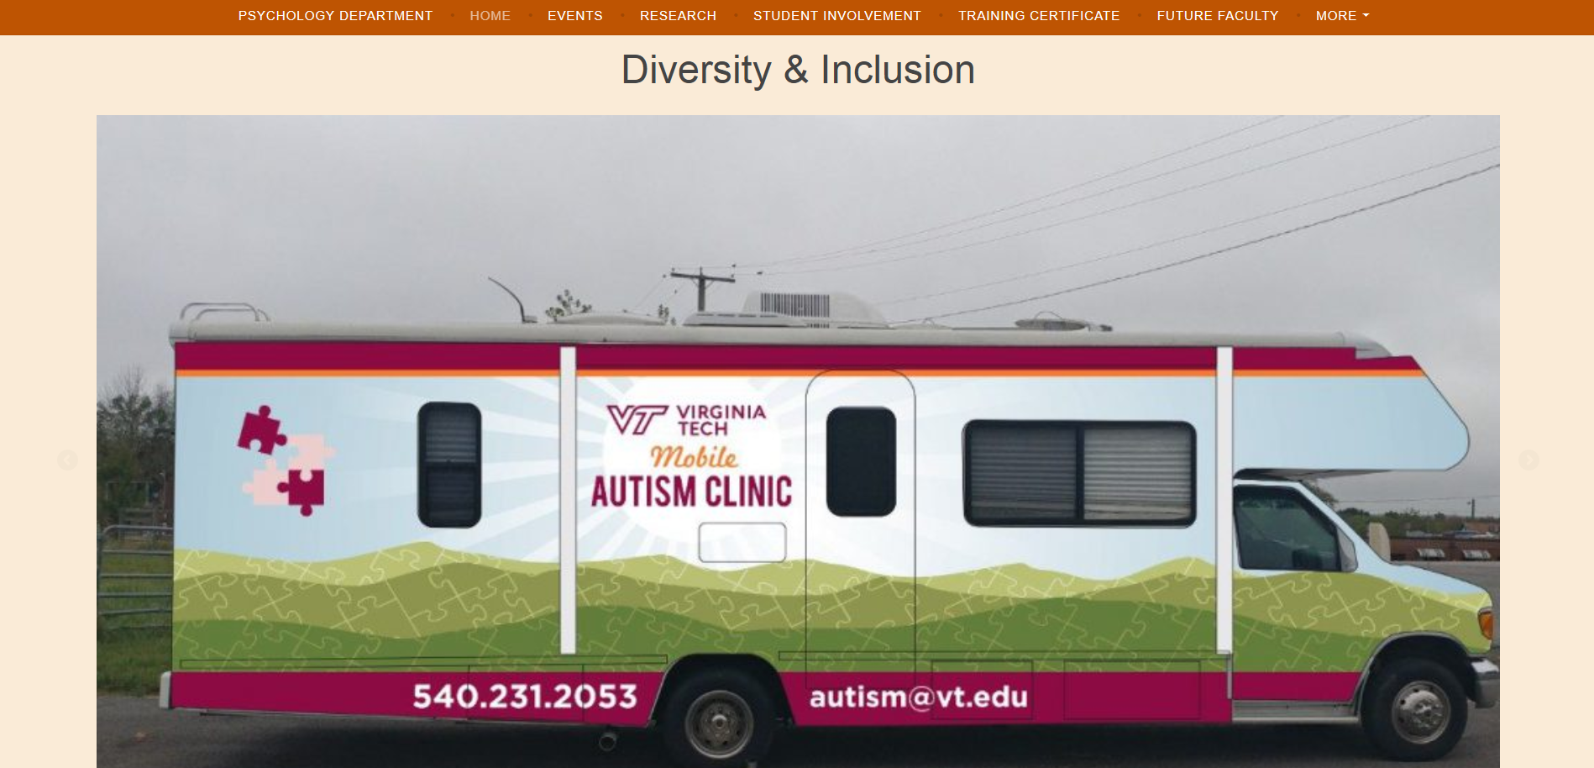
Figure 7. Virginia Tech Diversity Homepage

This page features a menu bar that allows navigation to any of the other webpages that the Diversity and Inclusion website encompasses. The menu bar stays at the top of the page as the user scrolls through the page.

It includes a statement from the Department detailing its commitment to Diversity and Inclusion and the University’s endeavors that align with these principles. It also includes the College of Science’s definition of Diversity as it applies to the College.

It includes sections for Events and News Articles that are of interest to Diversity and Inclusion within the Department.

7.2 Courses We Offer

This page (see Figure 8) features undergraduate courses that the Department offers that cover topics related to Diversity and Inclusion. It currently includes the course title, course number, and a brief description of the material covered in each course.

It includes information on the Psychology Department Undergraduate Course Catalog and a link to the catalog itself.

It includes a short statement on the Training Certificate Program with a link to the program’s webpage.

It finally includes a link to the Virginia Tech Timetable of Classes so that users can see more specific information about the courses listed above as well as some of the other courses the Department offers.
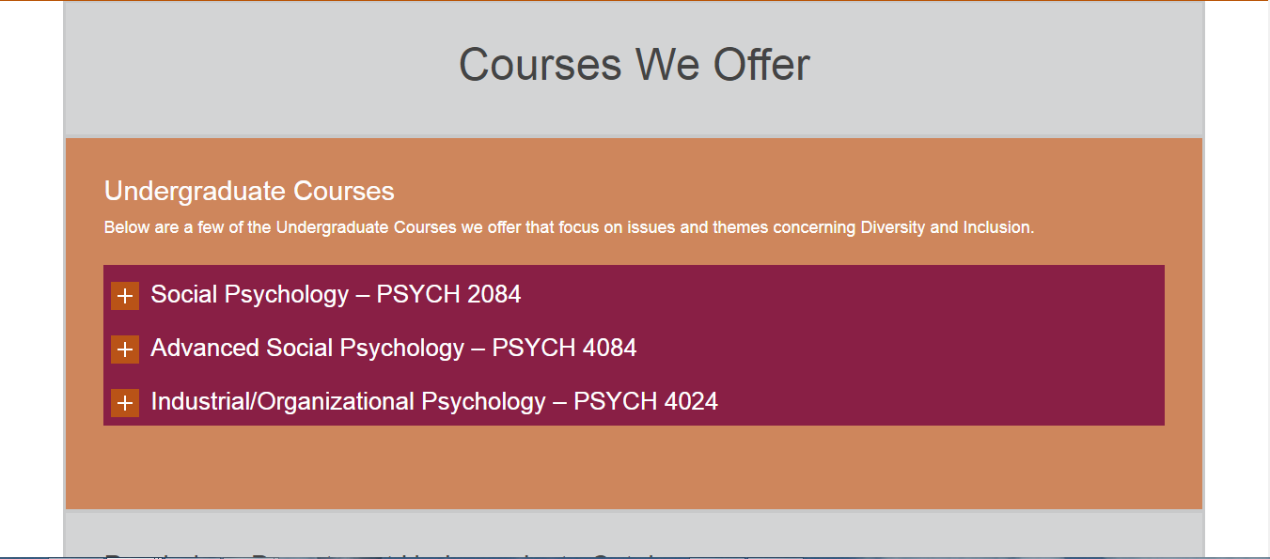
Figure 8. Courses We Offer Page

7.3 Our Team

This page (see Figure 9) features a statement about what the role of the Diversity Committee is and some of the activities that it is involved in throughout the year.

It then contains a section that covers the members of the Committee. This section shows pictures of the members of the Committee along with their name and title. Clicking on their picture will bring the user to their Virginia Tech Profile Page.

Names and some contact information for other Staff, Undergraduate Students, and Graduate Students are included after the above section.
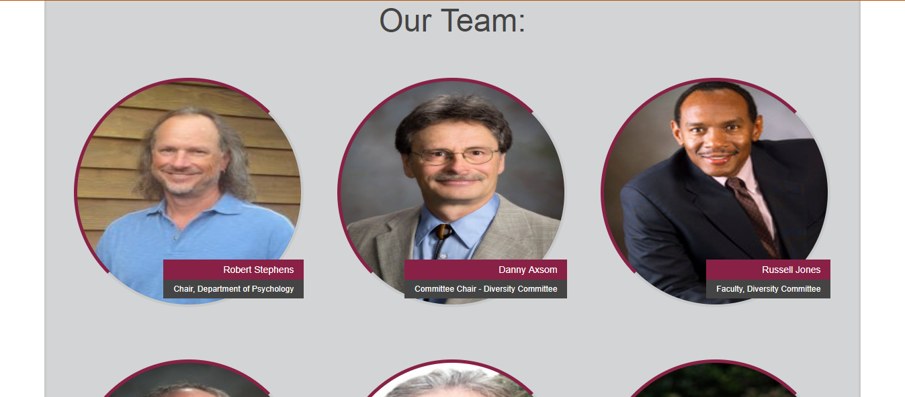
Figure 9. Our Team Page

7.4 Student Involvement

This page (see Figure 10) features the Student Organizations that the Committee currently advises and supports. It contains a brief description of the Committee’s involvement in each organization.
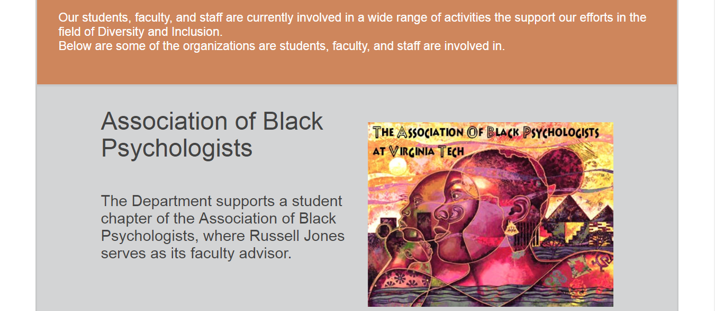
Figure 10. Student Involvement Page

7.5 Faculty Research

This page (see Figure 11) features the research that faculty in the Department are currently conducting or have conducted concerning Diversity and Inclusion principles. Links to some of the labs are provided so that the user can gain even more information on the topics. Much of this research is also related to serving the greater community.
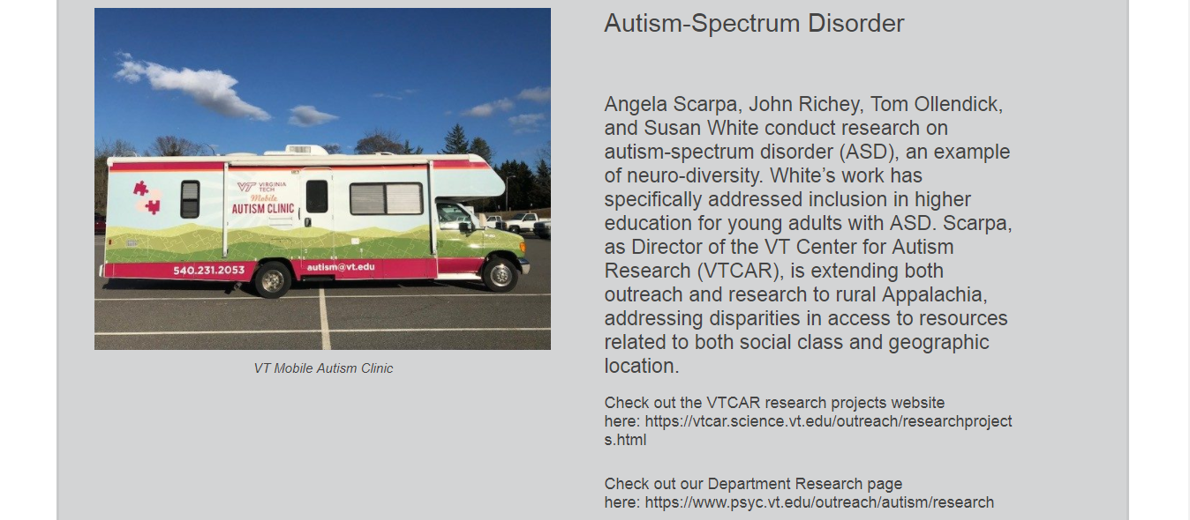
Figure 11. Research Page

7.6 Service To Our Community

This page (see Figure 12) features the Department’s initiatives and involvement in service to the community, both local and national. It contains information on who is involved, the organization they are affiliated with, and what they have been doing.

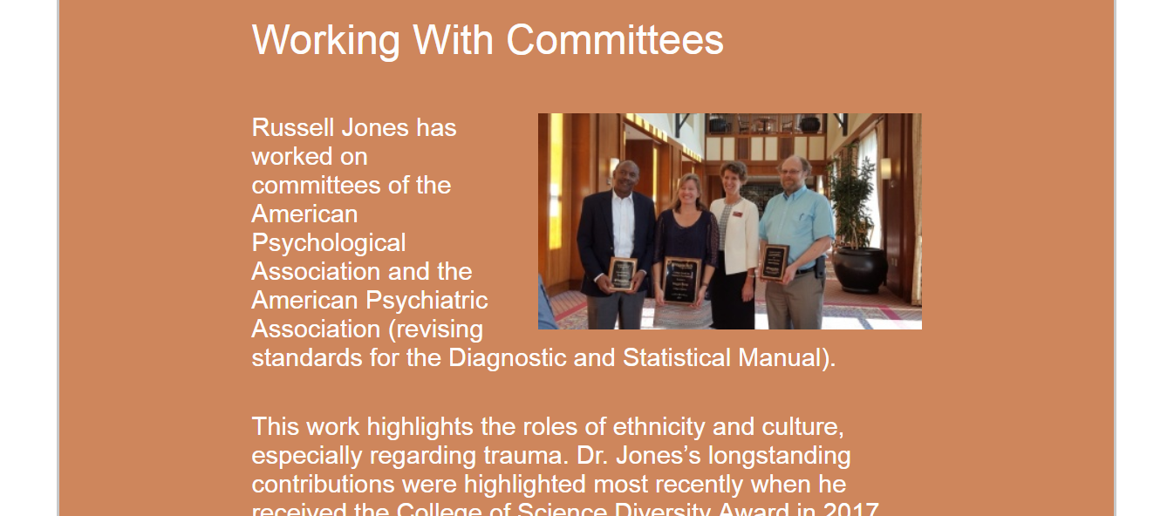
Figure 12. Service Page

7.7 Future Faculty Program

This page (see Figure 13) describes the Future Faculty Program for the Department. It contains information about the purpose of the program and information about the application process.

It also contains information about Dr. Vanessa Diaz, a member of the Department who was recruited through the Future Faculty Program.

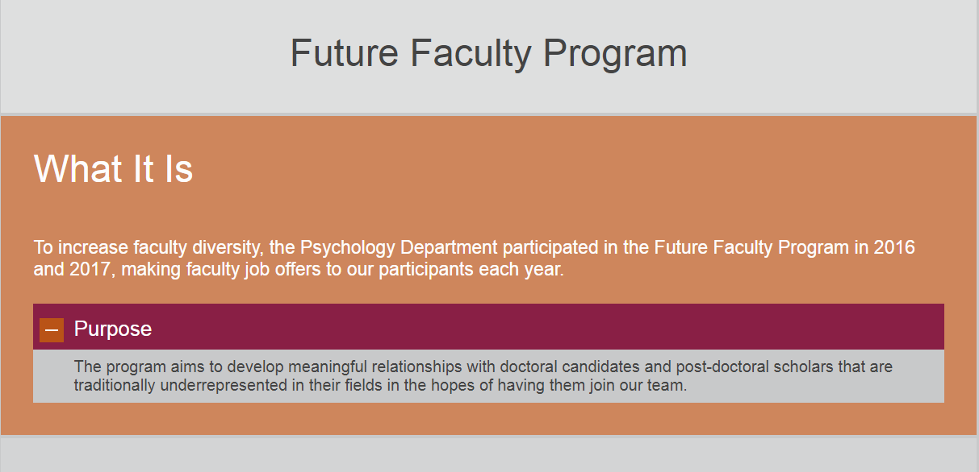
Figure 13. Future Faculty Program Page

7.8 Training Certificate Program

This page (see Figure 14) contains information about the Training Certificate Program that the Department offers. It includes a section describing the Three Tiered System that is the means of advancing through the program. It includes specific information about each facet of every tier of the program.

It also includes a Frequently Asked Questions section that will help the user with common problems or questions they may encounter.

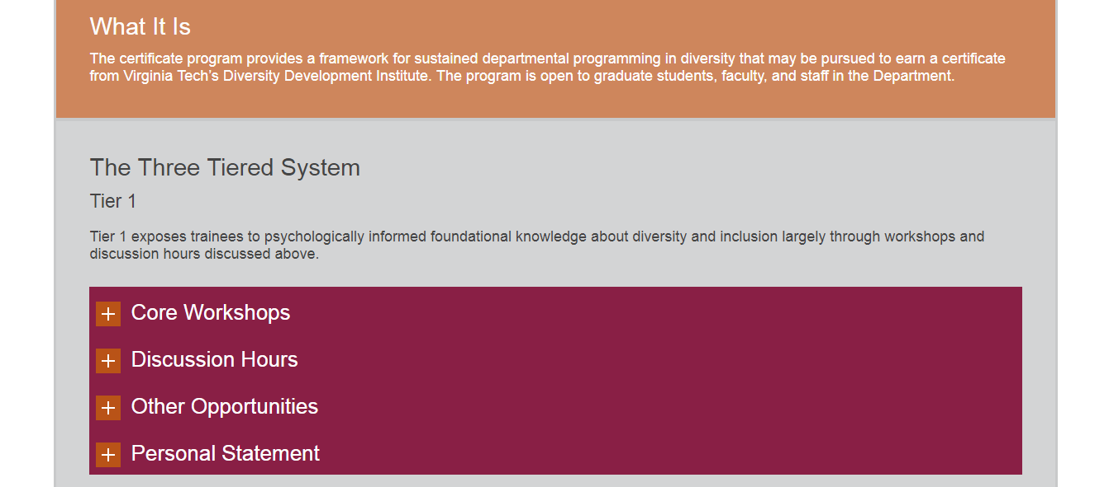
Figure 14. Training Certificate Program Page
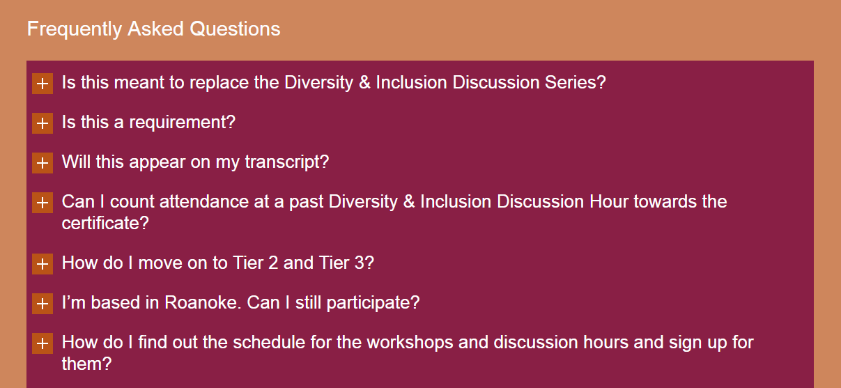

Figure 15. Frequently Asked Questions
7.9 Events

This page (see Figure 16) features an embedded calendar that showcases events that the Department is hosting or supporting.

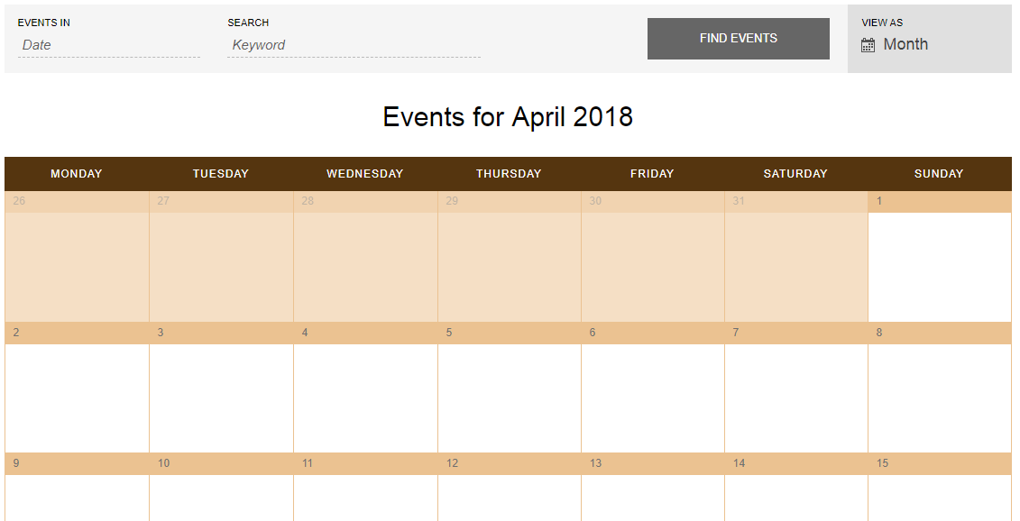
Figure 16. Events Page

7.10 Resources Page

This page (see Figure 17) showcases the Principles of Community for Virginia Tech and information on the Office of Diversity and Inclusion for Virginia Tech. The page also provides links for more information on each of these.

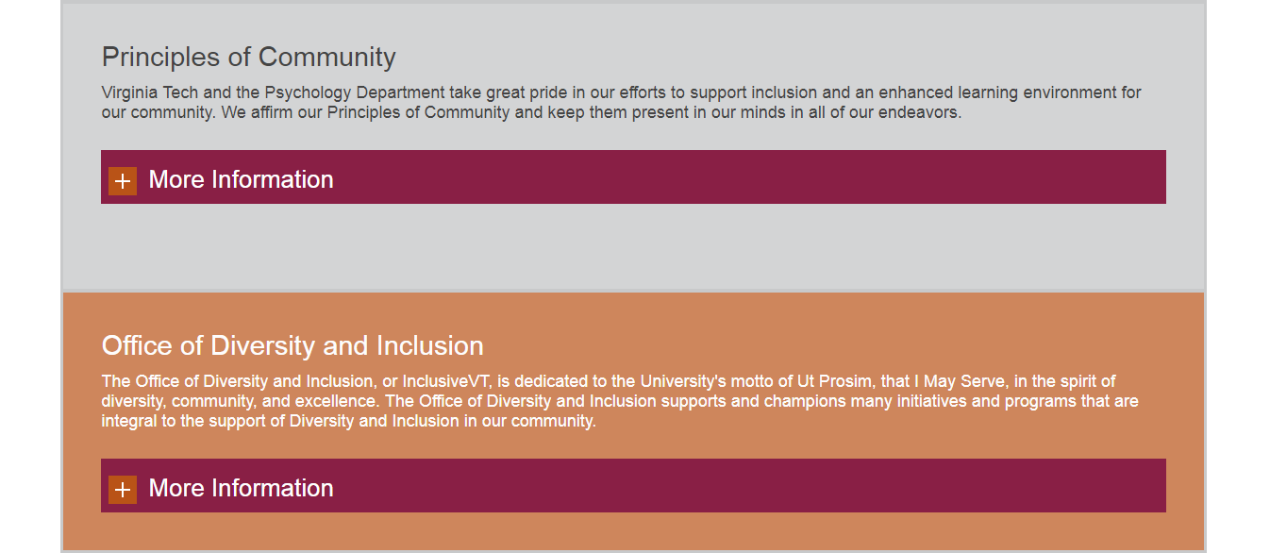

Figure 17. Resources Page

7.11 Graduate Student Achievements

This page (see Figure 18) features achievements made by graduate students in the Department. It showcases the Department’s Diversity Scholars spanning from 2014 until 2017.

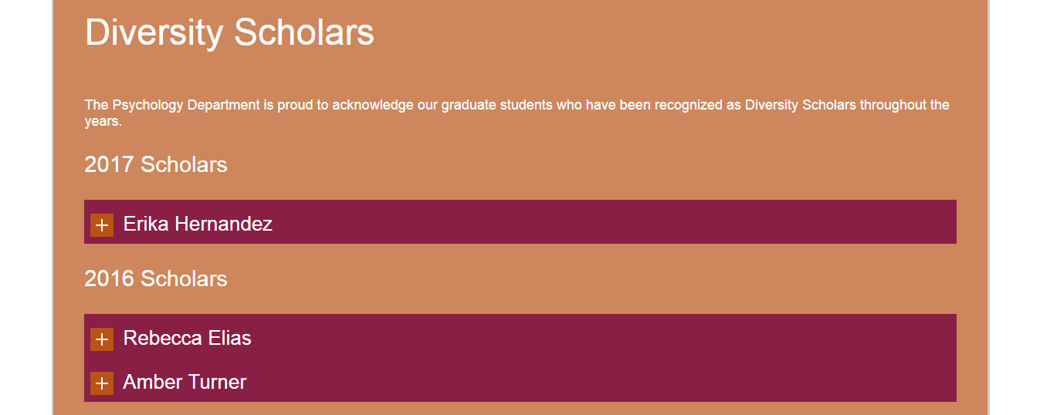Travelling further down the page (see Figure 19) will show information about the Edward A. Bouchet Graduate Honor Society and Amanda Halliburton, a 2017 inductee into the society. There is also a link to find out more information about the society.
Figure 18. Graduate Student Achievements Page
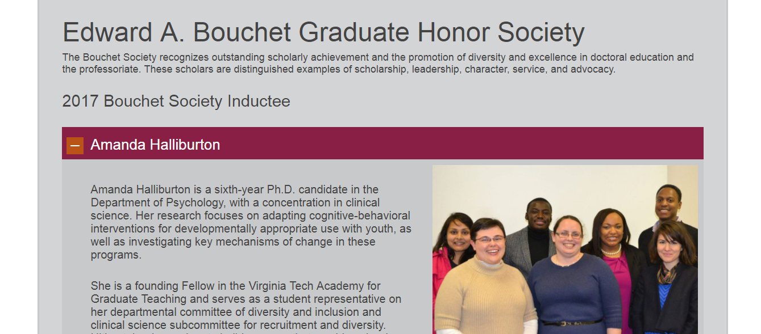
Figure 19. Bouchet Society

7.12 Video Tutorials

The team developed various video tutorials to walk the user through how to edit different portions of the website. This was done because the clients expressed that the current website is difficult to edit for non-specialists. See details in Table 1.

Tutorial Name | Time Length (min: sec) | Description
Adding_a_Page | 3:57 | This video tutorial explains the process of adding and editing a new page to the website.
Adding_Background_Content | 2:29 | This video tutorial explains the process of adding more content with alternating background colors to match the current theme of each webpage.
Adding_Dropdown_Content | 2:42 | This video tutorial explains the process of adding dropdown content to any webpage.
Create_Events | 4:47 | This video tutorial explains the process of creating new events on the Events Calendar for the Events Page.
News_and_Events | 1:55 | This video tutorial explains how to add new News Articles and Events Articles to the main page of the website.
Our_Team | 3:01 | This video tutorial explains how to add, edit, or delete individuals from the Our Team page.
Picture_Slideshow | 1:27 | This video tutorial explains how to edit the picture slideshow on the main page of the website. It also explains how to create a new slideshow.
Table 1. Video Tutorials

8.0 Developer Manual

  - Getting Started

1. To start, you will get an invitation to admin the webpage via e-mail, as shown in Figure 20.

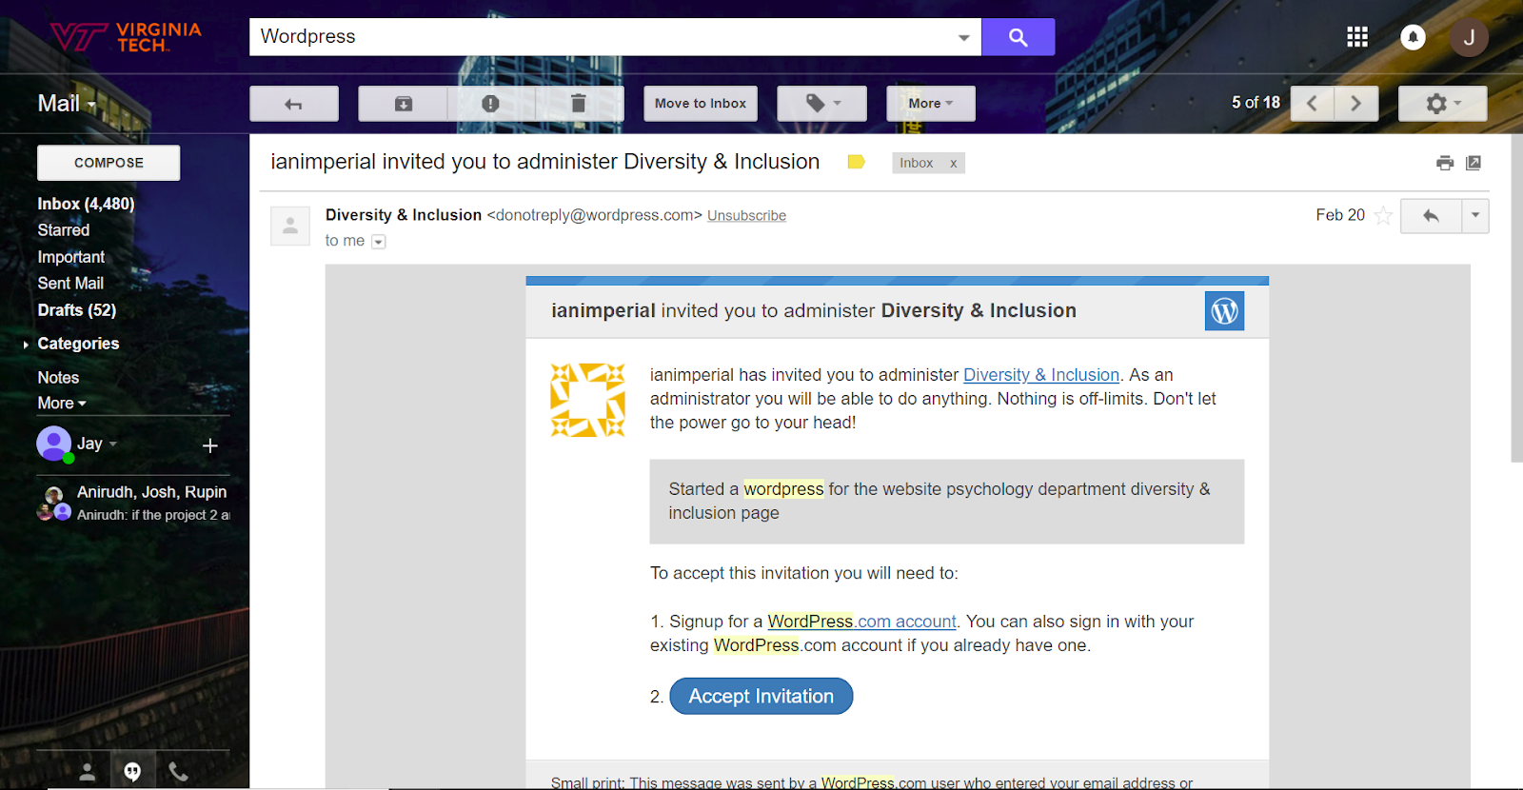
Figure 20. Invitation to Administrate Email
2. Once you have accepted the invitation and created a WordPress.org account (if you have not done so), you will have access to edit the webpage. Proceed to this site: www.diversity.psyc.vt.edu/wp-admin and login with your new credentials (see Figure 21).
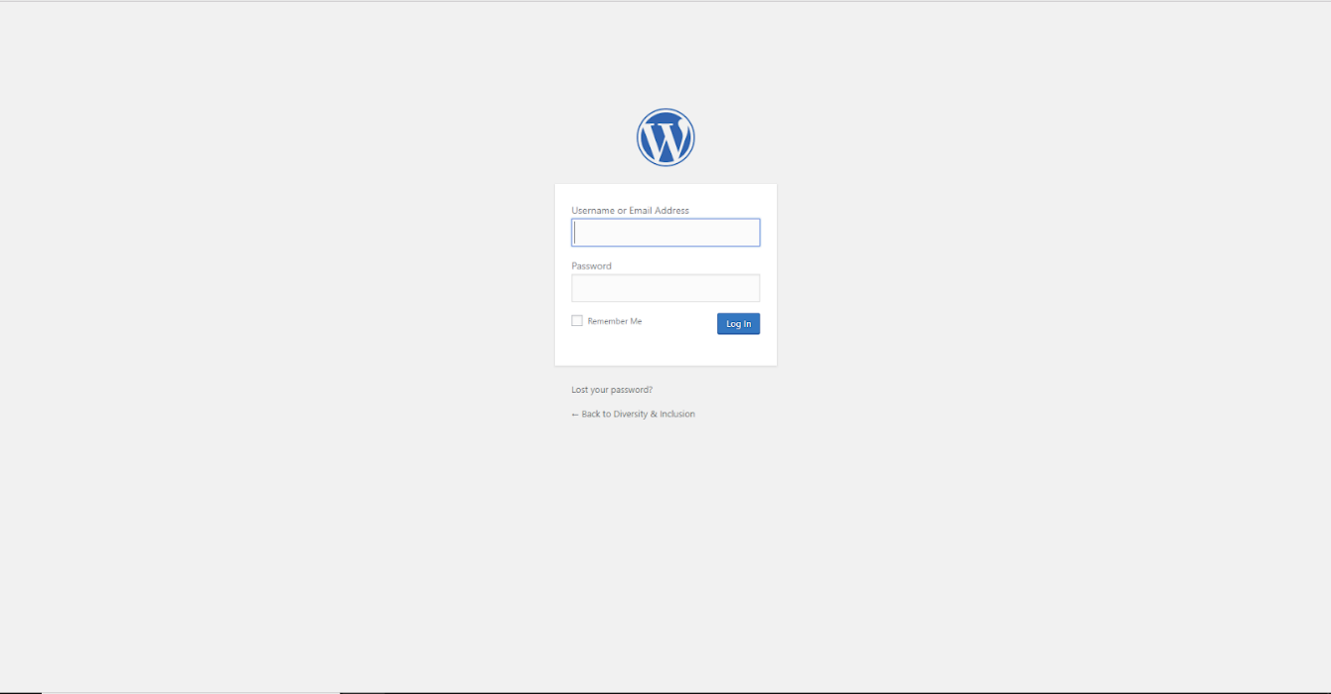
Figure 21. WordPress Login Page
3. Once you have logged in with the correct credentials, your screen should look like Figure 22.
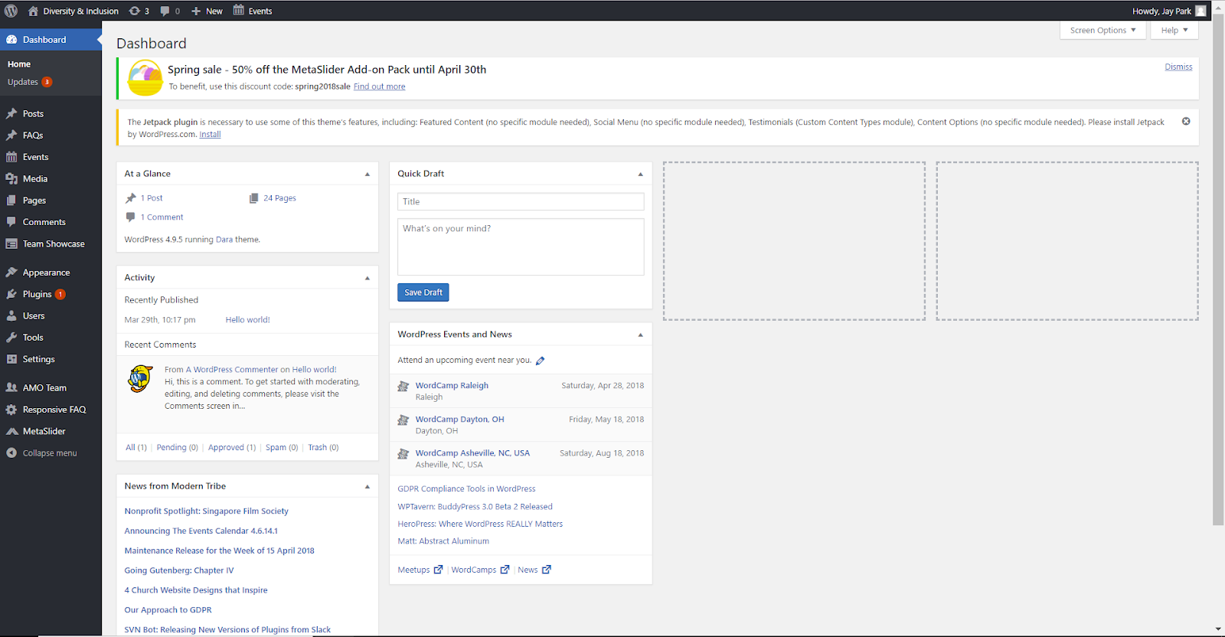
Figure 22. Dashboard Page

8.2 Editing Existing Content

1. Once you have done the steps in 8.1, hover over Diversity and Inclusion in the top-left corner and click on “Visit Site” (see Figure 23).
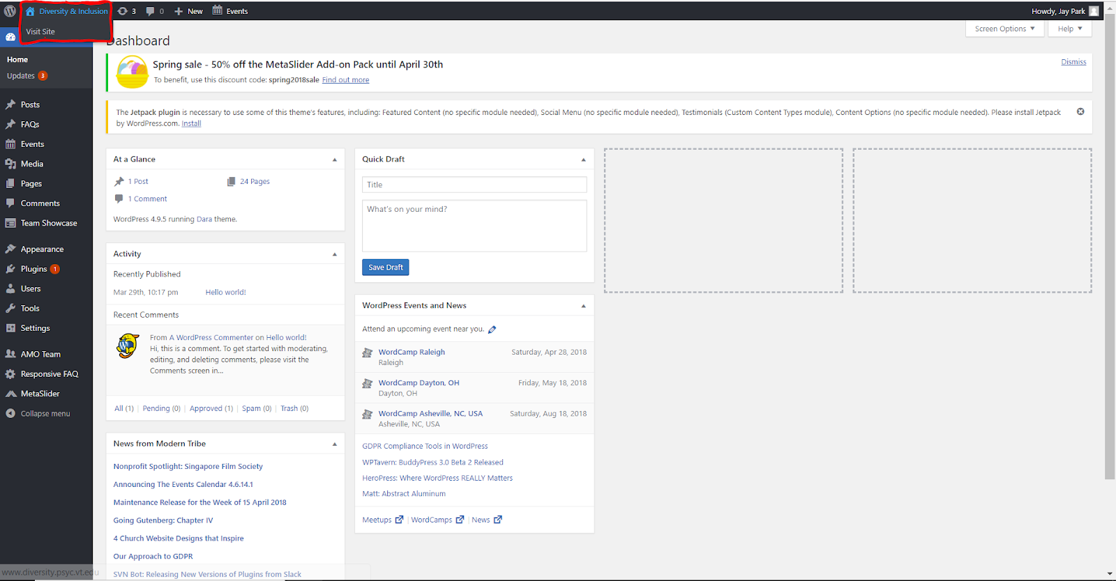
Figure 23. Visit Site

2. After you click “Visit Site”, your page should look like Figure 24. Go to the top left side of the webpage and click Customize.

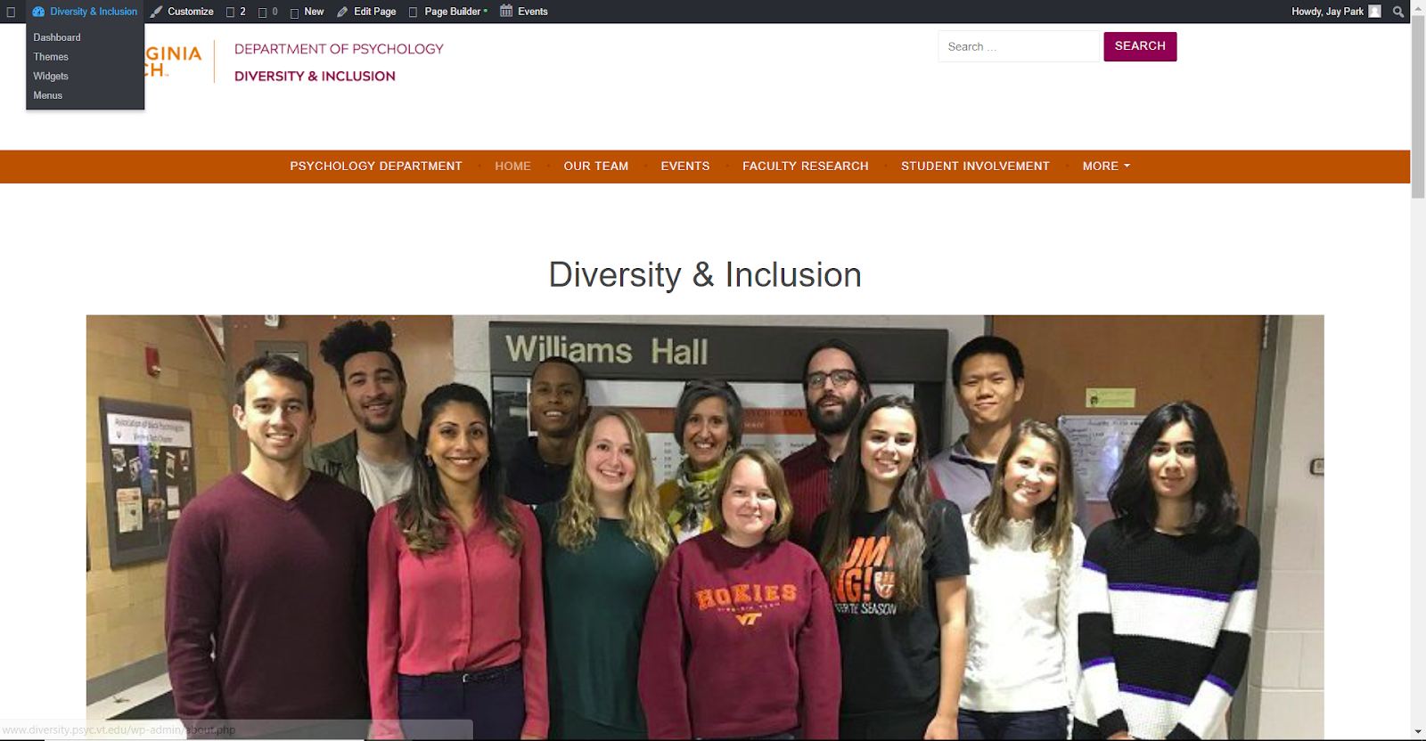
Figure 24. Customize

3. By clicking on Customize, it will lead you to customize page (see Figure 25). On this screen you will be able to do changes such as changing the Typography, Header Images, and adding custom CSS code (if you are familiar with such).

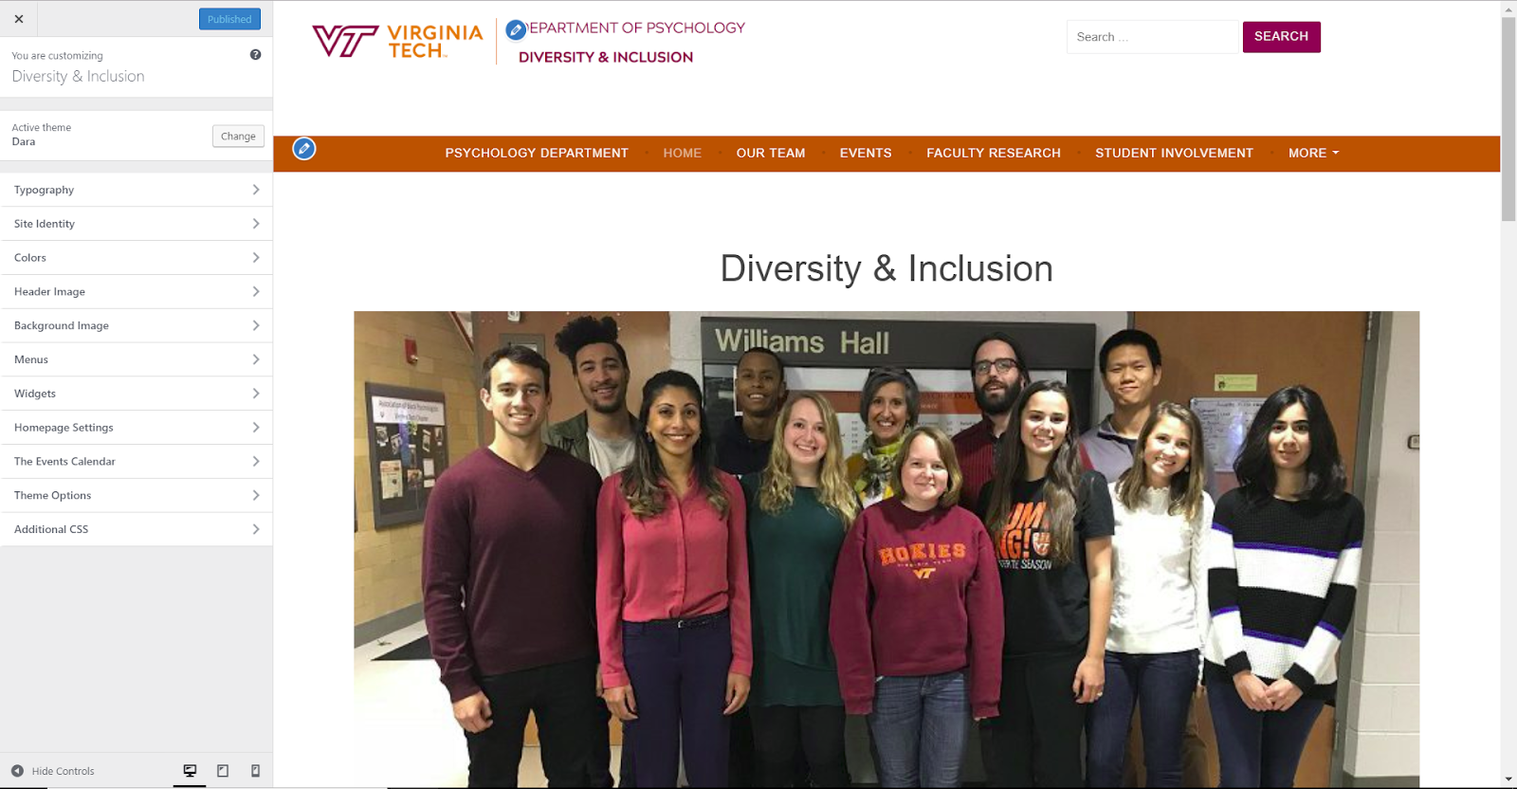
Figure 25. Customize Options
4. If you would like to change the content of the web-page, click on the X on the top-left side of the sidebar and it should lead you back to Step 2 of Section 8.2. Click on “Edit Page” on the top sidebar. After you click “Edit Page”, it should look like Figure 26. You can add your changes to the textbox, and then confirm your changes by clicking on “Update” which is on the right side of the screen in the “Publish menu”
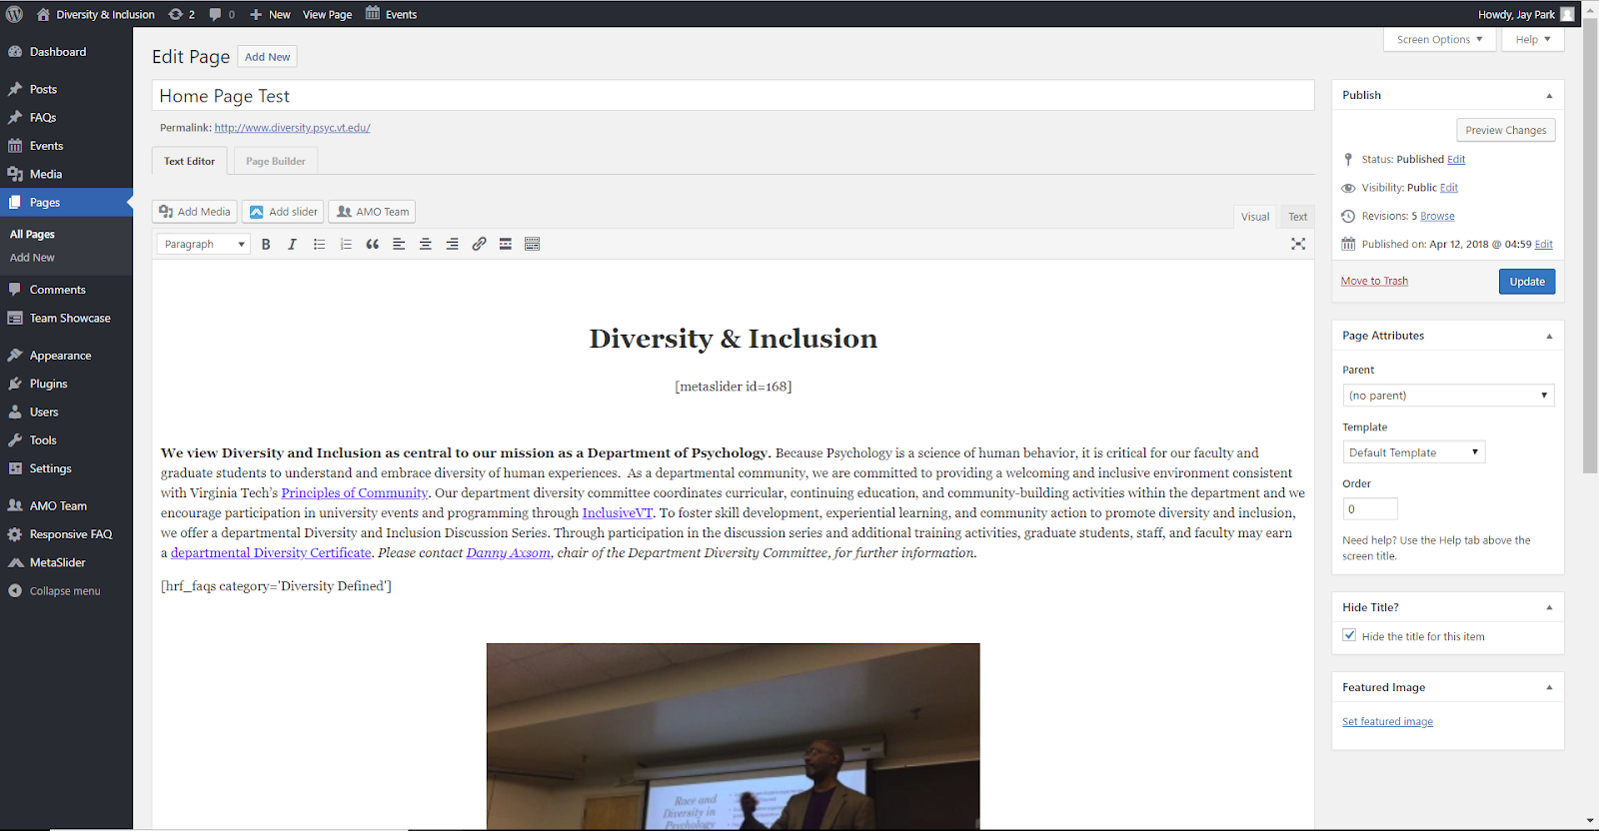
Figure 26. Edit Page

9.0 Lessons Learned

9.1 Virginia Tech Webmaster

Our initial approach to redesigning the Diversity and Inclusion webpages was to contact the Virginia Tech Webmaster and ask for any HTML files associated with the Virginia Tech Neuroscience webpage. The Clients noted that they liked the theme of the Neuroscience Department’s webpages and we wanted to be able to best emulate that Department’s theme [5]. After looking through some of the other Virginia Tech Departments’ webpages, we noticed a similar theme on many of them. We realized that this must be a standard theme developed by the University and the best way to get access to the theme would be to approach the Virginia Tech Webmaster.

We contacted the Webmaster twice, each email one week apart, and received no response to either request. Unfortunately, email was the only provided way of contact through the Virginia Tech “Contact Us” website, so we were unable to call or visit anyone. This was a setback for us because after inspecting the HTML of the webpages, we realized we could not easily replicate the designs because of the heavy use of scripting in the files.

Thus, we were forced to reconsider how we could approach a means of designing and constructing the Department’s webpages. This is what drove us to consider using WordPress as a means of constructing the webpages.

We spoke with Ben Pfountz about our experiences with the Webmaster and he explained to us that the Webmaster is likely a large group of individuals rather than one person. He expressed that they likely would never respond to our requests because our project is a much smaller scope than what they typically receive. He was inclined to move away from working with a University-related resource because it would be easier for us to keep this project amongst a smaller group where we can have full access and authority over the project.

9.2 WordPress Functionality

We decided to utilize WordPress for our Content Prototype because of our experience with the Virginia Tech Webmaster and our conversation with Ben Pfountz. WordPress offers free hosting for our webpages and offers a lot of options for customization. It also offers the Clients the ability to edit the content of the webpages fairly easily, which is much different than if the team had utilized HTML for the construction of the webpages.

One of the factors we had to consider was the type of membership we would subscribe to for the webpage. There are four different membership types: Free, Personal, Premium, and Business [11].

Free accounts require a WordPress.com subdomain to be included in the URL, allow for additional features, provide several themes, and 3GB of storage. The account is free for life [11].

The Personal account allows for a custom domain name, basic design customization, exclusion of WordPress ads, and 6GB of storage. The account costs $4 per month [11].

The Premium account allows for a custom domain name, unlimited themes, advanced design customization, 13GB of storage, and an exclusion of WordPress ads. The account costs $8 per month [11].

The Business account allows for a custom domain name, unlimited themes, advanced design customization, unlimited storage space, exclusion of WordPress ads, plugins, uploadable themes, and no WordPress branding. The account costs $25 per month [11].

Each higher tier of account offers more features and storage space to the user. We had to meet with the clients to weigh the costs and benefits of each account because one of their design ideas was to use a slideshow on the front page, which is only available to Business account users [11].

9.3 WordPress.com vs. WordPress.org

During the second round of presentations in class, another group doing a type of website development mentioned that they had decided to use WordPress.org. This sparked our curiosity, so we decided to do some research on WordPress.org as an alternative. Upon performing our research, we determined that WordPress.org would indeed be more beneficial as it would be free for upgraded capabilities in terms of themes, plugins, and customizability. The only catch for migrating to WordPress.org is that we would need a domain name and web hosting [13]. We asked our clients whether or not the psychology department had one available for us to use, but they directed us to the VT4Help Web Hosting [9].

Through this service, we submitted a ticket requesting a new hosting site and domain for our Psychology Department Diversity & Inclusion website.

We received the domain www.diversity.psyc.vt.edu for the Psychology Department Diversity & Inclusion website. All of the team and Ben Pfountz were given Administrative Access to the hosting site’s backend.

9.4 Timeline for Project

The team established a timeline for the semester within the first two weeks of working on the project with meaningful milestones spread throughout the semester. We adhered to the timeline very well and only altered the timeline in regards to meeting times and giving ourselves a few more days for creating new designs and the video tutorials. Overall, we felt that we had enough time throughout the semester to accomplish our immediate goals and some of our stretch goals as well.

10.0 Acknowledgements

Our Clients

- Dr. Robert Stephens, Chair of the Psychology Department
  - stephens@vt.edu
- Dr. Danny Axsom, Chair of the Diversity Committee
  - axsom@vt.edu
- Dr. Roseanne Foti, Incoming Chair of the Psychology Department
  - rfoti@vt.edu
- Ben Pfountz, Psychology Department IT Specialist
  - bpfountz@vt.edu

Our Professor

- Dr. Edward Fox, CS 4624 Multimedia, Hypertext, and Information Access Professor
  - fox@vt.edu

VT Web Hosting

- Joy Huntley
  - joyh@vt.edu

11.0 References

1. Department of Psychology, “Department of Psychology,” Psychology: Diversity. [Online]. Available: https://www.psychology.iastate.edu/diversity/. [Accessed: 19-Mar-2018].

2. Department of Psychology, “Department of Psychology,” Diversity and Inclusivity in Psychology - Department of Psychology. [Online]. Available: http://psych.la.psu.edu/diversity. [Accessed: 19-Mar-2018].

3. Google, “Gmail,” Gmail. [Online]. Available: gmail.com. [Accessed: 20-Mar-2018].

4. Stephens, Robert, et al. “InclusiveVT Inclusion and Diversity Strategic Planning Guide.” InclusiveVT Inclusion and Diversity Strategic Planning Guide, 9 June 2017.

5. School of Neuroscience, “Home,” School of Neuroscience. [Online]. Available: https://neuroscience.vt.edu/. [Accessed: 19-Mar-2018].

6. U.S. Department of Health & Human Services, “Heuristic Evaluations and Expert Reviews,” Usability.gov. [Online]. Available: https://www.usability.gov/how-to-and-tools/methods/heuristic-evaluation.html [Accessed: 30-Apr-2018].

7. Virginia Tech, “The Virginia Tech Brand,” Virginia Tech. [Online]. Available: vt.edu/brand.html.

8. Virginia Tech, “Welcome to Ensemble,” Virginia Tech. [Online]. Available: ensemble.cms.vt.edu/.

9. Virginia Tech 4Help, “Web Hosting,” Virginia Tech 4Help. [Online]. Available: https://vt4help.service-now.com/sp?id=sc_cat_item&sys_id=229f35ffdbd80700e3a0f839af96193a. [Accessed: 23-Mar-2018].

10. VT Psychology Department, “Diversity & Inclusion,” Diversity & Inclusion. [Online]. Available: https://www.diversity.psyc.vt.edu/. [Accessed: 30-Apr-2018].

11. WordPress, “Choose your WordPress.com flavor,” WordPress.com. [Online]. Available: https://wordpress.com/pricing/. [Accessed: 19-Mar-2018].

12. WordPress, “Download WordPress,” WordPress.org. [Online]. Available: https://wordpress.org/download/. [Accessed 23-Mar-2018].

13. WordPress, “WordPress Web Hosting,” WordPress.org. [Online]. Available: wordpress.org/hosting/. [Accessed: 23-Mar-2018].

