Yellow Ant - Hymenoptera: Formicidae
3104-1587
Eric Day, Department of Entomology, Virginia Tech
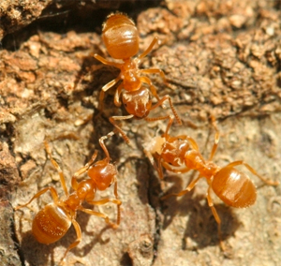
Yellow ants. David Cappaert, Michigan State University. Bugwood.org.
Description
Workers are robust, smooth and shiny; they avoid light except when swarming.
Size: Workers: 1/16 inch (4mm) or less.
Color: Yellow or darker in color.
Habitat
Yellow ants swarm in the fall and spring causing great concern! They can appear around the outside of houses, usually associated with sidewalks, patios, other concrete slabs, and foundation walls. They also appear in basements. Their nests are in these locations, but go unnoticed for most of the year.
Life Cycle
They swarm in the spring and fall, and there may be thousands of winged ants produced from one or more nests in the area. It is not uncommon for several nests to swarm at the same time- producing lots of ants!
Type of Damage
Yellow ants are not structural pests. They nest in soil or even in wood close to houses, but rarely enter houses in search of food. They do not damage wood.
Control
If control is necessary, use some liquid insecticide directly on the nest.

