Build Your Own Water Cycles
Activity Found at: https://www.pwd.org/build-your-own-water-cycles
LESSON PURPOSE:
Water is reused over and over in a closed system. In this activity, you can build a mini-terrarium to observe the processes involved in the water cycle.
OBJECTIVE:
To demonstrate the processes of evaporation, transpiration, and condensation in the water cycle.
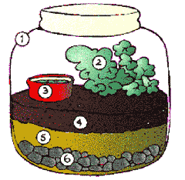
MATERIALS NEEDED:
- Gallon-sized jar with lid, plastic works well.
- Small plant or cutting
- Plastic cup, partially buried in soil
- Potting or top soil
- Sand
- Gravel
PROCEDURE:
- Put a layer of clean, washed gravel into the jar.
- Add clean sand - approximately 2 inches.
- Add at least 2 inches of topsoil.
- Place the plant to one side, cover roots well with soil.
- Bury the cup partially in soil.
- Water the plant well, making sure all of the soil is damp.
OBSERVATIONS/ACTIVITIES:
- Replace the lid with plastic wrap, secured well with an elastic band. Place a stone in the center of the plastic wrap to weigh it down, so that the plastic is somewhat inside the neck of the jar. Observe that water will collect on the underside of the plastic, and will then fall, as "rain". Some of the rain may collect in the cup.
- You can add water to the cup, and observe the amount of time (hours or days) it takes to evaporate.
- With a turkey baster, try adding colored water to the gravel area. (Some types of plants may change color!)
- You can speed up the process by placing the terrarium in a sunny window, or under a light.
- Tightly wrap one of the plant’s leaves with plastic. Leave it on overnight. In the morning, observe the droplets of water found on the inside of the plastic!
- Don’t forget to feed your plant once in a while!

