Enhancing Bikeshare Systems with E-Bikes in Semi-Hilly Cities:
Insights from Washington, D.C.
Cite as: Bakhshi, V., Ermagun, A., Dixit, K., Vajari, M. A., Qin, X. Hankey, S., Buehler, R. 2026. Enhancing Bikeshare Systems with E-Bikes in Semi-Hilly Cities: Insights from Washington, D.C. Transportation Research Part D.

Abstract
This study investigates spatial and temporal usage patterns of e-bikes and regular bikes within the Capital Bikeshare system in Washington, D.C. Leveraging a thorough analytical framework on over 6 million bikeshare trips, the analysis highlights distinct usage patterns shaped by the city’s semi-hilly terrain and bikeshare station placement. Comparing e-bikes and regular bikes, two main distinctions emerge: (i) e-bikes are predominantly used for longer distances and in areas with greater elevation (2.27 km vs. 1.73 km; 1.38% vs. 1.12% average slopes), and (ii) e-bikes enable broader dispersion across the city by connecting more distant bikeshare stations and supporting extended mobility. This disparity underscores the adaptability of e-bikes to more challenging urban terrains and longer trip distances. The findings are useful for urban planners and practitioners aiming to optimize bikeshare systems and suggest that incorporating e-bikes can address mobility challenges related to topography and trip distance.
Keywords: E-bikeshare Expansion, Urban Bikeshare Systems, Hilly Urban Mobility, Spatial Network flow Analysis, Random Forest and Logistic Regression

1. Introduction
Bikeshare systems have become popular as a sustainable transport solution (Fontes et al., 2022; Rudloff & Lackner, 2014). They offer benefits that include lower transport costs, improved health, and reduced emissions (Schwinger et al., 2022; Xu et al., 2023). These systems provide a flexible and affordable transport option and connect easily with public transport (Cao & Shen, 2019; Xu et al., 2023). Initially, bikeshare systems relied on docked stations, but the introduction of dockless systems pioneered in China in 2015 brought more convenience and flexibility (Guo et al., 2020; Shi et al., 2024). Now, over 1,000 cities globally have bike-sharing programs, and the number keeps growing (Anon, 2017; Buehler & Bakhshi, 2025; NACTO, 2022). Between 2010 and 2019, in the U.S., annual bikesharing trips grew from 321,000 to almost 50 million per year. Despite a temporary decline due to the COVID-19 pandemic, by 2022, usage rebounded to nearly 60 million trips, illustrating the increasing demand for this eco-friendly travel option (NACTO, 2022). At the same time, bikeshare adoption and trip patterns vary with local conditions such as terrain, where slopes and elevation can pose barriers that shape how systems are used (Behrendt et al., 2021; He et al., 2019; Schnieder, 2023).
With the integration of electric bikes (e-bikes), a new challenge for bikeshare systems is understanding how e-bikes change usage patterns, particularly in relation to terrain, because slopes and elevation changes are among the strongest barriers to using regular bikes (Behrendt et al., 2021; He et al., 2019). This is especially relevant in semi-hilly cities like Washington, D.C., where elevation, infrastructure, and system design vary across neighborhoods. Understanding how these factors shape the distinct usage patterns of e-bikes relative to regular bikes remains an area that needs more research. Addressing this shortcoming requires analysis of spatial dispersion and the physical context in which bikeshare trips occur.
Building on this need, analytical approaches must account for the complexity of bikeshare use in varied topographies. Traditional descriptive and inferential methods are often limited in capturing nonlinear relationships, spatial dispersion, and how terrain interacts with trip behavior. Advanced approaches such as statistical modeling, network analysis, and machine learning have been applied in other systems or regions to examine differences across rider groups and demand conditions (Bao et al., 2017; Noland et al., 2019; Wergin & Buehler, 2017; Xing et al., 2020). Yet, despite their growing use, these methods have only occasionally been directed toward questions of varied topography and the role of e-bikes in bikeshare systems, leaving important dimensions of bikeshare use in semi-hilly contexts insufficiently explored.
This study provides a comparative analysis of usage patterns of e-bikes and regular bikes in the Capital Bikeshare system in Washington, D.C., one of the oldest and largest bikeshare systems in the United States. The analysis relies on more than six million trips from both docked regular bikes and e-bikes within the Capital Bikeshare system and makes two contributions. First, we examine the comparative spatial characteristics of e-bike and regular bike trips in the semi-hilly context of Washington, D.C., focusing on measures such as distance, gradient, and network dispersion. To do this, we apply statistical tests and network analysis. Our study extends existing research that compares e-bikes and regular bikes in flatter geography and smaller systems. Second, our analysis focuses on the impact of topography on the usage of e-bikes vs regular bikes, controlling for other variables identified in the literature, through multivariate modeling and machine learning. This goes beyond prior research on e-bikes and regular bikes that was mainly based on descriptive statistics and smaller samples.
The rest of the paper is organized as follows: Section 2 reviews the existing literature on e-bike integration into bikeshare systems, their distinct usage patterns, the role of topography, and comparative studies. Section 3 introduces the data, study area, and variable construction. Section 4 outlines the methods, including descriptive statistics, network analysis, and a hybrid modeling framework using logistic regression and random forest. Sections 5 and 6 present the findings and interpret them across all methodological objectives, and the last section concludes with key insights and implications for bikeshare system planning.

2. Literature Review
E-bikes are reshaping urban transport by providing an alternative mode for short and intermediate trip distances. Equipped with an electric motor, e-bikes assist in pedaling or provide power through a throttle and motor, making it easier to cover challenging terrains and longer distances. This feature is particularly beneficial for those who may find regular cycling too strenuous due to physical constraints, age, or the nature of their trips. Consequently, e-bikes have expanded the usage of cycling to a broader set of user populations, including older adults and those with health concerns, by reducing typical barriers such as hilly landscapes and the need for high physical exertion (Arning & Kaths, 2025a; Dill & Rose, 2012; MacArthur, 2013; Rérat et al., 2024; Rose, 2012; Yang et al., 2024). Additionally, the ability to quickly accelerate at intersections and sustain higher speeds makes e-bikes ideal for urban settings, enabling riders to efficiently navigate steep inclines and busy roads (Yang et al., 2024). Studies suggest that e-bikes contribute to more frequent cycling, longer trips, and a shift from other transportation modes. For instance, e-bike users often ride more often and travel farther than traditional cyclists (Dill & Rose, 2012; MacArthur, 2013; Rose, 2012).
The integration of e-bikes into bikeshare systems has the potential to enhance these systems. Initially centered around traditional bicycles with fixed docking stations, the advent of dockless systems and fleet electrification could help improve user convenience and system flexibility. This evolution has made bikesharing a more attractive and accessible option (Gordon et al., 2013; Li et al., 2024; MacArthur, 2013; Yang et al., 2024). Additionally, considering the higher purchase price of e-bikes compared to regular bikes, shared e-bikes provide short-term convenient bicycle rentals without ownership drawbacks such as maintenance and theft risks, offering convenience and lower risks. Shared e-bikes have become prevalent in Asia and Europe and are gaining popularity in many U.S. cities. Studies suggest that shared e-bikes could substitute for car trips or augment transit ridership (Bachand-Marleau et al., 2012; Fitch et al., 2020; Martin & Xu, 2022). Furthermore, the adoption of shared e-bikes varies among different population groups and geographies. For example, higher-income neighborhoods in Zurich, Switzerland, exhibit increased demand, whereas in Beijing, predominantly younger to middle-aged males with lower socioeconomic status are the primary users (Campbell et al., 2016; Guidon et al., 2019). Similarly in Philadelphia, PA, e-bikes have boosted bikeshare ridership more in areas with greater social disadvantage (Caspi, 2023; Schnieder, 2023).
Studies outside the U.S. have increasingly emphasized spatial and topographic analysis, with particular attention to the role of terrain in shaping e-bike and regular bike use, including evidence from bikeshare programs in China and broader cycling analyses in Europe. In Kunming, China, Li et al. (2024) found that shared e-bike trips were typically longer and more spatially dispersed than regular bike trips, with e-bikes often providing direct connections to destinations while regular bikes more frequently involved transfers via public transit; however, this study relied on only two weeks of data. Similarly, Shi et al. (2024) analyzed dockless bikeshare in five cities of Zhejiang Province using a multi-scale geospatial network framework and reported that e-bike trips were on average 2.33 minutes longer and 0.57 km farther than bike trips, with 25.5% of e-bike trips exceeding 2 km compared to only 8% for regular bikes. While offering valuable insights into behavioral differences, this work was limited by its short seven-day duration and by not fully accounting for interactions with nearby transit. Beyond China, recent studies from Germany have explicitly incorporated topography into travel mode choice modeling, focusing on personally owned bicycles. Arning and Kaths (2025a) used national survey data to estimate mode choice and demonstrated that gradients strongly influence both e-bike and regular bicycle demand, while treating the two as distinct modes rather than variants of the same behavior. In a related application, Arning and Kaths (2025b) modeled bicycle traffic assignment in the hilly city of Wuppertal and showed how incorporating gradients into impedance functions revealed differences in network flows between e-bikes and regular bikes. Together, these studies illustrate how slopes and elevation shape bikeshare and personal usage in varied contexts and how e-bikes alter travel behavior by reducing, but not eliminating, the barriers posed by hilly terrain.
In the United States, research on bikeshare systems has also begun to consider spatial context and, in particular, how terrain shapes differences between e-bike and regular bike use. He et al. (2019) analyzed an all-electric bikeshare in Park City, Utah, a mountainous environment with steep gradients, and showed that ridership patterns were closely tied to the city’s elevation profile and recreational destinations, illustrating how electric bikeshare can operate under conditions that might be less favorable for regular bicycles. However, this research was conducted on an all-electric small bike share system mainly targeting recreational purposes and may not fully represent patterns while both types of bikes coexist in an urban setting. Richmond, Virginia, offers a contrasting case as a relatively flat mid-sized city. Yang et al. (2024) mainly through descriptive analysis found that e-bike trips were generally longer and faster than regular bike trips and more common along major roads and cycleways, pointing to differences in travel speed and route choice even where slope variation is modest. At a larger metropolitan scale, Xie et al. (2024) studied New York City’s Citi Bike system, a network operating mainly in flat terrain, and observed that e-bike trips followed distinctive temporal patterns such as greater off-peak use, while also noting differences in how trips interacted with the city’s modest elevation changes. Building on the understanding of user preferences and travel patterns, the study by Schnieder (2023) utilized Deep Neural Networks (DNNs) and Random Forests (RFs) to predict demand in e-bike versus regular bike-sharing systems. This study underscored key predictors for e-bike usage, such as weather conditions, trip distances, and elevation differences, but highlighted the need for distinct trip characteristics’ impact based on various cities.
Taken together, existing studies suggest that e-bikes change the way bikeshare systems are used, but terrain has most often been treated as a contextual detail rather than a central explanatory factor. Work in different geographic settings has hinted that slopes and elevation differences matter, yet these insights are scattered across smaller systems, shorter study periods, or cities with limited variation in topography. What remains missing is a focused assessment that examines e-bikes and regular bikes side by side in a large and long-standing system, where varied elevation provides the conditions to study both spatial patterns of use and the association of terrain more directly. Our analysis of Washington, D.C.’s Capital Bikeshare system is designed to fill this need, situating e-bike usage within a semi-hilly urban landscape and evaluating how trip characteristics such as distance, gradient, and network dispersion differ between bike types, as well as the extent to which topography shapes the likelihood of e-bike use once other system factors are taken into account.

3. Data and Study Area
This research focuses on the Capital Bikeshare system in Washington, D.C., one of the oldest and largest government-funded bikeshare programs in the United States. Since its launch in 2010, Capital Bikeshare has expanded to include over 750 stations and 6,000 bicycles across eight jurisdictions, offering both multi-gear regular and pedal-assist e-bikes. Regular bikes are priced at $0.15 per minute and e-bikes at $0.35 per minute for non-members, plus a $1 unlock fee for both bike types; Capital Bikeshare members are exempt from unlock fees and receive discounted rates. We used the publicly available comprehensive anonymized trip data from 2022 and 2023, which provides a detailed record of usage patterns, including start and end times, trip durations, station locations, user, and bike type.
Because of data availability, the analysis is limited to trips that originated and ended at stations within Washington, D.C. Specifically, during the selected study period, there were 5,163,476 trips on regular bikes and 927,139 trips on e-bikes. The dataset details each trip’s duration, start and end date and time, start and end station identifiers, and member type, distinguishing between registered members (Annual, 30-Day, and Day Key Members) and casual riders (Single Trip, 24-Hour Pass, 5-Day Pass).
Further enriching the dataset, we integrated socio-demographic variables, including census tract demographic data from the D.C. Open Data source, which offers the American Community Survey (ACS) 5-year demographic data spanning from 2017 to 2021. This includes age, gender, population, race, and median income metrics of census tracts surrounding docking stations. The study also accounts for the proximity of public transit, evaluating the number of bus and train stations within a 150-meter buffer around each Capital Bikeshare docking station. Lastly, we include weather data on an hourly basis from Open-Meteo to assess weather impacts on bikeshare usage to assess environmental impacts on bikeshare usage (Open-Meteo).

4. Methods
This study examines the travel patterns among 384 bikeshare stations in Washington, D.C., treating each trip between these stations as a distinct unit of analysis. The analysis is designed to address two main research questions: (1) how do spatial usage patterns differ between e-bikes and regular bikes, and (2) to what extent does elevation influence the likelihood of using an e-bike versus a regular bike, controlling for other trip and system characteristics.
To address the first question, we first employed the Mann-Whitney U test to establish baseline differences between the two bike types. This nonparametric test assesses whether two independent samples originate from the same distribution, which is particularly useful in our context for comparing distributions of trip distances, gradients, and other continuous variables that are not normally distributed. The results from this test provide foundational insights that inform the subsequent analytical steps. Building on this, we constructed a network flow structure to evaluate dispersion patterns between e-bikes and regular bikes. We utilized the average clustering coefficient as a metric to measure the network's spatial flow dispersion. This analysis helps identify how trips are clustered across neighborhoods and how e-bike usage may differ in terms of network structure.
To address the second research question, we developed a hybrid modeling approach combining logistic regression and random forest models. These models allow us to quantify the association of elevation alongside other trip attributes. To precisely evaluate the usage of e-bikes and regular bikes, the study introduced a metric capturing the daily availability ratio of e-bikes to regular bikes at each docking station. This ratio helped to discern the availability of both e-bikes and regular bikes at the docking stations. Data was subsequently filtered to exclude days and stations where either bike type was unavailable, ensuring the analysis reflected conditions where both e-bikes and regular bikes were available. This filtering resulted in a final dataset comprising 4,698,143 regular bike trips and 918,249 e-bike trips.
The use of both logistic regression and random forest models leverages the strengths of each traditional econometric method to clarify direct relationships and to accommodate complex interactions and nonlinearities. This dual-model approach not only enhances the precision and robustness of our findings but also ensures that the results are statistically sound and practically relevant. This methodological framework aims to deliver a thorough understanding of usage dynamics and the determinants influencing the selection of bike types within the bikeshare system.

4.1. Dispersion Analysis of E-Bikes Vs. Regular Bikes
In bikeshare systems, the movement patterns of bike trips between stations can be effectively analyzed using network flow structure analysis. This method visualizes and quantifies the interactions between various nodes (stations) and the traffic flow between them (edges), providing a comprehensive view of how e-bikes and regular bikes disperse across various urban areas and neighborhoods. By constructing a network flow structure, this study delineates cycling flow networks, where origins and destinations (OD) are treated as pairs of nodes connected by the volume of trips between them. The strength of these connections is directly proportional to the trip frequency, highlighting the primary routes within the network.
To further understand the local connectivity or the degree of clustering within these networks, we employed the average clustering coefficient. This metric is an established measure used to assess how closely connected groups of nodes (stations) are and indicates the likelihood of nodes clustering together. It is calculated as the average of all local clustering coefficients within the network, where a local clustering coefficient for a node assesses how interconnected its immediate neighbors are, essentially evaluating how close these neighbors are to form a complete graph. This analysis is necessary for revealing the local density of connections and has been widely adopted in network studies across various domains (Gallotti & Barthelemy, 2015; Newman, 2003; Porta et al., 2006; Watts & Strogatz, 1998; Zhong et al., 2014). The clustering coefficient for a node 𝑣 is computed using the formula in equation 1:
(1) : $C\left(v\right)=\frac{2E_{ν}}{k_{ν}\left(k_{ν}-1\right)}$
where $E_{ν}$ denotes the number of edges between the neighbors of $ν$, and $k_{ν}$​ is the degree of $ν$ — the number of neighbors it has. The term $k_{ν}$($k_{ν}$-1) represents the total possible connections among the neighbors if every neighbor was linked to every other. The network’s Average Clustering Coefficient, $C_{ave}$ , is then calculated by equation 2: (2) $C_{ave}=\frac{1}{N}\sum_{ν∈V}{c\left(ν\right)}$
where N is the total number of nodes, and 𝑉 is the set of all nodes in the network. A higher $C_{ave}$suggests a greater level of clustering, indicating robust local connectivity, which can significantly influence the efficiency of vehicle scheduling and the strategic design of bikeshare system operations.
Cross-comparison of the topography map of regions and network flow structure could also help to assess how slopes influence the clustering of trips and community dynamics within the bikeshare system. This integration allows for a comprehensive understanding of how environmental factors interplay with structural network properties to affect bike and e-bike usage in an urban setting. Identifying neighborhoods with high internal cycling activity based on these metrics enables targeted fleet management and operational optimizations within these key communities.

4.2. Logistic Regression Analysis
As the initial phase of our hybrid modeling approach to analyze the influencing factors comparing e-bike and regular bike trips within the Capital Bikeshare system, we began by developing a logistic regression model. This model is a fundamental tool for analyzing how various independent variables are associated with the likelihood of a trip by e-bikes. It is structured around a binary dependent variable that categorizes each trip as either an e-bike or a regular bike trip. The logistic regression model identifies significant factors and quantifies the strength and direction of their relationships with e-bike usage. The odds ratios derived from this model provide insights into the relative probabilities of choosing an e-bike in response to specific changes in trip-related factors.
To support the modeling analysis, we constructed a set of explanatory variables that capture trip-specific factors and contextual influences. Spatial characteristics were derived from the shortest network-based paths between bikeshare stations, calculated using the HERE Routing API (Here). These paths provided a realistic approximation of rider routes, which were then overlaid with high-resolution (1-meter) elevation data to extract average gradients, both uphill and downhill, as well as approximate trip distances. This method allowed for a representation of the physical effort and terrain variations associated with each trip. Temporal controls included trip duration and categorical indicators for time-of-day periods, day of the week, and season. Additional predictors included localized transit accessibility and weather conditions at the time of trip initiation.
Before implementing the logistic regression model, we ensured minimal multicollinearity among the explanatory variables to maintain the integrity of our statistical analyses. This involved calculating Variance Inflation Factors (VIF) for each predictor, a standard practice for identifying multicollinearity issues in regression analyses. Only variables with VIF scores less than 10, indicating low multicollinearity, were included in the final model configuration. Table 1 presents the full list of these variables in their categories and the sources from which we acquired the data. The logistic regression equation is structured as follows in equation 3, as described by Washington et al. (2010):
(3) Logit(𝑝)=log($\frac{p}{1-p}$)=$β_{0}+β_{1}x_{1}+β_{2}x_{2}+…+β_{n}x_{n}$
where 𝑝 represents the probability of having an e-bike trip, $x_{1}$, $x_{2}$, …,$x_{n}$ are the explanatory variables, and β₀, β₁, …, β_{n} are the coefficients estimated.
An iterative process was utilized to refine the model, beginning with bivariate analyses to screen potential factors and assess their unadjusted effects on the prevalence of e-bike trips. This approach is performed using the stats library in Python. We developed the model by incrementally adjusting for different combinations of variables to achieve the best theoretical and empirical fit. Upon establishing a satisfactory model configuration, we conducted the full logistic regression analysis to explore the adjusted effects of the selected variables on the likelihood of having e-bike trips.

4.3. Random Forest
To complement the logistic regression analysis and better understand the relative importance of predictors influencing e-bike usage, we employed a Random Forest (RF) model. This approach enables us to assess which factors (e.g., trip characteristics, topography, temporal variables, built environment features) play the most prominent roles in differentiating e-bike trips from regular bike trips. Due to computational limitations, the model was trained on a 5% stratified sample of the availability-filtered dataset, with stratification based on bike type, year, month, weekend, and user category.
Random Forest (RF) is an ensemble learning method that constructs multiple decision trees using bootstrapped samples of the data and randomly selected subsets of features at each split (Pal, 2017). This randomness reduces tree correlation and helps prevent overfitting. During tree construction, the model selects the optimal feature and split point at each node to minimize impurity (Kwigizile et al., 2022). For classification tasks, Gini impurity is commonly used as the splitting criterion, calculated in the equation 4:
(4) $Gini=1-\sum_{i=1}^{n}{p_{i}^{2}}$
In this equation, $p_{i}$ denotes the likelihood that a given sample belongs to class $ⅈ$, with 𝑛 representing the total number of classes. Gini impurity measures the probability that a randomly selected element from the dataset would be misclassified. A lower Gini value signifies a more homogeneous node, suggesting that the samples within it are more similar.
For the final prediction, traditional Random Forest classification typically relies on majority voting, where each tree makes an independent prediction, and the most frequently predicted class is selected. However, this approach is sensitive to class imbalances and can lead to biased predictions favoring the majority class.
In contrast, our model utilizes predicted probabilities instead of direct majority voting. Rather than selecting the most frequently predicted class, each tree generates a probability distribution over the possible classes. The final probability score for each class is computed as the average of the predicted probabilities from all trees. This averaged probability is then compared to a threshold to determine the final class.
To enhance classification performance, our model also applies a tunable decision threshold instead of the default 0.5 threshold. Multiple threshold values are tested, and the one that maximizes balanced accuracy is selected. This approach provides greater flexibility in decision-making, helping to mitigate the effects of class imbalance and ensuring that the model does not disproportionately favor the majority class.

4.3.1. Model Calibration and Tuning
In the training phase, we partitioned the dataset for the Random Forest (RF) model into two portions: 70% was used for training purposes, and the remaining 30% was set aside for testing. To calibrate the model, a k-fold cross-validation method was employed. This method involves dividing the dataset into 'k' equal segments, known as folds. The model is then trained on the 'k-1' of these folds, while the remaining fold serves as the validation set. This cycle is performed 'k' times, ensuring that each fold is utilized once as the validation set (Jung, 2018). For this particular analysis, a 10-fold cross-validation was implemented.
For model selection and tuning, balanced accuracy was used as the primary evaluation metric instead of standard accuracy. Balanced accuracy is an evaluation metric that adjusts for class imbalance by averaging the recall (sensitivity) for each class. Unlike standard accuracy, which can be misleading in imbalanced datasets, balanced accuracy ensures that both classes contribute equally to the performance evaluation.
The formula for balanced accuracy is as follows in equation 5:
(5) $Balanced Accuracy=\frac{Sensitivity+Specificity}{2}$
In this formula, Sensitivity measures the proportion of actual positive instances correctly identified by the model, and Specificity measures the proportion of actual negative instances correctly classified.
During the tuning phase, the model adjusted several key parameters to optimize performance. These adjustments included setting the number of estimators, which determines the total number of trees in the forest; defining the maximum depth of each tree, essential for managing model complexity and preventing overfitting; and establishing the minimum number of samples required to split a node, which controls when a node will further divide.
The model employed a systematic grid search to identify the optimal hyperparameter configuration. Based on the search results, the final model was configured with a maximum tree depth of 10, a minimum split requirement of 4 samples per node, and a total of 200 trees in the forest. As mentioned earlier, the selection of the best parameters was based on balanced accuracy, ensuring that the model achieved fairer classification performance, particularly in handling class imbalance.

4.3.2. Permutation-Based Variable Importance
Interpretability refers to the ability to understand the underlying reasons behind predictions (Miller, 2019). Traditional models like linear regression, logistic regression, and decision trees have simple structures, making them easily interpretable. However, complex machine learning models such as Random Forests present challenges in direct interpretation due to their intricate structures. To overcome this, researchers have developed model-agnostic interpretation methods. These methods assess how variations in input variables impact the model's prediction performance, thereby estimating the marginal effects of the variables, their significance, and how they interact with one another. Interpretation methods fall into two categories: those that address the overall model behavior (global interpretability) and those that analyze specific individual predictions (local interpretability).
One effective model-agnostic technique for evaluating global interpretability in predictive models is the permutation-based variable importance (VIMP). This method measures the significance of a feature by calculating the increase in prediction error when the values of that feature are randomly shuffled, keeping all other features constant. This shuffling breaks down the link between the feature and the outcome, shedding light on the feature’s impact on the model's accuracy. A significant drop in model performance suggests the feature's importance, whereas a slight change indicates a minimal impact. Additionally, permutation-based variable importance considers both the direct effects of the feature and its interactions with other variables, allowing it to manage the challenges posed by highly correlated variables effectively(Kim, 2021).
In this method, we first measure the initial performance of our machine learning model using the accuracy formula:
In this method, we first measure the initial performance of our model using balanced accuracy.
(6) ${Balanced Accuracy}_{orig}=Balanced Accuracy\left(y_{true},{\hat{y}}_{pred}\right)$
where $y_{true}$ represents the actual values, and ${\hat{y}}_{pred}$​ denotes the model's predicted values from the input matrix X.
Next, to assess the importance of a specific feature j, we randomly shuffle its values in the dataset, creating a modified dataset $X_{perm,j}$. We then recompute the model’s balanced accuracy using the permuted dataset:
(7) ${Balanced Accuracy}_{perm,j}=Balanced Accuracy\left(y_{true},{\hat{y}}_{perm,j}\right)$
where ${\hat{y}}_{perm,j}$ ​ represents the predictions after feature j has been shuffled.
To quantify the importance of feature j (denoted as ${VIMP}_{j}$ ​), we compute the average difference in balanced accuracy between the original model and the model with the permuted feature, across 30 trials:
(8) ${VIMP}_{j}=\frac{1}{n}\sum_{i=1}^{n}{\left({Balanced Accuracy}_{orig}-{Balanced Accuracy}_{perm,j}^{\left(i\right)}\right)}$
where n is the number of permutation trials (30 in this study).
This calculation provides an estimate of how crucial feature j is by observing how much the balanced accuracy decreases when the feature's relationship with the target variable is disrupted. Features with a high importance score indicate a strong influence on predictions, whereas those with low importance scores contribute minimally to the model’s decision-making process.

5. Results

5.1. Trip Characteristics and Spatial Connectivity Across Bike Types
Using the Mann-Whitney U test to compare trip distance, elevation, duration, and speed, we find statistically significant differences between regular bikes and e-bikes across all metrics. Compared to trips by regular bikes, e-bike trips cover longer distances on average (2.27 km vs. 1.73 km), navigate steeper inclines (1.38% vs. 1.12%), are shorter in duration (13.64 min vs. 19.31 min), and maintain higher speeds (12.43 km/h vs. 8.74 km/h). These baseline comparisons provide a quantitative foundation for the subsequent analysis of spatial connectivity and the factors influencing bike type selection.

Table 1 - List of Variables Included in the Models by Category and Source
Category | Variable |  | Description | Source
Trip Characteristics | Route distance (km) |  | Distance between origin and destination based on shortest path | HERE API
Trip Characteristics | Trip duration (minutes) |  | Time elapsed during the trip | Capital Bikeshare System
Topography & Infrastructure | Average positive gradient |  | Average upward slope percentage of the route | 1-meter DEM via Elevation Raster
Topography & Infrastructure | Average negative gradient |  | Average downward slope percentage of the route
Topography & Infrastructure | Length of trails in buffer (km) | Total length of bike trails within the 150 m station buffer |  |  | DC Open Data
User Type | Member users |  | Binary for whether the user is a registered member | Capital Bikeshare System
Temporal Factors | Spring |  | Binary variable for trips in spring | Capital Bikeshare System  Trip Timestamp
Temporal Factors | Summer |  | Binary variable for trips in summer
Temporal Factors | Fall |  | Binary variable for trips in fall
Temporal Factors | Nighttime |  | Binary variable for trips occurring after sunset
Temporal Factors | Weekend |  | Binary variable for weekend trips
Temporal Factors | Early AM hours (0 to 5) |  | Trips starting between 00:00 and 05:00
Temporal Factors | AM peak hours (6 to 8) |  | Trips starting between 06:00 and 08:00
Temporal Factors | Mid-day hours (9 to 14) |  | Trips starting between 09:00 and 14:00
Temporal Factors | Peak afternoon hours (15 to 17) |  | Trips starting between 15:00 and 17:00
Temporal Factors | Evening hours (18 to 19) |  | Trips starting between 18:00 and 19:00
Temporal Factors | Late evening hours (20 to 24) |  | Trips starting between 20:00 and 24:00
Transit Accessibility  (within 150m buffer) | Subway stations at the origin |  | Number of subway stations near origin station | WMATA GIS/Open Data
Transit Accessibility  (within 150m buffer) | Subway stations at the destination |  | Number of subway stations near destination station
Transit Accessibility  (within 150m buffer) | Bus stations at the origin |  | Number of bus stops near origin station
Transit Accessibility  (within 150m buffer) | Bus stations at the destination |  | Number of bus stops near destination station
Demographic & Socioeconomic Status | % Male at origin |  | Percentage of male population in origin census tract | ACS 5-Year  (NHGIS)
Demographic & Socioeconomic Status | % White at origin |  | Percentage of white population in origin census tract
Demographic & Socioeconomic Status | Median age at origin (years) |  | Median age of population in origin tract
Demographic & Socioeconomic Status | Median age at destination (years) |  | Median age of population in destination tract
Demographic & Socioeconomic Status | Degree less than Bachelor at origin |  | Share of population with education below Bachelor's in origin
Demographic & Socioeconomic Status | Degree less than Bachelor at destination |  | Share of population with education below Bachelor's in destination
Demographic & Socioeconomic Status | % Workers 16+ with no vehicle at origin |  | Percentage of working-age population without vehicle in origin
Demographic & Socioeconomic Status | Median income at origin ($) |  | Median household income in origin census tract
Demographic & Socioeconomic Status | Median income at destination ($) |  | Median household income in destination census tract
Weather | Temperature_2m (Â°C) |  | Hourly ambient temperature | Open-Meteo Weather API
Weather | Precipitation (mm) |  | Hourly precipitation level
Weather | Relative humidity_2m (%) |  | Hourly relative humidity
E-bikes and regular bikes show distinct spatial usage patterns within the Capital Bikeshare system. Network graph analysis and clustering coefficients (Figs. 1) show that e-bikes, with an average clustering coefficient of 0.20, are more widely dispersed across the semi-hilly context of Washington, D.C., while regular bikes exhibit tighter clustering (0.24), especially in the city’s flatter central areas. To reinforce the network graph analysis, Fig. 2 maps the dominance of e-bike versus regular bike trips against the city's topography profile. Stations in hillier northern areas are overwhelmingly dominated by e-bike usage, while flatter downtown and southern areas see greater regular bike usage.
[Insert Figure 1 about here]
[Insert Figure 2 about here]

5.2. Correlates of e-bike trips
To understand what the correlates of e-bike trips are compared to regular bikes, we applied a hybrid analytical approach combining results of logistic regression and Random Forest variable importance (Tables 2 and 3). The Random Forest model demonstrated acceptable performance with a balanced accuracy of 0.677, supporting the reliability of the derived importance scores. According to the logistic regression results (Table 2), route distance is positively associated with the likelihood of having e-bike trips. Specifically, for each additional kilometer traveled, the odds of an e-bike trip increase by a factor of 1.29. This directional relationship aligns with the Random Forest analysis (Table 3), where route distance emerges as the most influential predictor, with a VIMP score of 7.96%, indicating its strong contribution to prediction accuracy. On the other hand, trip duration shows an inverse association in the logistic model: the odds of an e-bike trip slightly decrease as trip duration increases (OR = 0.97). The Random Forest model also identifies trip duration as an important predictor, with a VIMP score of 5.97%.
Uphill terrain is a key determinant of e-bike use in the Capital Bikeshare system. Our logistic regression model shows that a greater positive gradient of routes is associated with a greater likelihood of e-bike trips, with an odds ratio of 1.17 (Table 2). In the Random Forest analysis (Table 3), this variable ranks as the third most influential predictor of e-bike usage. In contrast, average negative gradient (downhill) shows a smaller but still positive association with e-bike use in the logistic regression model (OR = 1.16). However, this variable does not appear among the top-ranking predictors in the Random Forest analysis, suggesting that downhill segments are less associated with distinguishing e-bike trips compared to uphill conditions.
Seasonal and nighttime conditions show a modest association with the likelihood of e-bike use in Washington, D.C. According to the logistic regression model (Table 2), e-bike trips are more common during the fall season, with an odds ratio of 1.14. This pattern is also reflected in the Random Forest model (Table 3), where seasonality appears as a positive predictor, although its influence is smaller compared to factors like route distance or gradient. Alongside this, it is worth considering non-member users who may potentially have more casual rides, as another factor in the increase in odds of e-bike trips. In this study, we defined nighttime based on sunset times for each day and season. Based on logistic regression results, the nighttime analysis presents a different trend, with an odds ratio of 1.12 for using e-bikes during the night (Table 2).
Time of day shows a notable association with e-bike usage, particularly across commuting hours. Resulting from the logistic regression model (Table 2), the likelihood of having an e-bike trip increases during afternoon peak hours (15:00–17:00), with an odds ratio of 1.10. This pattern suggests that e-bikes are frequently used as a convenient option during after-work commutes. However, morning peak hours show a notable decline in e-bike usage.
E-bike usage in D.C. shows a nuanced association with proximity to transit stations. Partly aligned with prior research, our findings reveal a more directional and mode-specific relationship between e-bike usage and access to transit in the Capital Bikeshare system. According to the logistic regression model (Table 2), the presence of metro stations at trip origins slightly increases the odds of e-bike usage (OR: 1.04), suggesting that users may favor e-bikes after exiting the metro. In contrast, the presence of metro stations at destinations is associated with a reduced likelihood of e-bike use (OR: 0.85), indicating that e-bikes are less commonly used to reach metro stations. Transit accessibility variables are included in the Random Forest model (Table 3), but they rank lower in importance compared to physical and trip-related factors such as route distance, gradient, and duration.
Table 2 – Results of Logistic Regression Model (Trip by e-bike=1)
Category | Variable |  | Odds Ratio | P-value
 | const |  | 0.1714ª | 0.000
Trip Characteristics | Route distance (km) |  | 1.2910ª | 0.000
Trip Characteristics | Trip duration (minutes) |  | 0.9752ª | 0.000
Topography & Infrastructure | Average positive gradient |  | 1.1783ª | 0.000
Topography & Infrastructure | Average negative gradient |  | 1.0444ª | 0.000
Topography & Infrastructure | Length of Trails in buffer (km) |  | 0.9991ª | 0.000
User Type | Member users |  | 0.7462ª | 0.000
Transit Accessibility  (150m buffer) | Metro stations at the origin |  | 1.0415ª | 0.000
Transit Accessibility  (150m buffer) | Metro stations at the destination |  | 0.8583ª | 0.000
Transit Accessibility  (150m buffer) | Bus stations at the origin |  | 1.0265ª | 0.000
Transit Accessibility  (150m buffer) | Bus stations at the destination |  | 1.0339ª | 0.000
Temporal Factors | Spring |  | 0.9304ª | 0.000
Temporal Factors | Summer |  | 0.9278ª | 0.000
Temporal Factors | Fall |  | 1.1490ª | 0.000
Temporal Factors | Nighttime |  | 1.1298ª | 0.000
Temporal Factors | weekend |  | 0.9581ª | 0.000
Temporal Factors | Early AM hours (0 to 5) |  | 0.9661ª | 0.001
Temporal Factors | AM peak hours (6 to 8) |  | 0.8541ª | 0.000
Temporal Factors | Peak afternoon hours (15 to 17) |  | 1.1043ª | 0.000
Temporal Factors | Evening hours (18 to 19) |  | 0.9659ª | 0.000
Temporal Factors | Late evening hours (20 to 24) |  | 0.9778ª | 0.001
Demographic & Socioeconomic Status | % Male at origin |  | 1.0000ª | 0.000
Demographic & Socioeconomic Status | % White at origin |  | 1.0000ª | 0.000
Demographic & Socioeconomic Status | Median age at origin (years) |  | 0.9942^{b} | 0.051
Demographic & Socioeconomic Status | Median age at destination (years) |  | 0.9973 | 0.772
Demographic & Socioeconomic Status | Degree less than Bachelor at origin |  | 0.9997 | 0.173
Demographic & Socioeconomic Status | Degree less than Bachelor at destination |  | 1.0002ª | 0.000
Demographic & Socioeconomic Status | % Workers 16+ with no vehicle at origin |  | 1.0005 | 0.178
Demographic & Socioeconomic Status | Median income at origin (dollars) |  | 1.0000ª | 0.000
Demographic & Socioeconomic Status | Median income at destination (dollars) |  | 1.0000ª | 0.000
Weather | Temperature_2m (Â°C) |  | 0.9905ª | 0.000
Weather | Precipitation (mm) |  | 1.0230ª | 0.001
Weather | Relative humidity_2m (%) |  | 0.9988ª | 0.000
Pseudo R-square |  | 0.05617
Log-Likelihood |  | -2.3611e+06
LL-Null |  | -2.5016e+06
LLR p-value |  | 0.000
ª Significant at the 0.01 level.
^{b} Significant at the 0.05 level.
Table 3: Top Five Results of Permutation-based Variable Importance (VIMP)
Rank | Feature | Importance %
1 | Route Distance (km) | 7.96
2 | Trip duration (minutes) | 5.97
3 | Average positive gradient | 0.61
4 | % Non-White at destination | 0.25
5 | Degree less than Bachelor at destination | 0.24

Finally, our analysis shows that demographic variables such as age, gender, and race are not significantly associated with the likelihood of e-bike trips in the Capital Bikeshare system. This suggests that usage patterns are shaped more by trip and environmental characteristics than by user profiles. These insights point toward the importance of infrastructure-focused strategies. It is also worth noting that, given the large sample size, some odds ratios are statistically significant despite being close to 1.00—a typical pattern in big mobility datasets. These results should be interpreted with attention to both statistical significance and practical effect size.

6. Discussion
Our network analysis demonstrates that e-bikes influence bikeshare patterns in a semi-hilly setting. The clustering and network mapping results provide a system-level view of how terrain shapes travel flows. The lower clustering of e-bike trips indicates that motor assistance allows riders to link stations across greater distances and more varied topography, while the higher clustering of regular bikes reflects more localized circulation. The trip flow maps (Fig. 1) reveal clusters of regular bike trips in the central flat areas of the city, along with dense short-distance circulation in parts of the northern hills. By contrast, e-bikes generate stronger long-distance flows that connect the northern and northwestern hillier neighborhoods with other parts of the city. The station-level dominance map (Fig. 2) makes these contrasts even clearer, as e-bikes are used at docking stations in elevated northern areas and at destinations located farther from the downtown core, while regular bikes concentrate in the flat central districts and along adjacent corridors. Taken together, these patterns show that e-bikes not only lengthen individual trips but may also alter the structural reach of the bikeshare system, integrating neighborhoods that would otherwise remain peripheral. Beyond the analytical novelty, such network perspectives provide practical insights for planning by highlighting where e-bike availability is most critical for expanding access in a semi-hilly and spatially diverse urban context.
The modeling results further reinforce the network-level insights on the role of distance and efficiency in shaping e-bike and regular bike use in a topographically diverse context. Route distance emerges as the strongest correlate for increasing the odds of having e-bike trips, and Random Forest ranks it as the top predictor. While prior studies have often compared average distances across modes, our model directly estimates how distance increases the odds of e-bike use. For instance, research on Shanghai and Kunming in China reported 9% and 22% increases in average distances traveled for e-bike users (Cherry & Cervero, 2007; Yang et al., 2024), and in Richmond, VA, pedelecs traveled farther (4.68 km vs. 3.85 km) while achieving shorter trip times and higher speeds (Yang et al., 2024). In Washington, D.C.’s semi-hilly context, these effects are magnified, as e-bikes not only extend trip length but also sustain trip making across elevation barriers that regular bikes rarely overcome. Trip duration, by contrast, shows an inverse relationship with e-bike use, emphasizing that e-bikes are valued for fast, efficient travel. This pattern likely reflects practical considerations such as limited battery range or higher rental costs for extended rides, in addition to the time savings that e-bikes offer on steeper terrain.
Paths’ gradients emerge as the most decisive terrain factor shaping e-bike use in Washington, D.C. Uphill conditions play a central role in shaping e-bike and regular bike trip flows, consistently emerging among the strongest predictors of e-bike trips (Tables 2–3). This aligns with survey evidence from studies of non-bike sharing cyclists showing that 37% of e-bike users cite climbing hills as a major advantage, and with findings from Lausanne, Switzerland, where 95.8% of respondents agreed that electric assistance enabled them to cycle despite steep gradients (Behrendt et al., 2021; Rérat et al., 2024). It also echoes broader claims that e-bikes are uniquely suited to overcoming topographic barriers (Dill & Rose, 2012). Considering the comparatively weaker association between downhill conditions and e-bike use in Capital Bikeshare, these results suggest that uphill effort is more important than downhill slopes in determining e-bike adoption. From a planning perspective, this highlights the importance of better fleet distribution, as allocating more e-bikes to hillier neighborhoods could help expand access and boost ridership in areas traditionally underserved by bikeshare systems.
Seasonal and temporal conditions also play a meaningful role in shaping e-bike use, though in ways that reflect the unique context of Washington, D.C. Usage peaks in the fall season, likely due to the pleasant weather and scenic appeal of the season, and also considering non-member users who may potentially have more casual or recreational rides, as another factor contributing to increased e-bike trips. This aligns with prior work noting bike-sharing systems generally experience higher usage during warmer weather seasons (Kim & Pelechrinis, 2020). Beyond seasonality, nighttime riding also shows a slight preference for e-bikes, likely due to built-in features such as headlights that enhance visibility and comfort. These design advantages are particularly valued in the Capital Bikeshare system, where improved nighttime safety may help explain higher adoption of e-bikes after dark. Even more distinct is the pattern across commuting hours: while many cities see strong e-bike demand in both morning and evening peaks (Shi et al., 2024), D.C. shows a clear asymmetry. Morning trips into the lower-elevation downtown with higher employment centers often involve downhill routes that reduce the need for motor assistance, whereas afternoon return trips uphill prompt greater e-bike use. This highlights how local topography and job distribution shape daily rhythms of demand. From a context-specific planning lens, ensuring greater e-bike availability during afternoon hours, particularly along routes leading out of central employment zones, could improve system efficiency and user satisfaction. This is a key contextual finding, illustrating how terrain interacts with temporal patterns in ways not evident in flatter cities.
Integration with public transit shows similar context-specific nuances. While e-bikes are positively associated with transit access overall, our results suggest that riders rely more heavily on e-bikes for last-mile trips after exiting the metro than for first-mile connections to stations. This directional imbalance contrasts with studies in recreational or suburban contexts such as Utah Park, where proximity to both subway and bus stations consistently boosts the fully e-bike share system demand (He et al., 2019), and with findings in Kunming showing a strong correlation between e-bike usage and subway station access (Li et al., 2024). Bus stops, by comparison, show a small but consistent positive association with e-bike trips at both origins and destinations, reflecting their broader distribution across the region. Together, these findings underscore that while transit proximity is important, the way it shapes e-bike usage depends heavily on local geography and network design. In D.C., station spacing and the semi-hilly topography appear to condition how riders incorporate e-bikes into multimodal travel, with uphill return trips and dispersed bus access shaping demand in ways not captured by studies in flatter or less dense systems. For system planning, this suggests that transit integration strategies should not assume uniform patterns but rather account for the directional and terrain-related nuances revealed in semi-hilly urban contexts.
Overall, these findings suggest that e-bike policy in semi-hilly cities should prioritize strategic fleet distribution and temporal rebalancing. Increasing e-bike supply in elevated areas (northern and northwestern neighborhoods in our study area), ensuring availability during afternoon peak hours when uphill return trips are most common, and coordinating deployment near key transit hubs can directly address the terrain- and context-specific barriers we identify. Such targeted strategies go beyond generic system expansion and highlight how planning for e-bikes in semi-hilly settings requires attention to where and when the bikes are most needed.
While this study offers valuable insights, some considerations should be noted. First, the analysis focuses on trips within Washington, D.C., which may limit the generalizability of the findings. However, the distinct spatial and temporal patterns observed in D.C. underscore the importance of local context, pointing to the value of examining city-specific bikeshare dynamics in other settings. Second, the study is based on observed trip data and does not include direct information on user intentions or trip purposes. Incorporating such data in future research could enrich our understanding of behavioral drivers. Third, although shortest-path estimates effectively account for elevation and route-level characteristics, they may not fully capture the actual paths taken by riders. Access to real trajectory data would enhance the accuracy of route choice analysis. Future research using such trajectory data could also enable more direct estimation of the marginal effects of elevation on e-bike usage, which was beyond the scope of the present analysis. Fourth, broadening the geographic scope to include adjacent jurisdictions may reveal additional patterns of regional bikeshare use and inter-jurisdictional travel. Fifth, integrating user-level survey data could provide further context regarding motivations, preferences, and barriers to use, factors not observable in trip data alone. Recent behavioral tools, such as the Multidimensional Cyclist Behavior Questionnaire, which distinguishes skill- and style-related cycling behaviors, may also offer a structured way to capture heterogeneity in bikeshare riders tendencies (Bakhshi et al., 2025). Sixth, we focused on the average clustering coefficient to capture local neighborhood-level connectivity, which aligns with our goal of identifying station-level clustering differences between modes. Future work may explore modularity-based community detection for broader network segmentation. Finally, future research may also explore interactions with other shared mobility modes (e.g., e-scooters) and track the evolving role of e-bikes over time, particularly as infrastructure and policies continue to change.

7. Conclusion
By combining logistic regression, Random Forest variable importance (VIMP), and network-based clustering, we identified correlates of e-bike use in Washington, D.C.’s Capital Bikeshare system. We found that e-bikes are more likely to be used for longer trips, steeper routes, and during afternoon hours, particularly in areas where regular bikes are less practical due to physical or spatial constraints. Our findings highlight that e-bikes contribute to expanding the functional reach of bikeshare systems by enabling users to overcome barriers posed by topography and travel distance. In particular, the clustering of regular bike trips in hillier neighborhoods, compared to the broader dispersion of e-bike trips, reflects how e-bikes support more geographically distributed traveling in cities with varied terrain. These results offer practical insights for city planners, bikeshare operators, and policymakers. Investments in e-bikes in the Capital Bikeshare system, including better supplying e-bikes in topographically challenging areas or around metro stations in hillier areas, could help improve bikeshare usage and accessibility. Data-informed strategies, such as deploying more e-bikes during afternoon commute windows or in underused uphill areas, may further optimize system performance. Rather than relying on broad demographic targeting, interventions should focus on spatial factors shown to associate with usage. Ultimately, this study underscores that e-bikes play a distinct and complementary role in urban mobility systems. By aligning bikeshare design and policy to reflect these usage patterns, cities could create more inclusive, efficient, and sustainable transportation networks.

Acknowledgement
The authors received no funding for this research and declare no financial or competing interests.

References
Anon. (2017). Bike share in the U.S., National Association of City Transportation
Officials.
Arning, L., & Kaths, H. (2025a). Further, steeper, greener: Implications from an electric bicycle mode choice model. International Journal of Sustainable Transportation, 1-16.
Arning, L., & Kaths, H. (2025b). Will e-bikes revolutionize urban mobility? Development and application of a transport model differentiating between conventional and electric bicycle traffic. European Transport Studies, 2, 100029.
Bachand-Marleau, J., Lee, B. H., & El-Geneidy, A. M. (2012). Better understanding of factors influencing likelihood of using shared bicycle systems and frequency of use. Transportation research record, 2314(1), 66-71.
Bakhshi, V., Aghabayk, K., Palassi, M., & Buehler, R. (2025). Multidimensional Cyclist Behavior Questionnaire: Development of a tool for comprehensive evaluation of style and skill-related cycling behaviors in Iran. Journal of Transport & Health, 44, 102128.
Bao, J., Xu, C., Liu, P., & Wang, W. (2017). Exploring bikesharing travel patterns and trip purposes using smart card data and online point of interests. Networks and Spatial Economics, 17, 1231-1253.
Behrendt, F., Cairns, S., Raffo, D., & Philips, I. (2021). Impact of e-bikes on cycling in hilly areas: participants’ experience of electrically-assisted cycling in a UK study. Sustainability 13, 8946. In.
Buehler, R., & Bakhshi, V. (2025). Cycling and micromobility. In The Routledge Handbook of Sustainable Urban Transport (pp. 37-49). Routledge.
Campbell, A. A., Cherry, C. R., Ryerson, M. S., & Yang, X. (2016). Factors influencing the choice of shared bicycles and shared electric bikes in Beijing. Transportation Research Part C: Emerging Technologies, 67, 399-414.
Cao, Y., & Shen, D. (2019). Contribution of shared bikes to carbon dioxide emission reduction and the economy in Beijing. Sustainable Cities and Society, 51, 101749.
Caspi, O. (2023). Equity implications of electric bikesharing in Philadelphia. GeoJournal, 88(2), 1559-1617.
Cherry, C., & Cervero, R. (2007). Use characteristics and mode choice behavior of electric bike users in China. Transport policy, 14(3), 247-257.
Dill, J., & Rose, G. (2012). Electric bikes and transportation policy: Insights from early adopters. Transportation research record, 2314(1), 1-6.
Fitch, D., Mohiuddin, H., & Handy, S. (2020). Investigating the influence of dockless electric bike-share on travel behavior, attitudes, health, and equity.
Fontes, T., Arantes, M., Figueiredo, P. V., & Novais, P. (2022). A cluster-based approach using smartphone data for bike-sharing docking stations identification: Lisbon case study. Smart Cities, 5(1), 251-275.
Gallotti, R., & Barthelemy, M. (2015). The multilayer temporal network of public transport in Great Britain. Scientific data, 2(1), 1-8.
Gordon, E., Shao, Z., Xing, Y., Wang, Y., & Handy, S. (2013). Experiences of electric bicycle users in the Davis/Sacramento, California Area.
Guidon, S., Becker, H., Dediu, H., & Axhausen, K. W. (2019). Electric bicycle-sharing: A new competitor in the urban transportation market? An empirical analysis of transaction data. Transportation research record, 2673(4), 15-26.
Guo, N., Jiang, R., Wong, S., Hao, Q.-Y., Xue, S.-Q., Xiao, Y., & Wu, C.-Y. (2020). Modeling the interactions of pedestrians and cyclists in mixed flow conditions in uni-and bidirectional flows on a shared pedestrian-cycle road. Transportation research part B: methodological, 139, 259-284.
He, Y., Song, Z., Liu, Z., & Sze, N. (2019). Factors influencing electric bike share ridership: Analysis of Park City, Utah. Transportation research record, 2673(5), 12-22.
Here. https://www.here.com/developer?cid=Developer_Here-Routing-Google-YT-0-Dev-AMER-US-matchtype=p&utm_source=Google&utm_medium=ppc&utm_campaign=Dev_PaidSearch_DevPortal_AlwaysOn&utm_term=here%20routing%20api&gad_source=1&gclid=CjwKCAiAiOa9BhBqEiwABCdG8-uvTMqzWq8dYfI3DHDGG397EjPWGILp1BE4yo9LS57h2SgYCCAgnBoCjP0QAvD_BwE&gclsrc=aw.ds
Jung, Y. (2018). Multiple predicting K-fold cross-validation for model selection. Journal of nonparametric statistics, 30(1), 197-215.
Kim, E.-J. (2021). Analysis of travel mode choice in Seoul using an interpretable machine learning approach. Journal of Advanced Transportation, 2021(1), 6685004.
Kim, I., & Pelechrinis, K. (2020). The anatomy of the daily usage of bike sharing systems: elevation, distance and seasonality. ACM SIGKDD workshop on Urban Computing,
Kwigizile, V., Kwayu, K. M., & Oh, J.-S. (2022). Leveraging the spatial-temporal resolution of crowdsourced cycling data to improve the estimation of hourly bicycle volume. Transportation research interdisciplinary perspectives, 14, 100596.
Li, Q., Zhang, E., Luca, D., & Fuerst, F. (2024). The travel pattern difference in dockless micro-mobility: Shared e-bikes versus shared bikes. Transportation Research Part D: Transport and Environment, 130, 104179.
MacArthur, J. (2013). E-Bikes in the United States.
Martin, R., & Xu, Y. (2022). Is tech-enhanced bikeshare a substitute or complement for public transit? Transportation research part A: policy and practice, 155, 63-78.
Miller, T. (2019). Explanation in artificial intelligence: Insights from the social sciences. Artificial intelligence, 267, 1-38.
NACTO. (2022). National Association of City Transportation Officials (NACTO). Shared Micromobility in 2022. Available from: https://nacto.org/publication/shared-micromobility-in-2022/#:~:text=Shared%20micromobility%20trips%20are%20up,in%20the%20U.S%20and%20Canada. https://nacto.org/publication/shared-micromobility-in-2022/#:~:text=Shared%20micromobility%20trips%20are%20up,in%20the%20U.S%20and%20Canada.
Newman, M. E. (2003). The structure and function of complex networks. SIAM review, 45(2), 167-256.
Noland, R. B., Smart, M. J., & Guo, Z. (2019). Bikesharing trip patterns in New York City: Associations with land use, subways, and bicycle lanes. International Journal of Sustainable Transportation, 13(9), 664-674.
Open-Meteo. https://open-meteo.com/en/docs/historical-weather-api#start_date=2022-01-01&end_date=2022-12-31&hourly=temperature_2m,relative_humidity_2m,dew_point_2m,apparent_temperature,precipitation,rain,snowfall,snow_depth,pressure_msl,cloud_cover,cloud_cover_low,c
Pal, R. (2017). Predictive modeling based on random forests. Predictive Modeling Of Drug Sensitivity, 149-188.
Porta, S., Crucitti, P., & Latora, V. (2006). The network analysis of urban streets: a primal approach. Environment and Planning B: planning and design, 33(5), 705-725.
Rérat, P., Marincek, D., & Ravalet, E. (2024). How do e-bikes compete with the other modes of transport? Investigating multiple dimensions of a modal shift. Applied Mobilities, 1-14.
Rose, G. (2012). E-bikes and urban transportation: emerging issues and unresolved questions. Transportation, 39, 81-96.
Rudloff, C., & Lackner, B. (2014). Modeling demand for bikesharing systems: neighboring stations as source for demand and reason for structural breaks. Transportation research record, 2430(1), 1-11.
Schnieder, M. (2023). Ebike Sharing vs. Bike Sharing: Demand Prediction Using Deep Neural Networks and Random Forests. Sustainability, 15(18), 13898.
Schwinger, F., Tanriverdi, B., & Jarke, M. (2022). Comparing Micromobility with Public Transportation Trips in a Data-Driven Spatio-Temporal Analysis. Sustainability, 14(14), 8247.
Shi, X., He, J., & Zhang, Y. (2024). Analyzing the micro-mobility patterns of shared dockless bike and e-bike systems through multi-scale complex networks. Transportation, 1-32.
Washington, S., Karlaftis, M., & & Mannering, F. (2010). Statistical and Econometric Methods for Transportation Data Analysis.
Watts, D. J., & Strogatz, S. H. (1998). Collective dynamics of ‘small-world’networks. nature, 393(6684), 440-442.
Wergin, J., & Buehler, R. (2017). Where do bikeshare bikes actually go?: Analysis of capital bikeshare trips with GPS data. Transportation research record, 2662(1), 12-21.
Xie, Y., Smart, M., & Noland, R. B. (2024). Powering bikeshare in New York City: does the usage of e-bikes differ from regular bikes? Transportation Planning and Technology, 47(6), 875-902.
Xing, Y., Wang, K., & Lu, J. J. (2020). Exploring travel patterns and trip purposes of dockless bike-sharing by analyzing massive bike-sharing data in Shanghai, China. Journal of transport geography, 87, 102787.
Xu, M., Di, Y., Yang, H., Chen, X., & Zhu, Z. (2023). Multi-task supply-demand prediction and reliability analysis for docked bike-sharing systems via transformer-encoder-based neural processes. Transportation Research Part C: Emerging Technologies, 147, 104015.
Yang, Y., Sloate, E., Khadem, N., Chavis, C., & Frías-Martínez, V. (2024). Comparing e-bike and conventional bicycle use patterns in a public bike share system: A case study of Richmond, VA. Journal of Cycling and Micromobility Research, 2, 100023.
Zhong, C., Arisona, S. M., Huang, X., Batty, M., & Schmitt, G. (2014). Detecting the dynamics of urban structure through spatial network analysis. International Journal of Geographical Information Science, 28(11), 2178-2199.

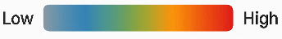  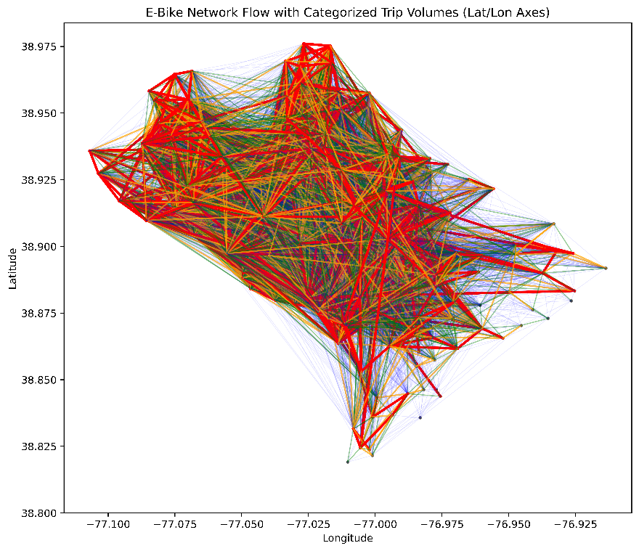 | 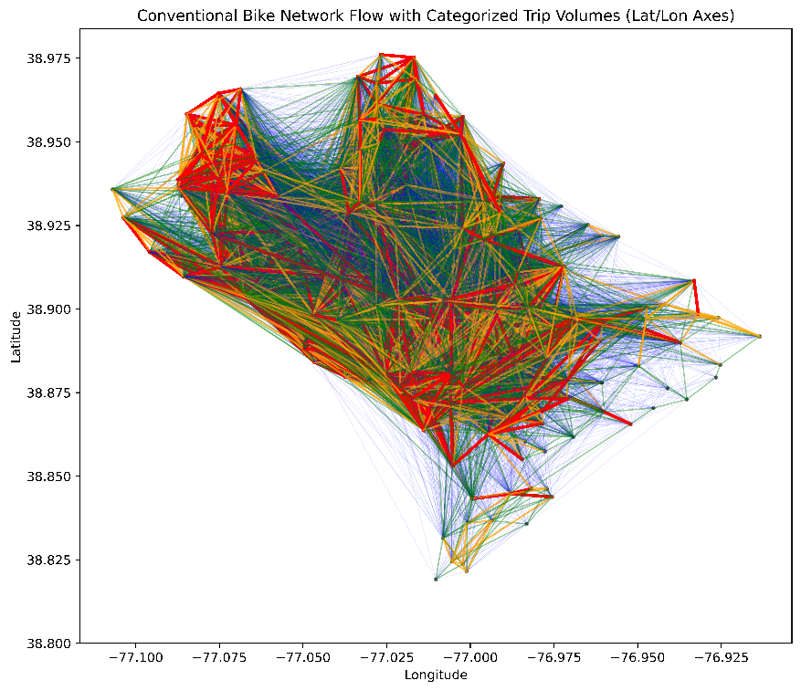
Trip Flow Network of E-Bikes | Trip Flow Network of Regular Bikes
Fig.1. Edge colors represent quantiles of normalized trip volumes between stations; node layout reflects
real geographic location. E-bike network shows broader dispersion than regular bike network.

Fig. 2. Station-Level Destination Dominance of E-Bikes Versus Regular Bikes
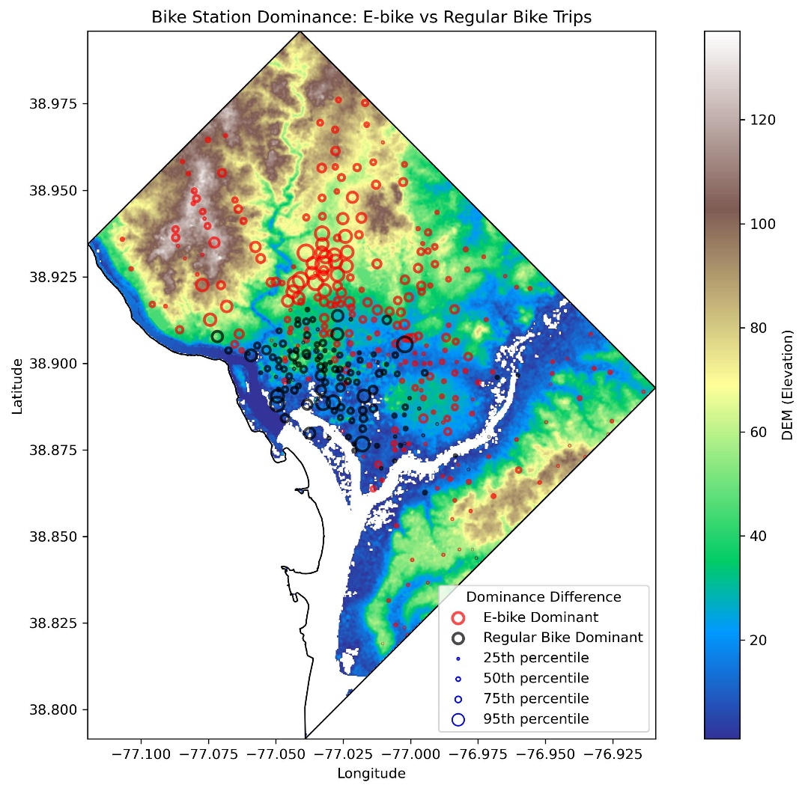
in Relation to D.C. Elevation Gradients

