Controls on the Leeside Angle of Dunes in Shallow Unidirectional Flows
Julia Cisneros^{1,2} and Jim Best^{2,3}
¹Department of Geosciences, Virginia Tech, Blacksburg, Virginia, USA
²Department of Earth Science and Environmental Change, University of Illinois at Urbana Champaign, Urbana, Illinois, USA
³Departments of Geography and GIS and Mechanical Science and Engineering, and Ven Te Chow Hydrosystems Laboratory, University of Illinois at Urbana Champaign, Urbana, Illinois, USA
Corresponding author: Julia Cisneros (cisneros@vt.edu)

Key Points:
- Low, intermediate, and high angle dunes form in shallow laboratory flows.
- Sediment suspension and bedform superimposition are the key mechanisms controlling the formation of low-angle dunes.
- Liquified leeside avalanches do not play a role in the formation of low-angle dunes.

Abstract
Dunes are ubiquitous features in alluvial channels, serve as major agents of sediment transport and contribute significantly to flow resistance. Research in the past decade has illustrated the complexity of dune geometry and widespread occurrence of dunes that have a low leeside angle. However, debate exists concerning the occurrence of such dunes and their formative processes. This paper seeks to further our understanding of low-angle dunes by utilizing data from a robust set of shallow flow laboratory experiments detailing equilibrium bedform morphology across a range of sediment transport conditions. Analysis of bedform morphology demonstrates that dunes with low-angle leesides are generated in shallow laboratory flows, and hence are not restricted to deep rivers. Of the possible processes that have been proposed to explain the formation of low-angle dunes, this finding unequivocally shows that liquefied leeside avalanches, which rely on deep flows for their generation, are not a controlling mechanism. In addition, dunes formed under suspension-dominated conditions possess lower leeside angles compared to those formed in bedload-dominated conditions. However, where bedload transport dominates and sediment suspension is likely of lesser importance, low-angle dunes are still present, and preliminary analysis shows that bedform superimposition can result in lowering of the dune leeside angle. Low and intermediate angle dunes formed in these various conditions also have a lower potential for large-scale, permanent, leeside flow separation compared to angle-of-repose dunes, confirming the need to account for these differences in predictions of flow resistance associated with dune form roughness.
Plain Language Summary
Dunes that form on a riverbed have often been thought to possess high-angle sloping downstream faces. However, in deep rivers, it has been shown that dunes overwhelmingly have shallower sloping, low-angle, downstream faces – forming low-angle dunes. This finding has raised questions regarding the occurrence of low-angle dunes within different depth rivers and the processes controlling their formation. In this paper, we analyze data from shallow-depth laboratory experiments that detail 3D maps of dunes in order to examine their shape and help understand the processes that lead to their formation. We show that liquefied leeside avalanches are not a control because low-angle dunes can form in shallow flows where such avalanches cannot be generated. Instead, we find low and intermediate angle dunes are common when sediment transport is dominated by particles in suspension rather than in bedload transport, suggesting sediment suspension is vital to their generation. However, when sediment transport is dominated by particles rolling along the bed in bedload transport, smaller, superimposed bedforms can lower the leeside angle of the dune over which they are climbing. These findings suggest a balance between sediment suspension and bedform superimposition as mechanisms controlling the formation of low and intermediate angle dunes. Such characterization of dunes is important for predicting flow and flood height within river channels.

1 Introduction

Dunes are the most prevalent alluvial bedform and their morphology is determined by the flow and sediment conditions in which they form, and the feedbacks of dune morphology upon flow and sediment transport (Yalin, 1964; Allen, 1968; Mclean et al., 1994; Bennett and Best, 1995; Best, 1993, 2005a). Dunes exert a major influence on flow and sediment suspension through generation of macroturbulence in the region of the dune crest and leeside (Jackson, 1976, Jopling and Forbes, 1979; Best, 1995; Nelson et al., 1993; Mclean et al., 1994; Bennett and Best, 1995; Best, 2005b; Hardy et al., 2021). Through dune migration and changes in shape and size, dunes are major movers of sediment (Engelund and Fredsøe, 1976, Ten Brinke et al., 1999; Naqshband et al., 2014), with their translation and amalgamation leading to the development of larger barforms that can influence river planform change (Hickin, 1974; Dinehart, 1992; Carling, 1996; Best, 2005a). Most bedload transport is captured within individual dunes through leeside deposition, whereas the suspended load flux is largely advected downstream (Naqshband et al., 2014). Several scales of bedforms may co-exist superimposed on another bedform for long periods of time, especially when primary dunes are in disequilibrium for prolonged times (Leary and Ganti, 2020). When superimposition occurs, both scales of bedforms may contribute to the rate of sediment transport in equal magnitudes, with the smaller superimposed bedforms sometimes exceeding the volume of transport related to the primary dunes (Zomer et al., 2021; Lee et al., 2022). In addition, dune migration and leeside deposition determine the nature of cross-stratification preserved in the sedimentary record and that is key to paleoenvironmental interpretations (Allen and Collinson, 1974; Paola and Borgman, 1991; Almeida et al., 2016; Best and Fielding, 2019). Therefore, quantifying the links between flow, sediment transport, and dune morphodynamics is vital to understanding modern and ancient sedimentary environments.

Much of our understanding concerning the formation and morphodynamics of dunes has relied on physical experiments conducted using shallow laboratory flows (Best, 2005a; Bridge and Best, 1988; Guy et al., 1966; Southard and Boguchwal, 1990; van den Berg and Van Gelder, 1993; Yalin, 1964), where the principal mode of transport was bedload. In these cases, quantification of dune morphology has often occurred through sidewall visual observations or single centerline bed profiles. Although such experiments have yielded much progress in our understanding, they have not covered the full range of conditions that may characterize natural channels. For example, when physical experiments are undertaken to observe the formation of bedforms in fine sands, it becomes difficult to make morphologic observations via sidewall imaging, or use acoustic techniques, as fine sand in suspension may hinder visibility or signal backscatter. However, recent research using lightweight sediment as bed material (Nashqband and Hoitink, 2020, 2021), has investigated conditions more akin to high-suspension conditions in natural rivers and illustrated the need to rethink bedform phase stability diagrams to account for sediment suspension under lower Froude number conditions than traditionally assumed.

Research has also shown that dunes in large rivers possess low-angle leesides, a finding that is different to that reported from many shallow flow experiments and rivers (Guy et al., 1966; Kostaschuk and Villard, 1996; Roden, 1998; Kostaschuk, 2000; Best and Kostaschuk, 2002; Best, 2005a; Almeida et al., 2016; Bradley and Venditti, 2017; Galeazzi et al., 2018; Kostaschuk and Venditti, 2019; Cisneros et al., 2020). Low-angle dunes, with leesides less than 10°, do not possess a zone of permanent flow separation (Best and Kostaschuk, 2002; Motamedi et al., 2013; Kwoll et al., 2016; Lefebvre and Cisneros, 2023), and in deep flows often possess a height with respect to flow depth that is less than dunes in shallower flows (Cisneros et al., 2020). Additionally, Reynolds-averaged models indicate that intermediate dunes, with a small zone of intermittent flow separation, form at leeside angle greater than $10°$ and their intermittent flow separation zone grows until 17° (Lefebvre and Cisneros, 2023). Finally at 17$°$, high angle dunes with permanent flow separation zones form and the spatial extent of this zone depends on leeside shape (Lefebvre and Cisneros, 2023) until becoming a fully developed zone of permanent flow separation at 24° producing angle-of-repose dunes (Lefebvre and Winter, 2016). These differences in the spatial and temporal occurrence of flow separation over the lee side result in lower magnitude turbulence and a weaker shear layer associated with lower angle leesides (low and intermediate dunes) compared to high angle and angle-of-repose dunes (Best and Kostaschuk, 2002; Best, 2005a; Kwoll et al., 2016). Kwoll et al. (2016) found that leeside angles of 10° and 20° experience bed shear stresses 8% and 33% greater than a flat bed, whereas dunes with leeside angles of 30° resulted in shear stresses 90% greater than those over a flat bed. In addition, low-angle dunes are associated with increases in suspended sediment flux due to suspension events occurring along both the stoss and lee sides (Bradley et al., 2013). Superimposed bedforms have been observed to climb over the stoss and lee sides of low-angle dunes when the lee side is less than 11° (Zomer et al., 2021) and the occurrence of this amalgamation leads to the production of turbulent coherent structures that result in sediment resuspension (Bennett and Best, 1996; Frias and Abad, 2013). Debate also exists as to the influence of different scales of form roughness upon hydraulic resistance in a river, with flow resistance produced by very low-angle (less than 5°) bedforms being found to be minimal compared to the influence of both superimposed bedforms, and the undulating, longitudinal gradient of an alluvial channel (de Lange et al., 2021).

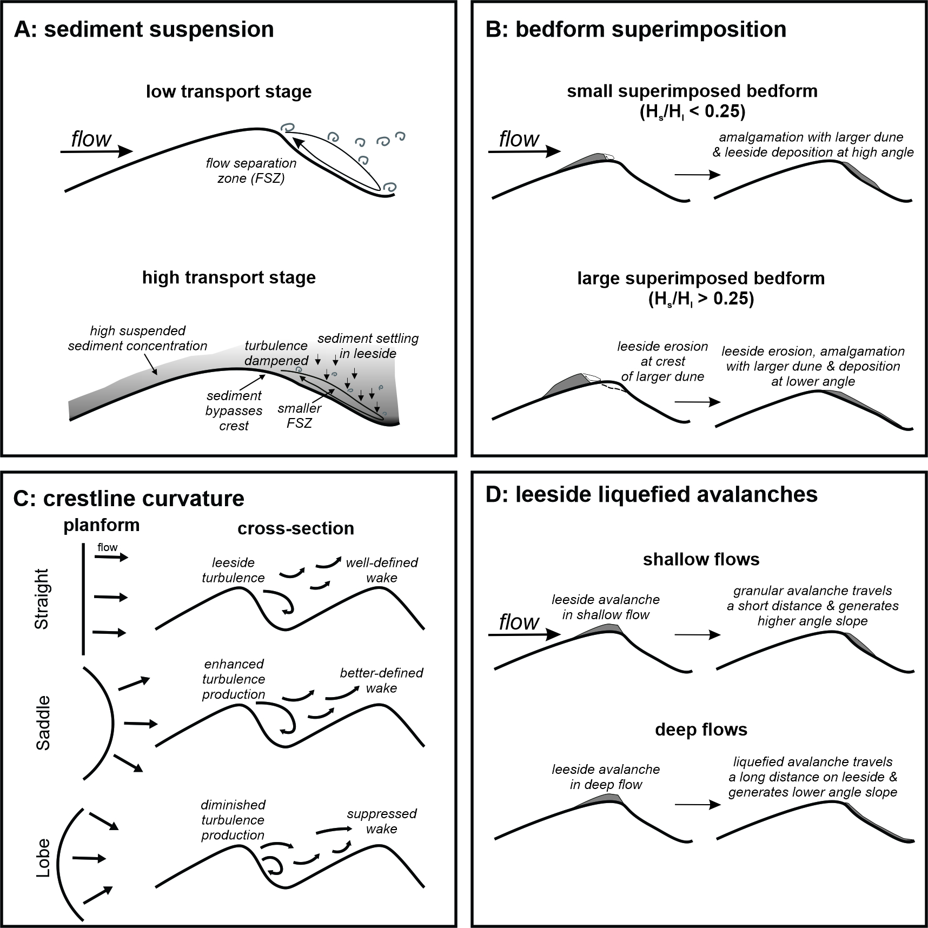
Figure 1. Schematic representation of the four mechanisms proposed in previous studies to cause the formation of low-angle dunes.

Several mechanisms have been proposed to explain the formation of low-angle dunes (Figure 1) in both shallow and deep flows (Best et al., 2020), including:

i) The influence of sediment suspension in modulating turbulence or increasing the bypassing of sediment over the dune leeside slope (Figure 1A; Baas and Best, 2002, 2008; Baas et al., 2016; Hendershot et al., 2016; Naqshband et al., 2016; Bradley and Venditti, 2017). Significant concentrations of suspended sediment have been hypothesized to cause a dampening of turbulence associated with the leeside flow separation zone, thereby decreasing leeside scour in the trough region, and enhance the bypass of sediment over the dune leeside that will increase sediment deposition in the dune leeside and trough. Both of these mechanisms will produce lower leeside angles.

ii) Bedform superimposition, whereby dune interactions modify the flow structure in the crestal region of the downstream bedform due to the leeside separation zone and associated free shear layer of the upstream bedform, thus causing crestal/leeside erosion and lessening dune leeside angle (Figure 1B, Allen and Collinson, 1974; Allen, 1978; Reesink and Bridge, 2009; Reesink et al., 2018). In steady flows, Reesink and Bridge (2009) describe the influence and interactions between a smaller, superimposed bedform (height, H_{S}) and the large bedform that it is climbing over (height, H_{L}). Specifically, Reesink and Bridge (2009) describe how these two bedform scales interact during the migration of the smaller bedform, when the reattachment point of its flow separation zone becomes coincident with the crest of the larger dune. If H_{S} is sufficiently large (> 25%) relative to H_{L}, Reesink and Bridge (2009) argue that erosion occurs at the brink point of the large dune (Reesink and Bridge, 2009). However, when a relatively small dune (H_{S}/H_{L} < 0.25) passes over the large dune, the large dune leeside is only partially reduced in angle and this erosion surface does not reach the base of the large dune, with the base of the leeside slope of the larger dune thus remaining at the angle-of-repose (Reesink and Bridge, 2009). Reactivation surfaces are thus formed by the passage of superimposed bedforms over a larger dune, with these surfaces being lower angle with passage of a relatively high (H_{S}/H_{L} > 0.25) compared to a relatively small (H_{S}/H_{L} < 0.25) superimposed bedform (Reesink and Bridge, 2009).

iii) The influence of three-dimensional dune crestlines in constricting/expanding flow, which controls leeside flow patterns and sediment routing (Figure 1C, Allen, 1968c; Lawless and Robert, 2001; Parsons et al., 2005; Venditti, 2007, Hardy et al., 2021). Three-dimensional dune crestlines may lead to the development of 3D flow structures that influence lateral flow, resulting in complex sediment routing during the constriction and expansion of flow (Allen, 1968c; Lawless and Robert, 2001; Parsons et al., 2005; Venditti, 2007; Hardy et al. 2021). The orientation and location of dune slip faces also determines the occurrence of flow separation and downstream extent of its associated turbulent wake, which results in variations in bed shear stress when morphologic variations in crest location and slip face exist along a three-dimensional dune (Venditti, 2007; Lefebvre, 2019). Hardy et al. (2021) show an increase in flow velocity over 2D crestlines compared to 3D crestlines that is related to a reduction in the separation zone on the dune leeside, but flow over three-dimensional crestlines exhibits more turbulent vortices that generate higher shear stresses compared to 2D crestlines. From these variations, it follows that variations in bedform three-dimensionality may influence form roughness and bed shear stress and lead to differences in the predicted sediment transport (Smith and McLean, 1977; Kostaschuk and Villard, 1996; Venditti, 2007; Kwoll et al., 2016; Lefebvre and Winter, 2016). Although it remains unclear whether changes in flow and sediment transport that occur from 3D to 2D dunes are related to changes in leeside angle, such variations in the topology of flow separation zones could influence the generation of low angle dunes. Thus, evaluating the relationship between crestal sinuosity and leeside morphology may be invaluable to understanding the formation of low-angle dunes.

iv) The presence of liquefied avalanches, produced as a result of excess pore pressures in grain flows present on dune leesides in deep flows, which travel further into the lee trough and lower the leeside angle (Figure 1D, Kostaschuk and Venditti, 2019). However, several problems arise in this model being able to produce liquefied avalanches (Best et al., 2020). Firstly, liquefied avalanches may occur in any flow depth as long as there is a pressure differential to create an excess of pore pressure (Benjamin and Yeh, 2016; Best et al., 2020). This excess pore pressure may be produced in several ways, for example through the result of grain rearrangement and rapid shear (Iverson and LaHusen, 1989), or turbulence fluctuations in the dune leeside (Motamedi et al., 2013; Abe, 2019), which is prevalent in all environments where flow and sediment transport is occurring over a non-uniform and mobile bed (Allen, 1968a,b). The assertion that low-angle dunes are only found in deep flows due to this liquefaction process also suggests that high-angle dunes cannot be formed in the same condition, yet in deep rivers, while the majority of dunes are low-angle, high-angle dunes do exist with leesides up to 30°, albeit at low abundance (Roden, 1998; Cisneros et al., 2020). Additionally, over a range of dune sizes, low- and high-angle dunes exist (Best et al., 2020). The liquefied avalanche mechanism is also based on a conceptual model with a simple-shape leeside (Kostaschuk and Venditti, 2019), yet Cisneros et al. (2020) have shown that leesides often have complex leeside shapes with high and shallow sloping segments. Consequently, it is improbable that a liquefied flow would be able to traverse over a leeside with various high and low sloping segments without halting or becoming discontinuous (Best et al., 2020). Following the hypothesis of Kostaschuk and Venditti (2019), the leeside liquefaction process should be absent in shallow flows, resulting in low-angle dunes also being absent.

It is also unclear whether shallow flow experiments and shallow rivers exhibit the flow and sediment transport conditions required to promote the formation of low-angle dunes. In large rivers, low Froude numbers, high transport rates, and highly variable flow and sediment transport rates are common (Julien and Klaassen, 1995; Roden, 1998; Kostaschuk and Villard, 1996; Kostaschuk, 2000; Best and Kostaschuk, 2002; Shugar et al., 2010; Kostaschuk and Venditti, 2019a). In shallow flume experiments, the Froude number is often much larger compared to deep rivers (Naqshband and Hoitink, 2020), whereas sediment mobility often represents conditions of bedload or mixed load transport (Naqshband et al., 2014; Bradley and Venditti, 2017). In such laboratory experiments, high Froude numbers result in observations of dunes near the transition to upper-stage plane bed conditions, yet the physical mechanisms that link dune morphology to Froude number are poorly understood (Naqshband and Hoitink, 2020). The inability to correctly scale Froude number in shallow flow experiments thus leads to a knowledge gap in investigating and understanding dune stability regimes under shallow laboratory flows. As a result, our ability to predict bedform regimes has been dominated by using laboratory observations of high-angle dunes (Kostaschuk and Villard, 1996; Naqshband et al., 2014; Naqshband and Hoitink, 2020). The formation of low-angle dunes in shallow flow experiments under properly scaled, low Froude numbers and sediment transport parameters (Naqshband et al., 2014; Naqshband and Hoitink, 2020), suggests that the reason low-angle dunes are absent in the laboratory is not that they do not exist, but that: i) they are difficult to produce under similar conditions, and ii) that it is difficult to measure and create their formative conditions in a laboratory setting.

Recent work has created dunes at low Froude numbers in shallow flow laboratory flows by using low-density sediment, with low-angle dunes being successfully formed under suspension numbers (the ratio of bed shear stress to grain settling velocity, u*/w_{s}) similar to large rivers (c. 0.4 to > 3; Naqshband and Hoitink, 2020, their figure 3). In this case, an increase in leeside angle is seen for increasing suspension numbers less than c. 1, but when the suspension number equals and exceeds unity, dune leeside angle decreases with increasing suspension number at a rate similar to data from deep flows (Naqshband and Hoitink, 2020). In these experiments, the growth of dune height, wavelength and leeside slip face angle also adjusted at similar timescales (Naqshband and Hoitink, 2021). Specifically, before the leeside angle reaches the onset of flow separation (10°; Lefebvre and Cisneros, 2023), sediment largely bypasses the dune crest and flow reattachment point. When leeside angle increases, associated with more permanent flow separation scour in the bedform trough intensifies, resulting in dune growth as more sediment is delivered to the crest and deposited in the leeside region of flow recirculation (Naqshband and Hoitink, 2021). Naqshband and Hoitink (2021) also confirmed, through a liquefaction model, that low-angle dune slip faces were maintained without liquefied avalanches.

Recently, an extensive and robust set of experiments were conducted across a range of transport conditions from dune growth through to dune equilibrium, and that illustrated a transport scaling relationship between dune height and dune wavelength (Bradley and Venditti, 2019a,b). These experiments focused on five transport conditions ranging from the threshold of sediment transport through to suspended sediment transport dominated conditions, and across three flow depths (0.15, 0.20, 0.25 m; see Bradley and Venditti, 2019a), offering a unique insight into the development and equilibrium morphology of dunes across different transport stages. Bradley and Venditti (2019a,b) found that dunes become flatter and longer with increasing suspended load, and suggested that sediment suspension is a major control determining the morphology of dunes in these shallow flow experiments. These recent studies detailing the formation of low-angle (Naqshband and Hoitink, 2020) and flattened (Bradley and Venditti, 2019a) dunes in laboratory flows thus suggest that suspended sediment transport is likely an important control on the formation of low-angle dunes in both deep and shallow flows, as also highlighted in earlier work on the dune – upper stage plane bed transition (Bridge and Best, 1988). However, a detailed quantification of leeside angle, and its change with transport stage, has not been conducted on the datasets of Bradley and Venditti (2019a), but is pivotal to discussions of changing dune morphology.

The present paper thus aims to examine the nature of dune leeside character by analyzing the datasets from Bradley and Venditti (2019a) to address three research questions: 1. Do low-angle dunes form in shallow flow laboratory experiments?; 2. What is the relative prevalence of different angle dunes across transport stages, and do these conditions provide insight into the possible controls on low-angle dune formation, and 3. What is the relative importance of sediment suspension and bedform superimposition on the formation of low-angle dunes?

2 Datasets and methods

2.1 Data detailing equilibrium morphology of dunes

The data used herein comprise c. 600 maps detailing the equilibrium morphology of dunes across various flow depth and transport stages reported by Bradley and Venditti (2019a). These data comprise xyz grids and are available through a data archive (Bradley, 2018) that accompanies the papers by Bradley and Venditti (2019a,b). The laboratory flume used by Bradley and Venditti (2019a,b) was 15 m long, 1 m wide, and 0.6 m deep, recirculated both water and sediment and possessed an adjustable slope (slope range = -0.5 - 2%). The experiments used a well-sorted medium sand (D₅₀ = 550μm, Bradley and Venditti, 2019a). The transport stages studied ranged from the threshold of sediment transport through bedload-dominated to suspended load dominated transport, and with initial flow depths of 0.15, 0.20 and 0.25 m. Each transport condition was investigated at each of the three flow depths. In each run, a constant, steady flow was imposed over an initially flat bed, and dunes began to develop. Each run continued through bedform growth until morphological equilibrium had been reached, defined as when the bedforms were not systematically increasing or decreasing in size, and flow was then sustained for 10 hours at the desired discharge (Bradley and Venditti, 2019a). The initial flume slope for each run was set so that it matched the water level slope over an initially flat bed. For each run under each flow depth, sediment transport conditions were varied by increasing the pump discharge in five steps from the initiation of motion (threshold) to washout of dunes: threshold (THLD), bedload (BDLD), lower-mix (LMIX), upper-mix (UMIX), and suspended load (SPSN), which coincide with increasing sediment transport in suspension. In each run, a full-bed morphological scan was taken every 10 minutes, over 10 hours of run time, using the Swath Mapping System detailed in Venditti et al. (2016). The original maps were gridded with an x-axis (downstream) spacing of 1.29 cm and a y-axis (cross-stream) spacing of 3.05 cm. For the analysis conducted herein (see below), equal x and y spacing is required and thus the y-axis was interpolated from the original spacing of 3.05 cm to 1.29 cm. In the experiments, only the THLD and BDLD conditions were scanned under 0.25 m flow depth because the higher discharges required to reach high transport conditions were above the capacity of the pump. Herein, the runs will be referred to by their flow depth-transport condition pair, such that, for example, the threshold (THLD) run at 15 cm flow depth is referred to as THLD 15.

The entirety of bed scan data (every 10 minutes over 10 hours for each condition) acquired after equilibrium was reached were analyzed using the Bedform Analysis Method for Bathymetric Information (BAMBI, see details in Cisneros et al., 2020) to compile extensive measurements detailing the morphology of dunes. In brief, BAMBI uses aspect maps of the bathymetry to define crest and trough locations as the transition between downstream facing lee sides and upstream facing stoss sides. This operation occurs across the entire gridded map by slicing the map into profile lines with a length equal to the downstream axis of the map in the flow direction and width equal to one grid cell. Measurements occur along each profile line for each dune that is defined by having an upstream trough point, a length of stoss defined cells, a crest point, a length of lee defined cells, and a downstream trough point. Morphologic measurements include dune height, mean leeside angle, maximum leeside angle, dune wavelength, flow depth at the dune crest (local flow depth), and the relative height of the location of the steepest slope on the leeside for each dune measured. The maximum leeside angle is referred to herein as the steep slope (following similar nomenclature in Lefebvre and Cisneros (2023) when referring to the morphological element commonly known as the “slipface”, so as to not infer the type of sediment transport on the dune leeside). The mean leeside angle is herein referred to as ‘leeside angle’. Morphologic measurements were reported for the primary dunes and secondary, superimposed bedforms. In the figures presented herein, the average of the morphologic measurements for each bed scan are reported, such that each experimental case has a total number of datapoints that correspond to the total number of scans per experiment (53 to 59 scans/points). Additional data, reported by Bradley and Venditti (2019a), include transport stage (${τ^{*}}/{τ_{c}^{*}}$) where τ*and τ*_{c} are bed shear stress and critical bed shear stress respectively, shear velocity (u*), particle fall velocity (w_{s}), and Froude number (Fr), for each scan in each experiment. For more information regarding the acquisition of this additional data, see Bradley and Venditti (2019a).

To assess leeside angle over three-dimensional crestlines, the leeside slope was also measured manually over different types of dune crestline planform shapes, including straight, lobe and saddle shaped crestlines (see Figure 1 for definitions). Measurements were taken along profile lines that were defined along the apex of the dunes, and values of leeside angle were measured. Manual quantification was required to explicitly measure the apex of the dune because, depending on the crestline length and map resolution, the BAMBI measurements were not always centered at the apex. This manual measurement was consistent with the BAMBI method, except for the use of a looking angle within BAMBI to determine cell slope changes from stoss to leesides. For manual measurements, the crest was defined as the point where slope along the profile changed from upstream to downstream facing, whilst the trough is the point where the slope changed from downstream to upstream facing. The main difference in measurement technique is thus that the manual method was performed along a single profile, and did not take into account the cells around the area within one cell in the downstream and spanwise directions (a 3x3 grid) from each point along the profile. In this case, only one measurement was used for each dune along the apex of the crestline, which is different to the BAMBI method that outputs dune measurements across the entire width of a dune. For this reason, the measurement values may not be directly comparable to BAMBI measurements, but deploying this method allows the measurements to be compared for three-dimensional crestlines.

3 Results

Data are presented herein detailing the relationship between dune leeside angle for each bed scan and a range of parameters, including relative dune height, flow depth, transport stage, suspension number and Froude number (3.1). The analysis shows the range of dune leeside angles across each experimental condition from threshold to suspension dominated flows and each flow depth (3.2). In the diagrammatic presentation of results in 3.1 and 3.2, each point represents the average of the morphological measurements reported for a bed scan, whilst the bold outline points represent the average value from all of the bed scans for each case. To ensure clarity, the mean leeside angle reported in BAMBI is referred to as leeside angle whilst the average, maximum, and minimum values are referred to as such. For the threshold conditions at 0.15 m flow depth, the response of dune leeside angle during bedform superimposition is explored (3.3) and leeside angle over three different dune crestline types – straight, lobe and saddle – is examined (3.4). Finally, the potential for flow separation over all dunes is examined in order to quantify the percentage of dunes that potentially experience no flow separation, intermittent, permanent and developing, or permanent and fully developed flow separation.

3.1 Leeside angle

The relationship between local flow depth and leeside angle for all experiments, ranging from THLD to SPSN transport stages and flow depths from 0.15-0.25 m (Figure 2a), shows dunes were formed in all flow depths, with leeside angles ranging from 10° to 30°. In general, a trend is present where minimum leeside angle increases with increasing flow depth for the 15 and 20 cm flow depths (Figure 2a and Table 2) for each condition, similar to observations regarding flow depth and dune height that have been reported from large rivers (Cisneros et al., 2020). For experiments at 25 cm flow depth, where only the THLD and BDLD conditions were investigated, the minimum leeside angle increases to c. 15°, with the maximum leeside angle remaining at c. 28°. However, in all transport cases, the average leeside angles are at, or below, 24° (Figure 2 bold outline symbols).

The relationship between leeside angle and relative dune height (Figure 2b) also reveals that, for the same relative dune height, leeside angle is lower at greater transport stages, specifically for the UMIX and SPSN experiments. Relative dune height is often lowest for the THLD case, whereas BDLD and LMIX are characterized by relatively higher dunes, with UMIX and SPSN dunes being lower and possessing relative dune heights between these extremes.

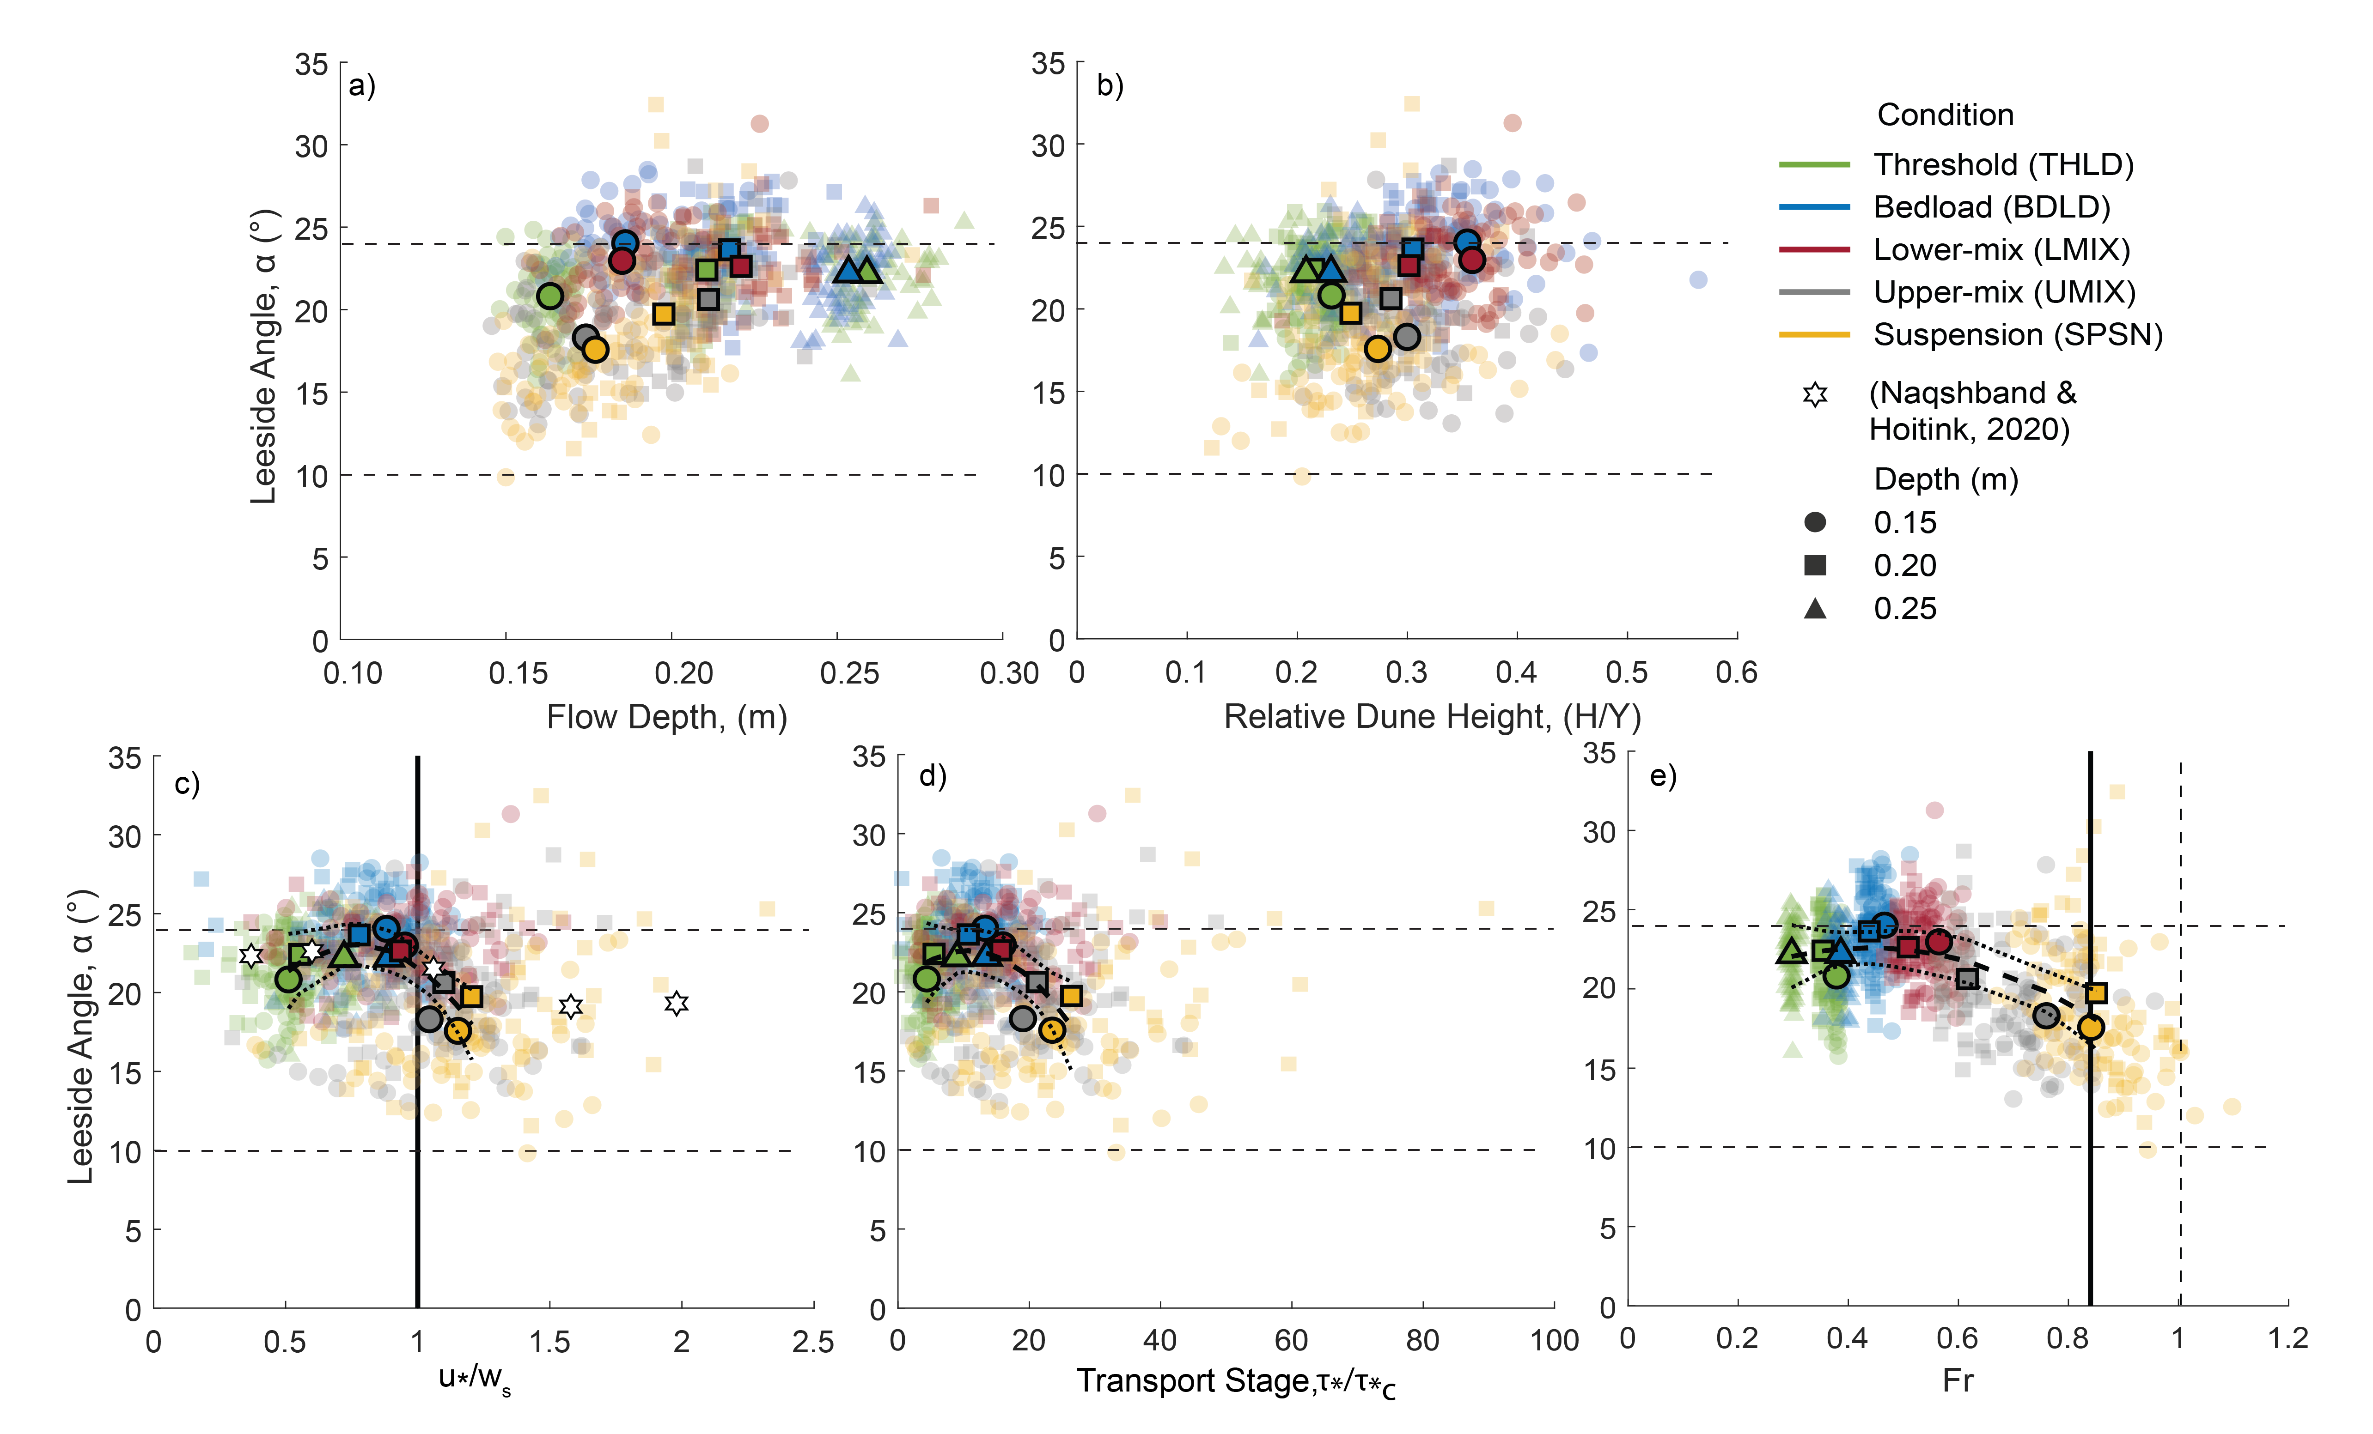Figure 2. Relationship between leeside angle and: (a) flow depth, (b) relative dune height, (H/Y), (c) suspension number (u*/w_{s}), (d) transport stage (τ/τ_{*c}), and (e) Froude number (Fr), for all experiments. The average values of the individual scans are represented as pale colored symbols, whereas the average values for all scans per transport and flow depth condition are shown as bold outlined symbols. Dashed horizontal lines on the y-axis represent leeside angle values at 10° and 24°. Values for suspension number, transport stage, and Froude number for each scan are from Bradley and Venditti (2019a). Ιn (c) solid vertical line represents suspension number equal to 1, and in (e) solid and dashed vertical lines denote Froude number equal to 0.84 and 1 respectively. In (c), additional data represented as stars is from Naqshband and Hoitink (2020). In (c-e) the dashed curve represents a polynomial regression fit to the average values of transport and flow depth condition pairs, with the dotted curves showing the 95% confidence intervals of the regression.

The relationships between leeside angle and suspension number (u*/w_{s}, Figure 2c), transport stage (${τ^{*}}/{τ_{c}^{*}},$Figure 2d), and Froude number (Fr, Figure 2e) show broadly that from the THLD condition to the BDLD condition, dune leeside angle increases and then decreases through to the SPSN condition. A polynomial regression was fitted to the average values of each transport and flow depth condition pair to assess the inflection point at which leeside angle changes from increasing to decreasing for all transport and flow depth cases. The transition to decreasing leeside angle occurs below a suspension number of unity, highlighted by the bold line (Figure 2c), and specifically the inflection point of this curve is at 0.76 with a THLD and BDLD case falling on either side of the inflection point. For the same flow depth conditions, the leeside angle decreases between the BDLD and LMIX case. Within the same transport conditions, for example THLD, UMIX, and SPSN, the average leeside angles are lower in the 15 cm than the 20 cm flow depth experiments (Figure 2c).

With increasing transport stage for the same flow depth (Figure 2d), the average leeside angles increase (from THLD to BDLD) and then decrease (from BDLD to SPSN). Similar to the relationship with suspension number, for THLD, UMIX, and SPSN, the average leeside angle is lower for the 15 cm flow depth than at 20 cm. The inflection point for the ${τ^{*}}/{τ_{c}^{*}}$ regression fit line is 10.6, with the polynomial regression line possessing a peak between the THLD and BDLD cases (Figure 2d).

Leeside angle also increases and decreases with increasing Froude number (Figure 2e), with the decrease for the same flow depth occurring between the BDLD and LMIX conditions. The inflection point of the regression fit for Fr = 0.44 occurs within the range of the bedload cases. For the THLD, BDLD, LMIX, and UMIX experiments, the Froude number is always greater at shallower flow depths. This is most obvious in the UMIX condition, where the average Froude numbers for the 15 cm and 20 cm flow depths are 0.76 and 0.62 respectively (Figure 2e), but the leeside angle only differs by c. 2°. For the SPSN condition, both the 15 and 20 cm flow depths possess similar average Froude numbers (0.84 and 0.85, respectively) and leeside angles (leeside angle changes from c. 18° to 20°, respectively). In the SPSN case, however, the average leeside values are at, or just above, Fr = 0.84 (Figure 2e) and these dunes are likely at, or near, the transitional regime from dunes to upper-stage plane bed (Bridge and Best, 1988; Best and Bridge, 1992; van den Berg and Van Gelder, 1993). Importantly, the decrease in leeside angle that occurs at Fr = 0.44 indicates that suspension likely plays a significant role in decreasing leeside angle at Fr < 0.84, also providing additional support for the contentions of Naqshband and Hoitink (2020).

To assess the statistical significance of differences in dune leeside angles for different transport stage-flow depth experimental conditions, t-tests were performed comparing each experimental condition to the other 11 cases. A t-test was chosen because of the unequal sample size and variance in each case. Table 1 shows a matrix representation of the t-test statistic, with an alpha value of 0.05, whilst Table S1 displays a matrix representation of the t-critical values, which changed slightly for each test based on the degrees of freedom and thus sample size.

Two key points are apparent from tests of the statistical significance of difference between the experimental conditions. First, most sample populations are statistically different when compared to a reference population, including each sample compared to the THLD15, BDLD15, BDLD20, UMIX20, SPSN15, and SPSN20 cases. Of the samples that are statistically similar to the reference population, BDLD25 and SPSN15 stand out as examples that are statistically similar to a different transport condition (for example BDLD25 is similar to the THLD25 case). Less surprisingly, statistically similar cases also exist between the same transport condition; for example, LMIX20 is similar to LMIX15. Of all these comparisons, the most notable are that the THLD 15, BDLD15, BDLD20, UMIX20 and SPSN20 cases show no statistical similarity to any other case, including those that are either similar in transport or flow depth. Secondly, the lower-mix, upper-mix and suspension cases are not statistically similar to any of the bedload or threshold cases, as shown by the lack of red values reported in the bounded areas of the t-test matrix (Table 1).

Table 1. T-test statistics of leeside angles for transport-flow condition populations. In this table, the critical t-number changes based on the reference population (as reported in Table S1). The value of alpha is 0.05. The values represented in red show that the two populations compared, as shown through the x and y axis of the matrix, failed to reject the null hypothesis and the sample population is not statistically different than the reference population. The values presented in black thus reject the null hypothesis and these sample populations are statistically different than the reference population. Rows represent cases as a sample and columns represent cases as a reference population.
 | THLD15 | THLD20 | THLD25 | BDLD15 | BDLD20 | BDLD25 | LMIX15 | LMIX20 | UMIX15 | UMIX20 | SPSN15 | SPSN20
THLD15 | 0.00 | -22.67 | -21.56 | -44.60 | -39.33 | -20.62 | -25.29 | -25.65 | 40.99 | 6.78 | 44.55 | 31.61
THLD20 | 23.43 | 0.00 | 1.15 | -22.67 | -17.22 | 2.11 | -2.71 | -3.08 | 65.80 | 30.44 | 69.48 | 56.11
THLD25 | 20.89 | -1.08 | 0.00 | -22.34 | -17.23 | 0.90 | -3.62 | -3.97 | 60.62 | 27.47 | 64.08 | 51.53
BDLD15 | 32.55 | 16.01 | 16.82 | 0.00 | 3.85 | 17.50 | 14.09 | 13.83 | 62.46 | 37.50 | 65.06 | 55.62
BDLD20 | 35.67 | 15.11 | 16.12 | -4.78 | 0.00 | 16.96 | 12.73 | 12.41 | 72.85 | 41.82 | 76.08 | 64.34
BDLD25 | 23.00 | -2.28 | -1.04 | -26.74 | -20.86 | 0.00 | -5.20 | -5.61 | 68.71 | 30.56 | 72.68 | 58.25
LMIX15 | 19.94 | 2.07 | 2.95 | -15.22 | -11.07 | 3.68 | 0.00 | -0.28 | 52.25 | 25.29 | 55.06 | 44.86
LMIX20 | 22.57 | 2.63 | 3.60 | -16.67 | -12.03 | 4.42 | 0.32 | 0.00 | 58.64 | 28.54 | 61.77 | 50.38
UMIX15 | -27.09 | -42.08 | -41.34 | -56.57 | -53.09 | -40.73 | -43.81 | -44.05 | 0.00 | -22.61 | 2.35 | -6.20
UMIX20 | -4.19 | -18.18 | -17.50 | -31.73 | -28.47 | -16.92 | -19.81 | -20.03 | 21.12 | 0.00 | 23.32 | 15.33
SPSN15 | -23.29 | -35.13 | -34.55 | -46.60 | -43.84 | -34.07 | -36.51 | -36.69 | -1.86 | -19.74 | 0.00 | -6.76
SPSN20 | -14.35 | -24.64 | -24.13 | -34.59 | -32.20 | -23.71 | -25.83 | -25.99 | 4.26 | -11.27 | 5.87 | 0.00

Overall, across different transport conditions for the same flow depth, the inflection point of the polynomial fit occurs between the THLD and BDLD cases for suspension number and transport stage, and between BDLD and LMIX for Froude Number. Comparing the same flow depth conditions, an increase in leeside angle consistently occurs from the THLD to BDLD cases, followed by a decrease from the BDLD through to SPSN cases. These findings are consistent with previous literature that shows particles can be entrained into suspension at suspension numbers as low as 0.4 (Nino et al., 2003), suggesting that the lowering of leeside angle may begin shortly after the onset of particle entrainment into suspension and not suspension dominance. Thus, the consistent decrease in leeside angle occurs as transport begins to be characterized by an increasing suspended sediment flux.

3.2 Distributions of leeside angle

The distributions of leeside angle from all scans reveal differences across experimental conditions, especially between upper and lower transport conditions (Figure 3a-l). A kernel distribution was fitted to the distribution, which allows a better fit compared to parametric models (e.g. gamma, Gaussian), especially when there is more than one peak (Naqshband and Hoitink, 2020). Additionally, the steep slope is plotted on Figure 3a-l for all dunes in each scan and represented as a black outlined histogram. The leeside angle and steep slope angles of dunes in a range of large rivers (Cisneros et al., 2020) is also presented in Figure 3m.

For the experimental leeside angles, average values of the distributions range from >20.8° in the low transport cases (THLD, BDLD, and LMIX) and <20.6° in the high transport cases (UMIX and SPSN, Figure 3a-l). Peaks of these distributions also lie above 20° for the low transport cases and below 20° for the high transport cases. Some distributions have two peaks, such as BDLD20 that has peaks at 23° and 27°. The standard deviation of all distributions is consistently between 1.5-2.5 for the low transport cases, whereas the high transport cases possess standard deviations greater than 2.9, with the higher transport cases having distributions with a wider spread (Table 2). The skewness for all cases is low and has a maximum range of 0.62 from zero, but the skewness is negative for all THLD and BDLD cases and positive for LMIX, UMIX and SPSN cases (Table 2). Thus, the tails of the distributions are skewed to lower leeside angles for THLD and BDLD cases and to higher leeside angles for LMIX, UMIX and SPSN cases. The kurtosis of all distributions ranges up to +/- 1 from 3, and there is no trend with increasing transport stage (Table 2). Thus, the tails of the distributions range from slightly heavy or light compared to a normal distribution for all cases.

The average values of the steep slope for all experimental cases are shifted by c. 10° higher compared to the leeside angles in all experimental cases. The average angles of steep slopes for all cases ranges between 29.5° to 35.8° (Table S2). From low transport cases to high transport cases, the standard deviation of steep slopes increases from values <2 in the threshold experiments to > c. 5 in suspension load cases (Table S2). The distributions thus adopt a wider spread as transport stage increases. Additionally, skewness is low across all cases with values ranging up to +/- 0.72 (Table S2). Generally, the low transport cases have a more negative skewness, whereas the high transport cases have positive skewness. Apart from the THLD 15 case, the kurtosis of all low transport conditions from THLD through LMIX is greater than 3, whereas the higher transport cases possess kurtosis values less than 3 (Table S2). Thus, the low transport cases possess heavier tails compared to a normal distribution, whereas the high transport cases have lighter tails.

Data from large rivers (Figure 3m; as reported in Cisneros et al., 2020), have an average leeside angle of 12.1° and an average steep slope of 17.8° (Table 2 and Table S2). The distribution of leeside angles from these large rivers is widely distributed with a standard deviation of 5.89 with heavier tails (shown by a kurtosis of 4.71) and a tail skewed toward higher values, with a positive skewness of 1.48 (Table 2). The histogram of steep slopes for large rivers is also widely distributed (Figure 3m), shown by a standard deviation of 7.78, with a light tail (kurtosis of 1.54) and a less positive skewness with a value of 0.95 (Table S2).

Overall, from low to high transport stages, these distributions confirm the trend that dune leeside angles change from dominantly high (peaks > 20°) to low (peaks < 20°), and the distributions of leeside angle vary from having discrete, high peaks, to being peaks that are broader and flatter. With increasing transport stage, leeside angle decreases, and the standard deviation and skewness of the leeside angle distributions increases (Figure 3). Across all transport cases, steep slopes are high angle, peaking around 30° regardless of the average leeside angle. Finally, the leeside angles shift towards lower values with positive skewness for large rivers, showing a similar distribution to the high transport cases in the experiments, whereas the distribution of steep slopes is dissimilar to any of the experimental cases, possessing lower average values that are more widely distributed compared to the experimental cases.

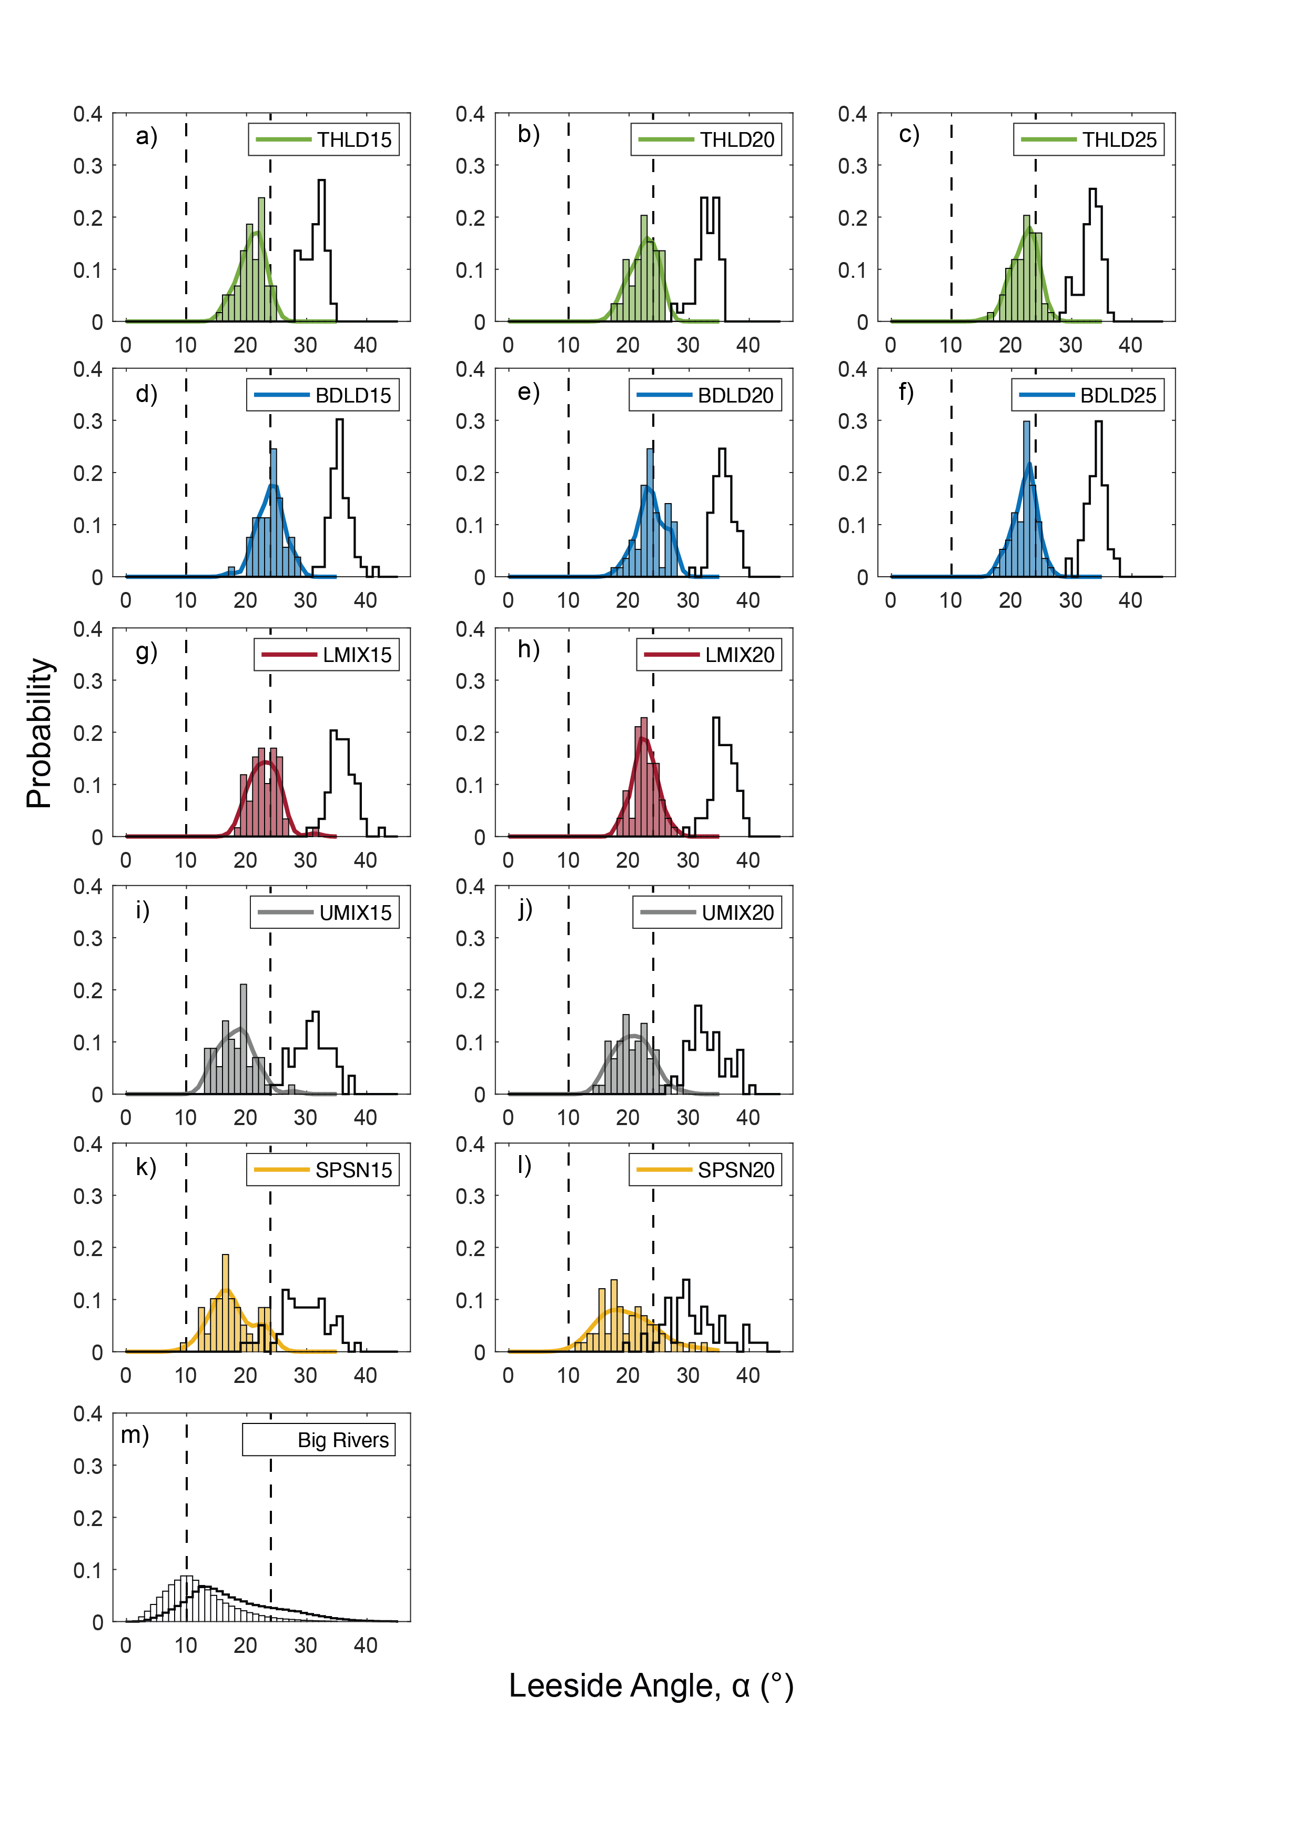

Figure 3. Distributions of leeside angle (filled) and steep slopes (outlined) for all experiments (a-l) and from the worlds large rivers (m). Dashed lines represent leeside angles at 10° and 24°. See Table 2 for descriptive statistics of leeside angle distributions and Table S2 for descriptive statistics of steep slope distributions.

3.3 Response of leeside angle to bedform superimposition

During dynamic equilibrium conditions, as superimposed bedforms climb up and over the stoss side and crestal platform of a larger dune, the leeside angle of the downstream bedform may sometimes lower (Figure 4), similar to the sequence proposed by Reesink and Bridge (2009). This is illustrated herein for one example from the THLD 15 case where the temporal change in leeside angle for one large dune is reported together with the leeside angle of the superimposed bedforms when they are present (Figure 4a). In this figure, the bedform height and leeside angles are presented only for the dune and superimposed bedforms highlighted in yellow (Figure 4c). When there is more than one superimposed bedform on the stoss side of the large dune, the largest height is reported as H_{S}. When a superimposed bedform is present, the ratio of the superimposed bedform height (H_{S}) to the large dune height (H_{L}) is also plotted (Figure 4b). Here, the profile corresponds to 160 to 250 minutes after equilibrium has been reached, with each successive profile being at a time increment of 10 minutes (Figure 4c). The four shaded 3D maps (Figure 4d) show the area around the single line profile at t = 160, 210, 230 and 250 minutes (+/- five resolution cells in the y-direction from the profile line taken from the center of the map). The areas shaded yellow (Figure 4c, d) highlight the large dune discussed herein.

At t = 160 minutes (Figure 4c, di), the dune leeside angle is 24.3° and, over time, three superimposed bedforms begin to develop (t = 190 minutes, Figure 4c, dii). These superimposed bedforms migrate over the stoss and crest of the larger dune, and at 200 minutes H_{S}/H_{L} = 0.23 and the dune leeside of the larger dune begins to lower. The leeside angle of the superimposed bedform declines to 17° at t = 190 minutes and reaches a minimum of 6° at t = 200 minutes. From t = 190 to 220 minutes (grey shaded area, Figure 4a, b), the leeside angle of the larger dune thus lowers from 26.3 to 10.4° (Figure 4a), at the same time as superimposed bedforms form on the stoss side of the large dune (t = 190 minutes), migrate along the stoss, and eventually move onto the dune leeside (t = 210 minutes). During this sequence, H_{S}/H_{L} decreases from 0.23 to 0.12 (from t = 190 to 220 minutes). The purple outlined map (Figure 4c, dii) corresponds to one profile before the large dune reaches its lowest angle (dune leeside angle = 15.7° at 210 minutes) and after superimposed bedforms climb over the larger dune crest and onto the dune leeside. At 220 minutes, the last superimposed bedforms arrive at the large dune crest and the large dune leeside angle reaches its lowest value in this sequence of 10.4°. The leeside angle of the superimposed bedform at this time (t = 220 min, Figure 4a) is 19°. By 230 minutes, the superimposed bedform has migrated over the crest and dune leeside, and the leeside angle of the larger dune begins to increase again. From t = 230 to 250 minutes, when no bedform superimposition is evident, the leeside angle of the large dune increases from 19.0° to 23.9°. The orange shaded map (Figure 4c, diii) shows the higher angle large dune at 230 minutes. Finally, at 250 minutes, superimposed bedforms begin to form on the stoss side of the large dune once again, and the corresponding 3D map (red shaded box, Figure 4c, div) shows developing superimposed bedforms with H_{S}/H_{L} = 0.255 and leeside angle = 30°.

In summary, this example illustrates that bedform superimposition influences the leeside angle as superimposed bedforms migrate over a dune. Specifically, it suggests that when a superimposed bedform of sufficient height migrates over a dune crest, turbulence generated along the shear layer of the flow separation zone in the lee of the superimposed bedform causes erosion of the large dune crest, and thus lowering of the leeside angle (Reesink and Bridge, 2009). In the example presented herein, where H_{S}/H_{L} is near 0.25, the superimposed bedform leeside angle is likely great enough (c.15°) to possess a zone of flow separation, and its migration causes the large dune leeside angle to decrease by c.16° over a period of 30 minutes. As superimposed bedforms migrate over the large dune crest and amalgamate with the large dune, the large dune leeside angle increases back to 19° over a 10-minute time period. Leeside angle continues to increase when superimposed bedforms are present if H_{S}/H_{L} is low (c. 0.12), although the superimposed bedform leeside angle is 19°, supporting the results of Reesink and Bridge (2009) that detail amalgamation of a superimposed bedform with the main dune, crestal/leeside erosion and the lowering of the dune leeside angle. Such increases in dune leeside angle have also been reported on the rising stage of flood hydrographs (Roden, 1988; Bradley and Venditti, 2021) and suggest that relative dune height, related to time-varying flows, may be critical in influencing dune leeside angle. Bedform superimposition may thus contribute to the formation of lower dune leeside angles under low sediment transport conditions.

 | Number  of scans | Minimum ($°$) | Median ($°$) | Average ($°$) | Maximum ($°$) | Range ($°$) | Skewness | Kurtosis | Standard  Deviation ($°$)
THLD15 | 59 | 15.75 | 20.86 | 20.82 | 24.84 | 9.08 | -0.39 | 2.59 | 2.14
THLD20 | 59 | 17.22 | 22.59 | 22.40 | 25.97 | 8.75 | -0.41 | 2.34 | 2.19
THLD25 | 59 | 16.01 | 22.50 | 22.16 | 26.39 | 10.38 | -0.50 | 3.05 | 2.04
BDLD15 | 53 | 17.34 | 24.20 | 24.02 | 28.47 | 11.13 | -0.30 | 3.40 | 2.20
BDLD20 | 57 | 17.70 | 23.64 | 23.63 | 27.77 | 10.07 | -0.19 | 2.60 | 2.36
BDLD25 | 57 | 17.92 | 22.49 | 22.19 | 26.23 | 8.32 | -0.40 | 2.84 | 1.92
LMIX15 | 59 | 18.16 | 22.96 | 22.97 | 31.27 | 13.10 | 0.49 | 3.99 | 2.37
LMIX20 | 57 | 18.42 | 22.69 | 22.62 | 27.62 | 9.21 | 0.09 | 2.92 | 2.00
UMIX15 | 57 | 13.06 | 18.26 | 18.30 | 27.83 | 14.77 | 0.50 | 3.51 | 2.93
UMIX20 | 59 | 14.89 | 20.66 | 20.62 | 28.69 | 13.80 | 0.24 | 2.67 | 2.99
SPSN15 | 59 | 9.84 | 16.89 | 17.57 | 24.48 | 14.64 | 0.26 | 2.38 | 3.47
SPSN20 | 58 | 11.57 | 18.77 | 19.73 | 32.43 | 20.86 | 0.62 | 3.13 | 4.46
World’s big rivers* | - | - | - | 12.12 | - | - | 1.48 | 4.71 | 5.89

Table 2: Statistics for distributions of leeside angle for all experiments presented in Figure 3. The acronyms represent different transport and flow depth condition pairs: transport cases are Threshold = THLD, Bedload = BDLD, Lower-mix = LMIX, Upper-mix = UMIX, and Suspension = SPSN and flow depths range from 15 = 0.15 m, 20 = 0.20 m, and 25 = 0.25 m. *The data for the worlds big rivers represents the average values of the dataset reported by Cisneros et al. (2020).

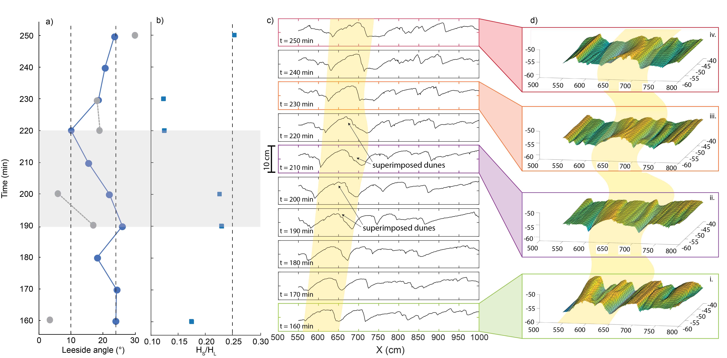

Figure 4. Visualization of the influence of bedform superimposition on dune morphology, showing (a) leeside angle and (b) relative height ratio, H_{S}/H_{L}, as linked to (c) successive longitudinal bed profiles and (d) 3D bedform maps (i-iv). In (a) blue markers denote leeside angle of large dune and grey markers denote superimposed bedforms. Note that values for superimposed bedforms do not exist when these bedforms are absent. The vertical-axes in (c) and (d), taken from the centerline and area around the centerline, depict a consistent 10 cm elevation range, with a 10-minute time interval between successive profiles. Dashed lines represent leeside angles at 10° and 24° and H_{S}/H_{L} = 0.25.

3.4 Leeside angle and the three-dimensionality of dune crestlines

To assess any difference in leeside angle between three-dimensional dune crestlines, manual measurements of leeside angle across lobe, straight, and saddle planform segments of dune crestlines (Figure 5 inset), as defined by Allen (1968c), were made for scans from the THLD 15, BDLD 15, and SPSN 15 experiments (Figure 5). In this plot, the number of leesides measured ranges from 2 to 54, and the slope from the crest to dune trough was averaged to yield a mean leeside slope. The mean leeside angles of the straight, lobe, and saddle crestlines vary slightly in the THLD case, from 13.8° to 12.0°. In the BDLD case, leeside angles range from 29.9° to 27.4°, but in the SPSN case the range was more significant, from 18.7° to 9.3° (Figure 5).

Maps of the leeside angles measured by BAMBI, color coded by leeside angle, show the range of angles present in a scanned map for all cases (Figures S1 and S2). In the threshold cases, lobes, saddles and straight crestlines are present and leeside angles range across the dune crestline, with segments transitioning between low angle (<10°) and intermediate and high angle (10° - 24°) and angle-of-repose (>24°). For the straight-crested dunes in the threshold, bedload and lower-mix cases, leeside angles vary from <10° to >24°, with more segments of 10° - 24° (Figures S1a, b, c). Across all flow depths, saddle crestlines have distinct segments of <10° and between 10-24° (see Figure S1d, e) and in other cases possess higher values between 10-24° and greater than 24°, and lower angles along the crestline nearest to the sidewall (Figure S1 f, g). Lobe crestlines have greater leeside angles (> 24°) across the entire dune (Figure S1h, i, j).

In the upper transport cases, lobes and saddles become less common, and the crestlines are more often straight crested. Here, the leeside angles are less variable, as shown by similar colors, across straight crestlines (Figure S2 a, b, c, d, e). Leeside angle also differs across the lobes and saddles, with lower values along the crestline nearest to the sidewall, and higher values at dune crestline apices (Figures S2f, g). Overall, decreasing three dimensionality appears more prevalent with increasing transport stage, as reflected by the difficulty in detecting three-dimensional crestlines in the upper transport conditions, but this trend is difficult to quantify given the current data. Specifically, the ability to quantify the relationship between leeside angle values measured by BAMBI to the three dimensionality of the crestlines is not possible, and this creates a difficulty in investigating any possible trend. However, Figure 5 shows little difference between leeside values across the apices of different three-dimensional dune crestlines for each transport case. Specifically, for all crestline types and transport stages, except lobes in the SPSN case, the median values of leeside angle are within the first and third quartiles of the other crestline types, and the first and third quartile values of each case lie within the minimum and maximum values for the other cases. Thus, whilst position on a three-dimensional dune may have some influence on leeside angle, with the saddle and lobe segments being lower-angle than straight-crested segments, the changes in leeside angle due to three-dimensionality are less marked than those shown previously in relation to either transport stage or bedform superimposition. However, future research with appropriate data sets is needed to quantify the variability in leeside angle across three-dimensional dune crestlines.

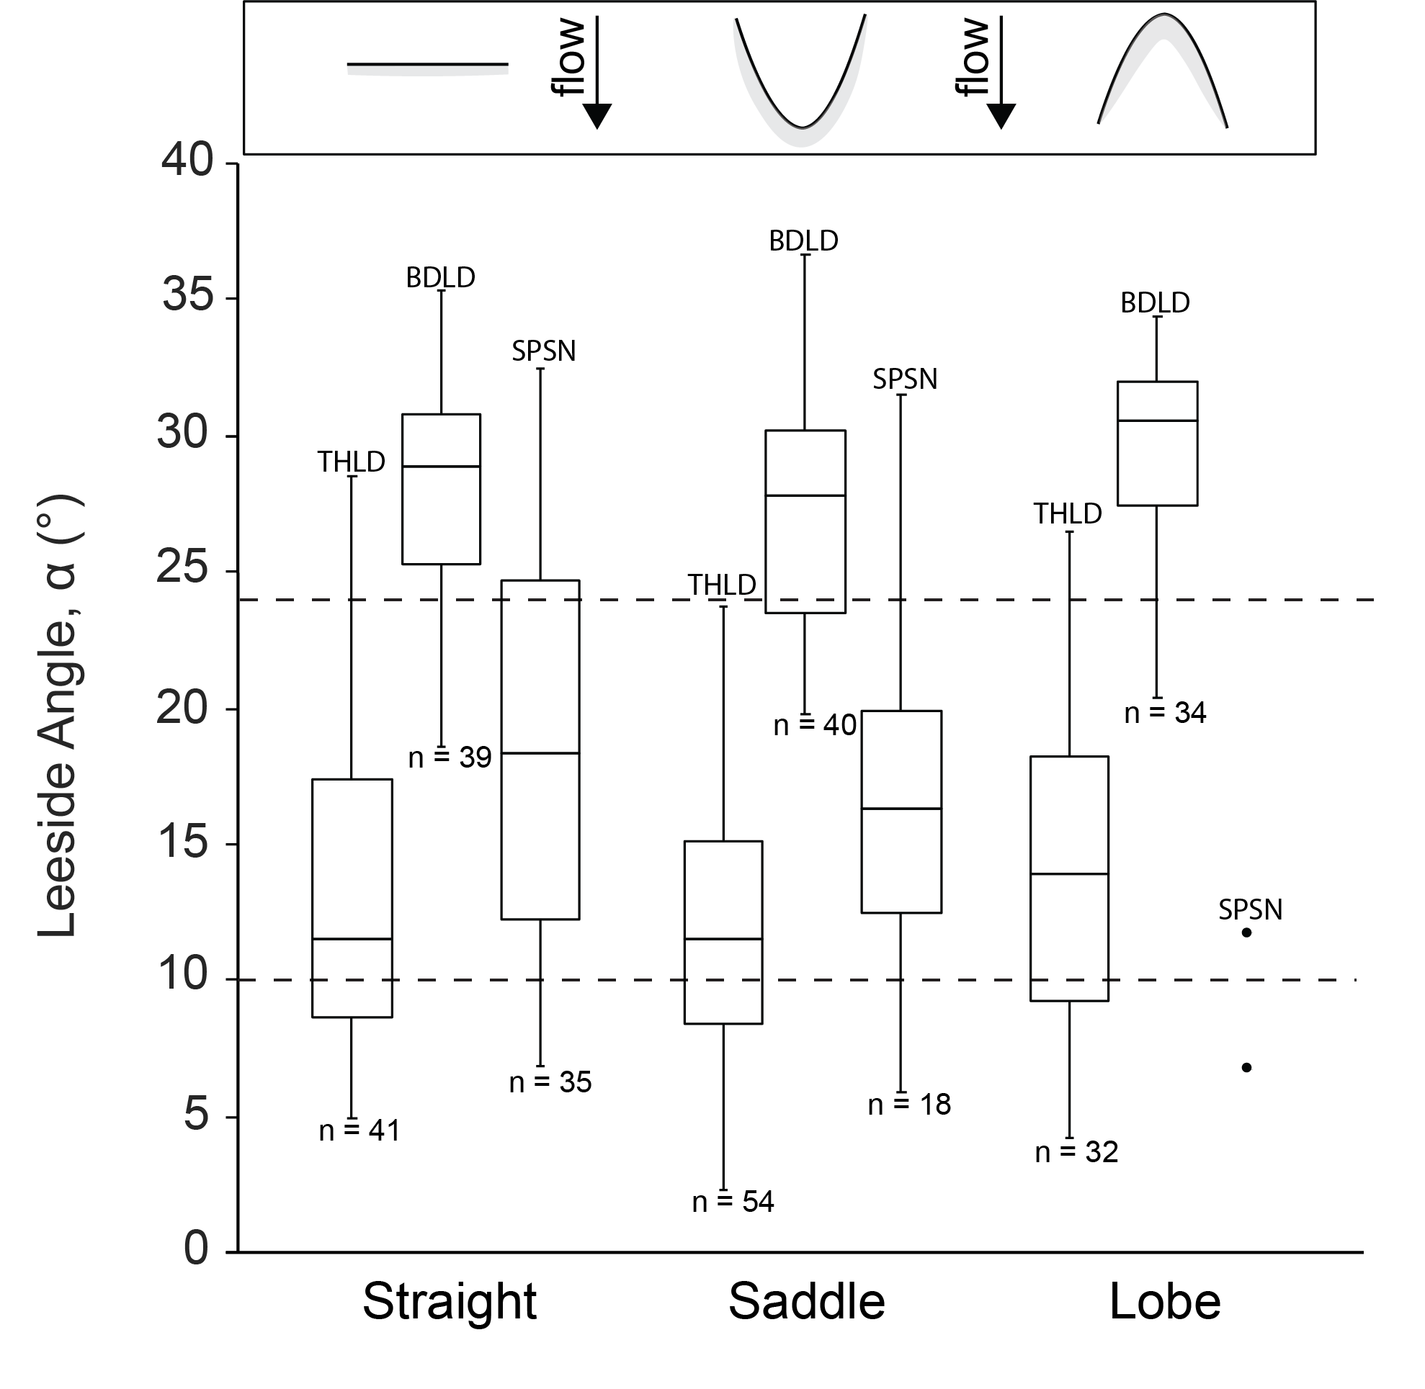

Figure 5. Box and whisker plot of leeside angle measured across lobes, straight crests, and saddles (see inset definition diagram) in the THLD 15, BDLD 15, and SPSN 15 cases. The first quartile, median, and third quartile are shown by the bottom, middle and top lines bounding each box, with the minimum and maximum values shown as the bottom and top whiskers, respectively. For the SPSN case, only two values were available. Dashed lines represent leeside angles of 10° and 24°.

5 Discussion: processes controlling the formation of low and intermediate dunes in shallow flows

The extensive laboratory dataset examined herein demonstrates unequivocally that low and intermediate dunes form in shallow flows (0.15 – 0.25 m flow depth) across a range of transport stages from the threshold of sediment transport through to suspended load dominated transport. The percentage of dunes that experience no flow separation, intermittent, permanent and developing, and fully developed permanent flow separation are presented in Table S3, as derived from finding the percentages of dunes in each category for each scan, and calculating the average value of each experimental condition using the scan averages. In shallow flows with low to high sediment transport rates, up to 4% and 7% of dunes respectively, on average, have leeside angles <10°. Intermediate dunes (10-17°) make up to 27% and 44%, respectively. High angle dunes (17-24°), reach up to 44% and 50%. Finally, angle-of-repose dunes represent up to 54% and 44% of dunes from low and high transport stages, respectively. These results demonstrate that low and intermediate angle dunes are present (from 4 - 44%) in shallow laboratory flows), and thus that the role of liquefied leeside avalanches as a major control in the formation of low-angle dunes, which has been proposed to be related to flow depth (Kostaschuk and Venditti, 2019), cannot be operative. In addition, limited analysis of bedform three-dimensionality reveals only a small influence on leeside angle. It is thus more likely that the causative mechanisms promoting the growth of lower-angle dune leesides (low and intermediate) relate to sediment transport stage and bedform morphodynamics and kinematics, and specifically the importance of sediment suspension and bedform superimposition (Figure 6).

5.1. The formative processes of low-angle and intermediate dunes

Suspension-dominated transport is likely to influence the formation of low and intermediate angle dunes in two ways. First, sediment suspension acts to modulate turbulence associated with the shear layer bounding the flow separation zone in the dune leeside (Bridge and Best, 1988; Kostaschuk and Villard, 1996, 1999; Baas and Best, 2008; Baas et al., 2009), with a dampening of turbulence leading to greater sedimentation on the leeface and decreased trough scour. High suspended load concentrations have also been hypothesized to lead to more sediment bypassing the dune crest than in bedload-dominated conditions, thereby promoting increased sediment deposition in the dune leeside (Kostaschuk and Villard, 1996, 1999). Recent work in the Huang He River, China (Ma et al., 2017) shows the overwhelming influence of suspension-dominated transport in very-fine sediments (130 – 190 $μ$m). Ma et al. (2017) suggest that reformulation of the Engelund-Hansen sediment transport prediction (Engelund and Hansen, 1967) is required to better predict total load (bedload and suspended load) transport in fine-grained rivers, and that transport in such channels has been underpredicted by an order of magnitude. Most salient to the present work is that a transition exists between sediment transport modes, from when suspension and bedload coexist to when suspension dominates. In the latter case, sediment flux is much greater than predicted for a range of fine sediment grain sizes, and this transition may be linked to differences in dune morphology, namely the ‘flatness’ of the dunes (Bridge and Best, 1988; Ma et al., 2017; Bradley and Venditti, 2019a; Naqshband and Hoitink, 2020) that are a result of the influence of conditions with large concentrations of suspended sediment (Figure 6, Ma et al., 2017). The present analysis illustrates how this transition may also reflect the influence of sediment suspension on dune leeside angle when transport stage increases (Figure 6).

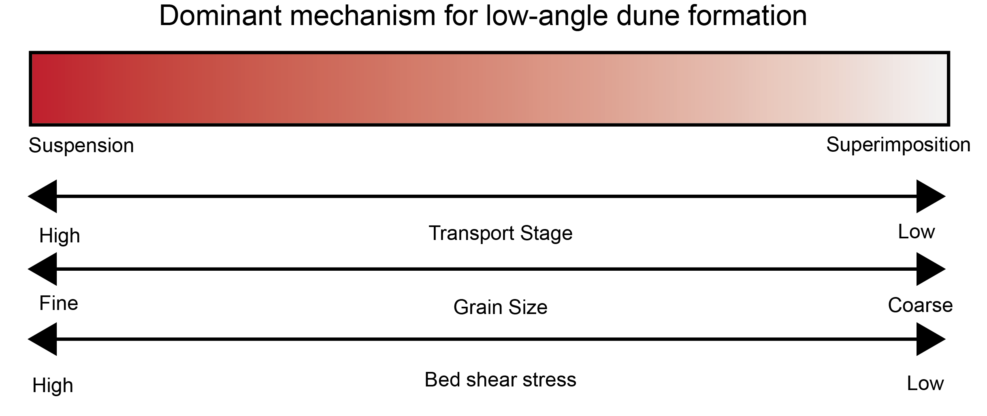

Figure 6. Schematic summary of the relative significance of transport stage, grain size and bed shear stress and their influence upon whether sediment suspension or bedform superimposition is the principal formative mechanism producing low and intermediate angle dunes.

Examination of the relationships between leeside angle, suspension number, transport stage, and Froude number under equilibrium flow conditions, reveals a range of leeside angles from 10° - 32° (Figure 2). From transport threshold through to suspension-dominated conditions, leeside angles increase and then decrease with increasing suspension number, transport stage and Froude number (Figure 2c-e). Specifically, a transition occurs near a suspension number (u*/w_{s}) of ∼0.75, transport stage ($\text{τ/}{\text{τ}}_{\text{*c}}$) ∼10 and Froude number (Fr) ∼0.4, where average leeside angle begins to decrease above these values. The transition from slightly increasing to decreasing leeside angle occurs consistently at the onset of suspended sediment transport. In these experiments, this onset occurs between the bedload (BDLD) and lower-mix (LMIX) conditions when suspended load flux increases from 0 g·s⁻¹·m⁻¹ to 70.8 g·s⁻¹·m⁻¹ but bedload flux only exhibits a slight increase from 14.8 g·s⁻¹·m⁻¹ to 21.3 g·s⁻¹·m⁻¹. This is similar to previous field and experimental observations that have documented a decrease in dune leeside angle and dune height at higher transport stages ( Ma et al., 2017; Bradley and Venditti, 2019a; Naqshband and Hoitink, 2020). Specifically, these data exhibit a similar behavior with increasing leeside angle at low suspension numbers until suspension transport increases, and then decreasing leeside angle thereafter. The trends revealed herein show that dune leeside angle is less under upper transport conditions than lower transport conditions, regardless of dune size. The relationship between leeside angle and suspension number revealed herein matches that reported by Naqshband and Hoitink (2020), who used low-density sediment in flows of lower Froude number. The present observations, specifically the decrease in leeside angle that occurs at the onset of suspended sediment flux, also support the contention of Naqshband and Hoitink (2020) that low-angle leesides may be related to sediment suspension, rather than transitional Froude numbers, as the onset of the lowering of leeside angle herein was at Fr ⁓ 0.4 (Figure 2e). In addition, the decrease in leeside angle occurs before the suspension number equals unity, and at the onset of suspended sediment flux between the bedload and lower-mix experimental conditions. This result suggests that the effects of sediment suspension on dampening leeside turbulence, or bypassing deposition in the crest and deposition of sediment on the dune leeside, may occur before suspended sediment transport is the dominant sediment transport flux. The present analysis thus confirms the likely importance of sediment suspension as a mechanism that contributes to the lowering of dune leeside angle, but has been previously difficult to measure in the field and model in the laboratory.

Although the discussion above illustrates the key role of sediment suspension in forming low and intermediate dunes at higher transport stages and suspension numbers, it is also evident that intermediate dunes exist (11-27%, Table S3) at lower transport conditions. In order to examine if the dunes documented herein are able to generate flow separation, the data for leeside angle and H/Y were plotted alongside previous indices for the onset of flow separation (Figure 7). These data demonstrate that the maximum percentage occurrence of dunes that do not reach the onset of permanent flow separation (leeside angle < 17°) is 29% at low transport stage (THLD 15 case), as compared to 51% at high transport cases (UMIX 15 case, Figure 7 and Table S3). Thus, although their abundance is slightly less at low transport stages, dunes that do not experience permanent flow separation do exist under these conditions and thus a mechanism for their formation is required that does not involve the transport of suspended sediment. Exploratory analysis (Figure 4) reveals how bedform superimposition causes lowering of dune leeside angle in the threshold experimental condition where the suspended load flux was zero. In these bedload dominated conditions, bedform superimposition may be the dominant process to lower dune leeside angles (Figure 6). When bedform superimposition occurs, smaller dunes migrate up and over the larger dune stoss side and crest and, as they do so, they lower the leeside angle of the large dune due to erosion in the reattachment region of the flow separation zone associated with the superimposed bedform. Reesink and Bridge (2009) found that when the superimposed bedform is greater than 25% of the large dune height, leeside slope reduction occurs as the smaller dune approaches the larger dune crest. Although detailed investigation of this mechanism requires higher temporal and spatial resolution data than available herein, the present exploratory analysis provides an example of how leeside angle may become lower due to bedform superimposition. In this case, when the leeside angle of the large dune begins to lower, the superimposed bedforms near the large dune crest possess H_{S}/H_{L} = 0.23 and leeside angle = 17$°$ (Figure 4). Since H_{S}/H_{L} is lower than 0.25 and the leeside is <24$°$, this suggests that the process of crestal erosion may occur at a lower H_{S}/H_{L} than proposed by Reesink and Bridge (2009), and also at leeside angles lower than those required for permanent flow separation. In this case, flow acceleration over the superimposed bedform, and intermittent or developing permanent flow separation, may generate increased bed shear stresses that lower the leeside angle of the larger dune through crestal erosion. The increased bed shear stresses associated with superimposed bedforms (Bennett and Best, 1996) have also been shown to increase suspended sediment flux by producing resuspension events (Frias and Abad, 2013). This increase in transport stage may also shift the dominant process from bedform superimposition to sediment suspension (Figure 6), providing a feedback to sediment suspension that is related to intermittent flow separation. It is also inevitable that this process is not constrained to a 2D profile but instead bedform superimposition occurs across the dune field at various times, producing a complex three-dimensional pattern of crestal erosion due to superimposition. The increase in turbulence associated with 3D dunes compared to 2D dunes also leads to complex erosional patterns and sediment pulses (Hardy et al., 2021), and future work would benefit from investigating the formation of superimposed bedforms and their influence on dune morphology and the three-dimensionality of dune crestlines. Additionally, it is difficult to investigate the mechanism of bedform superimposition at higher transport stages, where dune celerity may be greater than the sampling frequency and acoustic detection of the bed surface also becomes difficult. Thus, understanding the importance of superimposition at higher transport stages remains a subject worthy of future study, especially as suspension begins to dominate sediment transport and where the importance of superimposition remains unclear.

5.2. Implications

The present analyses illustrate the distinct differences in leeside angle between dunes formed in lower and upper transport stages, and provide key insights into the formation of low and intermediate angle dunes in shallow flows. First, these data show dunes that do not experience permanent flow separation can form in shallow flows, predominantly when suspended sediment is the major sediment transport flux, but also at lower sediment transport stages. Bradley and Venditti (2019a,b) noted that dunes in suspension-dominated flows are longer and flatter than in bedload-dominated flows, and the present analysis of these data show those relationships are related to lowering of the leesides. Past work (Kostaschuk and Venditti, 2019) has speculated low and intermediate angle dunes do not form in shallow flows, and that their formation is linked to the presence of liquefied leeside avalanches that require greater flow depths. However, the present analysis demonstrates that low and intermediate angle dunes can form in flows as shallow as 0.15 m, and thus the processes that result in their formation are not a phenomena solely confined to deep flows (Bradley and Venditti, 2017; Kostaschuk and Venditti, 2019; Best et al., 2020).

The dominance of lower angle dunes in suspension-dominated flows (lower-mix to suspension cases herein) is similar to that found in large rivers (Cisneros et al., 2020). However, the mean leeside angle and steepest slope of dunes in large rivers are lower than the experimental suspension cases, and distributions of leeside angle in these rivers are more widely spread than the experimental suspension cases (Figure 3 and Table1). The positive skewness of both the upper transport experiments and large rivers show that these distributions are shifted towards lower leeside angles with tails extending to higher angles. Leeside angles in large rivers are the most positively skewed distribution, with the lowest leeside angle values and steep slopes, compared to the experimental cases. These data illustrate how the characteristics of dune leesides revealed by the experimental data have clear parallels with large rivers, and provide clarification on some of the processes that dominate their formation.

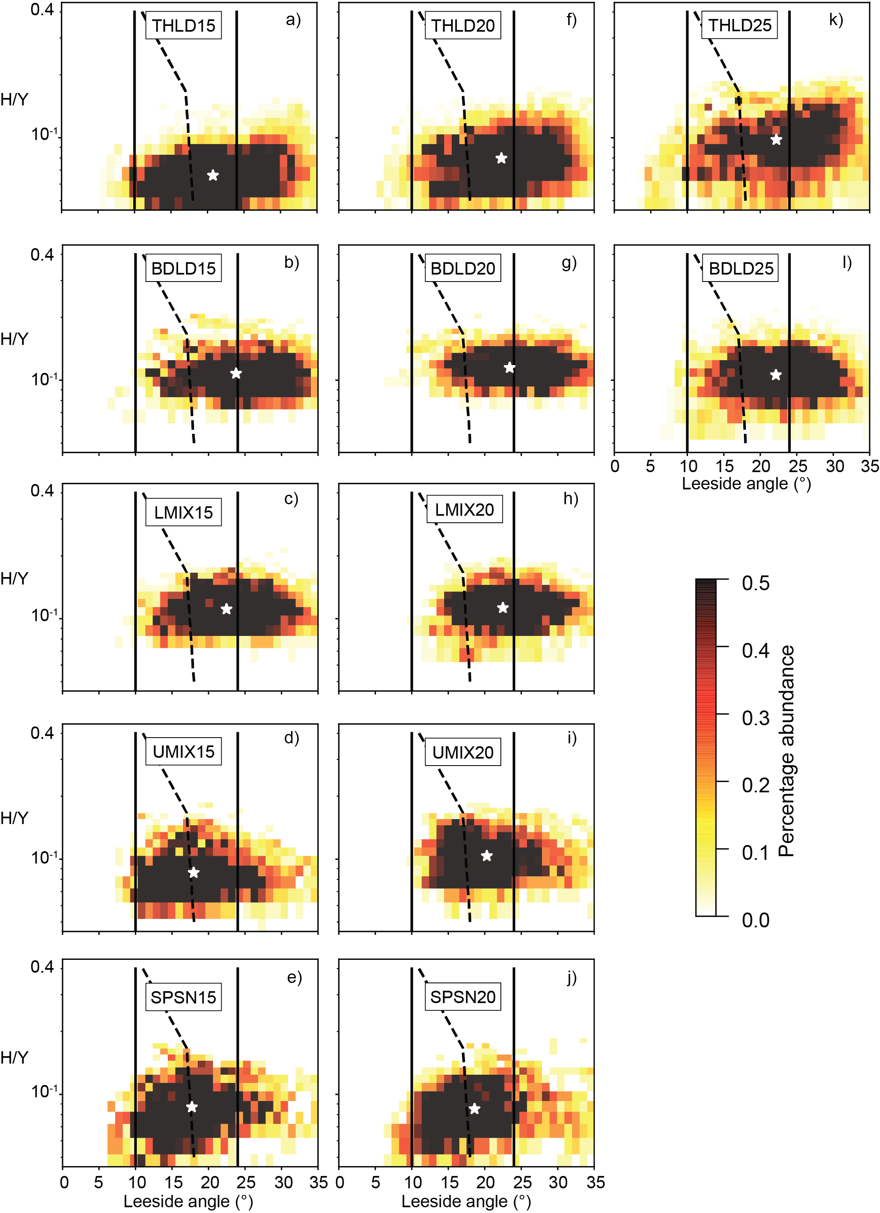

Figure 7. Hotspot graphs showing the potential for flow separation for all experiments. The relative dune height (H/Y) is plotted against lee-side angle for (a,f,k) THLD, (b,g,l) BDLD, (c,h) LMIX, (d,i) UMIX, and (e,j) SPSN dunes over (a-e) 15 cm, (f-j) 20 cm, and (k, l) 25 cm flow depth. The white star symbol represents the average value for leeside angle and H/Y for each case. Zones of no permanent flow separation (<10°), the onset of permanent flow separation (dashed line, Lefebvre and Winter, 2016) and fully developed, permanent flow separation (>24°) are indicated on each plot. Note how fewer dunes possess high leeside angles at greater transport stages.

In shallow flows under lower transport conditions, these data show 11-29% of dunes are low or intermediate angle and do not reach the onset of permanent flow separation (Figure 7; percentage abundance found between 0 under the dashed line), being similar to past work that suggests most dunes would not possess fully developed permanent flow separation (Kostaschuk and Villard, 1996; Best and Kostaschuk, 2002; Kwoll et al., 2016; Lefebvre and Winter, 2016). Under these lower transport conditions, bedform superimposition may provide a mechanism to generate lower angle leeside slopes. In addition, dunes formed under low and high transport conditions will influence flow differently due to their different leeside angles. Under lower transport conditions, flow resistance produced through form drag from flow recirculation associated with high-angle leesides (>24$°$) will be greater than that produced over low and intermediate angle dunes (Kwoll et al., 2016; Lefebvre and Winter, 2016; Ma et al., 2022). Under lower transport conditions, a greater percentage of angle-of-repose dunes exist (up to 54%), which past literature has used to predict flow resistance, suggesting flow roughness and resistance predictions in bedload-dominated rivers may not require substantial modification. However, most dunes reported herein have leesides < 24° (Figure 7) and therefore do not possess fully developed flow separation. Under the same flow depth in the present experiments at high transport conditions, a higher percentage of dunes likely either exhibit no permanent flow separation or no fully developed permanent flow separation (Figure 7). Under lower transport conditions, between 71% - 89% of dunes reach the onset of permanent flow separation, whereas this figure reduces to 56% - 88% in high transport conditions (Figure 7). Using results from recent modeling that predict bed shear stress associated with dunes with leesides ranging from 10, 20, and 30 degrees (Kwoll et al., 2016), it can be speculated that the bed shear stress over dunes of the same height and under the same flow depth will be at least 10% less under high rather than low transport conditions. Incorporating these flow resistance and bed shear stress reductions for low-and high- transport stages into morphodynamic and flood risk models, especially in cases where rivers are undergoing variable flow conditions and transitions in sediment transport capacity, holds important consequences for understanding and managing many of the world’s fine-grained rivers (Ma et al., 2022).

6 Conclusions

To aid understanding of the processes responsible for the formation of low-angle dunes, bedform maps were analyzed from shallow flow (0.15 to 0.25 m deep) laboratory experiments detailing dune morphology. The experimental cases ranged from the threshold of sediment transport through to bedload- and suspended- load dominated transport. This analysis reveals the presence of low and intermediate angle dunes in all shallow flows and that such dunes become more prevalent at higher transport stages. Past research has suggested several potential factors may lead to the formation of dunes that do not experience permanent flow separation, including the influence of sediment suspension, the occurrence of bedform superimposition, the presence of liquefied leeside avalanches, and the influence of bedform crestline three-dimensionality. The present analysis confirms that the percentage of low and intermediate dunes increases in suspension-dominated flows, suggesting sediment suspension is key, but the occurrence of intermediate angle dunes in bedload-dominated flows also indicates superimposition may play a role in the formation of low and intermediate dunes. The occurrence of low-angle and intermediate dunes that do not experience permanent flow separation in shallow (0.15 m) flows confirms that the role of liquefied avalanches, which has been speculated to be related to pore pressures generated under deep flows, cannot be a control. From limited data, the negligible difference between leeside angles across three-dimensional dune crestlines under different transport conditions suggests that three-dimensionality in dune crestline shape does not appear to be a key factor influencing leeside angle. Future research should investigate how dune leeside angle may change under unsteady flows, especially when transport stages are most likely to vary between bedload and suspended load dominated. Such considerations may be critical to better predicting flow resistance and flood stage in alluvial channels.

Acknowledgments
This material is based on the PhD research of JC at the University of Illinois and supported by the National Science Foundation Graduate Research Fellowship under grant no. DGE-1746047, as well as by the University of Illinois and Jack and Richard Threet chair in Sedimentary Geology to JB. We are indebted to Ryan Bradley and Jeremy Venditti for making their outstanding dataset publicly available. We are very grateful to Alice Lefebvre, two anonymous reviewers and editors Mikael Attal and Luca Solari who provided insightful comments that greatly aided completion of this paper. Any opinion, findings, and conclusions or recommendations expressed in this paper are those of the authors and do not necessarily reflect the views of the National Science Foundation.

Open Research
BAMBI is available at https://github.com/juliamorphology/bambi_0.1.0. The experimental maps analyzed in this study are available in the data location referenced (Bradley, 2018).

References
Allen, J.R.L., 1968. Current Ripples: Their relation to patterns of water and sediment motion. North-Holland Publishing Company, Amsterdam. 443 pp.
Allen, J.R.L., 1978. Polymodal dune assemblages: an interpretation in terms of dune creation—destruction in periodic flows. Sediment. Geol., 20, 17–28.
Allen, J.R.L., Collinson, J.D., 1974. The superimposition and classification of dunes formed by unidirectional aqueous flows. Sediment. Geol., 12, 169–178.
Almeida, R.P. de, Galeazzi, C.P., Freitas, B.T., Janikian, L., Ianniruberto, M., Marconato, A., 2016. Large barchanoid dunes in the Amazon River and the rock record: Implications for interpreting large river systems. Earth Planet. Sci. Lett., 454, 92–102.
Baas, J.H., Best, J.L., 2002. Turbulence modulation in clay-rich sediment-laden flows and some implications for sediment deposition. J. Sediment. Res., 72, 336–340.
Baas, J.H. and Best, J.L. 2008 The dynamics of turbulent, transitional and laminar clay-laden flow over a fixed current ripple, Sedimentology, 55 , 635–666 doi:10.1111/j.1365-3091.2007.00916.x.
Baas, J.H., Best, J.L., Peakall, J., 2016. Predicting bedforms and primary current stratification in cohesive mixtures of mud and sand. J. Geol. Soc., 173, 12–45.
Baas, J.H., Best, J.L., Peakall, J., Wang, M., 2009. A phase diagram for turbulent, transitional, and laminar clay suspension flows. J. Sediment. Res., 79, 162–183.
Bennett, S.J., Best, J.L., 1995. Mean flow and turbulence structure over fixed, two- dimensional dunes: Implications for sediment transport and bedform stability. Sedimentology, 42, 491–513.
Bennett, S.J., Best, J.L. 1996. Mean flow and turbulence structure over fixed ripples and the ripple-dune transition. In: Coherent flow structures in open channels, (Eds: Ashworth, P.J., Bennett, S.J., Best, J.L. and M^{c}Lelland, S.J.), Wiley and Sons, 281-304.
Best, J.L. 1993. On the interactions between turbulent flow structure, sediment transport and bedform development: some considerations from recent experimental research. In: Turbulence: perspectives on flow and sediment transport', (Eds: Clifford, N., French, J.R. and Hardisty, J), 61-92. Wiley and Sons.
Best, J.L., 2005a. The fluid dynamics of river dunes: A review and some future research directions. J. Geophys. Res. Earth Surf., 110, 1–21.
Best, J.L. 2005b The kinematics, topology and significance of dune-related macroturbulence: some observations from the laboratory and field. In: Fluvial Sedimentology VII (Eds. Blum, M.D., Marriott, S.B. and LeClair, S.), 41-60, International Association of Sedimentologists, Blackwell.
Best, J.L., Bridge, J.S., 1992. The morphology and dynamics of low amplitude bedwaves upon upper stage plane beds and the preservation of planar laminae. Sedimentology, 39, 737–752.
Best, J.L., Fielding, C.R., 2019. Describing fluvial systems: Linking processes to deposits and stratigraphy, in River and Reservoir: Geoscience to Engineering, edited by Corbett, P.W.M., Owen, A., Hartley, A.J., Pla-Pueyo, S., Barreto, D., Hackney, C. & Kape, S.J., Geol. Soc. Lond. Spec. Publ., 488, 152–166.
Best, J.L., Kostaschuk, R.A., 2002. An experimental study of turbulent flow over a low-angle dune. J. Geophys. Res., 107, 3135–3153.
Best, J.L., Cisneros, J., Almeida, R.P.D., Galeazzi, C., Ianniruberto, M., Ma, H., Unsworth, C., van Dijk, T.A.G.P., 2020. Comment: Why do large, deep rivers have low-angle dune beds? Geology, 47, 919–922.
Bradley, R.W., Venditti, J.G., 2017. Reevaluating dune scaling relations. Earth-Sci. Rev., 165, 356–376.
Bradley, R. (2018). Transport Scaling of Dunes in Shallow Flows [Data set]. SFU Research Data (FRDR). https://doi.org/10.25314/20c155da-4fcb-4a3f-9672-f02f8e2e33be
Bradley, R.W., Venditti, J.G., 2019a. Transport scaling of dune dimensions in shallow flows. J. Geophys. Res. Earth Surf., 124, 526–547.
Bradley, R.W., Venditti, J.G., 2019b. The growth of dunes in rivers. J. Geophys. Res. Earth Surf., 124, 548–566.
Bradley, R. W., Venditti, J. G., Kostaschuk, R. A., Church, M., Hendershot, M., & Allison, M. A. (2013). Flow and sediment suspension events over low-angle dunes: Fraser Estuary, Canada. Journal of Geophysical Research: Earth Surface, 118, 1693–1709
Bridge, J.S., Best, J.L., 1988. Flow, sediment transport and bedform dynamics over the transition from dunes to upper stage plane beds. Sedimentology, 35, 753–764.
Carling, P.A., 1996. Morphology, sedimentology and palaeohydraulic significance of large gravel dunes, Altai Mountains, Siberia. Sedimentology, 43, 647–664.
Cisneros, J., Best, J., van Dijk, T., Almeida, R.P.D., Amsler, M., Boldt, J., Freitas, B., Galeazzi, C., Huizinga, R., Ianniruberto, M., Ma, H., Nittrouer, J.A., Oberg, K., Orfeo, O., Parsons, D.R., Szupiany, R.N., Wang, P., Zhang, Y., 2020. Dunes in the world’s big rivers are characterized by low-angle lee-side slopes and a complex shape. Nat. Geosci., 13, 152–162.
de Lange, S. I., Naqshband, S., & Hoitink, A. J. F. (2021). Quantifying hydraulic roughness from field data: Can dune morphology tell the whole story? Water Resources Research, 57, e2021WR030329. https://doi.org/10.1029/2021WR030329
Dinehart, R.L., 1992. Evolution of coarse gravel bed forms: Field measurements at flood stage. Water Resour. Res., 28, 2667–2689.
Engelund, F., Fredsøe, J., 1976. A sediment transport model for straight alluvial channels. Nordic Hydrology, 7, 293–306.
Engelund, F., Hansen, E., 1967. A monograph on sediment transport in alluvial streams. Teknisk Vorlag., Technical University of Denmark, Copenhagen. 62 pp.
Frias, C. E., and Abad, J. D. (2013), Mean and turbulent flow structure during the amalgamation process in fluvial bed forms, Water Resour. Res., 49, 6548– 6560, https://doi.org/10.1002/wrcr.20456.
Galeazzi, C.P., Almeida, R.P. D., Mazoca, C.E.M., Best, J.L., Freitas, B.T., Ianniruberto, M., Cisneros, J., Tamura, L.N., 2018. The significance of superimposed dunes in the Amazon River: Implications for how large rivers are identified in the rock record. Sedimentology, 65, 2388–2403.
Guy, H.P., Simons, D.B., Richardson, E.V., 1966. Summary of alluvial channel data from flume experiments, 1956-61. Geol. Survey Prof. Paper 462-I, Washington. 104 pp.
Hardy, R. J., Best, J. L., Marjoribanks, T. I., Parsons, D. R., & Ashworth, P. J. (2021). The influence of three-dimensional topography on turbulent flow structures over dunes in unidirectional flows. Journal of Geophysical Research: Earth Surface, 126, e2021JF006121. https://doi.org/10.1029/2021JF006121
Hendershot, M.L., Venditti, J.G., Bradley, R.W., Kostaschuk, R.A., Church, M., Allison, M.A., 2016. Response of low-angle dunes to variable flow. Sedimentology, 63, 743–760.
Jackson, R., 1976. Sedimentological and fluid-dynamic implications of the turbulent bursting phenomenon in geophysical flows. J. Fluid Mech., 77, 531–560.
Jopling, A.V., Forbes, D.L., 1979. Flume study of silt transportation and deposition. Geogr. Ann., 65, 127–133.
Julien, P.Y., Klaassen, G.J., 1995. Sand-dune geometry of large rivers during floods. J. Hydraul. Eng., 121, 657–663.
Kostaschuk, R., Villard, P., 1996. Flow and sediment transport over large subaqueous dunes: Fraser River, Canada. Sedimentology, 45, 849–863.
Kostaschuk, R., Villard, P., 1999. Turbulent sand suspension over dunes, in: Fluvial Sedimentology VI, edited by N.D. Smith, and J. Rogers, Spec. Publ. Int. Assoc. Sedimentol. 28, 3–14.
Kostaschuk, R., 2000. A field study of turbulence and sediment dynamics over subaqueous dunes with flow separation, Sedimentology, 47, 519-531.
Kostaschuk, R.A., Venditti, J.G., 2019. Why do large, deep rivers have low-angle dune beds? Geology, 47, 919–922.
Kwoll, E., Venditti, J.G., Bradley, R.W., Winter, C., 2016. Flow structure and resistance over subaqueous high- and low-angle dunes. J. Geophys. Res. Earth Surf., 121, 545–564.
Lawless, M., Robert, A., 2001. Three dimensional flow structure around small-scale bedforms in a simulated gravel bed environment. Earth Surf. Process. Landf., 26, 507–522.
Leary, K. C. P., Ganti, V. (2020). Preserved fluvial cross strata record bedform disequilibrium dynamics. Geophysical Research Letters, 47, e2019GL085910. https://doi.org/ 10.1029/2019GL085910.
Lee, J., Singh, A., & Guala, M. (2022). Reconstructing sediment transport by migrating bedforms in the physical and spectral domains. Water Resources Research, 58, e2022WR031934. https://doi.org/10.1029/2022WR031934
Lefebvre, A., & Cisneros, J. (2023). The influence of dune lee side shape on time-averaged velocities and turbulence. Earth Surface Dynamics, 11(4), 575-591.
Lefebvre, A., Winter, C., 2016. Predicting bed form roughness: the influence of lee side angle. Geo-Mar. Lett., 36, 121–133.
Ma, H., Nittrouer, J.A., Naito, K., Fu, X., Zhang, Y., Moodie, A.J., Wang, Y., Wu, B., Parker, G., 2017. The exceptional sediment load of fine-grained dispersal systems: Example of the Yellow River, China. Sci. Adv., 3, 1–8.
Ma, H., Nittrouer, J.A., Fu, X., Parker, G., Zhang, Y., Wang, Y., Wang, Y., Lamb, M.P., Cisneros, J., Best, J.L., Parsons, D.R., Wu, B., 2022. Amplification of downstream flood stage due to damming of fine-grained rivers. Nat. Commun., 13, 3054. https://doi.org/10.1038/s41467-022-30730-9.
McLean, S.R., Nelson, J.M., Wolfe, S.R., 1994. Turbulence structure over two- dimensional bed forms: Implications for sediment transport. J. Geophys. Res., 99, 12729–12747.
Motamedi, A., Afzalimehr, H., Gallichand, J., Fazel Najaf Abadi, E., 2013. Lee angle effects in near bed turbulence: An experimental study on low and sharp angle dunes. Int. J. Hydraul. Eng., 1, 68–74.
Naqshband, S., Hoitink, A.J.F., 2020. Scale‐dependent evanescence of river dunes during discharge extremes. Geophys. Res. Lett., 47, e2019GL085902.
Naqshband, S., Ribberink, J.S., Hulscher, S.J.M.H., 2014. Using both free surface effect and sediment transport mode parameters in defining the morphology of river dunes and their evolution to upper stage plane beds. J. Hydraul. Eng., 140, 06014010.
Naqshband, S., Ribberink, J. S., Hurther, D., and Hulscher, S. J. M. H. (2014), Bed load and suspended load contributions to migrating sand dunes in equilibrium, J. Geophys. Res. Earth Surf., 119, 1043– 1063, doi:10.1002/2013JF003043.
Naqshband, S., van Duin, O., Ribberink, J., Hulscher, S., 2016. Modeling river dune development and dune transition to upper stage plane bed: Improving the simulation of dune transition to upper stage plane bed. Earth Surf. Process. Landf., 41, 323–335.
Naqshband, S., Hurther, D., Giri, S., Bradley, R. W., Kostaschuk, R. A., Venditti, J. G., & Hoitink, A. J. F. (2021). The influence of slipface angle on fluvial dune growth. Journal of Geophysical Research: Earth Surface, 126, e2020JF005959. https://doi.org/10.1029/2020JF005959
Nelson, J.M., McLean, S.R., Wolfe, S.R., 1993. Mean flow and turbulence fields over two-dimensional bed forms. Water Resour. Res., 29, 3935–3953.
Nino, Y., Lopez, F., & Garcia, M. (2003). Threshold for particle entrainment into suspension. Sedimentology, 50(2), 247–263. https://doi.org/10.1046/j.1365‐3091.2003.00551.x
Paola, C., Borgman, L., 1991. Reconstructing random topography from preserved stratification. Sedimentology, 38, 553–565.
Parsons, D.R., Best, J.L., Orfeo, O., Hardy, R.J., Kostaschuk, R., Lane, S.N., 2005. Morphology and flow fields of three-dimensional dunes, Rio Paraná, Argentina: Results from simultaneous multibeam echo sounding and acoustic Doppler current profiling. J. Geophys. Res. Earth Surf., 110, 1–9.
Reesink, A.J.H., Bridge, J.S., 2009. Influence of bedform superimposition and flow unsteadiness on the formation of cross strata in dunes and unit bars - Part 2, further experiments. Sediment. Geol., 222, 274–300.
Reesink, A.J.H., Parsons, D.R., Ashworth, P.J., Best, J.L., Hardy, R.J., Murphy, B.J., M^{c}Lelland, S.J., Unsworth, C., 2018. The adaptation of dunes to changes in river flow. Earth-Sci. Rev., 185, 1065-1087.
Roden, J.E., 1998. The sedimentology and dynamics of mega-dunes, Jamuna River, Bangladesh. PhD thesis, University of Leeds. 340 pp.
Shugar, D.H., Kostaschuk, R., Best, J.L., Parsons, D.R., Lane, S.N., Orfeo, O., Hardy, R.J., 2010. On the relationship between flow and suspended sediment transport over the crest of a sand dune, Río Paraná, Argentina. Sedimentology, 57, 252– 272.
Southard, J.B., Boguchwal, L.A., 1990. Bed configurations in steady unidirectional water flows. Part 2. Synthesis of flume data. J. Sediment. Petrol., 60, 658–679.
Ten Brinke, W.B.M., Wilbers, A.W.E. and Wesseling, C., 1999. Dune growth, decay and migration rates during a large-magnitude flood at a sand and mixed sand-gravel bed in the Dutch Rhine River System, in Fluvial Sedimentology VI, edited by N.D. Smith, and J. Rogers, Spec. Publ. Int. Assoc. Sedimentol., 28, pp.15-32.
van den Berg, J.H., Van Gelder, A., 1993. A new bedform stability diagram, with emphasis on the transition of ripples to plane bed in flows over fine sand and silt, in Alluvial Sedimentation, edited by M. Marzo and C. Puigdefabregas, Spec. Publ. Int. Assoc. Sedimentol., 17, 11–21.
Venditti, J. G., Church, M., & Bennett, S. J. (2005). Morphodynamics of small‐scale superimposed sand waves over migrating dune bed forms. Water resources research, 41(10).
Venditti, J.G., 2007. Turbulent flow and drag over fixed two- and three-dimensional dunes. J. Geophys. Res., 112, F04008, doi:10.1029/2006JF000650.
Venditti, J. G., Lin, C. Y. M., & Kazemi, M. (2016). Variability in bedform morphology and kinematics with transport stage. Sedimentology, 63(4), 1017-1040.
Yalin, M.S., 1964. Geometrical properties of sand wave. J. Hydraul. Div., 90, 105–119.
Zomer, J. Y., Naqshband, S., Vermeulen, B., & Hoitink, A. J. F. (2021). Rapidly migrating secondary bedforms can persist on the lee of slowly migrating primary river dunes. Journal of Geophysical Research: Earth Surface, 126, e2020JF005918. https://doi.org/10.1029/2020JF005918

