Short title: Irrigation and herbicide use

Impact of irrigation levels on herbicide activity in the cotton production system
Jasleen Singh Makkar^{1,2}, Rupinder Saini³, Preetaman Bajwa^{1,4}, Sukhbir Singh⁵, Lindsey Slaughter⁵ and Glen Ritchie⁶

¹Former Graduate Research Assistant, Department of Plant and Soil Science, Texas Tech University, Lubbock, TX, USA; ²Research Associate, Eastern Virginia Agricultural Research and Extension Center, Virginia Tech, Warsaw, VA, USA; ³Research Assistant Professor (ORCID 0000-0002-8033-6940), Department of Plant and Soil Science, Texas Tech University, Lubbock, TX, USA; ⁴Graduate Research Assistant, Cornell University, Ithaca, NY. ⁵Associate Professor, Department of Plant and Soil Science, Texas Tech University, Lubbock, TX, USA; ⁶Professor, J. A. Love Chair, and Department Chair, Department of Plant and Soil Science, Texas Tech University, Lubbock, TX, USA.
Author for correspondence: Rupinder Saini, Research Assistant Professor, Department of Plant and Soil Science, Texas Tech University, Bayer Plant Science Building, 2911 15th Street, Mail Stop 42122, Lubbock, TX 79415, USA.
(Email: r.saini@ttu.edu)

Abstract
Cotton production in the Texas High Plains faces significant challenges due to water scarcity resulting from uneven rainfall patterns and declining levels of the Ogallala aquifer. Deficit or reduced irrigation is one of the most common water management strategies to increase water use efficiency and cotton productivity in the region. However, deficit irrigation can affect the efficacy of herbicides on weeds. This study investigates how varying irrigation levels affect herbicide efficacy on weeds in cotton production systems. A two-year field study was conducted at Texas Tech University Quaker Research Farm in 2023 and 2024. The experiment was randomized three times in a split-plot design with two irrigation levels: I1 [100% crop evapotranspiration (ET_{c}) replacement] and I2 [50% ET_{c} replacement] as the main plot factor and different pre-emergent (PRE) and post-emergent (POST) herbicide combinations as the subplot factor. Results indicated that reducing the irrigation level to I2 did not affect the total weed density or biomass production but resulted in decreased Palmer amaranth height and biomass production compared to I1. Among herbicide treatments, acetochlor, prometryn, or S-metolachlor PRE fb glyphosate + acetochlor, prometryn, or S-metolachlor POST provided the most effective weed control, reducing total weed density, Palmer amaranth weed density and biomass compared to the untreated control and to PRE alone. Although I2 resulted in lower plant height in both years than I1, it produced comparable cotton biomass and lint yield. Among the herbicide treatments, PRE fb glyphosate + residual herbicide POST yielded significantly higher lint yield than the untreated control in both years. In conclusion, the study demonstrates that deficit irrigation is an effective water conservation technique that maintains cotton yield and herbicide efficacy. Additionally, using PRE fb POST herbicide combinations, farmers can achieve effective weed control and sustain cotton productivity in semi-arid regions.

Nomenclature: Acetochlor; glyphosate; prometryn; S-metolachlor; alkali sacaton, Sporobolus airoides Torr; mat sandbur, Cenchrus longispinus (Hack.) Fernald; Palmer amaranth, Amaranthus palmeri S. Watson; red-stem stork's bill, Erodium cicutarium L.; silverleaf nightshade, Solanum elaeagnifolium Cav.; Texas blueweed, Helianthus ciliaris DC.; cotton, Gossypium hirsutum L.

Keywords: Herbicide efficacy; deficit irrigation; Palmer amaranth.

Introduction
Cotton is the leading cash crop in Texas. Since 1965, Texas has led the United States in both planted acreage and upland cotton production (ERS-USDA 2023). Within Texas, the Texas High Plains (THP) contributes 61% of planted acres and 49% of the total production (NASS-USDA 2022). Despite most cotton production occurring in the THP, the region's semi-arid climate poses unique challenges to cotton productivity. Cotton requires 700 to 1300 mm of water to fulfill its water needs, depending on climate and the length of its growing period (Hussain et al. 2020). Meanwhile, the THP receives annual precipitation of 350-550 mm, which is insufficient to meet the cotton crop water requirement. As a result, farmers in the THP rely heavily on supplemental irrigation from the Ogallala Aquifer, one of the largest freshwater aquifers in the world. However, groundwater extraction for irrigation in the THP region creates a significant gap between withdrawal and recharge (Butler Jr et al. 2013; Scanlon et al. 2012) of the Ogallala aquifer. The depth of water is a crucial factor influencing the price of irrigated cropland (Torell et al. 1990) in the THP region, while the decrease in saturated thickness significantly affects pumping rates (Hendricks and Peterson 2012). Declines in the water table have prompted a transition from irrigated to dryland farming, as the saturated thickness of the aquifer is not enough to sustain pumping in certain regions (Terrell et al. 2002). This depletion emphasizes the critical need for effective irrigation water management techniques, such as deficit irrigation, to optimize crop yields and water use efficiency (WUE) (Maupin et al. 2014).
Deficit irrigation is one of the efficient water-conservation techniques, an irrigation management strategy that applies less water than the crop requires to increase WUE (Azad and Ancev 2016; Capra et al. 2008). Cotton exhibits moderate drought tolerance (2004); however, a significant reduction in water availability can lead to decreased yields due to reduced boll retention and growth (Chai et al. 2016; Grimes and Yamada 1982). Therefore, balancing water conservation with maintaining crop yields is essential in deficit irrigation practices. In addition to its impact on cotton productivity, deficit irrigation or dryland cropping systems pose significant challenges for weed management, particularly regarding herbicide efficacy and weed growth and development.
Despite the shift toward integrated weed management strategies to reduce reliance on herbicides and the development of herbicide-resistant weed species, herbicides remain the primary tool for weed control. The ease of herbicide application and cost-effectiveness make them essential for maintaining high yields in competitive cropping systems (Green 2014). However, the efficacy of herbicides, especially soil-applied preemergence (PRE) herbicides, is highly dependent on soil moisture content, which is influenced by both irrigation scheduling and rainfall (Johnson and Zimmer 2022; Walker 1971). Optimal soil moisture content is required to facilitate the movement of herbicides into the weed seed germination zone and ensure effective weed control (Bell et al. 2015). Most soil-applied herbicides require 12 – 25 mm of precipitation or irrigation within 5 to 7 d of application for their activation (Smith et al. 2016). Reduced irrigation or dryland systems may reduce herbicide performance by limiting soil moisture, thereby increasing herbicide adsorption to soil particles (Adamson et al. 2024; Miller and Norsworthy 2018). Furthermore, prolonged exposure of herbicides on dry soil increases the risk of photodegradation of the active ingredients (Katagi 2004), which can further reduce the efficacy of the soil-applied herbicides. Reduced irrigation or drought conditions also impact hydrolytic degradation by slowing both hydrolysis (Chow et al. 2023) and microbial degradation (Flint and Witt 1997; Stickler et al. 1969), which could contribute to carryover effects and potential damage to succeeding crops. Therefore, optimum soil moisture is crucial for the performance and dissipation of soil-applied herbicides. Also, foliar-applied herbicides, such as glyphosate, are affected by soil moisture levels (Elmore 1982). Water stress in weeds can alter herbicide absorption, translocation, and metabolism, thereby reducing the effectiveness of postemergence (POST) herbicides and contributing to greater crop-weed competition (Mendes et al. 2022; Waldecker and Wyse 1983). Therefore, knowledge of the effects of deficit irrigation on weed control and herbicide performance is necessary to optimize herbicide applications and achieve profitable cotton production in the future.
Although several research works have investigated the effects of water stress and deficit irrigation on cotton yields, less attention has been given to the influence of limited irrigation on herbicide effectiveness. Lower irrigation levels could negatively affect herbicide efficacy, making it difficult to assess how variations in water management can impact weed control outcomes. Considering the essential role of herbicides in modern cotton cultivation, especially in controlling noxious weeds such as Palmer amaranth, it is essential to understand the interactions between water availability, herbicide efficacy, and weed competition in cotton production systems in the THP. Therefore, this study was initiated to (1) evaluate the effect of different irrigation rates on herbicide efficacy and cotton productivity and (2) assess the effectiveness of various herbicide combinations in controlling Palmer amaranth and other weed species under limited water conditions.

Materials and Methods

Study Site
A two-year field experiment was conducted during the growing seasons of 2023 and 2024 at the Quaker Research Farm, Texas Tech University, Lubbock, Texas (33.6014 N, 101.908 S, 992 m asl). The study site is located in a semi-arid zone with an average annual precipitation of 350-550 mm and an average annual evapotranspiration of 1500-1750 mm (Singh et al. 2022). The average annual maximum and minimum temperatures are 23.3 C and 7.8 C, respectively. The experimental site soil is Amarillo sandy clay loam (fine-loamy, mixed, superactive, thermic Aridic Paleustoll) with a pH of 7.9 and 0.6% organic content at a depth of 0-10 cm (Bajwa et al. 2025).

Land Preparation and Planting
A tractor-mounted disk plow was used to prepare the seedbeds. Cotton cultivar DP2020B3XF was planted on June 7 in 2023 and May 14 in 2024, using a four-row planter with 100 cm spacing between the rows to achieve a target density of 98,800 plants ha⁻¹. The field was irrigated using a subsurface irrigation system with drip tapes installed at a depth of 30 cm and spaced 100 cm apart. The field was divided into four irrigation zones, each measuring 55 m in length and 8 m in width. Twelve plots, 6 m long and 4 m wide, were established within each irrigation zone. The field was fertigated with pre-plant fertilizer URAN 32 (NPK 32-0-0, Nutrient Ag Solution, Loveland, CO) at 80 kg N ha⁻¹, according to soil test recommendations. Also in 2024, the trial was conducted in a different field within the Quaker Research Farm to avoid increasing the weed seed bank in the same field.

Experimental Design and Treatments
The irrigation treatments and herbicide combinations were randomized and replicated three times in a split-plot design. Two irrigation treatments, I1: 100% crop evapotranspiration (ET_{c}) replacement and I2: 50% ET_{c} replacement, were in the main plot, and herbicide treatments were in sub-plots (Table 1). Irrigation stress was maintained from the day of planting in both years. The irrigation application was determined based on the ET_{c} requirement, calculated as a product of reference evapotranspiration (ET_{o}) and stage-specific crop coefficients (K_{c}) (Allen et al. 1998). The ET_{o} was calculated from the weather data using the Penman-Monteith method (Zotarelli et al. 2010). A weather station (Davis Instruments 6152, Wireless Vantage Pro2, Davis Instruments Corporation, Hayward, California) was installed near the experimental site to record weather data. The K_{c} values used for cotton were K_{c} Seeding = 0.40 [7 DAP (days after planting)], K_{c} 1st square = 0.45 (8 - 45DAP), K_{c} 1st bloom = 0.80 (46-65 DAP), K_{c} Max bloom = 1.08 (66-86), K_{c} 1st open = 1.23 (87-110), K_{c} 25% open =1.25 (111-125), K_{c} 50% open = 1.05 (126-133), K_{c} 95% open = 0.60 (134-151) and K_{c} Picking = 0.10 (152-162) (Ko et al. 2009). The difference between ET_{c} and precipitation was used to compute the irrigation water requirement. The field was irrigated once a week to replenish the ET_{c} from the last week. Each zone had a water meter installed to record the amount of water applied. The I1irrigation treatment received 487 mm of supplemental irrigation in 2023 and 521 mm in 2024, while the I2 treatment received 166 mm in 2023 and 264 mm in 2024.
Herbicides were sprayed using a CO₂-pressurized backpack sprayer with four nozzles (TeeJet XR8002-VS) on 46-cm spacing, delivering 140 L ha⁻¹ at 207 kPa. In both years, PRE herbicides were applied one day after planting, followed by (fb) POST herbicides on July 13 (35 DAP) in 2023 and June 15 (30 DAP) in 2024.

Data Collection
Palmer amaranth and total weed density were recorded at 6 and 9 weeks after planting (WAP) by counting the number of weeds in a 0.25 m² quadrat randomly placed in three different spots within each plot. The height of Palmer amaranth in the same quadrat was also measured. The total weed biomass and Palmer amaranth biomass were obtained by cutting the aboveground weed biomass from the same quadrats at 6 and 9 WAP, drying the samples in an oven at 70 C for 48 hr, and weighing.
The height of the cotton plants was measured on five plants per plot at 30, 55 DAP, and harvest. For plant biomass at harvest, cotton plants 1 m in length were harvested, oven-dried at 70 C for 48 hr, and weighed on a calibrated scale. Harvest timing was determined by visible physiological maturity and roughly 75% boll opening across the plot (Gwathmey et al. 2001). The harvested cotton was ginned to determine lint yield. It should be noted that yield measurements were taken from a small sample of plants per plot, which may limit precision and the extrapolation of results to the entire plot.

Statistical analysis
The field experiment data were analyzed using an analysis of variance split-plot design in R version 3.5.2, with the Agricolae package version 1.2-8. Irrigation and herbicide treatments, and a combination of irrigation and herbicide treatments, were treated as fixed effects. Replications, a combination of replications with irrigation and a combination of replications with herbicide treatments, were treated as random effects. Data for 2023 and 2024 were analyzed separately because the two years differed in environmental conditions and management factors. Treatment means were compared using the LSD test with a significance level of 5%. SigmaPlot software version 14 (Systat Software, San Jose, CA) was used to create the figures.

Results and discussions

Irrigation and weather conditions
The average maximum and minimum temperatures were 32.3 C and 17.5 C in 2023, and 32.9 °C and 18.9 °C in 2024, respectively (Figure 1). The daily average relative humidity in 2023 and 2024 was 47.7% and 46.5%, respectively. The daily average solar radiation recorded was 21.1 and 22.4 MJ m⁻² in 2023 and 2024, respectively. The total rainfall during the growing season was 249 mm in 2023 and 238 mm in 2024.

Total weed density and biomass production
In both years, total weed density was unaffected by irrigation levels (Figures 2A and 2C). However, herbicide treatments significantly affected weed density (Figures 2B and 2D). The interaction between irrigation levels and herbicide treatments was non-significant for total weed density due to precipitation events of 10.9 mm in 2023 and 29.6 mm in 2024, which occurred within 24–48 hours of herbicide application. The rainfall provided optimal moisture conditions for the activation of all the PRE.
In 2023, at 6 WAP, treatments PRE fb glyphosate POST application of prometryn, S-metolachlor, and acetochlor provided significantly better weed control than PRE S-metolachlor and the untreated control (Figure 2B). In 2024, all the herbicide treatments significantly reduced the weed density compared to the untreated control at 6 WAP (Figure 2D). However, acetochlor, prometryn, or S-metolachlor PRE, fb glyphosate + acetochlor, prometryn, or S-metolachlor POST, resulted in significantly lower weed density than the prometryn, S-metolachlor, and acetochlor PRE treatments and the untreated control. Similar results were observed at 9 WAP in both 2023 and 2024; all the PRE fb glyphosate + residual POST herbicide treatments significantly reduced weed numbers compared to untreated control and sole PRE herbicide treatments (Figures 2B and 2D).
In terms of weed biomass production, irrigation levels had no significant effect in either year (Figures 3A and 3C). Plots irrigated at I1 and I2 produced 880 g m⁻² and 564 g m⁻² in 2023 and 1140 g m⁻² and 872 g m⁻² in 2024, respectively; however, the differences were not significant. This lack of significance may be partially explained by the high Palmer amaranth population at the site, which is well documented to have drought tolerance (Matzrafi et al. 2021), allowing it to maintain growth even under reduced soil moisture. Additionally, both irrigation treatments received sufficient in-season rainfall events, likely minimizing soil moisture differences between I1 and I2 and reducing the ability to detect treatment effects. However, contrary results were observed by Abdulkareem et al. (2024), lowering the irrigation volume resulted in a 2.3-fold decrease in weed biomass production under field conditions. El-Metwally et al. (2020) also reported a 25.7% reduction in total weed biomass production at 40% ETc compared to 100% ETc in peanuts under field conditions.
All herbicide treatments reduced total weed biomass compared to the untreated control (Figures 3B and 3D). In 2023, weed biomass at 6 WAP showed results similar to those for total weed density. The plots treated with acetochlor, prometryn, or S-metolachlor PRE, and with glyphosate + acetochlor, prometryn, or S-metolachlor POST, showed reductions of 41%, 40%, and 34% in weed biomass production compared to the untreated control (Figure 3B). Additionally, PRE prometryn treatment resulted in a 24% reduction in weed biomass compared with the untreated control. In 2024, again, acetochlor, prometryn, or S-metolachlor PRE, fb glyphosate + acetochlor, prometryn, or S-metolachlor POST, resulted in a reduction in weed biomass compared to the S-metolachlor or prometryn PRE and the untreated control (Figure 3D).
However, in both 2023 and 2024, weed biomass increased between 6 and 9 WAP due to a new flush of weeds. The increase in weed biomass was due to a rise of 4.2 C in average air temperature (Travlos et al. 2020) and several precipitation events (Kathiresan and Gualbert 2016) totaling 20 mm in 2023 and 44 mm in 2024 between 6 and 9 WAP. However, acetochlor, prometryn, or S-metolachlor PRE fb glyphosate + acetochlor, prometryn, or S-metolachlor POST provided effective weed control. In 2023, at 9 WAP, the S-metolachlor, prometryn, or acetochlor PRE fb glyphosate + S-metolachlor, prometryn, or acetochlor POST resulted in 42%, 38%, and 26% lower weed biomass, respectively, compared to the untreated control (Figure 3B). Similar reductions in total weed biomass were observed in 2024 (Figure 3D). The acetochlor, prometryn, or S-metolachlor PRE fb glyphosate + acetochlor, prometryn, or S-metolachlor POST consistently led to less weed biomass production than the untreated control. Glyphosate is a slow-acting, non-selective contact herbicide that effectively controls established weeds up to 10-15 cm tall (Armstrong and Lancaster 2011; Soltani et al. 2016). Therefore, the POST application of a tank mix of glyphosate with residual herbicides controlled established weeds and restricted the flush of new weeds. According to Price et al. (2008), combining glyphosate with a residual herbicide improved weed control by 53 percentage points compared with glyphosate alone in POST cotton applications. Koger et al. (2007) also reported a 70–80% reduction in weed biomass with a mixture of glyphosate and residual herbicide compared to the sole application of glyphosate in cotton.

Palmer amaranth height
Palmer amaranth height was significantly affected by both irrigation levels and herbicide treatments (Figure 4). Specifically, at 9 WAP, the I2 irrigation level resulted in a 30% and 27% reduction in Palmer amaranth height compared to plots irrigated at I1 in 2023 and 2024, respectively (Figures 4A and 4C). Water stress can limit photosynthetic activity and plant growth (Aranjuelo et al. 2011). Similarly, Chahal et al. (2018) reported a 50% reduction in Palmer amaranth height at 50% field capacity (FC) compared to 100% FC in greenhouse conditions.
Among the herbicide treatments, in 2023 at 6 WAP, prometryn PRE fb glyphosate + prometryn POST resulted in significantly lower Palmer amaranth height than the untreated control. In contrast, in 2024, all the herbicide treatments resulted in significantly lower Palmer amaranth plant height than the untreated control (Figures 4B and 4D). More pronounced results in 2024 than 2023 can be linked to the trial being conducted in a different field to avoid increasing the seedbank, which may have altered initial weed pressure and seedbank composition. At 9 WAP, the prometryn, S-metolachlor, or acetochlor PRE fb glyphosate + prometryn, S-metolachlor, or acetochlor POST treatments significantly reduced Palmer amaranth height in both 2023 and 2024 compared to the untreated control.

Palmer amaranth density and biomass production
Irrigation levels resulted in comparable Palmer amaranth density in 2023; however, reducing the irrigation level from I1 to I2 in 2024 resulted in a 25% decrease in Palmer amaranth density at 9 WAP (Figures 5A and 5C). In 2024, I1 plots received a total of 104 mm precipitation plus supplemental irrigation between 6 WAP and 9 WAP, whereas plots under I2 received 48 mm in the same period. This difference in moisture reduced Palmer amaranth germination in I2 plots compared to I1 plots, resulting in a difference in Palmer amaranth density between the irrigation levels (Han et al. 2022).
In 2023, herbicide treatments had no impact on Palmer amaranth density compared to the untreated control until 6 WAP (Figure 5B). However, by 9 WAP, prometryn, acetochlor, or S-metolachlor PRE fb glyphosate + prometryn, acetochlor, or S-metolachlor POST reduced Palmer amaranth density by 63, 52, and 41% compared to the untreated control, respectively. During the 2024 growing season, all herbicide treatments had lower Palmer amaranth density than the untreated control (Figure 5D). By 9 WAP, similar to 2023, the S-metolachlor, acetochlor, or prometryn PRE fb glyphosate + S-metolachlor, acetochlor, or prometryn POST resulted in 74, 70, and 66% lower Palmer amaranth density, respectively, compared to the untreated control. More significant results at 9 WAP in both 2023 and 2024 can be attributed to the effective control of a new flush of weeds by the sequential application of residual herbicides in a tank mix with glyphosate as POST. With lower weed densities of up to 6 WAP, glyphosate effectively controlled the existing 10-15 cm tall Palmer amaranth (Kouame et al. 2024; Norsworthy et al. 2012), while the sequential application of residual herbicides reduced the emergence of new Palmer amaranth plants (Chahal et al. 2015). Similarly, Price et al. (2008) reported effective Palmer amaranth control in cotton production with POST application of glyphosate in a tank-mix with soil residual herbicide compared to glyphosate alone. Also, Travlos et al. (2020) observed 96% control of Palmer amaranth with a POST glyphosate application tank-mixed with S-metolachlor in cotton production. Similarly, Scott et al. (2001) and Dotray et al. (1996) reported effective control of Palmer amaranth with tank mixing a residual herbicide in POST systems.
Palmer amaranth biomass was impacted by irrigation levels (Figure 6). Reducing irrigation from I1 to I2 reduced Palmer amaranth biomass by 35% and 50% at 9 WAP in 2023 and 2024, respectively (Figures 6A and 6C). Due to reduced CO₂ intake and photosynthetic activity, less biomass was accumulated under water stress conditions (Tran 2014). Similarly, Chahal et al. (2018) reported a 40% reduction in Palmer amaranth biomass accumulation with 50% field capacity (FC) compared to 100% FC.
In 2023, at 6 WAP, S-metolachlor, prometryn, or acetochlor PRE fb glyphosate + S-metolachlor, prometryn, or acetochlor POST, and prometryn PRE resulted in lower Palmer amaranth biomass compared to the untreated control, but this reduction was not statistically significant (Figure 6B). In contrast, in 2024, most herbicide treatments significantly reduced Palmer biomass production compared to the untreated control (Figure 6D). As observed at 6 WAP, S-metolachlor, prometryn, or acetochlor PRE fb glyphosate + S-metolachlor, prometryn, or acetochlor POST, and prometryn PRE resulted in lower weed biomass than the untreated control at 9 WAP in 2023 (Figure 6B). However, in 2024, all the herbicide treatments resulted in lower Palmer amaranth biomass production than the untreated control (Figure 6D). Similarly, Hay et al. (2019) reported a 66 % increase in Palmer amaranth control with PRE fb POST herbicide combination than PRE application in soybean. Aulakh et al. (2012) found similar results, with a 24% increase in Palmer amaranth control with PRE + POST herbicide treatment compared to PRE herbicide alone.

Cotton height and yield
In both 2023 and 2024, cotton plant height was reduced in I2 irrigation at harvest compared to I1 (Table 2). Deficit irrigation-induced water stress results in physiological responses in plants, which change growth patterns and resource utilization (Jiao et al. 2024). Water stress results in earlier transitions from vegetative growth to the reproductive stage and the allocation of resources to reproductive organs (Chai et al. 2016; Du et al. 2008). This early switch restricted vertical growth and shorter plant height. In previous studies, Liu et al. (2017) also reported lower cotton plant height under deficit irrigation than under full irrigation. However, the reduction in plant height did not affect total plant biomass or lint yield in either year (Table 2). The lack of effect of irrigation level on lint yield can be attributed to the heavy precipitation events totaling 106 mm in 2023 and 79 mm in 2024 during the boll-setting stage, resulting in similar lint yields across irrigation treatments. Similarly, Fazel et al. (2022) and Liu et al. (2017) observed comparable biomass and lint yield from cotton under deficit irrigation compared to fully irrigated cotton.
In 2023, S-metolachlor, prometryn, or acetochlor PRE fb glyphosate + S-metolachlor, prometryn, or acetochlor POST produced 81, 67, and 61% greater plant biomass than the untreated control (Table 2). Similarly, in 2024, all herbicide treatments, except for prometryn PRE prometryn, produced higher plant biomass than the untreated control. The acetochlor, S-metolachlor, or prometryn PRE fb glyphosate + acetochlor, S-metolachlor, or prometryn POST produced 80, 70, and 65% higher biomass than the untreated control, respectively. The greater biomass produced in the herbicide-treated plots compared to the untreated control can be attributed to effective weed control in the treated plots. Similar results were observed for lint yield among herbicide treatments (Table 2). In 2023, S-metolachlor, prometryn, or acetochlor PRE fb glyphosate + S-metolachlor, prometryn, or acetochlor POST produced higher lint yield than the untreated control. The S-metolachlor PRE fb glyphosate + S-metolachlor POST yielded 94% more lint than the untreated control. Similar results were observed in 2024: S-metolachlor or acetochlor PRE fb glyphosate + S-metolachlor or acetochlor POST yielded higher lint yield than the untreated control. In previous studies, Askew and Wilcut (2002) and Buchanan and Burns (1970) also highlighted the importance of residual herbicides for effective weed management, as cotton is highly susceptible to early-season weed interference. Also, Cahoon et al. (2015) reported a 30-40% increase in cotton lint yield with PRE + POST herbicide combinations compared to glyphosate POST alone. Similarly, Clewis et al. (2008) reported that glyphosate + S-metolachlor POST produced lint 22% higher than S-metolachlor PRE.
In conclusion, this study shows that deficit irrigation is an effective water conservation strategy that preserves cotton yield and herbicide efficacy. While irrigation levels did not significantly affect total weed density or biomass, reduced irrigation (I2) limited Palmer amaranth growth, particularly in 2024, due to water stress and efficient herbicide application of PRE herbicide programs, followed by POST plus residual herbicide, consistently improved weed control, enhanced cotton growth, and yield. Although deficit irrigation reduced cotton height in both years, timely rainfall during the boll-setting stage helped maintain yields across different irrigation treatments. These results highlight that combining strategic irrigation practices with herbicide programs enhances weed suppression and supports cotton production in water-scarce environments.

Practical implications
Implementing deficit irrigation strategies and effective herbicide management practices in semi-arid regions facing water scarcity challenges can help optimize water use efficiency, mitigate weed competition, and maintain cotton yield under limited water resources. Adopting integrated weed management approaches and incorporating residual herbicides into weed management practices can help effectively control herbicide-resistant weed species, such as Palmer amaranth, while minimizing the risk of weed resistance. Furthermore, identifying herbicide combinations with superior efficacy in weed control and crop yield enhancement provides valuable insights for optimizing weed management practices and maximizing cotton production in transgenic herbicide-tolerant cotton systems.

Acknowledgments

We thank the Department of Plant and Soil Science at Texas Tech University for its support. We also thank Lelton, his farm crew, and graduate student Arjun Kafle for their help in this study.

Funding:
This research received no specific grant from any funding agency, commercial or not-for-profit sectors.

Competing Interests
The author(s) declare none.

References
Adamson DM, Sbatella GM, Kniss AR, Dayan FE (2024) Reduced irrigation impact on soil-applied herbicide dissipation and rotational crop response. Weed Technol 38:e11
Allen RG, Pereira LS, Raes D, Smith M (1998) Crop evapotranspiration-Guidelines for computing crop water requirements-FAO Irrigation and drainage paper 56. Fao, Rome 300:D05109
Aranjuelo I, Molero G, Erice G, Avice JC, Nogues S (2011) Plant physiology and proteomics reveals af response to drought in alfalfa (Medicago sativa L.). J Exp Bot 62:111-123
Armstrong J, Lancaster S (2011) Herbicide how-to: Maximizing glyphosate activity: Oklahoma Cooperative Extension Service.
Aulakh JS, Price AJ, Enloe SF, van Santen E, Wehtje G, Patterson MG (2012) Integrated Palmer amaranth management in glufosinate-resistant cotton: I. Soil-inversion, high-residue cover crops and herbicide regimes. Agron J 2:295-311
Azad MS, Ancev T (2016) Economics of salinity effects from irrigated cotton: an efficiency analysis. Water Economics and Policy 2:1650002
Bajwa P, Saini R, Singh S, Makkar J, Trostle C, Singh H (2025) Effect of early and late post emergence herbicides on weed suppression, crop injury, and biomass yield of industrial hemp in semiarid conditions. Agrosyst. geosci. environ. 8:e70078
Bell HD, Norsworthy JK, Scott RC, Popp M (2015) Effect of row spacing, seeding rate, and herbicide program in glufosinate-resistant soybean on Palmer amaranth management. Weed Technol 29:390-404
Butler Jr J, Stotler R, Whittemore D, Reboulet E (2013) Interpretation of water level changes in the High Plains aquifer in western Kansas. Groundwater 51:180-190
Cahoon CW, York AC, Jordan DL, Seagroves RW, Everman WJ, Jennings KM (2015) Cotton response and Palmer amaranth control with pyroxasulfone applied preemergence and postemergence. Weed Sci 16:17
Capra A, Consoli S, Scicolone B (2008) Deficit irrigation: Theory and practice. Agricultural Irrigation Research Progress, Nova Science Pub., USA:53-82
Chahal PS, Aulakh JS, Jugulam M, Jhala AJ (2015) Herbicide-resistant Palmer amaranth (Amaranthus palmeri S. Wats.) in the United States—mechanisms of resistance, impact, and management. Herbicides, Agronomic Crops and Weed Biology. Rijeka, Croatia: InTech:1-29
Chahal PS, Irmak S, Jugulam M, Jhala AJ (2018) Evaluating effect of degree of water stress on growth and fecundity of Palmer amaranth (Amaranthus palmeri) using soil moisture sensors. Weed Sci 66:738-745
Chai Q, Gan Y, Zhao C, Xu H-L, Waskom RM, Niu Y, Siddique KH (2016) Regulated deficit irrigation for crop production under drought stress. A review. Agron Sustain Dev 36:1-21
Chow R, Curchod L, Davies E, Veludo A, Oltramare C, Dalvie M, Stamm C, Röösli M, Fuhrimann S (2023) Seasonal drivers and risks of aquatic pesticide pollution in drought and post-drought conditions in three Mediterranean watersheds. Sci Total Environ 858:159784
Clewis SB, Miller D, Koger C, Baughman T, Price A, Porterfield D, Wilcut J (2008) Weed management and crop response with glyphosate, S-metolachlor, trifloxysulfuron, prometryn, and MSMA in glyphosate-resistant cotton. Weed Technol 22:160-167
Dotray PA, Keeling JW, Henniger CG, Abernathy JR (1996) Palmer amaranth (Amaranthus palmeri) and devil's-claw (Proboscidea louisianica) control in cotton (Gossypium hirsutum) with pyrithiobac. Weed Technol 10:7-12
Du T, Kang S, Zhang J, Li F (2008) Water use and yield responses of cotton to alternate partial root-zone drip irrigation in the arid area of north-west China. Irrigation Sci 26:147-159
Elmore C Effects of the environment on foliar-applied herbicides
Fazel F, Moghbel F, Aguilar J, Koudahe K, Ansari H Exploring deficit irrigation strategies’ effects on cotton yield and yield components under linear move irrigation system in western Kansas. Pages 1: American Society of Agricultural and Biological Engineers
Green JM (2014) Current state of herbicides in herbicide‐resistant crops. Pest Manage Sci 70:1351-1357
Grimes D, Yamada H (1982) Relation of cotton growth and yield to minimum leaf water potential 1. Crop Sci 22:134-139
Gwathmey CO, Jackson T, Cothren JT, Lege KE, Logan J, Roberts BA, Supak JR (2001) Influence of environment on cotton defoliation and boll opening. Cotton harvest management: use and influence of harvest aid. The Cotton Foundation, Memphis TN
Han H, Li X, Wang T, Shi F (2022) Study on environmental conditions of seed germination and seedling growth of invasive plant Amaranthus palmeri S. Watson. Pol J Environ Stud 31:681-690
Hay MM, Shoup DE, Peterson DE (2019) Herbicide options for control of Palmer amaranth (Amaranthus palmeri) and common waterhemp (Amaranthus rudis) in double-crop soybean. Weed Technol 33:106-114
Hendricks NP, Peterson JM (2012) Fixed effects estimation of the intensive and extensive margins of irrigation water demand. J Agric Resour Econ:1-19
Hussain S, Ahmad A, Wajid A, Khaliq T, Hussain N, Mubeen M, Farid HU, Imran M, Hammad HM, Awais M (2020) Irrigation scheduling for cotton cultivation. Cotton production and uses: Agronomy, crop protection, and postharvest technologies:59-80
Jiao F, Ding R, Du T, Kang J, Tong L, Gao J, Shao J (2024) Multi-growth stage regulated deficit irrigation improves maize water productivity in an arid region of China. Agric Water Manage 297:108827
Johnson B, Zimmer M (2022) Soil applied herbicides and rainfall for activation. Pest&Crop Newsletter
Katagi T (2004) Photodegradation of pesticides on plant and soil surfaces. Reviews of environmental contamination and toxicology: Continuation of residue reviews:1-78
Kathiresan R, Gualbert G (2016) Impact of climate change on the invasive traits of weeds. Weed Biol Manage 16:59-66
Ko J, Piccinni G, Marek T, Howell T (2009) Determination of growth-stage-specific crop coefficients (Kc) of cotton and wheat. Agric Water Manage 96:1691-1697
Koger CH, Price AJ, Faircloth JC, Wilcut JW, Nichols SP (2007) Effect of residual herbicides used in the last post-directed application on weed control and cotton yield in glyphosate-and glufosinate-resistant cotton. Weed Technol 21:378-383
Kouame KB-J, Butts TR, Norsworthy JK, Davis J, Piveta LB (2024) Palmer amaranth (Amaranthus palmeri) control affected by weed size and herbicide spray solution with nozzle type pairings. Weed Technol 38:e17
Liu H, Gao Y, Sun J, Wu X, Jha SK, Zhang H, Gong X, Li Y (2017) Responses of yield, water use efficiency and quality of short-season cotton to irrigation management: interactive effects of irrigation methods and deficit irrigation. Irrigation sci 35:125-139
Matzrafi M, Osipitan OA, Ohadi S, Mesgaran MB (2021) Under pressure: maternal effects promote drought tolerance in progeny seed of Palmer amaranth (Amaranthus palmeri S Watson). Weed Sci 69:31-38
Maupin MA, Kenny JF, Hutson SS, Lovelace JK, Barber NL, Linsey KS (2014) Estimated use of water in the United States in 2010: US Geological Survey. Rep. 2330-5703.
Mendes KF, Mielke KC, D’Antonino L, Alberto da Silva A (2022) Retention, absorption, translocation, and metabolism of herbicides in plants. Pages 157-186 Applied weed and herbicide science: Springer
Miller MR, Norsworthy JK (2018) Influence of soil moisture on absorption, translocation, and metabolism of florpyrauxifen-benzyl. Weed Sci 66:418-423
NASS-USDA (2022) Quick Stats
Norsworthy JK, Ward SM, Shaw DR, Llewellyn RS, Nichols RL, Webster TM, Bradley KW, Frisvold G, Powles SB, Burgos NR (2012) Reducing the risks of herbicide resistance: best management practices and recommendations. Weed Sci 60(SPI):31-62
Price AJ, Koger CH, Wilcut JW, Miller D, Van Santen E (2008) Efficacy of residual and non-residual herbicides used in cotton production systems when applied with glyphosate, glufosinate, or MSMA. Weed Technol 22:459-466
Scanlon BR, Faunt CC, Longuevergne L, Reedy RC, Alley WM, McGuire VL, McMahon PB (2012) Groundwater depletion and sustainability of irrigation in the US High Plains and Central Valley. Proceedings of the national academy of sciences 109:9320-9325
Scott GH, Askew SD, Bennett AC, Wilcut JW (2001) Economic evaluation of HADSS™ computer program for weed management in nontransgenic and transgenic cotton. Weed Sci 49:549-557
Singh M, Singh S, Parkash V, Ritchie G, Wallace RW, Deb SK (2022) Biochar implications under limited irrigation for sweet corn production in a semi-arid environment. Front Plant Sci 13:1032
Smith HC, Ferrell JA, Webster TM, Fernandez JV, Dittmar PJ, Munoz PR, MacDonald GE (2016) Impact of irrigation volume on PRE herbicide activity. Weed Technol 30:793-800
Soltani N, Nurse RE, Sikkema PH (2016) Biologically effective dose of glyphosate as influenced by weed size in corn. Can J Plant Sci 96:455-460
Terrell BL, Johnson PN, Segarra E (2002) Ogallala aquifer depletion: economic impact on the Texas high plains. Water Policy 4:33-46
Torell LA, Libbin JD, Miller MD (1990) The market value of water in the Ogallala Aquifer. Land economics 66:163-175
Tran L-SP (2014) Response of plants to water stress. Front Plant Sci 5
Travlos I, Gazoulis I, Kanatas P, Tsekoura A, Zannopoulos S, Papastylianou P (2020) Key factors affecting weed seeds' germination, weed emergence, and their possible role for the efficacy of false seedbed technique as weed management practice. Frontiers in Agronomy 2:1
Waldecker M, Wyse D (1983) Soil moisture effects on glyphosate absorption and translocation in common milkweed. Weed Sci 33:299-305
Walker A (1971) Effects of soil moisture content on the availability of soil‐applied herbicides to plants. Pestic Sci 2:56-59
Zotarelli L, Dukes MD, Romero CC, Migliaccio KW, Morgan KT (2010) Step by step calculation of the Penman-Monteith Evapotranspiration (FAO-56 Method). Institute of Food and Agricultural Sciences. University of Florida 8

Table 1. Herbicide treatments in cotton in growing seasons of 2023 and 2024 at Lubbock, TX.
Herbicide treatmentª | Trade name | Manufacturer | Site of action | Rate | Time of applicationª
 |  |  |  | kg ai ha⁻¹
S-metolachlor | Dual Magnum® | Syngenta Crop Protection, LLC | 15 | 1.3 | PRE
Acetochlor | Warrant® | Bayer | 15 | 1.3 | PRE
Prometryn | Caparol 4L® | Syngenta Crop Protection, LLC | 5 | 1.3 | PRE
S-metolachlor  fb  S-metolachlor + Glyphosate |  | Syngenta Crop Protection, LLC + Bayer CropScience LP | 15  9 | 1.3  fb  1.3  +  1.2 | PRE  fb  POST
  Dual Magnum® + Roundup PowerMax® II
Acetochlor  fb  Acetochlor + Glyphosate | Warrant® + Roundup PowerMax® II- | Bayer CropScience LP- | 15  9 | 1.3  fb  1.3  +  1.2- | PRE  fb  POST
Prometryn  fb  Prometryn + Glyphosate | Caparol® 4L + Roundup PowerMax® II | Syngenta Crop Protection, LLC + Bayer CropScience LP | 5  9 | 1.3  fb  1.3  +  1.2 | PRE  fb  POST
Nontreated Control
ª Abbreviations: fb, followed by; PRE, preemergence; POST, postemergence.
Table 2. Effect of irrigation levels and herbicide treatments on cotton height, plant biomass, and lint yield at harvest during 2023 and 2024 at Lubbock, TX.ª
 | Final height |  |  |  |  | Plant biomass^{b} |  |  |  |  | Lint yield^{b}
Irrigation Levels (I) | 2023 |  | 2024 |  |  | 2023 |  |  | 2024 |  | 2023 |  |  | 2024
 | -----------cm--------- |  |  |  |  | ----------------------------kg ha⁻¹----------------------
I1 | 56 | a |  | 93 | a | 3050 | a | 4876 |  | a | 671 | a | 854 |  | a
I2 | 52 | b |  | 83 | b | 2857 | a | 4531 |  | a | 663 | a | 569 |  | a
p-value | 0.0297 |  |  | 0.0037 |  | 0.2949 |  | 0.6628 |  |  | 0.7669 |  | 0.0728
Herbicide treatment (H)
p-value | 0.0355 |  |  | 0.0050 |  | <0.001 |  | <0.001 |  |  | <0.001 |  | 0.0012
S-metolachlor | 49 | bc |  | 79 | c | 2207 | b | 4375 |  | bc | 531 | d | 620 |  | cd
Acetochlor | 59 | a |  | 85 | bc | 2048 | b | 4338 |  | bc | 467 | d | 692 |  | bc
Prometryn | 47 | c |  | 83 | bc | 2530 | b | 3535 |  | cd | 658 | c | 629 |  | cd
S-metolachlor PRE fb glyphosate + s-metolachlor POST | 58 | ab |  | 94 | ab | 4510 | a | 5815 |  | a | 974 | a | 896 |  | a
Acetochlor PRE fb glyphosate + acetochlor POST | 58 | ab |  | 99 | a | 3601 | a | 654 |  | a | 858 | b | 877 |  | ab
Prometryn PRE fb glyphosate + prometryn POST | 53 | abc |  | 94 | ab | 3859 | a | 5505 |  | ab | 835 | b | 809 |  | abc
Nontreated control | 55 | abc |  | 79 | c | 1921 | b | 2814 |  | d | 348 | e | 415 |  | d
ªMean values followed by different lowercase letters in each column indicate a significant difference in treatments (P ≤ 0.05, LSD test).
^{b} Abbreviations: NS, non-significant.

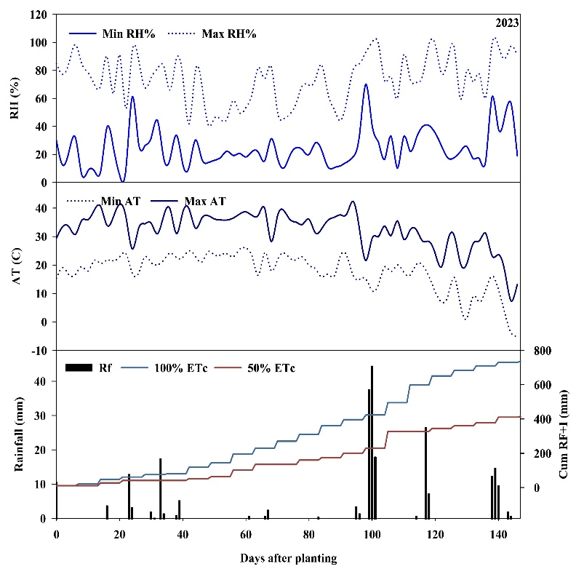
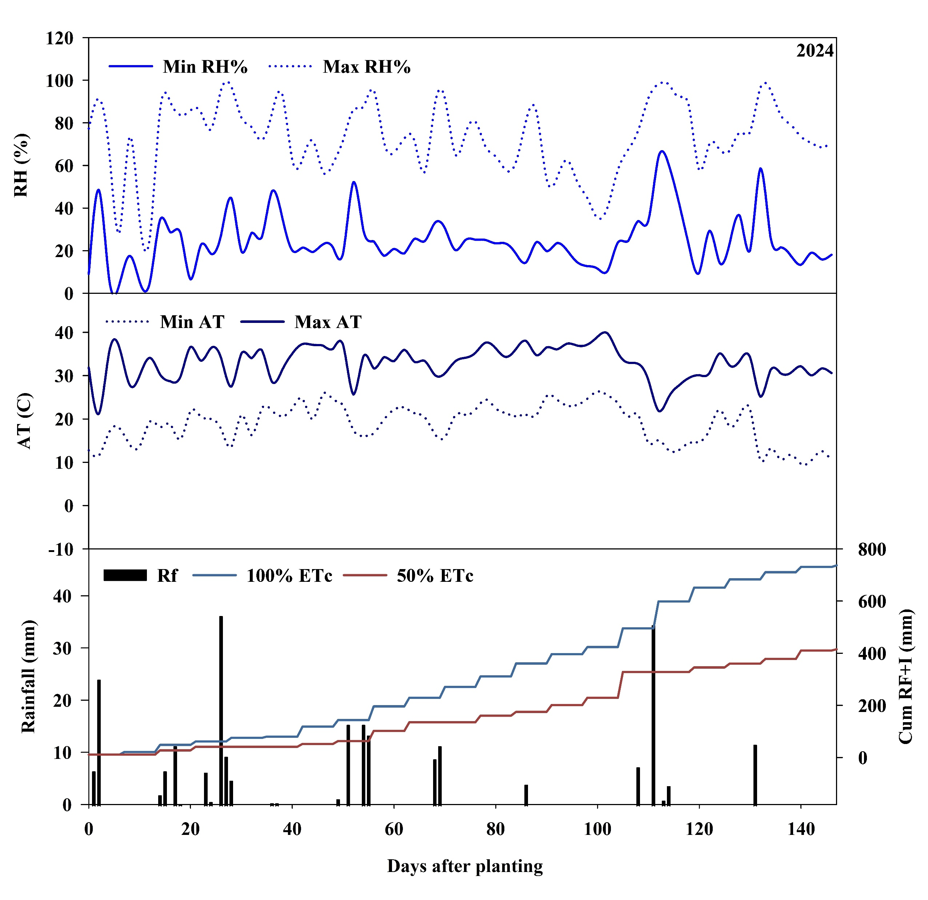

Figure 1. Daily maximum (Max) and minimum (Min) relative humidity (RH%), daily maximum and minimum air temperature (AT), rainfall (RF), and cumulative rainfall plus irrigation (Cum RF + I) during the 2023 and 2024 growing seasons at Lubbock, TX.
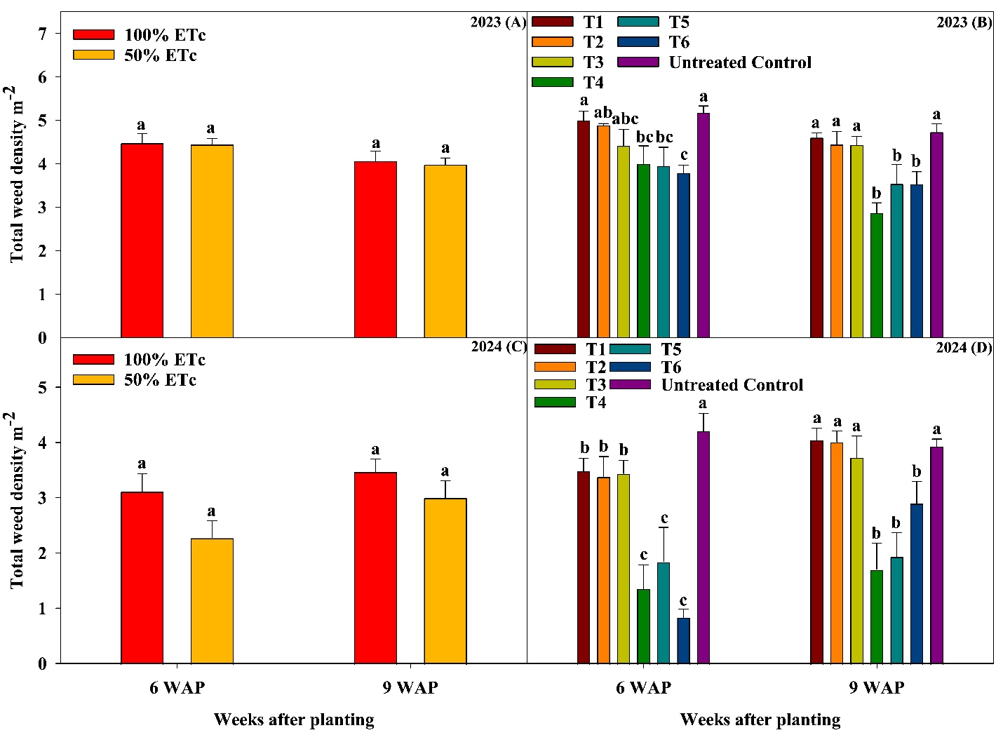
Figure 2. Effect of irrigation levels (A and C) and herbicide treatments (B and D) on total weed density at 6 and 9 weeks after planting (WAP) in cotton during 2023 and 2024 at Lubbock, TX. The standard bars represent ± standard errors; Different letters indicate significant differences among treatments at P ≤ 0.05, LSD test. T1: S-metolachlor, T2: Acetochlor, T3: Prometryn, T4: S-metolachlor PRE fb Glyphosate + S-metolachlor POST, T5: Acetochlor PRE fb Glyphosate + Acetochlor POST, T6: Prometryn PRE fb Glyphosate + Prometryn POST.

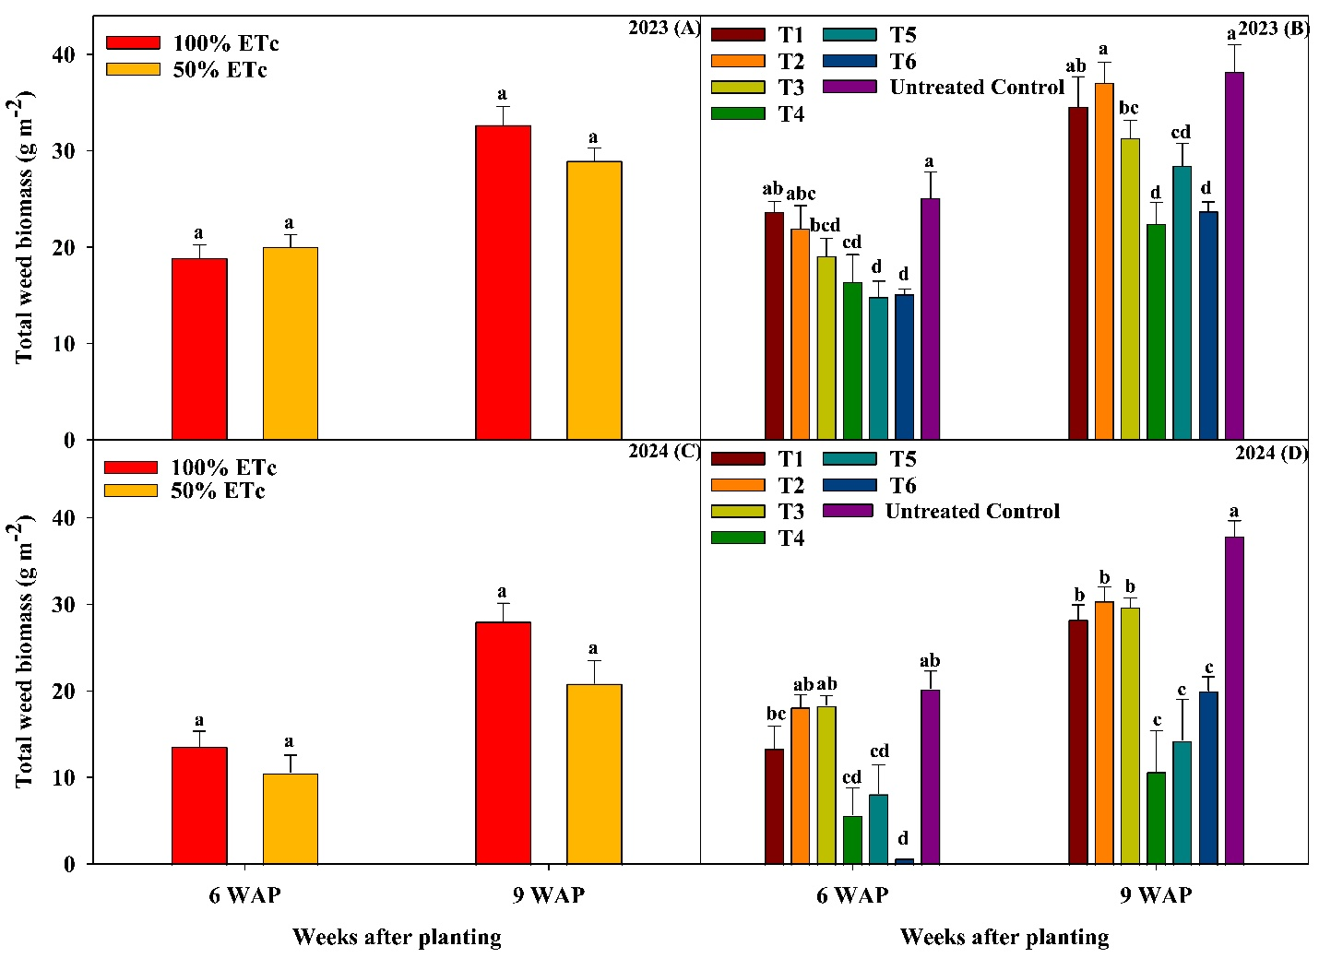
Figure 3. Effect of irrigation levels (A and C) and herbicide treatments (B and D) on total weed biomass at 6 and 9 weeks after planting (WAP) in cotton during 2023 and 2024 at Lubbock, TX. The standard bars represent ± standard errors; Different letters indicate significant differences among treatments at P ≤ 0.05, LSD test. T1: S-metolachlor, T2: Acetochlor, T3: Prometryn, T4: S-metolachlor PRE fb Glyphosate + S-metolachlor POST, T5: Acetochlor PRE fb Glyphosate + Acetochlor POST, T6: Prometryn PRE fb Glyphosate + Prometryn POST.

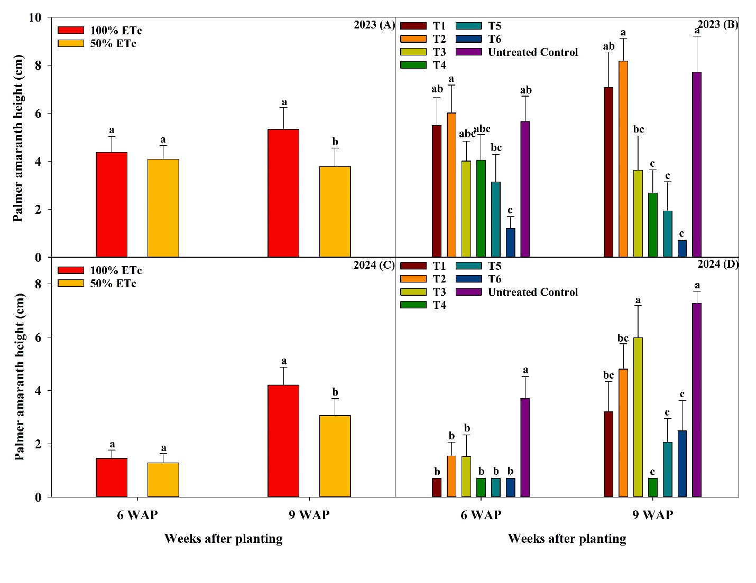Figure 4. Effect of irrigation levels (A and C) and herbicide treatments (B and D) on Palmer amaranth height at 6 and 9 weeks after planting (WAP) in cotton during 2023 and 2024 at Lubbock, TX. The standard bars represent ± standard errors. Different letters indicate significant differences among treatments at P ≤ 0.05, LSD test. T1: S-metolachlor, T2: Acetochlor, T3: Prometryn, T4: S-metolachlor PRE fb Glyphosate + S-metolachlor POST, T5: Acetochlor PRE fb Glyphosate + Acetochlor POST, T6: Prometryn PRE fb Glyphosate + Prometryn POST.

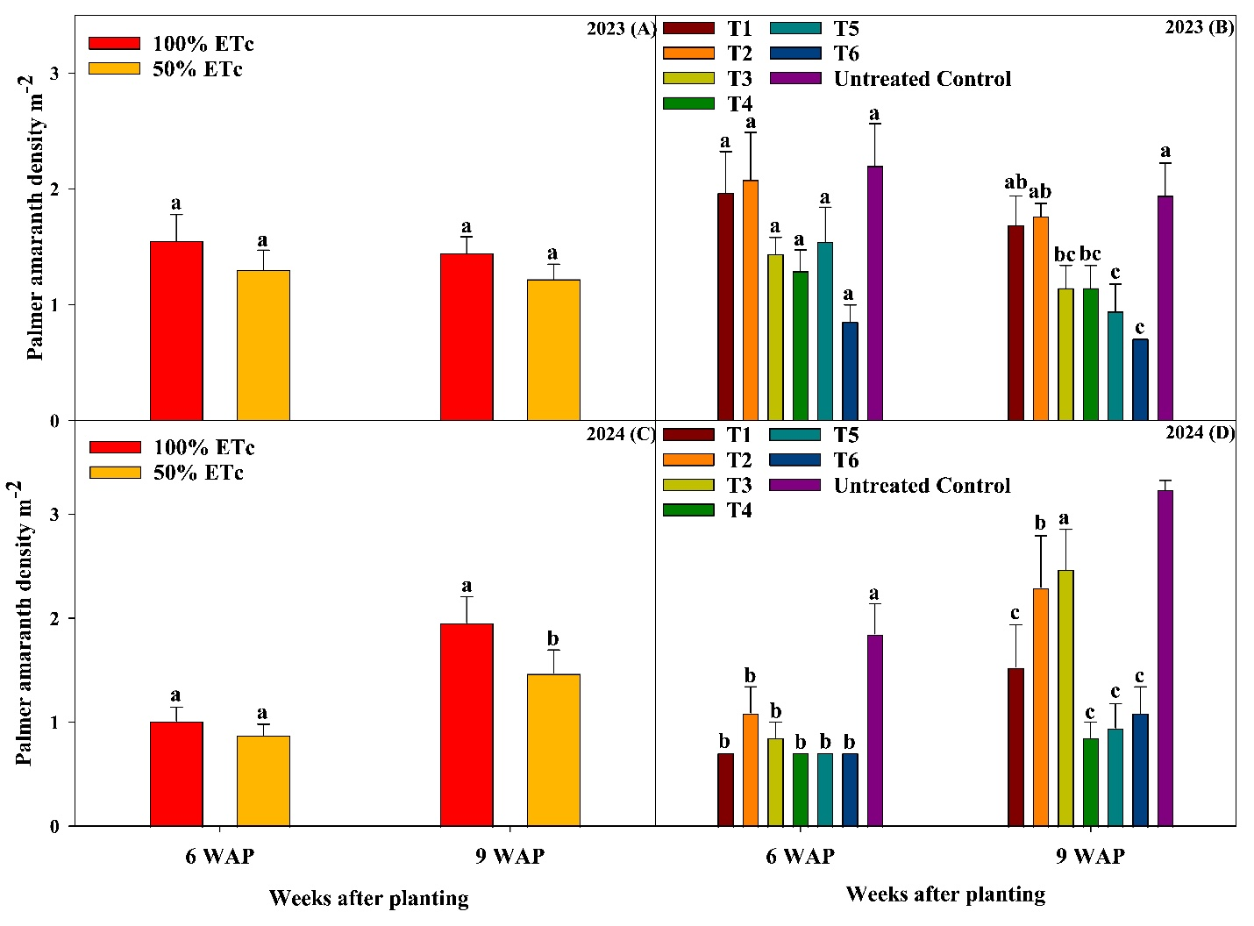
Figure 5. Effect of irrigation levels (A and C) and herbicide treatments (B and D) on Palmer amaranth density at 6 and 9 weeks after planting (WAP) in cotton during 2023 and 2024 at Lubbock, TX. The standard bars represent ± standard errors. Different letters indicate significant differences among treatments at P ≤ 0.05, LSD test. T1: S-metolachlor, T2: Acetochlor, T3: Prometryn, T4: S-metolachlor PRE fb Glyphosate + S-metolachlor POST, T5: Acetochlor PRE fb Glyphosate + Acetochlor POST, T6: Prometryn PRE fb Glyphosate + Prometryn POST

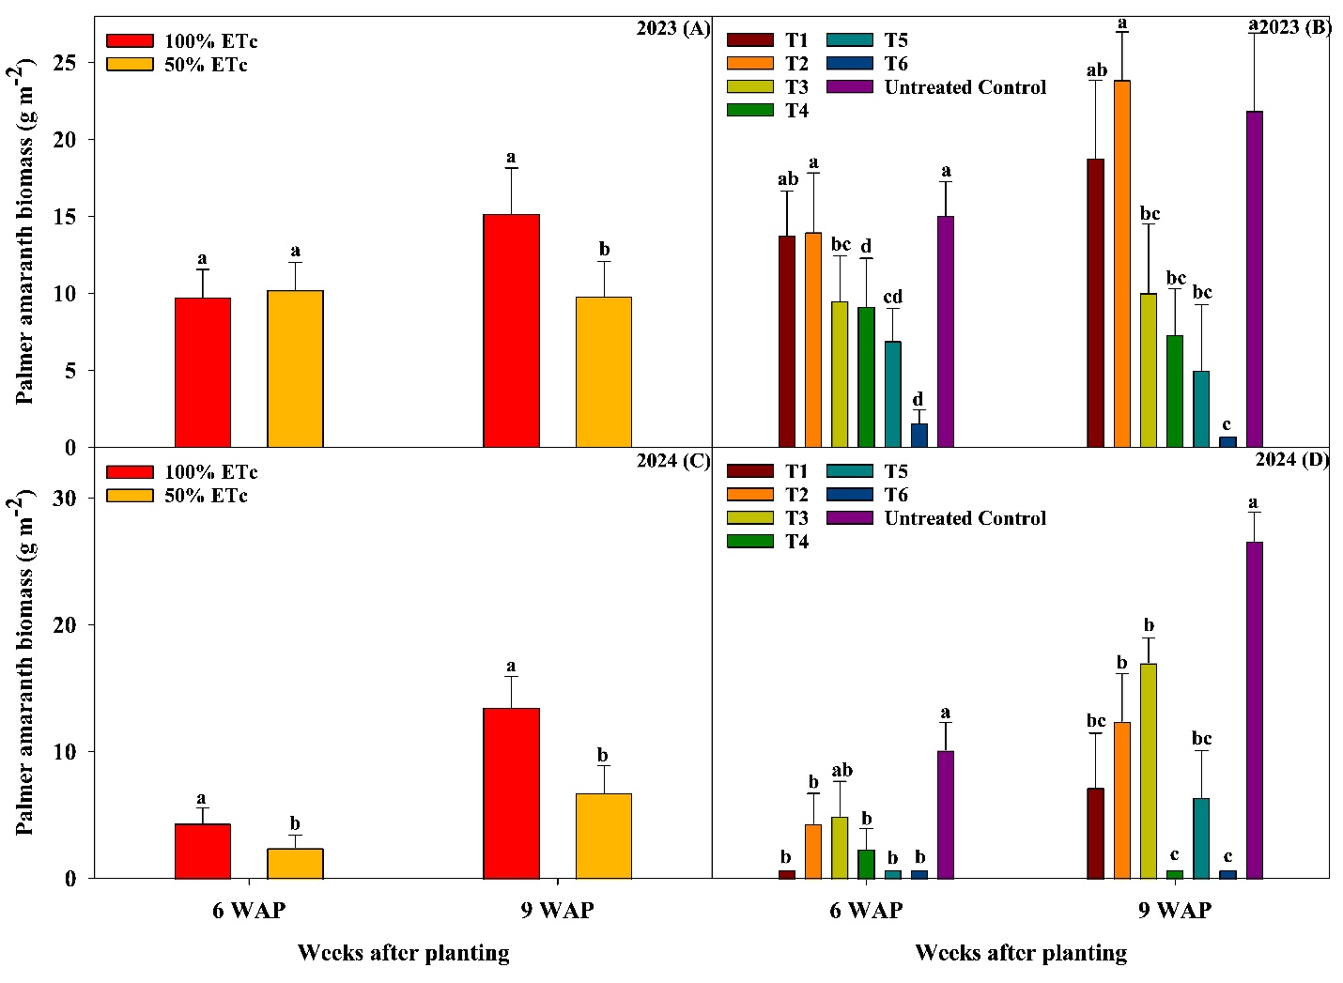
Figure 6. Effect of irrigation levels (A and C) and herbicide treatments (B and D) on Palmer amaranth biomass at 6 and 9 weeks after planting (WAP) in cotton during 2023 and 2024 at Lubbock, TX. The standard bars represent ± standard errors. Different letters indicate significant differences among treatments at P ≤ 0.05, LSD test. T1: S-metolachlor, T2: Acetochlor, T3: Prometryn, T4: S-metolachlor PRE fb Glyphosate + S-metolachlor POST, T5: Acetochlor PRE fb Glyphosate + Acetochlor POST, T6: Prometryn PRE fb Glyphosate + Prometryn POST

