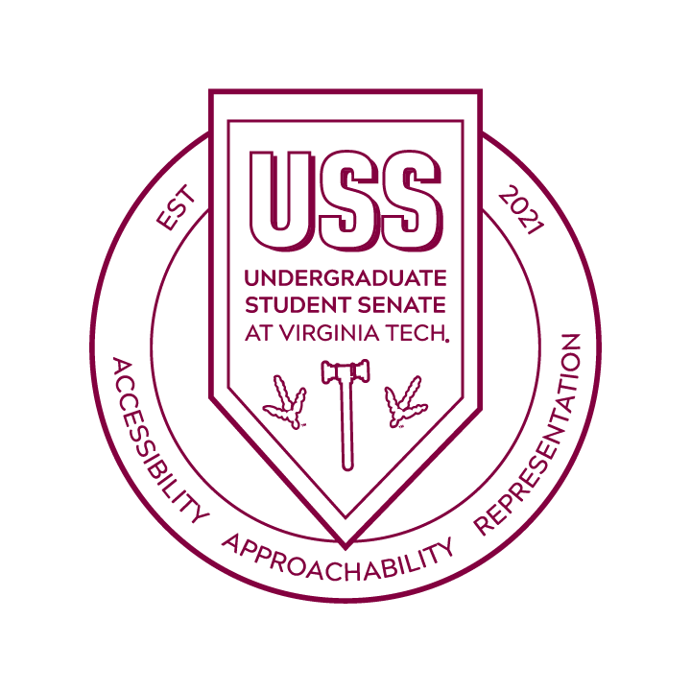
7th Meeting of the 2021-2022
Undergraduate Student Senate at Virginia Tech
Apr 26, 2022
Colonial Hall, Squires Student Center

Call to Order

Adoption of Agenda

Adoption of Previous Minutes

Guest Speaker
  - Maya Mahdi, Director of Hokie Vote Caucus

Old Business
  - Budget Approval/Review

New Business
  - USS Resolution RP2

Cabinet Reports

President, Caroline Lohr

Vice President for Issues and Policy, Ainsley Cragin

Vice President for Shared Governance, Ariana Guevara

Vice President for Equity and Inclusion, Emma Rosman

Vice President for Finance, Sara Wynkoop

Vice President and Undergraduate Representative to the Board of Visitors, Paolo Fermin

Vice President for Administration, Meredith O’Connor

USS Director Reports

Membership Development, Mallory Fields

Special Programs, John Frazier

Governmental Relations, Etienne Ouellet and Tamara Allen

Hokie Effect, Meredith Ashley, and David Cox

University Governance Reports

Advisor Reports

Dr. James Bridgeforth

Dr. Heather Wagoner

Gina Tamburro

Juwan Jacobs

Public Forum

Adjournment

