Sustainable Agriculture Natural Resource Management (SANREM) Project

Status Report (2010/11)
SACRED Africa, Bungoma

Dr. E J Mukhwana, J O Tungani & J Sogomo

Back ground
Sub-Saharan Africa (SSA) faces formidable food security and environmental challenges. While conservation farming systems capable of improving productivity have been developed, several broad constraints impede adoption for many of the 60 million smallholder farmers across SSA. Kenya is among the poor countries with poverty most pronounced in rural areas. Households engaged in crop farming remain the largest group of the poverty-stricken population. On average, rural households derive nearly three-quarters of their income from crop farming. Smallholders dominate the agricultural sector with over 90 percent of crop production being produced on farms averaging less than 2 hectares. Land degradation and low agricultural productivity are severe problems in Kenya and Uganda. The major forms of land degradation are soil erosion, soil fertility mining, soil compaction, water logging, and surface crusting.
The SANREM Project is designed to develop field-scale farming system components through a participatory process. It brings together participants from diverse backgrounds; University of Wyoming (USA), Moi University ( Kenya), Makerere University (Uganda), Appropriate Technology-Uganda, Manor House Agriculture College (Kenya), SACRED Africa (Kenya), Farmers and Stakeholders in the project regions.
Project Objectives
a. To compile information for prototype conservation agriculture practice systems (CAPS) and assemble advisory group of stakeholders.
b. To define the traditional farming system and develop prototype CAPS that build upon local practices while addressing agronomic and socioeconomic constraints.
c. To evaluate the agronomic, ecological and economic sustainability of CAPS compared to traditional practices
Research approaches
Information on prototype CAPS & Advisory Group
The project team developed prototype CAPS based on information from literature and from the practices in the study area. This was used to generate the research treatments for the project.
SACRED Africa identified and brought to together select persons in the agriculture sector in Bungoma County to form the advisory group. The first task was to explain the details of the project to the group which then made suggestions on how to improve on the research.
Defining the traditional farming system
The project team developed a common questionnaire that was used to conduct a baseline survey across the research sites. The questionnaire was designed to gather information from households on:
a. Household characteristics
b. Farming systems
c. Staple crop production and marketing practices
d. Knowledge and practice on CAPS
e. Sources of agriculture information & services
The baseline study was conducted between July and October 2010.
Evaluating performance of CAPS compared to traditional practices
SACRED Africa identified four on farm sites and one on station site on which field experiments were established in the first rain season of 2011. Each on farm site had one block while the on station site had four blocks thus the on station experiment area was four times each on farm experiment area.
Each block had nine plots of 10m x 10m wherein the following managements / treatments were tested:
a. Tillage practices; No till, Minimum till and Hand hoeing
b. Fertilization; With pre plant P (phosphorous) and without
c. Crop combinations; Maize - common bean / mucuna intercrop relay and mono crops of each
On station experiment was managed by SACRED Africa staff while on farm experiments were managed by farmers with guidance from SACRED Africa staff.
Sample Block lay out
Tillage | Maize-Maize | Rotation 1 | Rotation 2
Hand hoe
No-till
Min till

The data collected from the experiments during the first season was:
a. Select soil physical & chemical aspects at pre plant and after harvest
b. Crop biomass yield
c. Crop grain yield
d. Maize growth and cob characteristics
e. Bean growth and pod characterisitcs
Preliminary findings
Advisory Group
Launched on 18th October 2010 with the following composition;
Category | No. of persons
Government Agriculture Officers | 2
Agriculture Based NGO workers | 2
Business Organizations | 2
Farmer Group Representatives | 2
Agriculture Information Providers | 1
Provincial Administration | 1

The group particularly the government officials played a significant role in providing technical insights into the process.
Baseline Survey Summary
Baseline data from the three implementers was forwarded to Makerere University for joint analysis. Basic findings for Bungoma were:
Characteristic | General observation
Education level | Majority had upto basic education level KCPE & KCSE
Housing | Most temporal; iron roof with mud wall & floor
Household size | Average of 8 members
Farming systems | Small holders with average of 1.5 – 3.5 acres practicing mixed farming. Maize & beans the major crop. Poultry and Zebus common livestock
Farm tools & household assets | Most common; Hoes, machetes, bicycle, radio & mobile handset
Group membership | Self Help Groups
Sources of income | Sale of farm produce and retail shops
Knowledge on CAPS | Scanty
Most common CAPS | Plow in of residues

Rainfall pattern in the first season
The project provided a rain gauge that was used to collect rain fall data:
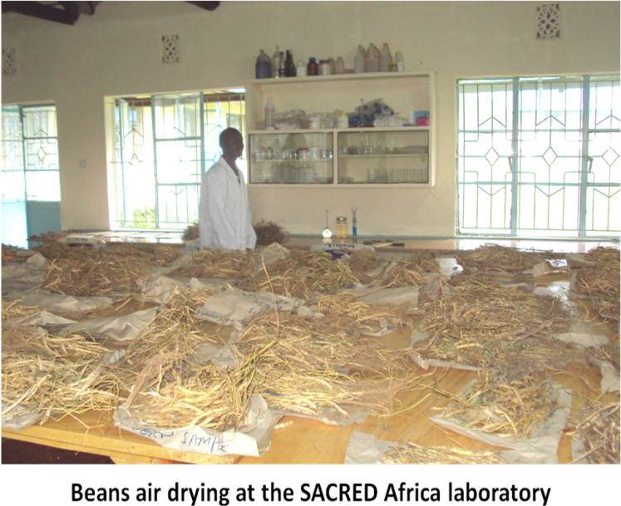
Bean Yield Data
On Station

The fertilized beans had conspicuously higher biomass yield than the unfertilized. Fertilization did not have a notable difference in grain yield

At the on station site, minimum till gave the lowest biomass and grain yields.
Maize biomass & yield data and growth & pod/cob characteristics still being compiled to be availed in subsequent reports.

Lessons learnt from the first season
Chemical weed control is a delicate exercise which if not done thoroughly may not bear fruit. The rate of weed growth in the region is so fast that managing them by chemicals is not very easy.
Most of the herbicides available in the Bungoma Region are pre emergence yet there is great need to also control weeds at post emergence level. The maize – bean intercrop practice makes post emergence weed control even more challenging.
CAPS farm tools and equipment are ideal in soils high in sand but not in the high clay soils. This was particularly observed in the use of the Jab-Planter.
Farmers are very keen on chemical weeding as they realize this will ease the weeding process if it worked well.

