“More Hack, Less Yak,” An Oral History of the Digital Humanities

Group Members:
Nikhil Plassmann
Ximeng Yuan
Jacob Sheppard
Brandon Myers

Client:
Purdom Lindblad,
College Librarian for Humanities and Digital Humanities

CS 4624
Virginia Tech
Blacksburg, Virginia
May 8th, 2013

Table of Contents:

Executive Summary.......................................................................3

Introduction....................................................................................4

User’s Manual............................................................................... 7

Developer’s Manual.......................................................................8

Lessons Learned/Problems and Concerns...................................12

Acknowledgements......................................................................14

Table of Figures:

Figure 1. Gail McMillan..................................................................4

Figure 2. Jim Glanville...................................................................5

Figure 3. Scott Pennington............................................................5

Figure 4. Interview storyboard.......................................................9

Figure 5. Promotional video storyboard.................... ..................10

Executive Summary:

The purpose of this project is to document the history of digital humanities. We started this task by interviewing digital humanists in Blacksburg, Virginia. These are former and current professors, archivists, practitioners, and faculty members of Virginia Tech that incorporate tools provided by computing with disciplines of the humanities. The project includes recordings of three interviews, an edited version of all the interviews, and a short promotional video highlighting the entire project and interview participants. We hope to inspire other people who are interested in this project to pick up from where we left off and continue the documentation at Virginia Tech or abroad. More importantly, we hope to help spread the knowledge about digital humanities and the stories of those who are part of it.

The project aims to document the history of digital humanities through filming of interviews with digital humanists. We were able to schedule and film interviews with three digital humanists at Virginia Tech with each interview lasting approximately one hour. Each interview focused on how that particular person got involved with digital humanities as well as projects they have done or are currently working on. Additionally, we would ask each interviewee about where they think digital humanities is going in the future.

Equipment used for the interviews were borrowed from Innovation Space at Virginia Tech. We used a variety of high quality cameras and audio devices to record the interviews. Due to issues with equipment reservation, lighting equipment were only used for the second interview. Due to the lack of audio quality of the first interview, we started to use lapel microphones to help with the recording. As a result, we were able to achieve higher quality audio with minimal background noise.

Raw video footage of the recorded interviews were uploaded to a workstation in Innovation Space. For editing the recorded interviews, we used two programs: Adobe Premiere and Adobe After Effects. Adobe Premiere was used to cut and attach videos and clips of the three interviews. Adobe After Effects was used to adjust the color of the videos as well as to alleviate audio problems that occurred during filming. We also used these programs to compile the useable edited footage into the final product which consists of clips from all three interviews lasting approximately 30 minutes total.

Introduction:

By watching our first interview, one will get the chance to learn about Gail McMillan. Once an Archivist at the Smithsonian Institution, Gail has done a lot of work involving archives and adapting them to deal with the current technology which has lead her to her current position as Director of The Digital Libraries and Archives at Virginia Tech. Throughout her career, she has worked on a wide variety of projects ranging from helping set up the national and international standard for digital databases containing electronic theses and dissertations to playing a large part in the development of the digital image database called VTImageBase that many use today.

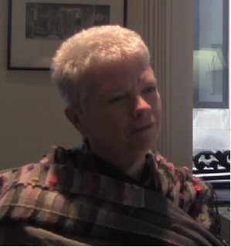
Figure 1. Gail McMillan

Our second interview will allow viewers to learn about Jim Glanville who was once a Chemistry professor at Virginia Tech but upon retirement became a historian who focuses on the Southwestern part of Virginia and a part he calls Holstonia. Initially being attracted to a town called Saltville in order to write about its now closed soda ash plant, Jim became interested in the pre-colonial history of the area when he found out that there was evidence suggesting that Spaniards had been there prior to Christopher Columbus's arrival. Through his writings about these times, which can be found online, and in newspapers, Jim is really making changes to what is known about Virginia’s history.

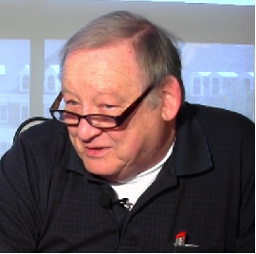
Figure 2. Jim Glanville

The final interview that we conducted was with Scott Pennington who is the E-Research Projects Coordinator at Virginia Tech and who has played a big role in helping maintaining endangered archives by working on projects with organizations like Matrix, The Center for the Humane Arts, Letters, and Social Sciences Online at Michigan State University, and now Virginia Tech, that relate to digitizing old documents and photos. Over the years, Scott has helped preserve history by working on projects ranging from digitizing old audio recordings from 70’s talk shows to numerous projects in parts of Africa, such as working on the Photography Archives in Bamako, Mali, while holding the title Head of Digitizing and African Projects at Matrix.

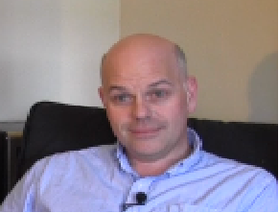
Figure 3. Scott Pennington

Editing the footage required a good deal of work beforehand after we were done filming. The first part was just getting the footage to a manageable format. Every interview was filmed in 1080p at 30 frames per a second, however the bit rates were different due to the cameras used. Gail’s was about 3,000 bits/sec, Jim’s was 7,000 and Scott’s was 2,000, resulting in different file sizes, also Scotts was uncompressed making it 36GB larges. Thus, after hours of waiting all the footage was narrowed down to 1280p, h.264, 30fps, and limited to a bitrate of 3,000. Once all the files were put a reasonable file size we began editing with Adobe Premiere, which was chosen due to our previous experience using it. The process of editing the interviews in 30-minute segments was done by cutting out the interviewer, adding in text for the questions and trying to fix any audio/visual problems as best we could. This was easily done with the cut feature on the adobe timeline and using the different audio and visual effects Premiere provided.

For particularly difficult segments we could take advantage of Adobe After Effects. This application allowed us to add in some more visual effects for particular segments, just as text or blocks, allowing us to layer footages, or even try and add the effect of a light that we didn’t have during filming. While these effects were fun to play around with, they did sometimes go too far and make the footage far too grainy. Thus, after a lot of experimentation the vast majority of the footage was simply editing for auto color, and exposure enhancement. Because in the end a darker picture was simply still better than a blown up image that lost all the detail.

The final job was to cut up the content and create a captivating Promotional Video that really capture the essence of the Digital Humanities. After screening the footage multiple times and finding the best moments, we cut the footage up and started pasting together a video. Probably the hardest part was choosing between different portions of content and sometimes having to remove stuff due to audio or visual issues. In the end it was more the content than the presence of problems that won as one clip of Jim was added despite some audio problems. Fortunately some of the tools, such as Dehummer and exponential fade allowed us to remove a lot of the problems and deliver a clip that was very important to the video. After putting the clips together we added some titles with after effects and then layered everything together with some nice transitions to maintain the flow of the video. Going back though we found these transitions could mess up the markers forcing us to delete rendered files and start again from scratch. However, despite having to rediscover some of the clips the final product came together, showcasing a great overview of the Digital Humanities.

User’s Manual:

The interview videos are meant to help those that wish to learn more about the field of digital humanities and those that are currently involved in it. By watching these videos, the viewers will get the chance to learn about three digital humanists who are, or at one point were, associated with Virginia Tech. It is hoped that these videos get others interested enough in the topic to carry out interviews of their own. For those wishing to carry out interviews like these with others within the field, these videos can also be used as a guide for how it could be done and the promotional video can be used to generate interest about the field so that others will watch the interviews to learn more about it.

Each of these interviews can be viewed by watching either the unedited or edited version, which can also be compared so that those wishing to build off what we have done can get an idea of what they might like to do when editing their own interviews. The unedited versions lengths range from 30 minutes to around one hour, while the edited versions are only around 30 minutes long.

The final video that can be watched is the promotional video. This video is a 5 minute long video that gives viewers an overview of what the project is about and glimpse of what the interviews are like. This is done by being made up of small segments from each interview as well as brief transitions used to inform viewers about the goals of this project and what topics were discussed. Not only can this video be used to help introduce the field to those that are unaware of it so that they then watch the actual interviews, it can also be used to get others in the field to carry out similar interviews with either of their mentors or even about themselves.

Developer’s Manual:

Included data files:

DHoral Final Presentation.pdf - PDF of final presentation.
DHoral Report.pptx – PowerPoint file of presentation.
DHoral Report.docx – Word document of report.
DHoral Report.pdf - This file, final report for project.
Gail_edit.mov - this is the edited version of the interview that was carried out with Gail McMillan
Gail_McMillan.mov - this is the unedited version of our interview with Gail McMillan
Jim_edit.mov - this is the edited version of the interview that was carried out with Jim Glanville
Jim_Glanville.mov- this is the unedited version of our interview with Jim Glanville
Scott_edit.mov - this is the edited version of the interview that was carried out with Scott Pennington
Scott_Pennington.mov - this is the unedited version of our interview with Scott Pennington

Storyboards:

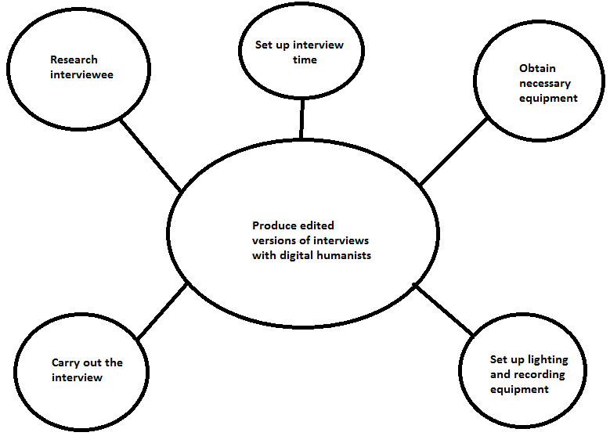
Figure 4. Interview Storyboard

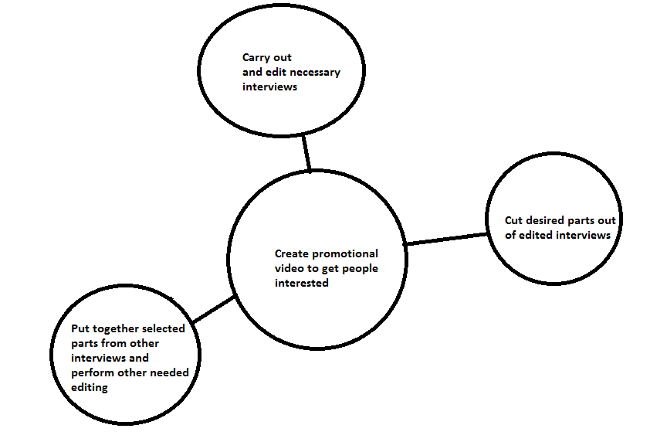
Figure 5. Storyboard for creating promotional video

Base interview questions:

1) When did you begin to identify your work as digital humanities?
-Did you self-identify? Was digital humanities applied to you by others?

2) What was your path to digital humanities? (How did you come to digital humanities? Why?)

3) Who were your mentors along this path?

4) What was your first project? What were the obstacles? How did you overcome them?

5) What projects do you define as successes?

6) How has the field changed from your first project to now?

7) Where do you see the field going in the future?

Lessons Learned/Problems and Concerns:

Timeline:

- Set up all interviews based on list provided by client February 13
- March 7: Conducted our first interview with Gail McMillan
- March 8-15: Edited the first interview to gain understanding of software
- March 27: Midterm presentation on our progress
- April 2: Conducted our second interview with Jim Glanville
- April 3-5: Edited the second interview
- April 23: Conducted our third, and final interview, with Scott Pennington
- April 24-30: Edited the third interview
- May 5: Final presentation on our final project results
- May 2-8: Created the promotional video using footage from interviews

Problems encountered and how we handled them:

One problem we encountered during the course of the project was issues due to scheduling. Our client was responsible for contacting and scheduling interviews with digital humanists. However, everyone had different schedules, which elongated the process. As a result, we ran out of time and were unable to schedule and carry out two interviews we originally planned to do. One planned interview was supposed to be with David Radcliffe, a Virginia Tech Professor of English. The other interview we considering doing were with Andrew Stauffer, the Director of NINES at the University of Virginia. NINES, which stands for a networked infrastructure for nineteenth-century electronic scholarship, is a database of digitized documents and publications from the nineteenth-century that everyone has access to. We really wanted to schedule an interview with Andrew because he was the only person that we planned to interview from outside of the Virginia Tech community. If we were to do the project over, we would schedule Andrew’s interview before any of the other interviews since it’s much easier to schedule with Virginia Tech digital humanists.

Another problem we encountered during the project was the lack of availability of equipment from Innovation Space. One contributing factor was that we didn’t reserve the camera usually until a day or so before the interviews. This was a big problem, especially in the second half of the semester, because we were not the only group in need of a camera. Lighting equipment was just as difficult to reserve due to the same reasons. Thus, we used a different camera for one of the three interviews and lighting equipment only for the second interview. This problem also led to another problem during the editing phase of the project. One of the interviews was shot using a different aspect ratio than the others. Thus, it made compilation of the video clips from all three interviews much more difficult. If we were to repeat the project, we would reserve equipment ahead of time so that we have everything needed to record the interviews.

The problems that arose during the editing phase were not just limited to camera issues. While editing our second interview, we realized that the lapel microphone attached to the collar of our interviewee was too high up resulting in there being a large difference between the audio volume of the interviewer and interviewee causing a bit of an imbalance. Also, because the microphone was too close, the audio hit levels too high for the microphone to record it clearly, causing the audio be a bit distorted. Luckily, Adobe Premiere automatically fixes a lot of audio issues when the file is imported, so the software dealt with this problem. If we were to do this project, or a similar project, again, we would make sure to test all of our equipment thoroughly beforehand, so that we wouldn’t have this issue, causing us to have to rely on other software to fix the problem.

Acknowledgements:

Client:
Purdom Lindblad,
College Librarian for Humanities and Digital Humanities
purdom6@vt.edu
4041 Newman Library
Virginia Tech
Blacksburg, Virginia

We would like to thank our client, Purdom Lindblad, for guiding us through this project and for helping us contact digital humanists and schedule interviews throughout the semester.

We also want to thank the following people for interviewing with us and making this project possible:

Gail McMillan
Director of Digital Library and Archives
Virginia Tech
Blacksburg, Virginia

Jim Glanville
Professor Emeritus of Chemistry (Retired)
Virginia Tech
Blacksburg, Virginia

Scott Pennington
E-Research Projects Coordinator
Virginia Tech
Blacksburg, VA

