Review of vehicle hydroplaning and tire-pavement interactions
Sankar Mahadevan, Graduate Student
And
Saied Taheri, Associate Professor and Director
Center For Tire Research (CenTiRe)
Mechanical Engineering Department
Virginia Tech
Blacksburg, VA 24060

Abstract: This paper deals with the review of vehicle hydroplaning. The physics of hydroplaning, factors influencing hydroplaning and effective methods for preventing hydroplaning have been discussed. Tire tread pattern and pavement grooving are the widely used methods to curb hydroplaning. The paper discusses the work carried out by researchers on studying the effectiveness of both methods. A systematic comparison of the two methods has been presented and the advantage of each has been outlined. Computational methods for simulating hydroplaning tests have also been discussed. Future scope in hydroplaning research involving mapped terrain-treaded tire interactions, improved fluid structure interaction formulations and intelligent tire systems have also been discussed.
Keywords: Hydroplaning, pavement groove, tire grooves, tire tread, finite element, inflation pressure, intelligent tires

Introduction
Hydroplaning is a phenomenon which occurs when a layer of water builds up between the tires of a vehicle and the road surface which leads to loss of traction that prevents the vehicle from responding to control inputs such as steering, braking or accelerating [1]. Hydroplaning occurs when the tire encounters more water than it can expel. As a critical velocity is attained, fluid pressure in front of the wheel forces a wedge of fluid under the leading edge of the tire causing the tire to lift from the road [1].
Statistics from various parts of the world indicate that approximately 20% of all road traffic accidents occur in wet weather conditions. Although there are no detailed statistics on the exact causes of the wet-weather accidents, it is believed that low skid resistance and hydroplaning are major factors leading to the accidents [2].
The frictional force between the tire and the road surface diminishes when the vehicle drives on a road covered by water film. Hydroplaning occurs when the total fluid lift force is greater than or equal to the wheel load. As the velocity increases, dynamic pressure builds up between the tire and the road which tends to lift the tire and increase the chances of hydroplaning [3]. The vehicle velocity must be sufficiently high so that the inertial force developed in the fluid film is comparable to the tire inflation pressure. This effect causes the tire contact patch to buckle thus enabling a large layer of fluid film to support the load.
Hydroplaning is a complex phenomenon involving a number of factors such as tire-road interaction, tire deformation, tire pressure, groove patterns, water film depth, etc. It is time consuming and expensive to carry out physical testing using different groove patterns. Hence computational simulations and numerical methods are being used to predict the onset of hydroplaning.
The two major methods to reduce hydroplaning are:
- Pavement grooving
- Tire tread design
Researchers in the past have used a smooth tire model and performed simulations to find the impact of grooved pavements on hydroplaning speeds. Research has also been carried out to find the impact of treaded tires on smooth pavements and the attained hydroplaning speeds.
Future scope in this field involves the use of an actual treaded tire finite element (FE) model and its interaction with a mapped terrain model. This real world simulation would be able to provide a better estimate of the correlation between experimental data and FE model results. The availability of such data is limited to researchers because tire materials properties and structure information is considered proprietary. Hydroplaning study also lacks a real world mapped terrain model. It would be of great research interest to study such simulations. The paper also introduces the concept of intelligent tires to predict hydroplaning. Intelligent tire systems are of great importance in modern automobiles as they can provide valuable feedback about the tire-terrain interaction and with use of active control systems vehicle performance can be improved, thus increasing vehicle safety.
This review paper deals with study of the methods used to suppress hydroplaning. The effectiveness of a method can be related to the hydroplaning speed or the critical speed at which hydroplaning takes place. The greater the speed at which hydroplaning takes place, the more effective is the method. However, a lot of other factors have to be taken into consideration and thus a high hydroplaning speed cannot be considered to be an optimal solution. The paper mainly discusses the research carried out on tire and pavement grooving methods implemented over the years to curb hydroplaning.

Three zone concept
Albert, B.J [4] illustrates hydroplaning using the three zone concept. As shown in Figure 1, region A is called the bulk zone which can be stated as the region where complete hydroplaning takes place. Region B is called the thin film zone where partial hydroplaning takes place. Region C is called the dry zone or the adhesion region where the wheel completely adheres to the ground. Initially, when moving at low speeds, region C dominates and the vehicle is completely in contact with the road. As the vehicle velocity increases, the dynamical pressure of water builds up at the leading edge of the tire and completely lifts the tire. At this moment, region C diminishes and region A becomes the dominating region. The three zone concept is a widely used method to describe hydroplaning.
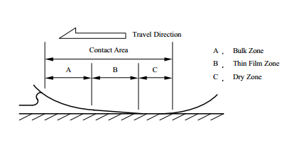
Figure 1. Three zone concept [4]

It is also important to study the ‘squeeze film’ concept that plays a significant role in hydroplaning. The reduction of tire traction forces in shallow water is usually explained by progressive penetration of a relatively thick film of water, called a ‘squeeze film’ into the tire contact region. The squeeze film is maintained in the contact patch by the hydrodynamic pressure generated with increasing velocity. When a portion of the contact patch is supported by the squeeze film, partial hydroplaning has taken place. This has been shown by region B in Figure 1. Certain amount of time is required to squeeze the water out of the tread-road interface to permit contact with the road surface. As the velocity of the vehicle increases, the time available to squeeze this film out decreases and a significant portion of the contact patch becomes supported by the squeeze film thus reducing the friction capability of the tires [5]. Squeeze film is usually observed in pavements with shallow water depth, this is the scenario usually observed in real world wet weather driving.
The Reynolds equation was derived using the universal laws of conservation of mass, conservation of momentum and conservation of energy. By applying boundary conditions and assuming the pressure to be independent of the z direction due to the narrow gap between two surfaces, the equations of mass and momentum can be combined and simplified to obtain the Reynolds equation, shown in Equation (1).
(1)
Where ρ, v, u, w and t represent the mean density, velocities in x, y and z directions and time, respectively
Equation (1) describes the fluid flow parameters that influence hydroplaning [6]. The three terms on the right hand side of Equation (1) represent the wedge, the stretch and the squeeze effects, respectively. The wedge effect has been explained by means of the three zone concept. The squeeze effect has also been explained above. The stretch effect term is only considered when the surface velocity changes in the sliding direction. This only occurs when the bodies in contact in the fluid boundaries are flexible and stretch the boundary surface along the direction of travel. However they are usually neglected in hydroplaning studies since the surface stretches are negligible in magnitude when compared to the deflection of the tire.

Factors influencing hydroplaning
A lot of research on hydroplaning was carried out in the 1960s by the National Aeronautics and Space Administration (NASA) to prevent hydroplaning of aircraft tires on water logged runways. One of the most commonly used equations for predicting hydroplaning was developed by NASA. The equation is as follows:
$V_{h}=6.35\sqrt{p}$ (2)
Where V_{h} is the tire hydroplaning speed (km/h) and p is the tire inflation pressure in kPa
$V_{p}=10.35\sqrt{p}$ (3)
Where V_{p} is hydroplaning speed in mph and p is the tire inflation pressure in psi.
This equation is also known as Horne’s hydroplaning equation [7] which is valid only for smooth tires with limited groove and tread design. As per Equation (2) or (3), tire inflation pressure can be regarded as one of the major factors influencing hydroplaning since the critical speed at which the vehicle will start hydroplaning depends solely on tire inflation pressure.
For tires operating under heavy load such as those found in trucks or trailers, consideration has to be given to the tire footprint area along with the inflation pressure. Horne [8] proposed an alternate equation for trucks where trailer load needs to be considered. With increasing load, the width/length ratio of the tire footprint decreases thus increasing the effective hydroplaning speed. The equation is as follows
$V_{p}=7.95\sqrt{p({FAR)}^{-1}}$ (4)
Where V_{p} is the dynamic hydroplaning speed in mph, p is the tire inflation pressure, FAR is the tire footprint aspect ratio i.e. width/length.
Gengenbach [9] developed an empirical equation which includes the thickness of the water film while calculating the hydroplaning velocity. His experimental tests showed that water film thickness has a significant impact on the hydroplaning speed. Gengenbach's equation, like Horne's, assumed that the wheel load and dynamic pressure were in equilibrium but used the cross section of the water film under the tire contact patch perpendicular to the surface velocity as the area for the force calculation. The area was multiplied by a lift coefficient and the equation to predict the total hydroplaning speed was derived as:
$$V=508 \sqrt{\frac{Q}{B*t*C_{l}}} \left(5\right)$$
Here,
V = total hydroplaning speed in km/h,
Q = wheel load in KP
B = maximum width of contact patch in mm,
t = thickness of water film in mm, and
C_{l} = lift coefficient determined empirically for a particular tire.
Gengenbach’s experiments proved that grooving of the tires considerably reduces the lift coefficient and thus increases the critical hydroplaning speed. The NASA hydroplaning equation was originally developed by Horne [7] was modified to its most recent form [8]:
$v_{p}=51.80-17.15\left(FAR\right)+0.72p_{t}$ (6)
Where,
v_{p} = hydroplaning speed, mph
p = tire inflation pressure, psi, and
FAR = tire footprint aspect ratio
The equation does not include the water film thickness however; it was developed for average water film thickness of 0.3 inches (7.62 mm)
One of the commonly used empirical models which relates hydroplaning speed to parameters such as water film thickness, tire inflation pressure and the pavement texture characteristics was developed by Gallaway [10]. The equation is as follows:
$Vp={(SD)}^{0.04}{(p)}^{0.3}{(TD+1)}^{0.06}A$ (7)
Where,
$A=max\left\{\left[\frac{10.409}{{WD}^{0.06}}+3.507\right],\left[\frac{28.952}{{WD}^{0.06}}-7.817\right]{TXD}^{0.14}\right\}$ (8)
Here, V_{p} is the hydroplaning speed in mph, SD is the spin-down in %, WD is the water film thickness in inches, p is the tire pressure in psi, TXD is the texture depth in inches, and TD is the tire tread depth in 32nds of an inch. However similar to the NASA hydroplaning Equation (2), this is valid only for plane pavement surfaces and smooth tires. These equations do not take into consideration the actual complexity of the tire; they provide an approximate estimate of the hydroplaning speeds taking into consideration a limited number of parameters.
Major pavement design factors influencing hydroplaning
The two main pavement design factors which influence hydroplaning are as follows:
- Micro-texture
- Macro-texture
Roadway micro-texture and macro-texture influence hydroplaning to a great extent. Mounce [11] describes micro-texture as the degree of polishing of the pavement surface, varying from harsh to polished, and is necessary to develop frictional forces between the tire and pavement on wet surfaces. The magnitude of the frictional forces increases with increased micro-texture. Micro-texture plays a significant role in preventing hydroplaning at low vehicle speeds. Pavement micro-texture provides the necessary asperities to break the thin layer of water present between the tire and the road surface enabling the tire to make contact with the road surface. The asperities are thousands of small projections which comprise the micro-texture. Micro texture corresponds to surface irregularities with wavelengths of pavement profile inferior to 0.5 mm and vertical amplitude inferior to 1 mm. It is related to the unevenness of the surface mainly due to gravel, sand and mortar in contact with the tire [12].
Macro-texture on the other hand plays a vital role at higher speeds. Macro-texture describes the size and extent of large scale protrusions from the surface of the pavement, varying from smooth to rough. Macro-texture depends on factors such as aggregate gradation, pavement construction method and groove patterns [11]. Macro-texture provides various channels for drainage, thereby reducing the hydrodynamic pressure between the tire and the pavement. Transverse and longitudinal groove designs are commonly used in pavements to reduce the possibility of hydroplaning. Macro texture corresponds to surface irregularities with wavelengths of pavement profile lying between 0.5 to 50 mm and vertical amplitude inferior to 10 mm. Macro texture facilitates the drainage of water macro film (1-50 mm) located at the tire road interface [12].
Wheel spin down as an indicator of hydroplaning
Stocker, A.J [13, 14] used wheel spin-down as the indicator of tire hydroplaning. Spin down is a term describing the loss of angular velocity of a wheel traveling over a flooded pavement as the speed of the vehicle remains constant or increases. Wheel spin down is caused by the buildup of hydrodynamic pressure in the forward portion of the tire contact patch. This force acts to oppose the normal rotating action of the tire and can build up to a point to cause the tire to stop rotating completely
It was observed experimentally that wheel spin-down occurred at a speed which was 70% of the critical hydroplaning speed predicted by Horne's hydroplaning Equation (2). As the tire tread becomes worn, the drainage provided by the tread becomes less efficient and the speed to cause a given amount of spin-down is decreased. Speeds to cause spin-down on worn tires is considerably less than for tires with a full tread depth. Decreasing the tire inflation pressure has the effect of increasing the area of the contact zone. The larger the area of the contact zone, the lower the speed to cause spin-down. Increasing the tire width has the effect of decreasing the speed to cause a given amount of spin-down. Increasing the wheel load while maintaining the same inflation pressure for a smooth tire increases the ground speed at which spin-down is initiated. An increase in water depth generally has the effect of decreasing the speed at which wheel spin-down is initiated. Thus wheel load, tire width and water depth play a significant role in hydroplaning and wheel spin-down.
Skid resistance of tires
A vast amount of research concerning friction characteristics and effects of the pavement texture and material has been conducted by researchers [15-18]. Skid resistance is generally quantified using some form of friction measurement such as a friction factor or skid number [19, 20]. Skid resistance is the opposing force developed at the tire-pavement contact area. It is the force that offers resistance to tires sliding on pavement surfaces. In other words, it is the ability of pavement to resist the skidding of a tire and an essential component of traffic safety to maintain vehicle control and reduce the stopping distance in emergency braking scenarios [21].
Friction Factor (similar to the coefficient of friction) can be described as
$$f=\frac{F}{L} (9)$$
Skid number SN= 100(f)
F= frictional resistance to motion in plane of interface
L=Load perpendicular to interface
Skid resistance developed between tire and pavement surface has two major components, namely, adhesion and hysteresis. The two components are respectively related to the two key properties of pavement surfaces, i.e. micro-texture and macro-texture. In dry road surfaces, the adhesion component of the tire dominates the skid resistance. However, on wet roadways, the interfacial film of fluid is spread uniformly and this effectively reduces the adhesion component to a very low value [22]. The hysteresis contribution usually is fairly independent of speed in the range in which highway tires are likely to slide. Thus, it gains in importance at higher speeds when adhesion component decreases. Tire hysteresis is an important area of study and its influence on vehicle hydroplaning is yet to be explored.
Fwa [23] calculated the skid resistance of tires in terms of the horizontal resistance force and normal load acting on the tire. The simulation results were verified with experimental data. A skid resistance number was calculated for each of the simulation runs. The skid resistance number can be expressed as follows.
$${SN}_{v}=\frac{F_{x}}{F_{z}} (10)$$
$F_{x}$= horizontal resistance force to motion acting on the axle of the tire;
$F_{z}$= vertical loading acting on the tire.
The horizontal resistance force $F_{x}$ is equal to the sum of the traction force developed at the tire-pavement contact and the fluid drag force due to the tire-fluid interaction. It was observed that with increase in vehicle speed the contribution of tractive force decreases and the fluid drag force are unable to compensate to the rapid decrease in tractive force offered by the tire. This has been represented in Figure 2. The tractive characteristics of the tire are dependent on the tire-pavement friction coefficient which is related to the material properties and structure of the tire. It is noted that even when the drag force reaches its maximum at the point of hydroplaning, its magnitude of SN= 9.5 is only 15.8% of the initial skid resistance SN₀= 60 available at zero or low sliding speed.

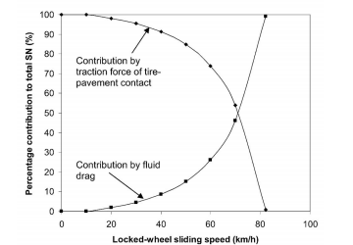
Figure 2. Influence of traction and drag forces on skid resistance [23]
The above observation suggests that under normal practical operating conditions where vehicle speeds are well below the hydroplaning speed, the available skid resistance is mainly derived from the traction force governed by the friction characteristics at the tire-pavement contact. The contribution of fluid drag forces only becomes important at high vehicle speeds approaching the hydroplaning speed. Thus the tire structure and material properties largely govern the traction capability of a tire as the vehicle approaches hydroplaning velocity. It has been found that the tread depth, groove width, groove position, numbers of grooves, tire inflation pressure, wheel load and water film thickness all have some effect on skid resistance especially for higher velocities.

Viscous and dynamic hydroplaning
Viscous hydroplaning is the problem associated with low speed operations on pavements with little or no micro-texture. This causes a very thin film of water to exist between the tire and pavement because of lack of micro-texture to penetrate the water film. Viscous hydroplaning is also called thin film hydroplaning as compared to dynamic hydroplaning which requires a thick film of water for hydroplaning to take place [11]. It occurs when very thin water films (less than 0.25 mm thick) exist on extremely smooth pavement surfaces [24]. Researches have observed that viscous hydroplaning depends on a number of factors such as tire wear, viscosity of the fluid and pavement texture. At low speeds, it is unlikely to occur unless the tire is almost completely worn and the pavement has a polished quality. This has been defined as a rare event occurring in extreme cases of tire wear.
Dynamic hydroplaning, as described in the ‘three zone concept’, occurs when uplift forces are created by a water wedge between a moving tire and the pavement. This phenomenon only occurs when the combined capacity of both the pavement and the tire is not enough to displace the required amount of fluid to prevent hydroplaning. Although viscosity or inertia predominates the occurrence of hydroplaning, both effects are present to some degree in all cases of hydroplaning [25]. Typically, full dynamic hydroplaning occurs at higher vehicle speed on thick water films when the water depth exceeds 2.5 mm [26]. Ongoing research is mainly focused on finding out ways to prevent dynamic hydroplaning as it is more prevalent in real life. Heavy rainfalls usually create conditions on which dynamic hydroplaning is facilitated.

Tire-pavement interactions
As it is expensive and time consuming to carry out hydroplaning study on pavements with different groove patterns and tread designs, empirical methods and computational simulations are being used extensively to study hydroplaning. To investigate the influence of groove patterns and groove depth on hydroplaning speeds, computational simulations have been performed to develop the optimum tire tread and pavement design. The main reason for creating grooves in the tire or pavement surface is to serve as flow channels to facilitate the drainage and discharge of water trapped between the contact patch of the tire and the pavement. This in effect increases the hydroplaning speed. The Fluid Structure Interactions (FSI) simulation is a very challenging and complex problem. Many researchers, both academic and industrial, are exploring new methods for solving FSI. Commercial finite elements codes have been used for hydroplaning simulations [3, 27-34]. Using the Arbitrary Euler Lagrangian (ALE), Coupled Euler Lagrangian (CEL) or other fluid structure interaction formulations, hydroplaning can be simulated by assigning different frames (Eulerian or Lagrangian) to the tire and the fluid domain. It would be impractical to solve FSI by simply considering an Eulerian or a Lagragian formulation for the entire model. It is a common practice to assign an Eulerian formulation to the fluid and a Lagrangian formulation to the tire. This method reduces the computational time and the mesh refinement needed for specifying the fluid domain. Water layers around the contact area, where deformed tire and fluid interfere, is equally divided into small size meshes. In the other region away from the contact region, the sizes of mesh are increased. This reduces the computation time. A void layer is usually added over the Eulerian water frame to introduce the splash and scattering effect as the tire passes over the layer of water. Figure 3 shows a typical tire hydroplaning simulation carried out using the Coupled Eulerian-Lagrangian method.

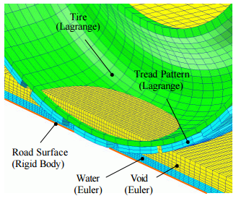
Figure 3. Model of a coupled problem of a tire and water film [3]
Ong, G.P [35] performed simulations to understand the effects of grooved pavements on hydroplaning speed. A simulation model was developed and results were verified with the data from the early work on hydroplaning carried out by Horne [7]. Finite volume method using the software Fluent was implemented for the simulation. The focus of the paper was to understand the influence of groove patterns on hydroplaning speeds. Pavement groove width, depth and spacing were varied for the simulation as shown Table 1. Transverse pavement grooving was used in the first part of the simulation.
Table 1: Groove dimensions studied [35]
Groove dimensions
Grooving design | Width w (mm) | Depth d (mm) | Spacing s (mm)
A | 6.35 | 6.35 | 25.4
B | 3 | 3 | 10
C | 5 | 5 | 45
It was shown that for Groove design A, with a tire inflation pressure of 186.2 kPa, the hydroplaning speed was 199.5 km/h. Without the groove pattern, Equation (2) predicted a hydroplaning speed of 86.9 km/h. This shows the significant influence of groove patterns on hydroplaning speed. The width and depth of the grooves were reduced for designs B and C; where the grooves were brought closer. The hydroplaning speed attained for groove design B was 156.10 km/h and for groove design C was 124.36 km/h. From these results, it is concluded that groove width and depth have a greater impact on hydroplaning speed as compared to groove spacing.
Ong et. al. [36] further carried out simulations evaluating the influence of each of the individual parameters mentioned above on the hydroplaning velocity. For each pavement grooving design, the simulation model was applied for cases of hydroplaning speeds ranging from 0 to 300 km/h in steps of 15 km/h, and the corresponding tire inflation pressure for each case was obtained. The relationship between the hydroplaning speed and tire inflation pressure for a particular pavement grooving design was then established. The effectiveness of varying the groove parameter to reduce the occurrence of hydroplaning was expressed in terms of the magnitude of the hydroplaning speed that can be raised by each unit increase of the groove parameter).
For the groove depth, it was found that for each millimeter increase in groove depth, the increase in hydroplaning speed that was achieved fell within the range of 0–70 km/h. More than 80% of the cases gave an increase in hydroplaning speed in the range of 0–10 km/h for each millimeter increase in groove depth. Similarly, simulations were carried out for groove width. For each millimeter increase in groove width, the rise in hydroplaning speed attained was within the range of 0–105 km/h. More than 80% of the cases gave an increase in hydroplaning speed within the range of 15–35 km/h for each millimeter increase in groove width. For each millimeter decrease in groove spacing, the rise in hydroplaning speed fell within the range of 0–35 km/h. More than 80% of the cases give an increase in hydroplaning speed in the range of 0–12 km/h for each millimeter reduction in groove spacing.
It can therefore be concluded as in the previous study, groove width is the most effective method of increasing the hydroplaning speed for a given set of pavement parameters. The previous study involved the use of transverse grooved pavements. However, transverse grooves are preferred in aircraft runways where there is a need for improved traction performance and high hydroplaning speeds to facilitate landings.
Highway agencies do not prefer transversely grooved pavements, as the entire highway has to be shut down for maintenance. In addition, transverse grooves increase the noise generated by tires. To overcome these problems, longitudinally grooved pavements are extensively used by highway agencies.
Ong et. al. [37], further performed simulations for longitudinal grooved pavements similar to the previous model. The results were compared with Equation (2) for a tire having an inflation pressure of 186.2 kPa. Similar to transversely grooved pavements it was found that a larger groove width and depth have a significant impact on the hydroplaning speeds. To make a comparison between the relative effects of groove width, depth and spacing on hydroplaning, an effectiveness index in terms of the magnitude of change in hydroplaning speed per unit change of a particular groove dimension was used similar to the previous study. For each millimeter (mm) increase in groove depth, the increase in hydroplaning speed that was achieved fell within the range of 0 to 9 km/h with a mean of 2.799 km/h/mm. For each mm increase in groove width, the increase in hydroplaning speed fell within the range of 0 to 16 km/h with a mean of 3.558 km/h/mm. For each mm decrease in groove spacing, the rise in hydroplaning speed fell within the range of 0 to 5.25 km/h with a mean of 1.057 km/h/mm. It can be observed that groove width provides a larger effectiveness index as compared to groove depth and spacing. This indicates that groove width is an important factor in reducing hydroplaning occurrences and could be considered as a primary design factor in pavement construction to prevent hydroplaning.
We can thus observe that for the same simulation model, transverse grooved pavements provide a higher hydroplaning speed as compared to longitudinal grooved pavements. The results have been summarized in Table 2.
Table 2 : Comparison of grooving measures
Pavement grooving method used | Parameter varied | Increase in hydroplaning speed per unit increase in groove parameter  (km/h)
Longitudinal grooving | Depth | 0-9
Longitudinal grooving | Width | 0-16
Longitudinal grooving | Spacing  (spacing decreased) | 0-5.25
Transverse grooving | Depth | 0-10
Transverse grooving | Width | 15-35
Transverse grooving | Spacing  (spacing decreased) | 0-12

The authors mentioned above carried out simulations for a smooth tire on grooved pavements. It is much more important to take into consideration the combined effects of tire grooves and pavement grooves on the hydroplaning speed.

Ribbed tire and grooved pavement interaction
Fwa et. al. [2], performed simulations to find the optimum groove-tread combinations to increase the hydroplaning speed. Ribbed tire interactions with grooved pavements were simulated using finite element analysis. Minimal work involving treaded tire and grooved pavement simulations have been carried out, thus there is much scope for improvement in this area. The effectiveness of each of the methods used in this study is described below. It should however be noted that these tire models are simplified models as compared to the real word treaded tire models. The following cases were studied by the authors:
a) Smooth tire sliding on smooth pavement surface.
b) Smooth tire sliding on longitudinally or transversely grooved pavement surface.
c) Longitudinally or transversely grooved rib tire sliding on smooth pavement surface.
d) Longitudinally grooved rib tire sliding on longitudinally grooved pavement surface.
e) Transversely grooved rib tire sliding on transversely grooved pavement.
f) Longitudinally grooved rib tire sliding on transversely grooved pavement surface.
g) Transversely grooved rib tire sliding on longitudinally grooved pavement surface.
A standard ASTM tire was adopted for the study. A constant tire inflation pressure of 186.2 kPa was considered as in the previous study and a constant wheel load of 2.41 kN was used. Groove depth, width, center to center spacing and water film thickness were the parameters that were varied in the study. However the paper was mainly used to illustrate the effect of groove depth on hydroplaning speeds.
Table 3 summarizes the results obtained from the simulation model. The results obtained prove that pavement grooving is more effective than tire tread grooving to reduce the occurrence of hydroplaning. Transverse pavement grooving increased hydroplaning speed by 12.86 km/h per mm groove depth as compared to transverse tire tread grooving which only provided an increase of 4.39km/h per mm groove depth. There was marginal difference in the increase in hydroplaning speed per mm groove depth for longitudinal grooved pavement and longitudinally grooved tire. The presence of a larger cross sectional area at the tire road contact for dispersal of water in case of transverse grooving is one likely explanation for the higher hydroplaning speed achieved. It was found that transverse grooved tire moving on a transverse grooved pavement produces the maximum hydroplaning speed because of the large net cross sectional area available to expel the fluid from the contact patch. However, number of other parameters such as wear, durability, noise and cornering characteristics were neglected in the study.
Table 3: Tire grooving vs pavement grooving effectiveness [37]
Hydroplaning Speed Increase per unit increase in Pavement Groove Depth |  | Hydroplaning Speed Increase per unit  Increase in Tire Groove Depth
Simulation performed | Km//h per mm depth | Simulation performed | Km/h per mm depth
Longitudinally grooved  pavement & smooth tire | 1.93 | Longitudinally grooved tire tread & smooth pavement | 1.68
Longitudinally grooved pavement & longitudinally  grooved tire | 1.26 | Longitudinally grooved tire  tread & longitudinally  grooved pavement | 1.03
Longitudinally grooved  pavement & transversely  grooved tire | 2.41 | Longitudinally grooved tire  tread & transversely grooved  pavement | 1.80
Transversely grooved  pavement & smooth tire | 12.86 | Transversely grooved tire tread & smooth pavement | 4.39
Transversely grooved  pavement & longitudinally  grooved tire | 12.80 | Transversely grooved tire  tread & longitudinally  grooved pavement | 4.84
Transversely grooved  pavement & transversely  grooved tire | 10.91 | Transversely grooved tire  tread & transversely grooved  pavement | 3.61
From the results obtained by increasing groove depth, it was found that increasing groove depth raises the hydroplaning speed irrespective of the existing pavement and tire tread conditions. Transverse grooving was found to be much more effective in increasing hydroplaning speed as compared to longitudinal grooving. This was also observed in the previous studies cited in this paper.
Slip ratio is also an important factor that influences hydroplaning. S. K Srirangam [38] simulated the effect of slip ratio on longitudinal frictional force which influences hydroplaning. It was found that the friction force decreases as the slip ratio increases. The author through simulations concluded that the decreasing rate of friction force was observed to be minimal for lower speeds irrespective of slip ratio. But, as the speed increased, there was an apparent drop of longitudinal friction force with increasing slip ratio.
From the above observations, a strong relationship was established between the slip ratio and braking ability of the tire. A striking reduction in braking forces was found when the vehicle velocity reached hydroplaning speed and at that speed there was hardly any braking traction available. Increasing slip angle reduced the hydroplaning speed for tires with the same inflation pressure.
In spite of all the authors indicating that transverse pavement and tire tread grooving are the most effective methods in reducing hydroplaning speeds, it is rarely used in real world scenarios. The major obstacle in using transverse grooved tires is the problem of tire wear, noise and skid resistance during cornering maneuvers. It is observed that the hydroplaning speeds attained with longitudinal grooving are sufficient for highway operations. It should be noted that when it comes to negotiating horizontal curves, the hydroplaning prevention effectiveness of longitudinal and transverse grooves become reverse. Longitudinal grooves would be more effective in meeting the demand for skid resistance and hydroplaning prevention during cornering maneuvers. In contrast, for high landing speeds like those attained in aircraft runways, transverse grooving is preferred. As mentioned earlier, transverse pavement grooving also has the problem of maintenance where the entire highway has to be closed, whereas for longitudinal grooving it is possible to close one lane at a time for maintenance purposes. Thus a number of parameters have to be considered before selecting the groove patterns for pavements and tire treads.
Modifications to Horne’s equations based on Fwa’s work
Based on the simulations carried out by Fwa [11, 23, 36, 39] investigators [40] modified Horne’s hydroplaning equation incorporating various other parameters such as wheel load, water film thickness, etc. The modified equations were based on the simulation results which indicated the influence of tire inflation pressure and tire load on the hydroplaning speed.
The following modified relationships were established based on Figures 4-6. Influence of tire load on hydroplaning speed can be denoted as:
$$v_{p}=\frac{10.49{\left(WL\right)}^{0.1957}}{{t_{w}}^{0.06}} (11)$$
Influence of inflation pressure on hydroplaning speed can be expressed as :
$$v_{p}=\frac{4.27{p_{t}}^{0.5001}}{{t_{w}}^{0.06}}+{2.58(P_{t})}^{0.4989} (12)$$
By combining Equations 11-12 the influence of both the parameters can be indicated as follows:
$$v_{p}={{(p_{t}}^{0.5})(WL)}^{0.2}\left[\frac{0.82 }{{t_{w}}^{0.06}}+0.49\right] (13)$$
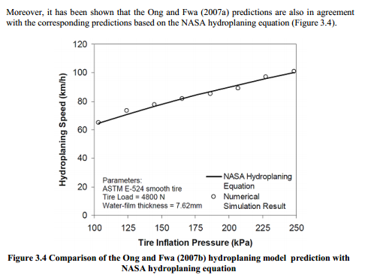
Figure 4. Comparison of simulation results with the NASA hydroplaning equation [40]
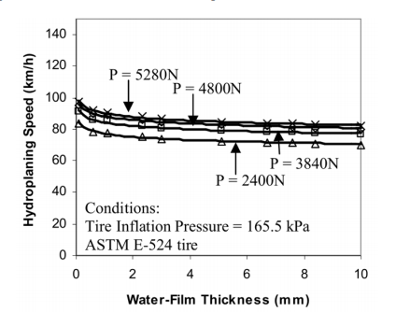
Figure 5. Influence of wheel load, water film thickness on hydroplaning speed [40]
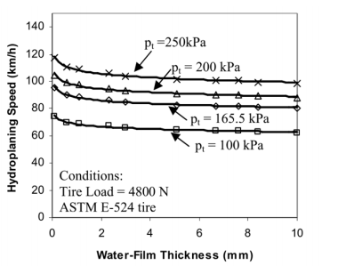
Figure 6. Influence of inflation pressure and water film thickness on hydroplaning speed [40]
Modified equations for truck tires
Similar to Horne’s truck tire equation, Equation (4), which takes into consideration the tire aspect ratio to evaluate hydroplaning speed, investigators derived a modified equation based on the results published by Ong et. al.
$$v_{p}=25{{(p_{t})}^{0.21}(\frac{1.4}{FAR})}^{0.5} (14)$$
Formula for calculating hydroplaning speed based on inflation pressure, wheel load and water thickness for truck tires can be represented as
$$v_{p}=a{{(p_{t})}^{0.21}(\frac{1.4}{FAR})}^{0.5}\left(\frac{0.268}{{t_{w}}^{0.651}}+1\right) (15)$$
Where ‘a’ is a constant obtained by curve fitting the data in Figure 7.

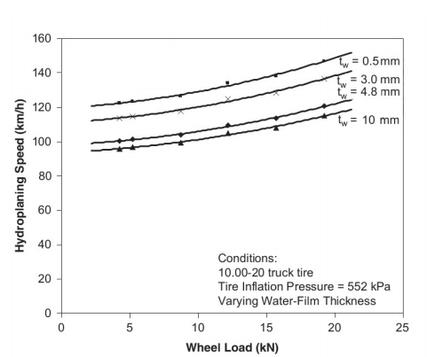
Figure 7. Influence of wheel load, water film thickness on hydroplaning speed of truck tires [40]
Considering a completely locked wheel [41] by comparing simulation data to experimental testing, it was found that the hydroplaning speed for a completely locked wheel can be obtained using Equation (16)
$V_{p}=5.43\sqrt{p_{t}} (16)$
For Equations (11)-(16)
$v_{p}$= vehicle hydroplaning speed in km/h
$t_{w}$= thickness of the water film in mm
$P_{t}$= tire inflation pressure in kPa
WL= wheel load in N
FAR= footprint aspect ratio

Influence of tire tread geometry on hydroplaning
Albert, B.J [18] has carried out extensive study to understand the influence of friction on wet road traction capability of a vehicle. He classified the factors influencing friction into four categories namely the road, tire, vehicle and speed. The impact of each was indicated on a scale of 1-10. Table 4 indicates the relative importance of each of these factors.
Table 4: Factors influencing friction[4]
Parameter | Condition | Impact
Road | Best to worst | 4 or 5 to 1
Tires | Worn completely smooth to best  new tire  Best to worst new tire | 2 or 2.5 to 1  1.5 to 1
Vehicle | Have little effect on straight ahead skidding. Effect on maximum sideway coefficient | 1.5 to 1
Speed | Effect of speed depends on all other factors, particularly road surface. Friction maybe practically zero at 150 km/h on some surfaces | 10 to 1
It can be seen that the tire, road and vehicle speed have a significant impact on the friction coefficient that influences hydroplaning. Albert also indicated the influence of tire tread geometry and materials on the brake force coefficient as seen in Figure 8.
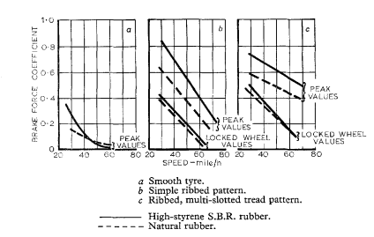
Figure 8. Influence of tire tread pattern on friction coefficient [4]
The graphs make it evident that tire tread design has a significant impact on the brake force coefficient attained. It is thus necessary to design the tread geometry appropriately to prevent hydroplaning. From Figure 8 it can be seen that the reduction in brake force coefficient with speed is least for the multi-slotted tread pattern tires. Also, the study indicated that smooth tires offer negligible brake force at speeds over 50 mph.
James. F. Sinnamon [5] carried out early research with experimental testing to find the influence of tread pattern on hydroplaning velocity. The author found that the hydroplaning speed for a fully patterned automobile tire is 10-12 mph higher than the hydroplaning speed for a worn out or a smooth tire. This is similar to the increase in hydroplaning speed when the tire pressure is increased from 15 psi to 30 psi. The influence of tread pattern on hydroplaning speed is so high because tread pattern features delay build-up of hydrodynamic pressure by providing channels for escape of water from the contact region. It was first observed that water depth had to be classified for the study of dynamic hydroplaning of treaded tires. The water depth that causes hydroplaning can be classified as follows:
- Deep water depth
- Shallow water depth
- Intermediate water depth
Horne’s [7] hydroplaning Equation (1) provides a useful approximation of deep water hydroplaning speeds of patterned tires. The values obtained are in between the hydroplaning speeds for a new patterned tire and a worn tire. It was found that the speed deviation of a tire with featureless full tread from Horne’s hydroplaning equation was a result of the increase in bending stiffness of the tire due to the presence of the solid tread. Horne’s hydroplaning equation takes into consideration a uniform contact patch with pressure equivalent to the tire inflation pressure. This can be attained for tires with minimal bending stiffness without the presence of a solid tread. It was observed that Horne’s equation is valid for cases with deep water on the surface when total hydroplaning takes place. Horne’s equation thus predicted total dynamic hydroplaning.
However in cases where shallow water prevails, which is typically observed in usual wet weather driving, it has been found that the hydrodynamic pressure produced at the leading edge of the water is not sufficient to cause hydroplaning of a patterned tire at normal highway speeds. Sinnamon [5] observed that the rapid drop in friction capability, as hydroplaning speed is approached, does not occur for a fully patterned tire in shallow water. However in case of a smooth tread tire moving in shallow water, this is a possibility, for which the concept of squeeze film penetration had to be introduced. When a portion of the tread in the contact patch is supported by a squeeze film partial hydroplaning is said to take place. Considering the contact pressure to be 75% of the tire inflation pressure [5], the speed at which partial dynamic hydroplaning occurs can be expressed as:
$V_{p}=7.2\sqrt{P_{i}}$ (17)
Where V_{p} is the hydroplaning speed in mph and P_{i} is the inflation pressure expressed in Psi. The author observed that the above equation provides an estimate of the speed at which partial hydroplaning will occur. However, the precise speed at which partial hydroplaning begins is difficult to determine.
Based on the observations made earlier, it is possible to increase the wet weather traction capability of the tires by making an increment in the groove area which in turn would reduce the tire road contact patch, thus increasing the tire load. This increased tire load with the added advantage of wider flow channels would help to improve wet weather traction. This can be considered similar to the case of increasing the tire inflation pressure, which reduces the contact area but increases the tire load and contact pressure. Reduced contact patch area however can induce the problem of tire tread wear and degraded handling performance.
Tread pattern has a significant impact on the occurrence of squeeze film hydroplaning. The effect of tread pattern is to reduce the size of the squeeze film in shallow waters. Maycock [42] found that for a typical ribbed tire, a rib width of less than 0.65 inches is necessary to prevent partial hydroplaning on a smooth highway with little or no micro texture. This width corresponds to a tire with 7 ribs. Advances in tread pattern design have however been made in recent years and tread design is not limited to longitudinally grooved tires. When implementing changes to tread design by varying groove width, it was found that above a particular groove width there were no changes in wet weather, shallow-water traction performance. Considering a tread pattern consisting on 5 longitudinal ribs, this critical groove width was between 0.1 inches and 0.2 inches [42].
Groove- rib interface study
It is necessary to study the hydrodynamic pressure build-up at the contact patch to understand the influence of groove-rib patterns on hydroplaning. The hydrodynamic pressure buildup at the grooves and beneath longitudinally grooved treads as a function of speed has been illustrated in Figure 9 [4]. The expulsion of water into the grooves is based on the presence of a pressure difference beneath the tire rib and the grooves. In shallow water conditions, the squeeze film beneath the tread is pushed into the grooves due to a pressure difference and the water is expelled through the groove channels. However in case of deep water conditions, the pressure buildup in the grooves along with the ribs increases. The difference in the pressure between the groove and ribs is marginal. This reduces the rate at which the water is expelled from the flow channels. Finally, the grooves become flooded and the presence of no pressure difference signals the onset of total hydroplaning.
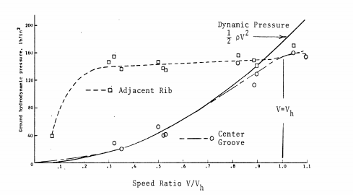
Figure 9. hydrodynamic pressure increase as a function of speed [4]
Figure 9 displays the increase in dynamic pressure as a function of speed. It can be seen that at low speeds the pressure difference between the grooves and the ribs is high thus allowing the water to be expelled out through the groove channels. As the speed increases, the pressure difference decreases and at a point when the groove pressure equals the rib pressure, total hydroplaning takes place.
Influence of tire sipes on hydroplaning
Sinnamon [5] explains that low friction prevails in coarse textured surfaces but for polished surfaces the presence of grooves might not be sufficient to prevent viscous hydroplaning. As mentioned earlier, the absence of pavement micro-texture leads to viscous hydroplaning. The process of introducing sipes or knife cuts in tires is to allow additional channels to expel water. They are extremely beneficial in improving wet weather traction on polished surfaces. Along with ribs and grooves, sipes are present in most modern day tires. When simple grooving becomes insufficient, the sharp edges of sipes provide high contact pressure points thus penetrating the water film. Sinnamon [5] states that sipes provide a temporary low pressure storage cavities for squeeze film water trapped beneath the tread ribs thus reducing the size of the squeeze film. Sipes also have at least one end opening into a groove thus providing an additional drainage passage. Typical design of sipes in modern day tires is shown in Figure 10.
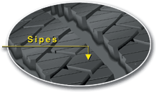
Figure 10. Representation of sipes on tires
Lee, K.S [43] studied the effects of sipes on viscous hydroplaning of pneumatic tires. Block type and rib type treads with sipes were studied. It was observed that for both types of tread patterns, the length of the sipe and the sipe angle has a significant impact on wet weather traction capability. Increasing the length of the sipes significantly improves the wet traction performance of tires. Limited research has been performed on the influence of sipes on viscous hydroplaning. However, all modern day tire manufacturers include sipes in the tread pattern as they provide improved traction performance. The influence of sipes on viscous hydroplaning can be an important area for academic research.
Effectiveness of tire groove patterns in reducing the risk of hydroplaning
Fwa [39] compared the hydroplaning speeds attained with tires having the same material and cross sectional properties but different groove patterns. As seen in Figure 11, a combination of longitudinal grooves and V-grooves produced maximum hydroplaning speeds. These results were attained for a water film thickness of 5 mm. It was observed that the presence of only longitudinal grooves in the tire produced a marginal increase in the hydroplaning speed. As mentioned earlier, the presence of only transverse grooves in the tire can lead to the problem of noise, vibrations and wear. Although very high hydroplaning speeds can be attained by using only transverse grooves, they are not preferred for use in modern automobiles. A combination of longitudinal grooves and transverse grooves along the edges with sipes included along the tire cross section is one of the most commonly observed groove patterns in modern day tires.
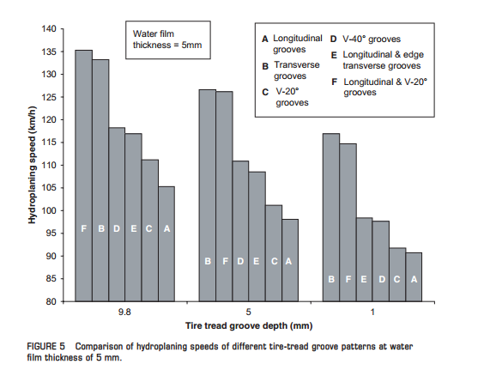
Figure 11. Comparison of hydroplaning speed of different tire-tread groove patterns [39]
Groove inclination angle also plays a vital role in increasing the hydroplaning speed. Fwa [39] studied the influence of groove inclination angle on hydroplaning speed. From Figure 12 it can be seen that the hydroplaning speed increases with increase in groove angle. This relationship also indicates the importance of sipes in modern day tires as their sharp angles of inclinations are greatly effective in increasing the hydroplaning speed.

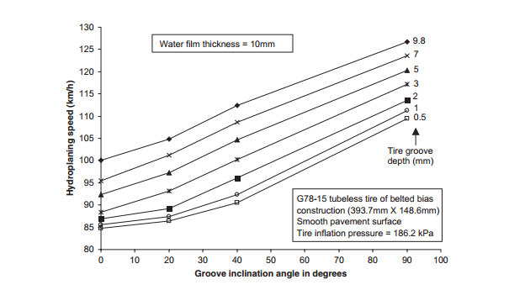
Figure 12. Influence of groove inclination angle on hydroplaning speed [39]
Seta et. al. [31] performed hydroplaning simulations for a tire with a blank tread and a fully patterned tread. From Figure 13, it can be seen that there is a very large reduction in hydrodynamic force generated when a tread pattern is included in the tire. The reduction in the hydrodynamic force generated with a fully patterned tire is much more significant as compared to a simple longitudinal or transverse grooved tire.
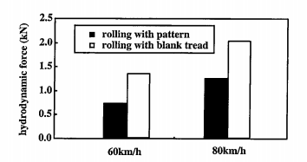
Figure 13 Effect of tread pattern on hydrodynamic force generated [31]
From Figure 14 we can see that the deformation at the leading edge is significantly reduced when a fully patterned tire is considered. This can be attributed to the reduction in the hydrodynamic force developed at the leading edge of the tire.
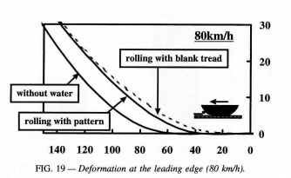
Figure 14 Deformation at the leading edge [31]
The amount of experimental and simulation data available for hydroplaning speeds obtained using a fully patterned tire is limited. Simulating hydroplaning for a fully patterned tire is a complex procedure because of the implementation of tread geometry to the tire using the global- local Finite Element approach [44-47]. This can be an important area for academic research. Development of new methods to incorporate tire tread pattern in Fluid Structure Interaction simulations is an active area of research.
Influence of pattern void on tire performance
Wies [48] studied the influence of pattern void on tire performance. Void is the air filled volume of grooves and sipes in a tread pattern complementing the volume of ribs and blocks made by rubber in ratio to the whole tread structure volume. Increase in void weakens the tread structure and can have a significant impact on tire traction capabilities in different driving conditions.
Increasing void provides additional space to absorb water in case of a flooded road surface. This reduces the contact area of the tire which is followed by an increase in contact pressure which helps the rubber blocks to penetrate the water film and results in an improved hydroplaning performance.
Contrarily, the larger void gives way to an increased air pumping effect and the higher contact pressures make the impact of the rolling rubber block to the road surface more intensive, which results in higher tire-road noise. Increasing the void makes the tread block structure softer and leads to a loss in dry handling behavior. Higher contact pressures also lead to increase in tire wear due to higher friction energy in the trailing area of the contact patch.
Another conflict in void influence can be found in the field of winter tire performance. Increasing void provides larger amount of snow interlocked with the penetrated tread pattern allowing for higher traction forces necessary to shear the snow. By contradiction higher void and a smaller contact area decreases ice braking behavior, which is due to viscous friction in a thin liquid layer between rubber and the icy surface.
Thus a tread pattern and void structure has to be decided based on a number of performance factors under different driving conditions. A tread pattern optimal for wet traction will perform poorly under other driving conditions.

Wet weather braking performance
In modern vehicles with application of Anti-Lock Braking Systems (ABS) it is of great importance to study the wet weather traction performance and vehicle braking performance close to hydroplaning velocities on water logged pavement surfaces.
L.D. Metz [49] studied the hydroplaning behavior during steady state cornering by means of experimental testing on a pavement with water depths close to 0.1 inch-0.2 inch. It was observed that wet pavement deceleration rates averaged ~ 0.4g while dry pavement deceleration rates were ~ 0.85g. As seen in Figure 15, some ABS cycling of both the right front (WSFR) and right rear (WSRR) wheels were noted during the test on the high-µ dry surface, though the right rear cycling was considerably less than that experienced at the right front wheel. In case of the wet pavement, there was some ABS activity at the right front wheel and essentially no ABS cycling at the right rear wheel. This demonstrates that the right front wheel cleared a path for the right rear wheel inducing higher tire/road adhesion for that rear tire. Stopping distances for both cases are quite close, indicating that, as expected, most braking takes place at the front wheels. All four wheels for both tests have an inflation pressure of 32 psi.
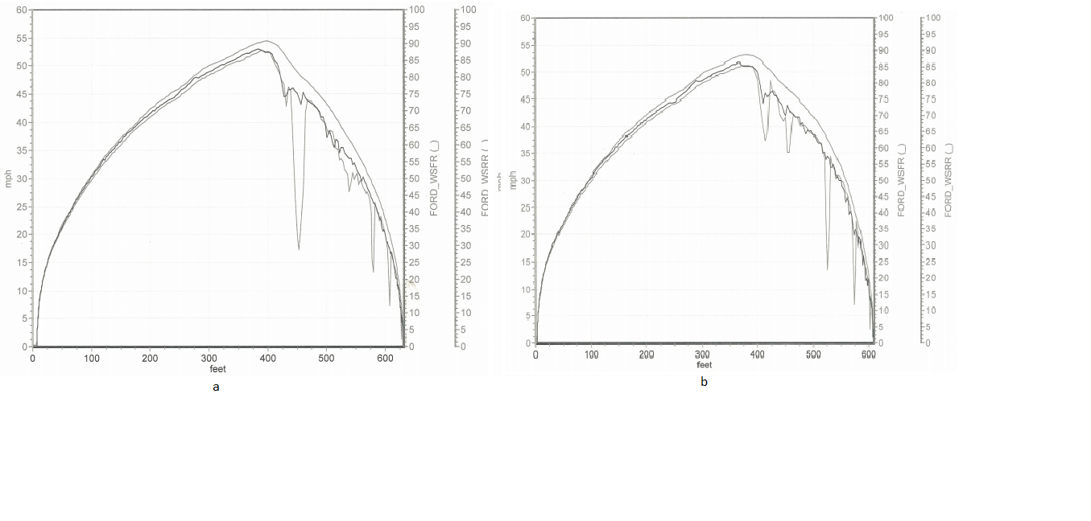
Figure 15 ABS activity on dry (a) and wet pavement surfaces (b) [49]
Figure 16 shows different characteristics for wheel speed values than those obtained in Figures 14 for normal inflation pressures. Instead of ABS cycling at the front wheel and little at the rear wheel, the pattern of tire behavior is completely reversed. With reduced tire pressure, test results indicate that the rear wheels of the vehicle do not generate sufficient local pressure underneath the tire to eject water, even when they are running in a path cleared by the front tire. Because of this, the rear tire ABS behavior shows nearly continuous cycling during the braking maneuver. The braking distance has also significantly increased with reduction in the inflation pressure. Thus the experimental tests correspond to Horne’s hydroplaning Equation (2).
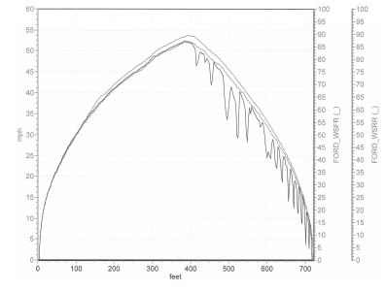
Figure 16 ABS activity with reduced inflation pressure of 15 psi [49]
Use of commercial finite element codes for braking simulations
J.R. Cho [32] simulated the braking performance of a patterned tire using commercial finite element software. The simulation was performed by coupling Lagrangian finite element method and Eulerian finite volume method. The braking simulations were carried out at a water depth of 10 mm. The effects of ABS can also be induced by considering appropriate angular velocities for braking simulations. Referring to Figures 17 (a) and (b), both of the frictional forces on wet and dry roads decrease at the beginning but increase with the vehicle speed, and the wet road condition produces smaller frictional force than the dry road condition regardless of the vehicle speed. These simulations show that commercial FE codes can now be used to simulate experimental hydroplaning testing. Both the experimental tests [49] and FE simulations for ABS [32] showed a 20 % increase in braking distance in wet surface as compared to a dry surface.
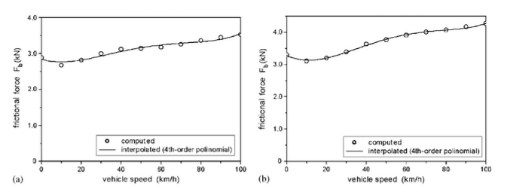
Figure 17 Frictional force versus vehicle speed at braking: (a) wet road (b) dry road [32]

Conclusion
Pavement grooving and tire tread patterns were reviewed and their influence on hydroplaning speed was established. Hydroplaning occurs when the combined capacity of tire and pavement grooves is not sufficient to expel the water out of the tire contact patch in limited time and the total fluid lift force is equal to the wheel load. As the vehicle velocity increases, the hydrodynamic pressure due to water builds up at the contact patch thus increasing the possibility of occurrence of hydroplaning at higher vehicle speeds.
Using finite element simulation models and experimental data, it was observed that pavement grooving had a far more significant impact on increasing hydroplaning speeds as compared to tire tread grooving. Transverse pavement and tire grooves were more effective in raising the hydroplaning speed as compared to longitudinal grooves. Number of factors such as noise, wear, skid resistance and maintenance limit extensive use of transverse grooves, therefore longitudinal grooves are the preferred methods of pavement grooving in highways. Modern treaded tires have limited use of transverse grooves and most tires have longitudinal grooves with few transverse grooves and sipes cut in them. The tread pattern geometry in itself is a vast area of research.
In real world driving, dynamic hydroplaning is more prevalent as compared to viscous hydroplaning. Pavement macro-texture is an effective method to prevent dynamic hydroplaning whereas lack of pavement micro-texture can lead to viscous hydroplaning. Sipes in tires can be used to prevent viscous hydroplaning.
Tire tread patterns have a significant impact on vehicle hydroplaning. Effective use of treads can lead to an increase of hydroplaning speeds by 10-12 mph as compared to smooth pattern less tires.
It can therefore be concluded that grooves on tires and pavements have to be selected appropriately taking into account a number of factors such as speed, noise, wear and skid resistance. An optimal design can be established taking into consideration the use of the roadway and tire. Pavement grooves can be designed depending on the roadway use; whether the purpose of the roadway is for highways, city driving or aircraft runways. Similarly tire treads can be designed specifically for wet weather driving or all-season tire treads can be designed similar to those used in modern automobiles.

Future scope
As discussed previously, vehicle hydroplaning can lead to serious road accidents and it is necessary to study tire-pavement interactions to devise optimum methods to prevent hydroplaning. Limited efforts have been taken by researchers to study the interactions between actual road surfaces and treaded tires. Valuable insight could be obtained if simulations are carried out between actual treaded tires used by tire manufacturers and mapped pavement surfaces which consist of macro-texture and micro-texture. These would help to validate simulations with real world experimental data. If a treaded tire model is made available by tire manufactures and if a terrain profile is available, it would be possible to simulate real world hydroplaning conditions using FE codes. However these simulations would require a lot of computational effort hence it is also necessary to look into other Fluid Structure Interaction (FSI) formulations.
Another alternate method to predict and prevent hydroplaning is by the use of Intelligent Tires Systems. By placing sensors or accelerometers in tires, it would be easier to calculate the frictional loss at the onset of hydroplaning. It is also possible to measure the tire footprint area using optical sensors to detect the reduction in the contact patch at the onset of hydroplaning. Accelerometers fitted in the inner liners of the tires are the most preferred method to predict hydroplaning [50-52]. The longitudinal acceleration data attained using the accelerometers can be used to estimate the contact patch length, deformation of the contact patch and this data can be used to predict hydroplaning. This feedback can be then sent to the vehicle ECU using active control systems to decelerate the car. Also as observed previously, there is limited data which explains hydroplaning speeds attained during cornering and for different slip angles. Availability of such simulation data would facilitate the development of intelligent tire systems.
A lot of research involving intelligent tires is being carried out; however these methods are limited to small slip angles and limited tire models. The use of sensors also raises the issue of increased cost to implement the intelligent tire system in cars. For mass production of such intelligent tires, development of a low cost system is an active area of research. As mentioned previously, simulating hydroplaning with treaded tire models on real world mapped terrain models would be of great importance for future research in this field.
Vehicle hydroplaning is thus an active area of research and has a number of applications in intelligent tire systems which can greatly improve vehicle safety and reduce the road accidents caused during wet weather driving.

References

1. Sillem, A., Feasibility study of a tire hydroplaning simulation in a monolithic finite element code using a coupled Eulerian-Lagrangian method, in Delft university of technology. 2008.
2. T.F Fwa, K.A., G.P. Ong, Relative effectiveness of grooves in tire and pavement in reducing vehicle hydroplaning risk. Transportation Research Record, 2010. 2155: p. 73-81.
3. Koishi, T.O.M., Hydroplaning Simulation using MSC. Dytran, in The Yokohoma Rubber Co. LTD. 2001: Japan.
4. Allbert, B.J., Tires and Hydroplaning. SAE Paper 680140, 1968.
5. Sinnamon, J.F., Hydroplaning and tread pattern hydrodynamics, in Highway safety research institute/ University of Michigan. October 1974. p. 132.
6. Kosgolla, J.V., Numerical simulation of sliding friction and wet traction force on a smooth tire sliding on a random rough pavement. 2012, University of South Florida.
7. Horne, W.B., and Dreher, R. C. , Phenomena of pneumatic tire hydroplaning, in National Aeronautics and Space Administration, Washington, D.C. 1963.
8. Horne, W.B., Yager, T.J and Iveyd.L, Recent studies to investigate effects of tire footprint aspect ratio on dynamic hydroplaning speeds. American society for testing and material, 1986. ASTM STP 929: p. 26-46.
9. Gengenbach, W., Experimental investigation of tires on wet pavements, in Automotive technology magazine. 1968. p. 70, 83-89, 288-293, 310-316.
10. Gallaway, B.M., Pavement and Geometric Design Criteria for Minimizing Hydroplaning. , in Federal Highway Administration 1979.
11. Mounce, J.M., Hydroplaning and roadway tort liability. Transportation Research Record, 1993(1401): p. 117.
12. V. Cerezo, M.G., M. Menissier, Hydroplaning speed and infrastructure characteristics. Proceedings of the Institution of Mechanical Engineers, 2010. 224(J9): p. 891.
13. A.J. Stocker, J.M.L., Variable associated with automobile tire hydroplaning. 1972, Texas Transportation Institute.
14. J. E. Martinez, A.J.S., A study of variables associated with wheel spin-down and hydroplaning. 1972, Texas Transportation Institute.
15. Gray, W.E., Measurements of 'Aquaplaning Height' on a Meteor Aircraft, and photos of flow pattern under a model tyre, in Aeronautical Research Council Current Papers. 1964: Ministry of Aviation.
16. Barrett, R.V., Drag and spray measurements from a small pneumatic tyre travelling through a water layer, in Technical Information and Library Services. 1963: Ministry of Aviation.
17. Gough, V.E., Badger, D.W. Tyres and Road Safety. in Fifth World Meeting of the International Road Federation. 1966.
18. J.C.Walker, B.J.A.a., Tyre to Wet Road Friction at high speeds. Proc Institution of Mechanical Engineers, 1965-66. Vol 180.
19. Board., H.R., Skid resistance. 1972: National Cooperative Highway Research Program Synthesis of Highway Practice, No. 14, Washington, D.C.
20. J.Y. Jeong, H.Y.J., Hydroplaning simulation of a tire in thin water using FEM and an estimation method and its application to skid nuber estimation. International journal of automotive technology, 2012. 14(2): p. 325-331.
21. Changyong, C., Skid resistance and hydroplaning analysis of rib truck tires, in Department of Civi and Environmental Engineering. National University of Singapore.
22. Moore, D.F., Prediction of skid resistance gradient and drainage characteristics for pavements. 1966: Highway Research Record.
23. Ong, T.F.F.a.G.P., Wet-Pavement Hydroplaning Risk and Skid Resistance. Joural of transportation enginering, 2008. 134(5): p. 182-190.
24. Horne, W., Yager, T. and Taylor, G, Review of Causes and Alleviation of Low Tire Traction on Wet Runways. 1968: NASA Technical Note.
25. Agarwal, S.K., Braking Performance of Aircraft Tires. Prog. Aerospace Sci, 1986. Vol. 23: p. 105-150.
26. Yager, T., Phillips, W.P. and Hore, W., A Comparison of Aircraft and Ground Vehicle Stopping Performance on Dry, Wet, Flooded, Slush, Snow, and Ice Covered Runways. 1970: NASA Technical Note.
27. Masataka Koishi, T.O., Hydroplaning simulation using fluid-structure interaction in LS-Dyna, in 9th international LS-DYNA users conference. 2006: Michigan.
28. T. W. Kim, H.Y.J., Hydroplaning simulations for tires using FEM, FVM and an asymptotic method. International journal of automotive technology, 2010. 11(6): p. 901.
29. J.R. Cho, H.W.L., J.S.Sohn, Numerical investigation of hydroplaning characteristics of a three-dimensional patterned tire. European Journal of Mechanics and Solids, 2006. 25.
30. Stephane Vincent, A.S., Augmented Lagrangian and penalty methods for the simulation of two-phase flows interacting with moving solids. Application to hydroplaning flows interacting with real tire tread patterns. Journal of computational physics, 2011. 230: p. 956-983.
31. Seta. E, N.Y., Kamegawa, T., Hydroplaning analysis by FEM and FVM: effect of tire rolling and tire pattern on hydroplaning. Tire Science and Technology, 2000. 28: p. 140-156.
32. J.R. Cho, H.W.L., A wet-road braking distance estimate utilizing the hydroplaning analysis of patterned tire. International journal of numerical methods in Engineering, 2007. 69: p. 1423-1445.
33. Bathe K.J, Z.H., Finite Element Developments for General Fluid Flows with Structural Interactions. International journal of numerical methods in Engineering, 2004. 60: p. 21-32.
34. Huo Wang, I.L., Al-Qadi, Simulation of tyre-pavement interaction for predicting contact stresses at static and various rolling conditions. International journal of Pavement Engineering, 2012. 13: p. 310-321.
35. Fwa, G.P.O.a.T.F., Transverse Pavement Grooving against Hydroplaning. I: Simulation Model. Journal of Transportation Engineering 2006. 132: p. 441-448.
36. T.F Fwa, K.A., G.P. Ong, Transverse pavement grooving against hydroplaning. II: Design. Journal of Transportation Engineering 2006. 132: p. 449-457.
37. Ong, G.P.a.T.F.F., Analysis of Effectiveness of Longitudinal Grooving against Hydroplaning. Transportation Research Record: Journal of the Transportation Research Board, 2006(1949): p. 113-125.
38. S.K Srirangam, K.A., A.Scarpas C Kasbergen, Hydroplaning of rolling tires under different operating conditions, in Airfield and Highway pavement conference. 2013, American Society of Civil Engineers: Los Angeles, CA, USA. p. 561-72.
39. T. F. Fwa, K.A.a.G.P.O., Effectiveness of Tire-Tread patterns in Reducing the Risk of Hydroplaning. Transportation Research Record: Journal of the Transportation Research Board, 2009. 2094.
40. M. Gunaratne, Q.L., Hydroplaning on Multi Lane Facilities. 2012: Florida department of transportation.
41. Srirangam Santosh Kumara, K.A., Study of Hydroplaning Risk on Rolling and Sliding Passenger Car. Procedia - Social and Behavioral Sciences, 2012. Volume 53: p. 1019–1027.
42. G, M., Experiments on tire tread patterns, in Road Research Laboratory Report. 1967.
43. Lee, K.S., Effect of sipes on viscous hydroplaning of Pneumatic Tires. Tire Science and Technology, 1998. 26(1): p. 23-35.
44. A. Saha, P.G., An Approach to Include Tread Pattern Geometry in FEA for Better Tyre Performance Prediction, in 2005 Abaqus Users Conference.
45. Cho, J.R., Kim, K.W.,, Mesh Generation Considering Detailed Tread Blocks for Reliable 3D Tire Analysis. Advances in Engineering Software, 2004. 35: p. 105-113.
46. Nikola Korunovic, M.T., Tire tread modelling for FEA, in 34th International Conference on Production Engineering. 2011: Serbia.
47. Korunovic, N., Detailed vs. Simplified Tread Tire Model for Steady-State Rolling Analysis. Journal for Theory and Application in Mechanical Engineering, 2012. 54: p. 153-160.
48. B. Wies, B.R., Influence of Pattern Void on Hydroplaning and related Target Conflicts. Tire Science and Technology, 2009. 37(3): p. 187-206.
49. Metz, L., Hydroplaning behaviour during Steady- State Cornering. SAE Int. J. Mater. Manuf., 2011. 4: p. 1068-1079.
50. Giorgia Audisio, C.F., Cyber Tyre: A Novel Sensor to Improve Vehicle's Safety, in SAE 2011 World Congress & Exhibition. 2011: Detroit, MI.
51. Arto Niskanen, A.T., Three axial accelerometers fixed inside the tyre for studying contatc patch deformations in wet conditions. Vehicle System Dynamics: International Journal of Vehicle Mechanics and Mobility, 2014. 52(Supplement 1): p. 287-298.
52. Vincenzo D'Alessandro, S.M., Phenomenological analysis of hydroplaning through intelligent tyres. Vehicle System Dynamics: International Journal of Vehicle Mechanics and Mobility, 2012. 50: p. 3-18.

