Feeding America Southwest Virginia
  - Converting FASWVA’s Website to Drupal and creating a Virtual Food Drive
  - CS4624 Spring 2013, Virginia Tech, Blacksburg, Virginia
  - Bradley Bailey, Sarah Dotson, Susan Feng, Lance Han, Sean Kelly, and Hunter Shepherd

Table of Contents
Executive Summary 4
Client’s Manual 5
Website 5
Change the Banner 5
Insert Module 7
WYSIWYG Module 10
Deleting Content in the CURRENT EVENTS Sidebar 12
Adding Content to the CURRENT EVENTS Sidebar 12
Adding New Content 16
Virtual Food Drive 17
What is a Virtual Food Drive? 17
Advantages of a Virtual Food Drive 17
Setting up Click and Pledge Payment in Drupal 17
Adding New Items 19
Developer’s Manual 21
Concept Map 21
Future Work 24
Next Steps 24
Multimedia 25
Lessons Learned 26
Timeline 26
Problems and Solutions 27
Development Site 27
Slow Up Speed 27
Missing Video Files 27
Learning Curve for Modules 27
Module Functionality 27
Acknowledgements 28
Erich Geist – FASWVA 28
Amy Milberger – No longer with FASWVA 28
Amy Wilson – No longer with FASWVA 28
Bradley Bailey – Virginia Tech 28
Sarah Dotson – Virginia Tech 28
Susan Feng – Virginia Tech 28
Lance Han – Virginia Tech 29
Sean Kelly – Virginia Tech 29
Hunter Shepherd – Virginia Tech 29
Works Cited 30
Appendix A 31
Hunger Quiz 31
Answer Key 31
Helpful Definitions: 33
Questions for Discussion: 33
Appendix B 34
An evening with…..YOUNG ARTISTS AGAINST HUNGER Feeding Body and Soul 34
We’d like to share a true story…. 34
Facts 34
Opportunity 35
Talent 35
Replication 36
You can make a genuine difference 36
Appendix C 37
Feeding America Style Guide 37
Primary Colors 37
Secondary Colors 37
Master Logo Versions 38
Improper Usage 38

Executive Summary
This report provides a detailed account of our progress on the Feeding America Southwest Virginia (FASWVA) website conversion from Joomla! to Drupal, starting with an in-depth look at the differences between Joomla! and Drupal. A Virtual Food Drive was created to meet a multimedia need of FASWVA, to have more interactive donating. This report includes information for future FASWVA personnel, future developers, and how our group has progressed and problems we ran into. New personnel need to understand the point of the FASWVA website and the Virtual Food Drive, editing and user manuals will help them as they start at FASWVA. Future FASWVA personnel will be able to see the new site, along with a manual for easy editing and manipulation. Future CS 4624 students will be able to pick up where our group has left off using our documentation and recommendations. Our group’s progress will be shown using a concept map, timeline, and a description of problems we ran into and how they were overcome.
As a result of efforts throughout the semester, we have made a fully functional website that is ready to be moved over to FASWVA’s host and made live. Additionally, we have completed a Virtual Food Drive, which is a way for the user to experience the act of shopping for food for others rather than donating a flat monetary amount. FASWVA personnel will be able to update content as well as encourage companies and individuals to hold food drives using the Virtual Food Drive.
The report finds Drupal to lead to easier editing and shows the Virtual Food Drive will improve the user’s experience while donating. The next step is to perform analytics after the website goes live. Recommendations discussed in the conclusion include:
- Launching the website
- Training personnel
- Perform regular audits on the website
- User test the Virtual Food Drive
Future groups should consider taking up the following multi-media aspects of this project:
- Hunger Quiz
- Hunger Simulation
- Peer to Peer Food Drives and Fundraisers
- Testimonies on Website
- Television Ready Promotional Video

Client’s Manual

Website
The new version of the FASWVA website will allow for a fuller user experience but more importantly the new website is easy to update and comes complete with a client’s manual.

Change the Banner
- Create the desired image and save it onto the desktop. For this example, I will be using Test-Banner.jpg
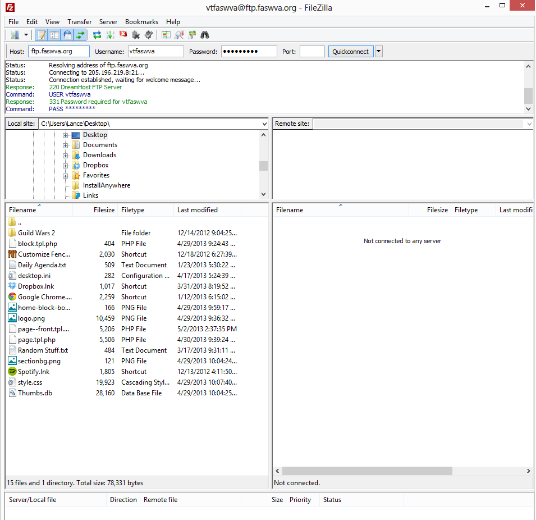
- Through a desirable FTP software, login with credentials to access the File Transfer Protocol
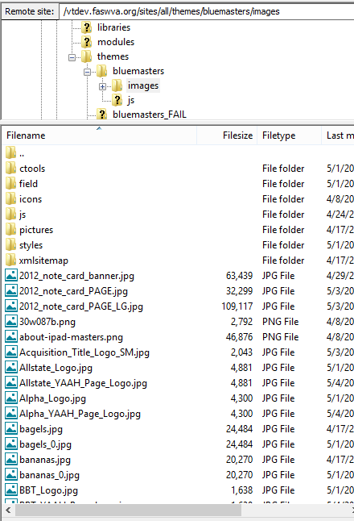
- Find the local file location using the file structure shown below.
- Locate the images file in the website’s FTP from the bottom right navigation panel. (Path: /vtdev.faswva.org/sites/all/themes/bluemasters/image
- Drag and drop the image from the left panel to the right panel.
- Open up the page—front.tpl.php file with notepad or any text-editing software.
- Find the <div id=”banner”> tag near the middle of the file.
- Create another <a> reference tag for extra banners or simply replace the URL.
- Replace URL in the <div class=”paging”> tag with the desired redirecting link.

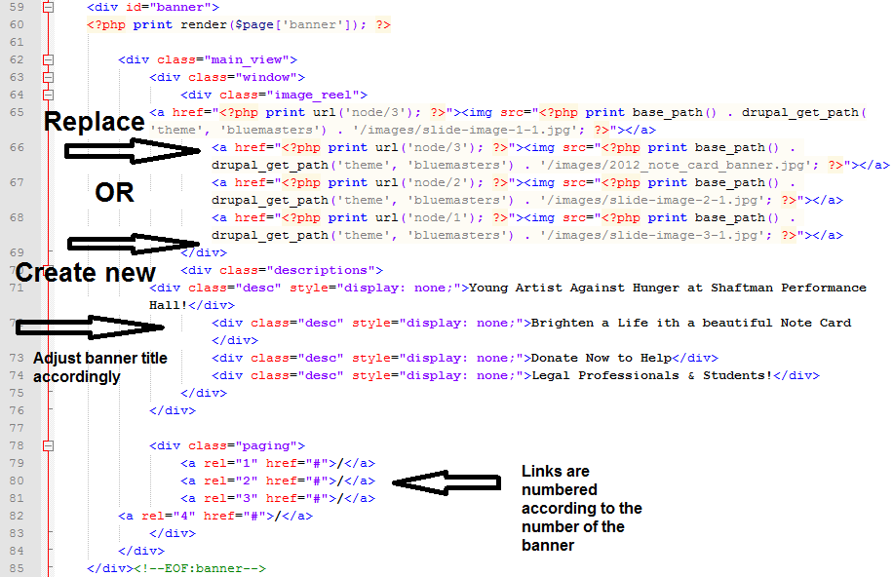
Insert Module
Description: The Insert module allows one to insert images, in addition to adding links a lot quicker with the WYSIWYG Editing Module.
Requirements:
- An existing installation of the WYSIWYG Module and an enabled editor compatible with WYSIWYG.

Instructions for installation:
- Make sure one of the editors of WYSIWYG module is enabled. If you do not have WYSIWYG installed please see the instructions below on how to install the WYSIWYG module.
- Download the Insert module (see link below). Be sure to download the correct version that is compatible with your Drupal installation.
http://drupal.org/project/insert
- Extract downloaded folder to the location of your Drupal installation, under sites/all/modules.
- On a browser, go to your Drupal site and log on.
- Go to Modules, and enable the Insert Module.

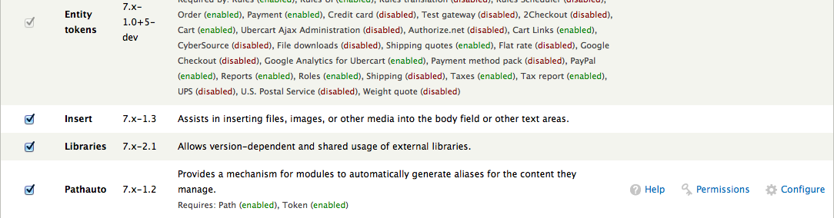

- After you saved the changes, go to Structure/Content on your browser. For each Content Type you would like the Insert module to be active in, go to manage fields.
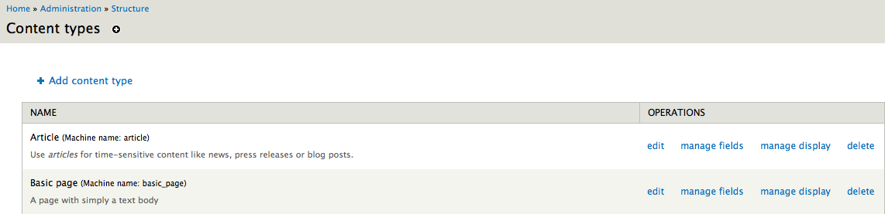

- Select edit under the Image label.

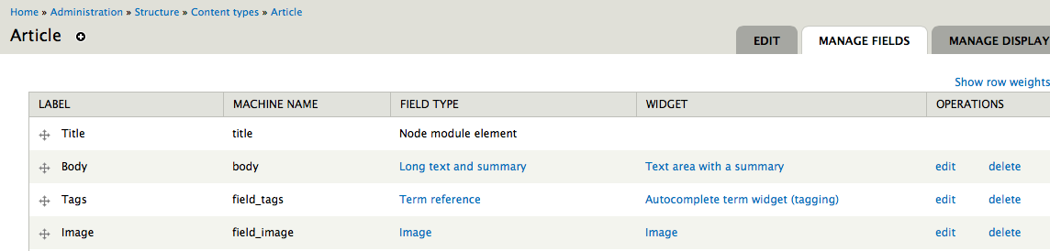

- Scroll down till you find the INSERT option and expand it.

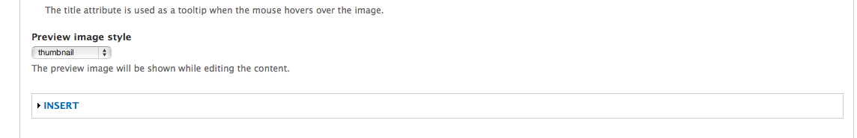
- Select the “Enable insert button” and under “Enabled insert styles”, select the styles you would like available. Next hit the Save Setting button on the bottom of the page.

- To make the installation worked, go to Add new Content and you should be able to see the following option available after you upload an image.

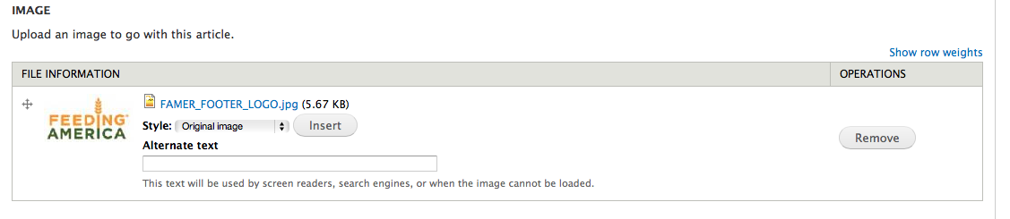

- To use the click and drag feature of the Insert Module, first make sure the Text Format is Full HTML (first image below) and then select the Insert button next to the image you uploaded (second image below).


- In your text editor now you should see the image you just uploaded. Now you are able to position the image by clicking and dragging among your content, in addition to resizing the image.

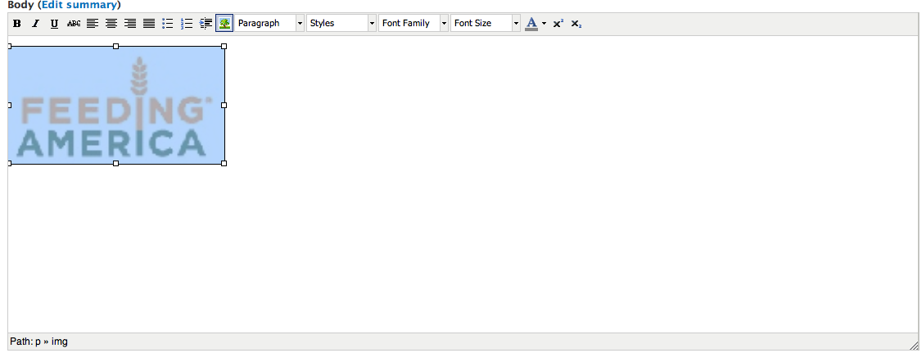

WYSIWYG Module
Description: The WYSIWYG module allows users to use client side editors to edit content. The following editors are supported: CKEditor, FCKeditor, jWysiwyg, markItUp, NicEdit, openWYSIWYG, TinyMCE, Whizzywig, WYMeditor, and YUI editor. The editor this manual is going to use is TinyMCE.
Instructions for installation:
- Download the WYSIWYG module from the Drupal website (see link). Be sure to download the version that is compatible with the version of Drupal installed.
http://drupal.org/project/wysiwyg
- Extract the compressed file to the location of your Drupal installation, under sites/all/modules. If the Module directory does not exist, make a modules folder.
- Download the TinyMCE module (see link). Select the appropriate package for your installation.
http://www.tinymce.com/download/download.php
- Once the download has been completed, extract the downloaded content to the location of your Drupal installation, under sites/all/libraries. If the libraries directory does not exist, make one. Therefore your directory list should be the location of your drupal_installation/sites/all/libraries/tinymce
- On your browser, go to the Drupal Site
- Go to Modules and enable the WYSIWYG module.
- Go to Configure (see figure below for location) and expand INSTALLATION INSTRUCTIONS. If you scroll down you should see besides TinyMCE the version that you’ve installed. If you do not see that, please make sure you’ve placed the tinymce folder under sites/all/libraries.

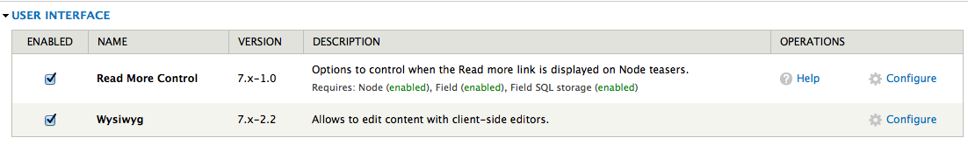
- For each of the text formats, go to edit, BUTTONS AND PLUGINS, and enable the buttons that you would like to show up on your content editor.
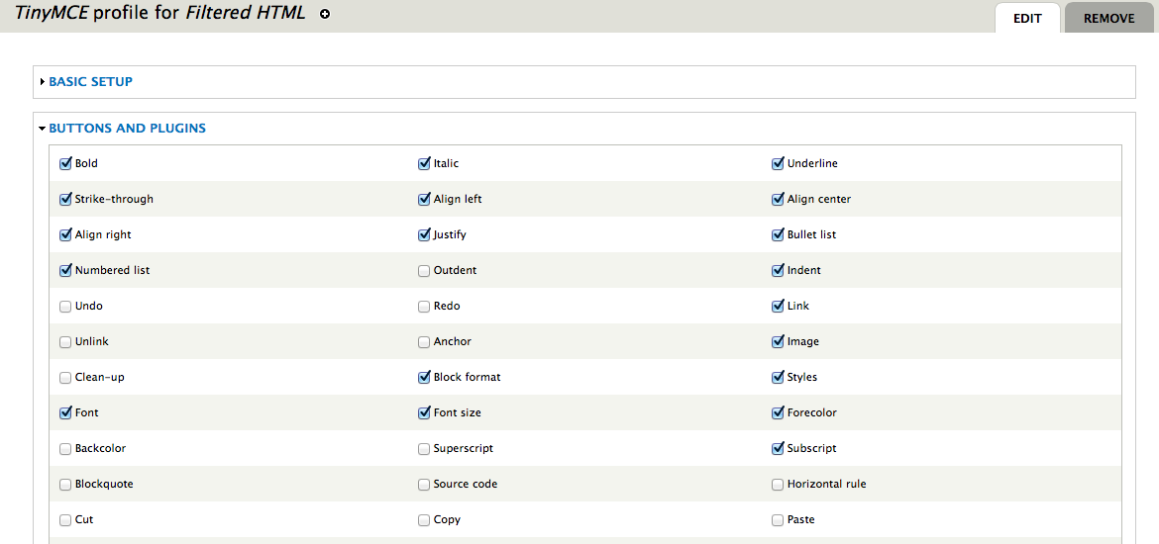
Be sure to select the link button for all Text Formats.
- To check to make sure your installation went correctly, add a new content type. Your content editor should now look like:

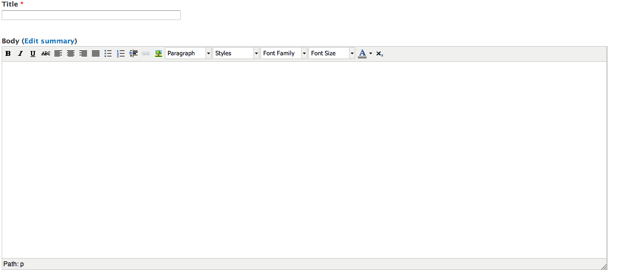
The buttons/plugins will differ depending on the options you enabled.

Deleting Content in the CURRENT EVENTS Sidebar
Description: Deleting a specific article in the CURRENT EVENT Sidebar.
Instructions for deleting content:
- On your browser go to your Drupal site and log in.
- Once logged in, go to Structure -> Blocks.
- Under Sidebar First, select the configure option for CURRENT EVENTS.

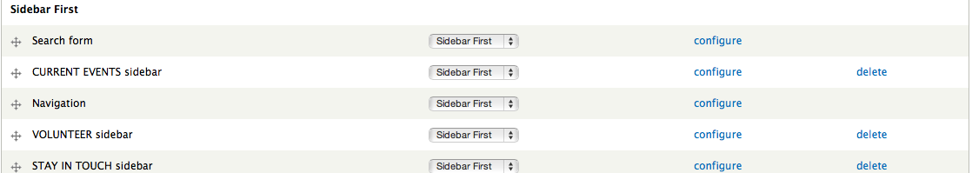

- Under Block body delete the title of the article you would like to delete and save.

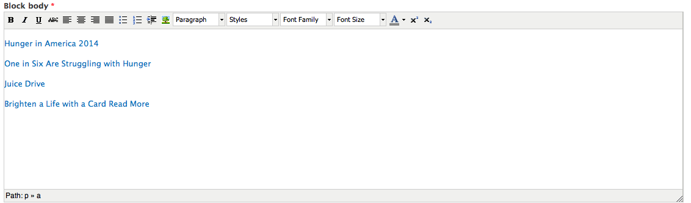
- Next go to Content and delete the article that is associated with the title you just deleted in the previous step.
- Refresh one of the pages that shows the CURRENT EVENTS sidebar and you should see that the link for the article has been removed.

Adding Content to the CURRENT EVENTS Sidebar
Description: Adding content to the CURRENT EVENTS sidebar. If the article already exists skip to step #4.
Instructions for adding content:
- On your browser go to you Drupal Site.
- Go to Content -> Add Content. Here you can select either an article or a basic page.
- Fill in your content in the appropriate spaces. Once done, under Publishing options unclick “Promoted to front page.” Save your content.

- If it doesn’t automatically take you back to the Content screen (see below), go to Content.

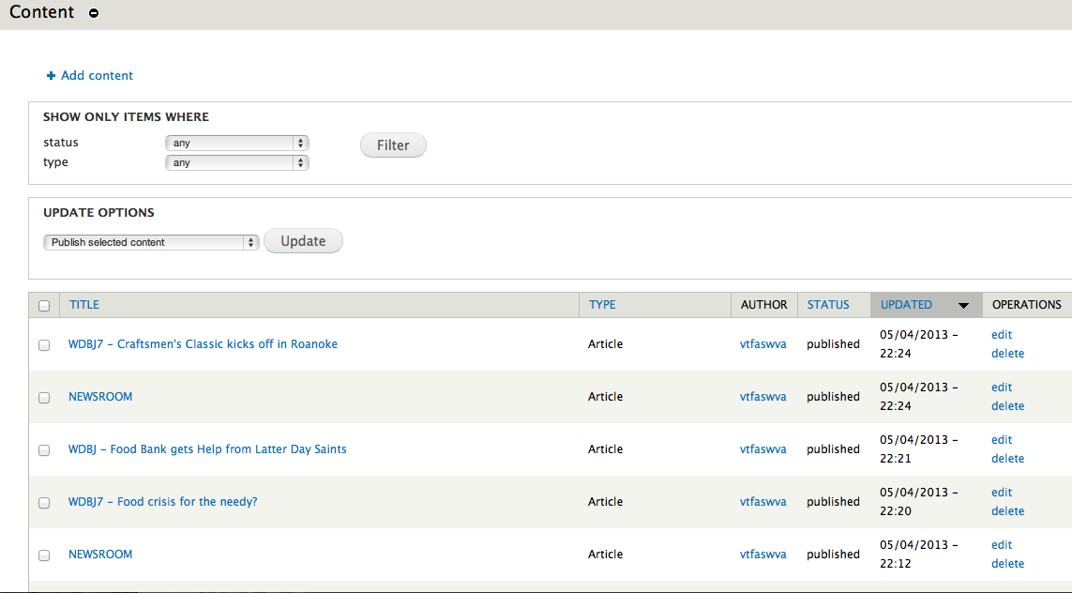
- Click on the article you’ve created under the TITLE column. For an example see below.
- Copy and paste the URL. Be sure to include http://.

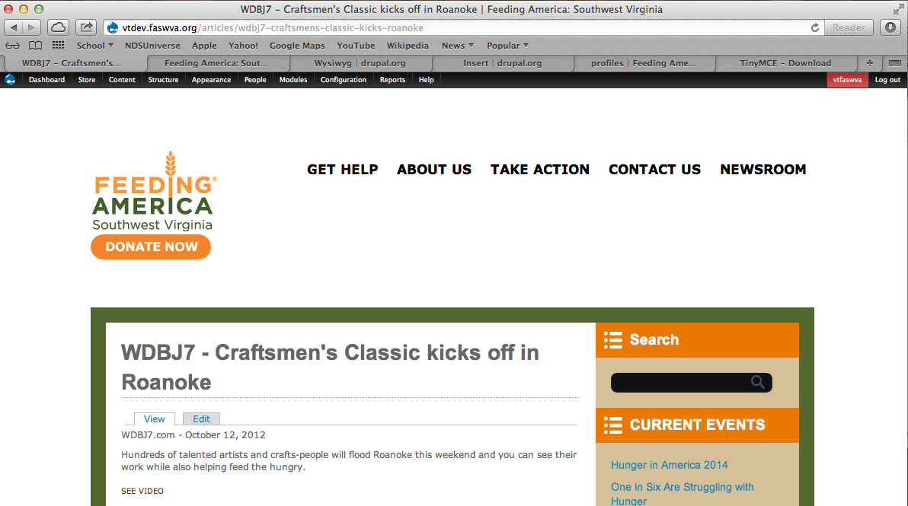
- Go to Structure -> Blocks. Under Sidebar First select the configure option for CURRENT EVENTS.

- Under Block body, type the title of your event on a new line.

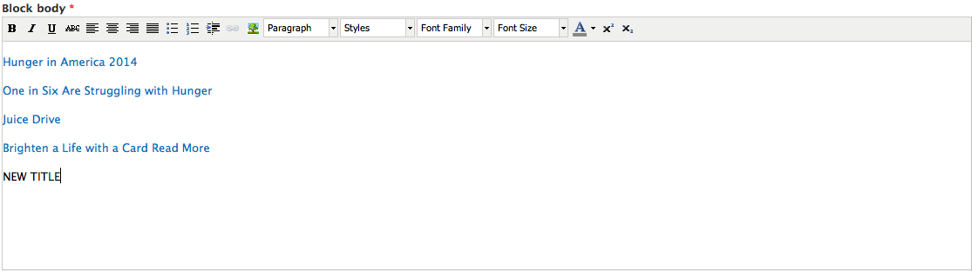
- Select the title you’ve just typed and select the link option on the toolbar. (Shown below)

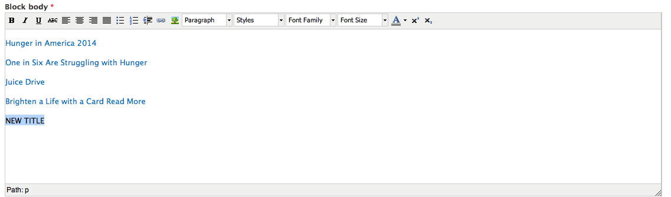
- Paste the URL you copied earlier in the link URL box and type your title in the Title text box.

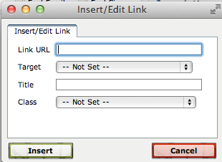
- Click Insert and Save on the bottom of the page.
- Refresh one of the pages that shows the CURRENT EVENTS sidebar and you should now see that the link for the new article has been added.

Adding New Content
Description: Adding new Content to your site and placing it under the right directory.
Instructions for adding new content:
- On your browser, go to your Drupal Site.
- Go to Content -> Add Content. Here you can select either an article or a basic page.
- Fill in your content in the appropriate spaces.
- To specify under which menu option the content should be contained in, go to Menu Settings and enable the “Provide a menu link.”

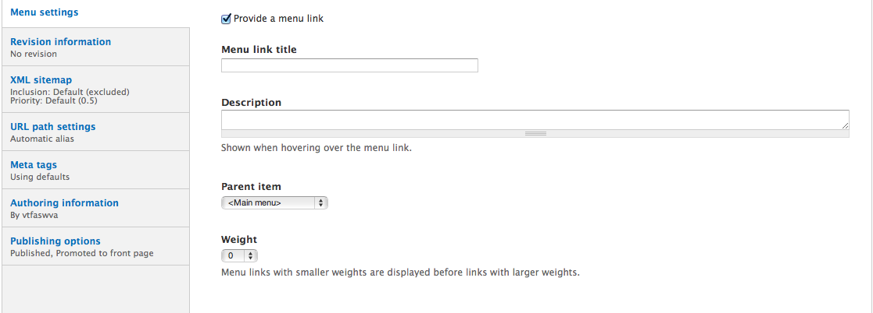
- Under Parent Item you should now be able to select which option you would like your new content to go under.

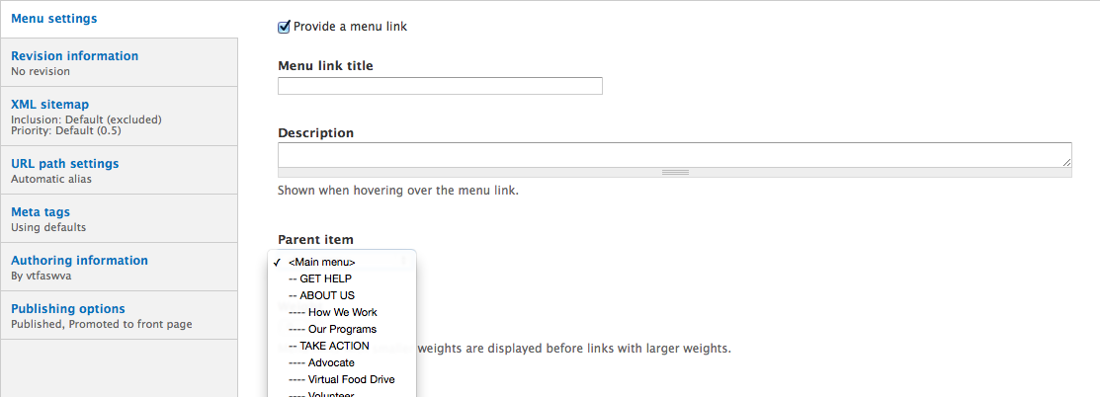
- Under Publishing options unclick “Promoted to front page.” Save your content.

Virtual Food Drive

What is a Virtual Food Drive?
A Virtual Food Drive is a web-based tool that allows individuals to participate in food drives regardless of their access to a food drop off location. This makes it possible for individuals to help a food drive from the comfort and convenience of their own home or workplace. The items that are able to be purchased are placeholders to help people understand how much their contribution will help the FASWVA food bank.

Advantages of a Virtual Food Drive

Convenient:
People who are busy or live far away from a drop off location can participate in minutes from their computer.

Easy and fun:
Virtual Food Drives are user friendly and interactive. They are similar to other online shopping experiences so users feel comfortable and can focus on the people they are helping.

Efficient:
Food banks spend valuable time and money storing and sorting food that are not able to be given away because it is too damaged. Buying in bulk allows for food banks to have more control over the foods that are distributed so they can buy hardier food that will store longer and is pre-sorted.

Administration:
Virtual Food Drive contributions are easy to keep track of because all of the funds go through the Click & Pledge site. There is no need to tally food products because the funds can be used where the food bank needs them.

Setting up Click and Pledge Payment in Drupal
The following instructions can be found at http://manual.clickandpledge.com/CiviCRM-Drupal.html.
  - Install CiviCRM4.2.
  - Open ‘database.sql’ in Cnp_CiviCRM and corresponding Drupal version folder
  - Run the query or import the file to your database server
  - Admin login
  - Access the CiviCRM
  - Add Payment Processor
    - Administrator
    - System Settings
    - Payment Processor
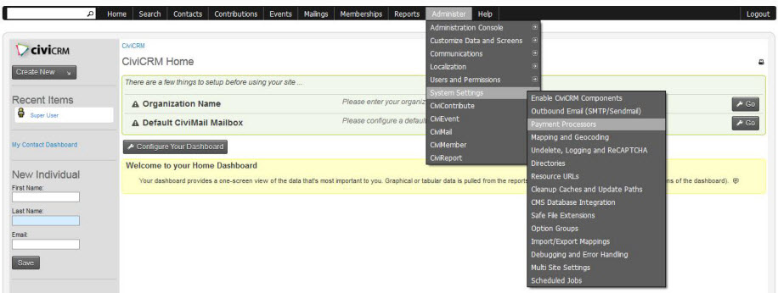
  - Add Payment Processor
  - Select ‘Click & Pledge’
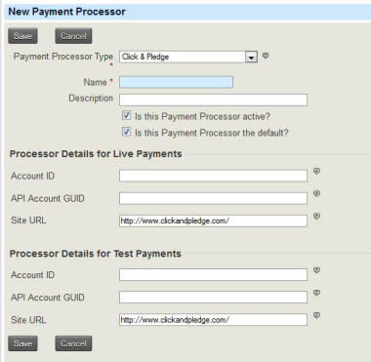
  - Enter your Click and Pledge ‘Account ID’ and ‘API Account GUID’
  - Click save

Adding New Items
Adding new items to the Virtual Food Drive is a fairly painless process which involves the following steps.
    - Log into the Drupal environment
    - In the top toolbar hover over “content > add content” and select “VirtualFoodDriveProduct”
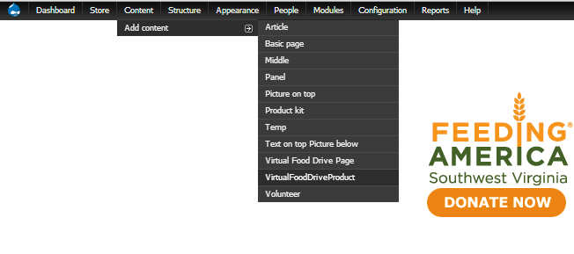

3. Enter the required information into the fields provided
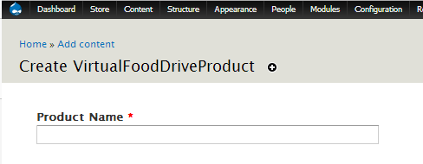
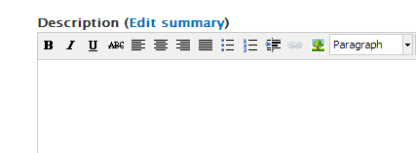
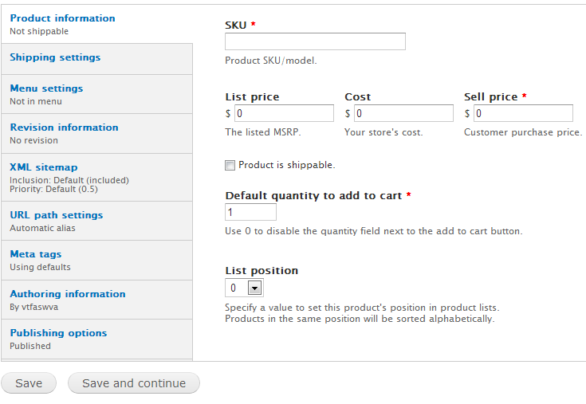
4. Click save and you’re done.

Developer’s Manual
Concept Map
At the start of this project FASWVA had a website map that staff members had signed off on. There have been some minor modifications to the website map. The original website map is shown in the Figure 1 below. This is followed by Figure 2, the final website map, created in CmapTools. As you can see below, the main change was Figure 2’s About Us contains most of the content from Figure 1’s Get Involved. This content was kept from the original site. In the concept map all of the information that needs to be updated is in light orange, dark green, and bright green.
Figure 1: Original Website Map

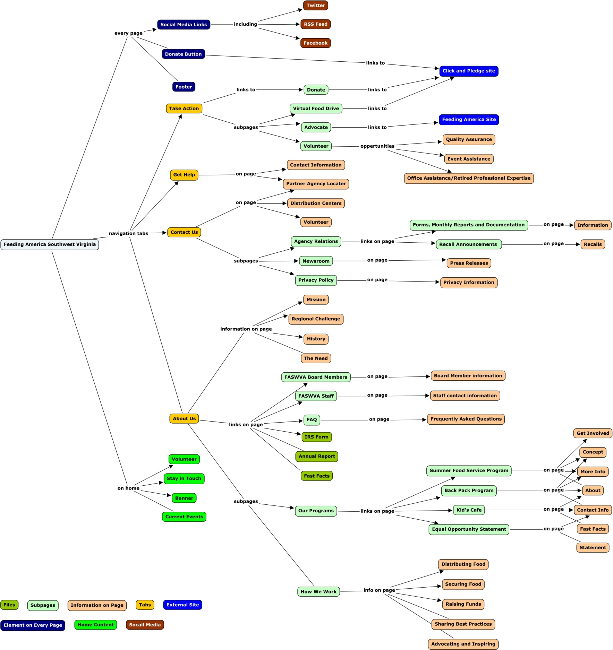
Figure 2: Final Website Map

Future Work
To enable the website to be used on a live server, further enhancements are necessary. Some of these enhancements are necessary for the launch and maintenance and others allow the website to be more useful to users by either providing more information, or make the website more accessible. These modifications can be performed either by staff of FASWVA or volunteers as the modifications are more time consuming than technically difficult.

Next Steps

Going Live
Foremost of the modifications that are needed is converting the site to a live site. This will entail a fairly large amount of work. The main task will be converting links to live links. Because the website our group developed was created on a development server, the internal webpages all include development only prefixes. Once complete, all links should be verified as working to ensure a quick, smooth transition. The pages will then need to be transferred to a live site that is openly accessible on the Internet. Once the transfer is complete, the links should be rechecked. Also all assets such as images and videos should be checked on all supported web browsers.

Training Personnel
Once the website is live, other maintenance steps need to be completed. Training personnel in the use and upkeep of the website is a first priority once the site is live. The website has been designed to ease in the addition of new material. However, some training is still required to use the software. It is much easier to add new content to certain parts of the websites than others. The News Room page, for example, is designed to facilitate the addition of new stories; on the other hand, the Get Help page changes infrequently. Thus it is more important than anyone updating the site better understands how to add content to the News Room page then the Get Help page.

Perform Regular Audits on the Website
Regular audits must be performed on the website. These will ensure that the website continues to run smoothly and efficiently. This is done through use analysis such as heat mapping and user testing. By analyzing how users get to certain pages and which pages receive the most traffic, the website can be reorganized and designed to help users reach the information they are searching for more easily.
From experience, we suspect that the “Our Programs” pages are too deep in the website’s structure. An audit would find other elements of the website that need to be moved around. Also as time goes by the website will become outdated and audited to help remedy small social changes in expectations on the web.

User Test the Virtual Food Drive
Analysis should also be done on the Virtual Food Drive to be sure that it continues to be used effectively and remains a useful donation tool. Having user testing would show how effective the current items that are being displayed are and help identify any confusing areas for users.

Multimedia
Multimedia elements would further enhance the website, making it more robust and engaging. These enhancements can be completed by staff or volunteers, such as future students. Some enhancements that were requested but outside the scope of this project include: a hunger quiz, hunger simulation, peer-to-peer food drive, testimonials, and a television promotional video. A project of similar difficulty to the creation of the website and Virtual Food Drive would include most if not all of these features.

Hunger Quiz
The Hunger quiz is designed to answer some of the common questions about hunger and inform the user of hunger facts in their area of which they might not be aware. Information for the Hunger quiz is in Appendix A. The concept is to have an interactive game that asks the user questions, scores the responses, and compares the scores with others who have taken the quiz. This element should not be difficult to add in Drupal; there are several Drupal quiz modules.

Hunger Simulation
The Hunger Simulation is designed to show what someone living with hunger goes through. The best example of this was on San Antonio Food Bank’s website: http://www.safoodbank.org/hunger101/. This Simulation allow you to step into the shows of 4 different people and try to get enough food to survive.

Peer-to-Peer Food Drives and Fundraisers
The concept behind the Peer-to-Peer sites is to allow individuals to set personal goals and invite family members and friends to donate to their food drive. This would be designed similarly to the Relay for Life individual page – that is, complete with Facebook and other social media plug-ins. It could also be used for company and organization food drives.

Testimonials on Website
Testimonials on the website would add a more personal experience. Some of the individuals FASWVA showed an interest in having interviewed included: staff, volunteers, and individuals who benefited from their services. The major challenge to overcome is finding individuals who are willing to speak about personal and painful memories when they needed other’s assistance to have enough food. FASWVA also showed an interest in having individuals who participated in their special event “Young Artist Against Hunger”. If this event is held annually it could be a great way for a future student group to get involved, see Appendix B.

Promotional Content
FASWVA sometimes receives free television and radio slots. It would be helpful if their current promotional video was updated with new information and photos and if a radio promo was created. Having promotional content updated would help FASWVA for years to come and would make better use of this free air time therefore encouraging stations to give additional time in the future.

Lessons Learned

Timeline

Problems and Solutions

Development Site
Erich Geist set up access for our group at Dreamhost. Initially we had some problems accessing the development site. After some reconfiguring we were able to access the site and started by downloading Drupal 7.

Slow Up Speed
Transferring content took a lot longer than expected because of the slow-up speed. The initial solution to this problem was to move content to a local instance and then drop the CSS files into the development site. This solution didn’t work because the development site is password encrypted.

Missing Video Files
On the original website videos were displayed using JavaScript. Since Drupal is not fully compatible with embedded video scripting through JavaScript, we needed to manually upload the video files onto the host servers. We were unable to overcome this problem in the current version of the site.

Learning Curve for Modules
Each module had separate tutorials and different intricacies. This was a problem when it came to completing a task in a timely manner; the solution was to move our timeline back for the Virtual Food Drive. This push back required our group to break into two distinct parts.

Module Functionality
The module we used to work on the Virtual Food Drive did not have as much functionality as we thought it would initially. We were unable to add text boxes for the information we wanted to add. The solution was to add a splash page with information.

Acknowledgements

Erich Geist – FASWVA
- Email: egeist@faswva.org
- Office: (540) 342-3011 x7011
- Mobile: (540) 597-3511
- Address: 1025 Electric Road, Salem, VA 24153
Erich Geist was our main contact with FASWVA and client throughout the semester. Erich was kind enough to meet with us weekly and responded promptly to all email inquiries. He step up the developmental site for us to use and researched Drupal and Joomla! to be fully informed at our meetings. He also took the time out of his busy schedule to attend our final presentation.

Amy Milberger – No longer with FASWVA
- No contact information
Amy Milberger participated in our meetings while she was with FASWVA. She also sent us the Feeding America style guide, Appendix C, as well as the information about the Young Artist Against Hunger, Appendix B. Amy M. also informed us about an audit that had been conducted on the old FASWVA website when she was at a conference. This feedback let to some of the changes we made to the original site map.

Amy Wilson – No longer with FASWVA
- No contact information
Amy Wilson participated in our meetings while she was with FASWVA. She also sent us the Hunger Quiz, Appendix A.

Bradley Bailey – Virginia Tech
- Email: bcbailey@vt.edu
Brad wrote the storyboard for the Virtual Food Drive. He drew the images for the initial version of the Virtual Food Drive and helped with the following iteration of the Virtual Food Drive. He also assisted in writing this report.

Sarah Dotson – Virginia Tech
- Email: sarahd6@vt.edu
Sarah organized all of the meetings with the client, took notes at those meetings, and informed/reminded group members of their deliverables. Sarah also researched Drupal and Joomla! extensively. She wrote the majority of the documentation and assisted in some style choices.

Susan Feng – Virginia Tech
- Email: sfeng88@vt.edu
Susan moved the majority of the content over from the original site to the development site. She researched Drupal templates and presented them to the client for approval. Susan also edited the style sheet and led trouble shooting measures when we were unable to access the development site.

Lance Han – Virginia Tech
- Email: lhanvt13@vt.edu
Lance familiarized himself with Drupal and assisted in all aspects of development on the site. He moved content over initially and found a way for non-technical admins to edit and add content to the site. Lance changed the majority of the Drupal template to make it match the Feeding America style sheet.

Sean Kelly – Virginia Tech
- Email: seankelley42@gmail.com
Sean was involved in editing the style sheet, insuring that all colors and logos comply with Feeding America’s Style Guide. He made many of the final touches and was able to edit on the fly during final review. Sean was also involved in the initial content transfer.

Hunter Shepherd – Virginia Tech
- Email: hunters1@vt.edu
Hunter made the majority of the Virtual Food Drive with assistance from Brad. He familiarized himself with the open source Drupal module ubercart (along with others) which was used for the underlying framework of the virtual food drive. He also set up the webpage view for the virtual food drive using the views Drupal module.

Works Cited
(n.d.). Retrieved 5 2, 2013, from Drupal: http://drupal.org/project/wysiwyg
(n.d.). Retrieved 4 12, 2012, from http://www.youtube.com/watch?v=GTuQRcSX7nE
Click & Pledge. (n.d.). Retrieved 4 21, 2013, from Payment Platform's Help & Online Manual: http://manual.clickandpledge.com/CiviCRM-Drupal.html
Drupal. (n.d.). Retrieved 5 2, 2013, from http://drupal.org
Drupal Insert. (n.d.). Retrieved 5 2, 2013, from http://drupal.org/project/insert
Drupal Wysiwyg. (n.d.). Retrieved 5 2, 2013, from http://drupal.org/project/wysiwyg
Second Harvest Food Bank. (n.d.). Retrieved 4 21, 2013, from http://feedoc.org/HowToHelp/DONATEFOOD/HoldAFoodDrive/VirtualFoodDrives.aspx
tinymce. (n.d.). Retrieved 5 2, 2013, from http://www.tinymce.com/

Appendix A

Hunger Quiz
1. How many children in Southwest Virginia qualify for free or reduced meals at school?
a) 55,000 b) 65,000 c) 75,000 d) more than 75,000
2. What percent of US children live in hungry or food insecure households?
a) 5% b) 10% c) 15% d) more than 15%
3. True or False?
Many clients of Feeding America (the nation’s food bank network) must make difficult choices between paying for food and other basic necessities?
4. How many people in southwest Virginia live in households considered to be food insecure?
a) 50,000 b) 100,000 c) 150,000 d) more than 150,000
5. True or false?
Most hungry clients of Feeding America Southwest Virginia partner agencies are uneducated and just don’t want to work?
6. What percentage of adults requesting emergency food assistance are employed?
a) 6% b) 13% c) 24% d) 37%
7. What percentage of US cities cannot provide adequate quantities of food to those in need?
a) 9% b) 16% c) 29% d) 45%
8. What’s the average cost of a 30-second commercial during the 2011 Super Bowl?
a) 1.5 million b) 2.2 million c) 2.6 million d) 3 million
9. How many of the clients served by Feeding America Southwest Virginia are children?
a) one-sixth b) one-fifth c) one-fourth d) one-third
10. How much of the edible food produced in the US is discarded before it’s eaten?
a) 20% b) 30% c) 40% d) more than 40%

Answer Key
1. D-more than 75,000
77,500 children in southwest Virginia are in such need that they qualify for these hunger relief programs. EverBank Field in Florida couldn’t hold that many hungry children – which puts the Gator Bowl in a whole new perspective.
Feeding America Southwest Virginia
2. D-more than 15%
The US has the highest child poverty rate of any other industrialized nation.
The Food Research and Action Center: Household Food Security in the United States 2005
3. True
42% must choose between food and utilities, 35% between food and rent or mortgage, and 32% between food and medicine or medical care.
Feeding America: Hunger in America 2006
4. D-more than 150,000
The number of people in southwest Virginia who live in food insecure households would fill Arrowhead Stadium, the fourth largest NFL Stadium in seating capacity – TWICE!
Feeding America Southwest Virginia
5. False
An estimated 58% of the clients served by Feeding America Southwest Virginia partner agencies are high school graduates. More than a third of the households served have at least one adult employed.
Feeding America Southwest Virginia
6. D-37%
Despite the fact that many people in need are working, they are not able to provide the basics for their families. Feeding America Southwest Virginia recently discussed this issue on National Public Radio; you can access the story here: http://www.wvtf.org/news_and_notes/audio/201012271130510.EE_FOOD_BANK.mp3
The United States Conference of Mayors: 2006 Hunger and Homelessness Survey
7. C-45%
Although we live in one of the wealthiest nations in the world, many of our cities can’t help their citizens meet their basic needs. This is where food banks step in.
The United States Conference of Mayors: 2006 Hunger and Homelessness Survey
8. D-3 million
This is a day when millions of dollars are spent to enjoy the Super Bowl experience. It is also a day that we can choose to turn our thoughts and dollars towards those without a bowl of soup to eat.
9. D-one-third
About one-third of Feeding America Southwest Virginia clients are under age 18.
Feeding America Southwest Virginia
10. D-more than 40%
There is enough food produced in the US to feed the world, let alone its own. However, according to a University of Arizona study, 40-50% of US produced food is discarded before anyone can eat it. For example, annual losses in retail food waste run in the tens of billions of dollars, which is why Feeding America Southwest Virginia uses “Prepared and Perishable” programs to distribute that food product to less fortunate families – instead of right to the trash!
University of Arizona News

Helpful Definitions:
Food security - access to enough food to maintain a healthy lifestyle.
Food insecurity - the limited or uncertain availability of safe, nutritious food.
Hunger - the uneasy or painful sensation caused by the involuntary lack of food, which may over time result in malnutrition.

Questions for Discussion:
• What surprised you in the hunger quiz and what did you already know?
• Why are so many people hungry?
• What does hunger mean for people who are working for a living? What about for the unemployed?
• Who is responsible to respond to this need and how? Consider different levels of responsibility: local, national, international, etc.
• How do food banks respond to community need?
• What are other things that need to be done in order to address the problem of hunger?

Appendix B

An evening with…..YOUNG ARTISTS AGAINST HUNGER Feeding Body and Soul

Feeding America Southwest Virginia recently began to plan a unique collaborative gathering that would support our hunger relief efforts while nurturing our community’s talented youth. We envision an uplifting gala that would showcase the gifts of our community’s young artists while significantly supporting the Food Bank’s mission to feed the hungry.
The Food Bank helps meet the challenges of those facing hunger and confronts the critical need to inspire and sustain their hope for a better tomorrow. More than just providing food to families, at-risk children and young adults have long been a concern of the Food Bank. Improving their potential through a variety of feeding programs has always been a priority. Programs such as our Kids’ Cafes, BackPack, summer feeding sites and nutrition education sessions demonstrate our commitment to contribute to the future success of at-risk children. It is important to sustain awareness of the problem of hunger in Southwest Virginia.

We’d like to share a true story….
Recently at one of the food pantries we serve, clients receiving food were asked to comment about their reasons for needing food assistance. In addition to the hundreds of other comments, we were struck by one dedicated young man’s message, “As a college student paying my way, I would go hungry at times, which would affect my education.” As a major food provider to families in our region struggling with food insecurity, this comment reminds us that the lack of sufficient food is often an impediment to education, at any age.
Feeding America Southwest Virginia’s successful recent re-branding and our commemorative gala for 30 years’ of service in our communities have helped raise the profile of the Food Bank exponentially. We now feel the timing is right to initiate a major unique signature fund-raising gala that will become an annual branded event to further raise the profile of the Food Bank and thereby its capacity and support.

Facts
Studies show that participating in the arts helps students develop a keener intelligence and succeed in their careers and personal lives.
Students of the arts outperform their non-arts peers on the SAT. The arts provide young people with learning experiences that engage their minds, hearts and bodies.
The arts nurture the development of cognitive, social and personal competencies.
The arts engage multiple skills and abilities.
Students who participate in music exercise more of their brain than in any other course they take in school.
As with many artistic disciplines, participating in classes such as Band focuses on group goals and the completion of those goals. This fosters cooperation, a skill highly valued in business and industry.
Motivated by the Food Bank’s interest in today’s youth, the Young Artists Against Hunger event will provide opportunities for young artists of various mediums to showcase their talents while helping the vulnerable, disadvantaged regional population in need of food assistance.

Opportunity
We know that Southwest Virginia is blessed with a wealth of young artists from many media: Jazz to Symphony musicians…Ballet to Clogging…Poets to Visual Artists….and Photographers to Culinary Artists.
Feeding America Southwest Virginia desires to create a collaborative platform to showcase their talent and cultivate their aspirations while generating awareness and support to reach out to those in need of food assistance.
Aspiring young artists are eagerly pursuing suitable opportunities to share their gifts with others, and we think Young Artists Against Hunger is a wonderful venue to do just that!
In addition to providing a platform to display their gifts, this event will provide our youth with a wonderful volunteer opportunity, since their efforts will be helping to advance the mission of the Food Bank.
Many young people today are looking for opportunities to get involved with charitable activities. Some participate because their curriculum requires it, others because they wish to contribute to the greater good, and still others simply because they are warm, compassionate, talented young adults who care.
While helping others is what volunteerism is all about, teens also find out that while they are giving, they are also receiving.
Through volunteering, teens develop a better appreciation for the little things in life and also receive the satisfaction of knowing they have made a difference in someone's life.

Talent
What will the Young Artists Against Hunger event be like? We will be selecting the best talent in the areas of music, visual arts, photography, dance and the culinary arts.
Through relationships with the Roanoke Symphony Orchestra, Southern Virginia University, the Roanoke College Children’s Choir, The School of Visual Arts at Virginia Tech and others, we intend to annually invite exceptional young students from high schools and colleges, churches, music labs, etc. throughout Southwest Virginia to participate in an evening of entertainment that we anticipate will rival professional events. We have already identified several incredibly talented individuals and groups that meet the criteria of those we expect to recruit for the Young Artists Against Hunger event. We have the relationships, access and capacity to select more than enough extraordinary young artists to fill an evening with thrilling performances and visual enjoyment year after year.

Replication
The Food Bank sees a Salem/Roanoke-based Young Artists Against Hunger as an exciting pilot event that has the potential to be replicated in Abingdon, where our Abingdon Distribution Center is located. The overall goal is to strengthen relationships with our donors, the corporate community and our youth throughout the 26 counties we serve.
We are hopeful that the inaugural Young Artists Against Hunger in both Salem/Roanoke and Abingdon will grow into an annual event with fresh talent emerging each year.
Presently, the Food Bank and Heartwood – Southwest Virginia’s Artisan Gateway in Abingdon, Virginia, are working to establish a long-term collaborative relationship to sponsor various annual events. Heartwood is an innovative organization with extraordinary infrastructure that is marketing Southwest Virginia as a single, unified tourist destination to benefit the economy of the entire region.
We are optimistic that Heartwood will host Young Artists Against Hunger each year and literally “set the stage” to replicate this event next year in the Abingdon area!

You can make a genuine difference
The Young Artists Against Hunger would be such a major contribution toward helping our talented youth and ultimately feeding the hungry in Southwest Virginia. Your involvement with this event would strengthen the efforts to attain the high standards we are setting for this first-class production.
FASWVA’s staff and PR and Communications Committee bear primary responsibility for the planning and logistics of the event. Also, we anticipate working with community leaders including Cyrus Pace, Executive Director of The Jefferson Center; members of the Roanoke Symphony Orchestra; Kimberly Davidson, Director of the Roanoke College Children’s Choir; Mark Milberger, Adjunct Professor at Southern Virginia University and Director of Music at Cave Spring United Methodist Church; and Betsy Bannan, Director of Advising - Advanced Instructor, Studio Arts for the School of Visual Arts at Virginia Tech; as well as various instructors in the arts throughout our region.
We sincerely hope you will catch the vision and will make a commitment to participate in this exciting event.

Appendix C

Feeding America Style Guide

Primary Colors
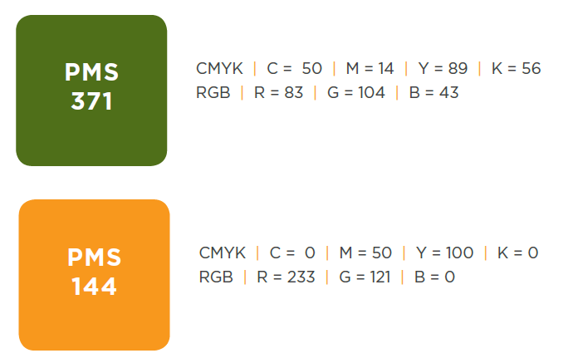

Secondary Colors
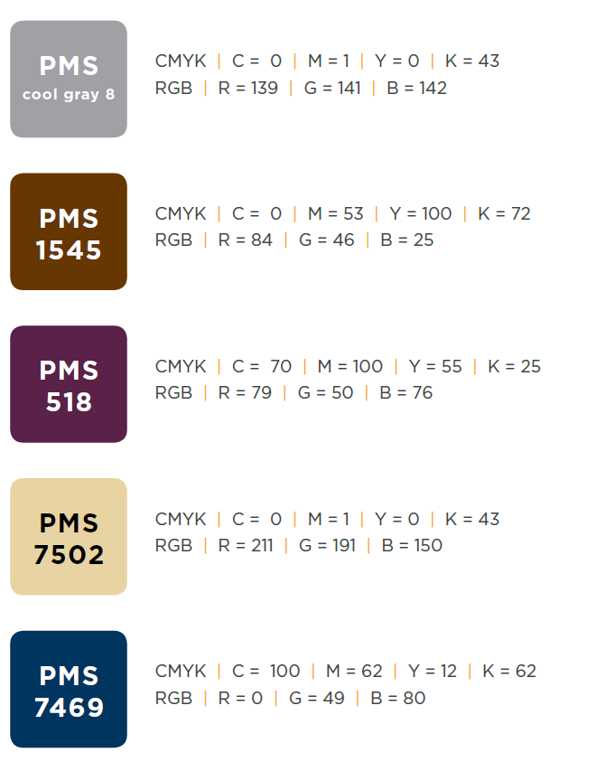
Master Logo Versions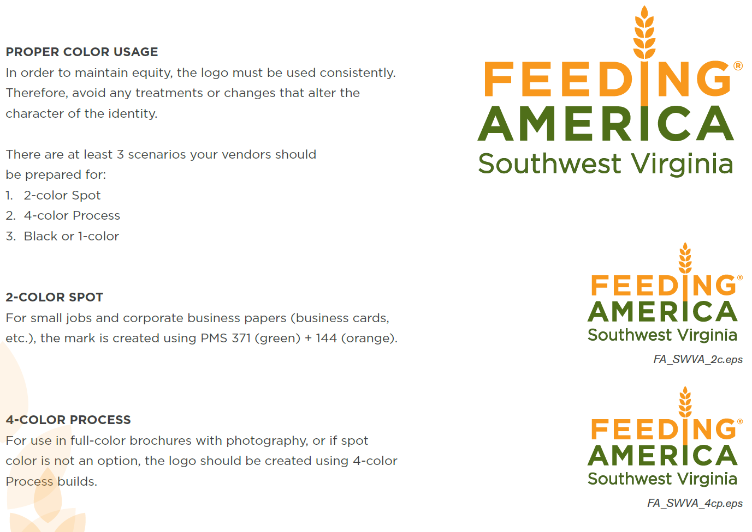

Improper Usage
