

YouTube Video Analysis

Final Report

CS4624 (Multimedia, Hypertext, and Information Access)

Spring 2021

Virginia Tech, Blacksburg VA 24061

Professor: Edward A. Fox
Client: Florian Zach

May 7, 2021

Prepared by
Akhil Bachubhay
Danny Chhour
Heji Deng
Trung Tran

Table of Contents
Table of Figures 3
Table of Tables 4
Abstract 5
Introduction 6
Background 6
Requirements 7
Video Metadata 7
Transcripts 7
Comments 7
Data Analysis 7
Design 8
Implementation 9
Data Collection Implementation 9
Parsing the Input File (playlist input file) 9
Getting video metadata 9
Getting video transcripts 10
Getting video comments (with API) 11
Getting video comments (web scraping) 11
Data Analysis Implementation 11
Text Data Preprocessing 11
Text Data Processing 12
Video Data Processing 16
Linking Different Data 18
Testing/Evaluation/Assessment 21
User’s Manual 22
Tutorials on use 22
Developer’s Manual 25
Environment 25
File Inventory 25
Dependencies 25
Methodology 26
The User and Goal 26
Lessons Learned 30
Timeline 30
Problems 30
Solutions 31
Future works 31
Acknowledgements 33
References 34

Table of Figures
Figure 1: Example of Youtube Video Metadata 10
Figure 2: CSV Output for an Example Video’s Transcript 10
Figure 3: CSV Output for an Example Video’s Comments 11
Figure 4: NLTK Word List After Preprocessing an Example Transcript 12
Figure 5: Graph of Counts vs. Sample Words 12
Figure 6: Keyword and Phrase Frequency DataFrame 13
Figure 7: Hearts in comment section 14
Figure 8: Jupyter Notebook Pandas Dataframe 14
Figure 9: Number of Hearts per Video 15
Figure 10: Graph of comment’s Number of Votes vs. Number of Sub-Comments 15
Figure 11: Number of Comments with a Time Link per Video 16
Figure 12: Graph of success score over the published date. 17
Figure 12.1: Graph of success score over the published date, for videos
starting in late 2018. 17
Figure 12.2: The data showed up when hovering the mouse over a certain
data point. 18
Figure 13: Graph of success score over the published date, except every
point is colored based on the most used word in the video transcript and
has the size related to the occurrence of that word. 19
Figure 13.1: Graph of success score over the published date, except every
point is colored based on the number of likes given out by the video creator. 19
Figure 13.2: Graph of success score over the published date, except every
point is colored based on the most used word in the comments and has the
size related to the occurrence of that word. 20
Figure 14: Program Crashed Log 21
Figure 15: The 1st cell. Selected cell is surrounded by a green frame 23
Figure 15.1: The toolbar. The “Run” is in the middle 23
Figure 15.2: The 2nd cell surrounded by green frame 23
Figure 15.3: The head of the 3rd cell surrounded by green frame 23
Figure 15.4: Sample cell surrounded by green frame. This cell generates the
plot with success score versus the published date of a video. 24
Figure 15.5: This sample cell generates the same graph as in Figure 15.4,
except every point has a color and size based on the most-used-word in its transcript. 24
Figure 16: Goal Flow Chart 27
Figure 17: Duplicate Videos Downloaded 31

Table of Tables
Table 1: Group Members 6
Table 2: Table of Services 28

Abstract
YouTube (youtube.com) is an online video-sharing platform that allows users to upload, view, rate, share, add to playlists, report, comment on videos, and subscribe to other users. Over 2 billion logged-in users visit YouTube each month, and every day people watch over a billion hours of video and generate billions of views. UGC (User-Generated Content) makes up a good portion of the content available on YouTube, and more and more people post videos on YouTube, many of which become well-known YouTubers [1]. A notable trend to look at for these YouTubers is how their channel grows over time.

We were tasked with analyzing how certain YouTubers become successful over time, how their early videos differ from later ones in terms of scripts, and how comments change with fame. Such analysis requires us to look into two sets of data. The first set is numerical data of the channels, which consists of view counts of videos, likes and dislikes on videos, published dates of the video, the interactions between the video creator and the audience, etc. The second set is textual data, which consists of the auto-generated scripts from videos as well as comments from the users. With the help of YouTube APIs and other available helper tools, we are able to scrape the metadata from data of videos and output them as CSV files for future studies.

For the analysis, we generate some scatter graphs where each dot stands for one instance of the video, where the x-axis represents the published date while the y-axis represents the views it gets, and then the color of the dot represents some other metrics for evaluation (for instance, the duration of videos). With the Python NLTK package, we are able to conduct analyses over the transcripts from the videos and comments, to see what words are spoken the most, what words appear frequently in the comments and if they are positive or negative, how many words the creator says in a minute, etc. Combining these data we can generate a more thorough scatter graph for discovering if there is a pattern on how certain YouTubers become more and more successful.

This project was developed using data solely from one channel as the basis, but it is expected to function correctly when used on other channels as well.

Introduction

Background
YouTube is a platform that people use to watch and post different kinds of videos on the website. There are many genres available for users to look up, ranging from daily blog videos to video game playthroughs to food reviews and many more. People can search for the type of videos they want to watch and those will appear. Focusing on video game channels, gamers are posting gameplay walkthroughs of new and upcoming games, speedruns of games, and even how to build something in a game. Many of these video game channels are becoming more and more successful over the years, gaining popularity in their respective video game genre. Once these channels become large enough, gamers can be considered as influencers, and make a nice living out of the revenue generated from the advertisements and sponsorships they display in their videos.

When a channel first starts posting videos, their viewership counts are relatively small. As the years pass, the number of subscribers they have increases, and in turn, the number of views per video increases. The goal of this project is to be able to download transcripts, comments, and metadata for a video from a YouTube link or YouTube playlist, and conduct a preliminary analysis of that data. It is hoped that from the data we gather, there will be a foundation for future academic studies to assess how gamers become successful over time, how their earlier videos differ from later ones, and how the comments on each video change as popularity increases on the channel.

We (see Table 1) are working with Dr. Florian Zach of the Howard Feiertag Department of Hospitality and Tourism Management for this project, focusing on a YouTube’s channel called Biffa Plays Indie Games [2]. Our roles cover the varied aspects of the project.

Table 1: Group Members
Group Members | Role(s)
Akhil Bachubhay | Downloading metadata, downloading transcripts, data analysis
Danny Chhour | NLTK analysis, create graphs and charts through Jupyter Notebook
Heji Deng | Data analysis, create graphs and charts through Jupyter Notebook
Trung Tran | Management, downloading comments, data analysis

Requirements
Our client requested data in two forms for this project, one of which is the metadata, transcripts, and comments from YouTube videos, and the other is a preliminary analysis of said data through NLTK and other data processing tools. Listed below are specifics for which data we were required to collect and produce.

Video Metadata
- Title
- Views
- Publish date
- Video duration
- Likes
- Dislikes
- Video ID
- Playlist ID (if applicable)

Transcripts
- Whether or not a video has one
- Text with time stamps

Comments
- Whether or not a video has them
- Comment ID
- Author
- Text
- Date
- Votes
- Heart (whether author of video liked the comment)
- Replies

Data Analysis
- A metric for evaluating the success level of a video, that factors in number of views, likes, dislikes, and comments.
- Word frequencies in transcripts, used to quantify the style of a video
- Word frequencies in comments, used to quantify the feedbacks from the viewers

Design
This program is designed to take a list of videos or playlists from YouTube and obtain video metadata along with the video’s transcript and comments. The program then uses NLTK and other tools to analyze the data obtained in order to make it easier for researchers to view. In order to achieve this, the program has two main parts.

The first part parses the given list and downloads all of the metadata, transcripts, and comments from the YouTube videos. If the list is a list of playlists, it is parsed to extract the individual video IDs from the playlist. From this point, the video IDs are passed through to calls of the YouTube Data API, which retrieves the metadata, comments, and transcripts. Next, the video IDs are also passed into a comment scraper function that helps with acquiring the “heart” metric described above. Once all data is collected for a video ID, the ID is stored in a file to ensure that with multiple runs of the program or duplicate videos, data is not downloaded multiple times unnecessarily. Finally, each of these datasets will be downloaded as a comma-separated values (CSV) file and stored in folders so that all metadata will be in a single folder, all transcripts will be in a single folder, and all comments will be in a single folder, with a single file also being output to report which videos have missing transcripts, comments, or metadata. Each of the CSV files will have the same column headers to facilitate processing.

The second part reads from the CSV files and first preprocesses the information by tokenizing the text into a list of words. Then the list is iterated through to remove punctuation as well as word stemming. Once preprocessing is complete, the list of words can then be processed by NLTK for word frequencies. Other tools can be used to process the data and find information such as the frequency of keywords or phrases, a comparison of comment vote counts to reply counts, a count of the number of comments that have time links to the video in them, a count of the comments that the video creator interacted with, the likes to dislikes ratio, the video publishing frequency, and a comparison of video length to viewer count. After information has been processed, it can then be displayed in a plot or graph form for easier comprehension.

Implementation

Data Collection Implementation
In the initial stage, our team met up several times to discuss how we are going to implement this program. The first thing we did was collect information from the client, and understand what we would need to do when developing the program. Once we understood that, we researched ways that we would accomplish these tasks. After spending some time on the web, we found several APIs online that were going to do what the client asked. At the time, we did not want to use the YouTube API for the project since there were some limitations when using it. So, we found ways to download the video comments and metadata through third parties, but this took a very long time to download since it was using a web scraper instead of the official YouTube API. We then looked for a way to download the YouTube transcripts, which we found a useful API for. Finally, after researching all of the different ways we can make the program, we met up with our client and presented the information that we found online to our client to see if he is happy with it and proceed from there. In the end, we decided to use the YouTube API for most processes as described in more detail below.

Parsing the Input File (playlist input file)
This stage consisted of reading in the input file using Python’s IO library [3], parsing each link to find the playlist ID, and passing through the YouTube Data API [4] through a get request. This would return a list of the video IDs for each video in the playlist. Note for the video input file, only the link itself needed to be parsed.

Getting video metadata
This function takes in the video IDs mentioned above and downloads and writes the metadata for each one. This is done through a get request of the API for the video object stored in YouTube’s database. This object is then accessed for the important fields we required such as title, views, etc. These fields are then written to a CSV file (see Figure 1) using the writing functions provided by Python’s CSV library. In addition to this process, video IDs are stored in an array to avoid duplicating writes to files.

Figure 1: Example of Youtube Video Metadata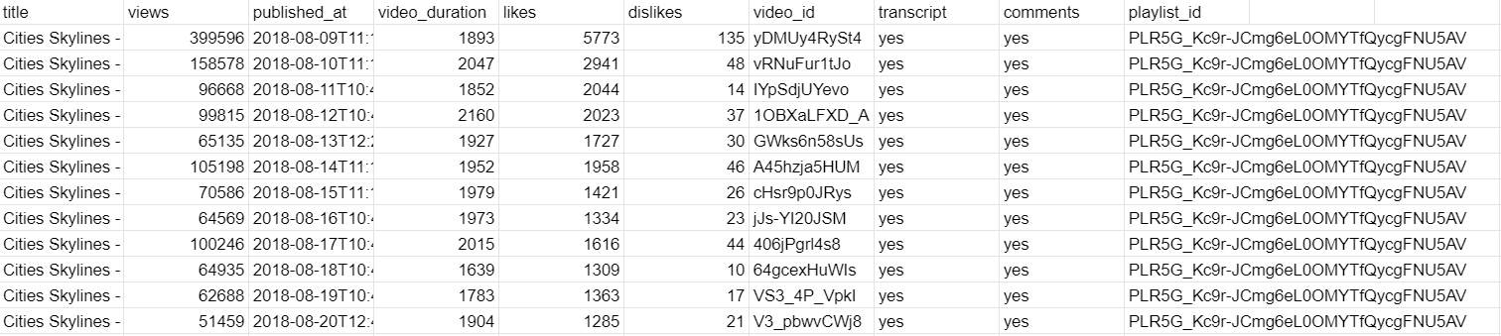

Getting video transcripts
This function also takes in the video IDs mentioned above and downloads and writes the transcripts for each one. This is done through a get request of the API for the transcript object stored in YouTube’s database for every applicable video. This object is then accessed for the important fields we required such as text and start and end time of each caption. These fields are then written to a CSV file (see Figure 2) using the writing functions provided by Python’s CSV library. In addition to this process, video IDs are stored in an array to avoid duplicating writes to files.[5]

Figure 2: CSV Output for an Example Video’s Transcript

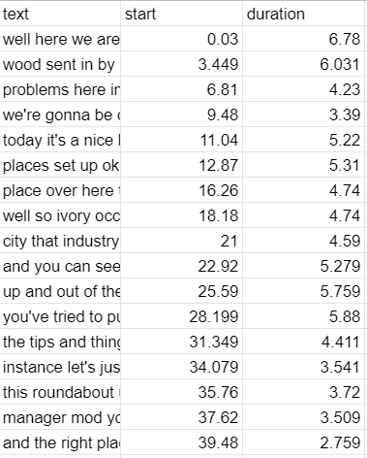

Getting video comments (with API)
This function takes in the video IDs mentioned above and downloads and writes the comments for each one. This is done through a get request of the API for the comment object stored in YouTube’s database for every applicable video. This object is then accessed for the important fields we required such as comment ID, author, votes, etc. Also accessed is the keys field, which allows us to get the comment IDs for every reply to this comment. Thus, we are able to replicate the process above for each of the comment replies as well using a loop. All of these fields are then written to a CSV file (see Figure 3), with replies in a structured format below the original comment, using the writing functions provided by Python’s CSV library. In addition to this process, video IDs are stored in an array to avoid duplicating writes to files.

Figure 3: CSV Output for an Example Video’s Comments
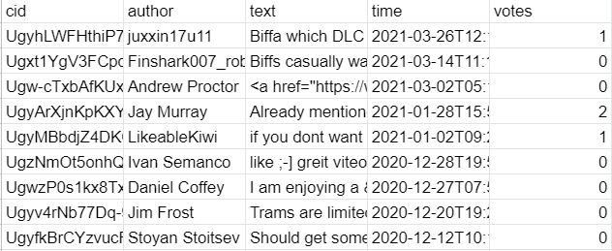

Getting video comments (web scraping)
This function also takes in the video IDs mentioned above and downloads and writes the comments for each one. This is done through a scraping of the webpage for each video using the requests Python library. This scraping will help acquire the “heart” metric mentioned above, which is then added to the comments files that were produced with the API. [6]

Data Analysis Implementation
The first step of this stage is to read through the CSV files generated by the data collection stage. This is done through the Pandas library. Using the Pandas library, a TextFileReader and DataFrame are returned and can be used for processing.

Text Data Preprocessing
To begin preprocessing, the program first takes all the lines of text data and joins them into a single string using a single space as a delimiter between lines. Using NLTK [7], it is then possible to tokenize the string into a list of words using whitespace as a delimiter as well as removing punctuation. Then NLTK’s stopword library is used to create a single list of 179 stop words (the, is, and, ...) and the list of words is filtered to remove these stop words from it. NLTK is then used for one of its word stemmers, specifically the SnowballStemmer, in order to transform words back into their word stem. Figure 4 shows an example transcript after being transformed into word stems.

Figure 4: NLTK Word List After Preprocessing an Example Transcript
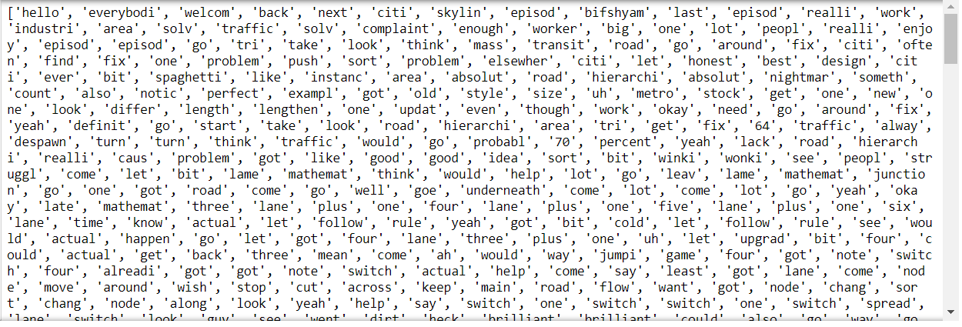

Text Data Processing
The list of words is used by NLTK to create a frequency distribution. This frequency distribution contains the number of times a word appears in the data and can be used to create a plot (see Figure 5) of the most commonly used words in the YouTube transcripts or comments.

Figure 5: Graph of Counts vs. Sample Words
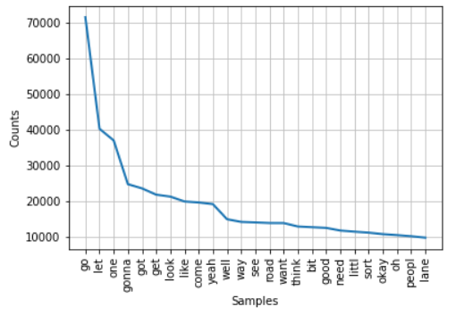
It is possible to obtain keyword frequency by going through every single word in the word list for each transcript and counting the number of times each keyword is used. In order to obtain phrase frequencies, for each transcript the program reads it line by line and uses NLTK’s bigram and trigram library in order to group words together in the list and compare them to the given phrases. For example, given a line ‘Hello my name is Bob’ and phrase ‘my name’, NLTK bigram is used to turn this sentence into a list of tuples of words, [(‘Hello’, ‘my’), (‘my’, ‘name’), (‘name’, ‘is’), (‘is’, ‘Bob’)]. After turning our chosen phrase ‘my name’ into a list of words, [‘my’, ‘name’], the program compares the phrase list to the tuples in the bigram list and increases the frequency count if a match is found. The frequencies are stored in a Pandas DataFrame which can be seen in Figure 6.

Figure 6: Keyword and Phrase Frequency DataFrame
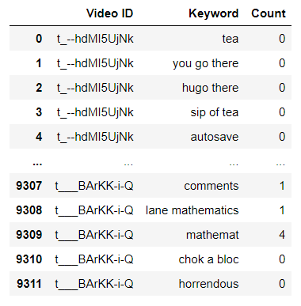

The Pandas DataFrame also contains information about the comments such as the comment ID, comment author, number of votes, and whether the comment contains a ‘heart’ or not. In Figure 7, an example of YouTube comments is shown with some comments containing a ‘heart’ after being liked by the video author. In Figure 8, the comments of a YouTube video are shown in a Pandas DataFrame.

Figure 7: Hearts in comment section
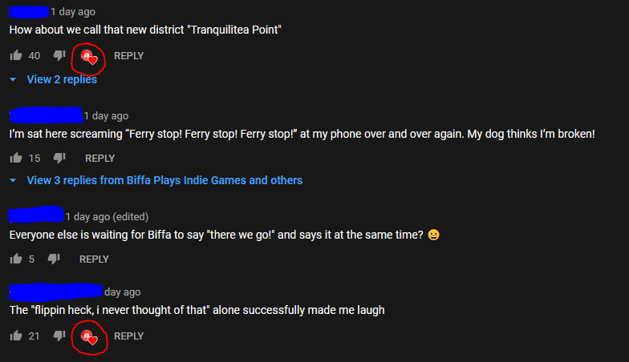

Figure 8: Jupyter Notebook Pandas Dataframe
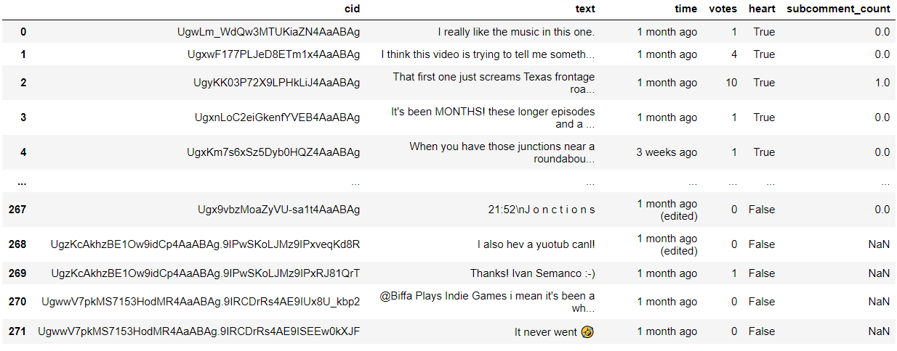

This information is used to count the number of ‘hearts’ that a video has and therefore how often a video author likes comments which can be seen in Figure 9.

Figure 9: Number of Hearts per Video
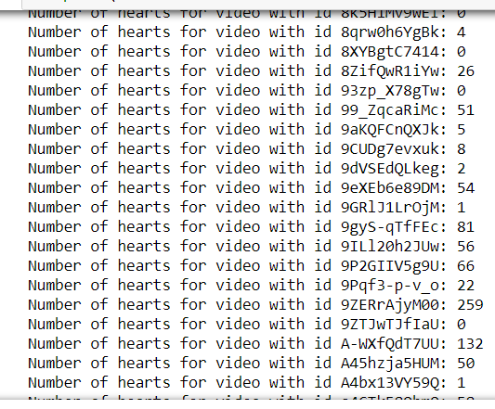
Data is also used in a plot, created by the Plotly library, to compare the number of votes a comment has received with the number of replies a comment has, which can be seen in Figure 10.

Figure 10: Graph of comment’s Number of Votes vs. Number of Sub-Comments
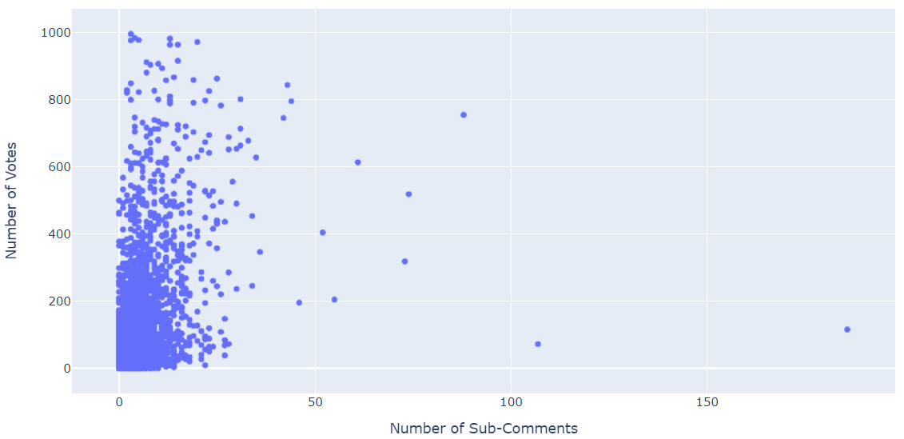
The Re library has regex functions that are used to find comments that have specific content, such as time links. For example, to find time links in a comment, regex is used to find two integers with a colon in between them such as 5:10. Figure 11 shows the result for each video

Figure 11: Number of Comments with a Time Link per Video
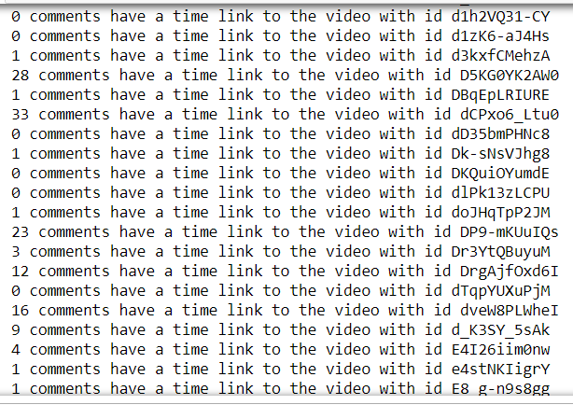

Video Data Processing
After Pandas [8] has been used to create a DataFrame from the CSV files, the DataFrames can be used to create new columns using processed information. A new column “score” is added as the evaluation of the success level of every input video v:
$Score(v)=Views(v)+25×Likes(v)+200×Comments(v)-225×Dislikes(v)$
This formula is inspired by the idea that the ideal likes to views ratio should be 1:25, the ideal comments to views ratio should be 1:200, and the ideal likes to dislikes ratio should be 1:9. [9][10]

The Plotly library [11] is used in conjunction with the Pandas library to turn DataFrames into plots, specifically this program uses the scatter plot function. Figure 12 is an HTML interactive graph generated with Plotly, with y-axis as success score and the x-axis as the published date. The bottom part is a range slider that allows users to zoom in and out into different intervals of x-axis, as shown in Figure 12.1. Hovering the mouse over a specific point allows the user to inspect the metadata of a specific video, as shown in Figure 12.2.

Figure 12: Graph of success score over the published date.
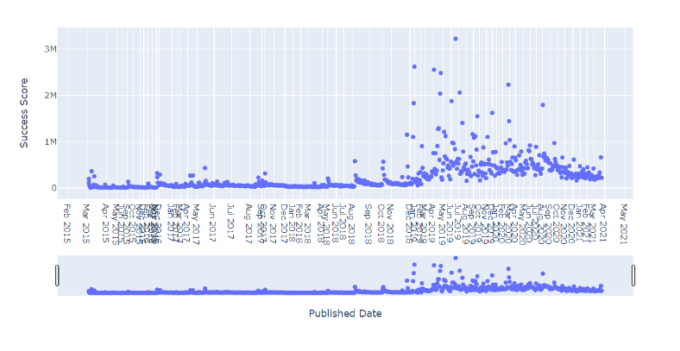

Figure 12.1: Graph of success score over the published date, for videos starting in late 2018.
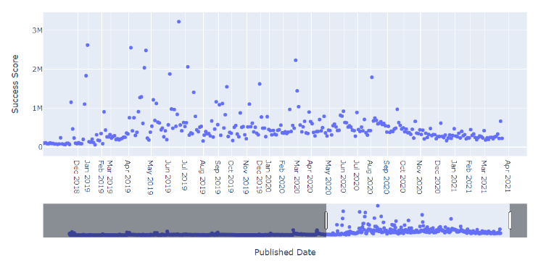

Figure 12.2: The data showed up when hovering the mouse over a certain data point.
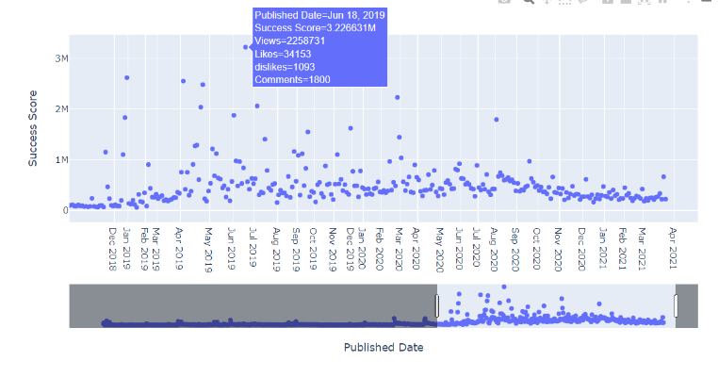

Linking Different Data
After getting the success score for every video, we start coloring and sizing every data point with different parameters and see if there are connections between that parameter and the success level. The figures below are derived from Figure 12, where data points have different colors and sizes based on different categories. Figure 13 attempts to quantify the styles of the videos with the most-used-word in transcripts. Figure 13.1 illustrates the connection between the number of likes given out from the video creator and the success score. Last but not least, Figure 13.2 attempts to quantify the style of comments with the most-used word in comments.

Figure 13: Graph of success score over the published date, except every point is colored based on the most used word in the video transcript and has the size related to the occurrence of that word.
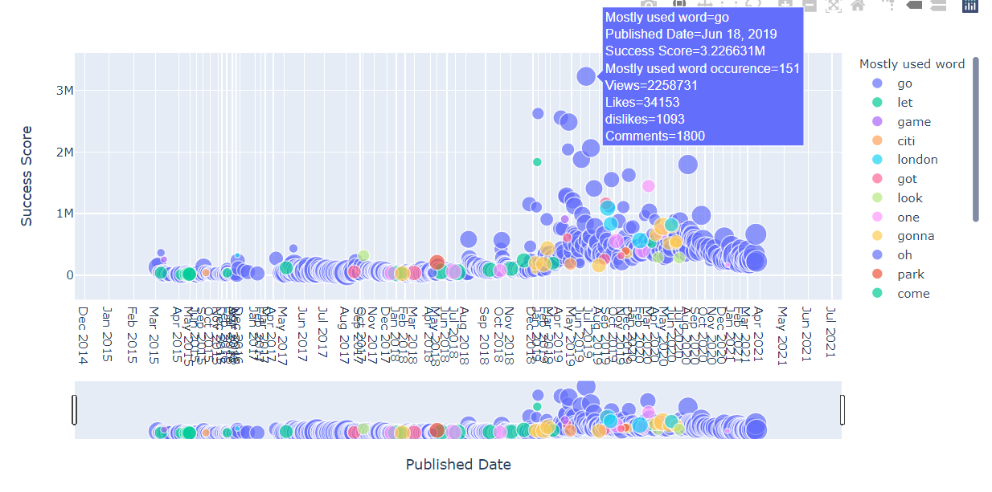

Figure 13.1: Graph of success score over the published date, except every point is colored based on the number of likes given out by the video creator.
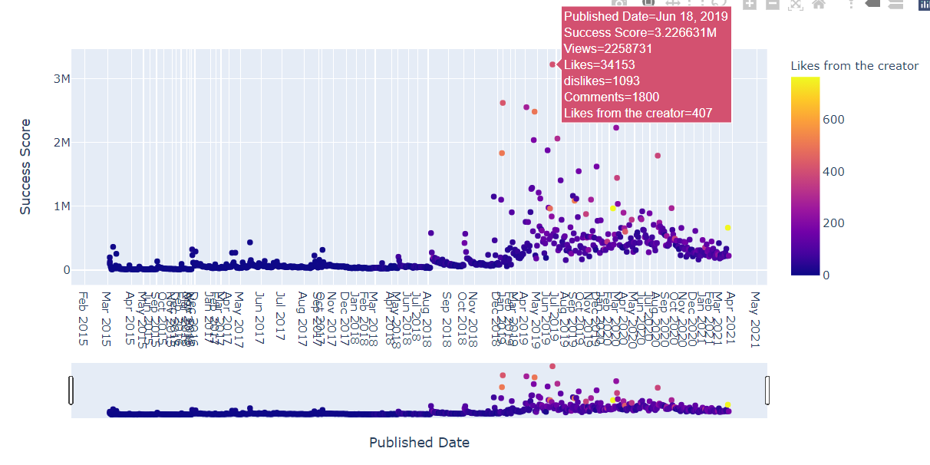

Figure 13.2: Graph of success score over the published date, except every point is colored based on the most used word in the comments and has the size related to the occurrence of that word.

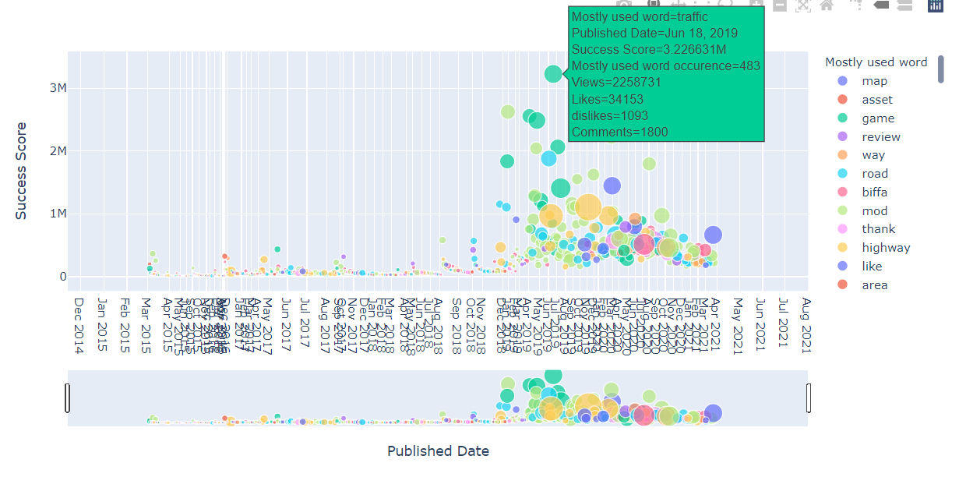

Testing/Evaluation/Assessment
Our testing was primarily done through our client’s personal server. Once our program was ready to be tested, we would notify our client that we were ready to run tests. From this point, Dr. Zach would pull down our git repository on his server and run the program through the command line interface provided with Python.

Once we had a minimum viable product for downloading the data, we went ahead and asked our client to run the program. This was the first overall run, and therefore had some bugs. In this run, the program downloaded the information correctly for about 500 videos, but then unfortunately crashed due to the comment web scraper failing (see Figure 14) for one of the videos and exiting the program. Although the run was a failure, we learned well from this experience, and made sure to fix these issues for the next run.

Figure 14: Program Crashed Log
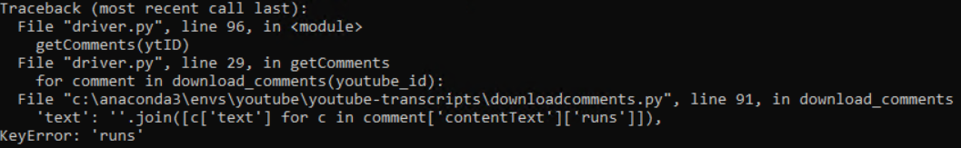

About a month later, after fixing various issues, and implementing many error catching blocks of code to ensure the program would not crash on such small issues, we decided to try a second run with Dr. Zach. In this run, the program performed much more successfully than before, downloading all the required videos with all information present.

User’s Manual
If this is the first time you are using the program and do not have any of the dependencies and programs installed on your computer, then please go to the developer’s manual second and install them. Without those dependencies and programs, you will not be able to run the program. Once you have those installed, you can then run the program as followed.

Tutorials on use
To add videos and playlists for analysis:
- To add and get data for multiple videos, go to the input_videos.txt file and fill in the YouTube links of the videos you want to get.
- To add and get data for multiple playlists, go to the playlist_videos.txt file and fill in the YouTube playlists you want to get.
How to scrape the data from YouTube:
- Go to the directory where the driver.py is located in the terminal. You can navigate to it with "cd path/to/file" and "cd .." to go back one previous folder.
- Run the command "python driver.py -h" for the help menu
- Run the command "python driver.py -v input_videos.txt" if you want to download the multiple videos files.
- Run the command "python driver.py" if you want to download the multiple playlists files.
How to conduct analysis over the data:
- Go to the directory where MasterAnalysis.ipynb is located in the terminal. You can navigate to it with "cd path/to/file" and "cd .." to go back one previous folder.
- Run the command “jupyter notebook MasterAnalysis.ipynb” and the system would open the file in your default browser
- Click on the 1st cell (Figure 15) of code to select it, and click “Run” (Figure 15.1) in the toolbar. This step imports the necessary packages to generate data visualizations.

Figure 15: The 1st cell. Selected cell is surrounded by a green frame
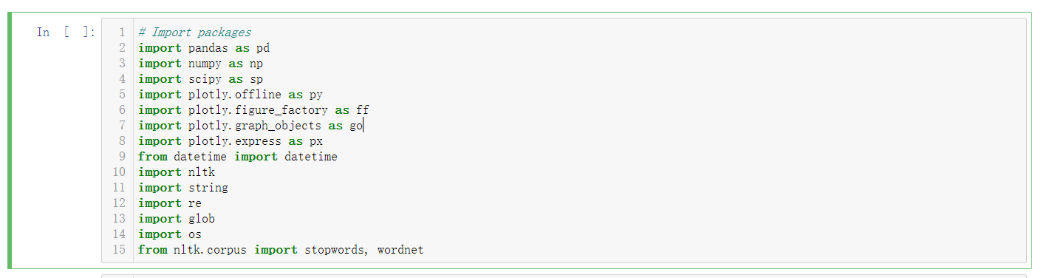

Figure 15.1: The toolbar. The “Run” is in the middle
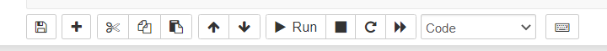
- Click on the 2nd cell of the code (Figure 15.2), and click “Run” in the toolbar. This step creates an empty Dataframe to store metadata for all requested videos.

Figure 15.2: The 2nd cell surrounded by green frame
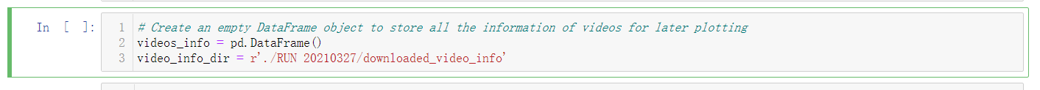
- Click on the 3rd cell of the code (Figure 15.3), and click “Run” in the toolbar. This step reads in all the existing data for all requested videos, processes them, and generates additional parameters for graphing useful plots. This might take some time depending on your computer’s performance and the sample size.

Figure 15.3: The head of the 3rd cell surrounded by green frame
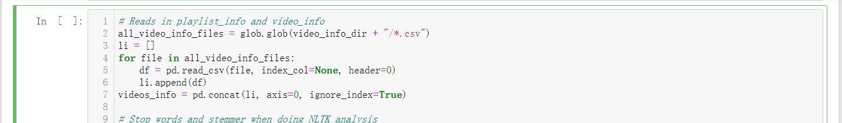
- At last, generate your plot(s) of interest by clicking any of the following cells (Figure 15.4, 15.5), and then click “Run”. Every cell of code has a header comment describing what plot would be generated.

Figure 15.4: Sample cell surrounded by green frame. This cell generates the plot with success score versus the published date of a video.
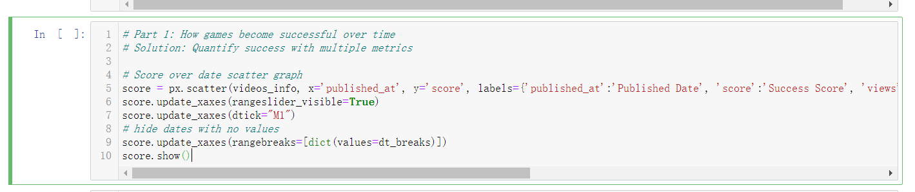

Figure 15.5: This sample cell generates the same graph as in Figure 15.4, except every point has a color and size based on the most-used-word in its transcript.
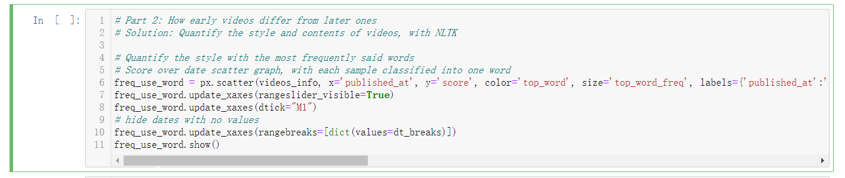

Developer’s Manual

Environment
- Youtube.com
  - Data source
- Python 3.9.1
  - Data collection script
  - Language analysis
- Jupyter notebook
  - Interactive data visualization

File Inventory
- driver.py
Download metadata from videos of provided playlists.
- downloadcomments.py
Downloads the comments from videos.
- nltk.py
Studies the auto-generated scripts and comments of videos.
- MasterAnalysis.ipynb
Reads the data and generates interactive data visualizations

Dependencies
- Install the most recent version of Chrome
- Install Python (for detailed instructions, visit https://www.python.org/)
- Install Anaconda (for detailed instructions, visit https://docs.anaconda.com/)
- Install Jupyter Notebook (for detailed instructions, visit https://jupyter.org/)
- Install required packages by typing these commands in the command shell:
  - pip install youtube_transcript_api
  - pip install -r requirements.txt --user
  - pip install python-youtube --user
  - pip install isodate
  - pip install numpy
  - pip install scipy
  - pip install pandas
  - pip install plotly==4.14.3
  - pip install nltk
    - Run a .py script with the following lines:
      - import nltk
      - nltk.download()
    - A GUI would pop up and prompt you to download useful packages; download all of them

Methodology
The methodology for this project was more narrow compared to those of our peers, since much of the project is automated. It only has one true user, and one overarching goal that they are trying to accomplish. With this said, we do try to go into as much detail as possible for what this goal is and how it can be accomplished using our application.

The User and Goal
User: YouTube Channel Transformation Researcher
Goal: Download data files, Examine, Analyze, and Document how a YouTuber’s channel changes over time (why it happened, can it be replicated, etc.)

This user and goal combination can be broken down into a series of sub-goals/tasks that are shown through the lens of our application as shown in Figure 16.

Figure 16: Goal Flow Chart
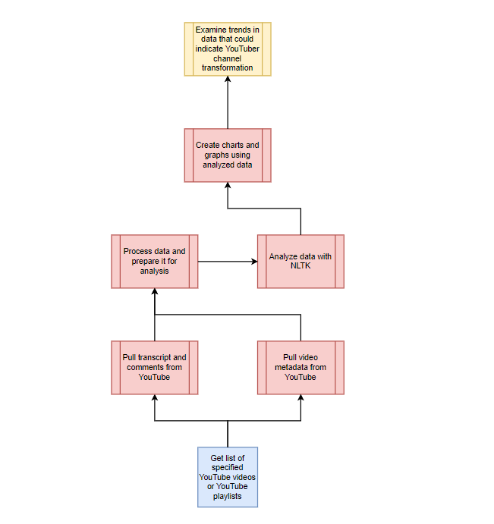
In order to examine how YouTubers’ channels transform over time, we will 1) create charts and graphs from the analyzed data. This task is dependent on the task of 2) analyzing data using NLTK on videos, which is dependent on the system supporting the tasks of 3) pulling transcripts and comments from YouTube videos and 4) pulling video metadata from YouTube.

So, the structure of the graph indicates how tasks are dependent on one another. As a result, we can derive a sequence of tasks required to accomplish the goal (as seen above). For each of these tasks/services we have developed a table (see Table 2) to show some of the more detailed procedures that occur during the completing of each task.

Table 2: Table of Services

SID | Service Name | Input file name(s) | Input file ID | Output file name | Output file ID | Libraries; Functions; Environments | API endpoint (if applicable)
5 | Pull video meta-  data from YouTube | List of YouTube video or playlist IDs | 1 | Downloaded Video metadata | 2 | Collect YouTube video ids from playlist and metadata about each video, tools for CSV and time | YouTube API
4 | Pull trans-  cript and com-  ments from YouTube | List of YouTube video or playlist IDs | 1 | Downloaded Transcripts and Comments | 3 | Collect YouTube video ids from playlist and comments and transcripts from each video using API methods and web scraping, tools for CSV and time | YouTube API, py-youtube, youtube_transcript_api
3 | Process data and prepare it for analysis | Downloaded Video Info, Transcripts, and Comments | 2, 3 | N/A | N/A | Pandas, NLTK, Re, String, Datetime, Jupyter Notebook | N/A
2 | Analyze data with NLTK | N/A | N/A | N/A | N/A | Pandas, NLTK, Re, String, Datetime, Jupyter Notebook | N/A
1 | Create charts and graphs using analyzed data | N/A | N/A | N/A | N/A | Plotly, Jupyter Notebook | N/A

The methodology as a whole can be described by the above materials, as well as a summarized description of our workflow model which is shown below.
Examine how YouTubers’ channel transforms over time:
Workflow 1 = Create charts and graphs using analyzed data(1) + analyze data with NLTK(2) + process data and prepare it for analysis(3) + {pull transcript and comments from YouTube(4), pull video metadata from YouTube(5)}

Lessons Learned
In this section we will discuss the timeline we projected from the beginning of the project, the problems we faced while working on the project, the solutions that we developed to solve those problems, and the future works that could be done to improve our project.

Timeline
Our initial timeline for the project when we first started was as follows:
- 2 weeks milestones:
  - Automate downloading of YouTube transcript by URL of video link and by channel name
- 4 weeks milestones:
  - Automate downloading of YouTube comments with upvotes/downvotes of the thread
  - The sub-comments of the thread
- 6 weeks milestones:
  - Data analysis using NLTK for YouTube transcripts
- 8 weeks milestones:
  - Data analysis using NLTK for YouTube comments
- 10 weeks milestones:
  - Visualization UI/UX for data analysis
- 12 weeks milestones:
  - Finish report, finalize program
Since all parties have a busy schedule, it was difficult to have a specific date layed out as for when we will meet with our client to update him on our progress. Instead, we based our timeline on a two weeks milestones accomplishment from the initial meeting with our client to the end of the semester. Whenever we have a meeting, we would then schedule the next meeting based on the availability of everyone at the end, so that everyone is on the same page.

Problems
When we first researched ways to accomplish the tasks that were given to us, we found several online resources that would work for us. One of them is to download the YouTube comments without using the YouTube API. Once we used it in our program, the first test run we had crashed when the comment web scraping failed for one of the videos. We talked about this in our testing/evaluation/assessment section as to what happened and what appeared in the terminal when the program crashed.

A second problem we had was with getting the metadata for the YouTube videos. We could not find a reliable script that would not use the YouTube API to download the metadata such as the video title, video identification, number of likes/dislikes, the viewer counts, etc. All of the ones we found had a restriction of grabbing up to 100 videos in a playlist only, so if a playlist had 300 videos, then we will not be able to collect the remaining 200 videos.

A third problem we encountered was that multiple videos with the same video identification were posted in multiple playlists, so when downloading the data, many repeated videos were being downloaded again (Figure 17). This is just a waste of time because the data we are getting from it are the same.

Figure 17: Duplicate Videos Downloaded
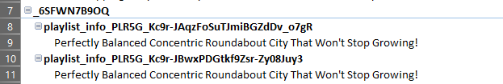

Solutions
In order to solve the first problem that we had with the comment web scraping, we implemented a series of try-catch blocks to handle exceptions that could occur during the web scraping process. If the scraper is not able to scrape the video, then the program would skip that video, and log the video identification into a list to let us know that the program was not able to scrape the data. We also created another function to get the comments data that uses the YouTube API. Using the YouTube API, we can guarantee that the program would be able to download the comments without worrying about the program breaking from using the script.

For the second problem, we used the YouTube API to collect the metadata. The data is presented in a list, and we were able to implement the code to grab data from the list and put it into a CSV file. This was not that difficult, since all we needed was to have an API key. We had one of our group members sign up to get one, making sure they did not link any payment information on the account. As long as we requested under 10,000 requests a day, we will be able to run the YouTube API to gather the metadata for the videos in the playlist.

Finally, to solve our last problem of having repeated videos being downloaded since they are across different playlists, we created a list that contains the unique video identifications and then writes that list into a file. Then when we are reading in a new playlist, we check with that output file to see if the video identification exists. If it does, then we would skip that video, if it does not, then we would download it and add that video into the output file.

Future works
There are many different areas where this project can be improved. Initially when we first started on this project, we planned on having a graphical user interface (GUI) in our system. This would make it easier for the user to navigate and use our program, instead of having to use the terminal to run the program. We did not have enough time to implement one, so this could be something that future groups can work on.

Another improvement for this project would be optimizing the time it took to download the data. Even though we are using YouTube's API to handle most of the downloading data, there are some functions in the program that are not using YouTube's API. Instead, it is a web scraper that finds the video’s comments section, grabs those data, and then writes those data into a file. These few functions are a lot slower than the YouTube’s API ones when downloading data, so if the future group can figure out a way to optimize that then it could be another thing they could work on.

There are also many perspectives to be improved in terms of the data analysis as well. Currently we only have a very basic model to evaluate the success level of a video, where the model is based on random blog posts with little academic significance. On top of that, we also only go with the most basic way to quantify the transcripts and comments from a video, which is by looking at the most used word. Whoever works on this project in the future can work on building a more solid model to evaluate the videos and quantify the styles, so that they can draw a clearer connection between them.

Acknowledgements
Client: Florian Zach, PhD, Assistant Professor, Howard Feiertag Department of Hospitality and Tourism Management (florian@vt.edu)

Professor: Edward A. Fox, PhD, Professor, Department of Computer Science (fox@vt.edu)

References
- YouTube. “YouTube for Press.” YouTube, 2021. https://www.youtube.com/intl/en-GB/about/press/. Accessed 1 Apr. 2021.
- Biffa. “Biffa Plays Indie Games.” Youtube, 17 Jan. 2011. https://www.youtube.com/c/BiffaPlaysIndie/featured/. Accessed 3 Feb. 2021.
- Python. “Io - Core Tools for Working with Streams.” Python Software Foundation, 2021, docs.python.org/3/library/io.html. Accessed 7 May, 2021.
- YouTube. “YouTube Data API.” Google Developers, last updated 9 Sep. 2020, https://developers.google.com/youtube/v3/docs/. Accessed 23 Apr. 2021.
- Depoix, Jonas. “YouTube Transcript/Subtitle API (including automatically generated subtitles and subtitle translations).” PyPi, 31 Mar. 2021, https://pypi.org/project/youtube-transcript-api/. Accessed 3 Feb. 2021.
- Bouman, Egbert. “youtube-comment-downloader.” Github, 31 Aug. 2015, https://github.com/egbertbouman/youtube-comment-downloader/. Accessed 3 Feb. 2021.
- NLTK. “NLTK 3.6.2 documentation.” NLTK Project, 20 Apr. 2021. https://www.nltk.org/api/nltk.html. Accessed 7 May, 2021.
- Pandas. “API reference.” Pandas Development Team, 2021. https://pandas.pydata.org/docs/reference/index.html. Accessed 7 May, 2021.
- Robertson, Mark. “3 Metrics Ratios to Measure YouTube Channel Success – Tubular Labs.” Tubularlabs, 18 Sept. 2014, https://tubularlabs.com/blog/3-metrics-youtube-success/. Accessed 23 Apr. 2021.
- McCulloch, Alexandria. “YouTube Videos: What’s Not to like? | Socialbakers.” Socialbakers, 2014, https://www.socialbakers.com/blog/2234-youtube-videos-what-s-not-to-like. Accessed 23 Apr. 2021.
- Plotly. “Python API reference for plotly.” Plotly, 12 Jan. 2021. https://plotly.com/python-api-reference/. Accessed 7 May, 2021.

