Titilola Obilade 12/12/2012
How Learning Occurs from the Lesson on Identifying Essential Information on a Sewing Paper Pattern Using Meaningful Reception Learning and Schema Theories
The lesson is delivered online and not face-to-face. The lesson consists of a 12-minute video where the instructor goes over the PowerPoint slides and displays different paper patterns, sewn jumpers and different notions. The notions are the threads, buttons zippers, applique and other accessories that can be used in sewing the article or garment. In addition to the video, there was a PowerPoint presentation with 28 slides. The lesson made use of various forms of technology. It made use of PowerPoint slides, iMovie and the smart board.
In the 12-minute video, the instructor takes learners through the entire lesson in an authentic classroom. The lesson makes use of concept maps that shows subsumption and relationships in the various parts of a paper pattern.
The lesson makes use of both meaningful reception learning and schema theories. The video starts by outlining the lesson into smaller parts; the introduction, the information on the front of the envelope, the information on the back of the envelope, the information on the instruction sheet, the information on the pattern pieces, assessment and summary.
Each small part was now anchored into another part and conceptual maps were drawn to show the relationships of these small parts with the entire paper pattern. As an example, the conceptual map on the items inside the pattern envelope showed anchoring of the items into one another. The conceptual map on the contents of the inside of the envelope was a derivative subsumption if the inside of the envelope is looked on as an origin of the contents (see Figure 1).
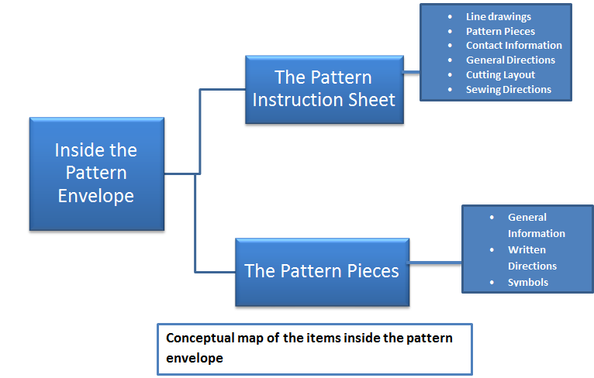
The lesson made several uses of advanced and comparative organizers in both the videos and in the PowerPoint slides embedded in the videos. The information on the back of the paper pattern and on the front of the paper pattern was placed side by side as comparative organizers in the PowerPoint slides and in the videos (see Figure 2). 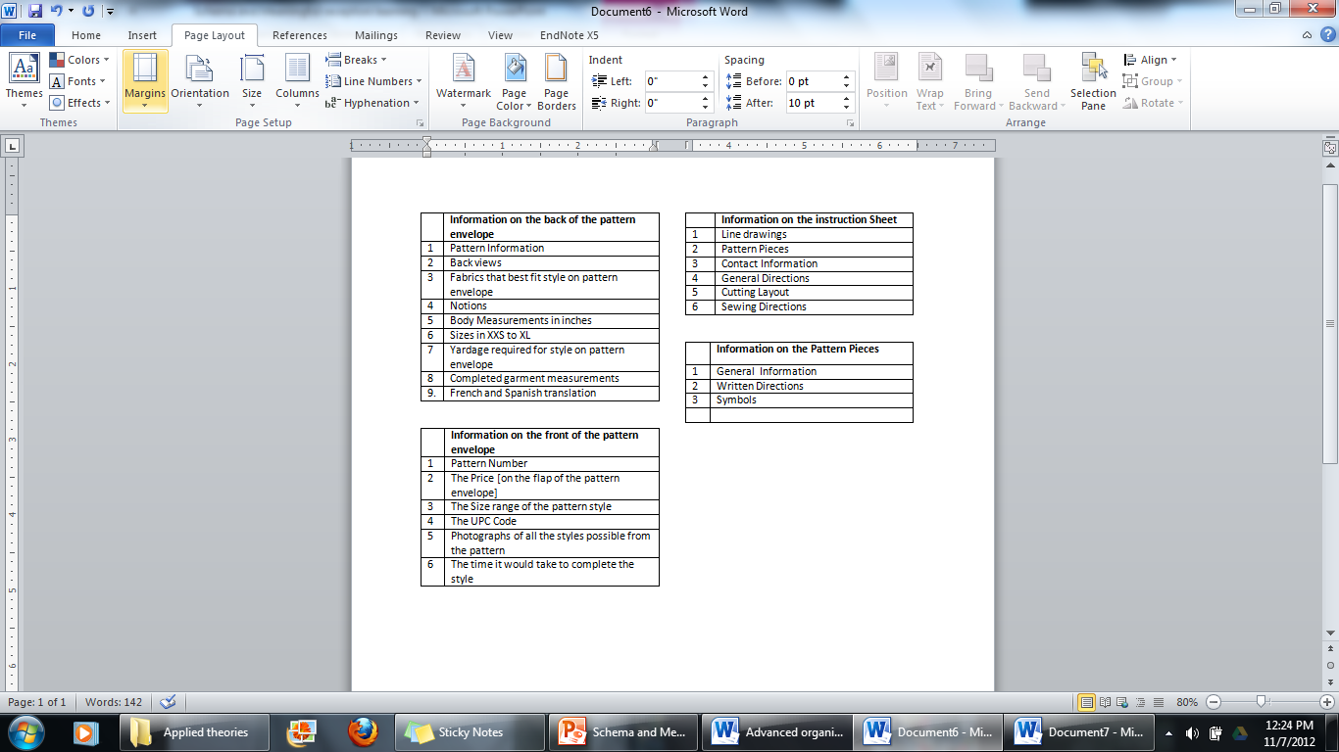
Figure 1

Figure 2 Comparative Organizer Showing the Essential Information on the Outside and Inside of a Paper Pattern Envelope

In the video, I activated their schema by asking them questions like” Do they remember cutting papers into gingerbread shapes in elementary schools and do they remember cutting coupons? If they cannot remember cutting paper shapes in elementary school, they can remember cutting coupons in their adult years. I also impressed them with self-efficacy in terms of motivation. If they think that they can read the directions for cutting gingerbread shapes and coupons, they can feel motivated and believe that they can read the directions on a paper pattern. I also showed them three jumpers that were made from the paper pattern I used in the lesson (see Figure 3).
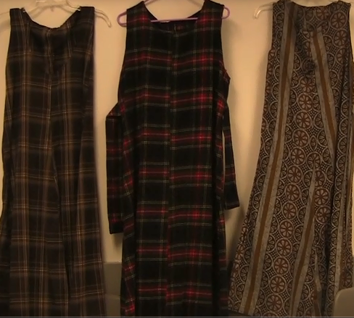
Figure 3.Three Jumpers Made From a Paper Pattern

The presentation of the information on the video that was on the smart board was also presented on PowerPoint. Through various forms of presentation, schemata change should occur through accretion, tuning and restructuring. In the video, learners might not easily identify with words like notions, so I showed them examples of notions, by showing them threads, needles and a tape measure. In the video, I showed the learners the tissue pattern in its full size as the PowerPoint could not clearly show the pattern in its entirety. These video clips would give them vicarious experiences and also motivate them. In the PowerPoint slides, I also asked them to recall the lesson before I took them to the assessment page (see Figure 4). In the recall slides, the slides showed the paper pattern as conceptual maps (see Figure 5).
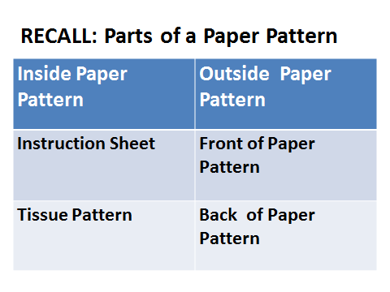
Figure 4 Table Showing Items Learners Should Recall
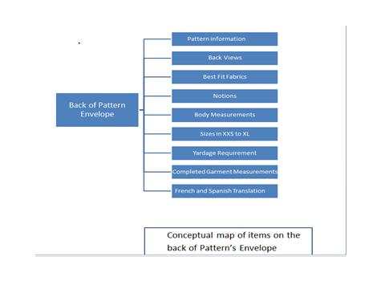

Figure 5
The assessment was structured in an organized format. It occurs after the learners would have gone over the recall slide and the conceptual maps. The materials are made meaningful in their organizing and in cross referencing as is shown in the conceptual maps. The assessment only asks them questions on what they have been taught. I also directed the learners to the slides where they could find all the answers.
How motivation is addressed in this lesson according to the theories of meaningful reception learning and schema.
In this lesson, the interests of the learners are generated by an introductory soundtrack from the late Donna Summer. The sound track is titled; She works hard for the money. It is an upbeat song that stirs curiosity and a perceptual arousal in the learner. The theme of the song and the video of the song are motivational. [Perhaps learners who are familiar with the song may be motivated to learn to sew as to save that money they have worked hard for because the lyrics of the song include words like ”She works hard for the money”].
The lesson organizes the images and labels them clearly in a way that is easy to understand. I used colored photos of an actual paper pattern and in addition to giving clear labels, this same paper pattern was used to make three jumpers that I presented in the video and PowerPoint (see Figures 3 and 6).
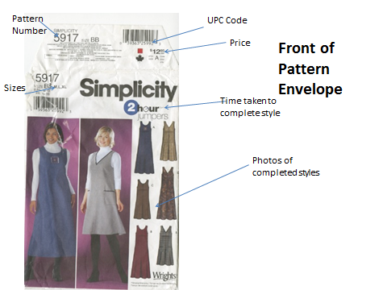
Figure 6

The perceptual arousal is achieved by the various instructional styles, the various texts, the many photos, the pictures, videos, the conceptual maps, the outlines, the organizations of the lesson, the comparative organizers, the cross referencing, the combination of the video and PowerPoint and the use of the smart board.
In addition, showing the photos of different paper patterns on the third slide [boys’ shirts, dresses, skirts and stuffed animals in the PowerPoint slide] would arouse their perceptual curiosity. In the video and in the PowerPoint, I also showed them different paper patterns of different styles and added that they could make different things from the paper pattern so it did not have to be jumpers alone (Figure 7).
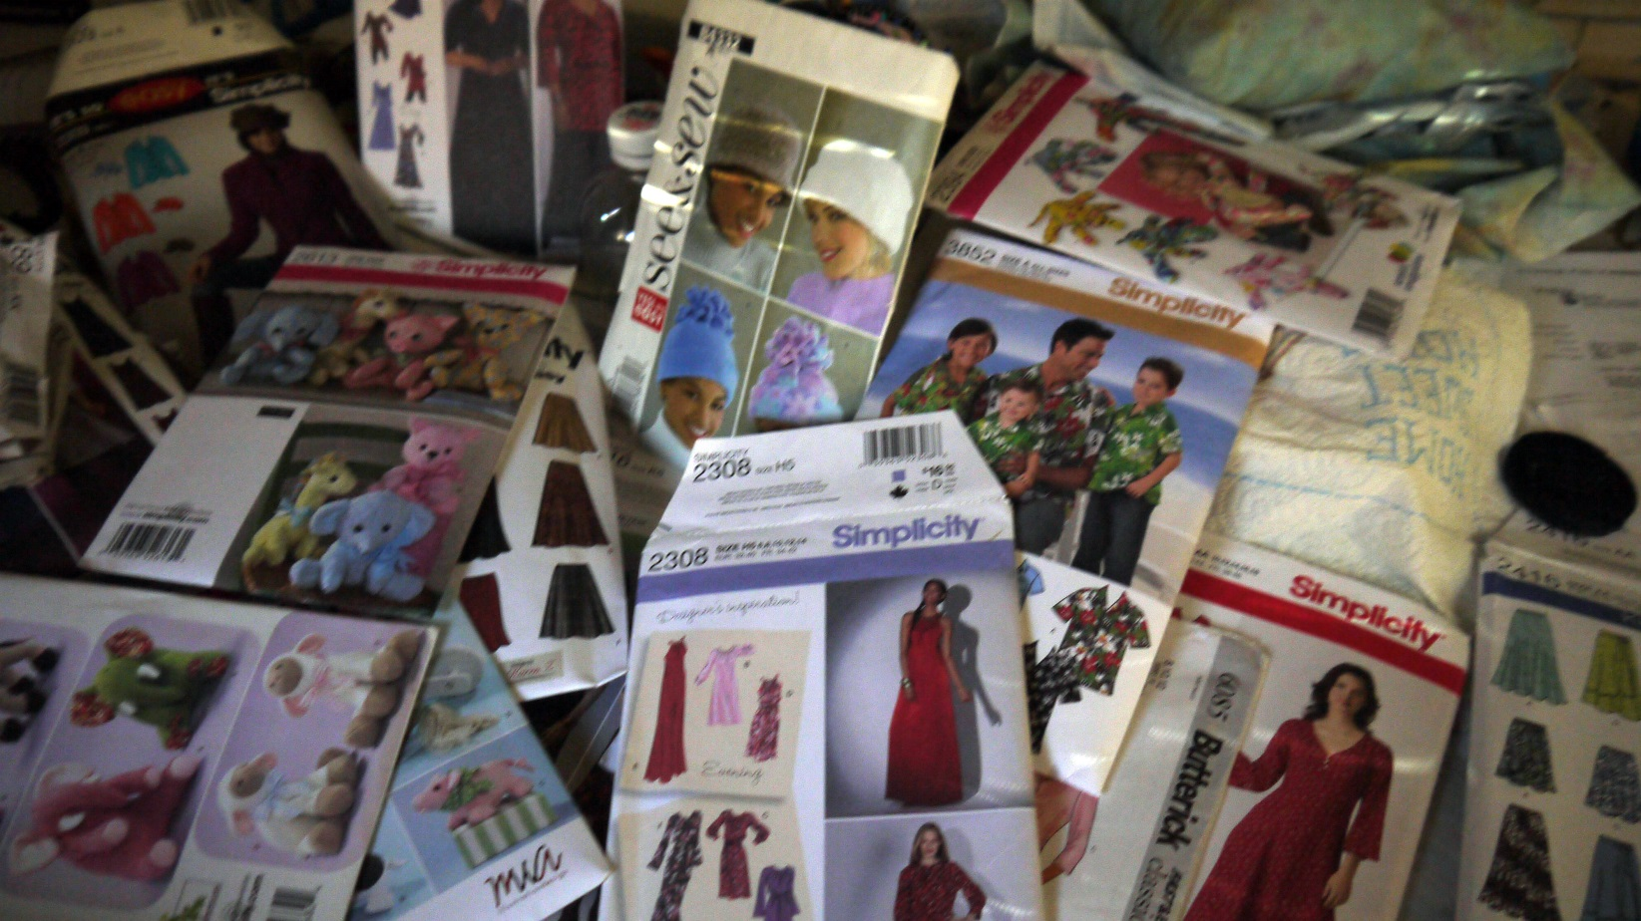

Figure 7 Photo of Many Sewing Paper Patterns

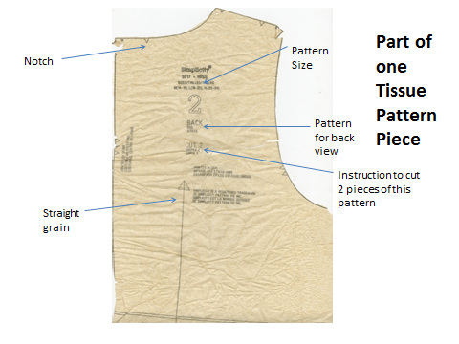
There are vicarious experiences because the learners are actually able to see the instructor who has shown them three jumpers made from the same paper pattern that she is using in the lesson. I showed them three jumpers made from three different fabrics. In the video, they are able to see the entire length of the tissue pattern that was not possible to be displayed fully on the PowerPoint slide because it was about four foot in height when fully unfolded.
Figure 8
The learners can also attribute their ability to read paper patterns to the video. They can also satisfy their outcome expectations because the video shows three jumpers that were made by the instructor. They can tell themselves that if the instructor can do it, so can they.
Analysis
The lesson is for participants at a recreation center. The participants are about ten in number. The PowerPoint slides would be played at the recreation center for the participants. They are females who are in their late twenties to early sixties. The assumptions made are that some time in their lives, they have read directions on how to cut paper, for decorations or for a coupon. It is also assumed that they can operate a movie player or computer and that they have access to a paper pattern.
In data collection, I would ask them why they want to learn how to read a paper pattern. If some of them want to learn because they want to sew for their grandchild, then I know that they are already motivated. If some want to learn as part of an alternative for a class credit they may not be as motivated. The participants may be stay-at home moms who come with their babies and are unable to be fully attentive with their babies beside them.
I would also look at their ages, their background, and their cultures. If they come from a culture where it is not acceptable to use a disembodied hand as a cursor and I used a disembodied hand as a cursor, this might discourage the learners from watching the video. Also, the recreation center may change the venue without notice or they may change the times that the video would be played to a time when most of the participants are not able to attend. I would also ask them how much time they can devote to the lesson.

Design and Development
The objective is to be able to identify the essential information on the front, back and on the inside of a sewing paper pattern. The lesson makes use of both meaningful reception learning and schema theories. As I described in the first page of this paper, I activated their prior knowledge by asking the learners to recall how they cut paper decorations in elementary school and by asking them to recall how they cut coupons from papers. In both recall scenarios, the learners were reminded that they had to read or at least follow the instructions. Further, I made use of advance organizers in the video and in the PowerPoints embedded in the video. I was able to present the contents on the back of the pattern envelope in a hierarchical manner that showed the items on the back of the pattern as combinatorial learning. The students can identify the back of a paper pattern.
In addition to identifying the back of a paper pattern, they are now able to add information on other items that can be found on the back of the pattern envelope. Combinatorial learning was used in describing the information on the front of the paper pattern (see Figure 9). The learners are able to include other items that can be found on the front of the paper pattern.
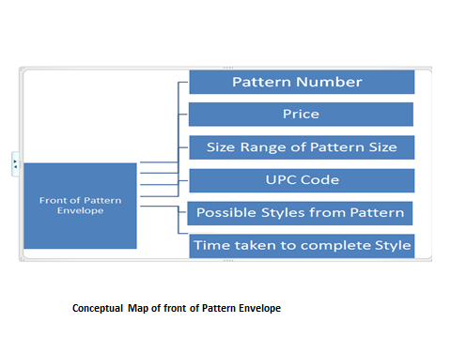
Figure 9
Formative Evaluation
What could have gone wrong? I might have identified the wrong audience. Perhaps, the audience is of a much younger age group and the 1980’s music that I played at the beginning would not appeal to them.
It could be that the recreation center may have another video playing in another room or a fitness class going on with distracting music and the participants learning about the sewing paper pattern may have had difficulty listening to the video. It could also be that a supra system; the recreation center has now started charging fees for each participant for each viewing of the video and this reduces their chances of watching the video multiple times.
If the lesson was poorly organized and the learners found it difficult to follow, the participants might not have gained any knowledge from the lesson. If I gave them information overload and presented them much more than they needed in the 12-minute video, the students would not learn as expected. If the learners were from a particular ethnic group and I did not use the language they understood, they might have difficulty in learning. In the assessment, I might have asked them questions on what I did not teach them at all. It could also be that the instructions in the assessment were confusing and difficult to understand.

