CS 4624: Multimedia, Hypertext and Information Access

Final Report: Lyme Disease in the United States

James Park, Nikolai Rabin
Virginia Polytechnic Institute and State University
Department of Computer Science
Blacksburg, VA 24061
May 3, 2021

Supervised by Dr. Edward A. Fox

Table of Contents
Table of Figures …………………………………………………………………...3
Table of Tables …………………………………………………………………….4
- Abstract ………………………………………………………………...………….5
- Introduction ………………………………………………………………………..6
- Requirements ………………………………………………………………....…...7
  - Software …………………………………………………………………...7
  - Data Collection …………………………………………………...…….....7
  - Data Exploration …………………………………………………………..8
  - Data Visualization ………………………………………………………....8
- Design ………………………………………………………………………...…...9
- Implementation …………………………………………………………………..10
  - Web Scraping ………………………………………………………….....10
  - Data Parsing ……………....……………………………………………...13
  - Data Exploration ………………………...……………………………….15
  - Data Visualization ………………………………………………………..18
- Evaluation and Results …………………………………………………………...21
- User’s Manual ……………………………………………………………………22
  - Required Software ……………………………………………….……….22
  - Pre-Existing Datasets ……………………………………………………..23
  - Web Scraping ……………………………………………………………..24
  - Data Parsing ……………………………………………………...…….... 25
  - Data Exploration ………………………………………………….……... 26
  - Data Visualization ……………………………………………….………..26
- Developer’s Manual…………………………………………………….…………28
- Lessons Learned ……………………………………………………………….….32
  - Timeline and Schedule ……………………………………….….………..32
  - Problems and Solutions ………………………………………..………….32
  - Future Work …………………………………………………….……...….33
- Acknowledgements ………………………………………………….…………….34
- References …………………………………………………………….………….. 35

Table of Figures

Figure 1: Data Science Process ………………………………………………………………...9
Figure 2: Web Scraping Code …………………………………………………………………10
Figure 3: URL and XPath Lines ………………………………………………………………10
Figure 4: Source Code Example ………………………………………………………………11
Figure 5: Example Online Table ………………………………………………………………12
Figure 6: Example .csv Conversion …………………………………………………………...13
Figure 7: Data unification Code for Countrywide Data ……………………………………….13
Figure 8: Merging of Countrywide Data ………………………………………………………14
Figure 9: Data Unification and Merge Code for Statewide Data ……………………………...14
Figure 10: Code for Statewide Data …………………………………………………………...16
Figure 11: Scatter Plot Showing Lyme Disease Incidence vs. HDI …………………………...16
Figure 12: Code for Countywide Data …………………………………………………………16
Figure 13: Scatter Plot Showing Lyme Disease Cases vs. Total Population …………………..17
Figure 14: Code for Animal Plots(Specifically Mammals In This Case) ……………………...17
Figure 15: Plot for Lithobates Septentrionalis Species ………………………………………...18
Figure 16: Lyme Disease Cases in the United States …………………………………………..19
Figure 17: Choropleth Graph of Rainfall and Temperature in the United States ……………....19
Figure 18: Choropleth Graph of Population Density and Total in the United States …………..20
Figure 19: Code Download Button …………………………………………………………….22
Figure 20: Code Download …………………………………………………………………….23
Figure 21: Data Loading Code …………………………………………………………………25
Figure 22: Environment Variables After Loading Data ………………………………………..25
Figure 23: Linear Regression Code …………………………………………………………….26
Figure 24: Linear Regression Output …………………………………………………………..26
Figure 25: Code for Choropleth Graphs .. ……………………………………………………...27
Figure 26: Developer Workflow Diagram ……………………………………………………...28
Figure 27: Timetable of our Schedule ………………………...…………………………....…...32

Table of Tables

Table 1: Data Frame Overview………...…………………………………………………...15
Table 2: Required Software………………………………………………………………...22
Table 3:.csv Files Included……………………...………………………………………….23
Table 4: All Files Included..………………………………………………………………..29

- Abstract

The main goal of this project is to assist our client, Dr. Luis Escobar, in identifying a number of variables that are causing an increased number of Lyme disease cases in the United States. Our client gave us data regarding the amount of Lyme disease cases per county/per state over the course of a number of years, and we were tasked with finding variables that could contribute to the rise of Lyme disease cases.

We were tasked to scrape data from various online sources reporting what could potentially impact the rise of Lyme disease cases, clean and merge the data with the Lyme disease data, generate various regression plots to see if there was a correlation, find the best predictor variables out of the ones we have collected, and generate a choropleth graph using the best predictor variables. A final report of the process, the data, the plots, and an explanation of our findings was also requested.

Utilizing the programming language R and some web scraping aids that are related, our team was able to scrape data on human population density by county, human population count by county, per capita income per county, human development index (HDI) by county, research and development spending per state, and temperature and precipitation per county. This data was parsed to fit with our Lyme disease data, and multiple regression plots were created using the data we collected as the X-axis and the Lyme disease cases as the Y-axis. Once all of the plots were completed, the plots with the highest correlation were picked out to be generated into choropleth graphs.

There were some challenges with finding datasets that were able to fit with our Lyme disease cases, so some improvisations were made with the data we scraped to better fit the original dataset we were given. There was not much data pertaining to each county online, so for some cases, our Lyme disease data had to be merged to be per state rather than per county.

The work completed by our team can further the research on Lyme disease to decrease the rates in the number of cases for the foreseeable future. By finding predictor variables that show a high correlation to the increasing number of Lyme disease cases, researchers will be able to focus their attention on these predictor variables to find the most efficient methods of decreasing the number of Lyme disease cases. We expect future Virginia Tech students, Lyme disease researchers, and our client will use and improve upon our code to continue the war against Lyme disease.

- Introduction

Lyme disease is the vector-borne disease that is caused by a bacteria called Borrelia burgdorferi [4]. Lyme disease is the most common vector borne disease in the United States. According to the CDC, nearly half a million people are diagnosed per year in the United States [1]. The number of cases regarding Lyme disease is continuing to grow, and researchers are consistently working towards reducing the numbers.

Lyme disease is typically transferred to humans through black legged ticks. Ticks can often be found in domains that are woody and grassy. Ticks will rest near the ends of tall grasses and attach themselves to creatures that walk through. During the spring, ticks begin laying their eggs and over the course of a year, the eggs will hatch and new ticks will be born during the summer time. After another year, ticks evolve through their younger stages and into their full adult stage by the following fall [4]. The risk of human infection from ticks is the highest during the spring and summer, as humans are outdoors more and ticks reach their adult stages during this time.

Lyme disease can cause a number of minor to severe symptoms. Some of those symptoms include fever, rash, headache, fatigue, allergy to red meats, and minor strokes [4]. The symptoms usually start with the rash, and over a course of 3 to 30 days, symptoms can start showing and worsen. Since ticks are rather small insects, they can often be hard to detect once they’ve attached to your body. Although many people are able to detect ticks on their body early, improper removal techniques cause the tick’s mouth to stay attached to the body, resulting in Lyme disease still being transmitted.

There are currently various lab testing methods to identify if someone has Lyme disease, as well as some treatments. With a few weeks of antibiotics, most Lyme disease cases can be treated successfully [4]. Although there are treatments for Lyme disease, the best one is prevention from getting it to begin with. This would include using insect repellent, reducing/avoiding time spent where ticks are located, and applying pesticides to various areas near your home where ticks can be common.

This has led us to the topic of our project. Although there are treatments for Lyme disease, it would be best to prevent the cases from arising in the first place. By utilizing data containing the number of Lyme disease cases in the United States and other datasets that were scraped online, our team hopes to find correlations between various predictor variables and the rise of Lyme disease. In doing so, it could help researchers better identify the source of the high number of cases and lower them for the future.

- Requirements

Our client had a number of specifications for this project. To start, our client gave us a dataset on the number of Lyme disease cases per county over a number of years. Our client requested we scrape additional data from the internet, create some models to show the correlation between the Lyme disease cases and the data we collected, explore the dataset to find predictor variables with the highest correlation, and create a choropleth graph with those predictor variables.

3.1 Software

Our client requested that the code we used for web-scraping and plot generation would be in the programming language R. R is a language and environment that is used for statistical computation and analysis, as well as graphics [5]. It provides an effective data handling facility, a large variety of tools for data analysis, as well as a large number of tools to provide graphics. Our client’s research team primarily uses R, so we were asked to do the same so that our client’s research team would have an easier time using our code as well. Since we’re primarily dealing with large datasets and plots, R was an obvious choice to handle our data and create the visuals that we needed.

3.2 Data Collection

Our client provided us a Lyme disease case count dataset that would serve as our response variable (Y-axis) in a regression model. We were requested to web-scrape additional data that would serve as our predictor variables (X-axis). Our client gave a few suggestions on the predictor variables we should collect such as:

- Human population density by county
- Human population count by county
- Human development index (HDI) per county
- Per capita income by county
- Research and development spending per state
- Temperature and precipitation per county per year
Our client was aware that a lot of this data was difficult to find online per county, so he suggested finding state data if the county data was not available. Additional data cleaning had to be done on the data that was web-scraped online, and the Lyme disease data had to be merged to match with some of the state data that was web-scraped. Our team had the flexibility of also finding additional datasets that we thought could be helpful.
3.3 Data Exploration

Once all of the data was cleaned and parsed, we were tasked with exploring these datasets and finding any correlations between the variables we have collected and the number of Lyme disease cases per county. Utilizing scatter plots and regression lines, we would be able to get a visual to see if any correlations could be seen.

The data that we collected would serve as our predictor variable (X-axis) and the number of Lyme disease cases would serve as our response variable (Y-axis). The data would have to be plotted on a scatter plot, and using a best fit line, a regression line would be created to see if there was a positive, neutral, or negative correlation. After all of the plots were to be created, our team would have to choose which predictor variables had the highest correlation in relation to the increase of Lyme disease cases in the United States.

3.4 Data Visualization

With the predictor variables that we have selected from the data exploration stage, we were to create a choropleth graph utilizing those variables. A choropleth graph is a map that provides an easy way to visualize how a variable varies across a geographical location. Since our data is in relation to various states and counties, it would be beneficial to use a choropleth graph to show the variations of our variables on a map. In addition to choropleth graphs, we were given the ability to include any other additional visualizations that our team thought would be beneficial to show the contributing factors of Lyme disease cases. Once all of these plots have been finalized, they would be included in a final report of our findings and our explanations on why these could potentially be causing an increase in cases.

- Design

Since our project is dealing with large datasets and visualizations of those datasets, we took a “Data Science Process” approach in terms of designing our project; see Figure 1. To start, we had the question of “What’s causing the increase in Lyme disease cases in the United States?” and we continued to build off of that.
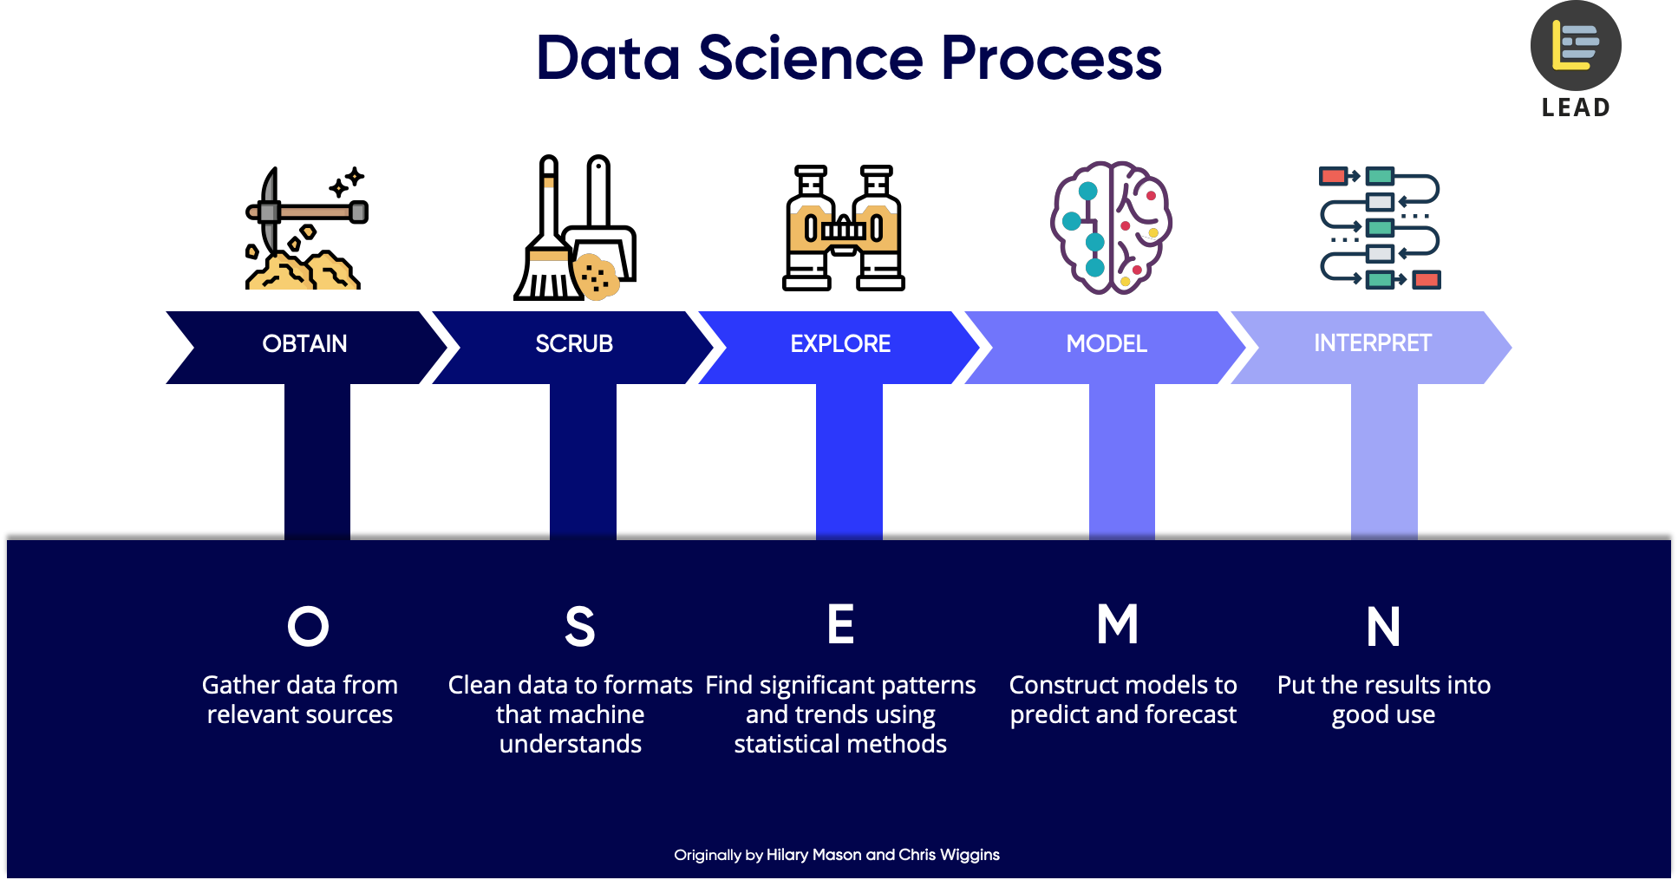
Figure 1: Data Science Process; adapted from https://towardsdatascience.com/

From there we followed the process of obtaining our data through various Wikipedia sources and other census datasets. Utilizing some R libraries, we were able to use some web-scraping tools to obtain the additional data that we needed. We then cleaned the data for any fields that could have been missing, in addition to removing some attributes that we did not really need. We began to explore our datasets more in depth and generate some simple scatter plots with a regression line to see any correlations at a glance. After this, we found the predictor variables that showed the highest positive correlation and continued to move forward with those datasets. Although we went through this iterative approach, the order in which we did these steps was rather fluid as we had to go back and forth between a number of steps to produce the best results.

- Implementation

Following the data science approach as mentioned above, we took iterative steps to scrape the data, parse it, explore the data, and then visualize it.

5.1 Web Scraping

Utilizing the R library “rvest” our team was able to web-scrape tables from a number of sources. The rvest library utilizes the URL of a website and the source code to obtain and extract tables within the website. The source code allows you to see the various HTML elements within a webpage, and rvest uses the variable names of these elements to obtain the information stored within those variables. Our team did extensive research to find some valid sources containing data pertaining to what we were looking for and utilized the rvest library from there. The code used for the web scraping is shown in Figure 2.

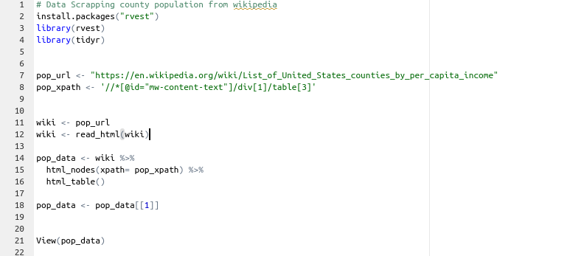
Figure 2: Web Scraping Code

This code base remained the same throughout the various online resources we used, with only lines 7 and 8 being changed to fit with that website; see Figure 3. For line 7, the URL of the website we were using was being updated to accommodate the various websites we utilized and line 8 represented the XPath of the table that we were trying to webscrape:

Figure 3: URL and XPath Lines

To find the XPath of a table on a website, we utilized the source code to find what our team was looking for, as shown in Figure 4.

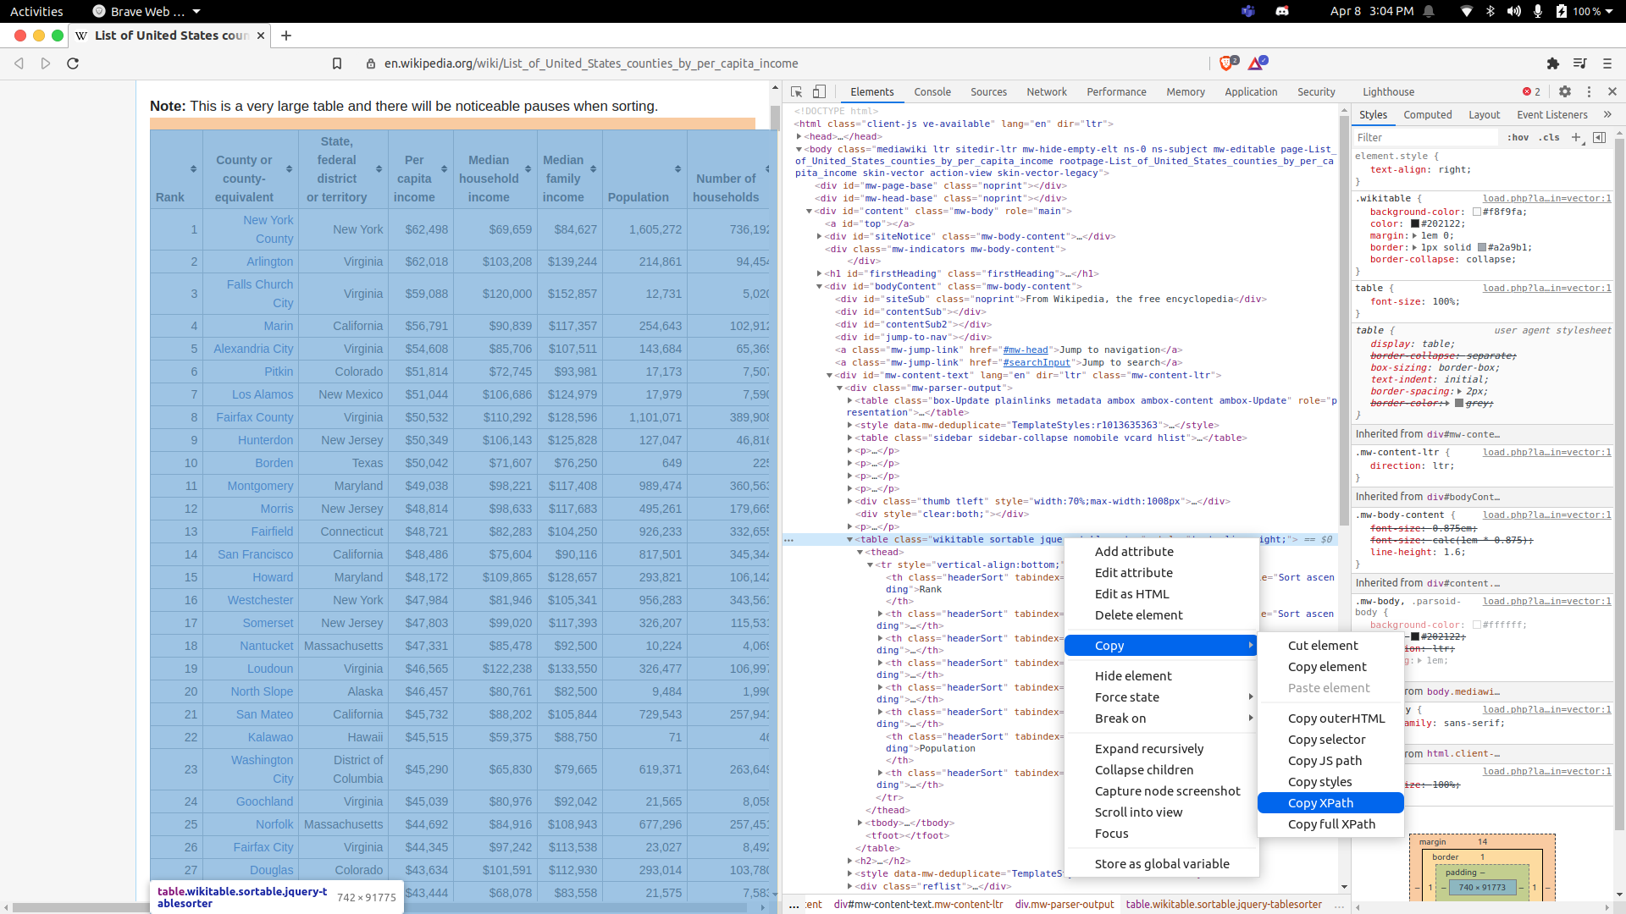
Figure 4: Source Code Example

Once the correct URL and XPath were successfully submitted, we were able to run our program and get an output of a .csv file containing the contents of the table. For example, we started with the Wikipedia table shown in Figure 5 that contained information on the HDI per state.

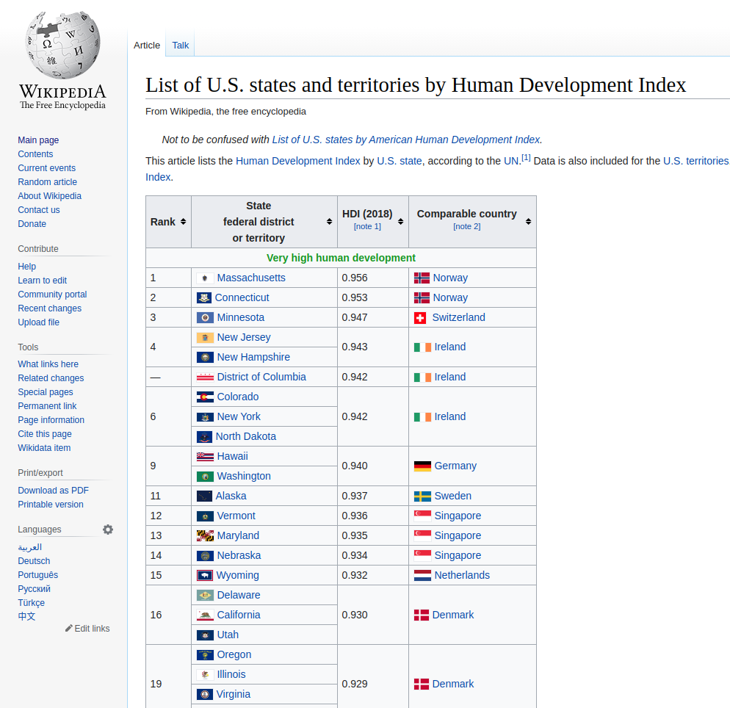
Figure 5: Example online table

After inputting the URL and XPath, we received a .csv file, shown in Figure 6, containing the same contents as the table.

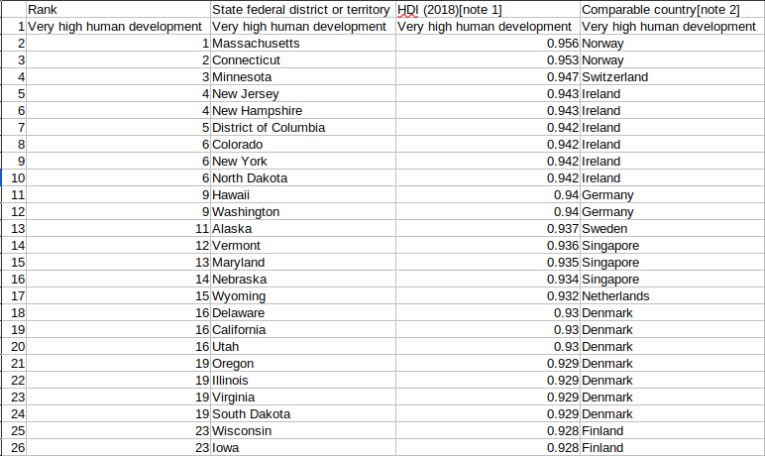
Figure 6: Example .csv conversion

5.2 Data Parsing

The first step in parsing the data is converting the .csv files we obtained from web scraping into dataframes. Dataframes are a 2D data structure with columns of differing types and are an efficient data structure when parsing through data that is in the form of a .csv file. Then some modifications were made to make the data more uniform to help make the merging go smoothly. Some changes had to be made to the column headers; those changes were easier to do manually. These changes were only made to the columns containing the state and county data since those are the basis for the merging. These were changed to “State” and “County”. Then the data in the columns also had to be made uniform. For the county data, there was a small variation in the number of counties, so merging them required the merge function in R. To make the data palatable for the command, all data in the state and county columns of these data frames were transformed into upper case, using code shown in Figure 7.

Figure 7: Data unification code for countywide data

The data was then combined using the merge function, as is illustrated in Figure 8 for Lyme data and income.

Figure 8: Merging of countywide data

For the statewide data there was a uniform number of columns, so to merge the data sets, the only manipulation that had to be made to the data was to change the order. The order of the state data was changed to be alphabetized to make merging the counties into one state easier. This was done because the data would be more reliable than using the merge function. Merging the data was possible because there was a uniform number of columns in the statewide data frames. Then all that was left was to add the new variable columns in the statewide Lyme dataframe. Figure 9 shows the code snippet where this happens.

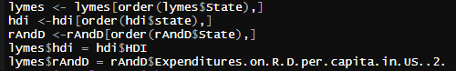
Figure 9: Data unification and merge code for statewide data

The dataframe was also changed to not include data points where no Lyme disease cases occurred.

For the animal datasets, generating plots required a different approach. Since each instance of a species of animal was its own column in the data sets, meaning that a duck in Roanoke county would be a different datapoint than a duck in Fairfax county, we could not just do a scatterplot like with the county and state data. So, we decided to map out where each species is located in the continental United states. To do this, we first had to clean the data so that only animals located in the continental United States were taken into account.

When all was said and done with data parsing, our data frames looked like what is shown in Table 1.

Variable | Dependent vs. Independent | Number of Data Points  (after cleanup) | State vs. County vs. Species
Amphibian Species | Independent | 73416 | Species
Bird Species | Independent | 136045 | Species
Human Development Index | Independent | 51 | State
Income | Independent | 3297 | County
Lyme Disease (county) | Dependent | 3193 | County
Lyme Disease (state) | Dependent | 42 | State
Mammal Species | Independent | 59018 | Species
Population Density and Total (State) | Independent | 50 | State
Population Density (County) | Independent | 3149 | County
Population Total (County) | Independent | 3193 | County
Precipitation | Independent | 3136 | County
Reptile Species | Independent | 66965 | Species
Research and Development | Independent | 51 | State
Temperature | Independent | 3136 | County

Table 1: Data Frame Overview

5.3 Data Exploration

With all of the data merged into a more usable format, data exploration is fairly simple. All that is needed to be done for this step is to plot the given variable against the Lyme disease data for the state and county data and to plot out the animal data on a map. To visualize the state and county data, the ggplot library was used since the only plots used at this point are simply plotting points [10]. Figure 10 gives code for plotting with statewide data, leading to the plot shown in Figure 11.

Figure 10: Code for statewide data
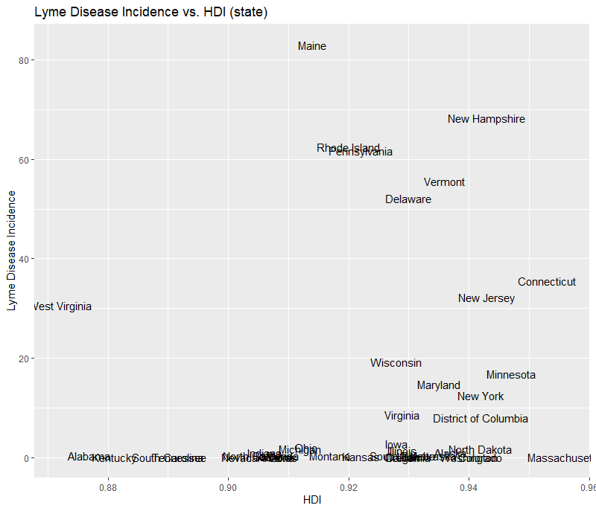
Figure 11: Scatter plot showing Lyme disease incidence vs. HDI

Figure 12 shows countywide data:
Figure 12: Code for countywide data
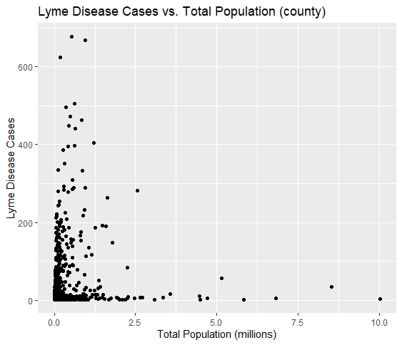
Figure 13: Scatter plot showing Lyme disease cases vs. Total Population

For the animal data, we simply plotted the locations of each species on a map of the United States using ggplot and facet wrapping each dataset so that there is a separate plot for each species. Figure 14 shows an example of the code used to do this and Figure 15 shows a plot that the code generates. Regarding this plot, it is for a single species. The plots generated from the code look a bit different, but the basic concept is the same.

Figure 14: Code for Animal Plots (specifically mammals in this case)

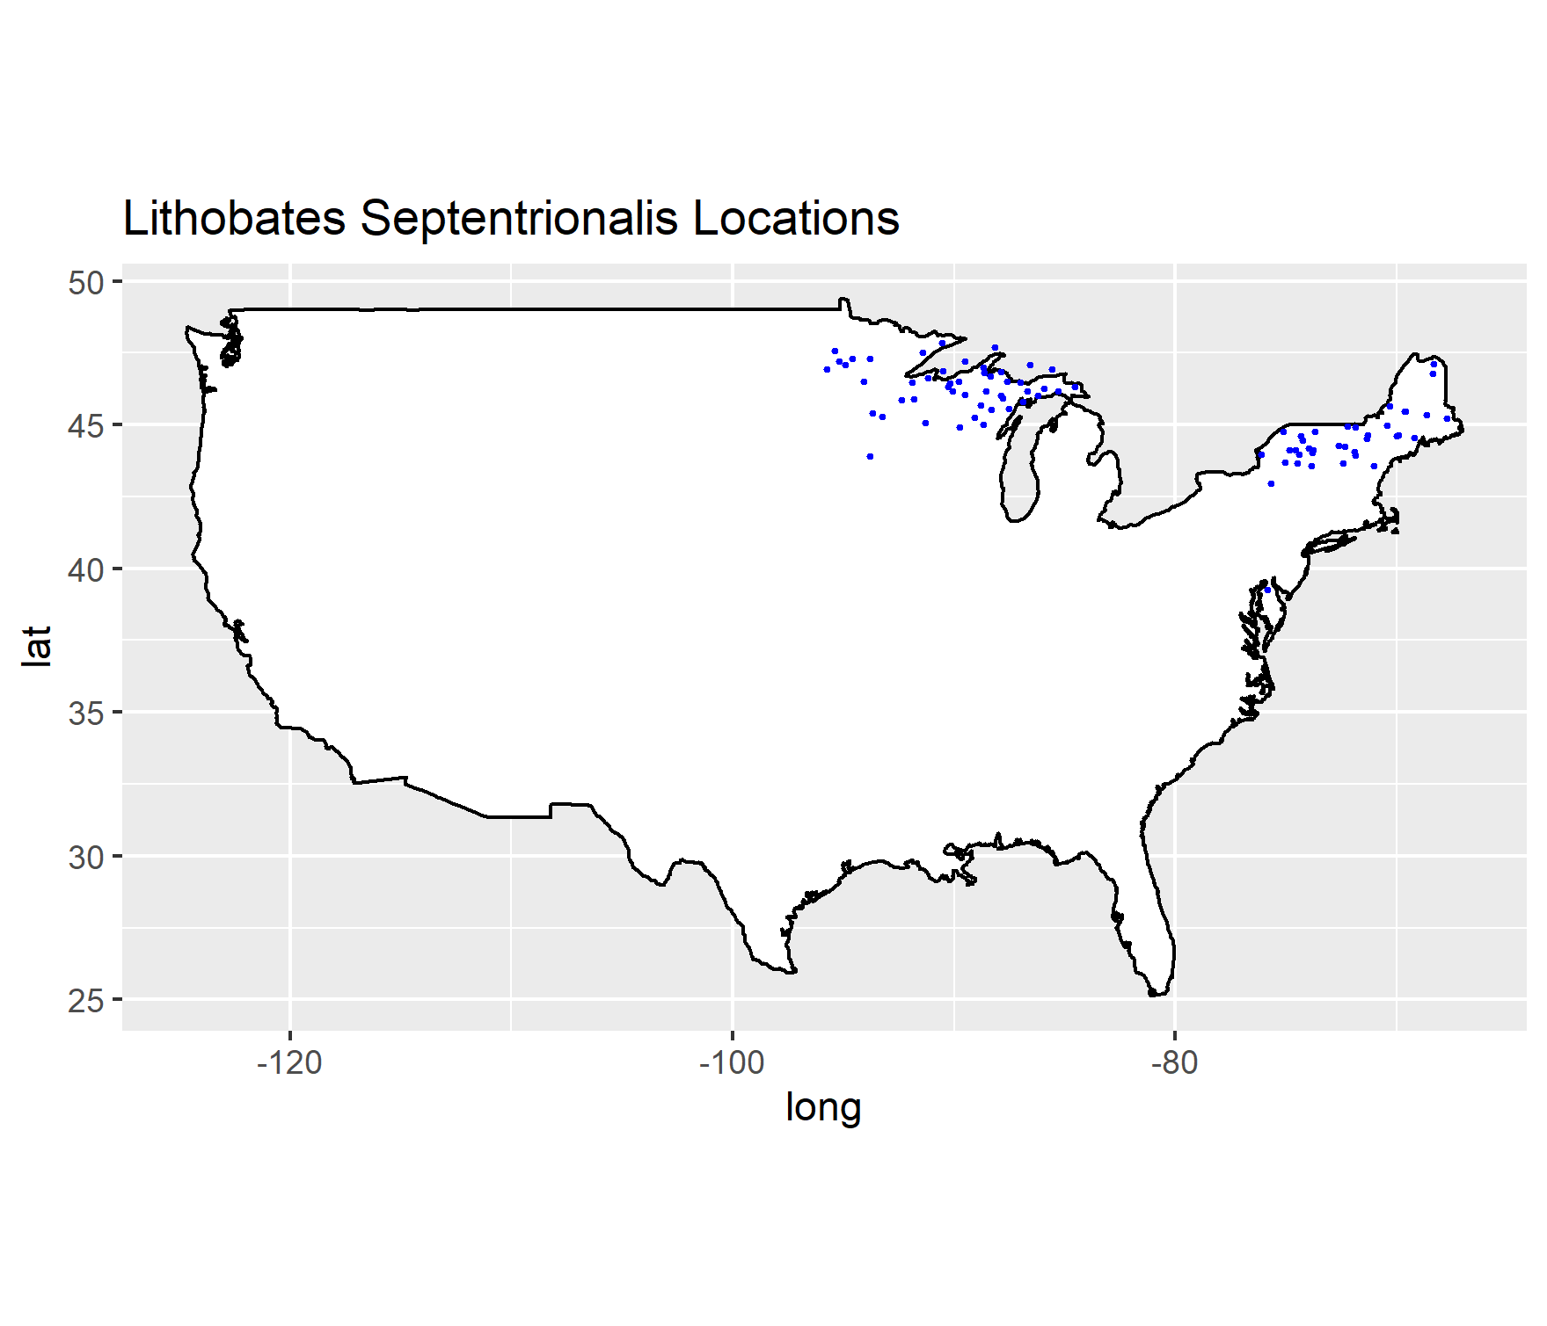
Figure 15: Plot for the Lithobates Septerionalis species

After all of the data was plotted out, we came to the conclusion that there were two sets of independent variables that could correlate with Lyme disease cases. The first pair is temperature and rainfall, and the other is population density and total population. Fully fleshed out representations of this data will be shown in the next sub-section.

5.4 Data Visualization

As stated in the previous sub-section, the exploration of data led us to believe there were two sets of independent variables that could correlate with Lyme disease cases. The first two are the average temperature and the amount of precipitation each area has. To show this we made a choropleth graph using R, that showed the two variables on a map of the United States. As shown in Figure 16, areas with a lower average temperature and a moderate amount of rainfall, appear to have a higher number of Lyme disease cases, as shown in Figure 15. These areas are shown as baby blue on the choropleth graph.
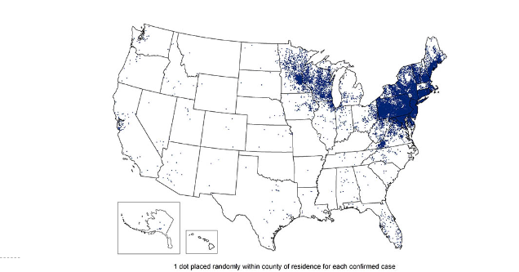

Figure 16: Lyme Disease Cases in the United States
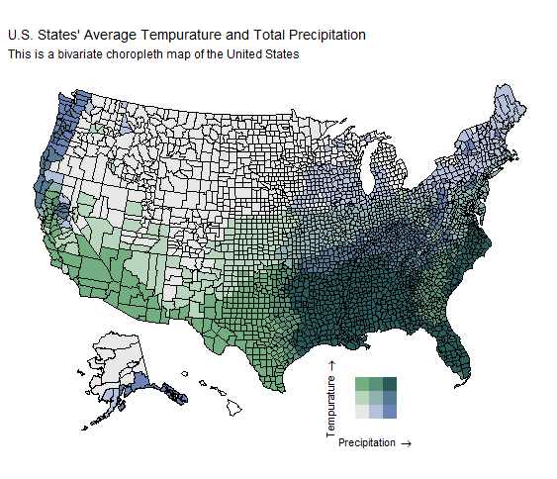
Figure 17: Choropleth Graph of Rainfall and Temperature in the United States

Another pair of variables that seemed to have a correlation were population density and total population, even if there seems to be less of a relationship than temperature and rainfall. The same type of graph was used, on a state by state basis this time, due to the limited county data. There seems to be a relationship between states with a high to moderate population along with a high to moderate density and Lyme disease cases, as shown in Figure 17.

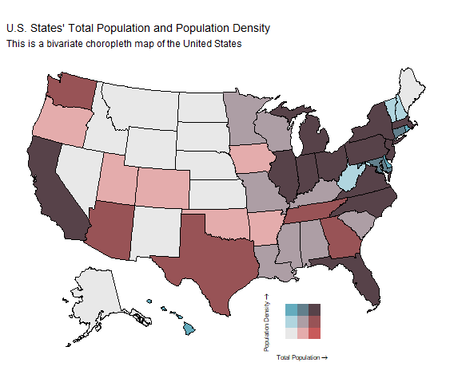
Figure 18: Choropleth Graph of Population Density and Total in the United States

- Evaluation and Results

Based on the finalized plots that we have created, the best predictor variables seem to be a combination of the total population, population density, average precipitation, and average temperature. As seen in Figure 15, the majority of Lyme disease cases are primarily found in the northeast portion of the United States. With a combination of Figure 16 and Figure 17, we were able to see that the majority of Lyme disease cases were found in areas of high population count and population density, as well as a high average precipitation and moderate temperature. It is important to note that all four of these predictor variables are considered when looking at the number of Lyme disease cases. As seen in Figure 17, California and Florida both have a high population count and high population density, but their average temperature is a lot higher and their average precipitation is a lot lower compared to the northeast region as seen in Figure 16.

- User’s Manual

For users that want to use their own datasets or create their own plots, follow the steps below.

7.1 Required Software

See Table 2 for the software used, where to download it, and how it was used.

Software | Where To Download | Use
IDE for R (Rstudio Recommended) | https://www.rstudio.com/products/rstudio/download/ | Used for compiling and running code
R language | https://www.r-project.org/ | Language used in programs
Github Repository | https://github.com/nikolairabin/LymeDiseaseCapstone | Where all previous code and figures are stored
Table 2: Required Software

While the IDE for R is not required, it is recommended as RStudio provides a very useful interface that can potentially help with the process. To access the code, plots, and .csv files that our team used, follow the URL for the GitHub repository. Once you’ve reached the repository, you should click on the green box with the download button and “Code” on it; see Figure 19.


Figure 19: Code Download Button

From there, you have the option to download the files in a zip folder or to download using HTTPS based on your preference; see Figure 20.

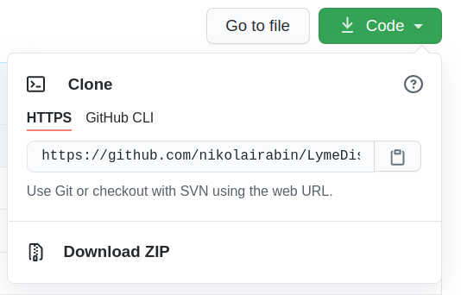
Figure 20: Code Download

At this point you should be able to access all of the files and use the code in your preferred IDE.

7.2 Pre-existing Datasets

Data | URL | XPath | File name
Precipitation | https://www.ncdc.noaa.gov/cag/county/mapping/110/tavg/202001/ytd/mean | .csv was downloaded from website | 110-pcp-202001-60.csv
Temperature | https://www.ncdc.noaa.gov/cag/county/mapping/110/tavg/202001/ytd/mean | .csv was downloaded from website | 110-tavg-202001-60.csv
Amphibians | .csv was supplied from client | .csv was supplied from client | amphibians.csv
Birds | .csv was supplied from client | .csv was supplied from client | birds.csv
Population (total) | https://randstatestats.org/ | .csv was downloaded from website | co-est2019-alldata.csv
Population (density) | https://randstatestats.org/ | .csv was downloaded from website | Current-Population-Density.csv
Human Development Index | https://randstatestats.org/ | .csv was downloaded from website | hdi_data.csv
Income | https://en.wikipedia.org/wiki/List_of_United_States_counties_by_per_capita_income | //*[@id="mw-content-text"]/div[1]/table[3] | income.csv
Mammals | .csv was supplied from client | .csv was supplied from client | Mammals.csv
Research and Development | https://en.wikipedia.org/wiki/List_of_U.S._states_by_research_and_development_spending | //*[@id="mw-content-text"]/div[1]/table | r&d.csv
Reptiles | .csv was supplied from client | .csv was supplied from client | reptiles.csv
Lyme Disease (state) | https://www.cdc.gov/lyme/datasurveillance/maps-recent.html | .csv was downloaded from website | lymesState.csv
Lyme Disease (county) | https://www.cdc.gov/lyme/stats/survfaq.html | .csv was downloaded from website | lymesCounty.csv
Table 3: .csv Files Included

Table 3 shows the datasets that can already be found in the repository, giving the URL, XPath, and .csv file used.

7.3 Web Scraping

To utilize the web-scraping functionality of our code, you should change lines 7 and 8 in the web scraping code to accommodate your respective website and XPath variable as noted in Figure 3. Note: The web scraping code can only convert tables to a .csv file. If the data that needed to be scraped is NOT a table, additional changes would have to be made in the code base to accommodate your needs.

7.4 Data Parsing

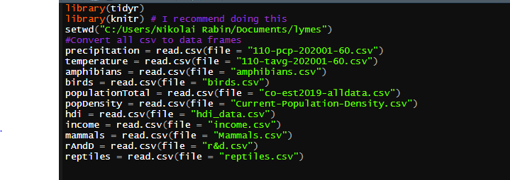
Figure 21: Data loading code

One prerequisite is to have all of the .csv files with the same names as shown earlier as well as to change the working directory in line 3 to the folder containing the data sets; see Figure 21. If you were to add your own dataset, a new variable would have to be created for the dataset you would like to add with the same syntax as the others shown. After running the code, you should see something along these lines in your environment variables tab in Rstudio; see Figure 22.

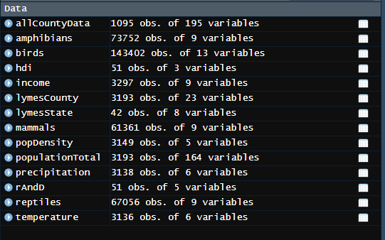
Figure 22: Environment variables after loading in data

If the data sets do not need to be updated, the datasets can be found on the GitHub page with the same file names as in the table. The data also need to be merged as described in the implementation section.

7.5 Data Exploration

For the data exploration, the main goal should be to narrow down the data to only the relevant parts. The easiest way to do this is to first make scatter plots to see if there is any obvious correlation between the given variable and the Lyme disease data. These scatter plots can be seen in Section 5.3. If there is no obvious correlation, then the data is cut from the next step. If there is a visual correlation, then regression testing is done on it. For example, the HDI scatter plot seems to have some sort of correlation between Lyme incidence and a high HDI. You should be able to run a linear regression on it and to check the R² value; see Figure 24.

Figure 23: Linear regression code

Figure 24: Linear regression output

Since the R² value is very low, we will want to try another type of regression or we will eventually scrap it if none of the other regression types pan out.

7.6 Data Visualization

One of the main goals of this project is to visualize possible causes of Lyme Disease cases. This was done by taking the variables deemed as relevant and putting the related variables into a choropleth graph. To get the data into a bivariate choropleth draft, you first need to combine the two variables into a single dataset and then run the bi_class function from the “bi-class” library on the dataset [13]. Then use the plot_usmap function from the library usmap to plot the data with the bi_scale_fill as the fill setting [11]. Figure 25 shows all of these concepts put together. The result of this code can be seen in Figures 16 and 17.

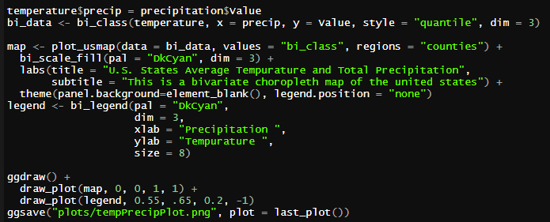
Figure 25: Code for Choropleth Graphs

- Developer’s Manual

To access the code and datasets used, follow steps from Section 7.1.

Figure 26 shows the workflow utilized for this project. The yellow rectangle is the overarching goal of the project. The red rectangles symbolize a main task, and the gray rectangles symbolize a subtask. The blue rectangles are the final deliverables for the project. An arrow pointing from a rectangle shows that the rectangle being pointed to must be completed for the source rectangle to proceed. For a short description of each rectangle, see the Developer Diagram Description directly below Figure 26.

Developer Workflow Diagram:

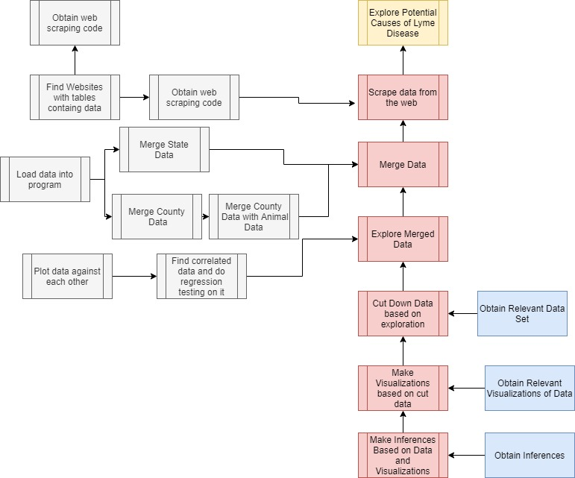
Figure 26: Developer Workflow Diagram

Developer Diagram Description:
- Scrape data from the web - Not all data was given to us. We needed to collect some on our own.
  - Obtain web scraping code - Code was obtained from client
  - Find websites with tables containing data - The code needs to have a URL and a path to the data.
  - Run the code on websites and path - converts a table from a website to a .csv file
- Merge Data
  - Load data into program - need to convert .csv files to dataframes in R
  - Merge state data - Statewide data needs to be merged and kept separate from county data due to mismatched columns
  - Merge county data
  - Merge animal data with county data - animal data needs to be merged with county data, but the animal data has different columns than the county data, requiring a different approach
- Explore merged data
  - Plot data against each other - simple scatter plots should be fine to get the ball rolling.
  - Find data that could be correlated and do regression testing on it - want to make sure that the data is relevant
- Cut down data based on exploration - data will need to be cut down to only include relevant data so that inferences can be derived more easily
- Make visualizations based on exploration - the visualizations will vary based on our findings from the previous step
- Make inferences based on visualizations and exploration

Table 4 shows all of the data and program files that were used throughout this project. The table explains the name of the file, the file type, a short description of the file, how it was used, what it outputs, and the file type/data type of the output.

Input file/ program name(s) | Input Type | Description | Use | Output file/ name (if applicable) | Output Type
rCodeForCapStone.R | R program | Code used of merging of input data and for the visualization of that data | Same as description | Merged data and Visualizations | Dataframe and pngs
web_scraping_in_R.R | R program | Code for web scraping | Used to generate .csv files | All of the files below | .csv
Precipitation | .csv | Precipitation data by county | For use in data  analysis in rCodeForCapStone.R | N/A | R Dataframe
Temperature | .csv | Temperature Data by county | For use in data analysis in rCodeForCapStone.R | N/A | R Dataframe
Amphibians | .csv | List of known amphibians in the United States. One row for each occurrence of that animal | For use in data analysis in rCodeForCapStone.RFor use in data analysis in rCodeForCapStone.R | N/A | R Dataframe
Birds | .csv | List of known birds in the United States. One row for each occurrence of that animal | For use in data analysis in rCodeForCapStone.R | N/A | R Dataframe
Population (total) | .csv | Population data by county | For use in data analysis in rCodeForCapStone.R | N/A | R Dataframe
Population (density) | .csv | Population data by county | For use in data analysis in rCodeForCapStone.R | N/A | R Dataframe
Human Develop- ment Index | .csv | HDI data by state | For use in data analysis in rCodeForCapStone.R | N/A | R Dataframe
Income | .csv | Income data by county | For use in data analysis in rCodeForCapStone.R | N/A | R Dataframe
Mammals | .csv | List of known mammals in the United States. One row for each occurrence of that animal | For use in data analysis in rCodeForCapStone.R | N/A | R Dataframe
Research and Develop- ment | .csv | R and D data by state | For use in data analysis in rCodeForCapStone.R | N/A | R Dataframe
Reptiles | .csv | List of known reptiles in the United States. One row for each occurrence of that animal | For use in data analysis in rCodeForCapStone.R | N/A | R Dataframe
Lyme Disease (state) | .csv | Lyme disease data by state | For use in data analysis in rCodeForCapStone.R | N/A | R Dataframe
Lyme Disease (county) | .csv | Lyme disease data by county | For use in data analysis in rCodeForCapStone.R | N/A | R Dataframe
Table 4: All included data and program files

- Lessons Learned

9.1 Timeline and Schedule

To be sure our team stayed on track, we created a schedule of the time that we would assign to certain parts of our project, while highlighting important deadlines that we had to meet; see Figure 27.

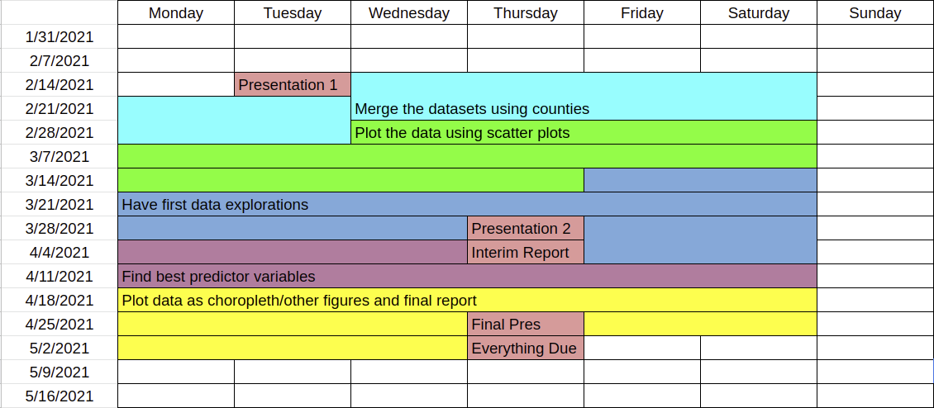
Figure 27: Timetable of our Schedule

The dark red cells represented the important deadlines that we had to meet such as presentation 1, presentation 2, interim report, final presentation, and when everything is due. Prior to starting the project, we had a meeting with our client to discuss deadlines that he would like for us to have, and we incorporated those same deadlines into this calendar to ensure that we stayed on track throughout the semester. Using other colors, we were able to highlight various portions in our calendar that we should spend on specific tasks. Throughout the semester, we had a number of meetings to discuss how we would go about completing these tasks and splitting up the work. For certain tasks we would split up work, while for others we would meet together virtually to complete them together. There was constant communication amongst team members to ensure that everything was completed on time and so help could always be provided if needed.

9.2 Problems and Solutions

Throughout this project, there were a number of problems that our team ran across. One of the biggest issues was figuring out which sets of data to scrape online and then actually being able to find it online. There were a very limited number of datasets online that had data going to the county level, so some improvisations had to be made on those datasets. Rather than finding the county level data, we had to settle for state level data, and merge our Lyme disease dataset into states to match with some of the other datasets.

Another problem that we came across was the lack of knowledge in R. Our client primarily used R for research and since most of our project had to do with working with data and creating plots, R seemed like the sufficient choice. This caused some issues as some team members were not too familiar with programming in R and had to learn it throughout the development process. Through help of other team members and our client, our team was able to accomplish this and still complete the necessary tasks needed for the project.

9.3 Future Work

For future work, there can be a number of improvements to this project. For one, the data that we use can quickly become outdated within the next few years. In the short term, the web scraping program can be updated to either read from a .csv file of URLs and XPaths or to read from user input on the command line. In the long term, changes to the program can be made where the data we use is automatically updated and made up to date. While our client requested a final report of our findings, we could also utilize the development of a website to display our data, scatter plots, and choropleth graphs to update with the new data as well. This will allow the data and graphics to be up to date every single year so that any developers or researchers could access the work that we have done.

Another improvement to this project would be to do more correlation analysis. Our group did correlation analysis with linear data, but a future group might want to improve on that by transforming the data and then doing correlated studies. For example, taking the log, square root, or normalizing either/or the dependent and independent variables to see if those signify a correlation.

One last improvement to the project would be to look into how geography plays a part. For example, a future group could do an analysis on the effect the neighboring counties have on a given county in terms of Lyme disease cases. A future group could also look into how much the terrain and plant life play correlate to Lyme disease cases.

- Acknowledgments

We would like to thank our client Dr. Luis Escobar as well as his assistant Mariana Castaneda Guzman. Dr. Escobar provided us with the initial dataset on Lyme disease cases and Mariana has been assisting our team throughout the project. Their information can be seen below:

Dr. Luis E. Escobar:

- Virginia Polytechnic Institute and State University
- Department of Fish and Wildlife Conservation
- Email: escobar1@vt.edu
- Website: https://fishwild.vt.edu/faculty/escobar.html

Mariana Castaneda Guzman:

- Virginia Polytechnic Institute and State University
- M.Sc. Student, Department of Fish and Wildlife Conservation
- Email: marianacg@vt.edu
- Lab: http://ecoguate2003.wixsite.com/escobar

We would also like to give an additional acknowledgement to our professor Dr. Edward Fox for facilitating.

Edward A. Fox:

- Virginia Polytechnic Institute and State University
- Department of Computer Science
- Email: fox@vt.edu
- Website: https://fox.cs.vt.edu
- Lab: https://dlib.vt.edu/

- References

[1] CDC. Data and surveillance. (2021, January 14). Retrieved April 08, 2021, from https://www.cdc.gov/lyme/datasurveillance/index.html
[2] CDC. How many people get lyme disease? (2021, January 13). Retrieved April 08, 2021, from https://www.cdc.gov/lyme/stats/humancases.html
[3] U.S. Department of Commerce. Index of /programs-surveys/popest/datasets. (2021, April 22). Retrieved April 26, 2021, from https://www2.census.gov/programs-surveys/popest/datasets/
[4] Cher Han Lau. 5 steps of a data science project lifecycle. (2019, January 03). Retrieved April 08, 2021, from https://towardsdatascience.com/5-steps-of-a-data-science-project-lifecycle-26c50372b492
[5] Wikipedia. List of U.S. States by research and development spending. (2020, May 14). Retrieved April 26, 2021, from https://en.wikipedia.org/wiki/List_of_U.S._states_by_research_and_development_spendig
[6] Wikipedia. List of United states counties by per capita income. (2021, March 04). Retrieved April 26, 2021, from https://en.wikipedia.org/wiki/List_of_United_States_counties_by_per_capita_income
[7] CDC. Lyme disease. (2021, March 05). Retrieved April 08, 2021, from https://www.cdc.gov/lyme/index.html
[8] RAND State Statistics. RAND US Database DESCRIPTIONS: Rand States statistics. (2021). Retrieved April 26, 2021, from https://randstatestats.org/us/changeRegions?cx=7
[9] John Chambers. What is R? (2021). Retrieved April 08, 2021, from https://www.r-project.org/about.html
[10] Hadley Wickham, Winston Chang, et al. ggplot2 (2020, December 30). Retrieved February 2021, from https://cran.r-project.org/web/packages/ggplot2/index.html
[11] Paolo Di Lorenzo. usmap. (2021, January 21), Retrieved February 2021, from https://cran.r-project.org/web/packages/usmap/usmap.pdf
[12] Richard Becker, Allan Wilks. Mapdata. (2018, March 29), Retrieved February 2021, from https://cran.r-project.org/web/packages/mapdata/mapdata.pdf
[13] Christopher Prener, Timo Grossenbacher, Angelo Zehr. biscale (2020, May 06), Retrieved April 2021, from https://cran.r-project.org/web/packages/biscale/index.html
[14] Edzer Pebesma. sf (2021, March 17), Retrieved April 2021, from https://cran.r-project.org/web/packages/sf/index.html
[15] Claus O. Wilke. cowplot (2020, December 15), Retrieved April 2021, from https://cran.r-project.org/web/packages/cowplot/vignettes/introduction.html
[16]Yihui Xie. knitr (2021, March 04), Retrieved April 2021, from https://cran.r-project.org/web/packages/knitr/index.html
[17] Hadley Wickham. tidyr. (2021, March 03), Retrieved February 2021, from https://cran.r-project.org/web/packages/tidyr/index.html

