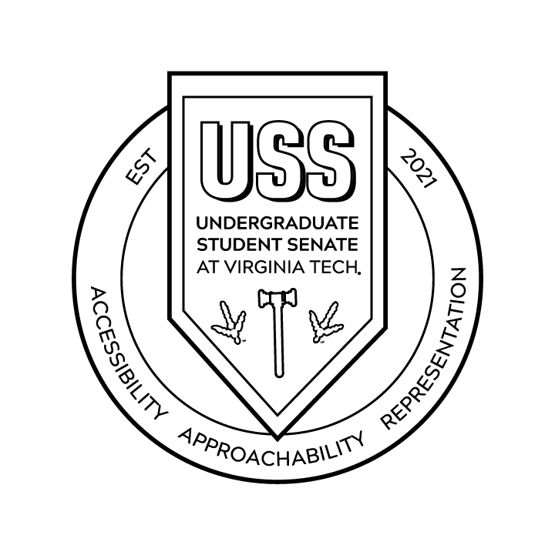
Senate Meeting for 2022-2023
Undergraduate Student Senate at Virginia Tech
Oct 11, 2022
Colonial Hall, Squires Student Center

- Call to Order
  - President Lohr called the meeting to order at 6:36 pm
  - President Lohr read the agenda
- Adoption of Agenda
  - President Lohr called for a motion to approve the agenda
    - Senator Zachery Schmidt moved to approve agenda
      - Senator Monica Nguyen seconded the motion
- Adoption of Previous Minutes
  - Senator Martin Ochoa approved the adoption of the previous minutes
  - Senator Princess Merritt seconded the motion
- Cabinet Reports
  - To be sent out via email
- Director Reports
  - To be sent out via email
- University Governance Reports
  - CEOD Resolution 2022-23A
  - CUSP Resolution 2022-23A
- Old Business
  - none
- New Business
  - Committee Presentation and Selection
    - Incoming Vice President for Administration, Eireann Maybach- in charge of committees
      - https://forms.gle/bwKkAh8ptspkt3k37
      - Ask her any questions
      - Question: What is the process for moving committees?
        - The chair of the committee has control over the times and meeting locations. You will hear from them directly.
    - Mikey Ventura, Director of Membership Development- Membership Development
      - You will get a project based on your strengths
      - It has a huge scope - constantly growing
    - Mollie Coogan, Interim Director for Communications and Marketing - Comm and Marketing
      - A lot of work trying to improve outreach
      - Use the Instagram
      - Create physical media
      - Brainstorm ways to communicate with students
    - Ainsley Cragin, Vice President for Issues and Policy-Issues and Policy
      - Working on individual projects
        - Ask constituents
      - Find your passions and work on them - for now,
      - When CUSA starts generating legislation then they will look at the scope of USS and make sure what we are passing is in our scope
      - Meeting with administration and community members
      - Advocating for constituents
    - Sara Wynkoop, Vice President for Finance- Appropriations Committee
      - 2-hour meetings every week - 4-6 pm on Mondays in Room 219 in Squires
      - Hear request from the 800 student organizations on campus
      - Impact students by funding their events
      - Helps send students to conferences and competitions
      - Super rewarding position
      - You submit a request via GobblerConnect and the request is looked at during the 4-6 pm meeting
      - appropriations@vt.edu << if you have questions about funding
    - Meredith O’Connor, Vice President for Administration - Administration
      - You bring concerns to make USS better
        - Structural, Communication, or Organizational
      - Make the Senate more efficient
      - Takes the minutes
      - Create the Senate Drive
        - Resources and Information
    - Jamal Ross, Vice President and Representative to the Board of Visitors - Accountability
      - Laid back and chill
      - Track attendance
      - Engage with one another
      - Meet regularly on committee times
    - Incoming VP for Administration Eireann Maybach - Special Programs
      - Plan all USS external events
      - Town Halls, Inaugurations, etc.
      - “Party Planners”
      - Reach out to John Frazier if you have any questions
    - Senator Anahi Sanchez-Moya - Equity and Inclusion Committee
      - Commenting on USS legislation that is passed
      - Many ongoing projects
    - The form on committees will be sent out in Slack and Emailed to everyone.
- Sign up for Inauguration Prep!!!!
  - Balloon Arch!!
  - Fun!!!
- Guest Speaker
  - None
- Public Forum
  - Meredith O’Connor on behalf of Monica Nguyen
    - AASU - Cultural Show
      - October 23rd at 6 pm in Haymarket Theater
      - Check AASUVT on Instagram for more info
      - Message Monica Nguyen me if you have any questions
      - Says nothing about a cover charge
  - Senator Claudia Budzyn
    - Class of 2024 had a ring premiere
      - Leftover t-shirts so get one!!
      - You can get a ring and go to a ring dance
  - Hillel
    - Study Abroad - Perspectives
      - May 17 - 26
      - Completely paid for
      - Leaders for VT
      - Sending a link in Slack
      - Ask Mollie Coogan, Jamal Ross, and John Frazier
      - Meet people from Palestine and Israel
    - Hillel at VT Picnic for Peace
      - At GLC Lawn
    - Daniel Pearl Music Day
      - Waka Flocka Flame coming to VT
      - Nov. 3rd At Lyric Theatre
      - Volunteer opportunities for a free ticket
  - Senator Alex Pomeroy
    - Senate relations with the student body
    - https://docs.google.com/forms/d/e/1FAIpQLSc55P4xFuqc7rw186waYRPkwxDJsouPeZ_Oa6a0HHoHTEWa3Q/viewform?usp=sf_link
  - Senator Elizabeth Durham
    - Class of 2024 can’t go to the ring dance without buying a ticket
    - Class of 2023 can't go to Class of 2024 ring dance
    - BUY A RING!!!!!
  - Zach Wells - Skateboarding Club - VT Shred
    - They have nowhere to operate on campus
    - They cannot go anywhere off campus and skate. They have been kicked out of every place and contact everyone they can think of.
      - Parking Services was not helpful
      - They don’t have the funds to rent
      - Rec Sports - not recognized by Rec Sports so they can’t use their resources
      - Meet after 6 to avoid cars - can’t even use faculty lots
    - Asking for USS help
  - Mallory Fields, USS Project Coordinator: Student Fellow
    - Sent an Email to everyone - if you didn’t get it TELL HER
      - RSVP for Inauguration - email Phil
    - Onboarding
      - If you have not been onboarded - come to the next onboarding session
        - Oct 23, 2022 from 1 pm-4 pm
      - If you have already been onboarded - it is recommended that you come if you can
        - I cannot record the team-building stuff
      - Communicate with Mallory if you can’t come!!
    - Ask her questions!!
  - Senator Zachary Schmidt - Campus Accessibility
    - Infinity Loop
      - A giant accessibility sidewalk around campus
    - Trying to focus on the area outside of Surge
    - Working on the Quad between Slusher
    - Trying to push for more accessibility
  - Senator Mollie Coogan -
    - Conversations with the President of Exodus
      - Dance group on campus
      - They are being deprived of dance spaces
      - All of the spaces and times were canceled
        - 80 organizations are being affected by this
        - Equity and inclusion
        - Not serving students
    - Senator Princess Merritt- Could we write legislation about the due process to communicate issues better? Could we then do something legislatively to give spaces for cultural spaces and other clubs?
      - Ask Ainsley
      - Message Mollie
    - Ainsley Cragin, Vice President for Issues and Policy- meeting with Registrars about RSOs being run over and trying to fix it
      - Issues and Policy
      - Tell Ainsley personally to take a list of complaints
  - Kat Nelson, Deputy Advisor -
    - Please make sure you attend the Student Tailgate from 9:45-12 on Saturday at Hokie Village
  - Tamara Allen, Assistant Director of Governmental Relations
    - Oct 20th - Deliberate Dialogue with Hokie Vote Caucus
      - Making election day a university holiday
      - Students can then vote and engage in civic engagement
      - Tabling on Oct 17th from 10-2 pm in front of Turner
      - Reach out to Tamara for information
    - Oct 26th - more Tabling in front of Squires for absentee ballots
      - Looking for more moderators for the deliberate dialogue
        - Please reach out to her for more information
  - Senator Kiera Schneiderman - Parking and Transportation committee
    - Lots of tickets in front of Lavery Hall(only for handicapped and service vehicle parking)
      - University is going to install cameras to give out tickets
        - Don’t drive your car to get food
    - Students are leaving early from class to make the bus
      - Professors are complaining
      - Shortage of BT drivers - they are working on it
    - Marching Virginians
      - Not allotted parking on campus for gamedays
        - Athletics is in charge of marching band parking
    - When is the parking lot behind NCB opening again?
        - No idea
    - Can there be a designated commuter lot?
      - Realistically no
    - Parking at the bubble
      - Princess Merritt has walked from the bubble to the academic side of campus and recorded a video. Who to send it to?
        - Email Kiera to send her things about
      - Would it be appropriate to do it in the snow?
        - Yes
    - Asked for freshman to park farther away
      - Nothing like that is happening right now
      - Kiera will bring it up again
    - Could we say that freshmen do not have cars?
      - Maybe have some circumstances - special case basis
    - Would they be willing to lose that revenue?
      - Probably not - a good question
    - Parking spaces designated for food pick up at all dining halls
      - The spots are behind turner
    - Carpool spots, separate parking pass
      - Can buy and share with another person
    - An issue raised by the senate: booked a parking spot from 6-8 and got a ticket at 8:02
      - Parking personnel are not able to tell the time for the reservation, only that it is expired
      - In order to have your ticket looked at by the appeals court, you have to appeal the ticket twice
    - Does our legislation work on auxiliary funds?
      - Yes, it should
    - Can we have a google form for parking?
      - Google form will be created and sent out
    - Used to be a reduced-cost pass to only park in the chicken hill lot. Does that still exist?
      - Phil looking for it
  - Senator Christian Ramos - President of LASO
    - October 15th - come out to the Hokie Village Tailgate
      - LASO is co-sponsoring the tailgate with Student Affairs
    - October 21 LASO holding a gala in Commonwealth Ballroom to commemorate the end of Hispanic Heritage Month
      - At 6:15 doors open and the program starts at 7 pm
      - Formal attire!
      - $15 ticket
      - Catered by Hethwood Market
        - You don’t need a date to attend!! :)
  - Senator Ally Jett
    - BT - Operator problem
      - Problems with overcrowding and shortage of labor
        - They need diesel mechanics
        - The buses are broken down because of no mechanics
        - Infrastructure has changed
      - Working on rerouting the system
      - BT transit will be coming to one of our forums to speak to USS
    - Ainsley Cragin, Vice President for Issues and Policy
      - Possible idea: Crossing guard for Torg. bridge
      - Making a google doc for parking
      - Reach out with any questions
  - Caroline Lohr, President - Sexual Violence Climate and Culture(SVCC)
    - Event coming up
    - USS sponsored event
    - Community Engagement Sub-Committee: Focus on sex education, sexual violence, and what we can do to prevent/educate our campus
    - If you would like to be on the community engagement sub-committee reach out to Caroline
      - A new class is being offered called History of Sexual Violence at Virginia Tech, if you are on the subcommittee you get to pick first for the Spring of 2023.
  - Eireann Maybach and Mollie Coogan, Interim Directors for Communication and Marketing- Comm and Marketing
    - Will repost anything on social media that falls within the guidelines
    - If it is student-related and within the USS’ scope then send it their way.
- Adjournment
  - President Lohr read over the agenda
    - Senator Merritt motioned to adjourn
      - Senator Schmidt seconded the motion to adjourn
  - Adjourned at 7:37

