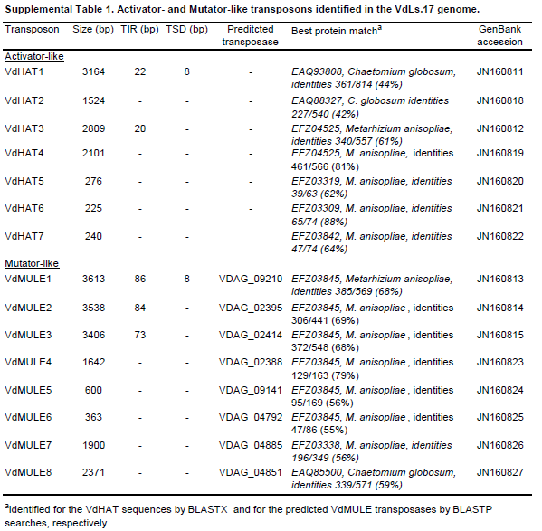
Supplemental Table 1
Amyotte et al., 2012

