Permissions from IEEE and ASME:

ASME:
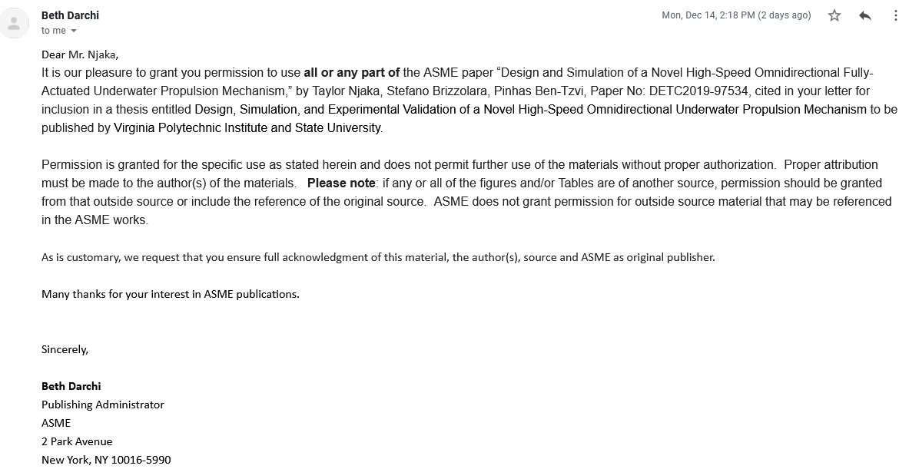

IEEE Transactions on Mechatronics: