ADS Assessment Video

Client: Adult Day Services
CS 4624 – Multimedia, Hypertext, and Information Access
Dr. Edward Fox
Virginia Tech
Blacksburg VA, 24061
May 19, 2019

Christopher Beemsterboer
Tyler Zebina

Table of Contents

Executive Summary / Abstract 3
Introduction 4
Requirements 5
Design 6
Implementation 7
Testing/Evaluation/Assessment 8
User’s Manual 9
Developer’s Manual 10
Lessons Learned 11
Acknowledgements 13
References 14

Executive Summary / Abstract

Sometimes the best way to learn something is not by being told how to do it, but by watching someone else do it first. In our Multimedia/Hypertext/Information Access capstone course, we worked with Adult Day Services to create a training video system to teach new instructors in their organization how to conduct recurring interviews with the Adults. Adult Day Services is an organization at Virginia Tech that provides person-centered care to older adults who need assistance.

Adult Day Services also aims to promote the physical, social, emotional, mental, and cognitive health of its participants, and they use a variety of assessments to measure overall well-being and participant progress. These assessments are conducted in the form of interviews, and the body language, tone, and speech of the interviewer are key to performing them successfully.

The training video system we created covers five different types of assessments and is designed to efficiently train new instructors to conduct these interviews. We filmed an Adult Day Services instructor conducting interviews with five different participants, each completing the five assessments. We edited the footage and compiled all of the clips of each type of assessment together, including transitions and titles. We later created a menu system which allows a user to select to play all of the training videos at once, or to play just the training video for a specific type of assessment. We have also included sub-categories within each type of assessment so the user can decide to view a specific participant as opposed to all four. We delivered this project in the form of a Blu-ray .iso file on a USB drive which contains the menu system and the associated videos. We have also included instructions on how to download a VLC media player, which is the optimal software for viewing the contents on the .iso file.

Introduction

Adult Day Services, more commonly known as ADS, is a provider for person-centered care to older adults who cannot be at home by themselves anymore. The services they provide include: Personal Care, Health Monitoring, Meals and Therapeutic Activities and Support, Education, and Respite for the Caregiver. Their Mission is to Provide:
- A center dedicated to the well-being of its adult participants.
- A resource for caregiver support.
- An education experience for students interested in gerontology.
- A research facility for students and faculty focused on care of elderly persons.
- Dissemination of research findings to professionals.

Our client has asked us to produce a training video which covers five different types of assessments that are used within Adult Day Services to assess member’s levels of cognitive, social, and emotional function. The five assessments are:
- Geriatric Depression Scale
- Mini Mental Status Exam
- Life Satisfaction
- Quality of Life
- Montreal Cognitive Assessment

These assessments are in the form of interviews and are performed by a therapeutic program manager between a user of ADS. The video will be used to train others to facilitate these interview assessments and each segment is typically 25 minutes long so the total length of the video will be around 1.5 hours.

Requirements

The video footage had a total of five demonstrations or assessments that were conducted in Wallace Hall. Four adults were interviewed for this video. The goal of the project was to capture how an ADS interview is done for future members of the team. We were given lots of advice such as minimum interaction with the adults during the interview filming process. We were also told to be respectful and respond to people in a polite manner.

The total length of the video was 90 minutes long with each interviewee taking about 25 minutes. Each of the five assessments were put together so the user could view interviews in their desired area of assessment (Life Satisfaction, Geriatric Depression Scale, etc.). We were also required to add an option to view all video clips at once.

As for filming we were required to keep the same, still camera angle throughout the whole project, meaning no cuts or zooms. The lighting had to be consistent and the audio had to be clear so the viewer can hear the interviewer’s questions.

As for the menu system we were told to make it easy to navigate as their previous version was very buggy. We also had to make the system easy to understand so the user can jump straight to their desired assessment. Video files will also have to be converted and compressed to be compatible with the DVD we use.

Design

Our design had two parts: the filming and our DVD menu system.
As for our filming, we wanted to capture a still angle of the entire interview and keep that angle for all future recording sessions. Because we cannot show a screenshot or image of the interview due to privacy reasons (as this is for internal use) we made a sketch to show that angle, as shown in Figure 1 and Figure 2.
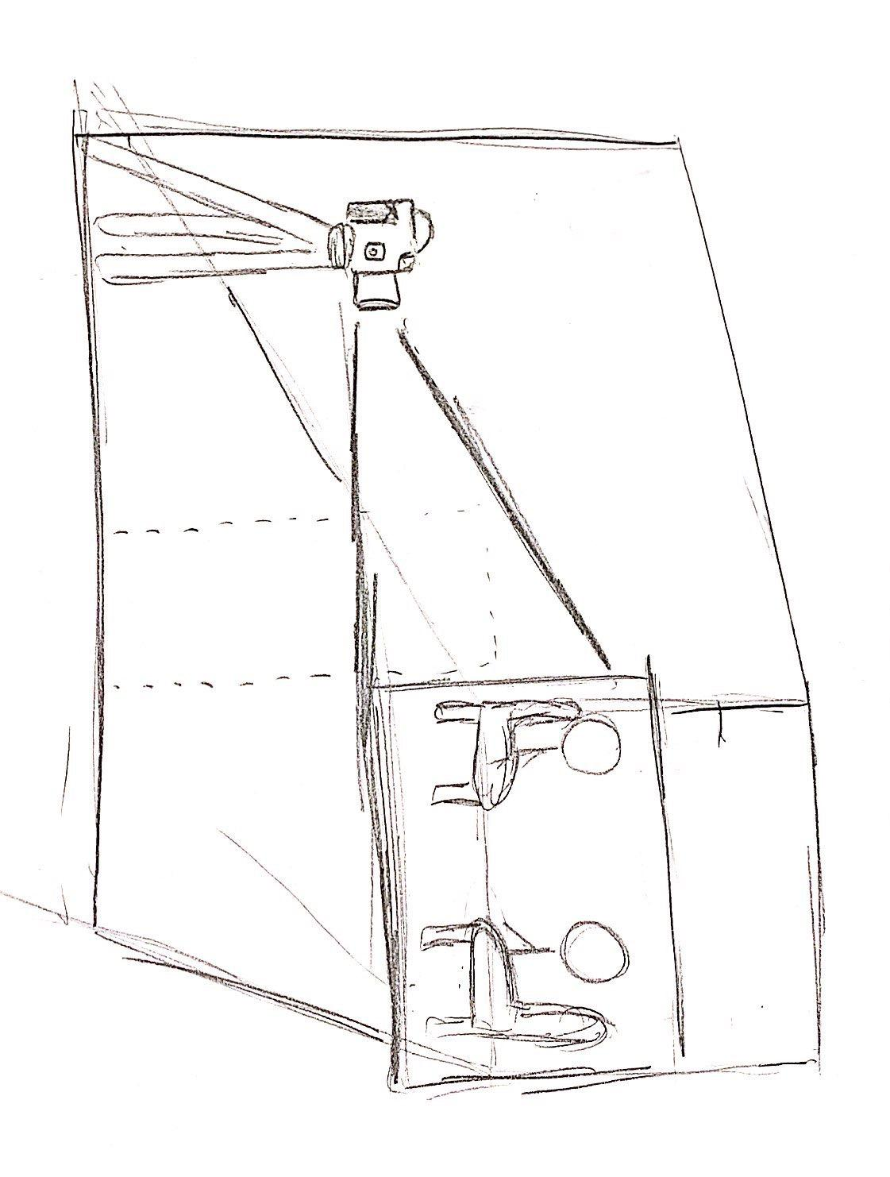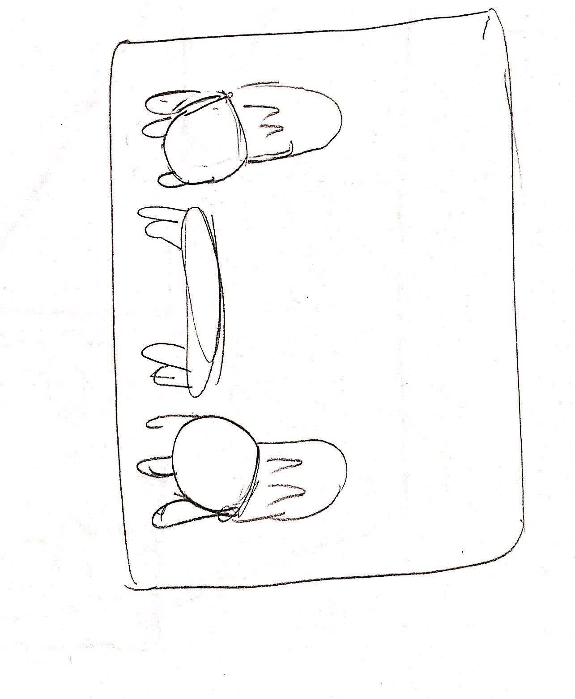
Figure 2: Desired Camera Angle
Figure 1: Desired camera angle and set up

As for the design of the menu system, we wanted something simple and easy to understand. We created the following prototypes to design this system as you can see in Figure 3 and Figure 4.
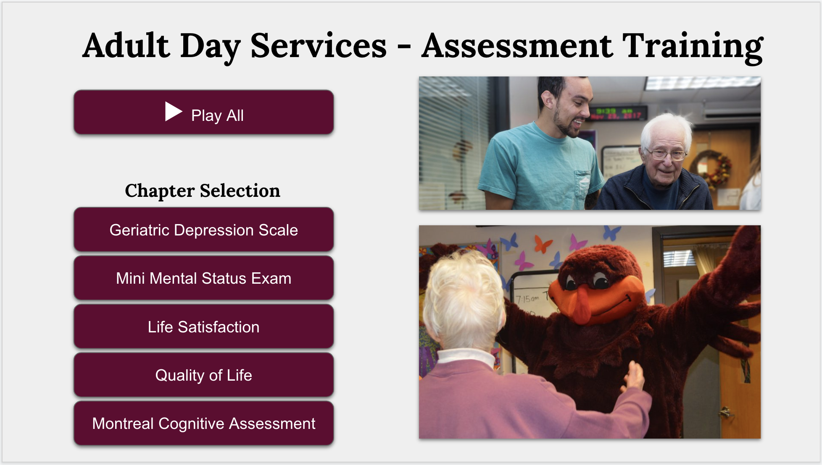
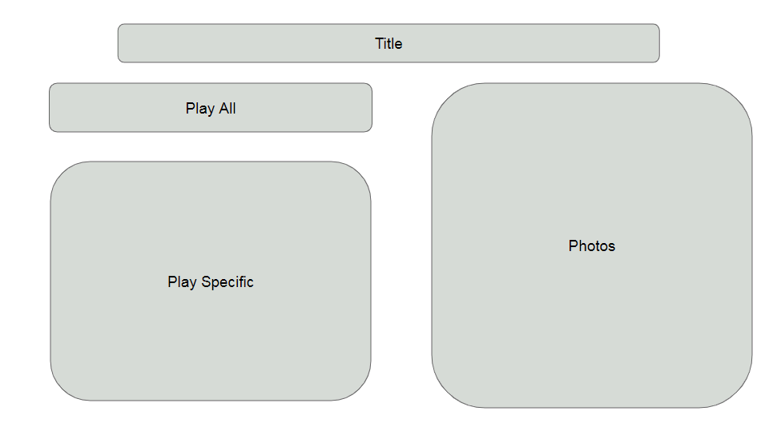

Figure 4: Desired Menu System Outline
Figure 3: Desired Menu System

Implementation

We recorded the video using a Nikon D5100 with an 18-55mm 3.5-5.6 G ED II lens, along with an external microphone (SGC-598 Photography Interview Shotgun MIC Microphone). We filmed four participants completing all of the assessments in two filming sessions. Throughout this phase of the project, we achieved a better understanding of how our work was helping such a great organization because we were able to spend a lot of face to face time with the adults and the staff. This is also the step where we ran into the most problems, whether it was lighting issues, audio quality, or the battery dying on us in the middle of the interview. This has led us to understand and experience a lot more about filming which we could take onto future projects.

We are editing the video and audio with Audio Premiere. For each interview that we have recorded, we are clipping each of the five assessments. We combined all of the clips that we have by assessment to create videos for each assessment that contain four different interviewees. We have also made a full length video that combines all five assessment videos. The main challenge we faced during this step was finding a good balance between video quality and file size. It was especially interesting to experience what comes after the filming stage because editing and producing the video was a large portion of the work we completed and an opportunity to gain new skills with professional software tools.

Finally, we used Adobe Encore to create the interactive menu, and associate our edited clips with buttons in the menu. The interactive menu has options to play the entire video at once, or play a specific assessment. Because this menu system was such an important part of this project for our client, we worked hard in searching for the best software to make it happen. Adobe Encore provided us the most flexibility when it came to both inputting and outputting media.

Testing/Evaluation/Assessment

Video Testing and Assessment
We met with our client to review the initial video footage. We asked the following set of questions to evaluate our work and receive feedback on what we needed to change:

How is the video quality?

Is the video cropped well?

How is the audio quality?

Is the voice of the interviewer audible?

Our client gave us valuable feedback regarding the cropping of two of the interviews. We used this feedback to crop the footage to focus on the interviewer.

Menu System Testing and Assessment
We plan on using the following testing assessment to evaluate the ease of use of our menu system with the people at Adult Day Services. The question answers will give us feedback regarding the overall user experience of our implementation.
Menu System UX Test steps:
- Open up the ‘User Manual.pdf’ file and follow the steps to open the video.
- Play the ‘Life Satisfaction’ assessment video.
- Play all of the assessment videos at once.
- Play the ‘Mini Mental Status Exam’ video.

We will ask the testers the following questions after completing all of the test steps:
Was the manual useful in providing the necessary instructions to use the system?

Were you able to open the video without installing any codecs or software?

If you needed to install any codecs or software, was the process difficult?

Was the menu system easy to navigate?

Were you able to quickly choose and navigate to the desired assessment video?

User’s Manual
1. Open the ‘ADS_Video_Assessment.iso’ file or insert the video assessment DVD into your computer.

2. Your default video player will open up and display the menu. Follow any prompts to install necessary codecs if your video player does not open the file.
- If your video player is still not compatible, then use the following link to download and install VLC Media Player:
https://www.videolan.org/vlc/index.html
VLC Media Player has default compatibility with the video file type.

3. From the menu in Figure 5, you can play all of the assessments at once, or choose a specific assessment to play. You can use the arrow keys and ‘enter’ key or your mouse to select a button in the menu. When you hover over a button or navigate to it with the arrow keys, then it will be highlighted in orange, as shown below.
- Select the ‘Play All’ button to play all of the assessments sequentially.
- Select the button labeled with the desired assessment name to play only that assessment.

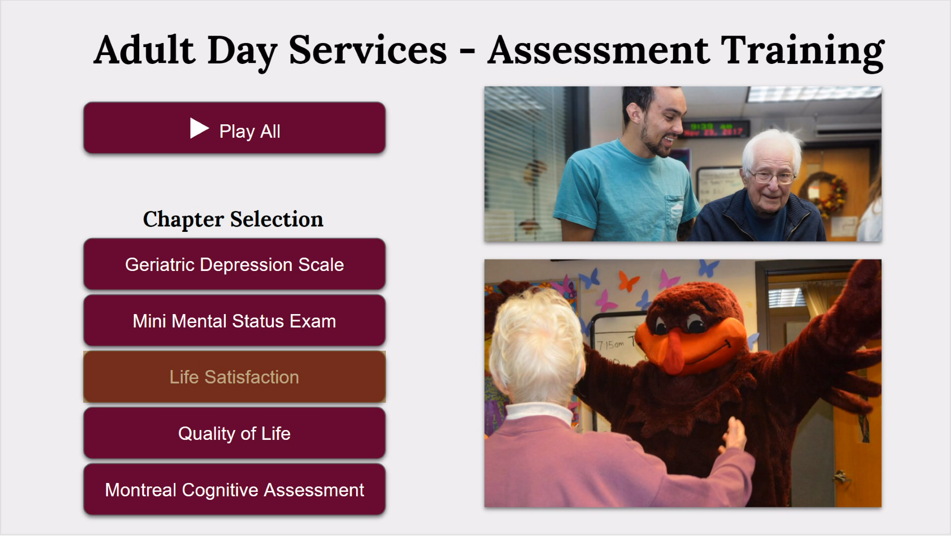

Figure 5: Final Menu System

Developer’s Manual

1. Project Files
All of the video and project files are stored in a folder called ‘ADS_Video_Assessment’.

The playable video file is called ‘ADS_Video_Assessment.iso’.

The video project file is called ‘ADS_Video_Assessment.ncor’.

The raw video files for the entire video and each of the assessments are called ‘All_Sssessments.MOV’, ‘Geriatric_Depression_Scale.MOV’, ‘Mini_Mental_Status.MOV’, ‘Life_Satisfaction.MOV’, ‘Quality_Of_Life.MOV’, and ‘Montreal_Cognitive.MOV’.

2. Project Software
The menu system was designed in Adobe Photoshop CS6 and Adobe Encore CS6. These applications can be downloaded and installed with a valid license from here:

https://helpx.adobe.com/download-install/kb/cs6-product-downloads.html

The videos were edited and produced using Adobe Premiere Elements 2019. This application can be downloaded and installed with a valid license from here:

https://helpx.adobe.com/download-install/kb/premiere-elements-downloads.html

3. Making Changes
The ‘ADS_Video_Assessment.ncor’ project can only be modified with Adobe Encore. The photoshop file for the menu system is also held within this project, and can only be modified using Adobe Photoshop. After making any changes in Adobe Encore, the project can be exported to a playable .iso file.

New buttons can be added to the menu using the following steps:
- Open the photoshop file listed in the Adobe Encore project.
- Create a layer for the new button, and create the button design.
- Convert this layer to a smart object, and save the file in Adobe Photoshop.
- Navigate to Adobe Encore, and right click the new button that is shown in the menu preview.
- Select ‘Convert to Button’ and give the button a name. The button can also be given an associated action at this point (i.e. play a video file or play a video file at a certain time)
Lessons Learned

Timeline
February 21: First recording session with client
February 26: View and edit first recording session
March 5: Second recording session with client
April 8 - April 12: Collected client feedback before final editing
April 18: Final editing and production
April 22: Project write-up and final presentation preparation
April 25: Final Presentation
April 26: Final report completion and VTech works submission

Problems Overcome
Throughout the process of completing this project we have run into some issues that we would like to address to show what we have overcome.

Towards the beginning of the project we had two teammates drop out of our group which caused a lot of disorganization. We were able to overcome this issue by stating the problems to our client which allowed us to scale the project down accordingly. Overall we believe this proved very useful.

Another problem we quickly realized was that our built-in camera audio was not sufficient for recording a high-quality video of an interview. We decided on using a standalone microphone before our first recording session that allowed us to collect clear, easy to understand sound. This also led us to figure out that it was more efficient to utilize our own equipment rather than renting it from Virginia Tech because the equipment was sometimes booked when we need it. This allowed for more flexibility in our recording sessions which was beneficial for both us and our client.

Our final big obstacle was finding the right DVD menu system creation software. Our initial choice was good but did not allow us to export to Blu-ray format which is the quality we were aiming for. Therefore we used Adobe Encore that allowed for more flexibility when dealing with importing and exporting video files.

Future Ideas
We would like to address some ideas we have on how to take this project further than what we have now. Right now, all the new members of ADS can view the assessment interview footage that we collected. Instead of focusing the training on that one area of work, we decided that it was a good idea to create either an application or website that will work as a training system. This system will include quizzes to test your knowledge, videos on ADS specifics, charts on how to act in certain scenarios, and videos on best techniques to communicate with the adults at the facility. Because this training mechanism will be strictly for internal use, we believe that an application on a tablet would be the best option for use. Although we have limited knowledge on the training that currently exists at ADS, it would be a good idea to compile them all along with the system we create so that employees could have all the information they need in one place.

Acknowledgements

Ila Schepisi, Advanced Instructor, Adult Day Services
schepisi@vt.edu

Sara Amos, Memory Masterclass Instructor, Adult Day Services
sara17@vt.edu

Adult Day Services
102 Wallace Hall 295 West Campus Drive Blacksburg, VA 24061, USA

References

Adult Day Services. About Us. Retrieved from https://www.ads.hdfs.vt.edu/about-us

Camera Decision. “Nikon D5100 Review and Specs.” Camera Decision,
cameradecision.com/review/Nikon-D5100.

