DOI: 10.1111/ejss.13413

Soil properties affect crop yield changes under conservation agriculture: A systematic analysis

Xiaohua Ren ¹ | Wenjing Zou ¹ | Juying Jiao ^{1,2} | Ryan Stewart ³ | Jinshi Jian ^{1,2}

1State Key Laboratory of Soil Erosion and Dryland Farming on the Loess Plateau, Institute of Soil and Water Conservation, Northwest A&F University,
Yangling, China
2Institute of Soil and Water Conservation, Chinese Academy of Science and Ministry of Water Resource, Yangling, China
3School of Plant and Environmental Sciences, Virginia Tech, Blacksburg, Virginia, USA

Correspondence
Juying Jiao, State Key Laboratory of Soil Erosion and Dryland Farming on the Loess Plateau, Institute of Soil and Water Conservation, Northwest A&F University, Yangling, Shaanxi, 712100, China.
Email: jyjiao@ms.iswc.ac.cn
Jinshi Jian, State Key Laboratory of Soil Erosion and Dryland Farming on the Loess Plateau, Institute of Soil and Water Conservation, Northwest A&F University, Yangling, Shaanxi, 712100, China.
Email: jinshi@vt.edu

Funding information
the Second Tibetan Plateau Scientific Expedition and Research Program (STEP), No.2019QZKK0603; the Talent Attracting Supporting Funds by Northwest A & F University under funding number A315022202; the U.S. Department of Agriculture NRCS Conservation Innovation Grant (No. 69-3A75-14-260); the QinChuanyuan Project of Shaanxi Province

Abstract
Conservation agriculture (CA) has the potential to sustain soil productivity and benefit agroecosystems, yet it is not fully understood how yield responses of different cropping systems are affected by inherent soil characteristics, for example, texture and dynamic soil properties, such as aggregation, nutrients and erosion. In this study, we conducted a systematic review to compare crop yield from cropland with conventional management versus different CA prac- tices, specifically reduced- or no-tillage, agroforestry, organic farming and cover crops. The data were first analysed for different climatic regions, soil tex- tures and cash crop types. We then quantified how yield responses correlated with soil properties change under different CA practices. The results showed that CA practices were associated with an overall mean crop yield increase of 12%. This response was primarily driven by corn, which had a mean yield increase of almost 41% after CA implementation, whereas other cash crops did not have significant yield responses or showed slight decreases, as rotation with mixtures of multiple cash crops had a mean decrease of 6% when using CA. The increase in corn yield after CA may be related to the enhanced ability of that crop to absorb nutrient elements (e.g. nitrogen) and reduce nutrient leaching. Agroforestry increased crop yield by 66% and cover cropping increased yield by 11%, likely due to increases in soil water content and nutri- ent availability and decreases in erosion and surface runoff. However, other agricultural systems showed no significant increase after CA compared with conventional row cropping practices. Using CA practices had the greatest yield benefit in tropical climates and when farming in coarse-textured soils. In addi- tion, legumes and grass-legume mixtures resulted in significant cash crop yield increases, possibly because legumes promoted the increase of soil nitrogen and depleted soil moisture less compared with other cover crops. The results pro- vide new insight into how interactions between soil properties and CA prac- tices affect crop yield and at the same time can help guide the development of practical, evidence-based guidelines for using conservation practices to improve yield in corn and other cash crops.

https://doi.org/10.1111/ejss.13413

1 | INTRODUCTION

Highlights
- Conservation agriculture resulted in an overall mean crop yield increase of 12%, mainly driven by yield increase in corn (41%).
- Agroforestry increased crop yield by 66% and
cover crop increased crop yield by 11%; other systems did not respond to conservation man- agement in terms of crop yield.
- Crop yield responses to conservation manage-
ment were greatest in tropical climate and coarse-textured soils.
- Changes in soil water content (SWC), nitrogen
(N), phosphorus (P), soil organic carbon (SOC) and erosion due to conservation management likely influence crop yield.

Food scarcity is a major global challenge that is being exacerbated by population growth, climate warming, water limitations, land use change and reduced land pro- ductivity (Anantha et al., 2021; Montgomery, 2007). The global population is expected to reach 9.5 billion by 2050 (Anantha et al., 2021; Gerten et al., 2020), making it even more urgent to have secure and stable crop production (Busari et al., 2015). Agricultural practices that feature intensive irrigation, fertilization and tillage have been widely adopted over the past few decades to improve soil quality and enhance crop productivity. When overused, these interventions can lead to soil structural destruction, nutrient loss, increased soil erosion and reduced biodiver- sity, each of which can reduce crop yield (Waqas et al., 2020; Zalles et al., 2019). Meanwhile, excessive appli- cation of inorganic fertilizers and pesticides exacerbates environmental problems, such as soil acidification (Dai et al., 2016), groundwater pollution (Huang et al., 2018) and elevated greenhouse gas emissions (Lv et al., 2020). Many researchers have sought solutions to change the physical, chemical and biological properties of soil to sus- tain agricultural productivity (Anantha et al., 2021; Lesur- Dumoulin et al., 2017; Sharma & Dhaliwal, 2021) and have identified conservation agriculture (CA) as a particu- larly promising framework for better practices.
Conservation agriculture is an approach that manages
agroecosystems for long-term productivity and profitabil- ity, while preserving natural resources and the environ- ment (Corsi et al., 2012). Conservation agriculture is characterized by three linked principles: (i) minimal mechanical soil disturbance; (ii) permanent organic soil cover; and (iii) diversification of crop species either grown in sequence or simultaneously (Corsi et al., 2012; Rusinamhodzi, 2015; Sithole et al., 2016; Troccoli et al., 2015). Many specific practices fit the definition of CA (Du et al., 2022; Sithole et al., 2016), including agrofor- estry (AF), no- or reduced-tillage (NTRT), cover crops (CCs) and organic farming (OF). These general categories also include many different practices. For instance, AF is a term that describes integrating cropping systems into for- estry management. These practices follow two general types: (1) crops being managed in rotation with trees that are harvested, or (2) crops that are grown simultaneously with trees, also known as intercropping (Kwesiga et al., 2003). No- and reduced-tillage, sometimes referred to as minimum tillage, aim to minimize soil disturbance

during cultivation and are often performed in conjunction with efforts to maintain crop residue on the soil surface (Domínguez & Bedano, 2016; Sinha et al., 2019; Zhang et al., 2022). Cover crops are close-growing crops that provide covering protection, soil improvement and other soil-related benefits between periods of normal crop production, or between trees in orchards and vines in vineyards (Adetunji et al., 2020; Hao et al., 2022). Cover crops have been widely adopted to increase SOC (Poeplau & Don, 2015), reduce sur- face runoff and soil erosion (Du et al., 2022) and control weeds (Osipitan et al., 2019). Organic farming (OF) is an agricultural system that uses organic fertilizers such as com- post and green manure and emphasizes techniques such as crop rotation and companion planting (Smith et al., 2019). With the demand for sustainable development, OF is expanding globally, with certified OF accounting for 70 mil- lion hectares worldwide (Paull, 2019).
Though CA was originally introduced to regulate wind and water erosion (Baveye et al., 2011), it is now considered to change soil properties and help farmers to achieve sus- tainable land production and support ecosystem services (Findlater, 2013; Sithole et al., 2016). Previous research has identified several benefits of CA over conventional manage- ment (CM) with respect to soil properties as well as crop yields. For example, CA can alter soil physical properties by reducing bulk density, decreasing soil erosion, improving soil structure and increasing soil organic matter content (Jian et al., 2020a; Roy et al., 2021; Rusinamhodzi, 2015). Likewise, the implementation of CA has been shown to

enhance soil chemical properties, including the availability of macro- and micro-nutrient availability (Jat et al., 2018; Nandan et al., 2019; Piazza et al., 2020; Roy et al., 2021). Conservation agriculture practices can also positively impact soil biochemical properties such as microbial bio- mass carbon (MBC) and enzymatic activities (Choudhary et al., 2018; Njaimwe et al., 2018; Piazza et al., 2020).
Changes in soil properties from CA can also affect crop yields (Abera et al., 2020; Adimassu et al., 2017; Pittelkow et al., 2015; Wolka et al., 2018). For example, CCs can affect crop yield by controlling weeds and modifying soil nutrient supply. A study conducted in Switzerland found that soils
planted with CCs—including hairy vetch, common vetch
and white mustard—enhanced plant production and resulted in crop yield increasing by up to 24% (Wittwer et al., 2017). At the same time, combining conservation measures often helps increase crop yield compared with any single approach (Palm et al., 2014; Pittelkow et al., 2015; Schomberg et al., 2009). For instance, Zhang et al. (2022) observed that no-tillage combined with straw addition improved crop yield in the long term compared with CM. Similarly, Jin et al. (2009) and Sidhu et al. (2015) reported higher wheat yield when combining no-tillage and residue retention versus conventional tillage with residue removal or burning. Such results have been hypothesized to be related to changes in soil physical properties, including increased soil water availability (Sharma & Dhaliwal, 2021). Other work, however, has determined that yield responses can be inconsistent and heterogeneous between different soils, management systems and crop types. Some studies have demonstrated a decrease in crop yield in the first few years of CA, especially in wet years, albeit with no influence on grain quality (Colecchia et al., 2015; Troccoli et al., 2015). Arora et al. (2010) reported that poor root growth and decreased availability of soil nitrogen (N) resulted in lower wheat yield in no-tillage compared with CM (Sharma & Dhaliwal, 2021). In the scientific research carried out so far, it has been found that yield using organic horticultural practices averaged 19% to 25% less than those in conventional horticulture (Lesur-Dumoulin et al., 2017; Ponisio et al., 2015; Seufert, 2018). This decrease may be due to the local environment (soil type, weather, pest pressure) and the crop management (Lesur-Dumoulin et al., 2017). Regardless, these contrasting or inconsistent results mean that it is difficult for growers to know which, if any, CA prac- tices to use for their operations if yield response is a primary consideration. Growers would also benefit from a better understanding of how different CA practices affect soil pro-
cesses and thus drive yield responses (Mhlanga et al., 2022).
In this study, our goal was to determine how changes in soil properties in response to CA affected crop yield, using observations collected from many different sites and cropping systems. In addition, we investigated
correlations between changes in yield and soil properties. We conducted a systematic analysis using the global soil health database SoilHealthDB (Jian et al., 2020b) with the aim of assessing whether there is consistent evidence of yield benefits from the use of CA. This effort will help to develop practical, evidence-based guidelines to effec- tively use CA to enhance soil properties and increase crop yield. Our specific objectives were to (i) assess and summarize the effects of CA on subsequent cash crop yield in different climatic regions, soil textures and crop types across the globe, and (ii) clarify the relationship between soil and crop yield changes under CA, so as to provide a basis for selecting appropriate CA practices in different regions.

2 | METHODS

The data obtained from SoilHealthDB (Jian et al., 2020b) were used to evaluate changes in crop yield resulting from the implementation of CA compared with CM. A total of 2372 comparisons between CA and CM were derived from
151 publications, encompassing 174 sites worldwide (Figure 1a). Notably, the distribution of observations was uneven among the individual studies, with the study con- taining the highest number of observations having 158 com- parisons, whereas the study with the fewest observations featured only 1 comparison. To address this discrepancy, a systematic approach was employed whereby the data were aggregated based on StudyID, ExperimentID, climate regions, soil texture, cash crop types, conservation manage- ment types and cover crop types. Note that, within Soil- HealthDB, an ExperimentID was uniquely assigned whenever any variations were present in factors such as cash crop, site, tillage, fertilizer level, cover crop, soil sampling depth, cover crop termination or cash crop rotation (see Jian et al., 2020b for detailed information). By calculating the average values of yield and various soil properties, a refined dataset comprising 499 comparisons was obtained (approxi- mately three comparisons per study; Figure 1b).
According to the climate Koppen classification (Peel et al., 2007), the climatic regions of all sites were identi- fied and grouped into tropical (A), arid (B), temperate
(C) and boreal (D) climates (Kottek et al., 2006). Follow- ing the Cornell Soil Health Framework, sand, loamy sand and sandy loam were grouped as coarse-textured soils; sandy clay loam, loam, silt loam and silt were grouped as medium-textured soils; and clay, sandy clay, clay loam, silty clay and silty clay loam were grouped as fine- textured soils (Moebius-Clune et al., 2016). Classification for cash crop and cover crop were directly reported in the SoilHealthDB (Jian et al., 2020b). Cash crops were cate- gorized as corn, orchard, soybean, sorghum, vegetable,

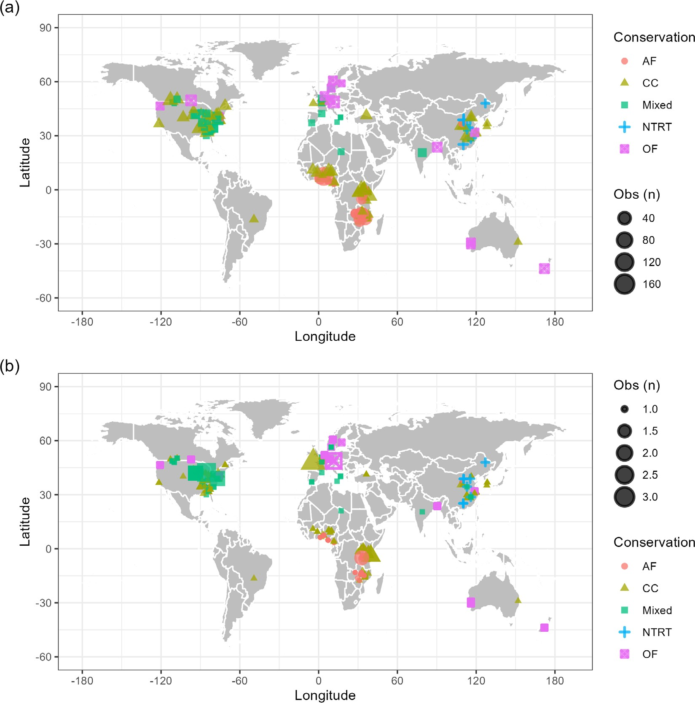

FIGURE 1 The spatial distribution of sites in the analysis from conservation agriculture (CA) studies. The dataset consisted of (a) 2372 pairwise comparisons and (b) 499 pairwise comparisons after aggregation from 151 papers and 174 sites. Conservation agriculture types included agroforestry (AF), cover cropping (CC), no-tillage or reduced-tillage (NTRT), organic farming (OF), other CA practices (Others) and a mixture of multiple CA practices (Mixed).

wheat and rotation with mixtures of multiple cash crops. Cover crops were categorized as grass, legume, mixtures of legume and grass (LG), broadleaf and other mixtures of more than two cover crops (MTT).
After digitizing and compiling the crop yield data, we used a systematic analysis to calculate the response ratio of yield was calculated, following Luo et al. (2006), the natural logarithm was applied to the response ratio of yield, hereafter named RR_{y}, where RR_{y} is calculated by:

RR_{y} = ln(Y_{conservation}/Y_{control}) (1)
where Y_{conservation} represents crop yield under CA, and Y_{control} represents crop yield under CM.
To estimate 95% confidence intervals, a nonparamet- ric bootstrap resampling technique (Hesterberg, 2011) was used by performing 10,000 iterations on the original RR values. From the resamples, the mean and 95% confi- dence intervals were computed to identify changes in yield and environmental properties under CA compared with CM (Du et al., 2022; Jian et al., 2020a; Puth et al., 2015).To enhance interpretability, RR_{y} values of the systematic analysis were presented as percent change using the formula: % change = (RR_{y} - 1) x 100.
In addition, the response ratios of 32 different envi- ronment properties (named RR_{x}) were calculated to reflect the impact of CA on crop yield and environment properties (Lu et al., 2013):

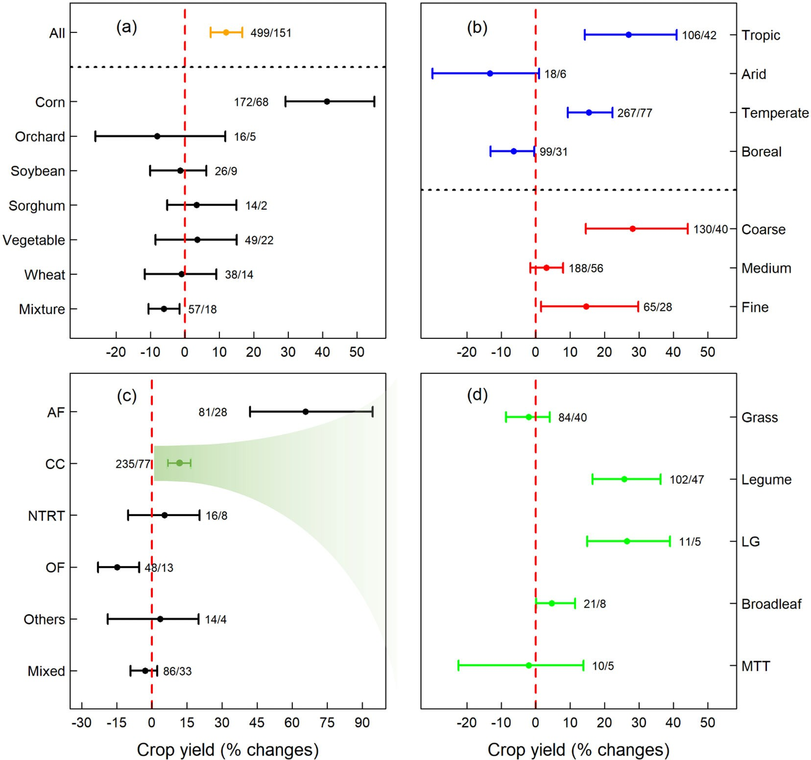

FIGURE 2 Crop yield response (as % change) due to implementation of: (a) conservation agriculture (CA) in all studies and as categorized by seven cash crop types, (b) divided by four climatic regions and three soil texture groups, (c) segregated into six conservation management types and (d) divided by five cover crop species or mixtures. The symbols used in the figure include dots with error bars, representing the overall mean yield values ±95% confidence intervals (scaled to %). Categories whose 95% confidence intervals do not cross
0 (represented by the vertical red lines) have significant differences between conservation management treatments and controls. The number of experiments followed by the number of studies is listed for each category. Note that panel (d) shows results from subdividing the results of cover crop (panel c) into six different cover crop groups.

RR_{x} = ln(X_{conservation}/X_{control}) (2)
where X_{conservation} represents the measured value of 32 different environment properties under CA, and X_{control} represents the measured value of 32 different environment properties under CM (Du et al., 2022). The 32 different environment properties included: weed, soil water content (SWC), soil temperature (ST), soil fauna (SoilFauna), runoff, porosity, pH, pests, soil penetration resistance (Penetration), soil phosphorus (P), other microbial indicators (OtherMicrobial), soil organic car- bon (SOC), N₂O, mineralizable nitrogen (Nmina), soil nitrogen (N), microbial biomass nitrogen (MBN), micro- bial biomass carbon (MBC), subsurface nutrient leaching
(leaching), saturated hydraulic conductivity (Ksat), soil potassium (K), infiltration, soil fungal characteristics (fungal), erosion, enzymatic assays (enzyme), electrical conductivity (EC), aggregation (Aggre), field-measured soil CO₂ efflux (CO₂), mineralizable carbon (Cmina), field-measured soil CH₄ efflux (CH₄), cation exchange capacity (CEC), bulk density (BD) and available water- holding capacity (AWHC).
Significant differences were observed in the RR_{y} values for corn compared with other cash crops, tropical com- pared with boreal climates, coarse-textured compared with medium-textured soils, AF compared with other conserva- tion types (Other CA) and legume cover crops compared with grass cover crops (Figure 2). Consequently, a simpler linear regression analysis was performed to explore the

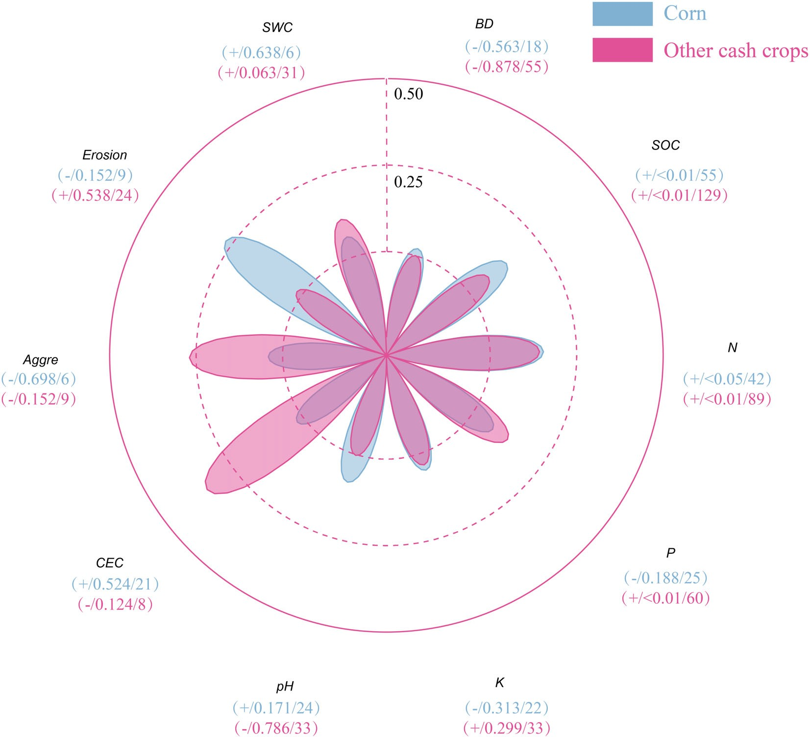

FIGURE 3 Regression between response ratios (RRs) of yield versus different soil properties under corn (blue colour) and other cash crops (pink colour). The vertices of the petal diagram indicate R² values (each concentric circle represents an R² increment of 0.25). The values in the parentheses represent the direction of slope/p-value of slope/size of samples of regression.

potential factors influencing the yield response after implementing CA under different conditions. Specifi- cally, the relationships between RR_{y} and RR_{x} were examined for corn versus other cash crops, boreal versus tropical regions, coarse- versus medium-textured soils, agroforest versus other CA and grass versus legume cover crops (Figure S1). It should be noted that only those soil properties with sufficient data for both groups
(n ≥ 6) were analysed (refer to Figures 3–7 for addi-
tional details). In addition, before regression analysis, both RR_{y} and RR_{x} underwent logarithmic transforma- tions. However, when we calculated the natural loga- rithm of the RR values for 32 environmental properties, we found that log-transformation only slightly improved normality for few soil properties (Figures S2-S9). There- fore, in order to determine whether log-transformation of RR_{x} was necessary, we conducted a thorough com- parison of p-value ( p) and R-square coefficients (R²) for the linear regression between RR_{y} and RR_{x} versus RR_{y}
versus ln(RR_{x}) (Table S1). We made the decision to employ ln(RR_{x}) based on a careful evaluation of the simple linear regression models, considering the following criteria:

- The correlation between RR_{y} and RR_{x} is not signifi- cant ( p ≥ 0.05), while the correlation between RR_{y} and ln(RR_{x}) is significant ( p < 0.05);
- The R² value improved by at least 10% in both groups (e.g., both corn and other cash crops).

Based on these criteria, it was determined that log- transformation was necessary for RR_{x} values of N and aggregation when comparing corn and other cash crops, RR_{x} values of N and P when comparing coarse- and medium-textured soils, and RR_{x} values of N when com- paring AF and other conservation systems (Table 1).
All data analysis was carried out in R software (Version 4.1.1, Team, 2013).

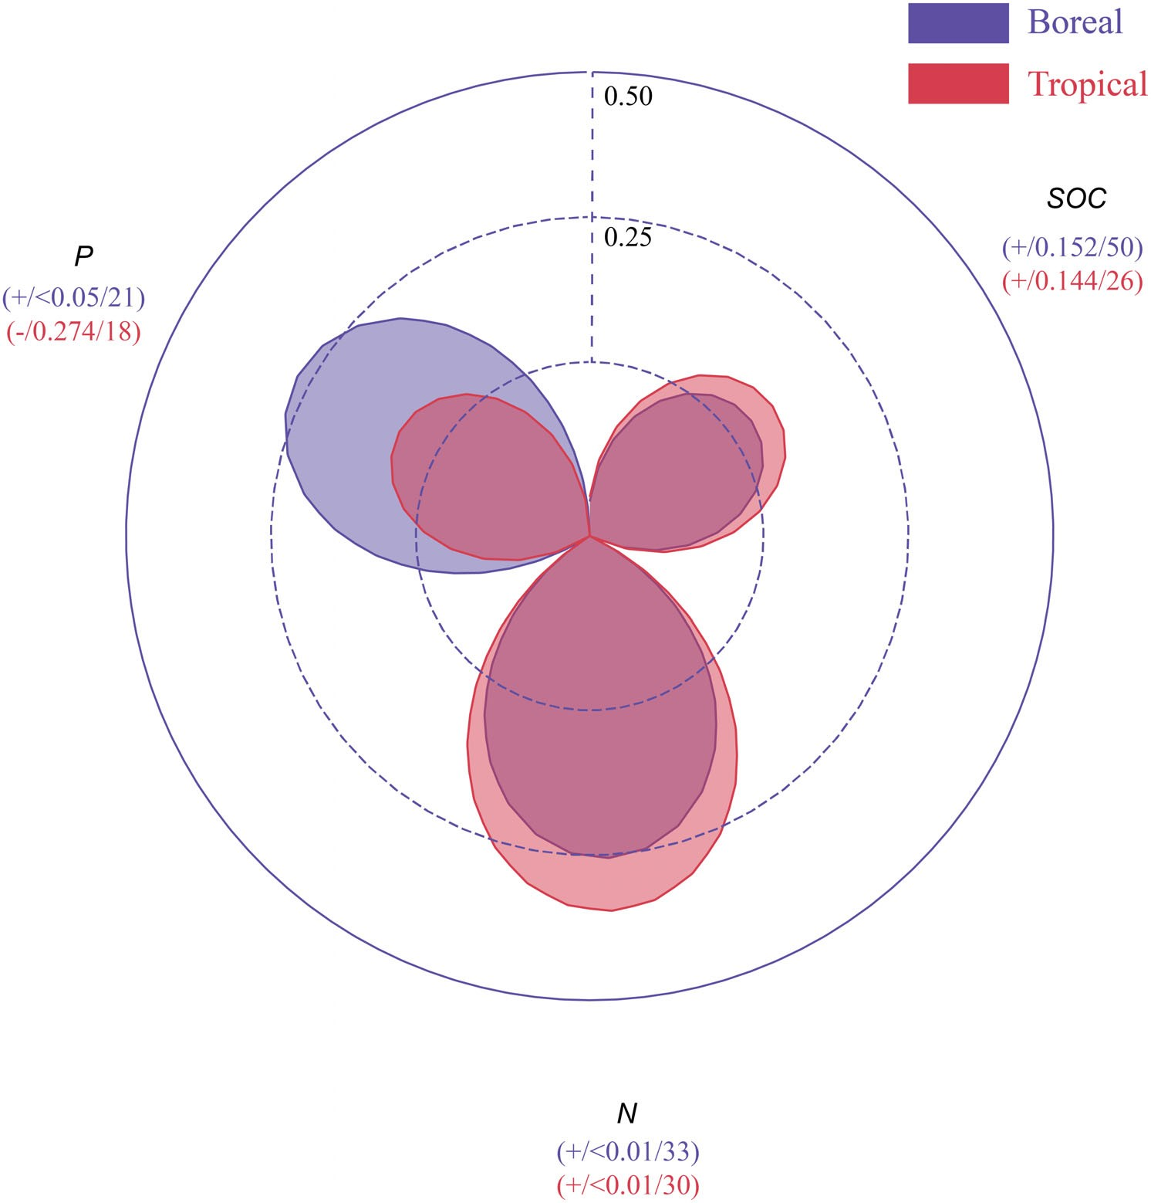
FIGURE 4 Regression between response ratios (RRs) of yield versus different soil properties under boreal regions (purple colour) and tropical regions (red colour). The vertices of the petal diagram indicate R² values (each concentric circle represents an R² increment of 0.25). The values in the parentheses represent the direction of slope/p-value of slope/ size of samples of regression.

| RESULTS

  - | Factors affecting crop yield changes when using conservation agriculture

Conservation agriculture demonstrated a positive impact on crop yield, resulting in a mean increase of 12% (Figure 2a). However, it is important to note that the yield responses varied across crops. Specifically, significant yield increases were observed in corn and rotation with mix- tures of multiple cash crops following the implementation of CA, with mean increases of 41% for corn and -6% for rotation with mixtures of multiple cash crops. On the con- trary, the remaining cash crops analysed did not exhibit significant responses in terms of yield.
The results also showed that the effects of CA on crop yield varied depending on climate type and soil texture. Among the different climate types, tropical regions exhib- ited the greatest increase in yield, with a mean increase of 27%, followed by a 15% mean increase in temperate regions (Figure 2b). By contrast, the implementation of CA in arid or boreal regions tended to lead to a decrease
in yield. When considering soil texture, crops planted in coarse-textured soils showed larger yield increases com- pared with those planted in fine- and medium-textured soils.
Examining the effects of various CA practices, it was found that AF resulted in the most substantial yield increase, and the use of CCs was also associated with a significant increase in yield (Figure 2c). By contrast, OF was associated with a significant yield decrease. The other three practices (no- or reduced-tillage, other CA practices and a mixture of multiple CA practices) were not associated with significant yield changes. The other CA practices category displayed a great variability in responses, likely reflecting the breadth of practices included in that category.
Furthermore, our analysis also examined the effects of different CC types. Cash crop yields significantly increased when planted following legume cover crops, broadleaf cover crops or mixtures of legume and grass crops (Figure 2d). On the contrary, the implementation of other types of CCs did not result in a significant effect on cash crop yields.

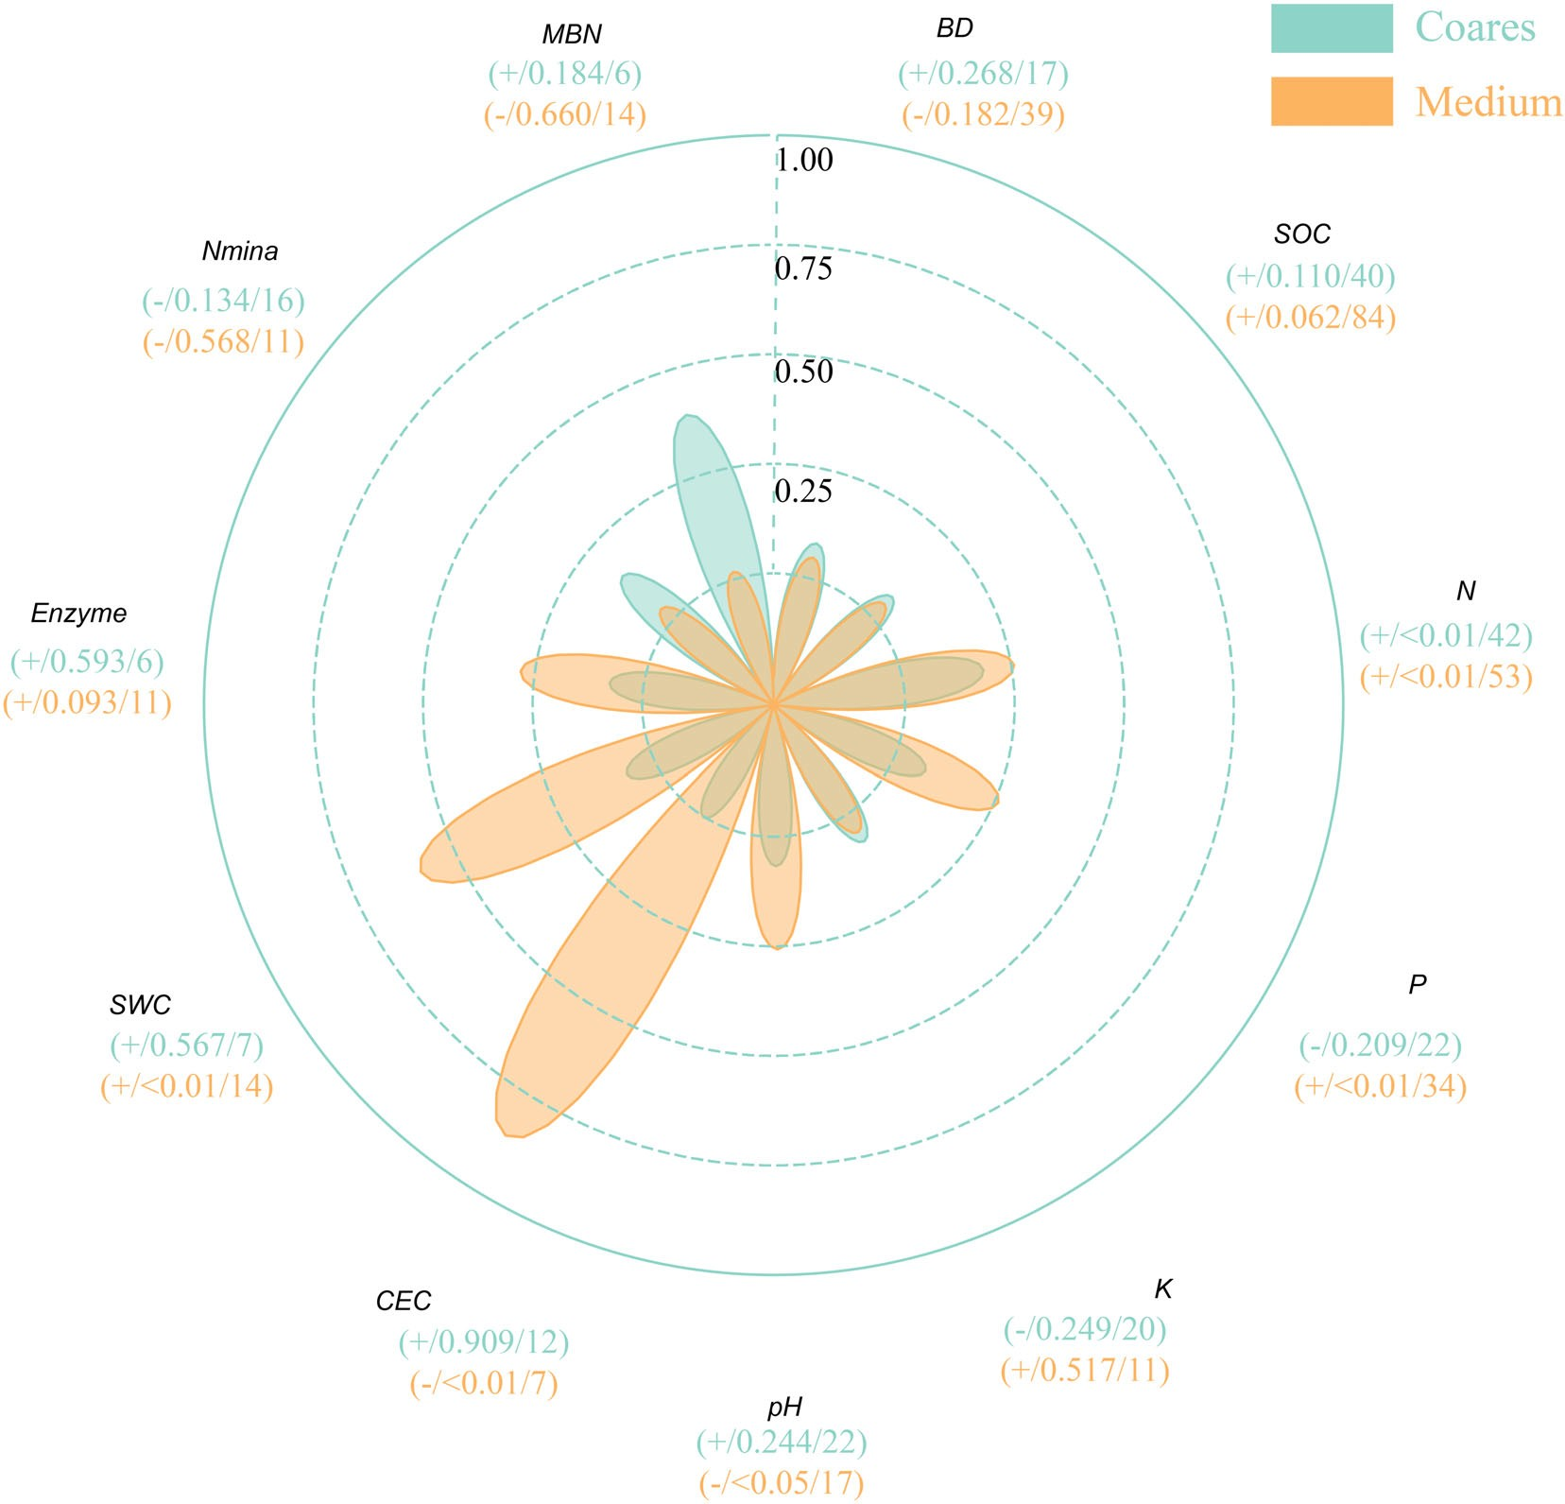

FIGURE 5 Regression between response ratios (RRs) of yield versus different soil properties under coarse-textured soils
(green colour) and medium-textured soils (yellow colour). The vertices of the petal diagram indicate R² values (each concentric circle represents an R² increment of 0.25). The values in the parentheses represent the direction of slope/p-value of slope/size of samples of regression.

| Linear regression results

Our results indicate a correlation between changes in crop yield and alterations in soil properties under CA. To delve deeper, we examined the relations between RR of yield and 10 specific soil properties for corn and other cash crops (sorghum, orchard crops, soybean, vegetable, wheat and mixtures). Regression analyses showed significant and positive correlations between corn yield changes and changes in SOC and N (slope >0 and p < 0.05, Figure 3), while the highest correlations were observed between corn yield and ero- sion (R² = 0.27) and N (R² = 0.15, Figure 3). No signifi- cant correlations were found with other soil properties. Similar linear regression analyses for other cash crops showed significant and positive correlations between
yield changes and changes in SOC, N and P (slope >0 and p < 0.05, Figure 3).
We also performed linear regression analyses to explore the relationship between yield response and soil properties for different climatic regions. In boreal areas (i.e. Koppen climate category D), yield changes exhibited significant and positive correlations with changes in soil N and P (slope >0 and p < 0.05, Figure 4). The highest correlation was observed between yield and P (R² = 0.27), while no signifi- cant correlations were found with SOC. Similarly, in tropi- cal regions, yield changes displayed a significant and positive correlation with changes in soil N (slope >0 and p < 0.05), but no significant correlations were observed with SOC and P (Figure 4).
Upon grouping the soils based on texture, the linear regression analyses demonstrated that yield changes in

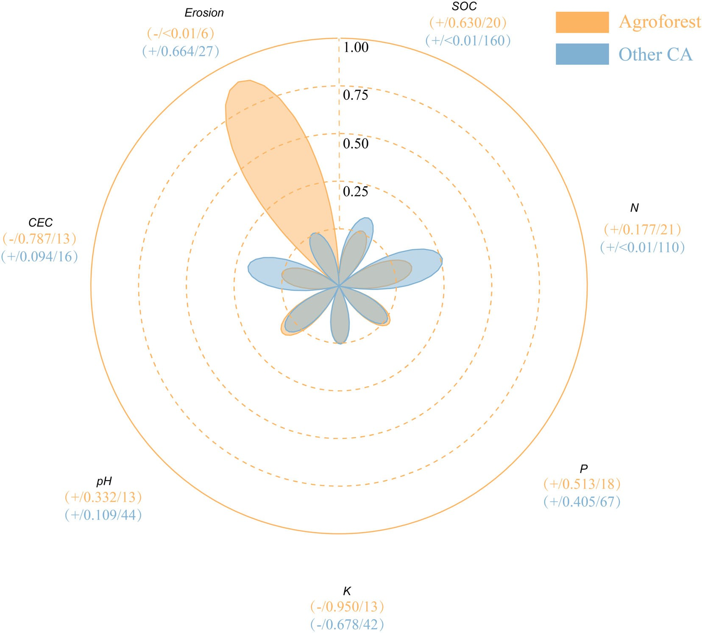

FIGURE 6 Regression between response ratios (RRs) of yield versus different soil properties under agroforestry (yellow colour) and all other conservation systems (blue colour). The vertices of the petal diagram indicate R² values (each concentric circle represents an R² increment of 0.25). The values in the parentheses represent the direction of slope/p-value of slope/size of samples of regression.

coarse-textured soils were significantly and positively correlated with changes in N (slope >0 and p < 0.05, Figure 5). No significant correlations were observed between yield and other soil properties changes in coarse-textured soils. In medium-textured soils, linear regression analysis revealed that yield changes were sig- nificantly and negatively correlated with changes in pH and CEC (slope <0 and p < 0.05). Additionally, yield changes were significantly and positively correlated with changes in soil N, P and SWC (slope >0 and p < 0.05, Figure 5). The strongest correlations were observed between changes in yield and CEC (R² = 0.86) and SWC (R² = 0.59). No significant correlations were observed between changes in yield and other soil prop- erties in medium-textured soils.
Furthermore, our regression analysis explored the correlations between yield response and soil properties for AF versus other CA practices (Figure 6). In the case of AF, yield changes were significantly and negatively correlated with changes in erosion (slope <0 and
p < 0.05). Conversely, for the other CA systems, yield changes were significantly and positively correlated with changes in SOC and soil N (slope >0 and p < 0.05). However, no significant correlations were observed between changes in yield and other soil prop- erties in these systems.
Finally, we performed linear regression analyses to examine the correlations between RR of yield versus RR of nine other soil properties, focusing on the use of grasses versus legumes as CCs (Figure 7). When grass species were used as the CC, no significant correlations were found between changes in yield and any of the soil properties. However, when leguminous CC species were planted, yield changes were significantly and positively correlated with changes in soil SWC, pH, N and MBN (slope >0 and p < 0.05). The strongest correlations were observed between yield and MBN (R² = 0.80), and yield and SWC (R² = 0.56). No significant correlations were found between changes in yield and other soil properties under leguminous CC species.

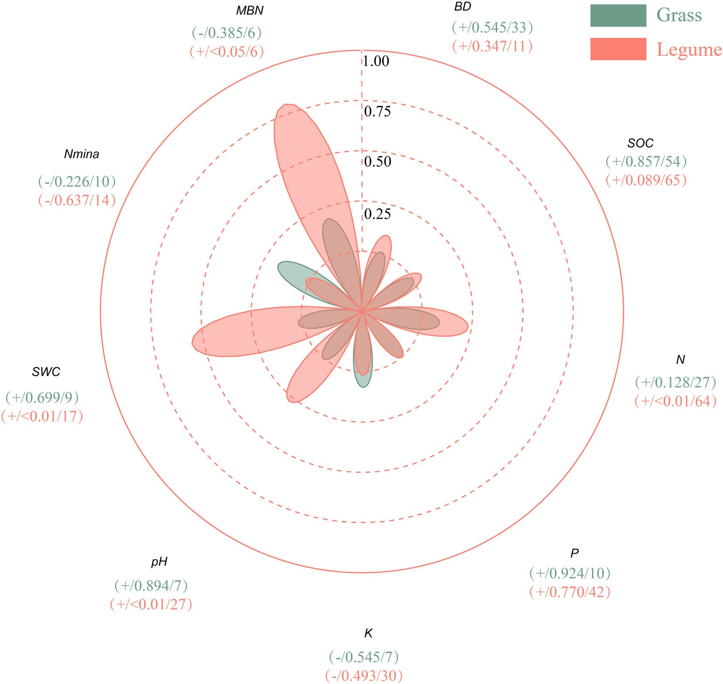

FIGURE 7 Regression between response ratios (RRs) of yield versus different soil properties under grass cover crop (green color) and legume cover crop (red color). The vertices of the petal diagram indicate R² values (each concentric circle represents an R² increment of 0.25). The values in the parentheses represent the direction of slope/p-value of slope/size of samples of regression.

| DISCUSSION

Conservation agriculture plays an important role in pro- moting the sustainability and protection of agroecosystems through improving soil chemical, physical and biologi- cal properties. Nonetheless, widespread adoption of CA practices is likely only to be achieved if these efforts result in tangible benefits, most notably maintenance or even improvement in crop yield. Previous work has sug- gested that crop yield response to CA may vary based on several factors, including climatic conditions, soil tex- ture, tillage practices, CC types, and pest and weed pres- sures (Jian et al., 2020c; Waqas et al., 2020; Xu et al., 2019; Zhang et al., 2022). A better understanding of the exact nature of these variations is essential to determining where and how CA is effective in increas- ing crop yield by changing soil properties. Therefore, the goal of this study was to conduct a systematic review
to understand these controls and interactions on a global scale.

| Crop yield changes after conservation management

Our analysis showed that the overall effects of CA on crop yield were positive, with a mean yield increase of 12% (Figure 2a). However, this response was primarily driven by the large yield response in corn, with a mean increase of 41% after the adoption of CA practices. These results are consistent with previous studies that have reported significant increases in corn yield, such as a study indicating a yield increase of 80% with CA com- pared with CM (Thierfelder et al., 2015). Our analysis indicated that vegetable and sorghum crops exhibited positive yield responses to CA, with respective mean

TABLE 1 Comparison of simple linear regression (SLR) coefficients to determine when it is the necessity to log-transform the response ratio (RR_{x}) of different soil properties. The table includes the following information: the regression sample size (n_total), the number of studies (n_study), the p-value and R-square coefficients (R²) for RR_{x}, the p-value (ln_p-value) and R-square coefficients (ln_R²) for ln(RR_{x}), the difference between R² and ln_R² (improved_R², %).
Improved_R² (%)
ln_R²
ln_p-value
R2
n_total n_study p-value
Property
Matrix of SLR between RR_{y} and RR_{x} or ln(RR_{x})
Corn

Soil nitrogen | 42 | 19 | 0.121 | 0.059 | 0.010 | 0.154 | 160.765
Aggregation | 6 | 2 | 0.739 | 0.031 | 0.698 | 0.042 | 34.799
Other cash crops
Soil nitrogen | 89 | 31 | 0.003 | 0.096 | 0.000 | 0.143 | 48.080
Aggregation | 9 | 5 | 0.222 | 0.204 | 0.152 | 0.269 | 32.108
Coarse-textured soils
Soil nitrogen | 42 | 18 | 0.067 | 0.081 | 0.004 | 0.185 | 128.218
Soil phosphorus | 22 | 8 | 0.320 | 0.049 | 0.209 | 0.078 | 57.411
Medium-textured soils
Soil nitrogen | 53 | 20 | 0.000 | 0.236 | 0.000 | 0.256 | 8.233
Soil phosphorus | 34 | 11 | 0.006 | 0.210 | 0.002 | 0.259 | 23.350
Agroforestry
Soil nitrogen | 21 | 10 | 0.231 | 0.074 | 0.177 | 0.094 | 25.746
Other conservation systems
Soil nitrogen | 110 | 40 | 0.000 | 0.145 | 0.000 | 0.259 | 78.236

increases of 4% and 3%. These findings suggest that the yield responses observed in different crops were likely influenced by various inherent and dynamic soil proper- ties at the study sites. These relationships were further evidenced by our categorical and regression analyses.
In terms of inherent properties, our study revealed dis- tinct yield responses among different soil textural catego- ries. Specifically, the effects of CA on crop yield were more pronounced in coarse-textured soils compared with medium-textured soils (Figure 2b). This observation can be attributed, at least in part, to the distribution of corn sites across temperate and tropical regions (Figure 8a). In addition, medium-textured soils (i.e., sandy clay loam, loam, silt loam and silt textures) often possess inherent physical and chemical properties, such as SWC and nutri- ent retention that are conducive to high agricultural productivity (Chaki et al., 2021,b; Matthews, 2014). Conse- quently, it is therefore possible that CA practices provide less benefit to soil properties changes in medium-textured soils compared with coarse- and fine-textured soils. Results from other studies provide some support for this hypothe- sis. For instance, in fine-textured soils, rice-wheat and rice-corn rotations under no-tillage exhibited significantly higher yields compared with conventional tillage, possibly due to improved soil structure (Chaki, Gaydon, Dalal, Bellotti, Gathala, Hossain, Rahman, & Menzies, 2021;

Islam et al., 2019; Kadiyala et al., 2012). Coarse- textured soils are often found in low-gradient environ- ments, such as the U.S. Coastal Plain, where good drainage is an important factor affecting crop yields (Chaki, Gaydon, Dalal, Bellotti, Gathala, Hossain, Rahman, & Menzies, 2021; Nyagumbo et al., 2020; Steward et al., 2018).
Our correlation analyses revealed that crop yields also responded to changes in dynamic soil properties, with a sig- nificance observed for soil nutrients (such as soil N and P). Specifically, our results indicated that corn yield, which is known to be influenced predominantly by N availability (Zhang et al., 2022), exhibited a positive correlations with total soil N (Figures 3, 4 and 5). Previous studies have shown that adopting leguminous CCs and tillage measures in corn production can enhance N availability and improve N use efficiency (Liebman et al., 2018; Pekrun et al., 2023). Additionally, our analysis identified a significant positive correlation between SOC and yield changes, although the
correlation coefficients were relatively small (R² < 0.25, Figures 3–7). It has been well-demonstrated that conserva- tion agriculture can increase SOC content (de S,a et al., 2017; Powlson et al., 2014), which in turn can signifi- cantly enhance corn yields (Bisheng et al., 2015). Recent research utilizing pedotransfer functions has further dem-
onstrated a positive relationship between SOC increases

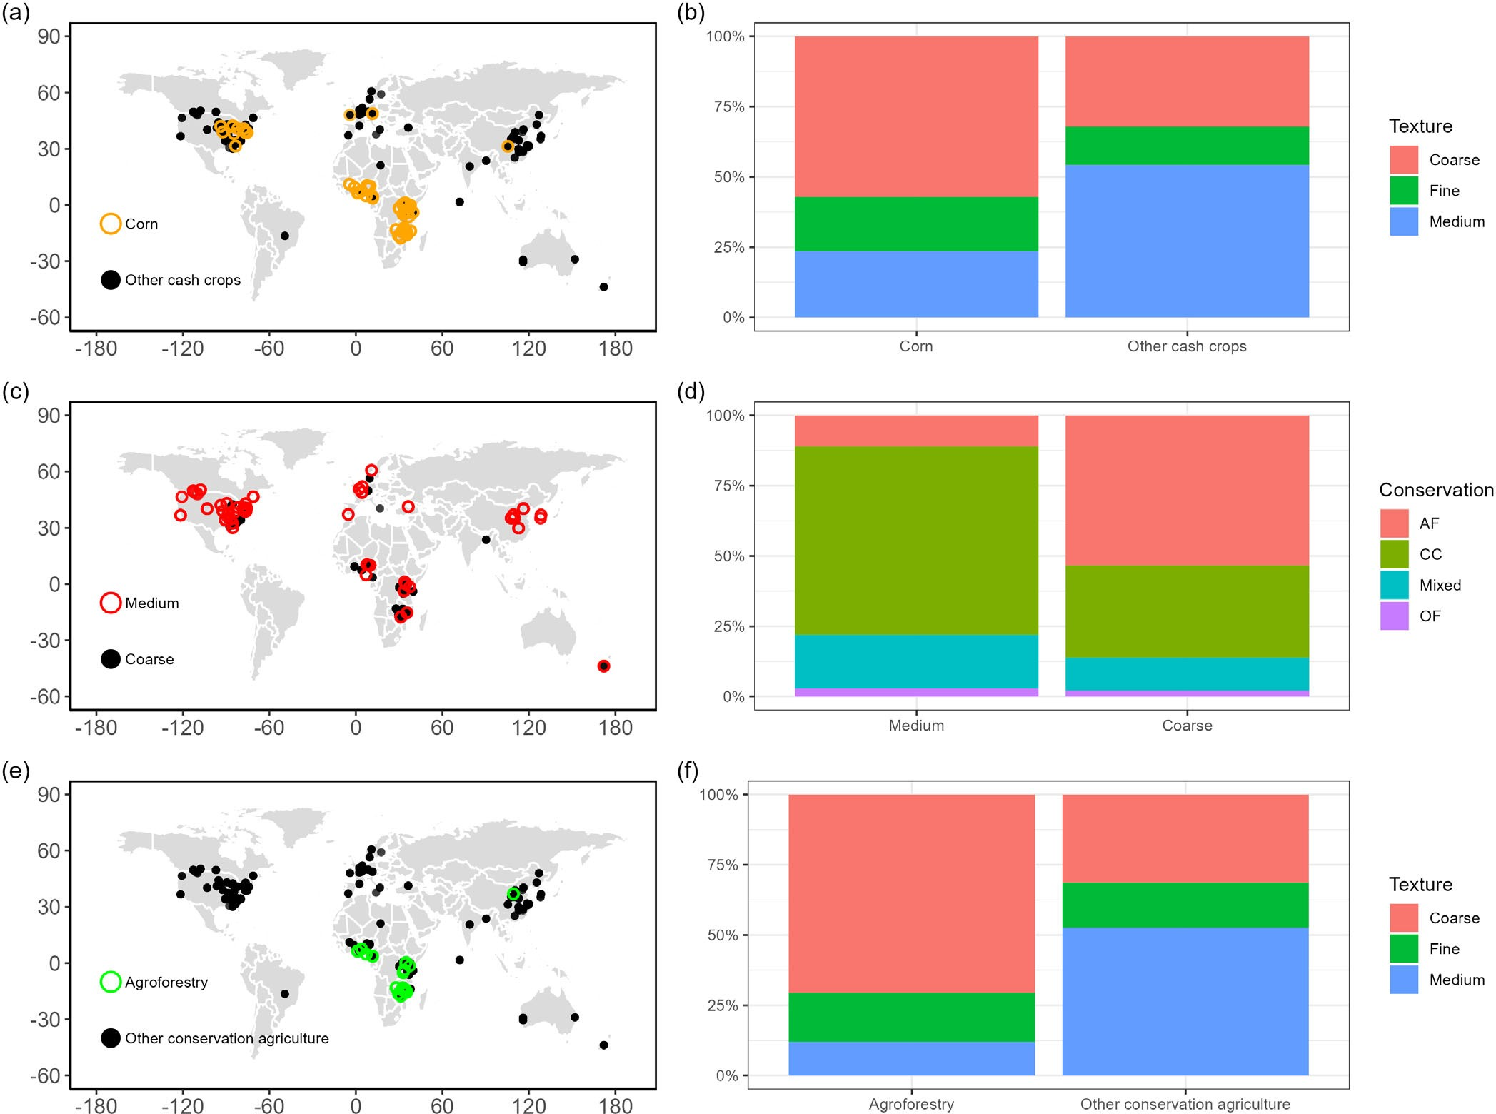

FIGURE 8 Spatial distribution of sites and proportion of sites by different soil texture types. (a) Spatial distribution of sites planted in corn versus other cash crops; (b) proportion of corn versus other cash crop sites by different soil texture types; (c) spatial distribution of medium-textured versus coarse-textured soils; (d) proportion of different textured soil sites by different conservation types; (e) spatial distribution of agroforestry versus other conservation agriculture; (f) proportion of agroforestry versus other conservation agriculture sites by different soil texture types.

resulting from CA and AWHC (Bagnall et al., 2022). This interaction likely contributed to the observed yield responses in our study, partially for corn crops planted in coarse-textured soils.
Phosphorus is also a critical nutrient for crop growth. We found that the yield changes of other cash crops were positively correlated with P, whereas such a relationship was not observed for corn (Figure 3). Likewise, we observed a correlation between yield and P in medium- textured soils, but not in coarse-textured soils (Figure 5). Phosphorus mainly accumulates in the soil surface and is easily washed away by surface runoff (Lu et al., 2023). Implementing protective measures in medium-textured soils can effectively reduce P loss while increasing P inputs. For instance, studies have shown that CCs and AF can significantly reduce soil erosion and surface run- off, thus reducing P loss (Du et al., 2022). Additionally,
the rapid increase in soil microorganisms after residue cover can lead to P accumulation (Lv et al., 2023). There- fore, a positive correlation between crop yield and P changes was observed in medium-textured soils with good structure. It is worth noting that a large portion of the corn sites included in this study were concentrated in coarse-textured soils (Figure 8b). Although CA practices can enhance P accumulation, they may not fully compen- sate for the inherent limitations of coarse-textured soils, such as large pore size, loose structure and high perme- ability, which are prone to leaching. Consequently, corn, similar to coarse-textured soils, does not show a signifi- cant relationship between yield and P changes.
Soil properties may play a significant role in the adop- tion and implementation of different CA practices (Corbeels et al., 2014; Sinha et al., 2019). Specifically, pro- ducers operating in challenging or less productive soils

(i.e., coarse- and fine-textured soils) may be more inclined to adopt CA practices (Laborde et al., 2021; Steward et al., 2018). The spatial distribution of cash crop types and CA practices included in our analysis provides supporting evidence for this phenomenon (Figure 8). More than half of the corn sites were located in coarse- textured soils, while other cash crop types were predomi- nantly located in medium-textured soils (Figure 8b).

| Crop yield changes under agroforestry

Our analysis showed that AF had a substantial impact on crop yield, with an increase of 66%, thus surpassing the yield increase observed in other CA types (Figure 2c). This result can be attributed to several reasons. Firstly, the majority of AF sites were located in tropical and tem- perate regions (Figure 8e), and approximately 70% of these sites had coarse-textured soils (Figure 8f). Addition- ally, changes in soil properties associated with AF likely contributed to the observed yield increases. Our results showed that crop yield changes under AF were negatively correlated with soil erosion. This interaction can be attrib- uted to the presence of canopy, tree trunks, roots and lit- ter, which effectively reduce soil erosion. Under typical conditions, the dense canopy cover of intercropped vegeta- tion intercepts rainfall, preventing direct impact on the ground, while the low canopy cover acts as a buffer, reduc- ing splash erosion (Efthimiou et al., 2020; Zheng et al., 2019). Tree trunks then act as barriers, reducing the carrying capacity of runoff, particularly for sand-sized par- ticles (Lal, 1989). Trees generally possess deeper root sys- tems compared with annual crops, contributing to soil stabilization (Morug,an-Coronado et al., 2020). Litter from perennial plants intercropped with trees also plays a cru- cial role in reducing erosion and runoff (Du et al., 2022). Finally, certain tree species, such as oaks and conifers, have the ability to transfer hydrophobic compounds to the soil, affecting infiltration rates and reducing runoff soil erosion (Ebel & Moody, 2017; Tessler et al., 2008). There- fore, crop yield was significantly and negatively correlated with erosion.
Although our analysis results did not reveal a significant relationship between crop yield variation and other soil properties under AF, it should be noted that improvements in soil nutrients, water availability and microclimate result- ing from AF practices may contribute to the observed yield increases. Studies have shown that the extensive and deep root systems of trees in AF systems access water and nutri- ents from deeper soil layers, redistributing them to the upper soil profile, thereby enhancing water efficiency and cash crop yields (Cardinael et al., 2015; Deng et al., 2022;
Isaac & Borden, 2019; Jose et al., 2004; Li et al., 2022; Rama- chandran Nair et al., 2010). The “nutrient pumping” effect and complementary water-use patterns of AF systems facili- tate resource utilization and nutrient cycling (Arenas- Corraliza et al., 2022; Borden et al., 2017; Burgess et al., 2022; Cannavo et al., 2011; Cannell et al., 1996;
Cardinael et al., 2015; Deng et al., 2022; Isaac & Borden, 2019; Schwendenmann et al., 2010; Van Noordwijk et al., 2015; Zhao et al., 2022). For example, one study dem- onstrated that litter from Faidherbia trees (8–22 years old) can contribute significant amounts of N, P and K to corn production, with higher corn yield, soil total N and SOC under the tree canopy compared with outside under the
canopy (Yengwe et al., 2018).
Additionally, AF practices can positively impact the microclimate experienced by crops, providing resilience against drought and heat waves (Arenas-Corraliza et al., 2022; Gomes et al., 2020; Karvatte et al., 2020; Kuyah et al., 2019; Schwab et al., 2015; Zhao et al., 2022). The shielding effect of tree leaves reduces direct solar radiation exposure to crops, moderates canopy temperature extremes, increases air humidity and enhances crop tolerance to drought stress (Arenas-Corraliza et al., 2022; Campi et al., 2009; Coble et al., 2020; Gutierrez et al., 1994; Inurreta-Aguirre et al., 2018; Kanzler et al., 2019; Lin, 2007; Serrano et al., 2018). Pruned tree branches and fallen leaves contribute to soil nutrients. These organic inputs serve as significant sources of nitrogen for soil organic nitrogen accumulation, and some leguminous trees in AF systems effectively associate with nitrogen-fixing bacteria, enhanc- ing atmospheric N fixation capacity (Li et al., 2022; Muchane et al., 2020). As a result, the availability of organic N may be sufficient to meet crop N requirements, poten- tially reducing the need for additional inorganic fertilization (Makumba et al., 2006).

| Cover crop species effects on cash crop yields

Our analysis determined that CCs led to an overall yield increase. However, the magnitude of the yield response varied depending on the type of CC used, as did the cor- relations with changes in other soil properties. Specifi- cally, legume CCs were associated with a significant mean yield increase of 26% (Figure 2d), which aligns with the results of other studies, including Adetunji et al. (2020). The positive correlation between crop yield and soil N, SWC and MBN changes observed when legumes were used as CCs (Figure 7) can be attributed to several factors. Firstly, the presence of legume cover crops reduces direct sunlight exposure to the soil, which can lead to reduced soil temperature and less soil moisture

loss (Pekrun et al., 2023; Rasmussen, 1999). Moreover, the straw from CCs can serve as a source of nutrient input, while simultaneously reducing soil compaction and surface runoff, thereby minimizing N losses (Adetunji et al., 2020). Additionally, legumes have the ability to fix large amounts of N through symbiotic asso- ciations with rhizobium bacteria (Adetunji et al., 2020; Thilakarathna et al., 2015), thereby enhancing soil fertil- ity and promoting carbon and nitrogen cycling (Fortuna et al., 2008). Studies have indicated that around 20% of the N in crop growth originates from the direct minerali- zation of newly introduced legumes, while the remaining 80% comes from pre-existing soil organic matter reser- voirs (Harris et al., 1994; Kramer et al., 2002; Tonitto et al., 2006). Finally, the chemical composition of CC res- idues, such as C:N ratio and lignin content, is another important feature that influences decomposition pro- cesses and N release into the soil (Adetunji et al., 2020; Alonso-Ayuso et al., 2014; Sullivan et al., 2020). Previous meta-analyses have also indicated a negative relationship between the C:N ratio of CCs and changes in SOC (Jian et al., 2020a), suggesting that the lower C:N ratio of legumes can lead to more rapid increases in SOC.
Although grass CCs were associated with a mean
yield decrease of 2%, the effects were variable and not sta- tistically significant (Figure 2d). Regression analysis showed no significant correlation between changes in crop yield and soil properties. This complex relationship may be attributed to the inherently complex of CC man- agement. Prior research has suggested that grass CCs can provide certain benefits when properly managed. For instance, grasses and nonlegumes have the ability to rap- idly absorb and recycle residual soil nutrients, such as nitrate (NO₃), at the end of the growing season, thereby reducing leaching losses (Cline & Silvernail, 2002; Thorup-Kristensen, 2006). Grasses may also be more effective than legumes in weed control, as they germinate earlier and tend to develop rapid root systems that can compete with weeds for water and nutrients (Ranells & Wagger, 1996). Some grass species, such as rye, sorghum and sorghum-sudangrass can suppress weed growth through allelopathy. However, these benefits may only become apparent when the CCs are given enough time to grow, which can lead to late planting of cash crops and subsequent yield declines (Clark et al., 1997; Decker et al., 1994; Thorup-Kristensen et al., 2003; Tonitto et al., 2006). Additionally, grasses may promote the pres- ence of certain soil diseases and pests (Adetunji et al., 2020; Gerlagh, 1968).
Our analysis also confirmed that mixing legume and
grass CCs can be an effective strategy for boosting cash crop yields. Indeed, a mixture of one legume and one grass was associated with the largest yield effect
(mean increase of 26%), consistent with the findings of Blanco-Canqui et al. (2015). This result likely reflects the complementary benefits of growing legumes and grasses together. During early growth stages, herbaceous plants tend to grow faster than legumes (Newman et al., 2007; Sainju et al., 2000), thereby helping to inhibit weed growth, prevent soil erosion and store nutrients for subse- quent plant growth (Adetunji et al., 2020; Ranells & Wagger, 1996). At later growth stages, legumes act as an N source that supports crop growth and ensures crop yield (Thilakarathna et al., 2015). On the contrary, mix- tures of more than two CCs did not show a significant yield increase. This particular comparison was con- strained by the limited number of observations, and the wide variety of possible mixtures likely obscured our abil- ity to detect any consistent yield response.

| SUMMARY AND CONCLUSIONS

Conservation agriculture (CA) has gained widespread acceptance as a sustainable approach for row cropping and other agricultural systems. However, the benefits of CA practices on row-crop yields are not uniform, and some practices may even hinder yields. Our comprehen- sive analysis revealed an overall mean increase of 12% in crop yield due to CA implementation. This yield response was mainly driven by corn, which exhibited an impres- sive 41% yield boost after adopting CA. Rotation with mixtures of multiple cash crops, by contrast, showed a modest (6%) decrease. Conversely, other cash crops did not show significant yield changes across studies. These yield responses were influenced by multiple factors, inducing climatic conditions, soil types, farming systems, crop types and CA practice types.
Our analysis delved into the interplay between yield responses and associated changes in soil properties, such as soil erosion, soil water content, soil nutrient levels (including SOC and soil N content) and nutrient losses. Notably, yield responses were more pronounced in coarse- and fine-textured soils compared with medium- textured soils. This result stems from several underlying factors, including greater improvements in soil properties when CA is implemented in the former two categories compared with the latter. In addition, CA practices may enhance cash crop yield by reducing surface runoff and erosion, improving soil nutrient levels and minimizing nutrient losses. Finally, AF practices, which were more prevalent in areas with coarse-textured soils, exhibited the most substantial yield benefits. These advantages can be attributed to changes in soil erosion, soil moisture and nutrient levels, as well as the creation of more favourable

microclimates when trees are incorporated into cropping systems. In conclusion, this study underscores the critical role of soil properties in determining crop yield responses to CA practices.

AUTHOR CONTRIBUTIONS
Xiaohua Ren: Data curation; writing – review and editing; writing – original draft; conceptualization; method- ology; validation; visualization; formal analysis; software;
project administration. Wenjing Zou: Methodology; data curation; formal analysis; validation; writing – review and editing; project administration; visualization. Juying Jiao: Conceptualization; methodology; writing – original draft; writing – review and editing; funding acquisition. Ryan Stewart: Project administration; visualization; investi- gation; validation; methodology; writing – review and edit- ing; writing – original draft. Jinshi Jian: Writing – review and editing; writing – original draft; conceptualization; meth- odology; software; formal analysis; data curation; resources;
validation; visualization; investigation; funding acquisition.

ACKNOWLEDGEMENTS
Xiaohua Ren, Jinshi Jian, Wenjing Zou and Juying Jiao were supported by the QinChuanyuan Project of Shaanxi Prov- ince, the Second Tibetan Plateau Scientific Expedition and Research Program (STEP), No.2019QZKK0603, and the Tal- ent Attracting Supporting Funds by Northwest A & F Uni- versity under funding number A315022202. Ryan Stewart was supported by the U.S. Department of Agriculture NRCS Conservation Innovation Grant (No. 69-3A75-14-260) and the Virginia Agricultural Experiment Station and the Hatch Program of the National Institute of Food and Agriculture,
U.S. Department of Agriculture.

CONFLICT OF INTEREST STATEMENT
The authors declare no conflict of interest.

DATA AVAILABILITY STATEMENT
The data that supports the findings of this study are avail- able in the supplementary material of this article.

ORCID
Jinshi Jian https://orcid.org/0000-0002-5272-5367

REFERENCES
Abera, W., Tamene, L., Tibebe, D., Adimassu, Z., & Kassa, H. (2020). Characterizing and evaluating the impacts of national land restoration initiatives on ecosystem services in Ethiopia. Land Degradation & Development, 31, 37–52.
Adetunji, A. T., Ncube, B., Mulidzi, R., & Lewu, F. B. (2020). Man-
agement impact and benefit of cover crops on soil quality: A review. Soil and Tillage Research, 204, 104717.
Adimassu, Z., Langan, S., Johnston, R., Mekuria, W., & Amede, T. (2017). Impacts of soil and water conservation practices on crop
yield, run-off, soil loss and nutrient loss in Ethiopia: Review and synthesis. Environmental Management, 59, 87–101.
Alonso-Ayuso, M., Gabriel, J. L., & Quemada, M. (2014). The kill date as a management tool for cover cropping success. PLoS One, 9, e109587.
Anantha, K. H., Garg, K. K., Barron, J., Dixit, S., Venkataradha, A., Singh, R., & Whitbread, A. M. (2021). Impact of best manage- ment practices on sustainable crop production and climate resilience in smallholder farming systems of South Asia. Agri- cultural Systems, 194, 103276.
Arenas-Corraliza, M. G., Lo,pez-Díaz, M. L., Rolo, V., C,aceres, Y., &
Moreno, G. (2022). Phenological, morphological and physiolog- ical drivers of cereal grain yield in Mediterranean agroforestry systems. Agriculture, Ecosystems and Environment, 340, 108158. Arora, V., Sidhu, A., Sandhu, K., & Thind, S. S. (2010). Effects of tillage intensity, planting time and nitrogen rate on wheat yield
following rice. Experimental Agriculture, 46, 267–275.
Bagnall, D. K., Morgan, C. L. S., Cope, M., Bean, G. M., Cappellazzi, S., Greub, K., Liptzin, D., Norris, C. L., Rieke, E., & Tracy, P. (2022). Carbon-sensitive pedotransfer functions for plant available water. Soil Science Society of Amer- ica Journal, 86, 612–629.
Baveye, P. C., Rangel, D., Jacobson, A. R., Laba, M., Darnault, C.,
Otten, W., Radulovich, R., & Camargo, F. A. O. (2011). From dust bowl to dust bowl: Soils are still very much a frontier of science. Soil Science Society of America Journal, 75, 2037–2048.
Bisheng, W., Dianxiong, C., Xueping, W., Jing, L., Guopeng, L., Weishui, Y., Xiangling, W., Yiyu, Y., & Xiaobin, W. (2015). Effects of long-term conservation tillage on soil organic carbon, maize yield and water utilization. Journal of Plant Nutrition &
Fertilizer, 6, 1455–1464 (In Chinese abstract).
Blanco-Canqui, H., Shaver, T. M., Lindquist, J. L., Shapiro, C. A., Elmore, R. W., Francis, C. A., & Hergert, G. W. (2015). Cover crops and ecosystem services: Insights from studies in temper- ate soils. Agronomy Journal, 107, 2449–2474.
Borden, K. A., Thomas, S. C., & Isaac, M. E. (2017). Interspecific
variation of tree root architecture in a temperate agroforestry system characterized using ground-penetrating radar. Plant and Soil, 410, 323–334.
Burgess, A. J., Correa Cano, M. E., & Parkes, B. (2022). The deploy- ment of intercropping and agroforestry as adaptation to climate change. Crop and Environment, 1, 145–160.
Busari, M. A., Kukal, S. S., Kaur, A., Bhatt, R.,& Dulazi, A. A. (2015). Conservation tillage impacts on soil, crop and the environment. International Soil and Water Conservation Research, 3, 119–129.
Campi, P., Palumbo, A. D., & Mastrorilli, M. (2009). Effects of tree windbreak on microclimate and wheat productivity in a Medi- terranean environment. European Journal of Agronomy, 30, 220–227.
Cannavo, P., Sansoulet, J., Harmand, J. M., Siles, P., Dreyer, E., & Vaast, P. (2011). Agroforestry associating coffee and Inga densi- flora results in complementarity for water uptake and decreases deep drainage in Costa Rica. Agriculture, Ecosystems and Envi- ronment, 140, 1–13.
Cannell, M. G. R., Noordwijk, M. V. A. N., & Ong, C. K. (1996). The central agroforestry hypothesis: The trees must acquire resources that the crop would not otherwise acquire. Agrofor- estry Systems, 34, 27–31.
Cardinael, R., Mao, Z., Prieto, I., Stokes, A., Dupraz, C.,
Kim, J. H., & Jourdan, C. (2015). Competition with winter

crops induces deeper rooting of walnut trees in a Mediterra- nean alley cropping agroforestry system. Plant and Soil, 391, 219–235.
Chaki, A. K., Gaydon, D. S., Dalal, R. C., Bellotti, W. D., Gathala, M. K., Hossain, A., Rahman, M. A., & Menzies, N. W. (2021). Conservation agriculture enhances the rice-wheat sys- tem of the eastern Gangetic Plains in some environments, but not in others. Field Crops Research, 265, 108109.
Chaki, A. K., Gaydon, D. S., Dalal, R. C., Bellotti, W. D., Gathala, M. K., Hossain, A., Siddquie, N. E. A., & Menzies, N. W. (2021). Puddled and zero-till unpuddled trans- planted rice are each best suited to different environments – An example from two diverse locations in the eastern Gangetic Plains of Bangladesh. Field Crops Research, 262, 108031.
Choudhary, M., Datta, A., Jat, H. S., Yadav, A. K., Gathala, M. K.,
Sapkota, T. B., Das, A. K., Sharma, P. C., Jat, M. L., & Singh, R. (2018). Changes in soil biology under conservation agriculture based sustainable intensification of cereal systems in indo- Gangetic Plains. Geoderma, 313, 193–204.
Clark, A. J., Decker, A. M., Meisinger, J. J., & McIntosh, M. S.
(1997). Kill date of vetch, rye, and a vetch-rye mixture: II. Soil moisture and corn yield. Agronomy Journal, 89, 434–441.
Cline, G. R., & Silvernail, A. F. (2002). Effects of cover crops, nitro- gen, and tillage on sweet corn. HortTechnology Horttech, 12, 118–125.
Coble, A. P., Contosta, A. R., Smith, R. G., Siegert, N. W., Vadeboncoeur, M., Jennings, K. A., Stewart, A. J., & Asbjornsen, H. (2020). Influence of forest-to-silvopasture con- version and drought on components of evapotranspiration. Agriculture, Ecosystems and Environment, 295, 106916.
Colecchia, S. A., De Vita, P., & Rinaldi, M. (2015). Effects of tillage systems in durum wheat under rainfed mediterranean condi- tions. Cereal Research Communications, 43, 704–716.
Corbeels, M., Sakyi, R., Kühne, R., & Whitbread, A. (2014). Meta-analysis of crop responses to conservation agriculture in sub-Saharan Africa. Rapport CIRAD.
Corsi, S., Friedrich, T., Kassam, A. H., Pisante, M., S,a, J. M., & de
Moraes, S. J. (2012). Soil organic carbon accumulation and greenhouse gas emission reductions from conservation agricul- ture: A literature review. Integrated Crop Management, 16, 13–27.
Dai, J., Wang, Z., Li, M., He, G., Li, Q., Cao, H., Wang, S.,
Gao, Y., & Hui, X. (2016). Winter wheat grain yield and sum- mer nitrate leaching: Long-term effects of nitrogen and phos- phorus rates on the loess plateau of China. Field Crops Research, 196, 180–190.
de S,a, J. C. M., Lal, R., Cerri, C. C., Lorenz, K., Hungria, M., & de
Faccio Carvalho, P. C. (2017). Low-carbon agriculture in South America to mitigate global climate change and advance food security. Environment International, 98, 102–112.
Decker, A. M., Clark, A. J., Meisinger, J. J., Mulford, F. R., &
McIntosh, M. S. (1994). Legume cover crop contributions to no- tillage corn production. Agronomy Journal, 86, 126–135.
Deng, P., Fan, W., Wang, H., Ti, J., & Xu, X. (2022). Chinese Torreya agroforestry alters the rhizosphere soil bacterial commu- nities and potential functions. Applied Soil Ecology, 177, 104504.
Domínguez, A., & Bedano, J. C. (2016). The adoption of no-till instead of reduced tillage does not improve some soil quality parameters in Argentinean Pampas. Applied Soil Ecology, 98, 166–176.
Du, X., Jian, J., Du, C., & Stewart, R. D. (2022). Conservation man- agement decreases surface runoff and soil erosion. International Soil and Water Conservation Research, 10, 188–196.
Ebel, B. A., & Moody, J. A. (2017). Synthesis of soil-hydraulic prop- erties and infiltration timescales in wildfire-affected soils. Hydrological Processes, 31, 324–340.
Efthimiou, N., Psomiadis, E., & Panagos, P. (2020). Fire severity and soil erosion susceptibility mapping using multi-temporal earth observation data: The case of Mati fatal wildfire in eastern Attica, Greece. Catena, 187, 104320.
Findlater, K. (2013). Conservation agriculture: South Africa's new green revolution? Africa Potal, 61, 1–10.
Fortuna, A., Blevins, R. L., Frye, W. W., Grove, J., & Cornelius, P. (2008). Sustaining soil quality with legumes in no-tillage sys- tems. Communications in Soil Science and Plant Analysis, 39, 1680–1699.
Gerlagh, M. (1968). Introduction of Ophiobolus graminis into new polders and its decline. Netherlands Journal of Plant Pathology, 74, 1–97.
Gerten, D., Heck, V., Jägermeyr, J., Bodirsky, B. L., Fetzer, I., Jalava, M., Kummu, M., Lucht, W., Rockström, J., Schaphoff, S., & Schellnhuber, H. J. (2020). Feeding ten billion people is possible within four terrestrial planetary boundaries.
Nature Sustainability, 3, 200–208.
Gomes, L. C., Bianchi, F. J. J. A., Cardoso, I. M.,
Fernandes, R. B. A., Filho, E. I. F., & Schulte, R. P. O. (2020). Agroforestry systems can mitigate the impacts of climate change on coffee production: A spatially explicit assessment in Brazil. Agriculture, Ecosystems and Environment, 294, 106858.
Gutierrez, M. V., Meinzer, F. C., & Grantz, D. A. (1994). Regulation of transpiration in coffee hedgerows: Covariation of environ- mental variables and apparent responses of stomata to wind and humidity. Plant, Cell & Environment, 17, 1305–1313.
Hao, X., Abou, M., Steenwerth, K. L., Nocco, M. A., Basset, C., &
Daccache, A. (2022). Are there universal soil responses to cover cropping? A systematic review. Science of the Total Environ- ment, 861, 160600.
Harris, G. H., Hesterman, O. B., Paul, E. A., Peters, S. E., & Janke, R. R. (1994). Fate of legume and fertilizer Nitrogen-15 in a long-term cropping systems experiment. Agronomy Journal, 86, 910–915.
Hesterberg, T. (2011). Bootstrap. WIREsComputational Statistics, 3,
497–526.
Huang, P., Zhang, J., Zhu, A., Li, X., Ma, D., Xin, X., Zhang, C., Wu, S., Garland, G., & Pereira, E. I. P. (2018). Nitrate accumu- lation and leaching potential reduced by coupled water and nitrogen management in the Huang-Huai-Hai plain. Science of the Total Environment, 610–611, 1020–1028.
Inurreta-Aguirre, H. D., Lauri, P. E,., Dupraz, C., & Gosme, M.
(2018). Yield components and phenology of durum wheat in a Mediterranean alley-cropping system. Agroforestry Systems, 92, 961–974.
Isaac, M. E., & Borden, K. A. (2019). Nutrient acquisition strategies
in agroforestry systems. Plant and Soil, 444, 1–19.
Islam, S., Gathala, M. K., Tiwari, T. P., Timsina, J., Laing, A. M., Maharjan, S., Chowdhury, A. K., Bhattacharya, P. M., Dhar, T., Mitra, B., Kumar, S., Srivastwa, P. K., Dutta, S. K., Shrestha, R., Manandhar, S., Sherestha, S. R., Paneru, P., Siddquie, N. E. A., Hossain, A., … Gérard, B. (2019). Conservation agriculture based sustainable intensification: Increasing yields and water

productivity for smallholders of the eastern Gangetic Plains.
Field Crops Research, 238, 1–17.
Jat, H. S., Datta, A., Sharma, P. C., Kumar, V., Yadav, A. K., Choudhary, M., Choudhary, V., Gathala, M. K., Sharma, D. K., Jat, M. L., Yaduvanshie, N. P. S., Singhf, G., & McDonaldg, A. (2018). Assessing soil properties and nutrient availability under conservation agriculture practices in a reclaimed sodic soil in cereal-based systems of North-West India. Archives of Agron-
omy and Soil Science, 64, 531–545.
Jian, J., Du, X., Reiter, M. S., Stewart, R. D., Zhao, J., Yang, Y.,
Zhang, K., Jeong, J., Zeng, Z., & Zang, H. (2020a). A meta-anal- ysis of global cropland soil carbon changes due to cover crop- ping. Soil Biology and Biochemistry, 245, 107735.
Jian, J., Du, X., & Stewart, R. D. (2020b). A database for global soil health assessment. Scientific Data, 7, 3–10.
Jian, J., Du, X., & Stewart, R. D. (2020c). Quantifying cover crop effects on soil health and productivity. Data in Brief, 29, 105376.
Jin, K., Sleutel, S., Buchan, D., De Neve, S., Cai, D. X., Gabriels, D., & Jin, J. Y. (2009). Changes of soil enzyme activi- ties under different tillage practices in the Chinese Loess Pla- teau. Soil and Tillage Research, 104, 115–120.
Jose, S., Gillespie, A. R., & Pallardy, S. G. (2004). Interspecific inter-
actions in temperate agroforestry. Agroforestry Systems, 61, 237–255.
Kadiyala, M. D. M., Mylavarapu, R. S., Li, Y. C., Reddy, G. B., & Reddy, M. D. (2012). Impact of aerobic rice cultivation on growth, yield, and water productivity of rice-maize rotation in semiarid tropics. Agronomy Journal, 104, 1757–1765.
Kanzler, M., Böhm, C., Mirck, J., Schmitt, D., & Veste, M. (2019). Microclimate effects on evaporation and winter wheat (Triti- cum aestivum L.) yield within a temperate agroforestry system. Agroforestry Systems, 93, 1821–1841.
Karvatte, N., Miyagi, E. S., de Oliveira, C. C., Barreto, C. D.,
Mastelaro, A. P., Bungenstab, D. J., & Alves, F. V. (2020). Infra- red thermography for microclimate assessment in agroforestry systems. Science of the Total Environment, 731, 139252.
Kottek, M., Grieser, J., Beck, C., Rudolf, B., & Rubel, F. (2006). World map of the Köppen-Geiger climate classification updated. Meteorologische Zeitschrift, 15, 259–263.
Kramer, A. W., Doane, T. A., Horwath, W. R., & van Kessel, C. (2002). Short-term nitrogen-15 recovery vs. long-term total soil N gains in conventional and alternative cropping systems. Soil Biology and Biochemistry, 34, 43–50.
Kuyah, S., Whitney, C. W., Jonsson, M., Sileshi, G. W., Öborn, I.,
Muthuri, C. W., & Luedeling, E. (2019). Agroforestry delivers a win-win solution for ecosystem services in sub-Saharan Africa. A meta-analysis. Agronomy for Sustainable Development, 39, 47.
Kwesiga, F., Akinnifesi, F. K., Mafongoya, P. L., McDermott, M. H., &
Agumya, A. (2003). Agroforestry research and development in southern Africa during the 1990s: Review and challenges ahead. Agroforestry Systems, 59, 173–186.
Laborde, J. P., Wortmann, C. S., Blanco-Canqui, H., &
Lindquist, J. L. (2021). Modeling soil texture and residue man- agement effects on conservation agriculture productivity in Nepal. Soil and Tillage Research, 213, 105113.
Lal, R. (1989). Agroforestry systems and soil surface management of a tropical alfisol. Agroforestry Systems, 8, 97–111.
Lesur-Dumoulin, C., Malézieux, E., Ben-Ari, T., Langlais, C., & Makowski, D. (2017). Lower average yields but similar yield
variability in organic versus conventional horticulture. A meta- analysis. Agronomy for Sustainable Development, 5, 37–45.
Li, S., Gong, S., Hou, Y., Li, X., & Wang, C. (2022). The impacts of agroforestry on soil multi-functionality depending on practices and duration. Science of the Total Environment, 847, 157438.
Liebman, A. M., Grossman, J., Brown, M., Wells, M. S., Reberg- Horton, S. C., & Shi, W. (2018). Legume cover crops and tillage impact nitrogen dynamics in organic corn production. Agron- omy Journal, 110, 1046–1057.
Lin, B. B. (2007). Agroforestry management as an adaptive strategy
against potential microclimate extremes in coffee agriculture.
Agricultural and Forest Meteorology, 144, 85–94.
Lu, M., Zhou, X., Yang, Q., Li, H., Luo, Y., Fang, C., Chen, J., Yang, X., & Li, B. (2013). Responses of ecosystem carbon cycle to experimental warming: A meta-analysis. Ecology, 94, 726–738.
Luo, Y., Hui, D., & Zhang, D. (2006). Elevated CO2 stimulates net accumulations of carbon and nitrogen in land ecosystems: A meta-analysis. Ecology, 87, 53–63.
Lv, F., Song, J., Giltrap, D., Feng, Y., Yang, X., & Zhang, S. (2020). Crop yield and N2O emission affected by long-term organic manure substitution fertilizer under winter wheat-summer maize cropping system. Science of the Total Environment, 732, 139321.
Lv, L., Gao, Z., Liao, K., Zhu, Q., & Zhu, J. (2023). Impact of conser- vation tillage on the distribution of soil nutrients with depth. Soil and Tillage Research, 225, 105527.
Makumba, W., Janssen, B., Oenema, O., & Akinnifesi, F. K. (2006). Influence of time of application on the performance of gliricidia prunings as a source of N for maize. Experimental Agriculture, 42, 51–63.
Matthews, J. A. (2014). Soil Texture. Encyclopedia of Environmental Change. SAGE Publications Ltd.
Mhlanga, B., Pellegrino, E., Thierfelder, C., & Ercoli, L. (2022). Con- servation agriculture practices drive maize yield by regulating soil nutrient availability, arbuscular mycorrhizas, and plant nutrient uptake. Field Crops Research, 277, 108403.
Moebius-Clune, B. N., Moebius-Clune, D. J., Gugino, B. K., Idowu, O. J., Schindelbeck, R. R., Ristow, A. J., van Es, H. M.,
Thies, J. E., Shayler, H. A., McBride, M. B., Wolfe, D. W., & Abawi, G. S. (2016). Comprehensive assessment of soil health— The Cornell framework manual, Edition 3.1. Cornell University. Montgomery, D. R. (2007). Soil erosion and agricultural sustainabil- ity. Proceedings of the National Academy of Sciences of the
United States of America, 104, 13268–13272.
Morug,an-Coronado, A., Linares, C., G,omez-Lo,pez, M. D., Faz, A´ ., & Zornoza, R. (2020). The impact of intercropping, till-
age and fertilizer type on soil and crop yield in fruit orchards under Mediterranean conditions: A meta-analysis of field stud- ies. Agricultural Systems, 178, 102736.
Muchane, M. N., Sileshi, G. W., Gripenberg, S., Jonsson, M.,
Pumariño, L., & Barrios, E. (2020). Agroforestry boosts soil health in the humid and sub-humid tropics: A meta-analysis. Agriculture, Ecosystems and Environment, 295, 106899.
Nandan, R., Singh, V., Singh, S. S., Kumar, V., Hazra, K. K.,
Nath, C. P., Poonia, S., Malik, R. K., Bhattacharyya, R., & McDonald, A. (2019). Impact of conservation tillage in rice– based cropping systems on soil aggregation, carbon pools and nutrients. Geoderma, 340, 104–114.
Newman, Y. C., Wright, D. L., Mackowiak, C., Scholberg, J. M. S., & Cherr, C. M. (2007). Benefits of cover crops for soil health (pp. 1–3). Edis.

Njaimwe, A. N., Mnkeni, P. N. S., Muchaonyerwa, P., Chiduza, C., & Wakindiki, I. I. C. (2018). Sensitivity of selected chemical and biological soil quality parameters to tillage and rotational cover cropping at the Zanyokwe irrigation scheme, South Africa. South African Journal of Plant and Soil, 35, 321–328.
Nyagumbo, I., Mupangwa, W., Chipindu, L., Rusinamhodzi, L., & Craufurd, P. (2020). A regional synthesis of seven-year maize yield responses to conservation agriculture technologies in east- ern and southern Africa. Agriculture, Ecosystems and Environ- ment, 295, 106898.
Osipitan, O. A., Dille, J. A., Assefa, Y., Radicetti, E., Ayeni, A., & Knezevic, S. Z. (2019). Impact of cover crop management on level of weed suppression: A meta-analysis. Crop Science, 59, 833–842.
Palm, C., Blanco-Canqui, H., DeClerck, F., Gatere, L., & Grace, P.
(2014). Conservation agriculture and ecosystem services: An overview. Agriculture, Ecosystems and Environment, 187, 87–105. Paull, J. (2019). Organic agriculture in Australia: Attaining the global majority (51%). Journal of Environment Protection and
Sustainable Development, 5, 70–74.
Peel, M. C., Finlayson, B. L., & McMahon, T. A. (2007). Updated world map of the Koppen-Geiger climate classification. Hydrol- ogy and Earth System Sciences, 11, 1633–1644.
Pekrun, C., Messelhäuser, M. H., Finck, M., Hartung, K., Möller, K., & Gerhards, R. (2023). Yield, soil nitrogen content and weed control in six years of conservation agriculture on- farm field trials in Southwest Germany. Soil and Tillage Research, 227, 105615.
Piazza, G., Pellegrino, E., Moscatelli, M. C., & Ercoli, L. (2020). Long-term conservation tillage and nitrogen fertilization effects on soil aggregate distribution, nutrient stocks and enzymatic activities in bulk soil and occluded microaggregates. Soil and Tillage Research, 196, 104482.
Pittelkow, C. M., Linquist, B. A., Lundy, M. E., Liang, X., van Groenigen, K. J., Lee, J., van Gestel, N., Six, J., Venterea, R. T., & van Kessel, C. (2015). When does no-till yield
more? A global meta-analysis. Field Crops Research, 183, 156–168.
Poeplau, C., & Don, A. (2015). Carbon sequestration in agricultural soils via cultivation of cover crops–a meta-analysis. Agriculture, Ecosystems & Environment, 200, 33–41.
Ponisio, L. C., M'gonigle, L. K., Mace, K. C., Palomino, J., de Valpine, P., & Kremen, C. (2015). Diversification practices reduce organic to conventional yield gap. Proceedings of the Royal Society B: Biological Sciences, 282(1799), 1–7.
Powlson, D. S., Stirling, C. M., Jat, M. L., Gerard, B. G., Palm, C. A.,
Sanchez, P. A., & Cassman, K. G. (2014). Limited potential of no-till agriculture for climate change mitigation. Nature Climate Change, 4, 678–683.
Puth, M. T., Neuhäuser, M., & Ruxton, G. D. (2015). On the variety of methods for calculating confidence intervals by boot- strapping. Journal of Animal Ecology, 84, 892–897.
Ramachandran Nair, P. K., Nair, V. D., Mohan Kumar, B., & Showalter, J. M. (2010). Carbon sequestration in agroforestry systems. Advances in Agronomy, 108, 237–307.
Ranells, N. N., & Wagger, M. G. (1996). Nitrogen release from grass and legume cover crop monocultures and bicultures. Agronomy Journal, 88, 777–882.
Rasmussen, K. J. (1999). Impact of ploughless soil tillage on yield and soil quality: A Scandinavian review. Soil and Tillage Research, 53, 3–14.
Roy, D., Datta, A., Jat, H. S., Choudhary, M., Sharma, P. C., Singh, P. K., & Jat, M. L. (2021). Impact of long term conserva- tion agriculture on soil quality under cereal based systems of North West India. Geoderma, 405, 115391.
Rusinamhodzi, L. (2015). Crop rotations and residue management in conservation agriculture.
Sainju, U. M., Singh, B. P., & Whitehead, W. F. (2000). Cover crops and nitrogen fertilization effects on soil carbon and nitrogen and tomato yield. Canadian Journal of Soil Science, 80, 523–532.
Schomberg, H. H., Endale, D. M., Jenkins, M. B., Sharpe, R. R.,
Fisher, D. S., Cabrera, M. L., & McCracken, D. V. (2009). Soil test nutrient changes induced by poultry litter under conven- tional tillage and no-tillage. Soil Science Society of America Jour- nal, 73, 154–163.
Schwab, N., Schickhoff, U., & Fischer, E. (2015). Transition to agro- forestry significantly improves soil quality: A case study in the central mid-hills of Nepal. Agriculture, Ecosystems and Environ- ment, 205, 57–69.
Schwendenmann, L., Veldkamp, E., Moser, G., Hölscher, D.,
Köhler, M., Clough, Y., Anas, I., Djajakirana, G., Erasmi, S., Hertel, D., Leitner, D., Leuschner, C., Michalzik, B., Propastin, P., Tjoa, A., Tscharntke, T., & van Straaten, O. (2010). Effects of an experimental drought on the functioning of a cacao agroforestry system, Sulawesi, Indonesia. Global
Change Biology, 16, 1515–1530.
Serrano, J., Shahidian, S., Marques Da Silva, J., Sales-Baptista, E., Ferraz De Oliveira, I., Lopes De Castro, J., Pereira, A., Cancela De Abreu, M., Machado, E., & de Carvalho, M. (2018). Tree influence on soil and pasture: Contribution of proximal sensing to pasture productivity and quality estimation in montado eco-
systems. International Journal of Remote Sensing, 39, 4801–
4829.
Seufert, V. (2018). Comparing yields: Organic versus conventional agriculture.
Sharma, S., & Dhaliwal, S. S. (2021). Conservation agriculture based practices enhanced micronutrients transformation in earth- worm cast soil under rice-wheat cropping system. Ecological Engineering, 163, 106195.
Sidhu, H. S., Singh, M., Singh, Y., Blackwell, J., Lohan, S. K.,
Humphreys, E., Jat, M. L., Singh, V., & Singh, S. (2015). Devel- opment and evaluation of the Turbo Happy Seeder for sowing wheat into heavy rice residues in NW India. Field Crops Research, 184, 201–212.
Sinha, A. K., Ghosh, A., Dhar, T., Bhattacharya, P. M., Mitra, B.,
Rakesh, S., Paneru, P., Shrestha, S. R., Manandhar, S., Beura, K., Dutta, S., Pradhan, A. K., Rao, K. K., Hossain, A.,
Siddquie, N., Molla, M. S. H., Chaki, A. K., Gathala, M. K., Islam, M. S., … Menzies, N. W. (2019). Trends in key soil parameters under conservation agriculture-based sustainable intensification farming practices in the Eastern Ganga Alluvial Plains. Soil Research, 57, 883–893.
Sithole, N. J., Magwaza, L. S., & Mafongoya, P. L. (2016). Conserva- tion agriculture and its impact on soil quality and maize yield: A south African perspective. Soil and Tillage Research, 162, 55–67.

Smith, O. M., Cohen, A. L., Rieser, C. J., Davis, A. G., Taylor, J. M.,
Adesanya, A. W., Jones, M. S., Meier, A. R., Reganold, J. P., & Orpet, R. J. (2019). Organic farming provides reliable environ- mental benefits but increases variability in crop yields: A global meta-analysis. Frontiers in Sustainable Food Systems, 3, 82.
Steward, P. R., Dougill, A. J., Thierfelder, C., Pittelkow, C. M., Stringer, L. C., Kudzala, M., & Shackelford, G. E. (2018). The adaptive capacity of maize-based conservation agriculture sys- tems to climate stress in tropical and subtropical environments: A meta-regression of yields. Agriculture, Ecosystems and Envi-
ronment, 251, 194–202.
Sullivan, D. M., Andrews, N., & Brewer, L. J. (2020). Estimating plant-available nitrogen release from cover crops (pp. 1–20). A Pacific Northwest Extension Publication.
Team. (2013). A language and environment for statistical computing.
R Foundation for Statistical Computing.
Tessler, N., Wittenberg, L., Malkinson, D., & Greenbaum, N. (2008). Fire effects and short-term changes in soil water repellency—Mt. Carmel, Israel. CATENA, 74, 185–191.
Thierfelder, C., Matemba-Mutasa, R., & Rusinamhodzi, L. (2015). Yield response of maize (Zea mays L.) to conservation agricul- ture cropping system in southern Africa. Soil and Tillage Research, 146, 230–242.
Thilakarathna, M. S., Serran, S., Lauzon, J., Janovicek, K., & Deen, B. (2015). Management of manure nitrogen using cover crops. Agronomy Journal, 107, 1595–1607.
Thorup-Kristensen, K. (2006). Effect of deep and shallow root sys- tems on the dynamics of soil inorganic N during 3-year crop rotations. Plant and Soil, 288, 233–248.
Thorup-Kristensen, K., Magid, J., & Jensen, L. S. (2003). Catch crops and green manures as biological tools in nitrogen man- agement in temperate zones. Advances in Agronomy, 79, 227–302.
Tonitto, C., David, M. B., & Drinkwater, L. E. (2006). Replacing
bare fallows with cover crops in fertilizer-intensive cropping systems: A meta-analysis of crop yield and N dynamics. Agricul- ture, Ecosystems and Environment, 112, 58–72.
Troccoli, A., Maddaluno, C., Mucci, M., Russo, M., & Rinaldi, M. (2015). Is it appropriate to support the farmers for adopting conservation agriculture? Economic and environmental impact assessment. Italian Journal of Agronomy, 10, 169–177.
Van Noordwijk, M., Lawson, G., Hairiah, K., & Wilson, J. (2015).
Root distribution of trees and crops: Competition and/or com- plementarity. Tree-Crop Interactions: Agroforestry in a Changing Climate, 221–257.
Waqas, M. A., Li, Y., Smith, P., Wang, X., Ashraf, M. N.,
Noor, M. A., Amou, M., Shi, S., Zhu, Y., Li, J., Wan, Y., Qin, X.,
Gao, Q., & Liu, S. (2020). The influence of nutrient manage- ment on soil organic carbon storage, crop production, and yield stability varies under different climates. Journal of Cleaner Pro- duction, 268, 121922.
Wittwer, R. A., Dorn, B., Jossi, W., & van der Heijden, M. G. A. (2017). Cover crops support ecological intensification of arable cropping systems. Scientific Reports, 7, 1–12.
Wolka, K., Mulder, J., & Biazin, B. (2018). Effects of soil and water conservation techniques on crop yield, runoff and soil loss in sub-Saharan Africa: A review. Agricultural Water Management, 207, 67–79.
Xu, J., Han, H., Ning, T., Li, Z., & Lal, R. (2019). Long-term effects of tillage and straw management on soil organic carbon, crop yield, and yield stability in a wheat-maize system. Field Crops Research, 233, 33–40.
Yengwe, J., Amalia, O., Lungu, O. I., & De Neve, S. (2018). Quanti- fying nutrient deposition and yield levels of maize (Zea mays) under Faidherbia albida agroforestry system in Zambia. European Journal of Agronomy, 99, 148–155.
Zalles, V., Hansen, M. C., Potapov, P. V., Stehman, S. V.,
Tyukavina, A., Pickens, A., Song, X. P., Adusei, B., Okpa, C., Aguilar, R., John, N., & Chavez, S. (2019). Near doubling of Brazil's intensive row crop area since 2000. Proceedings of the National Academy of Sciences of the United States of America, 116, 428–435.
Zhang, H., Hobbie, E. A., Feng, P., Niu, L., & Hu, K. (2022). Can
conservation agriculture mitigate climate change and reduce environmental impacts for intensive cropping systems in North China Plain? Science of the Total Environment, 806, 151194.
Zhao, L., Gao, X., He, N., & Zhao, X. (2022). Ecohydrological advantage of young apple tree-based agroforestry and its response to extreme droughts on the semiarid Loess Plateau. Agricultural and Forest Meteorology, 321, 108969.
Zheng, H., Wang, L., Peng, W., Zhang, C., & Daily, G. C. (2019). Realizing the values of natural capital for inclusive, sustainable development: Informing China's new ecological development strategy. Proceedings of the National Academy of Sciences, 116, 8623–8628.

