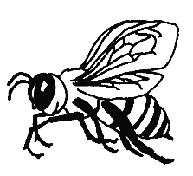
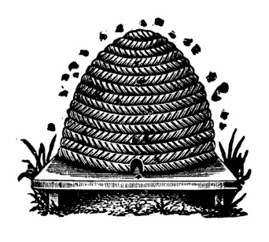
Fun with Pollinators

Honey bees pollinate flowers. Without pollination, you wouldn't get many fruits and vegetables. Pollination is the transfer of pollen from the male parts of a flower to the female parts of the same or another flower.

Green Monster Smoothies
Serves 2-3
Smoothies are easy to make! All you need is some fruit (some frozen is good) and some plain yogurt or milk or juice. If you like, add some greens like fresh spinach or kale! Using milk or yogurt will add protein and calcium. Why not keep bags of blueberries, strawberries or tropical fruit in the freezer—then they’re always available to add to smoothies or to plain yogurt for breakfast, snack or dessert.
Ingredients
1 cup canned crushed pineapple
1/2 cup frozen mangos or berries
1 frozen or fresh banana
1 – 2 cups raw spinach (or leaf lettuce, or loosely packed kale with ribs removed)
1 cup yogurt and milk as needed
Honey or sweetener to taste, up to 1 teaspoon

Directions
Combine all ingredients into a blender and puree until smooth. Pour into a glass and enjoy!

Honey Dip
Serves 10

Ingredients
8 oz. - low-fat plain yogurt
1/8 cup - honey
1 Tablespoons - orange juice
1/4 teaspoon - grated orange peel
Assorted fruits, for dipping

Directions
Combine yogurt in a small bowl with honey, orange juice and orange peel; mix well. Serve with sliced fruit.

Fun Fact: To make one pound of honey, the bees in the colony must visit 2 million flowers, fly over 55,000 miles and will be the lifetime work of approximately 768 bees.

