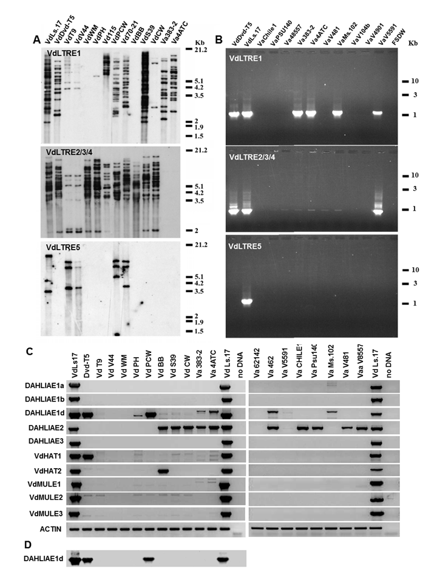
Supplemental Figure 6
Amyotte et al., 2012

