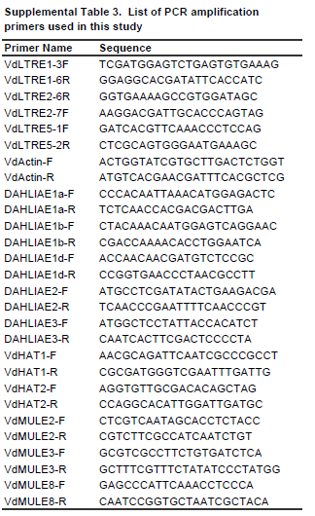
Supplemental Table 3
Amyotte et al., 2012

