Evaluation of cerebrospinal fluid biomarkers of endothelial damage and basement membrane degradation as indirect indicators of blood-brain barrier dysfunction in chronic canine hypothyroidism

Theresa Elizabeth Pancotto

Thesis submitted to the Faculty of the Virginia Polytechnic Institute and State University
in partial fulfillment of the requirements for the degree of
Master of Science
In
Veterinary Medical Science

John H. Rossmeisl Jr., Chair
William R. Huckle
Karen Dyer Inzana
Kurt L. Zimmerman

January 27, 2011
Blacksburg Virginia
Keywords: Cerebrospinal Fluid, Hypothyroid, Dog, Central Nervous System
Copyright© 2011 Theresa Elizabeth Pancotto

Evaluation of cerebrospinal fluid biomarkers of endothelial damage and basement membrane degradation as indirect indicators of blood-brain barrier dysfunction in chronic canine hypothyroidism

Theresa Elizabeth Pancotto
(Abstract)
A variety of neurologic illnesses including peripheral and cranial neuropathies, central vestibular disease, seizures and coma have been associated with hypothyroidism in dogs. Repeated studies have shown that there is loss of blood brain barrier (BBB) integrity in these animals. Current research has also shown the development cerebrospinal fluid abnormalities in neurologically normal hypothyroid dogs; a finding that is related to BBB degradation. This derangement may be secondary to atherosclerosis and vascular accidents. One possible mediator of vasospasm and ischemic brain injury is endothelin-1 (ET-1). Another group of mediators of vascular dysfunction that has been found in CSF of dogs with various other CNS diseases is matrix metalloproteinases (MMP). The purpose of this study was to assay molecular markers that may contribute to disruption in the blood brain barrier in chronically hypothyroid canines. We hypothesized that BBB disruption in hypothyroidism is mediated by ET-1 and MMPs, as evidenced by increased concentrations of these proteins in CSF compared to controls.
Cerebrospinal fluid (CSF) previously collected from 9 control and 9 experimentally induced hypothyroid dogs was used. Administration of I-131 was used to create the experimental model. CSF from time points 0, 6, 12, and 18 months post-induction were evaluated using an ELISA kit for endothelin-1. CSF from each time point was also evaluated using gelatinase zymography to detect MMP-2,9, and 14.
The endothelin assay was able to detect ET-1 in CSF as determined by a spike and recovery method. However, ET-1 was undetectable in CSF of control and hypothyroid dogs at all time points. Constitutively expressed MMP-2 was detectable in all dogs at all time points. No other MMPs were detectable in CSF.
ET-1 and gelatinase MMP,-9, and -14 are not primary mediators of BBB damage in chronically hypothyroid dogs. They could be involved secondarily and may be better evaluated with different assays or in temporal association with the development of clinical signs of neurologic dysfunction. Additional research is needed to confirm this finding and to evaluate biomarkers of non-vascular components of the BBB.

This work was funded by a grant from the Virginia Veterinary Medical Association’s
Veterinary Memorial Fund.

Acknowledgements
I sincerely thank the Virginia Veterinary Medical Association for their generous support and funding of this work. I am eternally grateful for Dr. Bill Huckle and his tireless assistance and patience throughout the more tedious aspects of this project. It is certain that without his mentorship, these experiments would have never been born out.
Dr. John Rossmeisl’s support through the planning and culmination of this project cannot go unmentioned. It was his previous work that paved the way for the investigation presented herein and his encouragement during my times of bitter despair that lead to its conclusion. His dedication and commitment to my education as a resident are unparalleled.
Lastly, but of no less importance, I would like to thank Dr. Karen Inzana for her unending emotional support and her dedication to the teaching institution that is Virginia Tech. I hope that I achieve as much perspective on life and learning as you have.
Although the research presented henceforth failed to support my hypotheses, I hope that in my future endeavors I achieve great things, following in the footsteps of those before me and their accomplishments in the field of veterinary neurology.

Table of Contents
Abstract ii
Acknowledgements iii
Table of Contents iv
Multimedia Object Listing v
Alphabetical Key of Abbreviations vi
Chapter 1- Introduction and Literature Review
Introduction 1
Literature Review 2
Chapter 2 - Materials and Methods
Part 1: Samples 27
Part 2: ELISA for Endothelin-1 27
Part 3: Zymogram for Matrix Metalloproteinases 2, 9, and 14 29
Chapter 3- Results 31
Chapter 4- Discussion 33
Chapter 5- Future Directions 37
Figures 39
Tables 42
References 44
Appendices 51
Vita 56
Supplement 1 57

Multimedia Object Listing

Figure 1
Standard curves for ET-1 ELISA plates #1 and #2

Figure 2
MMP zymogram gels

Figure 3
Components of the blood brain barrier

Figure 4
Mechanism of action and interaction of MMP 2, 9, 14

Figure 5
Zymogram gel of MMP 2, 9, 14 standards

Alphabetical Key of Abbreviations

BAER Brainstem auditory evoked response
BBB Blood-brain barrier
cAMP Cyclic adenosine monophospate
CSF Cerebrospinal fluid
CNS Central nervous system
ECM Extracellular matrix
ELISA Enzyme-linked immunosorbent assay
EMG Electromyography
ET Endothelin
GABA Gamma-amminobutyric acid
IACUC Institutional animal care and use committee
IgG Immunoglobulin-G
LC Locus coeruleus
MCT8 Monocarboxylate transporter 8
MMP Matrix metalloproteinase
MMPI Matrix metalloproteinase inhibitor
mRNA Messenger ribonucleic acid
MT-MMP Membrane-type matrix metalloproteinase
NCV Nerve conduction velocity
nTR Nuclear thyroid receptor
RBC Red blood cell
RIA Radioimmunoassay
rT3 Reverse triiodothyronine
T3 Triiodothyronine
T4 Thyroxine
TIMMP Tissue inhibitor of matrix metalloproteinase
TJP Tight junctional proteins
TP Total protein
TR Thyroid receptor
TRAP Thyroid receptor associated protein
TRE T3 response element
TRH Thyrotropin releasing hormone
TSH Thyroid stimulating hormone/Thyrotropin
WBC White blood cell

Chapter 1: Introduction and Literature Review
Introduction

Adequate thyroid function is critical for growth and development of animals. In the aging canine, thyroid function has an important role in the maintenance of body system metabolism including the nervous system. Central neurologic dysfunction due to hypothyroidism can be a life threatening complication of a very treatable disease. Our laboratory has previously documented dysfunction of the blood brain barrier in chronically hypothyroid canines as determined by CSF analysis [1]. It remains to be determined how this disruption occurs and the primary objective of this paper is to identify biomarkers of vascular dysfunction that may lead to BBB degradation. We hypothesize that BBB disruption in hypothyroidism is mediated by ET-1 and MMPs, as evidenced by increased concentrations of these proteins in CSF. Elucidating the mechanisms behind the development of this abnormality will aid our understanding of the critical role of thyroid hormone function in the adult central nervous system. Identifying the primary pathophysiology of BBB damage in this population may lead to specific therapeutic interventions aimed at reversing the underlying change in addition to thyroid hormone replacement therapy for more rapid and complete neurologic recovery.

Literature Review
1) Hypothyroidism in canines
Hypothyroidism is an endocrine disorder resulting in a deficiency of thyroid hormones. The largest study to date identified a 0.2% prevalence rate among dogs and an increased risk factor associated with sterilization [2]. In dogs the most common causes of hypothyroidism include auto-immune mediated thyroiditis and idiopathic thyroid atrophy [3, 4]. Thyroid hormone has diffuse influence on general metabolism and most organ function and thus deficiency can lead to a myriad of clinical signs. Diagnosis can be a challenge because of breed related differences in resting thyroid levels as well as the effects of non-thyroidal illness and drug administration on thyroid function tests [4, 5]. The most common clinical manifestations of hypothyroidism in canines are lethargy, weight gain, and dermatologic abnormalities including alopecia, seborrhea, pyoderma, poor hair coat, and otitis externa. Neurological manifestations of hypothyroidism have been noted in recent years and appear to involve both the peripheral and central nervous system [5-11]. Additionally, subclinical myopathic changes have been characterized in a group of experimentally induced hypothyroid dogs[12].
Thyroid testing has improved with the advent of additional tests and expansion of our knowledge of the disease. However due to the possible influence of external and internal environmental factors, an unequivocal diagnosis is not always made. Clinical signs and a positive response to therapy are sometimes used as final criteria for diagnosis. Available thyroid function tests include quantification of triiodothyronine (T3), thyroxine (T4), thyroid-stimulating hormone (TSH), auto-antibodies against thyroglobulin, T3 and T4, stimulation tests using TSH or very rarely thyrotropin-releasing hormone (TRH) [3], pertechnate scintigraphy, and biopsy [13-16].
A normal total T4 (TT4) is diagnostic for euthyroid function, but a low TT4 is not diagnostic for hypothyroidism due to the effects of exogenous substances, non-thyroidal illness, and breed variations. Free T4, which circulates at approximately 1000 times lower concentration than T4, yields a more accurate assessment of thyroid status and is less affected by non-thyroidal illness. Free T4 however, can still be markedly reduced by anti-convulsants and glucocorticoids and must be interpreted with caution in patients on these medications. T3 levels are preserved, primarily by increasing the peripheral conversion of T4 to T3, as long as possible to attempt to maintain normal metabolic function in the face of illness or decreased T4 secretion. Thus, triiodothyronine measurement alone is not recommended for diagnosis of canine hypothyroidism [3, 4].
Elevated thyroid stimulating hormone (TSH) in humans is used as the gold standard to screen for hypothyroidism. In canines this is not the case due to the false-negative rate (approximately 25%) of the existing TSH assays and susceptibility to suppression by non-thyroidal illness [4, 13]. When combined with low T4 or free T4, high TSH is diagnostic for hypothyroidism.
Auto-antibodies against thyroglobulin, T3 and/or T4 are identified in 30-50% of hypothyroid canine patients. Additionally, healthy dogs without any index of suspicion for hypothyroidism have tested positive for antibodies, making the test unreliable as a sole diagnostic assessment [3, 4]. Auto-antibodies and serum binding proteins may result in spuriously high T4 concentrations when measured by radioimmunoassay versus when measured by equilibrium dialysis. The latter contains a semi-permeable membrane that removes these proteins and this is the preferred method of measurement [17, 18].
Although TSH stimulation testing was once the veterinary gold-standard for diagnosis of hypothyroidism, canine TSH is not available. Recombinant human and bovine TSH can be obtained and used in its place but is cost prohibitive for routine clinical use. For this reason as well as the time involved in conducting stimulation tests and the advent and accessibility of newer, more specific tests, TSH response tests are infrequently used. Response testing to TRH has poor reliability and is not recommended [3, 13]. The recombinant nature of these products also makes anaphylaxis a possible risk of administration and has been reported in the dog [19]. Additionally at TRH doses greater than 0.1 mg/kg IV adverse drug side effects including miosis, salivation, vomition, urination, defecation, tachycardia, and tachypnea have been noted [20]. Thyroidal uptake of radioactive pertechnate in dogs with histopathological confirmation of hypothyroidism reliably distinguishes the difference between dogs with hypothyroidism and those with non-thyroidal illness. TSH and TRH stimulation, however, failed to discriminate between these populations [13].
Thyroidal biopsy is considered most definitive diagnostic test of thyroiditis and thyroid atrophy in dogs, although cytologic abnormalities do not necessarily reflect functional abnormalities [13-16]. An advantage of radioactive pertechnate administration is the reliable identification of functional abnormalities of the thyroid gland and the ability to differentiate hypothyroidism due to thyroidal illness from non-thyroidal illness [13]. Though the discriminatory power of this test is ideal, there are technical difficulties associated with routine use of radioactive materials including obtaining the materials. Radiation exposure can be an issue for personnel safety. Animals should not be handled while awaiting clearance which may be inconvenient for clients and could delay other testing or therapies.
In summation, the ideal, minimally invasive diagnostic profile for hypothyroidism is based on an index of clinical suspicion and a minimum of T4 and TSH serum concentrations; test sensitivity is improved by use of free T4 [3].
Hair and coat changes in hypothyroidism are due to failure to initiate anagen phase of hair growth in the absence of thyroid hormone. Hair follicles remain in telogen phase for an extended period of time and become dry and brittle. If clipped, hair often does not grow back because of this growth arrest. Hyperpigmentation of the skin is common in these areas [5]. Hypothyroidism also leads to hyperkeratinization, accumulation of glycosaminoglycans, and increased susceptibility to infections. These cutaneous changes result from decreased protein synthesis, mitotic activity and oxygen consumption [11]. More than 85% of truly hypothyroid dogs will have dermatologic changes and weight gain [5]. Our work in a colony of experimentally induced hypothyroid canines supports this observation with 9/9 dogs having skin changes, otitis externa, and/or weight gain by six months after induction [1].
Clinicopathologic findings common to dogs with hypothyroidism include non-regenerative anemia, hypercholesterolemia, hypertriglyceridemia, elevated alkaline phosphatase, elevated alanine aminotransferase, and elevated creatine kinase [2, 4, 11, 21]. Decreased production of erythropoietin and lack of stimulatory effect of thyroid hormones on eyrthroid precursors are thought to be responsible for the mild anemia that can occur [22]. Elevations of lipoproteins, possibly the most common serologic abnormality, are a reported feature of human spontaneous and canine experimental and spontaneous models of hypothyroidism. This is a result of decreased activity of hepatic lipase and cholesterol ester transfer protein, whose homeostatic activities are thyroid dependent [23-25]. Elevations in alkaline phosphatase and alanine aminotransferase of hypothyroid dogs remains to be definitively explained, but is thought to be due to hepatic dysfunction [2]. Thirty-five percent of spontaneously hypothyroid dogs in one study had elevated CK levels [21]. Altered clearance of CK has been a proposed explanation [2]. Experimental induction of hypothyroidism in canines has confirmed a subclinical myopathy related to alterations in muscle energy metabolism and depletion of muscle carnitine; this may offer an alternative explanation of increased serum CK in this population [12].
Variable neuromuscular signs associated with hypothyroidism have been sporadically reported and described [7, 8]. In 2009 subclinical myopathic changes were characterized in our experimentally induced hypothyroid canine colony [12]. All dogs developed biochemical, morphologic, and morphometric abnormalities consistent with myopathy, although subjects remained clinically asymptomatic for signs consistent with neuromuscular weakness. The myopathy was associated with depletion in skeletal muscle free carnitine. Authors postulate that alterations of thyroid hormone targets of skeletal muscle energy metabolism, including carnitine palmitoyltransferase-1, mitochondrial uncoupling protein genes, and mitochondrial carnitine-acylcarnitine translocase, may contribute to pathogenesis of this disease [12]. Peripheral neuropathies including laryngeal paralysis, facial nerve paresis/paralysis, and peripheral vestibular signs associated with hypothyroidism have been described but remain poorly characterized [7-9]. One possible mechanisms of neuronal dysfunction includes reduced activity of sodium-potassium-ATP pumps leading to depletion of ATP and subsequent depression in axonal transport resulting in axonal dysfunction and degeneration. Demyelination secondary to Schwann cell dysfunction has also been proposed as a mechanism of diffuse neuropathy [2, 9, 26, 27] . Focal cranial nerve neuropathies may result from myxedematous deposits causing nerve entrapment at the level of the skull foramina [2]. Experimentally induced hypothyroidism, however, failed to produce clinical or electrophysiologic changes consistent with peripheral neuropathy [28]. Based on this model one may conclude that peripheral nerves are resistant to the effects of hypothyroidism. Alternatively, the phenomenon of peripheral neuropathy may be mediated by autoimmune mechanisms, which were absent from the experimental model, or take longer than 18 months to develop.
Previously myxedema coma was perhaps the most well documented sign of CNS dysfunction associated with hypothyroidism. However, more recent reports have identified numerous occurrences of central vestibular disease as a consequence of acquired thyroid dysfunction [7, 9, 10]. Some of these animals had MRI or CT evidence of brain infarction and the vast majority of animals with CSF evaluation had documented albuminocytologic dissociation, a non-specific marker of BBB damage. All dogs improved with therapy, but repeat imaging and CSF evaluation were not done [7, 9, 10]. Additionally, our laboratory has demonstrated that neurologically normal hypothyroid canines have damaged BBB evidenced by increased fractional albumin in the CSF and an elevated albumin quota [1].
The pathophysiologic mechanisms contributing to myxedema coma primarily include decreased function of thyroid-hormone dependent calcium-ATPase pumps resulting in decreased cellular activity, hyponatremia as a result of Na/K ATPase pump failure, and mucopolysaccharide accumulation. Cerebral acidosis and hypoglycemia can also participate in pathogenesis of hypothyroid-coma [10, 29, 30]. However, the pathophysiologic changes causing focal and lateralizing clinical signs (e.g. central vestibular) remain to be well documented. Several mechanisms, in addition to altered metabolism and focal edema, have been proposed. The strongest prevailing theory is atherosclerosis leading to hypoxia and ischemic neural injury that may result in transient or persistent neurological deficits. A strong association has been made between the presence of atherosclerosis, hypothyroidism, and clinical CNS disease in both dogs and people [6, 31-34]. However, only some animals have histopathologically or imaging diagnosed infarctions that may be responsible for persistent and/or focal neurological signs, while others do not. Both dogs with and without infarcts require supplementation for clinical improvement to occur indicating that some other neural or glial functional injury may be responsible for clinical signs. An additional theory hypothesizes that altered neurotransmitter release or reuptake contributes to CNS deficits. Previous research has noted variable changes in ɤ-amino-butyric acid (GABA) receptor density, reuptake, and altered acetylcholinesterase activity [35, 36]. Lastly, disruption of the genomic and/or non-genomic actions of thyroid hormones may influence intracranial metabolism. These mechanisms are discussed in further detail below.

2) Cerebrospinal fluid
Cerebrospinal fluid (CSF) surrounds the central nervous system (CNS) and functions to support the brain and spinal cord, provide nutrients to the neuropil, and permit variations in intracranial blood volume. CSF is also the medium through which neurotransmitters and hormones travel, and it has the capacity to buffer chemicals that may accumulate in the neural parenchyma. CSF is composed of an ultra-filtrate of plasma with active transport of some molecules as well as independent protein synthesis. The choroid plexus, a network of modified ependymal cells and vasculature located throughout the ventricular system of the brain, produces approximately 58% of cerebrospinal fluid; leptomeningeal and parenchymal capillaries also make contributions [37, 38] . The rate of CSF production differs depending on species and varies with respect to the osmotic properties of blood. In the cat CSF is produced at a rate of 0.017 ml/min and 0.047 ml/min in the dog[37]. Absorption occurs via the arachnoid villi, tuft-like projections of the arachnoid membrane and subarachnoid space that extend into the venous sinuses and cerebral veins. Absorption serves as the primary mechanism for decreasing total CSF volume when intracranial pressure rises [37, 38].
Analysis of CSF is a useful ancillary diagnostic test in many situations. Evaluation of CSF is a very sensitive although non-specific method of detecting abnormalities in the CNS. Various analytic techniques have been described [39-41]. Routine CSF evaluation includes gross observation of color and turbidity, red blood cell count, white blood cell count, leukocyte differential count, total protein determination, and glucose measurement. Cytology is recommended on every CSF sample because morphologic cellular and extra-cellular abnormalities can be found in absence of pleocytosis [39].
Normal CSF is clear, colorless, and lacking turbidity due to minimal cellularity and total protein (TP) concentration three orders of magnitude less than the peripheral total protein (Appendix 1). Gross turbidity appears when cellularity reaches >200 leukocytes/uL, >700 erythrocytes/uL, and/or protein >100mg/dL (Jamison and Lumsden 1988 ). Concentrations of potassium and calcium are lower than that found in plasma, while CSF concentrations of chloride, sodium, and magnesium are higher than plasma concentrations (Appendix 1). Glucose tends to be approximately eighty percent of the peripheral blood glucose, reflective of the high metabolic rate of the neural tissue, and does not require insulin to be transported across the BBB [37] (Appendix 1).
Published reference intervals for CSF cell counts obtained from the cerebellomedullary cistern are <5 nucleated cells/uL comprised of predominantly lymphocytes and monocytes, and 0 RBC/uL (Appendix 1) [37, 41]. Pleocytosis, an elevation in CSF total nucleated cells, occurs most commonly in association with inflammatory diseases (immune-mediated and infectious) but can be seen with any neurologic disturbance. The latter diseases typically cause more mild elevations but the disease processes cannot be differentiated based on cell counts alone. Complicating matters further, inflammatory diseases can be associated with normal CSF cell counts if there is sparing of the meninges, ependymal cells, or if the patient received prior glucocorticoid therapy. None the less, distribution of cell types and morphologic appearance of cells can be important in refining the pathogenesis of the pleocytosis [39].
Total protein elevations, >25ug/dL, occur in diseases that disrupt the blood-brain barrier (BBB) through local inflammation and/or necrosis, altered CSF flow and absorption, or result from increased intrathecal globulin production [37]. Although elevations in protein often accompany pleocytosis, increased TP can occur without a concurrent increase in CSF nucleated cells, a condition called albuminocytologic dissociation. Most of this protein is transudate from the serum proteins, usually albumin, across a leaky BBB but can also result from intrathecal hemorrhage, intrathecal globulin production, or decreased absorption at the arachnoid villi [39, 41]. In the presence of subarachnoid hemorrhage, gross discoloration of the CSF may occur with the fluid appearing yellow as a result of bilirubin accumulation secondary to post-hemorrhagic RBC breakdown; this discoloration is called xanthochromia. Microscopically erythrophagocytosis is often seen. Protein electrophoresis can be used to determine the protein fractions. If albumin, which is exclusively from the serum, is identified, a comparison to serum albumin is useful to determine the integrity of the blood-brain barrier. A ratio of CSF albumin to serum albumin is the albumin quota (AQ) and in normal animals is < 0.3 [39, 42]. An increased AQ indicates non-specific damage to the BBB and leakage of albumin (Appendix 1).
Equation 1
AQ = [CSF protein (mg/dL) x CSF albumin (%)] = CSF albumin (mg/dL)
[Serum albumin (g/dL) x10] Serum albumin (g/dL) x10

Immunoglobulin G (IgG) is found in small amounts in the CSF of normal animals, 2.5-8.5 mg/dl [43]. Although serum IgG is more than 1000 times greater than CSF IgG, the values are strongly correlated and an elevation in serum IgG leads to a concurrent elevation in CSF IgG; it is therefore useful to evaluate a ratio to determine variability in CSF IgG due to serum variability [39].
Equation 2
IgG ratio = CSF IgG/Serum IgG
However, alone the IgG ratio is of little use since immunoglobulins can also be produced intrathecally. Therefore, in instances of elevated CSF globulins, one must determine whether serum leakage or intrathecal production is the source, and this can be done using the IgG index, the ratio of the IgG ratio to AQ. IgG index in normal dogs is considered to be <0.9. Higher values indicate local production of immunoglobulin [39].
Equation 3
IgG index = IgG ratio/AQ
It is not uncommon for routine CSF samples to contain minor blood contamination. In one study, 59% of samples had evidence of blood contamination with the average RBC = 10.4 +/1 12.6 cells/uL, range 0-46 cells/uL (Rossmeisl http://scholar.lib.vt.edu/theses/available/etd-01212003-145957/). Correction formulas have been developed to account for the effects of blood contamination. It has been shown that RBC <10,000 cells/uL has minimal effects on the composition of CSF [44, 45](Rossmeisl http://scholar.lib.vt.edu/theses/available/etd-01212003-145957/). It remains to be determined how much minor contamination could affect ancillary molecular and genetic tests and is likely dependent on the assay used.
Albuminocytologic dissociation is a common finding in the CSF of dogs and people with hypothyroidism [1, 5, 7-11, 46]. In general, little ancillary testing on CSF has been done to determine the nature of this abnormality [47-50]. In 1974 the bromide partition test was used to evaluate the integrity of the BBB in children with congenital hypothyroidism. Findings supported increased permeability of the BBB, rather than an increased production of protein, but there was no correlation with severity of clinical signs or other biochemical data. The abnormality resolved when patients were provided thyroid supplementation [50]. A colony of experimentally induced hypothyroid dogs developed albuminocytologic dissociation, elevated CSF fractional albumin, and high AQ confirming damage to the BBB and increased leakage of albumin in absence of immune-system dysfunction[1]. Nystrom et al [48]determined that CSF protein aberrations in human hypothyroid patients are likely not related to auto-immune destruction of the BBB based on normal CSF findings in antibody positive patients and abnormal CSF (albuminocytologic dissociation) in the absence of thyroid autoimmunity. These findings suggest increased BBB permeability in hypothyroidism unrelated to auto-immune destruction of BBB proteins.

2) The blood-brain barrier
Neuroscientists have known of the existence of the blood-brain barrier for over 100 years due to the work of German scientist Paul Ehrlich[51]. The BBB functions to regulate ingress and egress of substances from the plasma to the CSF and extracellular fluid of the interstitium. The blood-brain barrier has three interfaces: blood-brain, blood-CSF, and brain-CSF (Figure 3).
The parenchymal component of the BBB, the blood-brain interface, is formed from astrocyte foot-processes directly wrapping small parenchymal vessels thereby limiting flux of molecules into the CNS [52]. There is a thin interposing layer of extracellular matrix between the abluminal side of the endothelial wall and the foot process. Astrocytes function as buffers by absorbing local molecules and ions, and they can modulate the chemical composition of the neuro-microenvironment by secretion of various substances [51-53]. Brain capillaries have unique properties of their own that selectively limit paracellular and transcellular passage. They consist of specialized endothelial cells that lack fenestrations and are joined not only by typical endothelial adherens junctions, but also by tight junctional proteins (TJP) which more strongly prevent paracellular molecular passage. These endothelial cells also have fewer endocytotic vesicles than their extra-neural counter parts, reducing and slowing flux of large and/or hydrophilic molecules into the CSF. The endothelial cells contain proteins, such as p-glycoprotein, that function to actively pump out unwanted substances [37, 51, 52]. Therefore, for molecules and nutrients to gain entry to the CNS, they must either be highly lipophilic, very small, or bind to specific membrane transport proteins.
The blood-CSF barrier consists of the arachnoid villi and the choroid plexi. The arachnoid villi separate CSF from blood by a single layer of endothelilal cells [37]. These structures operate in a unidirectional fashion dictated by the higher CSF pressure compared to intracranial venous sinus pressure so that only egress of substances occurs [54]. At the level of the choroid plexus the CSF is separated from blood by a two-cell barrier. The first layer is constructed of endothelial cells of the vessels within the choroid plexus, which unlike the capillaries of the parenchyma are fenestrated. Cuboidal, epithelial cells of the choroid, which are continuous with the ependyma of the ventricular system, form the second layer and function in transcellular transport. A thin basement membrane and loosely arranged pial cells separate the endothelium from the epithelium [37].
The CSF-brain barrier is comprised of a single layer of ependymal cells that line the ventricles and a pial-glial membrane at the external surface. The ependyma is made of thin squamous cells possessing incomplete intercellular junctions and no basement membrane. The pia and astrocytes are separated from each other by only a thin basement membrane allowing metabolites of the CSF to have easy access to the extracellular fluid and vice versa [37]. The components of the BBB are demonstrated in Figure 3.
Physical integrity of the BBB is largely attributed to maintenance of tight junctions of endothelial cells. Tight junction formation and maintenance is dependent on the existence of normal adherens junctions between cells and if the adherens junctions are disrupted, tight junctions may also fail. Occludin is a junctional protein that is expressed in the brain in significantly higher amounts than junctional proteins of the peripheral endothelial cells. It is in part regulated by concentrations of cyclic-adenosine monophosphate (cAMP) directly as well as by genetic transcription [51]. It may therefore be possible that regulation of this protein depends in part on thyroid hormone, a known modulator of genetic transcription. It has also been demonstrated that TJPs are a substrate for matrix metalloproteinase (MMP) degradation in stroke models and disruption of tight junctions can be prevented by treatment with matrix metalloproteinase inhibitors (MMPIs) [55, 56].
There is existing evidence of BBB endothelial cell damage in chronically hypothyroid dogs. Pancotto et al. [1] showed elevations in CSF concentrations of vascular endothelial growth factor (VEGF), a marker of endothelial function, in 88% of chronically hypothyroid dogs who did not have plasma elevations of VEGF. This experiment was unable to definitively show whether VEGF was the cause of BBB damage or a result of it, but confirmed local production of VEGF in chronically hypothyroid dogs.
Astrocytes may not contribute as significantly to the morphologic integrity of the BBB compared to junctional proteins, but they have a prominent regulatory role over endothelial cell function as well as the surrounding microenvironment [51, 52]. It stands to reason that astrocyte damage can have wide spread effects causing global disruption to the BBB by direct glial alterations and secondarily through endothelial cell modification. S100 proteins are produced primarily by glial cells in the nervous system and regulate intracellular processes including growth, motility, cell cycle, transcription and differentiation [57]. S100B has been studied in numerous physiologic and pathologic settings, including cerebrocranial trauma, stroke, neurodegenerative disease, and various neoplasms[58]. Several biological roles of have been illuminated through this work. S100B has neurotrophic effects at physiologic levels. When over-expression occurs excess stimulation of inflammatory cytokines can result in neuron dysfunction and death [59]. Energy metabolism is regulated in part by actions of S100B through effects on phosphorylation of protein kinase C, calmodulin, and regulation of calcium ions [60]. As a diagnostic tool, measurement of S100B is a known marker of astrocyte damage and is a useful indicator of estimating the severity of CNS damage in human traumatic brain injury, stroke, and other cerebrovascular events [58, 61]. S100B has been measured in canine models of experimentally induced spinal cord trauma, intracranial hypertension, and cardiac arrest as evidence of glial damage in these models [62-64]. Our previous work has demonstrated that chronically hypothyroid dogs have significantly elevated S100B in CSF and serum compared to controls, supporting primary astrocyte damage in this disease [1].

3) Thyroid hormone functions in the adult central nervous system

Thyroid hormones are generated from thyroglobulin, a protein synthesized and secreted by thyrocytes utilizing circulating iodide. The processes of incorporating iodide into thyroglobulin and then coupling reactive iodine species to form active thyroid hormones are mediated by thyroid peroxidase. Thyroxine, T4, is the primary product of the thyroid gland, which is converted to tri-iodothyronine, T3, biologically active thyroid hormone, in the peripheral non-thyroidal tissues. Small amounts of active T3 and reverse T3 (RT3) are also secreted. Residual iodinated tyrosine molecules in the colloid are deiodinated by iodotyrosine deiodinase, allowing recycling of iodine. Iodinated thyronines including those found in T4 and T3 are resistant to this enzyme and pass freely into the circulation [65].
In circulation thyroid hormones are bound to three plasma proteins: albumin, transthyretin, and thyroxine binding globulin. There is a small volume of circulating free hormones as well. The latter provide negative feedback on the pituitary to regulate synthesis and secretion of thyroid stimulating hormone and decrease further synthesis and secretion of thyroid hormones [65].
Metabolism of thyroid hormones in peripheral tissues is accomplished by three different deiodinases: D1, D2, and D3. These enzymes convert inactive T4 to active T3 and catabolize T3 to deiodotyrosine. Some thyroid hormone is also conjugated in the liver to sulfates and glucuonides and excreted in the bile [65].
During development, thyroid hormone plays a crucial role in maturation of the embryo, cellular differentiation, and metabolic balance. This makes it necessary to maintain strict regulation of thyroid concentration, particularly in the brain during growth. Congenital or neonatal thyroid hormone deficiency leads to cretinism, a devastating physical and mental disease. However, with age thyroid hormone becomes increasingly important in regulating cellular metabolism [66] though its exact role in the CNS is less clearly defined.
It was initially thought that lipophilic thyroid hormones could diffuse through the cellular membrane, but recent studies have shown that membrane transport is carrier-mediated, particularly in the brain [66]. There is a high-affinity, low-capacity process of transport that is energy and temperature dependent as well as a low-affinity, high-capacity process that operates independent of energy, temperature, and sodium ion concentration. The latter is attributed to binding of thyroid hormones to cell-surface proteins such as the monocarboxylate transporter-8 (MCT8) and organic anion transporter 1c1 (OATP) proteins [66, 67]. The total amount of thyroid hormone cellular uptake depends on a variety of intra- and extracellular factors including ATP concentrations, carrier molecules per cell, sodium ion gradient, and concentration of thyroid hormone in the plasma [66].
Once inside the cell, the mechanism of action of thyroid hormone is primarily through activation of gene transcription via nuclear T3 receptors (TR). The un-liganded TRs constitutively bind T3 response elements on DNA and repress basal transcription. T3 and ligand binding triggers a conformational change in the TR that leads to activated transcription of the target genes. Common ligands associated with T3 binding to TRs include retinoids, vitamin D, fatty acids, and prostaglandins [66, 68].
Within the brain there are special mechanisms to preserve higher levels of thyroid hormone concentration and/or function in the face of systemically low levels of thyroid hormone. Rudas et al. [66] reviewed literature supporting this phenomenon, the culmination of which demonstrates that (1) the uptake of thyroid hormone in the brain is enhanced, (2) conversion from T4 to T3 is increased through increased expression and activity of type II deiodinases of the brain, and (3) the rate of loss of T3 from brain tissue is slowed. Importantly, this suggests that abnormalities in brain tissue that occur secondary to low thyroid hormone concentrations may be delayed and occur only after exhaustion of the above mechanisms. This has been supported to some extent by serial evaluations of experimentally induced, chronically hypothyroid dogs in which increasing abnormalities are detected in the CSF over time [1].
Cell surface and nuclear thyroid receptor distribution is not documented across species but is important not only in neural development but in the basic metabolism and function of the mature brain. Thyroid receptor distribution differs throughout the adult brain with potentially greater expression of thyroid receptor associated protein 220 (TRAP220) in the cerebellum [69] and MCT8 in the amgydala, cortex, and hippocampus [67]. Based on a recent study in mature rats, nuclear T3 receptors are overall less concentrated in the cerebellum than in the phylogenetically newer parts of the telencephalon. Nuclear T3 receptor distribution also differs among cell type and oligodendrocytes are essentially void of nT3R [70]. If Schwann cells have similar properties, this may explain some of the resistance to development of peripheral neuropathies from demyelination in chronic hypothyroidism [28]. There is currently not enough information about receptor distribution in the face of altered thyroid hormone concentration to predict how diseased thyroid states may ultimately affect brain metabolism as regulated through these receptors.
Recently, actions of thyroid hormone not primarily mediated through the nuclear thyroid hormone receptor have been described. These non-genomic mechanisms utilize cellular transduction systems via binding to novel cell surface proteins or extranuclear TR derivatives. The latter provides an interface for genomic and non-genomic mechanisms to occur together, with the former occurring over several hours and the latter over minutes. These extranuclear actions of thyroid hormone have been shown to affect the activity of the Na+/H+-exchanger, cellular motility, and protein trafficking. Whereas genomic mechanisms largely rely on binding of T3, non-genomic actions are sensitive to binding of T4 and rT3. Of explicit importance to our work is the fact that astrocyte maintenance, cytoskeletal growth, and migration depend on non-genomic mechanisms of rT3 and T4. This effect is mediated through laminin receptors and may play an important role in maintenance of the blood-brain barrier [68].
Thyroid hormone functions as a neurotransmitter in the autonomic nervous system of adults. T3 co-localizes with norepinephrine in gray matter of the brain, particularly the locus coeruleus (LC). When the LC is destroyed, T3 binding is also decreased [71]. Clinical evidence in depressed patients also supports the role of T3 and T4 in neurotransmitter modulation. Some patients with affective disorders undergoing pharmacologic and behavioral therapies had better responses with thyroid supplementation [72]. Alternatively this may be attributed to decreased levels of transthyretin, which have been reported in depressed individuals in the presence of normal peripheral thyroid function. Transthyretin, among other proteins, is produced and secreted by the choroid plexus into the CSF where it is responsible for uptake of T4 across the BBB [47]. Authors postulated that low CSF transthyretin contributed to altered CNS thyroid hormone regulation in this patient population [47]. There is an extensive body of literature further investigating neuroendocrine alterations in hypothyroid animals and people; it is beyond the scope of this manuscript to present further information regarding neurochemical regulation in this manner.

5) Endothelin-1 in the CNS

Endothelin-1 (ET-1) is a vascular-derived 21-amino acid peptide that causes vasoconstriction by autocrine and paracrine mechanisms and is the most potent of the endothelin subtypes. Active ET-1 is derived from the production of pre-proendothelin, which is subsequently cleaved to a biologically inert proendothelin (or Big-ET). Endothelin converting enzyme leads to formation of active ET on the abluminal side of the vasculature. The activities of ET-1 are mediated by G-protein receptors, subtypes ET_{A}, ET_{B}, and ET_{C}. The former is selective for ET-1 while the latter two are non-selective. ET-1 is not stored and its secretion is regulated by genetic transcription to provide acute changes of vascular tone and cardiac function [14, 65, 73]. The plasma half-life is very short, t_{1/2} = ~1 min [74] but tissue concentration is significantly higher and local effects may last as long as 60 minutes [74] [14]. ET-1 production is stimulated by chemical messengers such as angiotensin II, catecholamines, growth factors, insulin, oxidized LDL, HDL and thrombin as well as by local hypoxia and shear stress on the vessel wall. Known physiologic inhibitors of ET-1 include nitric oxide, atrial naturetic peptide, prostaglandin E2, and prostacyclin [65].
Endothelial cells of brain capillaries, although different from peripheral microvasculature (See section BBB), can secrete ET-1 [75, 76]. Interestingly, it has been shown that perivascular foot processes of astrocytes also secrete ET-1 [52, 76]. It has been previously shown that intraarterial ET-1 does not cause cerebral vasoconstriction but intracisternal ET-1 does [77]. Additionally people suffering from intracranial aneurysmal rupture have significantly higher CSF ET concentrations but similar plasma ET concentrations compared to controls [78]. This pattern of ET-1 distribution suggests that local production of ET-1 on the abluminal side of the intracranial vasculature is a unique source of brain ET-1 and has a specific role in managing local vascular tone.
Endothelin has been poorly studied in the dog outside of cardiac health and disease, where ET has been evaluated with increasing frequency in the last few years. Several authors have shown elevated endothelin-1 and/or ET-1 receptor density in association with alterations in myocardial contractility [79], decreased metabolic adaptation of the coronary arteries [80], heart worm disease[81], and chronic valvular disease[82]. Additionally it has been shown that plasma levels of ET-1 correlate with the severity of heart failure [83, 84] and can indicate a poor prognosis, such as in Dobermans with dialated cardiomyopathy [85].
Dogs have been used as experimental models of CNS injury for evaluation of endothelin in the CSF [86-88], but they have not been evaluated in clinical circumstances of neurological injury. Contrarily, for people, ET has been extensively studied in clinical patients with hemorrhagic and ischemic brain injury and permeability of the BBB [76-78, 87, 89-100].
Since the 1990’s scientists have discovered that endothelin plays an important role in regulation of BBB permeability. In clinical patients and animal models ET-1 concentrations were increased in the CSF and plasma after ischemic brain injury [97, 98, 100]. Additionally, ischemic injury can be induced by exogenous delivery of ET-1 [95] and injury in experimental models can be attenuated by ET_{A}-receptor antagonists [94].
The vasoconstrictor effects of ET-1 on local cerebral endothelium include alterations in cerebral blood flow and reduced transfer of small molecules across the BBB; both mechanisms have been shown to contribute to cerebral infarction [93, 95]. Although the direct effects of ET-1 on brain parenchyma are not well understood, several investigations have demonstrated possible non-vascular actions of ET-1. Activation of ET_{A} receptors stimulates Na+/K+ ATPase and Na+/K+/Cl- cotransport in cerebral capillary endothelium [101] and increases aquaporin expression leading to derangements in electrolyte and water homeostasis [94]. These effects are thought to be primarily mediated through ET_{A} receptors since effects of ET-1 activity are attenuated by administration of ET_{A}-antagonists but not ET_{B}-antagonists [94]. Free radical damage secondary to ET-1-stimulated induction of superoxide has also been established [102-104].
In summary, ET-1 plays a significant role in regulating vasomotor tone and water balance in the CNS with both hemorrhagic and ischemic brain injury. The actions of ET-1 are locally regulated and affect cerebral vasculature and the local microenvironment through vasoconstriction, increased electrolyte co-transport, increased deposition of aquaporins, and induction of superoxide free radical damage.
Endothelin, like any protein, can be measured using various methods. Enzyme-linked immunosorbent assays (ELISA) have been used most commonly. ET-1 is highly conserved amongst many mammalian species and is identical in the canine, human, mouse and rat[105]. This homology suggests that kits designed for human-sample use can be reasonably used in other species. Considerations of differences in physiologic concentrations and cross reactivity of other proteins may affect the validity of the assay in non-human species. Only one ELISA assay for ET-1 has been validated for use in canines for measurement of plasma concentrations of cardiovascular peptides [106]. Three ELISA kits were compared in this study by a two-step validation process and the ET-1 ELISA from IBL International was determined to be most precise, reproducible, linear and accurate assay evaluated. Radioimmunoassy [83], polymerase chain reaction (PCR), and mass spectrometry [107] have also been used to evaluate endothelin concentrations and are likely more sensitive.

6) Matrix Metalloproteinases

Matrix metalloproteinases (MMPs) are a family of zinc-dependent endopeptidases that are primarily involved in degradation of the extracellular matrix to promote cellular migration and tissue remodeling in both physiological and pathological states. There are over 17 proteinases in this family and they are divided into subcategories based on preferred substrates: collagenases, gelatinases, stromelysins, and membrane-type. In normal tissues, the enzymes have very low activity with only proenzyme MMP-2 (pro-gelatinase A) having any known constitutive presence [108-110]. MMPs are first secreted as zymogens which subsequently undergo extracellular activation. Each zymogen has a propeptide, catalytic, and substrate-binding domain. Membrane-type-matrix metalloproteinases (MT-MMPs) additionally have a unique transmembrane domain that anchors the protein to the cell membrane [108].
Zinc is bound to a cysteine residue within the propeptide domain that keeps the enzyme in a latent state. The first cleavage occurs by action of a protease on a susceptible loop within the propeptide region resulting in destabilization of the MMP via disruption of zinc binding. The second and final cleavage occurs by autolytic mechanisms or other proteases, often another MMP, which results in release of the pro-domain to yield the mature enzyme [108, 111]. MMPs, tissue inhibitors of MMPs (TIMMPs), cytokines, growth factors, oncogene products, plasmin, and macroglobulins have all been shown to regulate MMP activation in various in vivo and in vitro states [108, 109]. See Figure 3.
Physiologically MMPs are necessary in wound healing, blastocyst implantation, bone growth, and angiogenesis [109, 112]. Work in the last ten years has demonstrated pathophysiological roles of MMPs in the development of atherosclerotic plaques, demyelination, osteoporosis [55, 56, 108], metastases of malignant cancers, arthritis [56, 109], and secondary post-traumatic spinal cord injury [112]. Current research is investigating the utility of MMP inhibitors as therapeutic interventions in these disease states and has shown promising results with respect to treatment of multiple sclerosis [108].
There are three basic mechanisms responsible for regulation of MMP activity: genetic transcription, enzyme activation, and inhibition by tissue inhibitors of MMPs. Since MMPs have degradation activity against all proteins in the extracellular matrix, careful regulation is essential to prevent extensive and permanent tissue damage [109]. In stroke, MMPs are induced secondary to cerebral hypoxia. This enzymatic activation causes proteolysis of the tight junction proteins occludin and claudin, damaging the BBB and causing injury to the neuropil. Models of ischemic injury have shown that when MMP inhibitors are administered, early BBB integrity is restored thereby limited development of edema but overall recovery is slowed. This is thought to be due to decreased angiogenesis and neurogenesis associated with decreased MMP activity [56].
Although there is no well-defined parenchymal extracellular matrix (ECM) in the adult CNS, ECM exists surrounding the cerebral vessels and in a diffuse amorphous mixture throughout the CNS [109]. Thereby the BBB may be uniquely susceptible (compared to the parenchyma) to local MMP effects. Indeed it has been shown that delivery of MMPs intracerebrally causes marked degradation of the BBB in rats [113]. MMPs are expressed by many tissues throughout the body as well as in leukocytes in peripheral blood. Leukocytes associated with inflammation may contribute to elevations of MMPs in CNS disease. In vitro experiments have shown that within the CNS neurons, astrocytes, microglia, and oligodendrocytes are all individually capable of expressing various MMP members [56, 109, 114].
MMPs have been evaluated specifically in canines with chronic diseases as well as after acute-traumatic events affecting various tissues [109, 112, 115-118] but few of these studies examine MMP concentrations in the canine CNS [109, 112, 115-118]. In 1997 MMP activity was evaluated in aged beagle dogs with amyloid deposition compared to a control group to help determine the function of MMPs in development of β-amyloid plaques as a model of human Alzheimer’s disease [118]. MMP-9 was present in significantly higher amounts in amyloid-positive versus amyloid-negative brain specimens, similar to that seen in human Alzheimer’s disease. Based on this parallel, the authors concluded that MMP-9 may contribute to deposition of β-amyloid accumulation and that canines may be a good model for further study of age and disease associated amyloid deposition[118]. Several years later normal canine CSF was characterized with respect to the baseline activity of MMP 2 and 9 [110]. Subsequently CSF MMP activity has been measured in dogs with distemper associated leukoencephalitis, intervertebral disc disease, and CNS neoplasia [112, 115-117]. All of these diseases involve inflammatory change within the CNS and increased MMP activity was associated with altered BBB permeability. Increased permeability allows for the influx of inflammatory cells, which could be the primary source for MMPs. The evidence regarding the strength of the correlation between leukocyte migration and CSF MMP production is conflicting [119-124]. One study [125] has examined MMP concentrations in people with neurological diseases with and without pleocytosis. Thirty-percent of patients with detectable BBB damage (elevated AQ and normal cell counts) had undetectable MMP-9 by ELISA and zymography. Forty-six percent of patients had CSF MMP-9 concentrations higher than what was detected in serum, suggesting local production of MMP-9 [125]. Further work is needed to clarify the relationship of MMPs and leukocyte migration in the CNS.
MMPs are key players in regulation of tumor microenvironments participating in angiogenesis, inflammation, and metastasis [126, 127]. The predominant effects of MMPs are achieved through proteolytic mechanisms that govern chemokines and growth factors, such as TGF-β and VEGF [126]. Chemotaxis of epithelial cells [128] and macrophages [129] can occur independently of MMP catalytic activity. As such, MMP-inhibitors (MMP-Is) have become popular therapeutic targets for a variety of neoplasms. Unfortunately many of the MMP-Is have failed phase III clinical trials due to lack of selectivity of action and resultant untoward side effects [126, 130].
Zymography is the most sensitive and most commonly used method of measuring MMP activity; other methods include ELISA and quantification of mRNA. Zymography is a semi-quantitative method for evaluating enzyme activity; it does not measure total enzyme. Only a small sample volume (5-10 µL) is required, which is advantageous for any CSF analytical method, and MMPs are very stable when frozen at -70°C [110, 131]. They also are somewhat resistant to degradation from repeated freeze-thaw cycles [131]. Zymographic techniques can be adapted to select for particular MMPs based on substrate and can be performed in situ on frozen tissue samples to localize MMPs [111]. ELISA assays are able to be run in a significantly shorter period of time (4-5 hours versus 2 to 3 days) but require a larger sample volume (25 µL). Additionally the assay is based on quantity of enzyme, not activity [110].
Chapter 2: Materials and Methods
Samples

Blood and CSF samples obtained for evaluation in another study were used [12]. The samples came from a colony of 18 female, purpose-bred laboratory beagles. Hypothyroidism was induced by ¹³¹Iodine administration in nine dogs; nine served as untreated controls. After induction of general anesthesia, CSF was collected from the cerebellomedullary cistern in a routine manner by a board-certified neurologist (JHR). Blood was collected via routine venipuncture at the same time. The experimental protocol was approved by the Virginia Tech Institutional Animal Care and Use Committee. Collection times were 2 to 8 weeks prior to induction of hypothyroidism (time 0; baseline) and then at 6 (time 1), 12 (time 2), and 18 (time 3) months post-induction of hypothyroidism for a total of 72 samples of each substrate. CSF samples were separated into 0.5 ml aliquots at the time of collection. One CSF aliquot was immediately analyzed biochemically (total protein, glucose concentration) and cytologically (total nucleated cell count, red blood cell count, and leukocyte differential) by a board-certified clinical pathologist (KLZ) using routine methods. Remaining aliquots of CSF and serum were stored at -70°C until needed for analysis.

Endothelin-1 ELISA
The previously evaluated ELISA from IBL for use in canine plasma was selected [106]. A preliminary test was run to determine the usability of CSF as a substrate and whether or not extraction would be needed as a preceding step. The kit ET-1 standard (KitET-1) was prepared as according to the manufacturer. Commercially prepared ET-1 peptide (PhET-1) with identical amino acid sequence to human, rat, mouse, bovine, canine, and porcine ET-1 was purchased to use for comparison. Normal canine CSF was used in parallel spiked with KitET-1 and PhET-1.
The KitET-1 standard was reconstituted with distilled water as indicated by the manufacturer to a concentration of 200 pg/ml. Serial dilutions using EIA buffer from the IBL kit were prepared as directed to the following concentrations: 100 pg/ml, 50 pg/ml, 25 pg/ml, 12.5 pg/ml, 6.25 pg/ml, 3.13 pg/ml, 1.56 pg/ml, 0.78 pg/ml, and buffer (blank). Reconstituted KitET-1 standard was also serially diluted using normal canine CSF to the same concentrations.
The commercially prepared ET-1 (PhET-1) was reconstituted in proteinase-free water as according to the manufacturer to yield an initial concentration of 100 ug/ml. Subseuqent dilutions using proteinase-free water were performed to yield a product concentration of 100 ng/ml. The final dilution was made using EIA buffer from the IBL kit to yield a product concentration of 200 pg/ml, equivalent to the kit standard initial concentration. A 230uL aliquot of the solution was serially diluted into EIA buffer to the concentrations reported above. It was intended to dilute another 230uL volume of solution into normal canine CSF, however sufficient volume was unable to be obtained.
The three prepared serial dilutions (KitET-1/Buffer, KitET-1/CSF, PhET-1/Buffer) were run in duplicate on a single 96-well pre-coated anti-ET rabbit IgG plate. Sample volumes of 100 ul per well were used and the manufacturer directions for measurement were followed. The plate was read within 30 minutes of applying the stop solution at 450 nm on a Spectramax 250 plate reader. The software was programmed to read the un-spiked CSF as unknowns. The absorbance was plotted against concentration to yield the following curves (Appendix 2).
From the initial ET-1 ELISA experiment it was determined that repeatability of the assay was very high. Evidence of laboratory error, likely operator, was indicated by the presence of an outlier on the standard curve (KitET-1/Buffer). This may also have been related to interference with the KitET-1/CSF that lead to decreased absorbance compared to standard, but only at higher concentrations. The PhET-1/Buffer read significantly higher than the standard or CSF preparations and it was thought that the purchased product was sufficiently different from the kit standard and precluded further use (Appendix 2). Based on this information, the experiment was repeated. Additional dilutions were carried out on 230 uL of CSF extracted via Sep-Pak C-18 column. The extraction step did not improve the detection of lower concentrations and it was determined that this was an unnecessary step (Appendix 3). Standard curves were plotted and noted to be identical to each other and to those provided by the manufacturer (Appendix 4).
CSF was allowed to come to room temperature over 30 minutes and was gently mixed prior to pipeting. A standard dilution of KitET-1/Buffer was prepared simultaneously. For each subject, 100 ul of CSF from each time point was plated in duplicate. Samples were divided among two plates with CSF from control and hypothyroid dogs on each plate. Serially diluted kit standard endothelin-1 was plated in duplicate on each plate. The experiment was carried out as described by the manufacturer.

Matrix Metalloproteinase Zymogram
Criterion Precast Gels with 10% gelatin were used to conduct zymography for determination of the presence of MMP-2,9, and14. Purified MMP-2, MMP-9, and MMP-14 were used as standards. Enzyme standards were aliquoted and stored at -70°C until ready for activation and use. Single aliquots of MMP-2 and MMP-9 were activated using aminophenyl mercuric acetate (APMA) according to manufacturer’s instructions. The pH of each of the activated solutions was measured to be ~8.0, which was appropriate for use in the zymogram. An aliquot of MMP-14 was activated using trypsin according to manufacturer’s instructions. Enzyme in the amount of 1.2 ng, based on previous studies [110], was used. Because the concentration of each standard product was different, the volumes were different. A volume of each standard, equivalent to 1.2 ng, was diluted 2:1 with buffer for zymogram. The gel was loaded with 36 ul and 45 ul of each standard and was run at 125 V constant for 90 minutes. Current started at 90-120 mA/gel and final average current was 35-55 mA/gel. Sample proteases were renatured in renaturing solution for 30 minutes at room temperature then incubated over night at 37°C in development solution. Gels were stained with Coomassie Brilliant Blue R-250 staining solution for 1 hour at room temperature and destained until visible clear bands appeared.
CSF was allowed to come to room temperature and gently mixed. Standard aliquots of MMP-2,9, and 14 were activated as described above. To maximize sensitivity and adhere to 2:1::sample:buffer ratio, 20 ul of CSF was added to 40 ul of buffer in a sterile tube and 45 ul of the dilution was loaded into a well. CSF from control and hypothyroid dogs at each time point were loaded into wells so that samples were divided among 6 gels. MMP2 and MMP9, 18 ul, were loaded into the molecular marker wells on each gel to serve as controls. MMP14 was loaded into unused wells (Appendix 4). Gels were run three at a time according to the manufacturer’s directions and as described briefly above.

Chapter 3: Results
Endothelin-1
The preliminary experiment to determine if the IBL ELISA could detect ET-1 in canine CSF demonstrated that CSF spiked with ET-1 from the IBL kit was almost identical to the standard dilution curve. There was a significant unexpected deviation of the standard curve that was attributed to operator error (Appendix 2). This was confirmed with repeat ELISA of standard dilutions; curves were curvilinear and identical as expected (Appendix 4). The recombinant ET-1 (PhET-1) in buffer had notably greater absorbance than the kit standard or CSF spike with the kit ET-1.
The standard curves were produced as expected for the main experiment. However ET-1 was not detectable in any sample at any time point.
Figure 1
Standard Curves for Plates #1 and #2

See Table 1 for sample absorbance measurements.
Matrix Metalloproteinases – 2, 9, 14
The standard MMP-14 failed to migrate on any gel. MMP-2 and -9 standards resulted in predominant bands consistent with the expected result (Figure 5). All control dogs and all hypothyroid dogs had a band corresponding to that of MMP-2 standard at all time points. No other significant bands were detected in any sample at any time point.
Figure 2
MMP Zymogram Gels
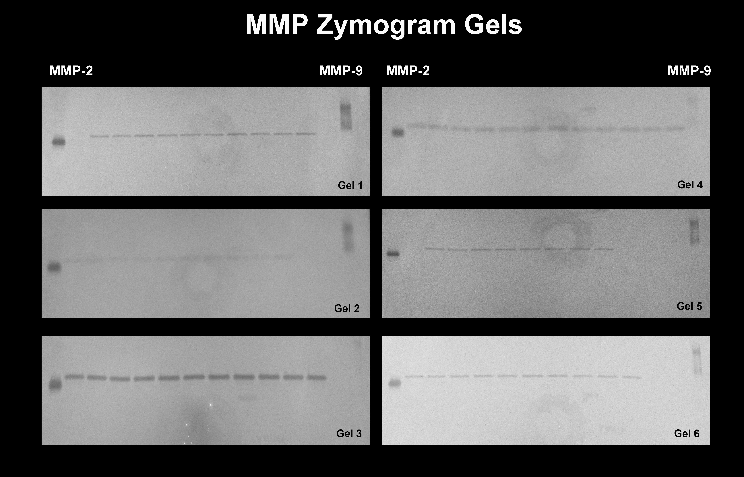
Chapter 4: Discussion
Endothelin-1
During the preliminary experiment, there was a notable difference in the absorbance of ET-1 included in the IBL kit compared to that of purified ET-1 purchased from another manufacturer. Although there is 100% homology among human, dog, bovine, porcine, mouse and rat endothelin [105], manufacturing differences may explain the different absorbance as measured by ELISA. Handling error is unlikely as the product was stored in dry form at 0-5°C and rehydrated immediately before use. No refreezing occurred.
Absence of endothelin-1 in the samples evaluated may reflect that this molecule is not involved primarily with BBB degradation of hypothyroid dogs. Alternatively, our results may be explained by sensitivity of the assay. Endothelin may be present in small enough amounts, particularly in an asymptomatic population, to preclude use of the ELISA. No experiments have been performed to directly compare the sensitivities of various methodologies.
In an unpublished experiment by our laboratory, we were able to find ET-1 by PCR in cerebral vasculature in two hypothyroid dogs that died. One animal succumbed to pulmonary thromboembolism and the other was euthanized for reasons unrelated to the study. Compared to a control, ET-1 was present in a larger amount. Compared to animals with documented cerebrovascular accidents, ET-1 was present in lesser amounts (Appendix 6). Astrocytes are activated in hypothyroidism[1], and these activated astrocytes may be capable of producing ET-1 in addition to that produced from cerebrovasculature [99]. Because of the various components of the BBB, the ET-1 secreted by astrocytes may not distribute to the CSF. From this combined assessment, it is plausible that CSF may not the best substrate from which to measure ET-1. Additionally, the plasma half-life of ET-1 is very short (<1 minutes) and it is typically found in higher concentrations in tissues than in plasma [74]. Therefore, homogenized brain tissue, microdiasylate or cerebral vasculature may provide a better assessment of ET-1 alterations than CSF, although these obviously preclude ante-mortem use.
Although clinical signs of neurologic dysfunction developed in two dogs during the course of the study, the experimental population was free of neurologic signs at the time of CSF collection. In previous investigations of ET-1 in ischemic brain injury, CSF collection and analysis was performed in proximity to experimental injury or the natural development of clinical signs in a patient population [77, 89, 97]. The importance of timing of collection may relate to the short plasma half-life of endothelin. Additionally, when animal models were employed, the experimental insult used to induce ischemic brain injury was severe. For example, Spatz et al. used gerbils that underwent temporary (5-120 min) or permanent bilateral carotid artery occlusion [89]. Dogs with neurologic sequelae of hypothyroidism can have marked infarctions [9] [10] and thrombosis and vascular change visible using clinical imaging techniques[9], but there have been no studies that document degree of atherosclerotic change temporally, with or without clinical signs, in dogs with thyroid dysfunction. After subarachnoid hemorrhage, CSF ET-1 elevations may be prolonged for weeks as the hemorrhage resolves and vasospasm persists [76, 78, 87]. Although both vascular rupture and occlusion can lead to brain ischemia, different secondary mediators may be activated, in part due to the toxic nature of hemoglobin on the brain parenchyma. Thus it would be presumptuous to assume that in all cerebrovascular accidents CSF ET-1 could remain elevated.
Actions of endothelin depend on binding to particular endothelin receptors. ET-1 has highest affinity for the ET_{A} receptor and primarily causes vasoconstriction[90]. The ET_{B} receptor mediates vasodilation [90] but is also involved in neuronal-glial crosstalk, particularly in the cerebellum [132, 133]. Altered receptor expression due to decreased genomic actions of thyroid hormones, in the face of normal ET-1 levels, may contribute to neurologic dysfunction.
Some studies have successfully frozen and thawed samples in the process of looking for endothelin with non-ELISA assays [107]. However, manufacturer’s of various endothelin ELISA kits all advise against repeated freeze/thaw cycles,. In this study, some samples had been thawed at least once after initial collection and prior to ET-1 assay for analytical reasons not reported here. Frozen samples also had to be sorted and transported. The samples were handled with utmost care and transported on dry-ice but some degree of thawing could have occurred.

Matrix Metalloproteinases
Although zymography is one of the most sensitive detection methods for MMP activity, its formerly common use has been surpassed by other analytical tests such as immunohistochemistry and PCR that do not rely on enzyme activity. This made it difficult to obtain standards and no single manufacturer produced all three standard enzymes for use in zymography. MMP-2 and -9 standards worked well on the precast gels, but MMP-14 failed to produce any band on the zymogram gel. This could be a result of technical error such as insufficient activation time or degradation during storage or a manufacturing problem. Cost prohibited obtaining additional standard for further evaluation.
The detection of MMP-2 in all samples served as an internal control since it has been demonstrated to be present in CSF of normal dogs[110]. However, zymography is not quantitative and it is possible that MMP-2 expression is altered compared to controls. Although we expected an increase in MMP activity, a decrease would also be feasible and this would be undetectable by the employed assay. Demyelinating diseases such as canine distemper have documented decreased MMP-2 activity relative to controls[134]. MMP-14 is also a membrane type MMP and is anchored to various cell membranes; this may ultimately limit its ease of detection in CSF. It is also possible that without severe enough injury to cause clinical signs, MMPs may be undetectable and evaluation of a population with clinical signs could yield different results.
Many tissues, including glial cells, neurons, endothelium, and leukocytes produce MMPs and their inhibitors. However, except for one study [125] , previous clinical investigations have only evaluated MMPs in the presence of pleocytosis; and it has been proposed that leukocytes may be the primary source of MMPs in the CNS [116]. The results of this work support the proposal that MMPs are likely a component of the inflammatory response and not a function of leakage across the BBB. Since CSF may not accurately reflect changes in the parenchyma, MMPs secreted from the glial elements may be better evaluated with in situ methods.

Chapter 5: Future Directions
The work presented herein has failed to demonstrate a significant role of ET-1 or MMP-9 or 14 as mediators of BBB degradation in hypothyroid dogs. It is also possible that CSF is simply not the appropriate substrate to evaluate for these vascular markers. If MMPs and ET-1 play a role in hypothyroid CNS dysfunction, it may be secondary to atherosclerosis induced ischemic injury and evaluation would be more appropriate when done in proximity to the onset of clinical signs. Future work may be better served assessing CSF in relationship to clinical syndromes of hypothyroid CNS dysfunction or evaluating tissue homogenates with more sensitive assays or using in situ methodologies.
Given the nature of BBB disturbance (eg albuminocytologic dissociation), leakage of albumin into the CSF due to loss of tight junctions may be better explained after evaluation of these specific proteins, such as the TJPs occludin and claudin. These proteins are known to be under genomic regulation although it has not been investigated whether or not thyroid hormone plays a part. Additionally, protein evaluation will be more specific for components of the blood-brain barrier and CSF-brain barrier, whereas CSF evaluation is more reflective of the blood-CSF barrier.
CSF is a conduit for neurotransmitters. Thyroid hormones have regulatory influences on neurotransmitter transport, activity, and degradation[35, 36]. If hypothyroid neurologic disturbance is due to neurotransmitter dysfunction, this may be a line of inquiry that yields more rewarding results. This however may not explain the finding of albuminocytologic dissociation in our population.
Atherosclerosis does occur in hypothyroid dogs as demonstrated in post-mortem studies. However the results presented here do not offer a mechanism for how this develops. VEGF was previously found to be elevated in our population of hypothyroid dogs and may be related to development of atherosclerosis and increased BBB permeability. In absence of elevations of other vascular markers, such as those evaluated here, the relationship between VEGF, ET-1, MMPs and BBB damage remains to be explained.

Figures
Figure 3
Blood-brain barrier
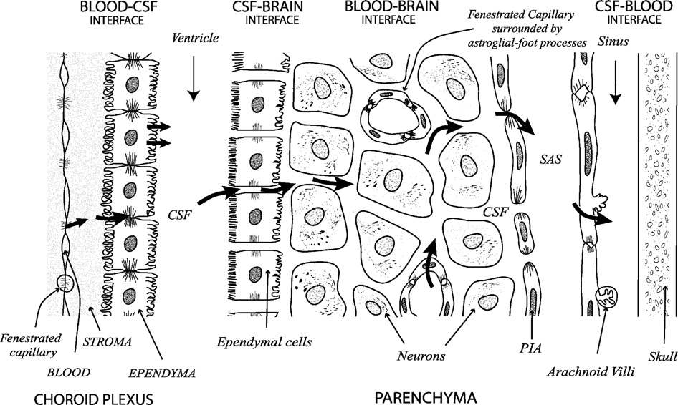 [135]

Figure 4
Matrix metalloproteinase mechanism of action and interaction
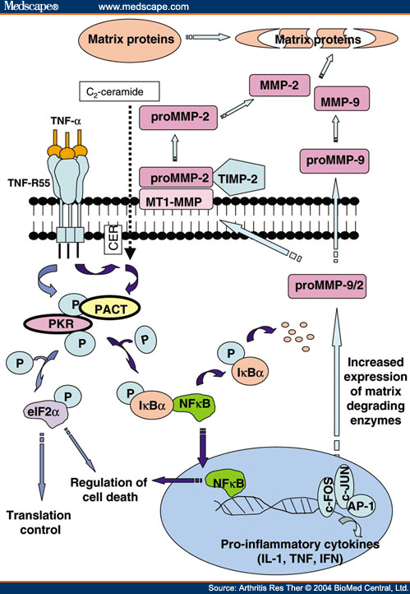

Figure 5
Zymography Gel Standards
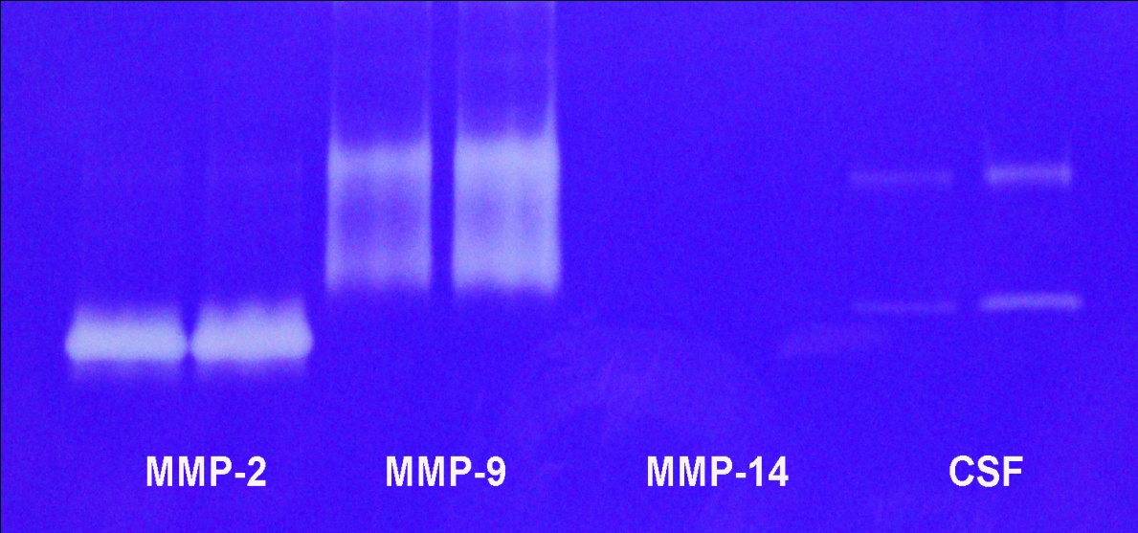
**CSF in this gel comes from pooled clinical patients with various neurologic diseases including IVDD in which MMP-9 has been documented.

Tables
Table 1
Absorbance values for control and hypothyroid dogs
Dog | Time 0 | Time 1 | Time 2 | Time 3
C-MAY | 0.038 | 0.001 | -0.025 | -0.016
 | -0.01 | -0.015 | -0.022 | -0.015
H-MCZ | -0.02 | -0.021 | -0.023 | -0.017
 | -0.004 | -0.017 | -0.015 | -0.01
C- MBA | -0.004 | -0.025 | -0.022 | -0.013
 | -0.011 | -0.024 | -0.021 | -0.029
H-BMBV | -0.01 | -0.007 | -0.028 | -0.022
 | -0.019 | -0.014 | -0.012 | -0.01
H-MCI | -0.025 | -0.029 | -0.02 | -0.02
 | -0.005 | -0.016 | -0.008 | -0.029
C-DMBV | -0.023 | -0.019 | -0.028 | -0.031
 | -0.035 | -0.04 | -0.035 | -0.029
H-MBN | -0.018 | 0 | -0.002 | xx
 | -0.015 | 0.005 | -0.02 | Xx
C-MAV | -0.009 | xx | -0.017 | -0.01
 | -0.016 | xx | -0.018 | -0.014
H-MBW | -0.019 | -0.02 | -0.029 | -0.016
 | -0.021 | -0.025 | -0.009 | -0.025
C-MAS | -0.021 | -0.03 | -0.013 | -0.02
 | -0.022 | -0.028 | -0.027 | -0.027
H-MCJ | -0.035 | -0.033 | -0.029 | -0.034
 | -0.03 | -0.045 | -0.036 | -0.036
H-MBS | -0.036 | -0.039 | -0.04 | -0.023
 | -0.033 | -0.029 | -0.03 | -0.034
C-MBL | -0.027 | -0.048 | -0.034 | -0.034
 | -0.004 | -0.034 | -0.036 | -0.038
C-MBH | -0.029 | -0.03 | -0.028 | -0.042
 | -0.032 | -0.043 | -0.037 | -0.04
C-MCN | -0.038 | -0.039 | -0.039 | -0.042
 | -0.044 | -0.043 | -0.044 | -0.048
C-MAW | -0.039 | -0.032 | -0.038 | -0.039
 | -0.051 | -0.032 | -0.038 | -0.042
H-MCC | xx | -0.009 | -0.025 | -0.015
 | xx | -0.0035 | -0.027 | -0.028
H-MAP | -0.029 | -0.033 | -0.026 | xx
 | -0.036 | -0.045 | -0.023 | xx
MBG | -0.033 | xx | xx | xx
 | -0.042 | xx | xx | xx

C = control
H = hypothyroid
xx = insufficient sample volume or unavailable
References

1. Pancotto, T., et al., Blood-brain-barrier disruption in chronic canine hypothyroidism. Vet Clin Pathol, 2010. 39(4): p. 485-93.
2. Panciera, D.L., Hypothyroidism in dogs: 66 cases (1987-1992). J Am Vet Med Assoc, 1994. 204(5): p. 761-7.
3. Kemppainen, R.J. and E.N. Behrend, Diagnosis of canine hypothyroidism. Perspectives from a testing laboratory. Vet Clin North Am Small Anim Pract, 2001. 31(5): p. 951-62, vii.
4. Ferguson, D.C., Testing for hypothyroidism in dogs. Vet Clin North Am Small Anim Pract, 2007. 37(4): p. 647-69, v.
5. Panciera, D.L., Conditions associated with canine hypothyroidism. Vet Clin North Am Small Anim Pract, 2001. 31(5): p. 935-50.
6. Blois, S.L., et al., A case of primary hypothyroidism causing central nervous system atherosclerosis in a dog. Can Vet J, 2008. 49(8): p. 789-92.
7. Bichsel, P., G. Jacobs, and J.E. Oliver, Jr., Neurologic manifestations associated with hypothyroidism in four dogs. J Am Vet Med Assoc, 1988. 192(12): p. 1745-7.
8. Jaggy, A., et al., Neurological manifestations of hypothyroidism: a retrospective study of 29 dogs. J Vet Intern Med, 1994. 8(5): p. 328-36.
9. Vitale, C.L. and N.J. Olby, Neurologic dysfunction in hypothyroid, hyperlipidemic Labrador Retrievers. J Vet Intern Med, 2007. 21(6): p. 1316-22.
10. Higgins, M.A., J.H. Rossmeisl, Jr., and D.L. Panciera, Hypothyroid-associated central vestibular disease in 10 dogs: 1999-2005. J Vet Intern Med, 2006. 20(6): p. 1363-9.
11. Scott-Moncrieff, J., Clinical signs and concurrent diseases of hypothyroidism in dogs and cats. Vet Clin North Am Small Anim Pract, 2007. 37: p. 709-722.
12. Rossmeisl, J.H., et al., Longitudinal study of the effects of chronic hypothyroidism on skeletal muscle in dogs. Am J Vet Res, 2009. 70(7): p. 879-89.
13. Diaz Espineira, M.M., et al., Assessment of thyroid function in dogs with low plasma thyroxine concentration. J Vet Intern Med, 2007. 21(1): p. 25-32.
14. Ettinger, S.J. and E.C. Feldman, Textbook of veterinary internal medicine : diseases of the dog and cat. 5th ed. 2000, Philadelphia: W.B. Saunders Co. 2 v. (various pagings).
15. Graham, P.A., et al., Lymphocytic thyroiditis. Vet Clin North Am Small Anim Pract, 2001. 31(5): p. 915-33, vi-vii.
16. Feldman, E.C. and R.W. Nelson, Canine and feline endocrinology and reproduction. 3rd ed. 2004, St. Louis, Mo.: Saunders. xi, 1089 p.
17. Fritz, K.S., R.B. Wilcox, and J.C. Nelson, Quantifying spurious free T4 results attributable to thyroxine-binding proteins in serum dialysates and ultrafiltrates. Clin Chem, 2007. 53(5): p. 985-8.
18. Vyas, S.K. and T.J. Wilkin, Thyroid hormone autoantibodies and their implications for free thyroid hormone measurement. J Endocrinol Invest, 1994. 17(1): p. 15-21.
19. Hasler, A. and K. Rohner, [Serious reactions after the TSH-stimulation test in the dog]. Schweiz Arch Tierheilkd, 1992. 134(9): p. 423-7.
20. Lothrop, C.D., Jr., P.M. Tamas, and V.A. Fadok, Canine and feline thyroid function assessment with the thyrotropin-releasing hormone response test. Am J Vet Res, 1984. 45(11): p. 2310-3.
21. Dixon, R.M., S.W. Reid, and C.T. Mooney, Epidemiological, clinical, haematological and biochemical characteristics of canine hypothyroidism. Vet Rec, 1999. 145(17): p. 481-7.
22. Green, S.T. and J.P. Ng, Hypothyroidism and anaemia. Biomed Pharmacother, 1986. 40(9): p. 326-31.
23. Mahley, R.W., K.H. Weisgraber, and T. Innerarity, Canine lipoproteins and atherosclerosis. II. Characterization of the plasma lipoproteins associated with atherogenic and nonatherogenic hyperlipidemia. Circ Res, 1974. 35(5): p. 722-33.
24. Duntas, L.H., Thyroid disease and lipids. Thyroid, 2002. 12(4): p. 287-93.
25. Rogers, W.A., E.F. Donovan, and G.J. Kociba, Lipids and lipoproteins in normal dogs and in dogs with secondary hyperlipoproteinemia. J Am Vet Med Assoc, 1975. 166(11): p. 1092-1100.
26. Dyck, P.J. and E.H. Lambert, Polyneuropathy associated with hypothyroidism. J Neuropathol Exp Neurol, 1970. 29(4): p. 631-58.
27. Pollard, J.D., et al., Hypothyroid polyneuropathy. Clinical, electrophysiological and nerve biopsy findings in two cases. J Neurol Sci, 1982. 53(3): p. 461-71.
28. Rossmeisl, J.H., Jr., Resistance of the peripheral nervous system to the effects of chronic canine hypothyroidism. J Vet Intern Med, 2010. 24(4): p. 875-81.
29. Greco, D., M. Bough, and K. Finora, Hypothyroidism and Myxedema Coma. Compendium, 2007.
30. Finora, K. and D. Greco, Hypothyroidism and myxedema coma. Compend Contin Educ Vet, 2007. 29(1): p. 19-31; quiz 31-2.
31. Hess, R.S., P.H. Kass, and T.J. Van Winkle, Association between diabetes mellitus, hypothyroidism or hyperadrenocorticism, and atherosclerosis in dogs. J Vet Intern Med, 2003. 17(4): p. 489-94.
32. Zeiss, C.a.W., G, Hypothyroidism and atherosclerosis in dogs. Compendium, 1995. 17(9): p. 1117-1129.
33. Dewey, C.S., JD; Hillock, SM; and Fondacaro, JV, An in-depth look: vascular encephalopathies in dogs: incidence, risk factors, pathophysiology, and clinical signs. Compendium, 2006. 28(3).
34. Patterson, J.S., M.S. Rusley, and J.F. Zachary, Neurologic manifestations of cerebrovascular atherosclerosis associated with primary hypothyroidism in a dog. J Am Vet Med Assoc, 1985. 186(5): p. 499-503.
35. Wiens, S.C. and V.L. Trudeau, Thyroid hormone and gamma-aminobutyric acid (GABA) interactions in neuroendocrine systems. Comp Biochem Physiol A Mol Integr Physiol, 2006. 144(3): p. 332-44.
36. Carageorgiou, H., et al., Changes in antioxidant status, protein concentration, acetylcholinesterase, (Na+,K+)-, and Mg2+ -ATPase activities in the brain of hyper- and hypothyroid adult rats. Metab Brain Dis, 2005. 20(2): p. 129-39.
37. DeLahunta, A. and E. Glass, Veterinary neuroanatomy and clinical neurology. 3rd ed. 2009, St. Louis, Mo.: Saunders Elsevier. ix, 540 p.
38. King, A.S., Physiological and clinical anatomy of the domestic mammals. 1987, Oxford [Oxfordshire] ; New York: Oxford University Press. v.
39. Chrisman, C.L., Cerebrospinal fluid analysis. Vet Clin North Am Small Anim Pract, 1992. 22(4): p. 781-810.
40. Christopher, M.M., V. Perman, and R.M. Hardy, Reassessment of cytologic values in canine cerebrospinal fluid by use of cytocentrifugation. J Am Vet Med Assoc, 1988. 192(12): p. 1726-9.
41. Jamison, E.M. and J.H. Lumsden, Cerebrospinal fluid analysis in the dog: methodology and interpretation. Semin Vet Med Surg (Small Anim), 1988. 3(2): p. 122-32.
42. Behr, S., et al., Assessment of a pyrogallol red technique for total protein measurement in the cerebrospinal fluid of dogs. J Small Anim Pract, 2003. 44(12): p. 530-3.
43. Kaneko, J.J., J.W. Harvey, and M. Bruss, Clinical biochemistry of domestic animals. 5th ed. 1997, San Diego, Calif.: Academic Press. xiii, 932 p.
44. Smith, M.O. and A.A. Lackner, Effects of sex, age, puncture site, and blood contamination on the clinical chemistry of cerebrospinal fluid in rhesus macaques (Macaca mulatta). Am J Vet Res, 1993. 54(11): p. 1845-50.
45. Hurtt, A.E. and M.O. Smith, Effects of iatrogenic blood contamination on results of cerebrospinal fluid analysis in clinically normal dogs and dogs with neurologic disease. J Am Vet Med Assoc, 1997. 211(7): p. 866-7.
46. Thompson, W.O., et al., The Protein Content of the Cerebrospinal Fluid in Myxedema. J Clin Invest, 1928. 6(2): p. 251-5.
47. Sullivan, G.M., et al., Low levels of transthyretin in the CSF of depressed patients. Am J Psychiatry, 1999. 156(5): p. 710-5.
48. Nystrom, E., et al., Cerebrospinal fluid proteins in subclinical and overt hypothyroidism. Acta Neurol Scand, 1997. 95(5): p. 311-4.
49. Hansen, J.M. and K. Siersbaek-Nielsen, Cerebrospinal fluid thyroxine. J Clin Endocrinol Metab, 1969. 29(8): p. 1023-6.
50. Szczepanski, Z. and F. Sliva, Bromide partition test in the evaluation of the blood-cerebrospinal barrier in children with congenital hypothyroidism and central nervous system disease. Acta Paediatr Acad Sci Hung, 1975. 16(3-4): p. 203-7.
51. Rubin, L.L. and J.M. Staddon, The cell biology of the blood-brain barrier. Annu Rev Neurosci, 1999. 22: p. 11-28.
52. Abbott, N., Astrocyte-endothelial interactions and blood-brain barrier permeability. J Anat, 2002. 200(5): p. 527.
53. Wolburg, H. and A. Lippoldt, Tight junctions of the blood-brain barrier: development, composition and regulation. Vascul Pharmacol, 2002. 38(6): p. 323-37.
54. Schliep, G. and K. Felgenhauer, Serum-CSF protein gradients, the blood-GSF barrier and the local immune response. J Neurol, 1978. 218(2): p. 77-96.
55. Yang, Y., et al., Matrix metalloproteinase-mediated disruption of tight junction proteins in cerebral vessels is reversed by synthetic matrix metalloproteinase inhibitor in focal ischemia in rat. J Cereb Blood Flow Metab, 2007. 27(4): p. 697-709.
56. Rosenberg, G.A. and Y. Yang, Vasogenic edema due to tight junction disruption by matrix metalloproteinases in cerebral ischemia. Neurosurg Focus, 2007. 22(5): p. E4.
57. Banfalvi, T., et al., [Role of S100B protein in neoplasms and other diseases]. Magy Onkol, 2004. 48(1): p. 71-4.
58. Yuan, X.S. and X.X. Bian, S100B protein and its clinical effect on craniocerebral injury. Chin J Traumatol, 2008. 11(1): p. 54-7.
59. Van Eldik, L.J. and M.S. Wainwright, The Janus face of glial-derived S100B: beneficial and detrimental functions in the brain. Restor Neurol Neurosci, 2003. 21(3-4): p. 97-108.
60. Rothermundt, M., et al., S100B in brain damage and neurodegeneration. Microsc Res Tech, 2003. 60(6): p. 614-32.
61. Bloomfield, S.M., et al., Reliability of S100B in predicting severity of central nervous system injury. Neurocrit Care, 2007. 6(2): p. 121-38.
62. Usui, A., et al., Neural tissue-related proteins (NSE, G0 alpha, 28-kDa calbindin-D, S100b and CK-BB) in serum and cerebrospinal fluid after cardiac arrest. J Neurol Sci, 1994. 123(1-2): p. 134-9.
63. Zhong, M.J., S; Wang, J, Acute effect of hyperventilation on intracranial hypertension dogs s100B and the C-reactive protein. Journal of Xi'an Jiaotong University, 2007.
64. Jing, L.C., Lyde; Weiguo, Zhang, Myelin basic protein, S-100B in dogs with acute spinal cord injury and the TMP and significance of the changes after treatment. Journal of Orthopedic Trauma, 2005. 7(6).
65. Ganong, W.F. and NetLibrary Inc., Review of medical physiology. 2005, McGraw-Hill Medical: New York. p. 928 p.
66. Rudas, P., Z. Ronai, and T. Bartha, Thyroid hormone metabolism in the brain of domestic animals. Domest Anim Endocrinol, 2005. 29(1): p. 88-96.
67. Bunevicius, R., Thyroid disorders in mental patients. Curr Opin Psychiatry, 2009. 22(4): p. 391-5.
68. Davis, P.J., J.L. Leonard, and F.B. Davis, Mechanisms of nongenomic actions of thyroid hormone. Front Neuroendocrinol, 2008. 29(2): p. 211-8.
69. Galeeva, A., et al., Comparative distribution of the mammalian mediator subunit thyroid hormone receptor-associated protein (TRAP220) mRNA in developing and adult rodent brain. Eur J Neurosci, 2002. 16(4): p. 671-83.
70. Ruel, J., R. Faure, and J.H. Dussault, Regional distribution of nuclear T3 receptors in rat brain and evidence for preferential localization in neurons. J Endocrinol Invest, 1985. 8(4): p. 343-8.
71. Dratman, M.B. and J.T. Gordon, Thyroid hormones as neurotransmitters. Thyroid, 1996. 6(6): p. 639-47.
72. Bauer, M., et al., Treatment of refractory depression with high-dose thyroxine. Neuropsychopharmacology, 1998. 18(6): p. 444-55.
73. Goddard, J. and D.J. Webb, Plasma endothelin concentrations in hypertension. J Cardiovasc Pharmacol, 2000. 35(4 Suppl 2): p. S25-31.
74. Lundberg, J.M., et al., Evidence for release of endothelin-1 in pigs and humans. J Cardiovasc Pharmacol, 1991. 17 Suppl 7: p. S350-3.
75. Dehouck, M.P., et al., Endothelin-1 as a mediator of endothelial cell-pericyte interactions in bovine brain capillaries. J Cereb Blood Flow Metab, 1997. 17(4): p. 464-9.
76. Kastner, S., et al., Endothelin-1 in plasma, cisternal CSF and microdialysate following aneurysmal SAH. Acta Neurochir (Wien), 2005. 147(12): p. 1271-9; discussion 1279.
77. Kraus, G.E., et al., Cerebrospinal fluid endothelin-1 and endothelin-3 levels in normal and neurosurgical patients: a clinical study and literature review. Surg Neurol, 1991. 35(1): p. 20-9.
78. Kessler, I.M., et al., Endothelin-1 levels in plasma and cerebrospinal fluid of patients with cerebral vasospasm after aneurysmal subarachnoid hemorrhage. Surg Neurol, 2005. 64 Suppl 1: p. S1:2-5; discussion S1:5.
79. Chu, L. and M. Endoh, Biphasic inotropic response to endothelin-1 in the presence of various concentrations of norepinephrine in dog ventricular myocardium. J Cardiovasc Pharmacol, 2000. 36 Suppl 2: p. S9-14.
80. Fazekas, L., et al., Coronary metabolic adaptation restricted by endothelin in the dog heart. Acta Physiol Hung, 2001. 88(1): p. 35-46.
81. Uchide, T. and K. Saida, Elevated endothelin-1 expression in dogs with heartworm disease. J Vet Med Sci, 2005. 67(11): p. 1155-61.
82. Mow, T. and H.D. Pedersen, Increased endothelin-receptor density in myxomatous canine mitral valve leaflets. J Cardiovasc Pharmacol, 1999. 34(2): p. 254-60.
83. Tessier-Vetzel, D., et al., Diagnostic and prognostic value of endothelin-1 plasma concentrations in dogs with heart and respiratory disorders. Vet Rec, 2006. 158(23): p. 783-8.
84. Prosek, R., et al., Plasma endothelin-1 immunoreactivity in normal dogs and dogs with acquired heart disease. J Vet Intern Med, 2004. 18(6): p. 840-4.
85. O'Sullivan, M.L., M.R. O'Grady, and S.L. Minors, Plasma big endothelin-1, atrial natriuretic peptide, aldosterone, and norepinephrine concentrations in normal Doberman Pinschers and Doberman Pinschers with dilated cardiomyopathy. J Vet Intern Med, 2007. 21(1): p. 92-9.
86. Narushima, I., et al., Contribution of endothelin-1 to disruption of blood-brain barrier permeability in dogs. Naunyn Schmiedebergs Arch Pharmacol, 1999. 360(6): p. 639-45.
87. Zimmermann, M., Endothelin in cerebral vasospasm. Clinical and experimental results. J Neurosurg Sci, 1997. 41(2): p. 139-51.
88. Willette, R.N., et al., Plasma- and cerebrospinal fluid-immunoreactive endothelin-1: effects of nonpeptide endothelin receptor antagonists with diverse affinity profiles for endothelin-A and endothelin-B receptors. J Cardiovasc Pharmacol, 1998. 31 Suppl 1: p. S149-57.
89. Spatz, M., et al., Nitro-L-arginine augments the endothelin-1 content of cerebrospinal fluid induced by cerebral ischemia. Brain Res, 1995. 684(1): p. 99-102.
90. Zimmermann, M. and V. Seifert, Endothelin and subarachnoid hemorrhage: an overview. Neurosurgery, 1998. 43(4): p. 863-75; discussion 875-6.
91. Barone, F.C., et al., Endothelin levels increase in rat focal and global ischemia. J Cereb Blood Flow Metab, 1994. 14(2): p. 337-42.
92. Leung, J.W., S.S. Chung, and S.K. Chung, Endothelial endothelin-1 over-expression using receptor tyrosine kinase tie-1 promoter leads to more severe vascular permeability and blood brain barrier breakdown after transient middle cerebral artery occlusion. Brain Res, 2009. 1266: p. 121-9.
93. Chi, O.Z., X. Liu, and H.R. Weiss, Effects of endothelin-1 on blood-brain barrier permeability during focal cerebral ischemia in rats. Exp Brain Res, 2001. 141(1): p. 1-5.
94. Lo, A.C., et al., Endothelin-1 overexpression leads to further water accumulation and brain edema after middle cerebral artery occlusion via aquaporin 4 expression in astrocytic end-feet. J Cereb Blood Flow Metab, 2005. 25(8): p. 998-1011.
95. Park, L. and J. Thornhill, Hypoxic modulation of striatal lesions induced by administration of endothelin-1. Brain Res, 2000. 883(1): p. 51-9.
96. Miller, R.D., et al., NMDA- and endothelin-1-induced increases in blood-brain barrier permeability quantitated with Lucifer yellow. J Neurol Sci, 1996. 136(1-2): p. 37-40.
97. Lampl, Y., et al., Endothelin in cerebrospinal fluid and plasma of patients in the early stage of ischemic stroke. Stroke, 1997. 28(10): p. 1951-5.
98. Bian, L.G., et al., Increased endothelin-1 in the rabbit model of middle cerebral artery occlusion. Neurosci Lett, 1994. 174(1): p. 47-50.
99. Tsang, M.C., et al., Perinatal hypoxia-/ischemia-induced endothelin-1 mRNA in astrocyte-like and endothelial cells. Neuroreport, 2001. 12(10): p. 2265-70.
100. Volpe, M. and F. Cosentino, Abnormalities of endothelial function in the pathogenesis of stroke: the importance of endothelin. J Cardiovasc Pharmacol, 2000. 35(4 Suppl 2): p. S45-48.
101. Kawai, N., et al., Endothelin 1 stimulates Na+,K(+)-ATPase and Na(+)-K(+)-Cl- cotransport through ETA receptors and protein kinase C-dependent pathway in cerebral capillary endothelium. J Neurochem, 1995. 65(4): p. 1588-96.
102. Maczewski, M. and A. Beresewicz, The role of endothelin, protein kinase C and free radicals in the mechanism of the post-ischemic endothelial dysfunction in guinea-pig hearts. J Mol Cell Cardiol, 2000. 32(2): p. 297-310.
103. Banes-Berceli, A.K., et al., Endothelin-1 activation of JAK2 in vascular smooth muscle cells involves NAD(P)H oxidase-derived reactive oxygen species. Vascul Pharmacol, 2005. 43(5): p. 310-9.
104. Dong, F., et al., Endothelin-1 enhances oxidative stress, cell proliferation and reduces apoptosis in human umbilical vein endothelial cells: role of ETB receptor, NADPH oxidase and caveolin-1. Br J Pharmacol, 2005. 145(3): p. 323-33.
105. Biondo, A.W., et al., Comparative sequences of canine and feline endothelin-1. Vet Clin Pathol, 2003. 32(4): p. 188-94.
106. Schellenberg, S., et al., Analytical validation of commercial immunoassays for the measurement of cardiovascular peptides in the dog. Vet J, 2008. 178(1): p. 85-90.
107. Walczak, M., et al., Determination of endothelin-1 in rats using a high-performance liquid chromatography coupled to electrospray tandem mass spectrometry. Talanta, 2010. 82(2): p. 710-8.
108. Johnson, L.L., R. Dyer, and D.J. Hupe, Matrix metalloproteinases. Curr Opin Chem Biol, 1998. 2(4): p. 466-71.
109. Yong, V.W., et al., Matrix metalloproteinases and diseases of the CNS. Trends Neurosci, 1998. 21(2): p. 75-80.
110. Bergman, R.L., K.D. Inzana, and T.J. Inzana, Characterization of matrix metalloproteinase-2 and -9 in cerebrospinal fluid of clinically normal dogs. Am J Vet Res, 2002. 63(10): p. 1359-62.
111. Snoek-van Beurden, P.A. and J.W. Von den Hoff, Zymographic techniques for the analysis of matrix metalloproteinases and their inhibitors. Biotechniques, 2005. 38(1): p. 73-83.
112. Levine, J.M., et al., Matrix metalloproteinase-9 activity in the cerebrospinal fluid and serum of dogs with acute spinal cord trauma from intervertebral disk disease. Am J Vet Res, 2006. 67(2): p. 283-7.
113. Larsen, P.H., et al., Myelin formation during development of the CNS is delayed in matrix metalloproteinase-9 and -12 null mice. J Neurosci, 2006. 26(8): p. 2207-14.
114. Dencoff, J.E., G.A. Rosenberg, and G.J. Harry, Trimethyltin induces gelatinase B and urokinase in rat brain. Neurosci Lett, 1997. 228(3): p. 147-50.
115. Mandara, M.T., et al., Matrix metalloproteinase-2 and matrix metalloproteinase-9 expression in canine and feline meningioma. Vet Pathol, 2009. 46(5): p. 836-45.
116. Turba, M.E., et al., Recruited leukocytes and local synthesis account for increased matrix metalloproteinase-9 activity in cerebrospinal fluid of dogs with central nervous system neoplasm. J Neurooncol, 2007. 81(2): p. 123-9.
117. Groters, S., S. Alldinger, and W. Baumgartner, Up-regulation of mRNA for matrix metalloproteinases-9 and -14 in advanced lesions of demyelinating canine distemper leukoencephalitis. Acta Neuropathol, 2005. 110(4): p. 369-82.
118. Lim, G.P., et al., Matrix metalloproteinases in dog brains exhibiting Alzheimer-like characteristics. J Neurochem, 1997. 68(4): p. 1606-11.
119. Gijbels, K., et al., Gelatinase in the cerebrospinal fluid of patients with multiple sclerosis and other inflammatory neurological disorders. J Neuroimmunol, 1992. 41(1): p. 29-34.
120. Paeman, L.R., et al., Evaluation of gelatinases and IL-6 in the cerebrospinal fluid of patients with optic neuritis, multiple sclerosis and other inflammatory neurological diseases. Eur J Neurol, 1994. 1: p. 55-63.
121. Leppert, D., et al., Matrix metalloproteinase-9 (gelatinase B) is selectively elevated in CSF during relapses and stable phases of multiple sclerosis. Brain, 1998. 121 ( Pt 12): p. 2327-34.
122. Kolb, S.A., et al., Matrix metalloproteinases and tissue inhibitors of metalloproteinases in viral meningitis: upregulation of MMP-9 and TIMP-1 in cerebrospinal fluid. J Neuroimmunol, 1998. 84(2): p. 143-50.
123. Paul, R., et al., Matrix metalloproteinases contribute to the blood–brain barrier disruption during bacterial meningitis. Ann Neurol, 1998. 44: p. 592-600.
124. Perides, G., et al., Matrix metalloproteinases in the cerebrospinal fluid of patients with Lyme neuroborreliosis. J Infect Dis, 1998. 177(2): p. 401-8.
125. Yushchenko, M., et al., Matrix metalloproteinase-9 (MMP-9) in human cerebrospinal fluid (CSF): elevated levels are primarily related to CSF cell count. J Neuroimmunol, 2000. 110(1-2): p. 244-51.
126. Kessenbrock, K., V. Plaks, and Z. Werb, Matrix metalloproteinases: regulators of the tumor microenvironment. Cell, 2010. 141(1): p. 52-67.
127. Deryugina, E.I. and J.P. Quigley, Pleiotropic roles of matrix metalloproteinases in tumor angiogenesis: contrasting, overlapping and compensatory functions. Biochim Biophys Acta, 2010. 1803(1): p. 103-20.
128. Dufour, A., et al., Role of the hemopexin domain of matrix metalloproteinases in cell migration. J Cell Physiol, 2008. 217(3): p. 643-51.
129. Sakamoto, T. and M. Seiki, Cytoplasmic tail of MT1-MMP regulates macrophage motility independently from its protease activity. Genes Cells, 2009. 14(5): p. 617-26.
130. Coussens, L.M., B. Fingleton, and L.M. Matrisian, Matrix metalloproteinase inhibitors and cancer: trials and tribulations. Science, 2002. 295(5564): p. 2387-92.
131. Sulik, A., M. Wojtkowska, and E. Oldak, Preanalytical factors affecting the stability of matrix metalloproteinase-2 concentrations in cerebrospinal fluid. Clin Chim Acta, 2008. 392(1-2): p. 73-5.
132. Schmidt-Ott, K.M., et al., Single-cell characterization of endothelin system gene expression in the cerebellum in situ. J Cardiovasc Pharmacol, 1998. 31 Suppl 1: p. S364-6.
133. Tuschick, S., et al., Bergmann glial cells in situ express endothelinB receptors linked to cytoplasmic calcium signals. Cell Calcium, 1997. 21(6): p. 409-19.
134. Puff, C., et al., Influence of persistent canine distemper virus infection on expression of RECK, matrix-metalloproteinases and their inhibitors in a canine macrophage/monocytic tumour cell line (DH82). Vet J, 2009. 182(1): p. 100-7.
135. Di Terlizzi, R. and S. Platt, The function, composition and analysis of cerebrospinal fluid in companion animals: part I - function and composition. Vet J, 2006. 172(3): p. 422-31.
136. Schumann, G.B. and L.G. Crisman, Semiquantitative approach to CSF cytopathology. Diagn Cytopathol, 1986. 2(3): p. 194-7.
137. Evinger, J.V. and R.W. Nelson, The clinical pharmacology of thyroid hormones in the dog. J Am Vet Med Assoc, 1984. 185(3): p. 314-6.

Appendix 1
Normal CSF Analysis [37, 41]
Parameter Cerebellomedullary Cistern Lumbar Cistern
Color Colorless Colorless
Turbidity Clear Clear
WBC <5 cells/uL <5 cells/uL
RBC 0 cells/uL 0 cells/uL
Total Protein <20 mg/dL <40 mg/dL
Blood glucose 80 mg/dL 80 mg/dL

Normal CSF Electrolytes [136]
 | pH | Ca | P | Mg | Cl | K | Glucose | Urea
CSF | 7.42 | 6.56 | 3.09 | 3.00 | 105 | 2.98 | 74 | 3.56
Ca = calcium in mg/dl
P = inorganic phosphorus in mg/dl
Mg = magnesium in mg/dl
Cl = chloride in mEq/L
K = potassium in mEq/L
Appendix 2
Experiment 1 comparing kit standard ET-1 to commercially prepared ET-1 and the standard prepared in pooled CSF

Std = kit standard ET-1 prepared in buffer
Ph = commercially prepared Et-1 prepared in buffer
CSF = kit standard ET-1 prepared in pooled CSF

Appendix 3
CSF as collected compared to CSF extracted via SepPak C-18 column

CSF = pooled CSF
Ext = CSF extracted via SepPak C-18 column

Appendix 4
Kit standard dilutions

Appendix 5
Zymogram gels
Gel | MMP2 | 1 | 2 | 3 | 4 | 5 | 6 | 7 | 8 | 9 | 10 | 11 | 12 | MMP9
1 |  | H-BMBV1 | H-BMBV3 | C-DMBV1 | C-DMBV2 | C-DMBV3 | C-DMBV4 | H-MCI1 | H-MCI1 | H-MCI3 | H-MCI4 | Buff | Buff
2 |  | C-MAY1 | C-MAY2 | C-MAY3 | H-MCZ2 | H-MCZ3 | H-MCZ4 | C-MBA1 | C-MBA2 | C-MBA3 | C-MBA4 | Buff | Buff
3 |  | H-MBW2 | H-MBW3 | H-MBW4 | C-MAS1 | C-MAS2 | C-MAS3 | C-MAS4 | H-MCJ1 | H-MCJ2 | H-MCJ3 | H-MCJ4 | Buff
4 |  | H-MBN1 | H-MBN2 | H-MBN3 | C-MCN1 | C-MCN2 | C-MCN3 | C-MCN4 | H-MCC2 | H-MCC3 | H-MCC4 | C-MBL2 | C-MBL3
5 |  | H-MBS1 | H-MBS2 | H-MBS3 | H-MBS4 | C-MBH1 | C-MBH2 | C-MBH3 | C-MBH4 | Buff | Buff | Buff | Buff
6 |  | C-MAV1 | C-MAV3 | C-MAV4 | H-MAP1 | H-MAP2 | H-MAP3 | C-MAW1 | C-MAW2 | C-MAW3 | C-MAW4 | MMP14 | MMP14

H = hypothyroid
C = control
Buff = buffer
Appendix 6
PCR of ET-1 in cerebral microvasculature in dogs.
Brain microvasculature from the vertebrobasilar system was harvested post-mortem from 4 healthy, purpose bred 4-year-old female beagles that were euthanized for reasons unrelated to the study, 2 hypothyroid dogs in our research colony that died or were euthanized during the study, and from 3 client owned dogs with clinical, MRI, and necropsy evidence of cerebellar ischemic infarctions (stroke). Tissues were evaluated for ET-1 expression by RT-PCR of the cerebral vascular tissue. GLUT-1, which known to be an abundantly and constitutively expressed in the cerebral vasculature served as the positive control. In the figure, GLUT-1 and ET-1 expression are compared relatively to expression of the housekeeping gene GADPH. Compared to controls, dogs with hypothyroidism and ischemic stroke demonstrate increased expression of ET-1.

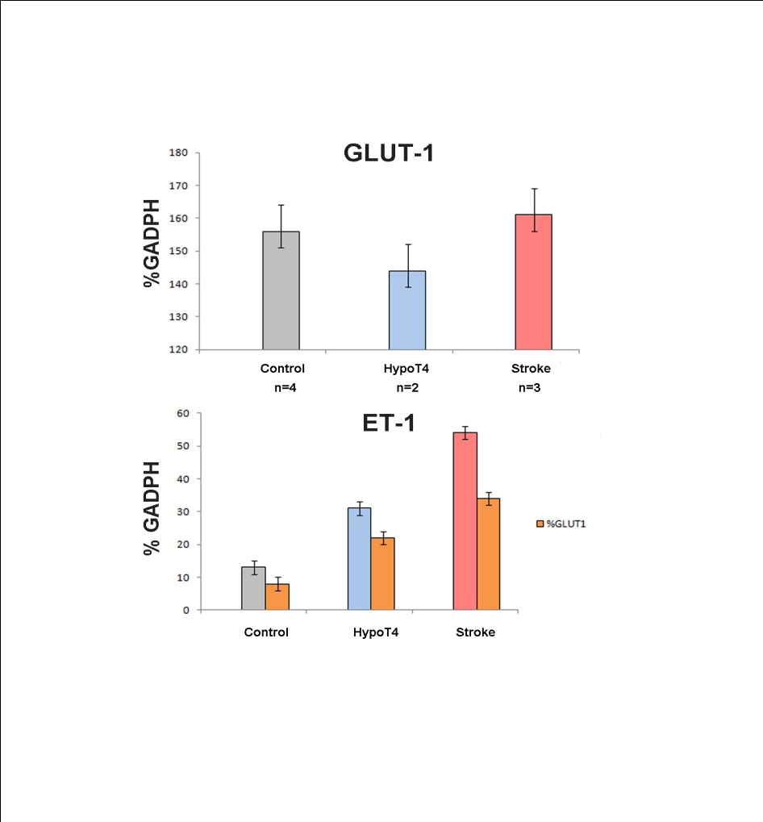
Vita
Theresa E. Pancotto was born in Durham, NC on February 21, 1980 at Duke University Hospital. She was raised in Concord, North Carolina and earned her Bachelor of Science degree in Cognitive Psychology from Trinity College at Duke University in 2002. She graduated with a Doctor of Veterinary Medicine and a Master of Science degree in laboratory animal medicine from Tufts Cummings school of Veterinary Medicine in 2007. Following graduation, Theresa completed a small animal rotating internship at Affiliated Veterinary Specialists in Orlando, Florida. In July of 2008 Theresa started a neurology and neurosurgery residency at the Virginia-Maryland Regional College of Veterinary Medicine. Theresa will take the ACVIM neurology subspecialty certifying examination June 2011.

Supplement 1
Reference #1: Blood-Brain-Barrier Disruption in Chronic Canine Hypothyroidism
Theresa Pancotto DVM, MS; John H. Rossmeisl, Jr. DVM, MS, DACVIM (SAIM and Neurology); David L. Panciera DVM, MS, DACVIM; Kurt L. Zimmerman DVM, Ph.D, DACVP (Anatomic and Clinical Pathology)
From:
Department of Small Animal Clinical Sciences (Pancotto, Rossmeisl, Panciera) and
Biomedical Sciences and Pathobiology (Zimmerman),
Virginia-Maryland Regional College of Veterinary Medicine, Mail Code 0442, Virginia Tech
Blacksburg, VA 24061
Address correspondence to Dr. Rossmeisl; jrossmei@vt.edu

Presented in part as an abstract at the American College of Veterinary Internal Medicine Forum, June 2009, Montreal, Quebec, Canada.ª

Acknowledgements:
This work supported in by Veterinary Memorial grants from the Virginia Veterinary Medical Association. The authors thank Stephanie Milburn, Ryan Gorbutt, Barbara Kafka, Dana Calicott, Ginny Dreier, and Dr. Shawn Clark for technical assistance, and Dr. Stephen Werre for statistical consultation.
Running Title: Hypothyroid BBB Disruption

Abstract
Background- Central nervous system manifestations of hypothyroidism have been associated with cerebrovascular complications. Reports of cerebrospinal fluid (CSF) abnormalities are rare in hypothyroid dogs.
Hypothesis- Chronic hypothyroidism causes blood-brain-barrier (BBB) abnormalities that are detectable using indirect CSF biomarkers.
Animals- Eighteen normal, euthyroid, mixed breed female dogs. Hypothyroidism was induced by ¹³¹Iodine administration in 9 dogs; 9 served as untreated controls.
Methods- Clinical and CSF examinations, blood and CSF protein electrophoresis, vascular endothelial growth factor (VEGF) and S-100B concentrations (by ELISA/ELICA), and CSF albumin quota (AQ) were measured at baseline and 6, 12, and 18 months after induction of hypothyroidism. Data were analyzed using repeated measures ANOVA.
Results- At baseline, no differences between groups were detected for any variable. Throughout the study, controls dogs remained free of neurologic disease, and had test variables that remained within the reference interval. Two hypothyroid dogs developed CNS signs during the study, associated with necropsy evidence of cerebrovascular disease. At 12 and 18 months, the CSF total protein, VEGF, and S-100B, and fractional albumin concentrations as well as AQ were significantly higher (p < 0.04) in hypothyroid dogs than controls. Among test variables assayed in blood the only significant difference was a higher S-100B concentration in hypothyroid dogs (p = 0.003) at 18 months.
Conclusions and Clinical Importance- BBB integrity is disrupted in chronic hypothyroidism. Significant increases in the CSF VEGF and S100-B in hypothyroid dogs indicates dysfunction in both endothelial and glial elements of the BBB. Thyroid dependent dysregulation of gene expression of constitutive BBB proteins may provide an alternative explanation for albuminocytologic dissociation other than its occurrence as a consequence of atherosclerosis and ischemic injury.
Key Words- Dog, cerebrospinal fluid, cerebrovascular, thyroid

Clinical manifestations of central nervous system (CNS) dysfunction attributable to canine hypothyroidism are rare compared with other clinical signs such as lethargy, weight gain, and dermatologic abnormalities.^{1,2} Central vestibular signs and myxedema coma are the most commonly reported CNS manifestations of canine hypothyroidism.³⁻⁶ Although the mechanisms responsible for the development CNS dysfunction associated with hypothyroidism are likely multifactorial, brain infarction resulting from atherosclerotic cerebrovascular disease has been commonly implicated, and hyperlipidemia is a common coincident clinicopathologic finding in dogs with hypothyroid associated CNS dysfunction.^{3,4,6-8}
Investigations of the effects of acquired hypothyroidism on blood-brain-barrier (BBB) integrity and cerebrospinal fluid (CSF) constituents are limited. Reports of CSF analyses in dogs with spontaneous clinical hypothyroidism are rare, with albuminocytologic dissociation being the predominant abnormality described.^{3,4,9,10} Studies performed in experimental rodent models and humans with spontaneous hypothyroidism variably suggest that BBB dysfunction can occur, but may be dependent on numerous factors such as the duration and severity of disease, genetic variation in brain-specific thyroid hormone transporters, as well as the method of induction of experimental hypothyroidism.¹¹⁻¹³ The mechanisms by which hypothyroidism may cause BBB disruption are also unclear, but failure of maintenance of endothelial integrity because of thyroid-dependent metabolic alterations, glial dysfunction from diminished transport of thyroid hormones into the CNS, development of atherosclerotic vascular disease, and autoimmune mechanisms have been proposed.^{6,7,11-13}
The objectives of this study were to describe the effects of chronic, experimentally induced hypothyroidism on canine CSF and BBB integrity. We hypothesized that chronic canine hypothyroidism causes blood-brain-barrier disturbances detectable with indirect cerebrospinal fluid biomarkers.

Materials and Methods
Dogs
Eighteen healthy, mixed breed, breeding bitches, aged 24-40 months and weighing between 7.5-11.5 kg, were obtained from a commercial source. Prior to the start of the study, each dog was determined to be healthy and neurologically intact based on lack of significant abnormalities on clinical and neurologic examination, complete blood count, serum biochemistry profile, urinalysis, zinc sulfate fecal flotation, and serum heartworm antigen test. Thyroid function tests [serum total thyroxine (T4) and total triiodothyronine (T3) concentrations determined by radioimmunoassay,^{14,15} free T4 determined by equilibrium dialysis,¹⁵ concentrations of autoantibodies to thryoglobulin were detected by ELISA,¹⁶ and concentration of autoantibodies to T3 and T4 were determined by radioimmunoassay.¹⁷ Thyroid function tests were performed at a commercial veterinary diagnostic laboratory service^{b} and were within reported reference intervals in all dogs. Dogs were fed a nutritionally balanced commercially available ration throughout the duration of the study. The experimental protocol was approved by the Virginia Tech Institutional Animal Care and Use Committee.

Induction of hypothyroidism
Following 15-18 weeks of acclimation and preliminary data collection, hypothyroidism was induced in nine, randomly selected bitches^{c} by intravenous administration by IV of 1 mCi/kg ¹³¹Iodine,^{d} a method previously demonstrated to be successful at the induction and chronic maintenance of hypothyroidism.^{18,19} Hypothyroidism was confirmed at 9, 40, and 75 weeks after ¹³¹Iodine treatment by finding serum T4 concentrations <5 nmol/L before and 4 hours after administration of 50µg frozen recombinant human TSH (rhTSH).^{e, 20, 21} The remaining 9 bitches served as untreated controls.

Clinical Evaluations
Prior to the induction of hypothyroidism and monthly thereafter, each dog underwent routine physical and neurologic examinations performed by a single investigator (JHR). Dogs that died or were euthanized underwent complete gross and microscopic necropsy examinations.

Blood and Cerebrospinal Fluid (CSF) Collection and Analyses
Blood and CSF were collected prior to (time 0) and at 6 (time 1), 12 (time 2), and 18 (time 3) months after the induction of hypothyroidism in all dogs. Blood samples were collected into sterile serum separator and EDTA tubes. Serum separator tubes were allowed to clot for 20 minutes, centrifuged for 10 minutes at 1,500 g, separated into 0.5 mL aliquots, and frozen at -70◦C until analysis. Citrate tubes were centrifuged for 10 minutes at 1,500 g and the plasma removed, separated into 0.5 mLaliquots, and frozen at -70◦C until analysis. Cerebrospinal fluid was collected from the cerebellomedullary cistern with dogs in right lateral recumbency by a single investigator (JHR) while dogs were under general anesthesia, as described previously.¹⁸ Following collection, CSF was separated into 0.5 mL aliquots. The first portion of one aliquot was immediately used for spectrophotometric determination of total protein (pyrogallol red colorimetric reaction)^{f} and glucose (hexokinase oxidase reaction)^{g} concentrations; the second portion of the aliquot was used for determining total nucleated cell and RBC counts (automated and manual methods)^{f} and for preparing Wright’s stained cytocentrifuge slides, using routine methods. Slides were reviewed by board-certified clinical pathologists (KLZ and SC) and used to generated differential cell counts.

Serum and CSF Protein Electrophoresis
Serum and CSF samples were allowed to thaw at room temperature for 30 minutes, homogenized and centrifuged for 15 minutes at 1,500 X g. Serum total protein was measured with a refractometer. Paired serum and CSF samples (250 µL volumes) from each dog and sampling time were analyzed during the same electrophoretic analytical run. Serum samples were diluted in distilled water to obtain a final concentration of 200 mg/dL prior to analysis. Protein electrophoresis was performed using a previously described semiautomated, commercially available analytical system^{h} with integrated densitometry software on agarose gels stained with acid violet^{i}, according to the manufacturer’s instructions.¹⁸
Albumin concentrations in serum and CSF were determined by multiplying the total protein concentration of the sample and the percentage of the albumin zone as determined by scanning densitometry. The AQ was then calculated as the ratio between the albumin concentrations in the CSF and serum (AQ = CSF albumin/Serum albumin). The normal reference interval for the AQ was considered to be < 0.3.²²

Plasma and CSF Vascular Endothelial Growth Factor (VEGF) ELISA
Citrated plasma was assayed using a commercially available ELISA kit designed to measure human VEGF^{j}, which has been previously validated by our laboratory for use in dogs for measurement of VEGF.²³ Assay of VEGF concentrations in both substrates from study dogs were performed in duplicate using 100 μl sample volumes. Colorimetric endpoints were measured on a microplate reader^{k}, and standard curves generated according to manufacturer’s instructions. The limit of detection was defined as 2.5 pg/mL based on the lowest reproducible absorbance change relative to reagent blanks (0.004). The manufacturer reported mean intra-assay and interassay coefficients of variation for this kit were 5.4 and 7.3%, respectively.
In order to assess the suitability of the VEGF ELISA assay for use in canine CSF, baseline VEGF concentrations were measured in triplicate 100 µL pooled CSF and plasma samples from six clinically normal dogs and VEGF assay calibrator diluent (RD6U).^{j} Purified canine VEGF²³ was then added to each of the pooled CSF, plasma, and diluents to make 500 pg/mL VEGF solutions, and VEGF concentrations re-assayed in triplicate using 100 µL samples The baseline VEGF concentration of each substrate was then subtracted and the difference used for calculation of the VEGF concentration.

Serum and CSF S-100B Electrochemiluminescence Immunoassay (ELICA)
Immediately after thawing, 100 µL samples of serum and CSF were each run in duplicate parallel batch fashion using a commercially available ELICA S-100B assay and fully automated analyzer^{l} according to the manufacturer’s instructions. This is a two step assay in which antigen first forms a sandwich complex with a biotinylated monoclonal S-100B specific antibody and a monoclonal S-100B specific antibody labeled with a ruthenium complex. Streptavidin coated microparticles are added in the next step and complexes are formed via interactions of biotin and streptavidin. The resultant chemiluminescent reaction is measured with a photomultiplier. According to the manufacturer, the assay has a detection limit of < 0.005 µg/L, a within assay coefficient of variability of < 1.8%, and total imprecision of < 3.1% for S-100B concentrations ranging from 0.08 to 2.13 µg/L.

Statistical Analysis
Effects of group (or treatment) and time on each measured quantitative variable were assessed using repeated measures analysis of covariance. The linear model included the baseline measurements as a covariate. Interactions between group and time were investigated using the slice option of Proc Glimmix followed by the Tukey’s procedure for multiple comparisons. To compare the proportions of dogs with detectable plasma or CSF VEGF concentrations, results were compared between the 2 treatment groups at each of the time points by use of the Fisher exact test with a Bonferroni adjustment for multiple comparisons.Statistical significance was set at alpha = 0.05. All analyses were performed using a statistical software package.^{m}

Results
Clinical Evaluations
No control dog developed clinical signs of neurologic dysfunction at any time point in the study. However, by time 1 all hypothyroid dogs demonstrated at least one extraneural sign consistent with hypothyroidism including weight gain (8/9), endocrine alopecia (5/9), seborrhea sicca (4/9), and superficial pyoderma or pododermatitis (4/9). At times 2 and 3, all hypothyroid dogs had at least two extraneural clinical signs compatible with hypothyroidism, which, apart from weight gain and obesity, were most often dermatologic in origin. One dog in the hypothyroid group developed signs of cervical hyperpathia 12 months into the study which resolved with administration of carprofen (1 mg/kg PO q 12 hrs for 5 days). This same dog died spontaneously of necropsy-confirmed pulmonary thromboembolic disease 14 months after induction of hypothyroidism, which left eight hypothyroid dogs for inclusion in the 18 month (time 3) sampling period. A thalamic lacunar infarction and systemic and cerebrovascular atherosclerosis were noted on gross and microscopic necropsy examination of this animal. Another hypothyroid dog experienced transient vestibular signs of 4 days duration 16 months into the study. After completing this study, this dog was euthanized for reasons unrelated to this investigation, and was confirmed to have multiple lacunar cerebrocortical and cerebellar infarctions associated with atherosclerotic vascular disease at necropsy.

Routine Cerebrospinal Fluid Analyses
At time 0, no significant differences were detected between groups for any quantitative CSF analyte, and CSF analyses were interpreted as normal in all control dogs at all time points throughout the study. At times 2 and 3, the CSF total protein concentration was significantly higher (p < 0.04) in hypothyroid dogs than controls (Figure 1). Within the hypothyroid group, the total CSF protein increased significantly over time (Figure 1). In hypothyroid dogs, the CSF total protein exceeded the upper range of the reference interval (i.e. > 25 mg/dL) in 1/9 dogs at time 1, 7/9 dogs at time 2, and 8/8 dogs at time 3. No differences were detected between or within the groups for any other measured CSF variable throughout the study (Table 1). Among control dogs, routinely measured quantitative CSF variables did not differ significantly throughout the duration of the study (Table 1, Figure 1).
Qualitatively, no cytologic abnormalities were noted in any CSF sample from either group at any time point in the study. Albuminocytologic dissociation was documented by the examining pathologist in 1/9 hypothyroid dogs at time 1, 7/9 hypothyroid dogs at time 2, and in 8/8 hypothyroid dogs at time 3.

CSF and Serum Protein Electrophoresis
Quantitative Electrophoretic Analysis
At time 0, no significant differences in the AQ or any measured serum or CSF protein electrophoretic fractions were detected between groups. Serum and CSF electrophoretic analytes were within the reference interval in all control dogs throughout the study. At times 2 and 3, the AQ and CSF albumin fractional concentration were significantly higher (p < 0.05) in hypothyroid dogs than controls (Table 2). Within the hypothyroid group, the AQ and CSF albumin fractional concentrations were significantly higher (p < 0.05) at times 2 and 3 compared to time 1 (Table 2). In the hypothyroid group, the AQ CSF exceeded the upper range of the reference interval (i.e. > 0.3) in 0/9 dogs at time 1, 6/9 dogs at time 2, and 8/8 dogs at time 3. No significant differences were detected between or within the groups for any measured serum variable (Table 3).

Qualitative Electrophoretic Analysis
No appreciable visual differences in electrophoretic profiles were detected between groups at time 0. Throughout the duration of the study, all control dogs had serum electrophoretic patterns interpreted as normal upon qualitative visual inspection (Figure 2A- bottom panel). Of the 36 CSF electrophoretic profiles obtained from the control group, 29/36 (81%) were interpreted as normal upon qualitative visual inspection (Figure 2A-top panel), with the remaining 7/36 (19%) of the control profiles having distortions in the globulin fractions that precluded meaningful interpretation (2/7 each from times 0, 1, and 3; and 1/7 from time 2). All 7/7 CSF samples from control dogs with a distorted globulin integration profile had CSF total protein < 16 mg/dL.
Of the 35 CSF electrophoretic profiles obtained from the hypothyroid group, 6/35 (17%) samples had distortions in the globulin fractions that precluded meaningful interpretation, similar to those described in the control group above. All 6 hypothyroid dogs (3 each from time from times 0 and 1) with a distorted globulin integration profile also had CSF total proteins < 16 mg/dL. Although no statistical differences were detected between control and hypothyroid groups for electrophoretic variables other than CSF albumin, visual inspection of paired serum and CSF electrophoretic profiles from 4/9 hypothyroid dogs (1/9 dogs at time 1, 3/9 dogs at time 2, and 4/8 dogs at time 3) revealed abnormalities in protein fractions other than albumin. These pattern abnormalities consisted of variable increases in the α-2 and pre-β fractions that were mirrored in serum and CSF (Figure 2B).

Plasma and CSF Vascular Endothelial Growth Factor (VEGF) ELISA
Mean concentrations of VEGF in pooled plasma (418 pg/mL, 95% CI; 389 to 447 pg/mL), CSF (441 pg/mL, 95% CI; 412 to 470 pg/mL), and RD6U assay diluent (430 pg/mL, 95% CI; 401 to 459 pg/mL) samples spiked with purified canine VEGF were not significantly different from each other.
VEGF was detected in a total of 22/36 plasma samples from control dogs, and 20/35 hypothyroid dogs. The proportion of dogs with a detectable plasma VEGF concentration did not differ significantly between groups at any time during the study (Table 4). The mean plasma VEGF concentration for all control samples was 9.6 pg/mL (range, 3.2 to 155.1 pg/mL), and the mean plasma VEGF in all hypothyroid dogs was 15.8 pg/mL (range, 4.5 to 306.8 pg/mL).
In control dogs, VEGF was undetectable in CSF throughout the duration of the study, as well as being undetectable in the hypothyroid group at time 0. The proportion of hypothyroid dogs with a detectable CSF VEGF concentration was significantly higher than that of controls at times 2 and 3 (Table 4). Mean CSF VEGF concentrations (+/- SEM) in hypothyroid dogs were 42.2 +/- 8.1 pg/mL at time 2 and 113.6 +/- 19.3 pg/mL at time 3.

Serum and CSF S-100B Assays
At time 0, no differences in S-100B concentrations were noted between groups for either substrate assayed. In hypothyroid dogs, time 3 serum S-100B concentrations were significantly higher than control dogs (p = 0.019), and significantly higher than all other time points (Figure 3A). Time 2 and 3 CSF concentrations of S-100B in the hypothyroid group were significantly higher than control dogs, and significantly different from hypothyroid group S-100B concentrations obtained time 1 (Figure 3B).

Discussion
In this experiment, we demonstrated a significant increase in the CSF albumin concentration and subsequently the AQ of hypothyroid dogs, and the results suggest that altered BBB permeability is a change seen in the chronic phases of canine hypothyroidism. Cerebrospinal fluid VEGF and S-100B were also significantly elevated in experimental subjects compared to baseline and controls lending support to the participation of endothelial and glial components, respectively, in the pathogenesis of BBB permeability.
Investigations of CSF changes in spontaneous canine hypothyroidism are limited, and similar to the results reported in this experimental model, the predominant finding has been the presence of albuminocytologic dissociation, a non-specific marker of CNS disease.^{3,4,9,10, 24} Elevations in CSF protein may occur via increased leakage of serum proteins across the BBB secondary to endothelial or astrocytic damage or increased immunoglobulin production within the CNS. Results of CSF electrophoretic profiles and albumin quota determinations in this study indicate that leakage of serum proteins across the BBB is the predominant mechanism responsible for the observation of albuminocytologic dissociation in hypothyroid dogs.
VEGF is an angiogenic and mitogenic substance that affects vascular endothelial cells in a variety of physiologic and pathologic states. It is an extremely potent promoter of vascular permeability.^{23,25} One of the most potent, known stimulators of VEGF expression is hypoxia of endothelial cells.^{23,25} In this study and others, systemic atherosclerotic vascular disease with concomitant lacunar or territorial ischemic brain infarctions have been documented in the brains of dogs with hypothyroidism both with and without clinical signs of neurologic dysfunction.^{3,7,8,24,26} Microenvironmental hypoxia associated with ischemic infarction or athersocleortic cerebrovascular disease could lead to expression of VEGF in the CSF. The elevated CSF VEGF concentration in hypothyroid dogs, together with the finding of no differences in plasma VEGF concentrations between groups indicates that the stimuli for VEGF overexpression occur locally within the CNS. It would be expected that if VEGF overexpression were solely due to an endothelial response to atherosclerosis, plasma VEGF concentrations would also have been elevated in hypothyroid dogs. Overexpression of VEGF provides one mechanistic explanation for the observed BBB permeability in this study, but it is unknown whether altered VEGF expression is a cause or effect of this change considering that indices of BBB permeability and CSF VEGF concentrations increased in a temporally coincident manner.
S-100B is a cytosolic calcium binding protein predominantly expressed by astrocytes and was selected as CSF biomarker representative of astrocyte contributions to the BBB in this study. This protein is useful as an early indirect marker of the severity of brain damage in humans with strokes or head trauma.^{27,28} It is a particularly useful biomarker since serum concentrations reportedly correlate well with CSF concentrations in humans with ischemic forms of brain injury.^{27,28} In humans, S-100B has a half-life of only 20-25 minutes, thus elevations in CSF or serum concentrations are associated with active CNS injury.²⁷ Although the S-100B enzymatic immunoassay has not, to our knowledge, been specifically validated for use in dogs, previous canine studies have also demonstrated that is a useful biomarker of canine central nervous system injury.²⁹ Persistently elevated concentrations of S-100B in hypothyroid dogs at sampling times 2 and 3 indicates chronic and active CNS glial damage or activation. However, serum S-100B was not significantly elevated until 18 months in the hypothyroid group. Therefore serum and CSF S-100B concentrations may not correlate as well in dogs as seen in humans
Extracranial sources of S-100B in people include skeletal muscle, adipose tissue, chondrocytes, melanocytes, and Langerhans cells of the epidermis.²⁷ Hypothyroidism commonly causes dermatologic changes and may cause myopathy in dogs, including the cohort of hypothyroid dogs reported here.¹⁸ Thus, some elevations of S-100B in these subjects may actually have been elaborated from the skin or muscle, although pathologic changes in epidermal Langerhans cells are not a reported feature of hypothyroid dermatopathy. However, significant CSF S-100B elevations preceded increases in serum S-100B, suggesting local production of S-100B in the CNS. In humans, serum glial fibrillary acidic protein and neuron specific enolase are more specific for CNS injury, have little to no extracranial sources, and are often used in conjunction with S-100B monitoring.²⁷ Future studies in dogs should consider evaluation and validation of these biomarkers in conjunction with S-100B to further clarify the source and determine the utility of CSF and serum S-100B measurement.
The most thoroughly understood effects of thyroid hormones are those genomically governed through nuclear thyroid receptors (TR), resulting in transcription regulation through promoter regions of target genes. TR can bind to DNA response elements in a ligand-independent fashion.³⁰ Unliganded TR function to repress basal transcription, but when ligands bind to the TR, a conformational change in TR occurs, resulting in activation of target gene transcription, which is further mediated by multiple cofactor complex interactions with TR.³⁰ Expression of VEGF and regulation of angiogeniesis is known to be genomically-mediated through TR.³¹ Therefore, the classic expected genomically-mediated effect of hypothyroidism would be a decrease in VEGF expression. Since CSF VEGF expression was increased in hypothyroid dogs in this study, other mechanisms, such as endothelial hypoxia, is likely responsible for this observation
Recent evidence also indicates that thyroid hormones have multiple, non-genomcially controlled physiologic roles, particularly in the CNS. The non-genomic effects of thyroid hormone are poorly understood, but may be mediated by cell surface receptors, cellular signal transduction cofactors, or extranuclear TR.³¹ Thyroid hormones play in an important role in the maintenance and function of the actin cytoskeletal scaffold of astrocytes, as well as astrocyte adhesion and signaling, and these actions are mediated through the integrin family of transmembrane adhesion molecules.³¹ As normal astrocytes also do not appear to have chromatin bound TR, it is plausible that a non-genomically mediated disruption in astrocyte function contributed to the CSF and serum S-100B proteins elevations observed in this study.^{30,31} The variable susceptibility of individual dogs to the adverse clinical CNS effects of hypothyroidism is also likely to be at least partially explained by genetic polymorphisms in brain-specific thyroid hormone transporters, or differential and tissue-specific expression of TR isoforms.^{13,32}
As we only evaluated CSF changes in this study, caution must be exercised when assuming that parallel changes occur in brain tissue of hypothyroid dogs. The blood brain barrier has two primary components: the blood-CSF and the CSF-brain barriers. CSF evaluation primarily reflects changes in substances that have crossed the blood-CSF barrier, and although the CSF-brain barrier may also be concomitantly affected by disease, brain parenchymal changes are not always reflected in CSF, even when parallel changes occur. In situ brain tissue evaluations using functional and morphologic neuroimaging or tissue samples would provide a more accurate assessment of CSF-brain barrier changes. These methods, however, are not practical nor available in current veterinary clinical practice.
Although CSF samples analyzed in this study were not grossly contaminated with peripheral blood,³³ the effects of blood contamination on the bioassays used in this study are unknown. Because only CSF values, not serum values, for all but S-100B were elevated in hypothyroid dogs, and the degree of blood contamination was not different between groups we feel that blood contamination did not adversely influence the values obtained. Furthermore, S-100B is known to be detectable in both serum and CSF and in this study was elevated in the CSF of hypothyroid dogs prior to elevations in serum.
In conclusion, our work demonstrated that there is increased BBB permeability in experimentally induced, chronically hypothyroid dogs as shown by elevations in CSF albumin and AQ. Elevations in CSF VEGF and CSF and serum S100-B suggest both endothelial and glial dysfunction contribute to the observed BBB alterations. Although the BBB alterations documented in this study may be an epiphenomenon associated with hypothyroidism, secondary to atherosclerosis or ischemic brain injury, they may also potentially be explained by both genomic and non-genomic effects of thyroid-deficiency on the structure and function endothelial and astrocytic components of the BBB. Further morphologic and functional studies are required to characterize the pathophysiologic mechanisms responsible for BBB disruption in chronic hypothyroidism.

Footnotes

ªRossmeisl JH, Panciera DL. Blood-brain barrier disruption in canine chronic experimental hypothyroidism (abstract #45). J Vet Int Med 2009; 23: 698.

^{b}Animal Health Diagnostic Laboratory, Michigan State University, East Lansing, MI

^{c}Microsoft Excel, Random Number Generation, Microsoft Corp., Seattle, WA

^{d 131}Iodine, Cardinal Health, Charlottesville, VA

^{e} Thyrogen, Genzyme Corp., Framingham, MA

^{f} Olympus AU400®, Olympus America, Inc., Melville, NY
^{g} Cell-Dyne 3700, Abbott Laboratories, Abbott Park, Illinois
^{h}Hydrasys 2, Sebia Inc., Norcross, GA
^{i}Hydragel HR Acid Violet, Sebia Inc., Norcross, GA
^{j}Quantikine DVE00, R & D Systems, Minneapolis, MN
^{k}Spectramax 250, Molecular Devices, Sunnyvale, CA
^{l}Elecsys 2010, Roche Diagnostics, Mannheim, Germany
^{m}SAS version 9.1.3, Cary NC

References
1. Panciera DL. Hypothyroidism in dogs: 66 cases (1987-1992). J Am Vet Med Assoc 1994;204:761-767.
2. Dixon RM, Reid SWJ, Mooney CT. Epidemiological, clinical, haematological and biochemical characteristics of canine hypothyroidism. Vet Rec 1999; 145: 481-487.
3. Higgins MA, Rossmeisl JH, Panciera DL. Hypothyroid-associated central vestibular disease in 10 dogs: 1999-2005. J Vet Int Med 2006; 20: 1363-1369.
4. Vitale CL, Olby NJ. Neurologic dysfunction in hypothyroid, hyperlipidemic Labrador retrievers. J Vet Int Med 2007; 21: 1316-1322.
5. Pullen WH, Hess RS. Hypothyroid dogs treated with intravenous levothyroxine. J Vet Int Med 2006; 20: 32-37.
6. Joseph RJ, Greenlee PG, Carrillo J, et al. Canine cerebrovascular disease: clinical and pathological findings in 17 cases. J Am Anim Hosp Assoc 1987;24:569-576.
7. Liu S-K, Tilley L, Tappe J, et al. Clinical and pathologic findings in dogs with atherosclerosis: 21 cases (1970-1983). J Am Vet Med Assoc 1986;189:227-232.
8. Hess RS, Kass PH, Van Winkle TJ. Association between diabetes mellitus, hypothyroidism or hyperadrenocorticism, and atherosclerosis in dogs. J Vet Intern Med. 2003;17:489-94.
9. Jaggy A, Oliver JE, Ferguson DC, et al. Neurological manifestations of hypothyroidism: a retrospective study of 29 dogs. J Vet Intern Med 1994;8:328-336.
10. Bichsel P, Jacobs G, Oliver JE, Jr. Neurologic manifestations associated with hypothyroidism in four dogs. J Am Vet Med Assoc 1988;192:1745-1747.
11. Nystrom E, Hamberger A, Lindstedt G, et al. Cerebrospinal fluid proteins in subclinical and overt hypothyroidism. Acta Neurol Scand 1997; 95(5): 311-314.
12. Raghunath M, Bala TS. Diverse effects of mild and potent goitrogens on blood-brain barrier nutrient transport. Neurochem Int 1998; 33(2): 173-177.
13. van der Deure WM, Appelhof BC, Peeters RP, et al. Polymorphisms in the brain-specific thyroid hormone transporter OATP1C1 are associated with fatigue and depression in hypothyroid patients. Clin Endocrinol (Oxf) 2008; 69(5): 804-811.
14. Nachreiner RF, Refsal KR. Radioimmunoassay monitoring of thyroid hormone concentrations in dogs on thyroid hormone replacement therapy. J Am Vet Med Assoc 1992; 201: 623-629.
15. Facktor MA, Mayor GH, Nachreiner RF, et al. Thyroid hormone loss and replacement during resuscitation form cardiac arrest in dogs. Resuscitation 1993; 26: 141-142.
16. Whitesall SE, Mayor GH, Nachreiner RF, et al. Acute administration of T3 or rT3 failed to improve outcome after cardiac arrest in dogs. Resuscitation 1996; 33: 53-62.
17. Nachreiner RF, Refsal KR, Graham PA, et al. Prevalence of serum thyroid autoantiboides in dogs with clinical signs of hypothyroidism. J Am Vet Med Assoc 2002; 220: 466-471.
18. Rossmeisl JH, Duncan RB, Inzana KD, et al. Longitudinal study of the effects of chronic hypothyroidism on skeletal muscle in dogs. Am J Vet Res 2009; 70(7): 879-889.
19. Panciera DL, Johnson GS. Plasma von Willebrand factor antigen concentration and buccal mucosal bleeding time in dogs with experimental hypothyroidism. J Vet Int Med 1996; 10: 60-64.
20. Sauve, F. and Paradis, M. Use of recombinant human thyroid-stimulating hormone for thyrotropin stimulation test in euthyroid dogs. Can Vet J 2000; 41:215-219.
21. De Roover, K; Duchateau, L; Carmichael, N; van Geffen, C and Daminet, S. Effect of storage of reconstituted recombinant human thyroid-stimulating hormone (rhTSH) on thyroid-stimulating hormone (TSH) response testing in euthyroid dogs. J Vet Intern Med 2006; 20:812-817.
22. Behr S, Trumel C, Cauzinille L, et al. High resolution protein electrophoresis of 100 paired canine cerebrospinal fluid and serum. J Vet Int Med 2006; 20: 657-662.
23. Troy GC, Huckle WR, Rossmeisl JH, et al. Endostatin and vascular endothelial growth factor concentrations in healthy dogs, dogs with selected neoplasia, and dogs with non-neoplastic diseases. J Vet Int Med 2006; 20: 144-150.
24. Patterson JS, Rusley MS, Zachary JF. Neurologic manifestations of cerebrovascular atherosclerosis associated with primary hypothyroidism in a dog. J Am Vet Med Assoc 1985;186:499-503.
25. Rossmeisl, JH; Duncan, RB; Huckle, WR; and Troy, GC. Expression of vascular endothelial growth factor in tumors and plasma from dogs with primary intracranial neoplasms. Am J Vet Res 2007; 68:1239-1245.
26. Blois SL, Poma R, Stalker, MJ, et al. A case of primary hypothyroidism causing central nervous system atherosclerosis in a dog. Can Vet J 2008;49:789-792.
27. Bloomfield, SM, MicKinney J, Smith L, et al. Reliability of S100B in predicting severity of central nervous system injury. Neurocrit Care 2007; 6:121-138.
28. Yuan, X and Bian, X. S100B protein and its clinical effect on craniocerebral injury. Chinese Journal of Traumatology 2008: 11(1):54-57.
29. Usui A, Kato K, Murase M, et al. Neural tissue-related proteins (NSE, G0-alpha, 280kDa calbindin-D, S100B and CK-BB) in serum and cerebrospinal fluid after cardiac arrest. J Neurol Sci 1994; 123:134-9.
30. Zhang J, Lazar MA. The mechanism of action of thyroid hormones. Ann Rev Physiol 2000; 62: 439-66.
31. Davis PJ, Leonard JL, Davis FB. Mechanisms of nongenomic actions of thyroid hormone. Frontiers in Neuroendocrinology 2008;29:211-218.
32. Leonard JL, Farwell AP, Yen PM, et al. Differential expression of thyroid hormone receptor isoforms in neurons and astroglial cells. Endocrinology 1994; 135: 548-555.
33. Hurtt A, Smith M. Effects of iatrogenic blood contamination on results of cerebrospinal fluid analysis in clinically normal dogs and dogs with neurologic disease. J Am Vet Med Assoc 1997;211:866-867.

Table 1- Quantitative Biochemical and Cytologic CSF Variables
Time | Group | Mean Glucose (mg/dL) | Median TNCC /μL  (Range) | Median RBC/μL  (Range)
0 | Control | 67.8 + 7.4 | 0 (0-3) | 0 (0-350)
0 | Hypothyroid | 70.3 + 9.1 | 1 (0-4) | 0 (0-60)
1 | Control | 69.9 + 6.6 | 1 (0-5) | 0 (0)
1 | Hypothyroid | 68.3 + 6.8 | 1 (1-3) | 0 (0-110)
2 | Control | 74.4 + 7.5 | 1 (0-2) | 0 (0-880)
2 | Hypothyroid | 73.9 + 4.8 | 0 (0-3) | 0 (0)
3 | Control | 70.1 + 6.3 | 2 (0-4) | 0 (0)
3 | Hypothyroid | 68.5 + 5.6 | 1 (0-4) | 0 (0-590)
Table 1 Key
Means expressed as mean + SEM
TNCC = Total nucleated cell count
RBC = Red blood cell count

Table 2- CSF Albumin Quota and Protein Electrophoresis
Time | Group | AQ | Albumin  (%) | Globulins (%)
 |  |  |  | α - 1 | α - 2 | β | γ
0 | Control | 0.21 + 0.06 | 39.2 + 3.8 | 11.0 + 1.8 | 14.2 + 2.5 | 21.7 + 4.0 | 8.4 + 1.2
0 | Hypothyroid | 0.19 + 0.07□ | 38.4 + 4.1□ | 12.1 + 2.3 | 16.6 + 1.8 | 22.4 + 3.7 | 7.9 + 0.9
1 | Control | 0.22 + 0.04 | 38.7 + 3.6 | 10.8 + 2.1 | 16.1 + 2.4 | 21.3 + 3.5 | 7.8 + 1.3
1 | Hypothyroid | 0.25 + 0.05○ | 40.4 + 3.3○ | 11.3 + 1.9 | 16.3 + 1.6 | 23.9 + 3.0 | 7.7 + 1.1
2 | Control | 0.20 + 0.07 | 39.6 + 3.7 | 12.3 + 1.6 | 15.5 + 1.7 | 20.1 + 4.1 | 8.1 + 1.4
2 | Hypothyroid | 0.36 + 0.05* | 48.6 + 2.4* | 10.2 + 2.4 | 17.8 + 2.1 | 23.2 + 2.7 | 8.2 + 0.8
3 | Control | 0.19 + 0.08 | 39.7 + 3.5 | 11.3 + 1.5 | 15.8 + 1.7 | 20.6 + 3.3 | 7.6 + 1.2
3 | Hypothyroid | 0.42 + 0.06*□○ | 47.3 + 3.2*□○ | 9.4 + 2.2 | 18.6 + 2.0 | 23.5 + 3.8 | 7.4 + 1.5

Table 2 Key
All values expressed as mean + SEM
AQ = Albumin quota
*Denotes significant difference between control and hypothyroid groups at indicated time.
Open paired symbols (□,○,,) designate a significant difference (p < 0.05) between mean values within the hypothyroid group at matched times.
Table 3- Serum Total Protein and Protein Electrophoresis
Time | Group | Total Protein  (g/dL) | Albumin  (%) | Globulins (%)
 |  |  |  | α - 1 | α - 2 | β | γ
0 | Control | 6.7 + 0.9 | 41.2 + 2.7 | 12.1 + 1.3 | 13.8 + 2.7 | 22.3 + 3.9 | 8.8 + 1.1
0 | Hypothyroid | 7.1 + 1.1 | 38.4 + 5.4 | 11.6 + 1.9 | 15.6 + 2.3 | 22.1 + 2.7 | 8.6 + 0.8
1 | Control | 6.9 + 1.0 | 44.7 + 3.9 | 11.3 + 2.4 | 14.9 + 3.1 | 21.6 + 3.5 | 8.5 + 1.0
1 | Hypothyroid | 7.0 + 0.7 | 40.7 + 5.3 | 12.3 + 2.1 | 17.3 + 2.8 | 23.9 + 3.5 | 8.7 + 1.2
2 | Control | 7.2 + 0.8 | 42.5 + 3.5 | 10.9 + 2.2 | 15.1 + 2.4 | 21.9 + 3.2 | 8.3 + 1.4
2 | Hypothyroid | 7.3 + 0.5 | 42.6 + 4.1 | 11.4 + 2.6 | 17.8 + 3.2 | 24.4 + 3.3 | 8.7 + 1.8
3 | Control | 6.8 + 0.6 | 39.8 + 3.7 | 11.3 + 1.5 | 15.9 + 2.6 | 22.6 + 2.9 | 8.1 + 1.2
3 | Hypothyroid | 7.2 + 0.5 | 43.2 + 3.2 | 10.6 + 2.5 | 17.5 + 2.4 | 23.5 + 3.8 | 8.9 + 1.5

Table 3 Key
All values expressed as mean + SEM

Table 4- Plasma and CSF VEGF Analyses
 | Proportion of Dogs with Detectable Plasma VEGF
Group/Time | 0 | 1 | 2 | 3 | Total
Control | 5/9 (55%) | 6/9 (67%) | 6/9 (67%) | 5/9 (55%) | 22/36 (61%)
Hypothyroid | 4/9 (44%) | 5/9 (55%) | 5/9 (55%) | 5/8 (63%) | 20/35 (57%)
 | Proportion of Dogs with Detectable CSF VEGF
Group/Time | 0 | 1 | 2 | 3 | Total
Control | 0/9 (0%) | 0/9 (0%) | 0/9 (0%) | 0/9 (0%) | 0/36 (0%)
Hypothyroid | 0/9 (0%) | 1/9 (11%)□,○ | 6/9 (67%)*,□ | 7/8 (87%)*,○ | 14/35 (40%)

Table 4 Key
See Table 2 key for explanation of symbols.

Figure Legends
Figure 1- CSF total protein concentrations by group (control-open circles; hypothyroid- solid circles) and time. For each group and time, the mean total protein concentration is represented by the solid horizontal line. See Table 2 Key for explanation of remaining symbols.

Figure 2- Representative CSF (top panels) and serum (bottom panels) qualitative electrophoretic patterns from control (A) and hypothyroid (B) dogs. A- Normal serum and CSF patterns are evident in the control dog. B- An abnormal spike in the α-2 fraction that is mirrored in the CSF and serum from the hypothyroid dog.

Figure 3- Serum (A) and CSF (B) S-100B concentrations by group (control-open circles; hypothyroid- solid circles) and time. For each group and time, the mean S-100B concentration is represented by the solid horizontal line.See Table 2 Key for explanation of symbols
.

Figure 1

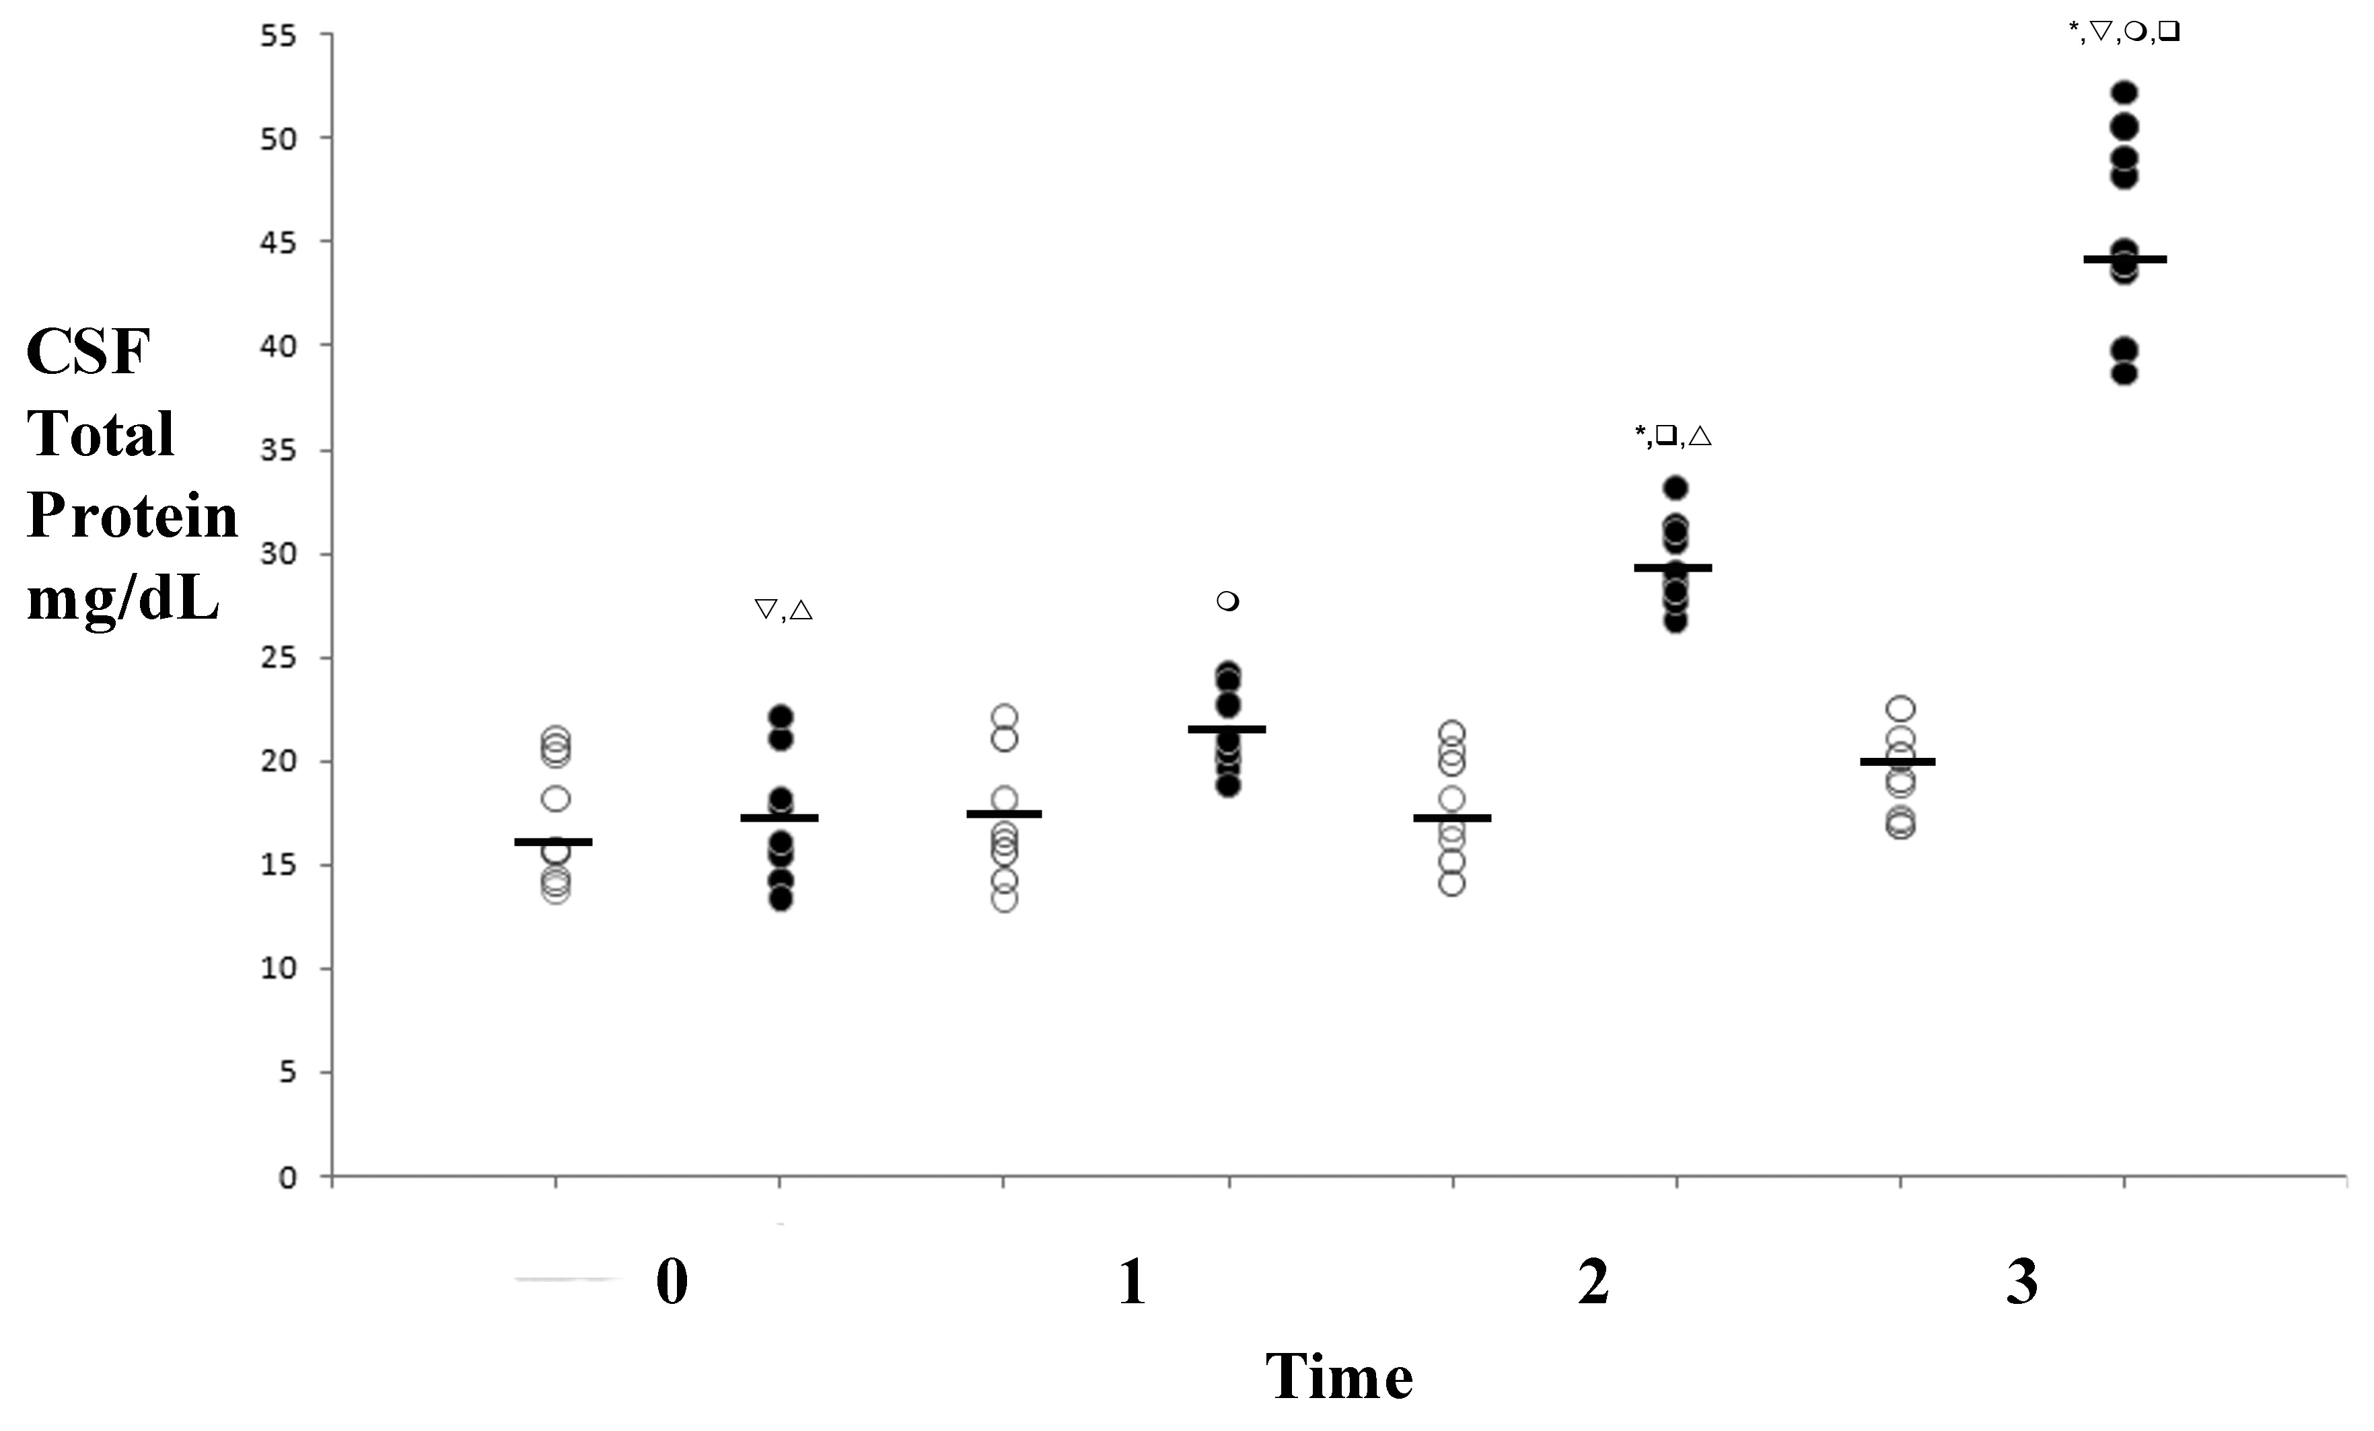

Figure 2
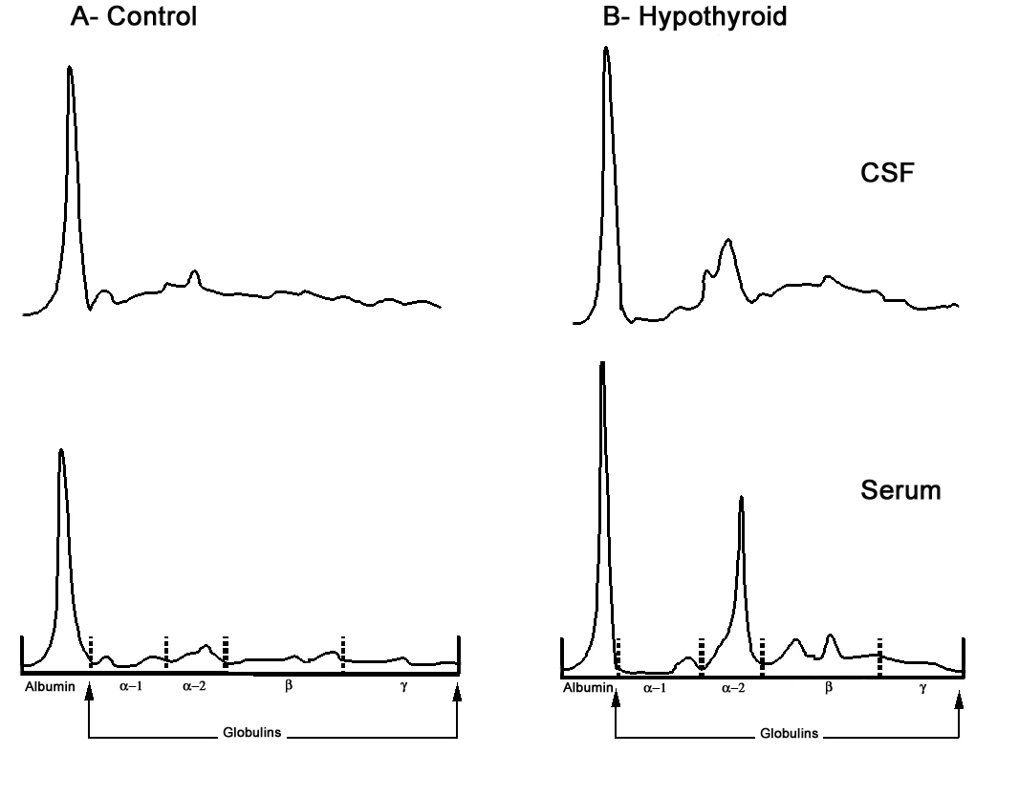

Figure 3

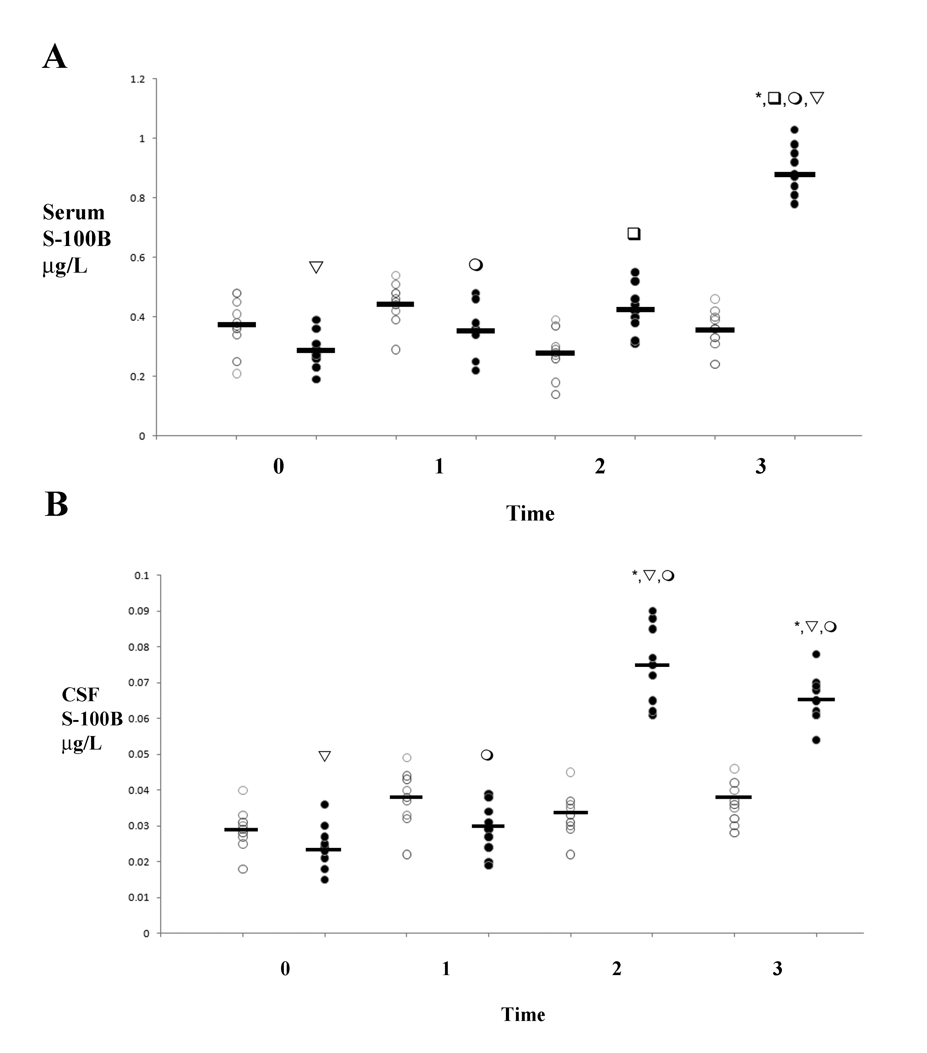

IBL International Endothelin-1 ELISA Catalog #JP27165
Phoenix Pharmaceuticals Inc Burlingame, CA USA
Molecular Devices Sunnyvale, CA USA
Bio-Rad Laboratories Inc.
Enzo Life Sciences Catalog #SE-503
Enzo Life Sciences Catalog #SE-504
Millipore Catalog #CC1043
Sigma-Aldrich Product #A9563
Criterion Renaturing Solution 2.5% Triton X-100
Criterion Development Solution 50 mM Tris, 200 mM NaCl, 5 mM CaCl2, 0.02% Brij-35
Staining solution 40% methanol, 10% acetic acid, 0.5% Coomassie Blue R-250
Destaining solution 40% methanol, 10% acetic acid
Phoenix Pharmaceuticals
http://www.rndsystems.com/pdf/QET00B.pdf 1.29.2011 4:30pm
http://www.uscnk.us/pdf/20091127173254.pdf 1.29.2011 4:30 pm

